Contents

1. NTAARP0001 6

2. NTAARP0002 8

3. NTAARP0003 10

4. NTAARP0004 12

5. NTAARP0005 14

6. NTABRT0001 16

7. NTABRT0002 18

8. NTABRT0003 20

9. NTABRT0004 22

10. NTABRT0005 24

11. NTABRT0006 26

12. NTABRT0007 28

13. NTABRT0008 30

14. NTADAC0001 32

15. NTADAC0002 34

16. NTADMR0001 36

17. NTADMR0002 38

18. NTAFIN0001 40

19. NTAFIN0002 42

20. NTAFIN0003 44

21. NTAFIN0004 46

22. NTAFIN0005 48

23. NTAFIN0006 50

24. NTAFIN0007 52

25. NTAFIN0008 54

26. NTAFIN0009 56

27. NTAFIN0010 58

28. NTAFIN0011 60

29. NTAFIN0012 62

30. NTAFIN0013 64

31. NTAFIN0014 66

32. NTAFIN0015 68

33. NTAFIN0016 70

34. NTAFIN0017 72

35. NTAFIN0018 74

36. NTAFIN0019 76

37. NTAFIN0020 78

38. NTAFIN0021 80

39. NTAFIN0022 82

40. NTAFIN0023 84

41. NTAFIN0024 86

42. NTAFIN0025 88

43. NTAFIN0026 90

44. NTAFIN0027 92

45. NTAFIN0028 94

46. NTAFIN0029 96

47. NTAFIN0030 98

48. NTAFIN0031 100

49. NTAFIN0032 102

50. NTAFIN0033 104

51. NTAGFU0001 106

52. NTAGFU0002 108

53. NTAGFU0003 110

54. NTAGFU0004 112

55. NTAGFU0005 114

56. NTAGFU0006 116

57. NTAGFU0007 118

58. NTAGFU0008 120

59. NTAGFU0009 122

60. NTAGFU0010 124

61. NTAGFU0011 126

62. NTAGFU0012 128

63. NTAGFU0013 130

64. NTAGFU0014 132

65. NTAGFU0015 134

66. NTAGFU0016 136

67. NTAGFU0017 138

68. NTAGFU0018 140

69. NTAGFU0019 142

70. NTAGFU0020 144

71. NTAGFU0021 146

72. NTAGFU0022 148

73. NTAGFU0023 150

74. NTAGFU0024 152

75. NTAGFU0025 154

76. NTAGFU0026 156

77. NTAGFU0027 158

78. NTAGFU0028 160

79. NTAGFU0029 162

80. NTAGFU0030 164

81. NTAGFU0031 166

82. NTAGFU0032 168

83. NTAGFU0033 170

84. NTAGFU0034 172

85. NTAGFU0035 174

86. NTAGFU0036 176

87. NTAGFU0037 178

88. NTAGFU0038 180

89. NTAGFU0039 182

90. NTAGFU0040 184

91. NTAGFU0041 186

92. NTAMAC0001 188

93. NTAMAC0002 190

94. NTAMAC0003 192

95. NTAMGD0001 194

96. NTAMGD0002 196

97. NTAMGD0003 198

98. NTAMGD0004 200

99. NTAMGD0005 202

100. NTAPCK0001 204

101. NTAPCK0002 206

102. NTAPCK0003 208

103. NTAPCK0004 210

104. NTAPCK0005 212

105. NTAPCK0006 214

106. NTAPCK0007 216

107. NTAPCK1009 218

108. NTAPCK1010 220

109. NTAPCK1011 222

110. NTAPCK1012 224

111. NTAPCK2013 226

112. NTAPCK2014 228

113. NTASSD0001 230

114. NTASSD0003 232

115. NTASSD0004 234

116. NTASSD0005 236

117. NTASSD0006 238

118. NTASSD0007 240

119. NTASSD0008 242

120. NTASSD0009 244

121. NTASSD0010 246

122. NTASSD0011 248

123. NTASSD0012 250

124. NTASSD0013 252

125. NTASSD0014 254

126. NTASSD0015 256

127. NTASSD0016 258

128. NTASSD0017 260

129. NTASSD0018 262

130. NTASSD0019 264

131. NTASTU0001 266

132. NTASTU0002 268

133. NTASTU0003 270

134. NTASTU0004 272

135. NTASTU0005 274

136. NTATAN0001 276

137. NTATAN0002 278

138. NTATAN0003 280

139. NTATAN0004 282

140. NTTDAB0001 284

141. NTTDAC0001 286

142. NTTDMR0001 288

143. NTTDMR0002 290

144. NTTDMR0003 292

145. NTTMGD0001 294

146. NTTPCK0001 296

147. NTTSTU0001 298

# NTAARP0001

| Min. | 1st Qu. | Median | Mean | 3rd Qu. | Max. |
| --- | --- | --- | --- | --- | --- |
| 27.94934 | 40.65914 | 47.43155 | 47.65542 | 54.06935 | 70.29734 |

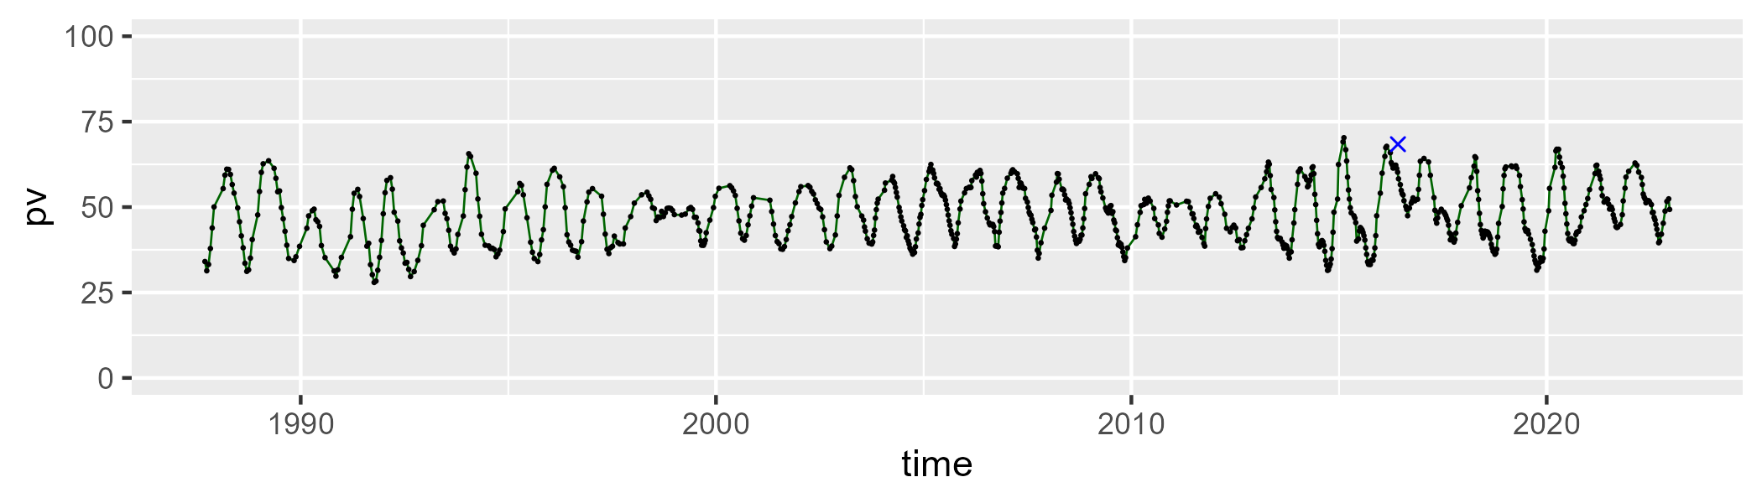

| Min. | 1st Qu. | Median | Mean | 3rd Qu. | Max. |
| --- | --- | --- | --- | --- | --- |
| 23.86954 | 39.07201 | 43.47261 | 43.74371 | 48.74631 | 69.21225 |

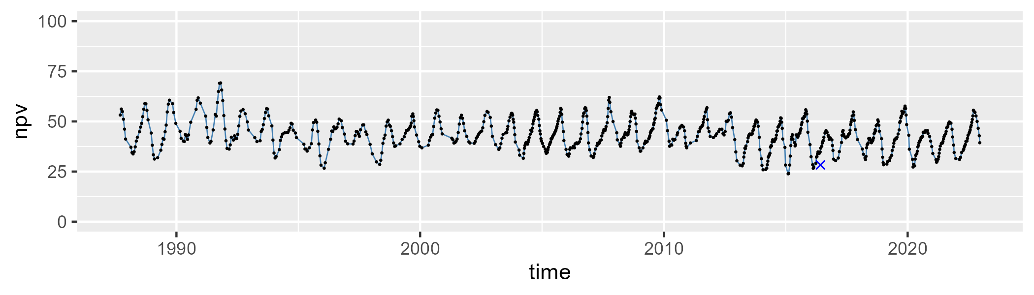

| Min. | 1st Qu. | Median | Mean | 3rd Qu. | Max. |
| --- | --- | --- | --- | --- | --- |
| 0 | 3.935678 | 6.113018 | 7.21693 | 10.09721 | 21.37977 |

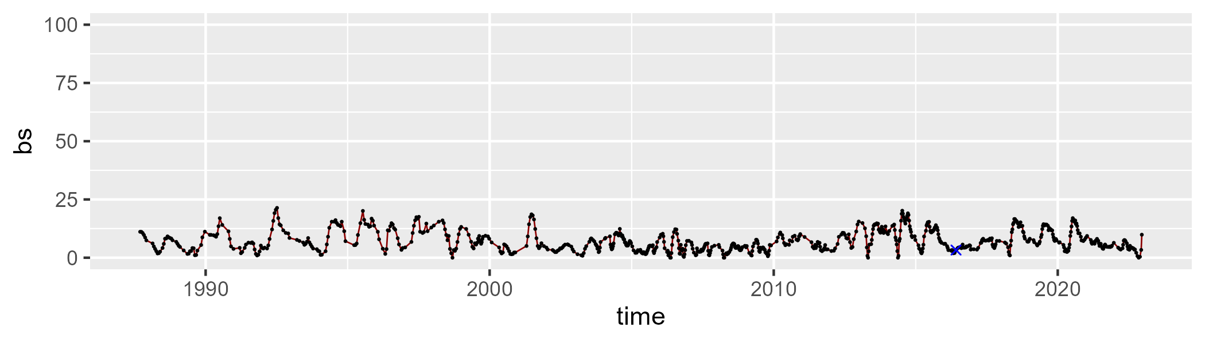

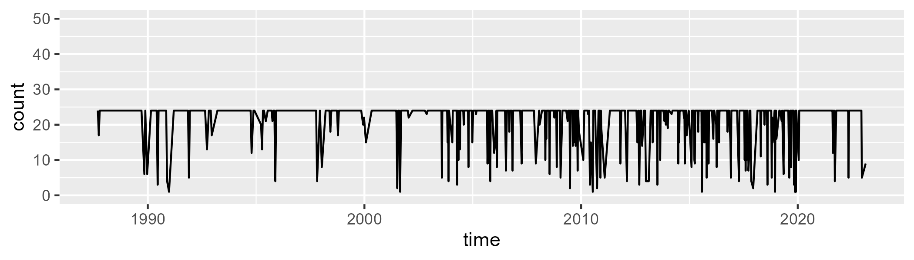

Min. : 1.0 1st Qu.:24.0 Median :24.0 Mean :21.8 3rd Qu.:24.0 Max. :24.0

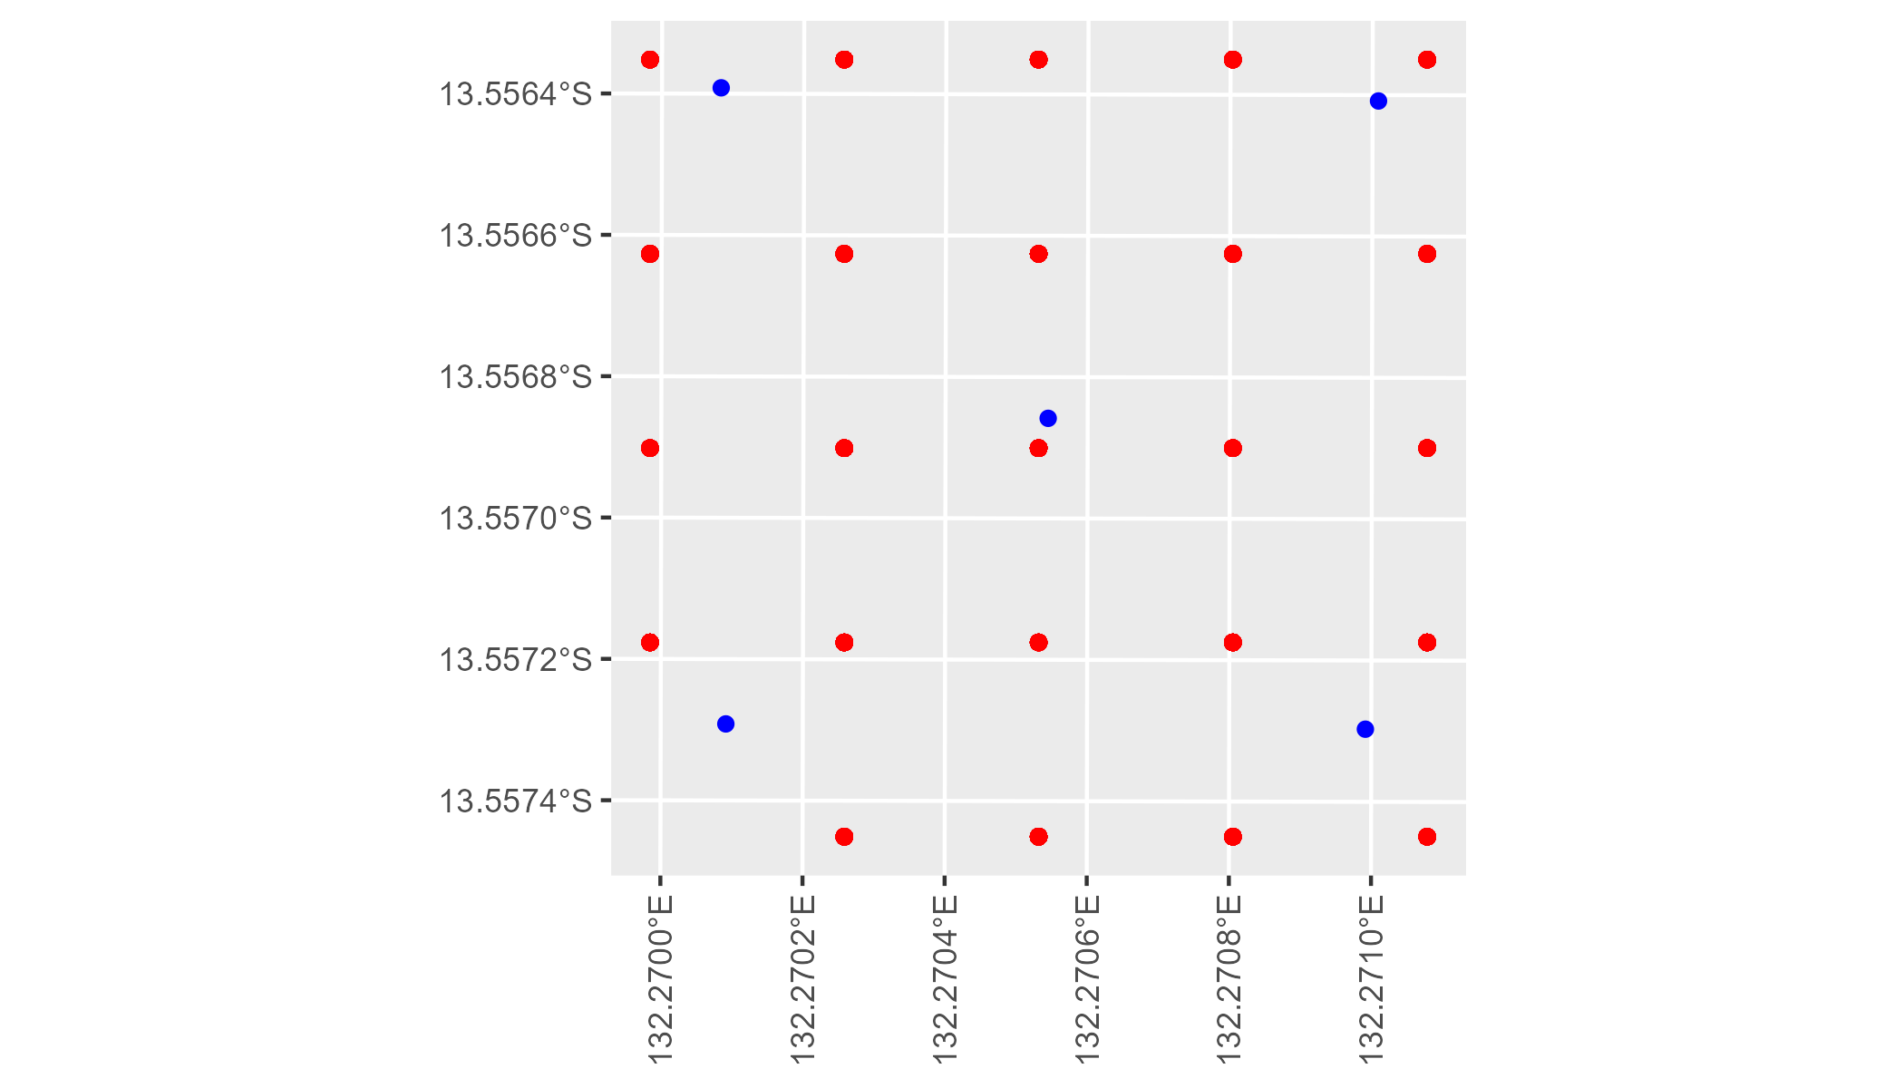

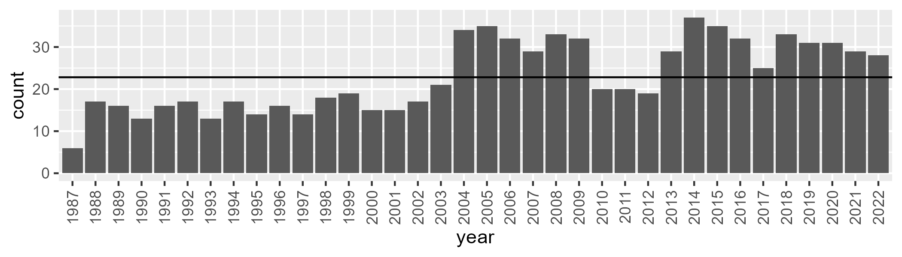

Number of samples: 828

# NTAARP0002

| Min. | 1st Qu. | Median | Mean | 3rd Qu. | Max. |
| --- | --- | --- | --- | --- | --- |
| 16.92116 | 30.66787 | 34.86953 | 35.08348 | 39.52109 | 51.29098 |

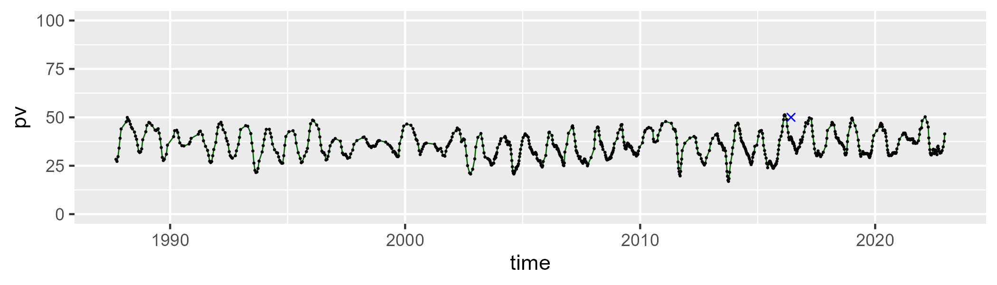

| Min. | 1st Qu. | Median | Mean | 3rd Qu. | Max. |
| --- | --- | --- | --- | --- | --- |
| 34.36721 | 45.46805 | 49.23729 | 49.26925 | 52.95791 | 68.17284 |

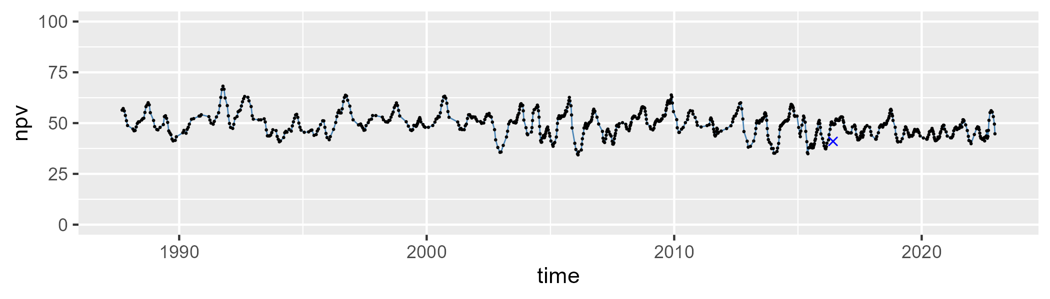

| Min. | 1st Qu. | Median | Mean | 3rd Qu. | Max. |
| --- | --- | --- | --- | --- | --- |
| 0.665962 | 9.035 | 12.66588 | 14.38076 | 18.71778 | 37.53609 |

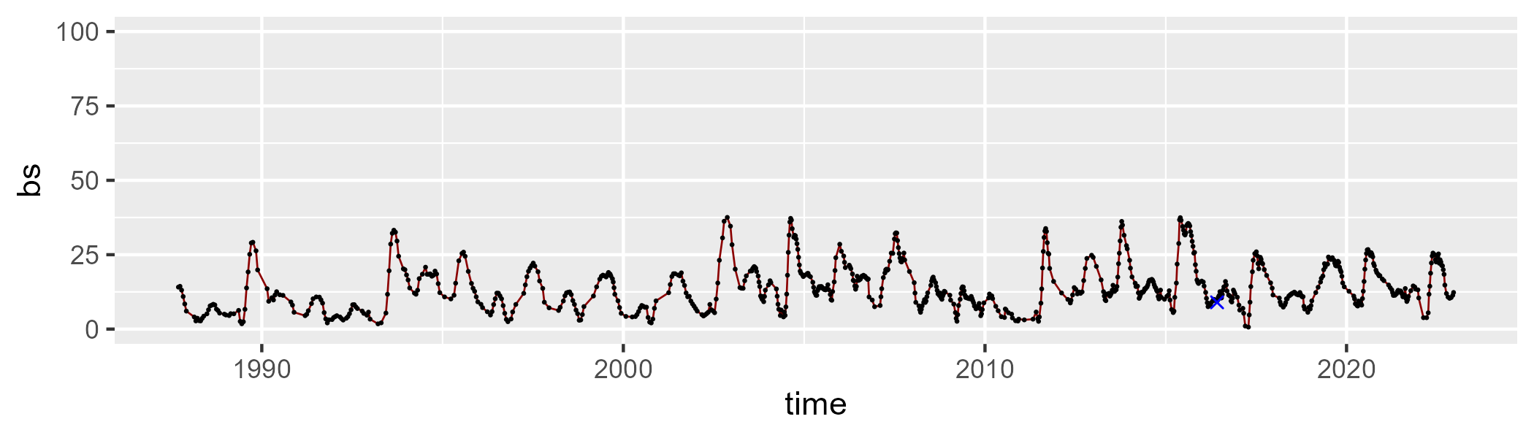

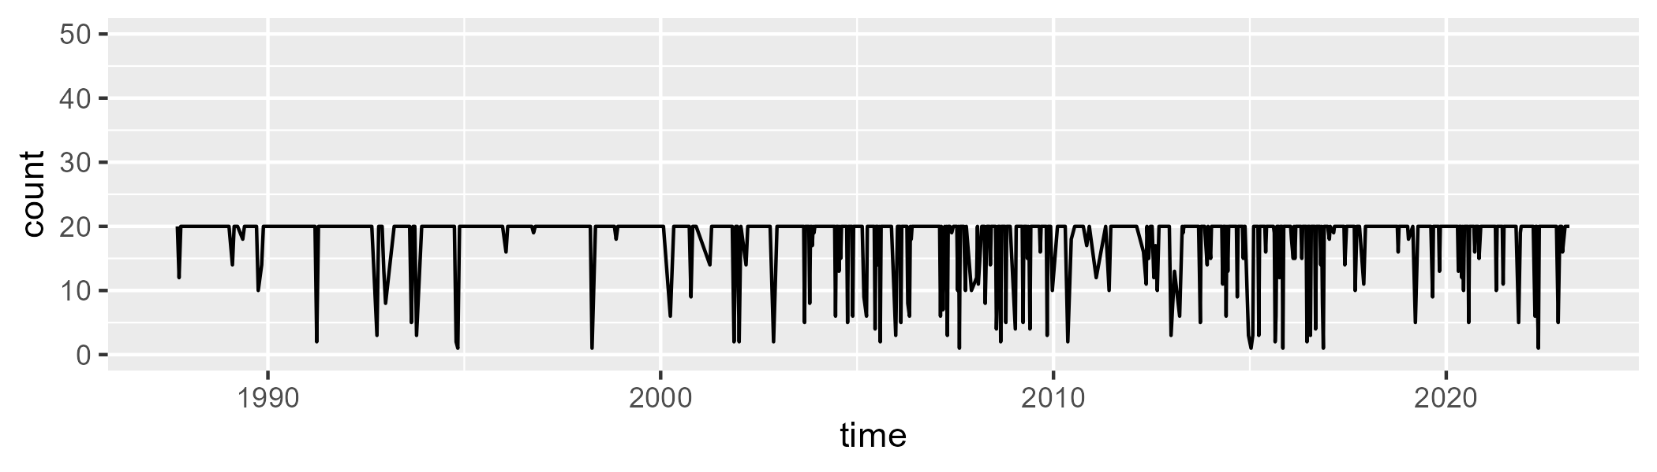

Min. : 1.00 1st Qu.:20.00 Median :20.00 Mean :18.27 3rd Qu.:20.00 Max. :20.00

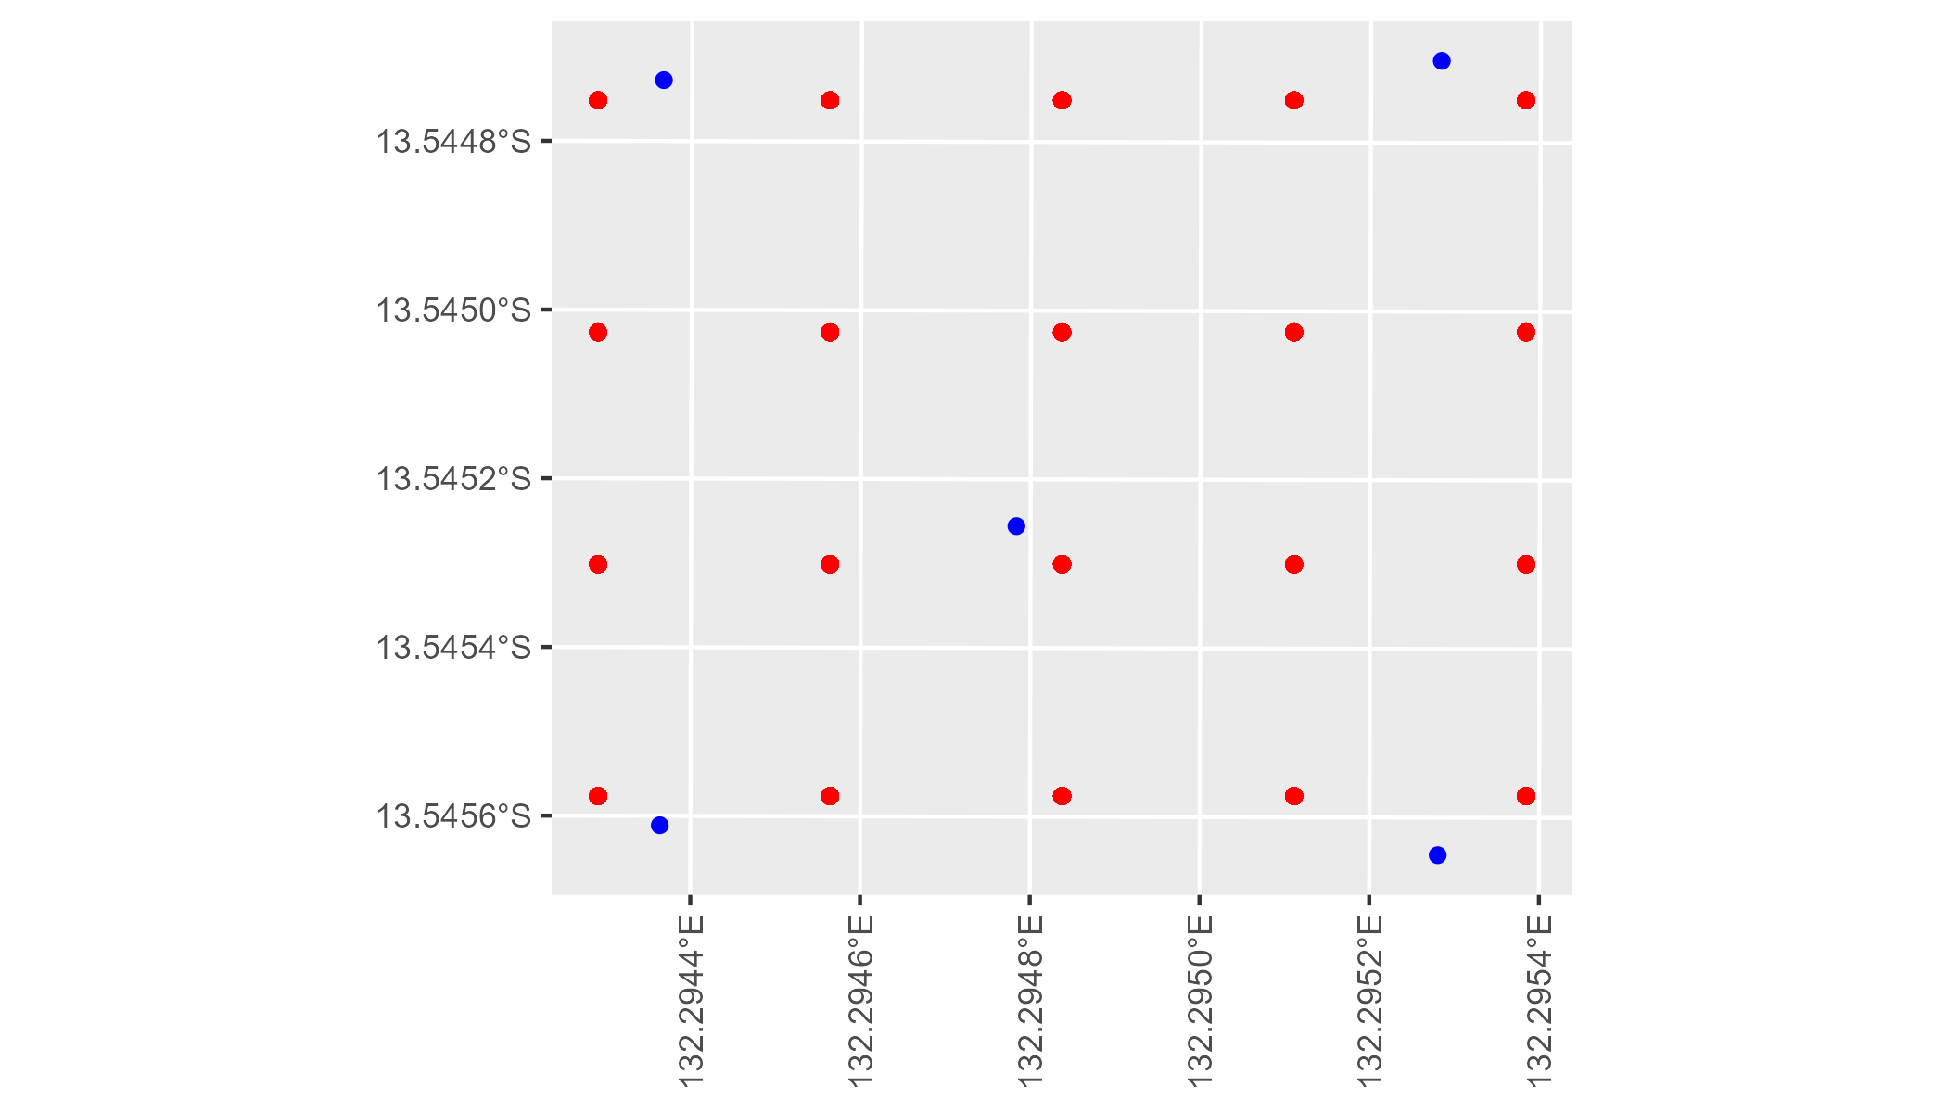

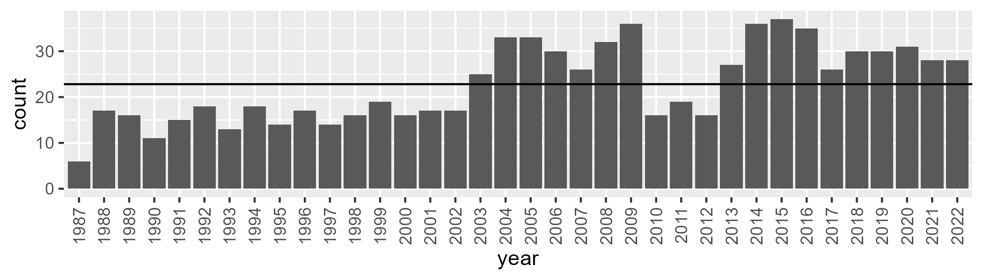

Number of samples: 818

# NTAARP0003

| Min. | 1st Qu. | Median | Mean | 3rd Qu. | Max. |
| --- | --- | --- | --- | --- | --- |
| 13.78718 | 28.24337 | 33.27043 | 36.21007 | 43.3711 | 63.36978 |

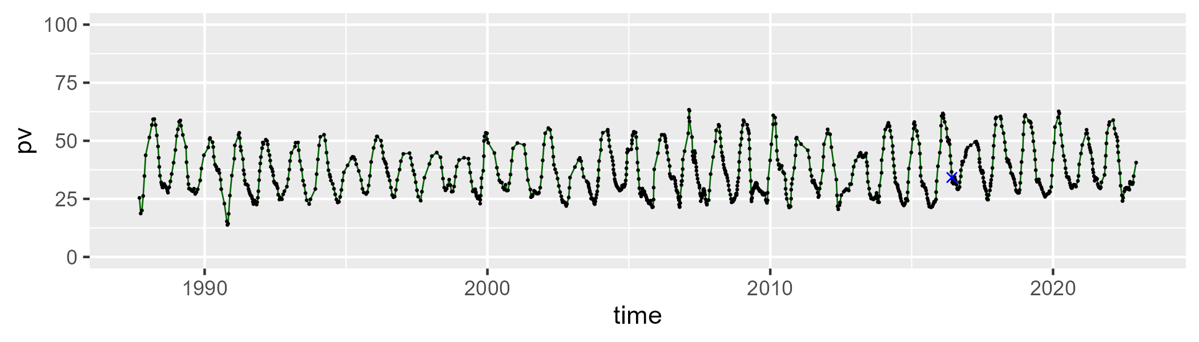

| Min. | 1st Qu. | Median | Mean | 3rd Qu. | Max. |
| --- | --- | --- | --- | --- | --- |
| 25.51943 | 41.95172 | 46.64542 | 46.36468 | 50.48732 | 68.43716 |

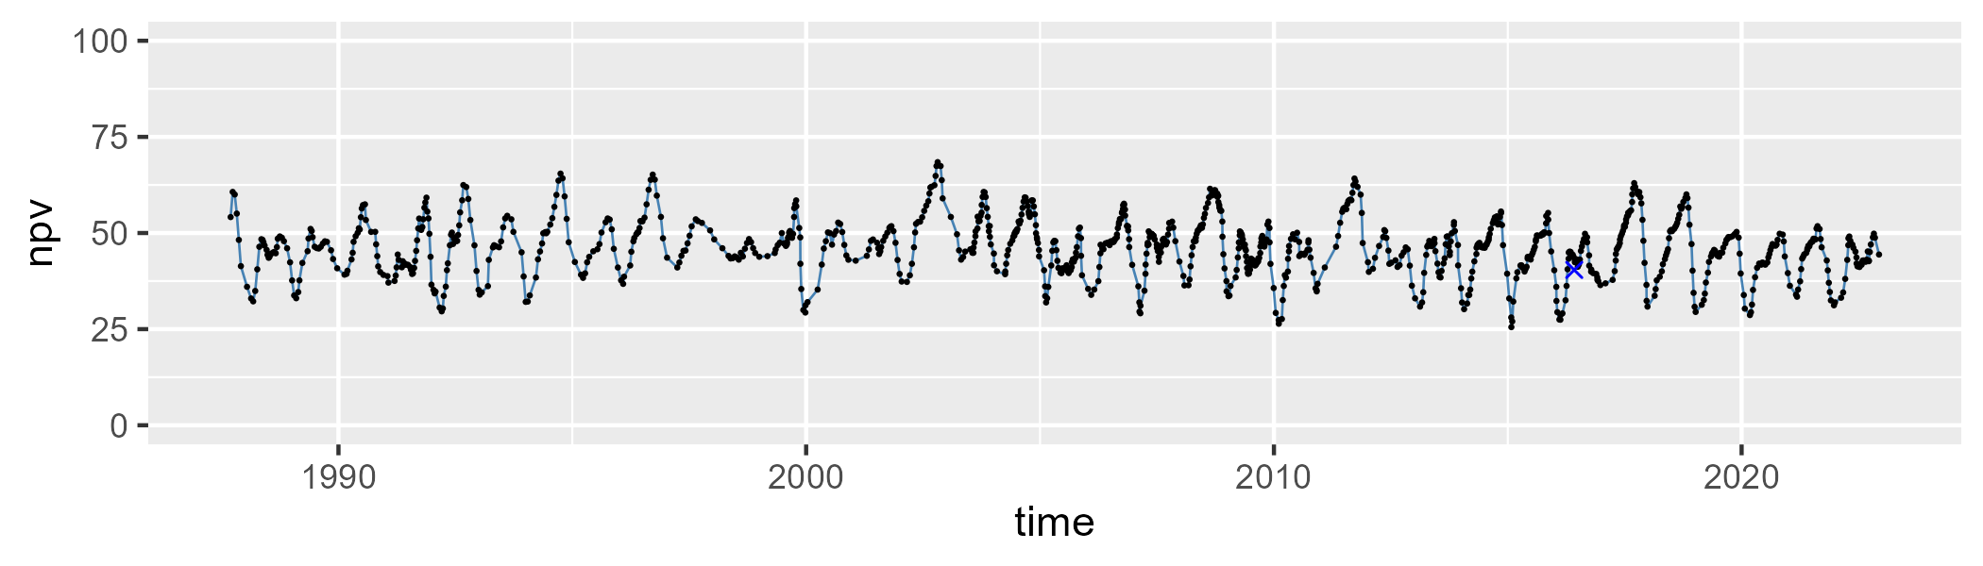

| Min. | 1st Qu. | Median | Mean | 3rd Qu. | Max. |
| --- | --- | --- | --- | --- | --- |
| 0 | 10.00087 | 15.36997 | 16.09936 | 22.09962 | 40.19187 |

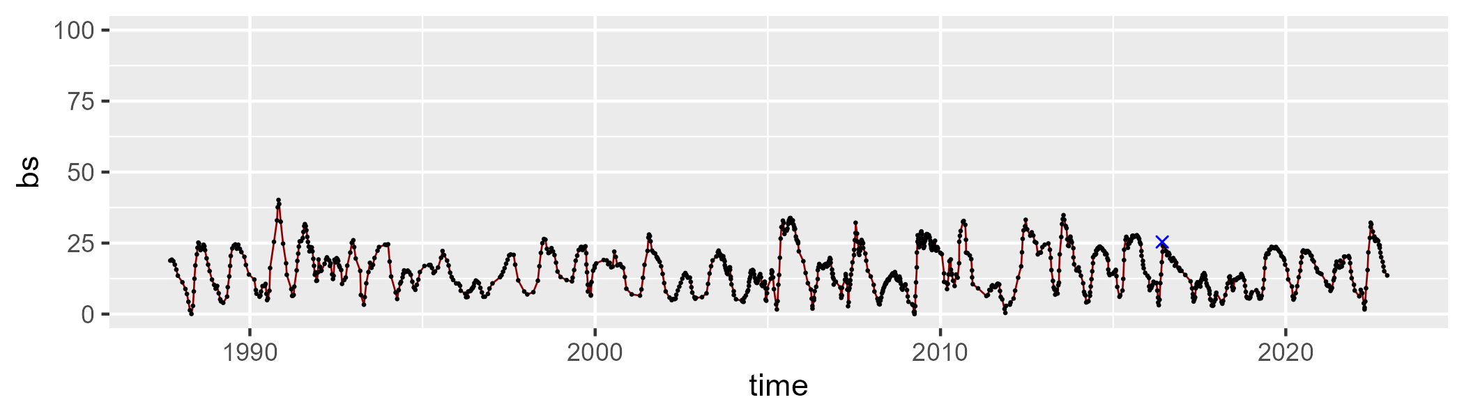

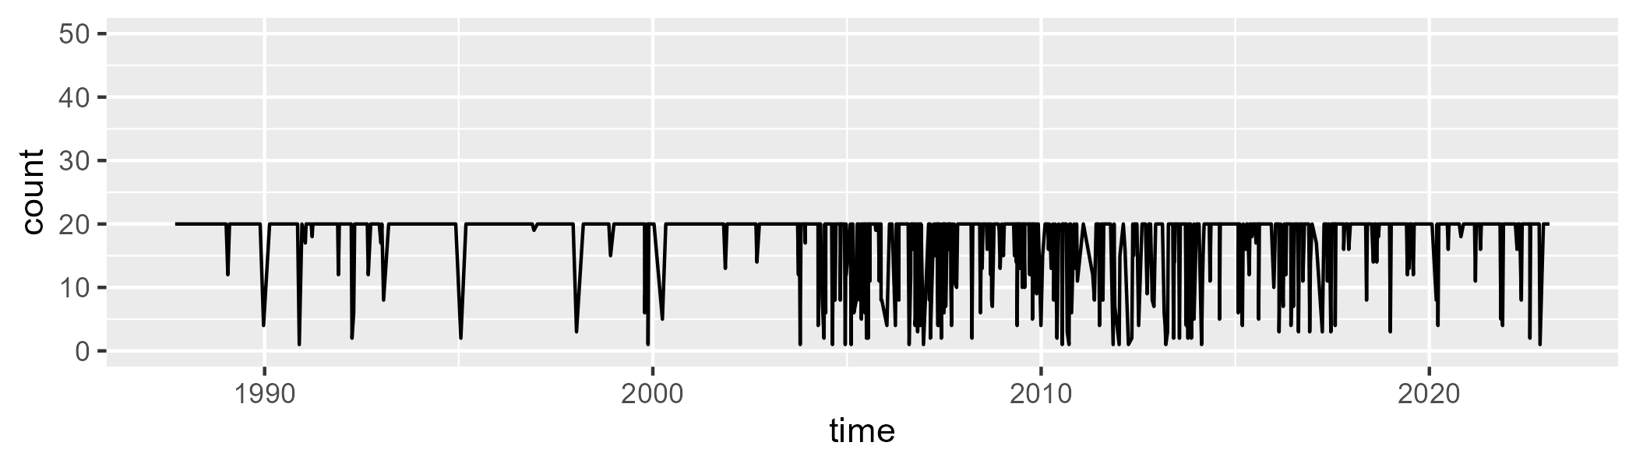

Min. : 1.00 1st Qu.:20.00 Median :20.00 Mean :17.95 3rd Qu.:20.00 Max. :20.00

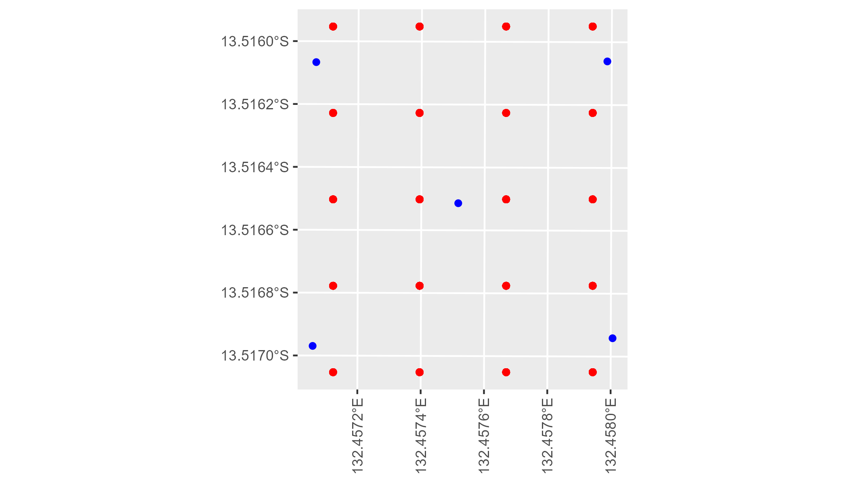

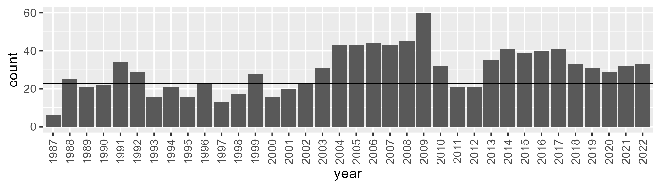

Number of samples: 1067

# NTAARP0004

| Min. | 1st Qu. | Median | Mean | 3rd Qu. | Max. |
| --- | --- | --- | --- | --- | --- |
| 17.75426 | 37.29298 | 44.39768 | 46.4669 | 56.55615 | 79.55999 |

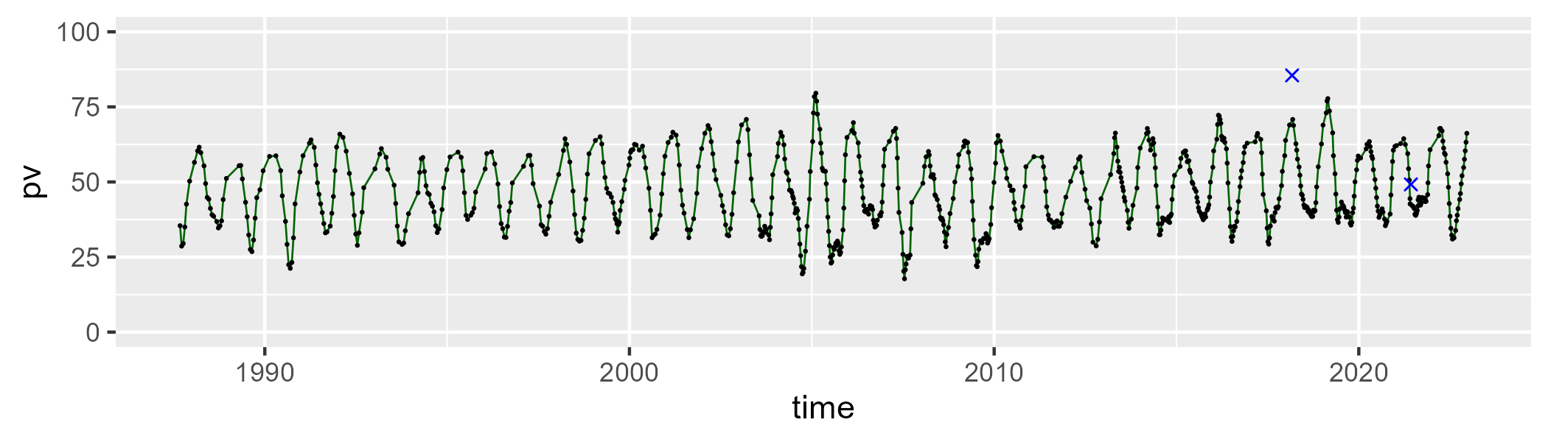

| Min. | 1st Qu. | Median | Mean | 3rd Qu. | Max. |
| --- | --- | --- | --- | --- | --- |
| 15.1477 | 36.43923 | 44.90963 | 43.21891 | 49.85281 | 61.24569 |

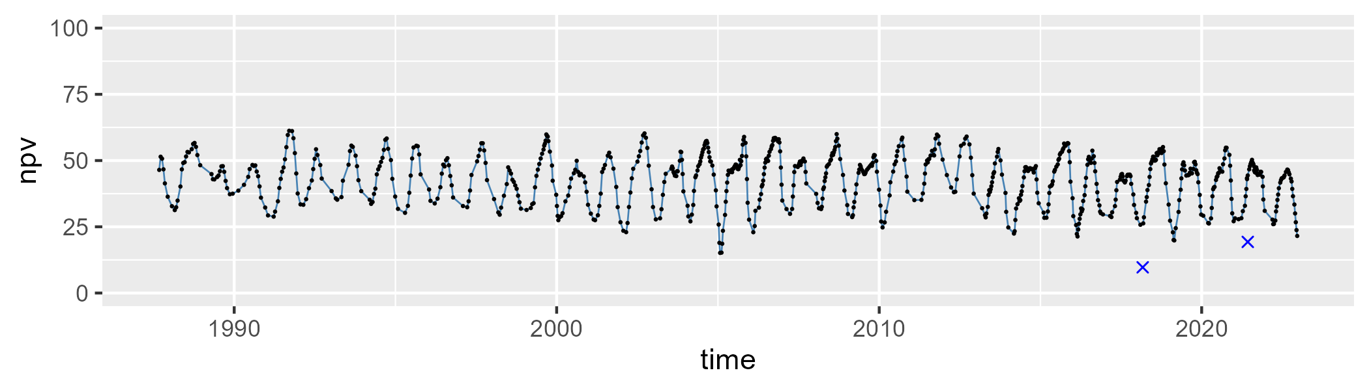

| Min. | 1st Qu. | Median | Mean | 3rd Qu. | Max. |
| --- | --- | --- | --- | --- | --- |
| 0 | 4.254884 | 7.572545 | 9.040887 | 12.37239 | 31.97533 |

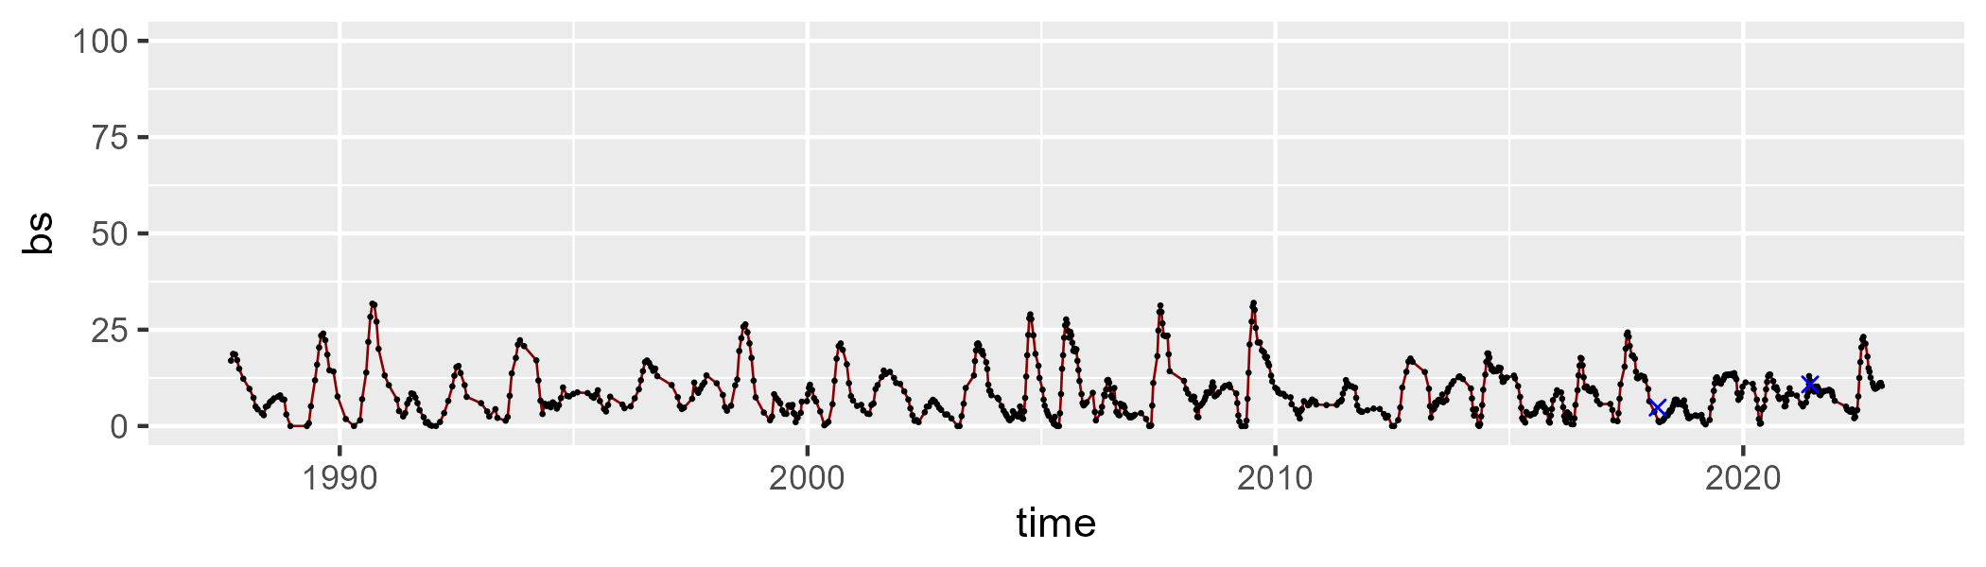

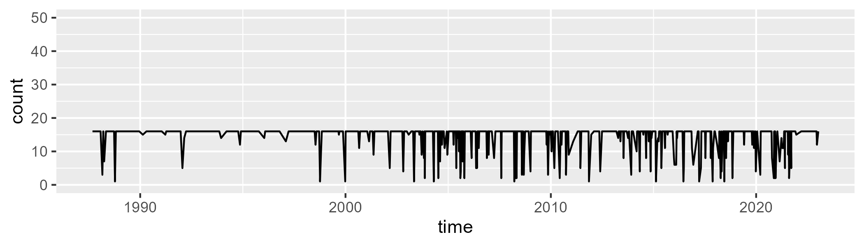

Min. : 1.00 1st Qu.:16.00 Median :16.00 Mean :14.58 3rd Qu.:16.00 Max. :16.00

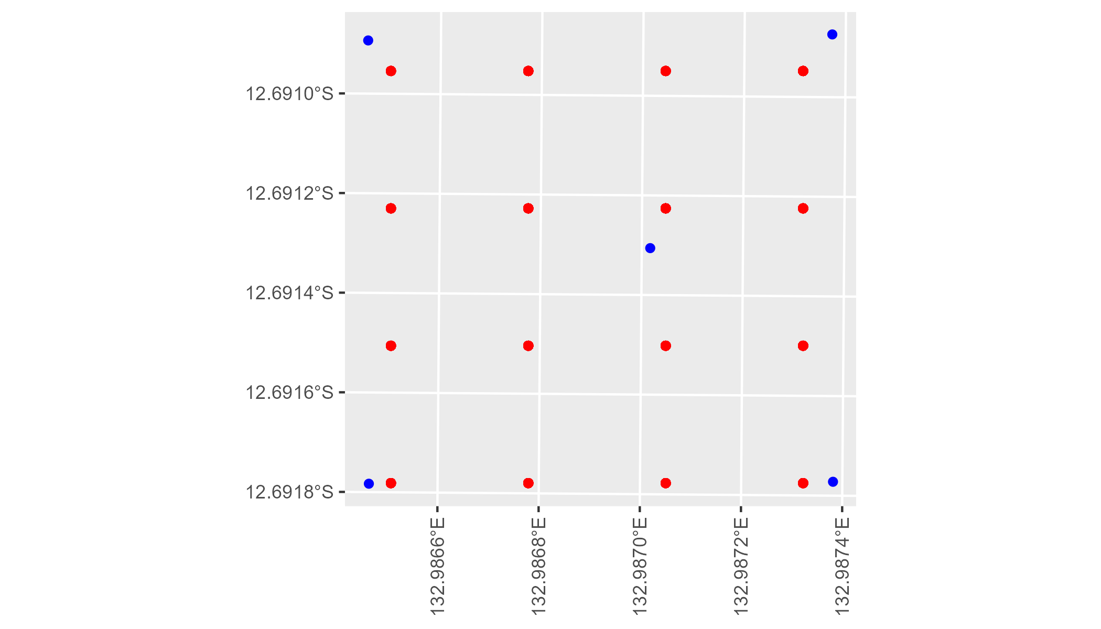

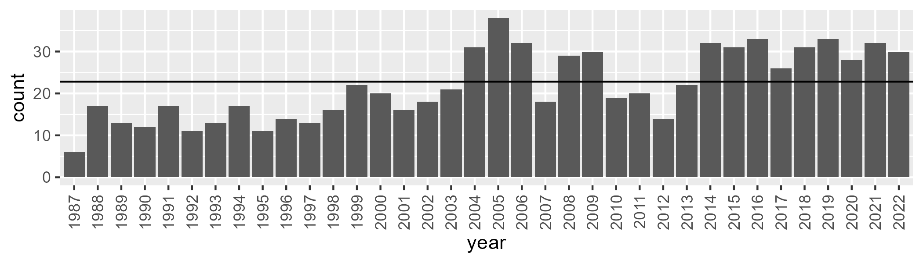

Number of samples: 786

# NTAARP0005

| Min. | 1st Qu. | Median | Mean | 3rd Qu. | Max. |
| --- | --- | --- | --- | --- | --- |
| 27.5405 | 42.06278 | 48.08119 | 47.53676 | 53.38218 | 65.97089 |

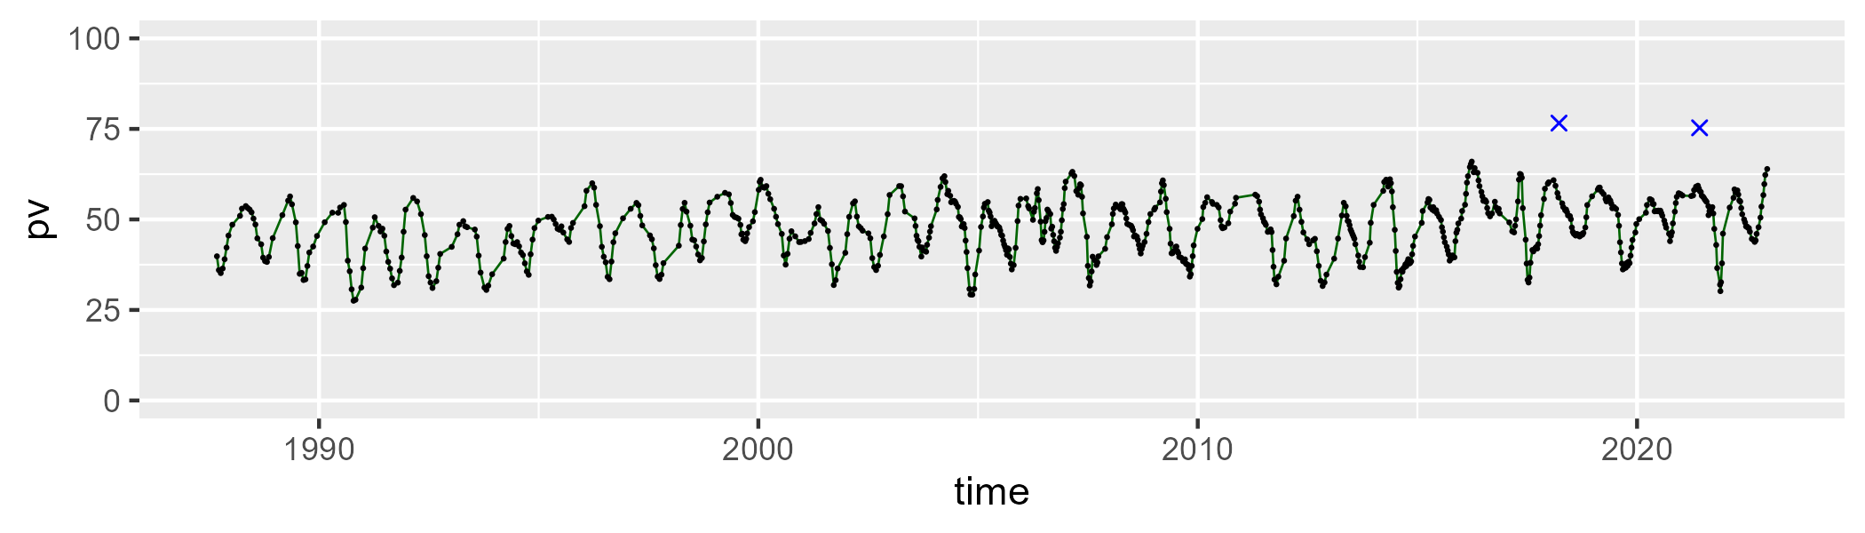

| Min. | 1st Qu. | Median | Mean | 3rd Qu. | Max. |
| --- | --- | --- | --- | --- | --- |
| 26.73033 | 39.15743 | 42.82833 | 43.23777 | 47.41709 | 63.55181 |

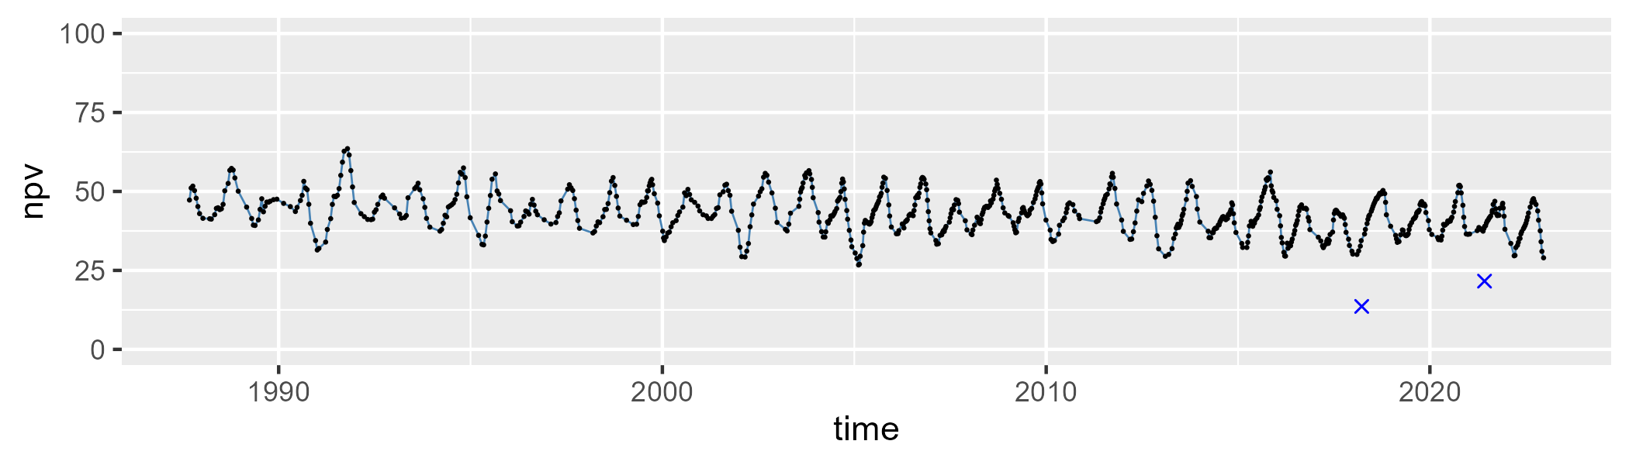

| Min. | 1st Qu. | Median | Mean | 3rd Qu. | Max. |
| --- | --- | --- | --- | --- | --- |
| 0 | 2.890777 | 6.017001 | 7.909861 | 11.06953 | 33.27886 |

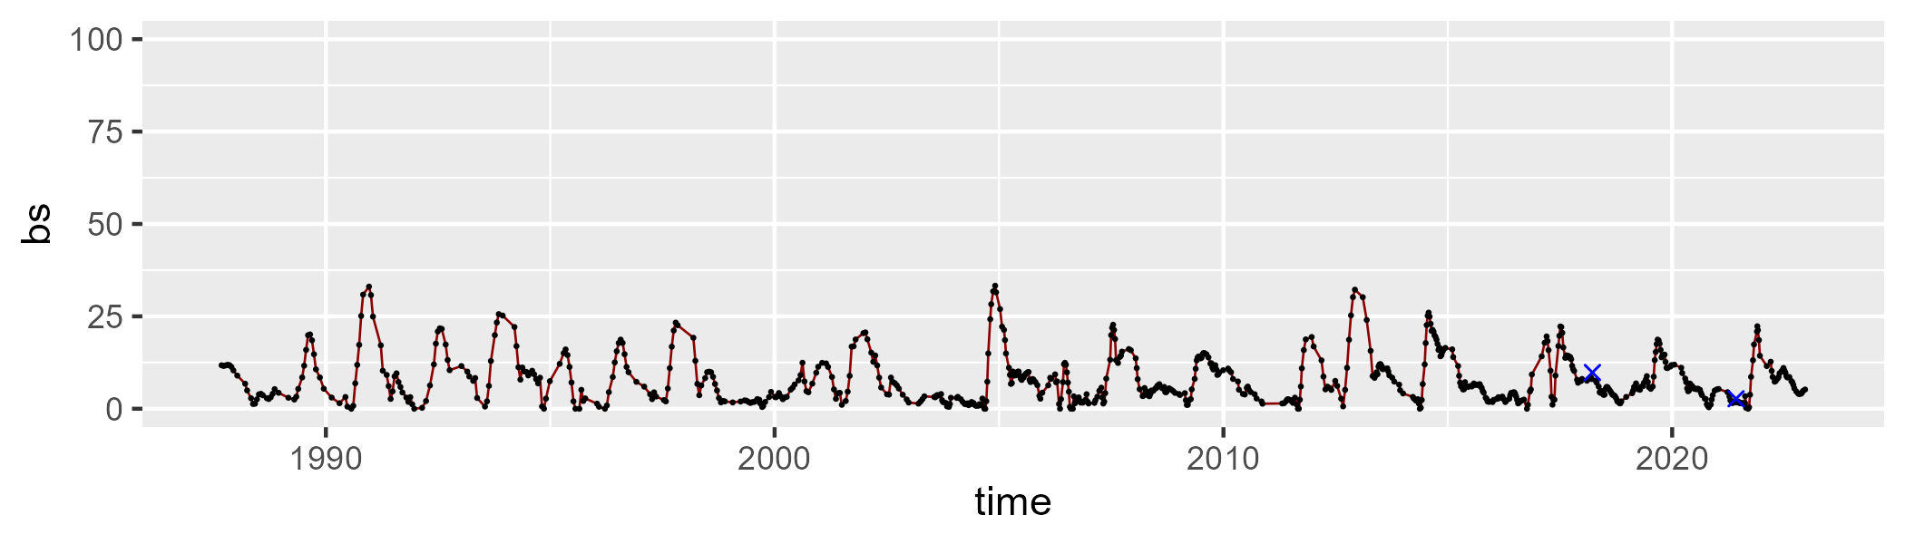

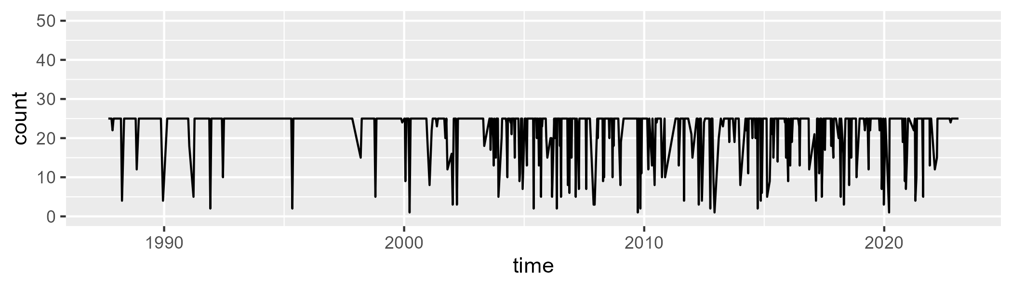

Min. : 1.0 1st Qu.:25.0 Median :25.0 Mean :22.6 3rd Qu.:25.0 Max. :25.0

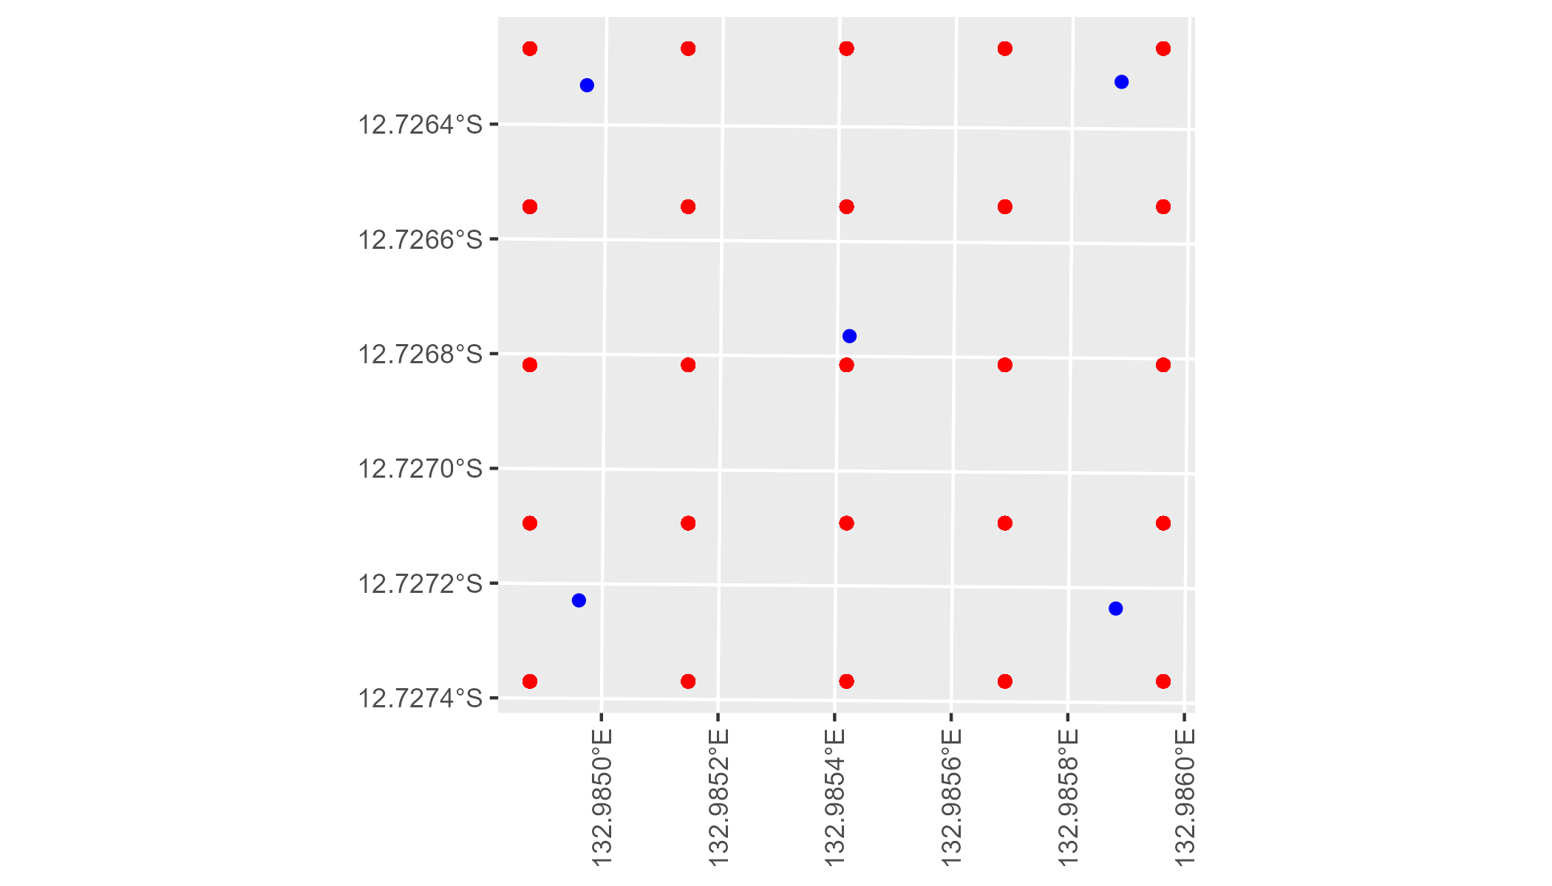

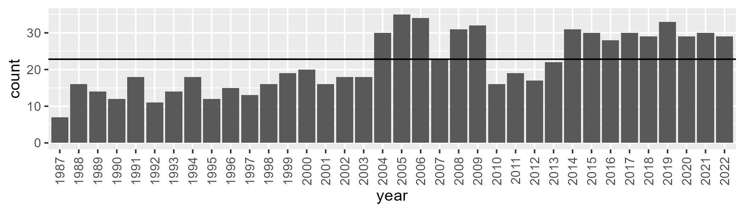

Number of samples: 785

# NTABRT0001

| Min. | 1st Qu. | Median | Mean | 3rd Qu. | Max. |
| --- | --- | --- | --- | --- | --- |
| 4.296309 | 10.11586 | 12.34788 | 14.2137 | 16.53961 | 43.65797 |

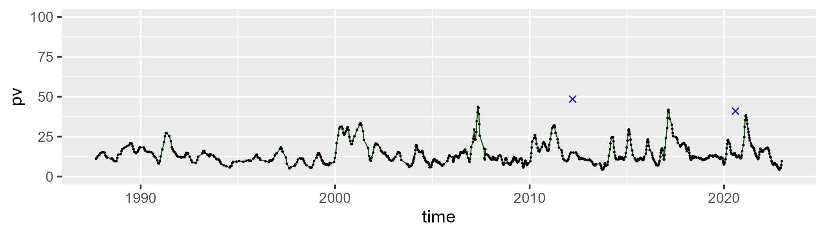

| Min. | 1st Qu. | Median | Mean | 3rd Qu. | Max. |
| --- | --- | --- | --- | --- | --- |
| 37.67691 | 46.61851 | 49.82775 | 49.5598 | 52.35148 | 61.08749 |

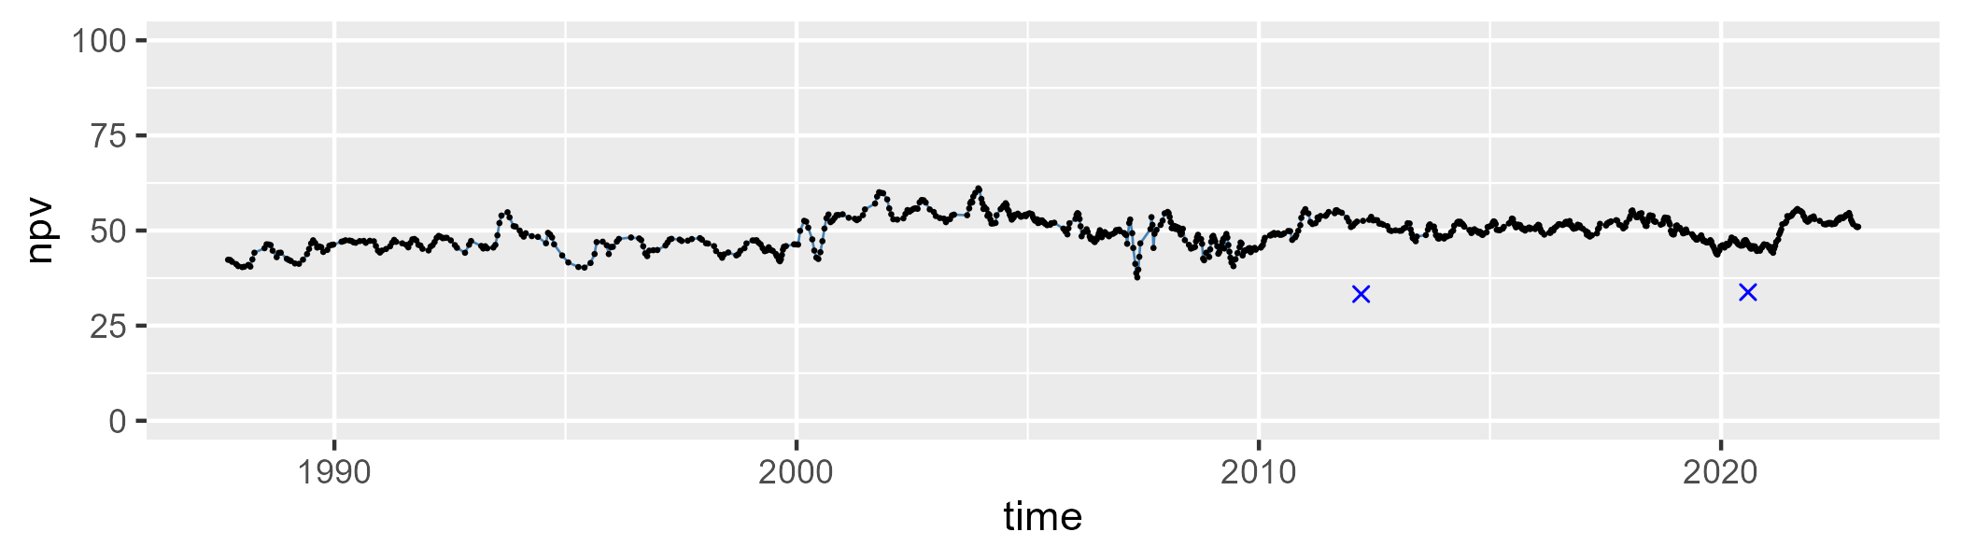

| Min. | 1st Qu. | Median | Mean | 3rd Qu. | Max. |
| --- | --- | --- | --- | --- | --- |
| 8.269859 | 30.6121 | 36.39728 | 34.93464 | 39.90153 | 49.41881 |

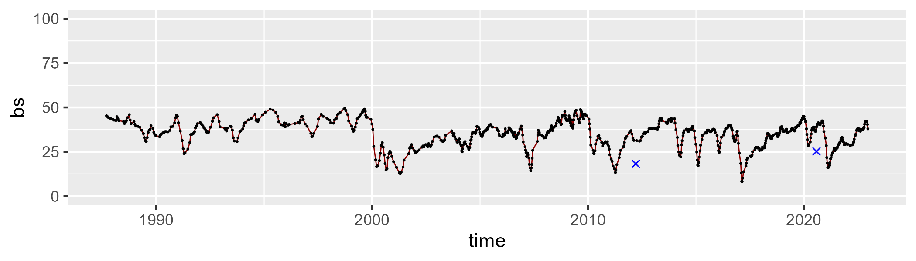

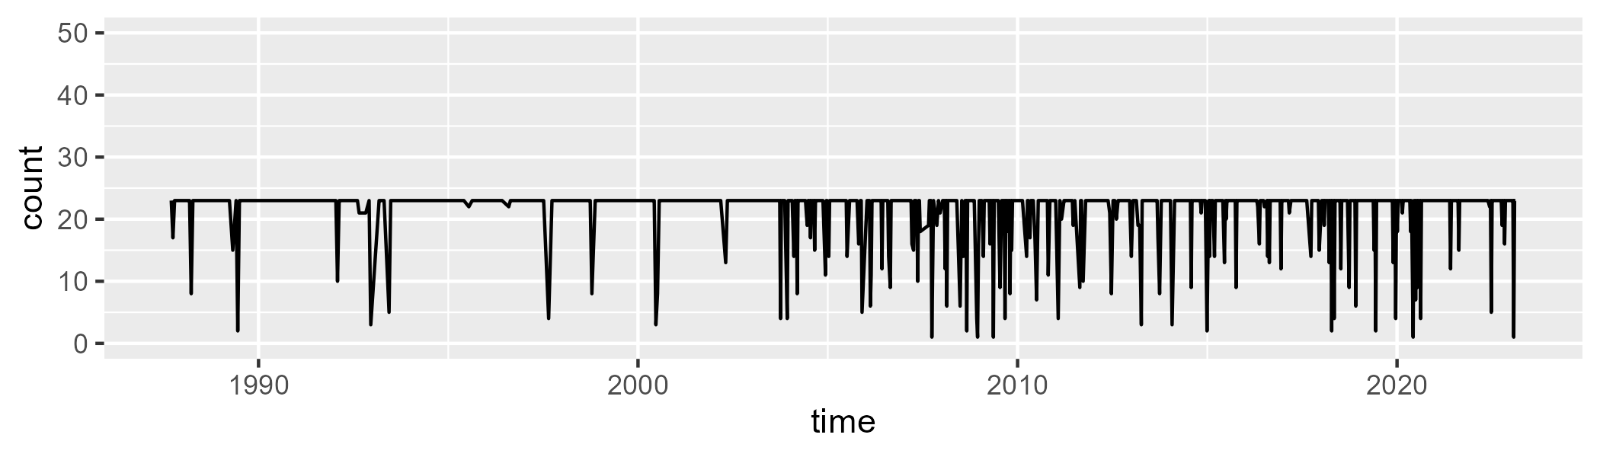

Min. : 1.00 1st Qu.:23.00 Median :23.00 Mean :21.39 3rd Qu.:23.00 Max. :23.00

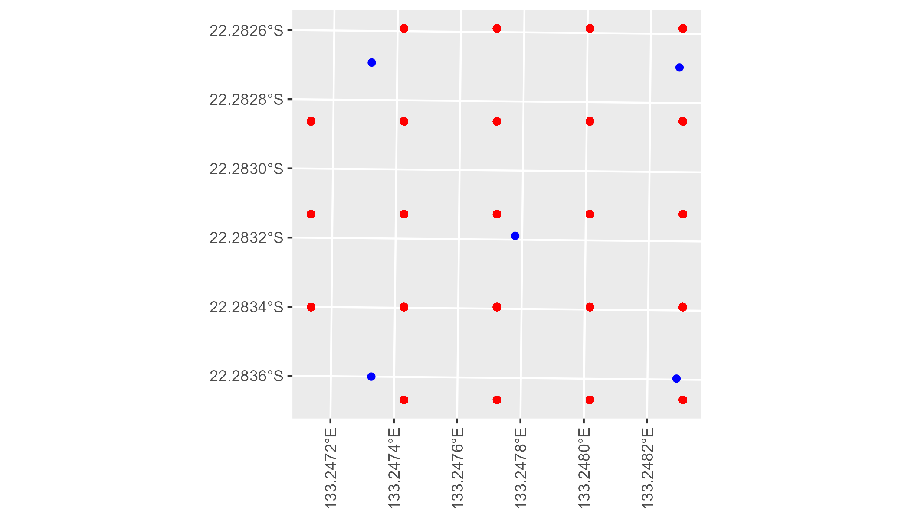

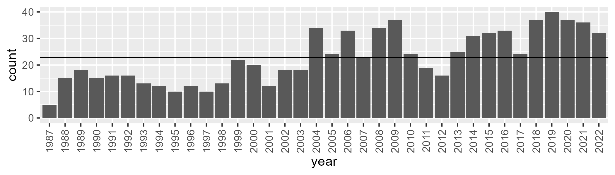

Number of samples: 816

# NTABRT0002

| Min. | 1st Qu. | Median | Mean | 3rd Qu. | Max. |
| --- | --- | --- | --- | --- | --- |
| 2.009872 | 9.841664 | 12.47775 | 14.45026 | 17.5681 | 45.95096 |

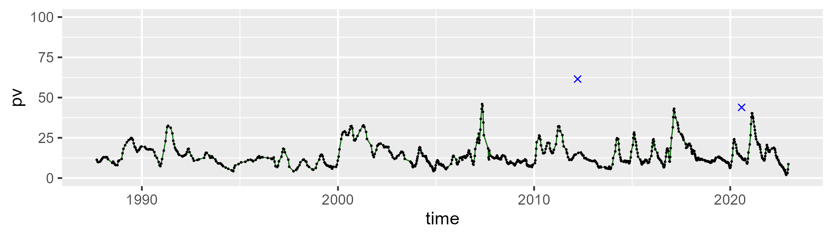

| Min. | 1st Qu. | Median | Mean | 3rd Qu. | Max. |
| --- | --- | --- | --- | --- | --- |
| 38.38563 | 50.63424 | 52.85099 | 52.69416 | 54.89973 | 61.71624 |

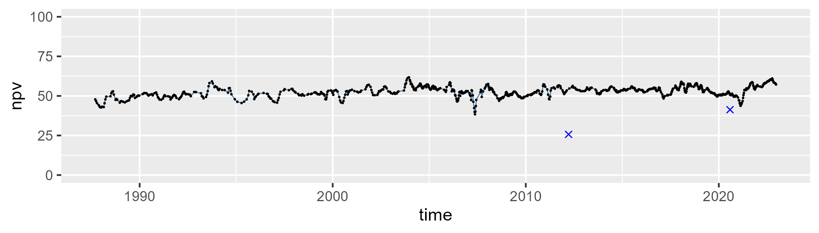

| Min. | 1st Qu. | Median | Mean | 3rd Qu. | Max. |
| --- | --- | --- | --- | --- | --- |
| 7.241743 | 27.8379 | 32.58127 | 31.61126 | 36.32709 | 44.93978 |

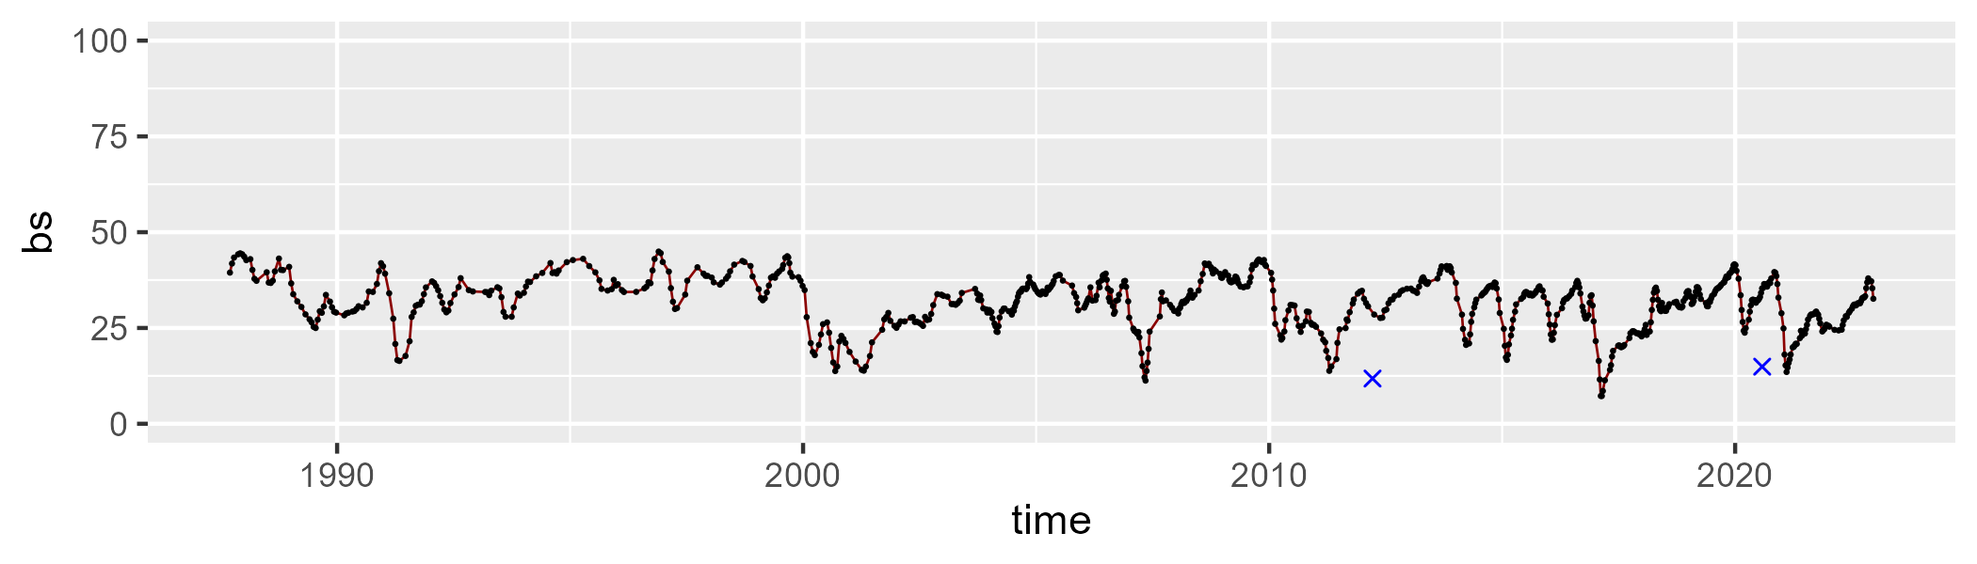

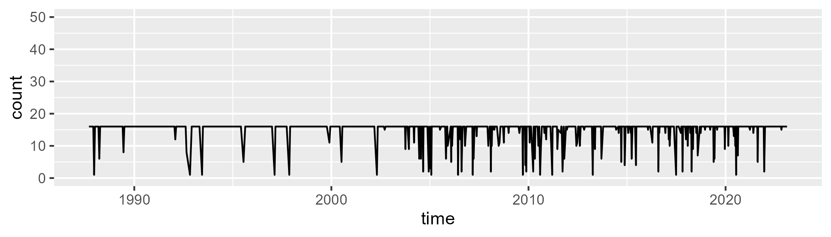

Min. : 1.00 1st Qu.:16.00 Median :16.00 Mean :14.92 3rd Qu.:16.00 Max. :16.00

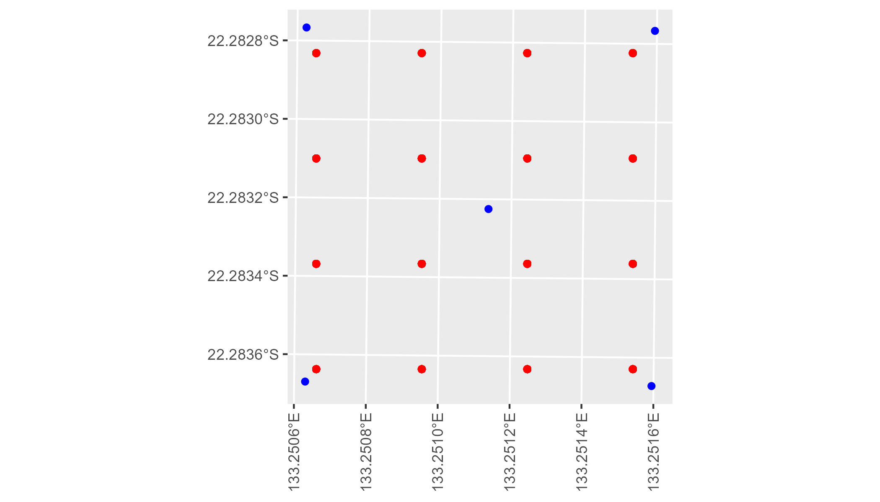

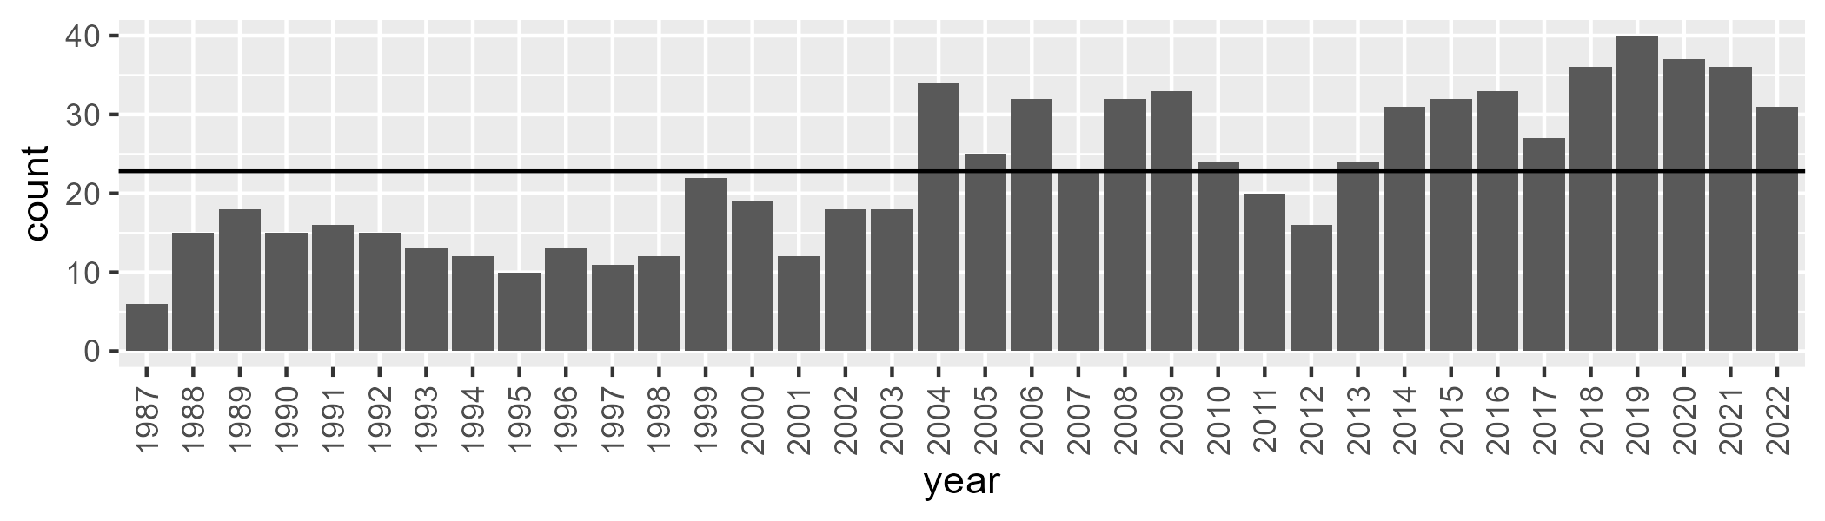

Number of samples: 811

# NTABRT0003

| Min. | 1st Qu. | Median | Mean | 3rd Qu. | Max. |
| --- | --- | --- | --- | --- | --- |
| 1.880037 | 9.542419 | 12.17017 | 14.18306 | 17.15495 | 43.52002 |

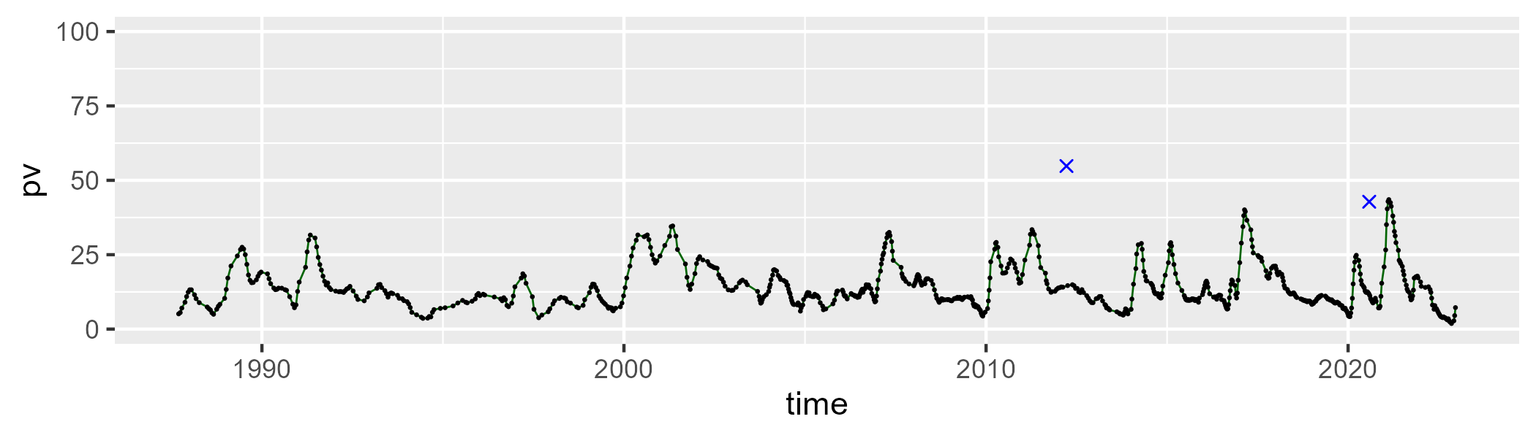

| Min. | 1st Qu. | Median | Mean | 3rd Qu. | Max. |
| --- | --- | --- | --- | --- | --- |
| 38.18168 | 50.16511 | 52.61624 | 52.55727 | 54.80253 | 66.06063 |

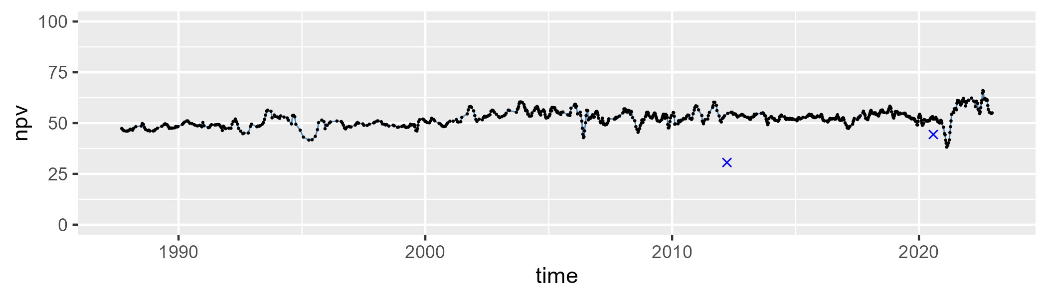

| Min. | 1st Qu. | Median | Mean | 3rd Qu. | Max. |
| --- | --- | --- | --- | --- | --- |
| 11.18189 | 26.83976 | 33.23967 | 31.9986 | 36.92685 | 49.35143 |

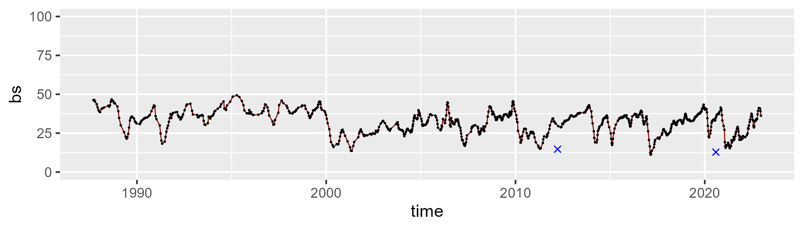

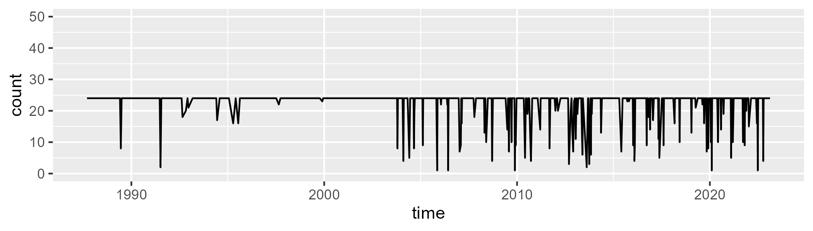

Min. : 1.00 1st Qu.:24.00 Median :24.00 Mean :22.62 3rd Qu.:24.00 Max. :24.00

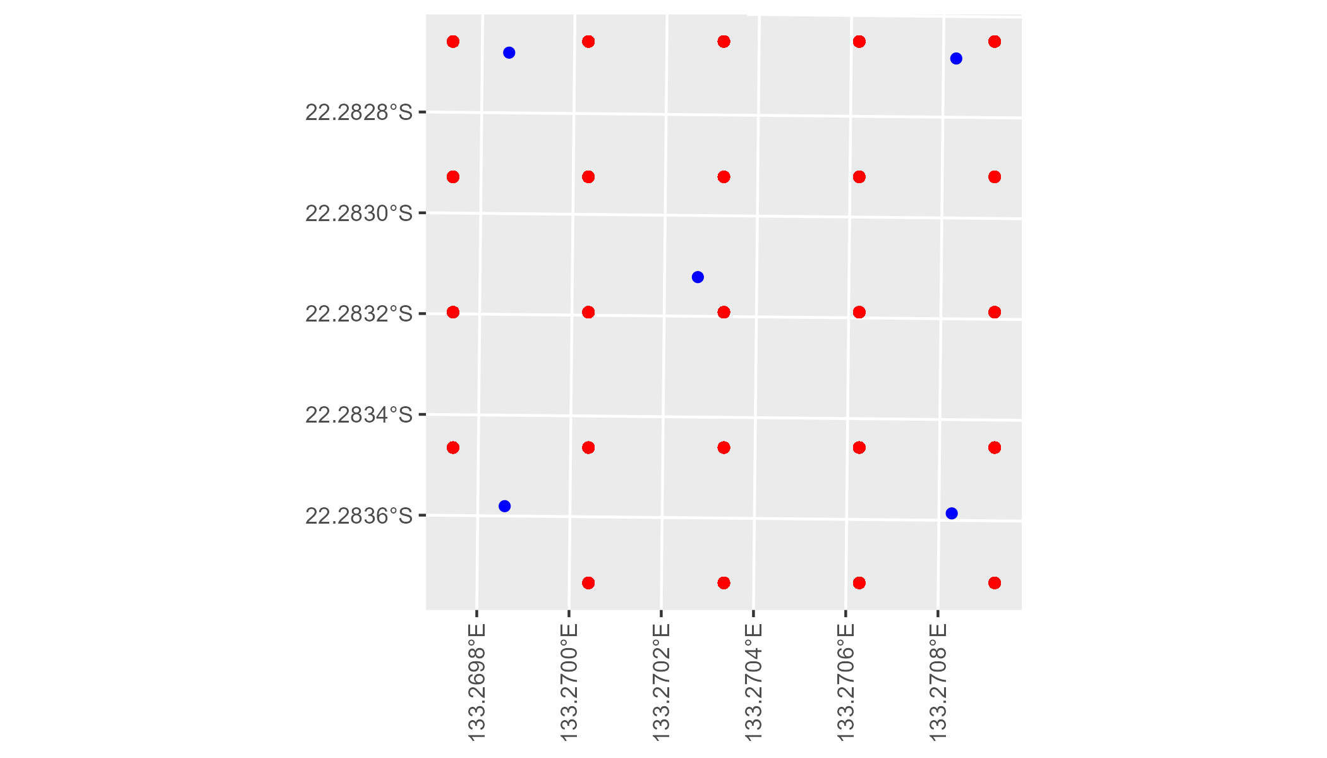

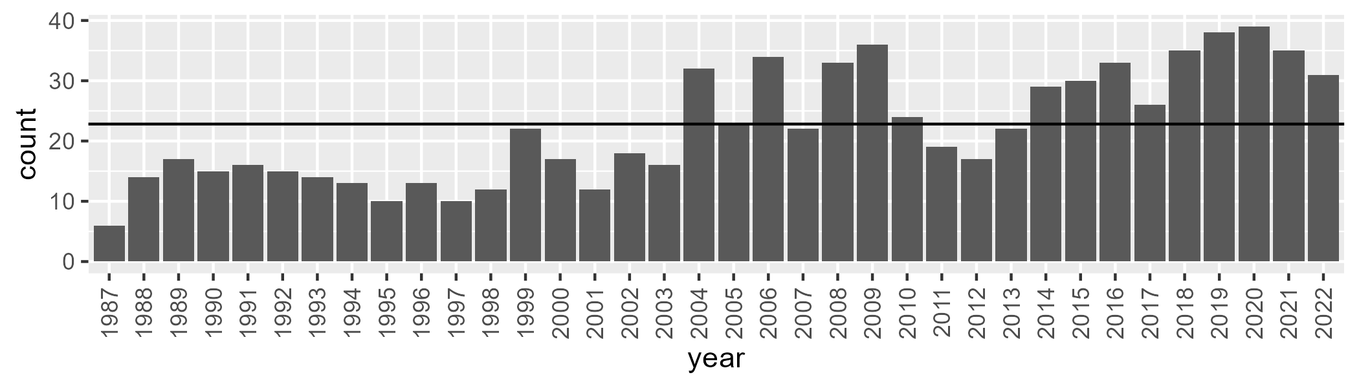

Number of samples: 798

# NTABRT0004

| Min. | 1st Qu. | Median | Mean | 3rd Qu. | Max. |
| --- | --- | --- | --- | --- | --- |
| 1.249798 | 9.425656 | 12.03722 | 13.80071 | 16.92526 | 40.73787 |

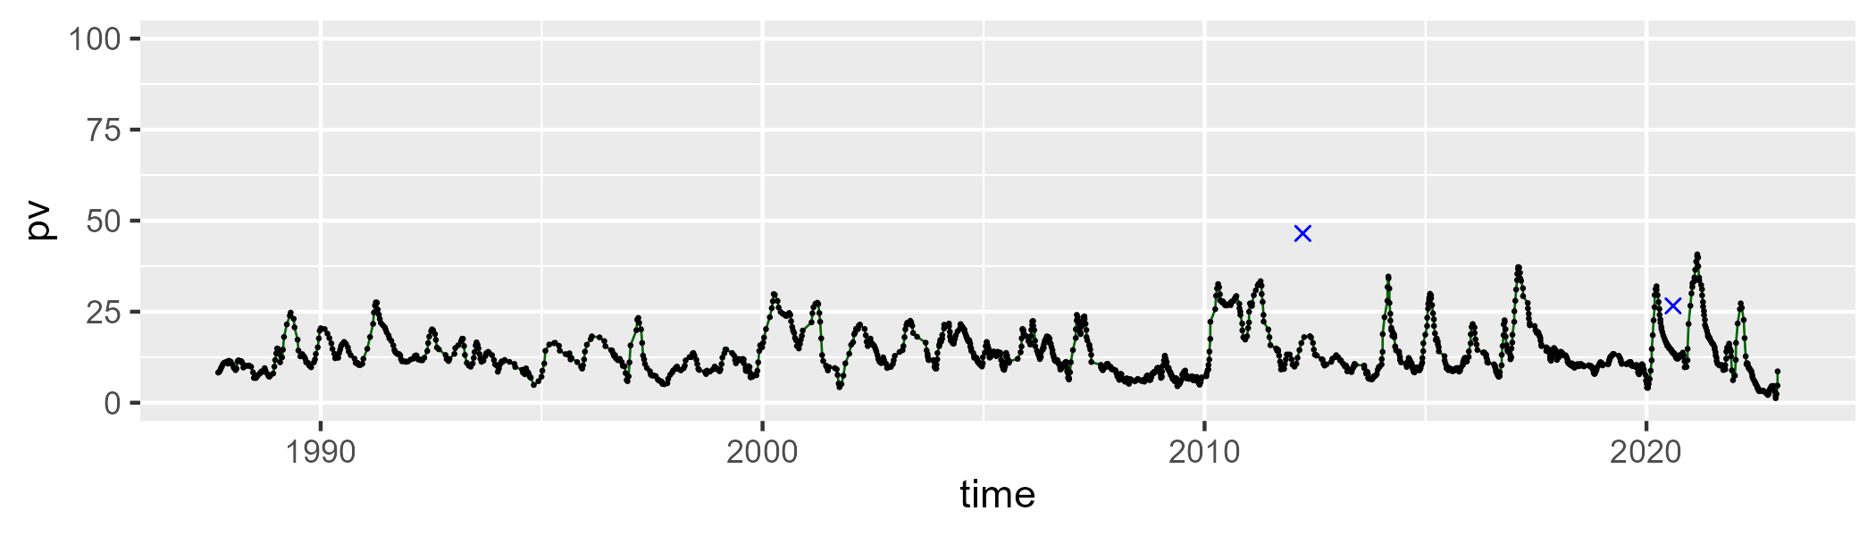

| Min. | 1st Qu. | Median | Mean | 3rd Qu. | Max. |
| --- | --- | --- | --- | --- | --- |
| 33.0568 | 42.01265 | 46.01552 | 45.7244 | 49.00436 | 64.65008 |

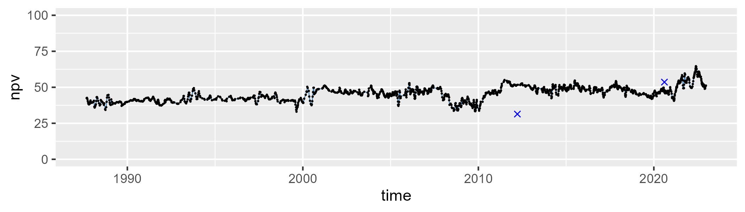

| Min. | 1st Qu. | Median | Mean | 3rd Qu. | Max. |
| --- | --- | --- | --- | --- | --- |
| 15.23954 | 33.49569 | 39.46311 | 39.07257 | 45.03595 | 58.68684 |

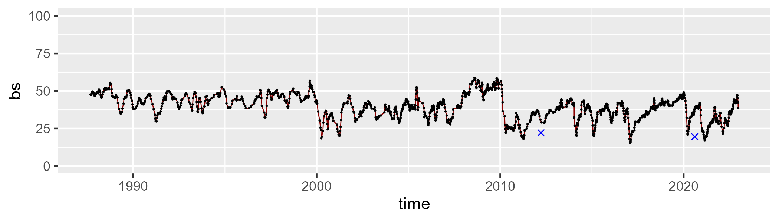

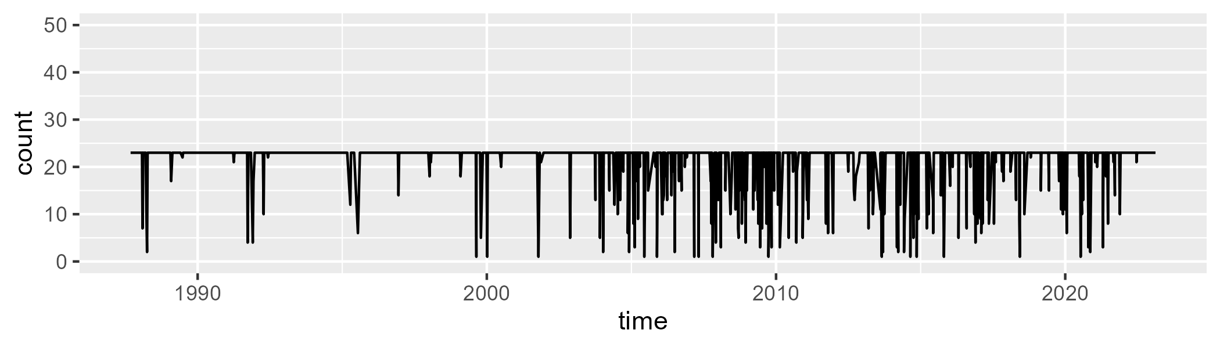

Min. : 1.00 1st Qu.:23.00 Median :23.00 Mean :21.44 3rd Qu.:23.00 Max. :23.00

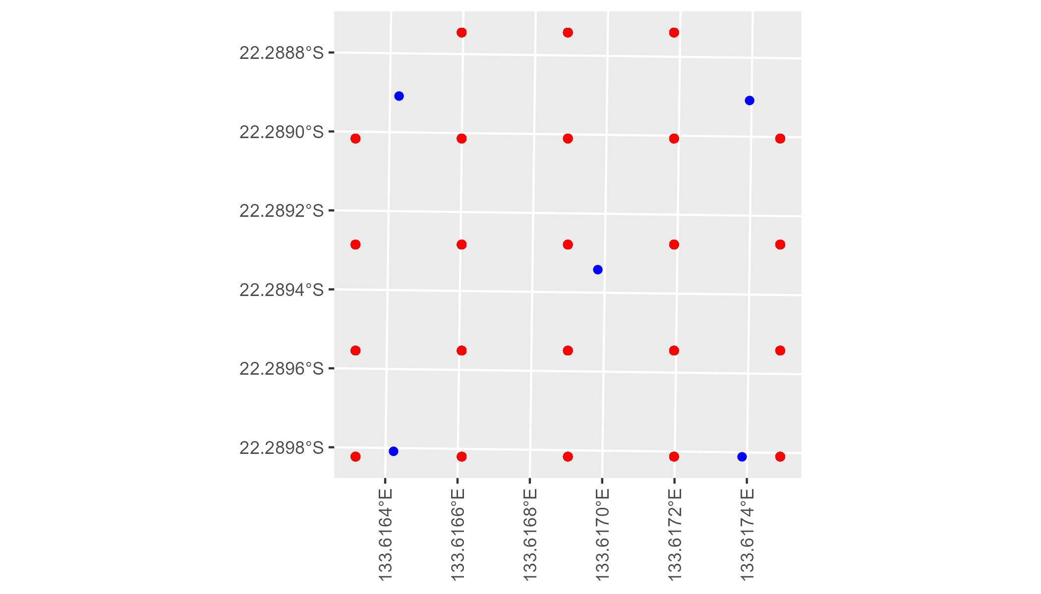

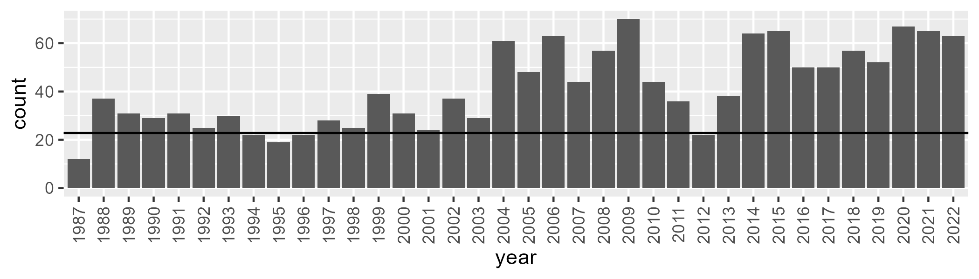

Number of samples: 1487

# NTABRT0005

| Min. | 1st Qu. | Median | Mean | 3rd Qu. | Max. |
| --- | --- | --- | --- | --- | --- |
| 2.290572 | 9.502605 | 12.33142 | 13.4325 | 16.19751 | 33.06258 |

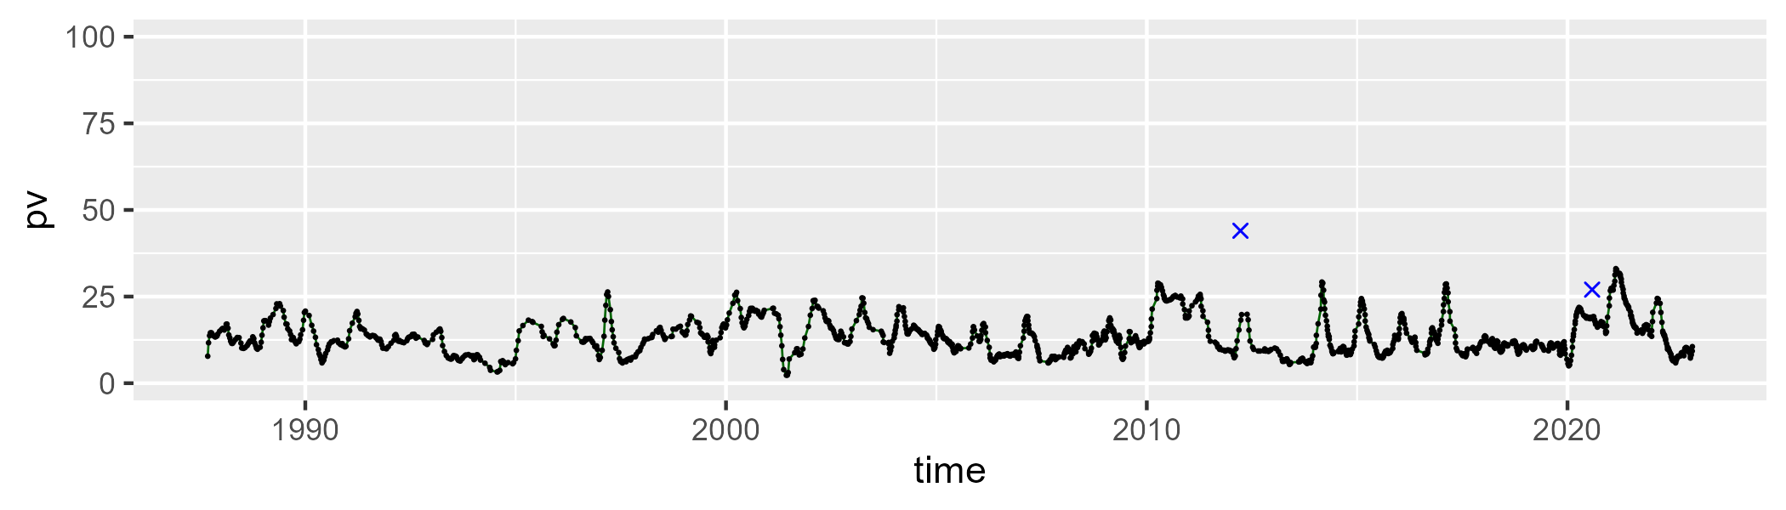

| Min. | 1st Qu. | Median | Mean | 3rd Qu. | Max. |
| --- | --- | --- | --- | --- | --- |
| 7.150418 | 25.57207 | 36.19649 | 33.80924 | 40.77173 | 58.25622 |

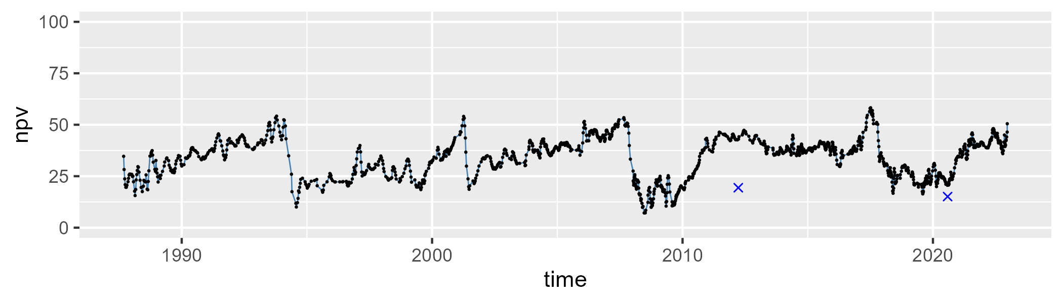

| Min. | 1st Qu. | Median | Mean | 3rd Qu. | Max. |
| --- | --- | --- | --- | --- | --- |
| 26.07956 | 43.67173 | 49.50696 | 51.18701 | 59.01157 | 84.76713 |

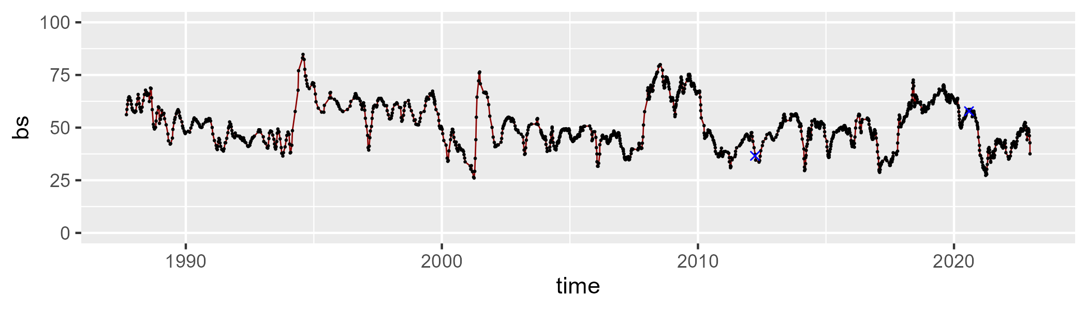

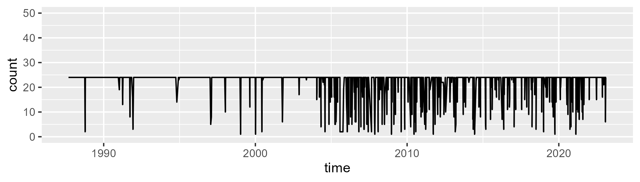

Min. : 1.00 1st Qu.:24.00 Median :24.00 Mean :22.29 3rd Qu.:24.00 Max. :24.00

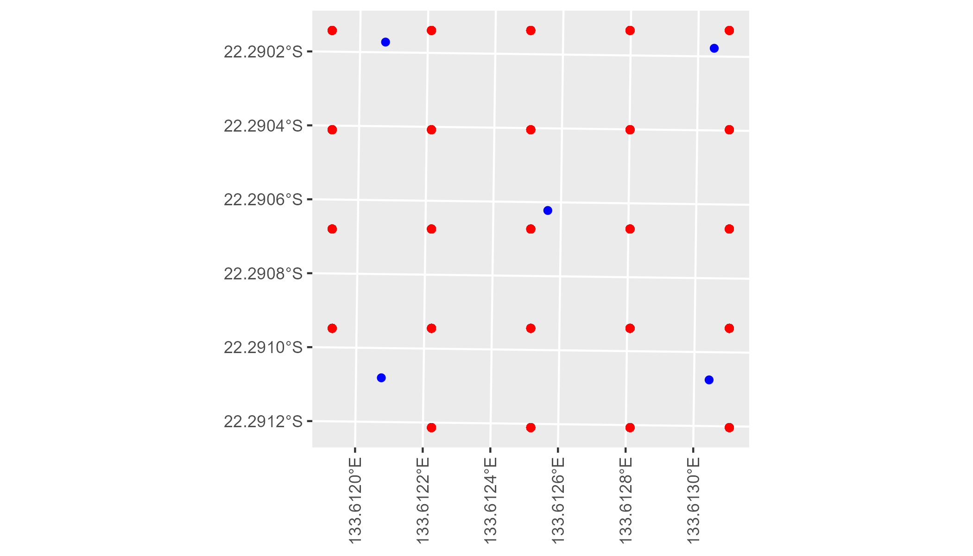

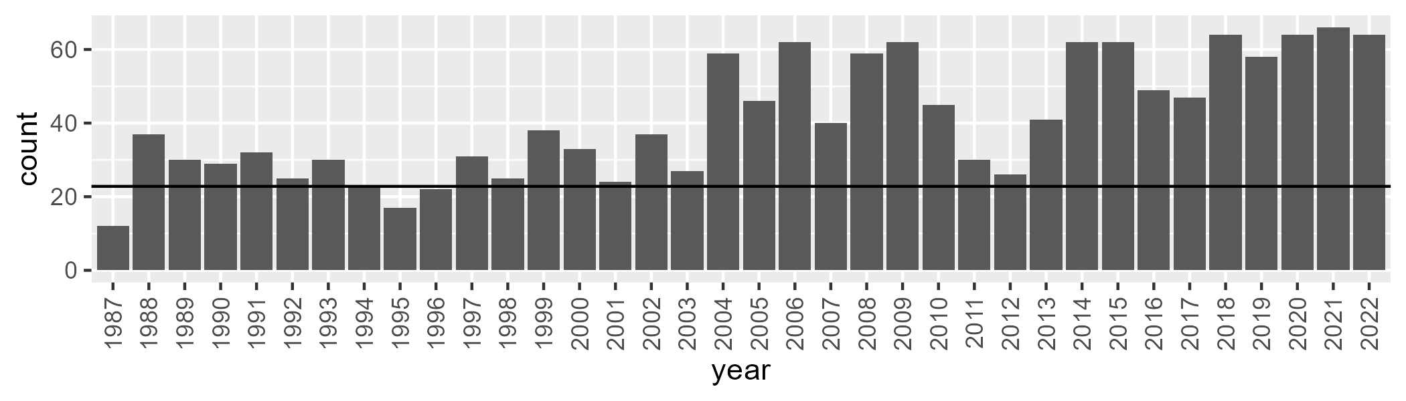

Number of samples: 1478

# NTABRT0006

| Min. | 1st Qu. | Median | Mean | 3rd Qu. | Max. |
| --- | --- | --- | --- | --- | --- |
| 1.001227 | 9.561453 | 12.0355 | 14.05125 | 16.76622 | 41.9615 |

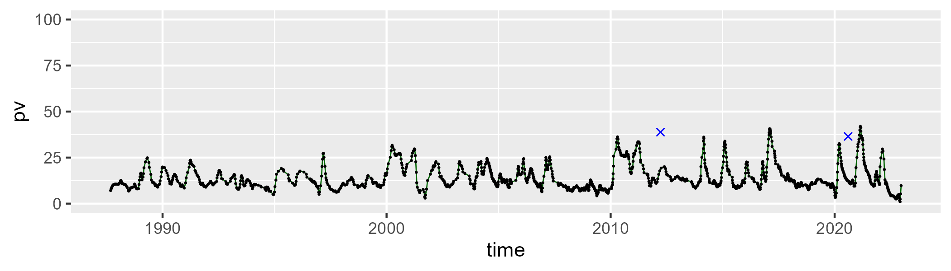

| Min. | 1st Qu. | Median | Mean | 3rd Qu. | Max. |
| --- | --- | --- | --- | --- | --- |
| 30.56875 | 41.1995 | 45.81466 | 45.64267 | 49.24329 | 68.54363 |

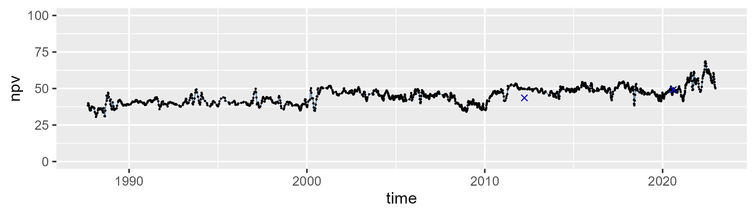

| Min. | 1st Qu. | Median | Mean | 3rd Qu. | Max. |
| --- | --- | --- | --- | --- | --- |
| 13.39373 | 32.60195 | 39.28027 | 38.90541 | 46.101 | 58.93698 |

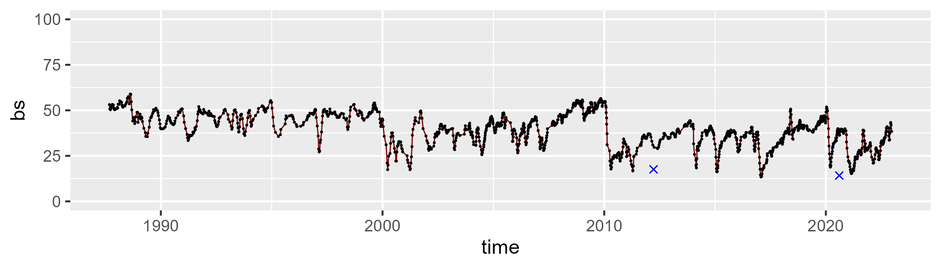

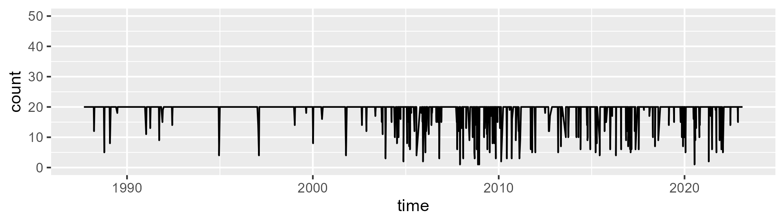

Min. : 1.00 1st Qu.:20.00 Median :20.00 Mean :18.93 3rd Qu.:20.00 Max. :20.00

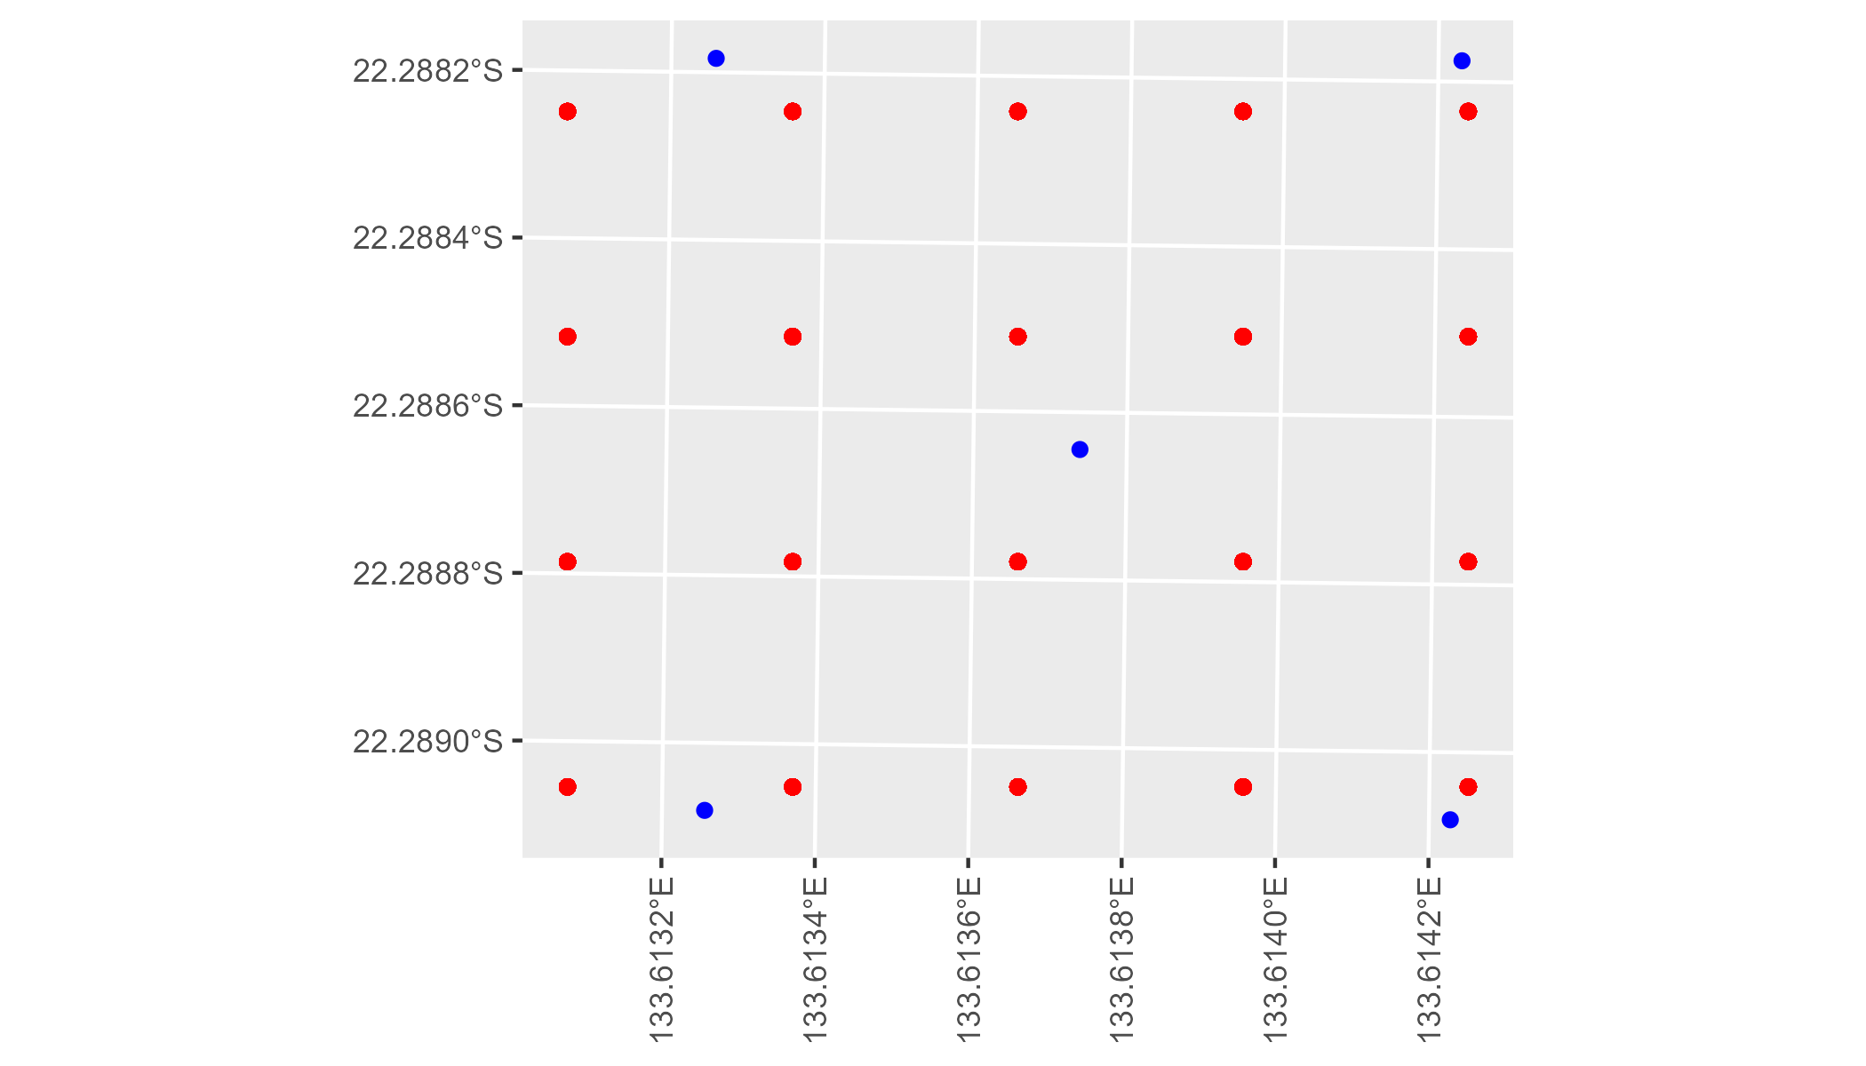

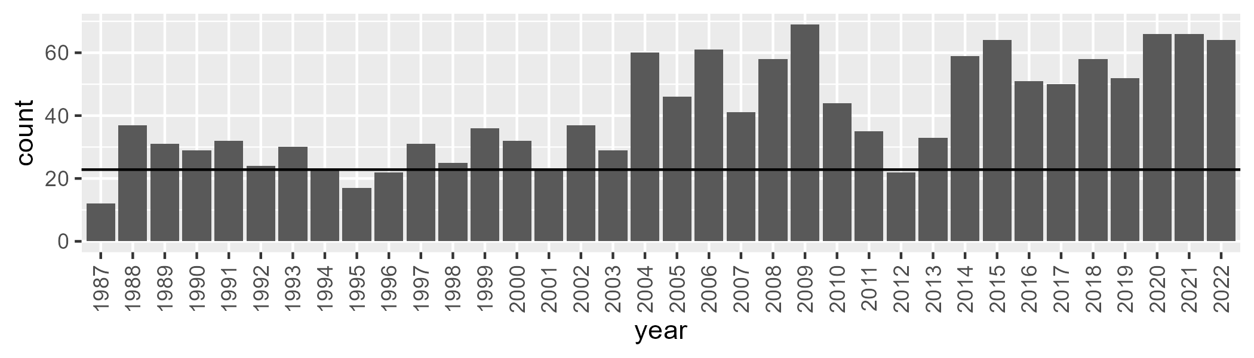

Number of samples: 1469

# NTABRT0007

| Min. | 1st Qu. | Median | Mean | 3rd Qu. | Max. |
| --- | --- | --- | --- | --- | --- |
| 1.62974 | 8.566659 | 11.62889 | 12.33383 | 15.29532 | 30.35032 |

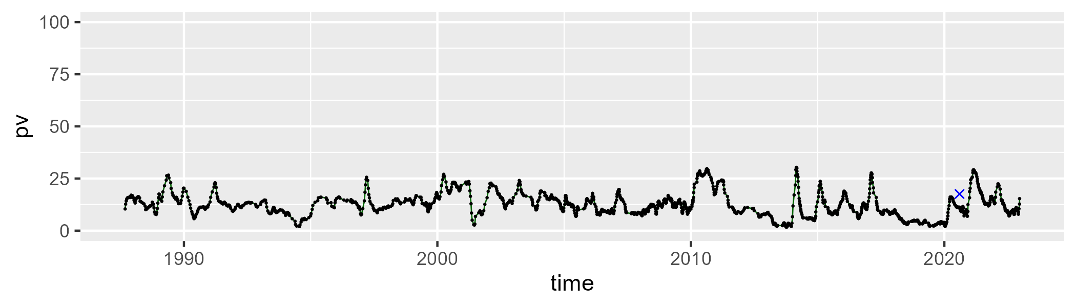

| Min. | 1st Qu. | Median | Mean | 3rd Qu. | Max. |
| --- | --- | --- | --- | --- | --- |
| 7.408643 | 29.71352 | 39.16278 | 36.66918 | 43.73284 | 60.15618 |

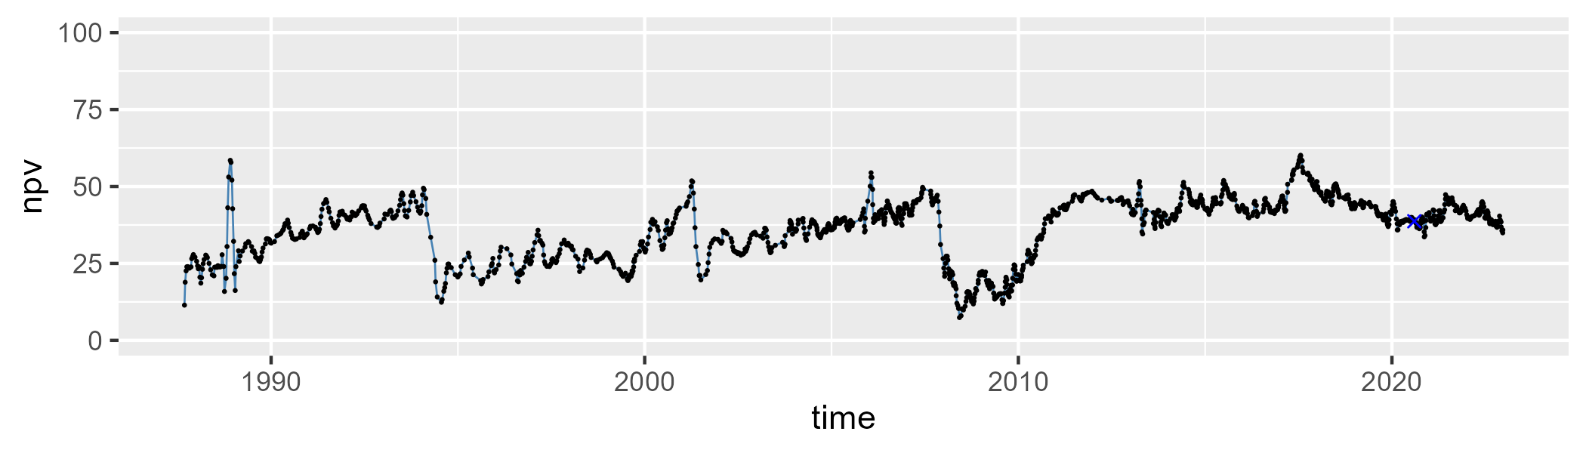

| Min. | 1st Qu. | Median | Mean | 3rd Qu. | Max. |
| --- | --- | --- | --- | --- | --- |
| 24.52047 | 42.5853 | 48.01905 | 49.4532 | 55.35904 | 83.98332 |

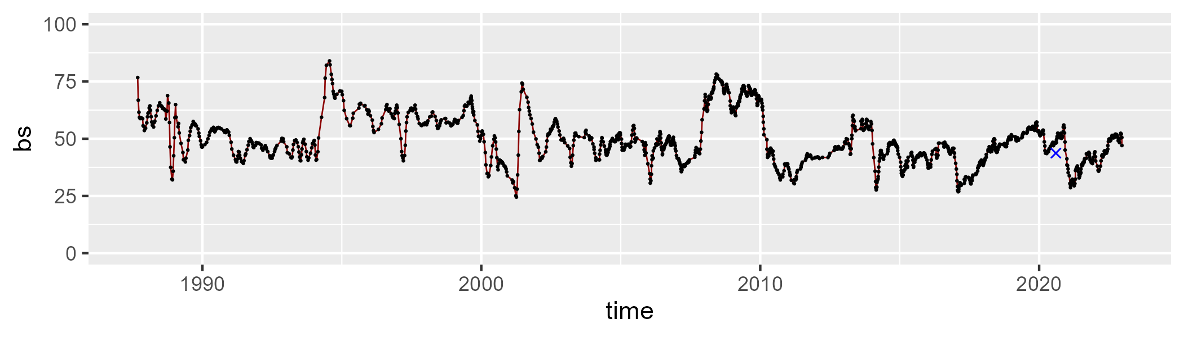

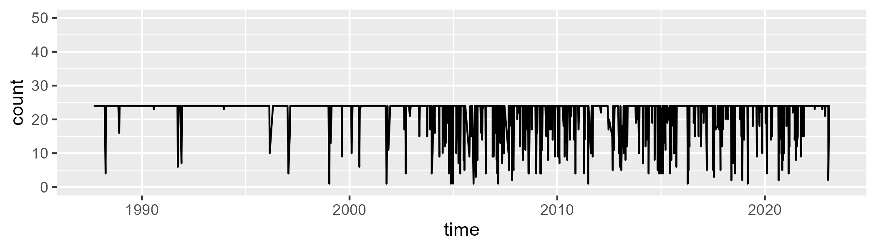

Min. : 1.00 1st Qu.:24.00 Median :24.00 Mean :22.18 3rd Qu.:24.00 Max. :24.00

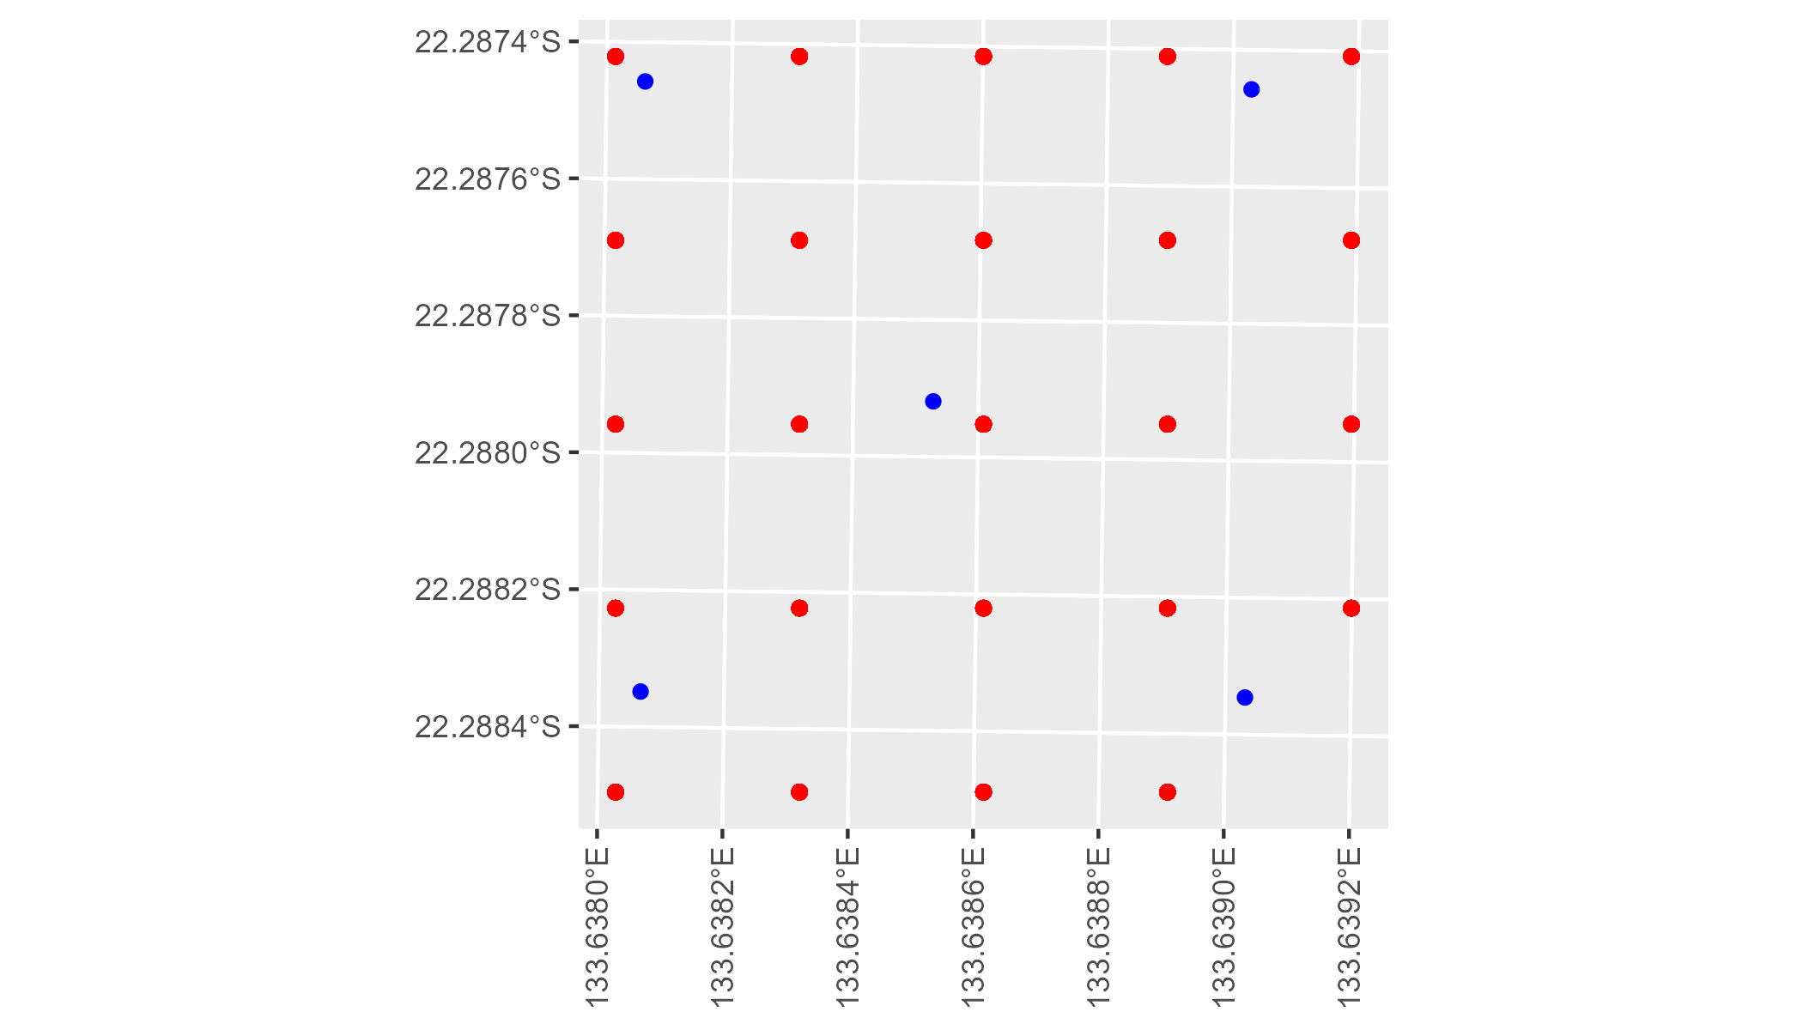

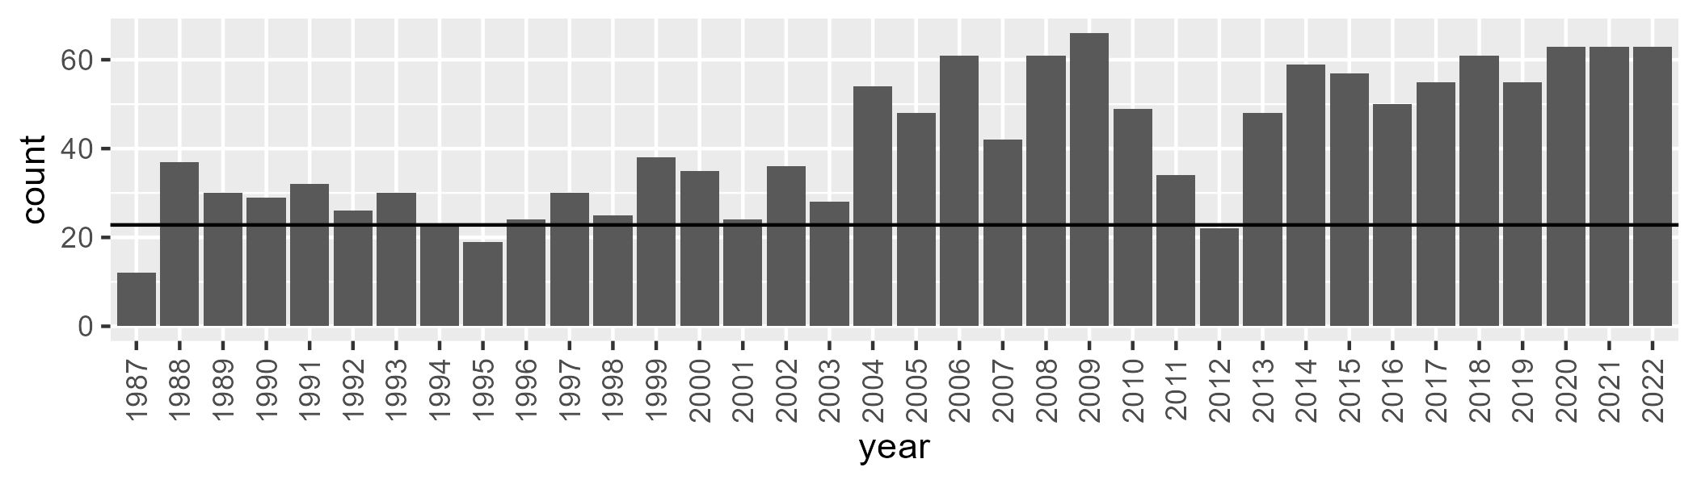

Number of samples: 1489

# NTABRT0008

| Min. | 1st Qu. | Median | Mean | 3rd Qu. | Max. |
| --- | --- | --- | --- | --- | --- |
| 2.358521 | 9.591785 | 13.22975 | 13.42762 | 17.32854 | 29.18413 |

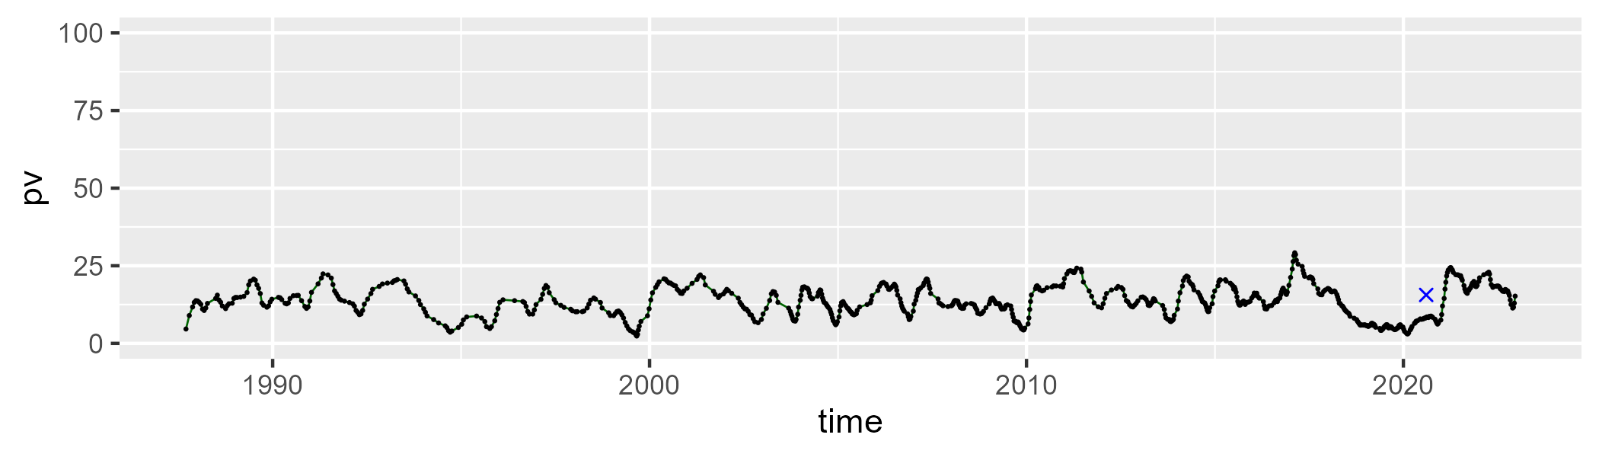

| Min. | 1st Qu. | Median | Mean | 3rd Qu. | Max. |
| --- | --- | --- | --- | --- | --- |
| 23.46497 | 37.33879 | 41.75153 | 41.66914 | 46.27392 | 55.85974 |

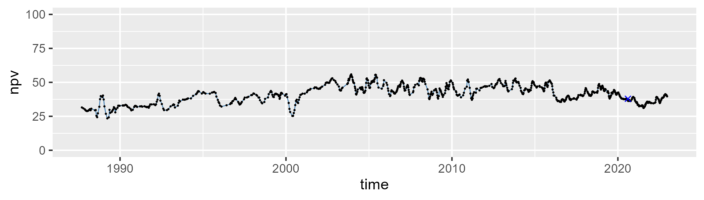

| Min. | 1st Qu. | Median | Mean | 3rd Qu. | Max. |
| --- | --- | --- | --- | --- | --- |
| 27.71199 | 37.68229 | 43.22439 | 43.41178 | 48.90998 | 62.3379 |

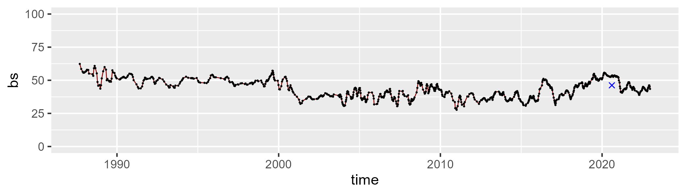

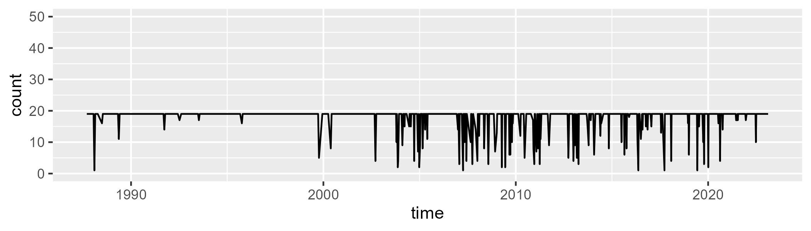

Min. : 1.00 1st Qu.:19.00 Median :19.00 Mean :17.78 3rd Qu.:19.00 Max. :19.00

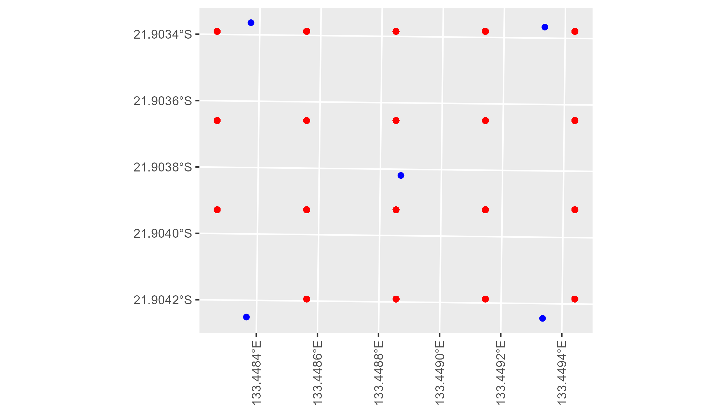

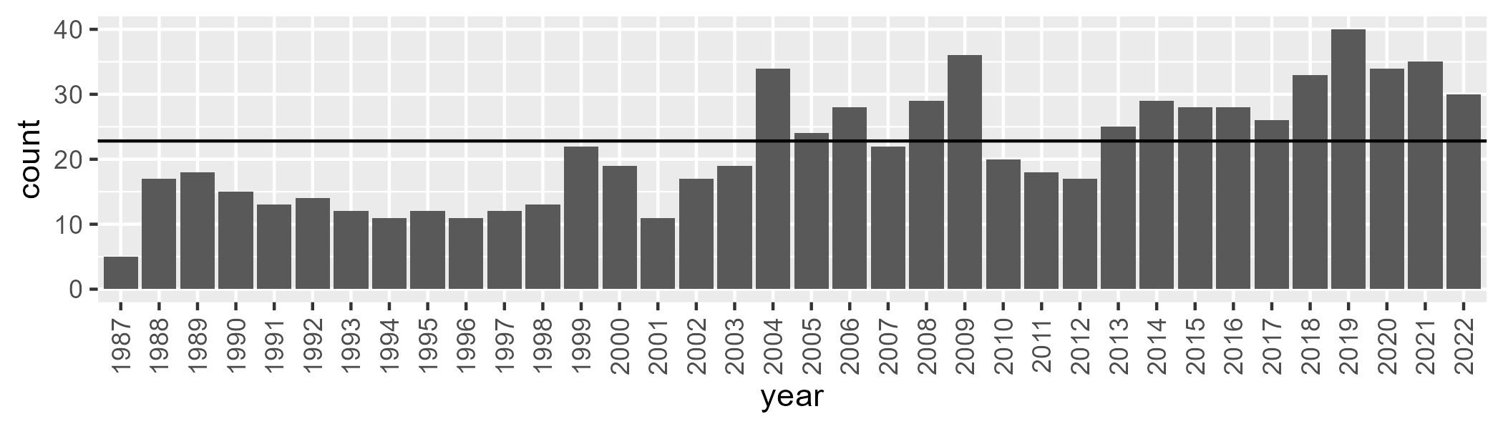

Number of samples: 777

# NTADAC0001

| Min. | 1st Qu. | Median | Mean | 3rd Qu. | Max. |
| --- | --- | --- | --- | --- | --- |
| 14.21293 | 41.13081 | 48.10387 | 48.0417 | 55.84947 | 72.55948 |

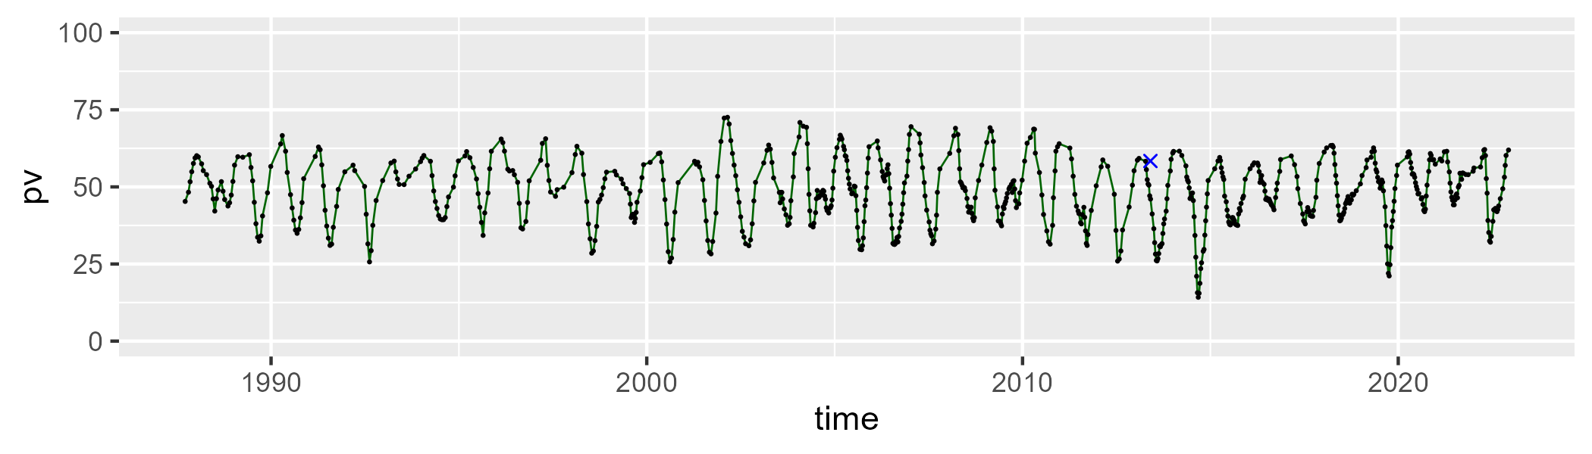

| Min. | 1st Qu. | Median | Mean | 3rd Qu. | Max. |
| --- | --- | --- | --- | --- | --- |
| 22.52003 | 36.2583 | 43.26373 | 41.56365 | 46.89169 | 58.72328 |

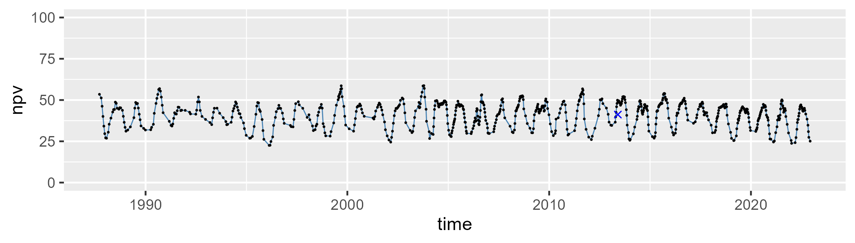

| Min. | 1st Qu. | Median | Mean | 3rd Qu. | Max. |
| --- | --- | --- | --- | --- | --- |
| 0 | 3.854901 | 7.284831 | 9.146244 | 12.85901 | 40.54017 |

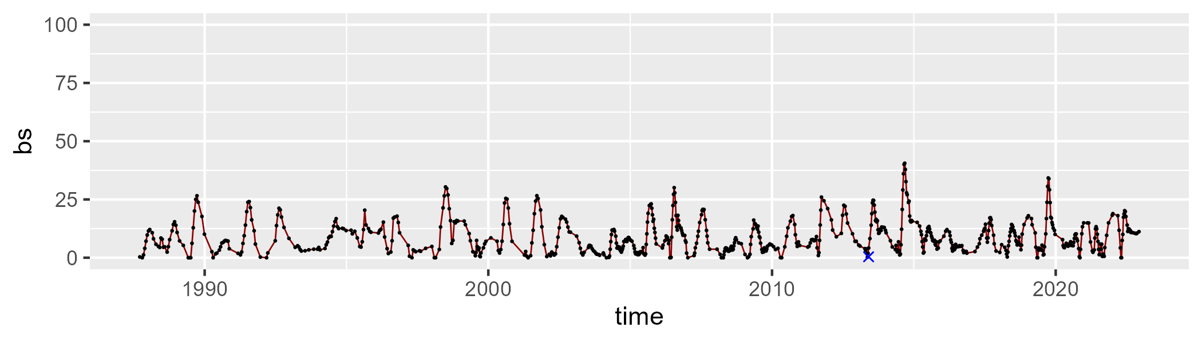

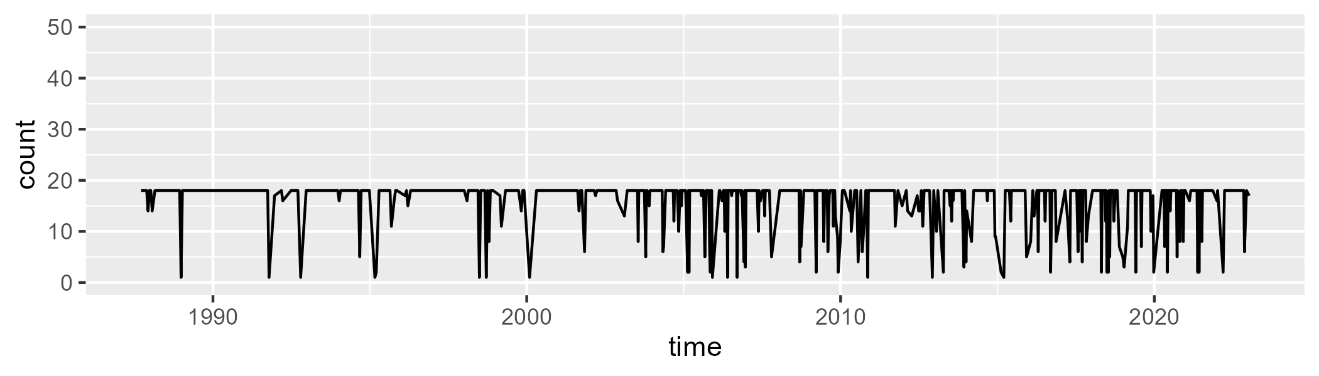

Min. : 1.00 1st Qu.:18.00 Median :18.00 Mean :16.22 3rd Qu.:18.00 Max. :18.00

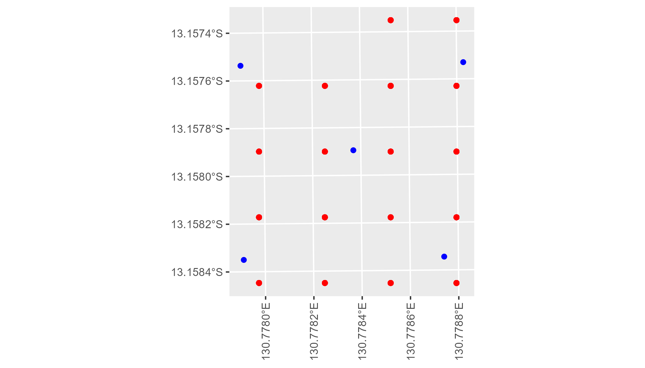

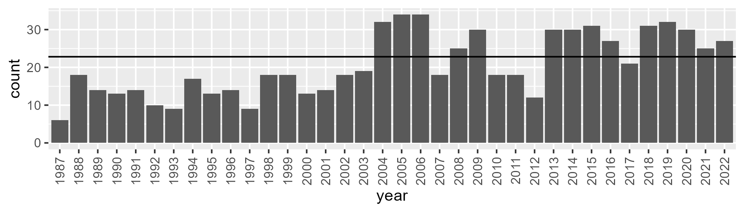

Number of samples: 742

# NTADAC0002

| Min. | 1st Qu. | Median | Mean | 3rd Qu. | Max. |
| --- | --- | --- | --- | --- | --- |
| 18.60483 | 42.97017 | 50.61301 | 49.89701 | 57.33195 | 71.29404 |

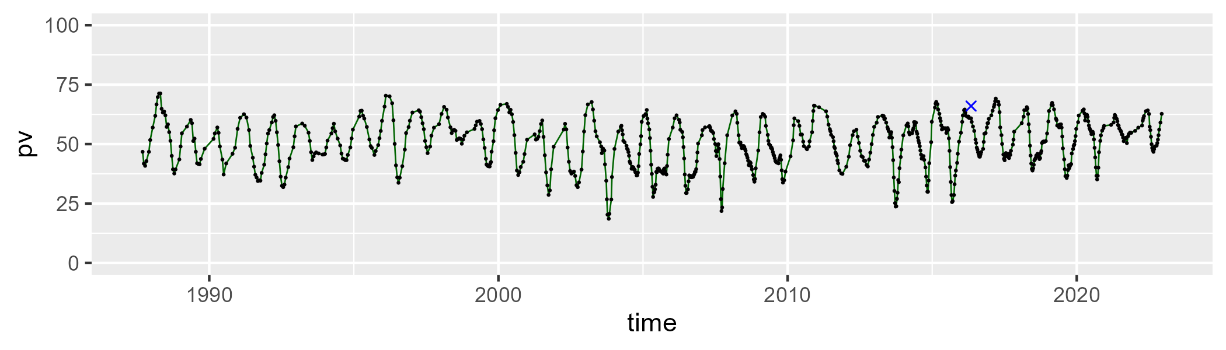

| Min. | 1st Qu. | Median | Mean | 3rd Qu. | Max. |
| --- | --- | --- | --- | --- | --- |
| 19.89039 | 34.68649 | 40.91831 | 40.17563 | 45.39431 | 64.26669 |

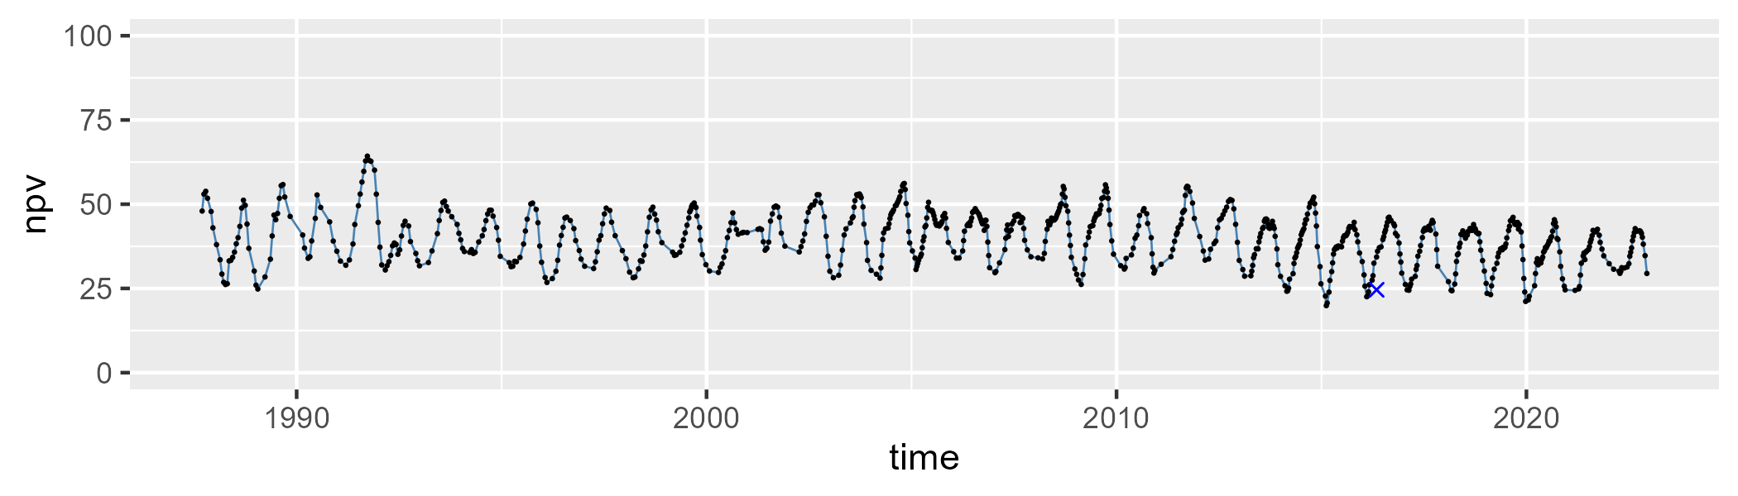

| Min. | 1st Qu. | Median | Mean | 3rd Qu. | Max. |
| --- | --- | --- | --- | --- | --- |
| 0 | 3.958398 | 6.749075 | 8.639377 | 11.90974 | 33.98793 |

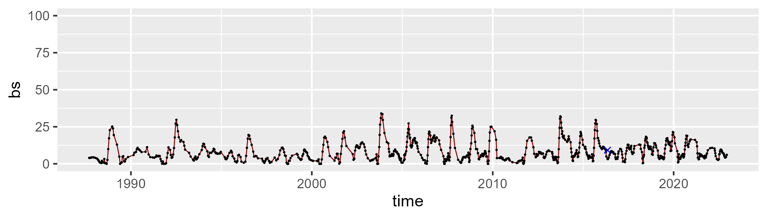

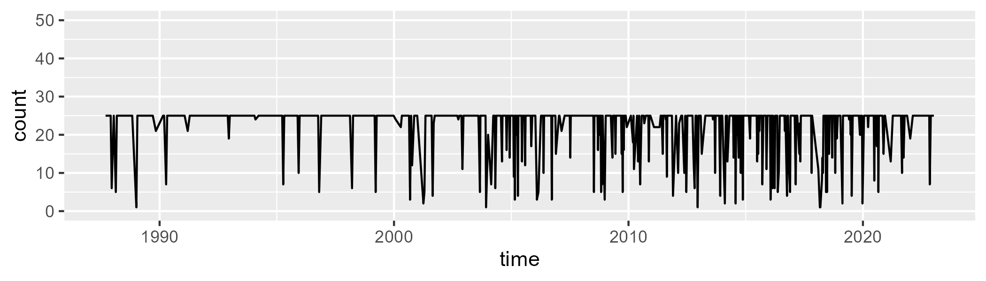

Min. : 1.00 1st Qu.:25.00 Median :25.00 Mean :22.69 3rd Qu.:25.00 Max. :25.00

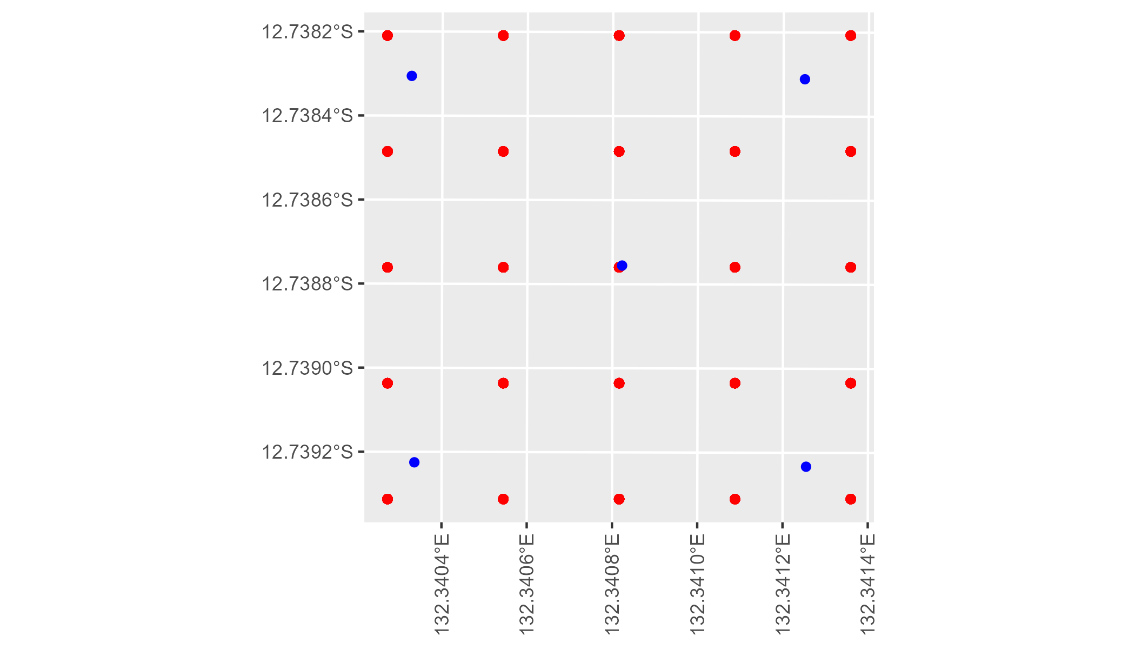

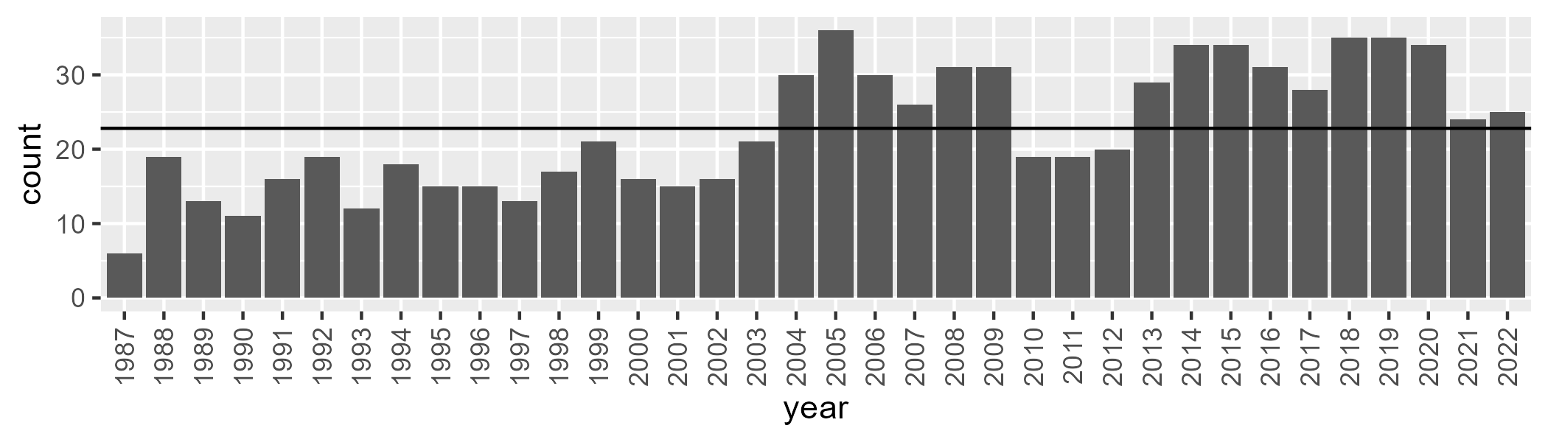

Number of samples: 814

# NTADMR0001

| Min. | 1st Qu. | Median | Mean | 3rd Qu. | Max. |
| --- | --- | --- | --- | --- | --- |
| 0 | 11.02872 | 15.68527 | 17.18167 | 23.11767 | 39.92781 |

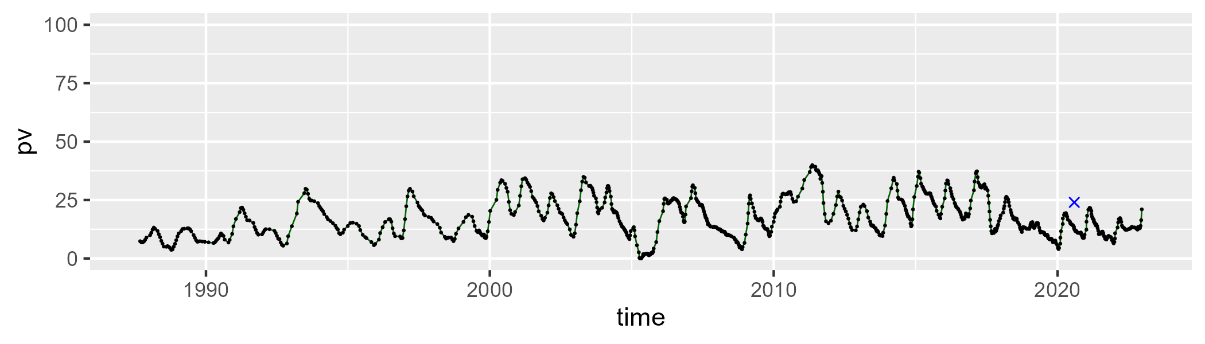

| Min. | 1st Qu. | Median | Mean | 3rd Qu. | Max. |
| --- | --- | --- | --- | --- | --- |
| 24.38119 | 39.34424 | 43.69675 | 44.66733 | 48.58761 | 65.7416 |

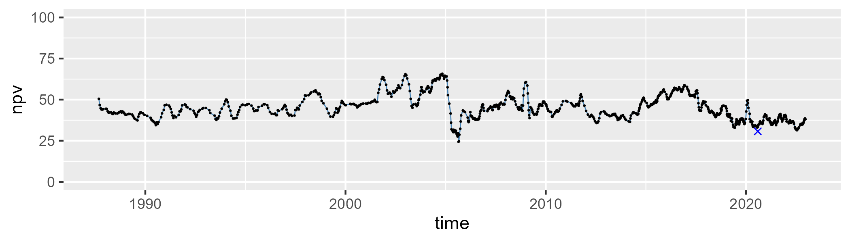

| Min. | 1st Qu. | Median | Mean | 3rd Qu. | Max. |
| --- | --- | --- | --- | --- | --- |
| 6.663945 | 27.04193 | 37.94282 | 36.70988 | 46.44167 | 72.23591 |

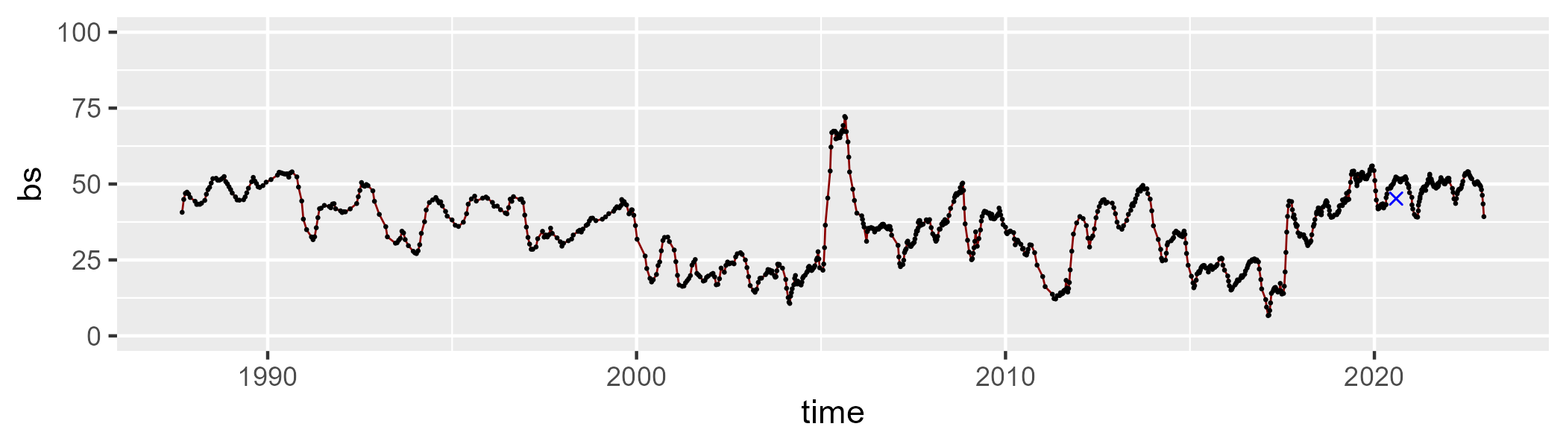

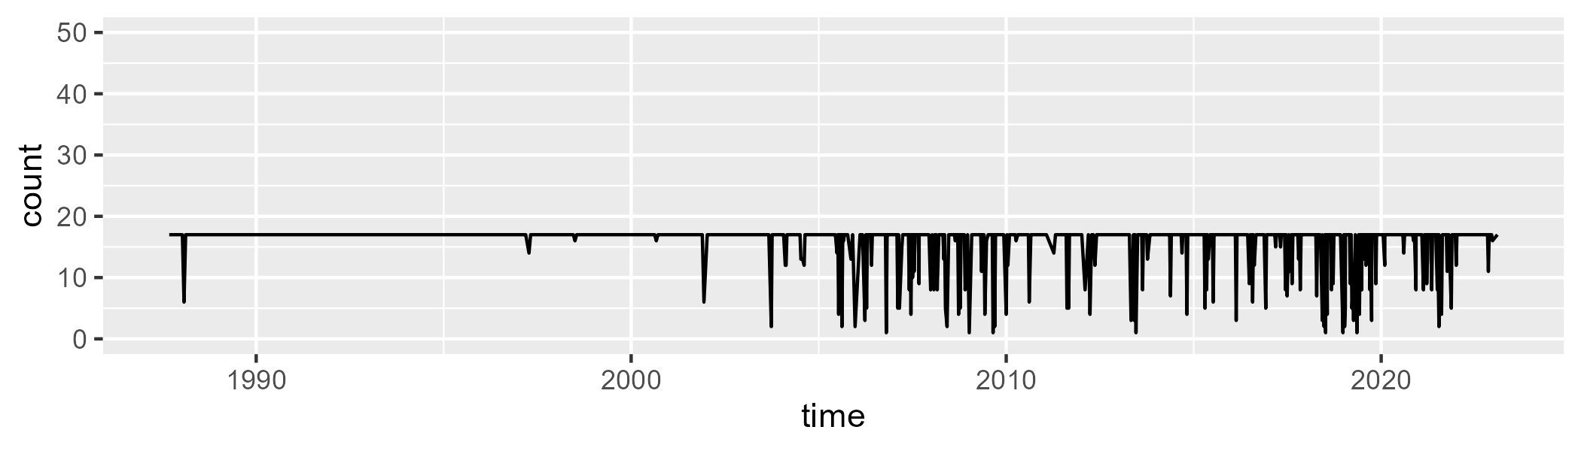

Min. : 1.00 1st Qu.:17.00 Median :17.00 Mean :15.77 3rd Qu.:17.00 Max. :17.00

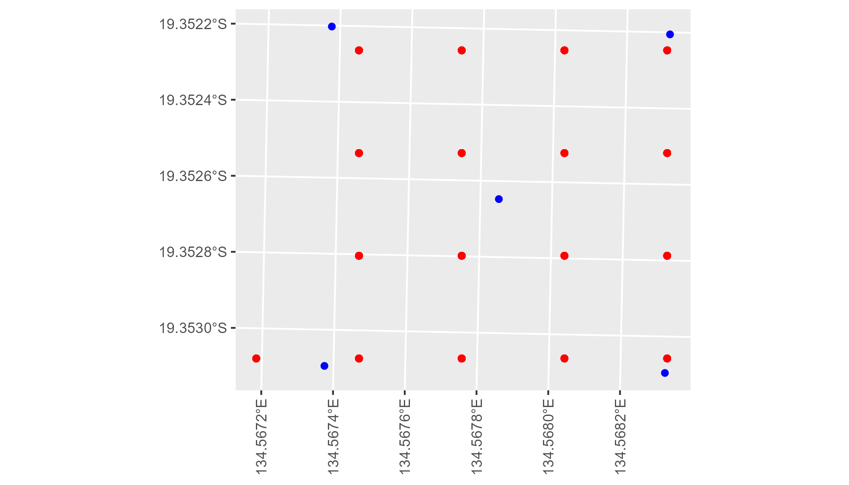

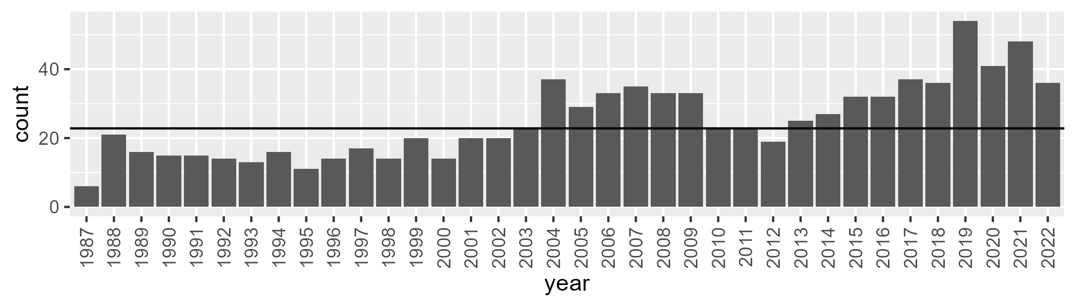

Number of samples: 902

# NTADMR0002

| Min. | 1st Qu. | Median | Mean | 3rd Qu. | Max. |
| --- | --- | --- | --- | --- | --- |
| 0 | 4.973353 | 7.404425 | 8.272474 | 10.39809 | 27.27352 |

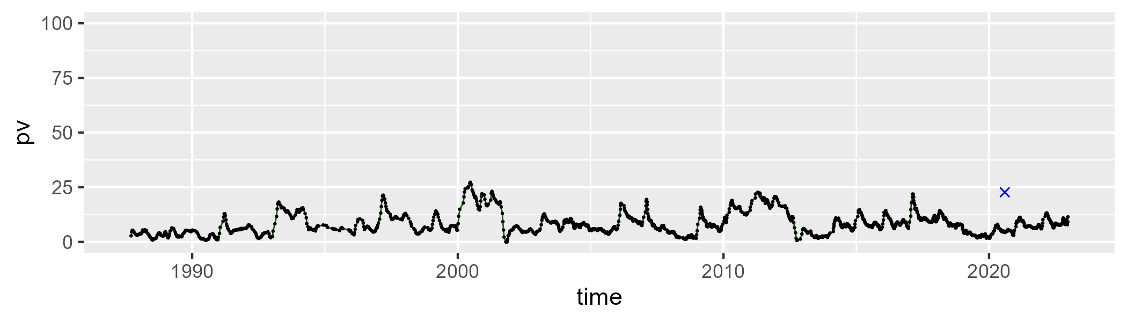

| Min. | 1st Qu. | Median | Mean | 3rd Qu. | Max. |
| --- | --- | --- | --- | --- | --- |
| 17.01809 | 31.10694 | 36.45043 | 36.77258 | 41.2154 | 61.15866 |

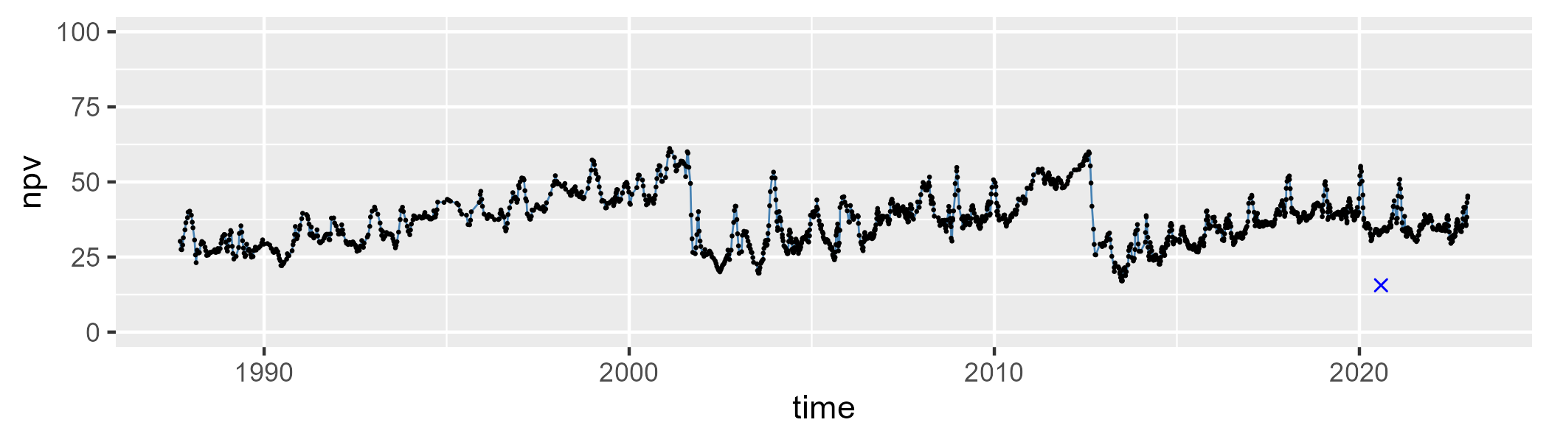

| Min. | 1st Qu. | Median | Mean | 3rd Qu. | Max. |
| --- | --- | --- | --- | --- | --- |
| 20.20771 | 48.31366 | 54.17339 | 53.34372 | 60.16727 | 78.1056 |

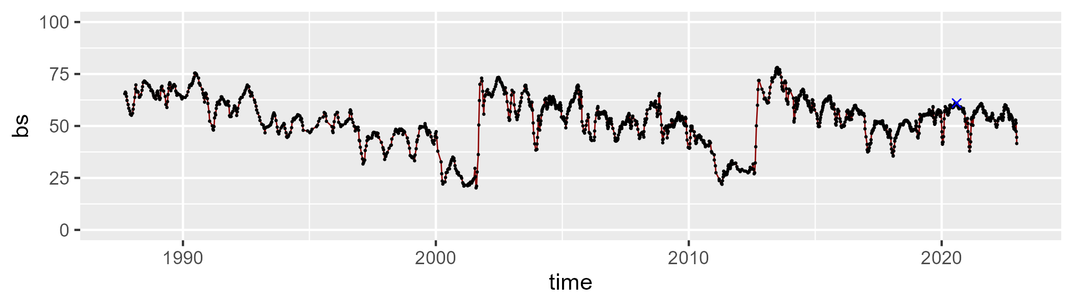

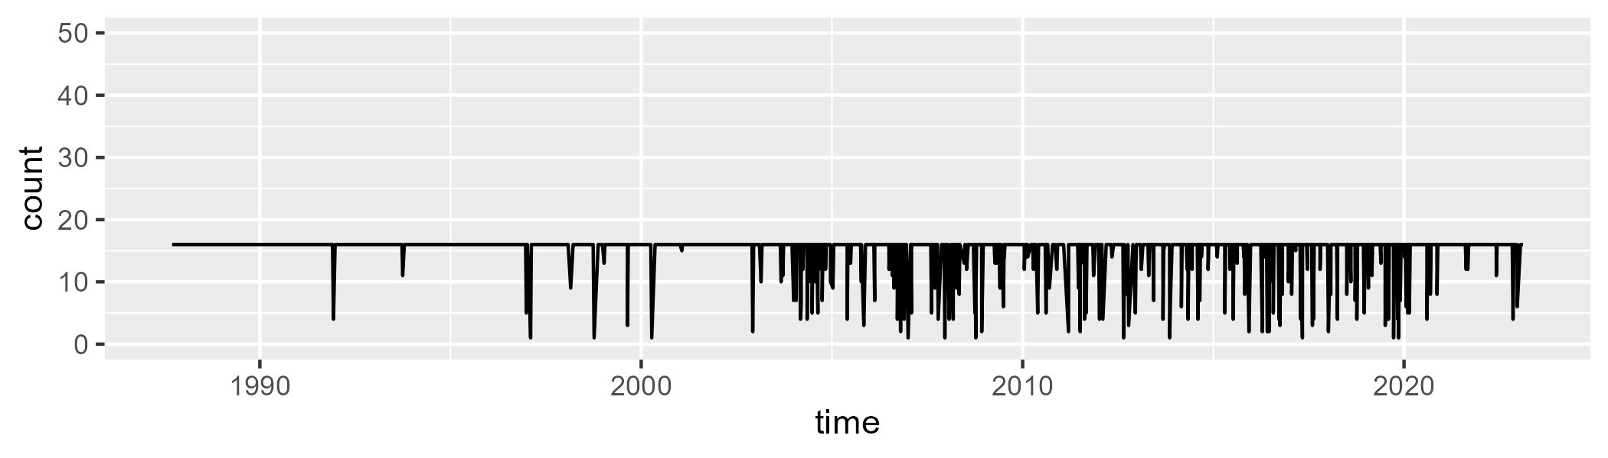

Min. : 1.00 1st Qu.:16.00 Median :16.00 Mean :15.13 3rd Qu.:16.00 Max. :16.00

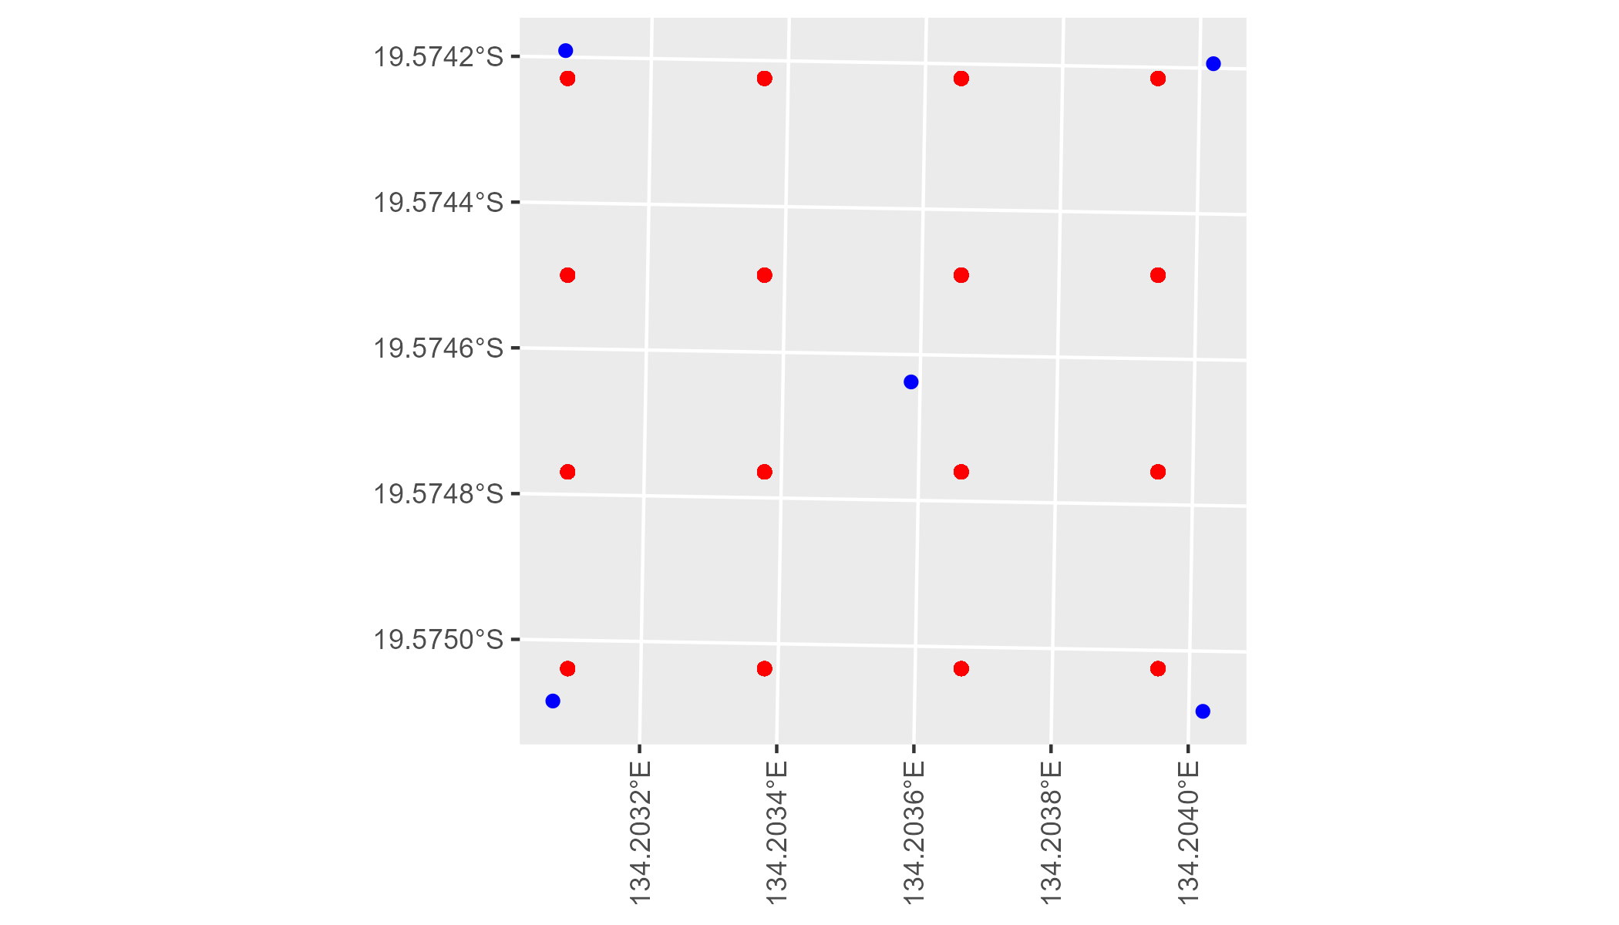

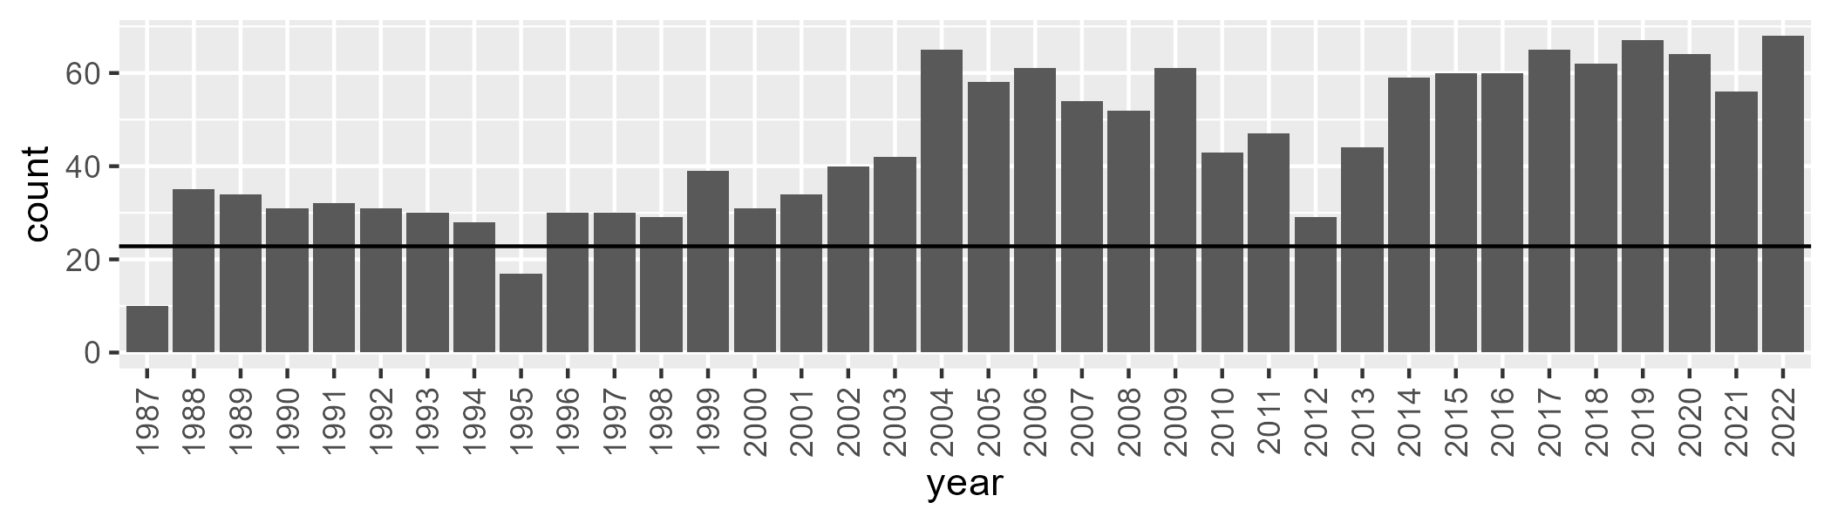

Number of samples: 1598

# NTAFIN0001

| Min. | 1st Qu. | Median | Mean | 3rd Qu. | Max. |
| --- | --- | --- | --- | --- | --- |
| 0 | 4.961584 | 7.529409 | 9.835101 | 12.86741 | 42.71148 |

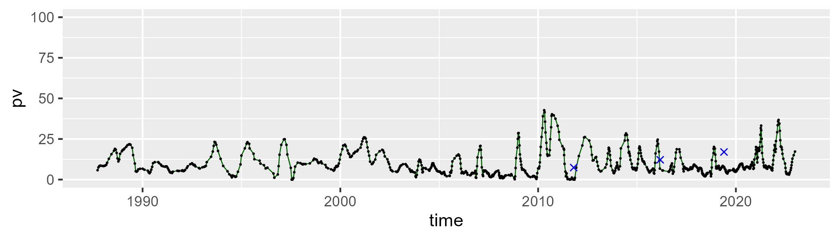

| Min. | 1st Qu. | Median | Mean | 3rd Qu. | Max. |
| --- | --- | --- | --- | --- | --- |
| 2.155319 | 22.65569 | 29.63059 | 30.80075 | 39.25523 | 78.29232 |

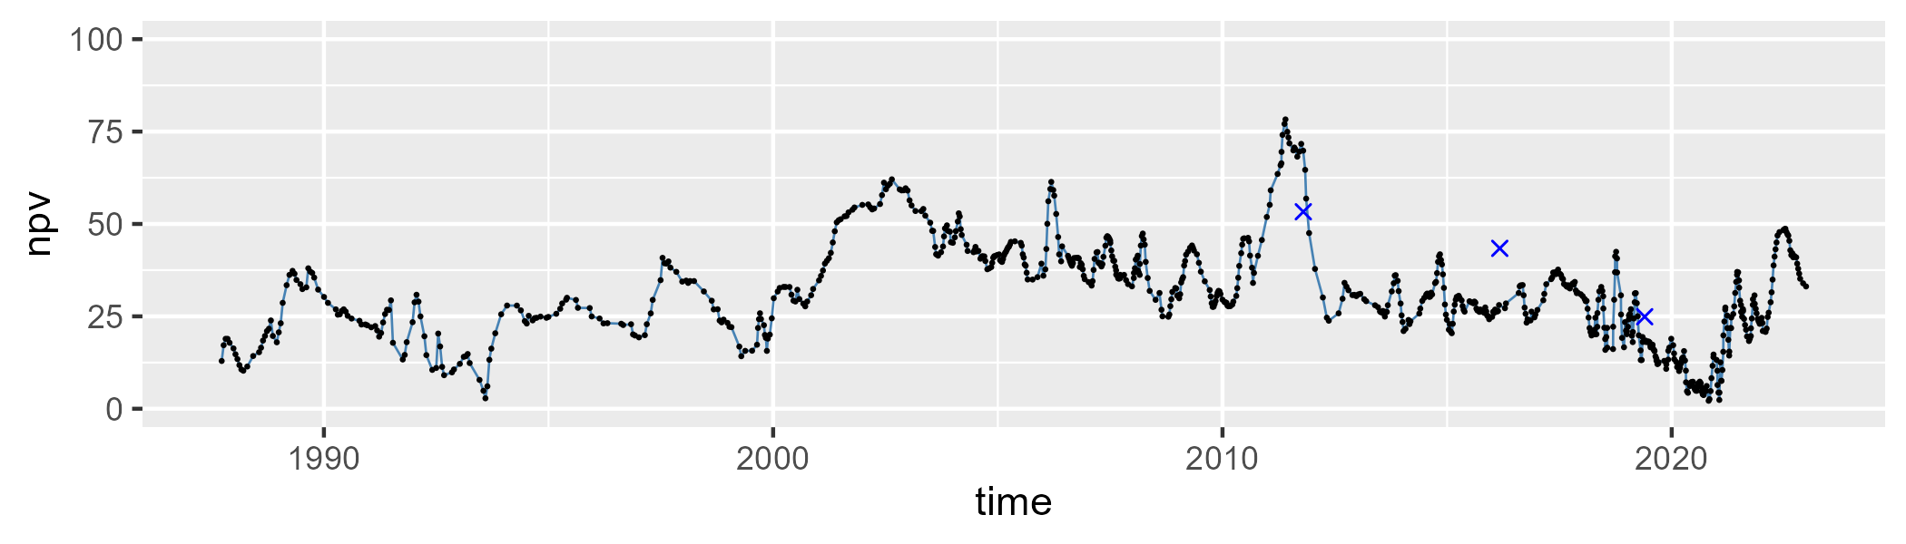

| Min. | 1st Qu. | Median | Mean | 3rd Qu. | Max. |
| --- | --- | --- | --- | --- | --- |
| 13.75592 | 50.4206 | 58.09722 | 57.85431 | 67.67391 | 88.03334 |

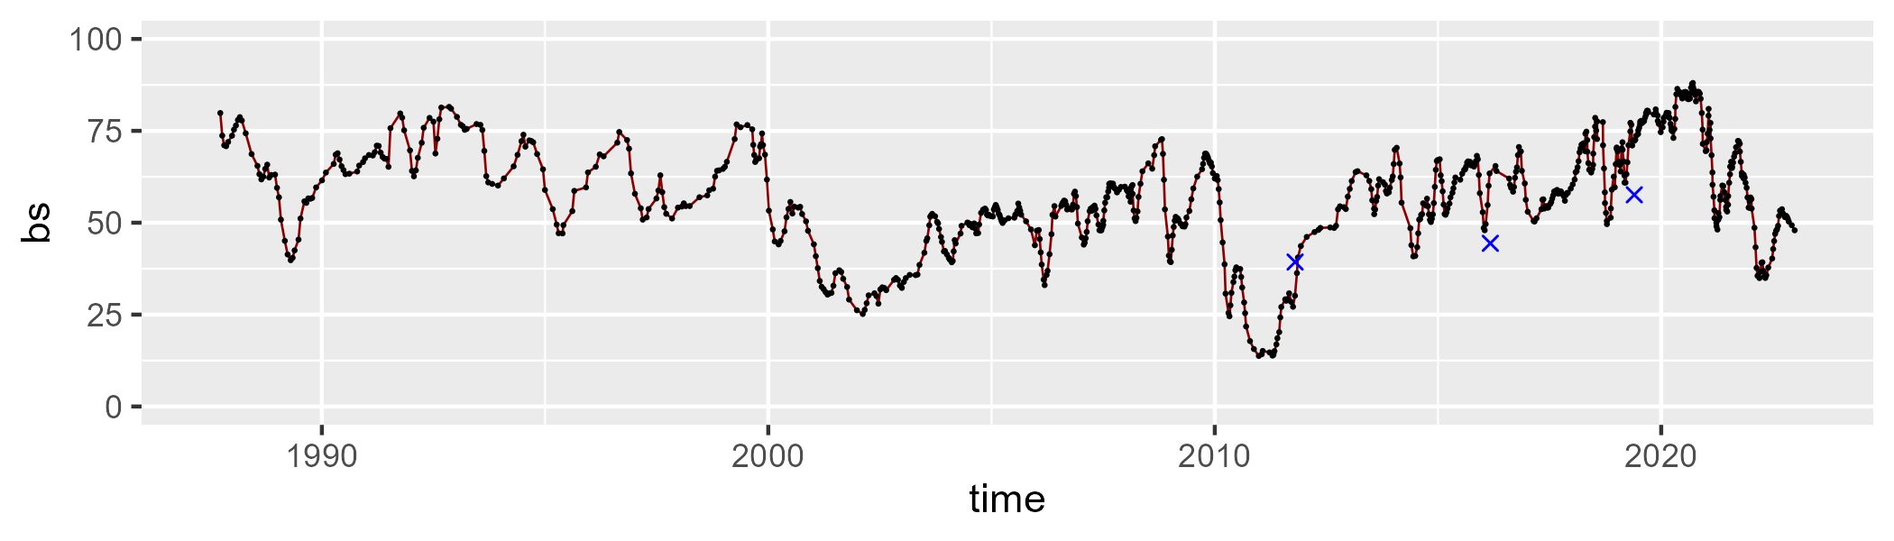

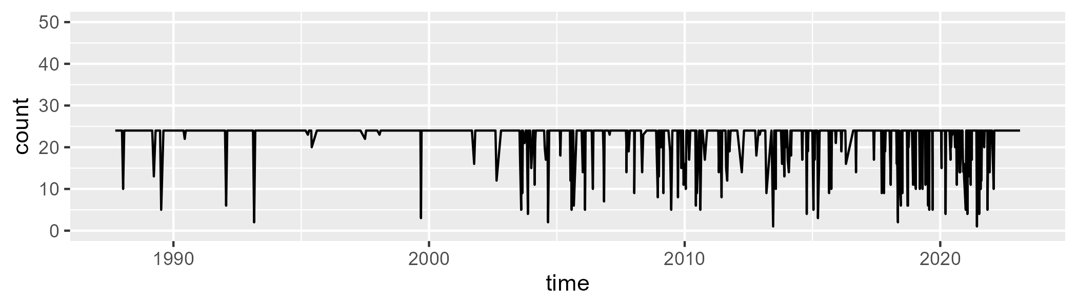

Min. : 1.00 1st Qu.:24.00 Median :24.00 Mean :22.12 3rd Qu.:24.00 Max. :24.00

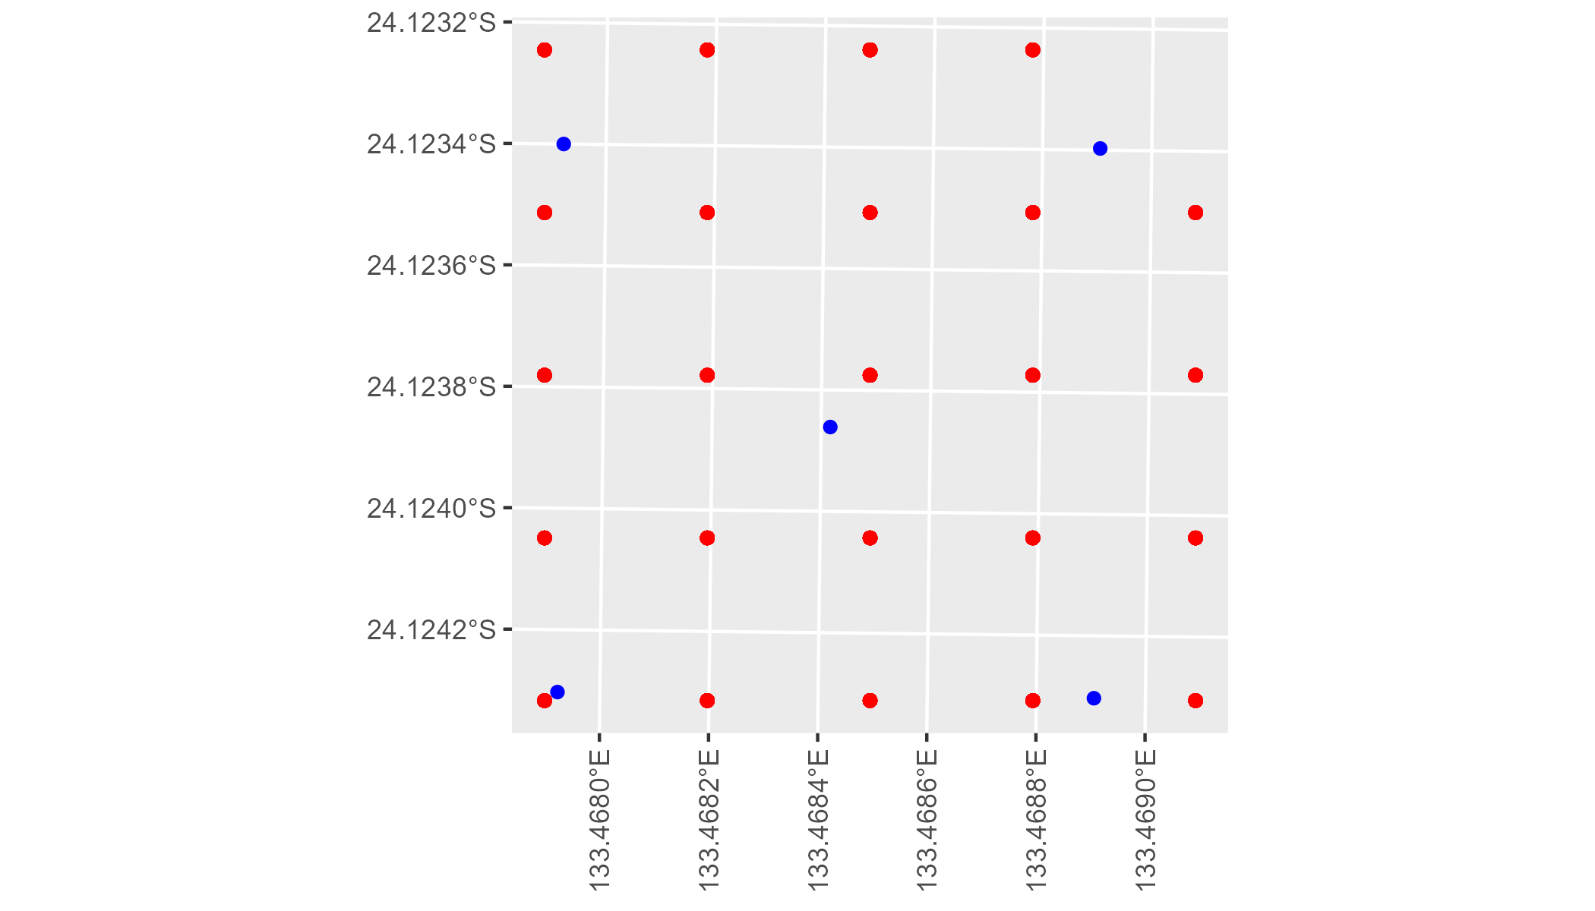

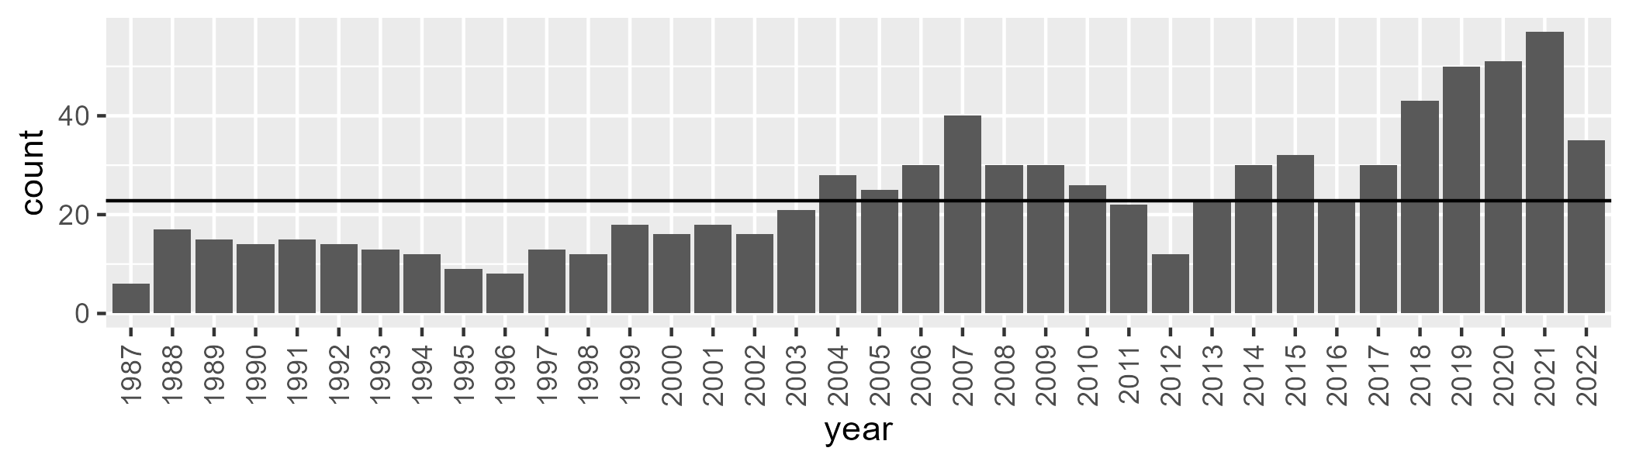

Number of samples: 854

# NTAFIN0002

| Min. | 1st Qu. | Median | Mean | 3rd Qu. | Max. |
| --- | --- | --- | --- | --- | --- |
| 6.689479 | 13.5424 | 16.38432 | 18.3571 | 20.60873 | 46.12415 |

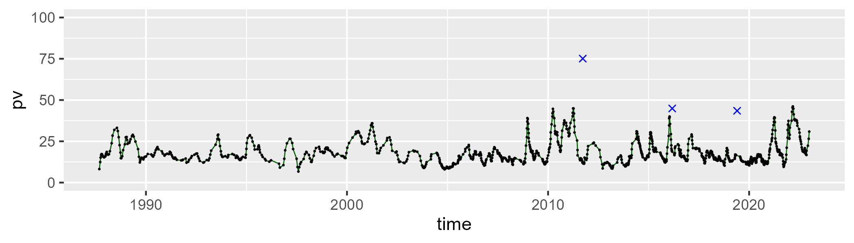

| Min. | 1st Qu. | Median | Mean | 3rd Qu. | Max. |
| --- | --- | --- | --- | --- | --- |
| 17.51534 | 39.68266 | 45.61394 | 44.23482 | 49.72487 | 70.04437 |

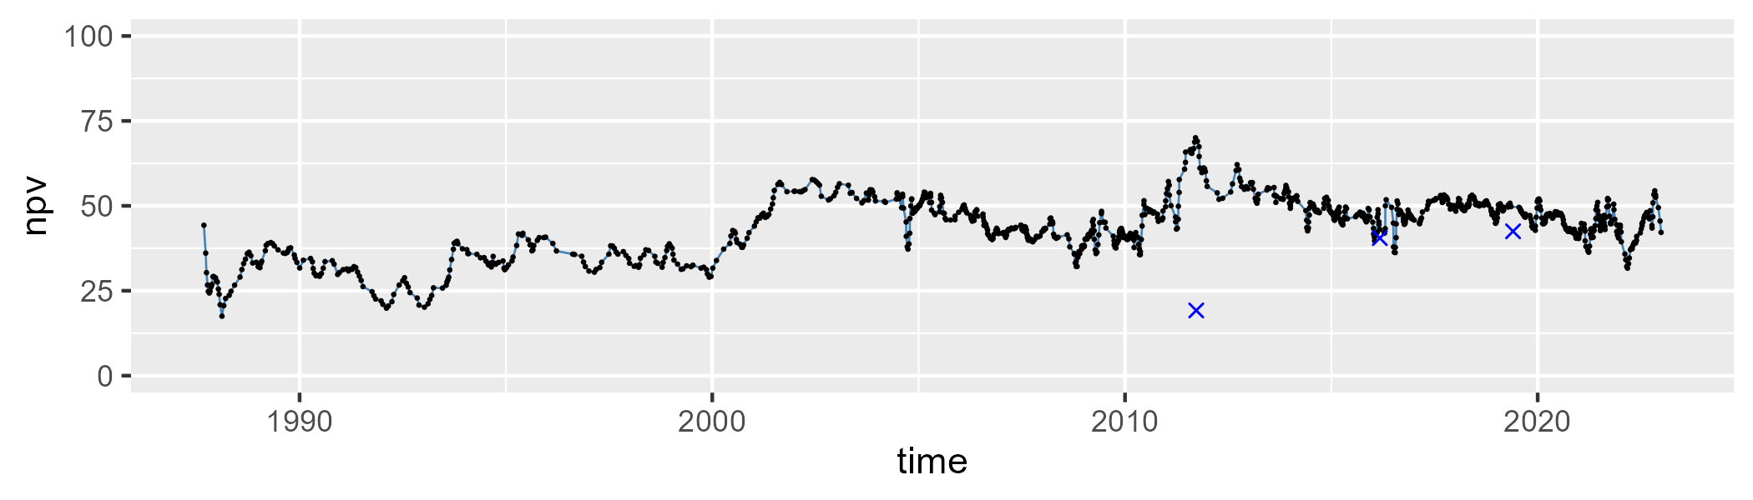

| Min. | 1st Qu. | Median | Mean | 3rd Qu. | Max. |
| --- | --- | --- | --- | --- | --- |
| 10.47007 | 30.27867 | 35.55468 | 35.99952 | 42.18203 | 66.02765 |

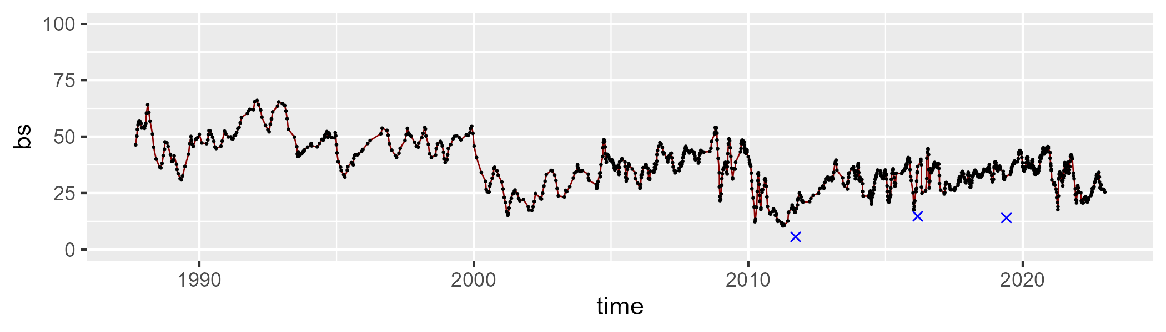

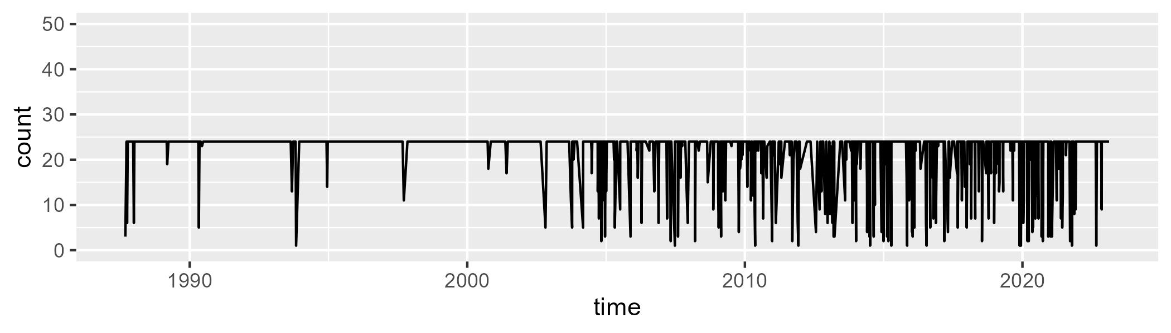

Min. : 1.00 1st Qu.:24.00 Median :24.00 Mean :21.52 3rd Qu.:24.00 Max. :24.00

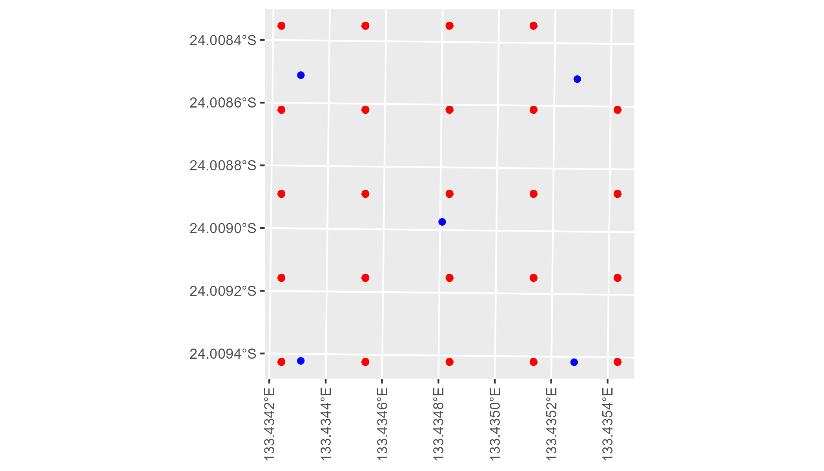

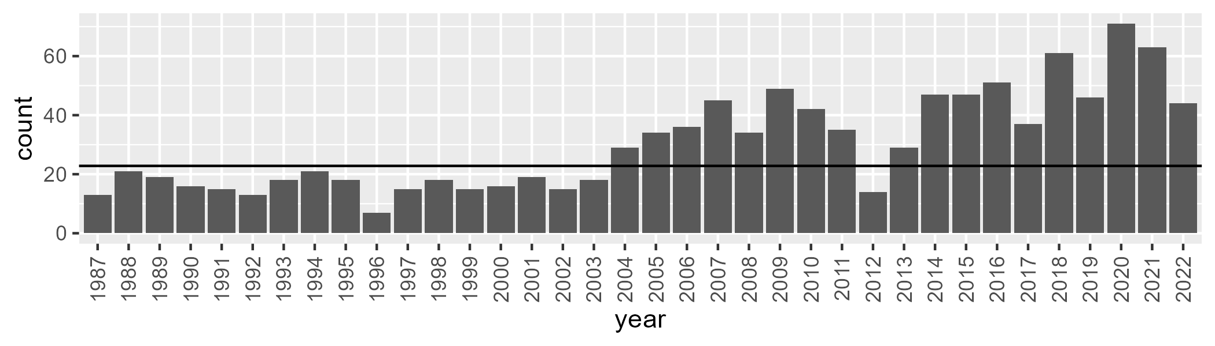

Number of samples: 1091

# NTAFIN0003

| Min. | 1st Qu. | Median | Mean | 3rd Qu. | Max. |
| --- | --- | --- | --- | --- | --- |
| 3.766639 | 9.334946 | 11.96327 | 12.00046 | 14.63484 | 24.8874 |

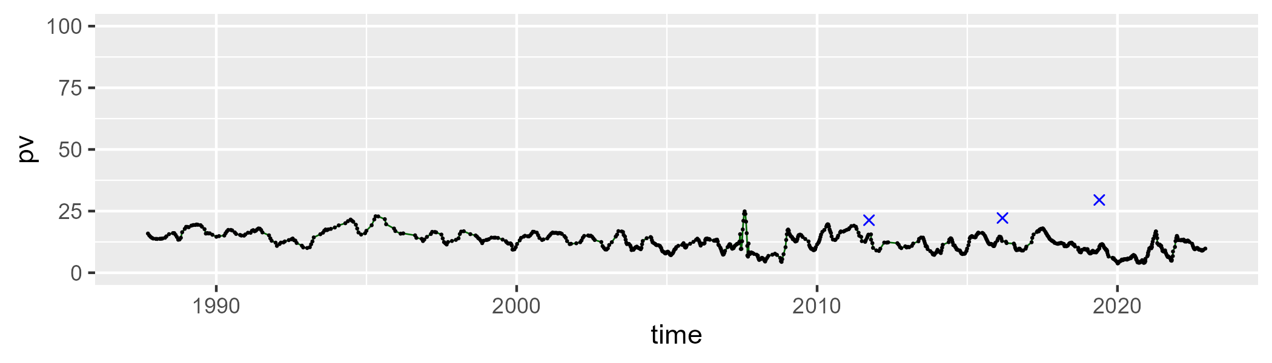

| Min. | 1st Qu. | Median | Mean | 3rd Qu. | Max. |
| --- | --- | --- | --- | --- | --- |
| 9.351963 | 30.02353 | 37.5219 | 35.4474 | 41.33368 | 51.213 |

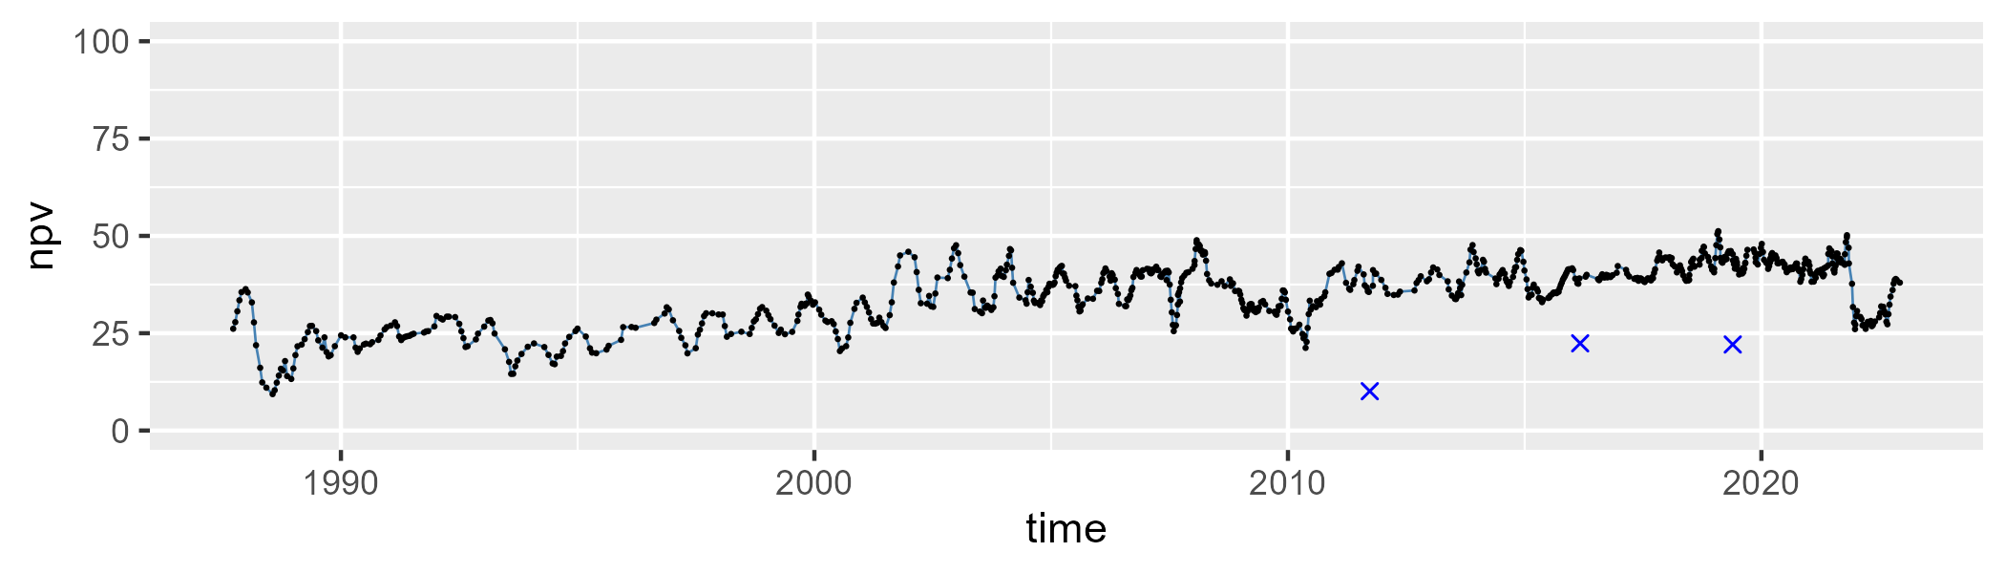

| Min. | 1st Qu. | Median | Mean | 3rd Qu. | Max. |
| --- | --- | --- | --- | --- | --- |
| 36.80401 | 46.80507 | 50.12877 | 51.13023 | 55.39477 | 73.42019 |

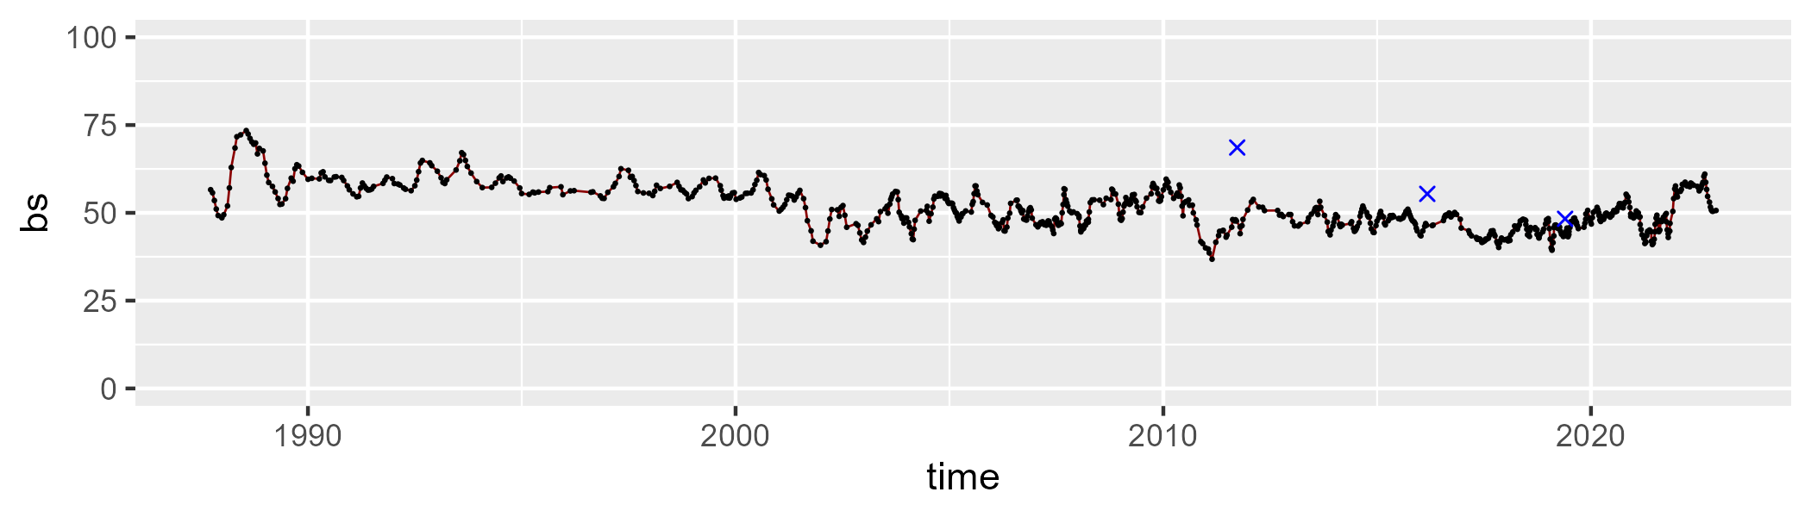

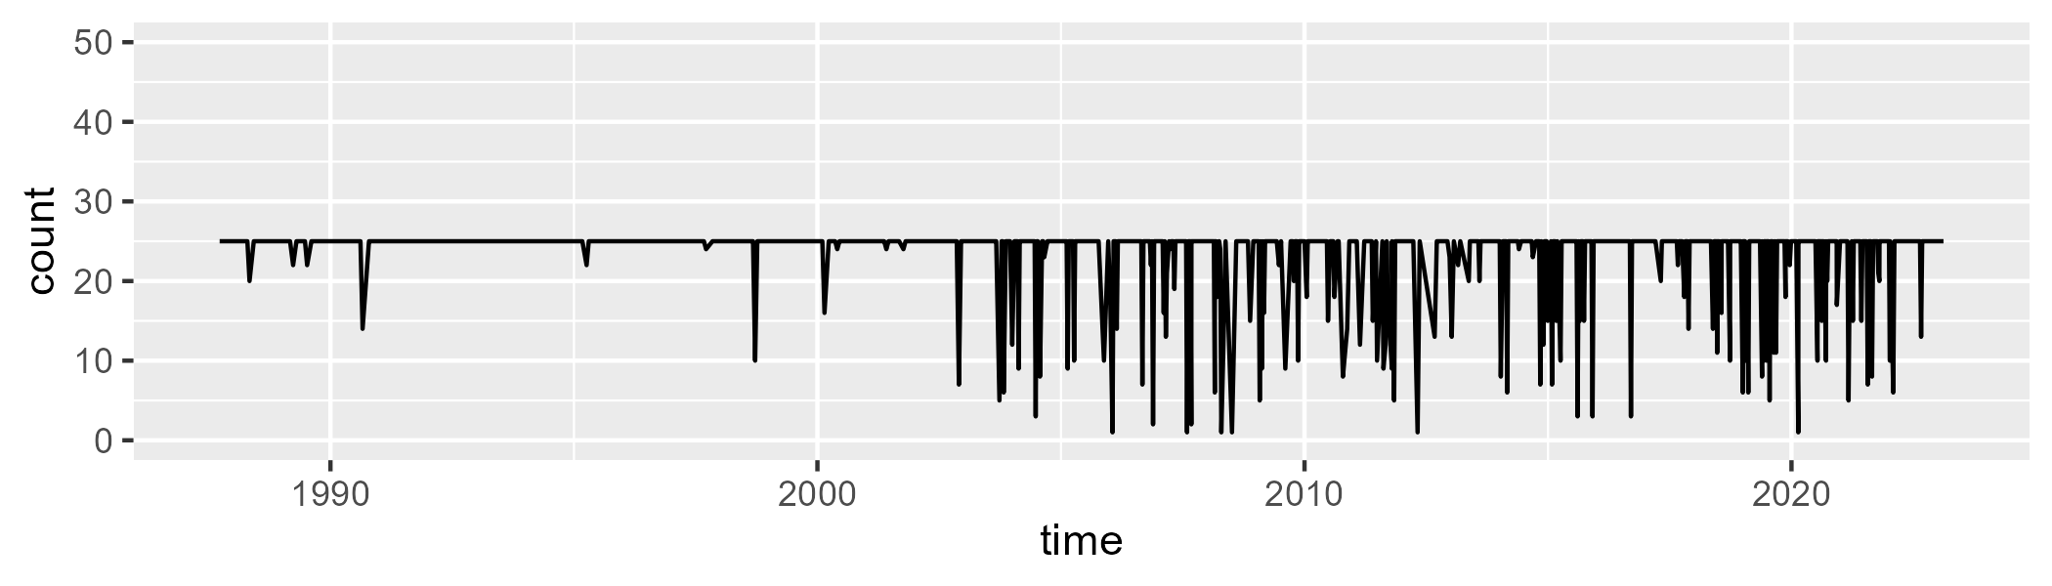

Min. : 1.00 1st Qu.:25.00 Median :25.00 Mean :23.17 3rd Qu.:25.00 Max. :25.00

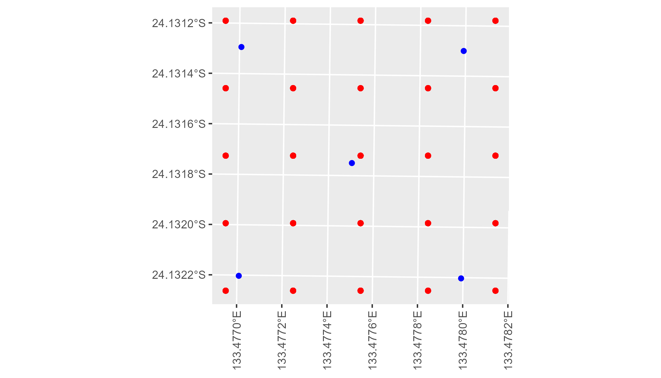

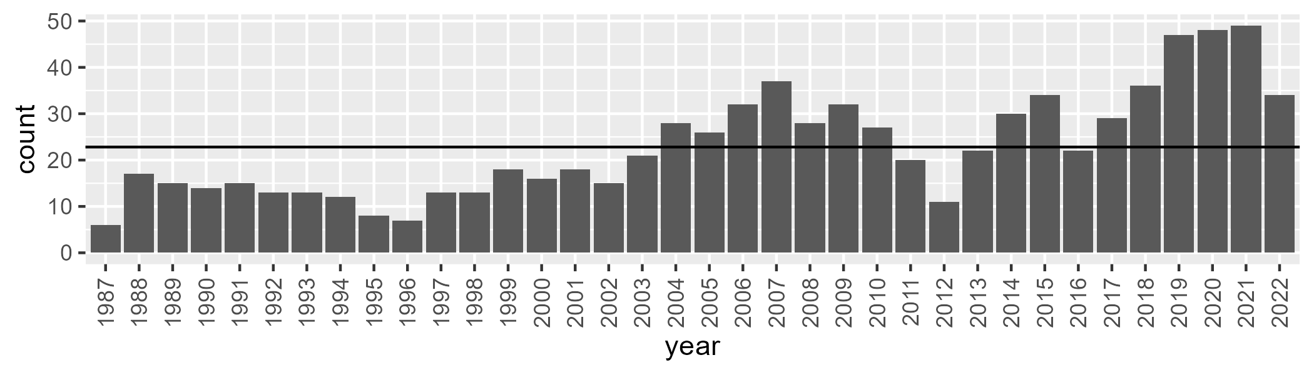

Number of samples: 826

# NTAFIN0004

| Min. | 1st Qu. | Median | Mean | 3rd Qu. | Max. |
| --- | --- | --- | --- | --- | --- |
| 3.80035 | 9.859981 | 12.75358 | 13.67516 | 16.4122 | 34.739 |

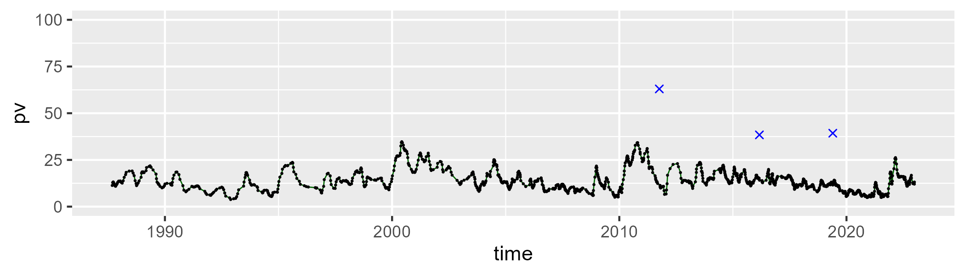

| Min. | 1st Qu. | Median | Mean | 3rd Qu. | Max. |
| --- | --- | --- | --- | --- | --- |
| 36.98988 | 49.50856 | 51.11733 | 50.97992 | 52.75633 | 59.65422 |

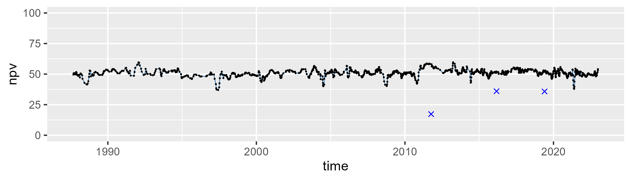

| Min. | 1st Qu. | Median | Mean | 3rd Qu. | Max. |
| --- | --- | --- | --- | --- | --- |
| 13.26139 | 31.04176 | 34.45259 | 34.03557 | 37.62744 | 52.65917 |

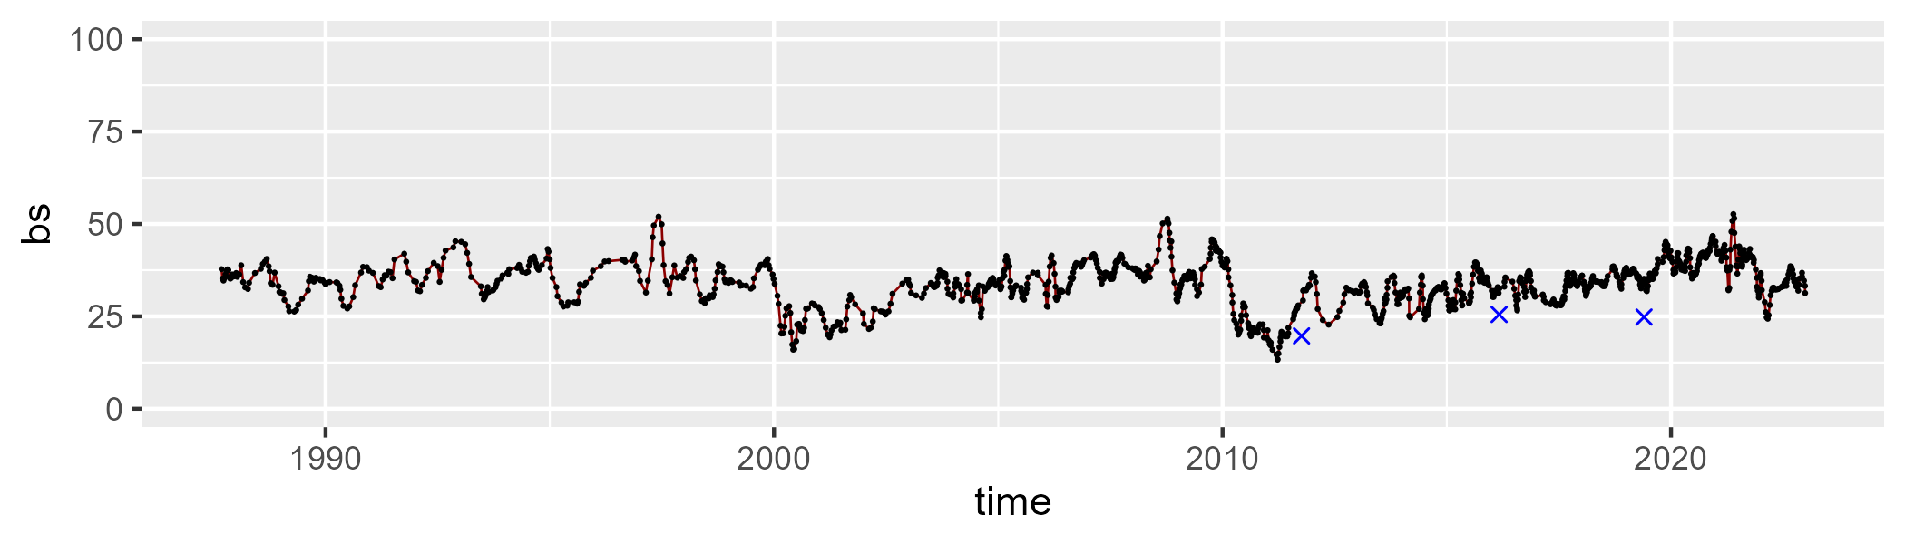

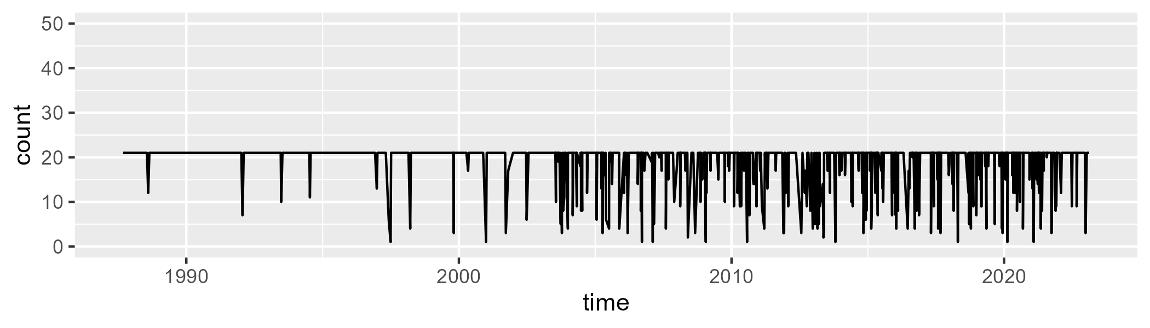

Min. : 1.00 1st Qu.:21.00 Median :21.00 Mean :19.27 3rd Qu.:21.00 Max. :21.00

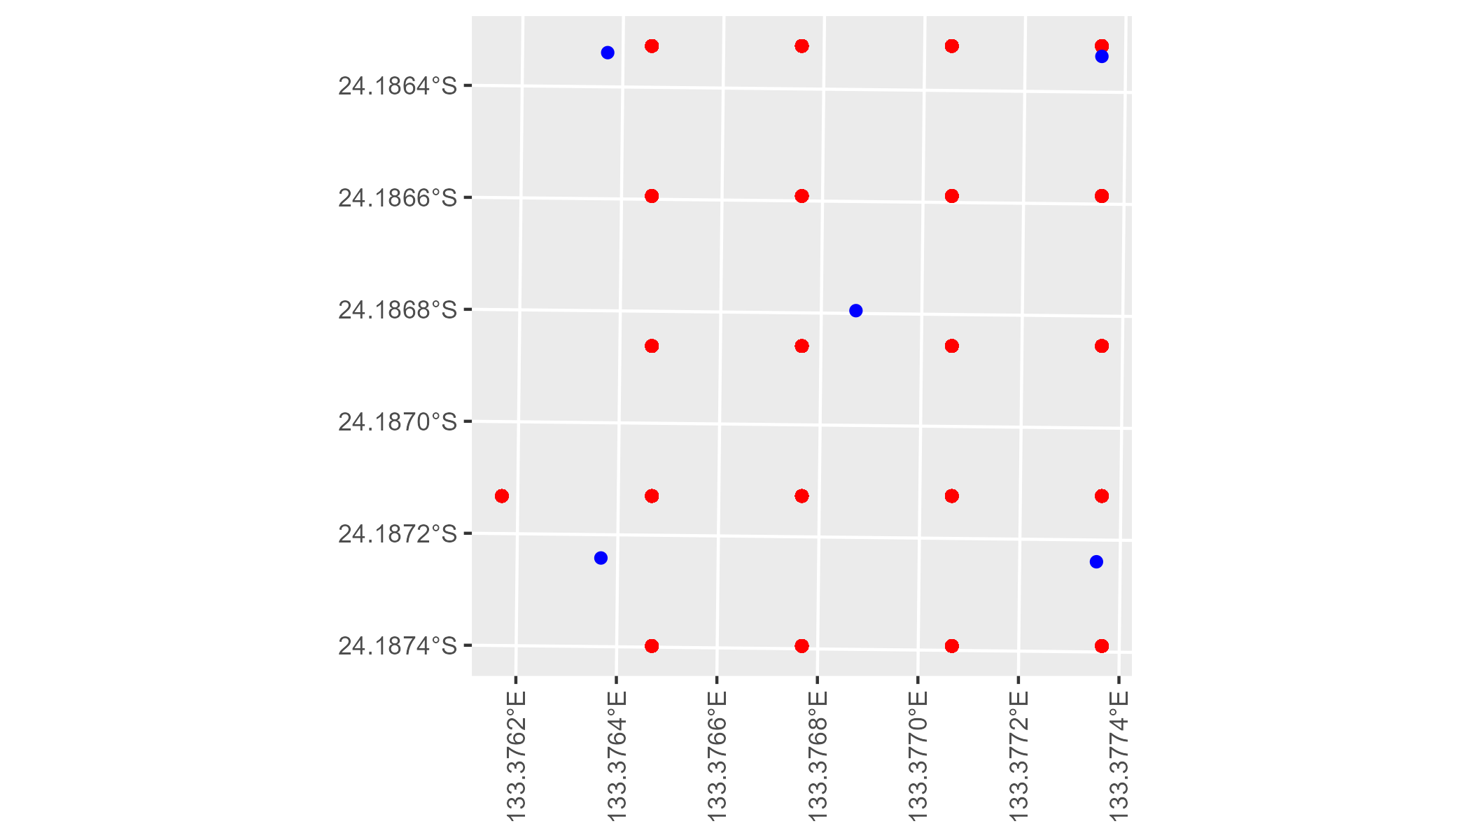

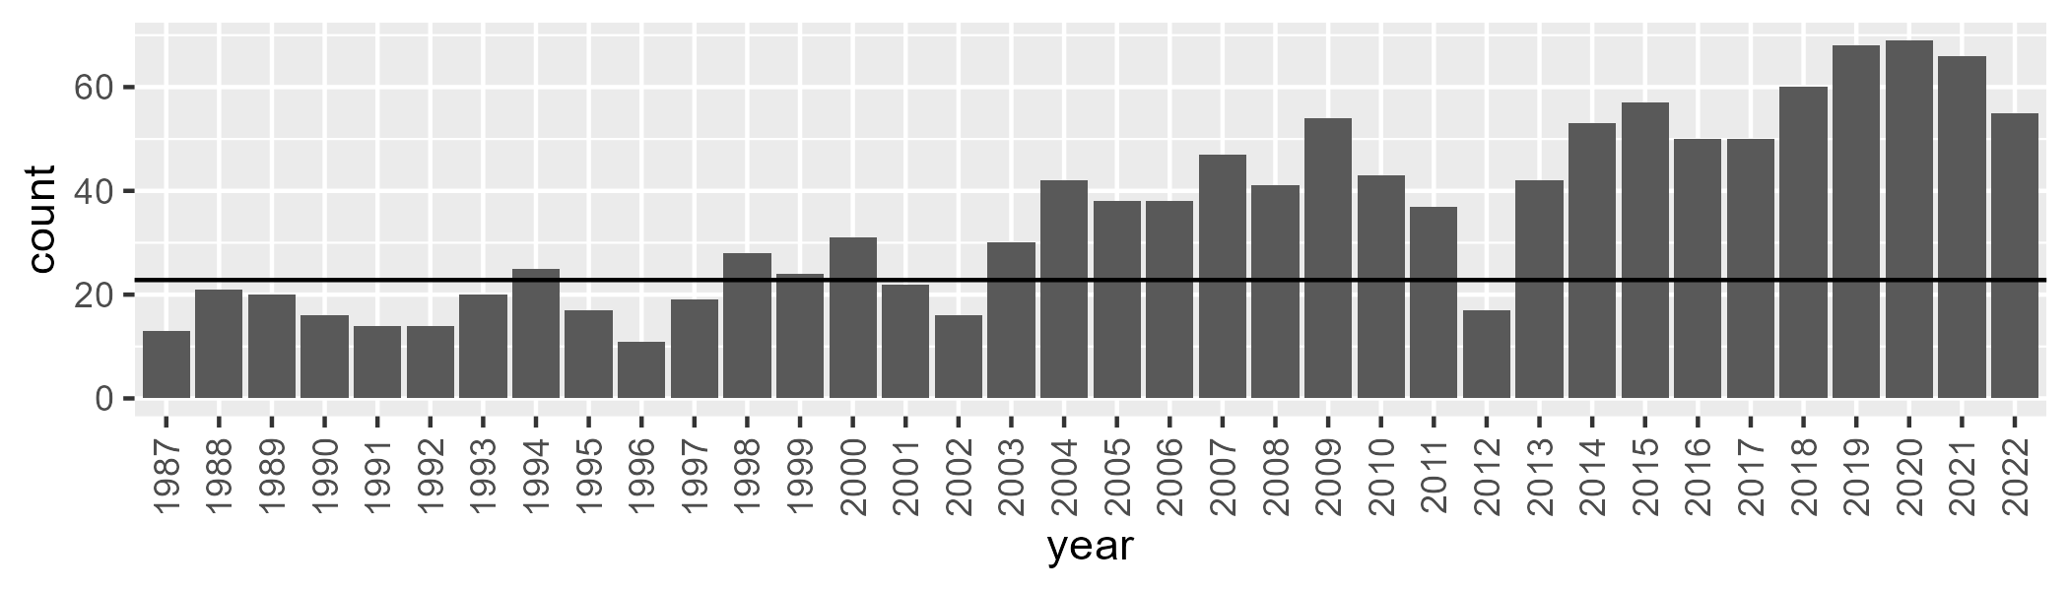

Number of samples: 1268

# NTAFIN0005

| Min. | 1st Qu. | Median | Mean | 3rd Qu. | Max. |
| --- | --- | --- | --- | --- | --- |
| 1.836952 | 7.221407 | 8.976419 | 9.671958 | 11.11059 | 27.76052 |

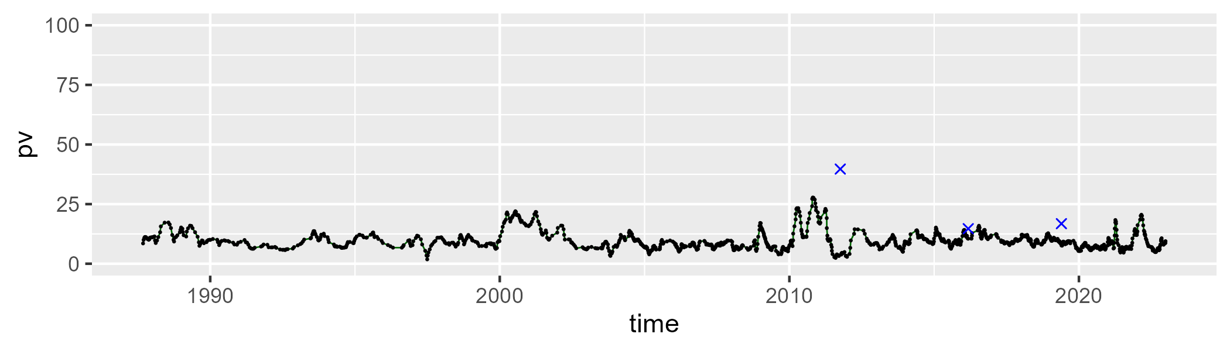

| Min. | 1st Qu. | Median | Mean | 3rd Qu. | Max. |
| --- | --- | --- | --- | --- | --- |
| 13.4533 | 28.3695 | 32.7457 | 33.45962 | 38.05601 | 68.09489 |

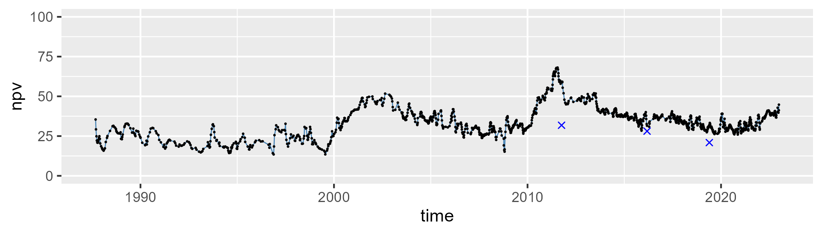

| Min. | 1st Qu. | Median | Mean | 3rd Qu. | Max. |
| --- | --- | --- | --- | --- | --- |
| 21.41993 | 50.26487 | 56.28748 | 55.32949 | 62.07039 | 77.35223 |

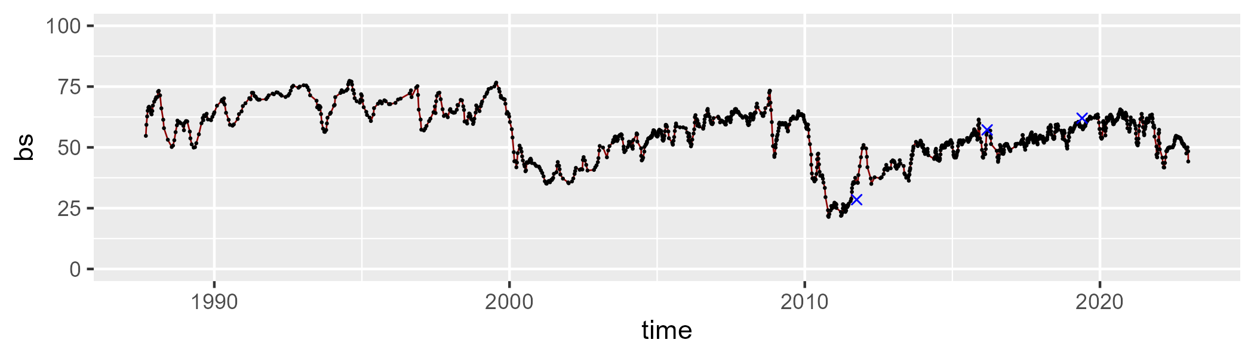

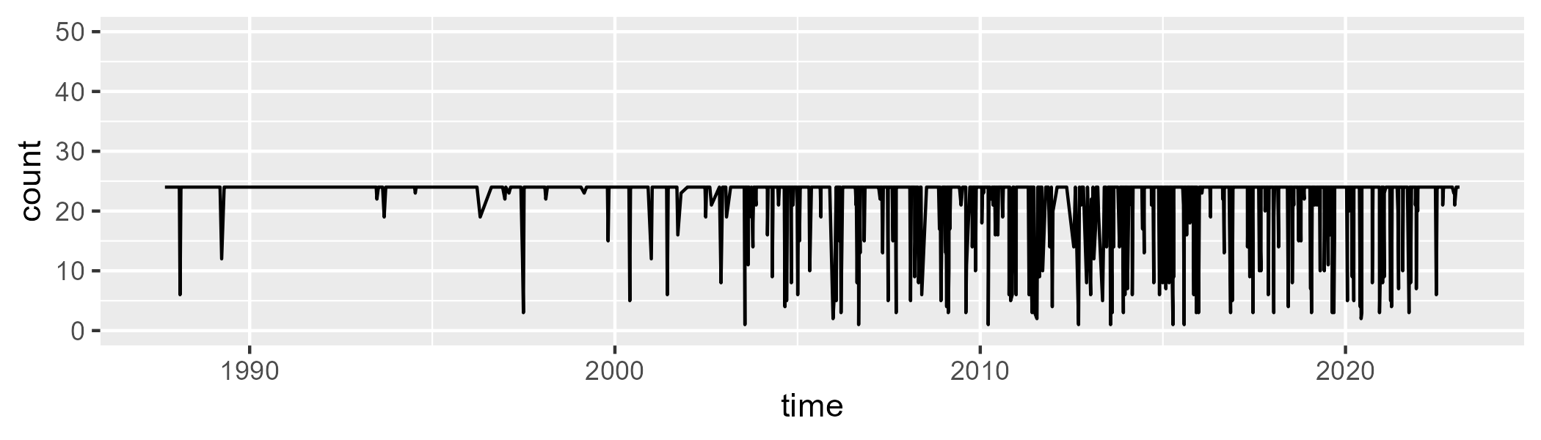

Min. : 1.00 1st Qu.:24.00 Median :24.00 Mean :22.04 3rd Qu.:24.00 Max. :24.00

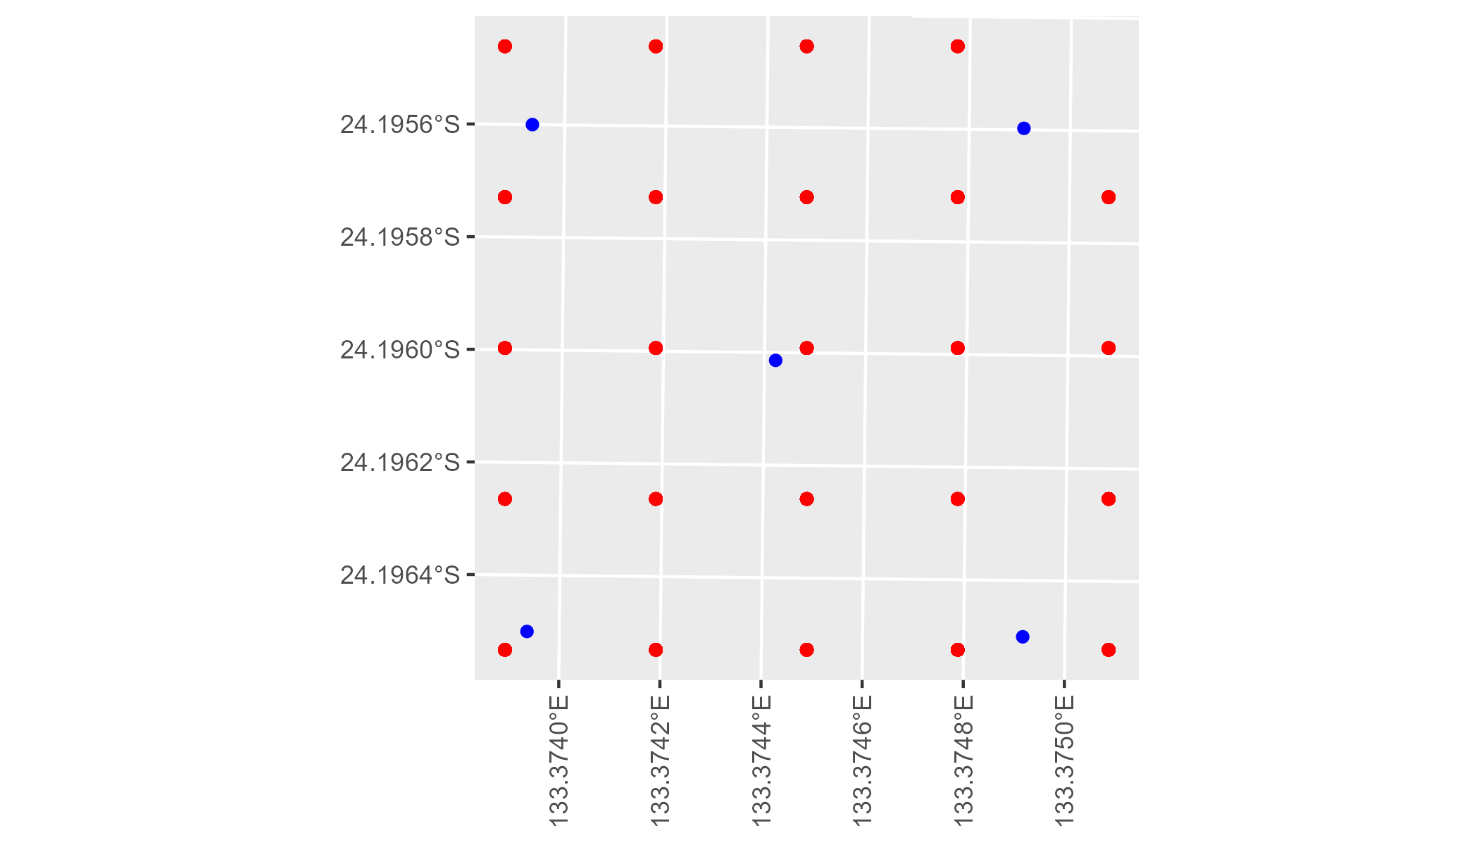

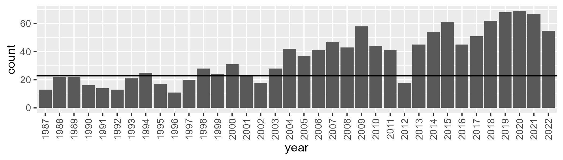

Number of samples: 1294

# NTAFIN0006

| Min. | 1st Qu. | Median | Mean | 3rd Qu. | Max. |
| --- | --- | --- | --- | --- | --- |
| 0 | 11.23958 | 13.52845 | 14.61375 | 17.03036 | 42.58558 |

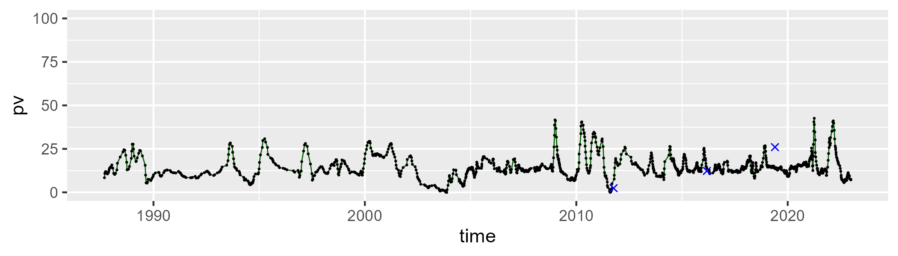

| Min. | 1st Qu. | Median | Mean | 3rd Qu. | Max. |
| --- | --- | --- | --- | --- | --- |
| 11.67609 | 25.3978 | 30.81695 | 32.81858 | 36.82576 | 83.76811 |

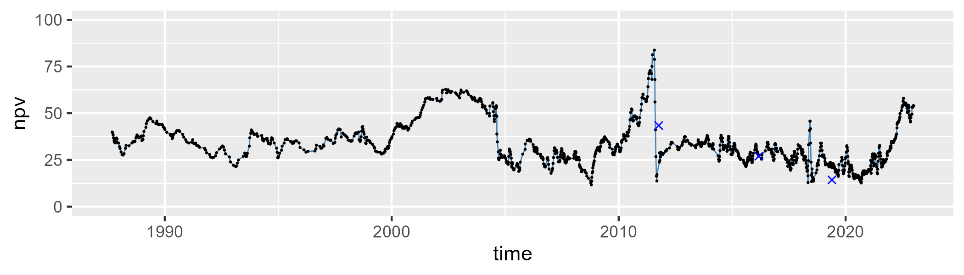

| Min. | 1st Qu. | Median | Mean | 3rd Qu. | Max. |
| --- | --- | --- | --- | --- | --- |
| 11.77453 | 43.84568 | 53.98791 | 50.99656 | 59.9602 | 82.68039 |

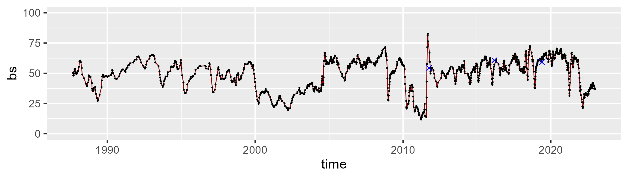

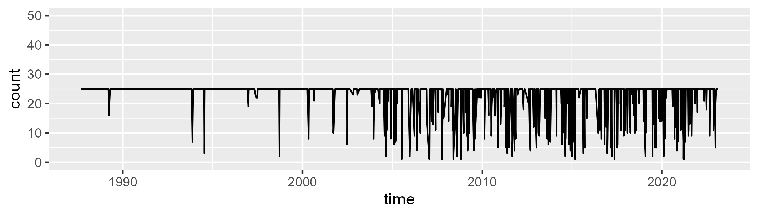

Min. : 1.0 1st Qu.:25.0 Median :25.0 Mean :22.9 3rd Qu.:25.0 Max. :25.0

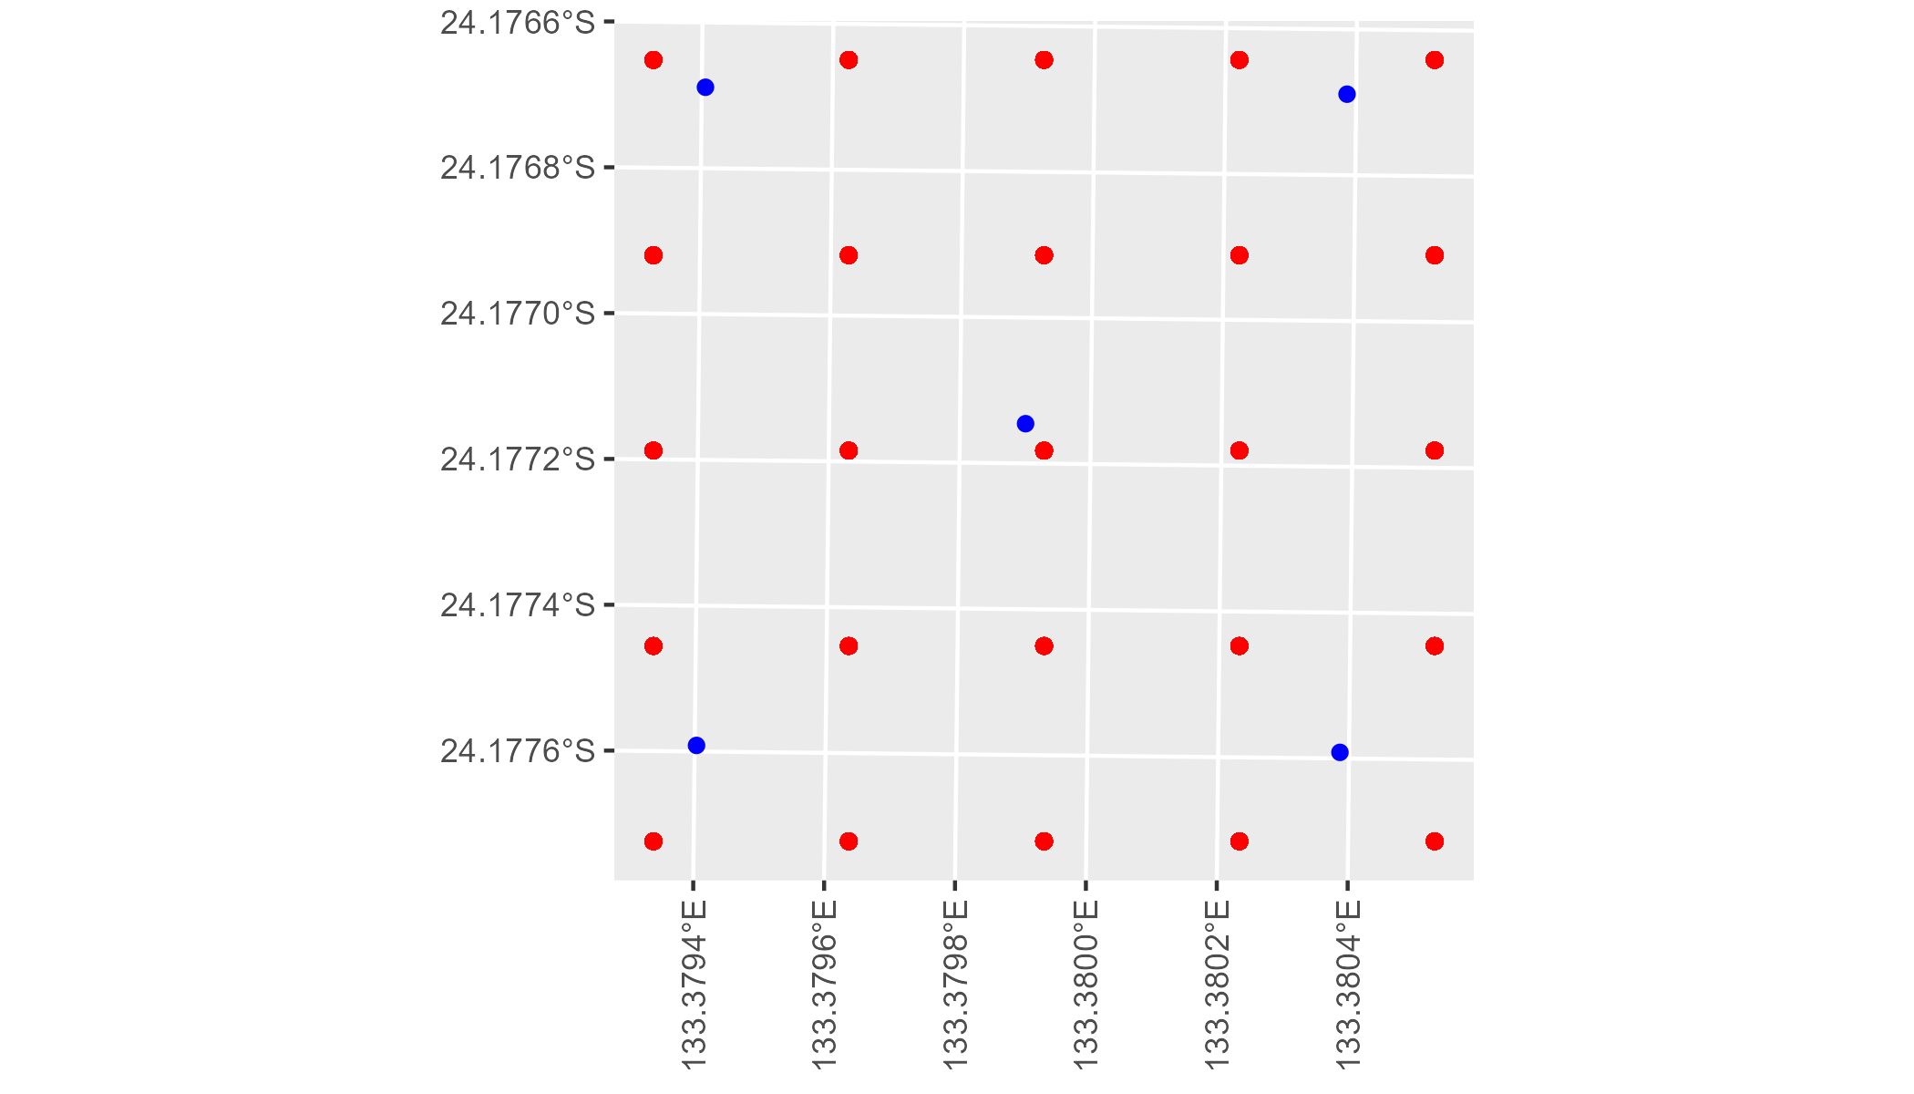

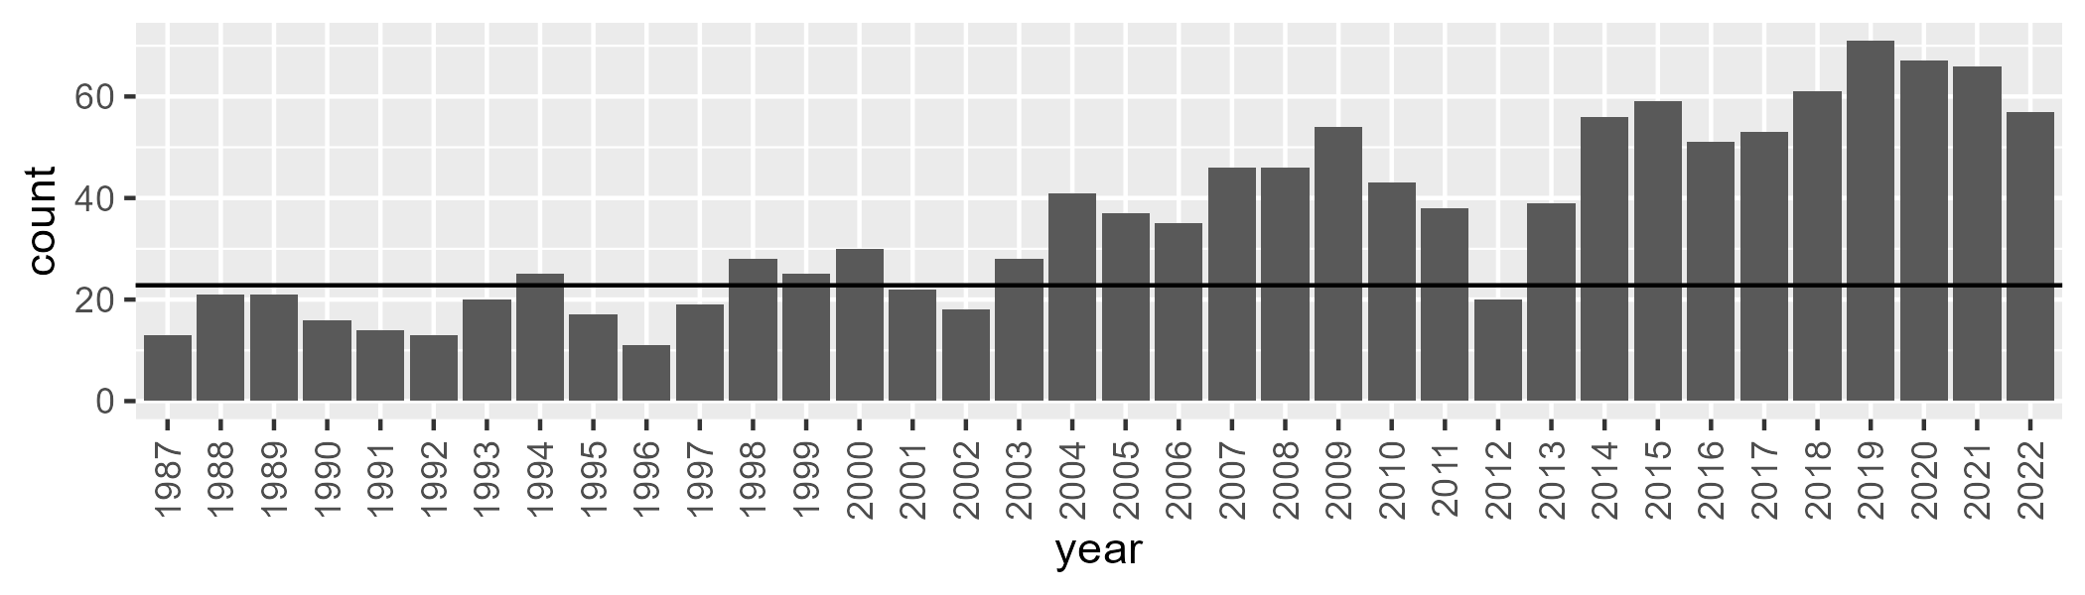

Number of samples: 1281

# NTAFIN0007

| Min. | 1st Qu. | Median | Mean | 3rd Qu. | Max. |
| --- | --- | --- | --- | --- | --- |
| 0.6716199 | 7.498603 | 9.459514 | 10.38757 | 12.50849 | 29.09455 |

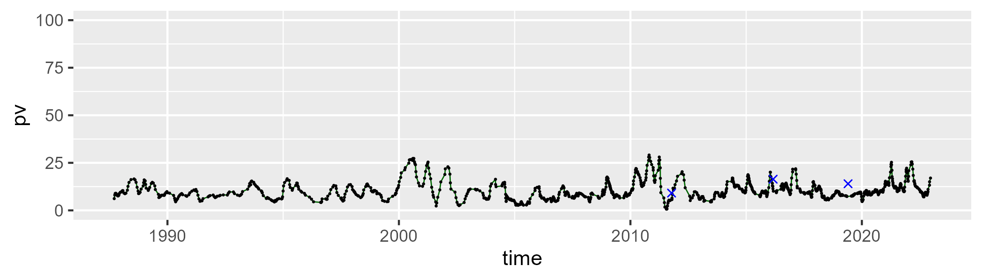

| Min. | 1st Qu. | Median | Mean | 3rd Qu. | Max. |
| --- | --- | --- | --- | --- | --- |
| 2.579699 | 18.46418 | 23.82085 | 24.73099 | 29.94383 | 58.91081 |

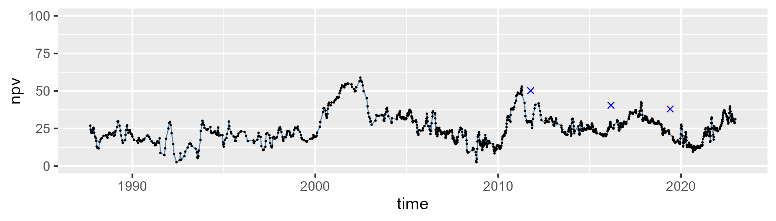

| Min. | 1st Qu. | Median | Mean | 3rd Qu. | Max. |
| --- | --- | --- | --- | --- | --- |
| 20.49838 | 57.7577 | 64.15811 | 63.26021 | 70.97961 | 87.98669 |

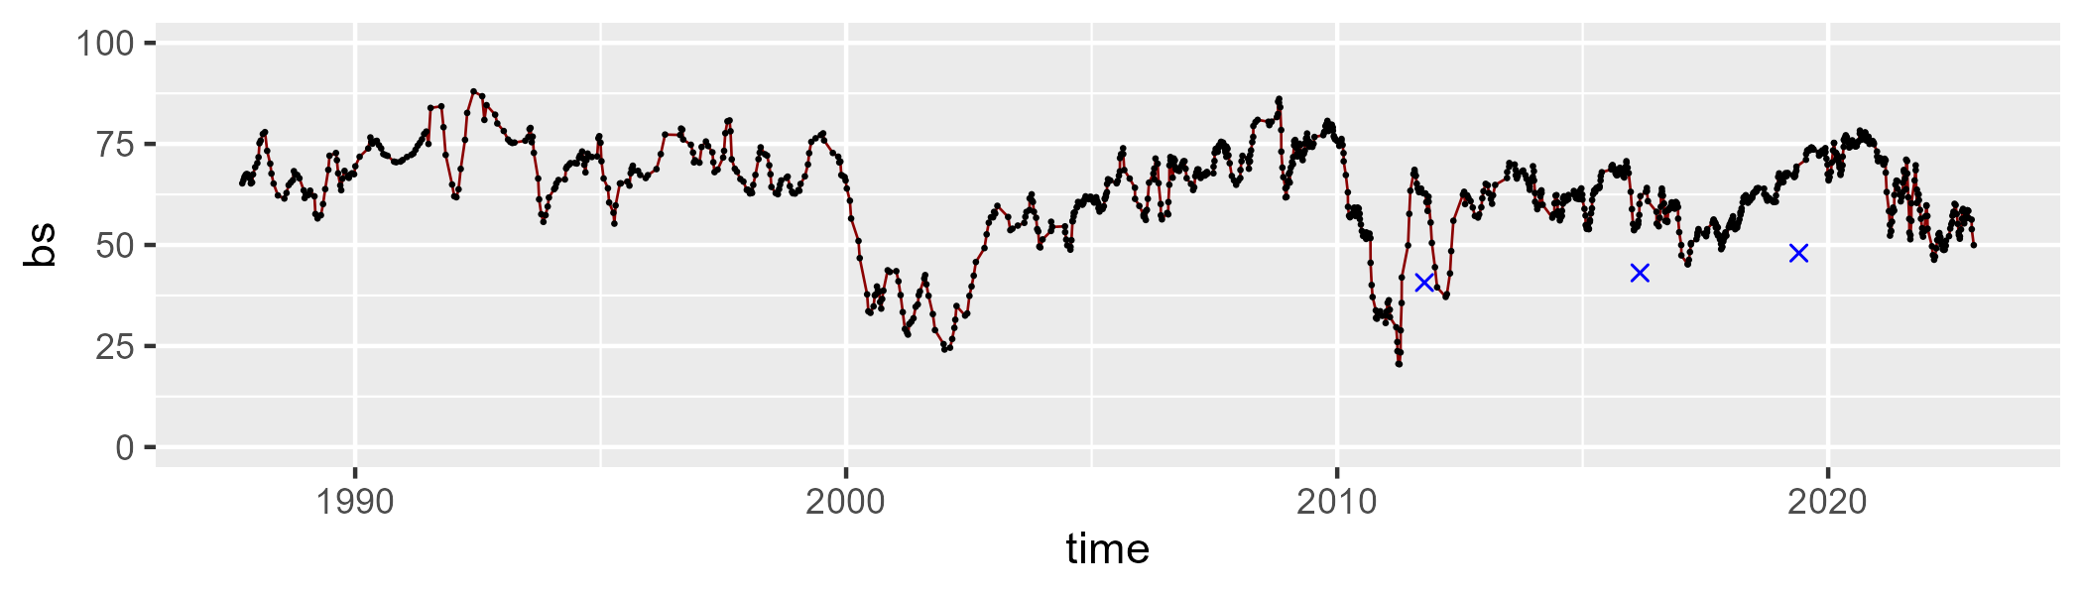

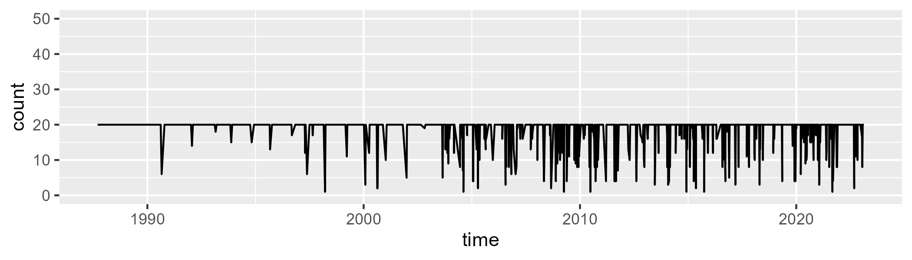

Min. : 1.00 1st Qu.:20.00 Median :20.00 Mean :18.56 3rd Qu.:20.00 Max. :20.00

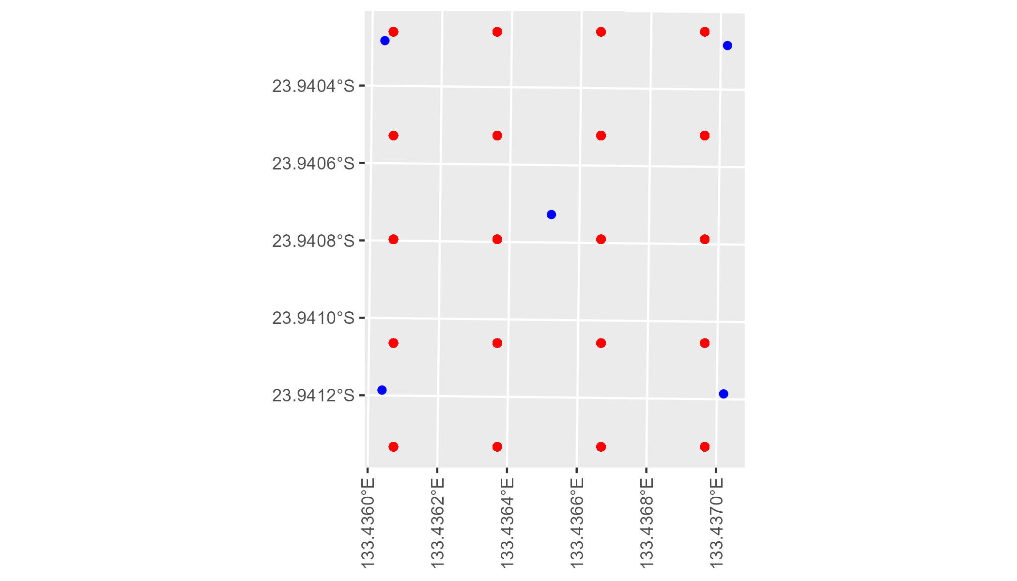

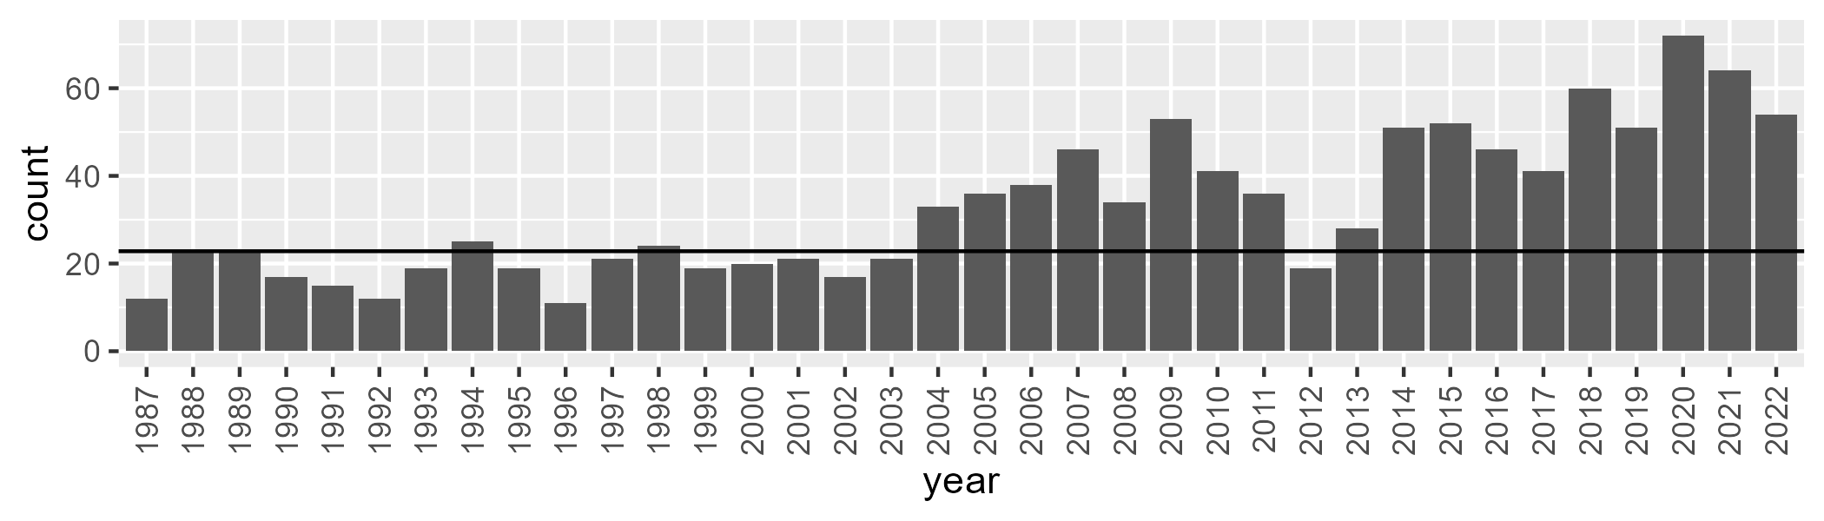

Number of samples: 1174

# NTAFIN0008

| Min. | 1st Qu. | Median | Mean | 3rd Qu. | Max. |
| --- | --- | --- | --- | --- | --- |
| 0 | 2.331203 | 5.714868 | 8.897445 | 12.8149 | 45.78627 |

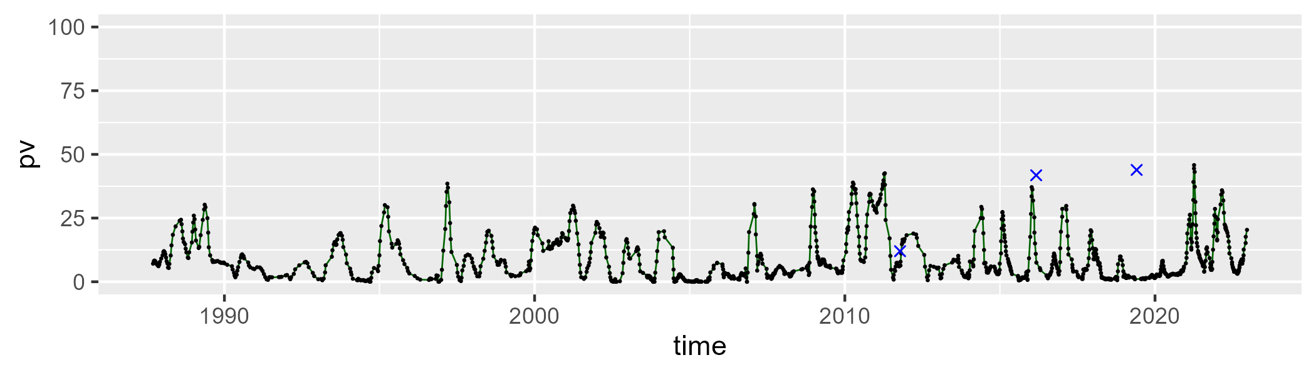

| Min. | 1st Qu. | Median | Mean | 3rd Qu. | Max. |
| --- | --- | --- | --- | --- | --- |
| 13.87586 | 28.00071 | 35.06555 | 35.25311 | 41.63767 | 75.26401 |

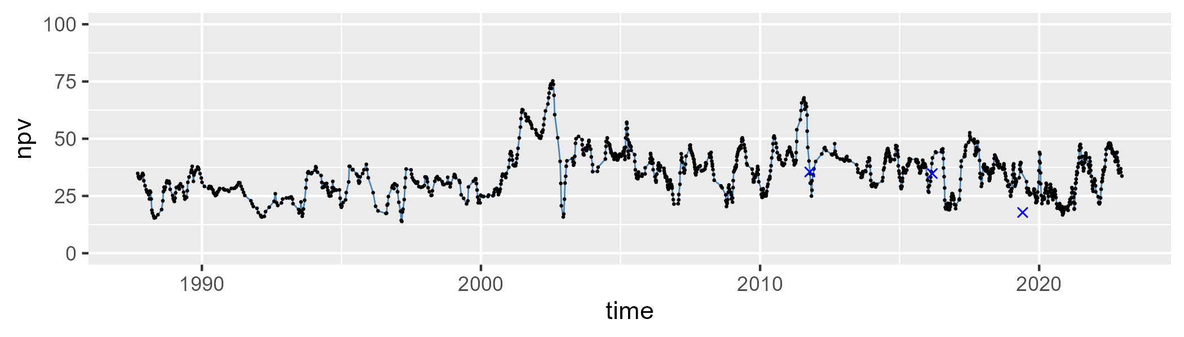

| Min. | 1st Qu. | Median | Mean | 3rd Qu. | Max. |
| --- | --- | --- | --- | --- | --- |
| 15.56858 | 47.93197 | 54.98875 | 54.38154 | 62.36013 | 81.44391 |

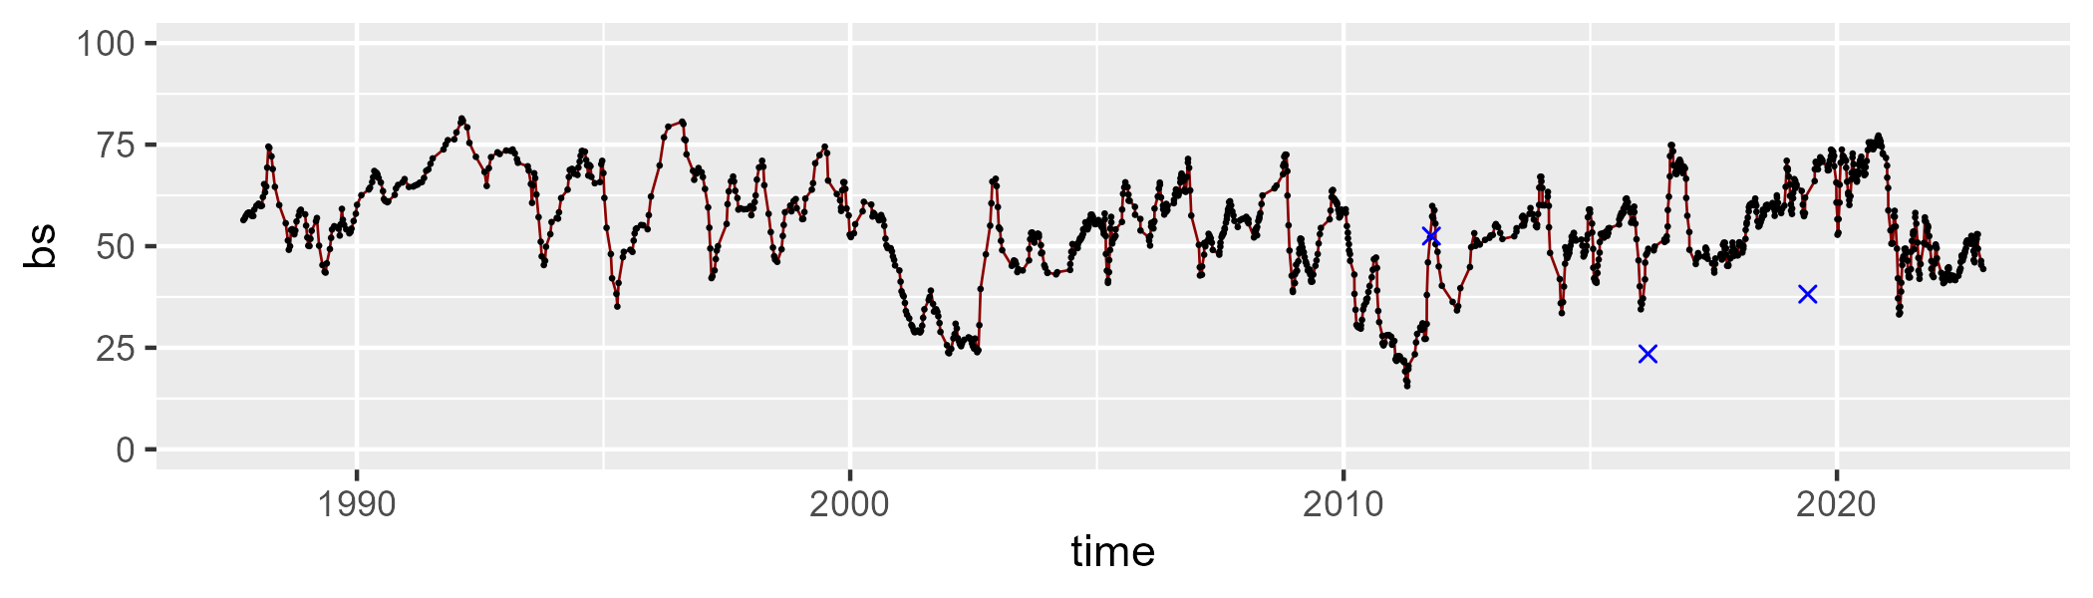

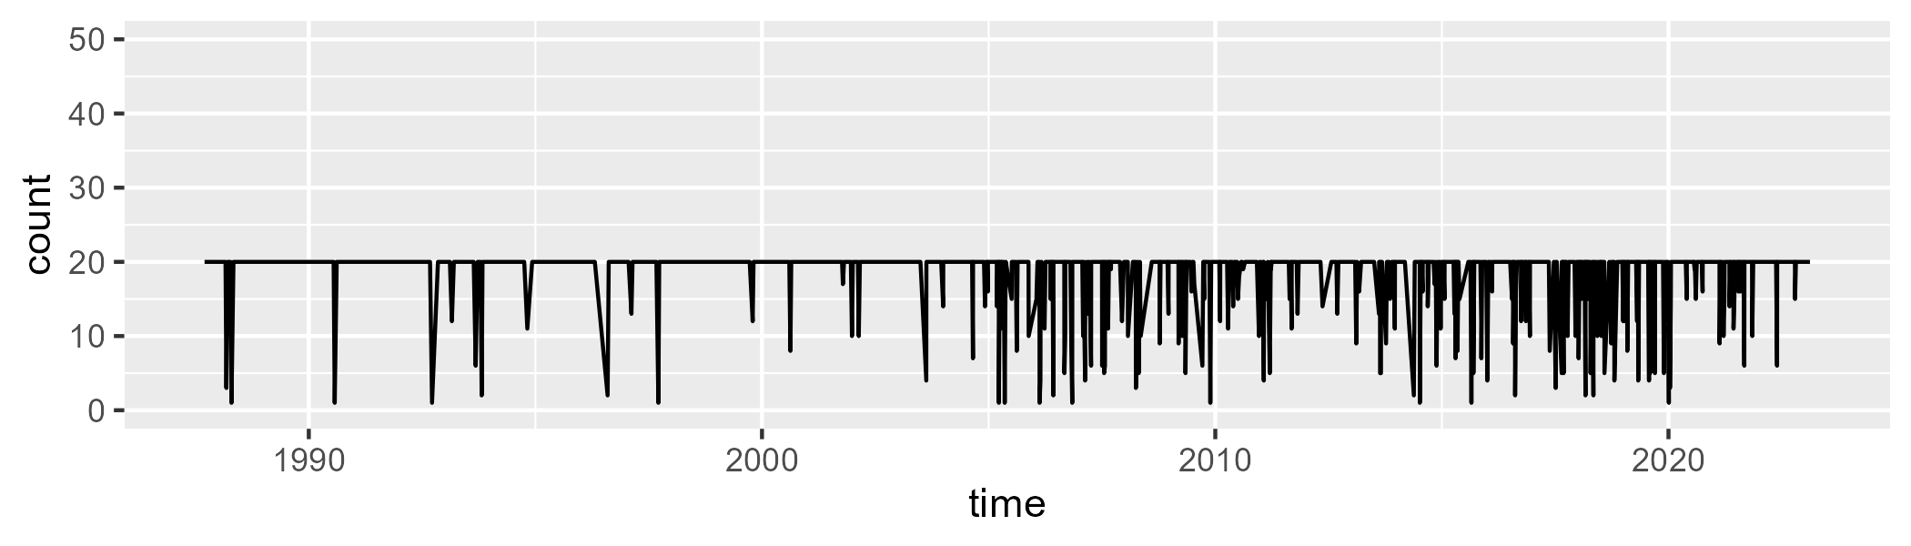

Min. : 1.00 1st Qu.:20.00 Median :20.00 Mean :18.66 3rd Qu.:20.00 Max. :20.00

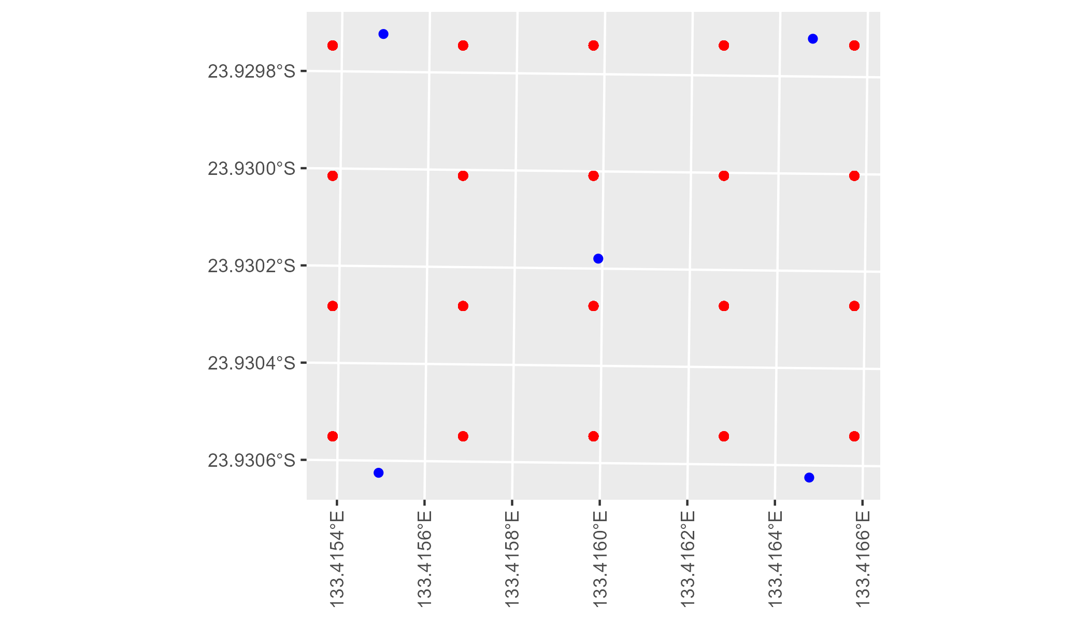

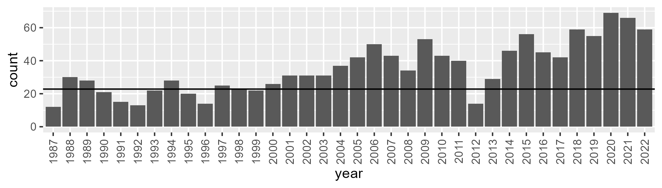

Number of samples: 1274

# NTAFIN0009

| Min. | 1st Qu. | Median | Mean | 3rd Qu. | Max. |
| --- | --- | --- | --- | --- | --- |
| 6.174844 | 12.26855 | 14.14085 | 15.04182 | 17.06393 | 29.76007 |

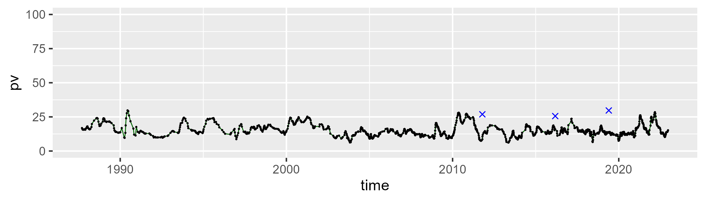

| Min. | 1st Qu. | Median | Mean | 3rd Qu. | Max. |
| --- | --- | --- | --- | --- | --- |
| 13.97999 | 27.78887 | 31.22828 | 31.57363 | 35.19189 | 54.34134 |

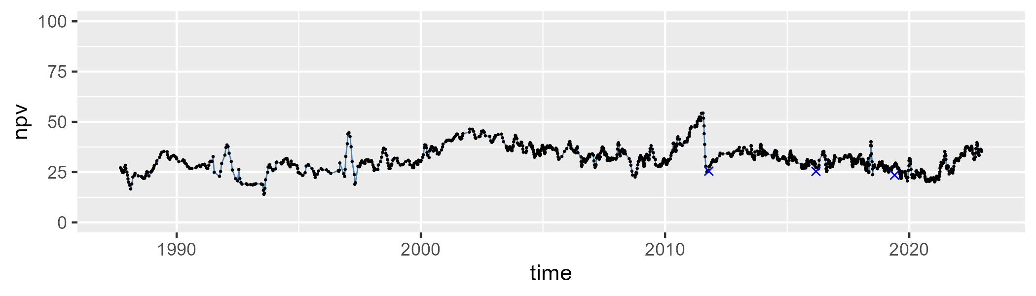

| Min. | 1st Qu. | Median | Mean | 3rd Qu. | Max. |
| --- | --- | --- | --- | --- | --- |
| 25.96626 | 48.23733 | 52.58092 | 51.75401 | 56.41927 | 68.73194 |

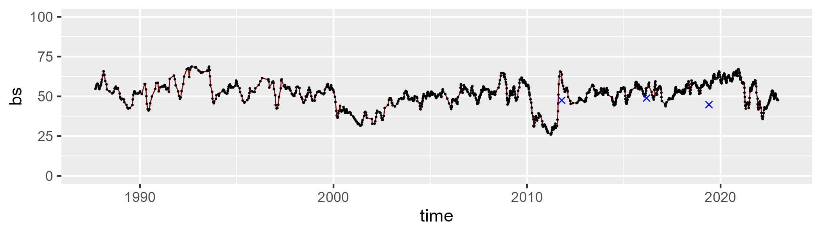

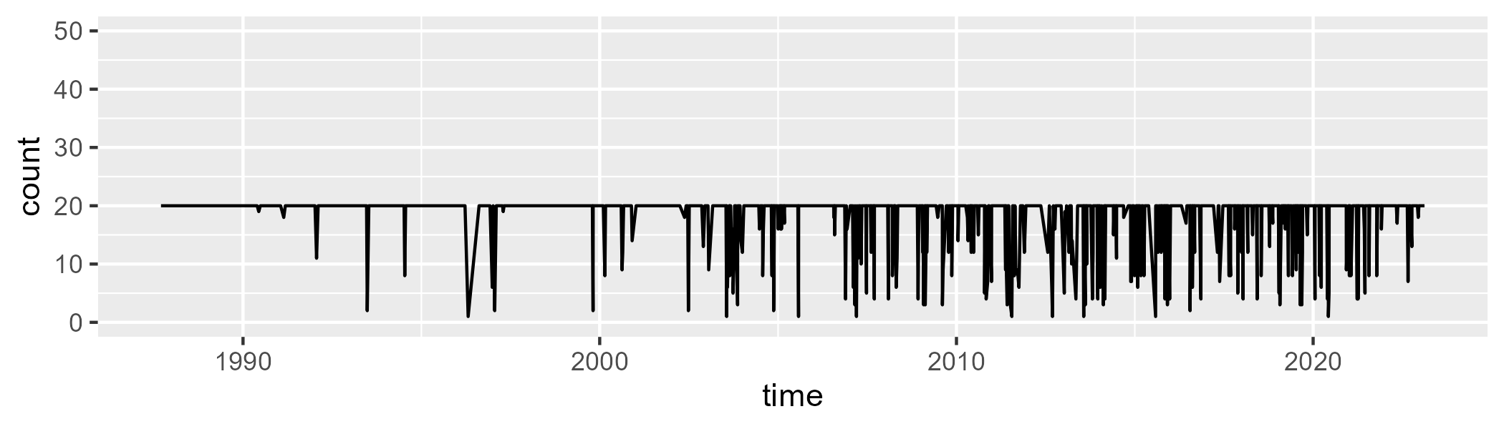

Min. : 1.00 1st Qu.:20.00 Median :20.00 Mean :18.45 3rd Qu.:20.00 Max. :20.00

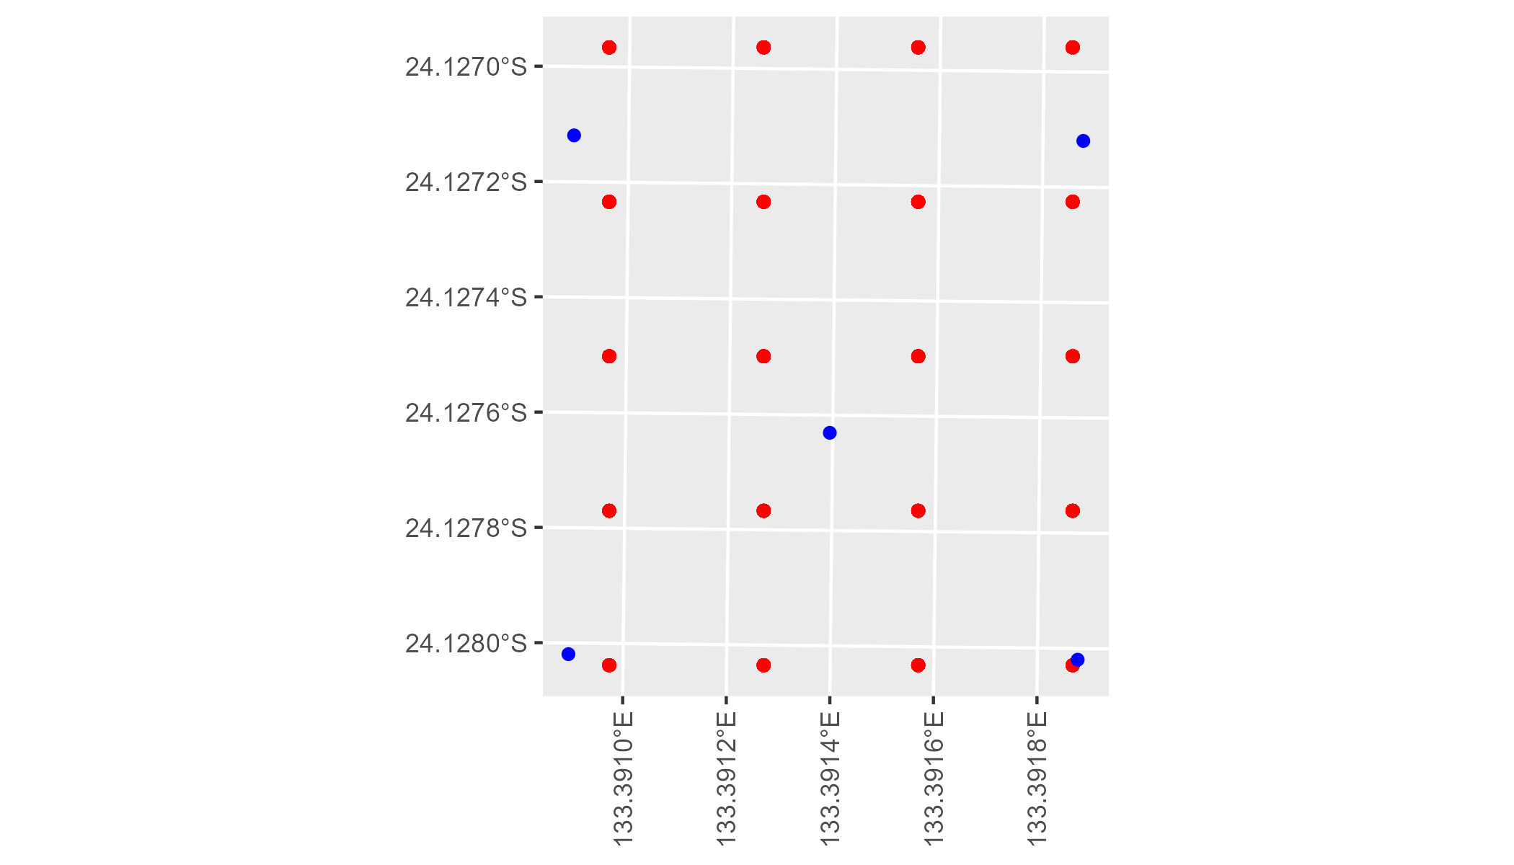

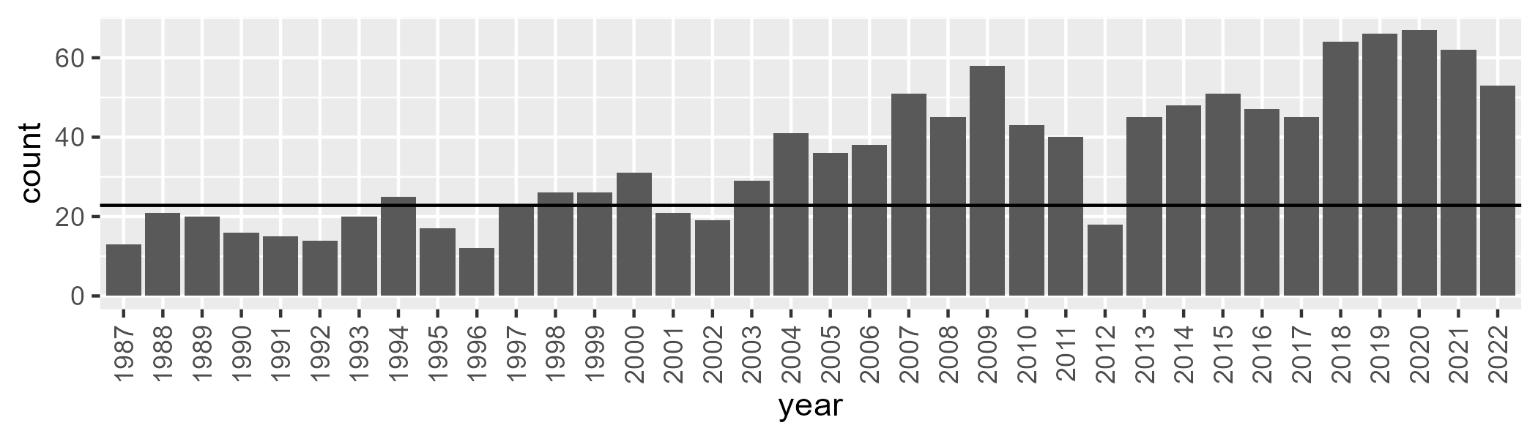

Number of samples: 1266

# NTAFIN0010

| Min. | 1st Qu. | Median | Mean | 3rd Qu. | Max. |
| --- | --- | --- | --- | --- | --- |
| 3.377381 | 10.88491 | 13.15825 | 13.90732 | 15.87468 | 30.22387 |

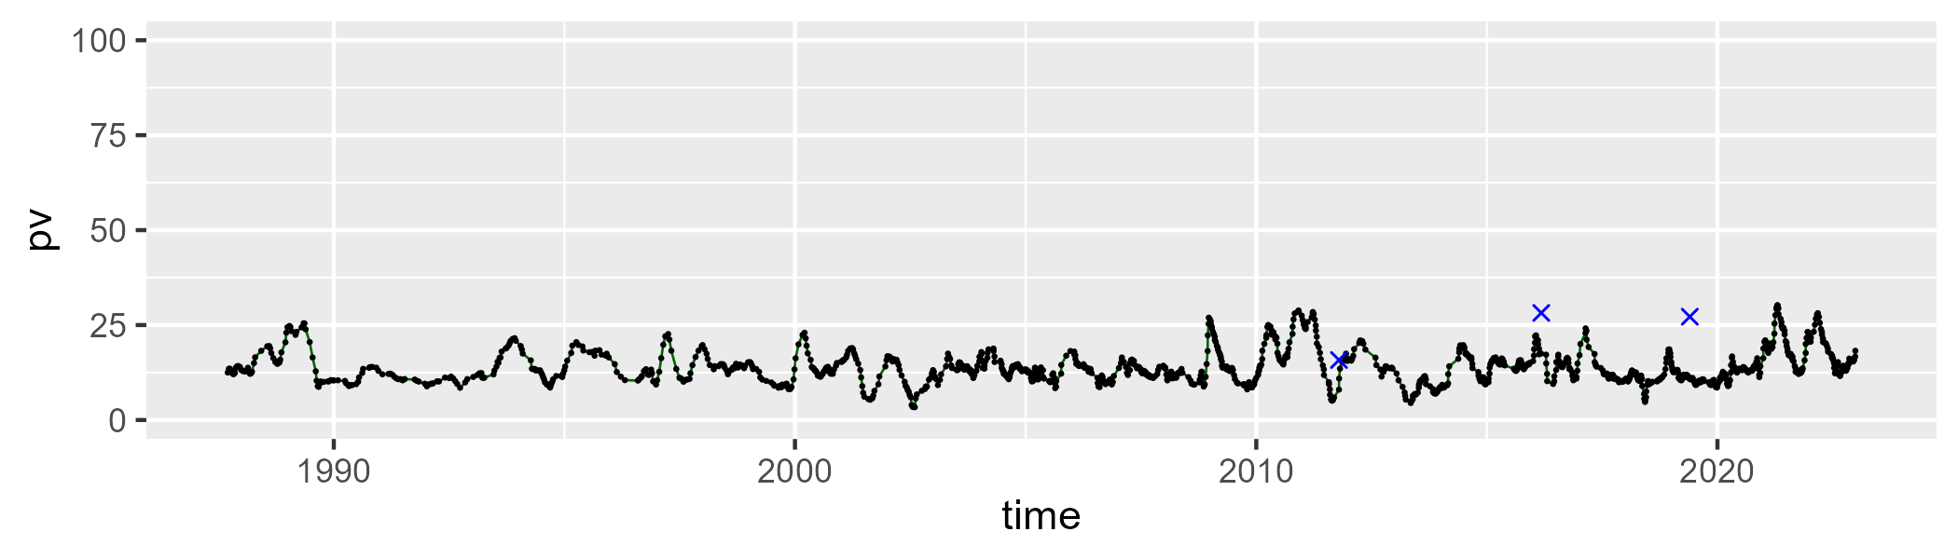

| Min. | 1st Qu. | Median | Mean | 3rd Qu. | Max. |
| --- | --- | --- | --- | --- | --- |
| 2.018624 | 21.13187 | 24.80226 | 25.78534 | 30.76757 | 64.88766 |

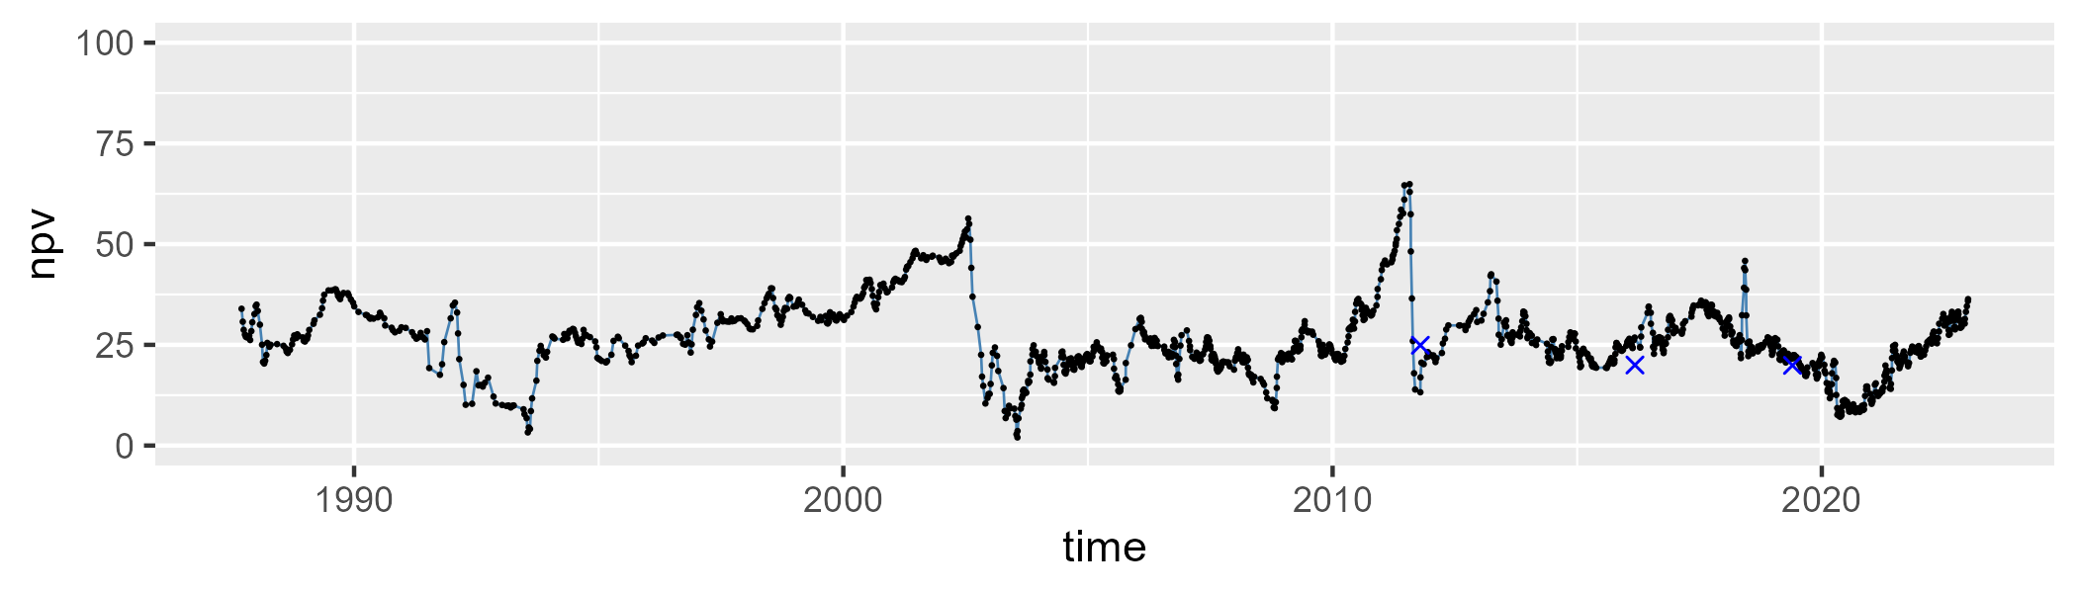

| Min. | 1st Qu. | Median | Mean | 3rd Qu. | Max. |
| --- | --- | --- | --- | --- | --- |
| 22.46346 | 53.43661 | 59.45231 | 58.68116 | 64.68686 | 81.62928 |

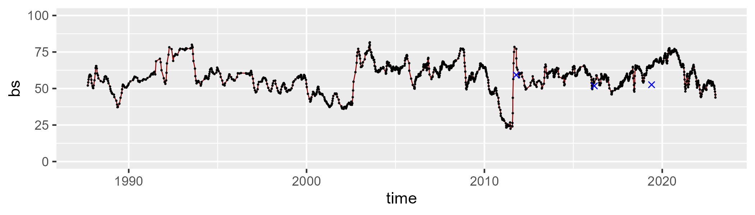

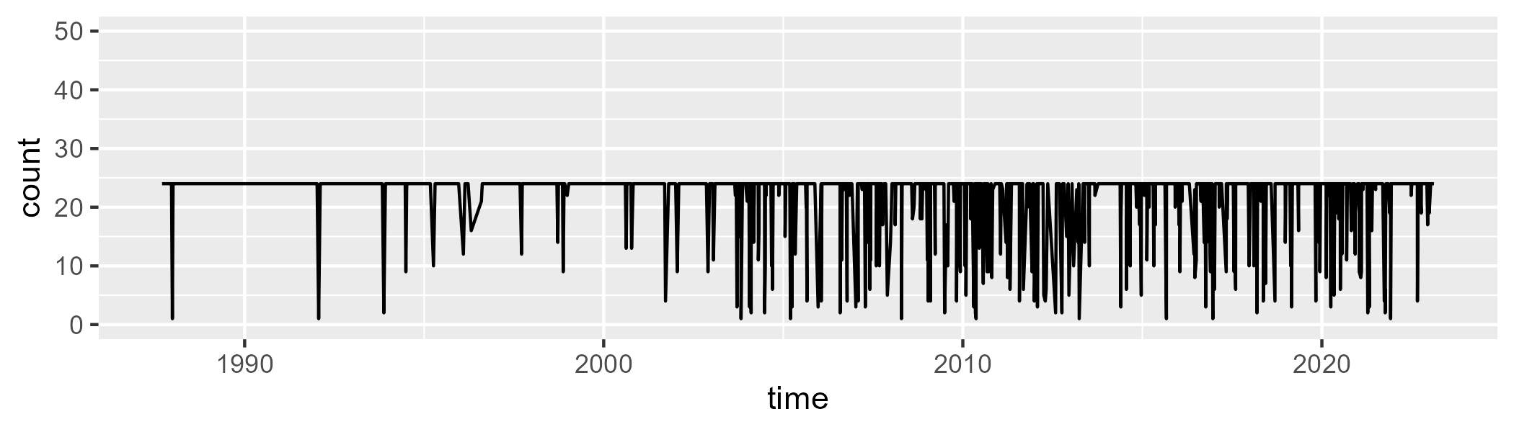

Min. : 1.00 1st Qu.:24.00 Median :24.00 Mean :22.02 3rd Qu.:24.00 Max. :24.00

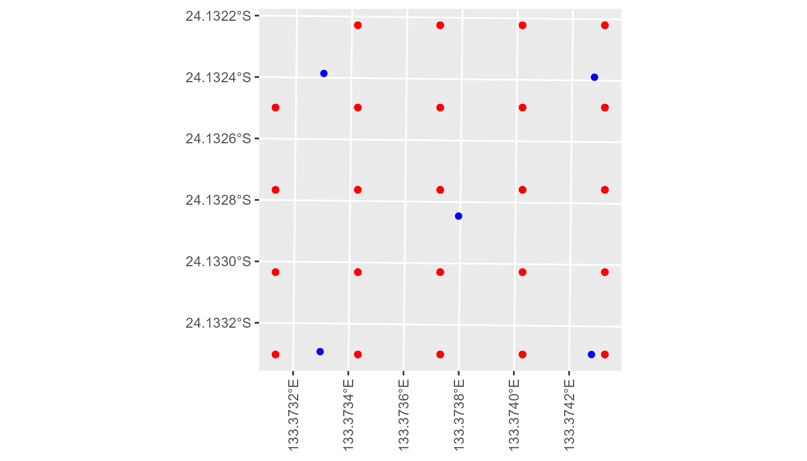

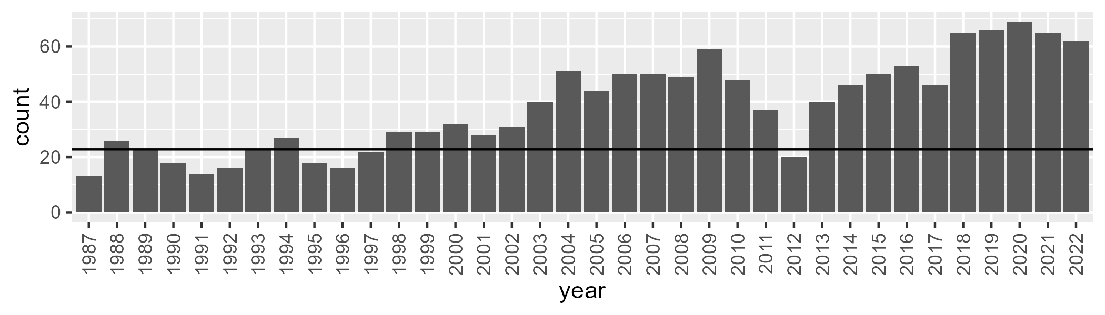

Number of samples: 1375

# NTAFIN0011

| Min. | 1st Qu. | Median | Mean | 3rd Qu. | Max. |
| --- | --- | --- | --- | --- | --- |
| 5.031884 | 10.8973 | 13.43358 | 14.8433 | 17.49515 | 35.76157 |

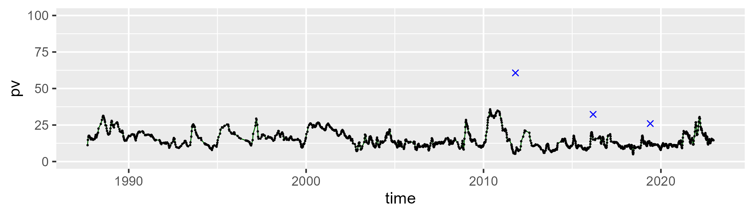

| Min. | 1st Qu. | Median | Mean | 3rd Qu. | Max. |
| --- | --- | --- | --- | --- | --- |
| 16.97381 | 32.52695 | 36.24854 | 37.2318 | 41.55823 | 60.27309 |

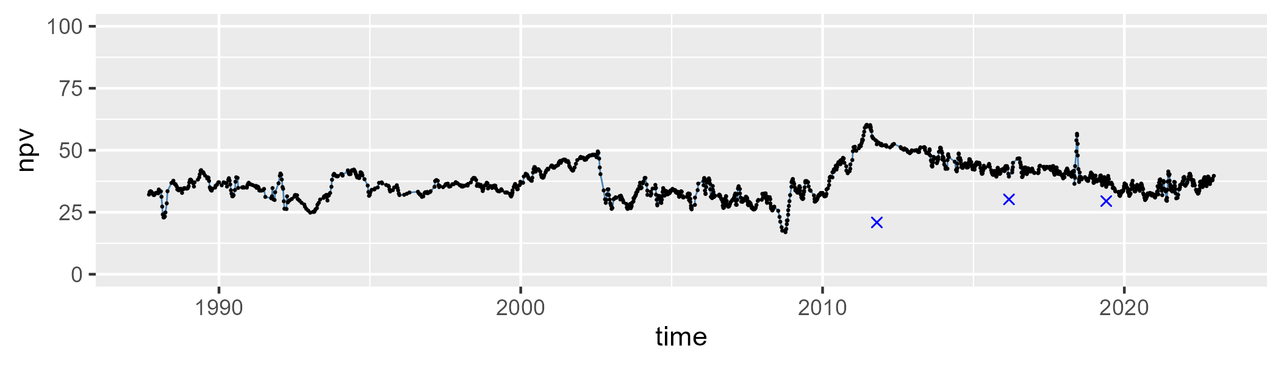

| Min. | 1st Qu. | Median | Mean | 3rd Qu. | Max. |
| --- | --- | --- | --- | --- | --- |
| 18.92356 | 41.69641 | 47.39311 | 46.39719 | 52.68559 | 72.15157 |

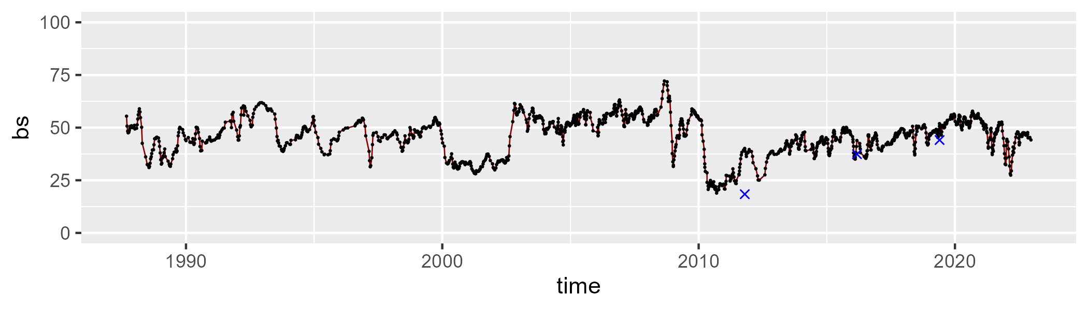

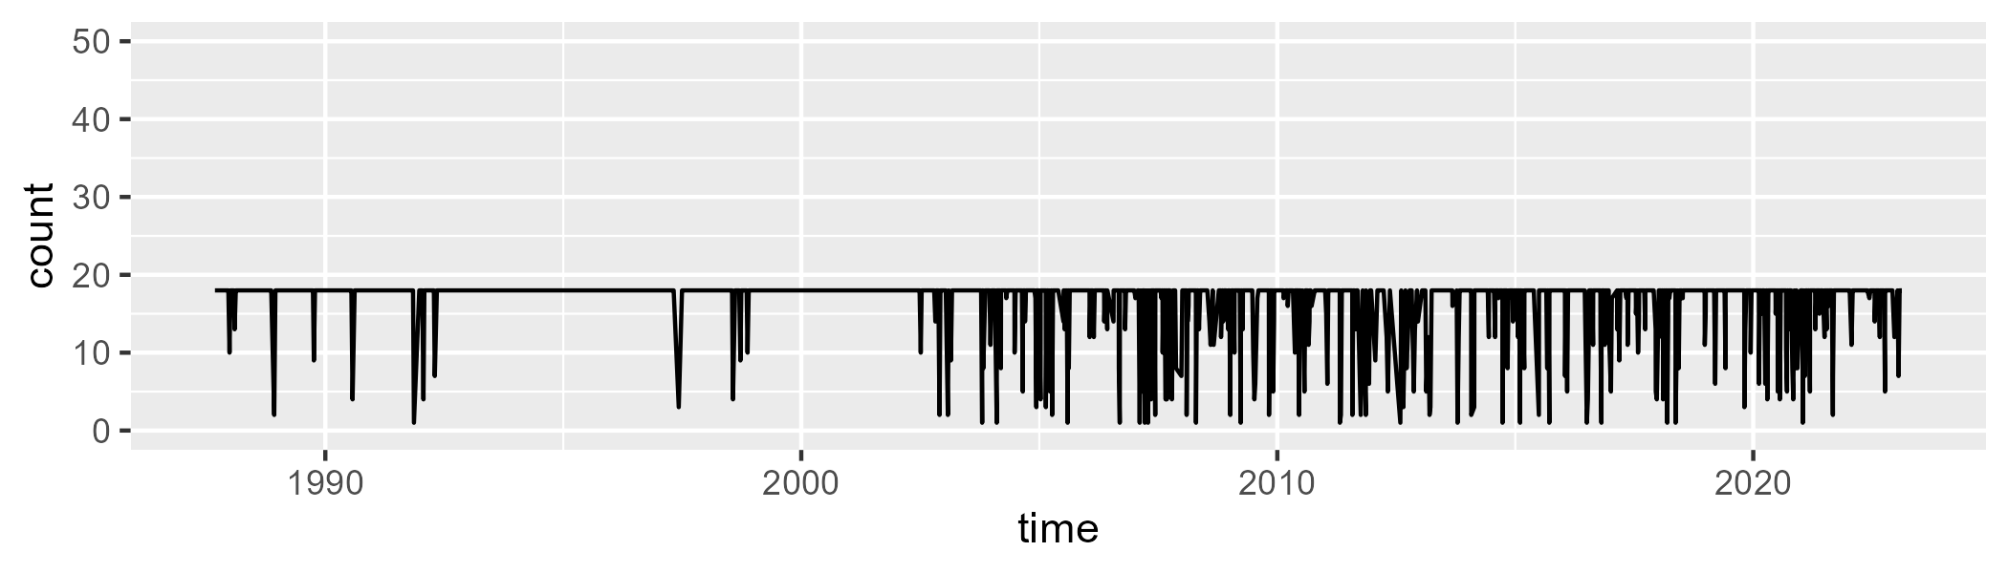

Min. : 1.00 1st Qu.:18.00 Median :18.00 Mean :16.65 3rd Qu.:18.00 Max. :18.00

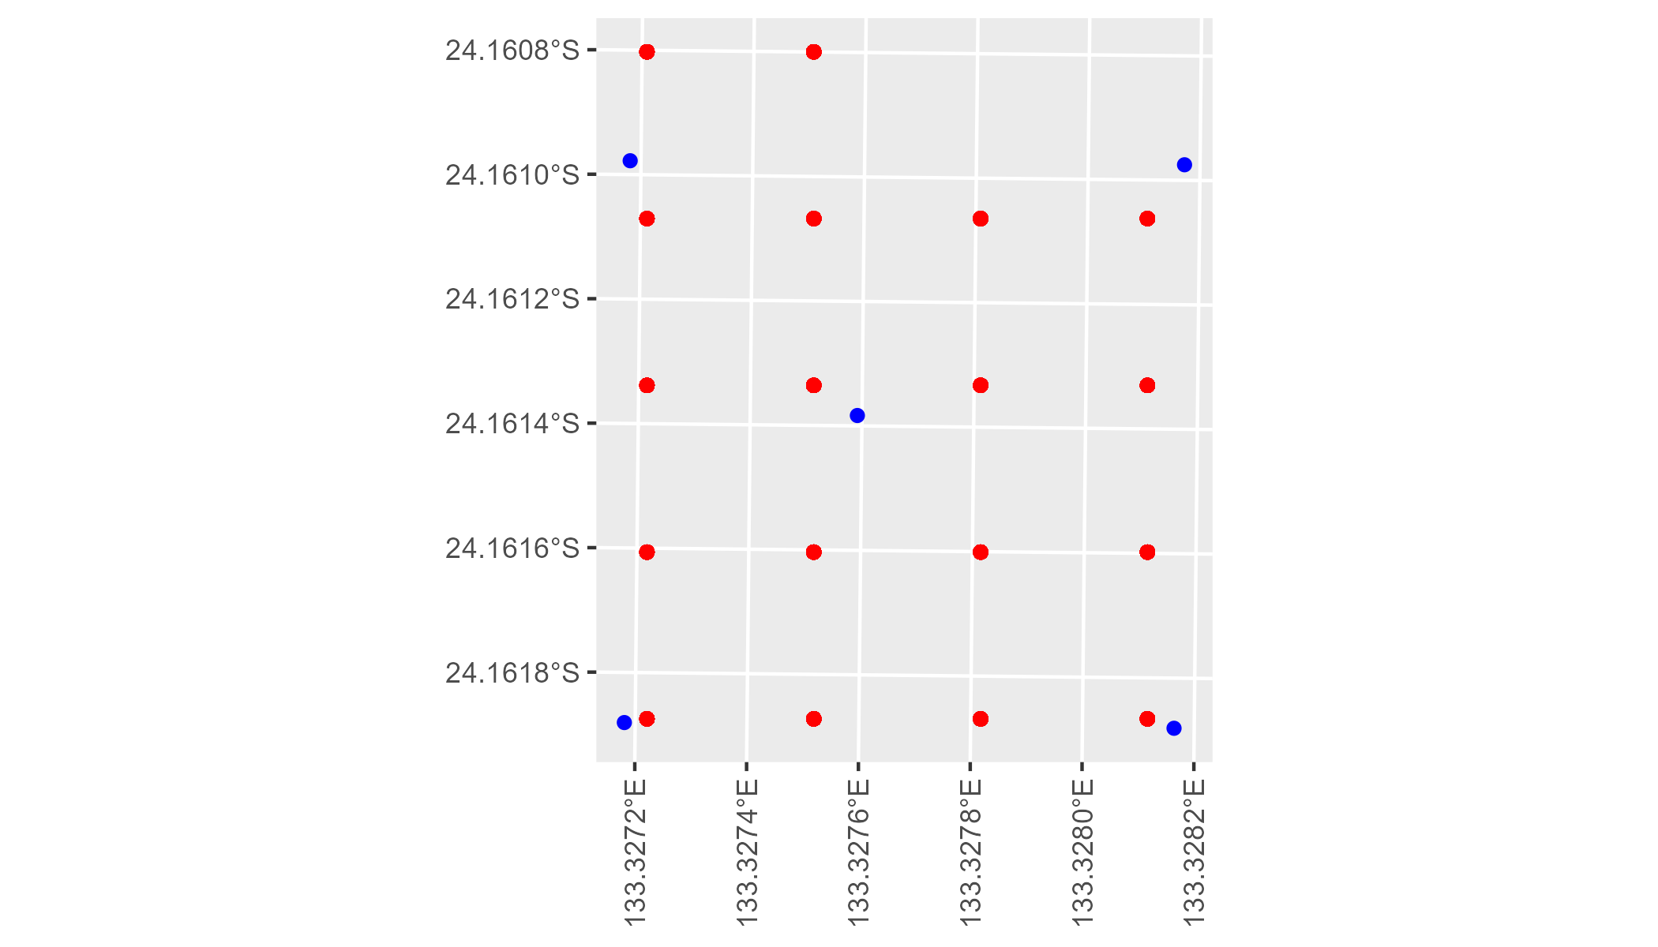

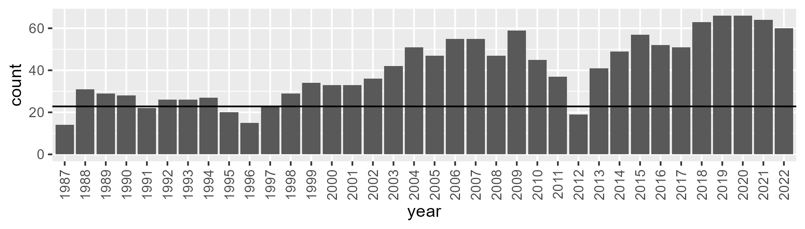

Number of samples: 1452

# NTAFIN0012

| Min. | 1st Qu. | Median | Mean | 3rd Qu. | Max. |
| --- | --- | --- | --- | --- | --- |
| 0 | 4.154973 | 5.487717 | 6.57459 | 7.271156 | 44.92222 |

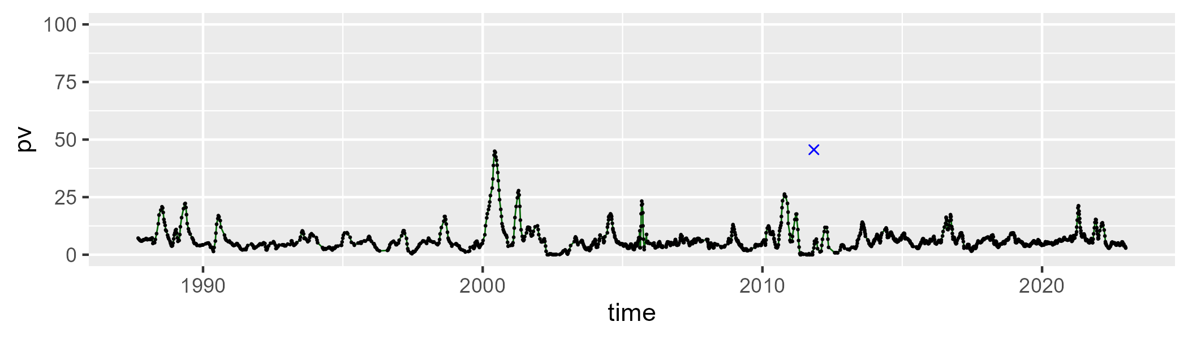

| Min. | 1st Qu. | Median | Mean | 3rd Qu. | Max. |
| --- | --- | --- | --- | --- | --- |
| 7.580994 | 19.87639 | 25.37966 | 28.17081 | 33.45405 | 71.68906 |

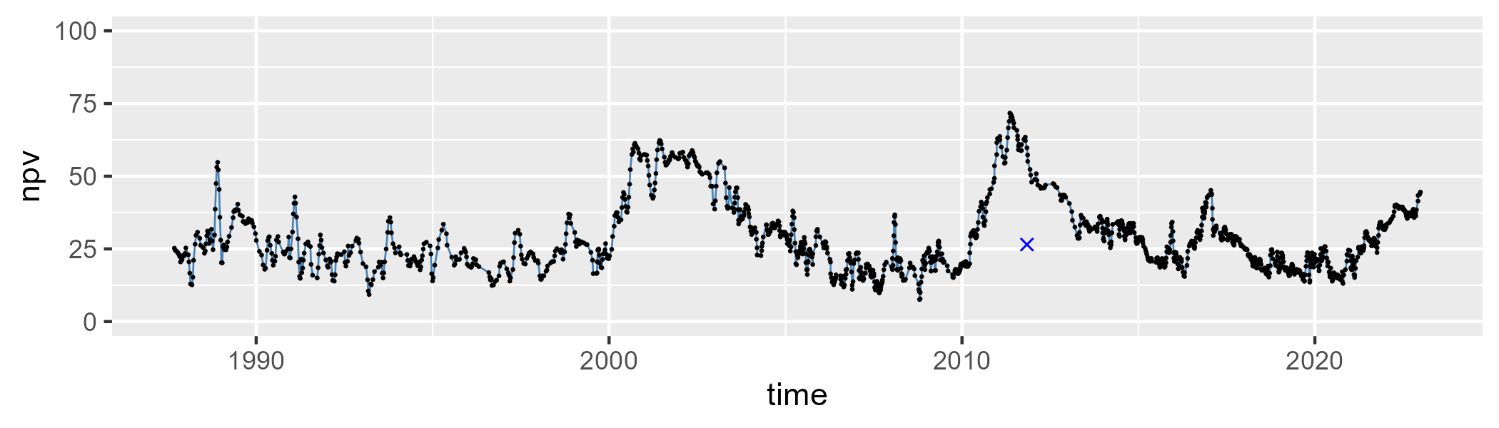

| Min. | 1st Qu. | Median | Mean | 3rd Qu. | Max. |
| --- | --- | --- | --- | --- | --- |
| 9.632828 | 56.94176 | 66.80525 | 63.66598 | 73.47706 | 84.14748 |

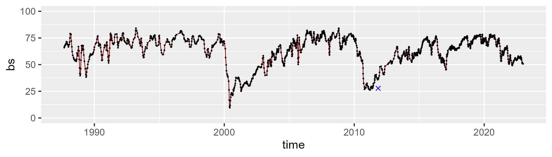

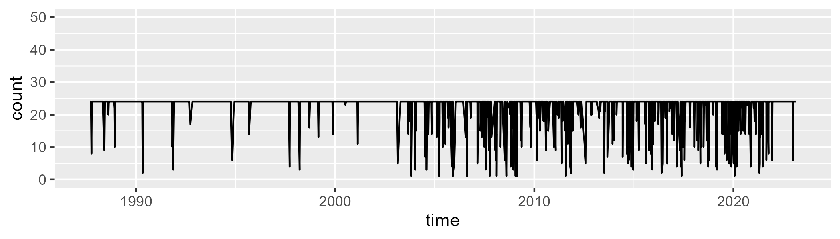

Min. : 1.00 1st Qu.:24.00 Median :24.00 Mean :22.27 3rd Qu.:24.00 Max. :24.00

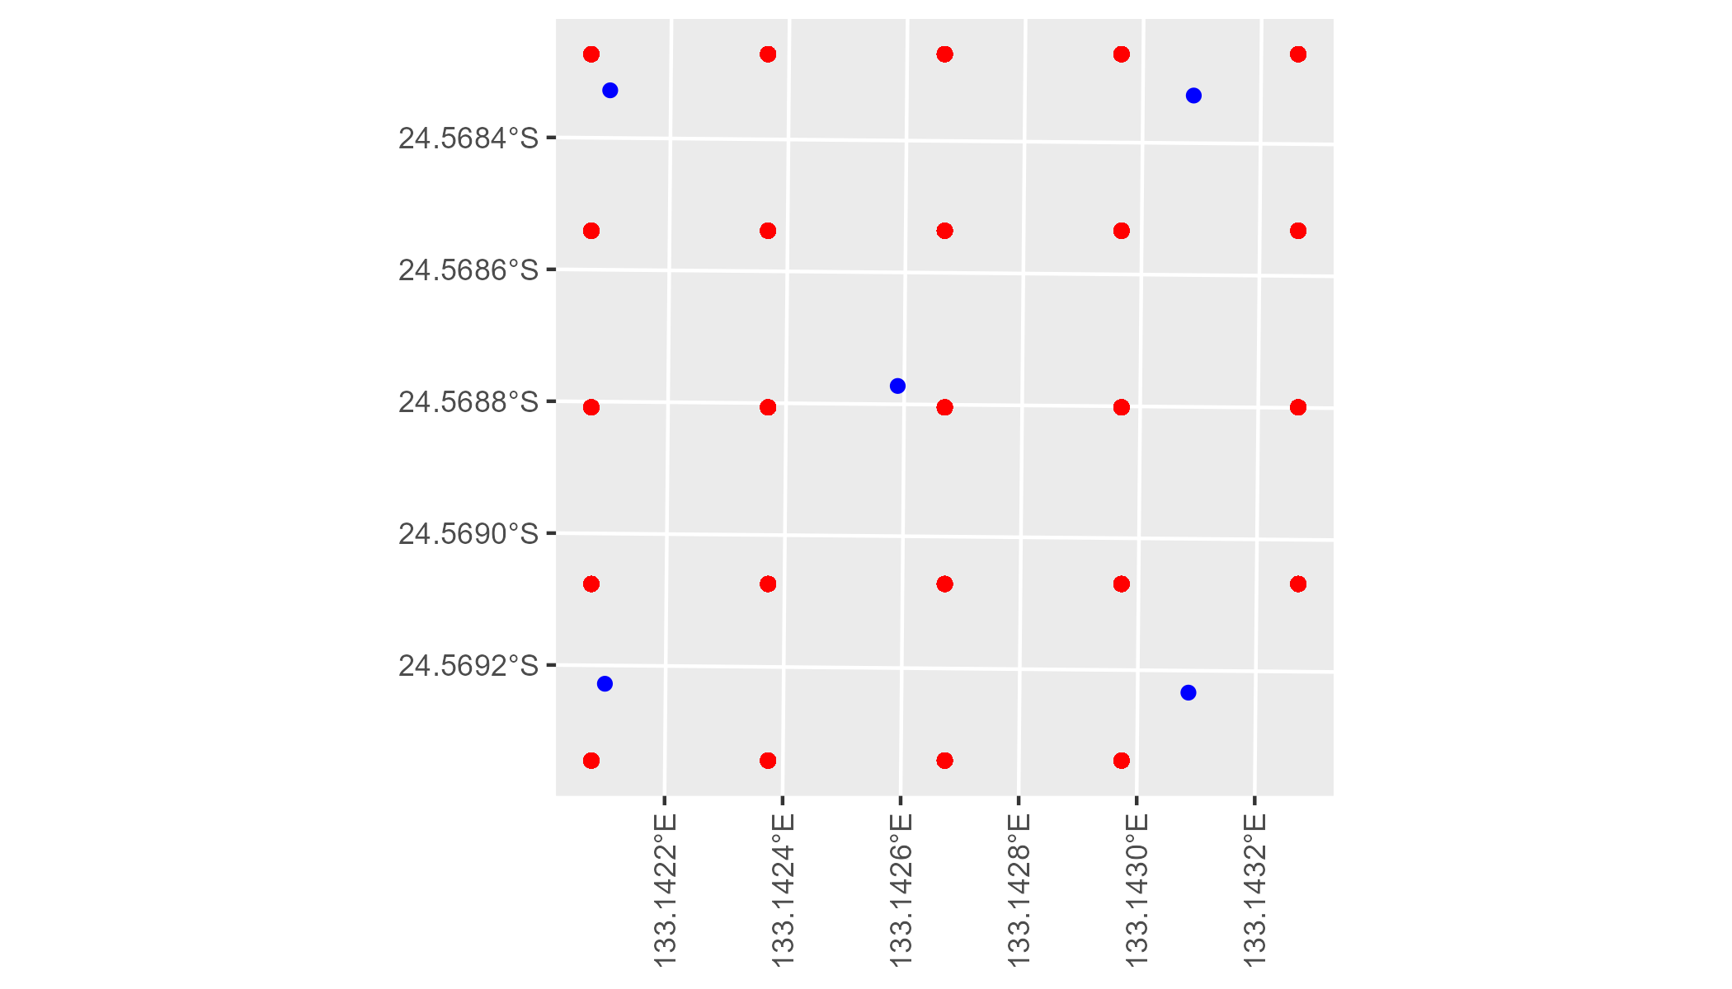

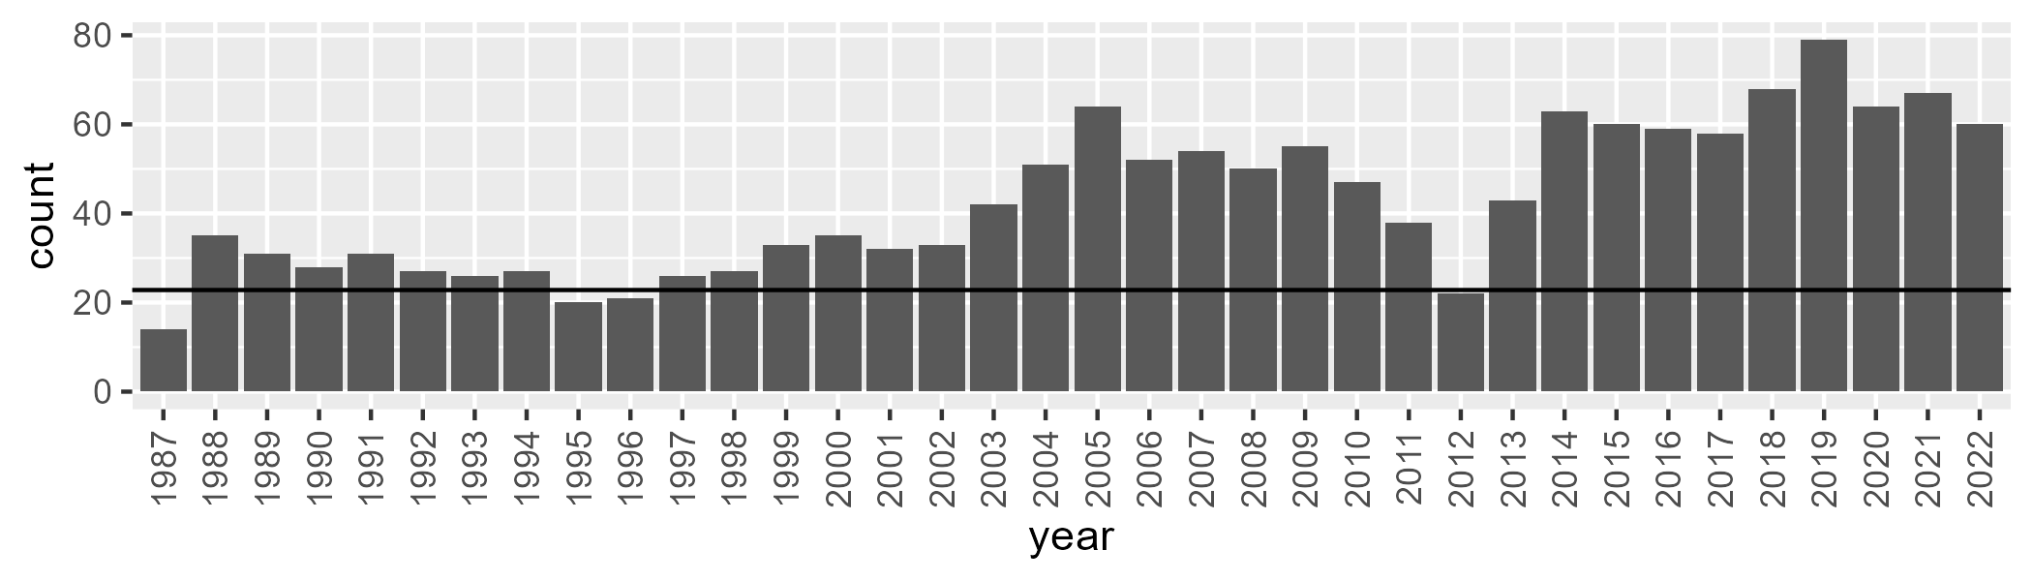

Number of samples: 1542

# NTAFIN0013

| Min. | 1st Qu. | Median | Mean | 3rd Qu. | Max. |
| --- | --- | --- | --- | --- | --- |
| 6.309135 | 15.47451 | 20.00639 | 20.56923 | 24.21588 | 47.5834 |

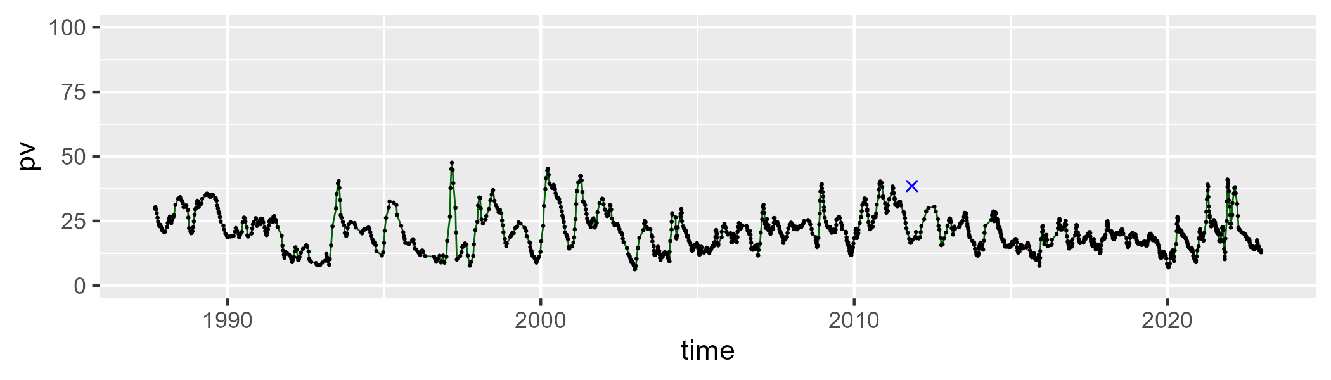

| Min. | 1st Qu. | Median | Mean | 3rd Qu. | Max. |
| --- | --- | --- | --- | --- | --- |
| 17.4318 | 34.59022 | 38.73833 | 38.88051 | 43.13383 | 60.76979 |

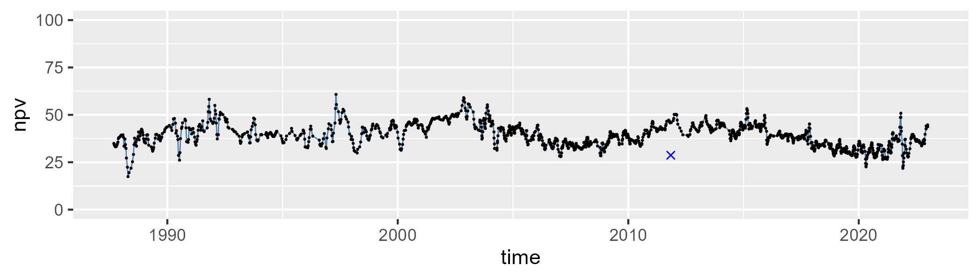

| Min. | 1st Qu. | Median | Mean | 3rd Qu. | Max. |
| --- | --- | --- | --- | --- | --- |
| 13.01848 | 34.06598 | 39.81621 | 39.04601 | 44.10361 | 58.5595 |

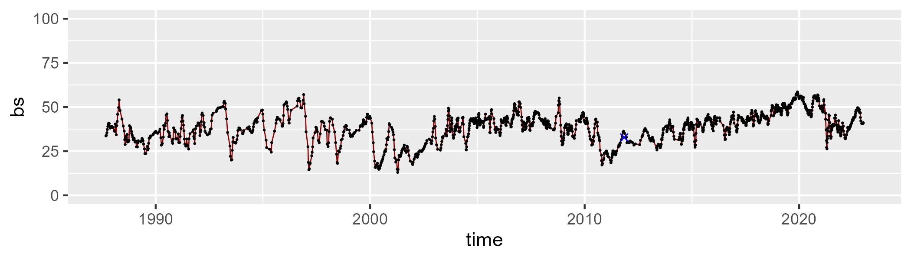

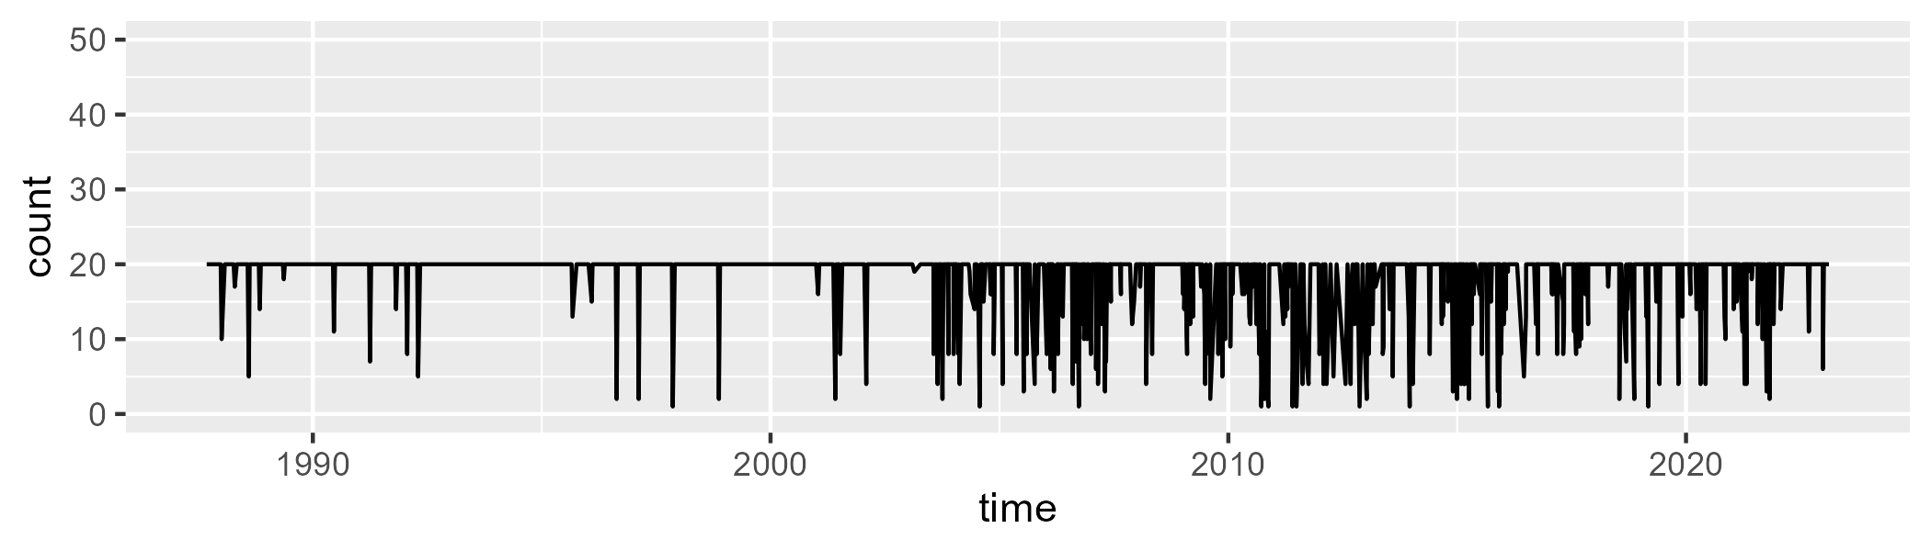

Min. : 1.00 1st Qu.:20.00 Median :20.00 Mean :18.47 3rd Qu.:20.00 Max. :20.00

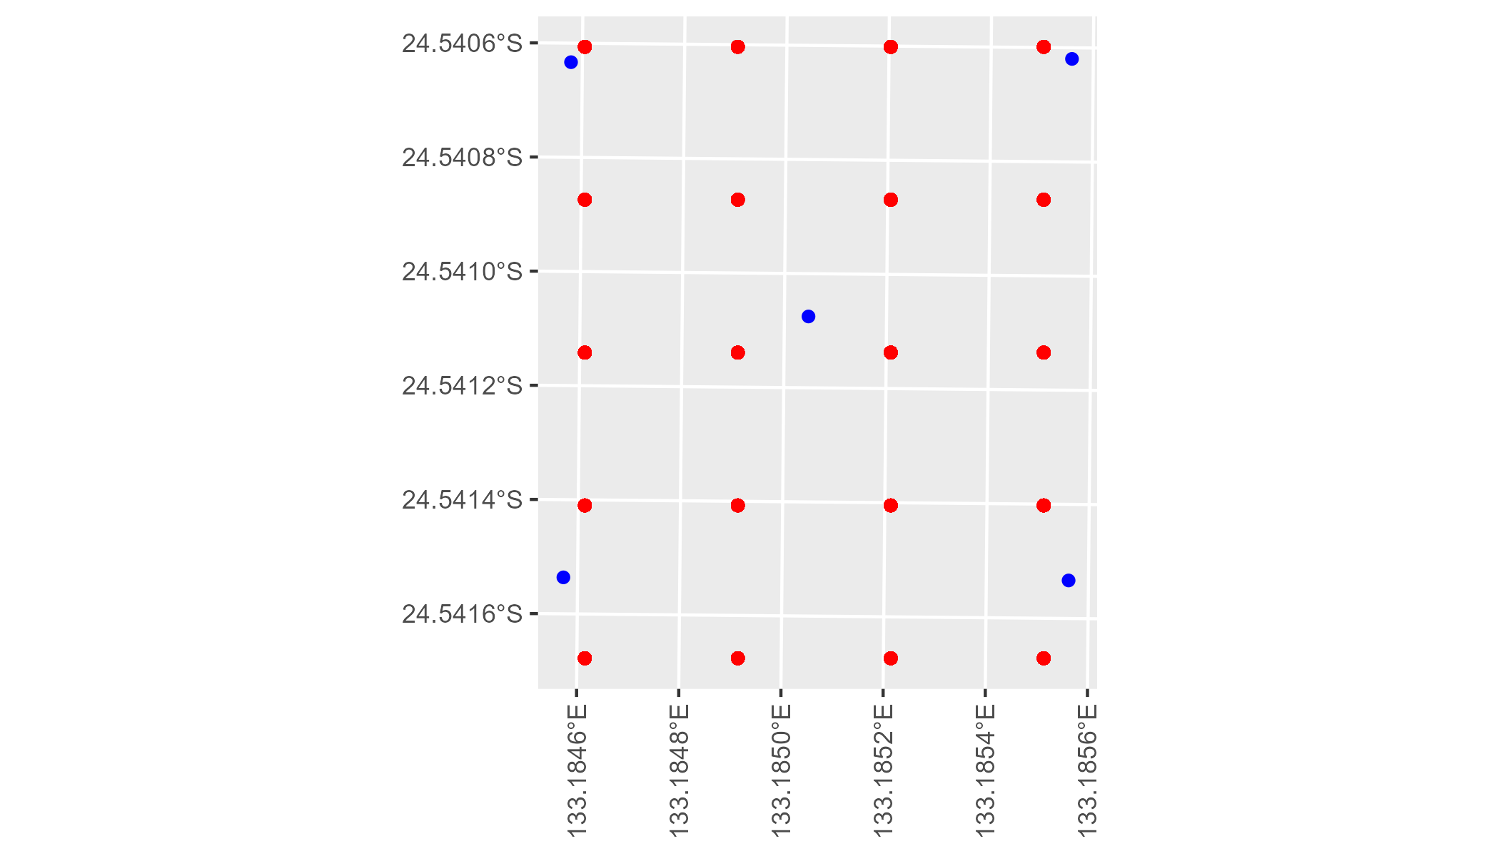

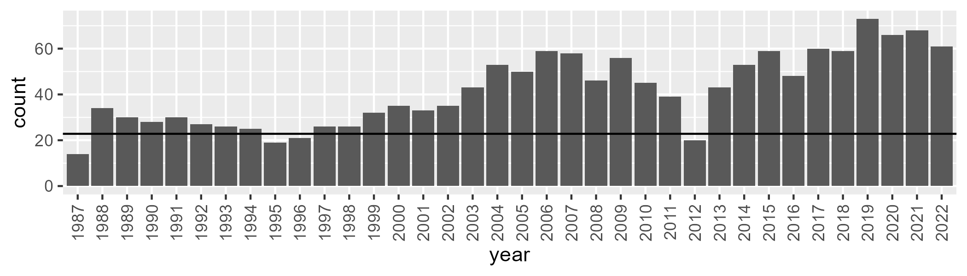

Number of samples: 1500

# NTAFIN0014

| Min. | 1st Qu. | Median | Mean | 3rd Qu. | Max. |
| --- | --- | --- | --- | --- | --- |
| 4.032395 | 9.298268 | 12.25221 | 12.78943 | 15.51453 | 30.1978 |

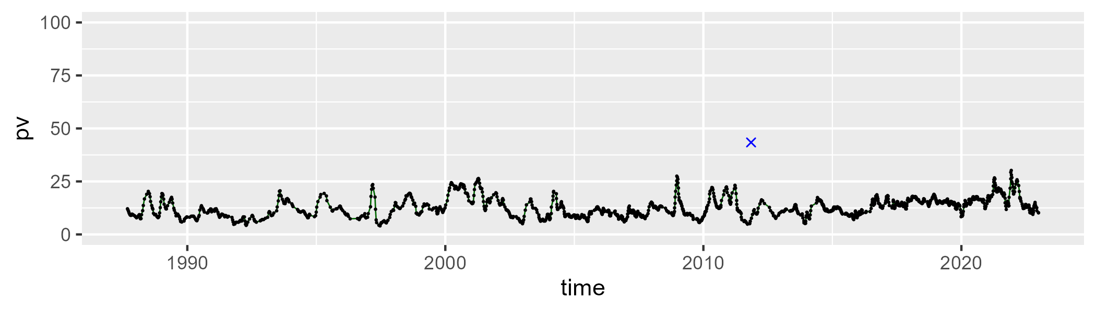

| Min. | 1st Qu. | Median | Mean | 3rd Qu. | Max. |
| --- | --- | --- | --- | --- | --- |
| 12.99605 | 29.00596 | 38.46626 | 36.69787 | 43.822 | 62.53378 |

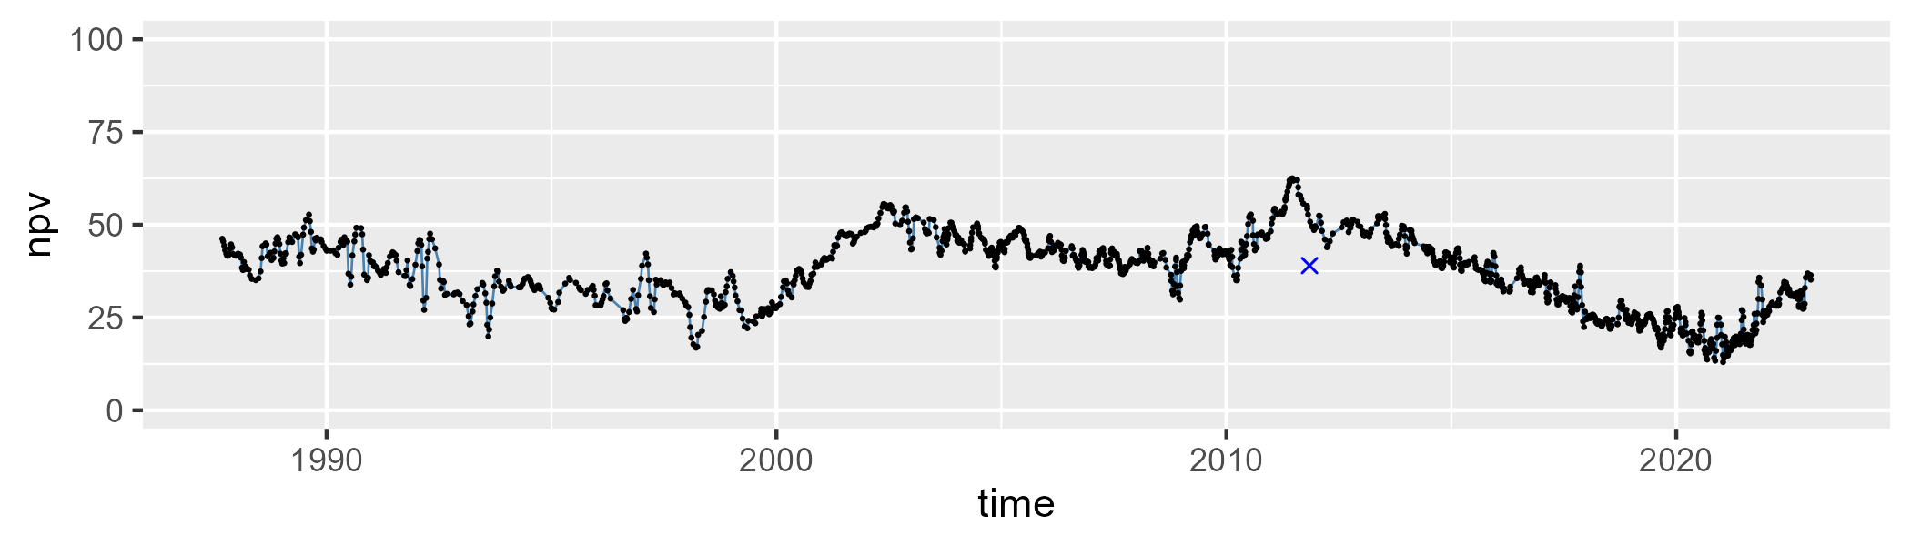

| Min. | 1st Qu. | Median | Mean | 3rd Qu. | Max. |
| --- | --- | --- | --- | --- | --- |
| 22.34213 | 43.06974 | 48.51278 | 48.99633 | 55.90046 | 69.34524 |

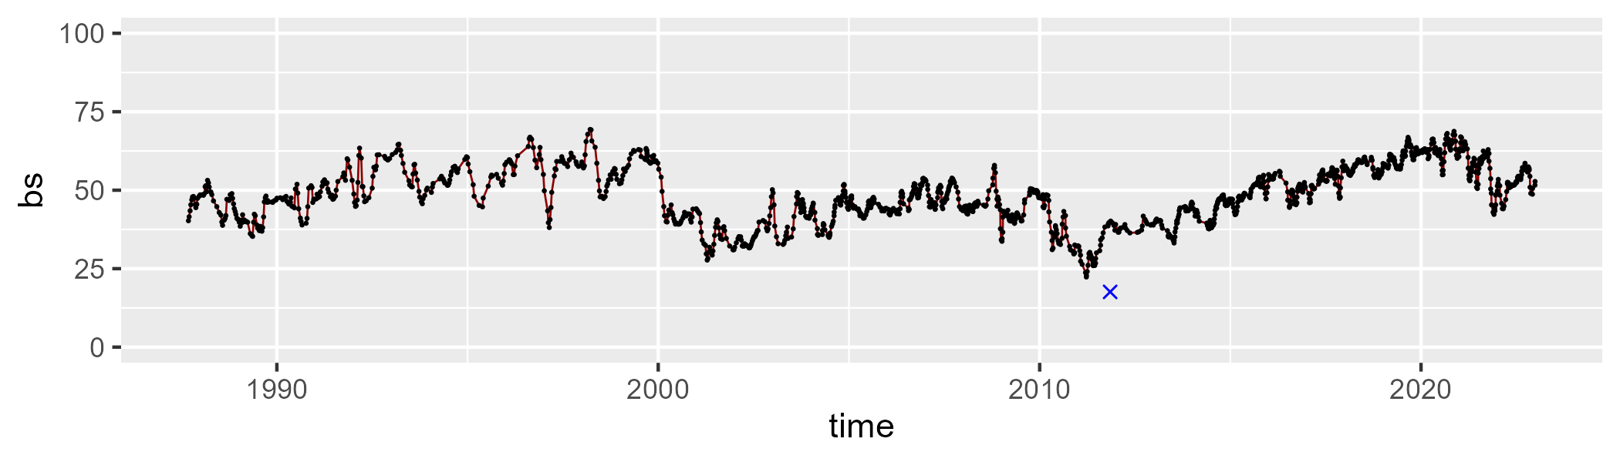

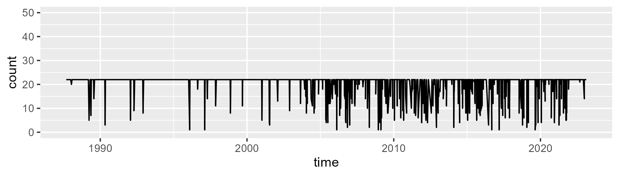

Min. : 1.0 1st Qu.:22.0 Median :22.0 Mean :20.5 3rd Qu.:22.0 Max. :22.0

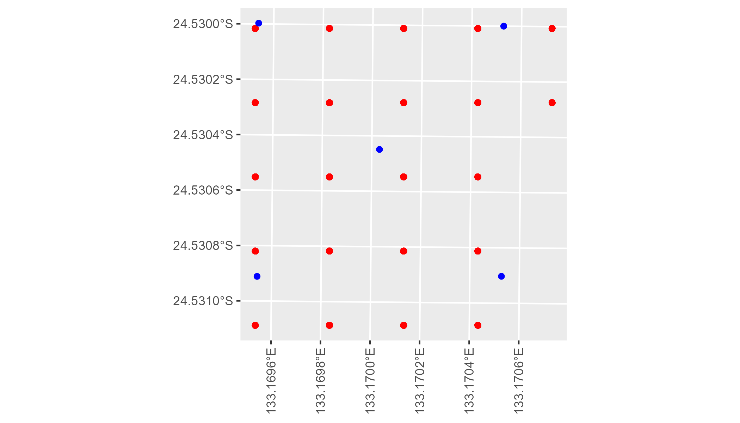

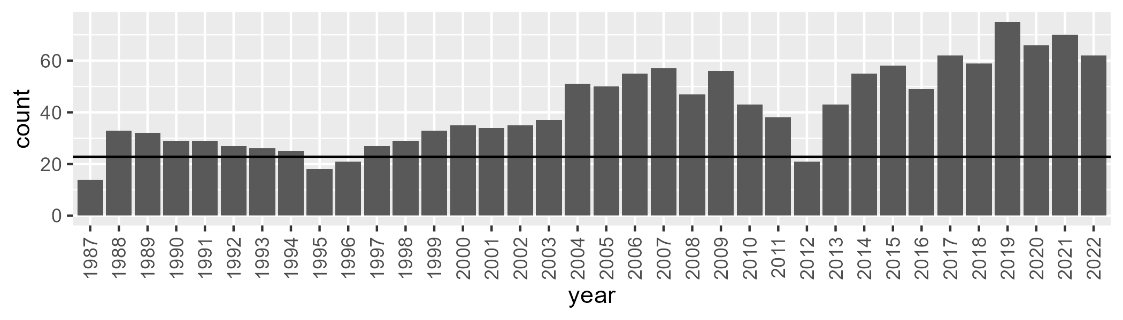

Number of samples: 1501

# NTAFIN0015

| Min. | 1st Qu. | Median | Mean | 3rd Qu. | Max. |
| --- | --- | --- | --- | --- | --- |
| 13.89888 | 24.14325 | 27.74005 | 28.03096 | 31.73929 | 45.97092 |

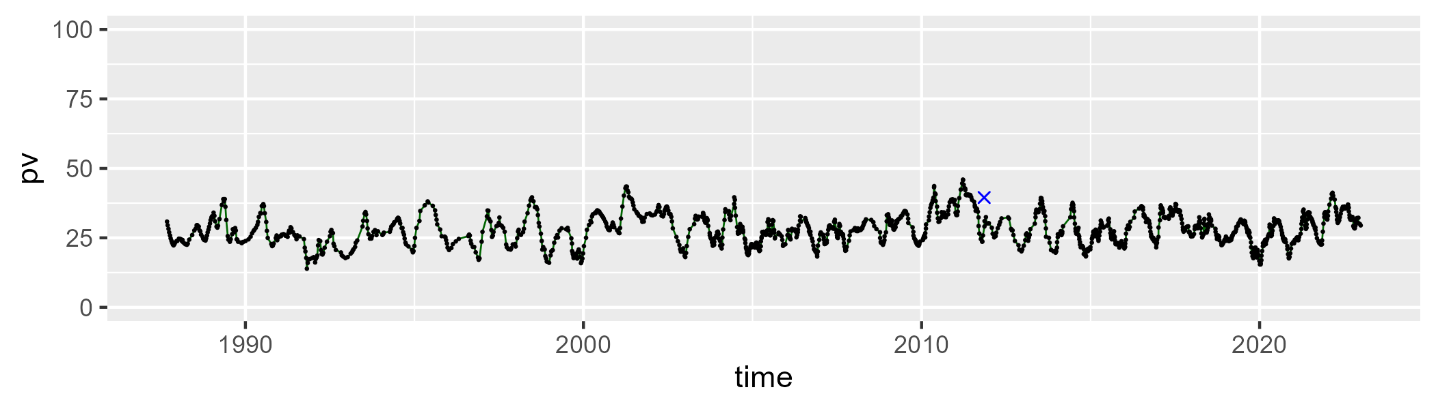

| Min. | 1st Qu. | Median | Mean | 3rd Qu. | Max. |
| --- | --- | --- | --- | --- | --- |
| 3.979065 | 21.39551 | 26.1198 | 26.08692 | 30.77341 | 46.32378 |

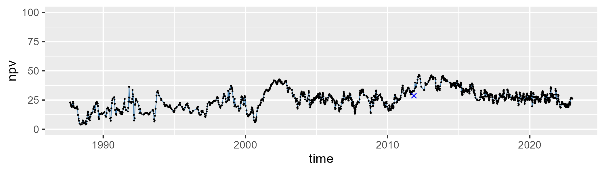

| Min. | 1st Qu. | Median | Mean | 3rd Qu. | Max. |
| --- | --- | --- | --- | --- | --- |
| 20.90409 | 38.37171 | 44.65331 | 44.36644 | 50.82012 | 70.40313 |

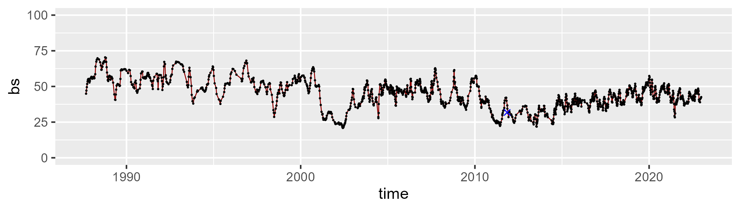

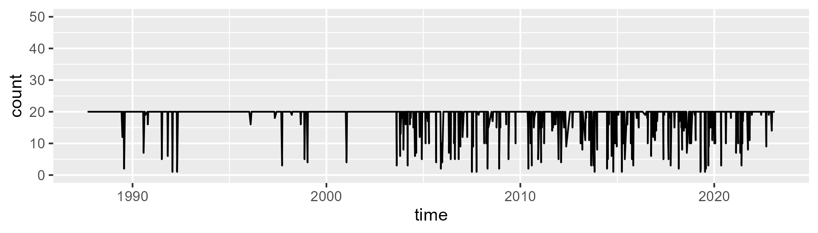

Min. : 1.00 1st Qu.:20.00 Median :20.00 Mean :18.83 3rd Qu.:20.00 Max. :20.00

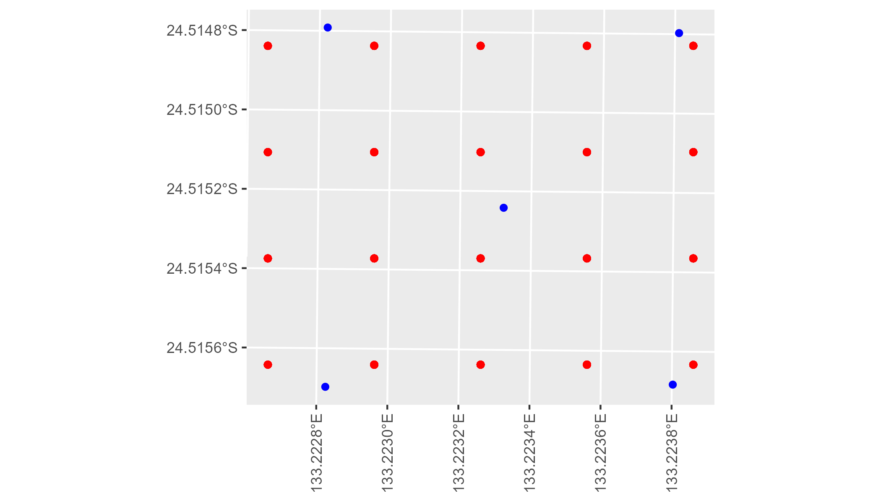

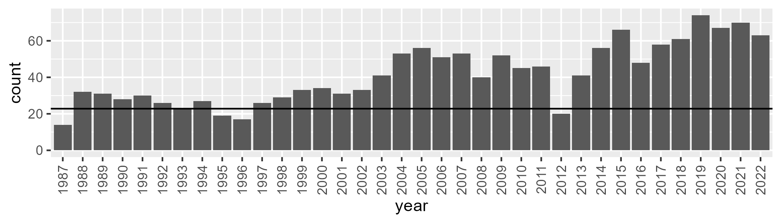

Number of samples: 1494

# NTAFIN0016

| Min. | 1st Qu. | Median | Mean | 3rd Qu. | Max. |
| --- | --- | --- | --- | --- | --- |
| 0.6218946 | 8.080716 | 10.04714 | 10.23916 | 11.91244 | 32.40204 |

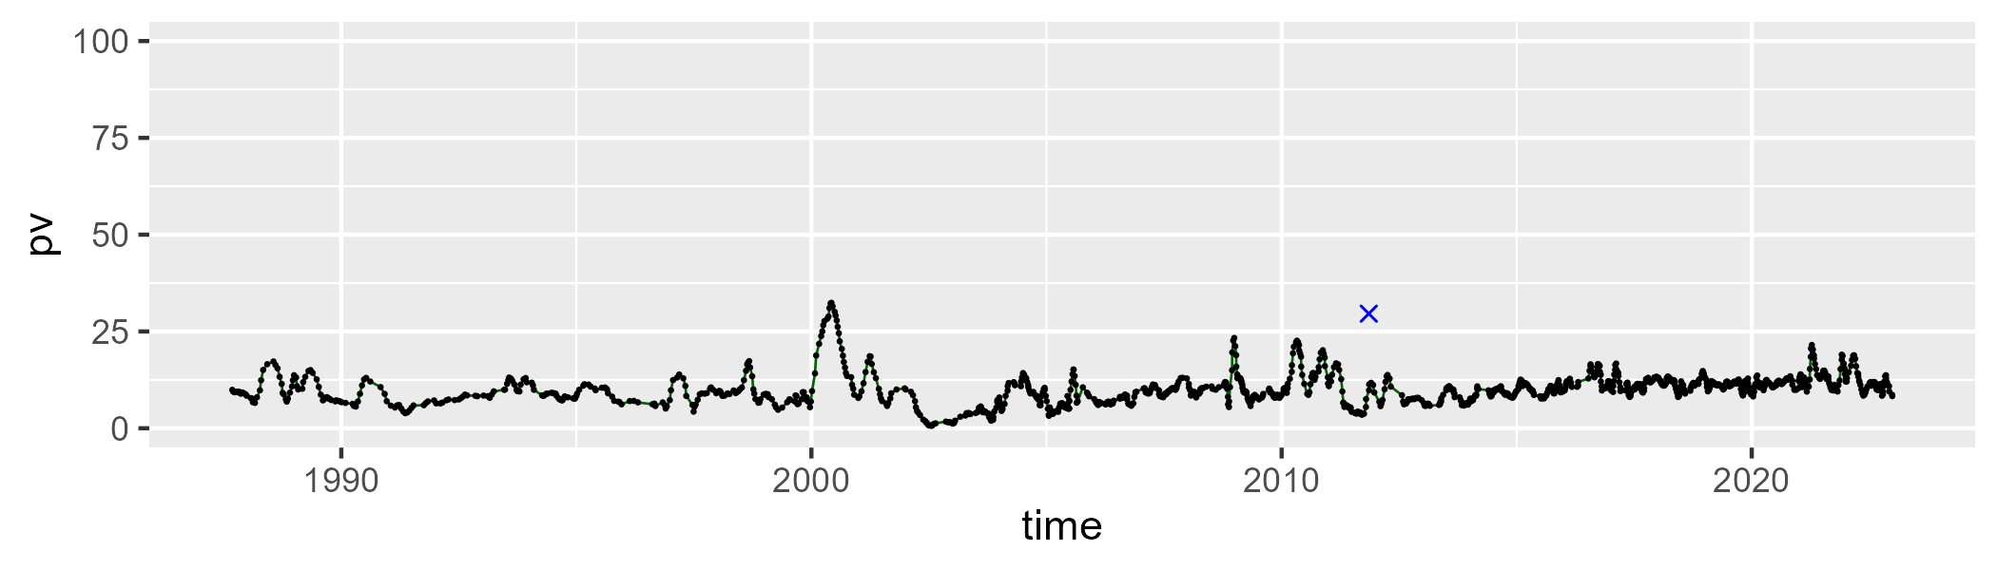

| Min. | 1st Qu. | Median | Mean | 3rd Qu. | Max. |
| --- | --- | --- | --- | --- | --- |
| 0 | 5.474716 | 11.65592 | 13.98705 | 20.3674 | 49.99104 |

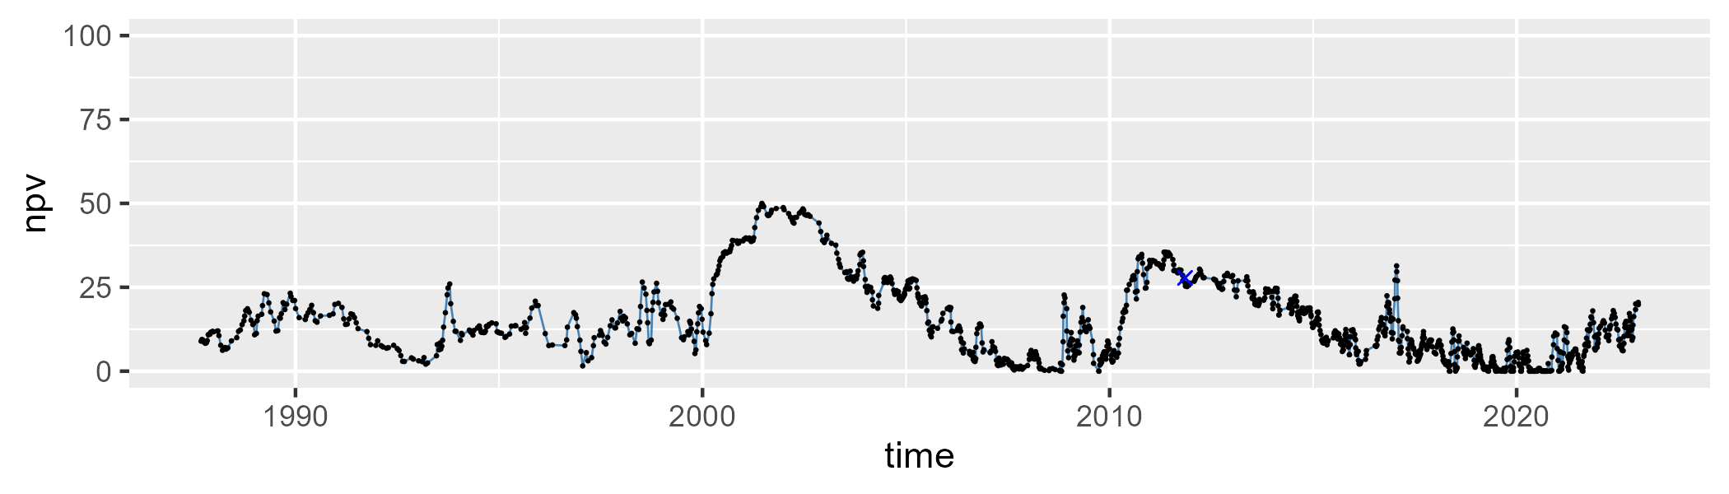

| Min. | 1st Qu. | Median | Mean | 3rd Qu. | Max. |
| --- | --- | --- | --- | --- | --- |
| 33.25035 | 68.53814 | 76.60207 | 74.23985 | 82.35048 | 90.9707 |

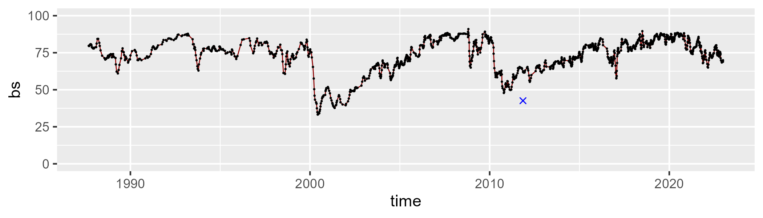

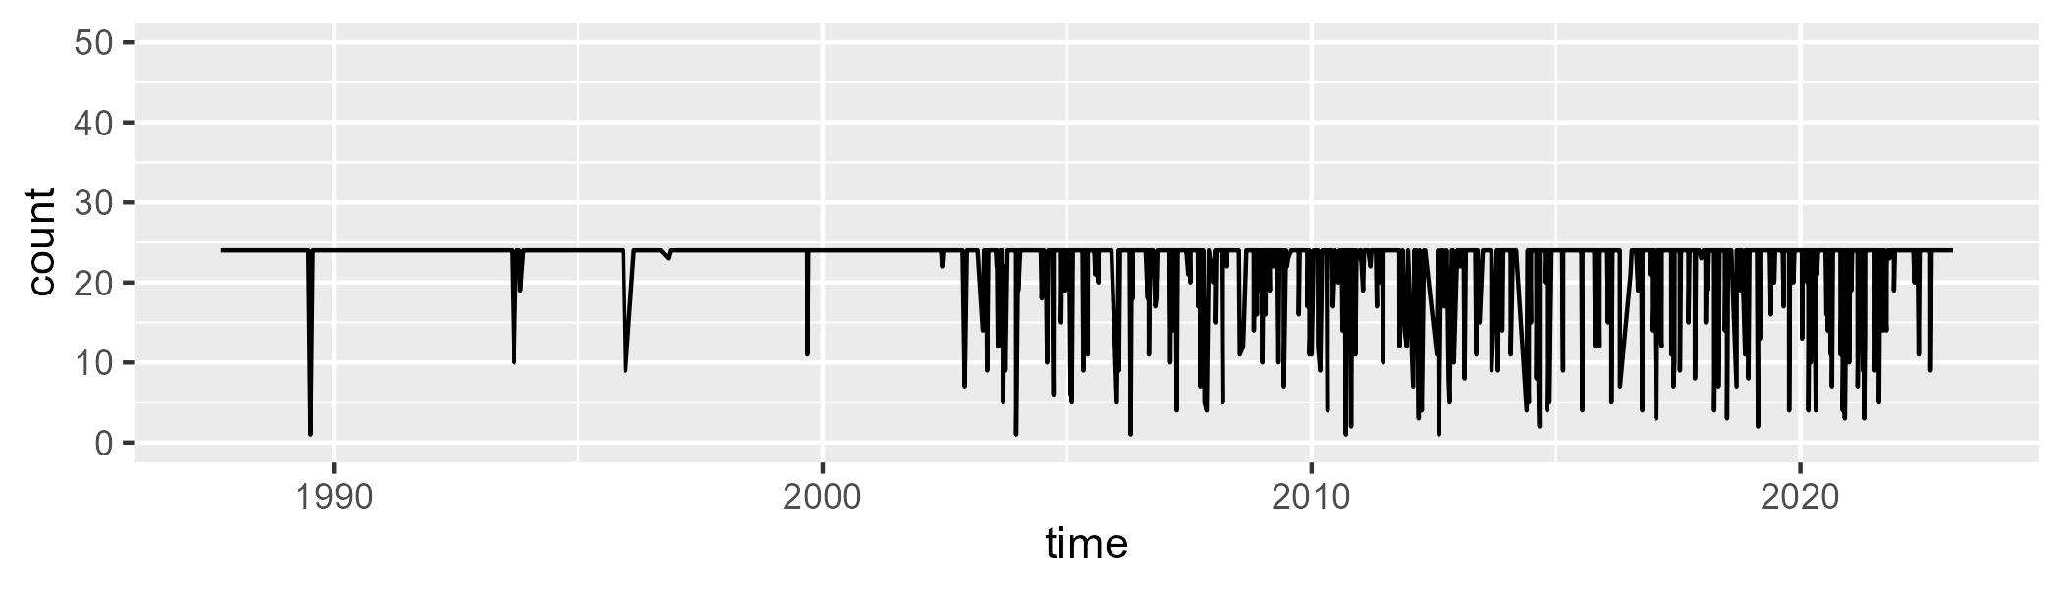

Min. : 1.00 1st Qu.:24.00 Median :24.00 Mean :22.27 3rd Qu.:24.00 Max. :24.00

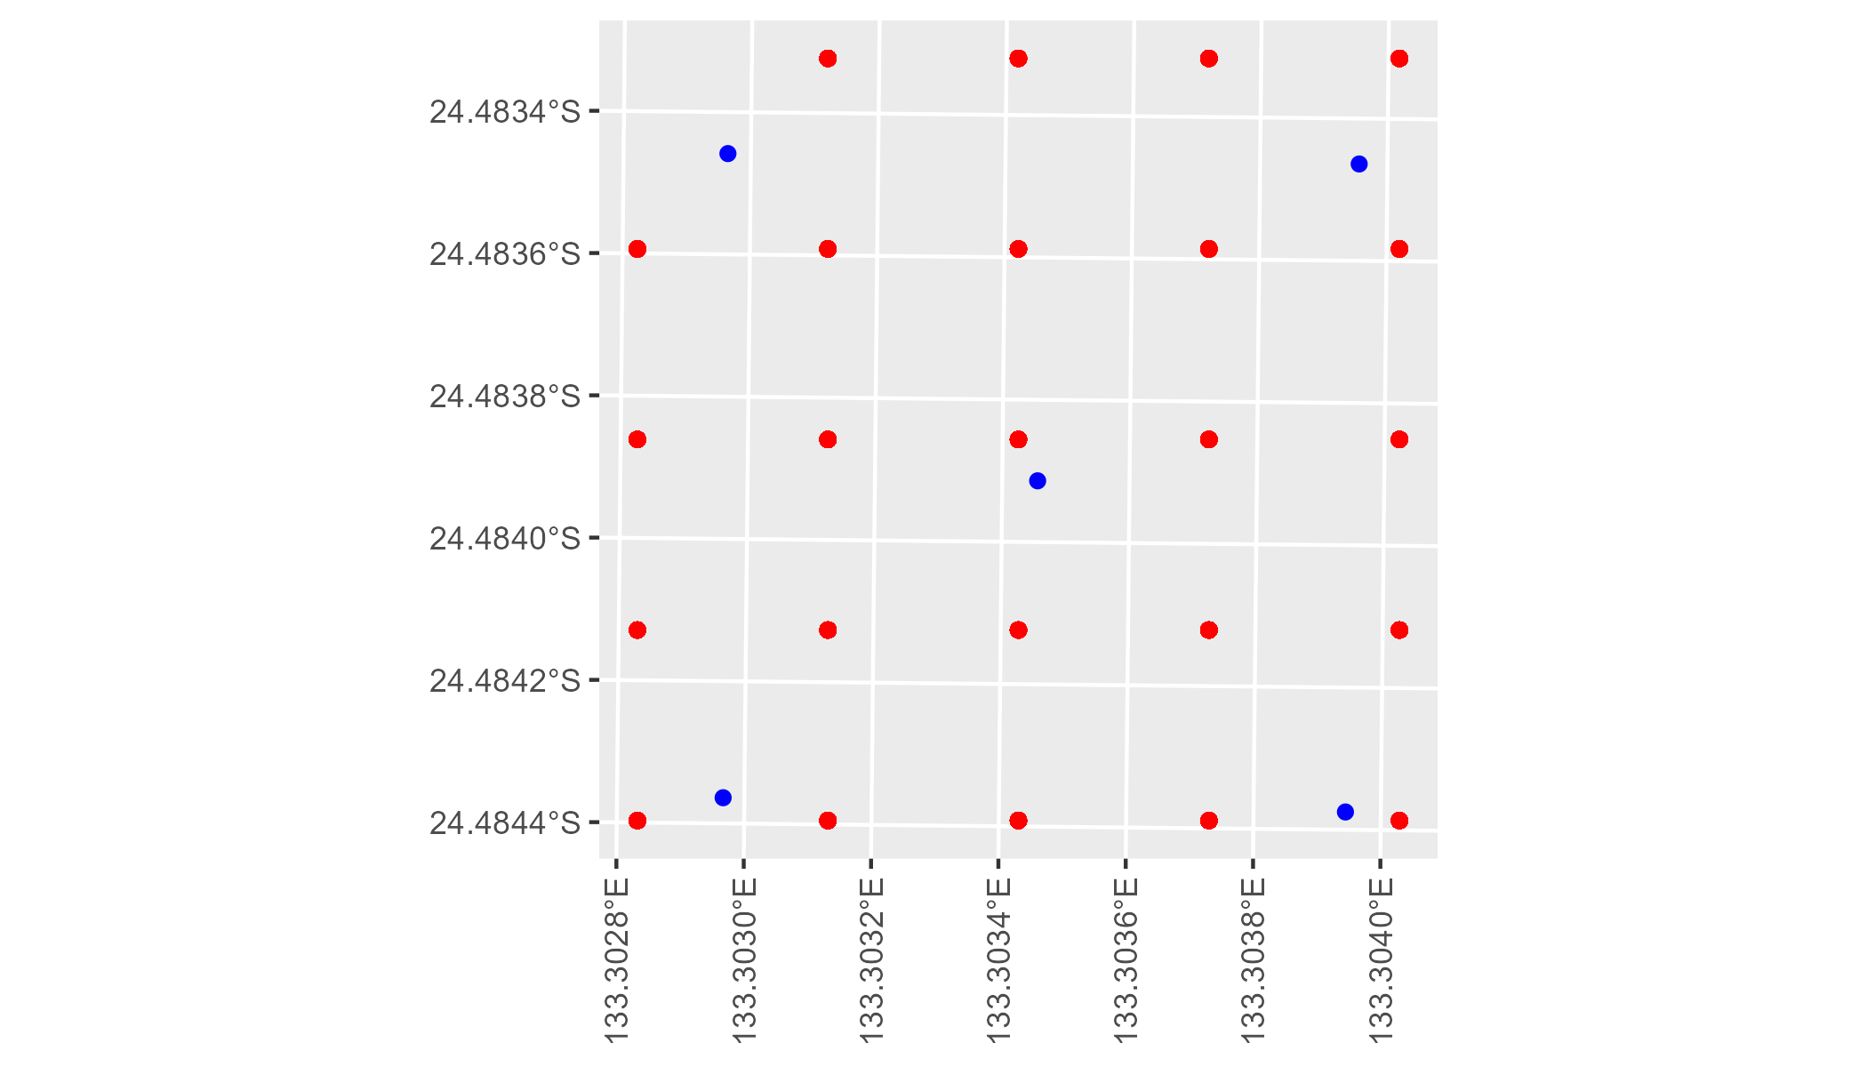

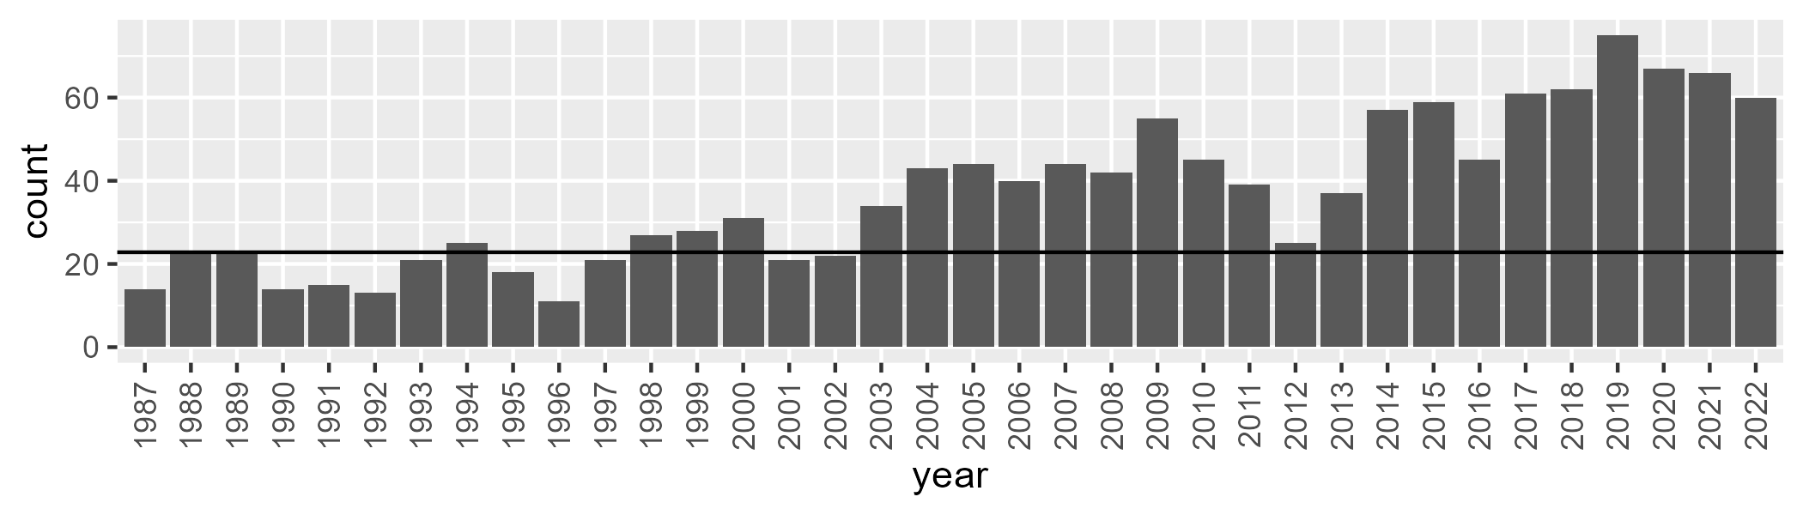

Number of samples: 1327

# NTAFIN0017

| Min. | 1st Qu. | Median | Mean | 3rd Qu. | Max. |
| --- | --- | --- | --- | --- | --- |
| 7.369131 | 12.74545 | 15.36376 | 16.1927 | 18.39255 | 37.24178 |

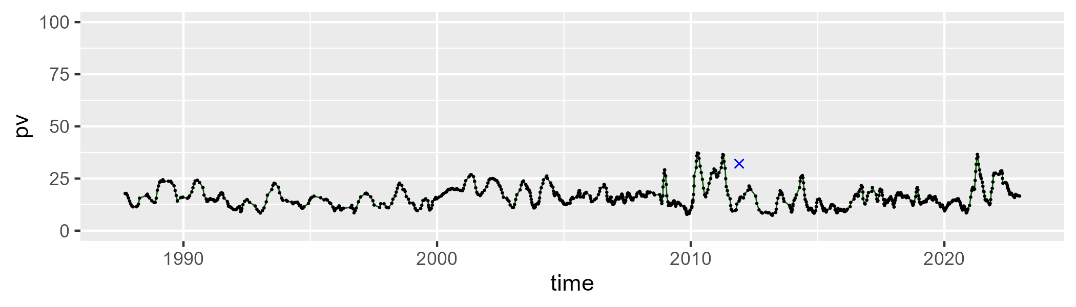

| Min. | 1st Qu. | Median | Mean | 3rd Qu. | Max. |
| --- | --- | --- | --- | --- | --- |
| 4.790659 | 15.55935 | 21.1328 | 22.41079 | 27.50296 | 59.7528 |

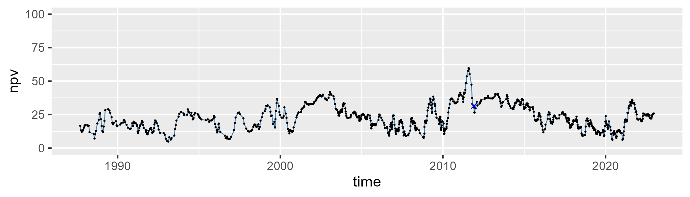

| Min. | 1st Qu. | Median | Mean | 3rd Qu. | Max. |
| --- | --- | --- | --- | --- | --- |
| 21.12842 | 53.2461 | 61.0575 | 59.92461 | 67.72667 | 84.78241 |

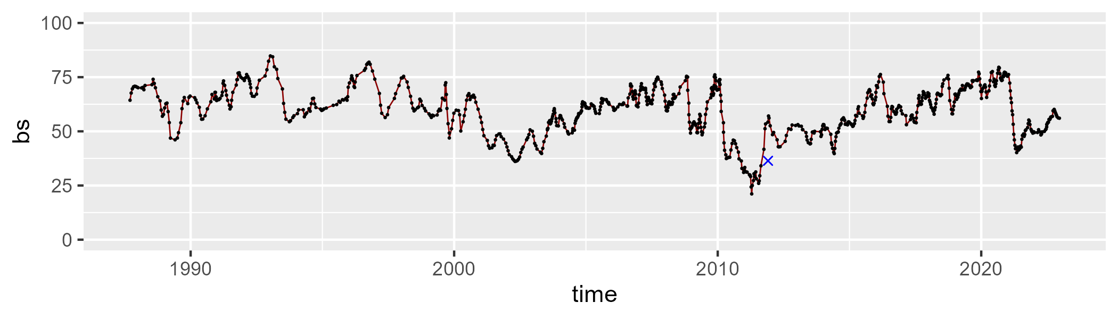

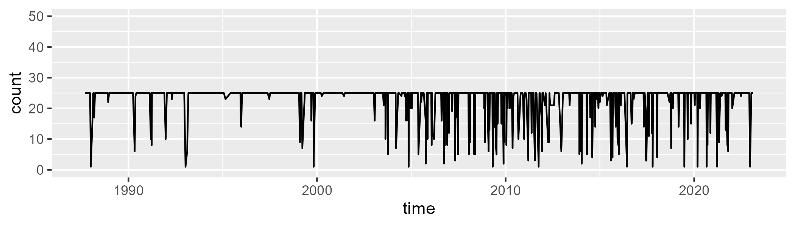

Min. : 1.00 1st Qu.:25.00 Median :25.00 Mean :22.73 3rd Qu.:25.00 Max. :25.00

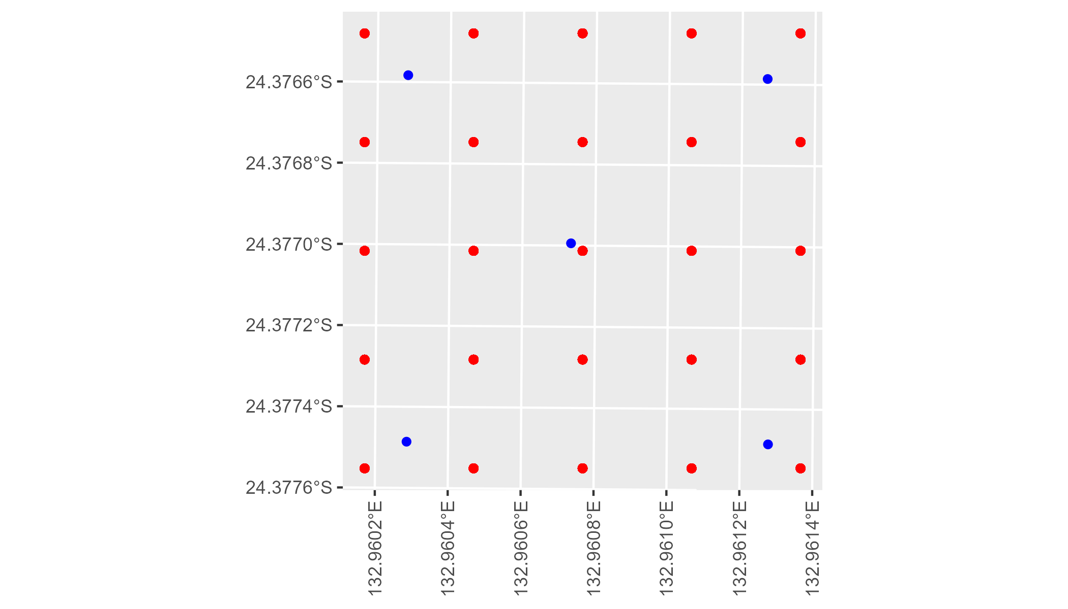

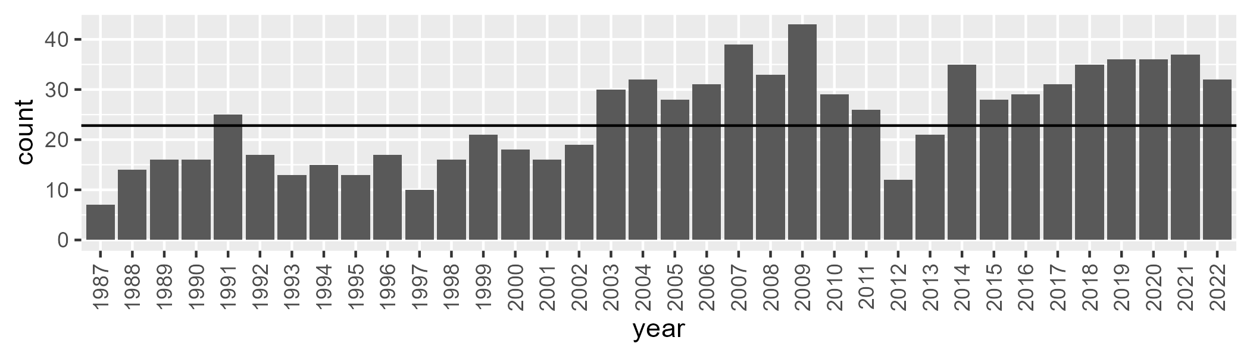

Number of samples: 876

# NTAFIN0018

| Min. | 1st Qu. | Median | Mean | 3rd Qu. | Max. |
| --- | --- | --- | --- | --- | --- |
| 4.719324 | 9.205172 | 11.13314 | 11.91682 | 13.83854 | 28.77159 |

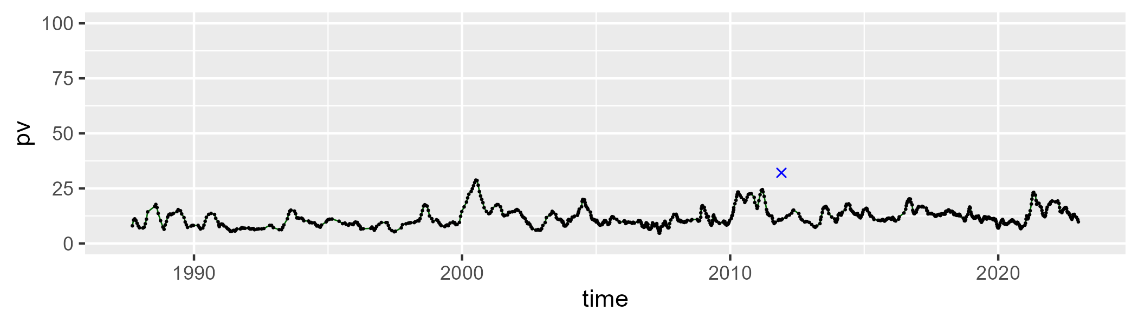

| Min. | 1st Qu. | Median | Mean | 3rd Qu. | Max. |
| --- | --- | --- | --- | --- | --- |
| 15.85658 | 27.35274 | 31.2516 | 31.49317 | 35.51765 | 48.50264 |

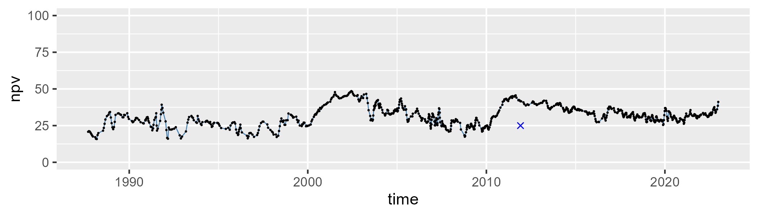

| Min. | 1st Qu. | Median | Mean | 3rd Qu. | Max. |
| --- | --- | --- | --- | --- | --- |
| 31.88177 | 48.98318 | 54.76819 | 55.019 | 60.99186 | 75.65746 |

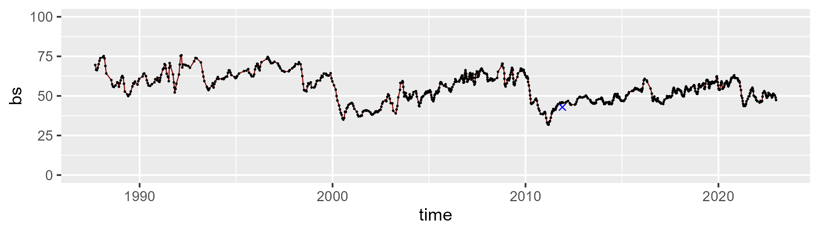

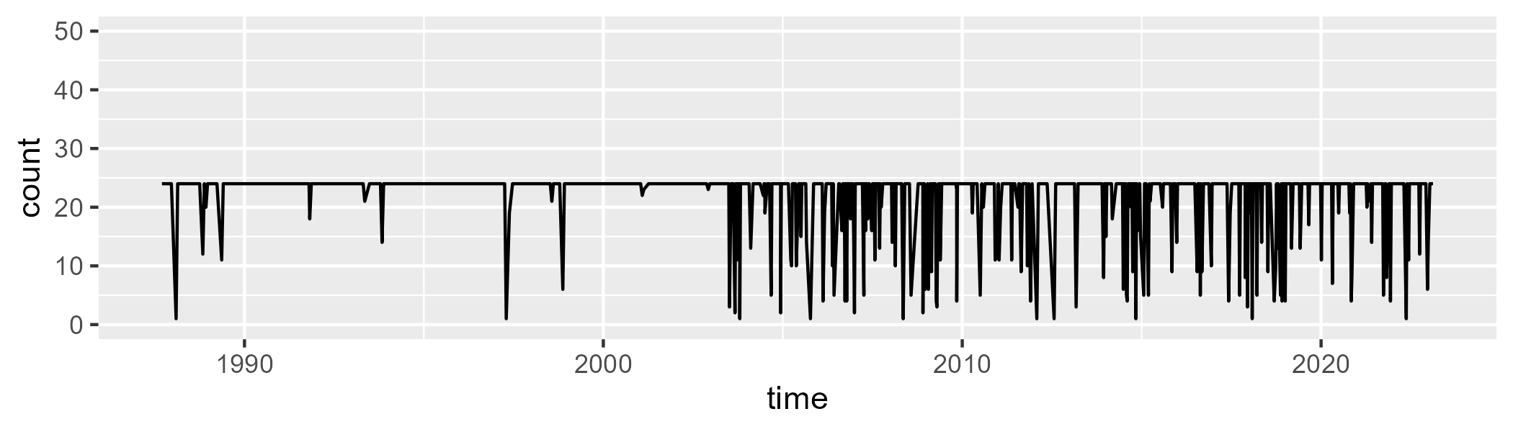

Min. : 1.00 1st Qu.:24.00 Median :24.00 Mean :21.86 3rd Qu.:24.00 Max. :24.00

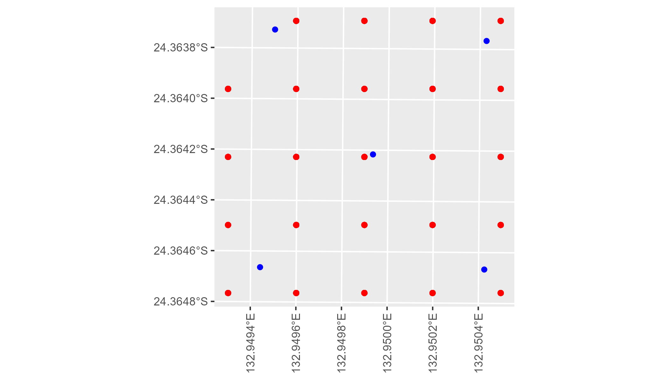

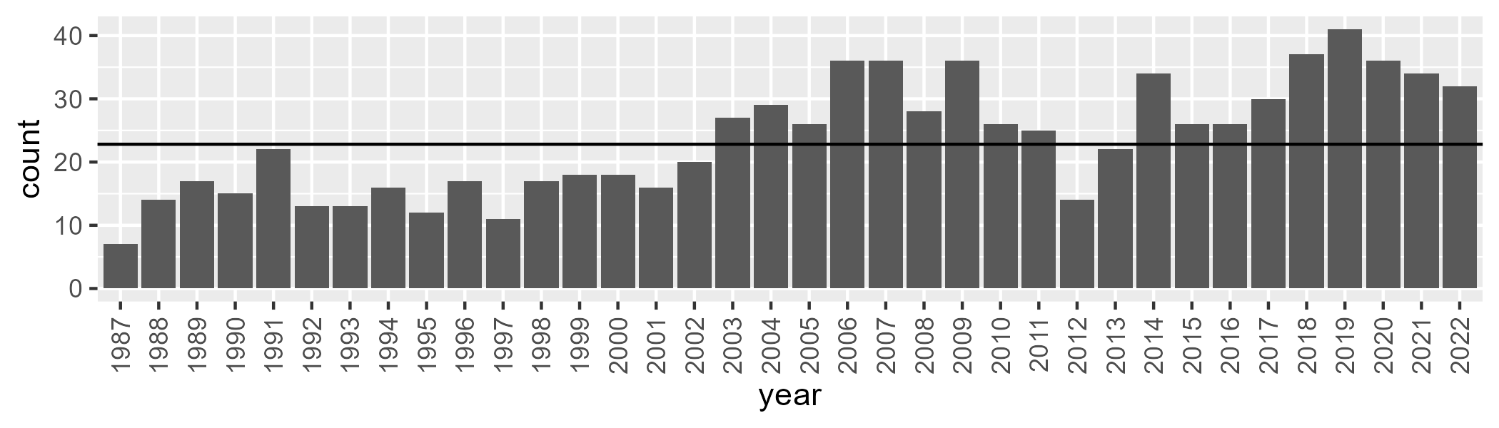

Number of samples: 847

# NTAFIN0019

| Min. | 1st Qu. | Median | Mean | 3rd Qu. | Max. |
| --- | --- | --- | --- | --- | --- |
| 4.408651 | 10.4383 | 12.33754 | 14.17949 | 16.18207 | 46.50218 |

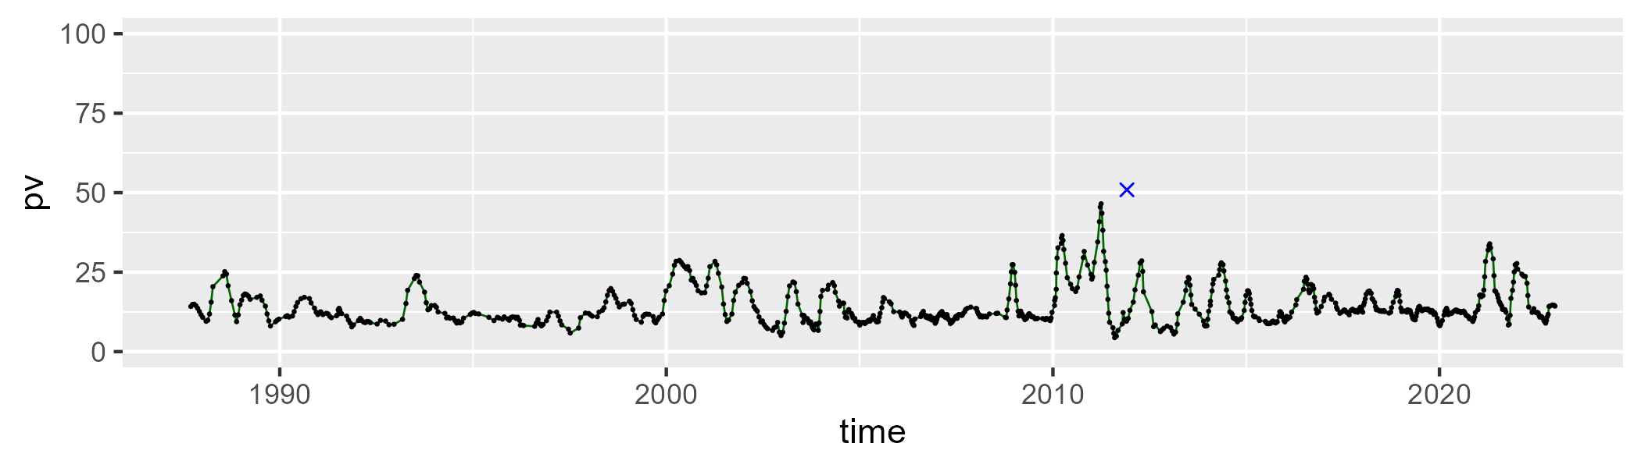

| Min. | 1st Qu. | Median | Mean | 3rd Qu. | Max. |
| --- | --- | --- | --- | --- | --- |
| 2.937569 | 17.08472 | 24.92862 | 25.95041 | 34.80723 | 58.29891 |

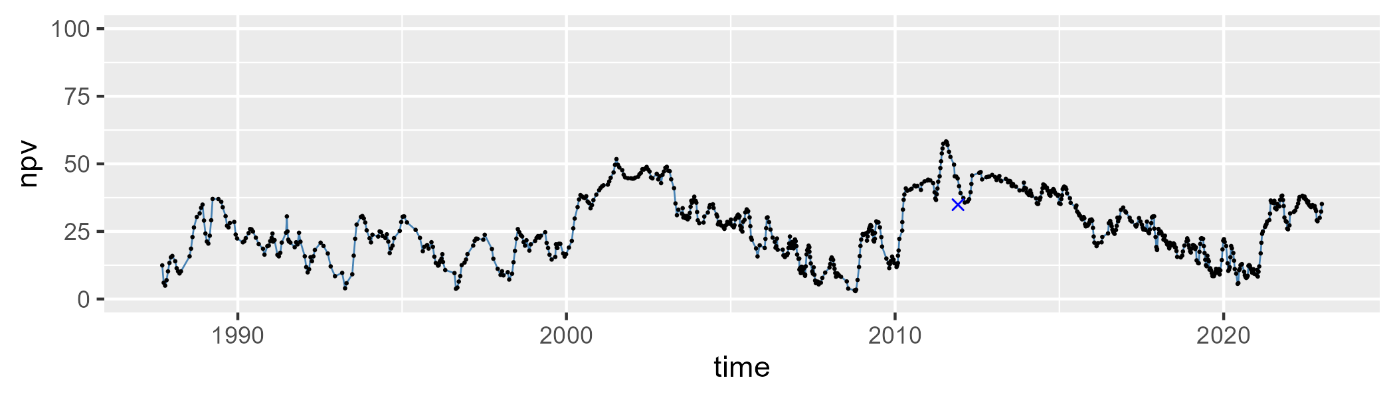

| Min. | 1st Qu. | Median | Mean | 3rd Qu. | Max. |
| --- | --- | --- | --- | --- | --- |
| 15.63842 | 48.4685 | 59.64996 | 58.33723 | 69.40576 | 85.83227 |

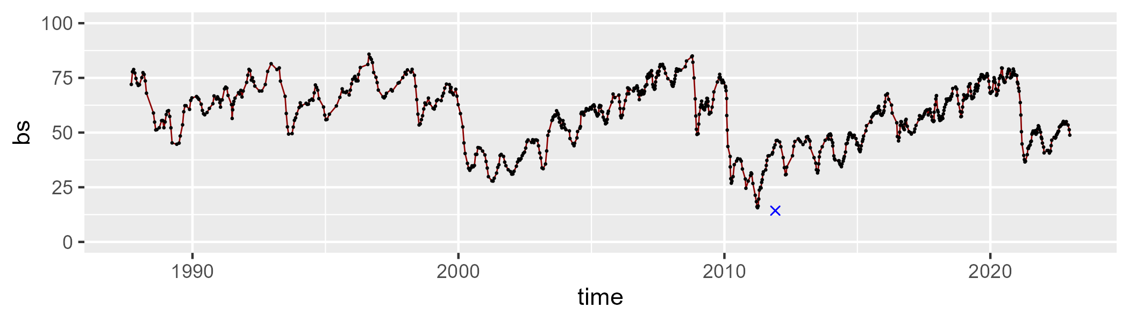

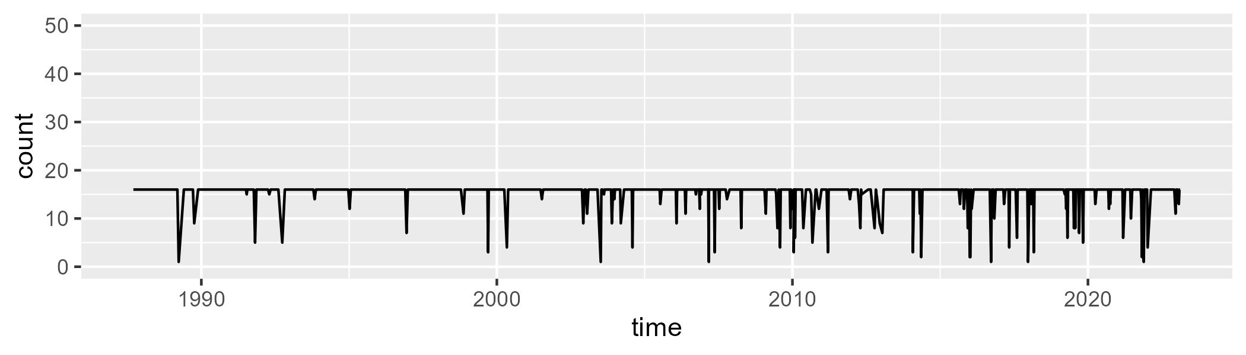

Min. : 1.00 1st Qu.:16.00 Median :16.00 Mean :15.22 3rd Qu.:16.00 Max. :16.00

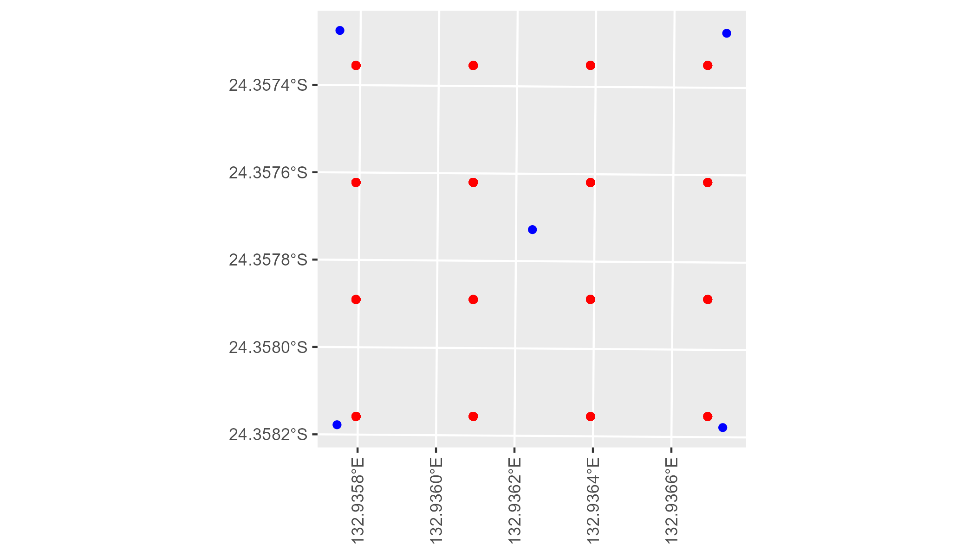

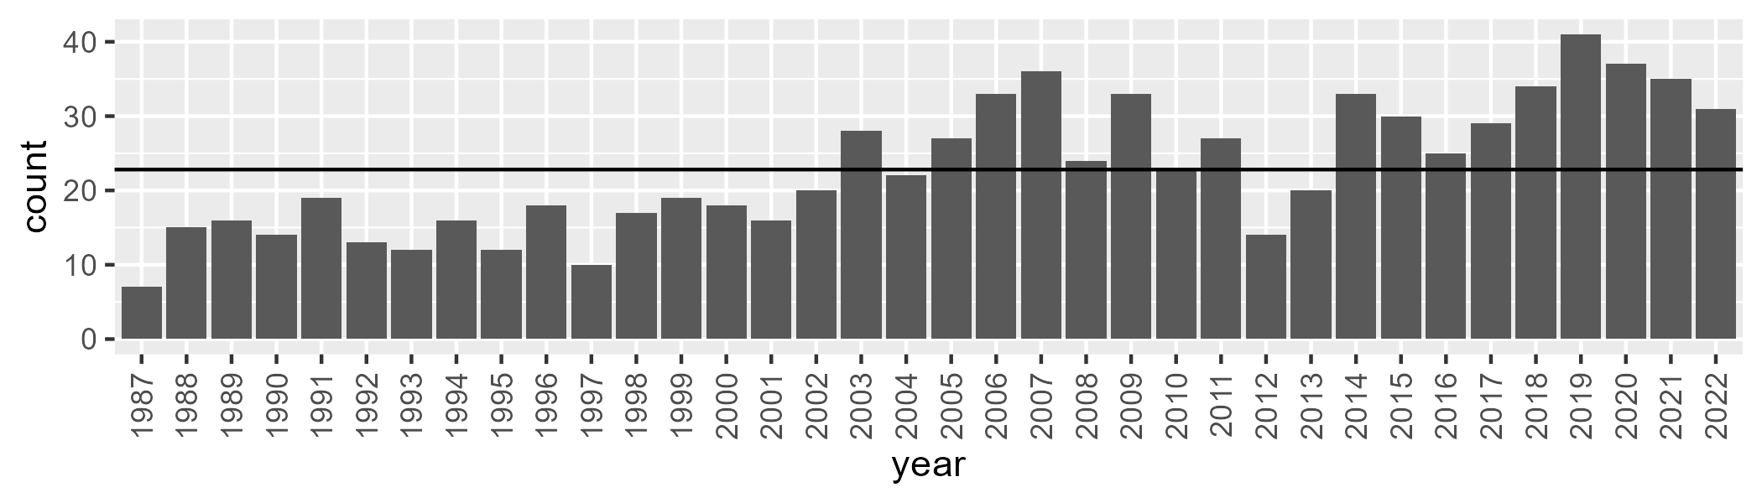

Number of samples: 824

# NTAFIN0020

| Min. | 1st Qu. | Median | Mean | 3rd Qu. | Max. |
| --- | --- | --- | --- | --- | --- |
| 2.361171 | 9.408489 | 13.69126 | 13.37914 | 16.55126 | 30.63418 |

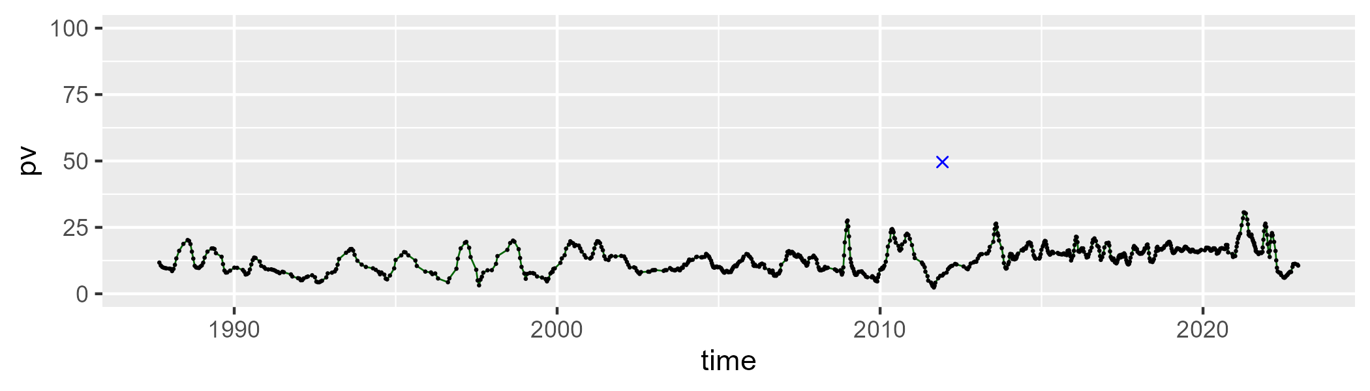

| Min. | 1st Qu. | Median | Mean | 3rd Qu. | Max. |
| --- | --- | --- | --- | --- | --- |
| 0.2312929 | 16.94207 | 30.11226 | 27.28622 | 35.96938 | 65.11624 |

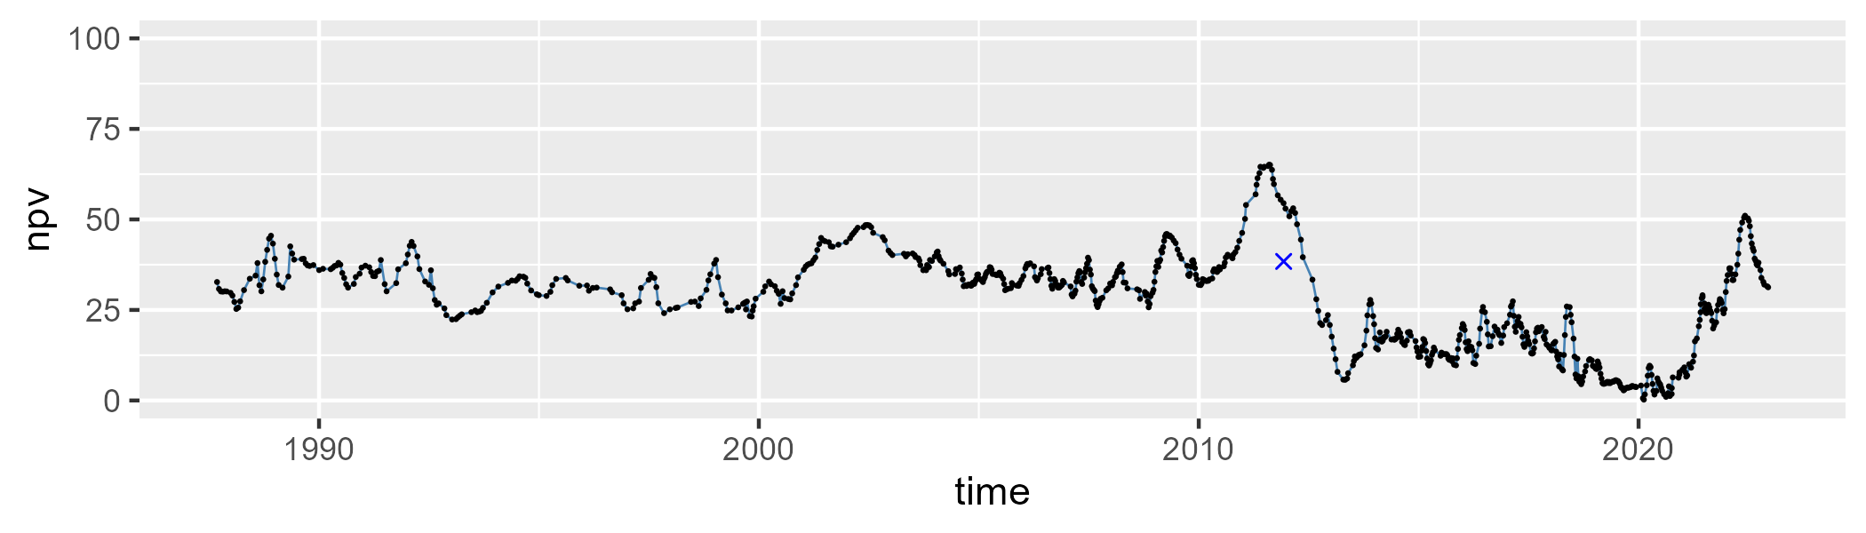

| Min. | 1st Qu. | Median | Mean | 3rd Qu. | Max. |
| --- | --- | --- | --- | --- | --- |
| 25.77778 | 50.65403 | 56.58542 | 57.76595 | 66.14691 | 81.29352 |

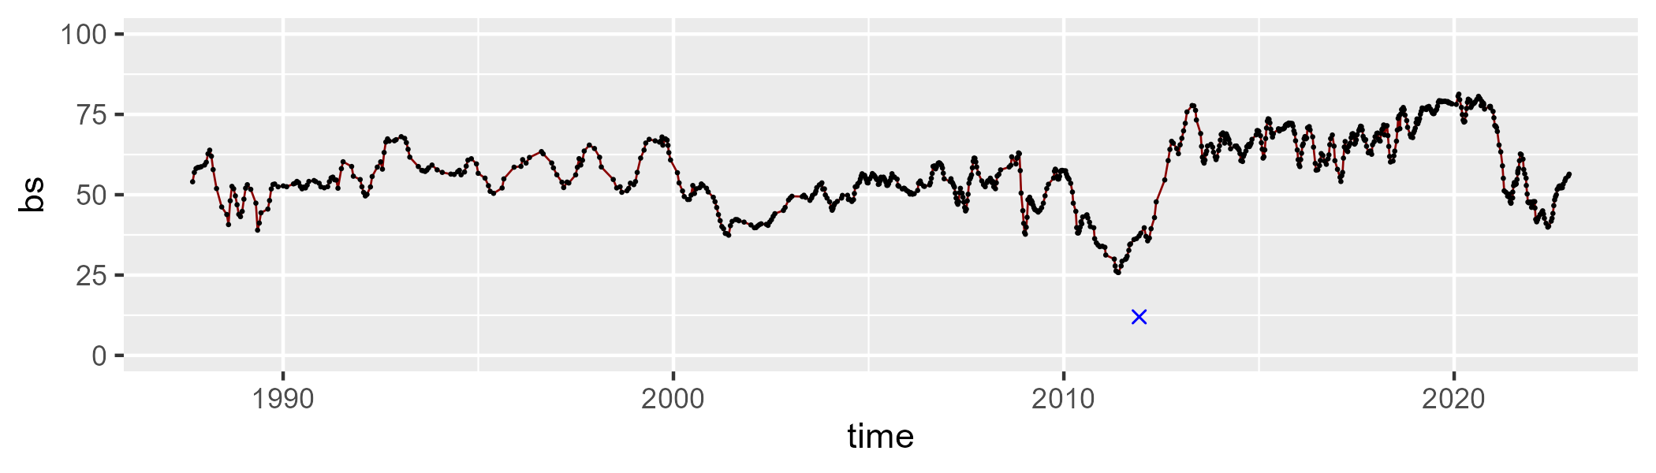

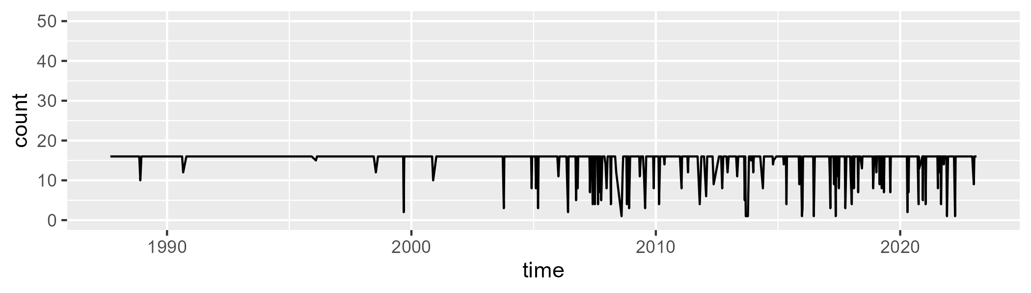

Min. : 1.00 1st Qu.:16.00 Median :16.00 Mean :15.08 3rd Qu.:16.00 Max. :16.00

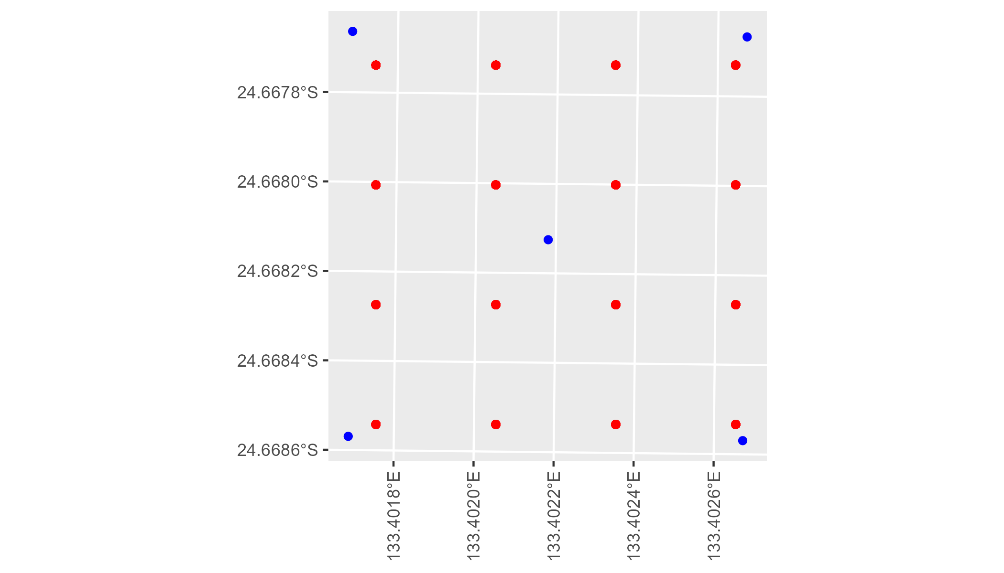

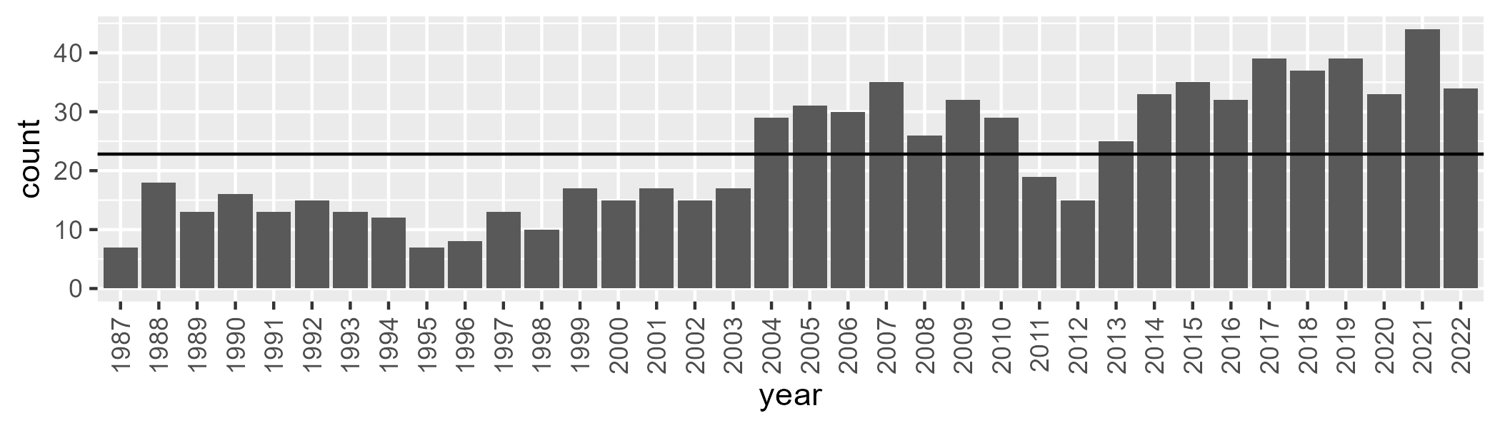

Number of samples: 823

# NTAFIN0021

| Min. | 1st Qu. | Median | Mean | 3rd Qu. | Max. |
| --- | --- | --- | --- | --- | --- |
| 4.356375 | 9.23003 | 10.55103 | 10.72879 | 12.01878 | 20.36689 |

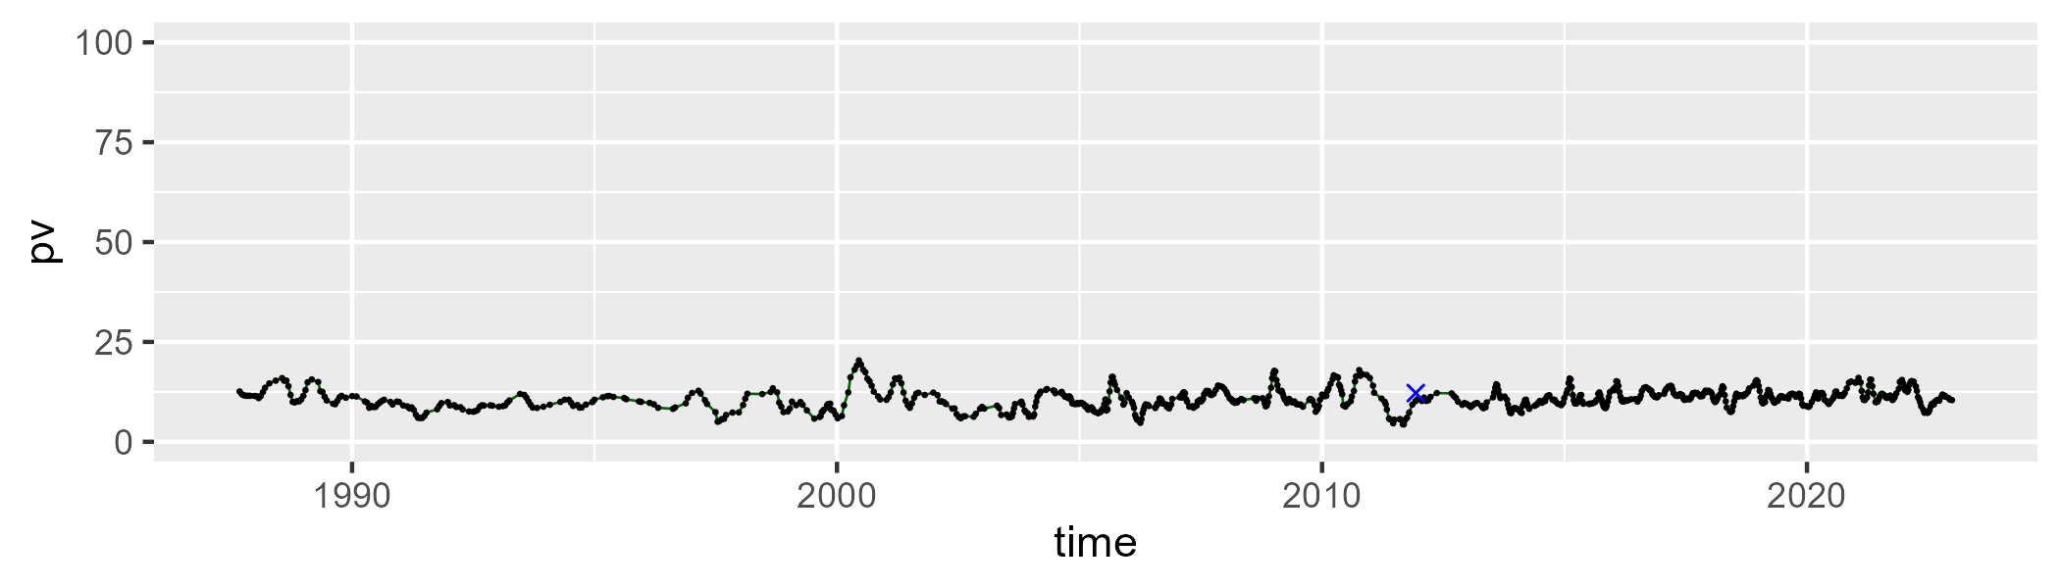

| Min. | 1st Qu. | Median | Mean | 3rd Qu. | Max. |
| --- | --- | --- | --- | --- | --- |
| 2.163942 | 9.217815 | 13.18072 | 14.3147 | 18.29876 | 35.0402 |

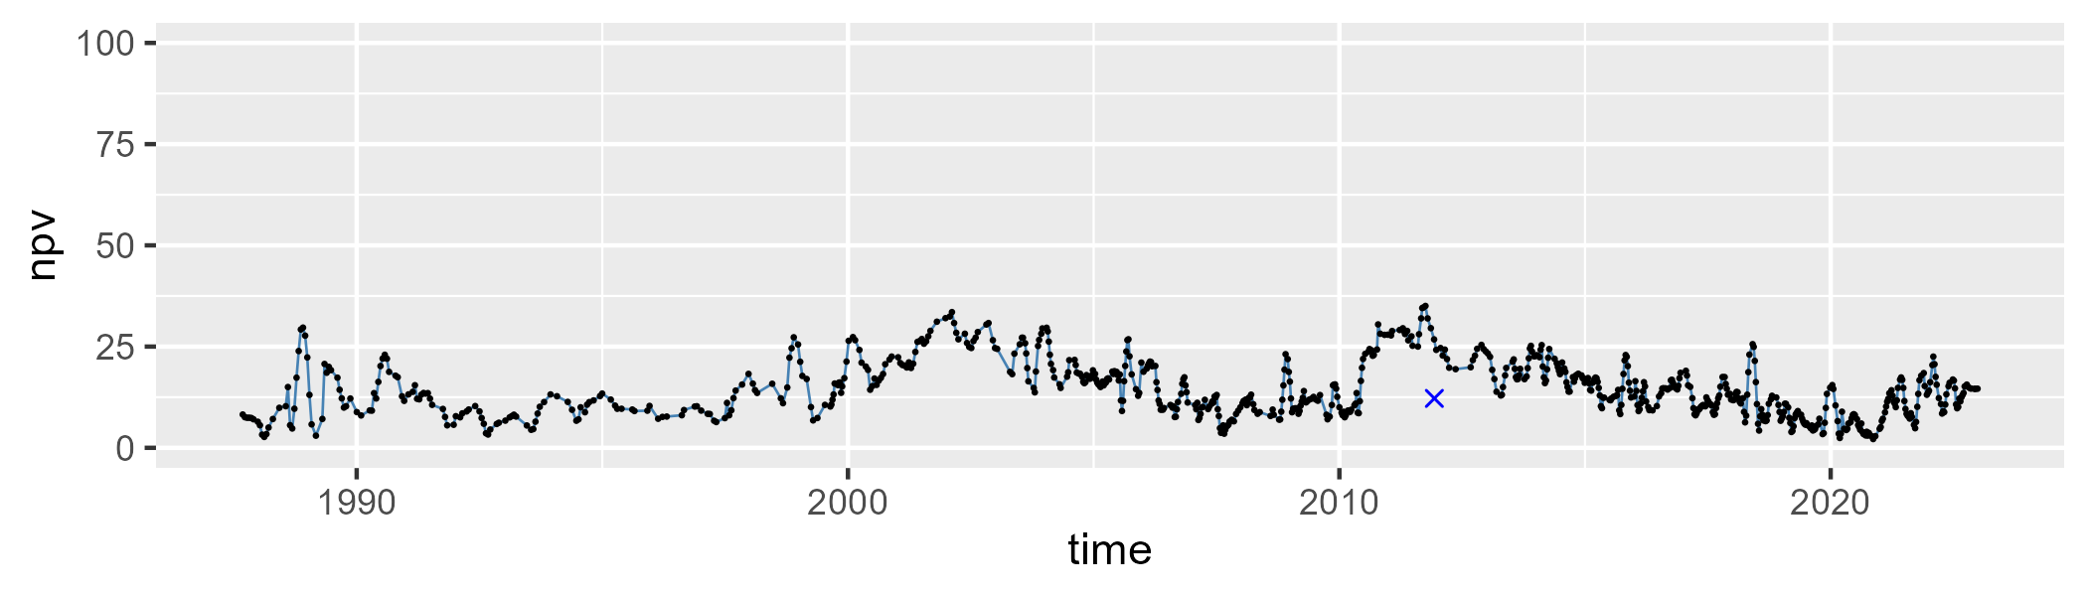

| Min. | 1st Qu. | Median | Mean | 3rd Qu. | Max. |
| --- | --- | --- | --- | --- | --- |
| 51.414 | 68.92676 | 74.27711 | 73.32319 | 78.48221 | 86.20488 |

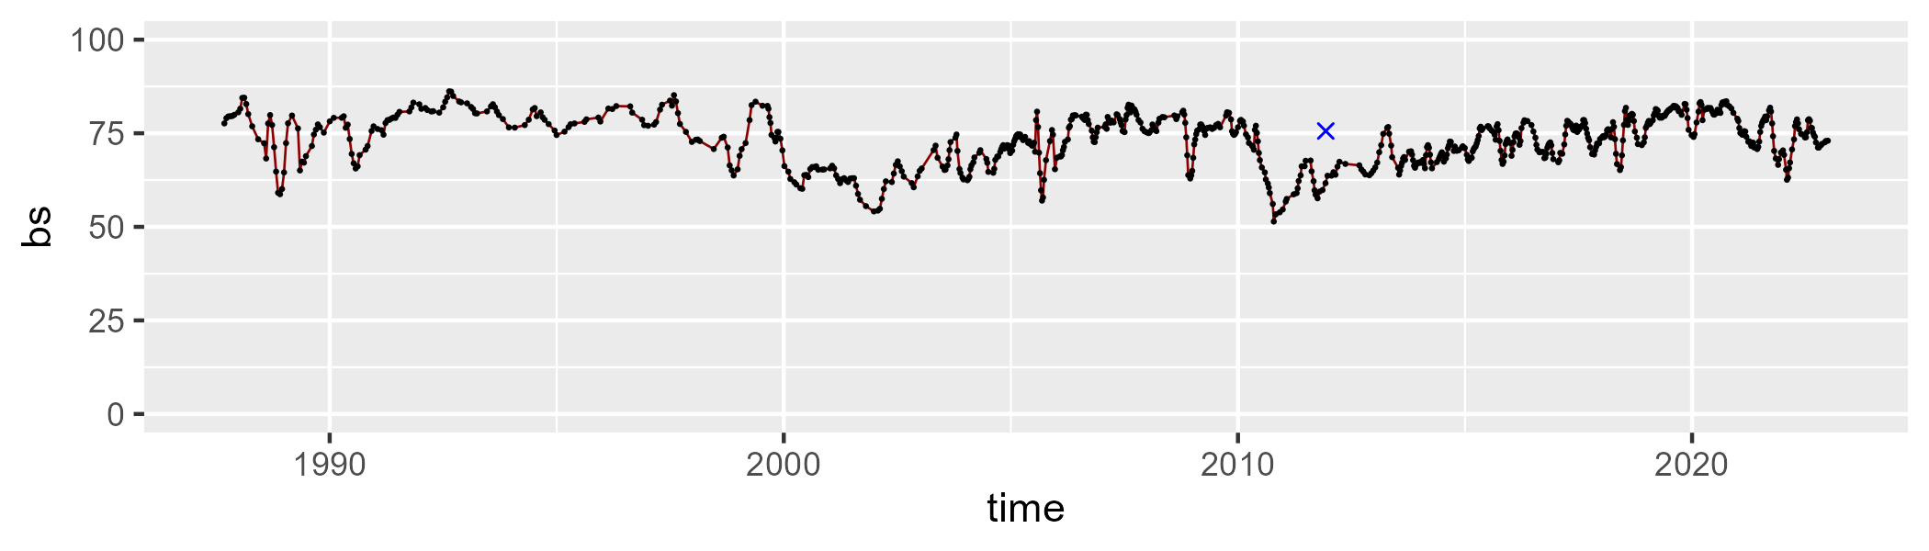

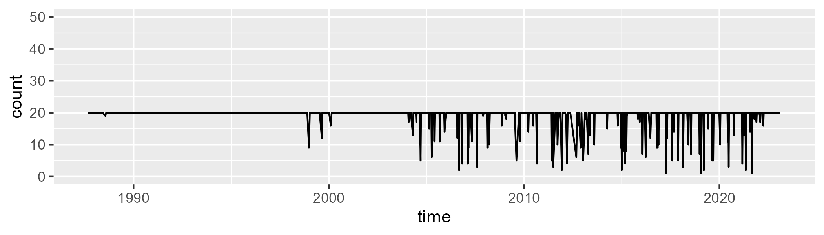

Min. : 1.00 1st Qu.:20.00 Median :20.00 Mean :18.87 3rd Qu.:20.00 Max. :20.00

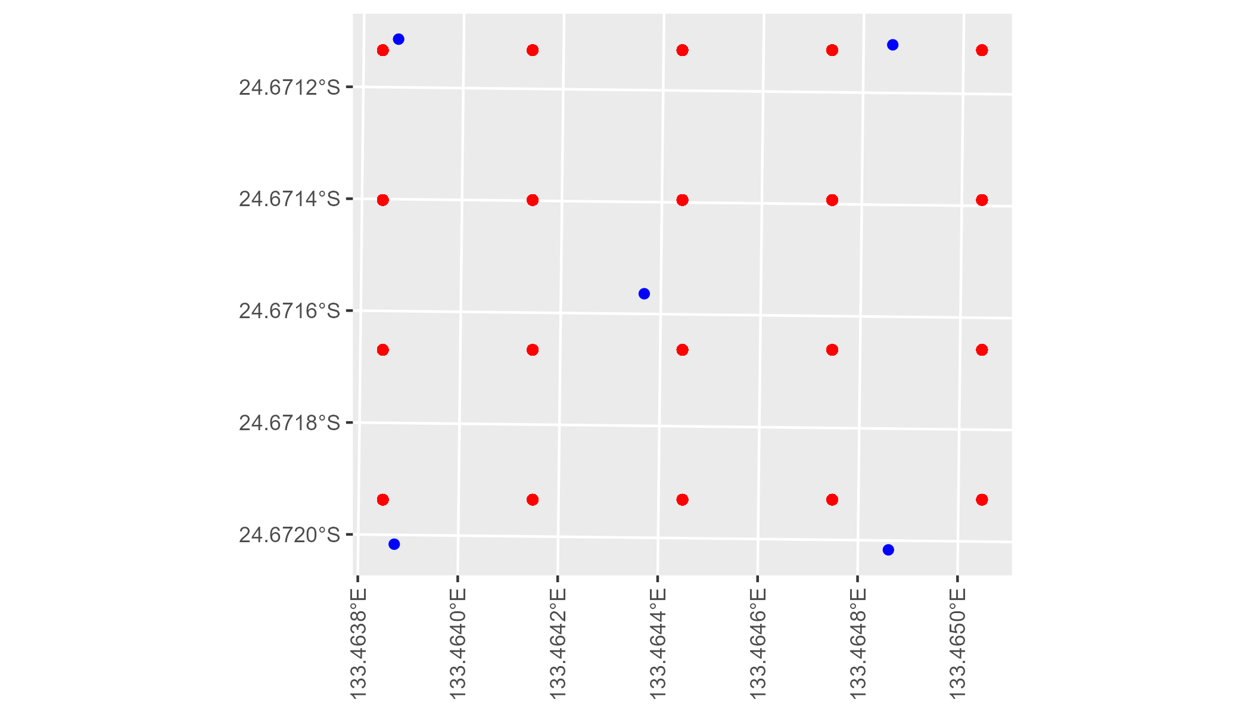

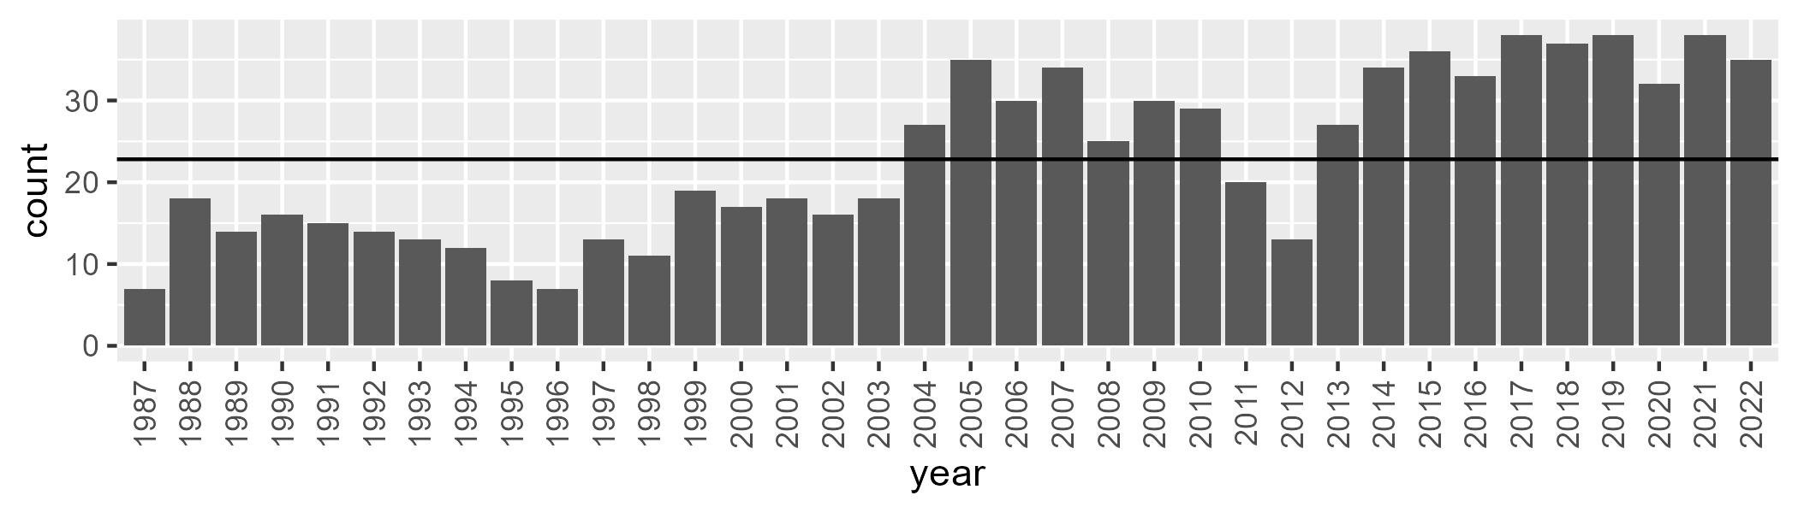

Number of samples: 827

# NTAFIN0022

| Min. | 1st Qu. | Median | Mean | 3rd Qu. | Max. |
| --- | --- | --- | --- | --- | --- |
| 1.976897 | 6.92403 | 8.502703 | 9.141608 | 10.50157 | 23.54195 |

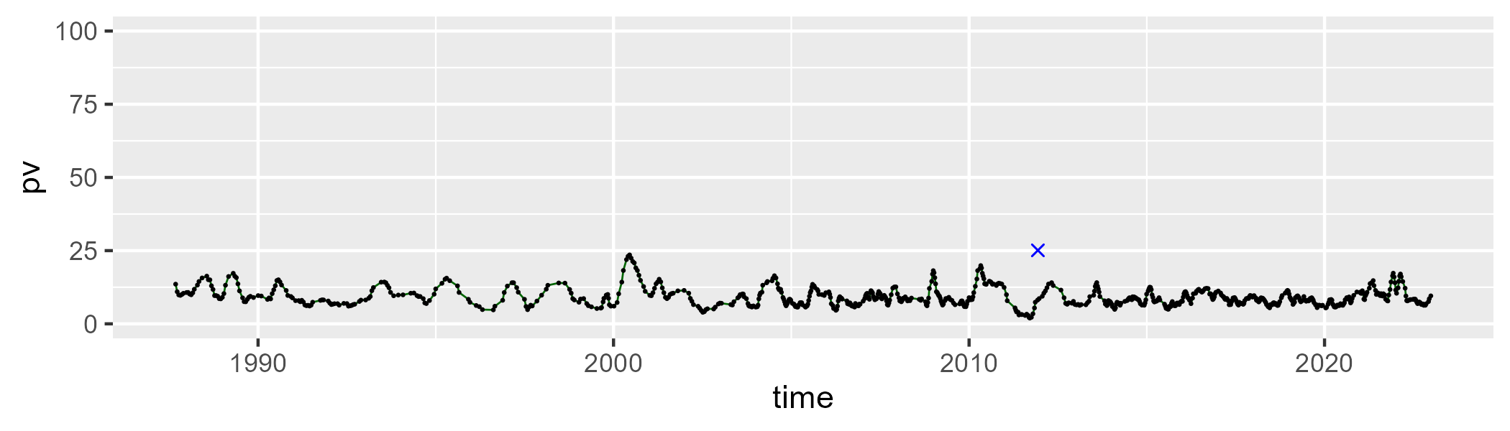

| Min. | 1st Qu. | Median | Mean | 3rd Qu. | Max. |
| --- | --- | --- | --- | --- | --- |
| 15.40375 | 29.00795 | 32.48713 | 32.41737 | 36.04323 | 48.56412 |

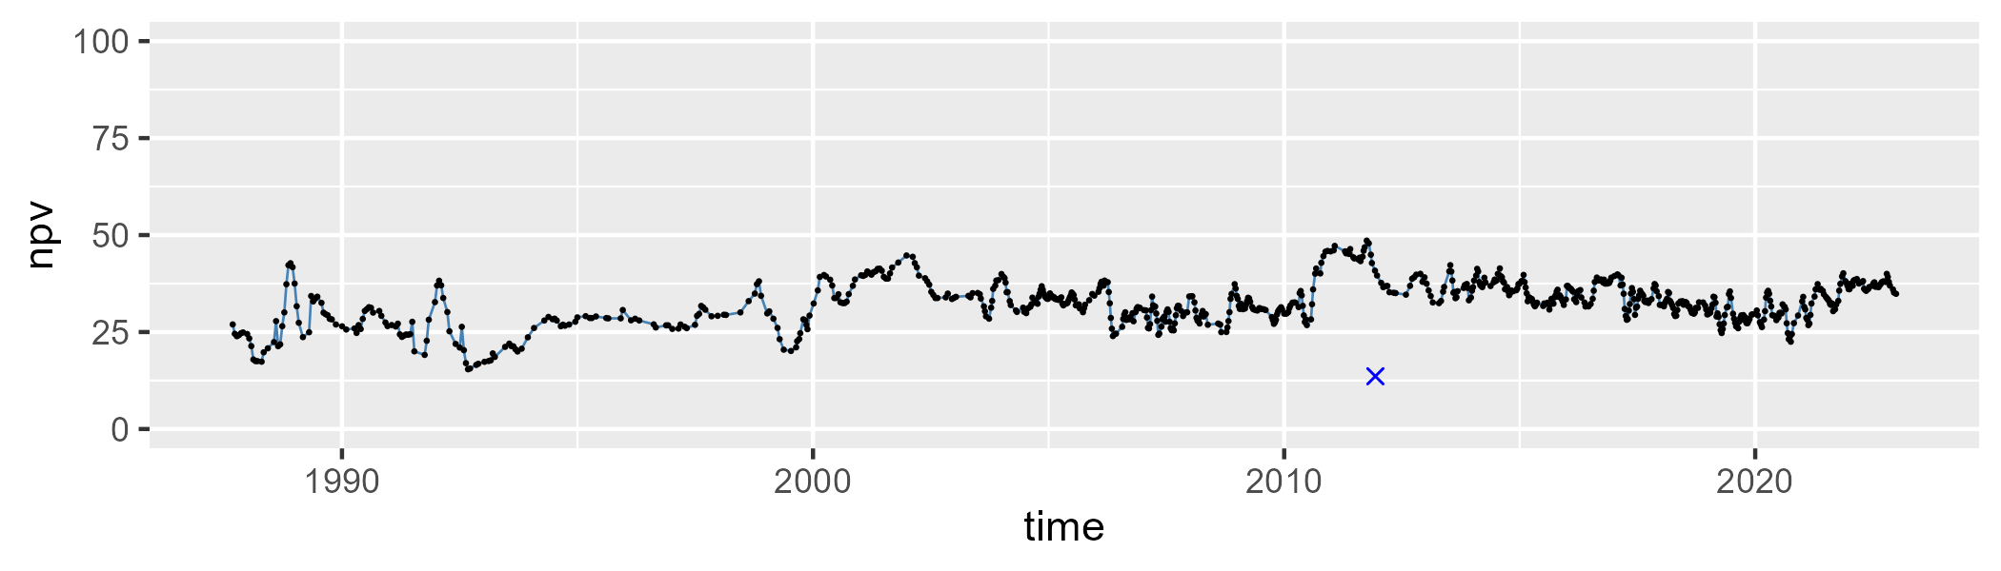

| Min. | 1st Qu. | Median | Mean | 3rd Qu. | Max. |
| --- | --- | --- | --- | --- | --- |
| 38.19154 | 53.14073 | 57.17843 | 56.92461 | 61.17254 | 76.48255 |

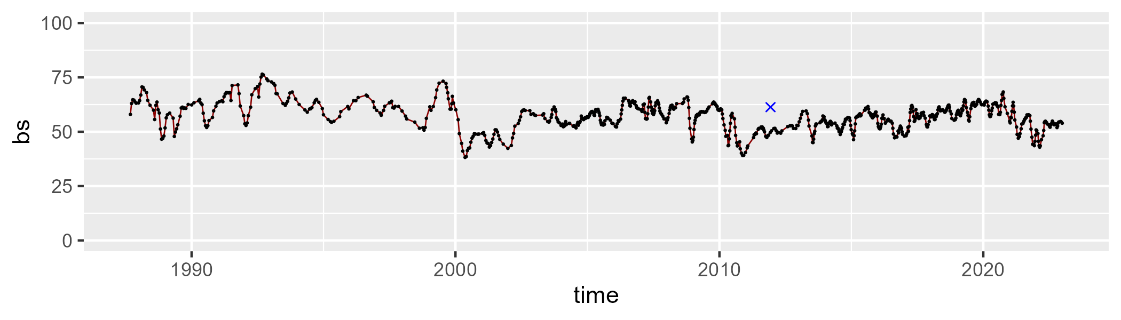

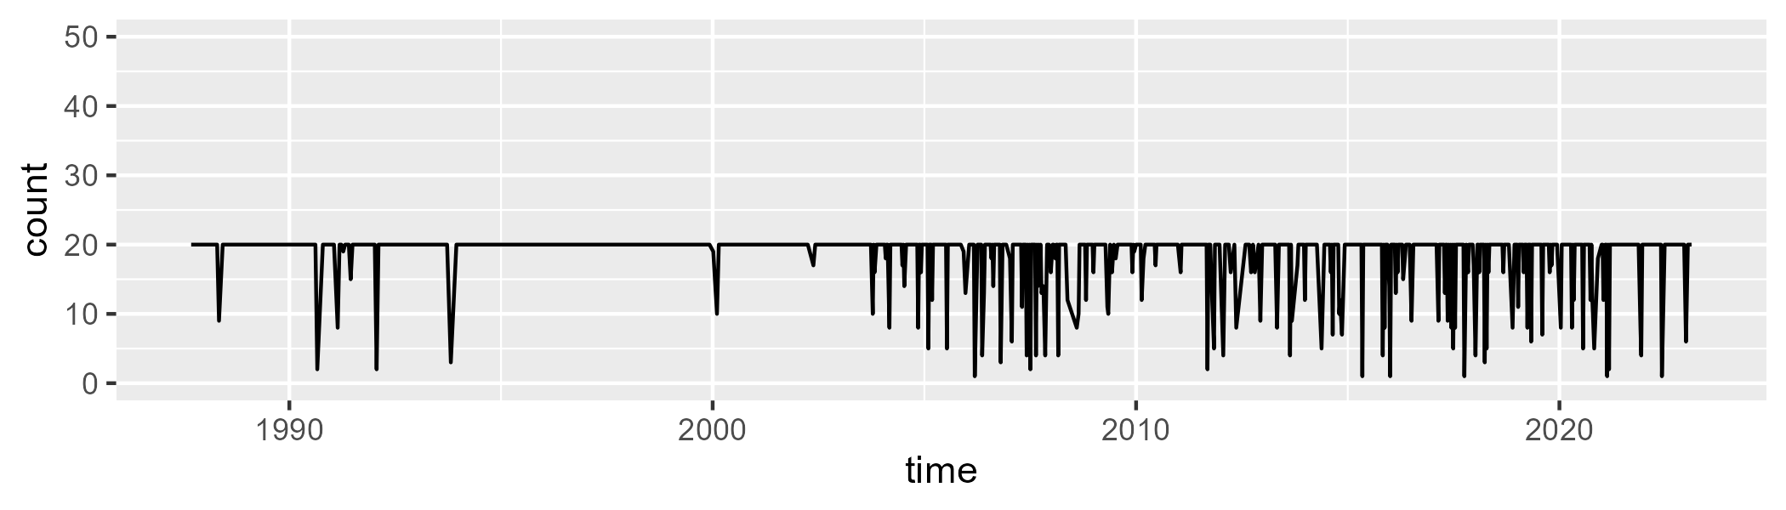

Min. : 1.00 1st Qu.:20.00 Median :20.00 Mean :18.53 3rd Qu.:20.00 Max. :20.00

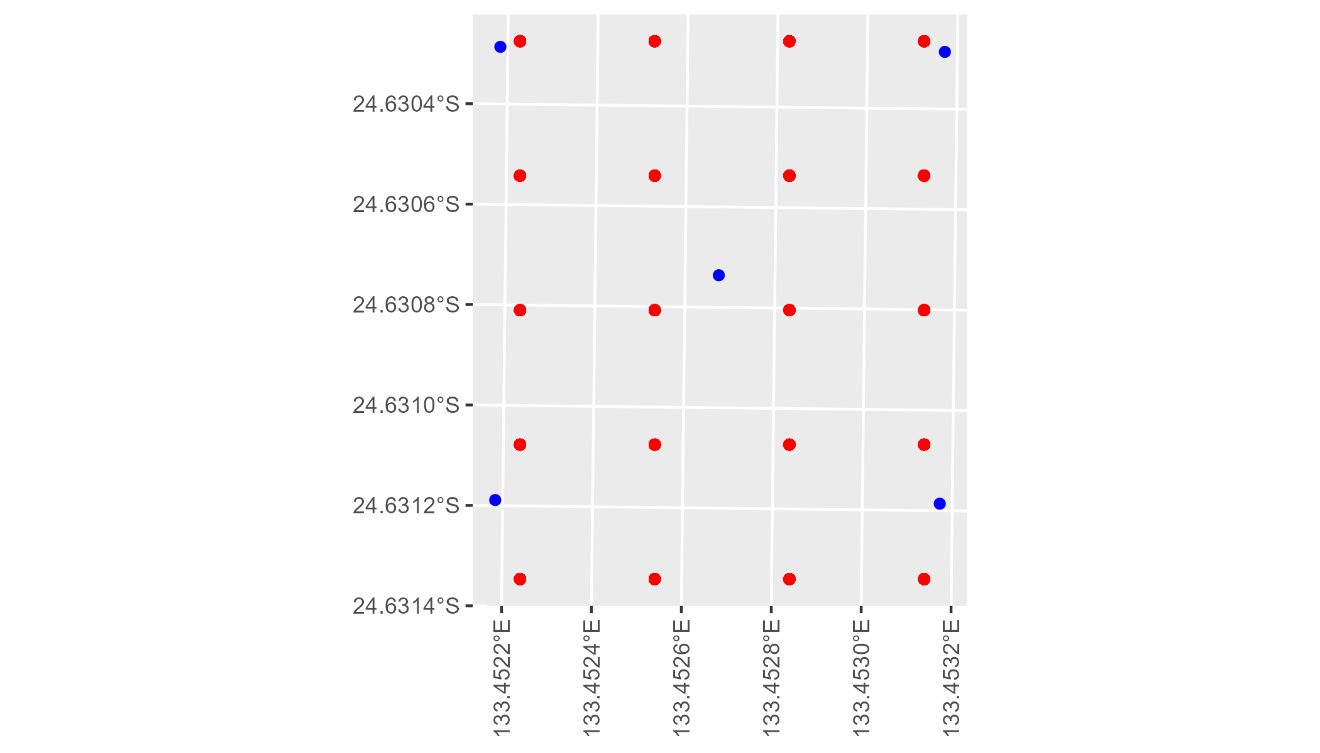

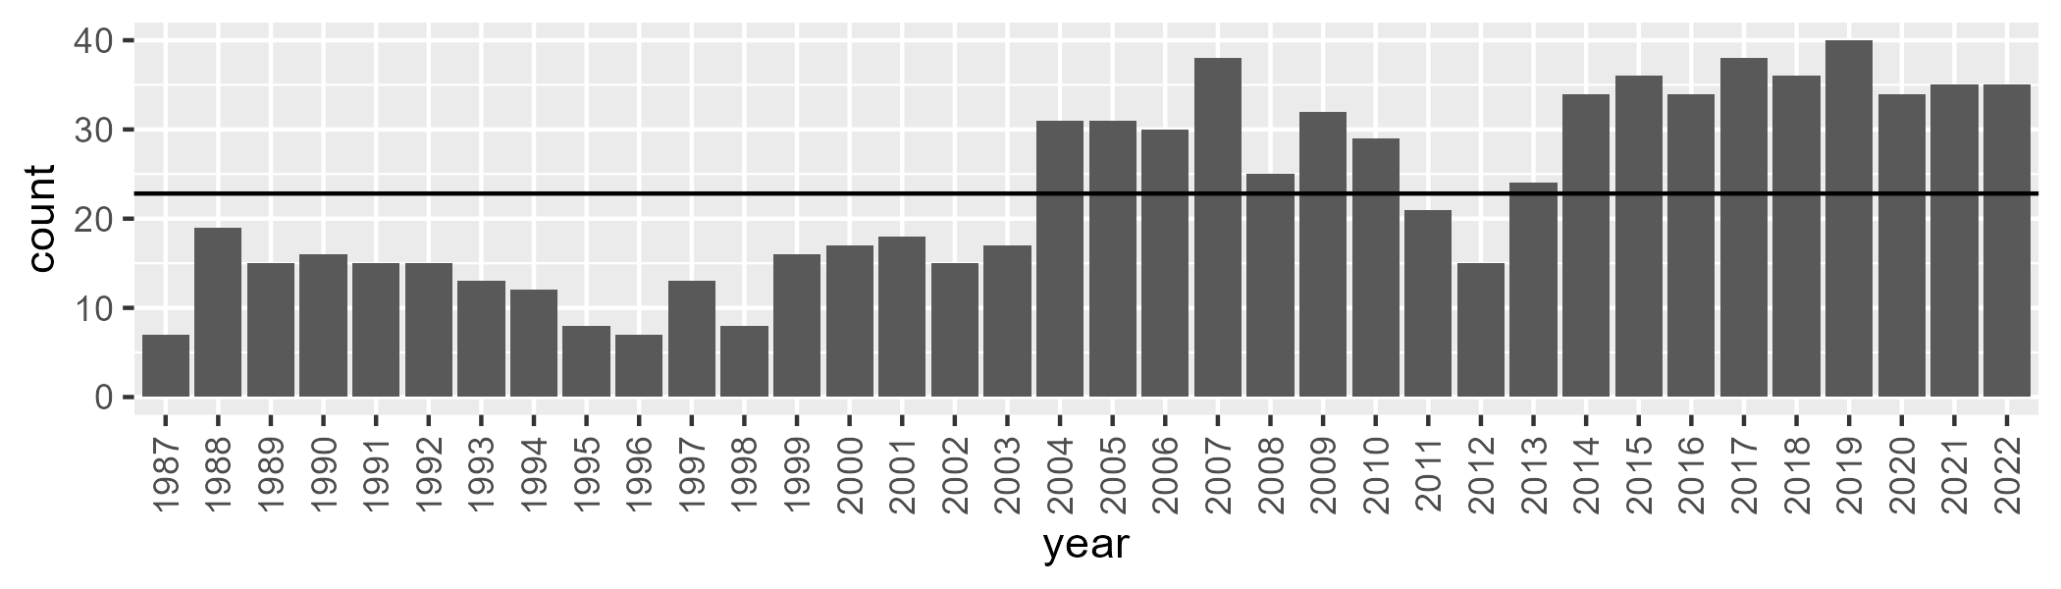

Number of samples: 829

# NTAFIN0023

| Min. | 1st Qu. | Median | Mean | 3rd Qu. | Max. |
| --- | --- | --- | --- | --- | --- |
| 6.106034 | 12.71535 | 14.74717 | 14.99099 | 16.88658 | 28.46412 |

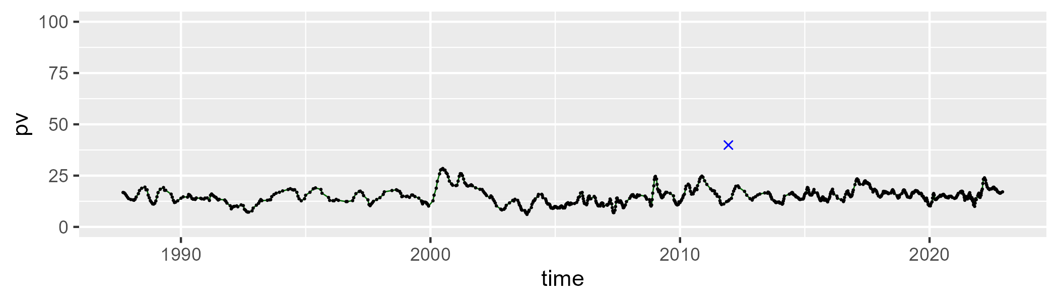

| Min. | 1st Qu. | Median | Mean | 3rd Qu. | Max. |
| --- | --- | --- | --- | --- | --- |
| 21.72297 | 30.29609 | 33.82193 | 34.469 | 37.85064 | 53.89904 |

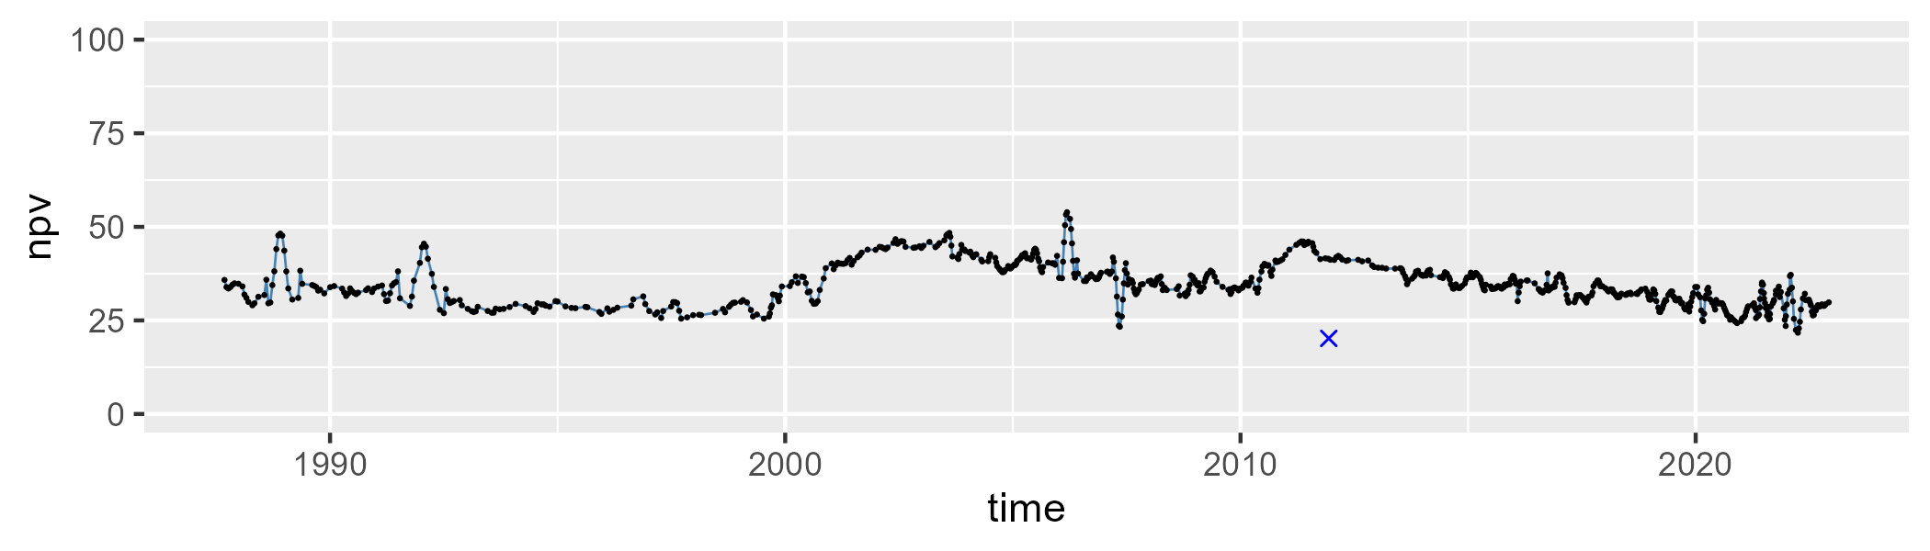

| Min. | 1st Qu. | Median | Mean | 3rd Qu. | Max. |
| --- | --- | --- | --- | --- | --- |
| 32.46283 | 45.68187 | 49.62104 | 49.00852 | 53.0528 | 68.45212 |

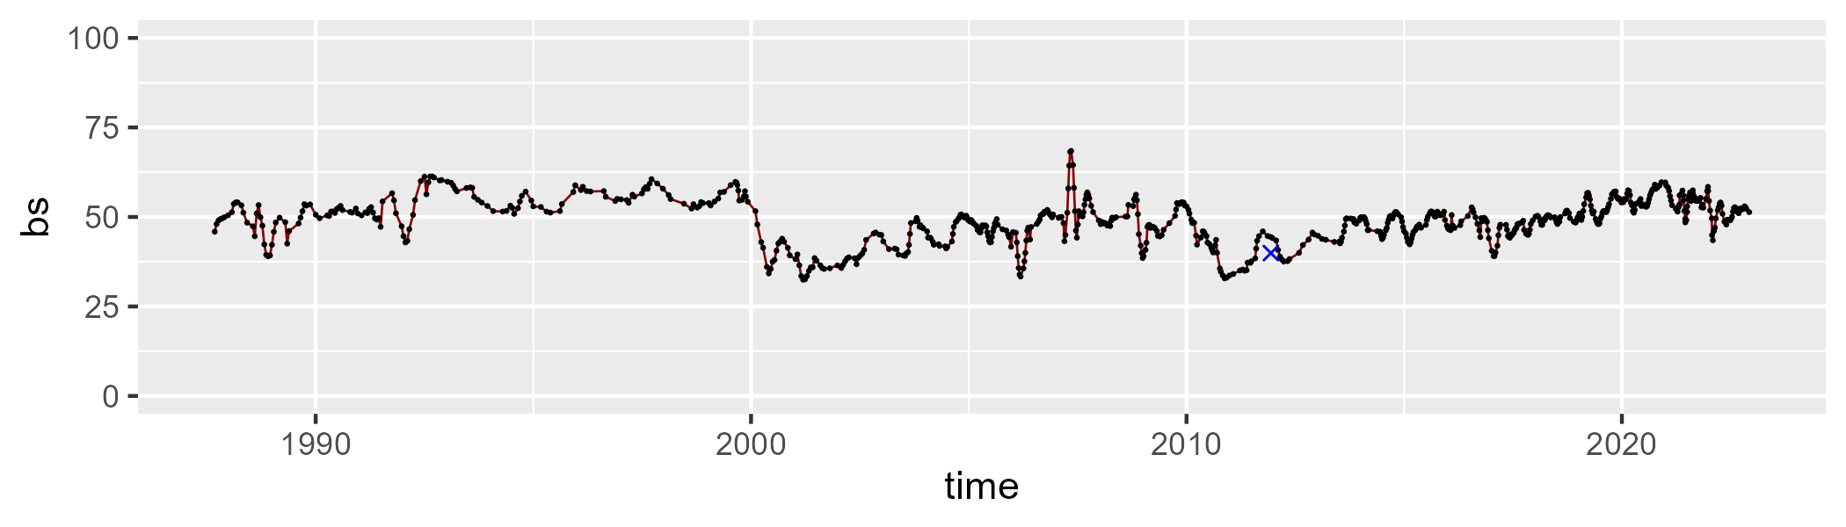

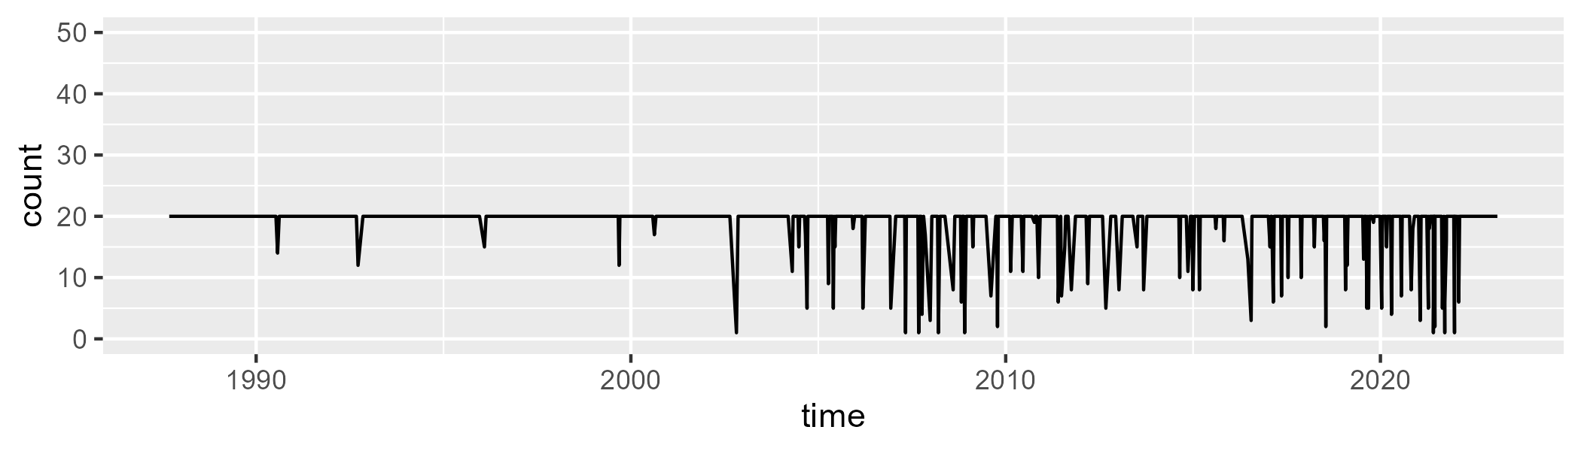

Min. : 1.00 1st Qu.:20.00 Median :20.00 Mean :18.89 3rd Qu.:20.00 Max. :20.00

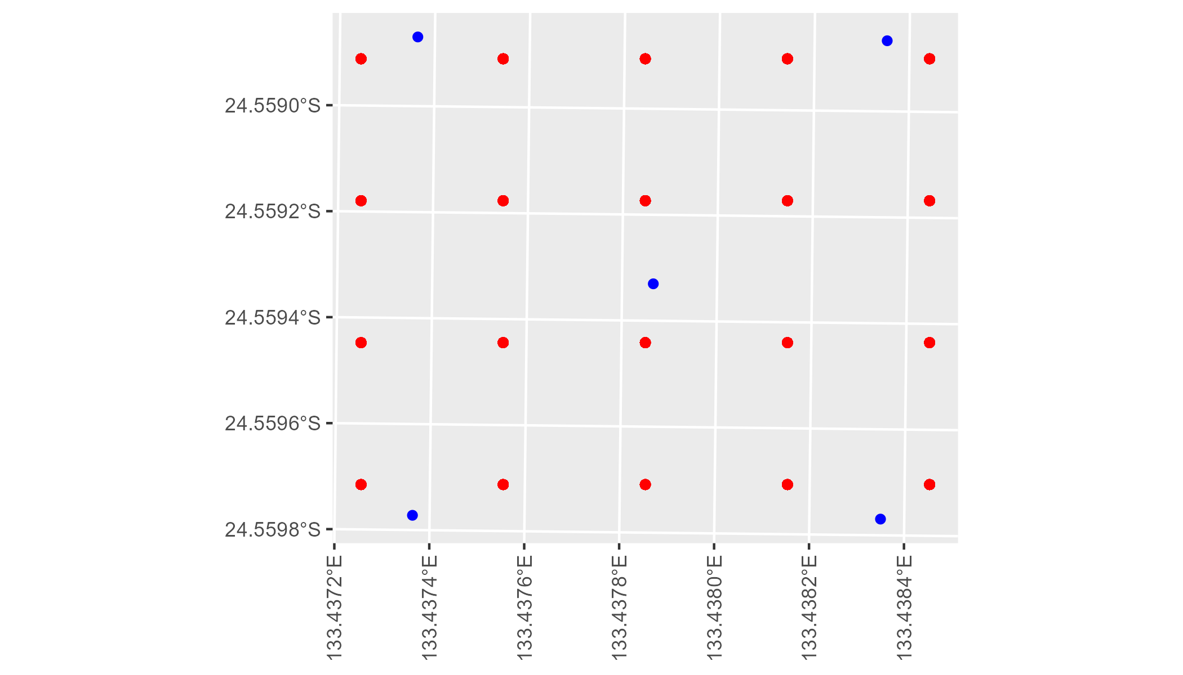

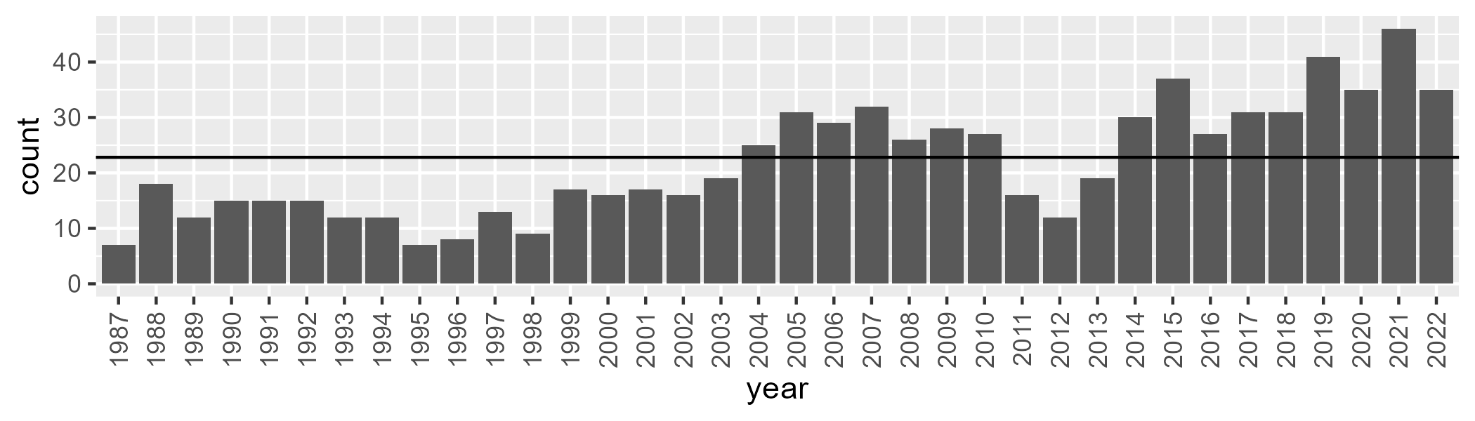

Number of samples: 786

# NTAFIN0024

| Min. | 1st Qu. | Median | Mean | 3rd Qu. | Max. |
| --- | --- | --- | --- | --- | --- |
| 7.78985 | 13.72099 | 16.25079 | 18.04684 | 20.717 | 47.18662 |

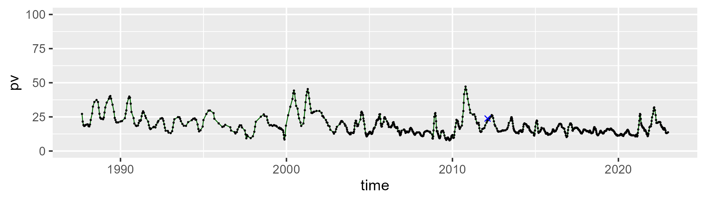

| Min. | 1st Qu. | Median | Mean | 3rd Qu. | Max. |
| --- | --- | --- | --- | --- | --- |
| 12.59017 | 28.59927 | 32.95839 | 32.06558 | 36.18456 | 47.66727 |

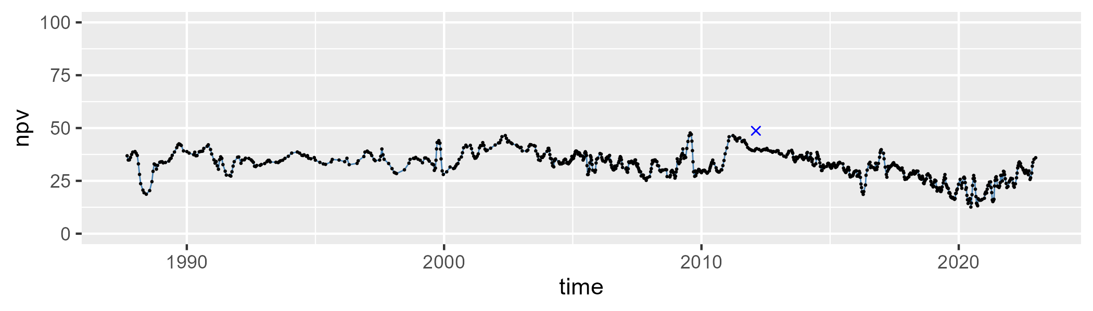

| Min. | 1st Qu. | Median | Mean | 3rd Qu. | Max. |
| --- | --- | --- | --- | --- | --- |
| 16.66444 | 42.70132 | 48.76352 | 48.39735 | 55.07918 | 73.14503 |

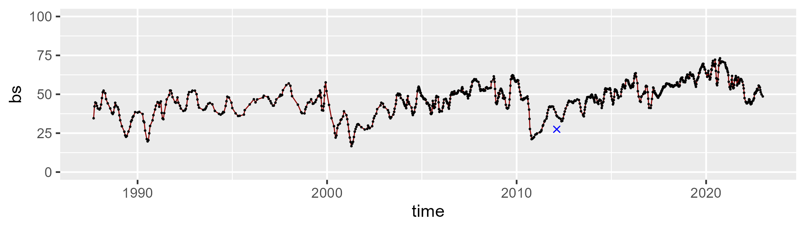

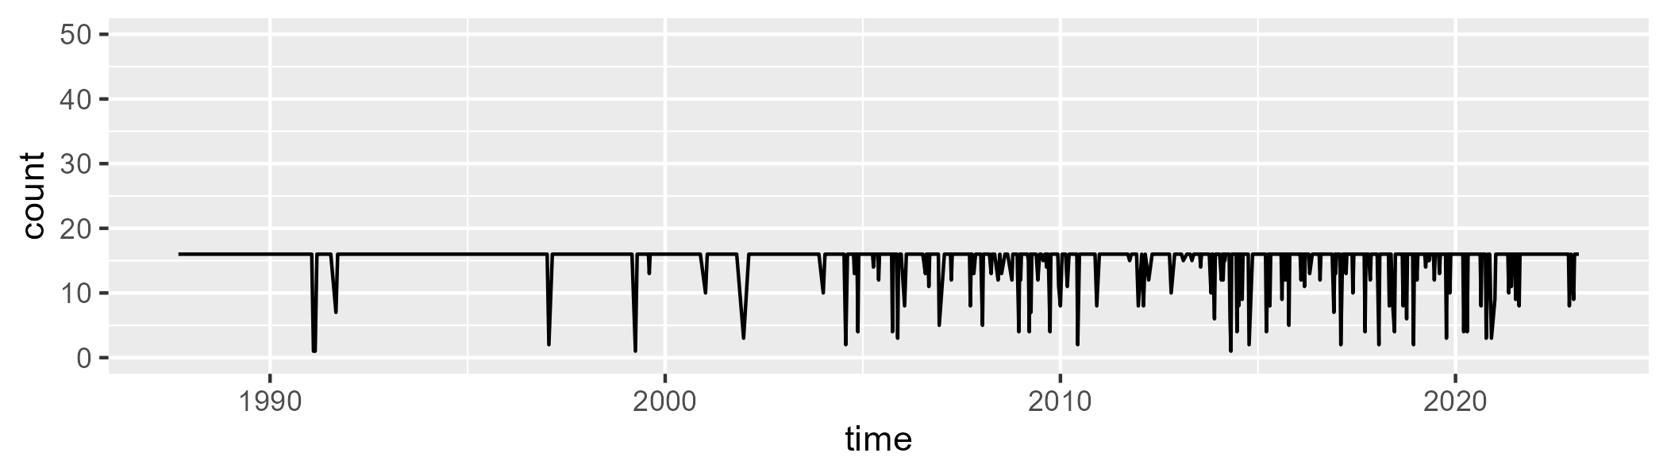

Min. : 1.0 1st Qu.:16.0 Median :16.0 Mean :15.1 3rd Qu.:16.0 Max. :16.0

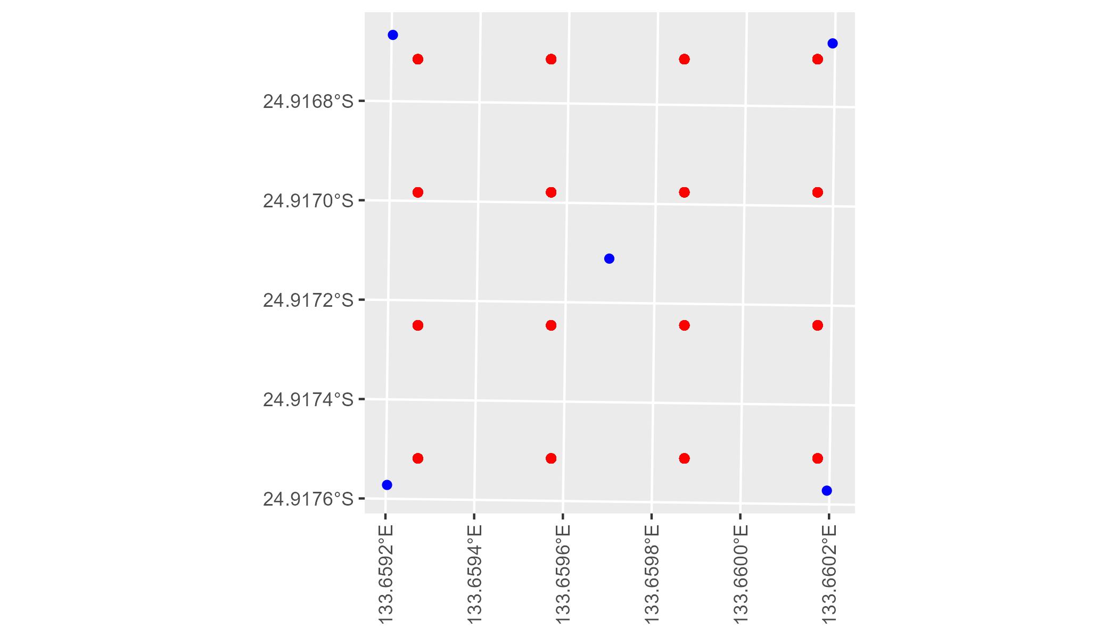

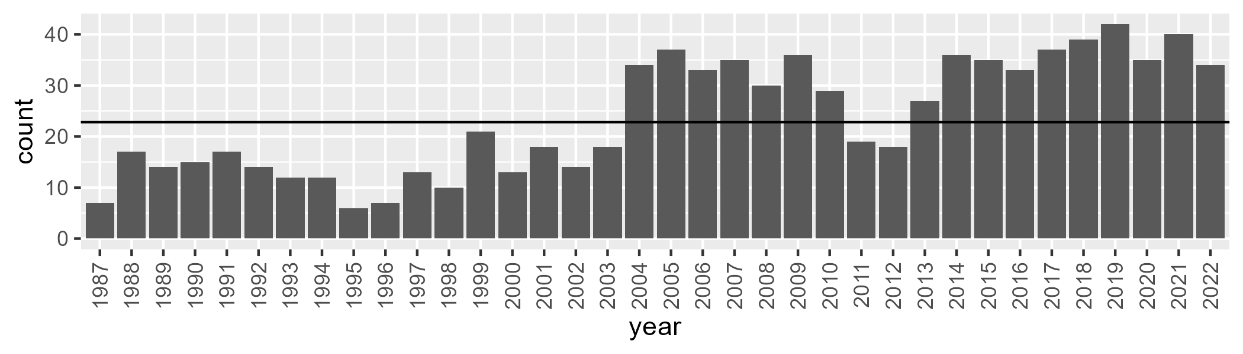

Number of samples: 857

# NTAFIN0025

| Min. | 1st Qu. | Median | Mean | 3rd Qu. | Max. |
| --- | --- | --- | --- | --- | --- |
| 1.854402 | 8.703164 | 10.45609 | 11.02627 | 12.76785 | 25.15052 |

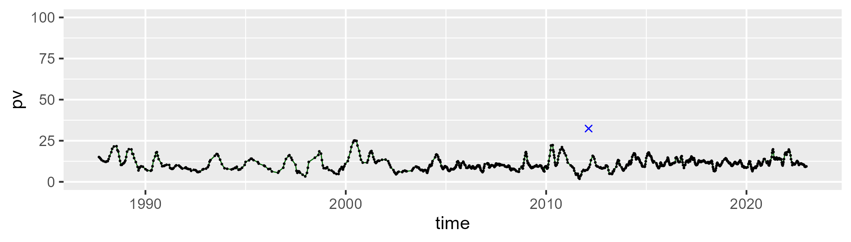

| Min. | 1st Qu. | Median | Mean | 3rd Qu. | Max. |
| --- | --- | --- | --- | --- | --- |
| 9.841149 | 24.18492 | 28.9041 | 29.73439 | 34.27513 | 51.59352 |

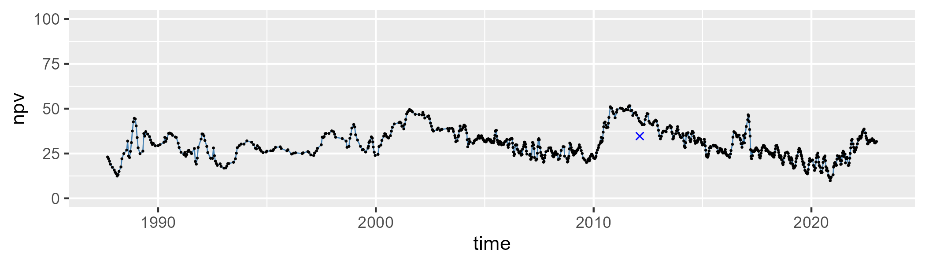

| Min. | 1st Qu. | Median | Mean | 3rd Qu. | Max. |
| --- | --- | --- | --- | --- | --- |
| 27.10783 | 52.56162 | 58.61369 | 57.74199 | 63.30601 | 75.20385 |

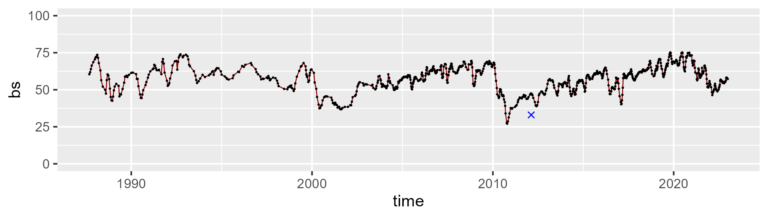

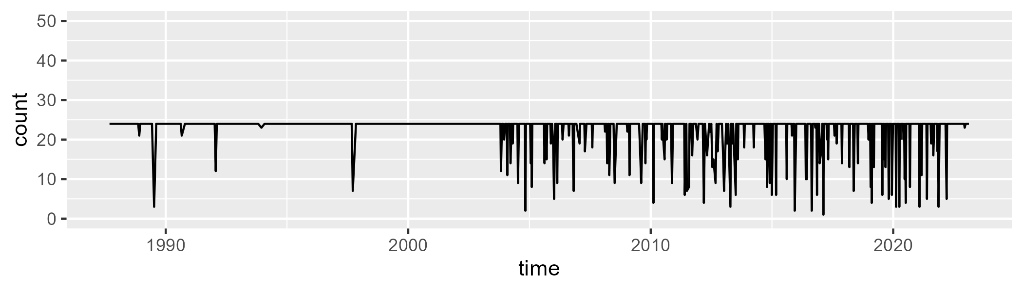

Min. : 1.00 1st Qu.:24.00 Median :24.00 Mean :22.51 3rd Qu.:24.00 Max. :24.00

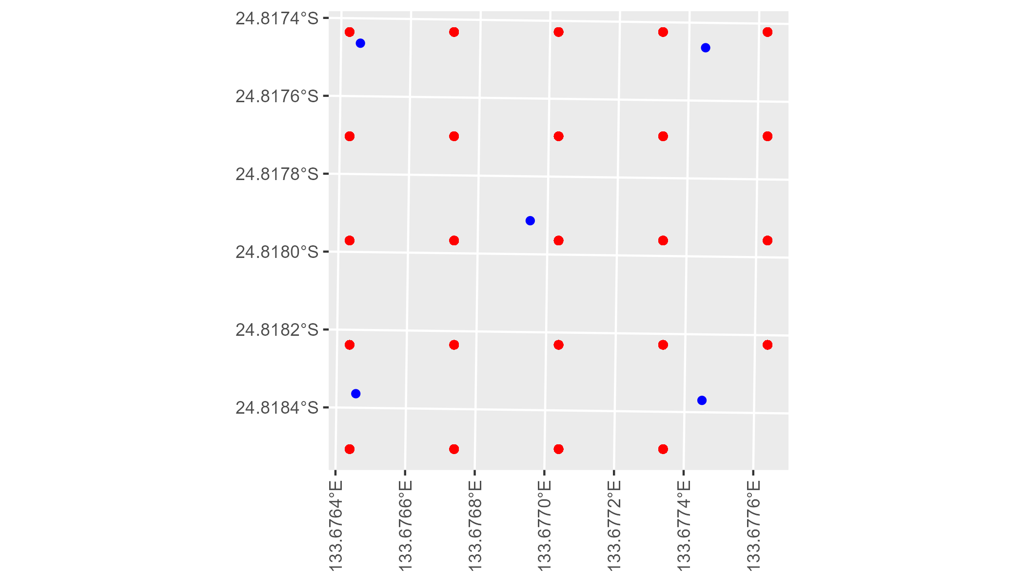

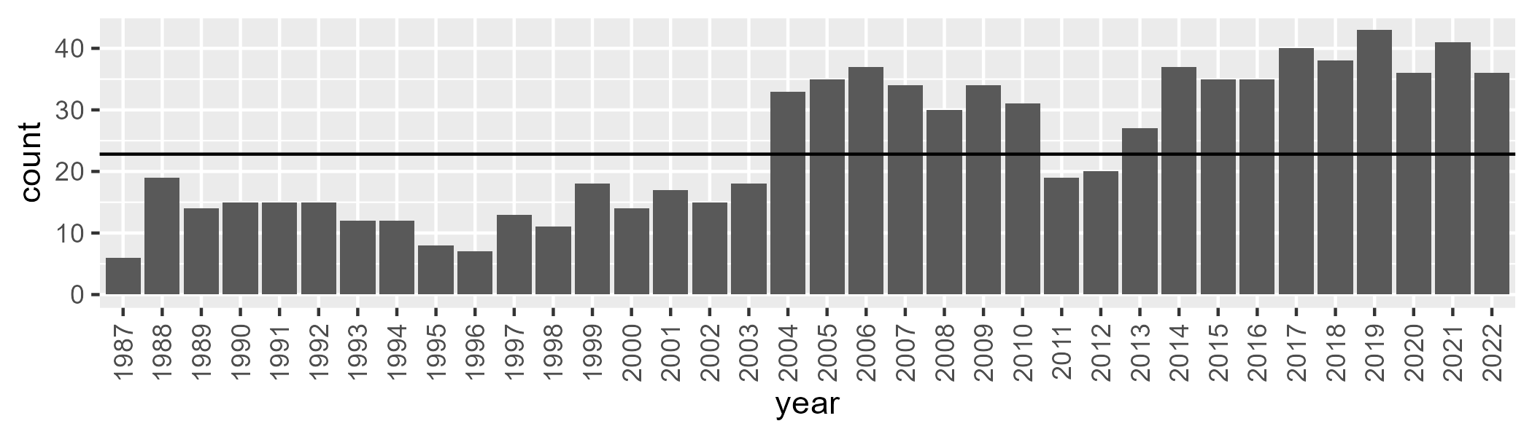

Number of samples: 870

# NTAFIN0026

| Min. | 1st Qu. | Median | Mean | 3rd Qu. | Max. |
| --- | --- | --- | --- | --- | --- |
| 3.623939 | 9.123307 | 11.77439 | 13.60044 | 16.70675 | 39.52488 |

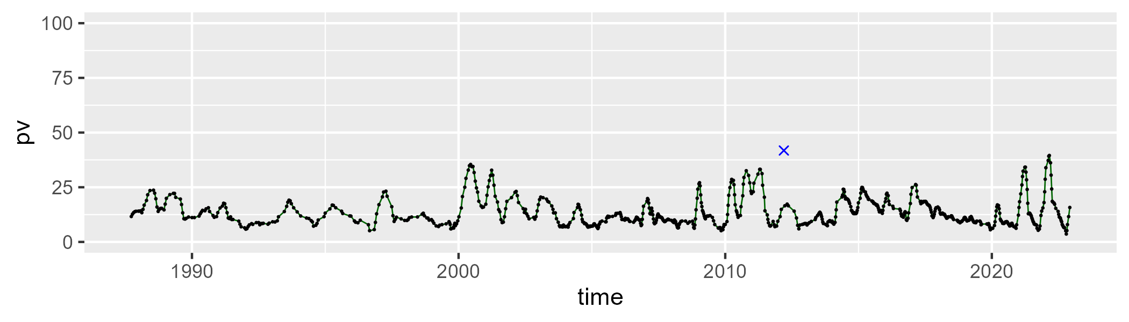

| Min. | 1st Qu. | Median | Mean | 3rd Qu. | Max. |
| --- | --- | --- | --- | --- | --- |
| 19.65391 | 35.12835 | 39.97569 | 40.3912 | 44.5732 | 65.53629 |

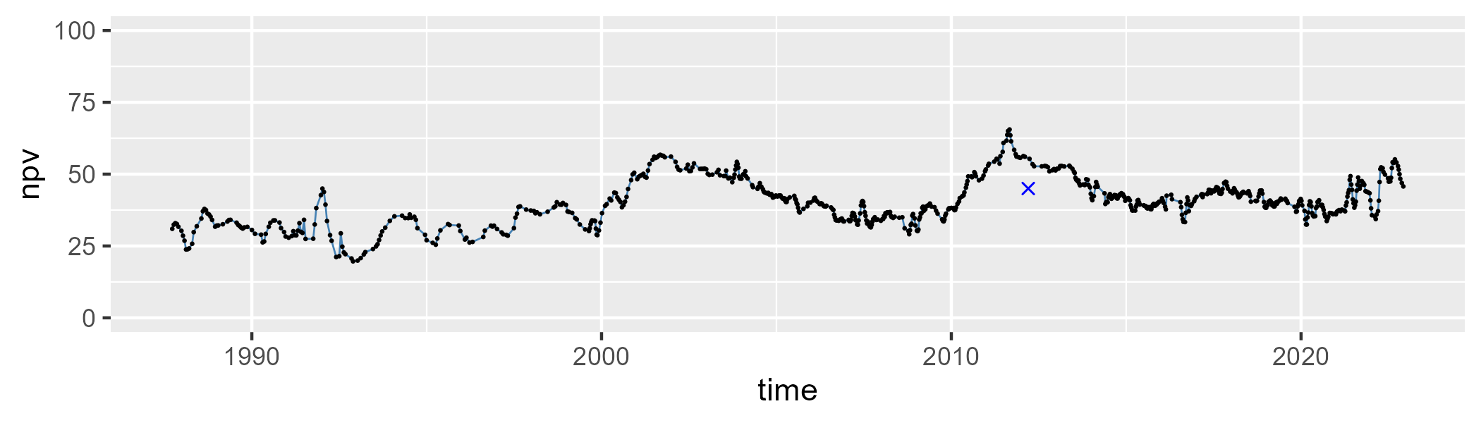

| Min. | 1st Qu. | Median | Mean | 3rd Qu. | Max. |
| --- | --- | --- | --- | --- | --- |
| 10.33598 | 37.70333 | 45.7026 | 44.54582 | 52.0317 | 70.30381 |

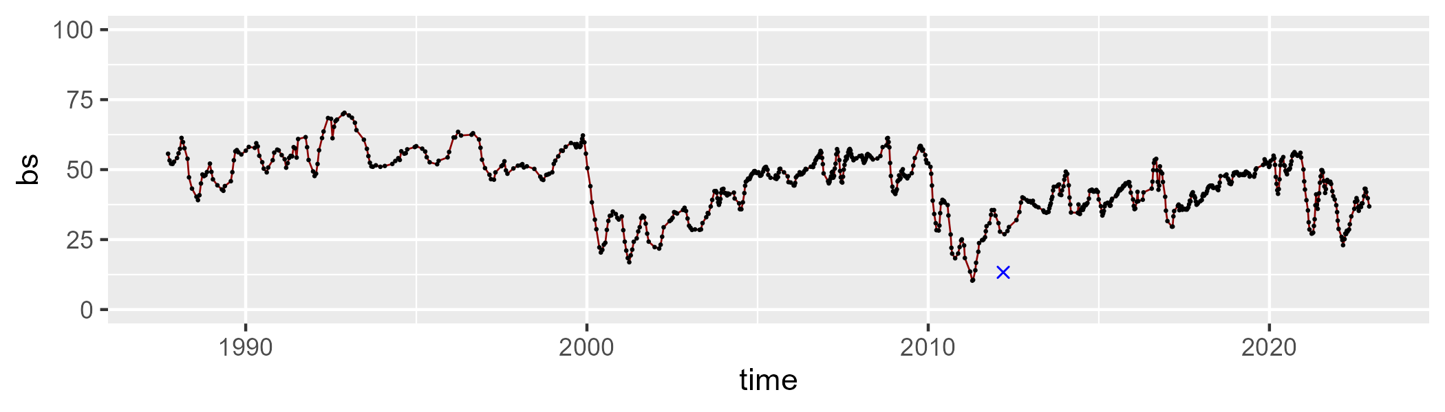

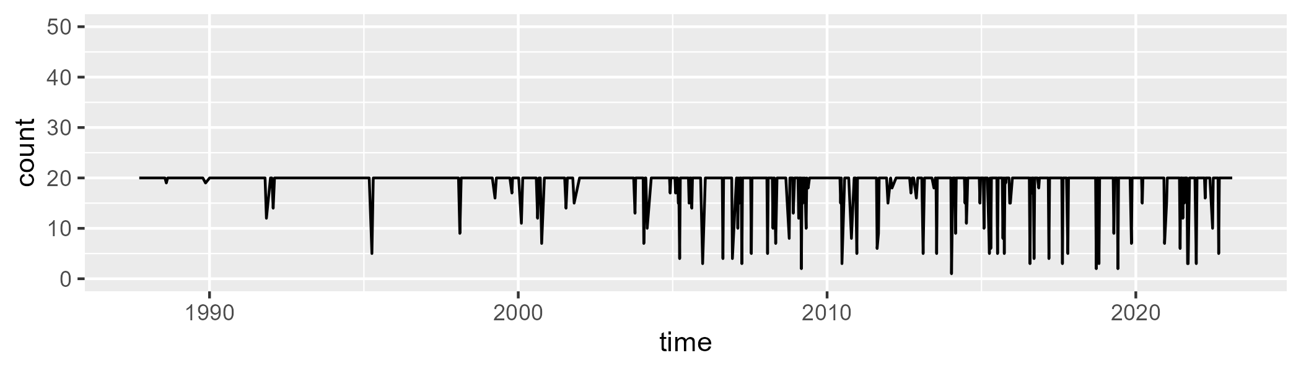

Min. : 1.00 1st Qu.:20.00 Median :20.00 Mean :18.83 3rd Qu.:20.00 Max. :20.00

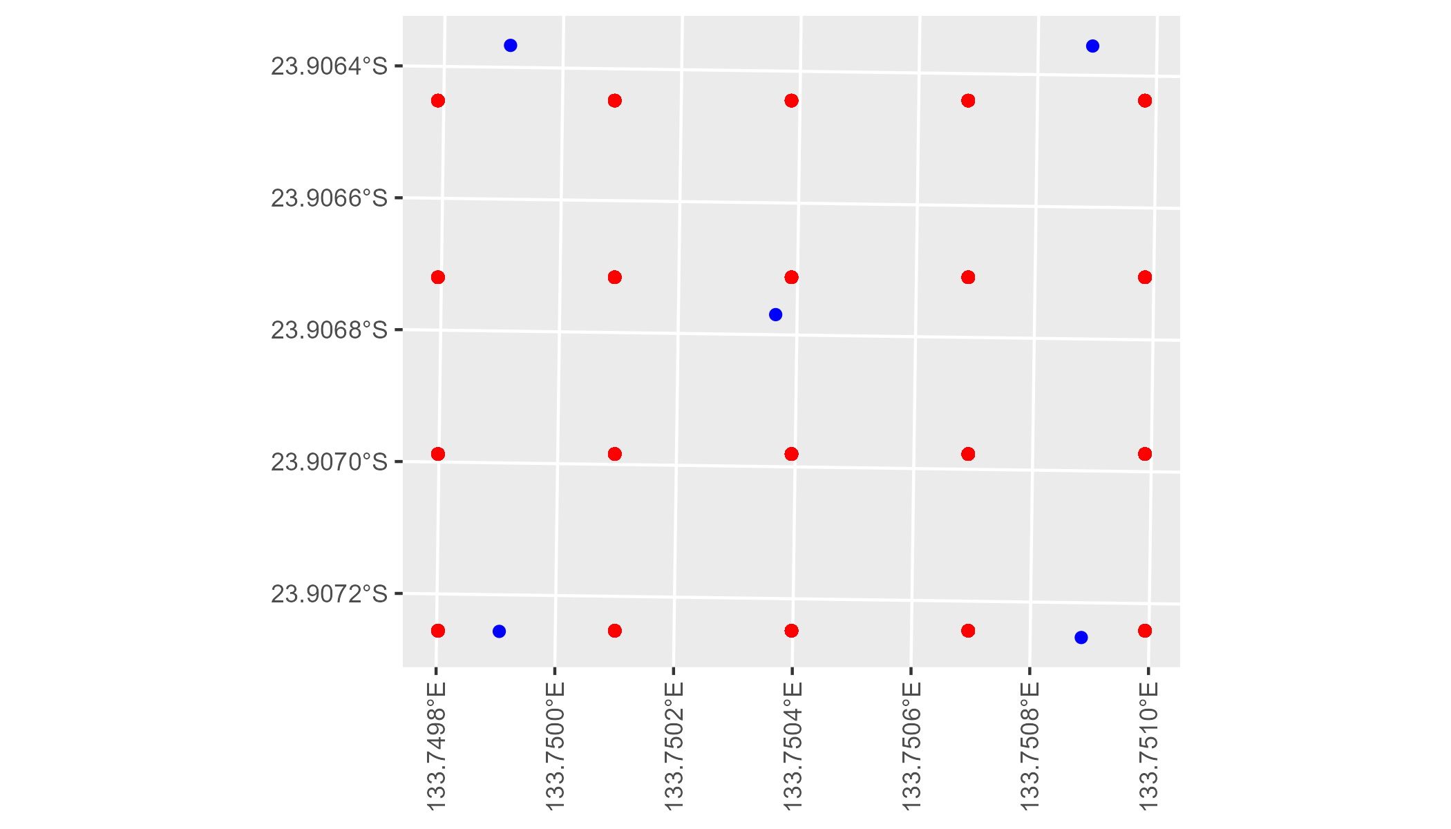

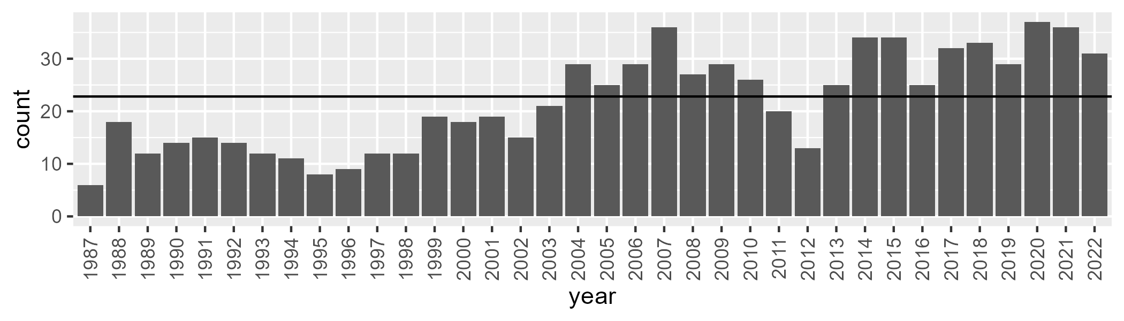

Number of samples: 785

# NTAFIN0027

| Min. | 1st Qu. | Median | Mean | 3rd Qu. | Max. |
| --- | --- | --- | --- | --- | --- |
| 0.5825566 | 6.606335 | 8.955766 | 10.14977 | 12.15846 | 35.41436 |

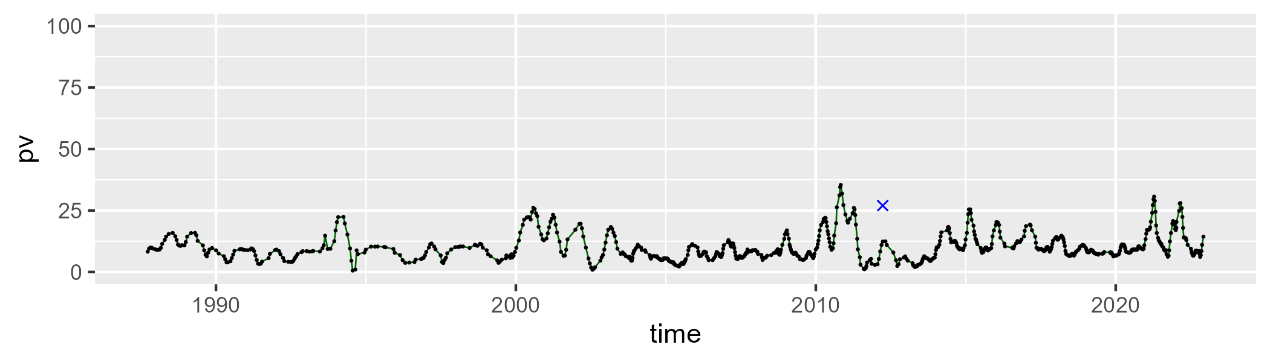

| Min. | 1st Qu. | Median | Mean | 3rd Qu. | Max. |
| --- | --- | --- | --- | --- | --- |
| 0 | 10.3711 | 22.22396 | 21.68841 | 29.28467 | 63.19809 |

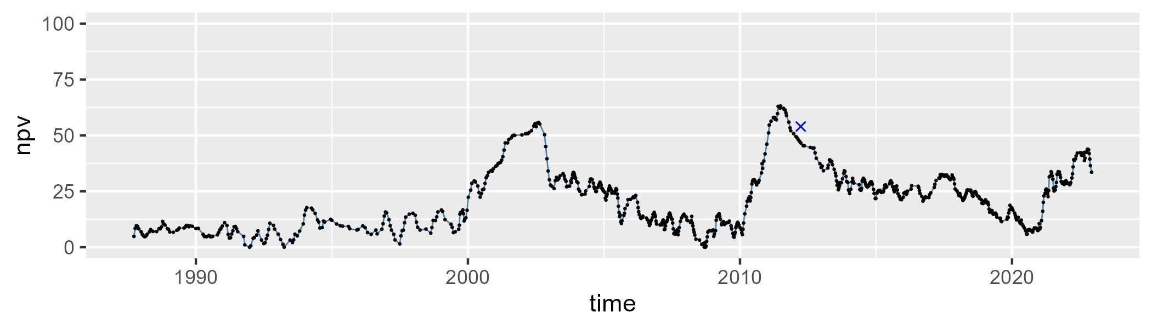

| Min. | 1st Qu. | Median | Mean | 3rd Qu. | Max. |
| --- | --- | --- | --- | --- | --- |
| 14.7578 | 57.07214 | 66.55961 | 66.64775 | 79.27723 | 93.12436 |

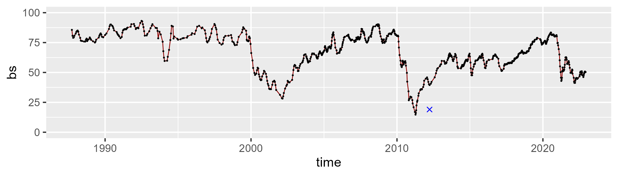

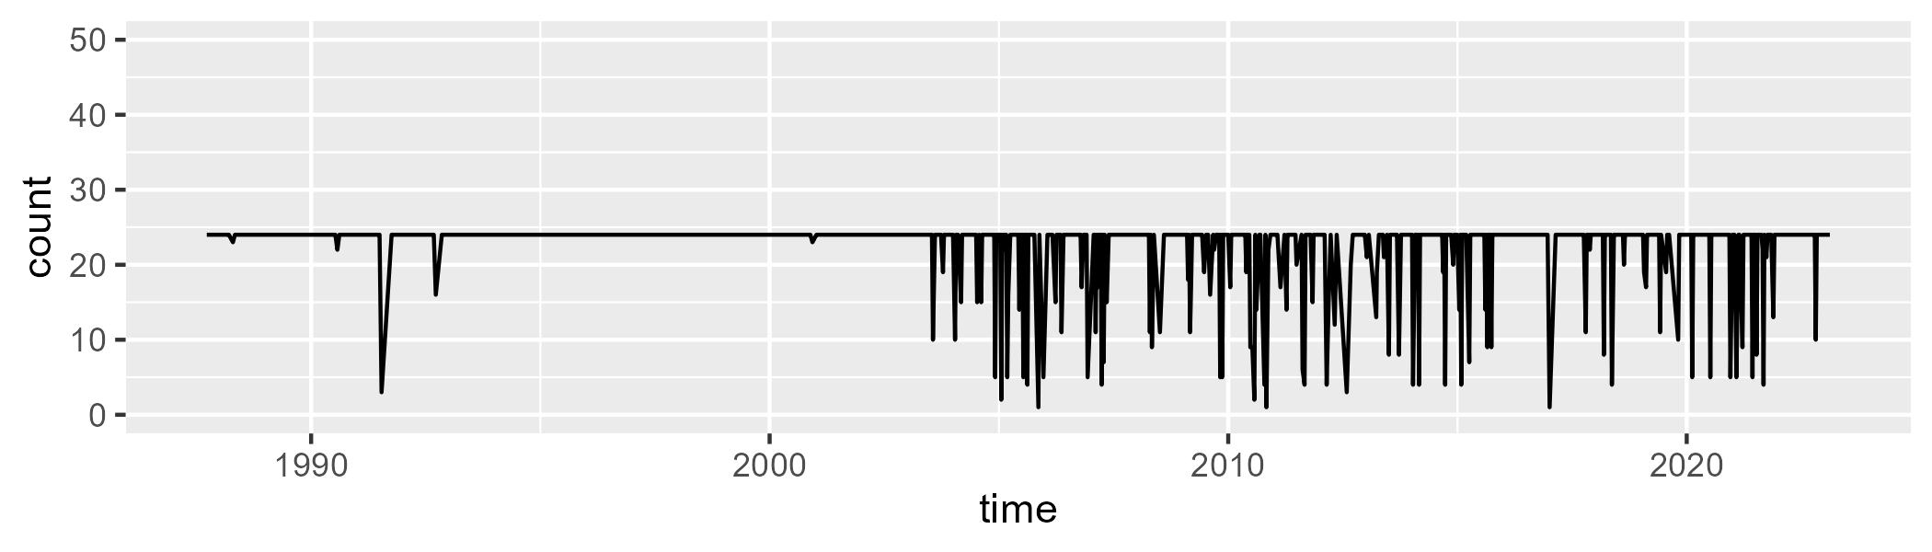

Min. : 1.00 1st Qu.:24.00 Median :24.00 Mean :22.42 3rd Qu.:24.00 Max. :24.00

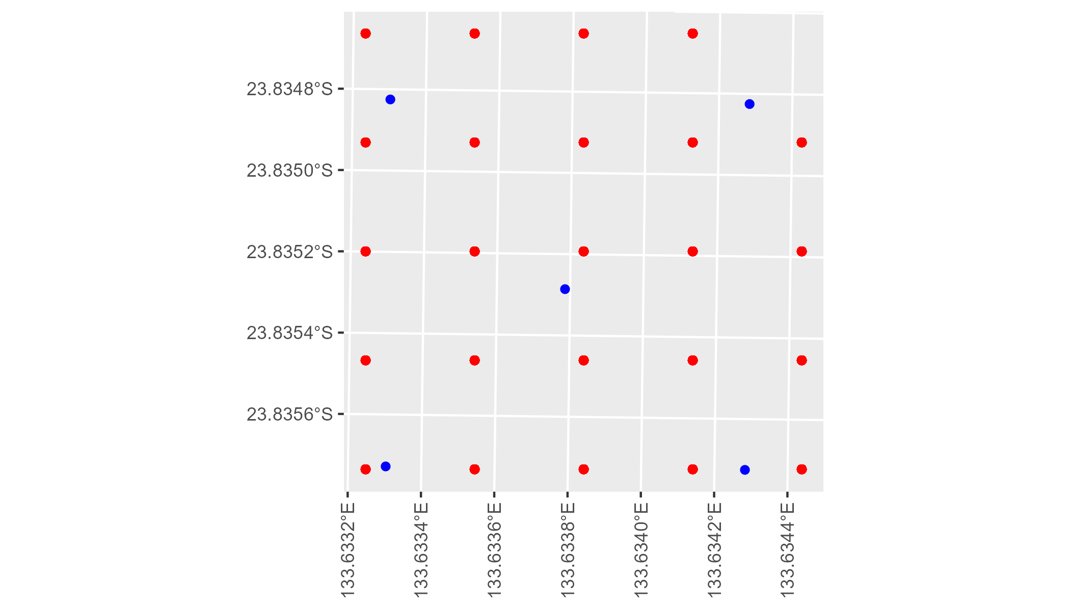

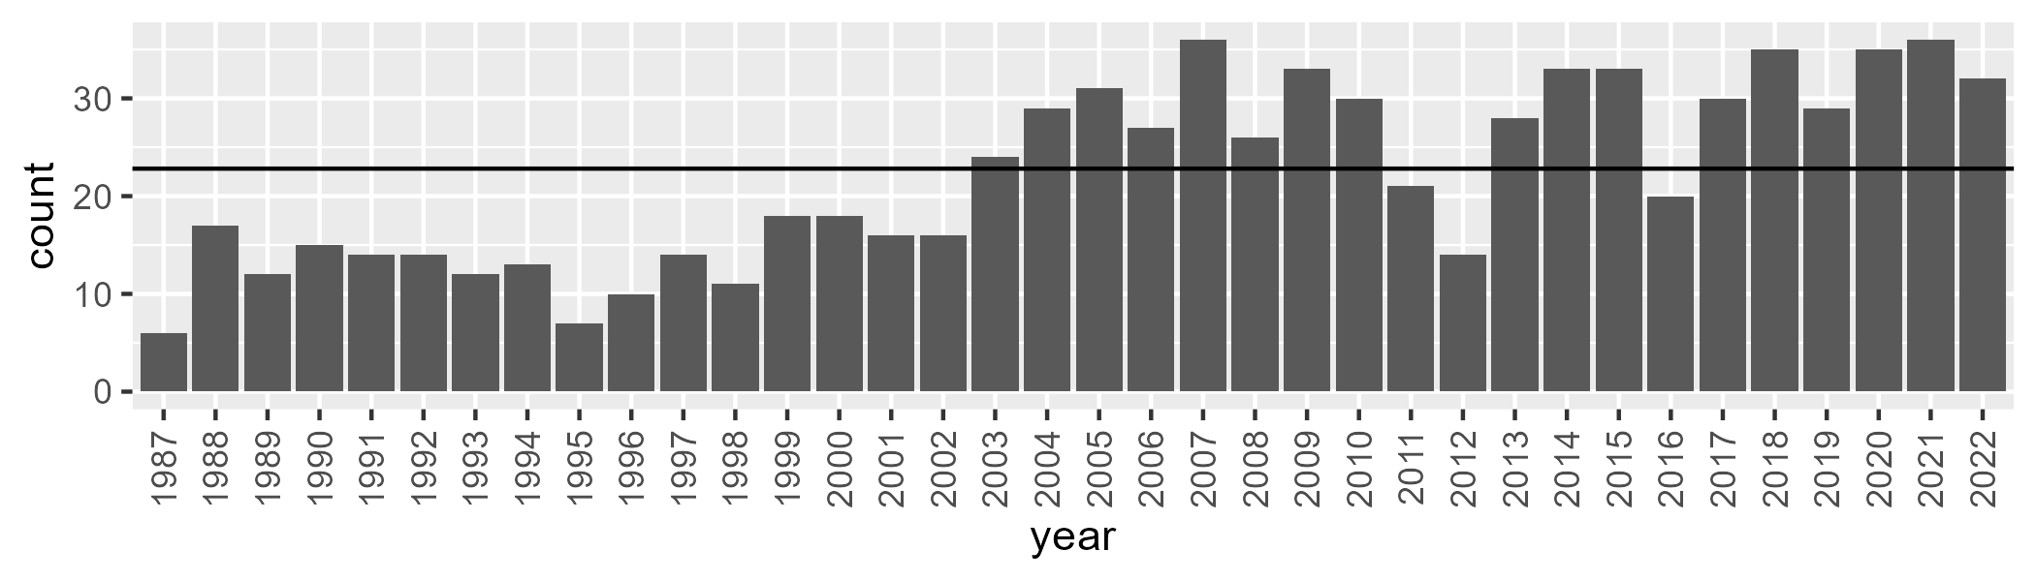

Number of samples: 795

# NTAFIN0028

| Min. | 1st Qu. | Median | Mean | 3rd Qu. | Max. |
| --- | --- | --- | --- | --- | --- |
| 3.119862 | 7.529749 | 8.856714 | 9.325689 | 10.69462 | 20.42449 |

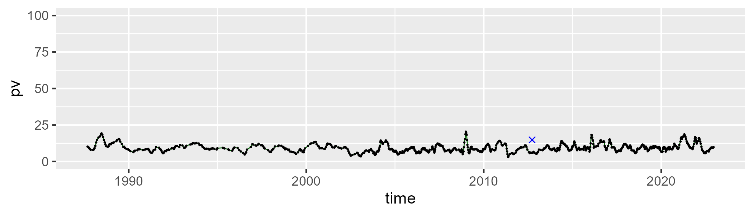

| Min. | 1st Qu. | Median | Mean | 3rd Qu. | Max. |
| --- | --- | --- | --- | --- | --- |
| 5.30746 | 18.03017 | 22.68453 | 22.75468 | 27.1406 | 45.63263 |

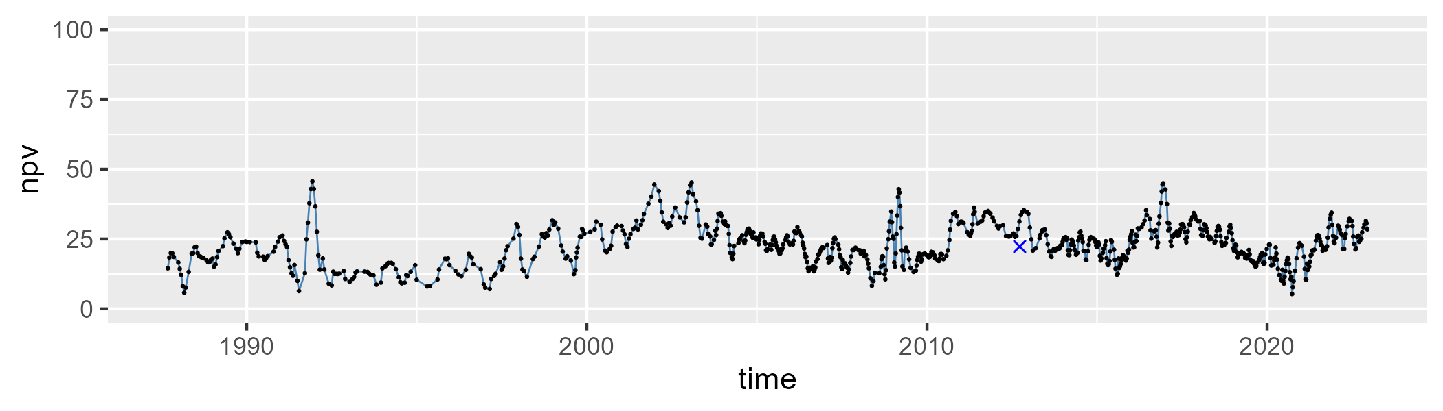

| Min. | 1st Qu. | Median | Mean | 3rd Qu. | Max. |
| --- | --- | --- | --- | --- | --- |
| 44.27436 | 61.44921 | 66.59161 | 66.29851 | 71.38787 | 82.08435 |

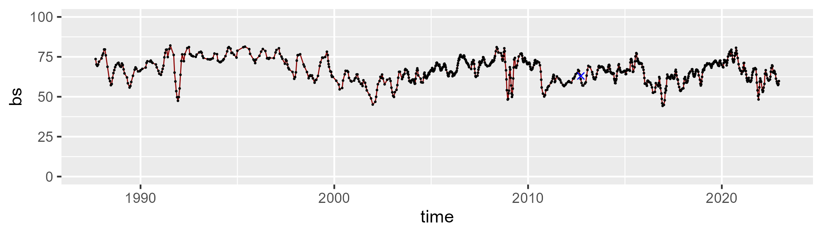

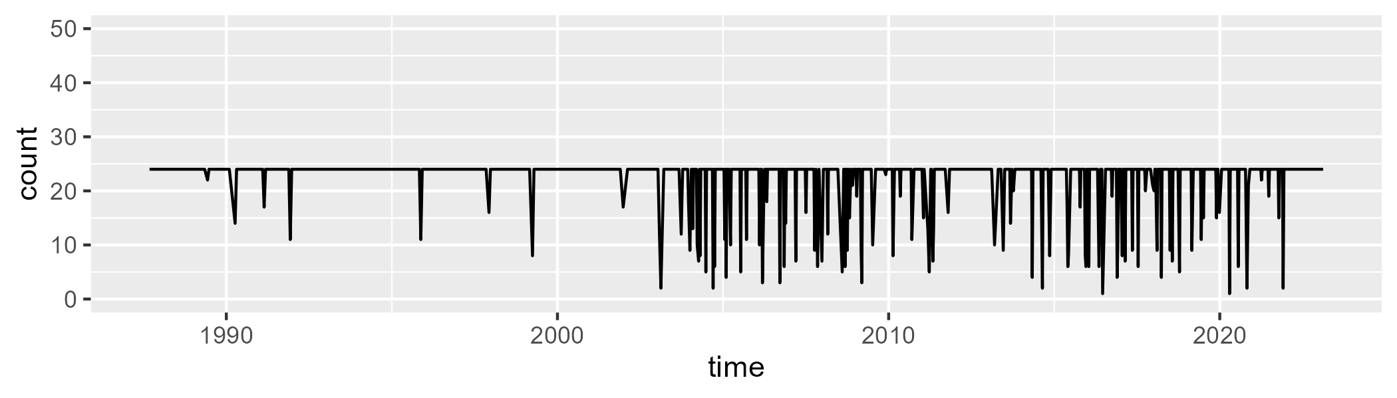

Min. : 1.00 1st Qu.:24.00 Median :24.00 Mean :22.45 3rd Qu.:24.00 Max. :24.00

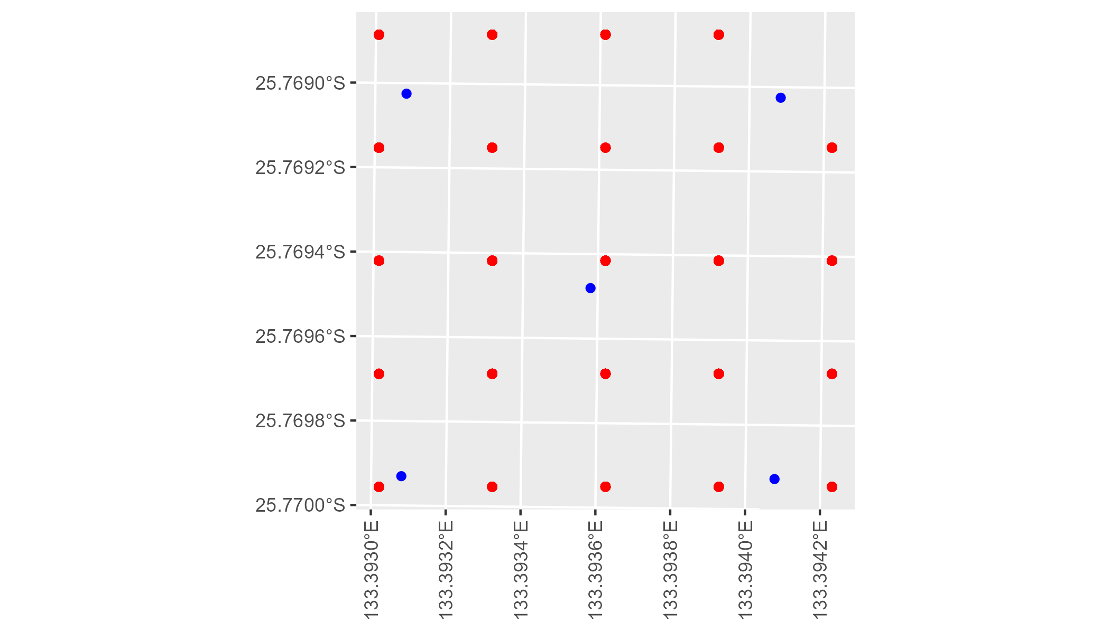

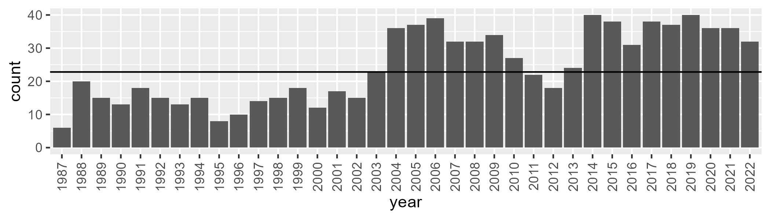

Number of samples: 876

# NTAFIN0029

| Min. | 1st Qu. | Median | Mean | 3rd Qu. | Max. |
| --- | --- | --- | --- | --- | --- |
| 0 | 4.002595 | 5.89079 | 7.399712 | 9.378707 | 36.61659 |

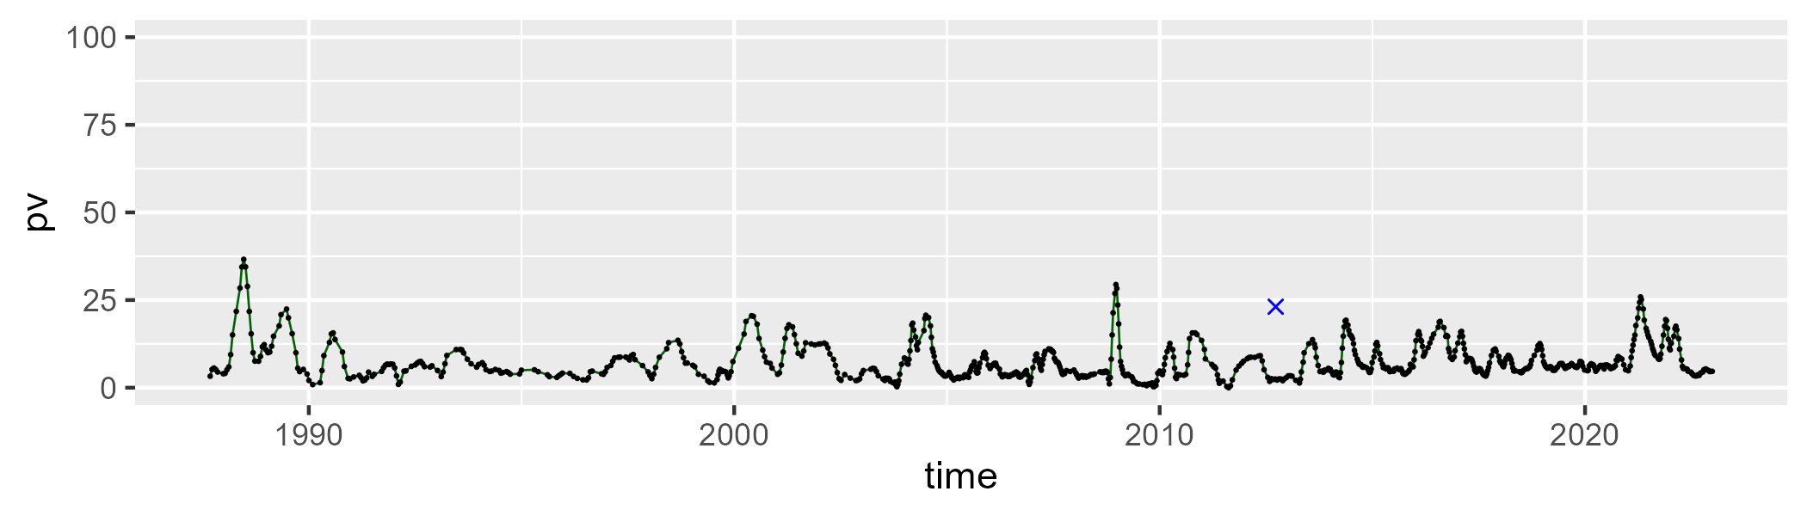

| Min. | 1st Qu. | Median | Mean | 3rd Qu. | Max. |
| --- | --- | --- | --- | --- | --- |
| 11.84909 | 25.29656 | 31.77409 | 31.29192 | 36.43971 | 55.97849 |

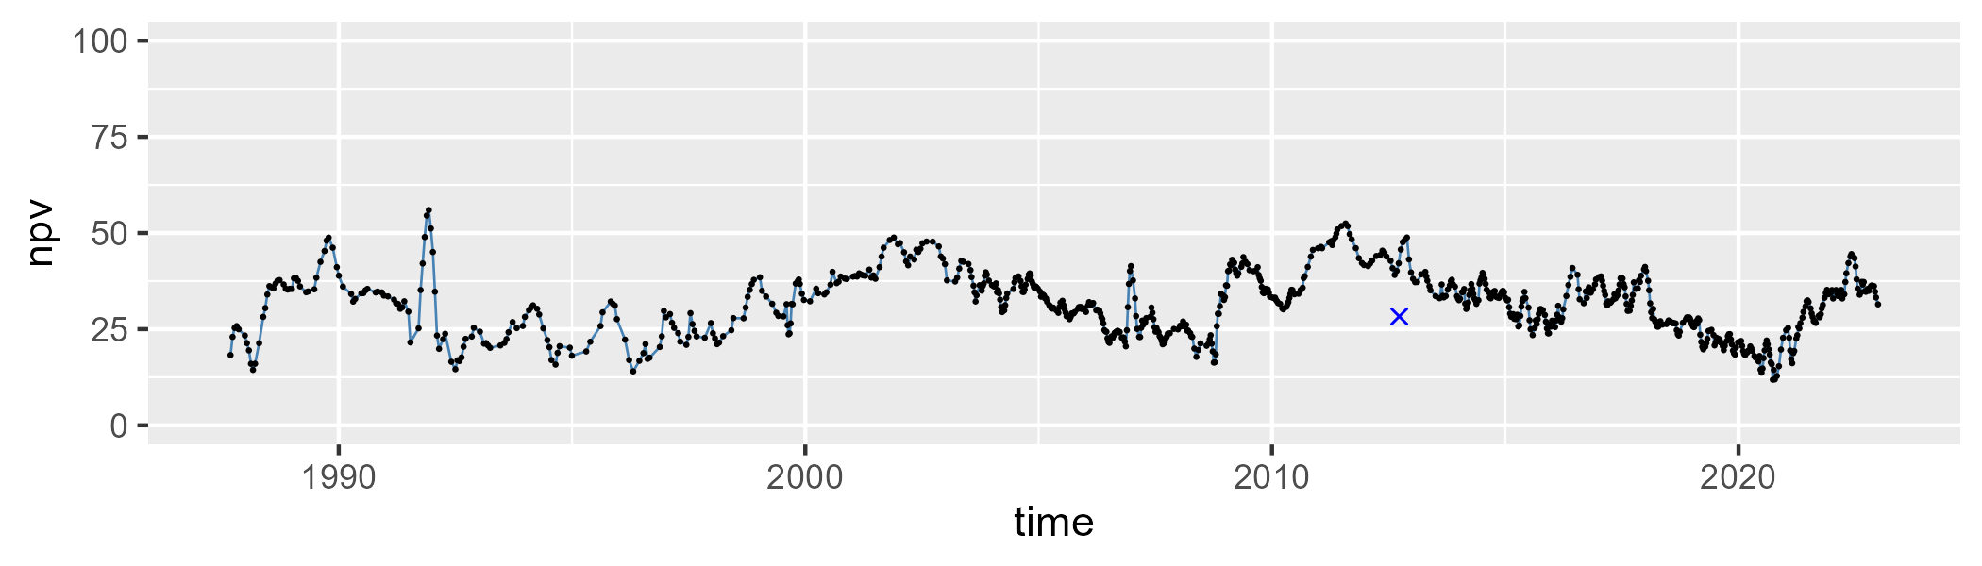

| Min. | 1st Qu. | Median | Mean | 3rd Qu. | Max. |
| --- | --- | --- | --- | --- | --- |
| 28.05555 | 53.35592 | 60.1007 | 59.76639 | 66.89578 | 81.83965 |

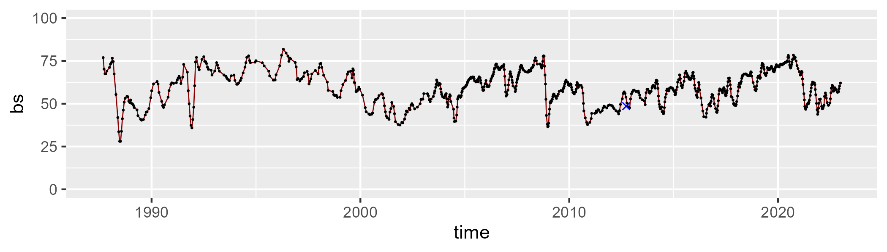

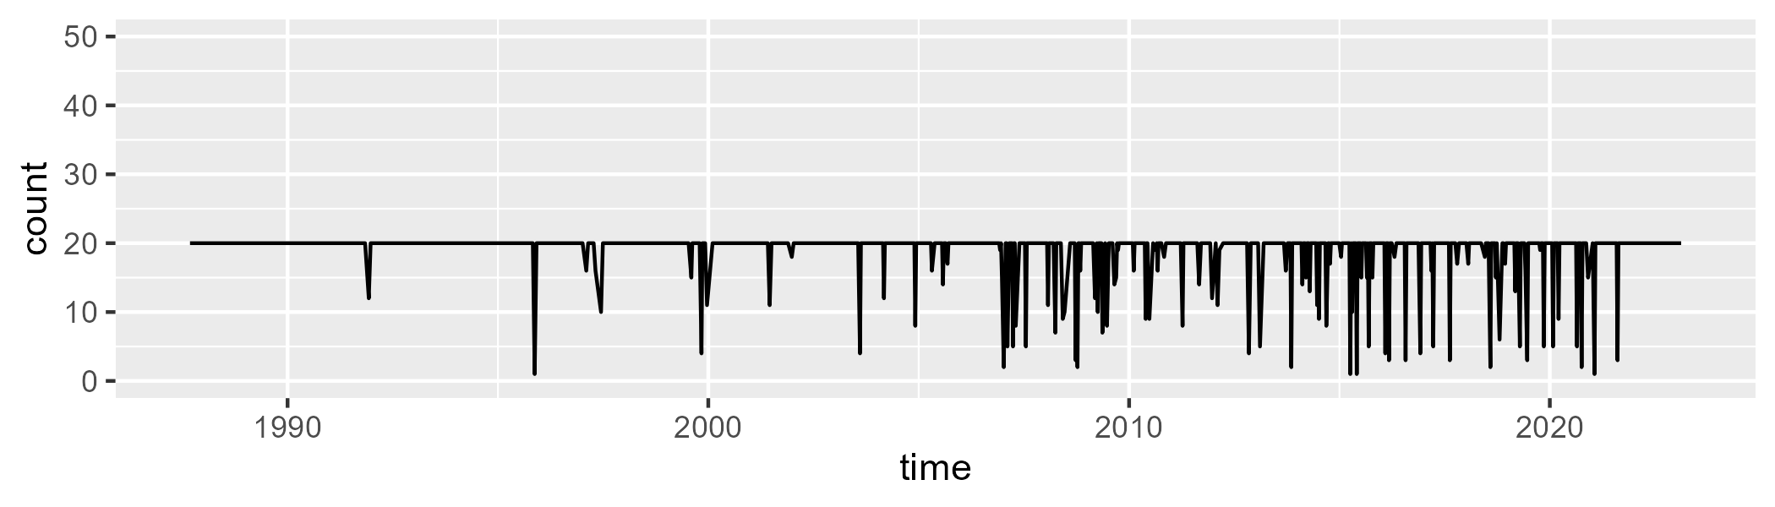

Min. : 1.00 1st Qu.:20.00 Median :20.00 Mean :18.91 3rd Qu.:20.00 Max. :20.00

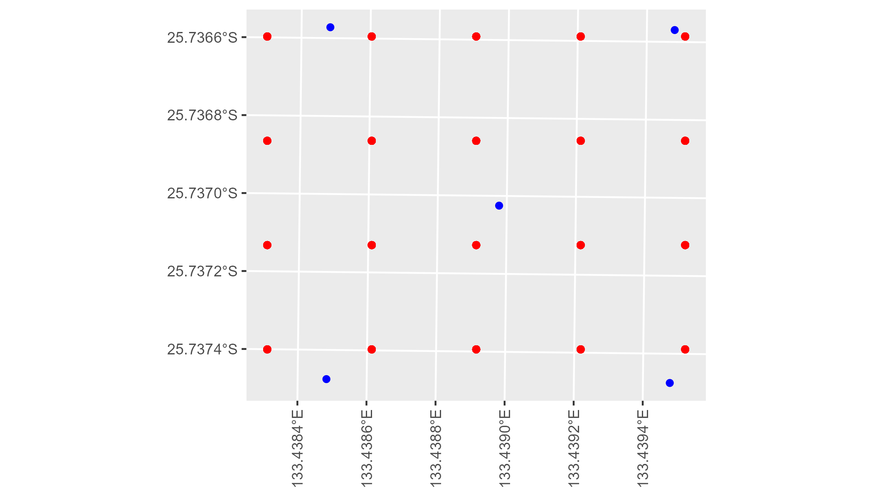

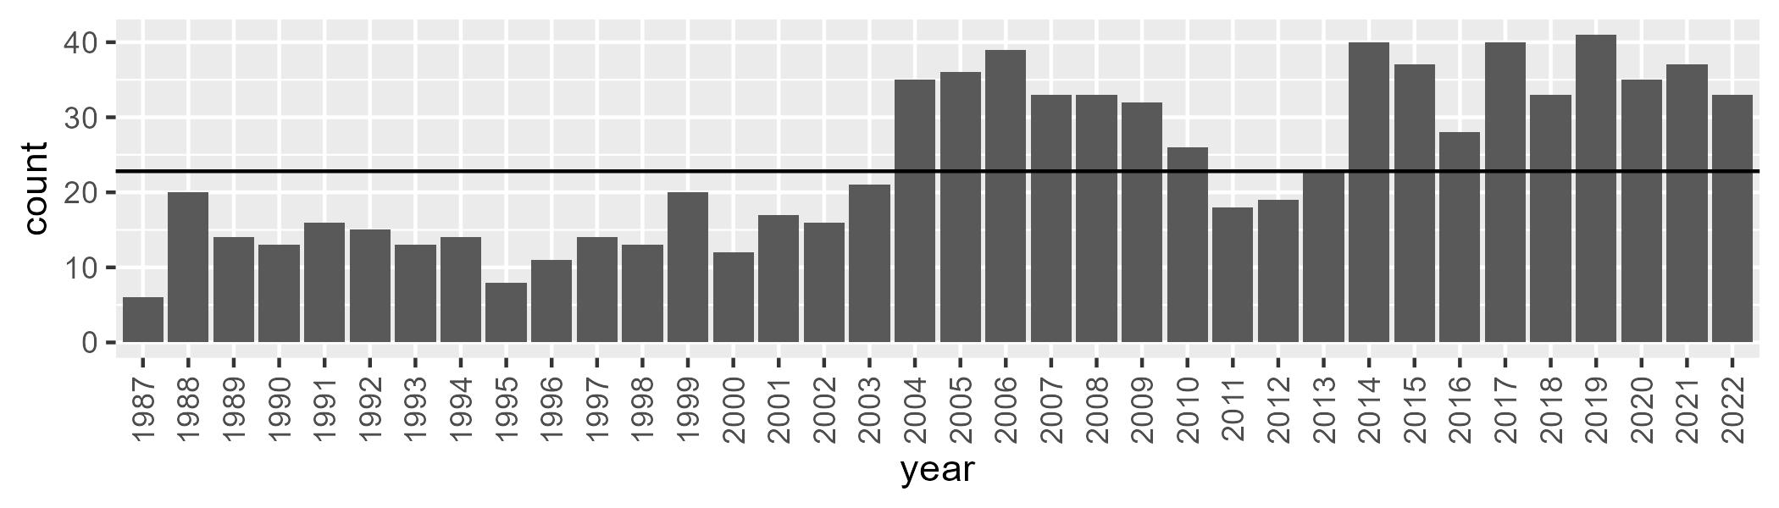

Number of samples: 861

# NTAFIN0030

| Min. | 1st Qu. | Median | Mean | 3rd Qu. | Max. |
| --- | --- | --- | --- | --- | --- |
| 2.809377 | 8.058893 | 10.52827 | 12.34169 | 15.06552 | 41.29601 |

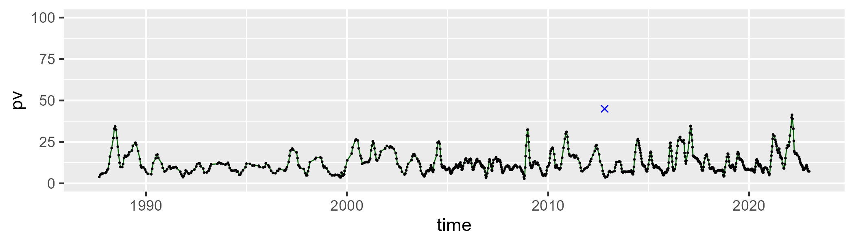

| Min. | 1st Qu. | Median | Mean | 3rd Qu. | Max. |
| --- | --- | --- | --- | --- | --- |
| 22.16642 | 39.72098 | 44.24225 | 43.74105 | 48.0399 | 58.40985 |

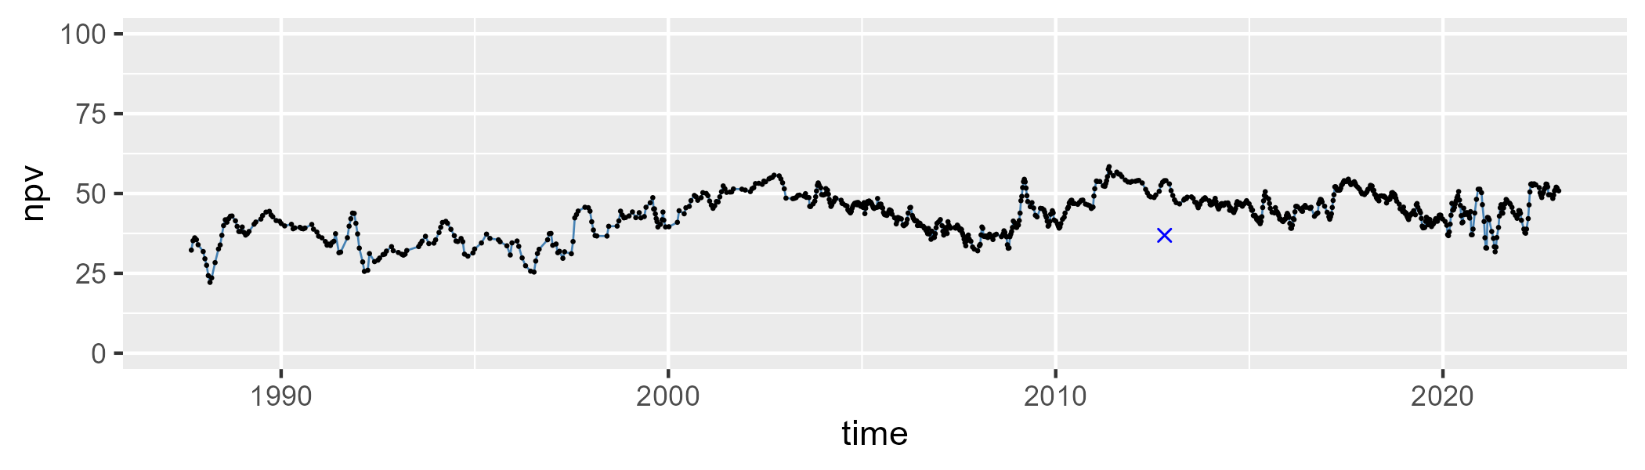

| Min. | 1st Qu. | Median | Mean | 3rd Qu. | Max. |
| --- | --- | --- | --- | --- | --- |
| 19.52596 | 36.73313 | 43.22949 | 42.51814 | 48.04599 | 67.06215 |

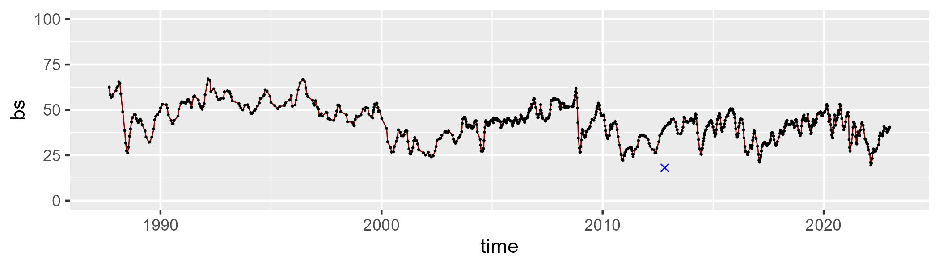

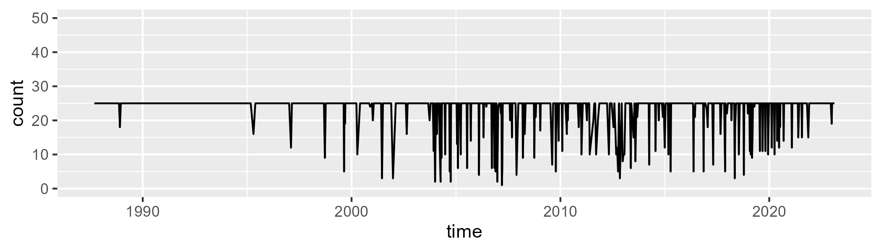

Min. : 1.00 1st Qu.:25.00 Median :25.00 Mean :23.27 3rd Qu.:25.00 Max. :25.00

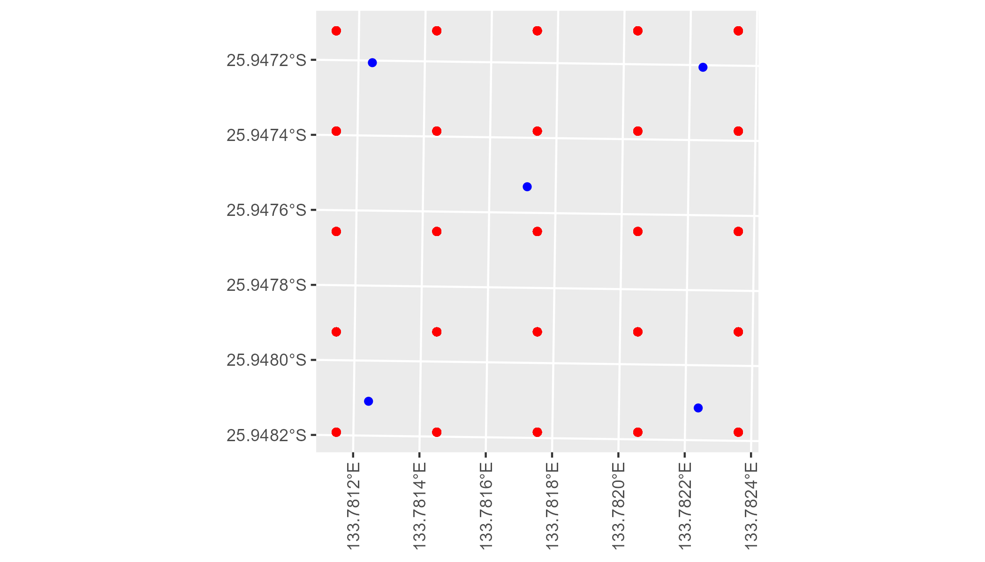

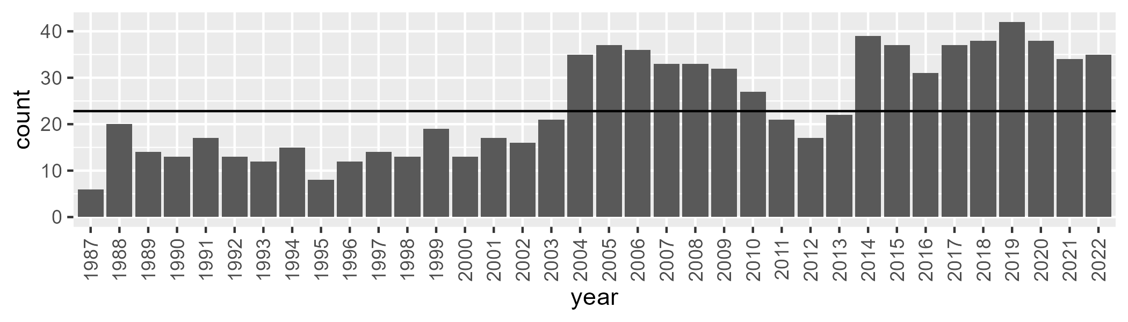

Number of samples: 867

# NTAFIN0031

| Min. | 1st Qu. | Median | Mean | 3rd Qu. | Max. |
| --- | --- | --- | --- | --- | --- |
| 0 | 0.8093357 | 1.635496 | 2.752536 | 3.533615 | 21.50282 |

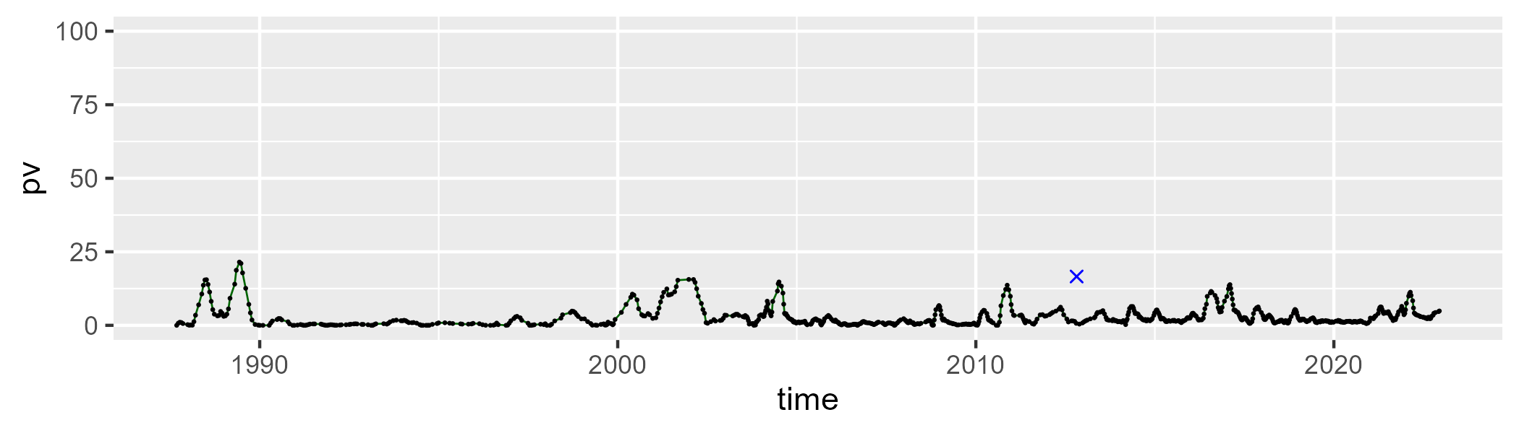

| Min. | 1st Qu. | Median | Mean | 3rd Qu. | Max. |
| --- | --- | --- | --- | --- | --- |
| 27.45849 | 43.05203 | 47.20955 | 47.81372 | 52.26684 | 66.54617 |

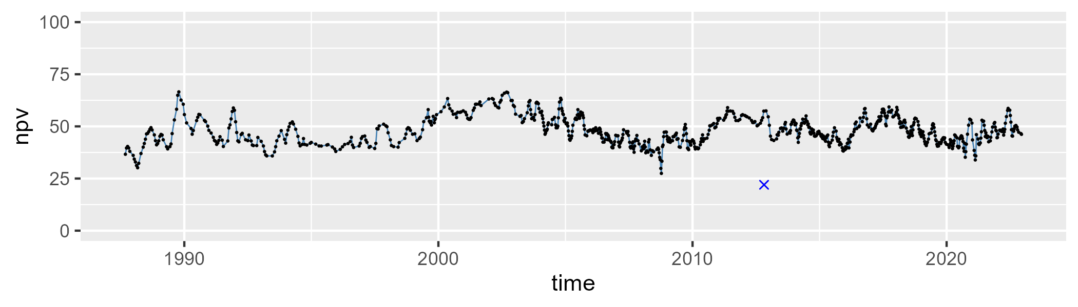

| Min. | 1st Qu. | Median | Mean | 3rd Qu. | Max. |
| --- | --- | --- | --- | --- | --- |
| 19.78552 | 42.2523 | 49.15493 | 48.17837 | 54.29454 | 71.18683 |

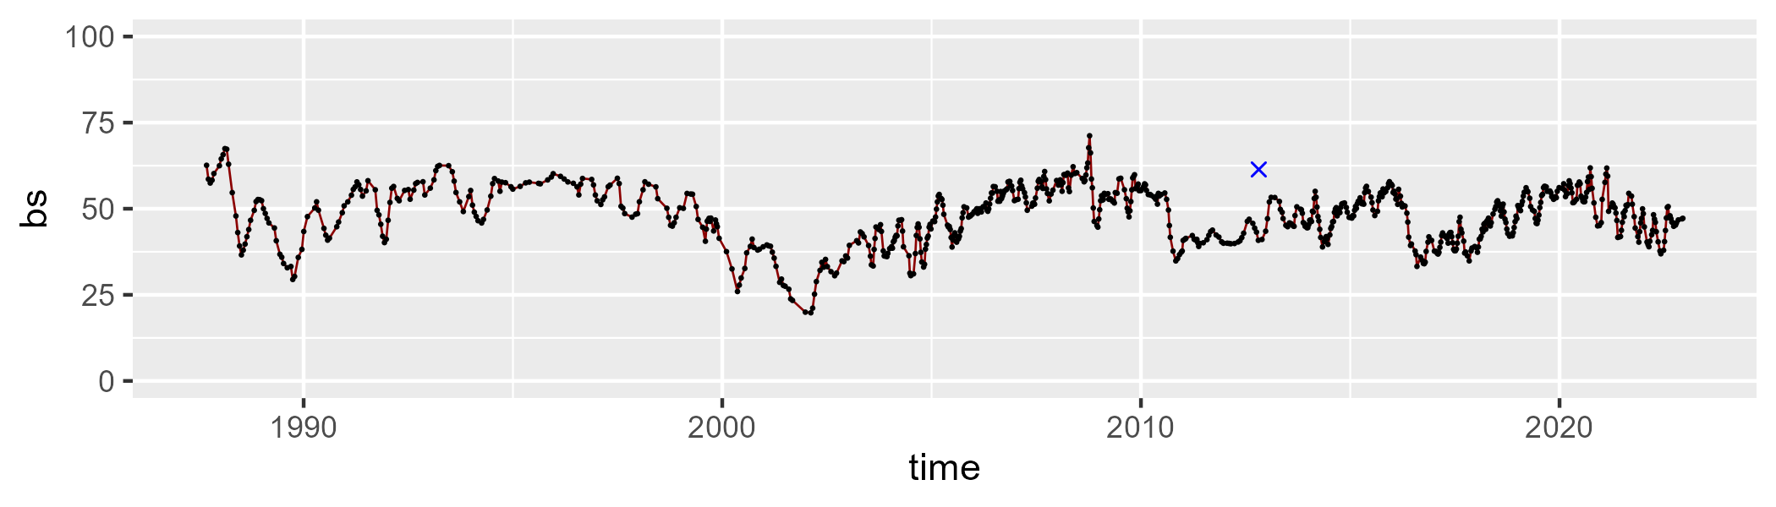

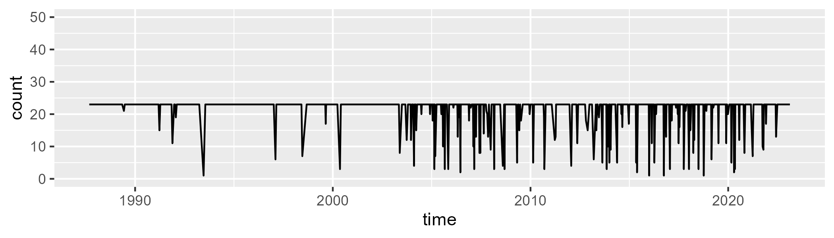

Min. : 1.00 1st Qu.:23.00 Median :23.00 Mean :21.46 3rd Qu.:23.00 Max. :23.00

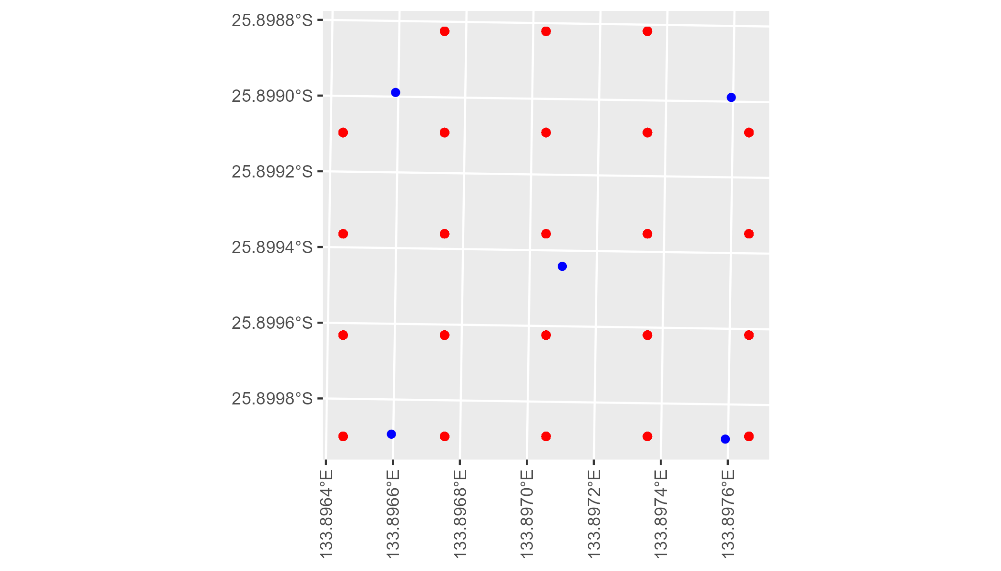

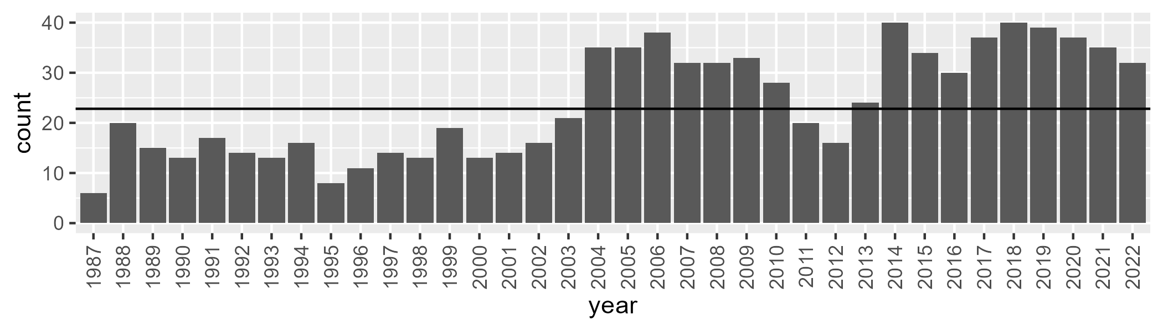

Number of samples: 860

# NTAFIN0032

| Min. | 1st Qu. | Median | Mean | 3rd Qu. | Max. |
| --- | --- | --- | --- | --- | --- |
| 3.493765 | 10.06347 | 12.52478 | 13.80071 | 16.27752 | 37.11454 |

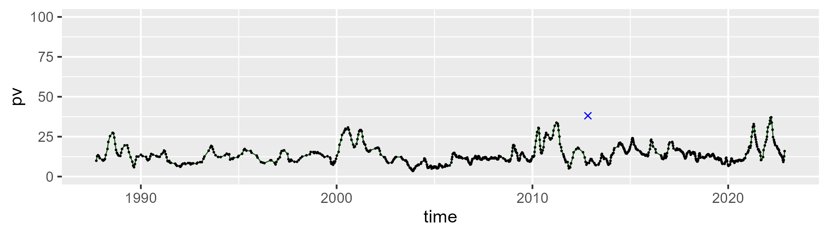

| Min. | 1st Qu. | Median | Mean | 3rd Qu. | Max. |
| --- | --- | --- | --- | --- | --- |
| 22.4396 | 33.57097 | 38.01919 | 38.19772 | 41.77307 | 63.5947 |

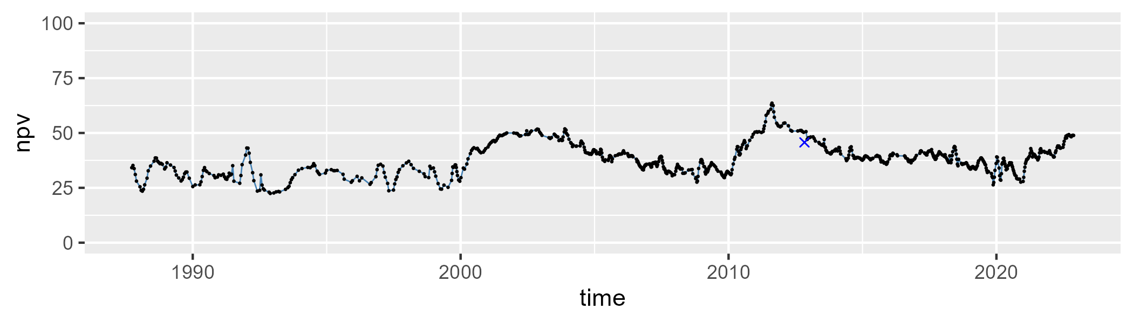

| Min. | 1st Qu. | Median | Mean | 3rd Qu. | Max. |
| --- | --- | --- | --- | --- | --- |
| 14.78263 | 40.51105 | 48.42897 | 46.5261 | 53.38262 | 67.25173 |

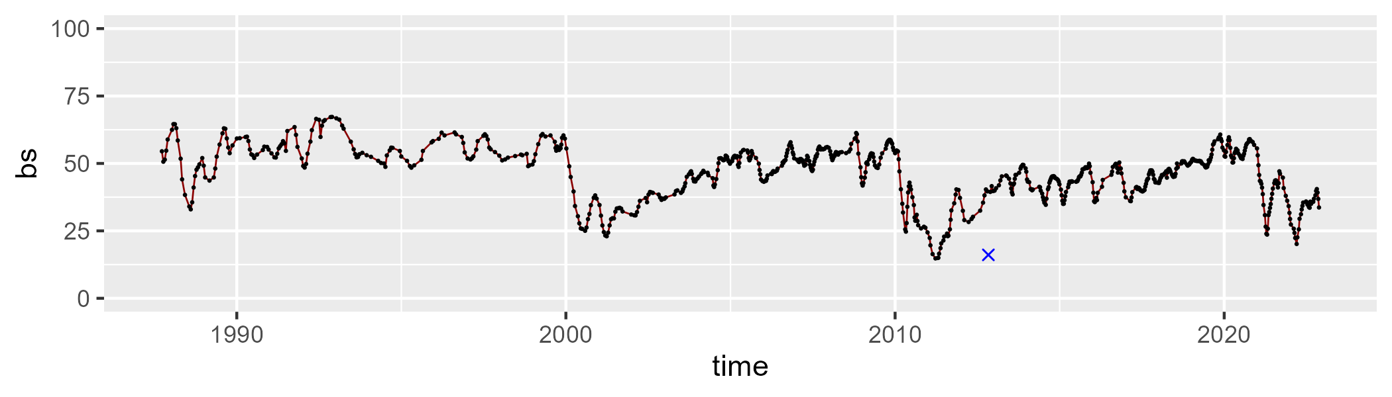

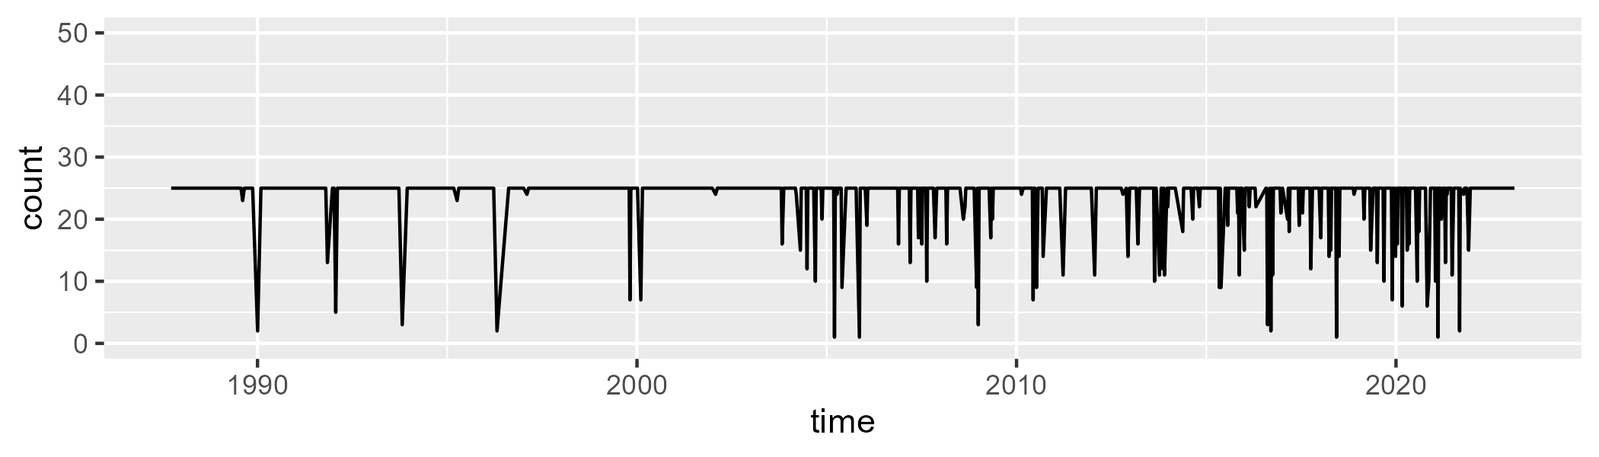

Min. : 1.00 1st Qu.:25.00 Median :25.00 Mean :23.65 3rd Qu.:25.00 Max. :25.00

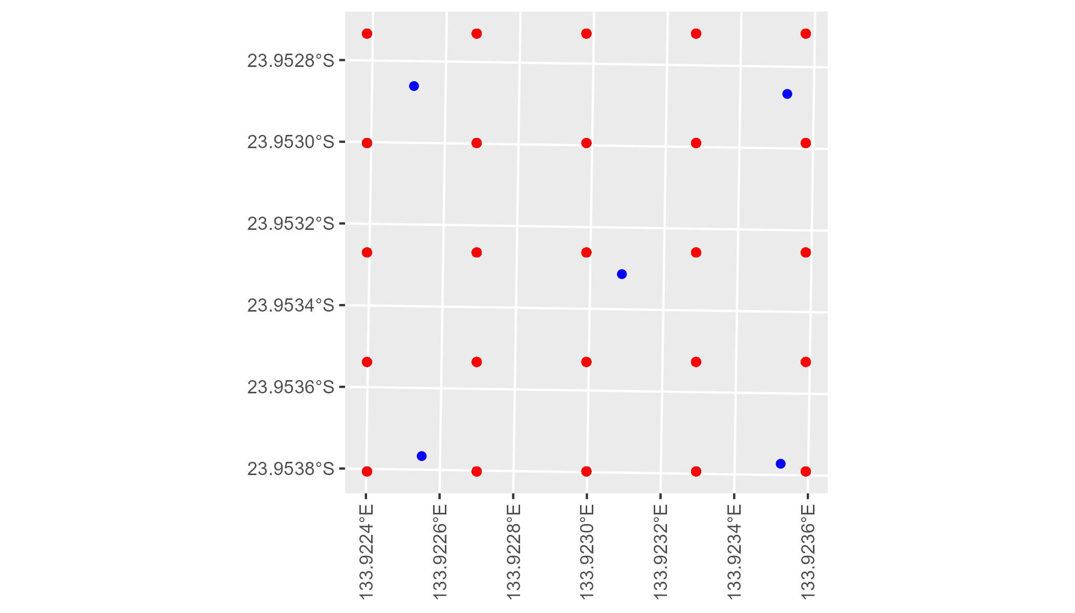

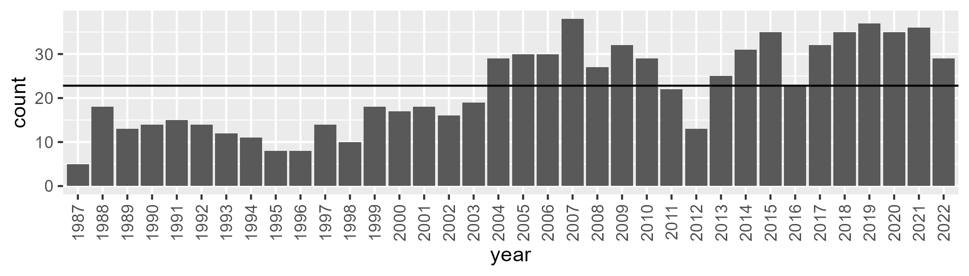

Number of samples: 798

# NTAFIN0033

| Min. | 1st Qu. | Median | Mean | 3rd Qu. | Max. |
| --- | --- | --- | --- | --- | --- |
| 5.491112 | 11.10185 | 13.73906 | 15.21881 | 17.61577 | 37.2375 |

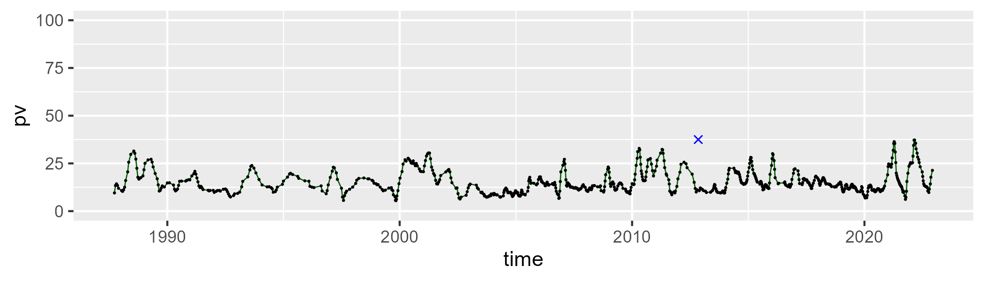

| Min. | 1st Qu. | Median | Mean | 3rd Qu. | Max. |
| --- | --- | --- | --- | --- | --- |
| 14.52239 | 29.01676 | 32.34773 | 33.26055 | 36.92858 | 55.66049 |

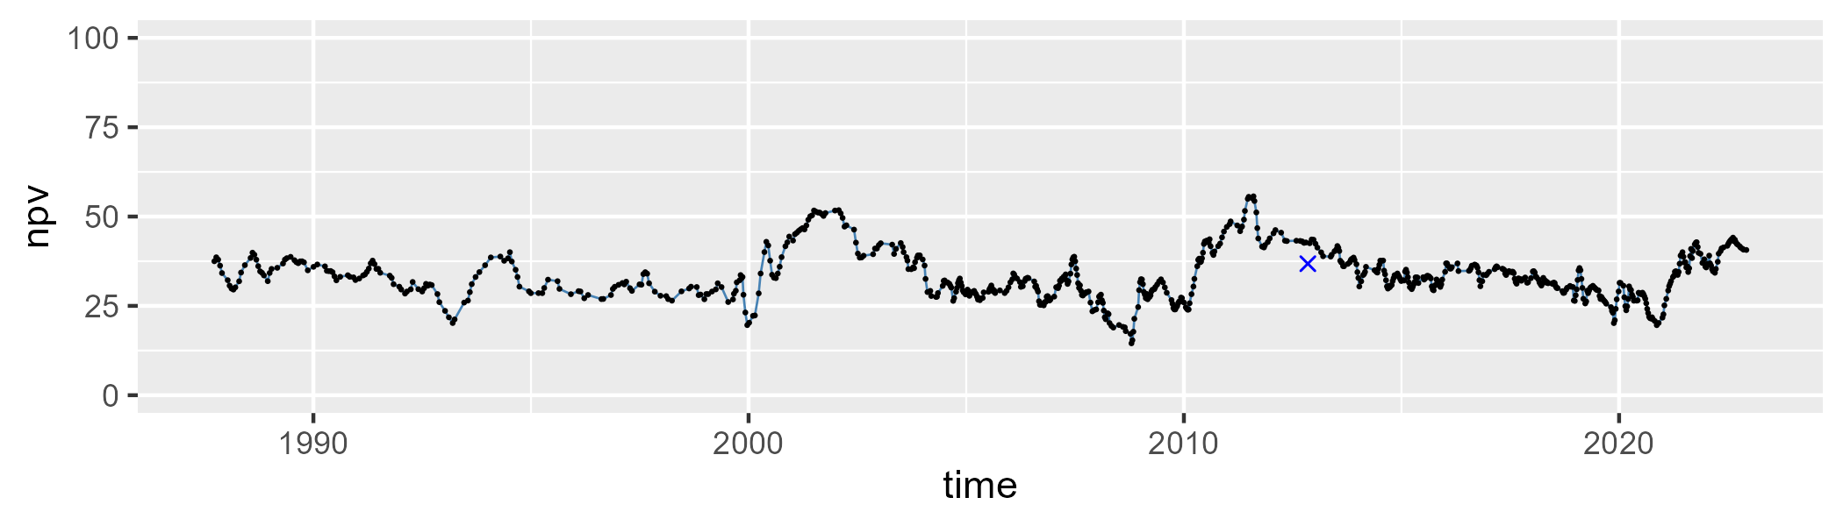

| Min. | 1st Qu. | Median | Mean | 3rd Qu. | Max. |
| --- | --- | --- | --- | --- | --- |
| 20.07844 | 44.95444 | 51.46593 | 50.01022 | 57.27609 | 73.11429 |

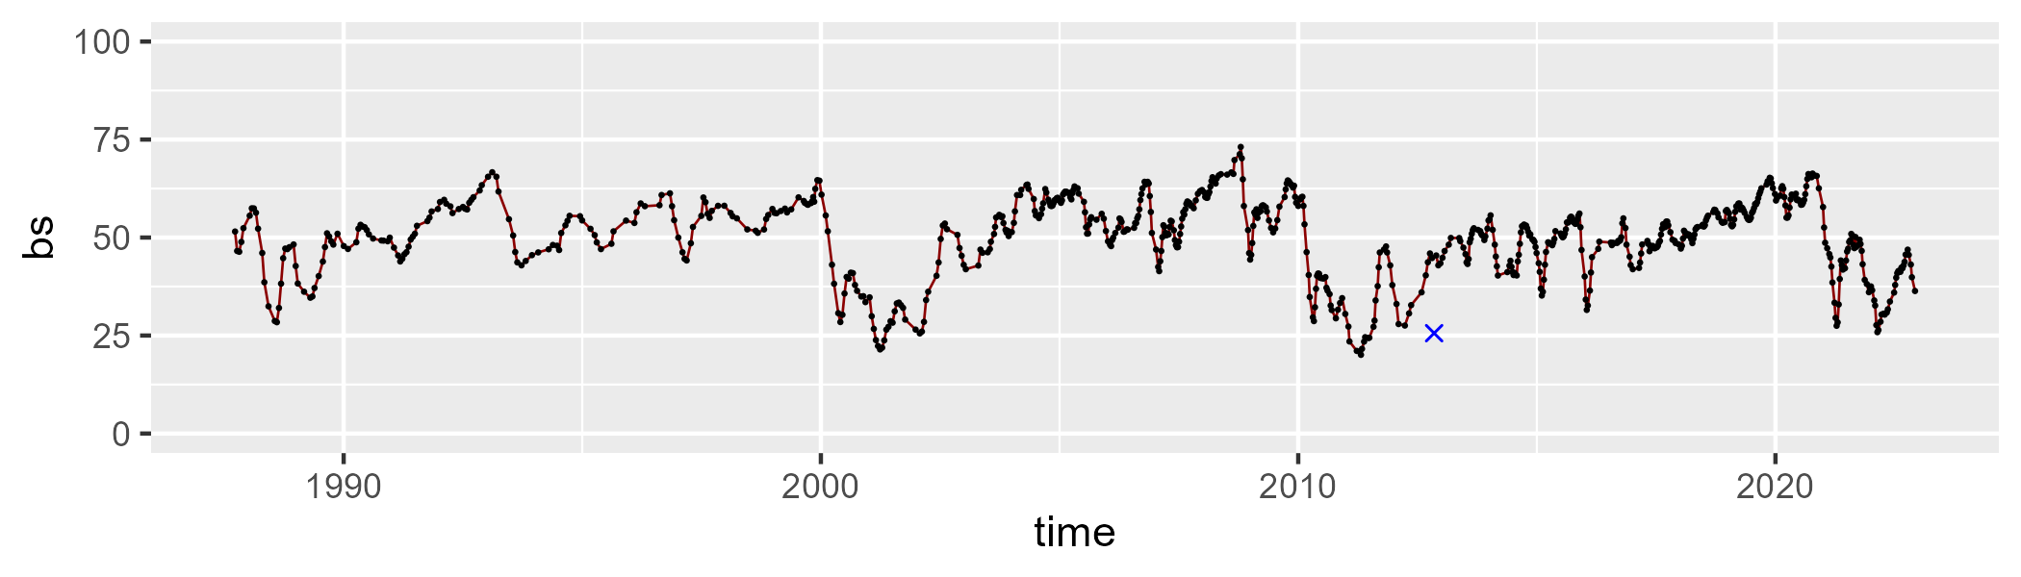

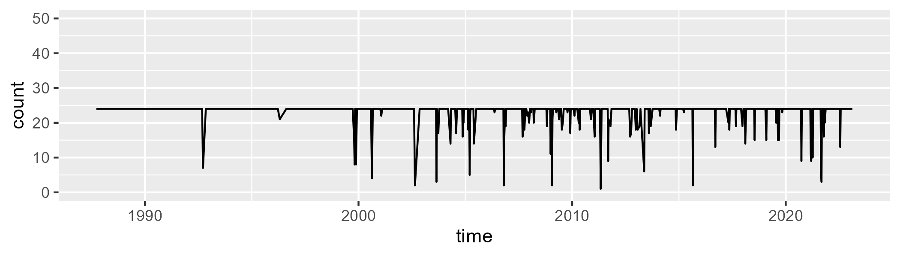

Min. : 1.00 1st Qu.:24.00 Median :24.00 Mean :23.11 3rd Qu.:24.00 Max. :24.00

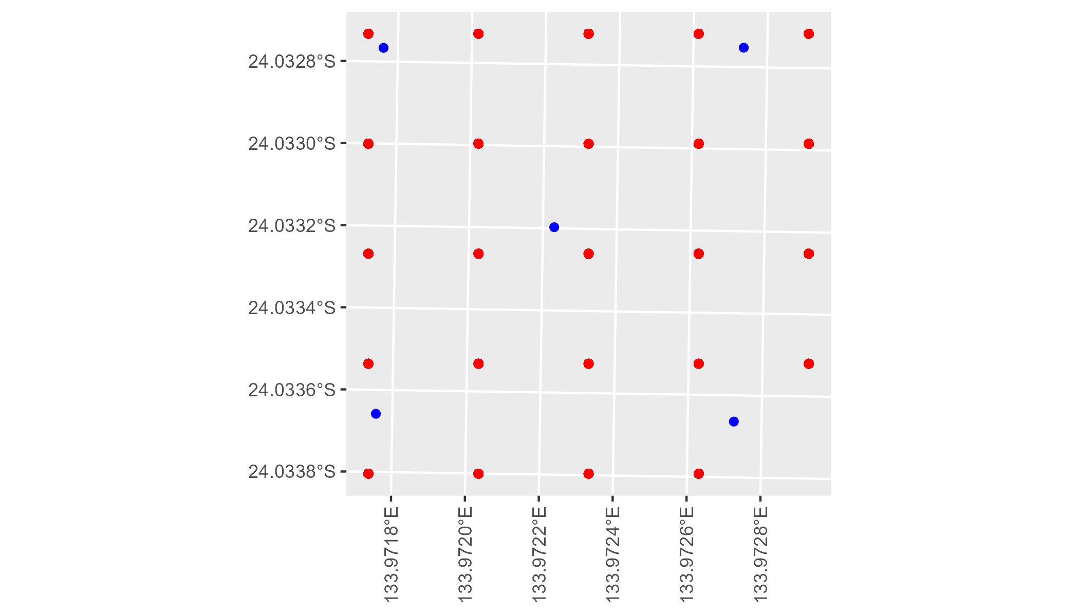

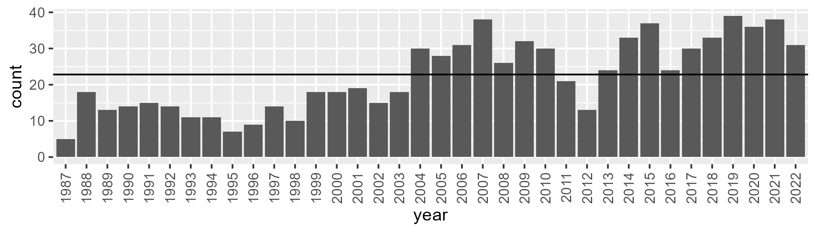

Number of samples: 803

# NTAGFU0001

| Min. | 1st Qu. | Median | Mean | 3rd Qu. | Max. |
| --- | --- | --- | --- | --- | --- |
| 0 | 8.68978 | 15.03699 | 16.14202 | 22.41342 | 47.76239 |

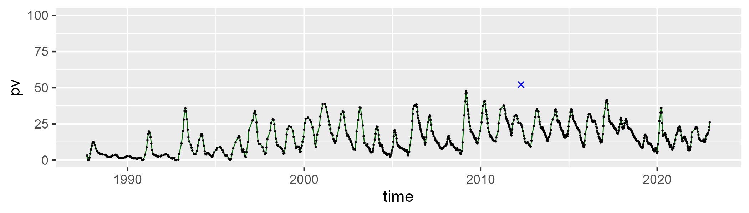

| Min. | 1st Qu. | Median | Mean | 3rd Qu. | Max. |
| --- | --- | --- | --- | --- | --- |
| 32.8494 | 50.54213 | 54.64455 | 55.15745 | 59.8662 | 79.89415 |

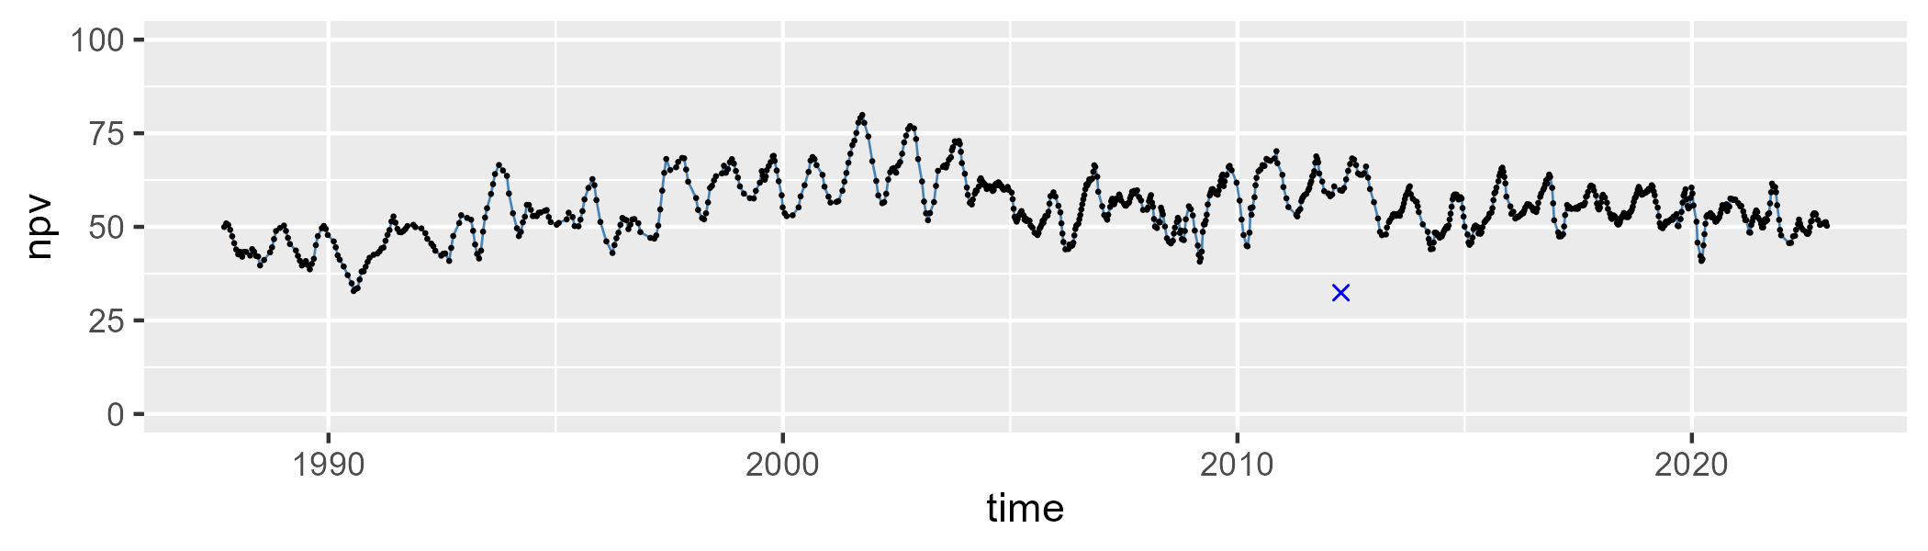

| Min. | 1st Qu. | Median | Mean | 3rd Qu. | Max. |
| --- | --- | --- | --- | --- | --- |
| 3.590627 | 19.54807 | 25.24218 | 27.40513 | 33.67814 | 65.11698 |

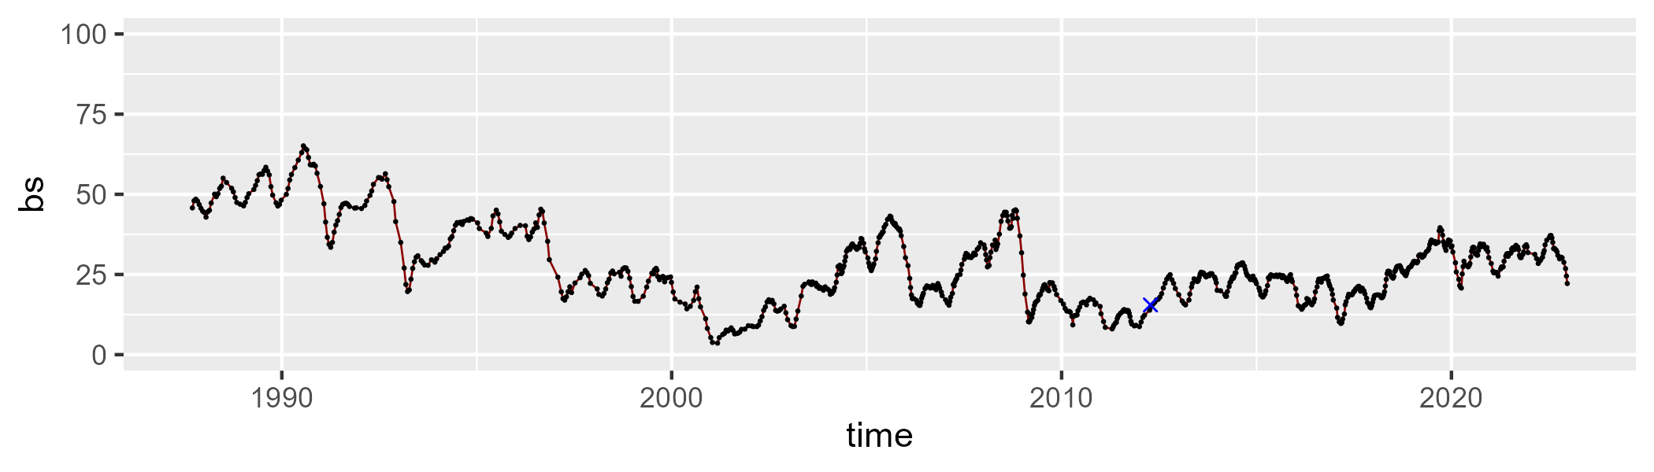

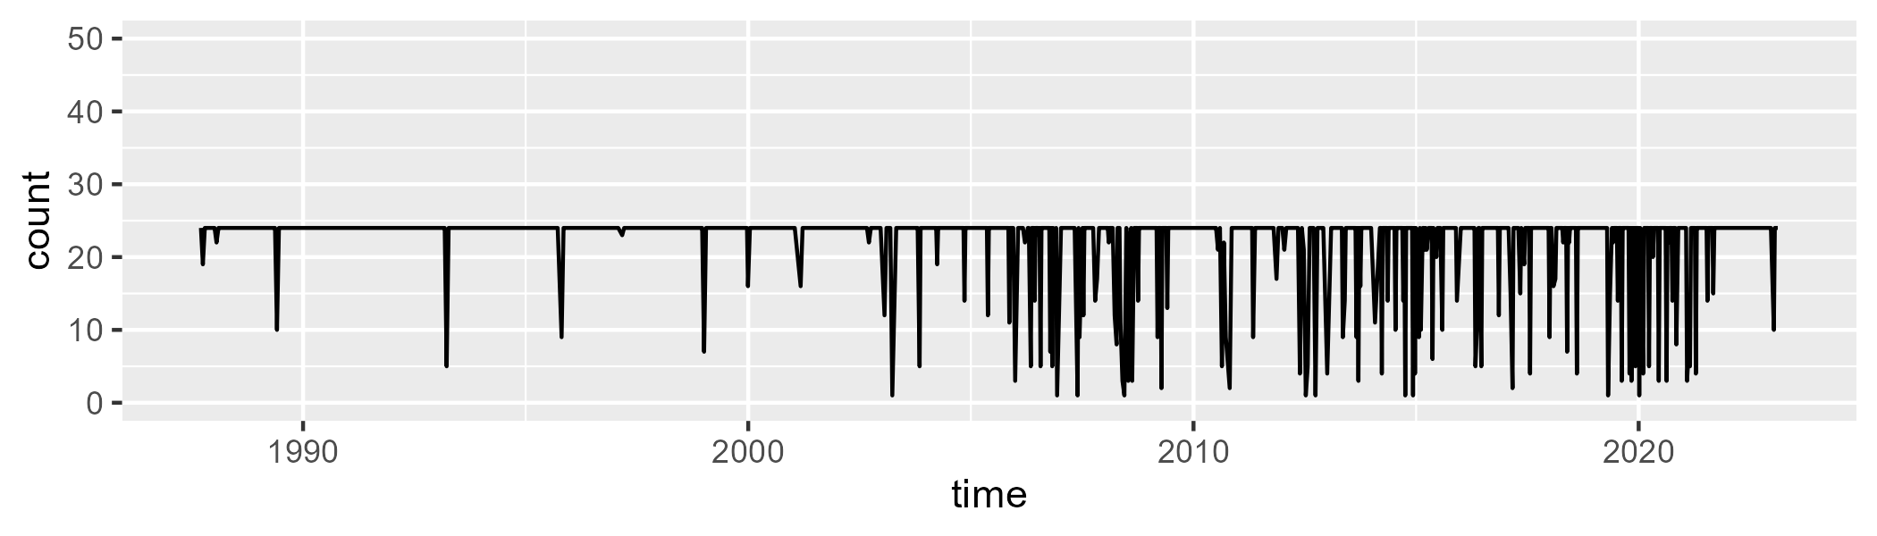

Min. : 1.00 1st Qu.:24.00 Median :24.00 Mean :22.23 3rd Qu.:24.00 Max. :24.00

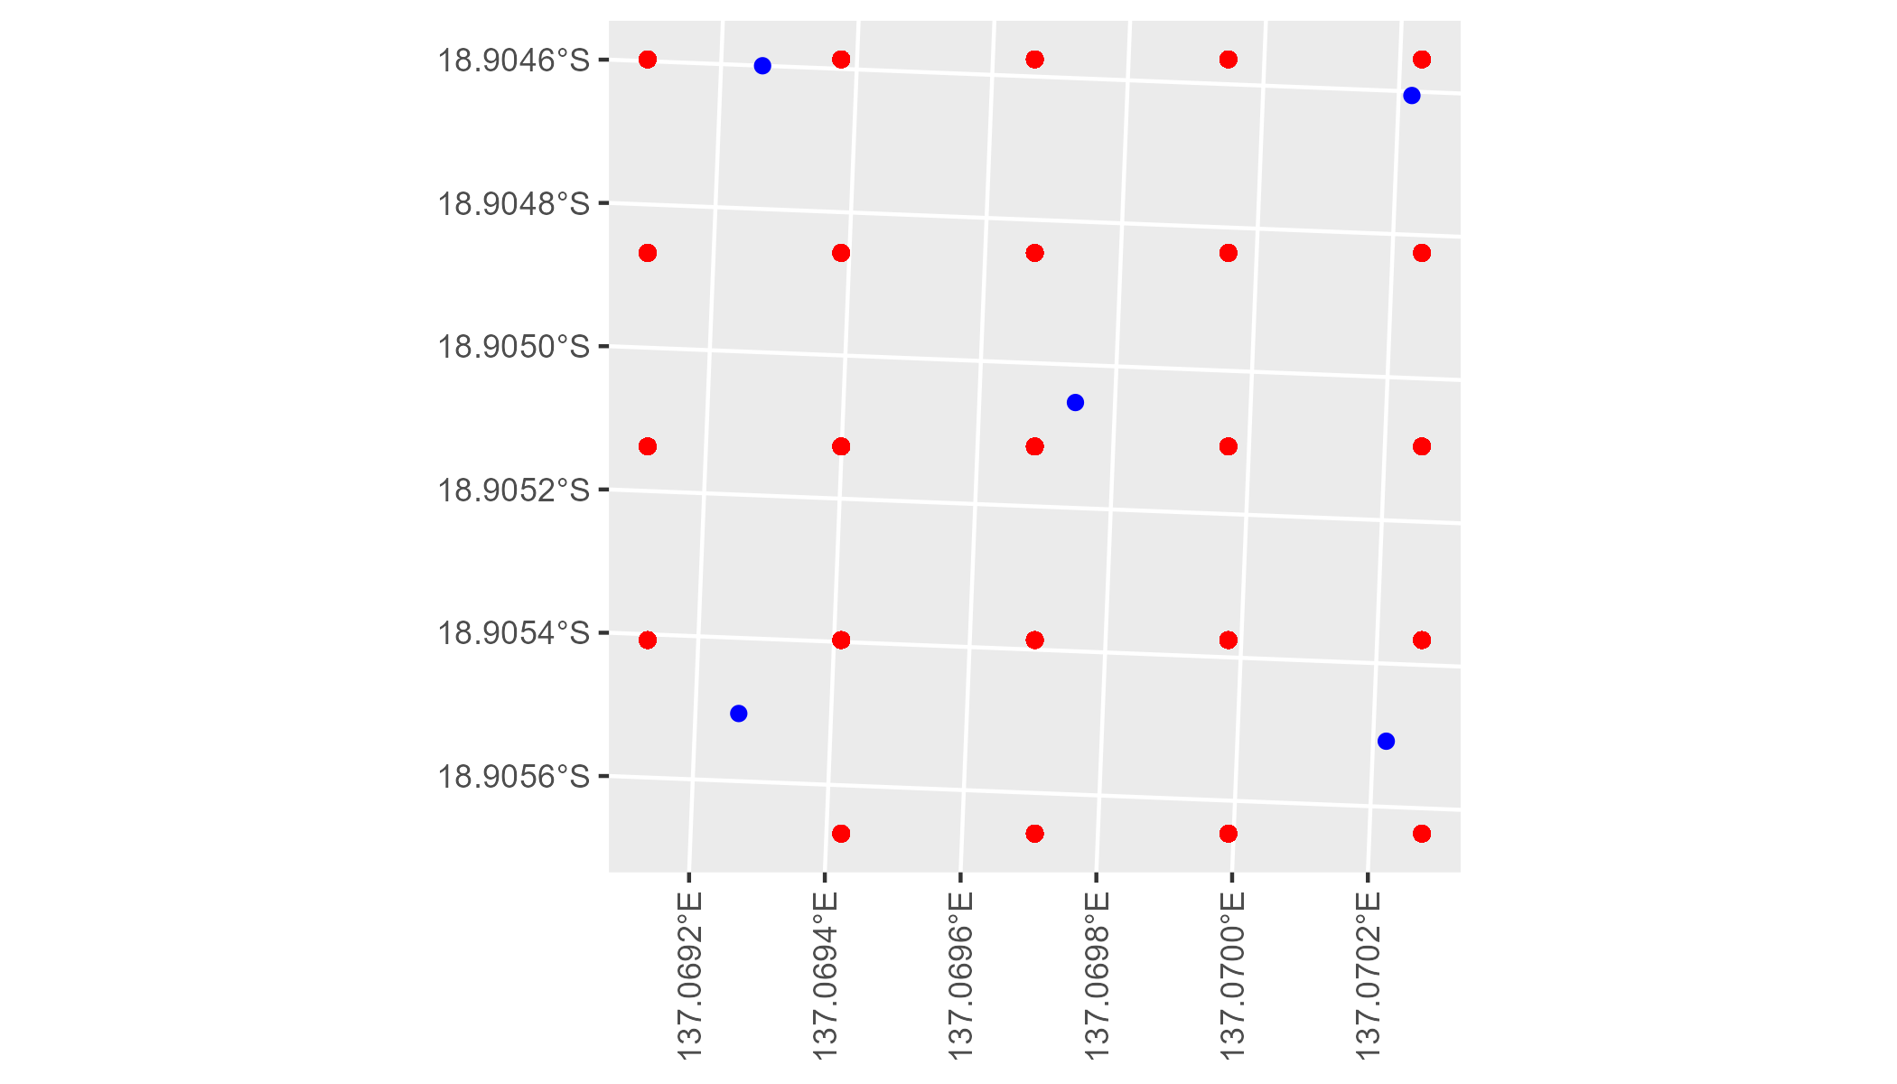

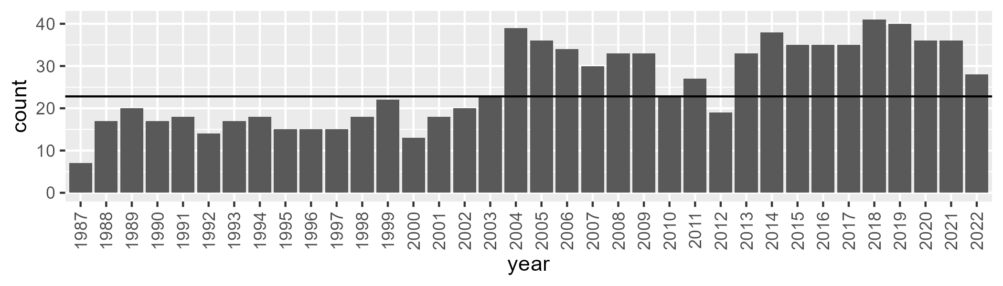

Number of samples: 918

# NTAGFU0002

| Min. | 1st Qu. | Median | Mean | 3rd Qu. | Max. |
| --- | --- | --- | --- | --- | --- |
| 0 | 4.064742 | 7.589675 | 8.693419 | 11.8949 | 31.31142 |

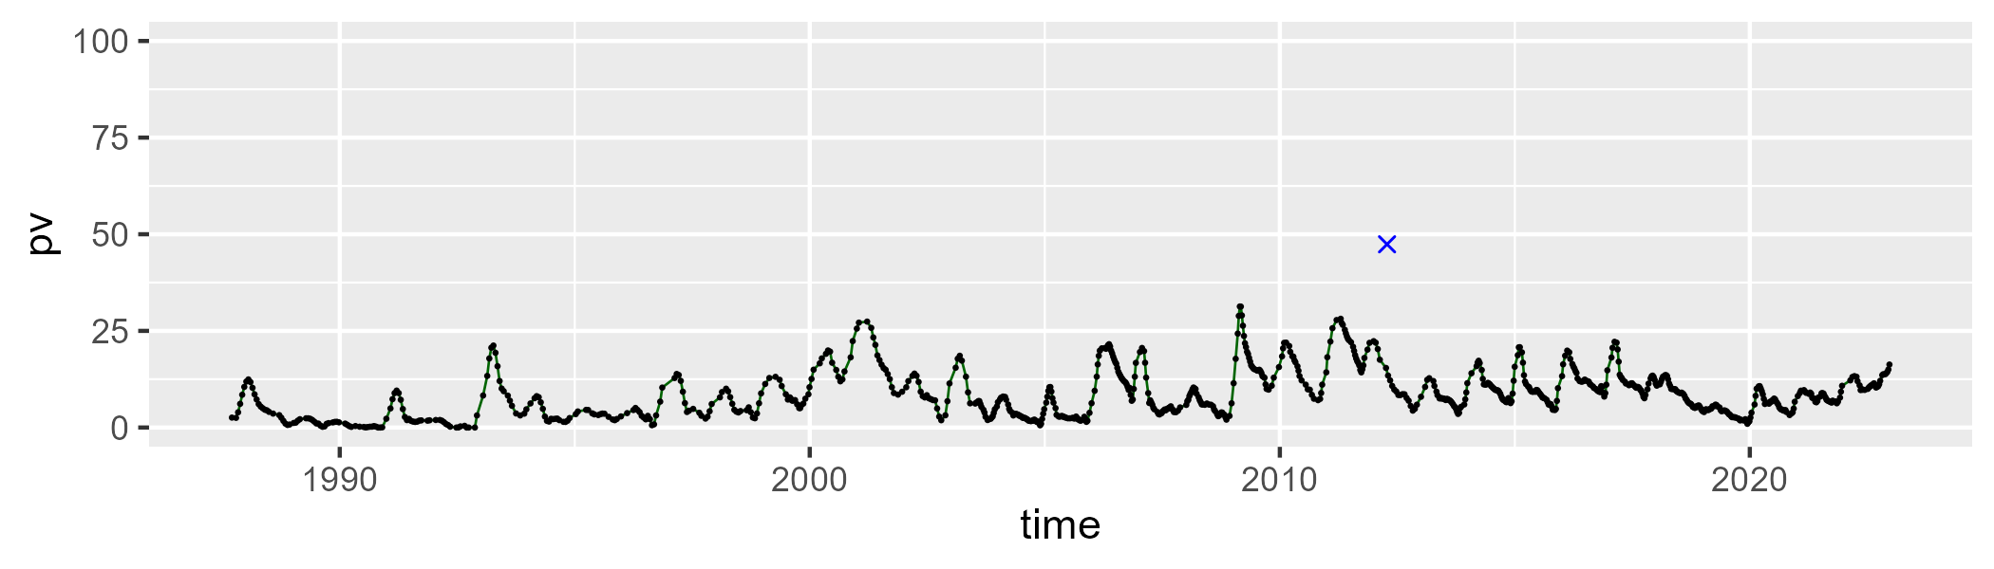

| Min. | 1st Qu. | Median | Mean | 3rd Qu. | Max. |
| --- | --- | --- | --- | --- | --- |
| 38.71499 | 49.10128 | 52.93717 | 53.23048 | 57.00555 | 73.64216 |

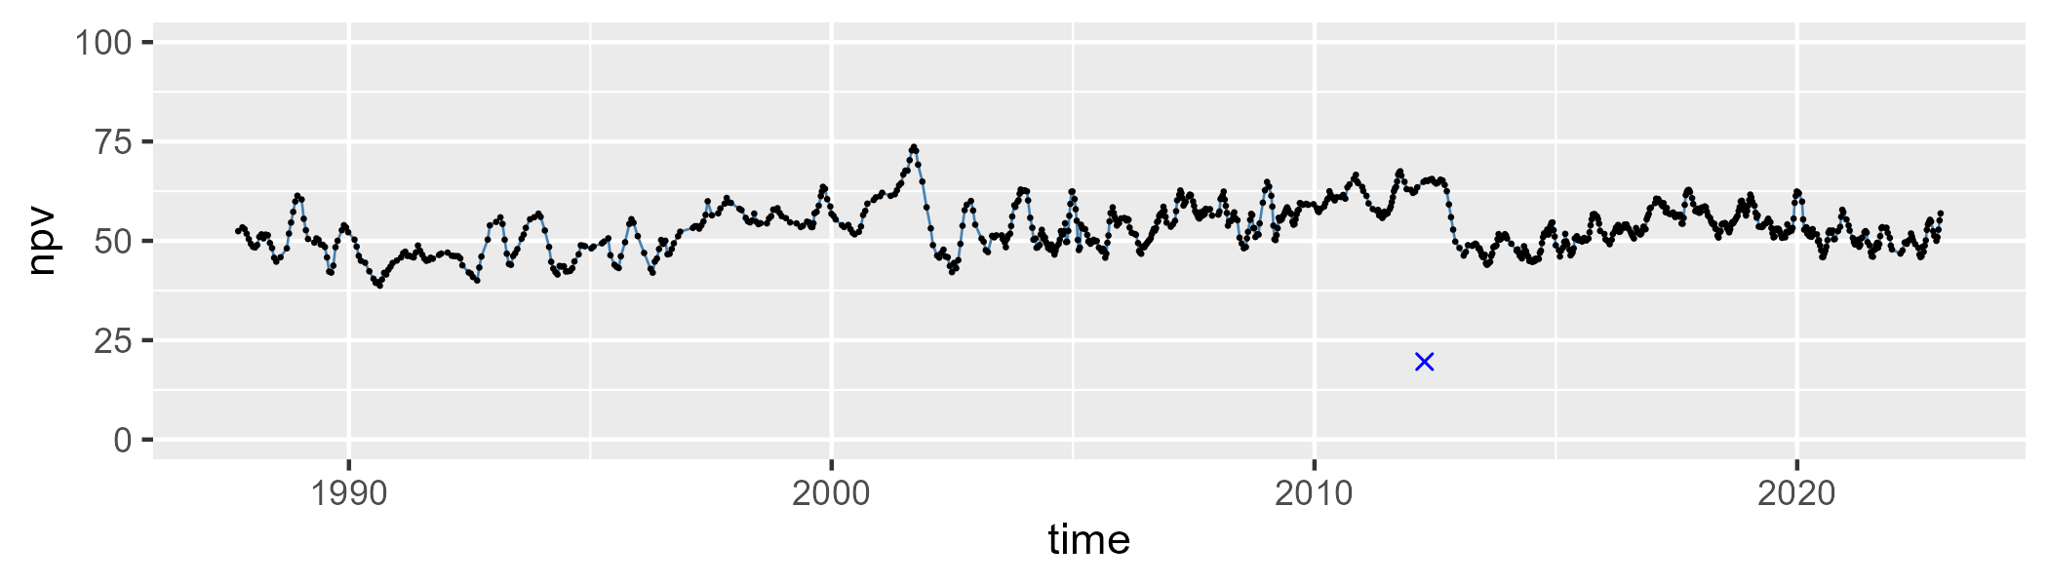

| Min. | 1st Qu. | Median | Mean | 3rd Qu. | Max. |
| --- | --- | --- | --- | --- | --- |
| 9.523464 | 31.41057 | 37.35071 | 36.67026 | 42.69313 | 60.08431 |

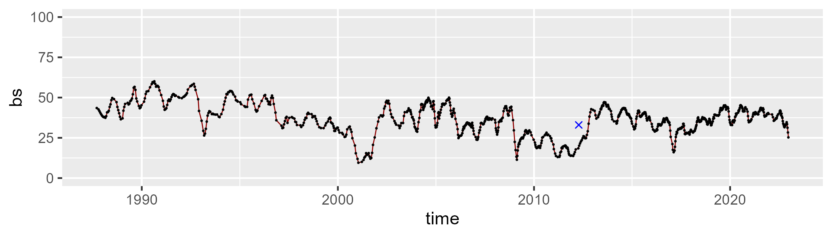

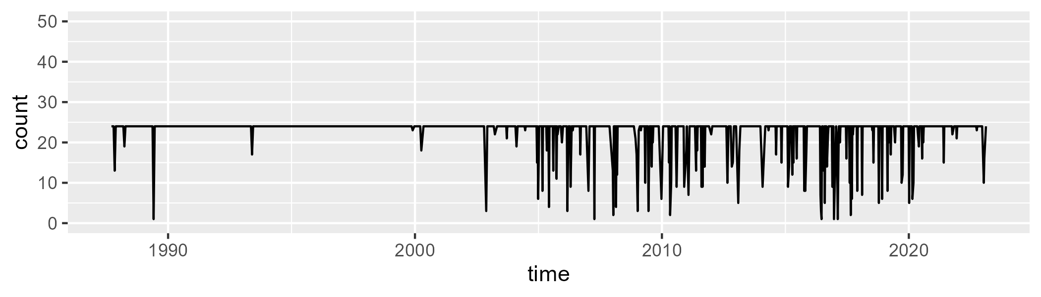

Min. : 1.00 1st Qu.:24.00 Median :24.00 Mean :22.66 3rd Qu.:24.00 Max. :24.00

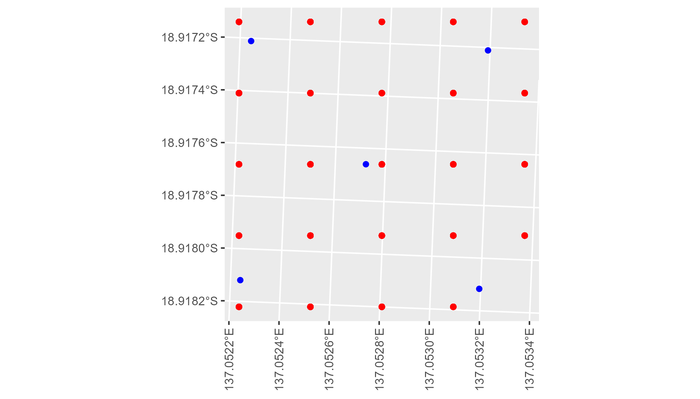

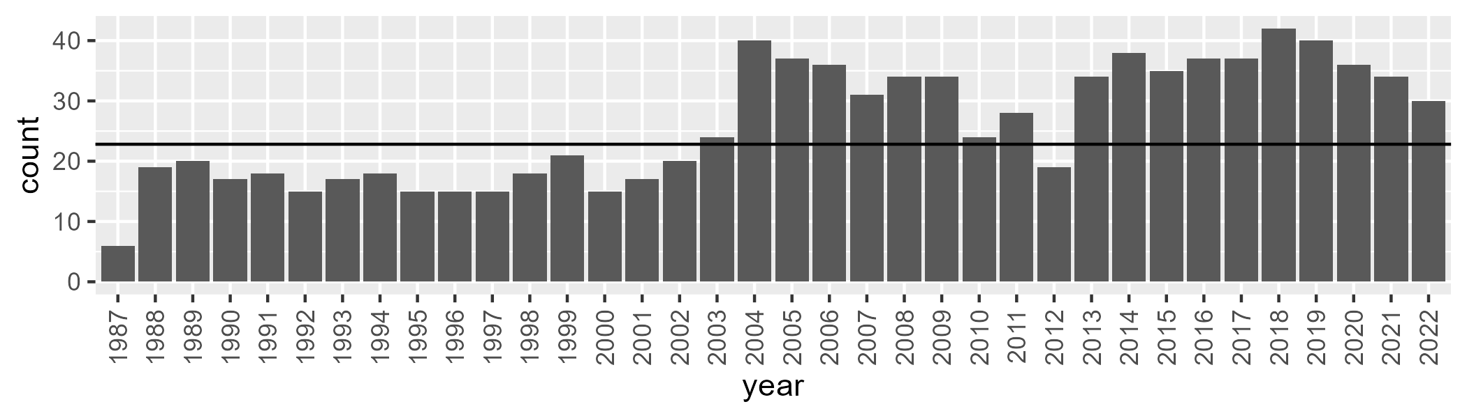

Number of samples: 936

# NTAGFU0003

| Min. | 1st Qu. | Median | Mean | 3rd Qu. | Max. |
| --- | --- | --- | --- | --- | --- |
| 11.83508 | 19.51322 | 23.516 | 24.06825 | 28.3734 | 37.73928 |

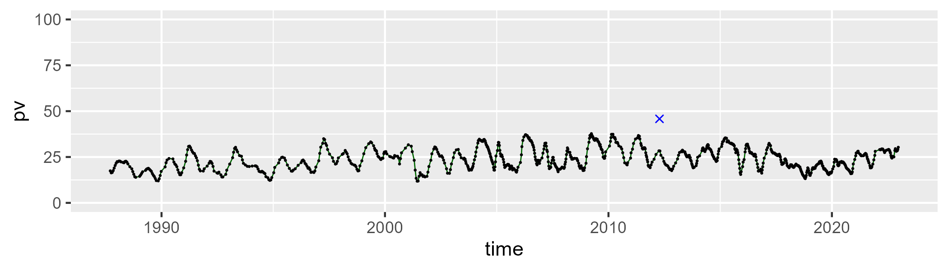

| Min. | 1st Qu. | Median | Mean | 3rd Qu. | Max. |
| --- | --- | --- | --- | --- | --- |
| 27.1331 | 40.75163 | 44.15667 | 44.17299 | 47.65509 | 66.12997 |

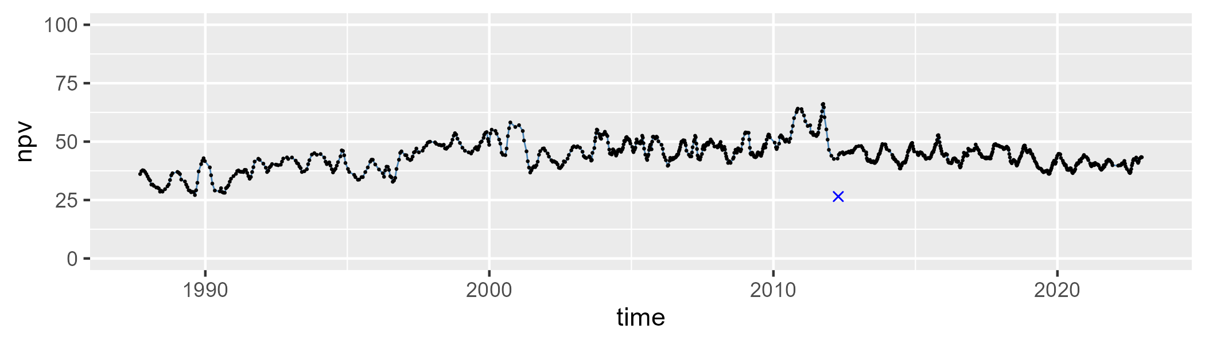

| Min. | 1st Qu. | Median | Mean | 3rd Qu. | Max. |
| --- | --- | --- | --- | --- | --- |
| 6.43328 | 23.75041 | 29.88744 | 30.34147 | 36.68971 | 56.29894 |

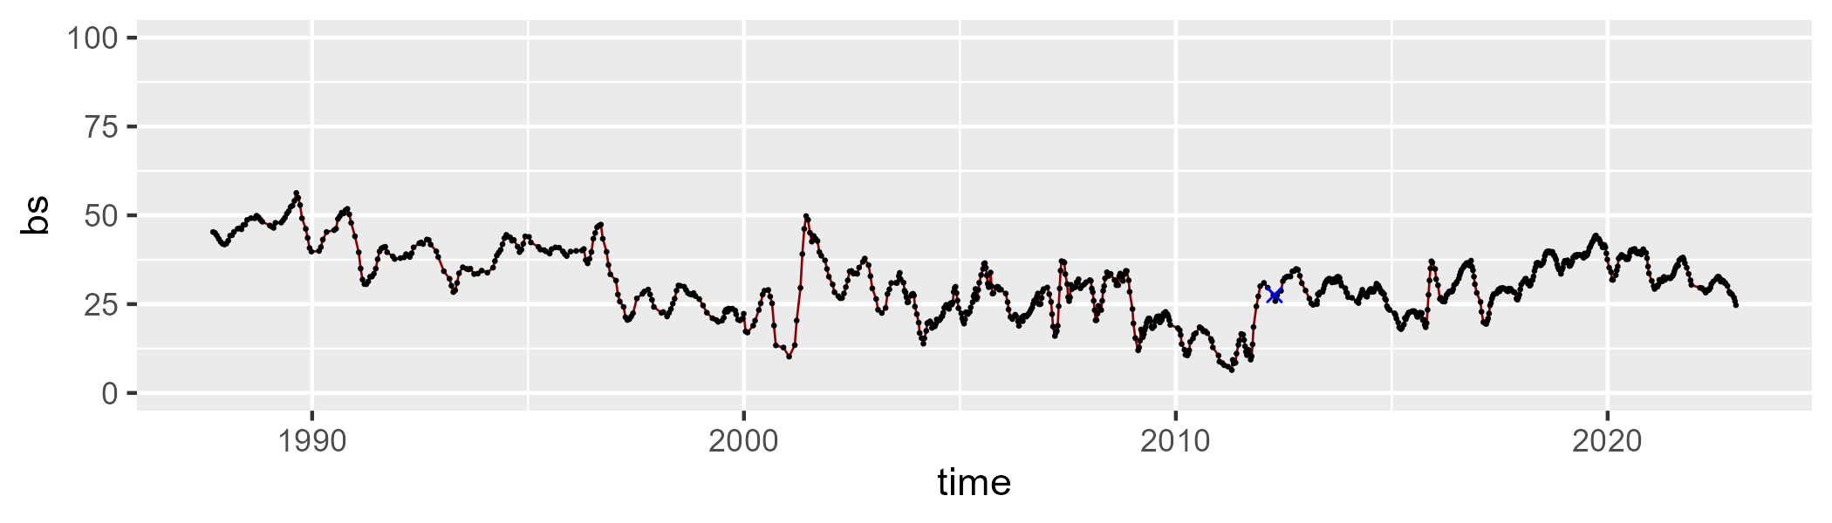

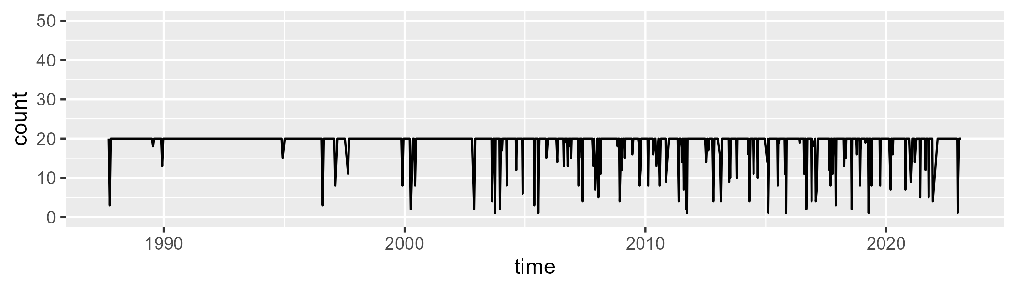

Min. : 1.00 1st Qu.:20.00 Median :20.00 Mean :18.82 3rd Qu.:20.00 Max. :20.00

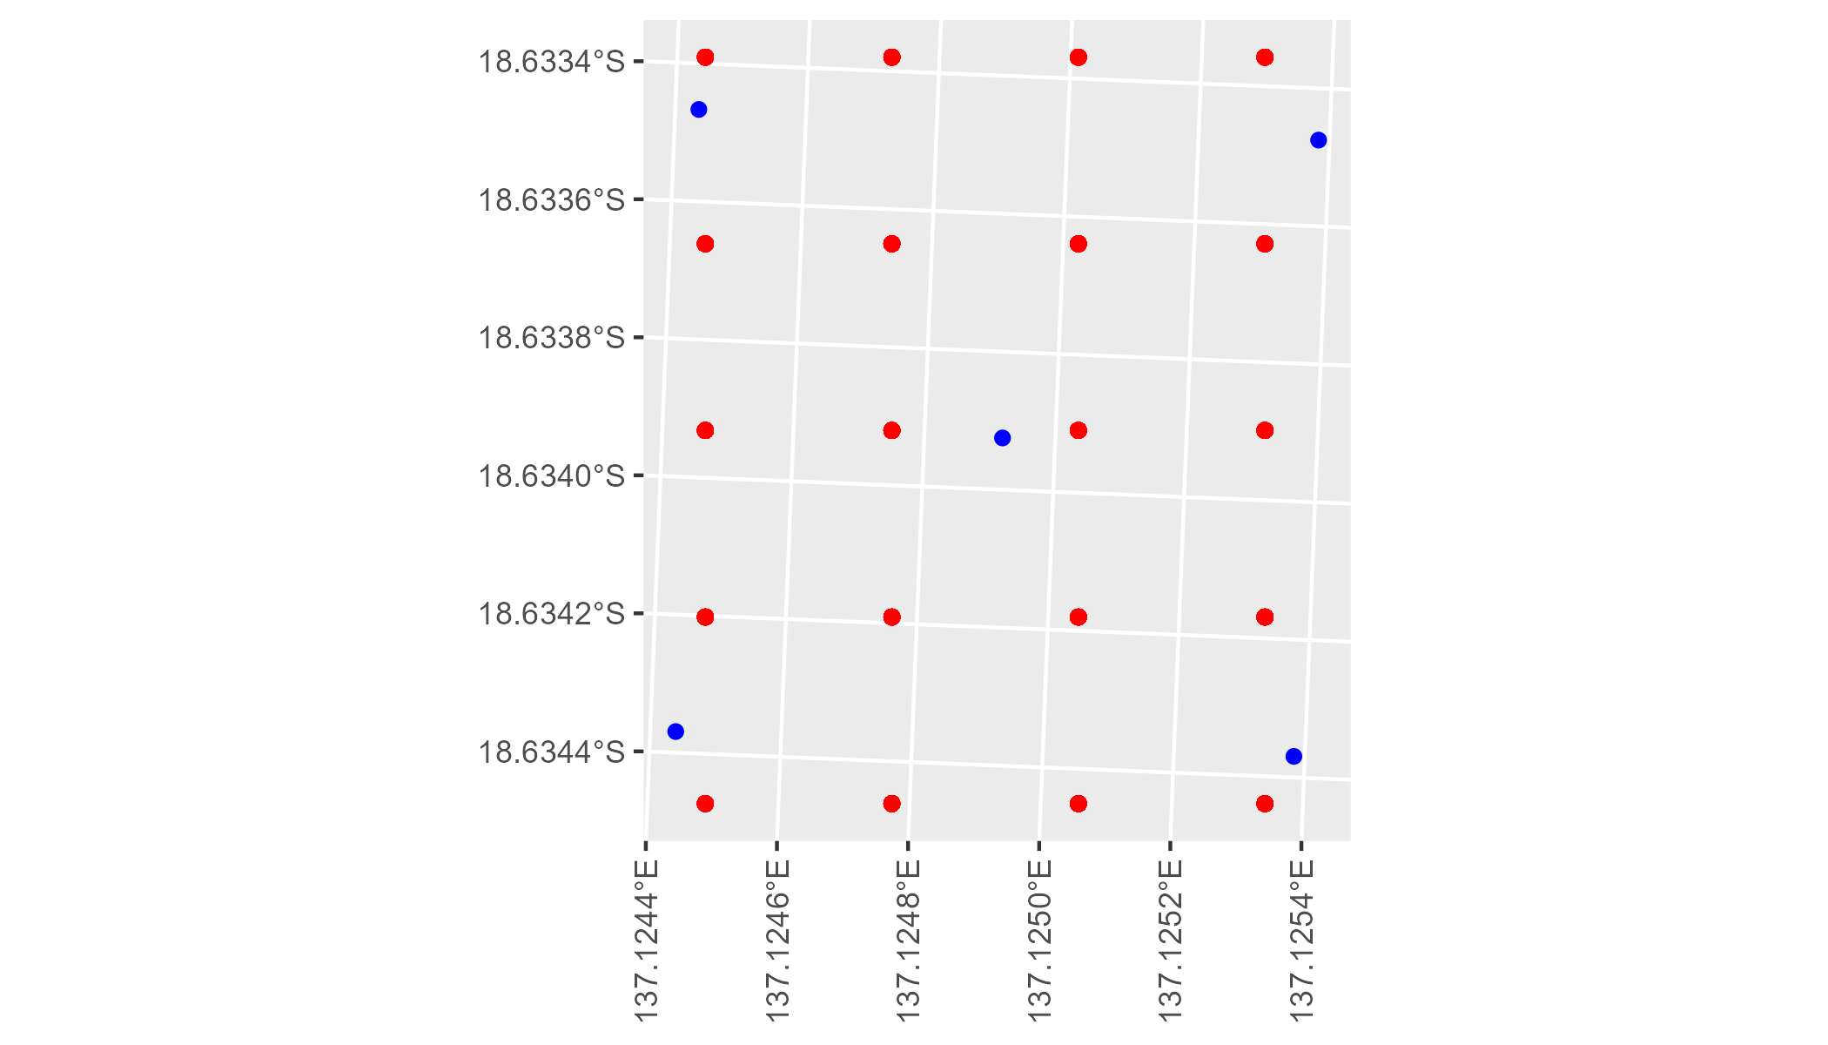

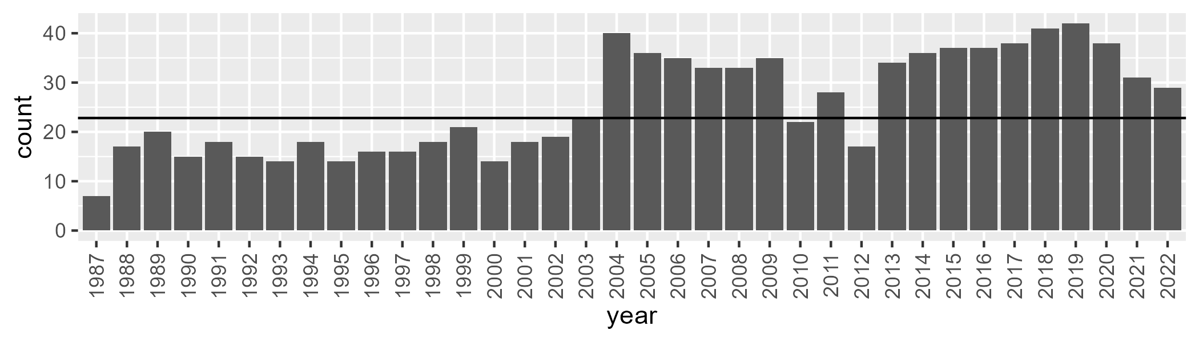

Number of samples: 925

# NTAGFU0004

| Min. | 1st Qu. | Median | Mean | 3rd Qu. | Max. |
| --- | --- | --- | --- | --- | --- |
| 0 | 9.177818 | 14.1228 | 14.79576 | 20.33178 | 31.4874 |

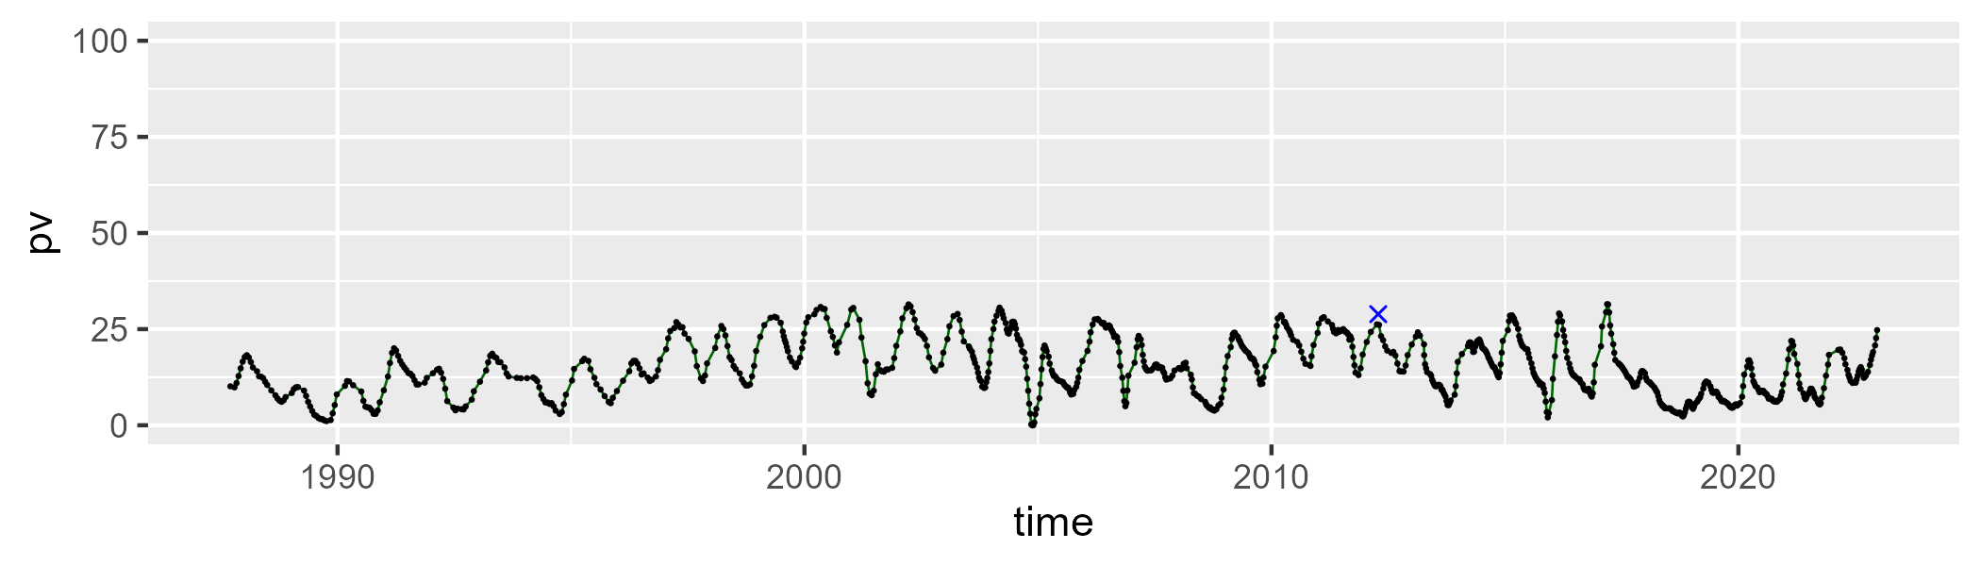

| Min. | 1st Qu. | Median | Mean | 3rd Qu. | Max. |
| --- | --- | --- | --- | --- | --- |
| 26.01655 | 41.8053 | 47.43673 | 47.4338 | 52.41512 | 73.91961 |

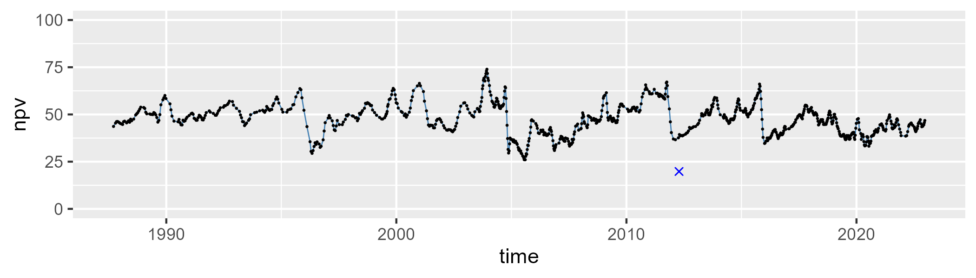

| Min. | 1st Qu. | Median | Mean | 3rd Qu. | Max. |
| --- | --- | --- | --- | --- | --- |
| 2.375438 | 29.22188 | 36.12716 | 36.36121 | 44.68192 | 70.23113 |

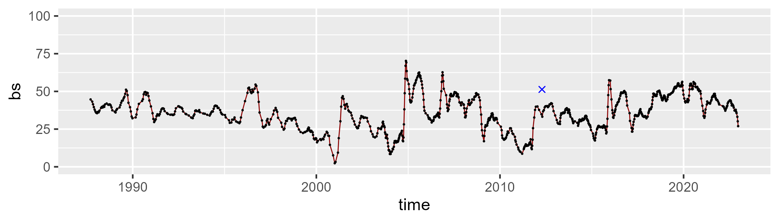

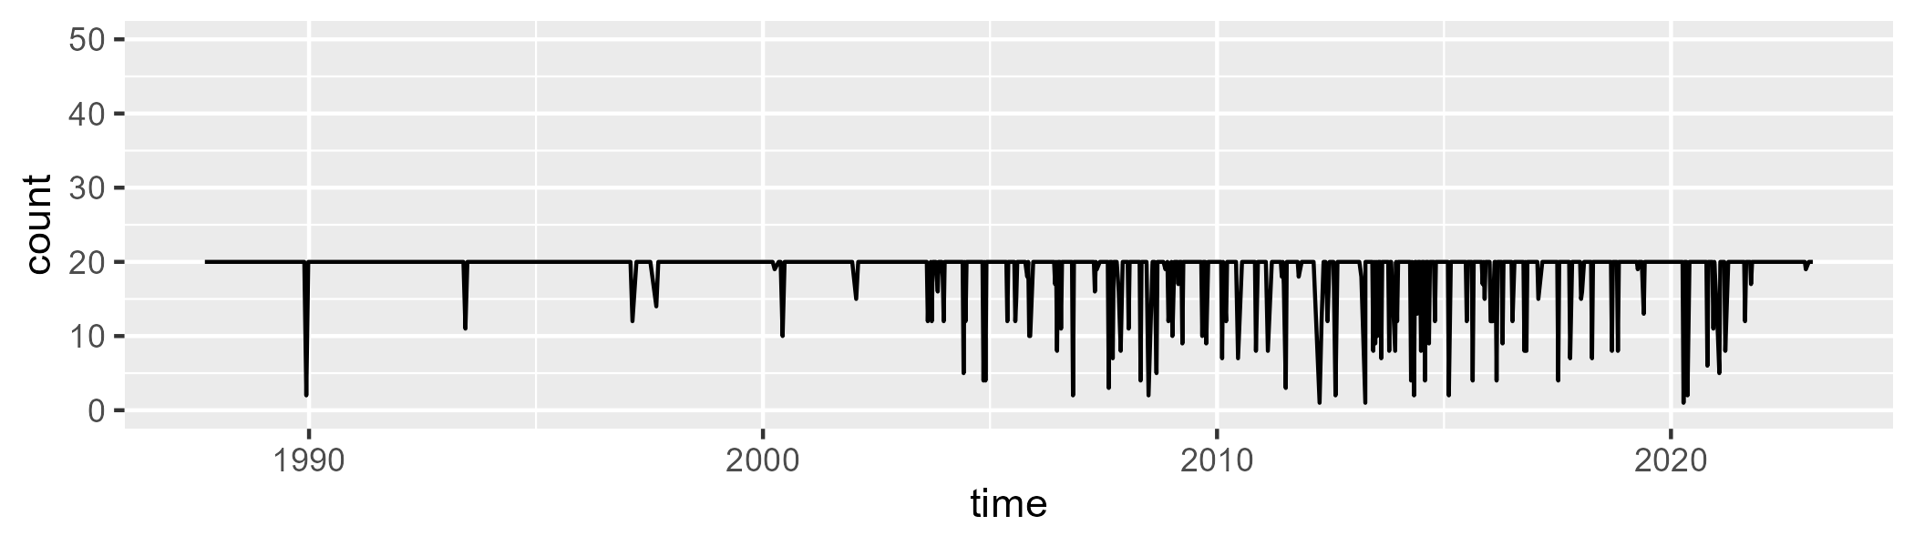

Min. : 1.00 1st Qu.:20.00 Median :20.00 Mean :18.87 3rd Qu.:20.00 Max. :20.00

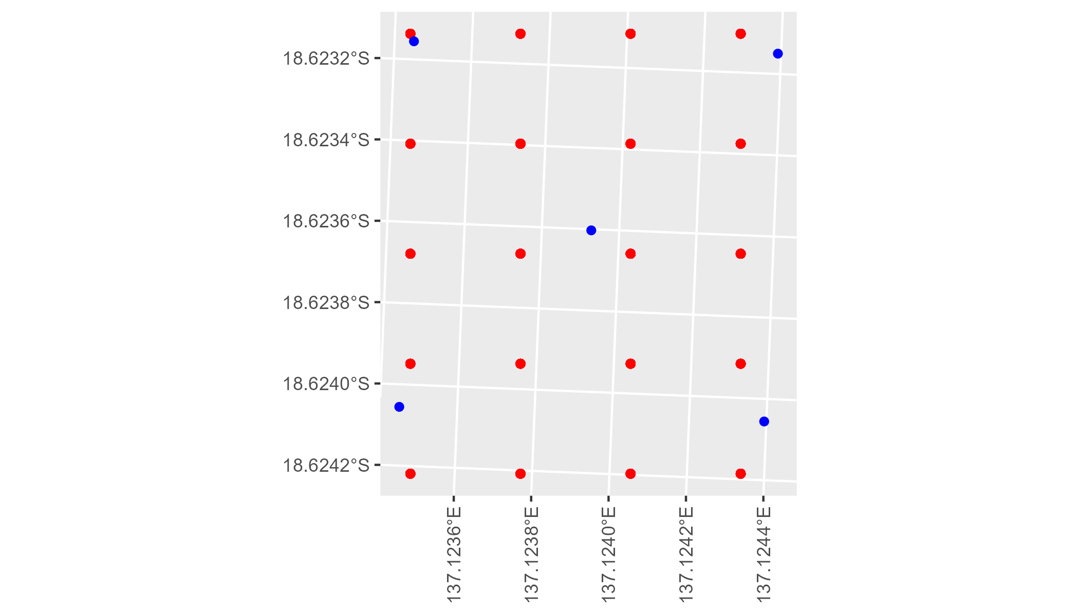

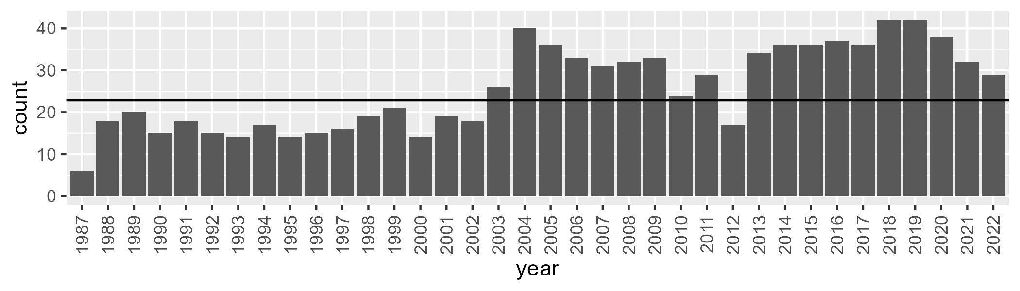

Number of samples: 922

# NTAGFU0005

| Min. | 1st Qu. | Median | Mean | 3rd Qu. | Max. |
| --- | --- | --- | --- | --- | --- |
| 7.64484 | 19.33314 | 23.43178 | 23.42224 | 27.83582 | 40.00171 |

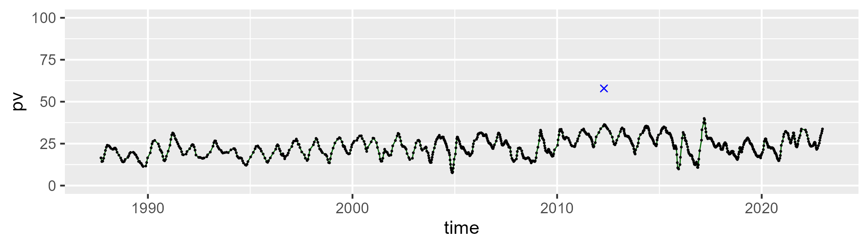

| Min. | 1st Qu. | Median | Mean | 3rd Qu. | Max. |
| --- | --- | --- | --- | --- | --- |
| 28.14961 | 42.10591 | 45.68068 | 45.65324 | 49.61923 | 62.46876 |

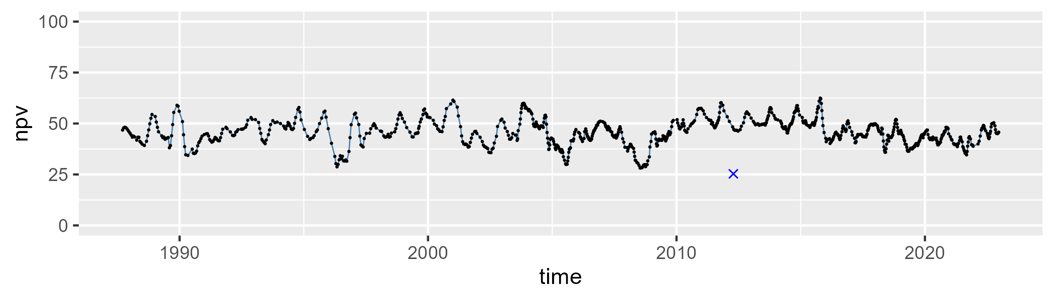

| Min. | 1st Qu. | Median | Mean | 3rd Qu. | Max. |
| --- | --- | --- | --- | --- | --- |
| 9.127062 | 23.76819 | 29.50431 | 29.5705 | 35.188 | 55.73749 |

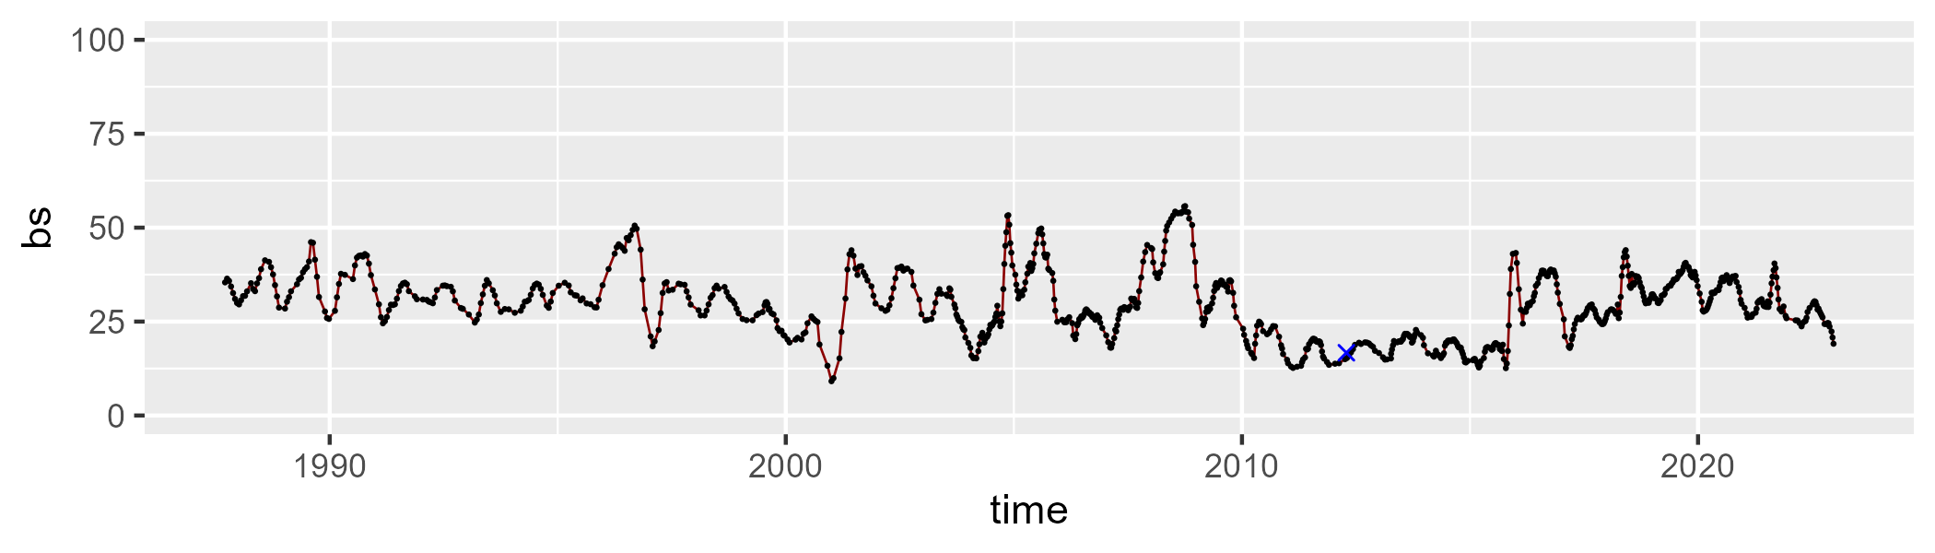

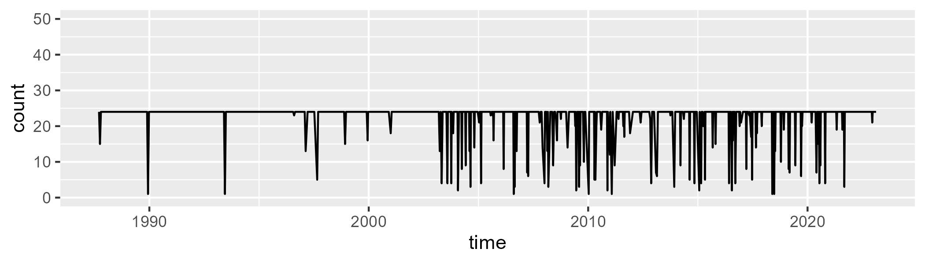

Min. : 1.00 1st Qu.:24.00 Median :24.00 Mean :22.44 3rd Qu.:24.00 Max. :24.00

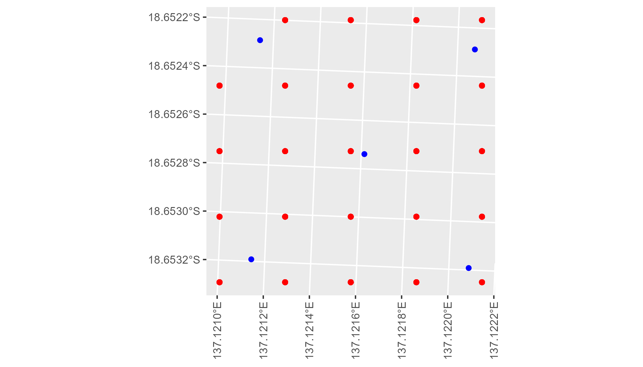

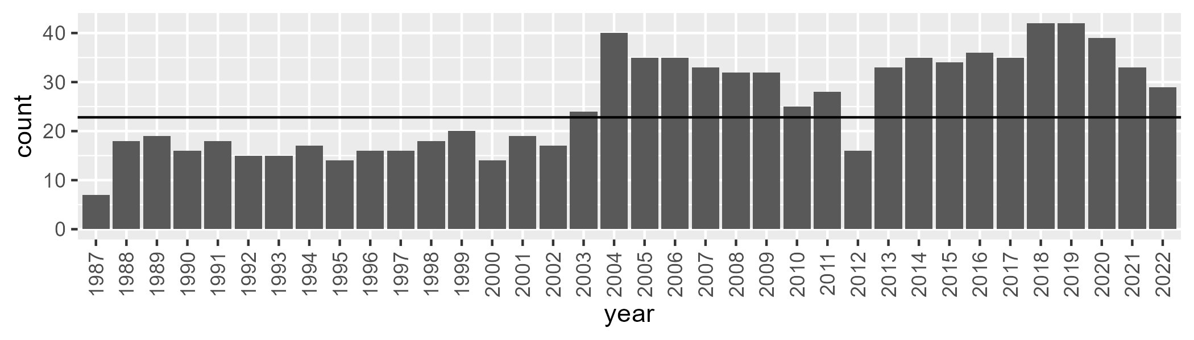

Number of samples: 917

# NTAGFU0006

| Min. | 1st Qu. | Median | Mean | 3rd Qu. | Max. |
| --- | --- | --- | --- | --- | --- |
| 4.172669 | 13.72971 | 19.79658 | 20.96871 | 27.47933 | 46.70307 |

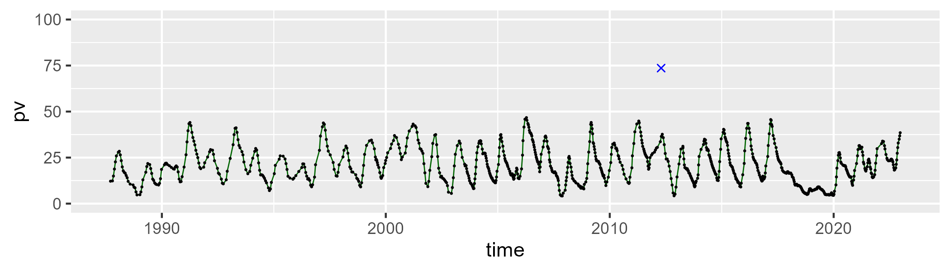

| Min. | 1st Qu. | Median | Mean | 3rd Qu. | Max. |
| --- | --- | --- | --- | --- | --- |
| 32.1465 | 44.85211 | 51.15086 | 51.57741 | 57.61486 | 72.63285 |

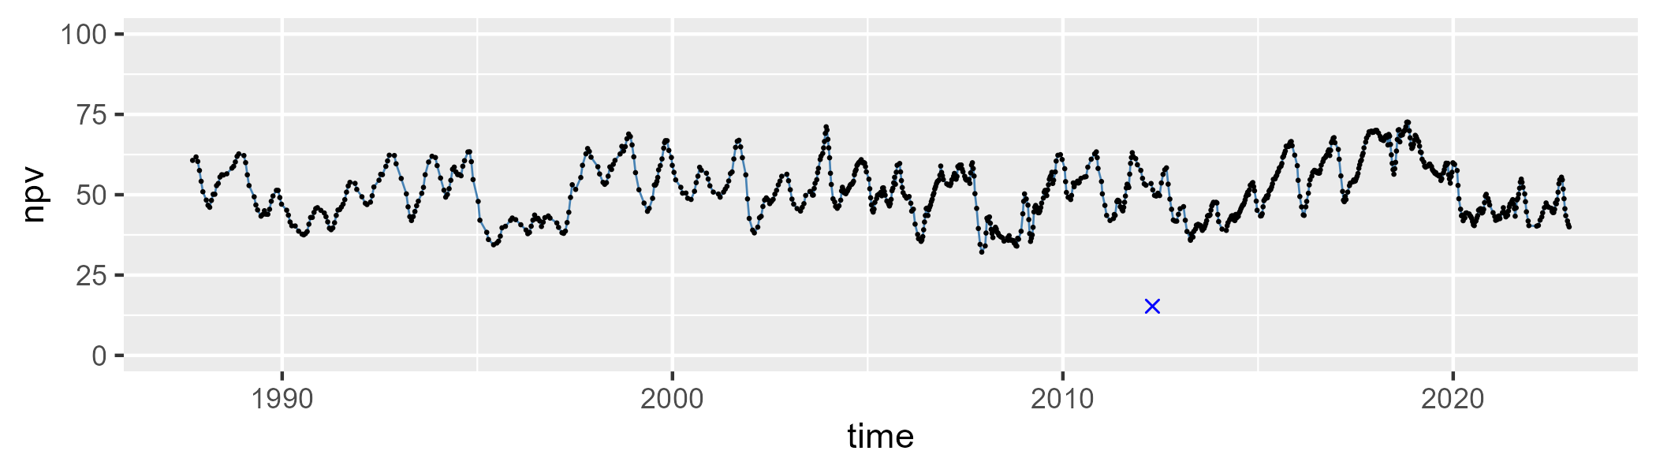

| Min. | 1st Qu. | Median | Mean | 3rd Qu. | Max. |
| --- | --- | --- | --- | --- | --- |
| 4.702531 | 19.36554 | 24.52826 | 26.08866 | 32.06135 | 60.74029 |

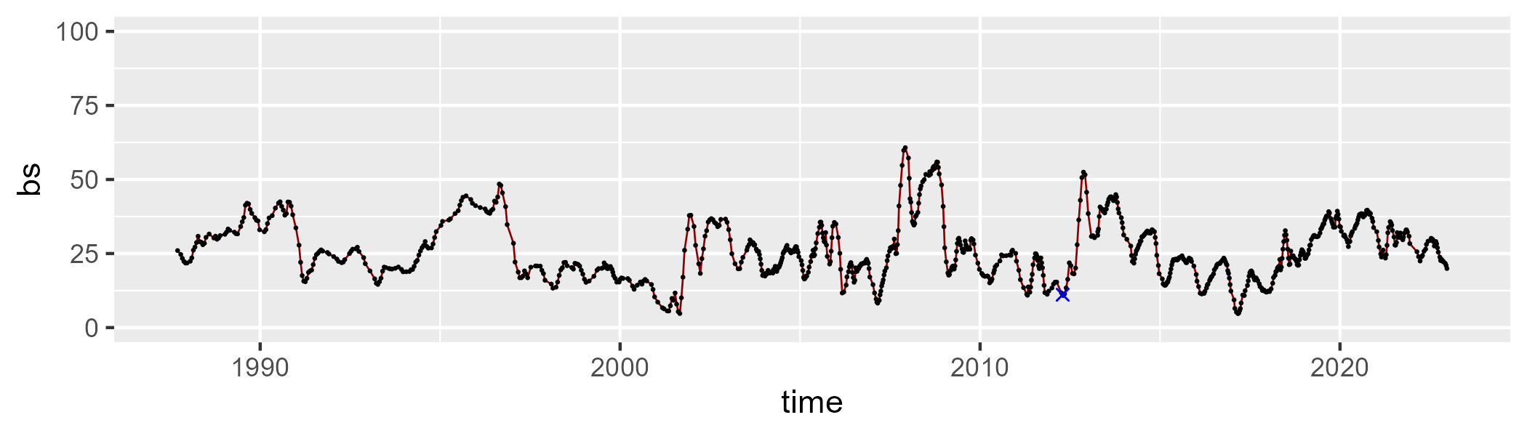

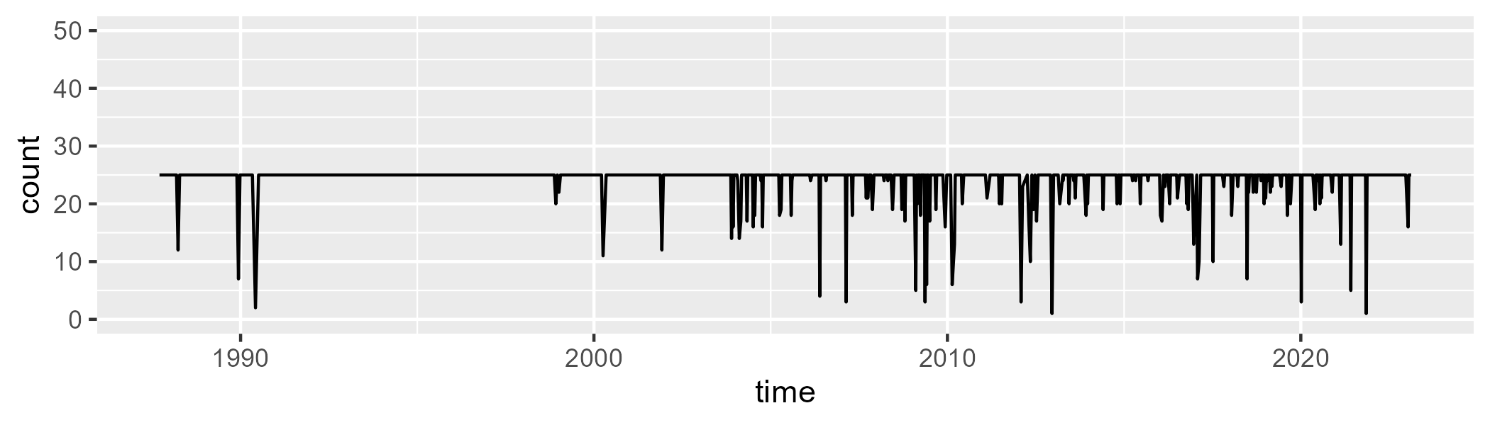

Min. : 1.00 1st Qu.:25.00 Median :25.00 Mean :24.11 3rd Qu.:25.00 Max. :25.00

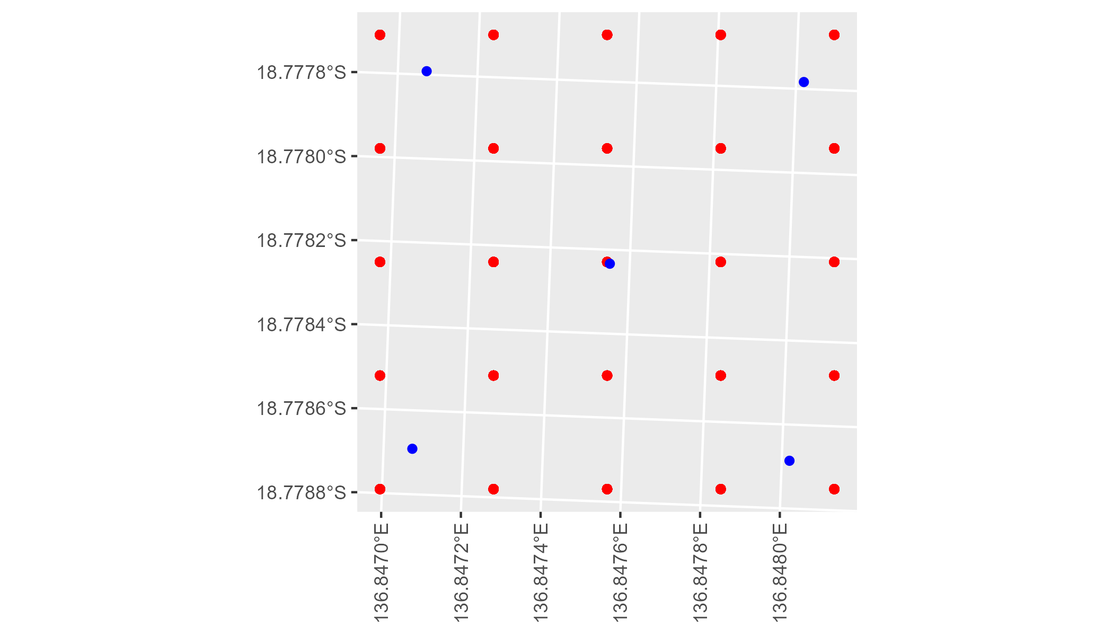

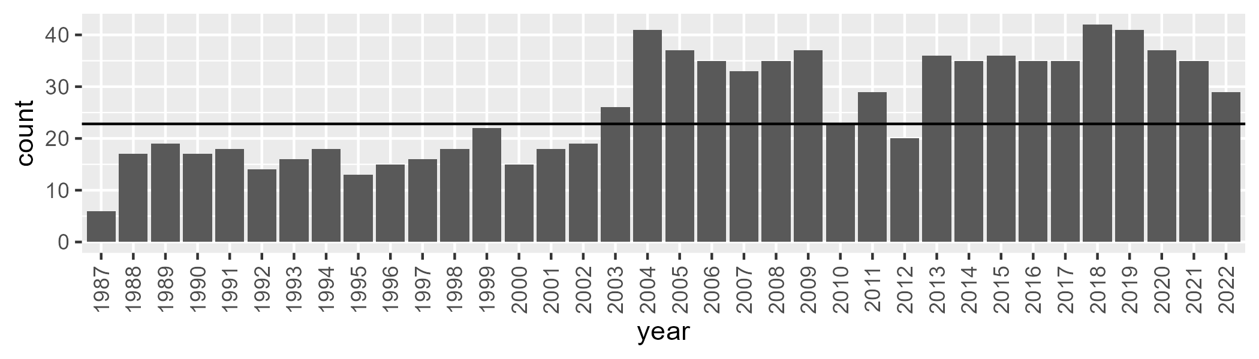

Number of samples: 938

# NTAGFU0007

| Min. | 1st Qu. | Median | Mean | 3rd Qu. | Max. |
| --- | --- | --- | --- | --- | --- |
| 0 | 2.323972 | 5.531136 | 6.966553 | 10.32326 | 26.29204 |

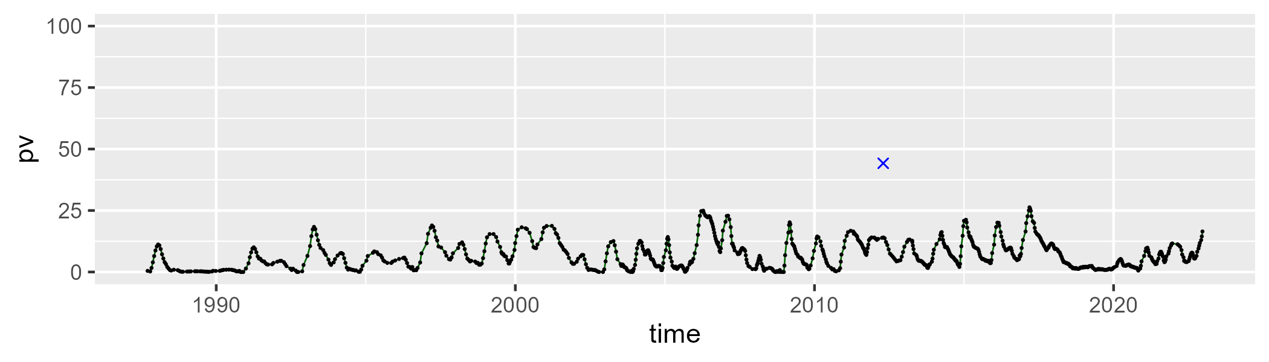

| Min. | 1st Qu. | Median | Mean | 3rd Qu. | Max. |
| --- | --- | --- | --- | --- | --- |
| 42.73121 | 57.69469 | 62.46241 | 62.20252 | 67.48433 | 80.70856 |

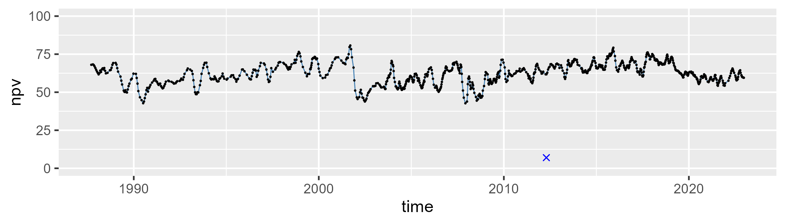

| Min. | 1st Qu. | Median | Mean | 3rd Qu. | Max. |
| --- | --- | --- | --- | --- | --- |
| 5.924814 | 23.00659 | 28.53386 | 29.64747 | 35.94907 | 55.54139 |

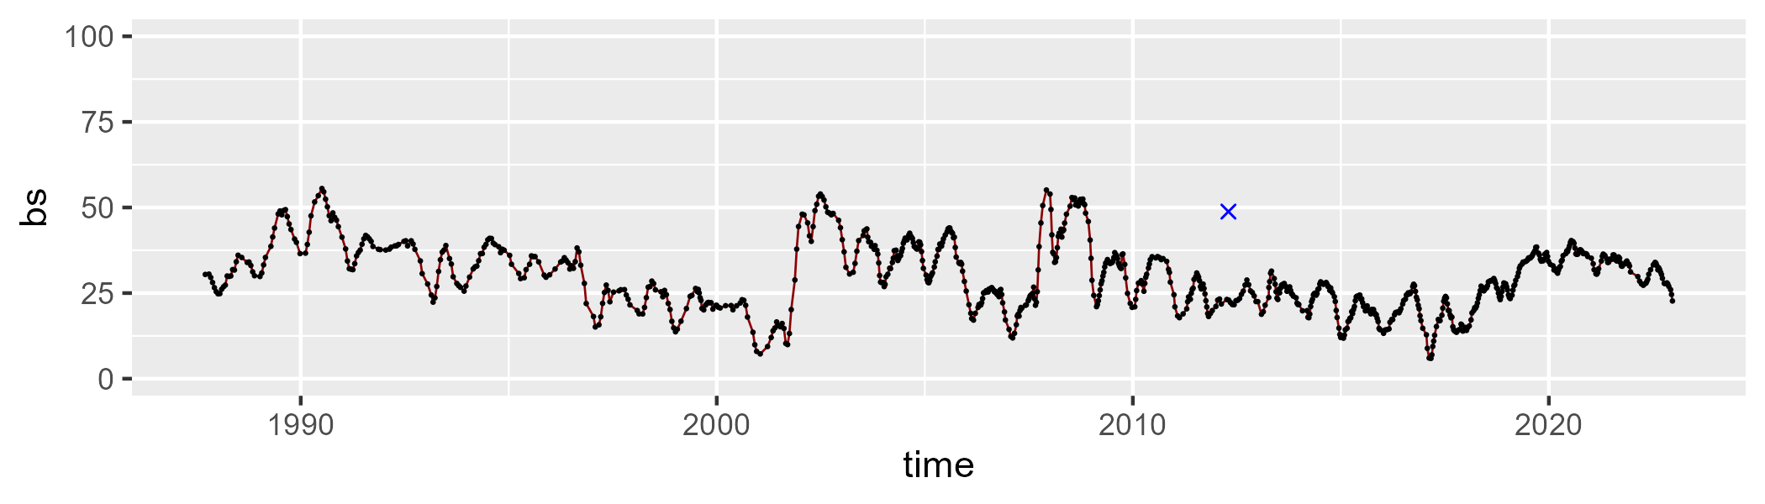

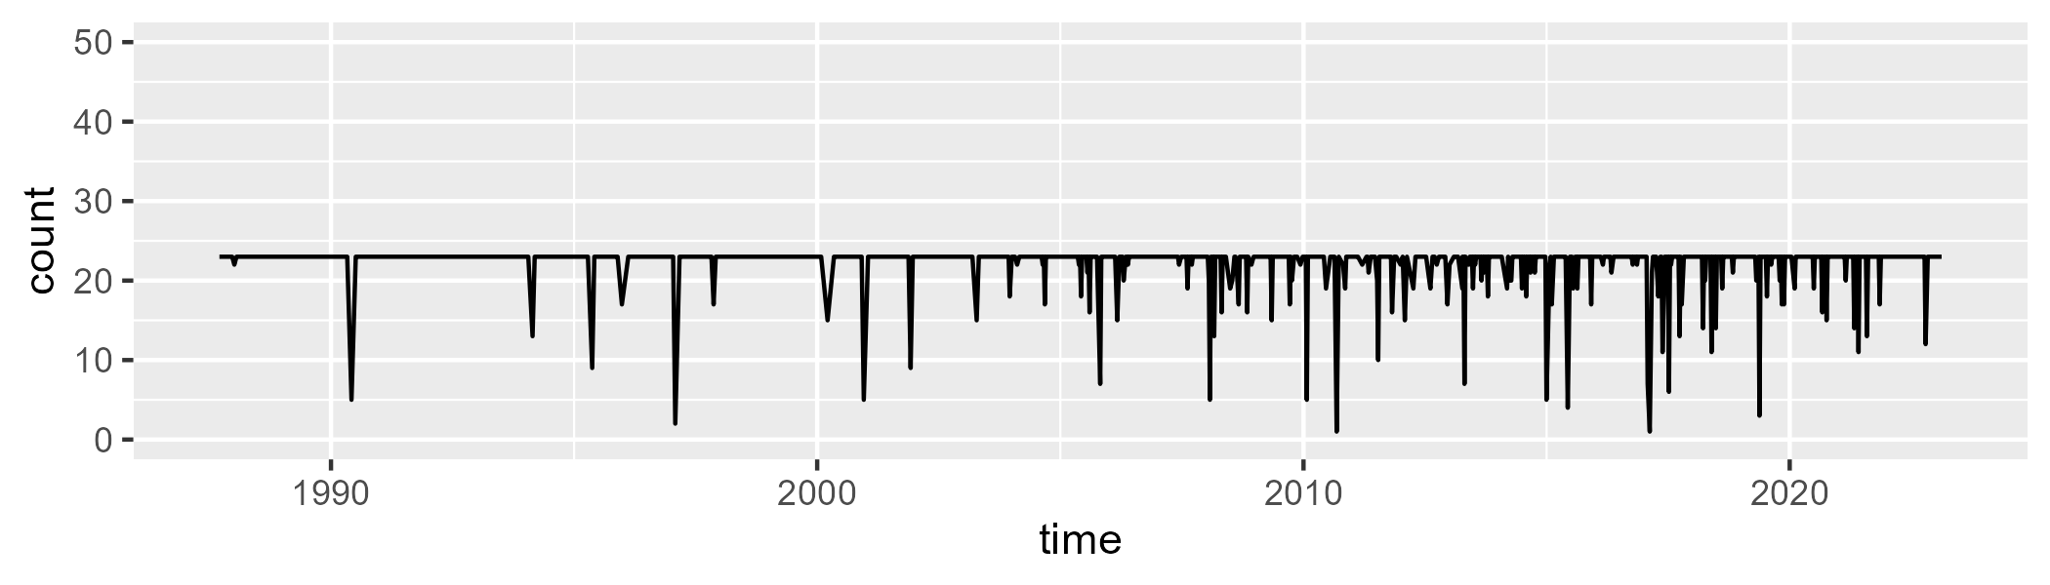

Min. : 1.0 1st Qu.:23.0 Median :23.0 Mean :22.2 3rd Qu.:23.0 Max. :23.0

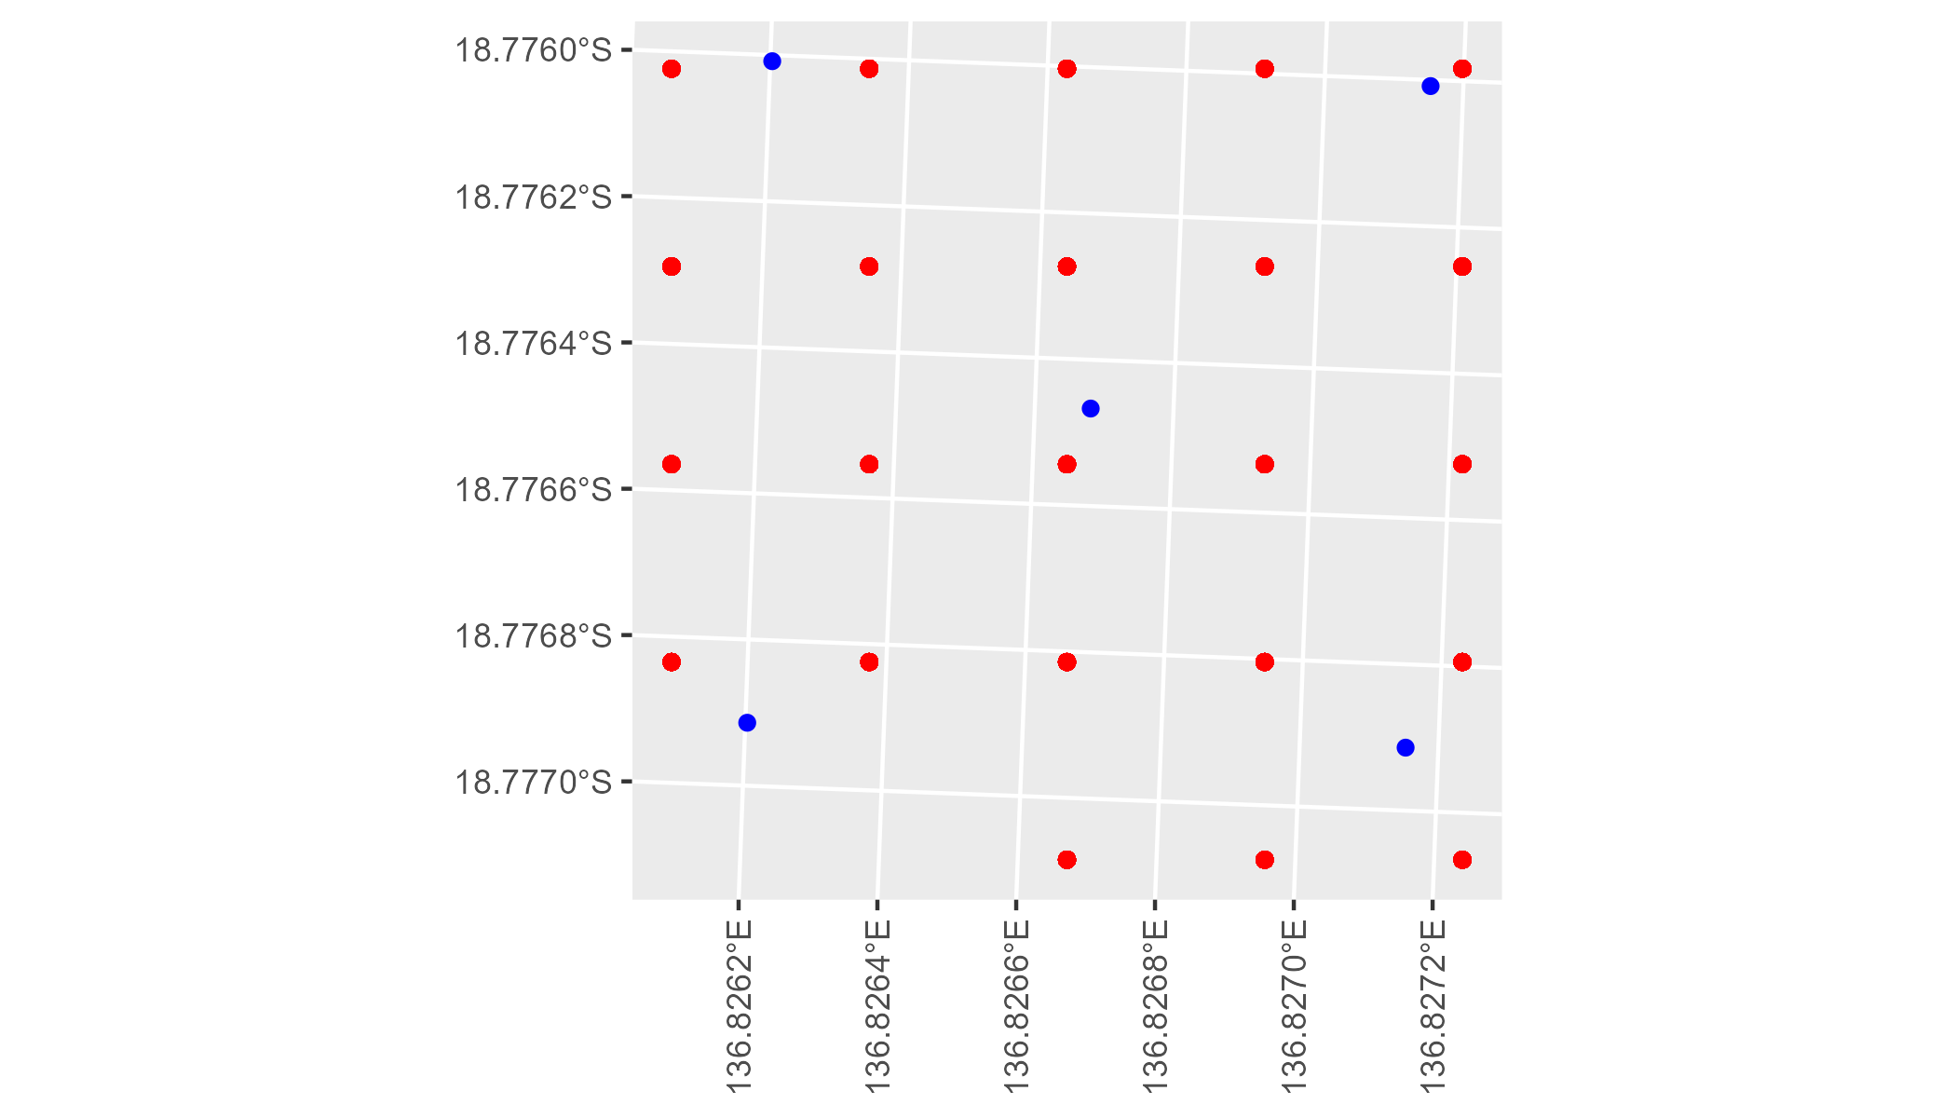

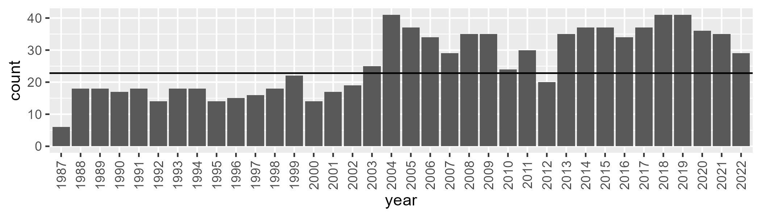

Number of samples: 934

# NTAGFU0008

| Min. | 1st Qu. | Median | Mean | 3rd Qu. | Max. |
| --- | --- | --- | --- | --- | --- |
| 0 | 2.693753 | 4.587831 | 5.865135 | 7.591065 | 23.02278 |

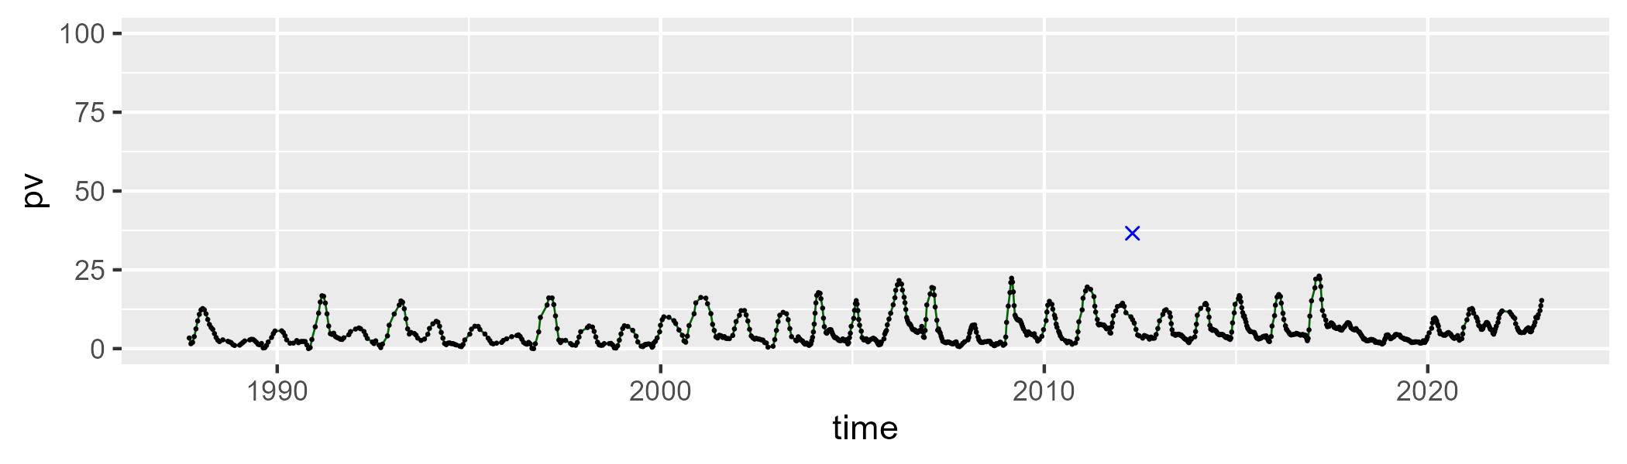

| Min. | 1st Qu. | Median | Mean | 3rd Qu. | Max. |
| --- | --- | --- | --- | --- | --- |
| 45.58482 | 55.91582 | 59.91952 | 59.36407 | 62.8111 | 75.25179 |

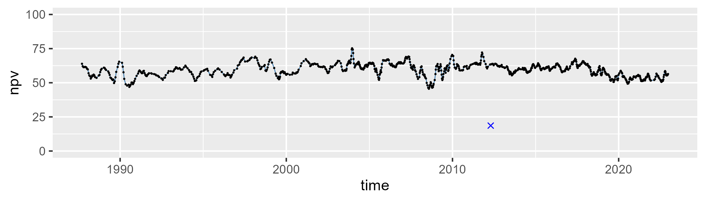

| Min. | 1st Qu. | Median | Mean | 3rd Qu. | Max. |
| --- | --- | --- | --- | --- | --- |
| 11.79565 | 28.64649 | 34.37676 | 33.65924 | 38.78937 | 51.1745 |

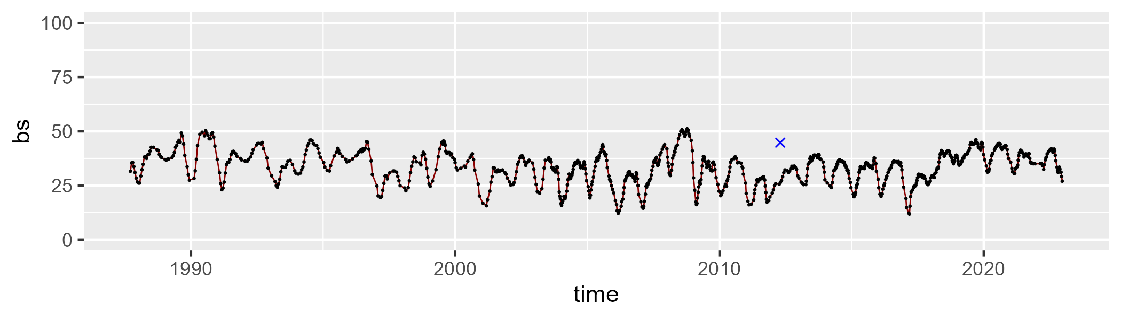

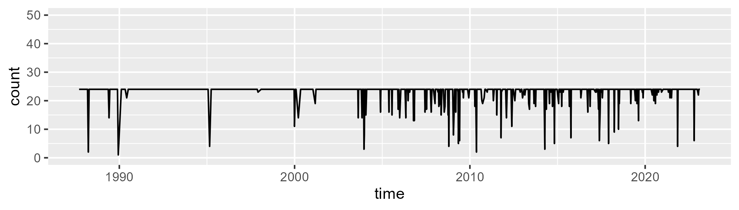

Min. : 1.00 1st Qu.:24.00 Median :24.00 Mean :23.08 3rd Qu.:24.00 Max. :24.00

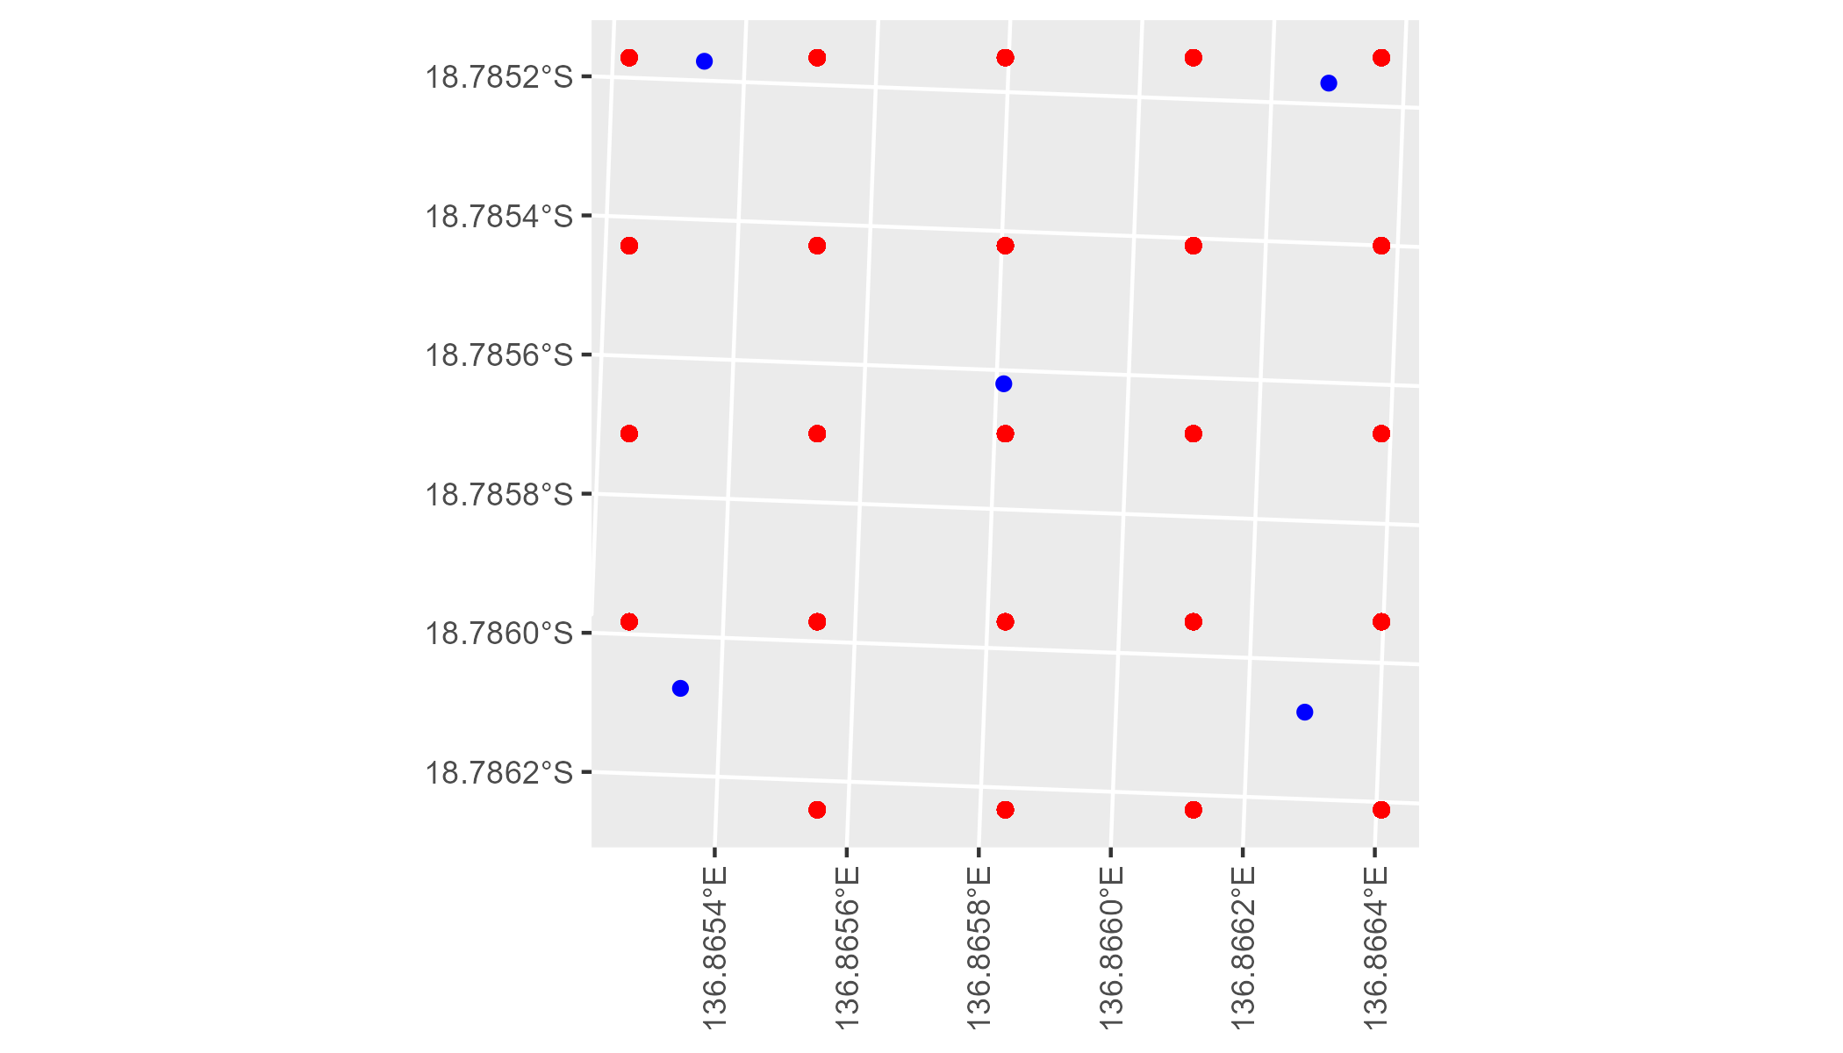

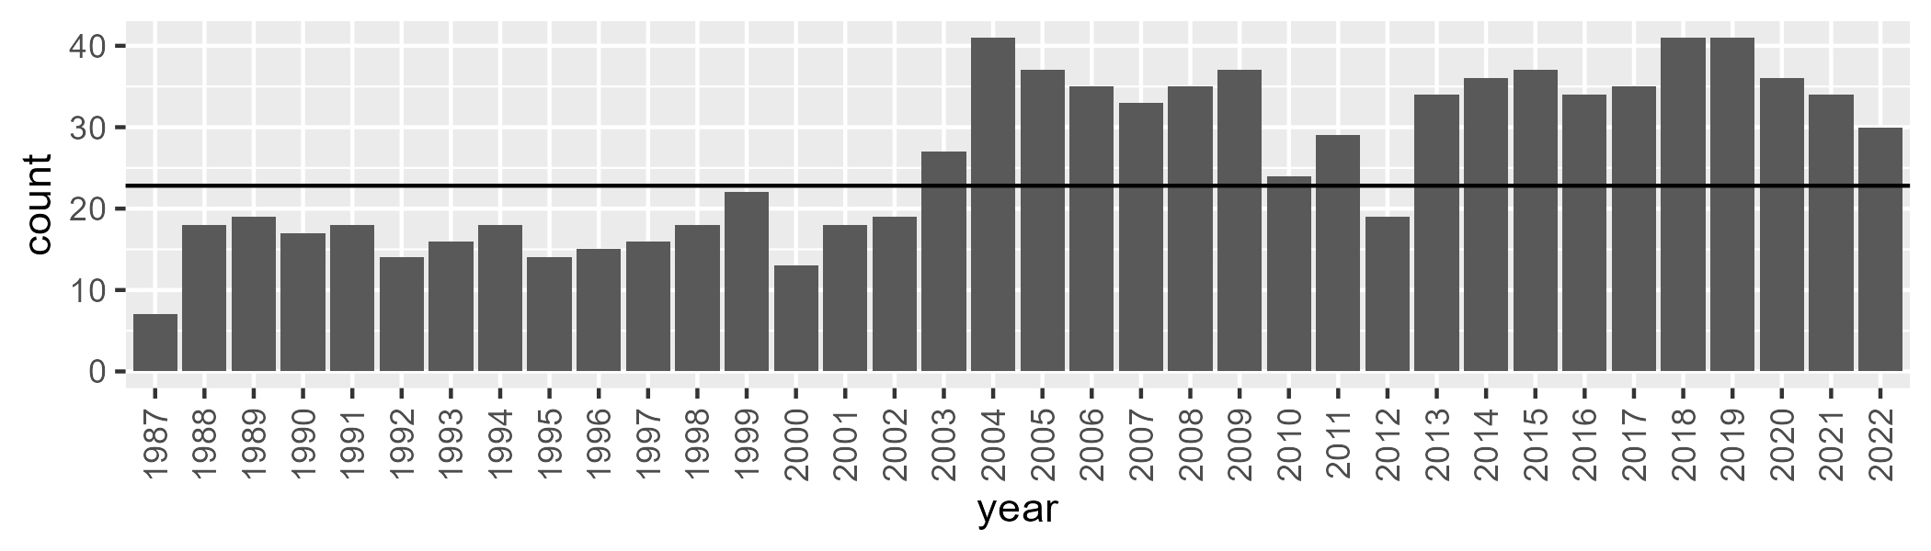

Number of samples: 937

# NTAGFU0009

| Min. | 1st Qu. | Median | Mean | 3rd Qu. | Max. |
| --- | --- | --- | --- | --- | --- |
| 5.474247 | 12.10272 | 15.77913 | 16.81307 | 20.81799 | 35.25871 |

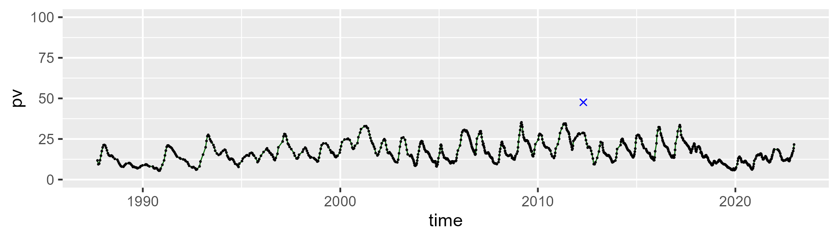

| Min. | 1st Qu. | Median | Mean | 3rd Qu. | Max. |
| --- | --- | --- | --- | --- | --- |
| 25.5228 | 38.91695 | 46.52689 | 45.32126 | 50.93334 | 64.23108 |

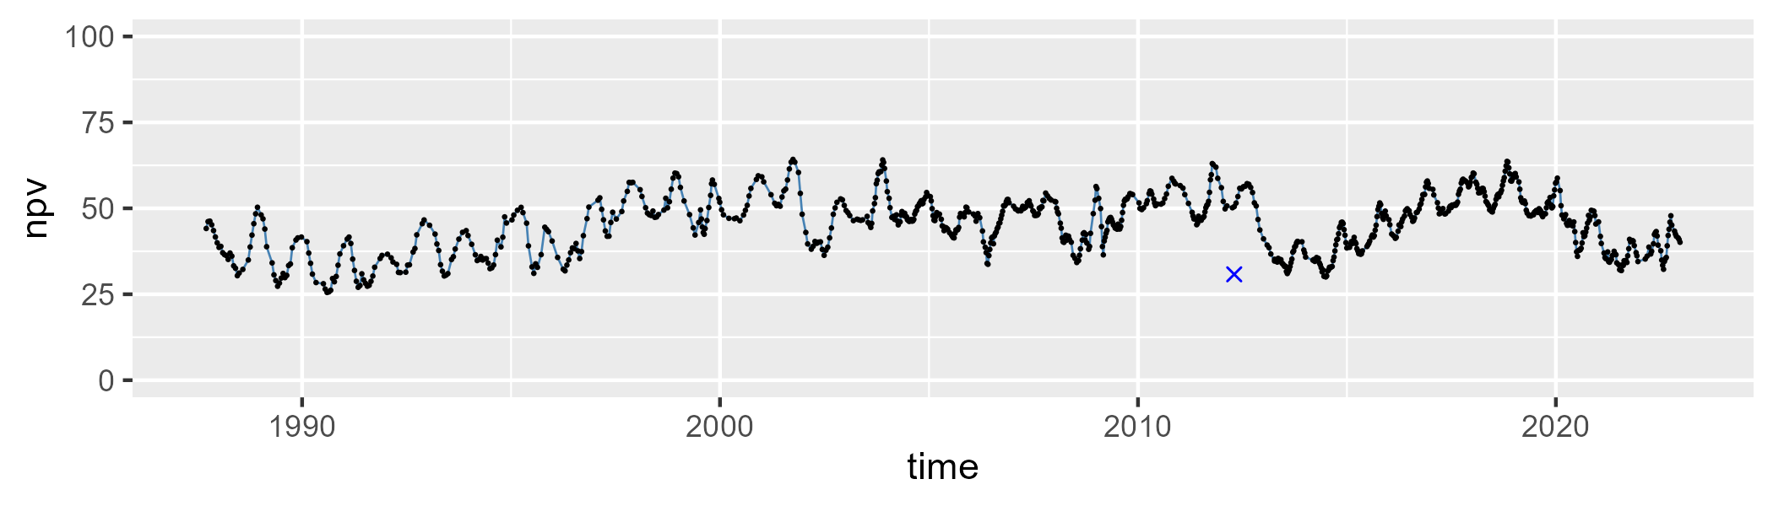

| Min. | 1st Qu. | Median | Mean | 3rd Qu. | Max. |
| --- | --- | --- | --- | --- | --- |
| 10.04437 | 28.52684 | 36.04035 | 36.46308 | 44.09538 | 66.20709 |

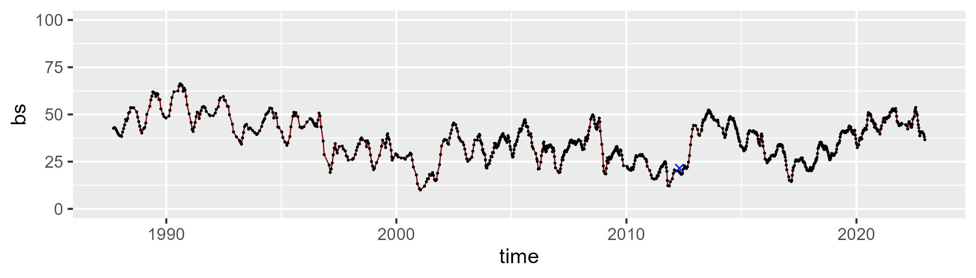

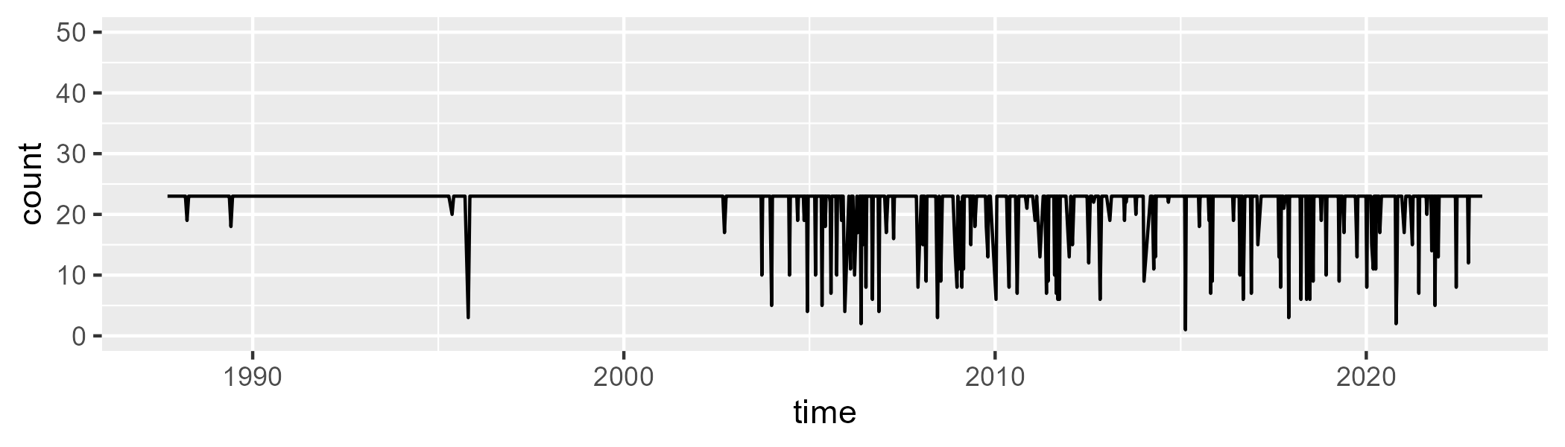

Min. : 1.00 1st Qu.:23.00 Median :23.00 Mean :21.71 3rd Qu.:23.00 Max. :23.00

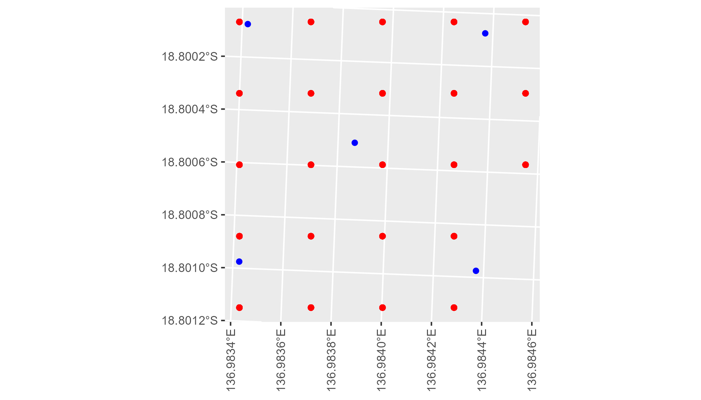

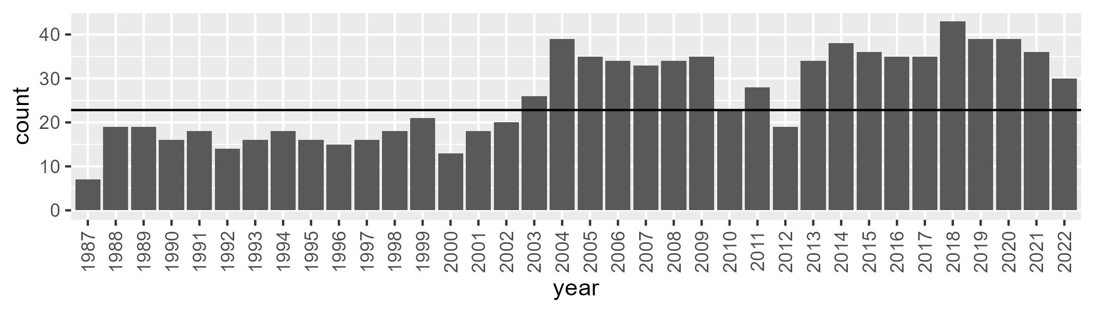

Number of samples: 935

# NTAGFU0010

| Min. | 1st Qu. | Median | Mean | 3rd Qu. | Max. |
| --- | --- | --- | --- | --- | --- |
| 2.967814 | 11.6879 | 15.86353 | 15.84209 | 19.82919 | 31.22968 |

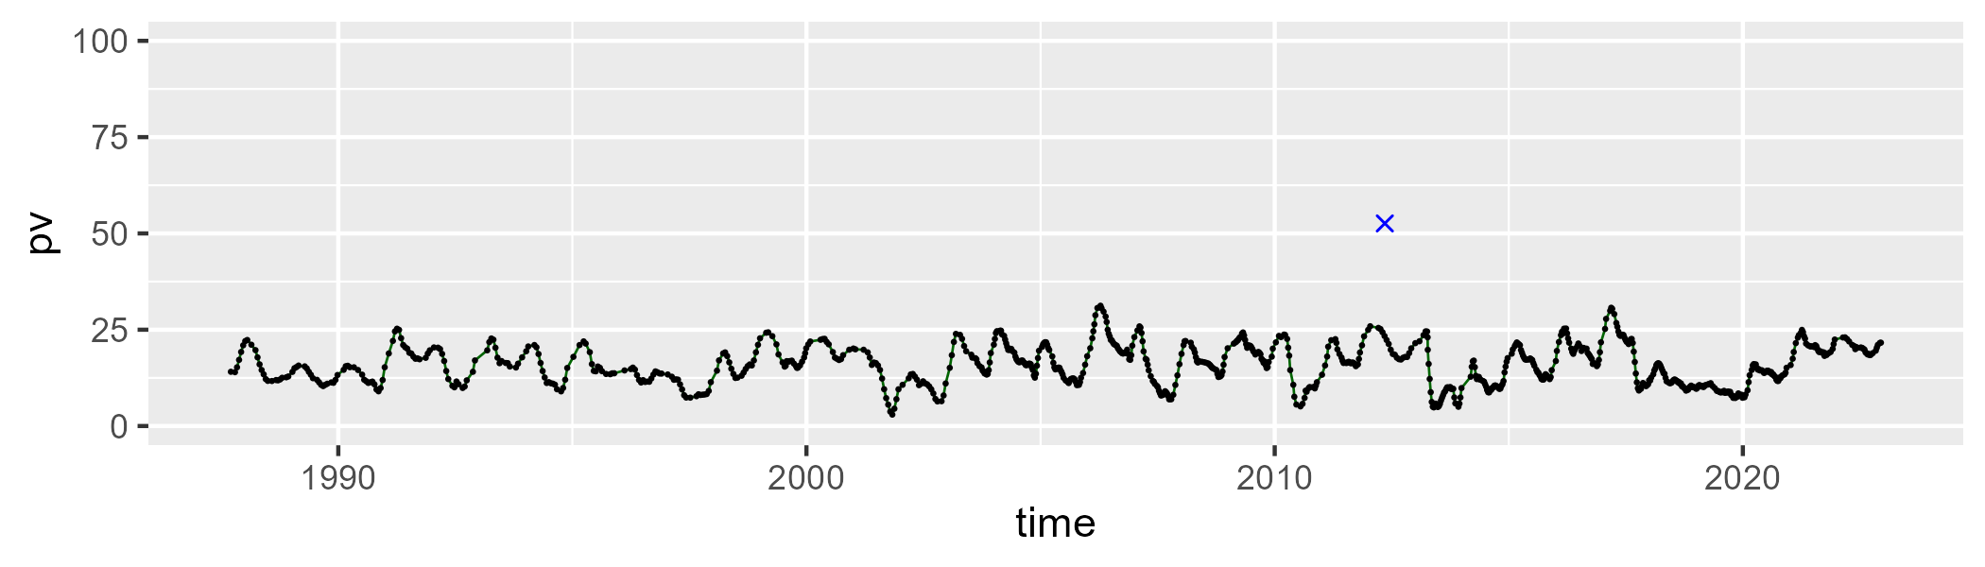

| Min. | 1st Qu. | Median | Mean | 3rd Qu. | Max. |
| --- | --- | --- | --- | --- | --- |
| 29.4392 | 43.16396 | 51.10589 | 50.65469 | 56.46352 | 76.95204 |

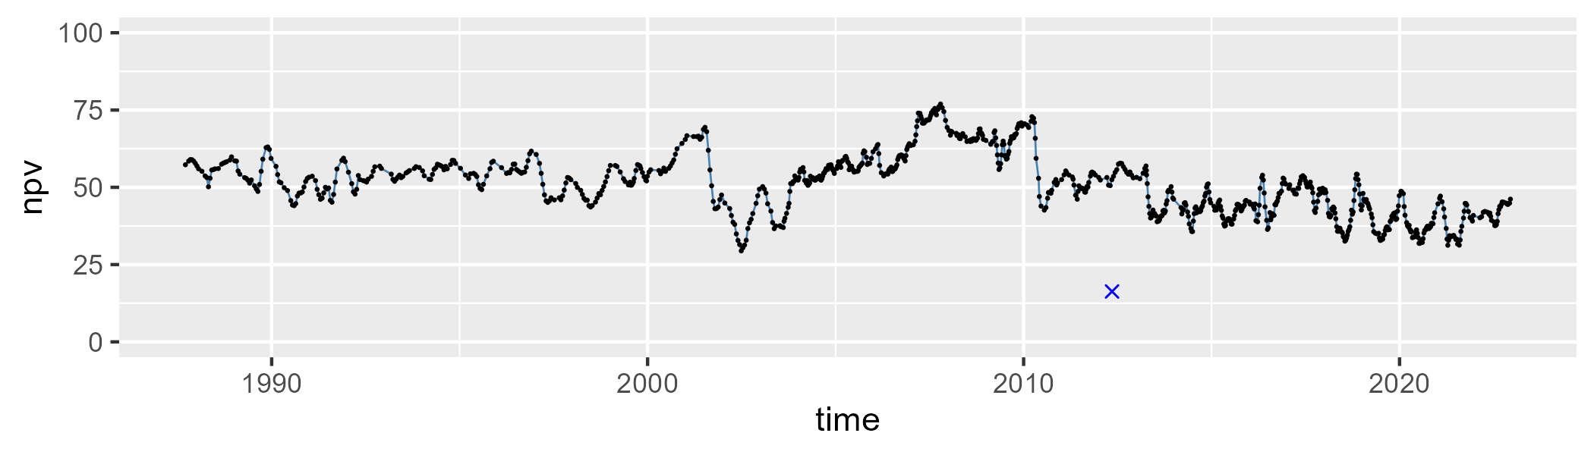

| Min. | 1st Qu. | Median | Mean | 3rd Qu. | Max. |
| --- | --- | --- | --- | --- | --- |
| 2.709781 | 23.61281 | 31.65777 | 32.13068 | 41.82305 | 57.47341 |

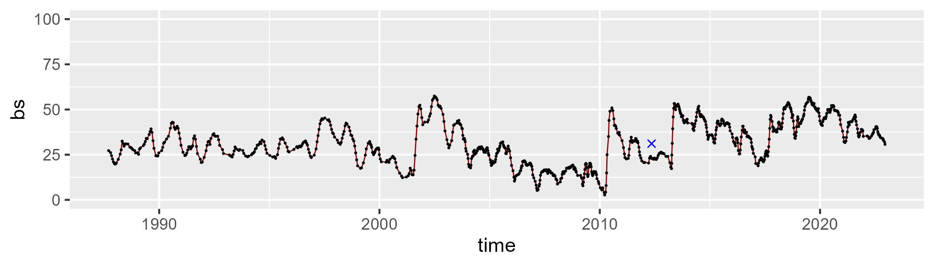

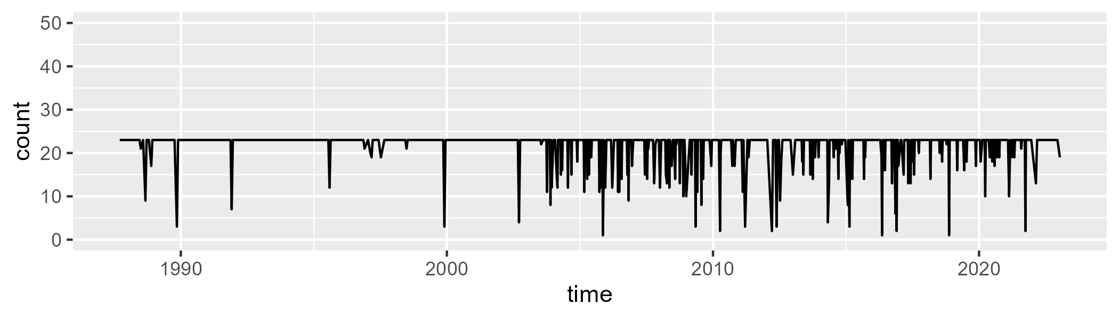

Min. : 1.00 1st Qu.:23.00 Median :23.00 Mean :21.76 3rd Qu.:23.00 Max. :23.00

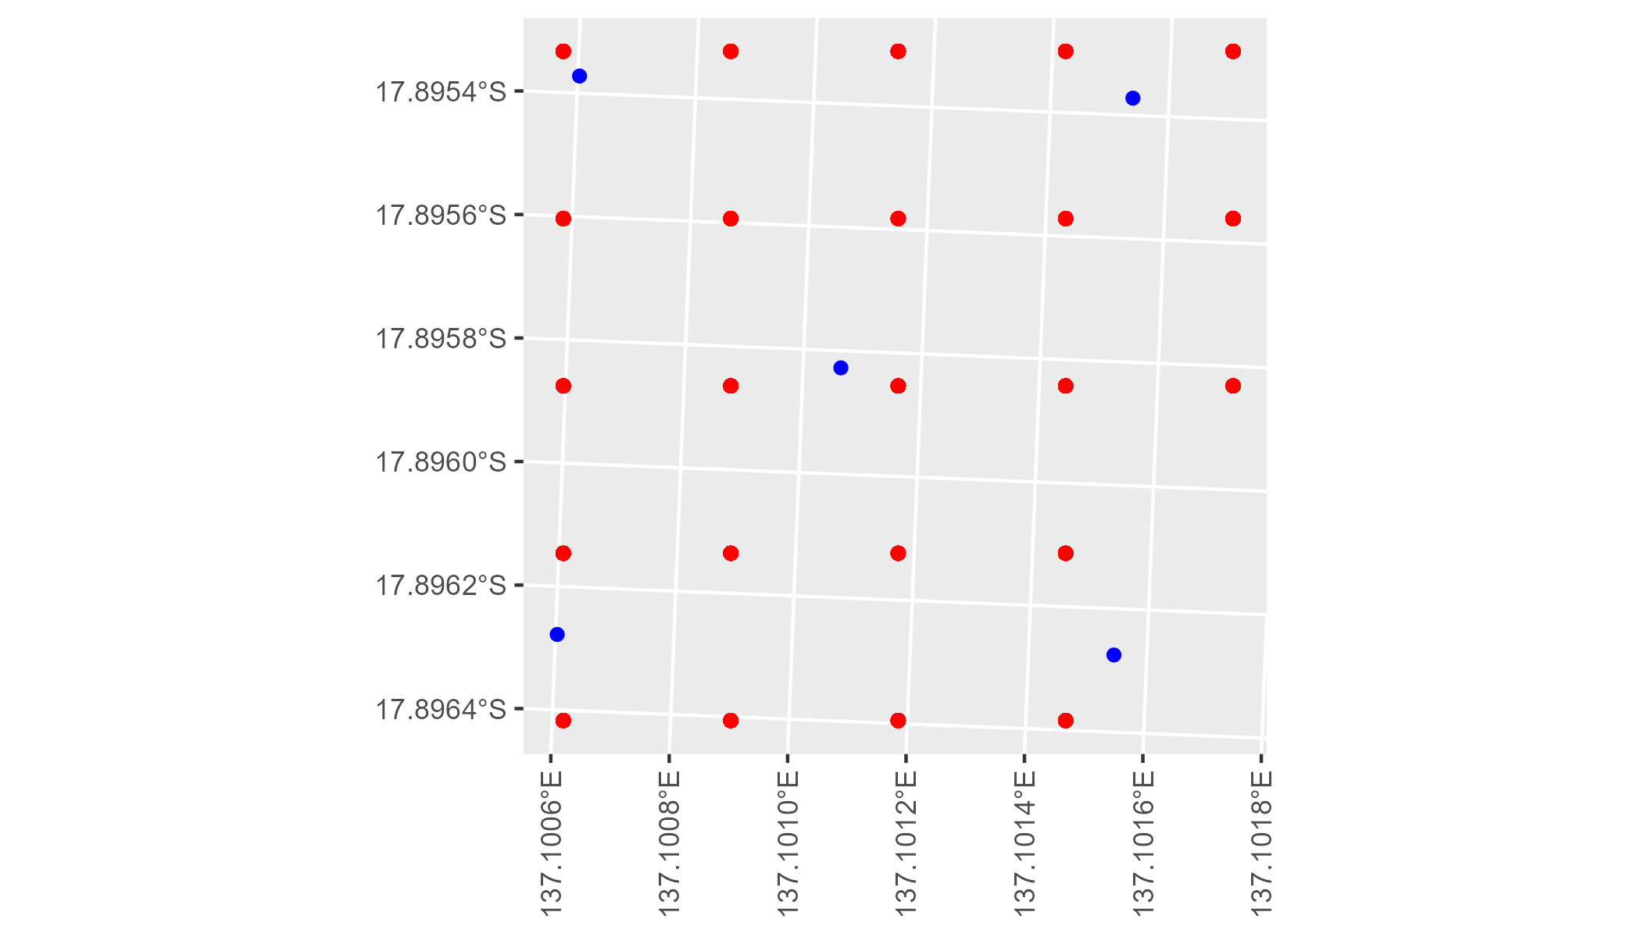

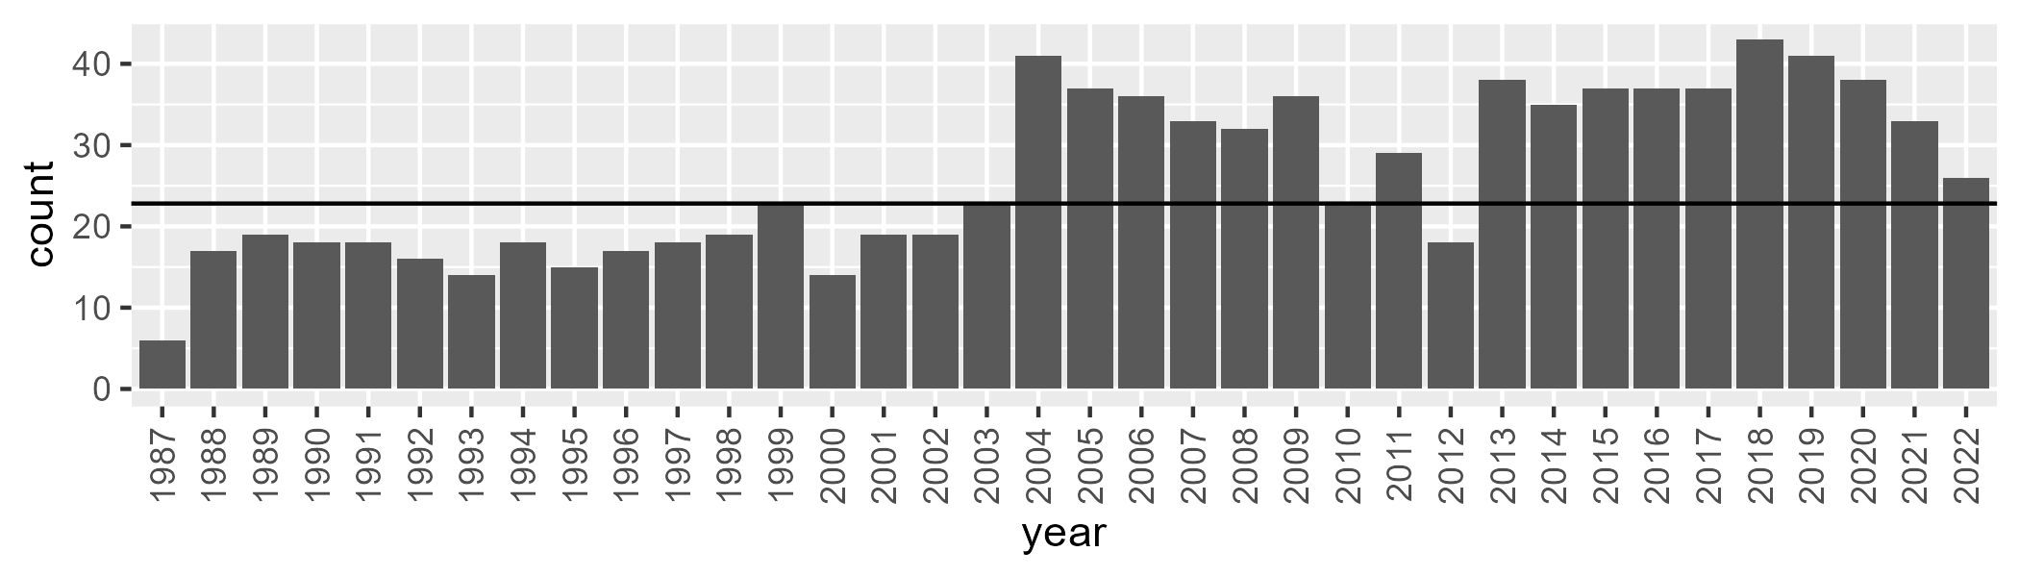

Number of samples: 943

# NTAGFU0011

| Min. | 1st Qu. | Median | Mean | 3rd Qu. | Max. |
| --- | --- | --- | --- | --- | --- |
| 1.556083 | 12.75634 | 17.00733 | 19.87788 | 25.93237 | 51.06771 |

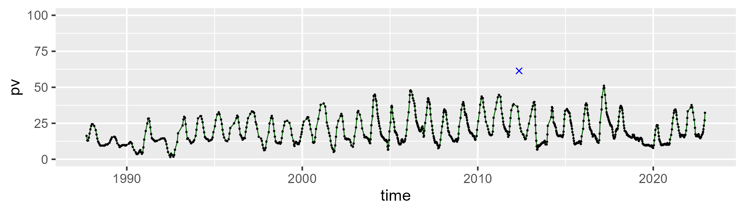

| Min. | 1st Qu. | Median | Mean | 3rd Qu. | Max. |
| --- | --- | --- | --- | --- | --- |
| 29.31097 | 45.27375 | 51.95633 | 52.2697 | 58.72994 | 78.98055 |

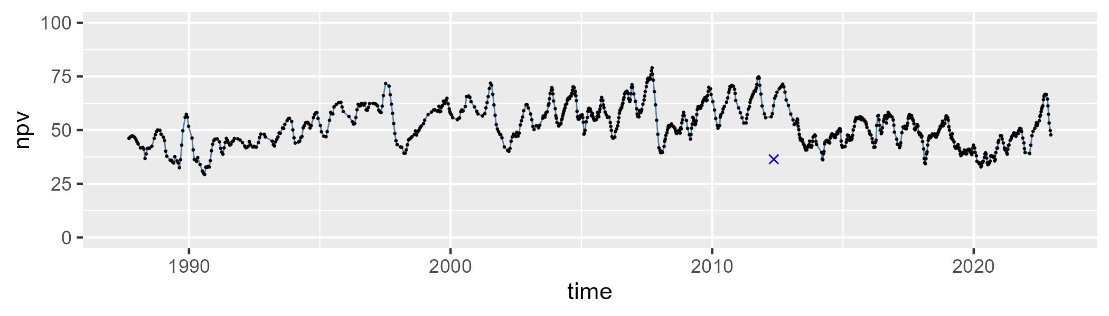

| Min. | 1st Qu. | Median | Mean | 3rd Qu. | Max. |
| --- | --- | --- | --- | --- | --- |
| 0 | 16.09232 | 26.37836 | 26.53419 | 34.49279 | 65.52205 |

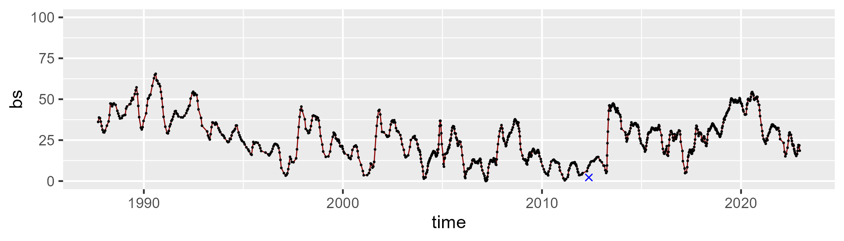

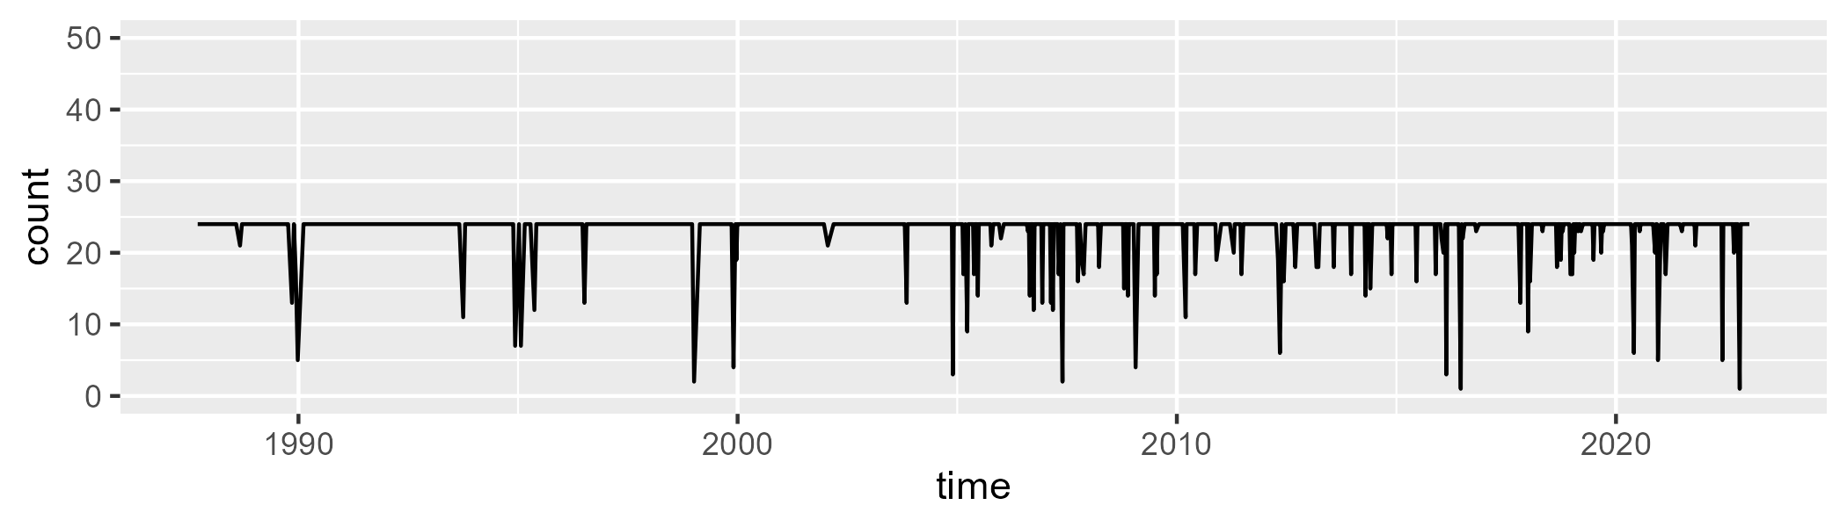

Min. : 1.00 1st Qu.:24.00 Median :24.00 Mean :23.18 3rd Qu.:24.00 Max. :24.00

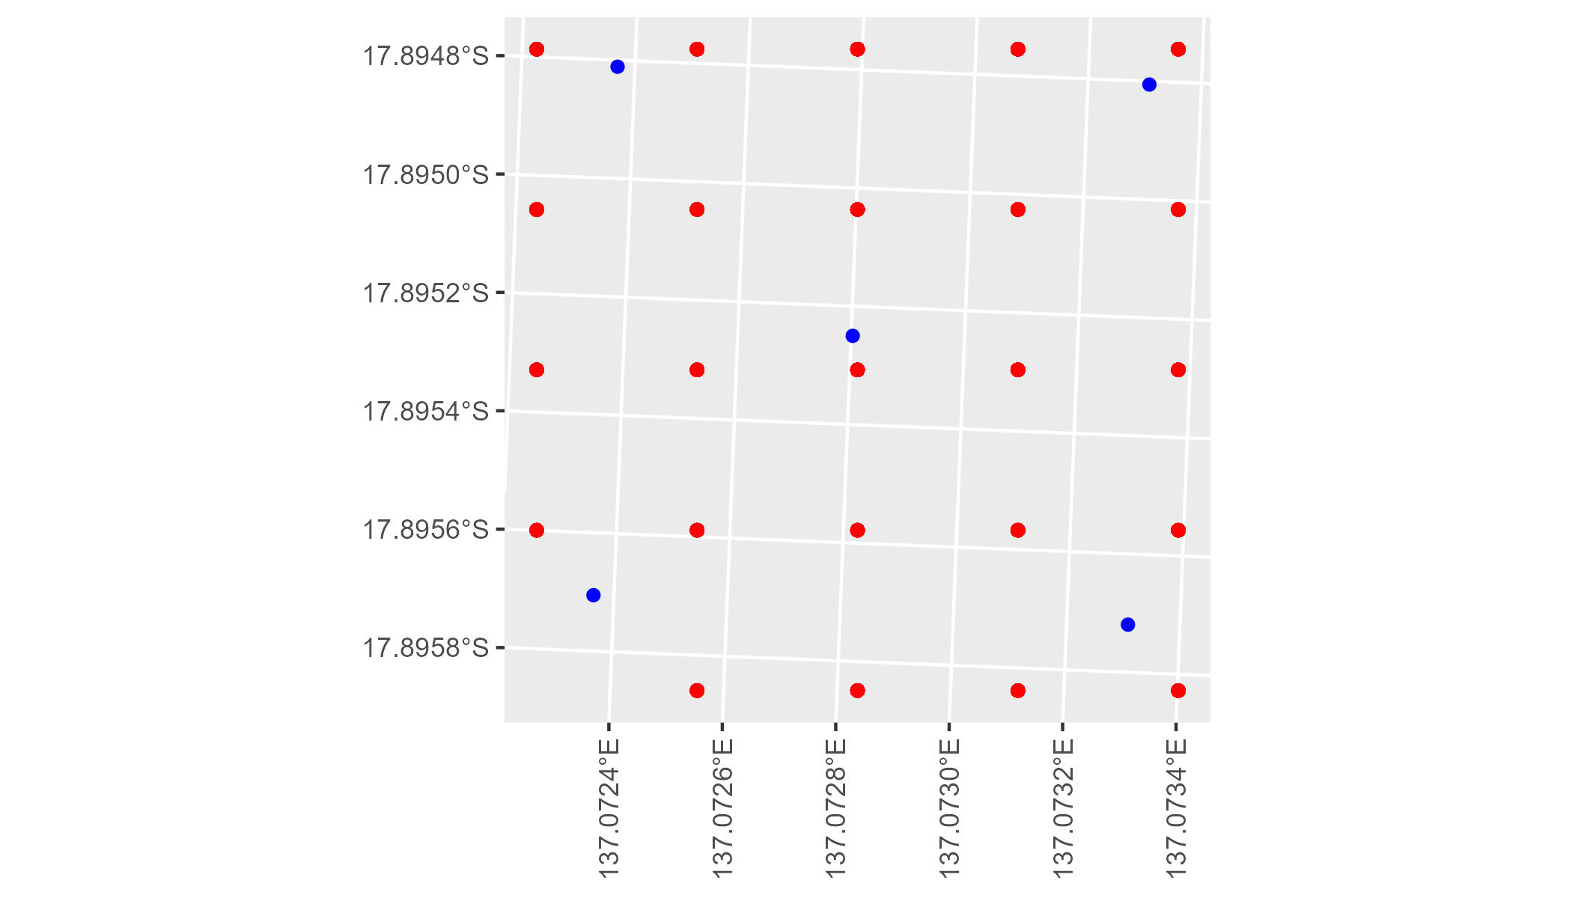

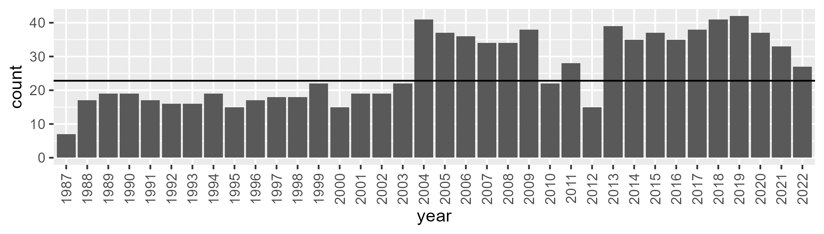

Number of samples: 944

# NTAGFU0012

| Min. | 1st Qu. | Median | Mean | 3rd Qu. | Max. |
| --- | --- | --- | --- | --- | --- |
| 5.510472 | 15.33372 | 21.19606 | 20.9068 | 25.76153 | 41.71625 |

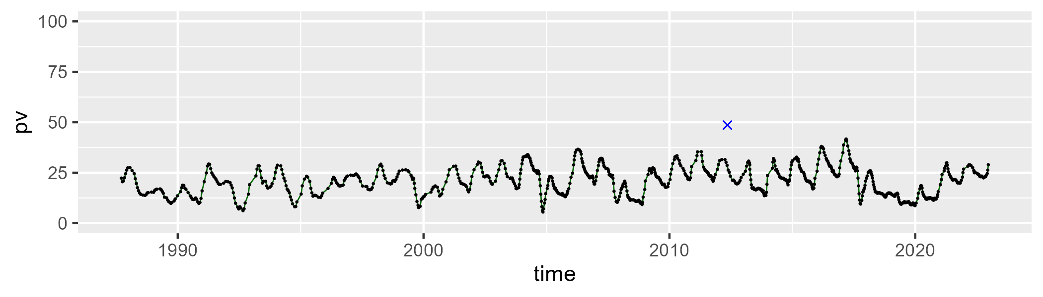

| Min. | 1st Qu. | Median | Mean | 3rd Qu. | Max. |
| --- | --- | --- | --- | --- | --- |
| 28.91407 | 43.19119 | 48.96701 | 48.44442 | 54.4153 | 65.96758 |

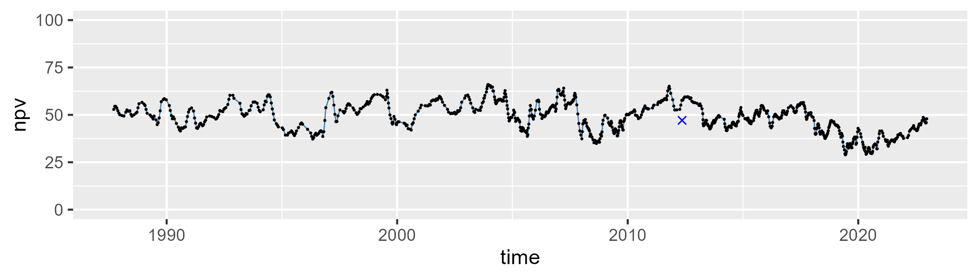

| Min. | 1st Qu. | Median | Mean | 3rd Qu. | Max. |
| --- | --- | --- | --- | --- | --- |
| 1.133605 | 19.91338 | 28.50316 | 29.31106 | 38.11607 | 59.84566 |

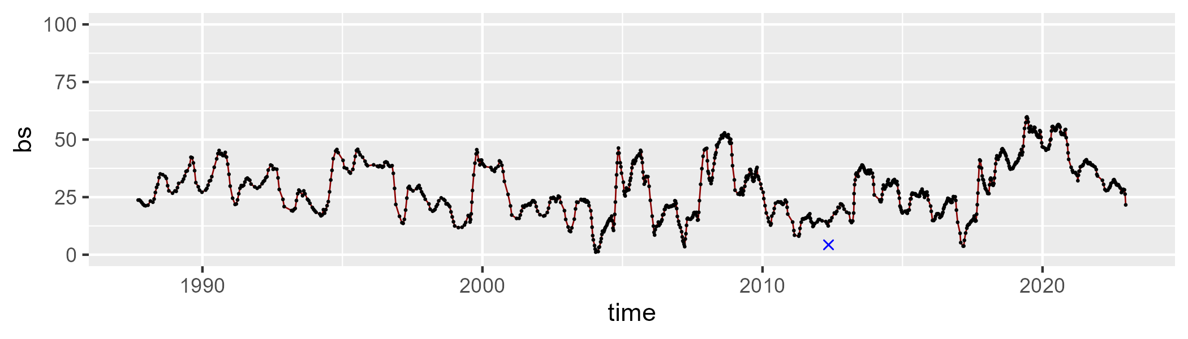

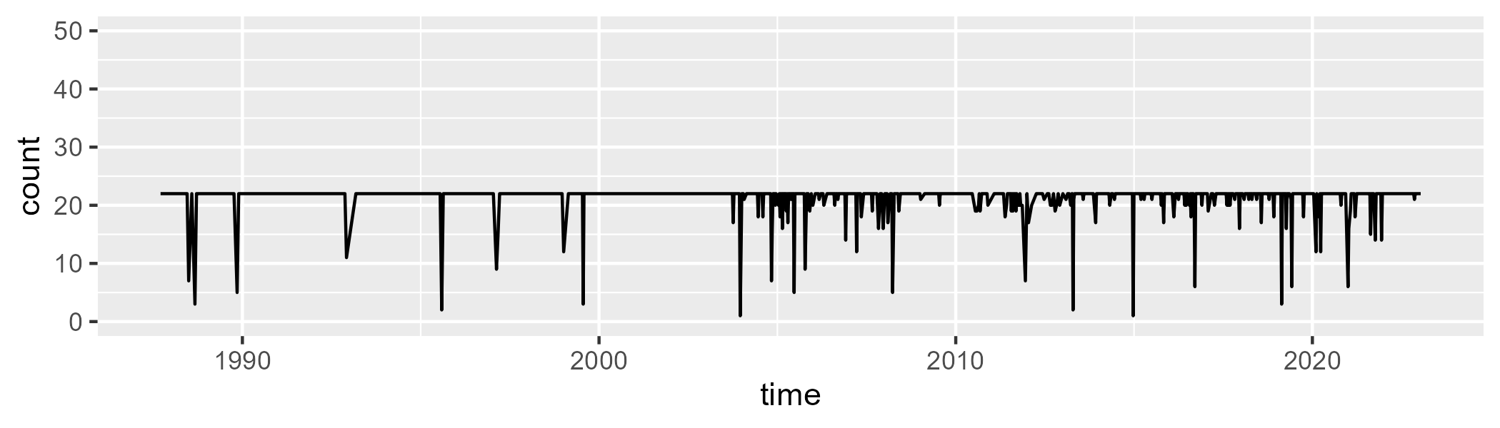

Min. : 1.00 1st Qu.:22.00 Median :22.00 Mean :21.31 3rd Qu.:22.00 Max. :22.00

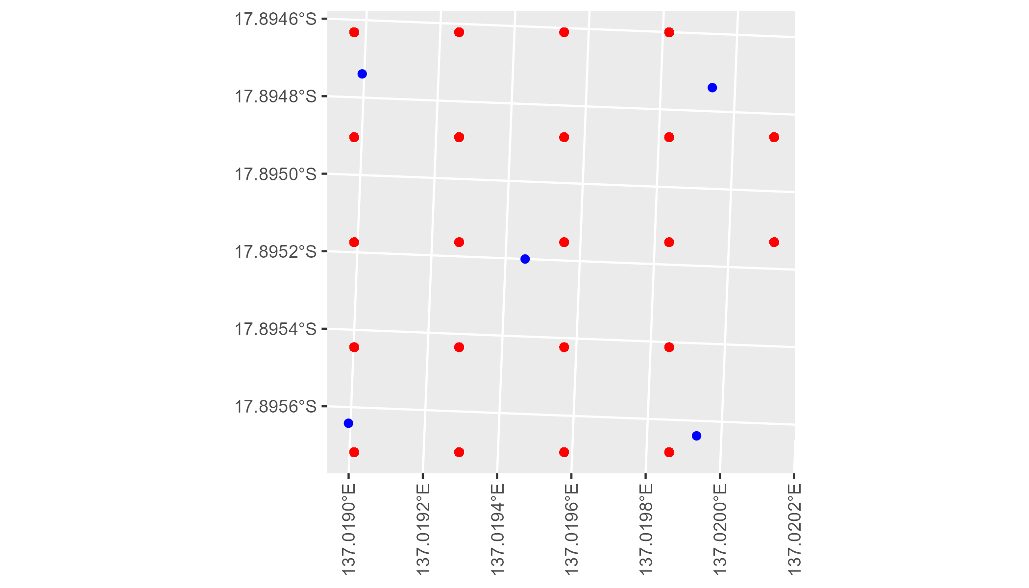

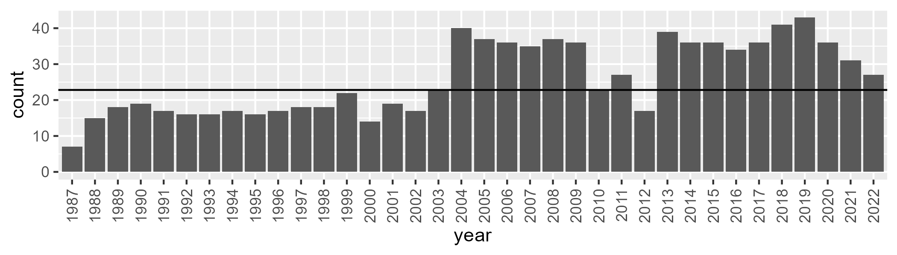

Number of samples: 936

# NTAGFU0013

| Min. | 1st Qu. | Median | Mean | 3rd Qu. | Max. |
| --- | --- | --- | --- | --- | --- |
| 2.453032 | 16.65916 | 22.82257 | 23.68104 | 30.08443 | 54.01966 |

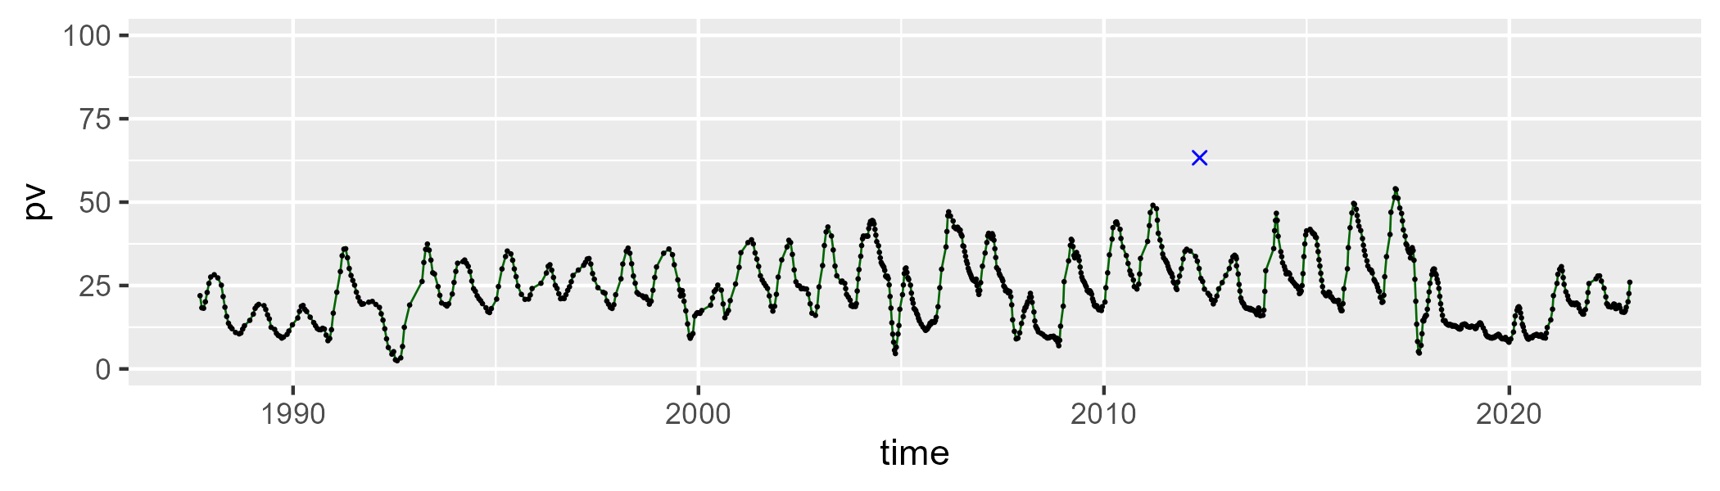

| Min. | 1st Qu. | Median | Mean | 3rd Qu. | Max. |
| --- | --- | --- | --- | --- | --- |
| 30.5719 | 44.36647 | 50.26608 | 49.95313 | 55.99049 | 71.68431 |

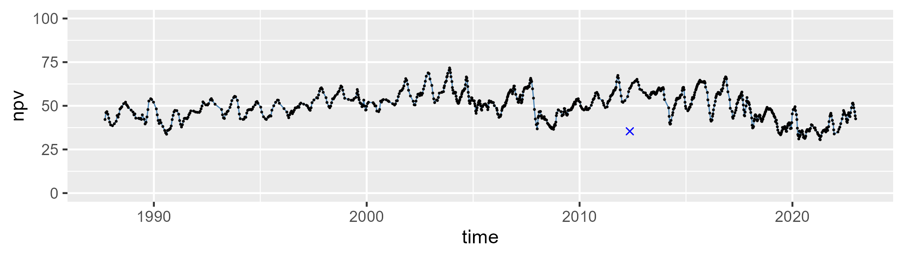

| Min. | 1st Qu. | Median | Mean | 3rd Qu. | Max. |
| --- | --- | --- | --- | --- | --- |
| 0.5895493 | 13.12076 | 23.33808 | 25.06456 | 36.32863 | 57.48538 |

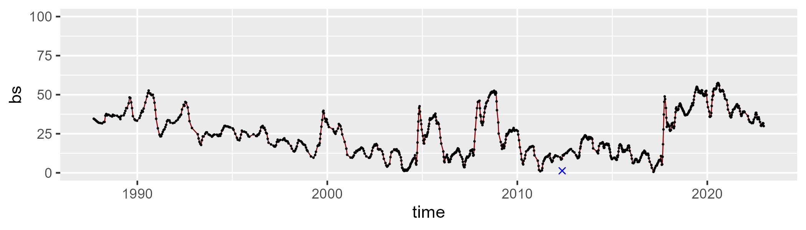

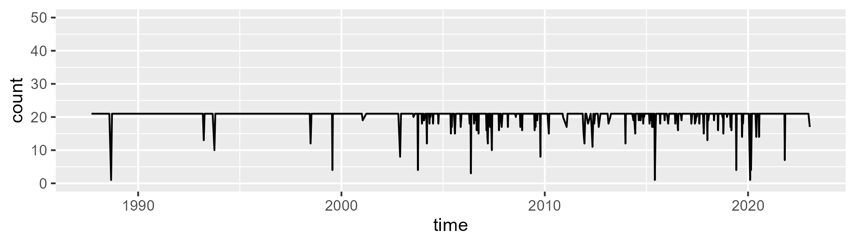

Min. : 1.0 1st Qu.:21.0 Median :21.0 Mean :20.4 3rd Qu.:21.0 Max. :21.0

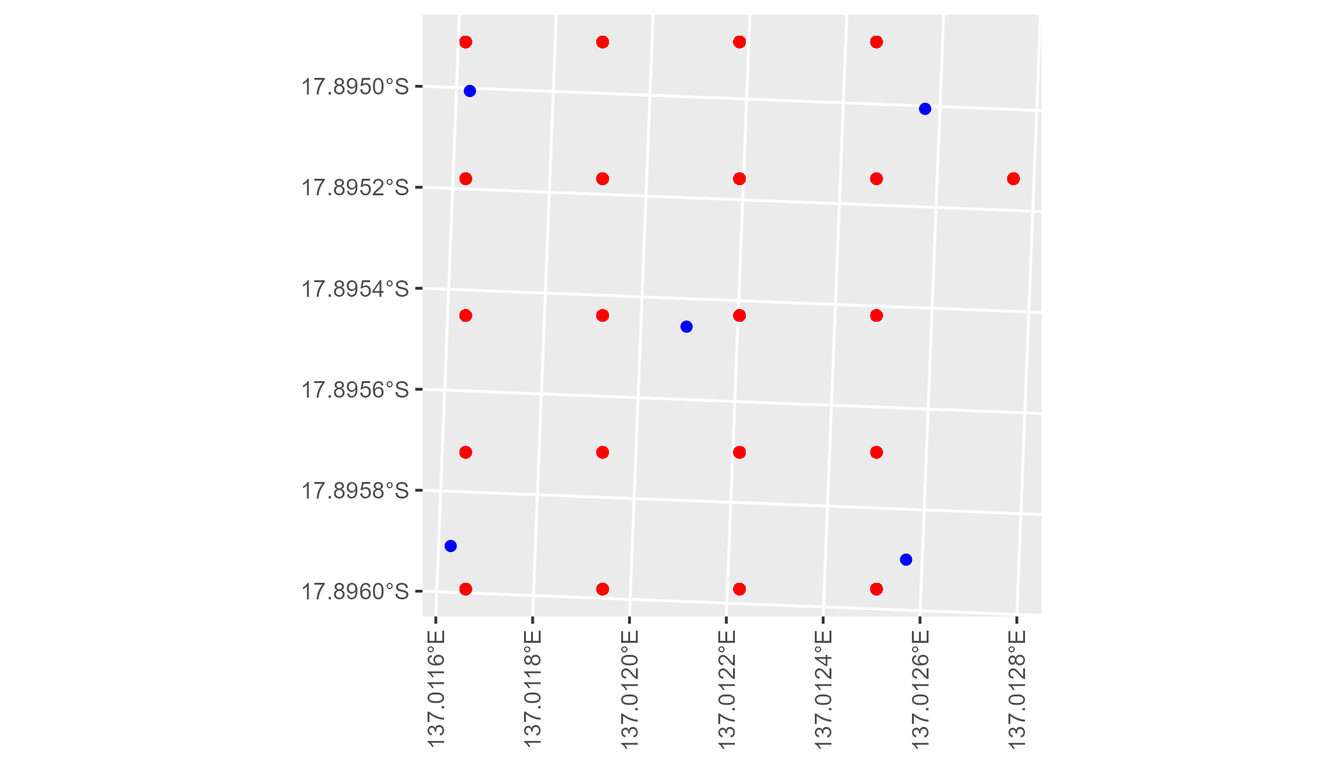

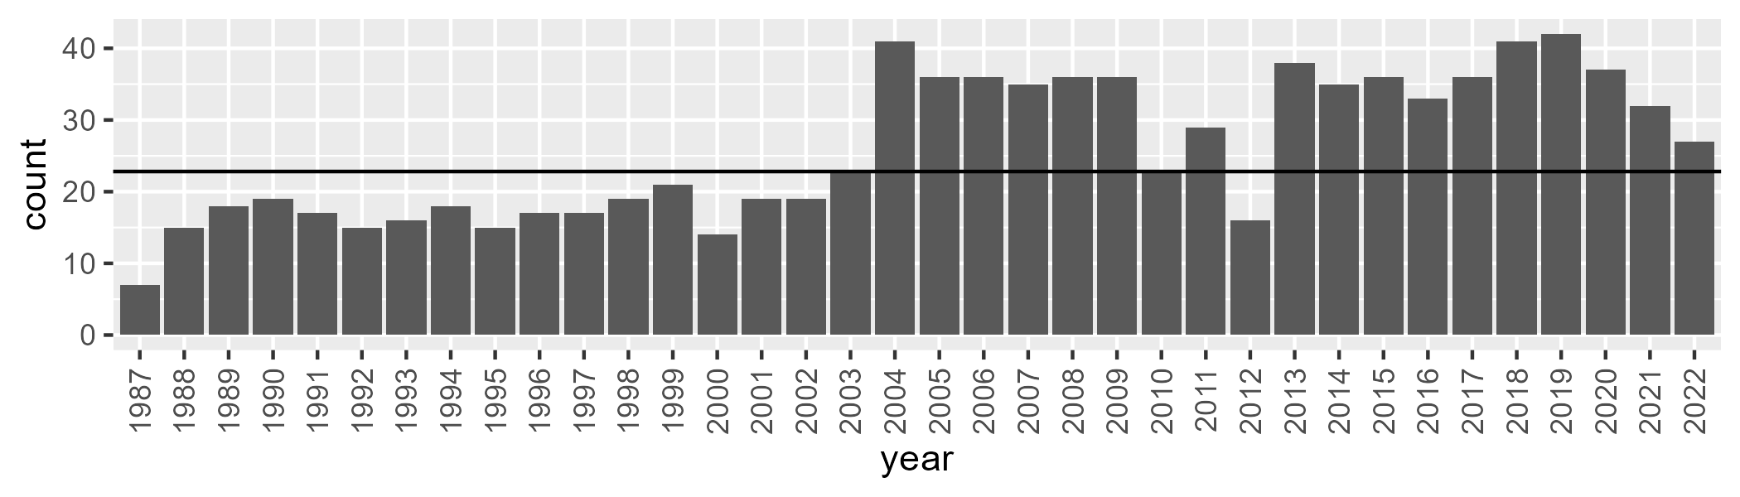

Number of samples: 934

# NTAGFU0014

| Min. | 1st Qu. | Median | Mean | 3rd Qu. | Max. |
| --- | --- | --- | --- | --- | --- |
| 3.20816 | 13.86049 | 18.57929 | 21.4204 | 27.26111 | 58.62157 |

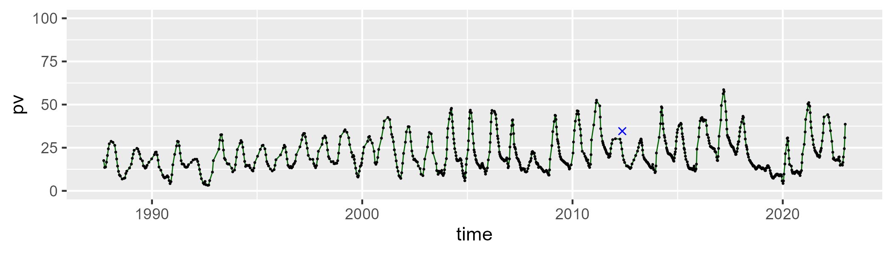

| Min. | 1st Qu. | Median | Mean | 3rd Qu. | Max. |
| --- | --- | --- | --- | --- | --- |
| 36.26676 | 50.82476 | 56.98598 | 56.68446 | 61.90268 | 75.79396 |

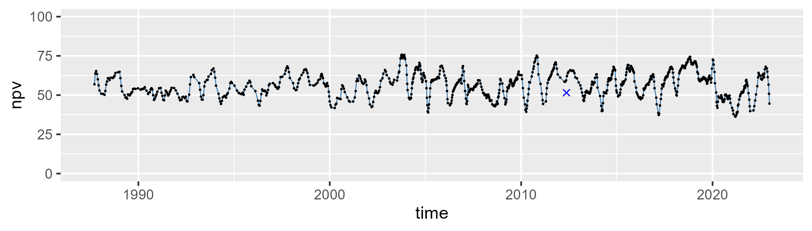

| Min. | 1st Qu. | Median | Mean | 3rd Qu. | Max. |
| --- | --- | --- | --- | --- | --- |
| 1.327759 | 13.51605 | 19.4004 | 20.60587 | 27.1498 | 48.93031 |

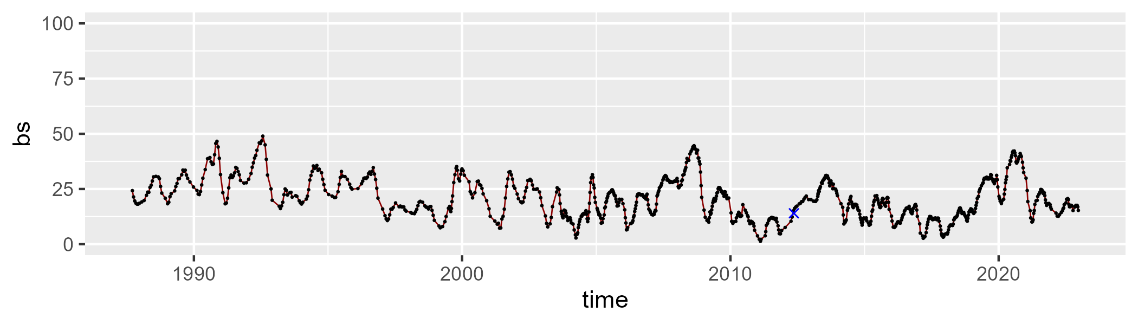

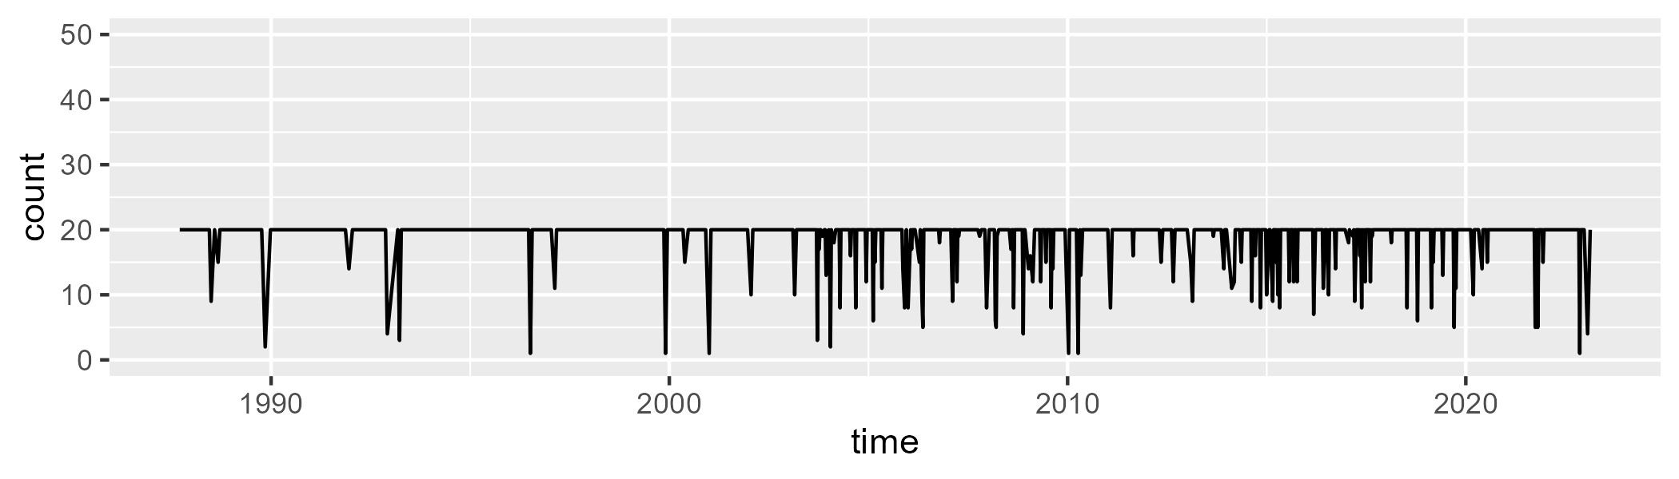

Min. : 1.00 1st Qu.:20.00 Median :20.00 Mean :18.95 3rd Qu.:20.00 Max. :20.00

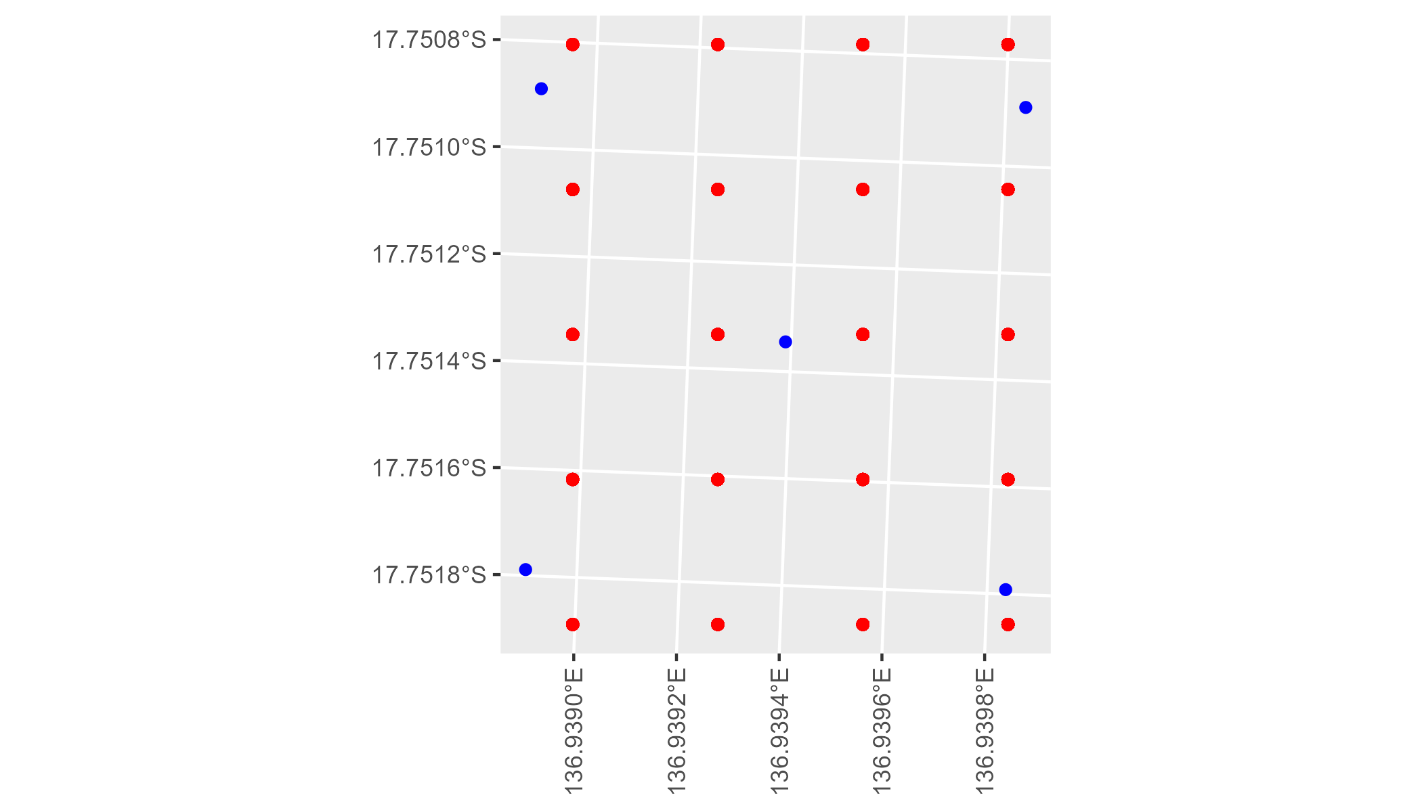

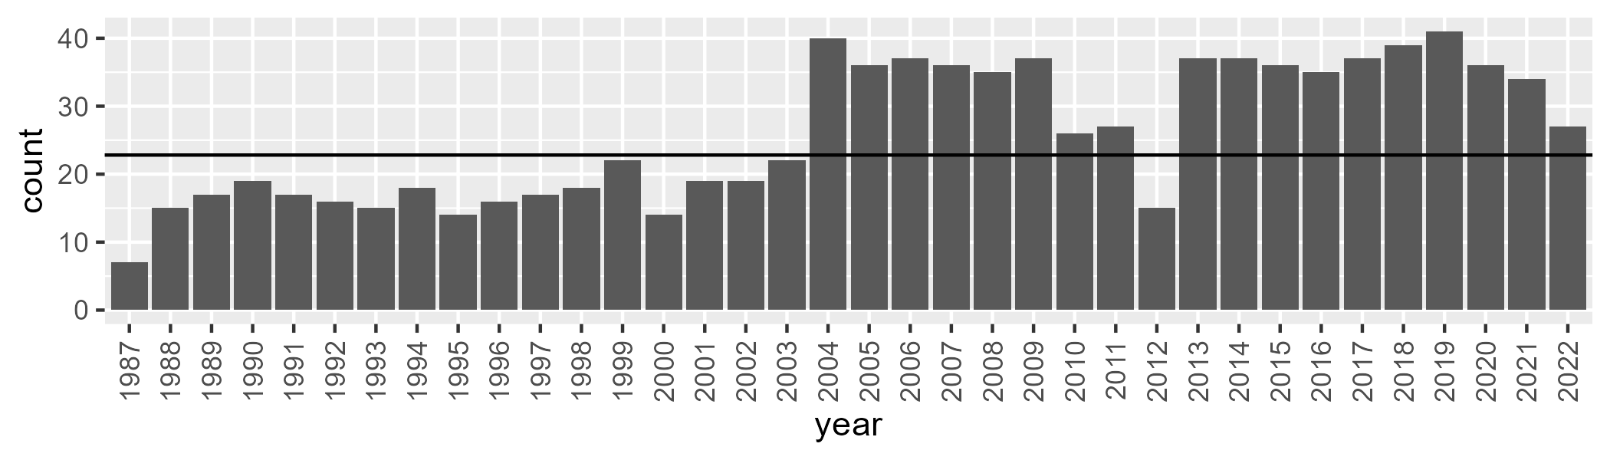

Number of samples: 933

# NTAGFU0015

| Min. | 1st Qu. | Median | Mean | 3rd Qu. | Max. |
| --- | --- | --- | --- | --- | --- |
| 2.587673 | 13.44355 | 16.97823 | 17.38925 | 20.82304 | 35.07203 |

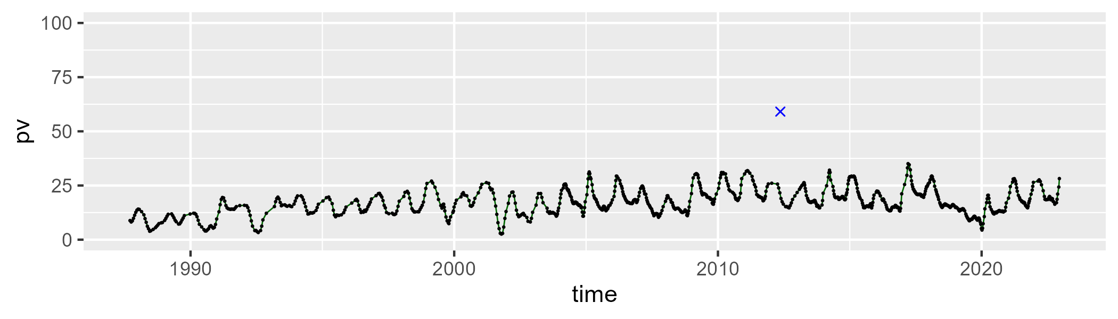

| Min. | 1st Qu. | Median | Mean | 3rd Qu. | Max. |
| --- | --- | --- | --- | --- | --- |
| 16.71702 | 40.65152 | 48.2565 | 48.10472 | 56.53786 | 70.05111 |

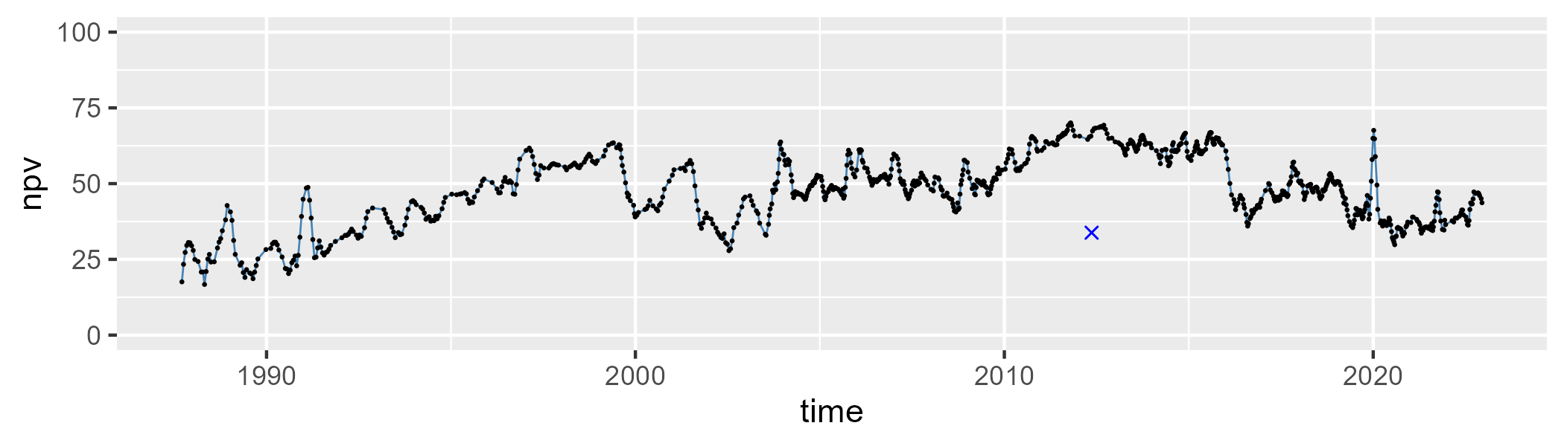

| Min. | 1st Qu. | Median | Mean | 3rd Qu. | Max. |
| --- | --- | --- | --- | --- | --- |
| 3.338299 | 20.8415 | 32.80228 | 33.14792 | 42.41864 | 74.22824 |

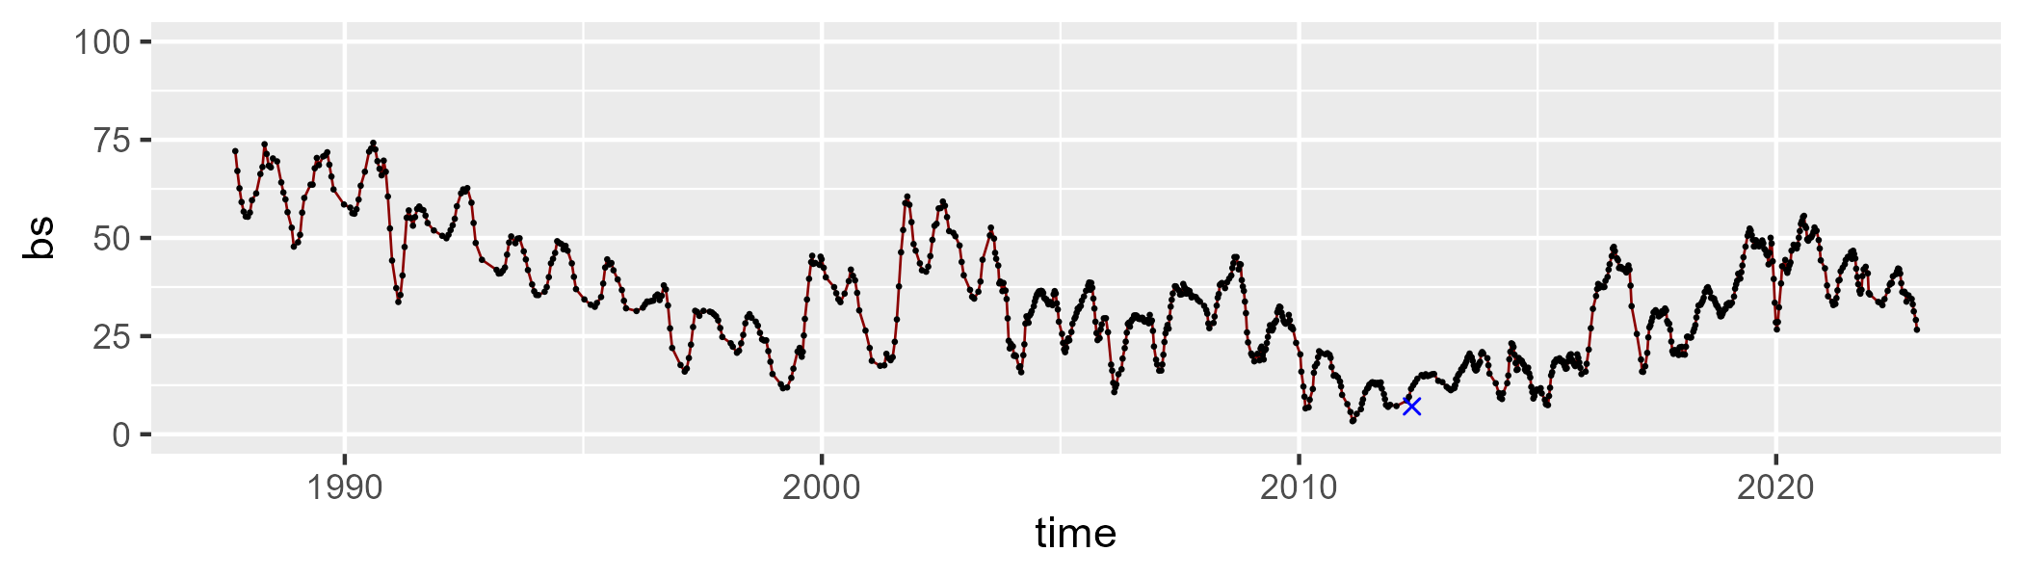

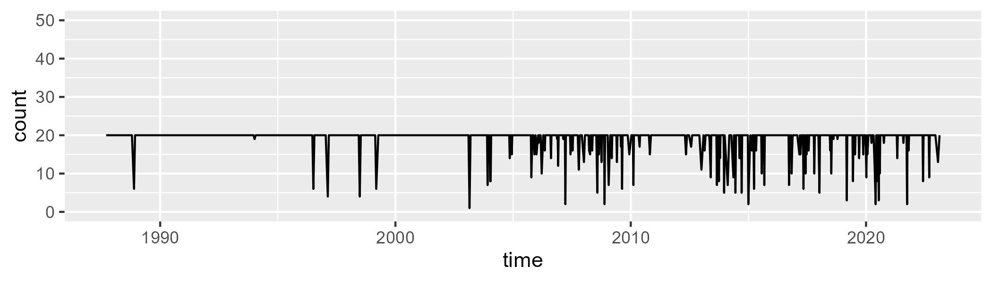

Min. : 1.00 1st Qu.:20.00 Median :20.00 Mean :19.05 3rd Qu.:20.00 Max. :20.00

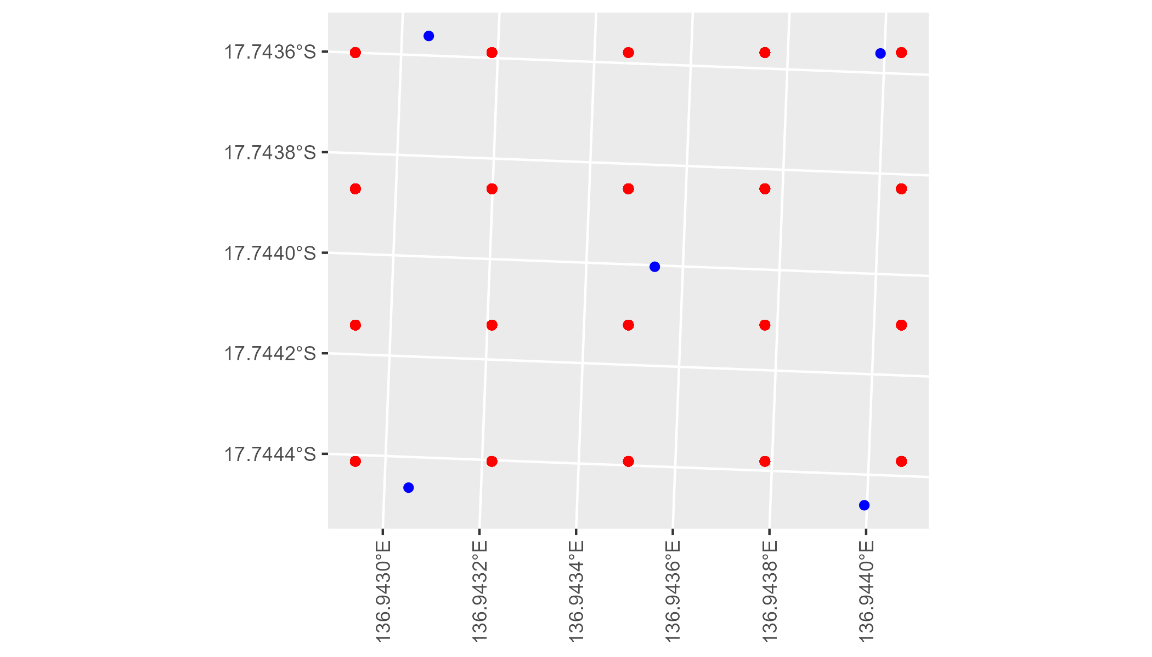

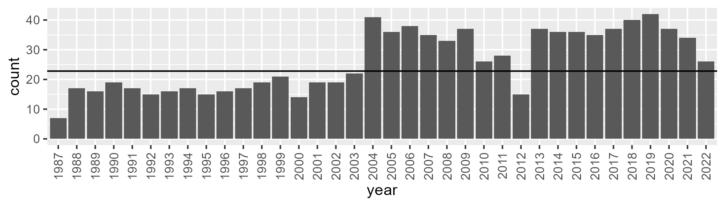

Number of samples: 935

# NTAGFU0016

| Min. | 1st Qu. | Median | Mean | 3rd Qu. | Max. |
| --- | --- | --- | --- | --- | --- |
| 3.689386 | 17.96609 | 24.86145 | 27.02338 | 34.70803 | 62.14232 |

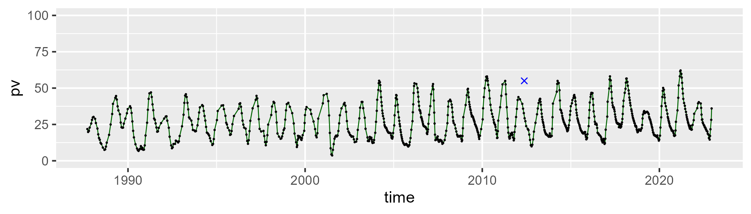

| Min. | 1st Qu. | Median | Mean | 3rd Qu. | Max. |
| --- | --- | --- | --- | --- | --- |
| 25.11935 | 47.41435 | 52.99497 | 52.97709 | 57.90985 | 72.60279 |

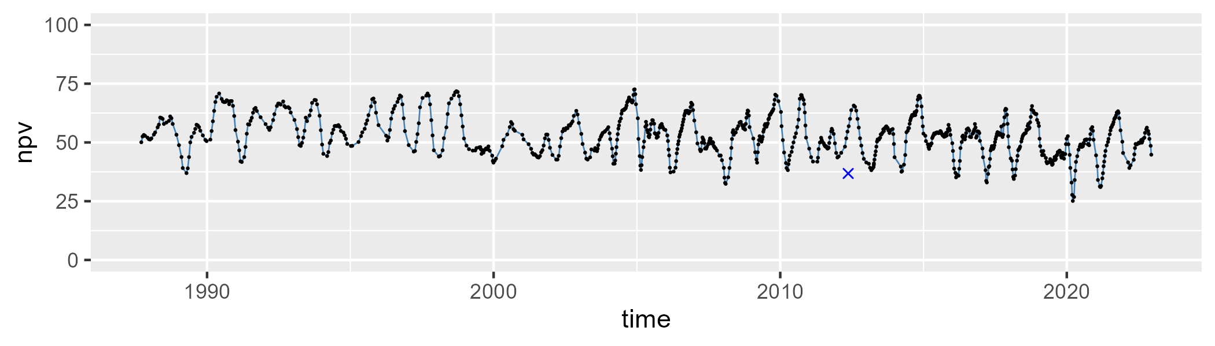

| Min. | 1st Qu. | Median | Mean | 3rd Qu. | Max. |
| --- | --- | --- | --- | --- | --- |
| 0 | 11.73288 | 17.30763 | 18.74612 | 24.99868 | 51.10348 |

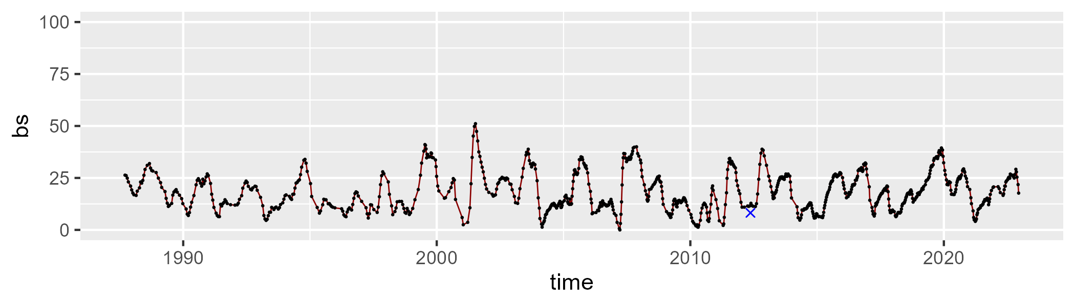

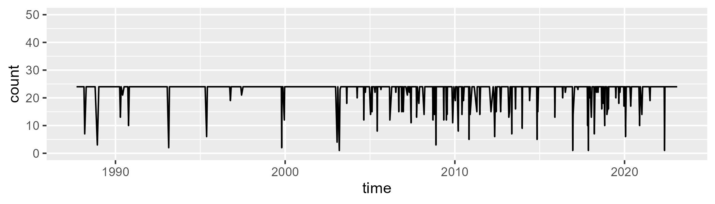

Min. : 1.00 1st Qu.:24.00 Median :24.00 Mean :22.98 3rd Qu.:24.00 Max. :24.00

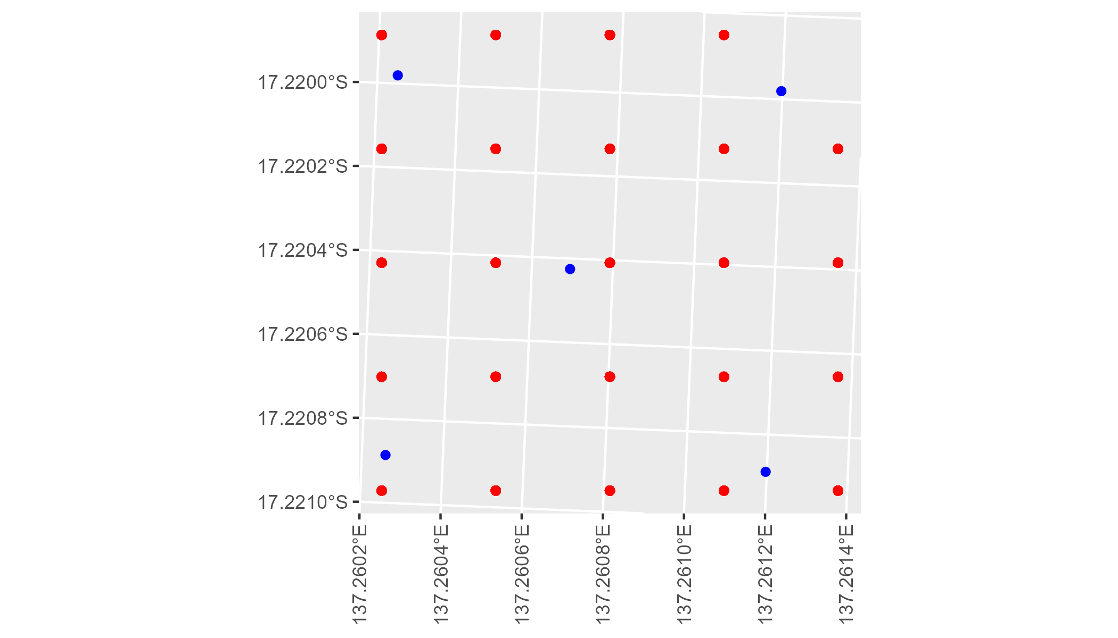

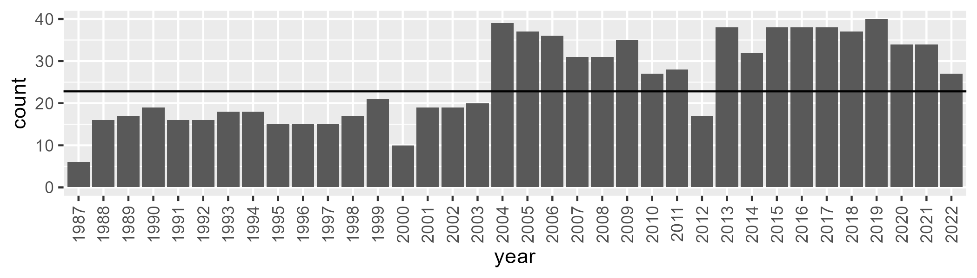

Number of samples: 914

# NTAGFU0017

| Min. | 1st Qu. | Median | Mean | 3rd Qu. | Max. |
| --- | --- | --- | --- | --- | --- |
| 4.252655 | 20.98231 | 27.30452 | 28.70683 | 35.52401 | 62.81363 |

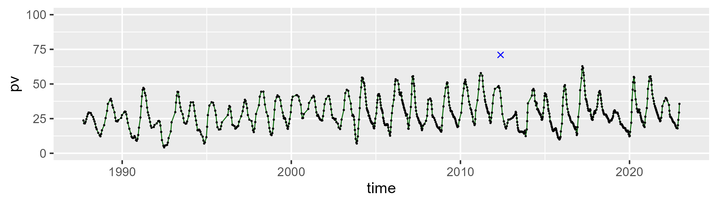

| Min. | 1st Qu. | Median | Mean | 3rd Qu. | Max. |
| --- | --- | --- | --- | --- | --- |
| 26.75168 | 51.60267 | 56.43317 | 56.07107 | 61.63028 | 74.6915 |

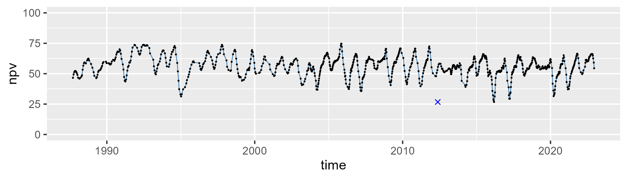

| Min. | 1st Qu. | Median | Mean | 3rd Qu. | Max. |
| --- | --- | --- | --- | --- | --- |
| 0.5802221 | 8.397854 | 12.57792 | 14.02974 | 18.27425 | 53.95321 |

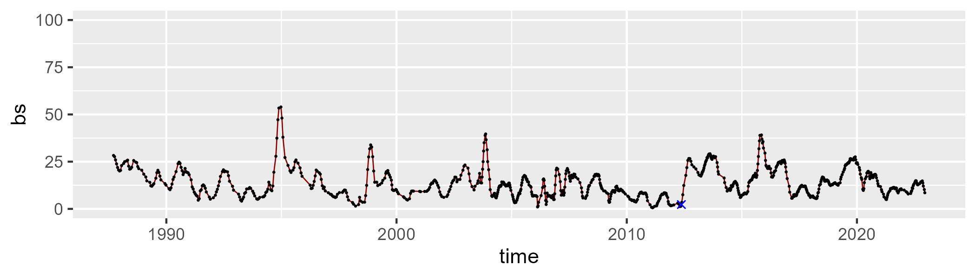

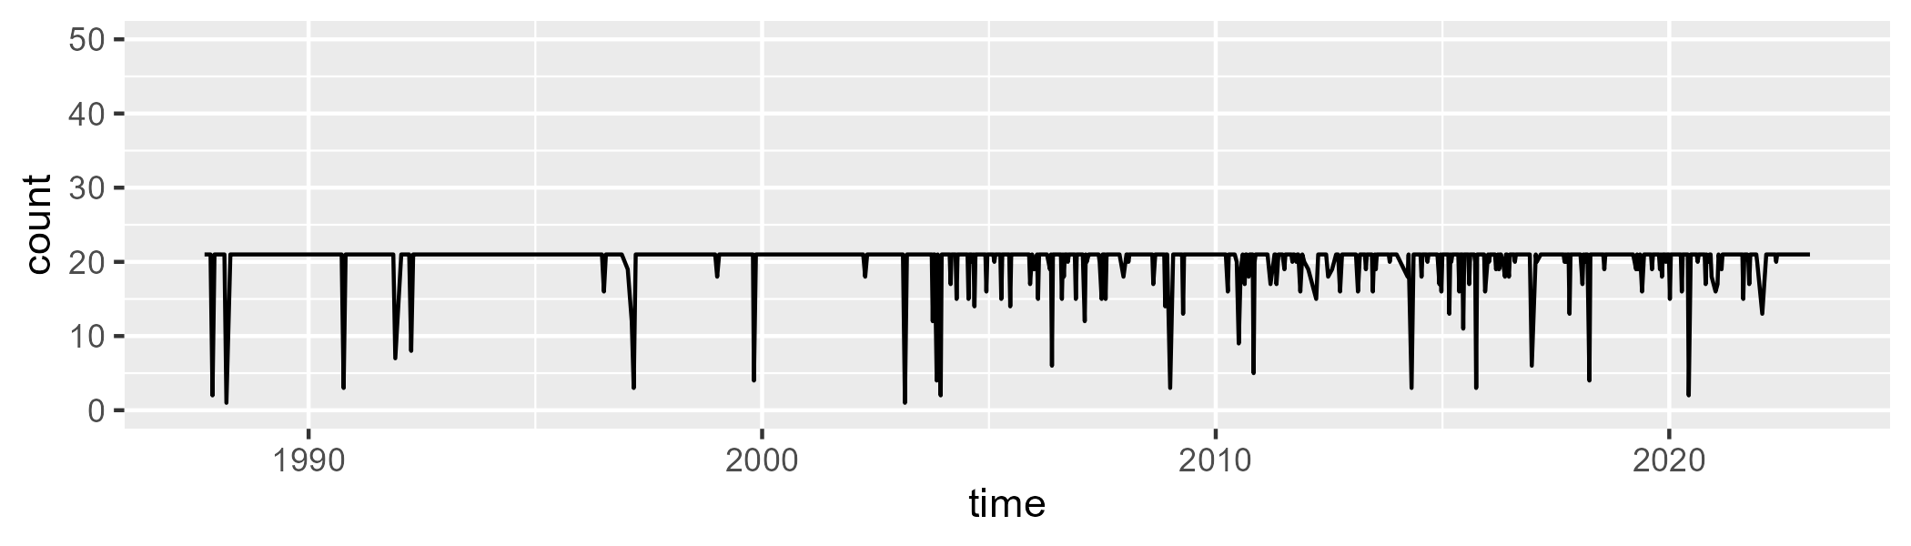

Min. : 1.00 1st Qu.:21.00 Median :21.00 Mean :20.24 3rd Qu.:21.00 Max. :21.00

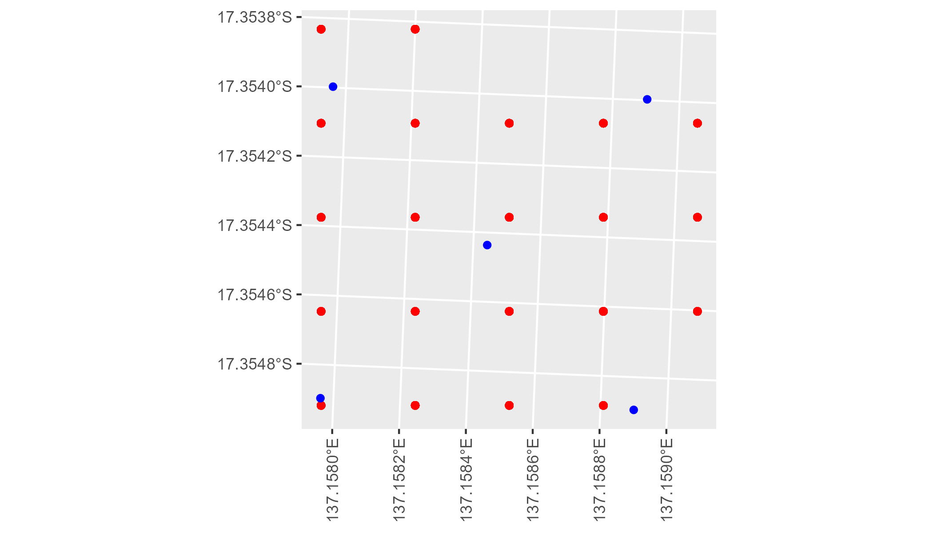

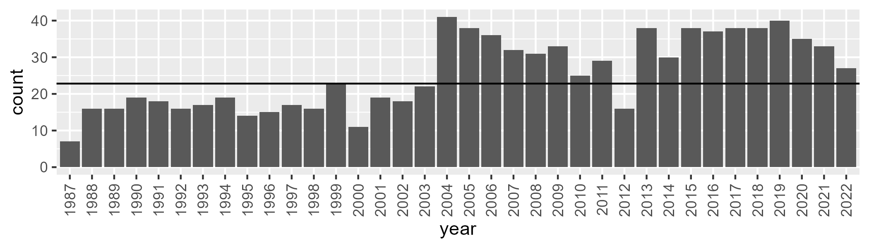

Number of samples: 918

# NTAGFU0018

| Min. | 1st Qu. | Median | Mean | 3rd Qu. | Max. |
| --- | --- | --- | --- | --- | --- |
| 8.195208 | 19.30151 | 22.68809 | 23.49042 | 27.21801 | 41.91542 |

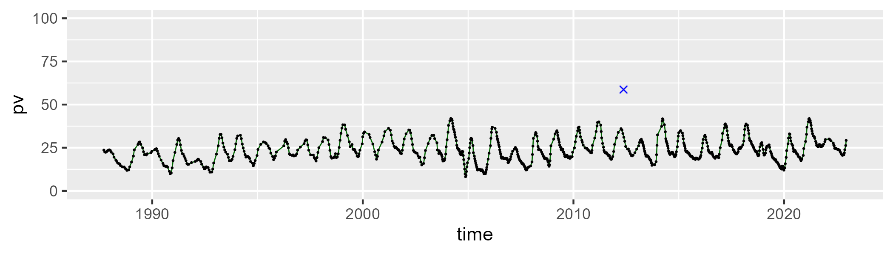

| Min. | 1st Qu. | Median | Mean | 3rd Qu. | Max. |
| --- | --- | --- | --- | --- | --- |
| 46.94236 | 59.81293 | 63.67379 | 63.43954 | 67.1029 | 78.51844 |

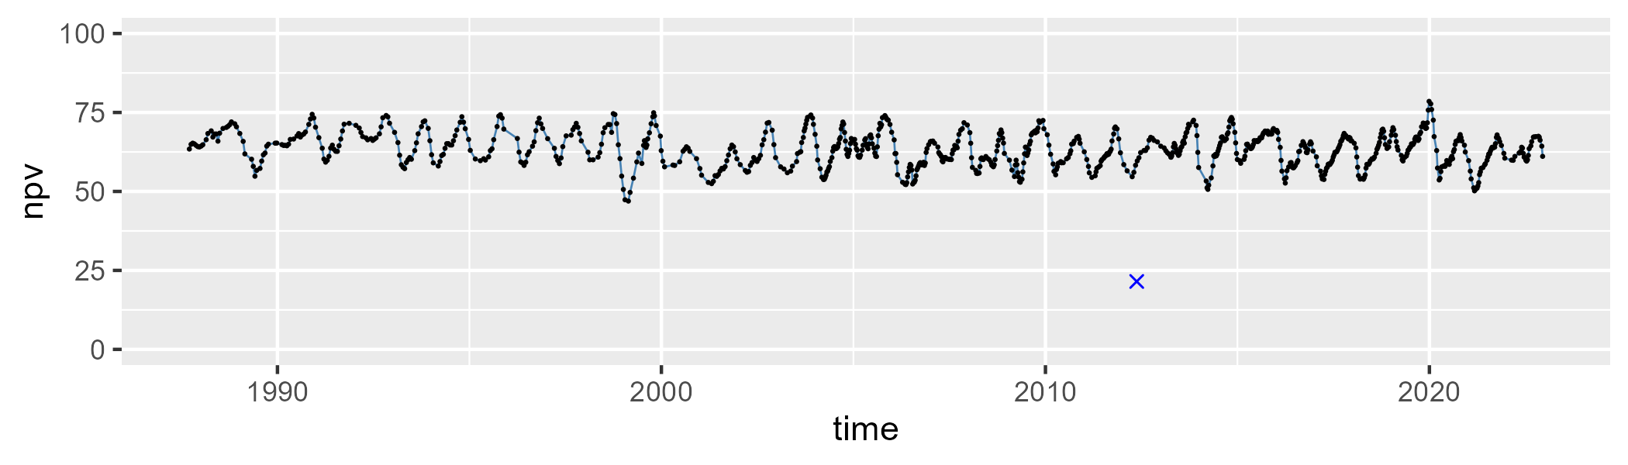

| Min. | 1st Qu. | Median | Mean | 3rd Qu. | Max. |
| --- | --- | --- | --- | --- | --- |
| 0.8926848 | 8.980539 | 11.43952 | 11.92405 | 14.66862 | 28.44794 |

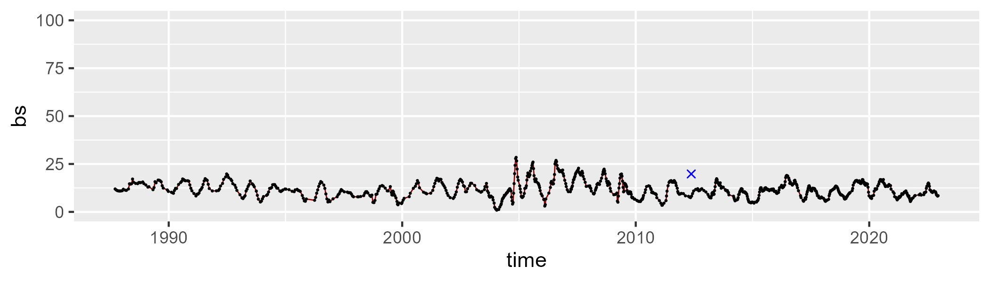

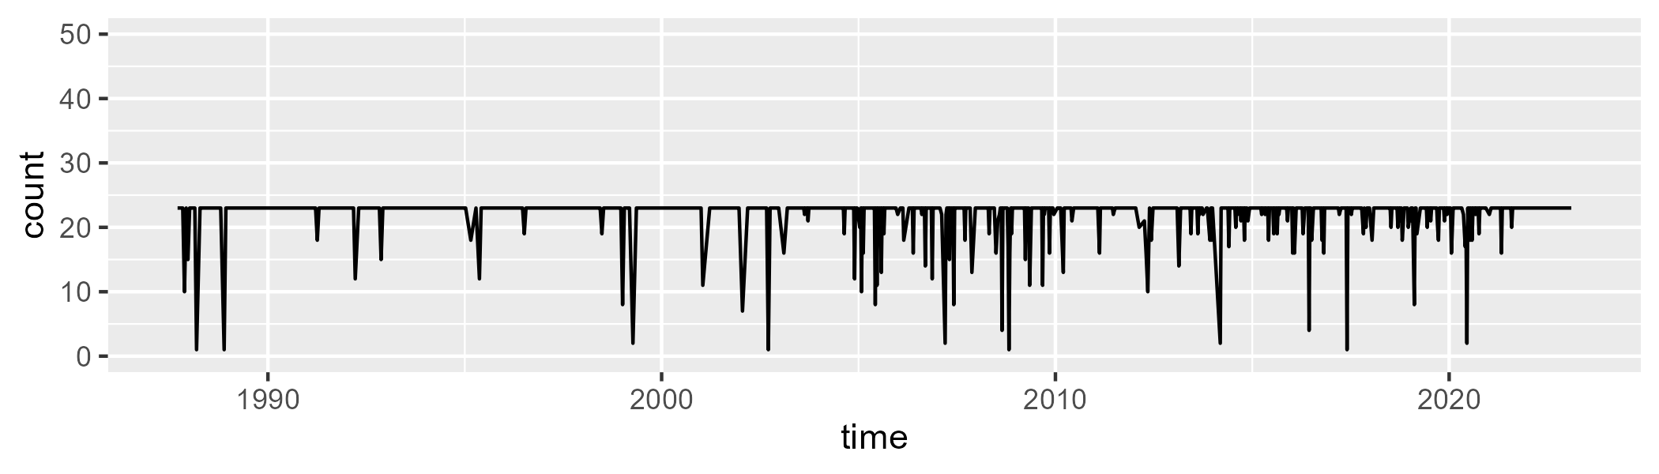

Min. : 1.00 1st Qu.:23.00 Median :23.00 Mean :22.06 3rd Qu.:23.00 Max. :23.00

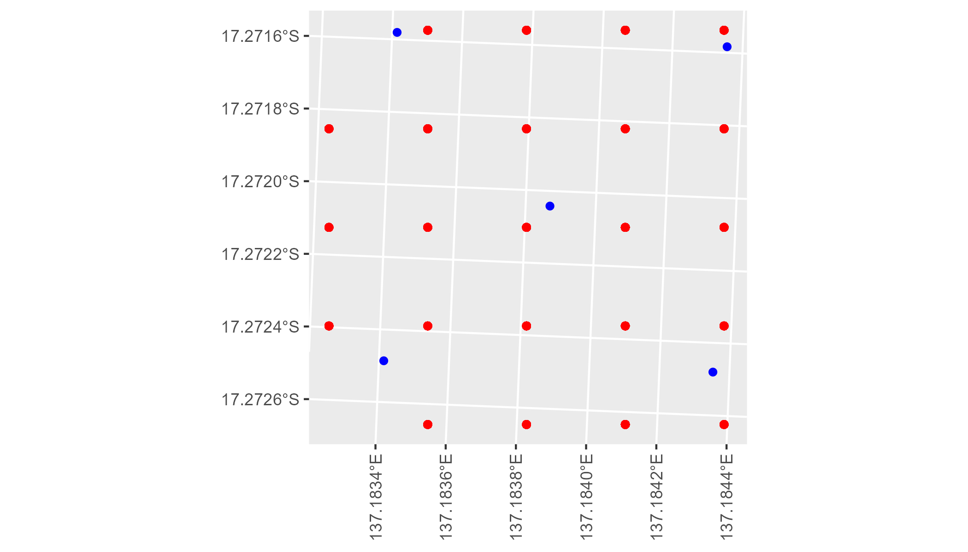

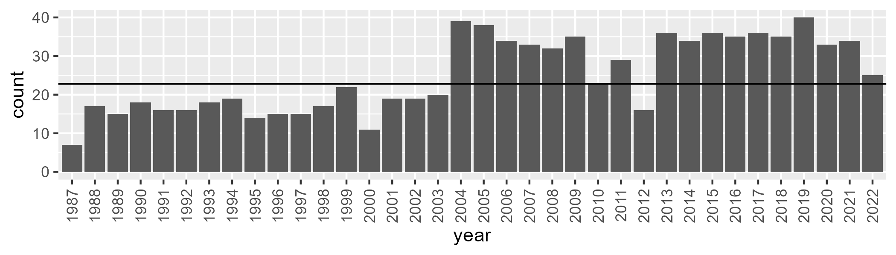

Number of samples: 901

# NTAGFU0019

| Min. | 1st Qu. | Median | Mean | 3rd Qu. | Max. |
| --- | --- | --- | --- | --- | --- |
| 7.985528 | 22.83131 | 26.97779 | 27.19457 | 31.38439 | 46.43724 |

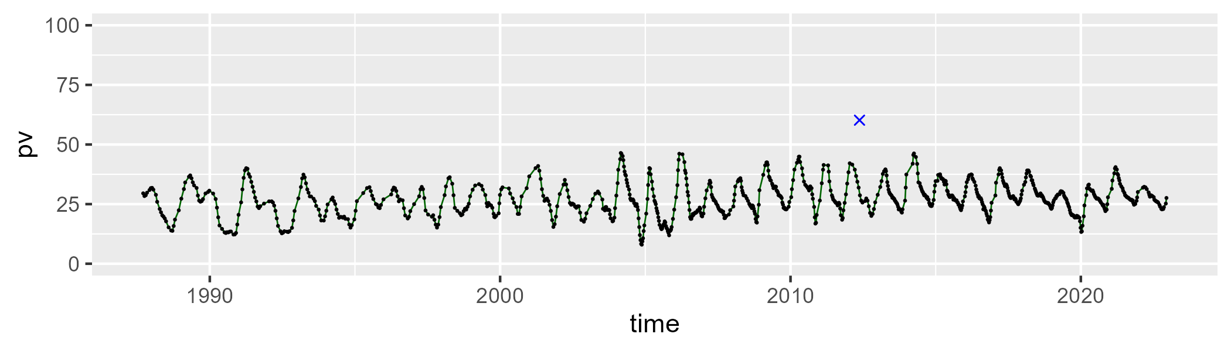

| Min. | 1st Qu. | Median | Mean | 3rd Qu. | Max. |
| --- | --- | --- | --- | --- | --- |
| 36.07402 | 46.09326 | 49.65934 | 49.85943 | 53.28047 | 61.56154 |

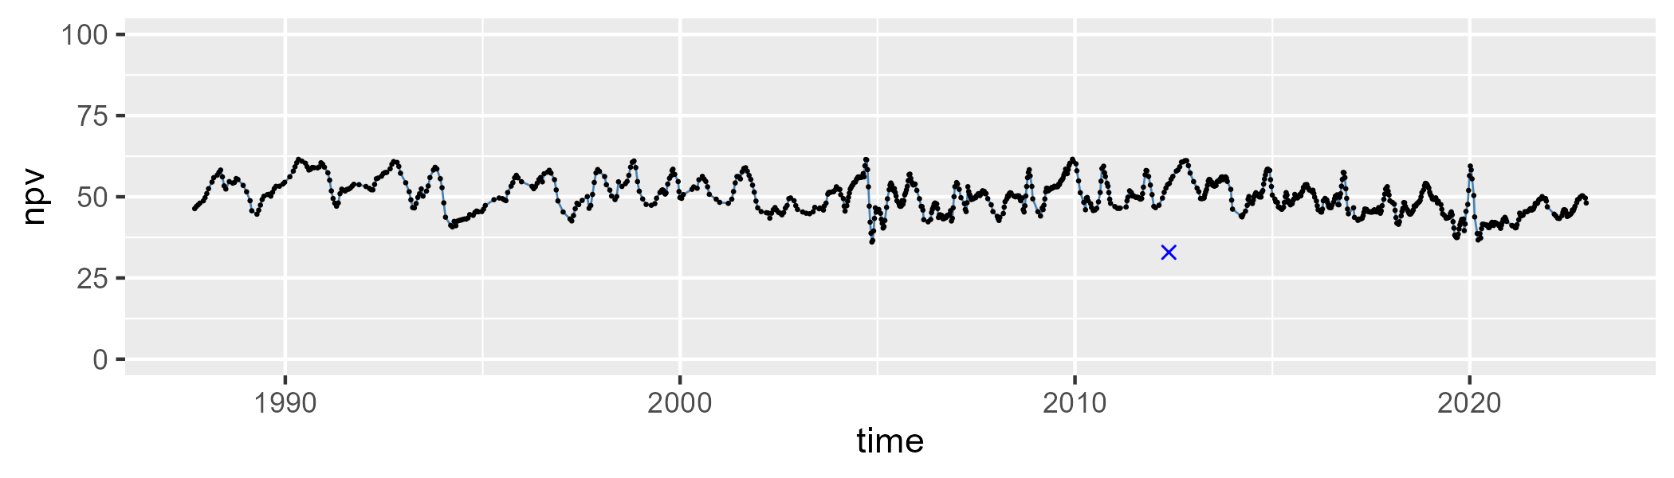

| Min. | 1st Qu. | Median | Mean | 3rd Qu. | Max. |
| --- | --- | --- | --- | --- | --- |
| 4.249259 | 16.75287 | 21.3769 | 21.66398 | 25.90528 | 54.08643 |

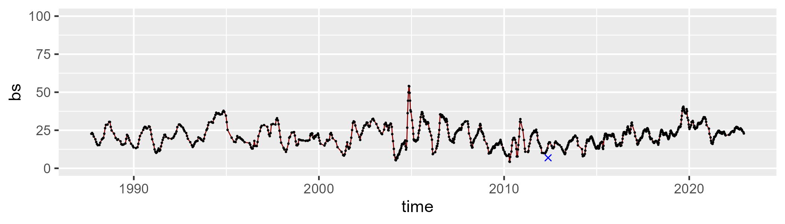

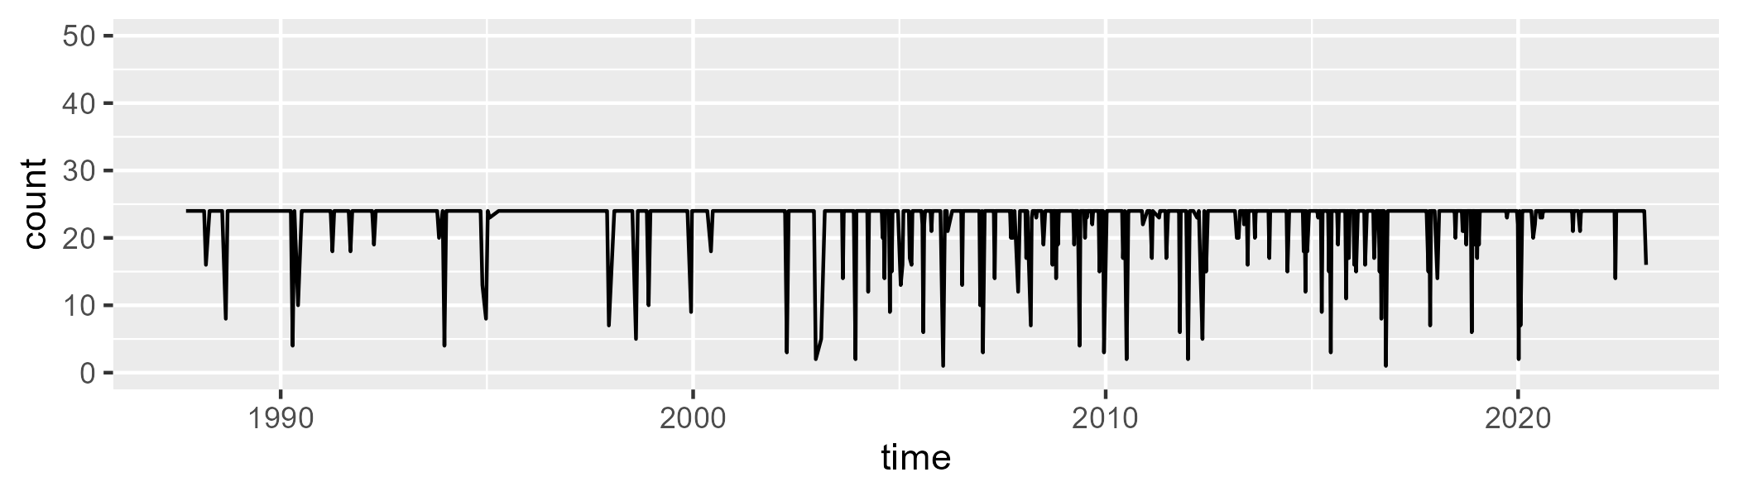

Min. : 1.00 1st Qu.:24.00 Median :24.00 Mean :22.77 3rd Qu.:24.00 Max. :24.00

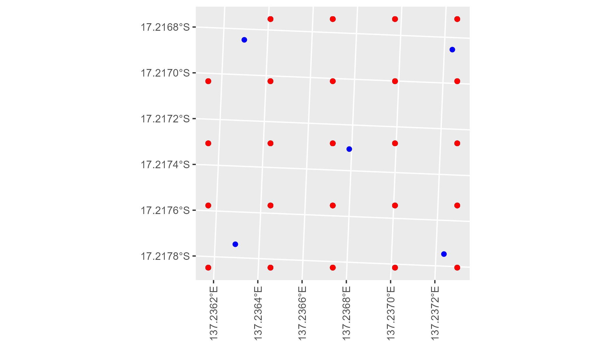

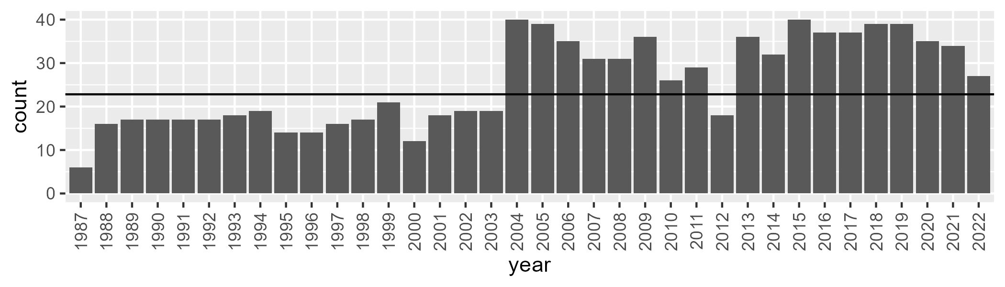

Number of samples: 918

# NTAGFU0020

| Min. | 1st Qu. | Median | Mean | 3rd Qu. | Max. |
| --- | --- | --- | --- | --- | --- |
| 8.582244 | 26.39514 | 31.94041 | 32.52652 | 38.33593 | 54.98189 |

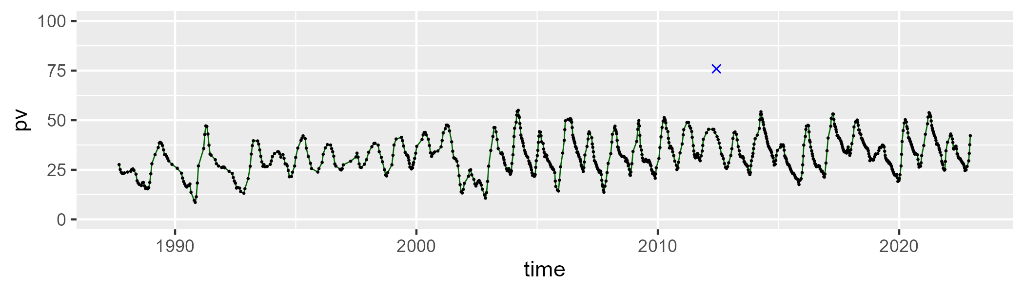

| Min. | 1st Qu. | Median | Mean | 3rd Qu. | Max. |
| --- | --- | --- | --- | --- | --- |
| 37.53964 | 49.63705 | 55.01111 | 54.71567 | 59.77944 | 76.78081 |

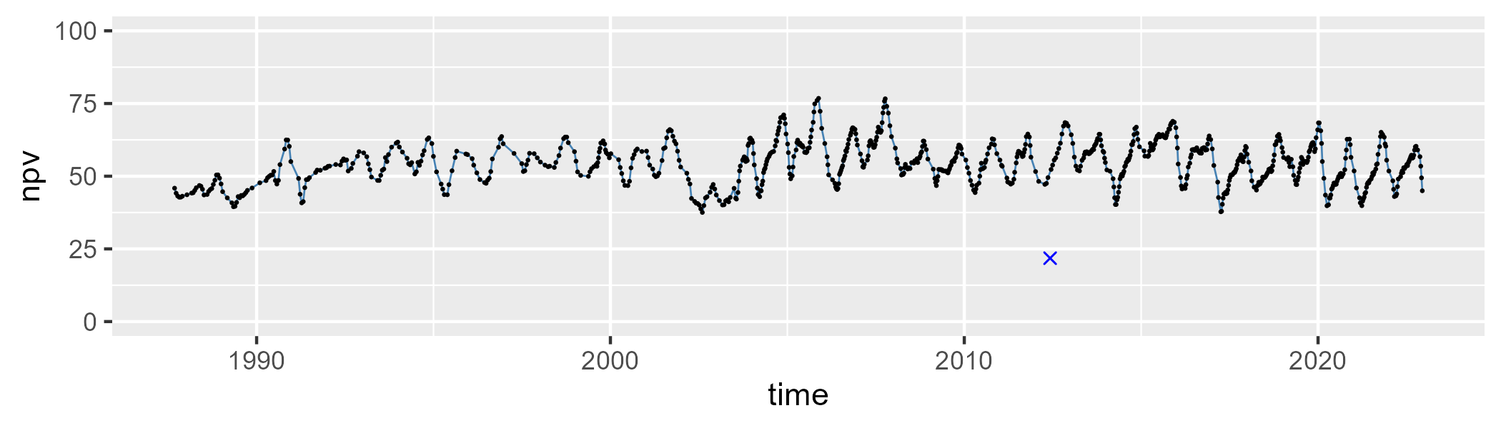

| Min. | 1st Qu. | Median | Mean | 3rd Qu. | Max. |
| --- | --- | --- | --- | --- | --- |
| 0 | 6.473266 | 9.778904 | 11.57357 | 14.25291 | 41.8016 |

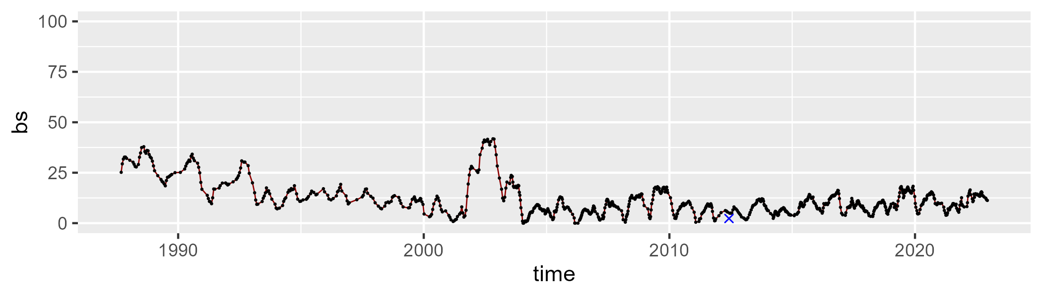

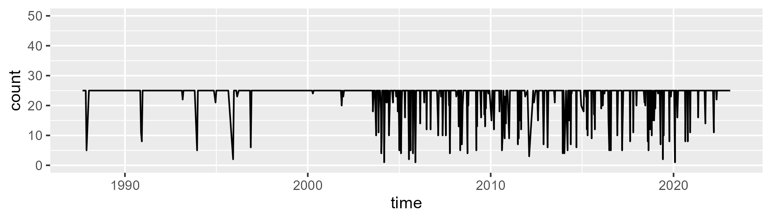

Min. : 1.00 1st Qu.:25.00 Median :25.00 Mean :23.23 3rd Qu.:25.00 Max. :25.00

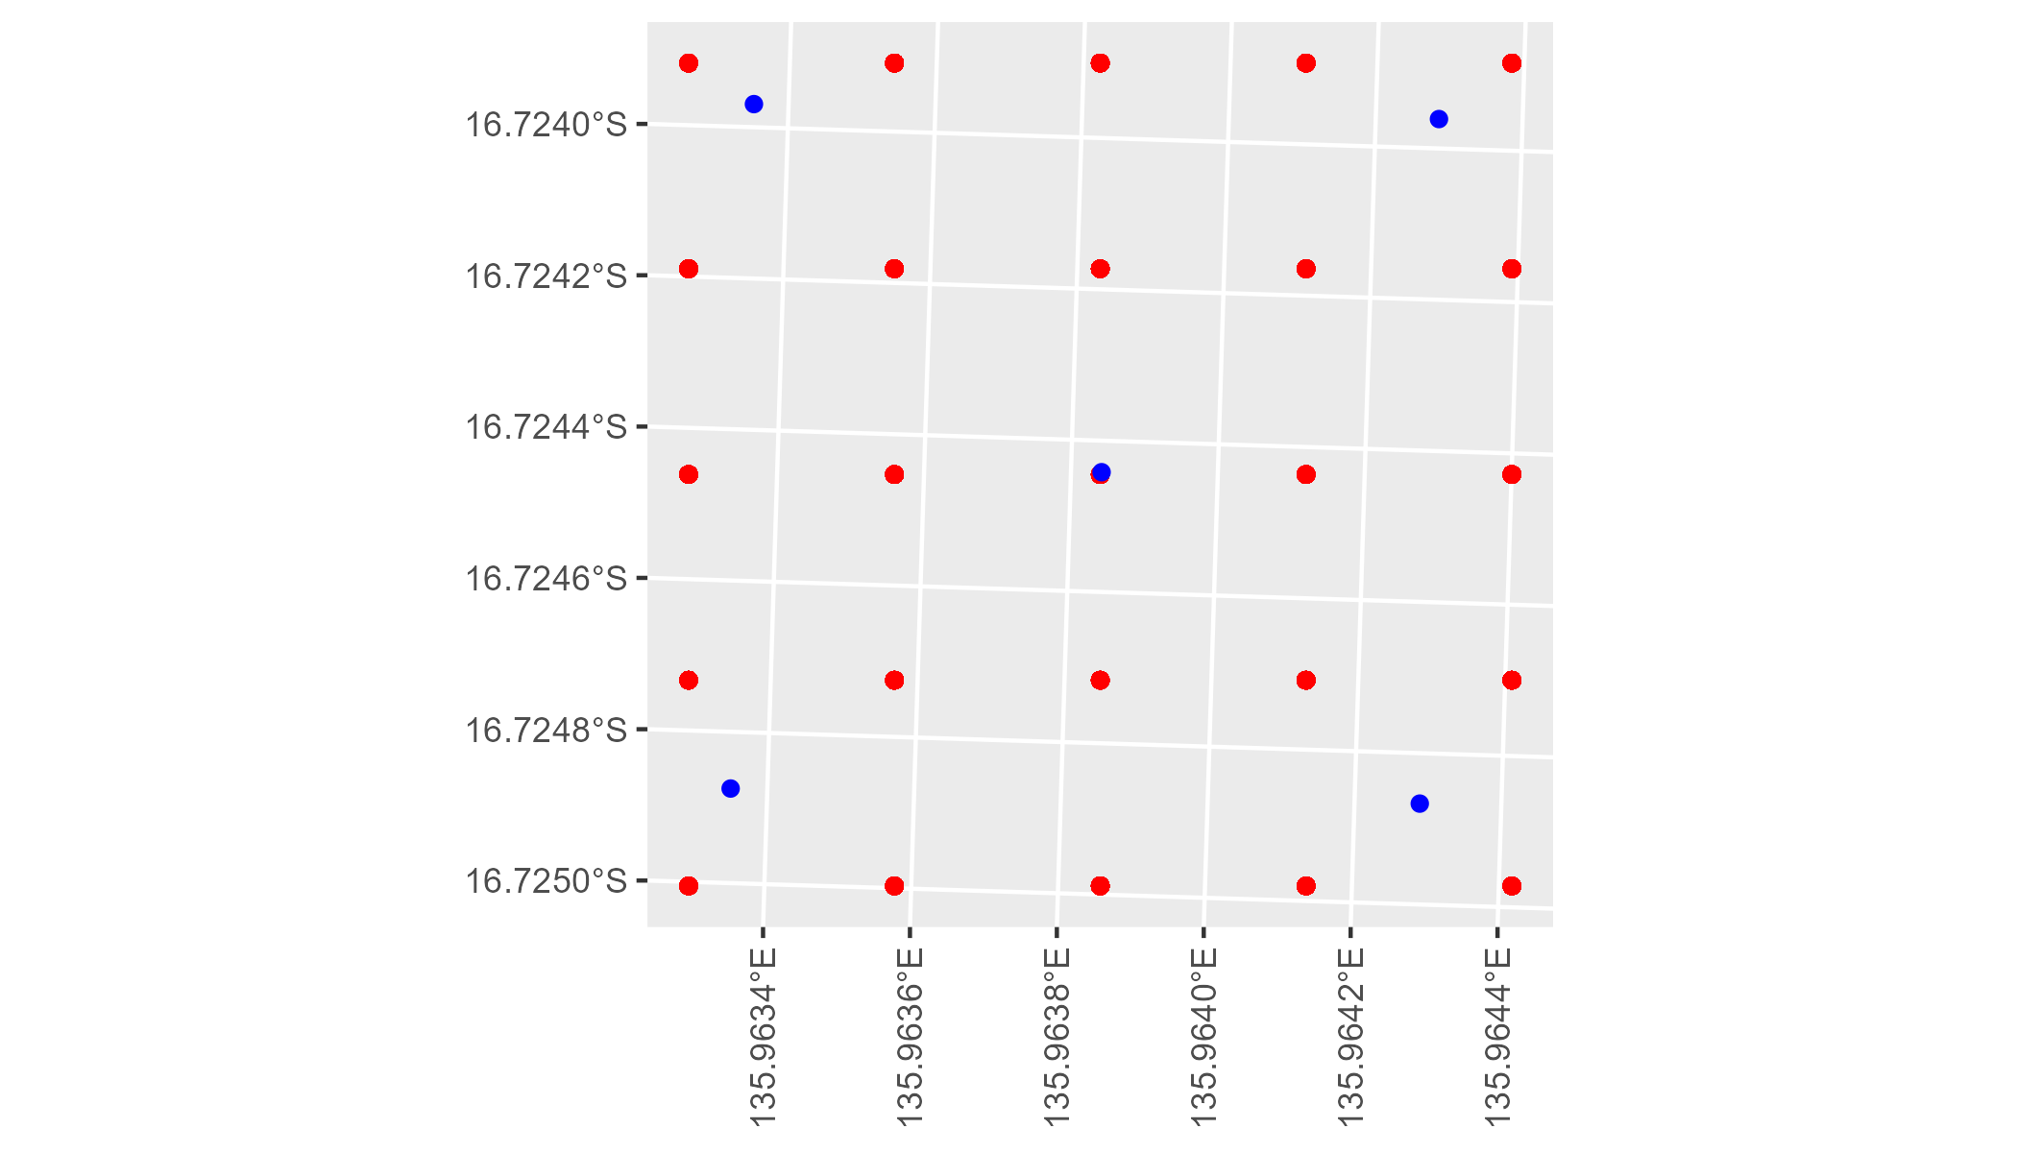

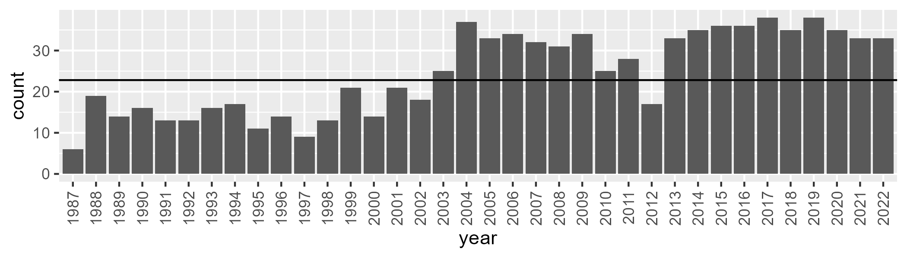

Number of samples: 883

# NTAGFU0021

| Min. | 1st Qu. | Median | Mean | 3rd Qu. | Max. |
| --- | --- | --- | --- | --- | --- |
| 4.571417 | 17.49764 | 21.03291 | 22.01398 | 25.96921 | 40.2406 |

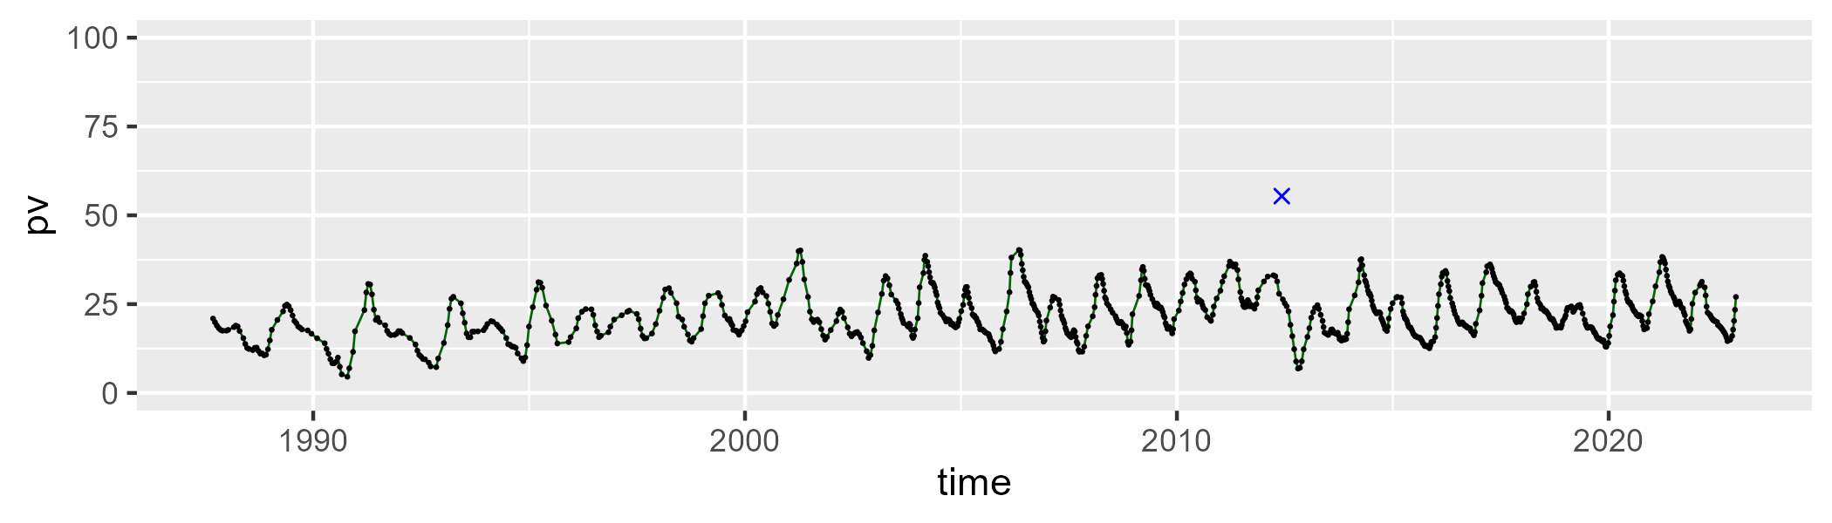

| Min. | 1st Qu. | Median | Mean | 3rd Qu. | Max. |
| --- | --- | --- | --- | --- | --- |
| 41.31502 | 51.5117 | 55.17263 | 55.09721 | 59.13384 | 72.16487 |

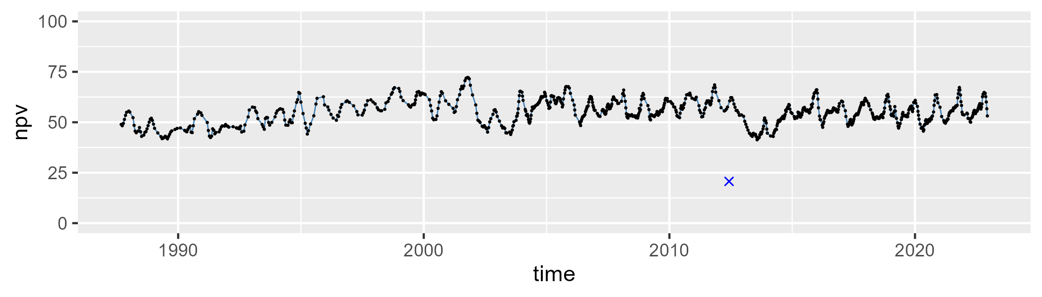

| Min. | 1st Qu. | Median | Mean | 3rd Qu. | Max. |
| --- | --- | --- | --- | --- | --- |
| 2.968313 | 16.09475 | 20.61788 | 21.61969 | 25.8276 | 44.71379 |

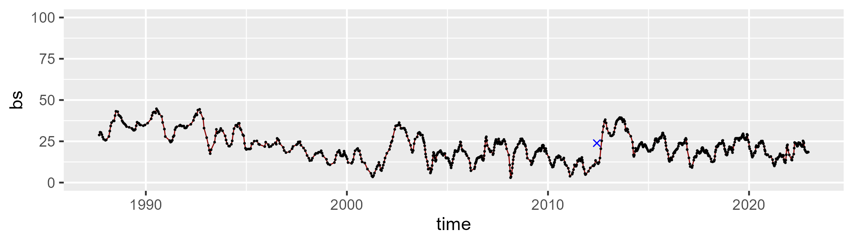

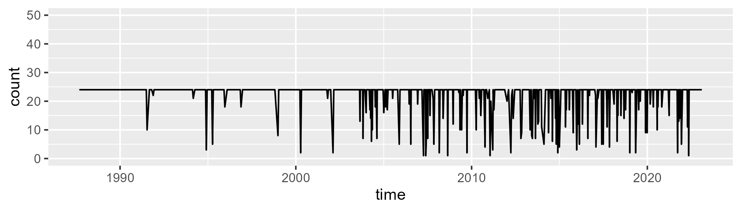

Min. : 1.00 1st Qu.:24.00 Median :24.00 Mean :22.26 3rd Qu.:24.00 Max. :24.00

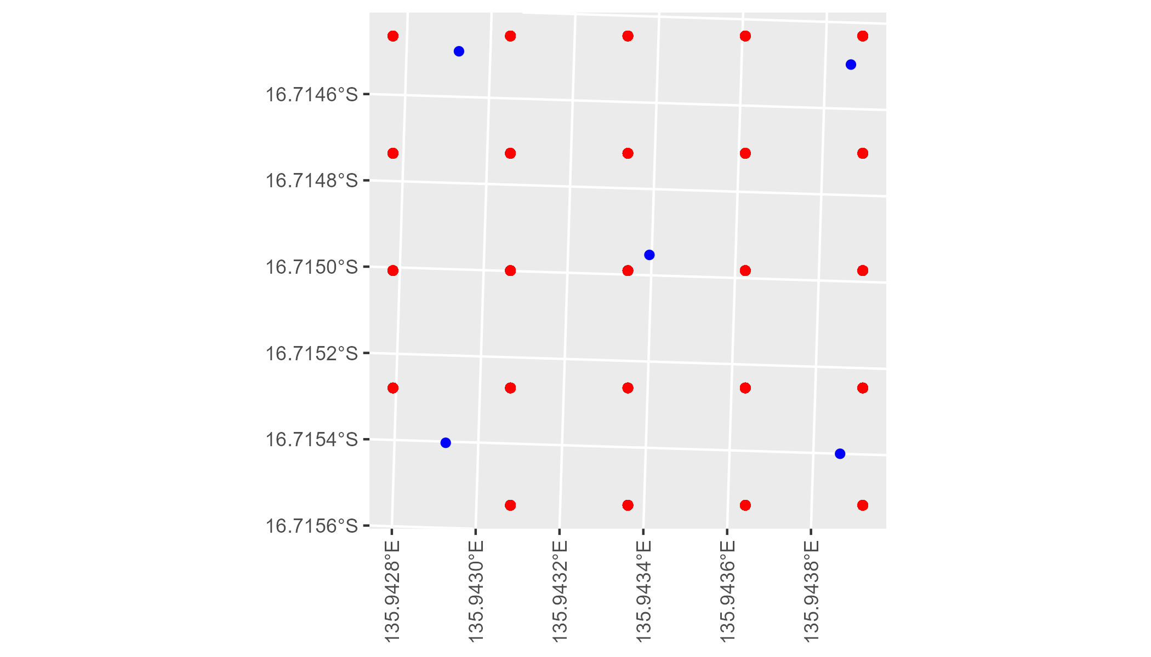

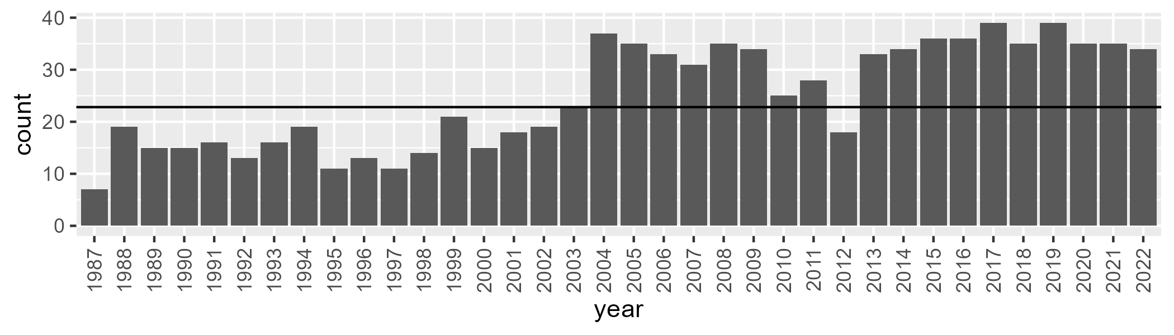

Number of samples: 897

# NTAGFU0022

| Min. | 1st Qu. | Median | Mean | 3rd Qu. | Max. |
| --- | --- | --- | --- | --- | --- |
| 2.616637 | 13.90681 | 17.51242 | 18.431 | 21.84151 | 37.56915 |

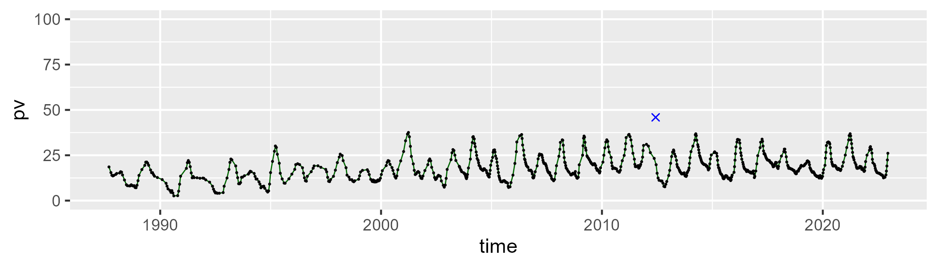

| Min. | 1st Qu. | Median | Mean | 3rd Qu. | Max. |
| --- | --- | --- | --- | --- | --- |
| 41.26479 | 50.9032 | 55.02628 | 54.93978 | 58.7166 | 74.40929 |

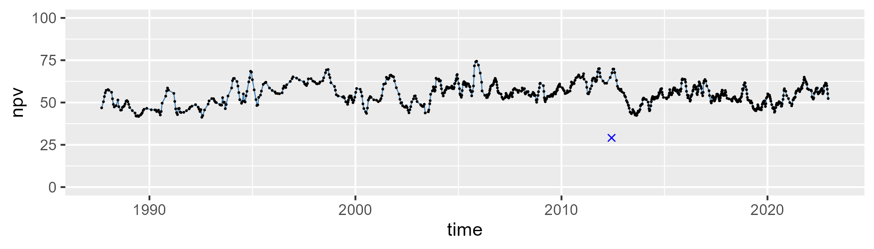

| Min. | 1st Qu. | Median | Mean | 3rd Qu. | Max. |
| --- | --- | --- | --- | --- | --- |
| 0.6118716 | 19.72707 | 24.67019 | 25.32313 | 30.18132 | 53.02942 |

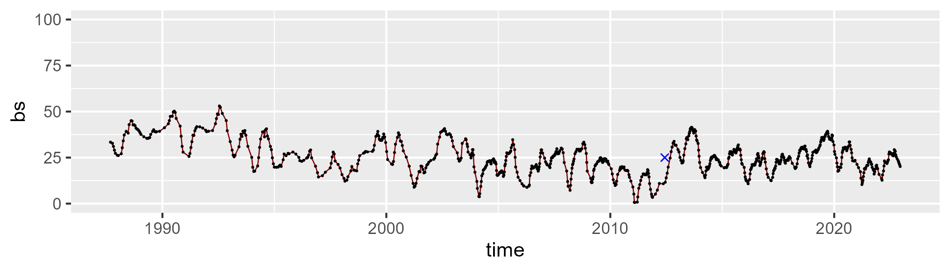

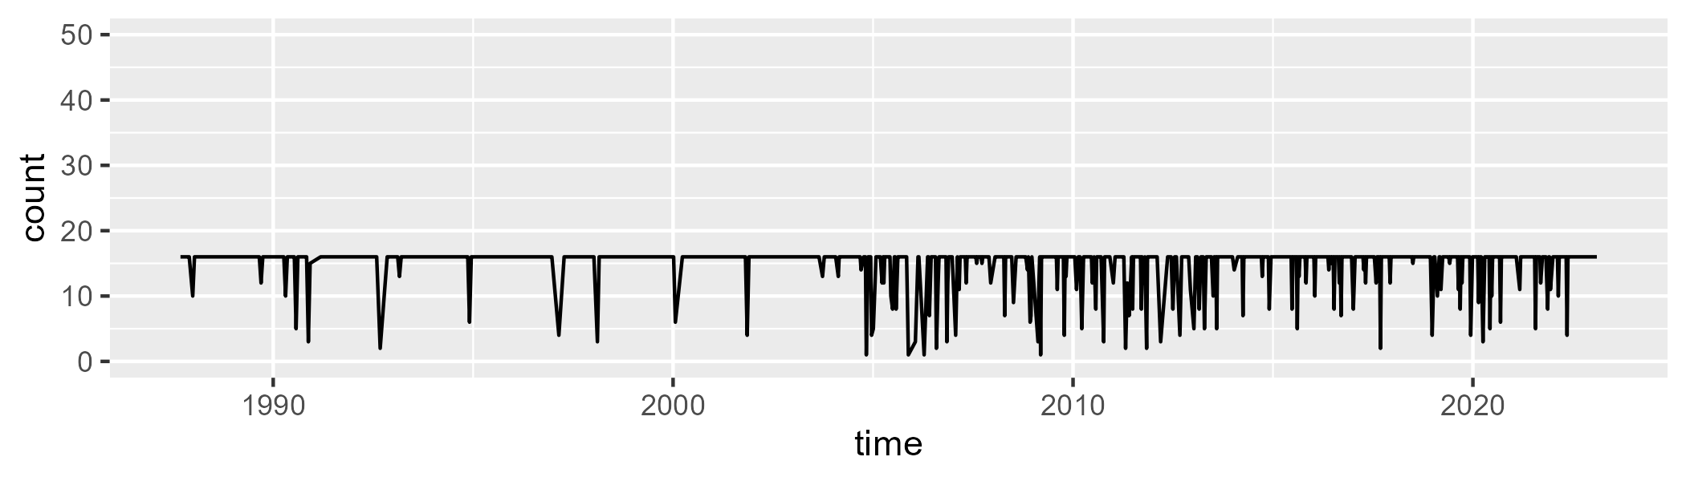

Min. : 1.00 1st Qu.:16.00 Median :16.00 Mean :14.97 3rd Qu.:16.00 Max. :16.00

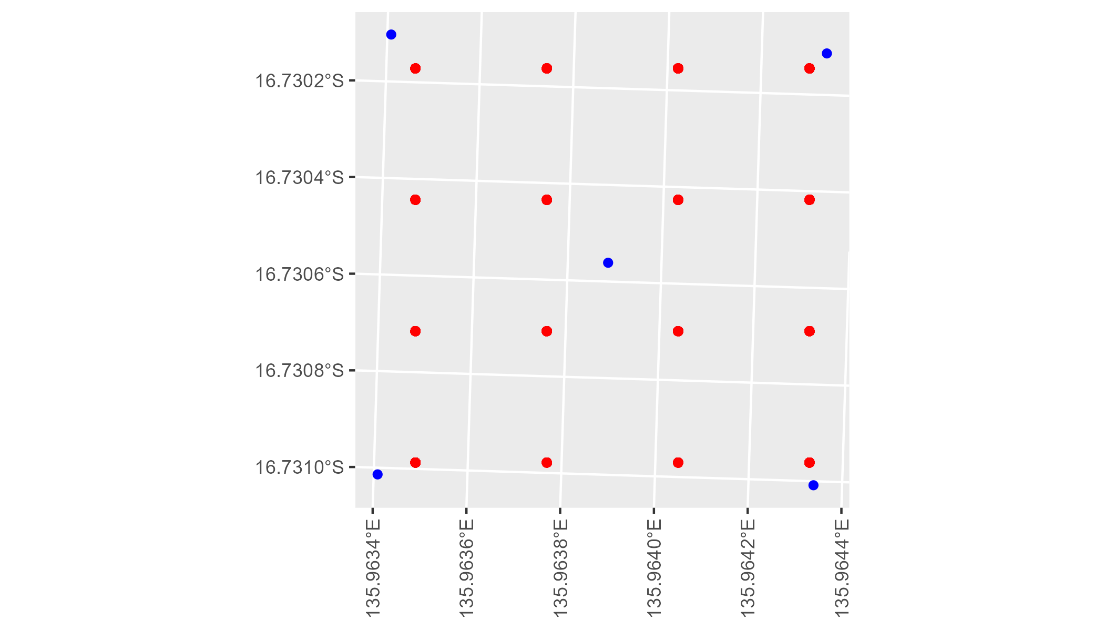

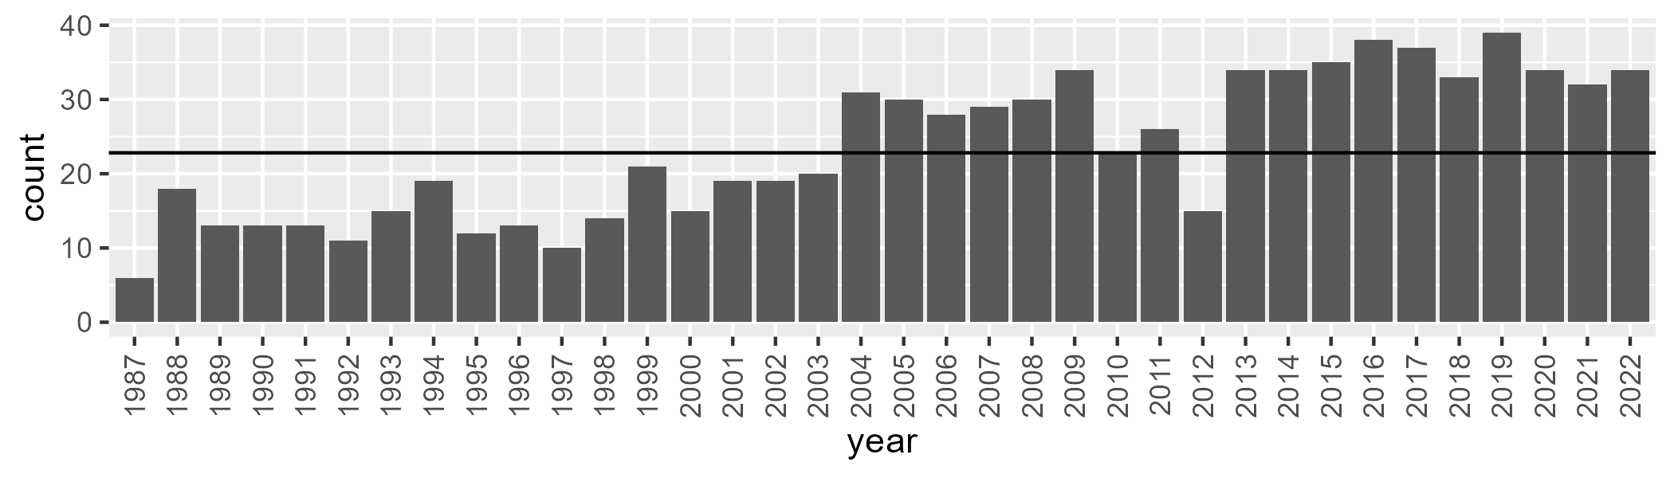

Number of samples: 847

# NTAGFU0023

| Min. | 1st Qu. | Median | Mean | 3rd Qu. | Max. |
| --- | --- | --- | --- | --- | --- |
| 0 | 12.85473 | 18.7063 | 19.85278 | 26.17501 | 49.84775 |

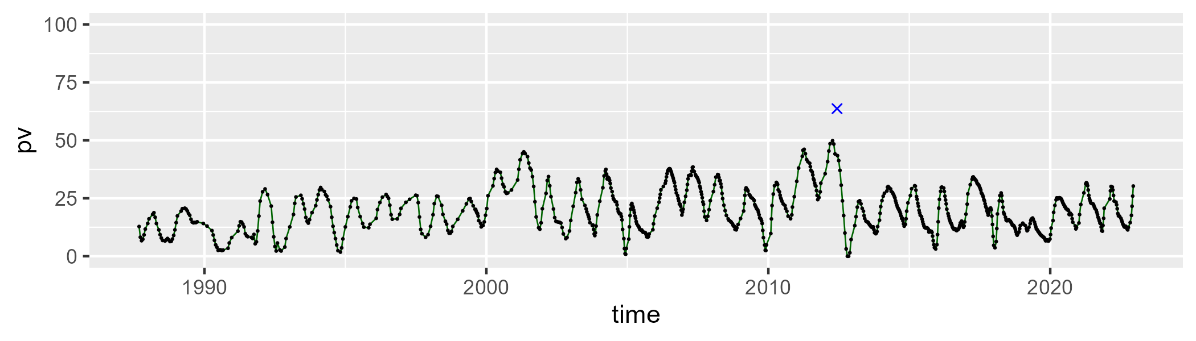

| Min. | 1st Qu. | Median | Mean | 3rd Qu. | Max. |
| --- | --- | --- | --- | --- | --- |
| 22.39219 | 40.77595 | 48.54139 | 48.8351 | 56.82898 | 77.29691 |

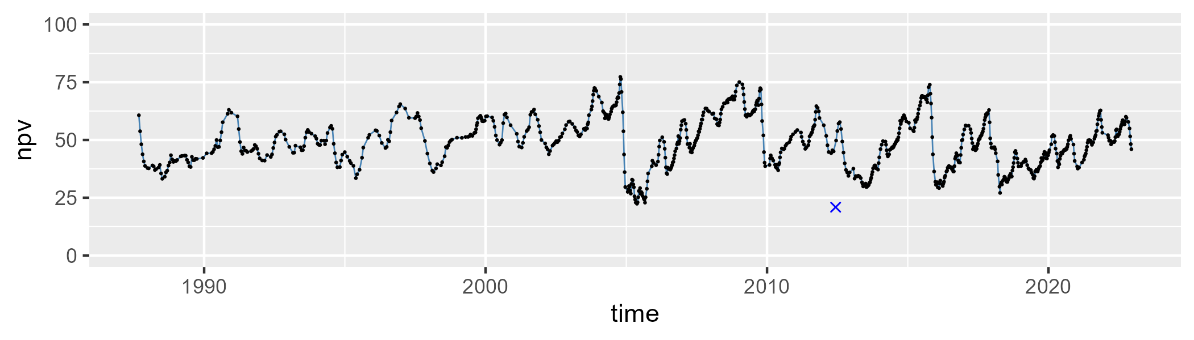

| Min. | 1st Qu. | Median | Mean | 3rd Qu. | Max. |
| --- | --- | --- | --- | --- | --- |
| 0.7544723 | 17.99127 | 27.67265 | 30.00766 | 43.21033 | 66.27584 |

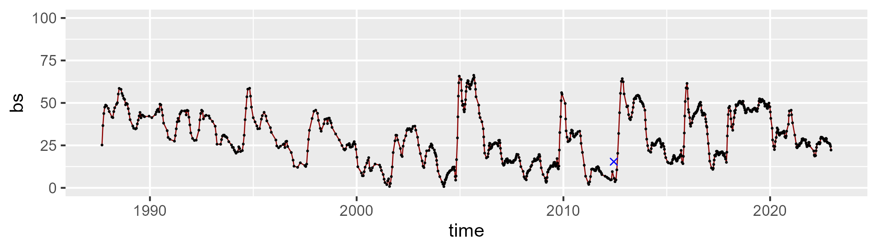

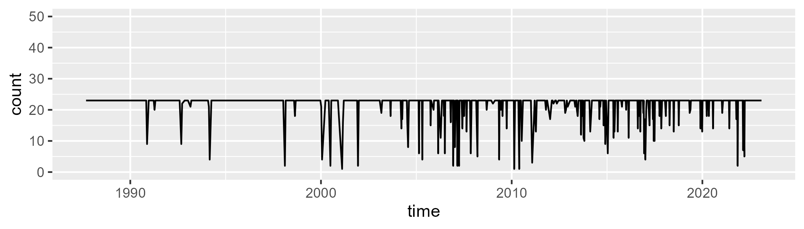

Min. : 1.00 1st Qu.:23.00 Median :23.00 Mean :21.81 3rd Qu.:23.00 Max. :23.00

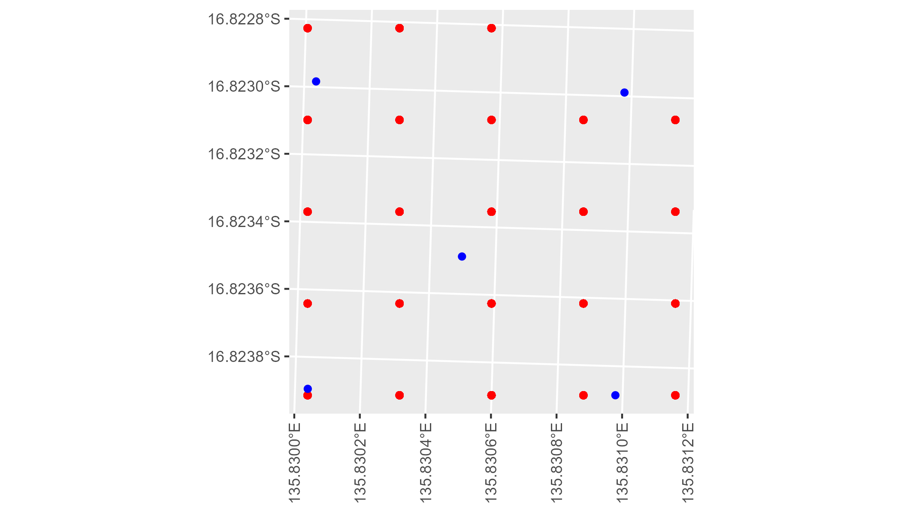

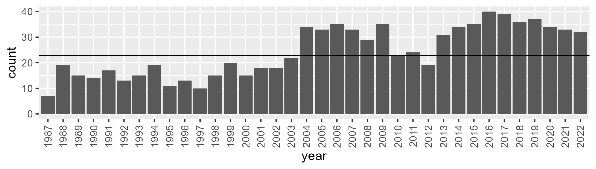

Number of samples: 877

# NTAGFU0024

| Min. | 1st Qu. | Median | Mean | 3rd Qu. | Max. |
| --- | --- | --- | --- | --- | --- |
| 0.4900034 | 11.25176 | 14.80285 | 15.56836 | 19.55643 | 31.10657 |

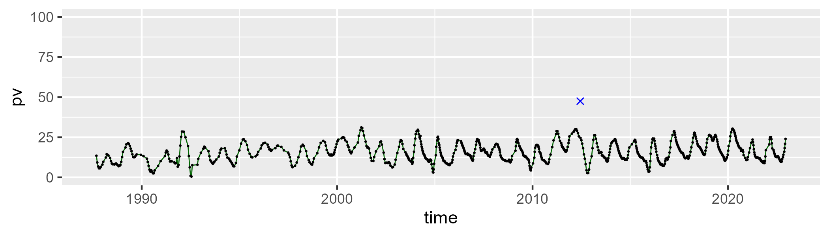

| Min. | 1st Qu. | Median | Mean | 3rd Qu. | Max. |
| --- | --- | --- | --- | --- | --- |
| 33.54504 | 49.2011 | 53.75914 | 54.07469 | 58.79807 | 76.46394 |

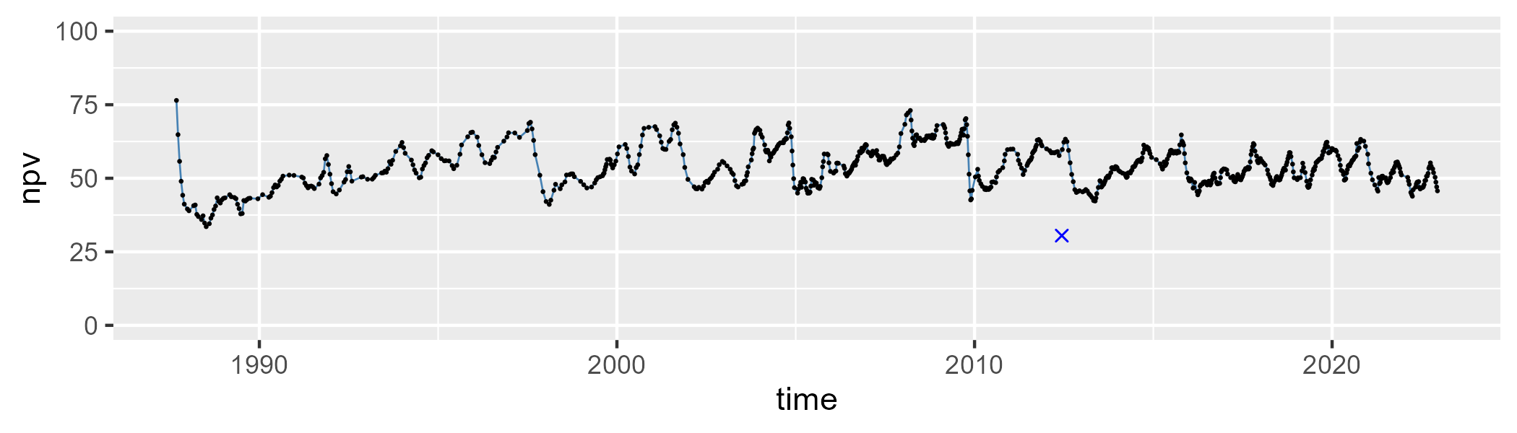

| Min. | 1st Qu. | Median | Mean | 3rd Qu. | Max. |
| --- | --- | --- | --- | --- | --- |
| 5.068909 | 23.76775 | 28.20925 | 28.98601 | 35.14236 | 56.77711 |

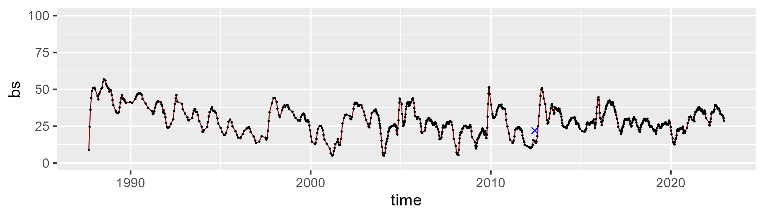

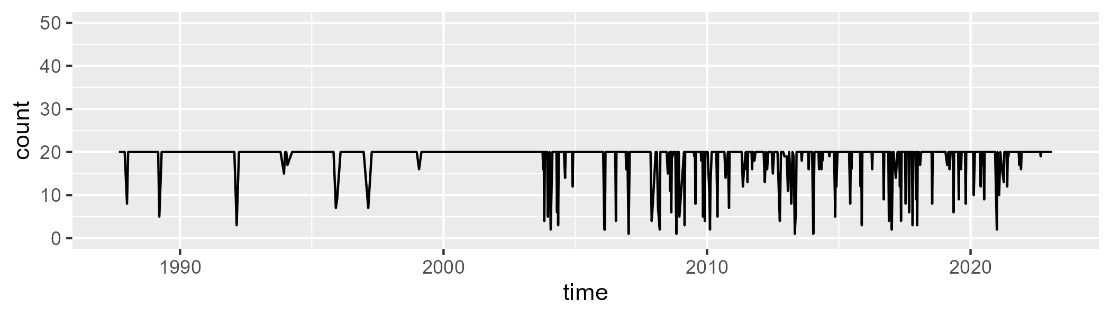

Min. : 1.00 1st Qu.:20.00 Median :20.00 Mean :18.78 3rd Qu.:20.00 Max. :20.00

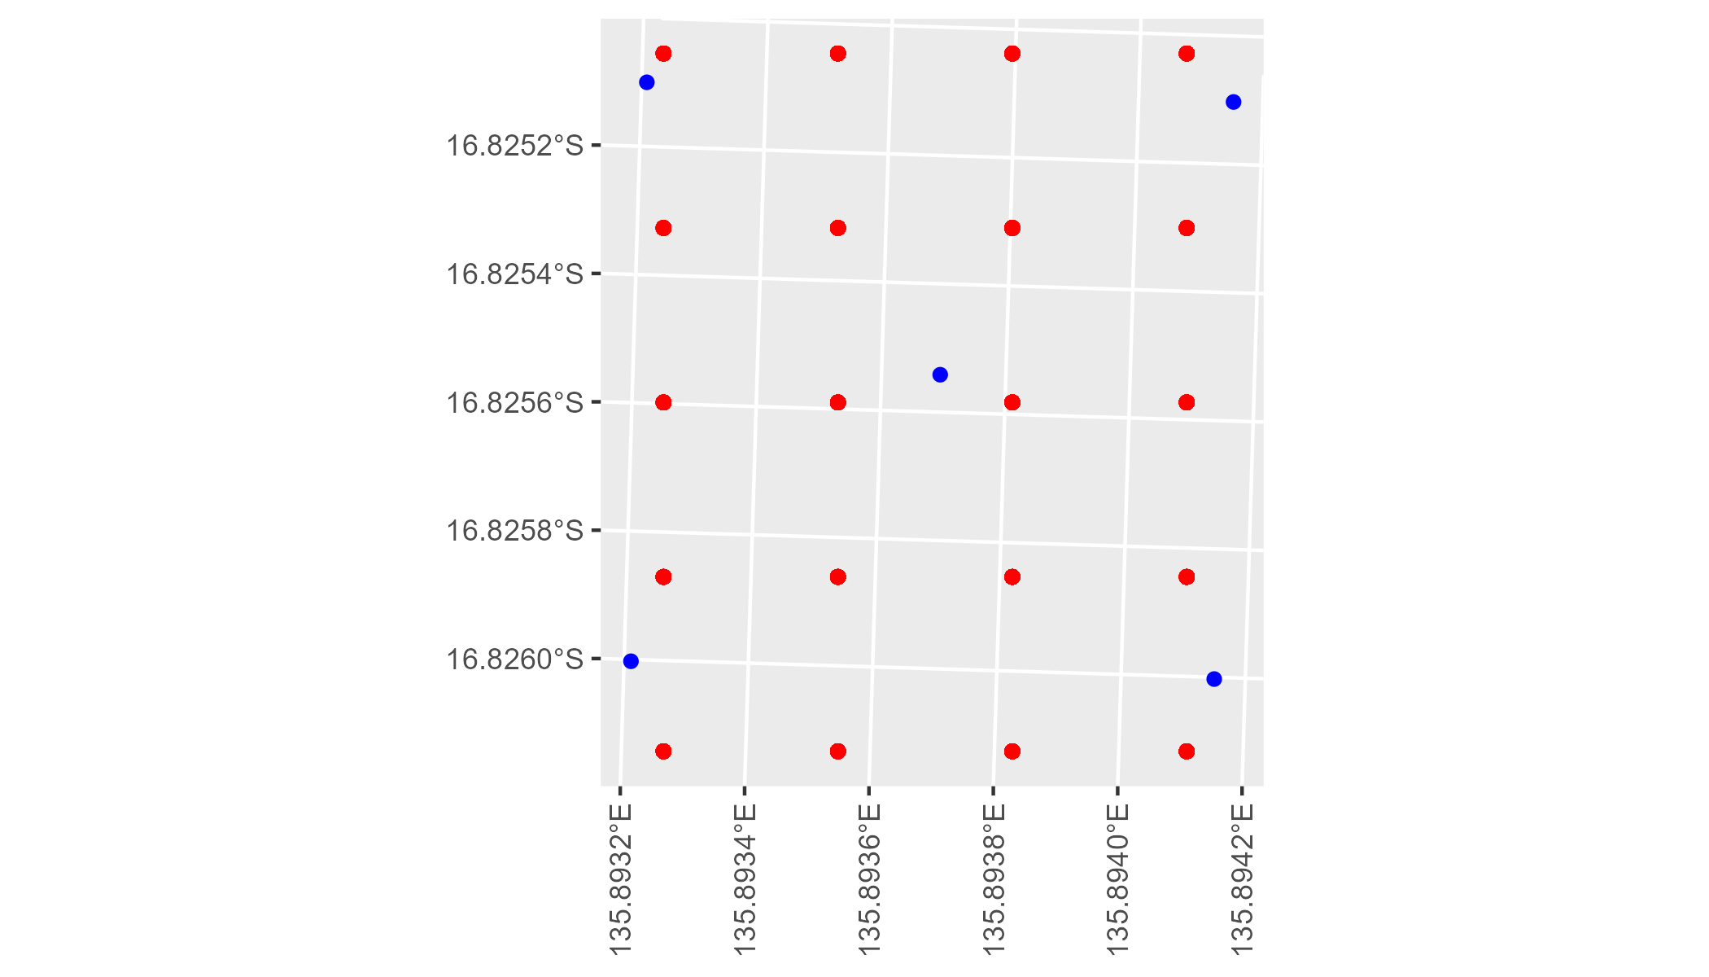

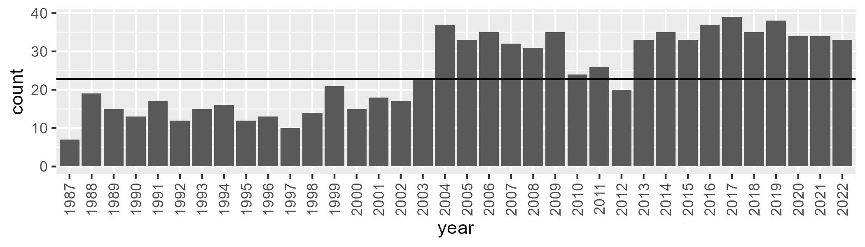

Number of samples: 881

# NTAGFU0025

| Min. | 1st Qu. | Median | Mean | 3rd Qu. | Max. |
| --- | --- | --- | --- | --- | --- |
| 12.9373 | 30.38521 | 36.33895 | 36.68886 | 42.85171 | 59.27996 |

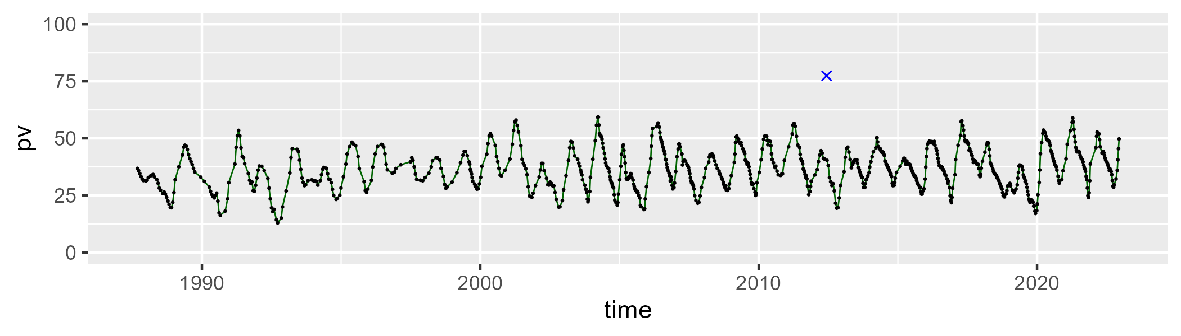

| Min. | 1st Qu. | Median | Mean | 3rd Qu. | Max. |
| --- | --- | --- | --- | --- | --- |
| 34.56791 | 48.95829 | 54.15195 | 53.85625 | 58.44934 | 73.99898 |

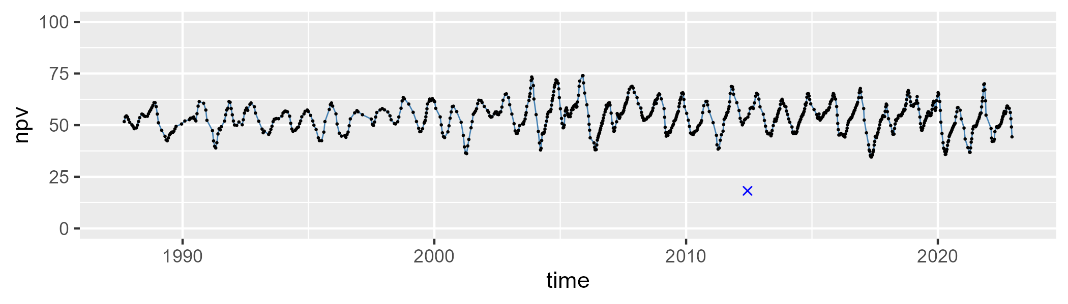

| Min. | 1st Qu. | Median | Mean | 3rd Qu. | Max. |
| --- | --- | --- | --- | --- | --- |
| 0.3645498 | 5.365687 | 7.63672 | 8.270613 | 10.2566 | 25.13917 |

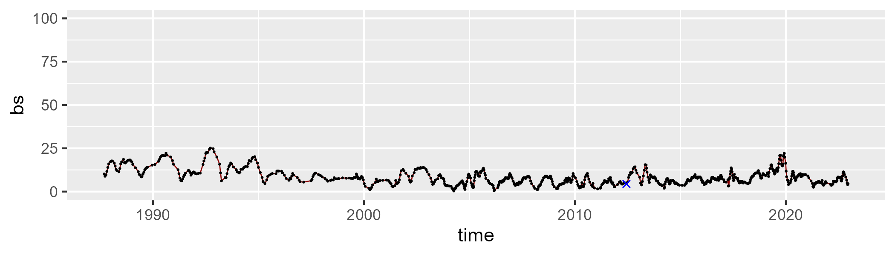

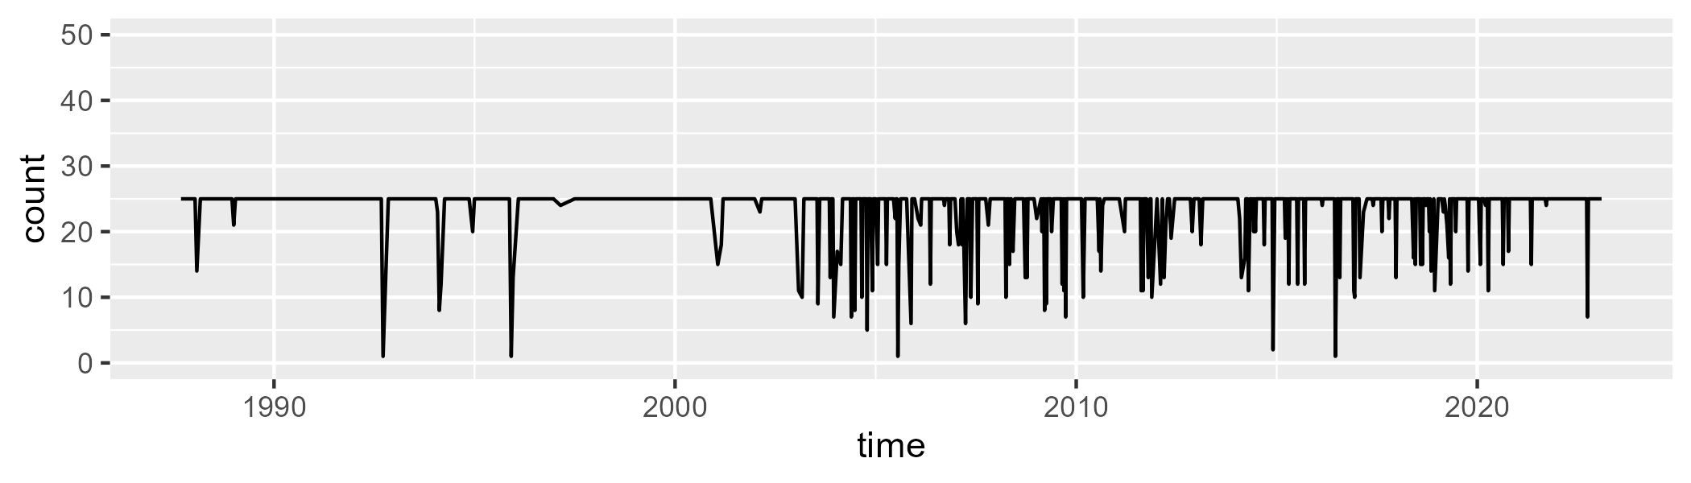

Min. : 1.0 1st Qu.:25.0 Median :25.0 Mean :23.6 3rd Qu.:25.0 Max. :25.0

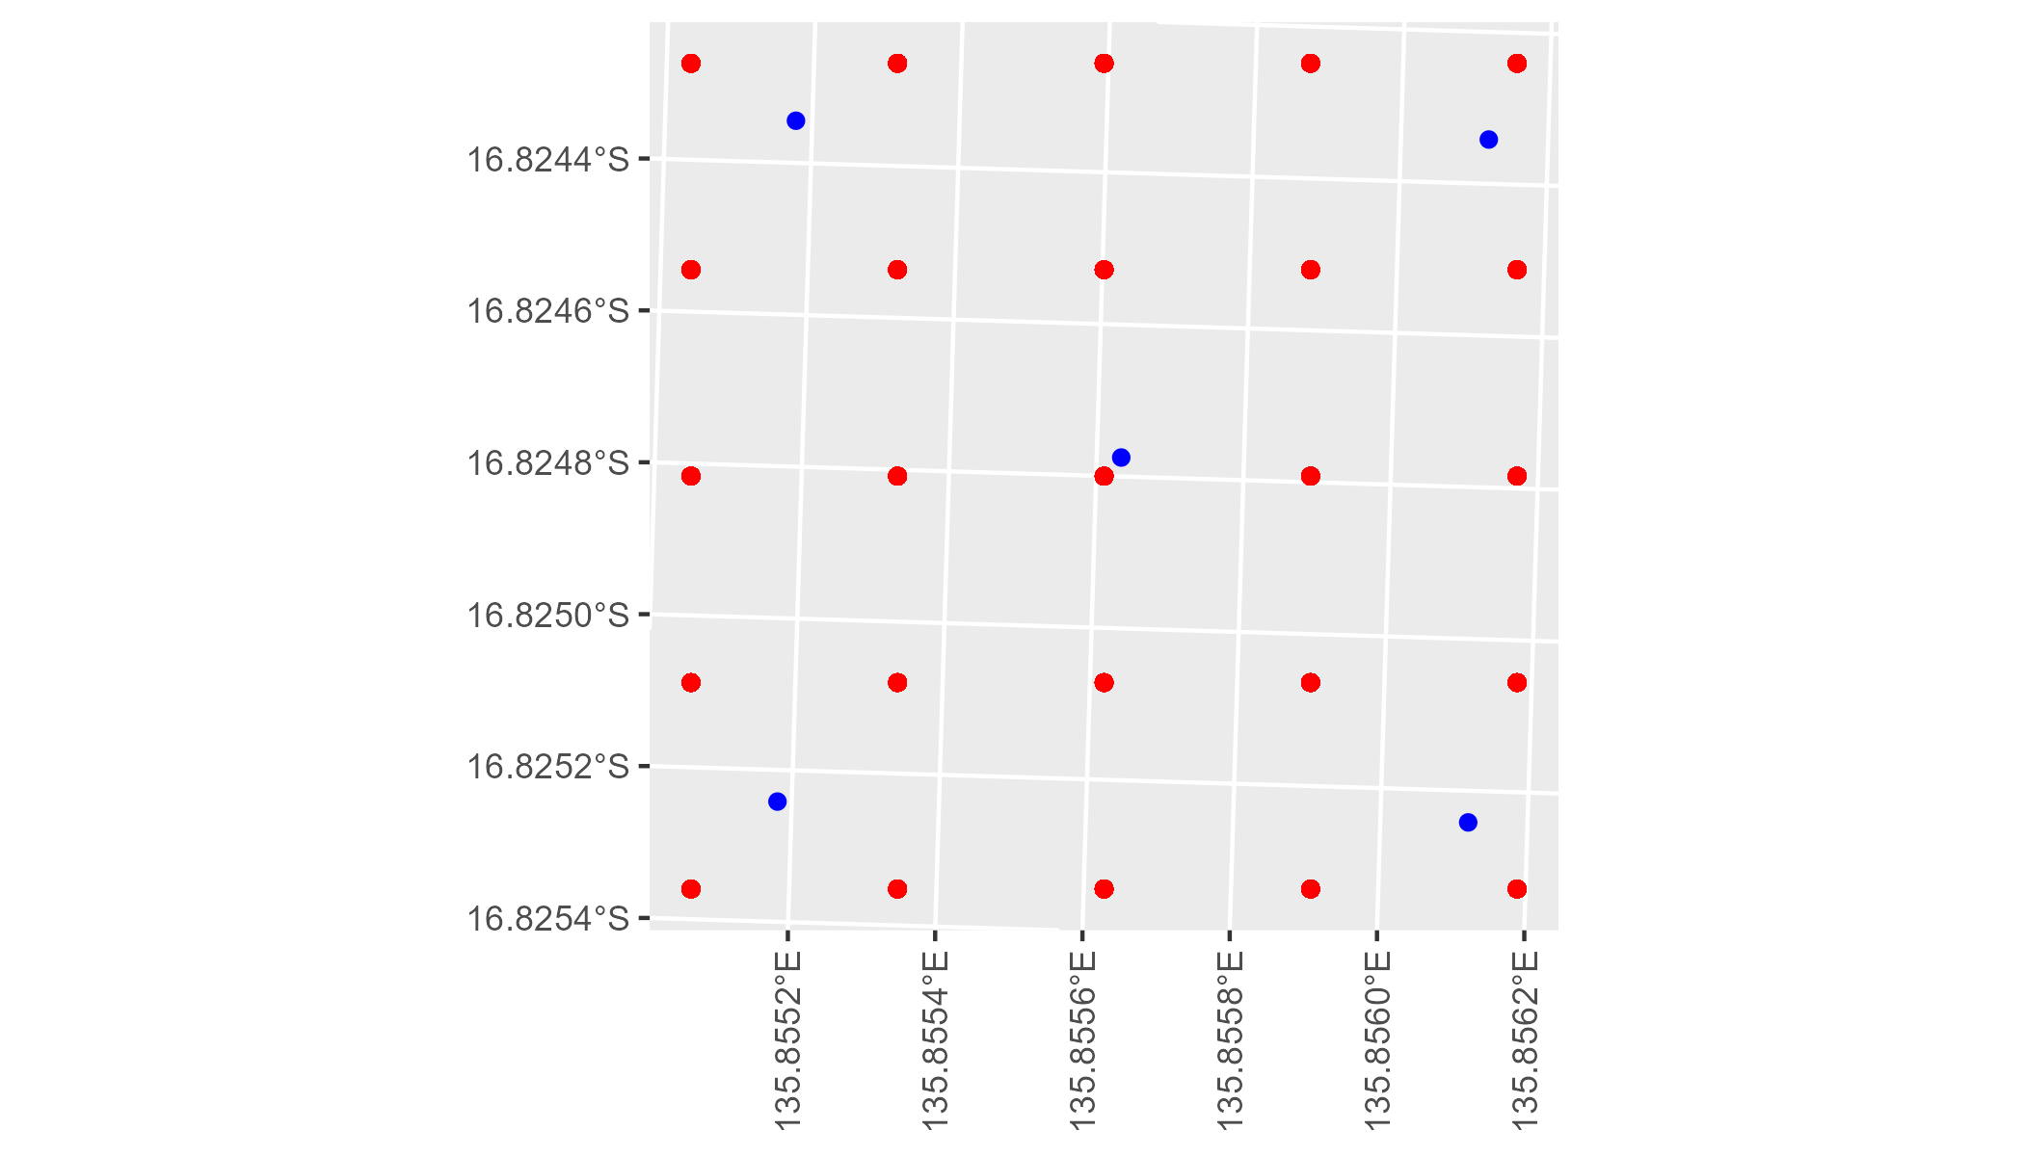

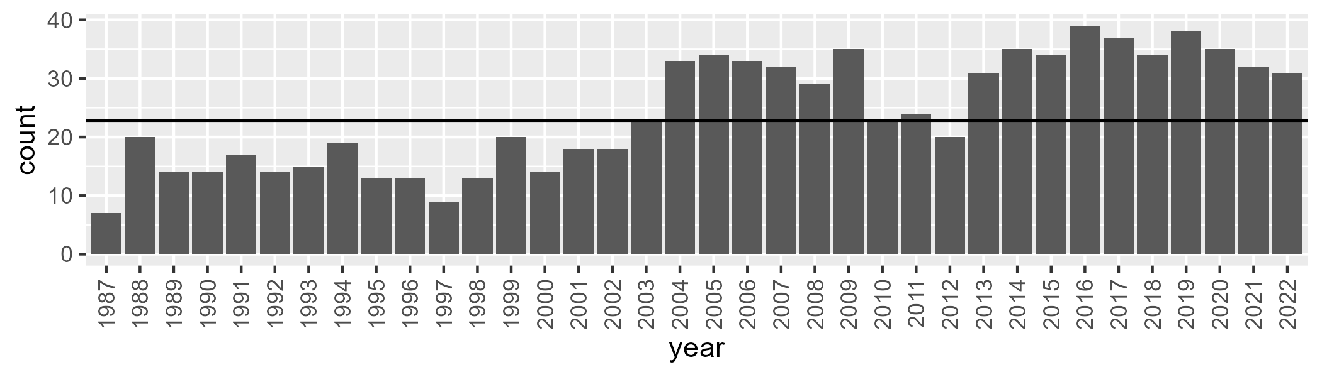

Number of samples: 870

# NTAGFU0026

| Min. | 1st Qu. | Median | Mean | 3rd Qu. | Max. |
| --- | --- | --- | --- | --- | --- |
| 2.519114 | 17.09884 | 22.9557 | 27.14348 | 35.05729 | 73.35825 |

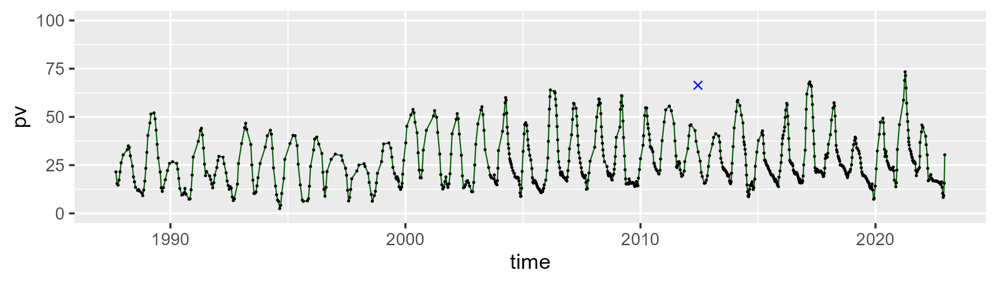

| Min. | 1st Qu. | Median | Mean | 3rd Qu. | Max. |
| --- | --- | --- | --- | --- | --- |
| 19.79824 | 42.47046 | 51.05499 | 51.35081 | 59.36622 | 83.35464 |

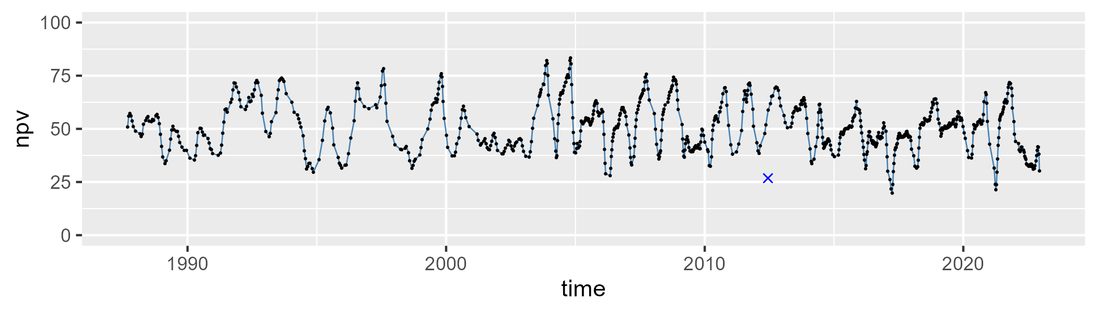

| Min. | 1st Qu. | Median | Mean | 3rd Qu. | Max. |
| --- | --- | --- | --- | --- | --- |
| 0 | 9.584585 | 17.38629 | 20.22342 | 28.42078 | 63.49355 |

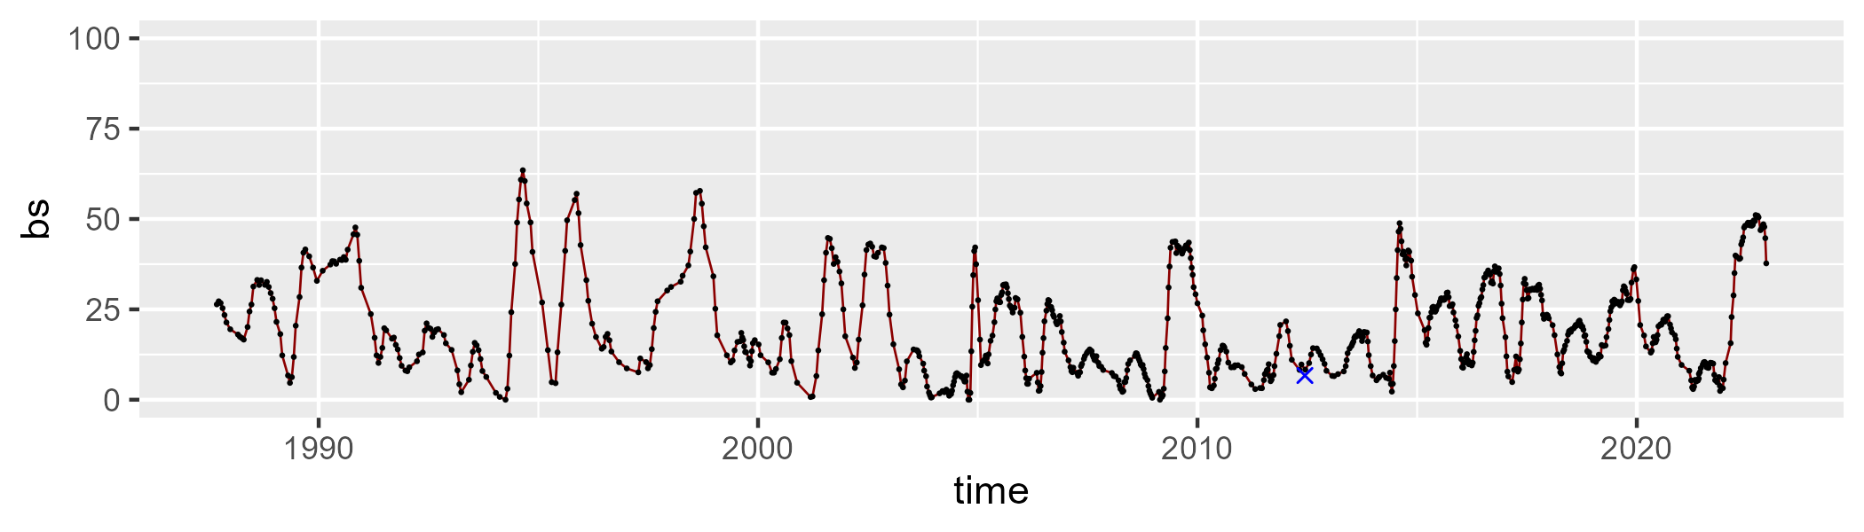

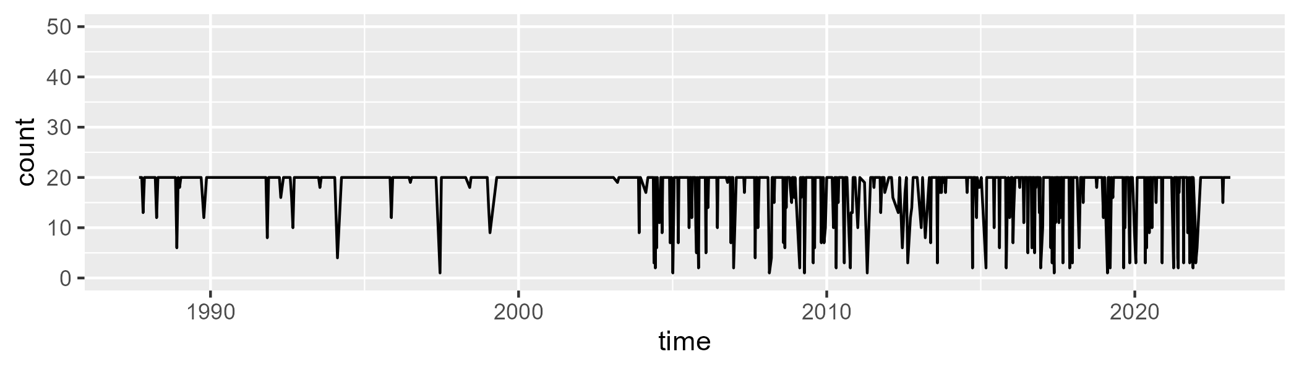

Min. : 1.00 1st Qu.:20.00 Median :20.00 Mean :18.08 3rd Qu.:20.00 Max. :20.00

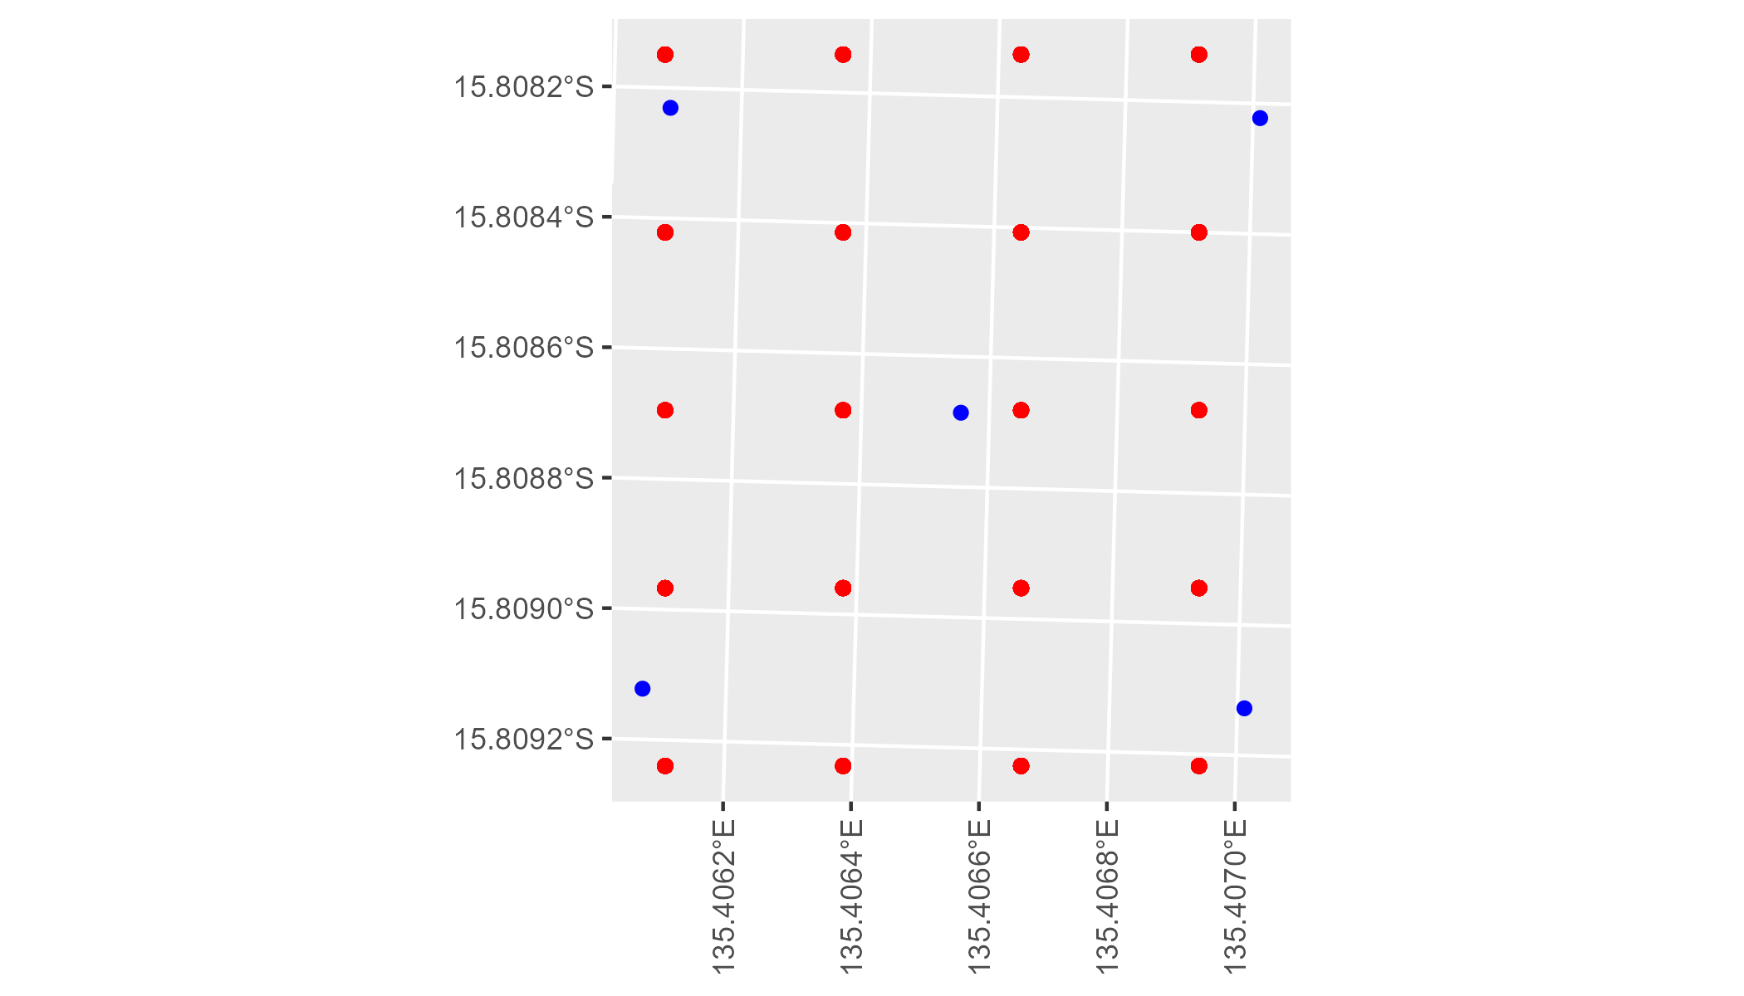

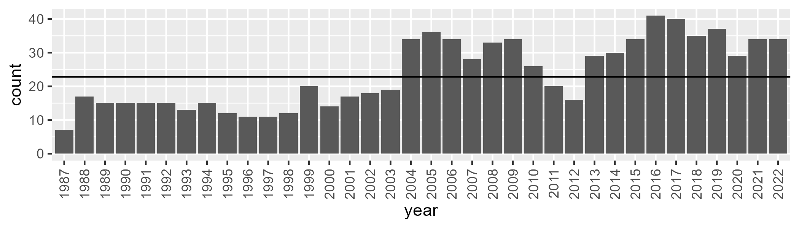

Number of samples: 850

# NTAGFU0027

| Min. | 1st Qu. | Median | Mean | 3rd Qu. | Max. |
| --- | --- | --- | --- | --- | --- |
| 4.474194 | 17.37899 | 23.95467 | 26.30956 | 33.32809 | 61.28256 |

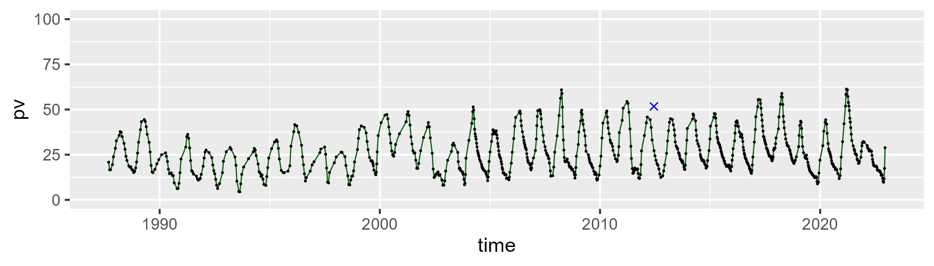

| Min. | 1st Qu. | Median | Mean | 3rd Qu. | Max. |
| --- | --- | --- | --- | --- | --- |
| 28.63816 | 49.89058 | 56.41512 | 56.05911 | 62.13699 | 80.50298 |

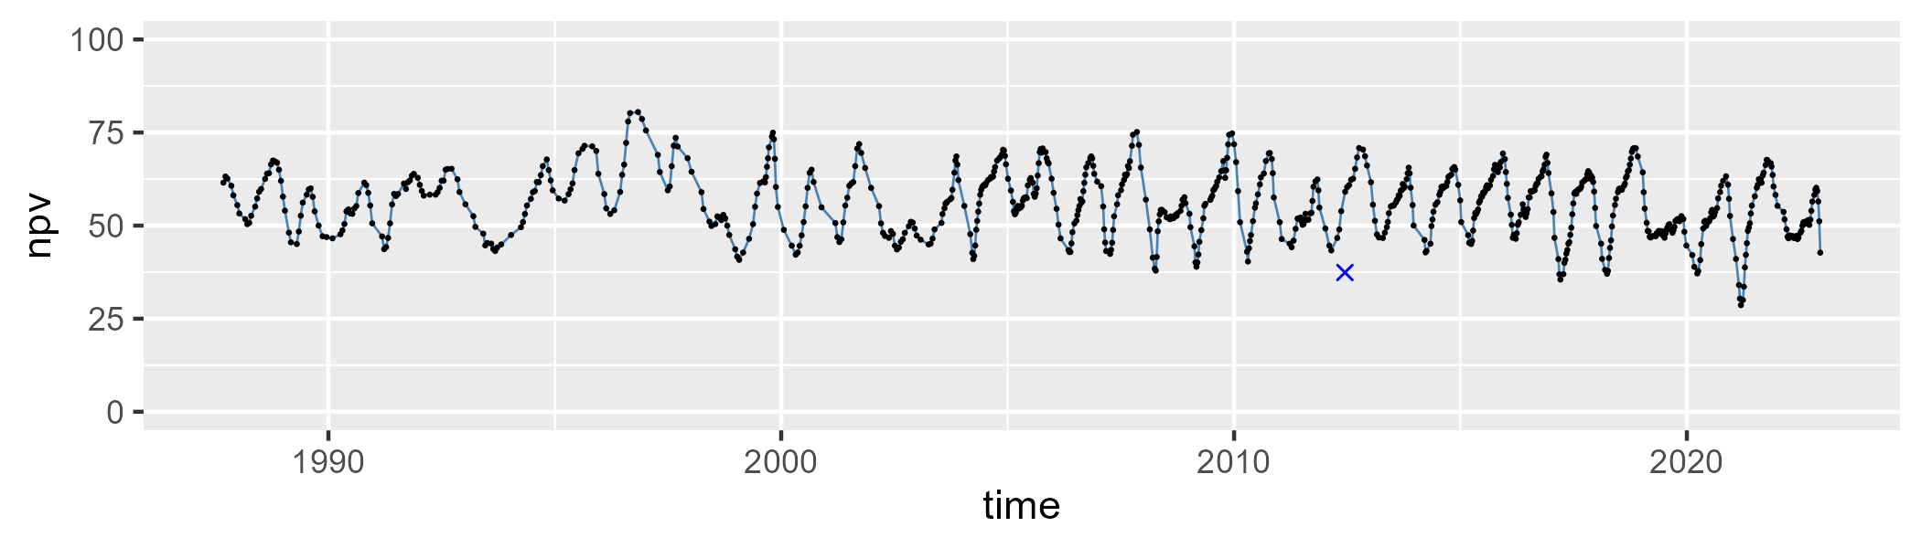

| Min. | 1st Qu. | Median | Mean | 3rd Qu. | Max. |
| --- | --- | --- | --- | --- | --- |
| 0 | 10.25707 | 14.25947 | 16.42449 | 22.25498 | 50.28699 |

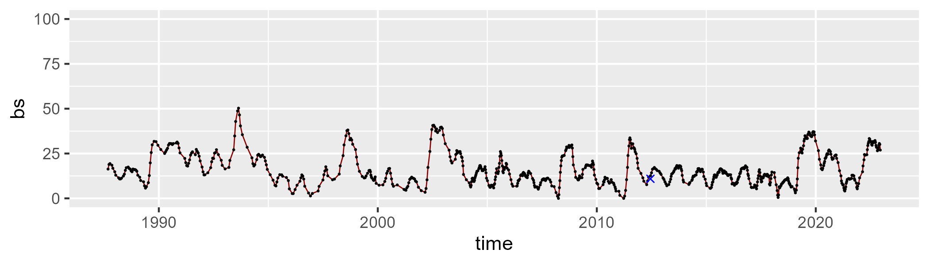

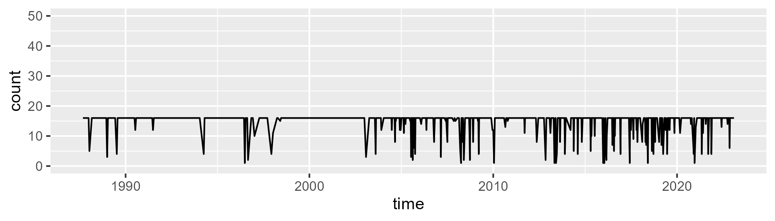

Min. : 1.00 1st Qu.:16.00 Median :16.00 Mean :14.84 3rd Qu.:16.00 Max. :16.00

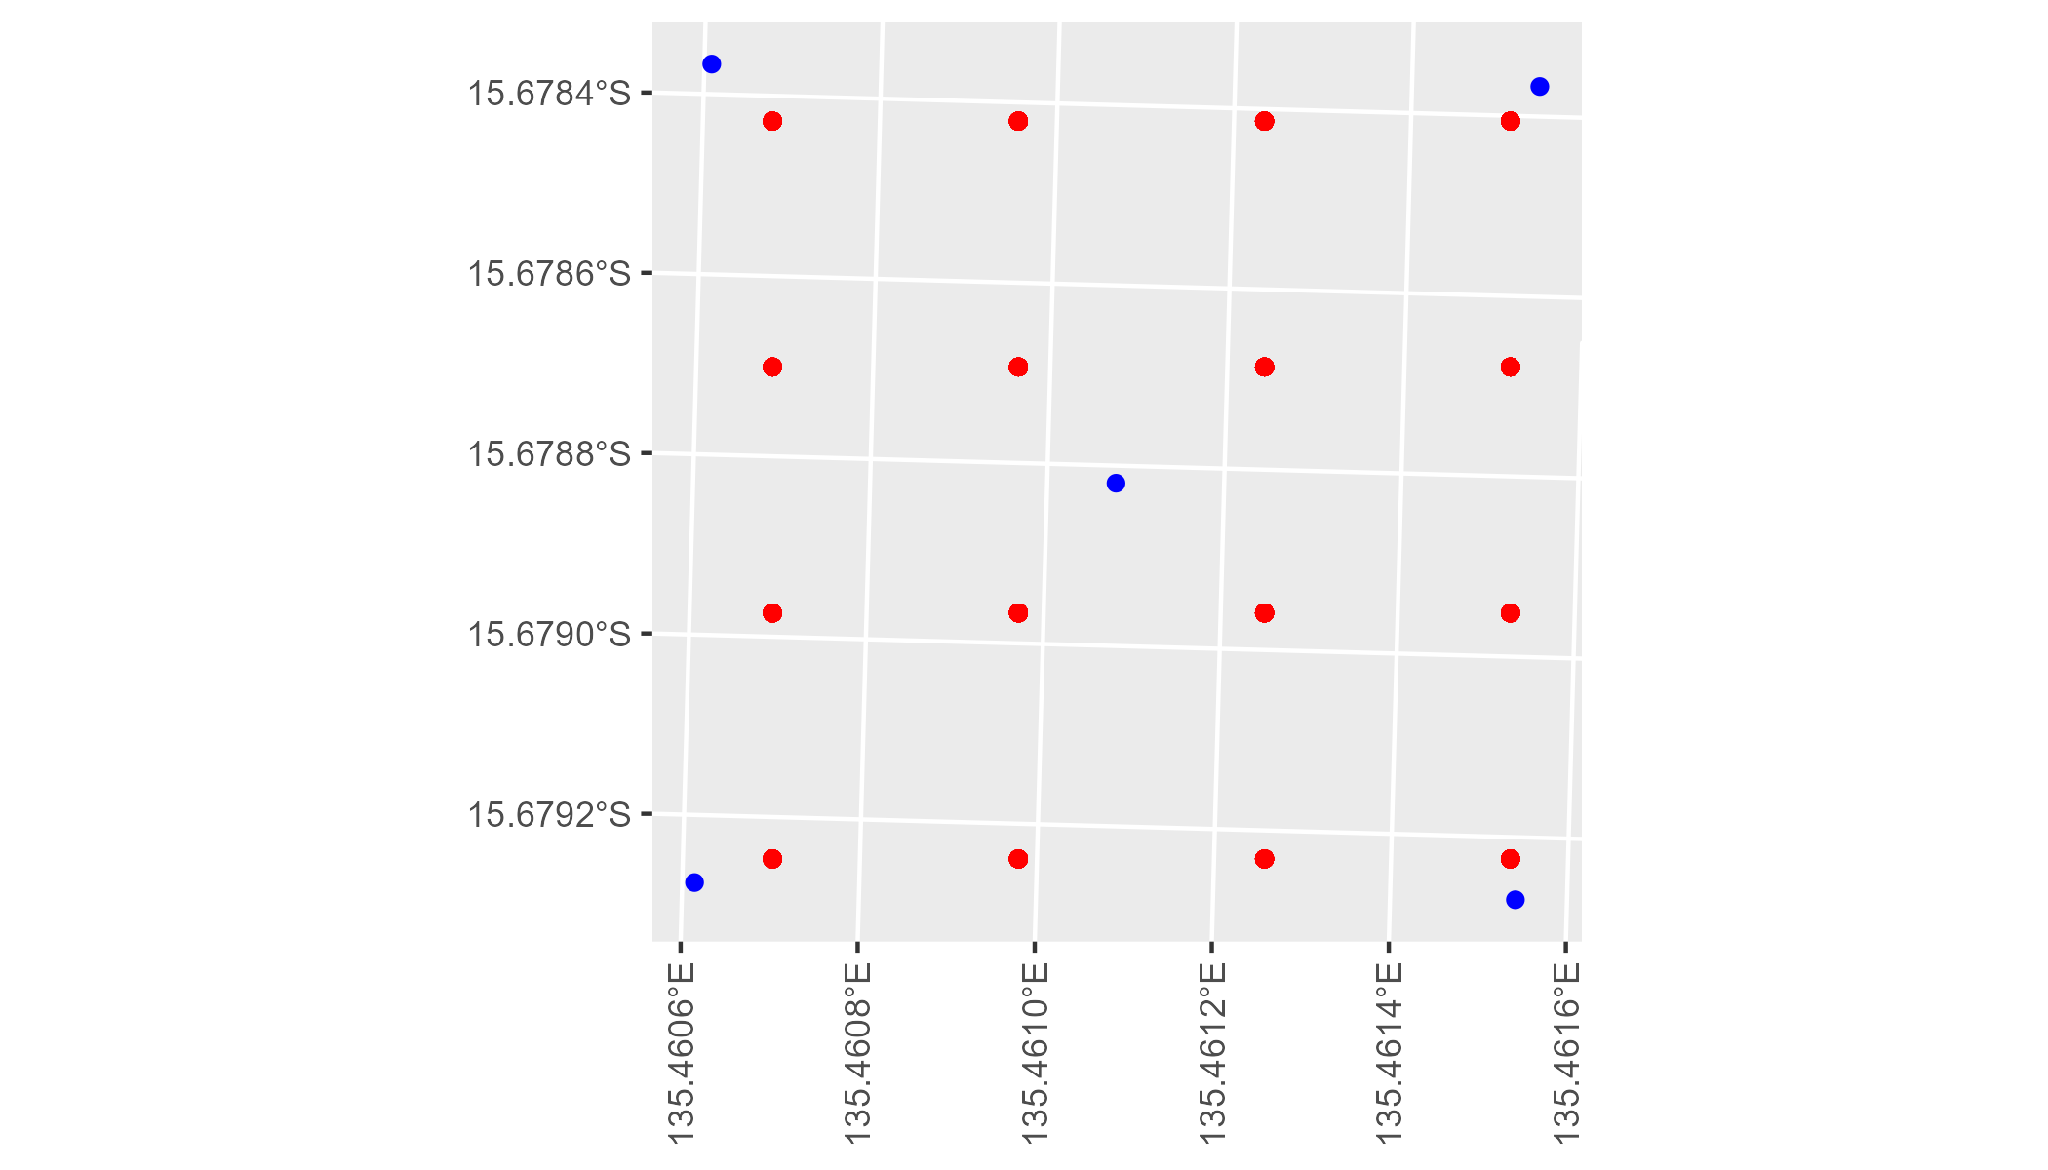

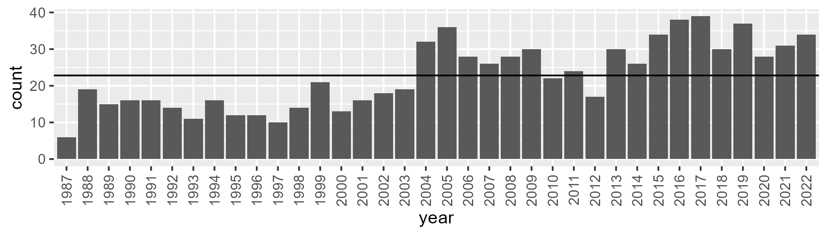

Number of samples: 818

# NTAGFU0028

| Min. | 1st Qu. | Median | Mean | 3rd Qu. | Max. |
| --- | --- | --- | --- | --- | --- |
| 5.424536 | 17.96941 | 24.43217 | 26.21284 | 33.816 | 53.83852 |

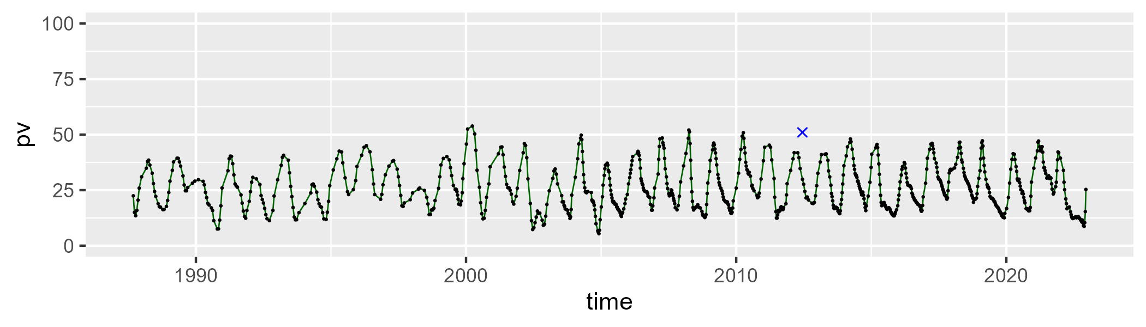

| Min. | 1st Qu. | Median | Mean | 3rd Qu. | Max. |
| --- | --- | --- | --- | --- | --- |
| 32.91276 | 45.55382 | 50.36851 | 51.15937 | 56.37218 | 76.2414 |

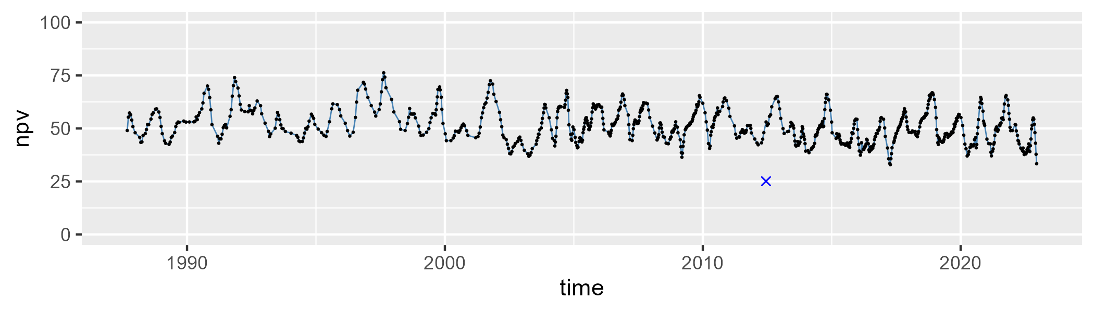

| Min. | 1st Qu. | Median | Mean | 3rd Qu. | Max. |
| --- | --- | --- | --- | --- | --- |
| 0 | 13.40572 | 20.09554 | 21.34679 | 28.75698 | 52.11069 |

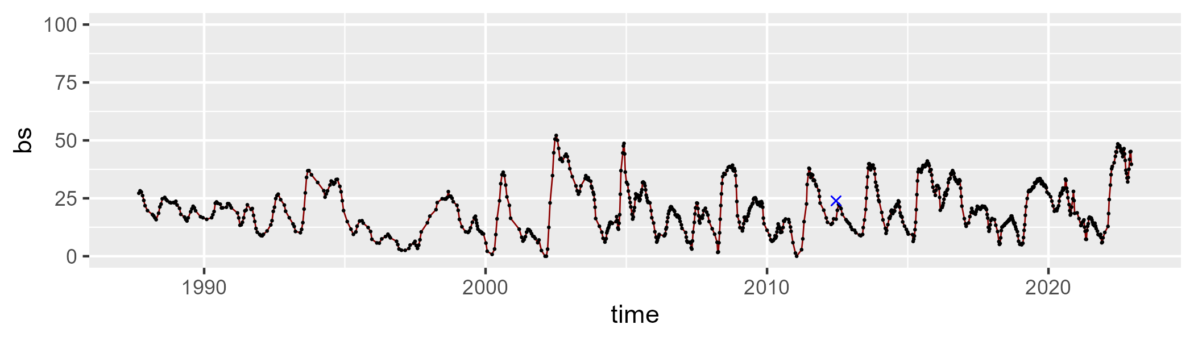

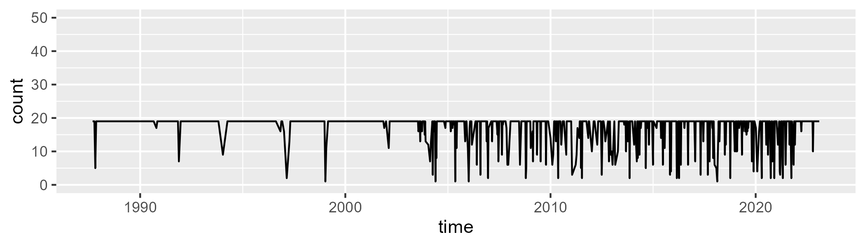

Min. : 1.00 1st Qu.:19.00 Median :19.00 Mean :17.23 3rd Qu.:19.00 Max. :19.00

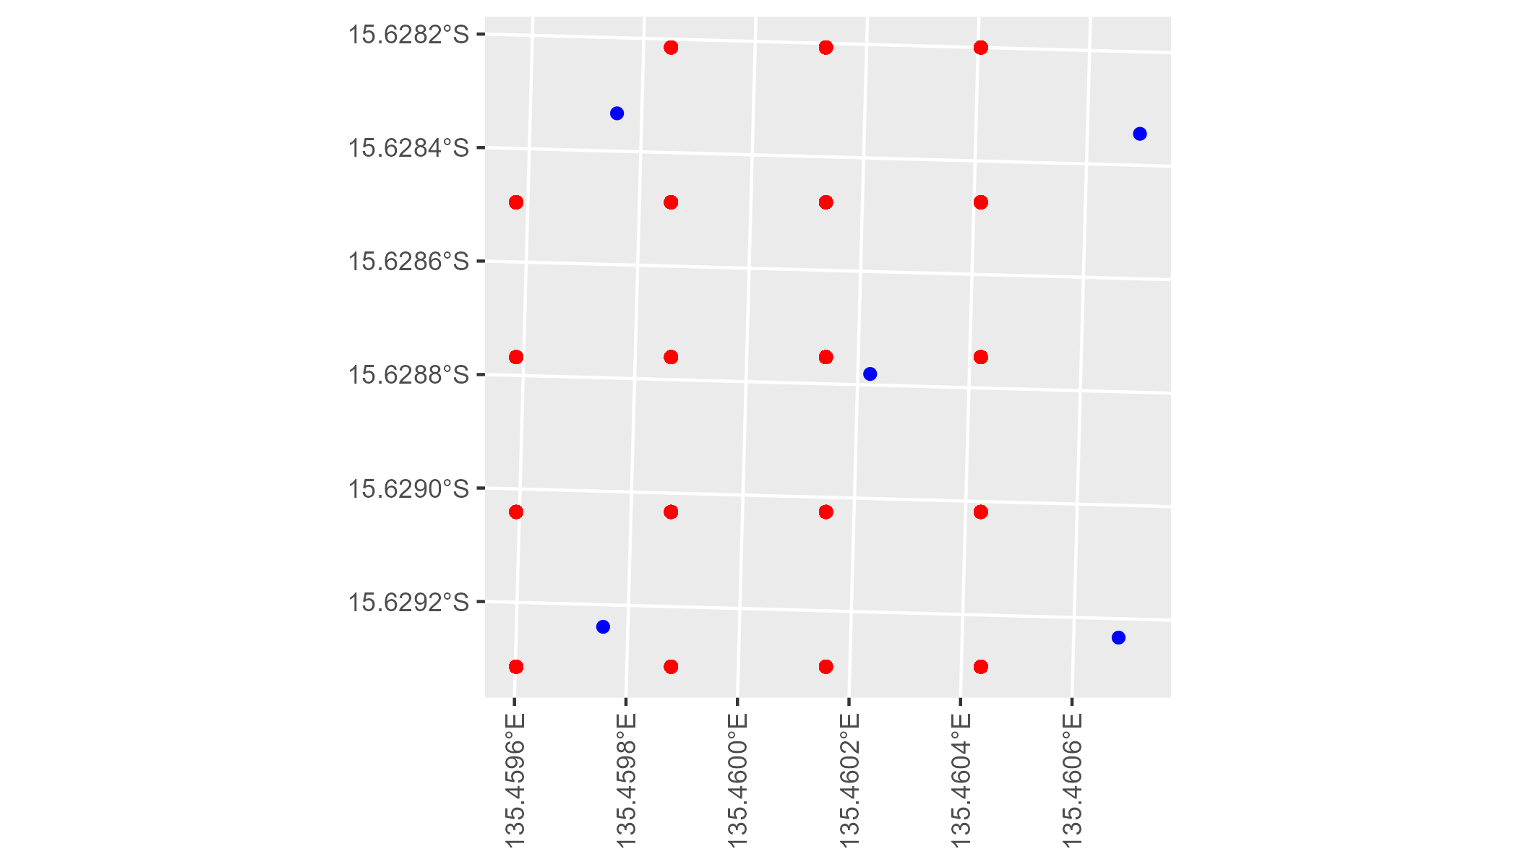

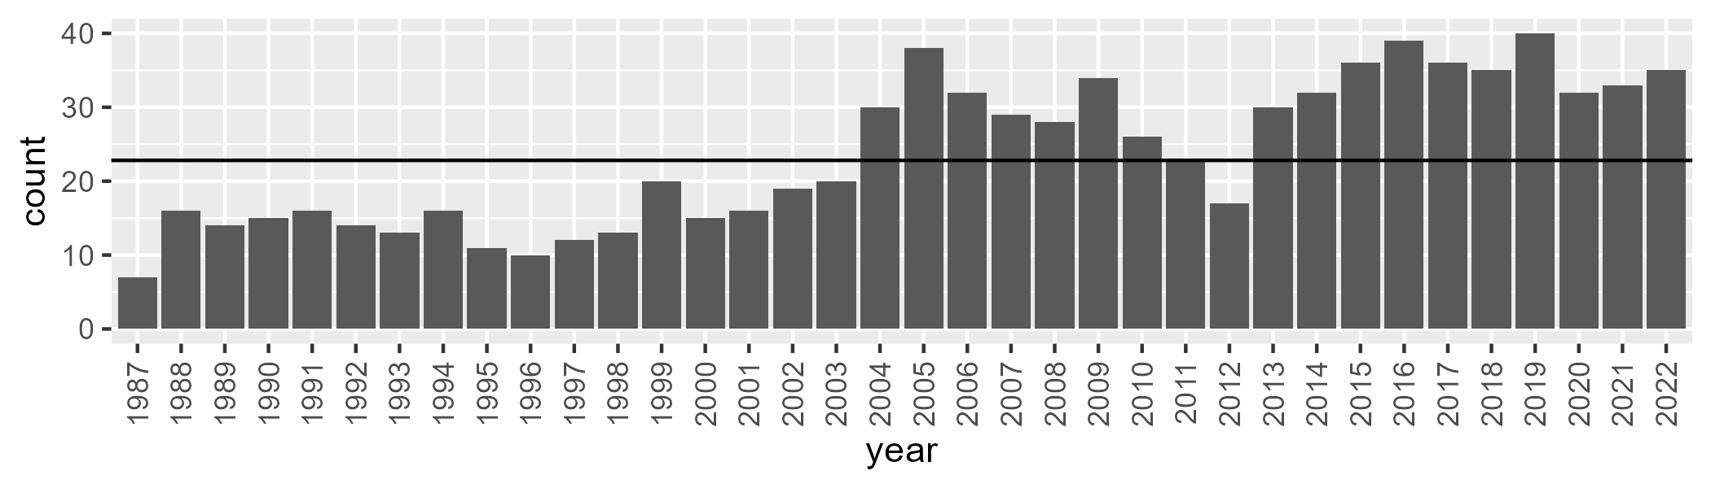

Number of samples: 852

# NTAGFU0029

| Min. | 1st Qu. | Median | Mean | 3rd Qu. | Max. |
| --- | --- | --- | --- | --- | --- |
| 4.165374 | 13.67233 | 19.54381 | 24.32938 | 32.45077 | 67.54041 |

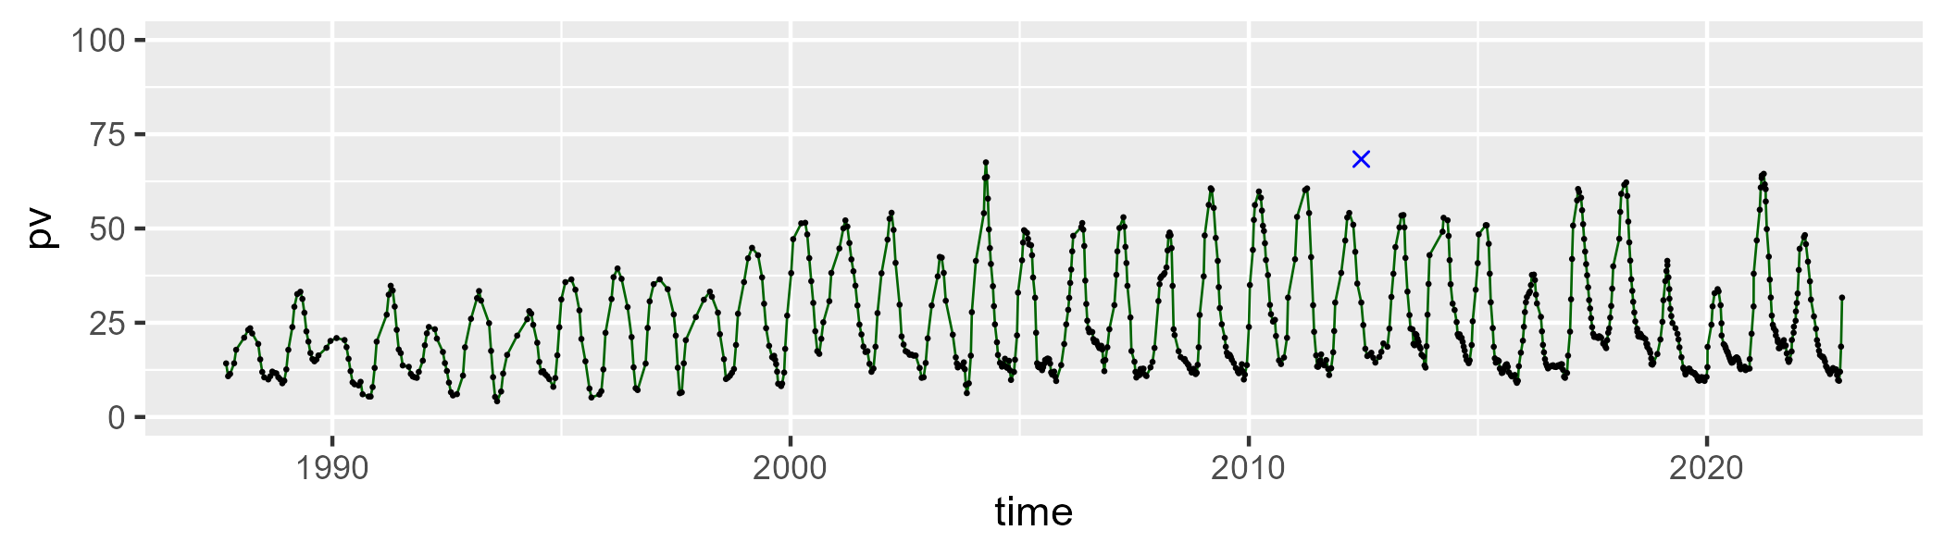

| Min. | 1st Qu. | Median | Mean | 3rd Qu. | Max. |
| --- | --- | --- | --- | --- | --- |
| 24.95835 | 44.77867 | 51.73172 | 52.85229 | 60.43323 | 83.53232 |

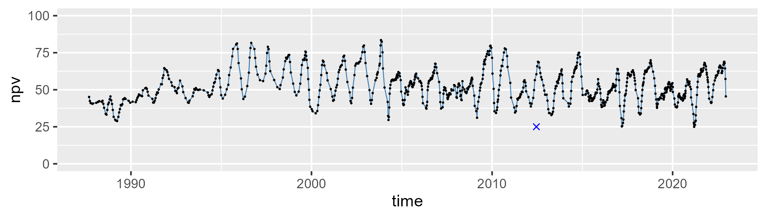

| Min. | 1st Qu. | Median | Mean | 3rd Qu. | Max. |
| --- | --- | --- | --- | --- | --- |
| 0.6629741 | 11.86666 | 19.13849 | 21.54016 | 32.08955 | 54.76747 |

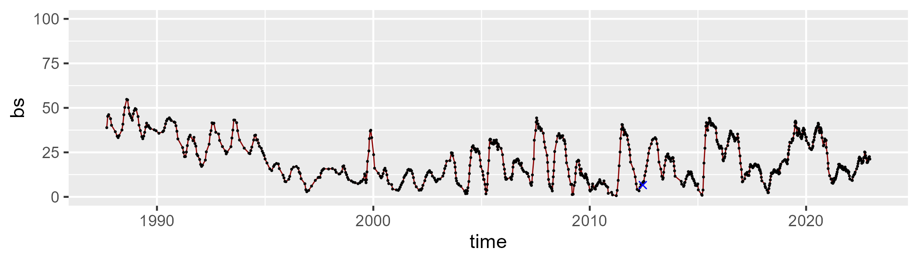

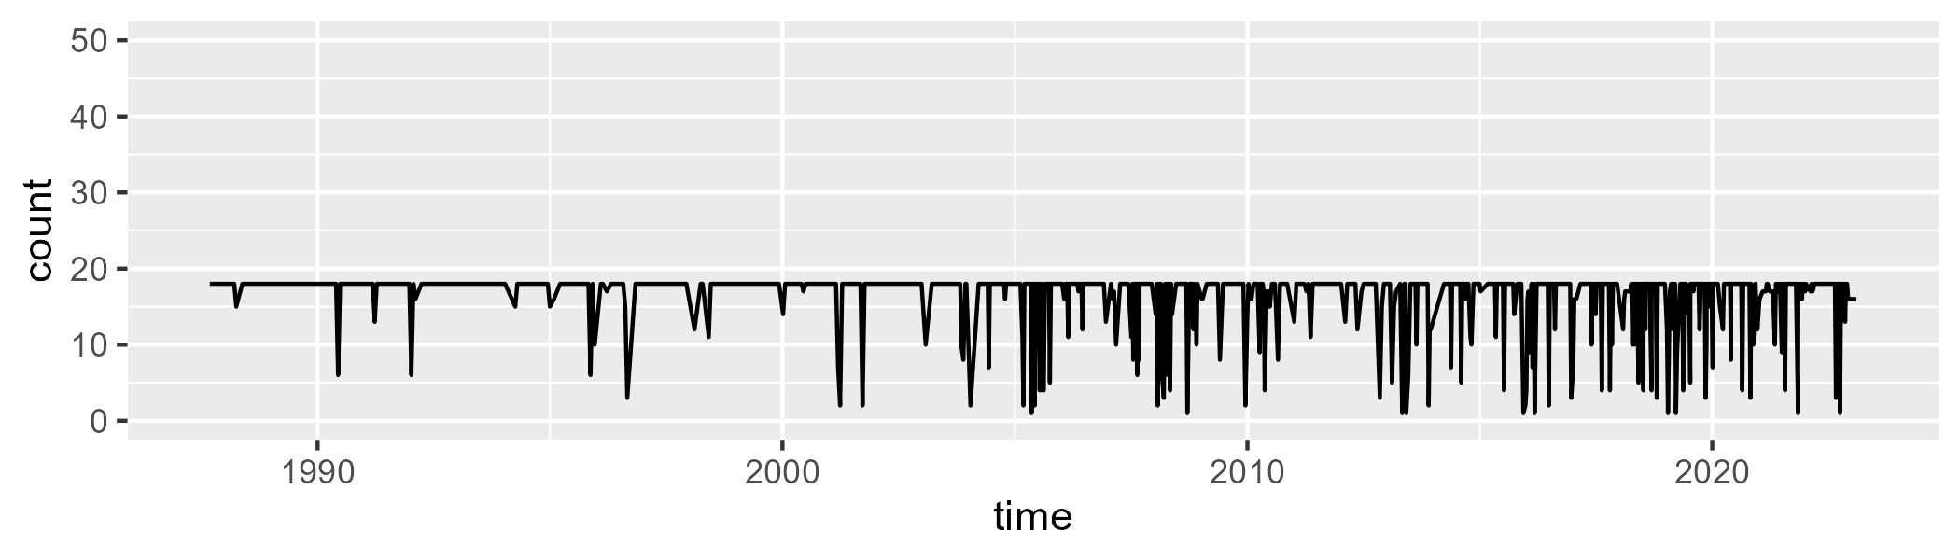

Min. : 1.00 1st Qu.:18.00 Median :18.00 Mean :16.39 3rd Qu.:18.00 Max. :18.00

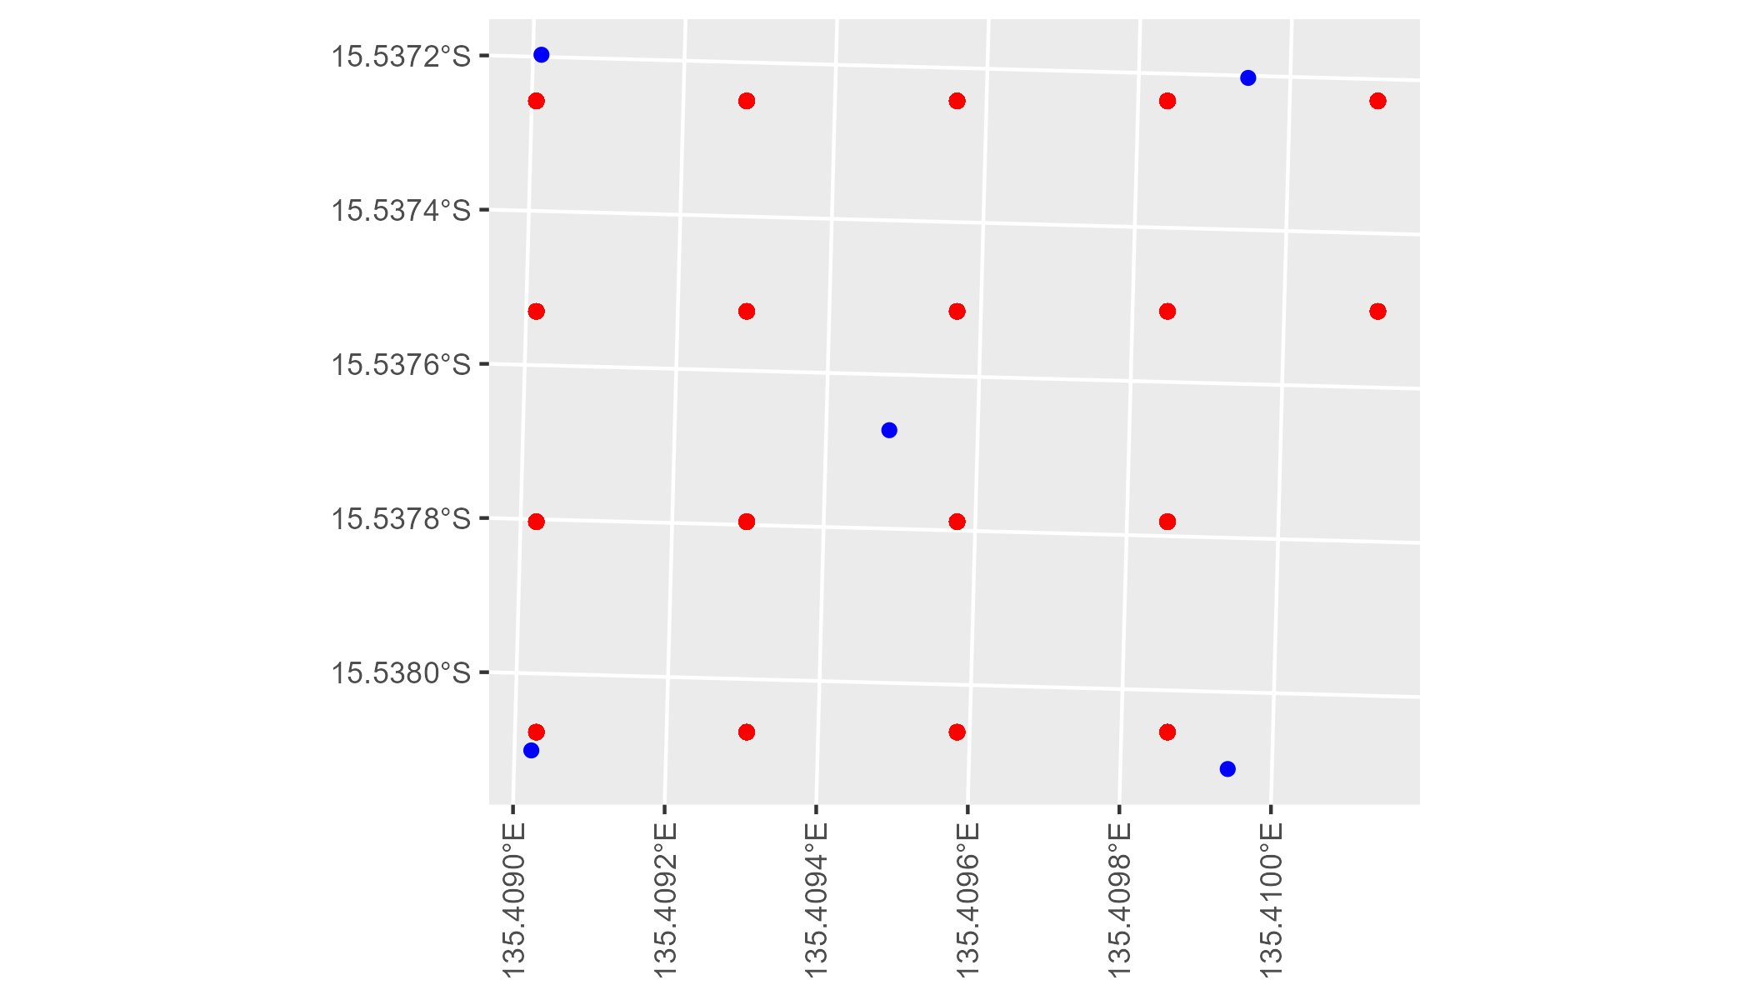

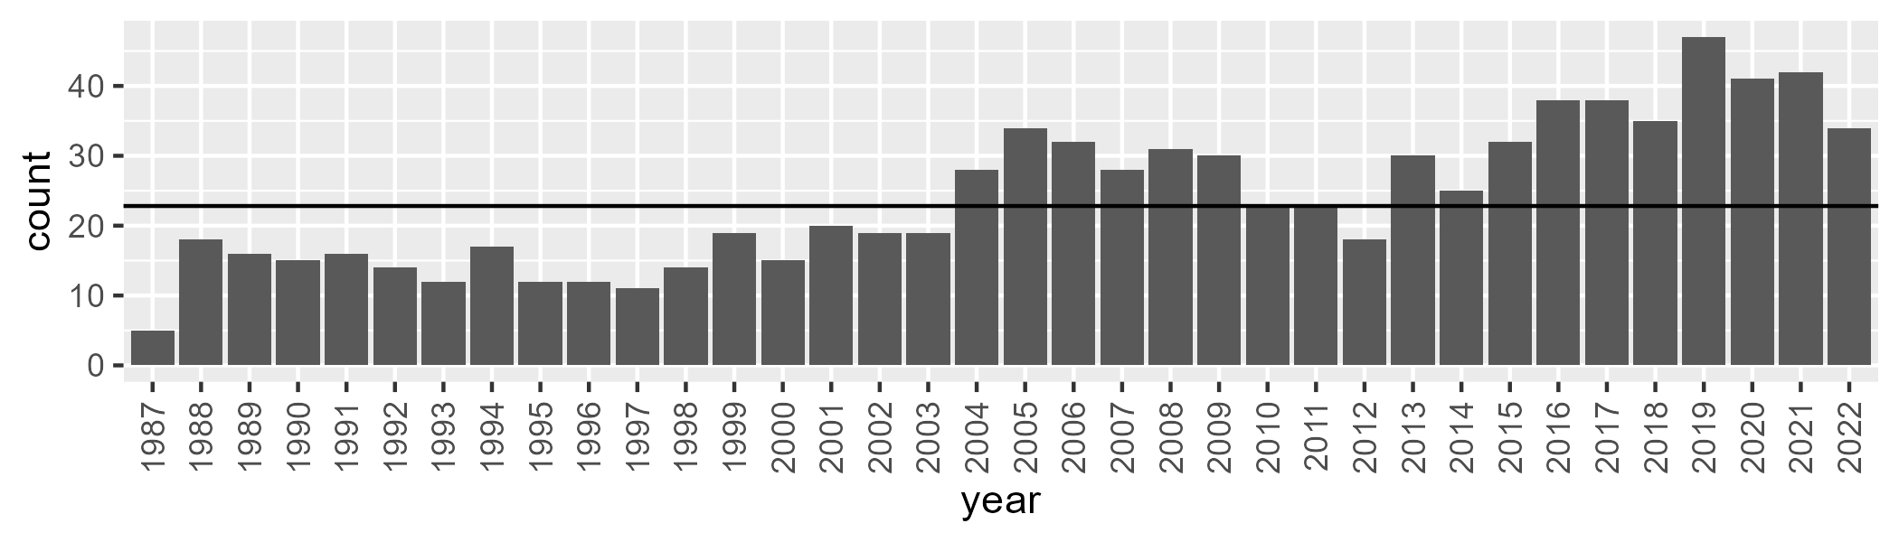

Number of samples: 863

# NTAGFU0030

| Min. | 1st Qu. | Median | Mean | 3rd Qu. | Max. |
| --- | --- | --- | --- | --- | --- |
| 11.98993 | 22.52324 | 27.61573 | 29.94465 | 36.97448 | 56.54378 |

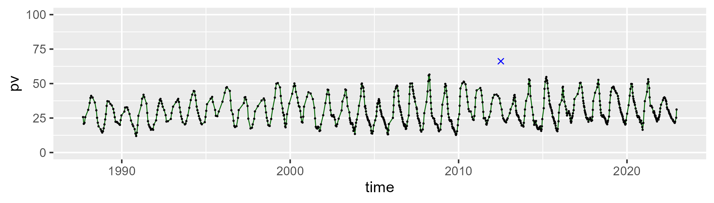

| Min. | 1st Qu. | Median | Mean | 3rd Qu. | Max. |
| --- | --- | --- | --- | --- | --- |
| 36.86871 | 54.81958 | 60.94647 | 60.16977 | 65.76238 | 77.18284 |

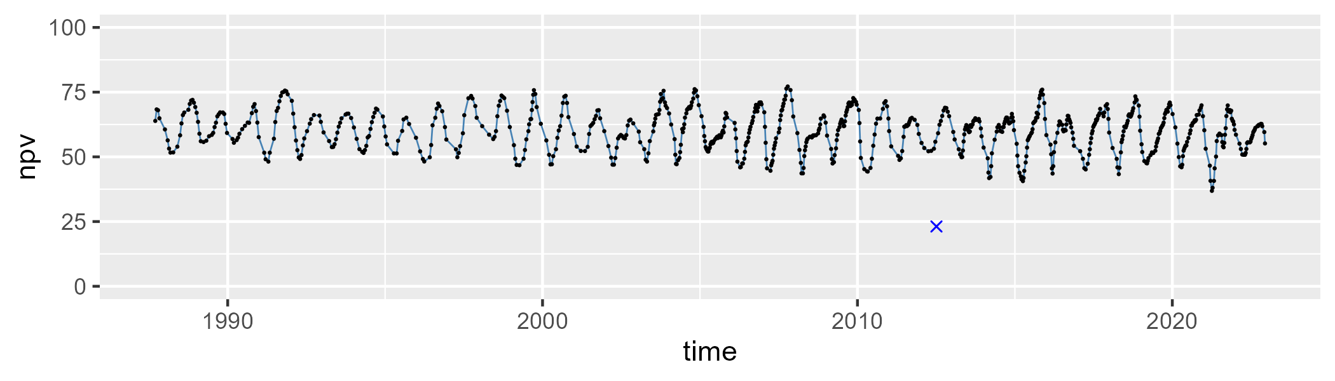

| Min. | 1st Qu. | Median | Mean | 3rd Qu. | Max. |
| --- | --- | --- | --- | --- | --- |
| 0 | 5.966954 | 8.4767 | 8.821602 | 11.32119 | 22.85509 |

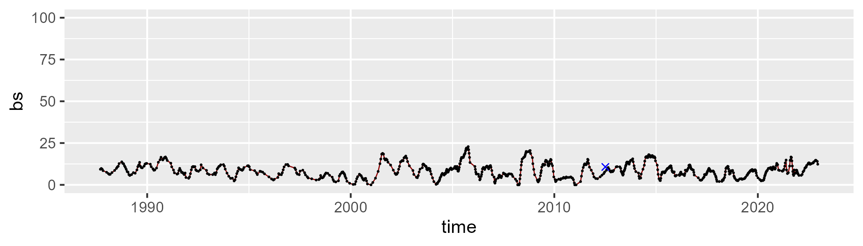

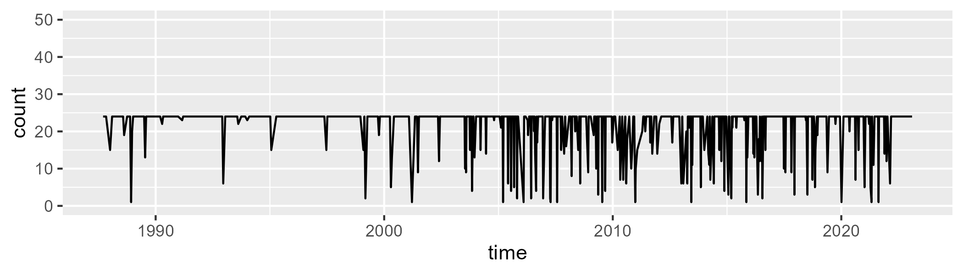

Min. : 1.00 1st Qu.:24.00 Median :24.00 Mean :21.81 3rd Qu.:24.00 Max. :24.00

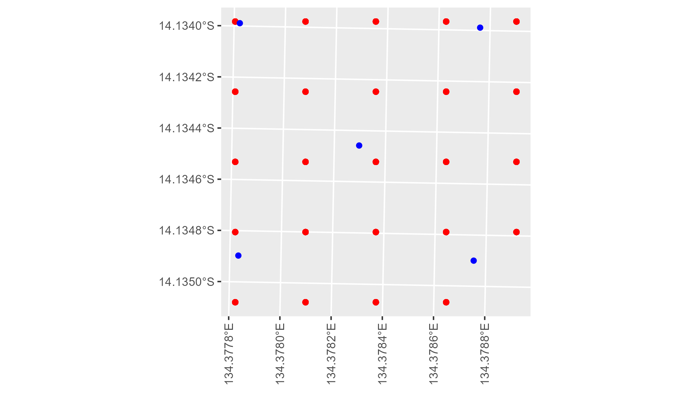

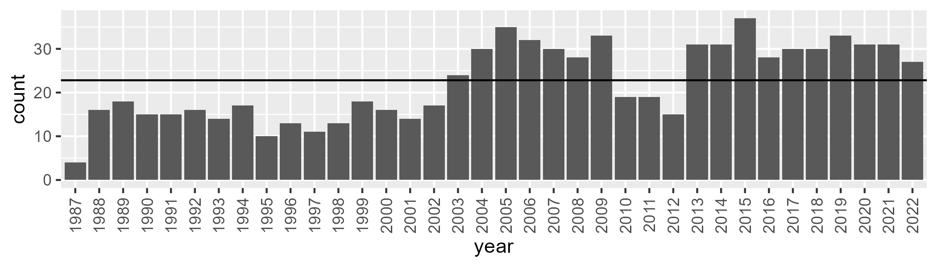

Number of samples: 801

# NTAGFU0031

| Min. | 1st Qu. | Median | Mean | 3rd Qu. | Max. |
| --- | --- | --- | --- | --- | --- |
| 7.708038 | 19.98323 | 25.23793 | 26.62691 | 32.65734 | 48.62431 |

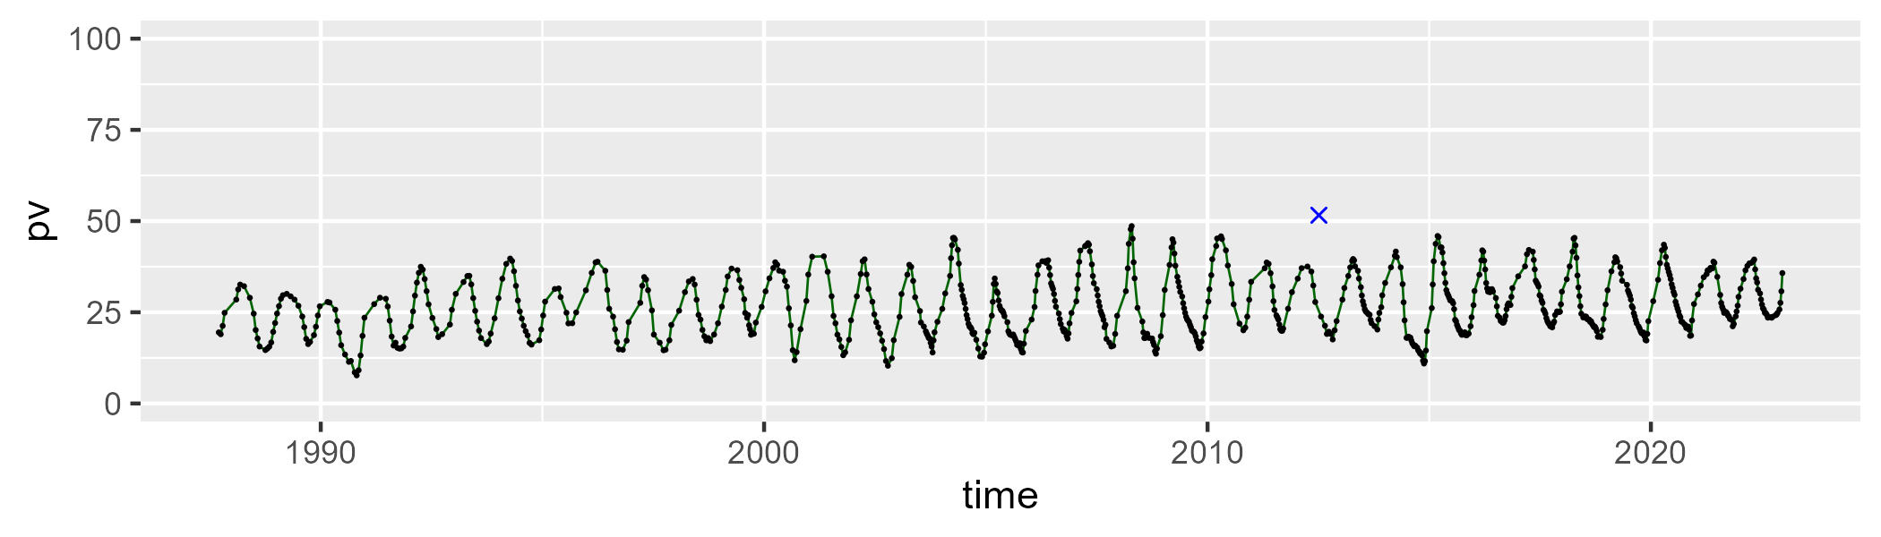

| Min. | 1st Qu. | Median | Mean | 3rd Qu. | Max. |
| --- | --- | --- | --- | --- | --- |
| 41.12265 | 54.0122 | 59.57337 | 59.62661 | 65.39865 | 75.88963 |

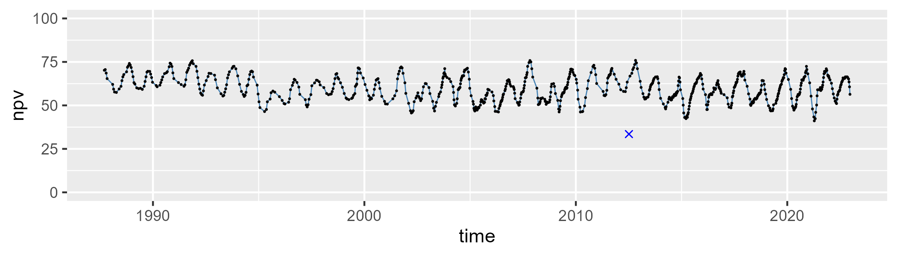

| Min. | 1st Qu. | Median | Mean | 3rd Qu. | Max. |
| --- | --- | --- | --- | --- | --- |
| 0 | 8.466925 | 11.41983 | 12.5773 | 15.43825 | 30.15184 |

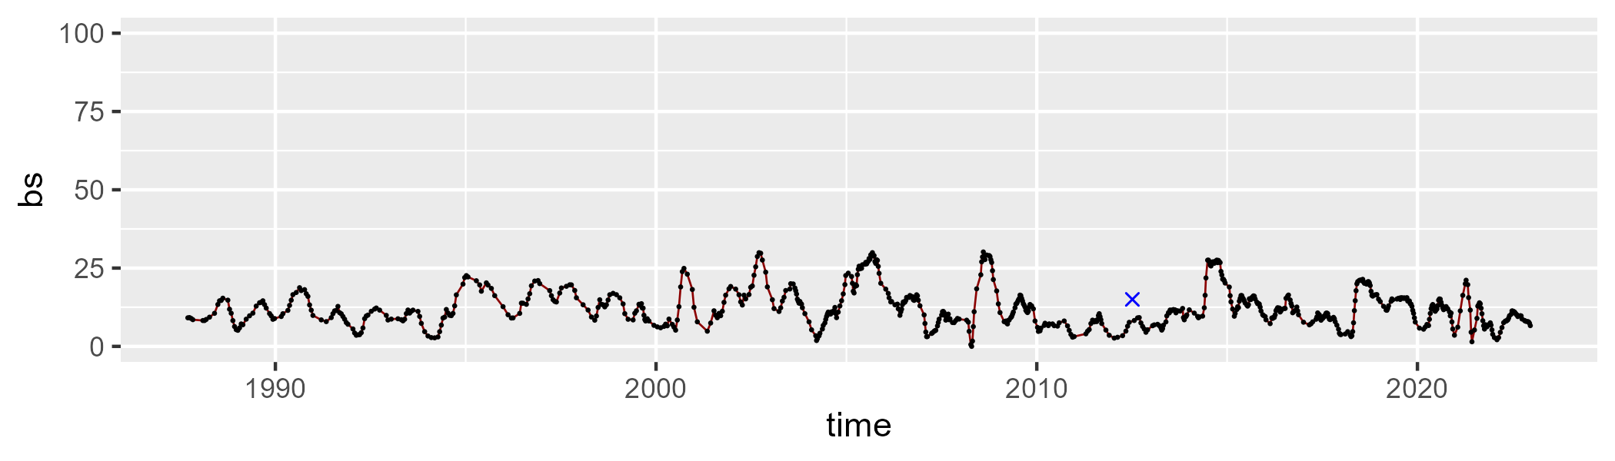

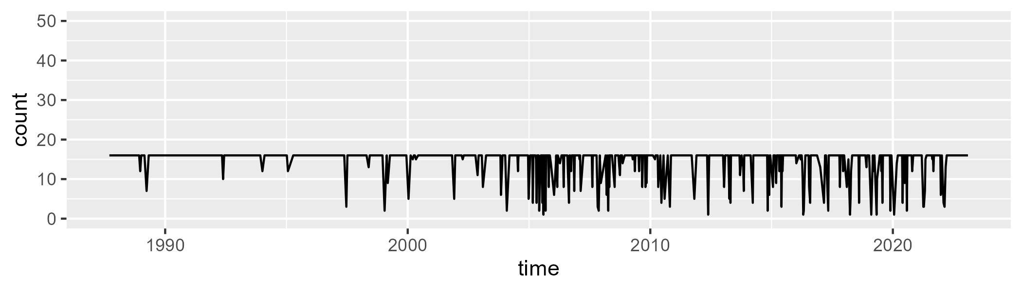

Min. : 1.00 1st Qu.:16.00 Median :16.00 Mean :14.73 3rd Qu.:16.00 Max. :16.00

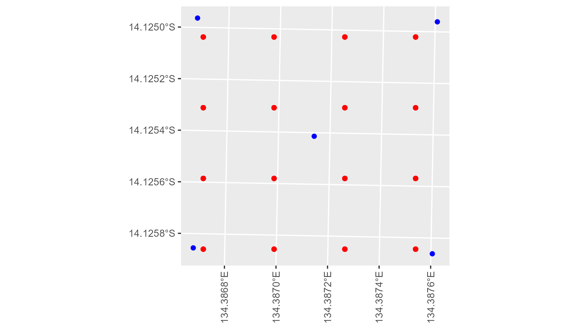

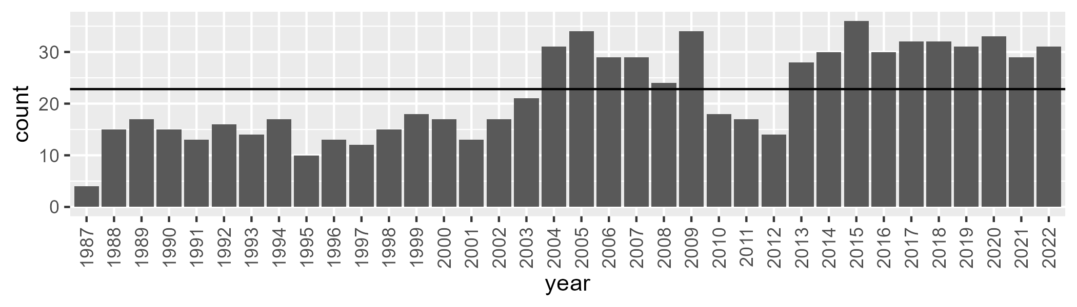

Number of samples: 789

# NTAGFU0032

| Min. | 1st Qu. | Median | Mean | 3rd Qu. | Max. |
| --- | --- | --- | --- | --- | --- |
| 1.553739 | 11.86222 | 16.59455 | 20.28821 | 27.98717 | 51.43063 |

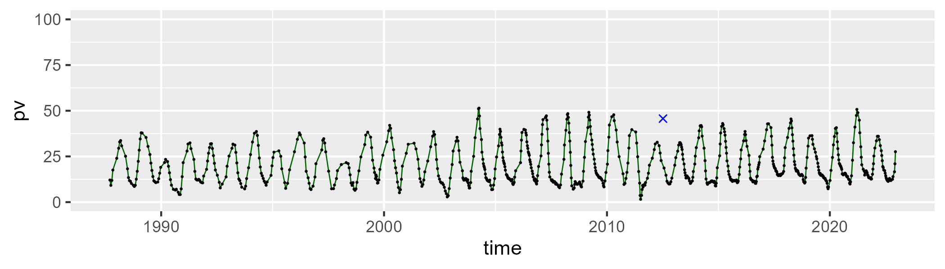

| Min. | 1st Qu. | Median | Mean | 3rd Qu. | Max. |
| --- | --- | --- | --- | --- | --- |
| 39.99573 | 55.11588 | 62.02277 | 61.6719 | 67.8446 | 83.2247 |

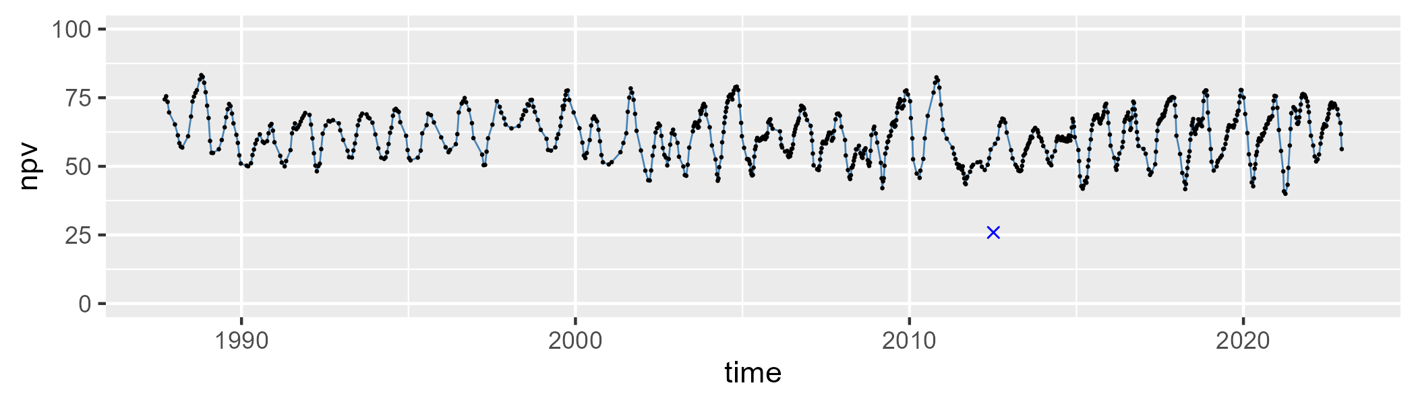

| Min. | 1st Qu. | Median | Mean | 3rd Qu. | Max. |
| --- | --- | --- | --- | --- | --- |
| 0 | 11.46571 | 16.35531 | 16.82436 | 20.57162 | 46.80078 |

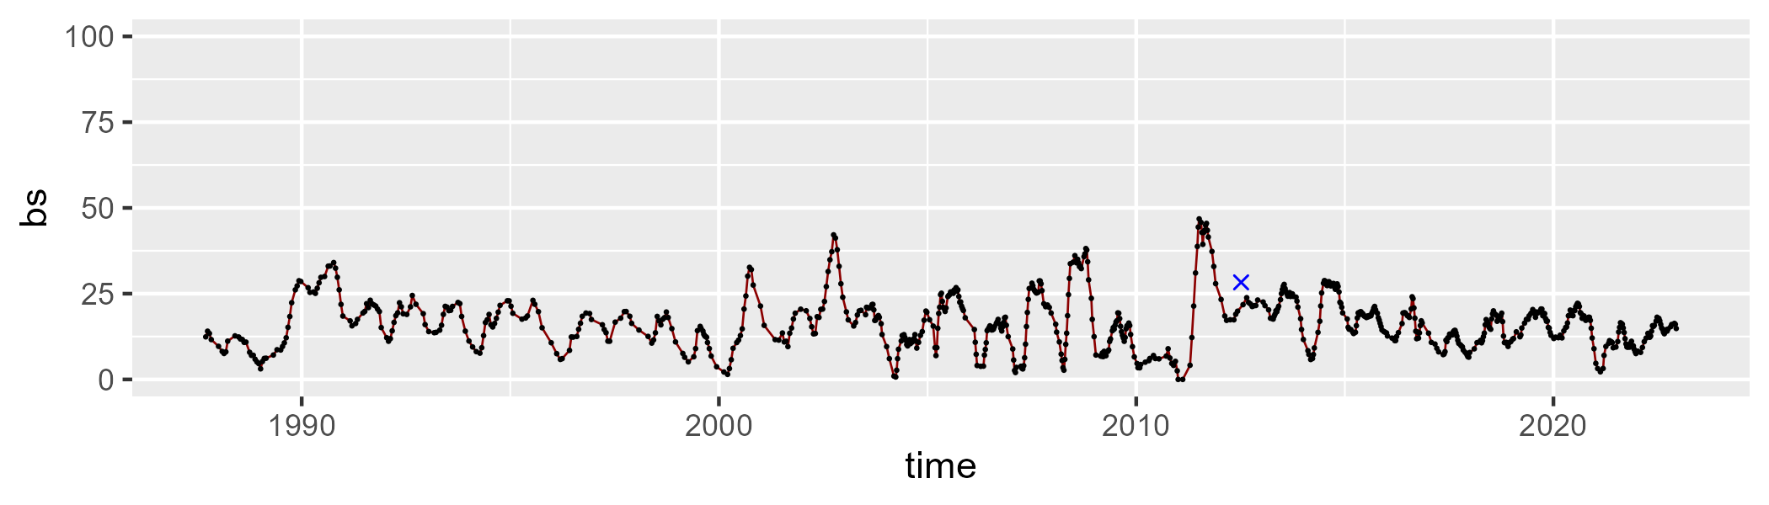

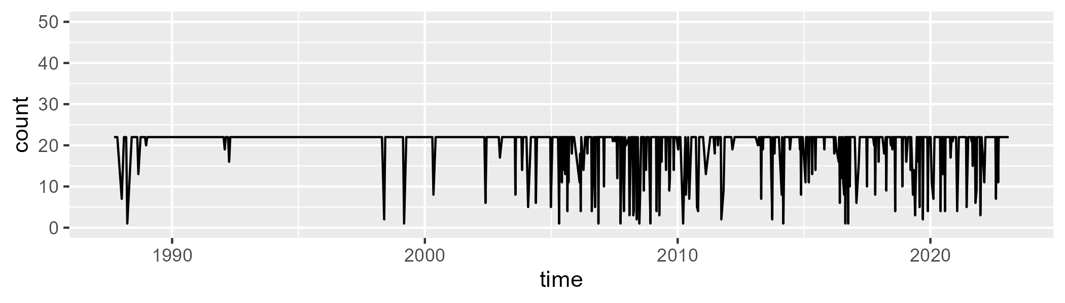

Min. : 1.00 1st Qu.:22.00 Median :22.00 Mean :20.08 3rd Qu.:22.00 Max. :22.00

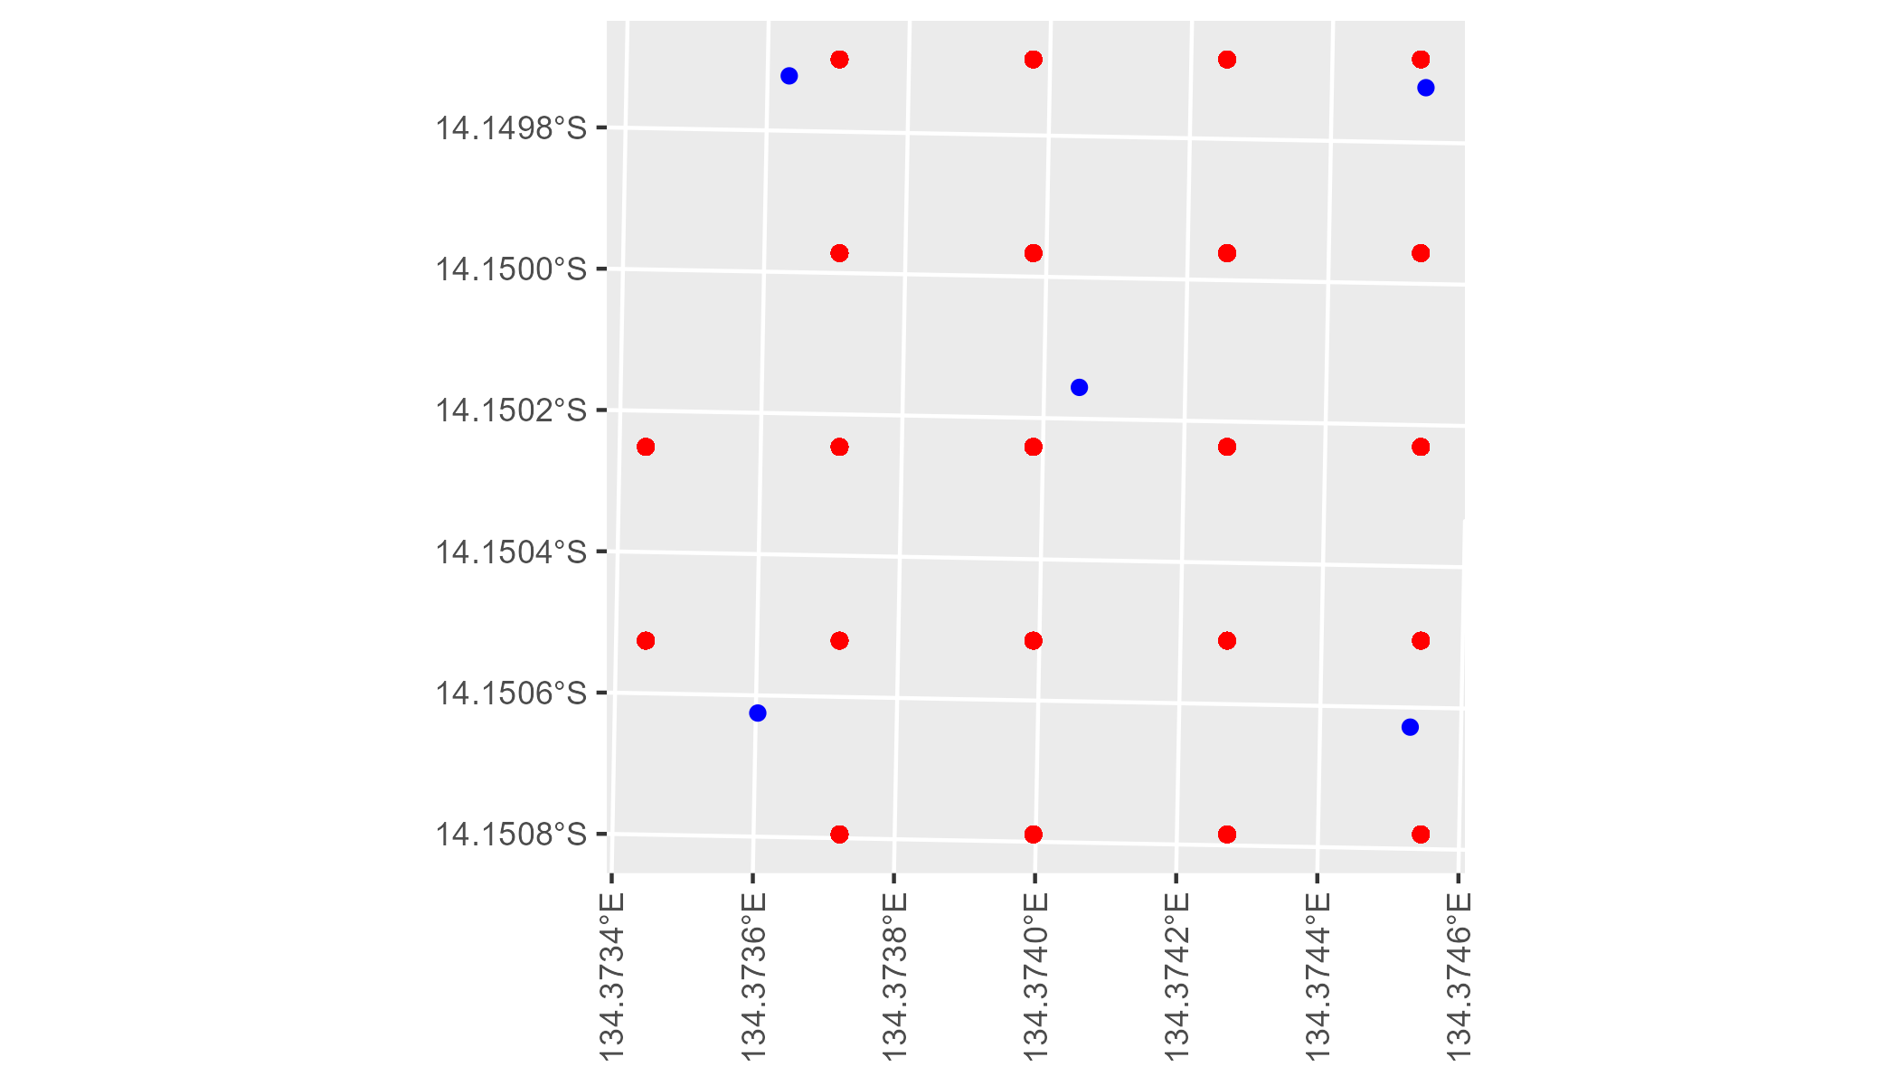

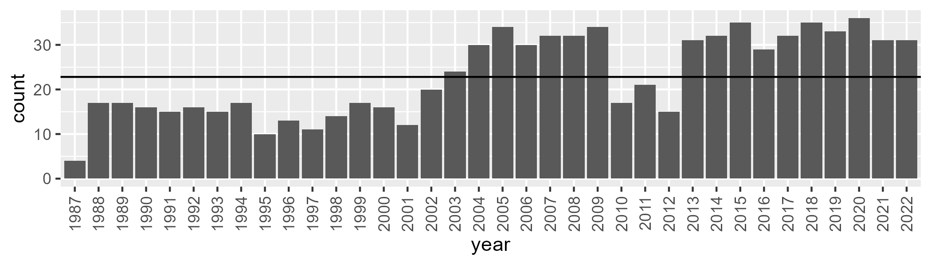

Number of samples: 824

# NTAGFU0033

| Min. | 1st Qu. | Median | Mean | 3rd Qu. | Max. |
| --- | --- | --- | --- | --- | --- |
| 20.8907 | 30.58848 | 36.55746 | 37.41442 | 44.17087 | 55.41656 |

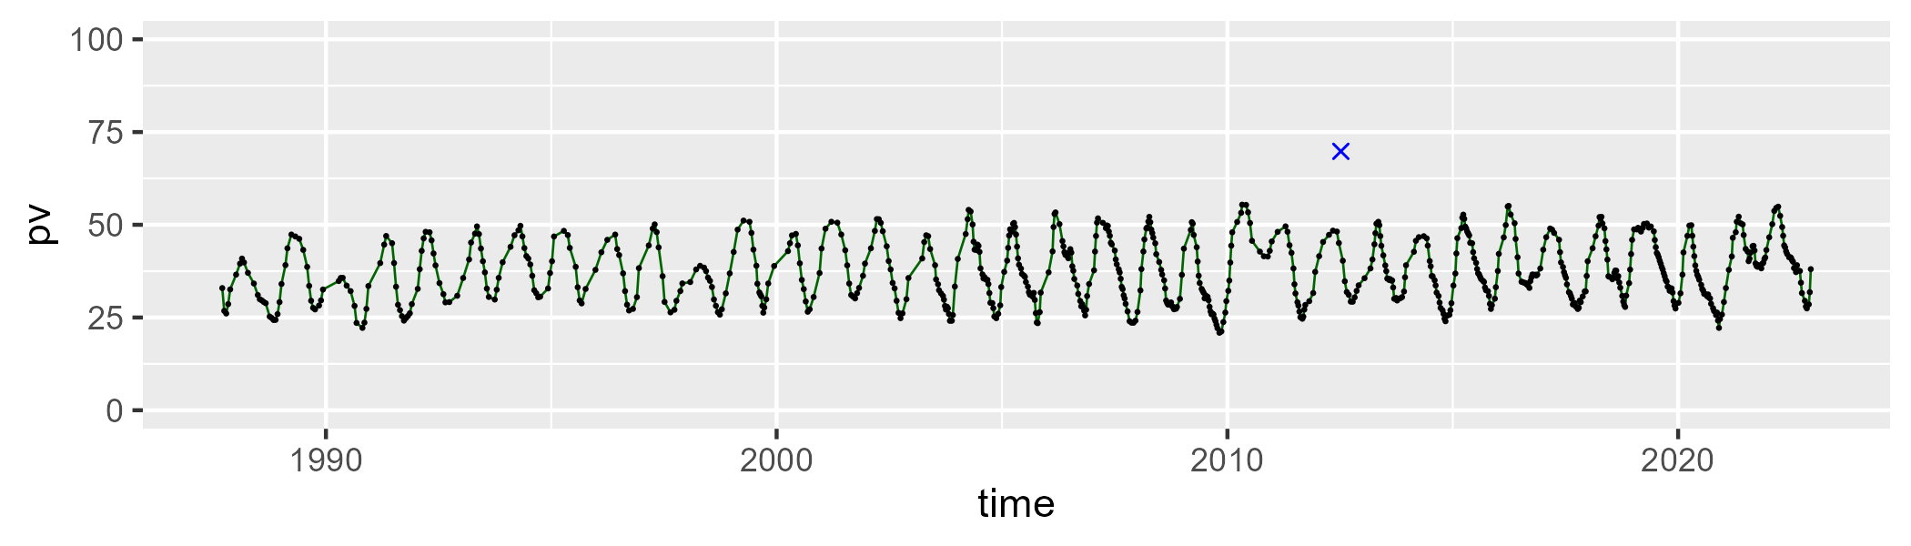

| Min. | 1st Qu. | Median | Mean | 3rd Qu. | Max. |
| --- | --- | --- | --- | --- | --- |
| 37.37686 | 49.03259 | 56.52869 | 55.91554 | 62.30088 | 74.06872 |

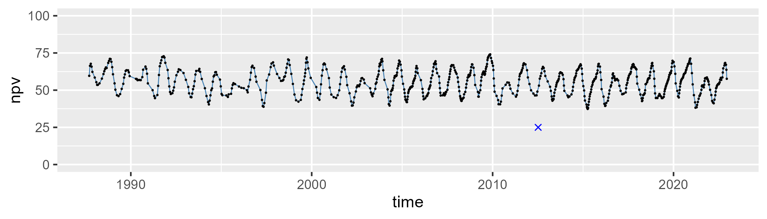

| Min. | 1st Qu. | Median | Mean | 3rd Qu. | Max. |
| --- | --- | --- | --- | --- | --- |
| 0 | 3.635744 | 5.176033 | 5.569199 | 6.944809 | 16.37327 |

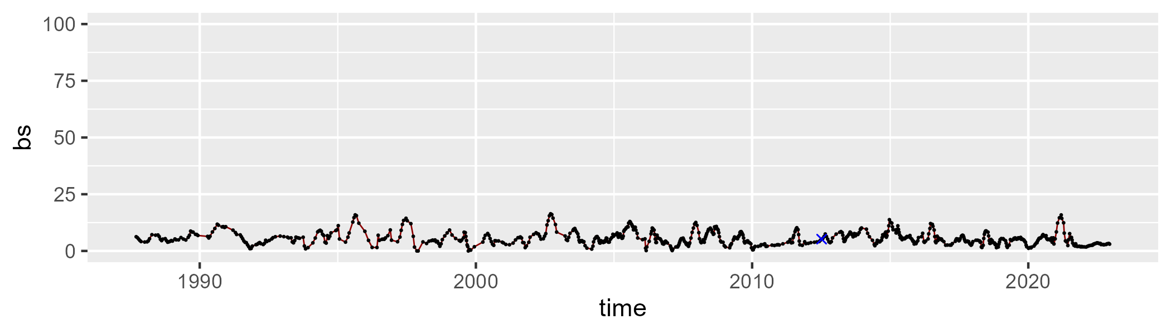

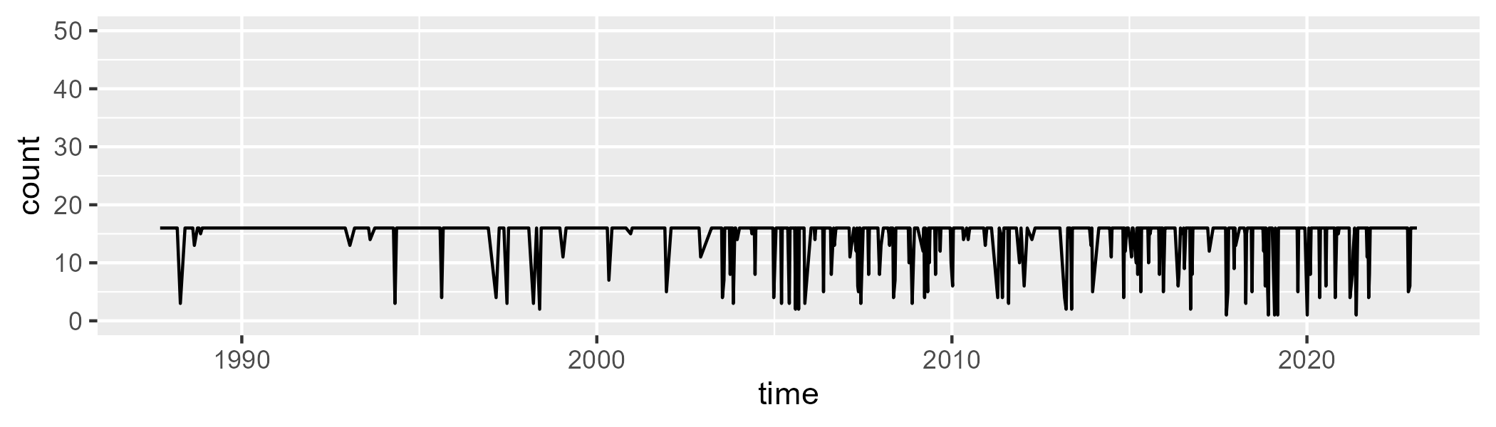

Min. : 1.00 1st Qu.:16.00 Median :16.00 Mean :14.73 3rd Qu.:16.00 Max. :16.00

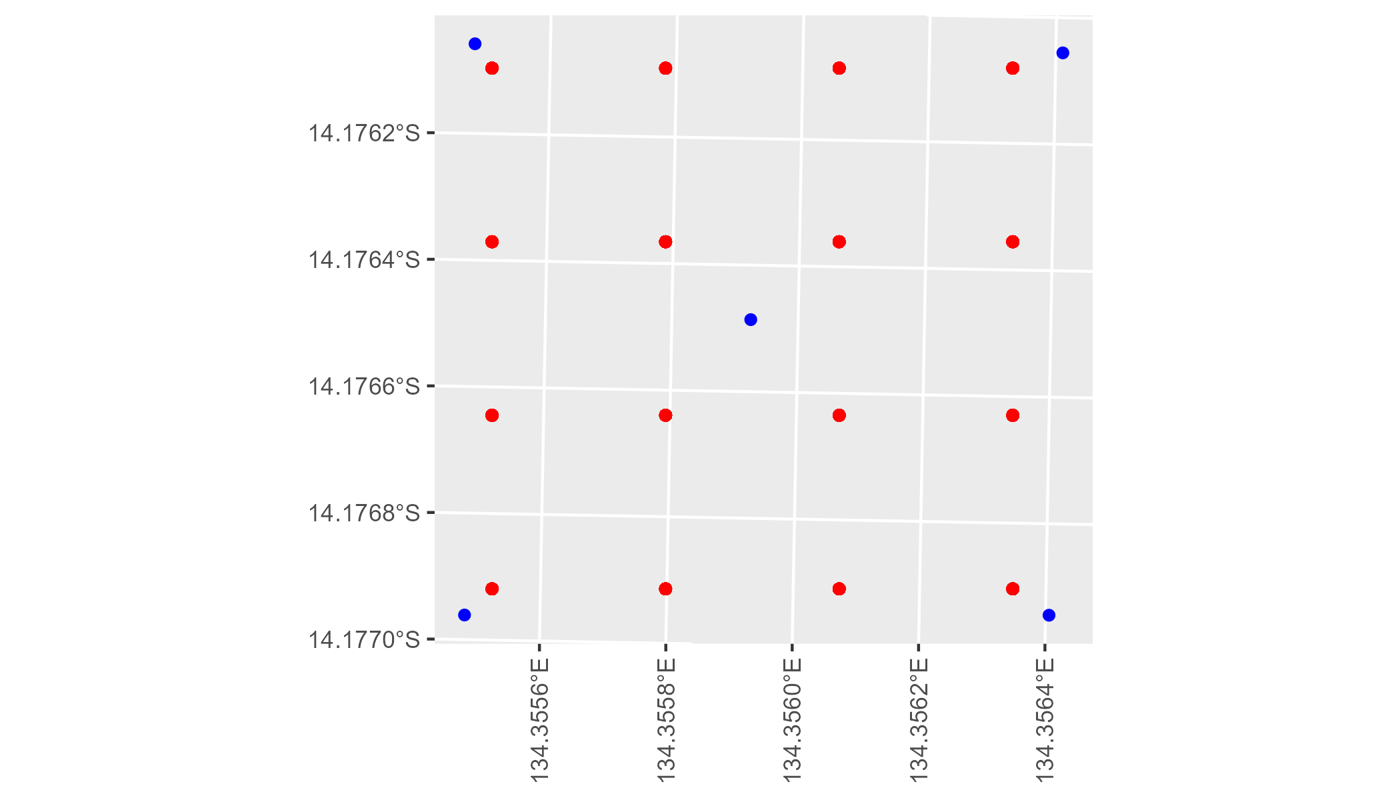

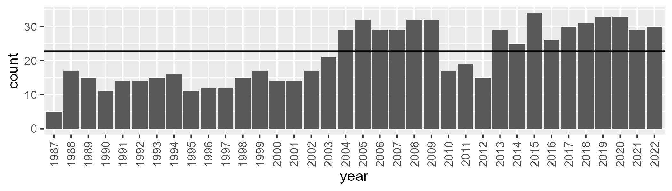

Number of samples: 774

# NTAGFU0034

| Min. | 1st Qu. | Median | Mean | 3rd Qu. | Max. |
| --- | --- | --- | --- | --- | --- |
| 8.019607 | 19.74798 | 24.06449 | 24.72482 | 29.94578 | 44.66214 |

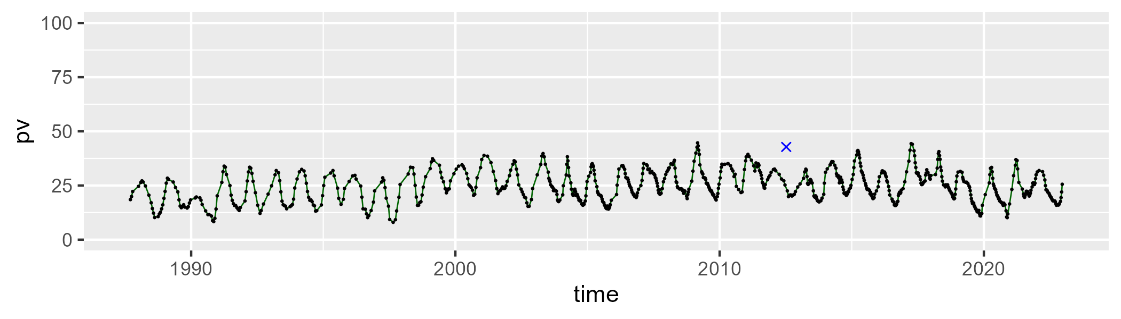

| Min. | 1st Qu. | Median | Mean | 3rd Qu. | Max. |
| --- | --- | --- | --- | --- | --- |
| 33.35701 | 46.52417 | 49.84509 | 49.82297 | 53.11072 | 66.88095 |

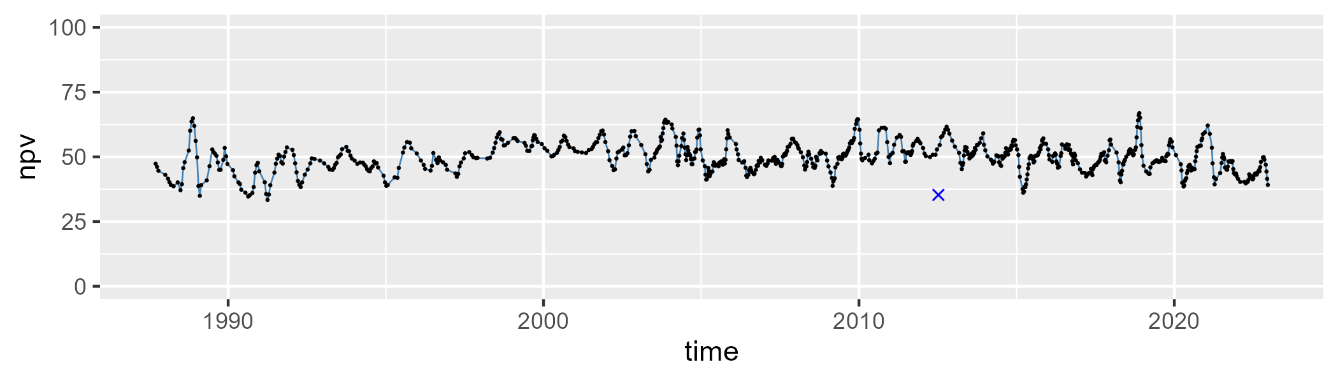

| Min. | 1st Qu. | Median | Mean | 3rd Qu. | Max. |
| --- | --- | --- | --- | --- | --- |
| 4.90165 | 18.52391 | 23.31603 | 24.14695 | 29.85798 | 52.41686 |

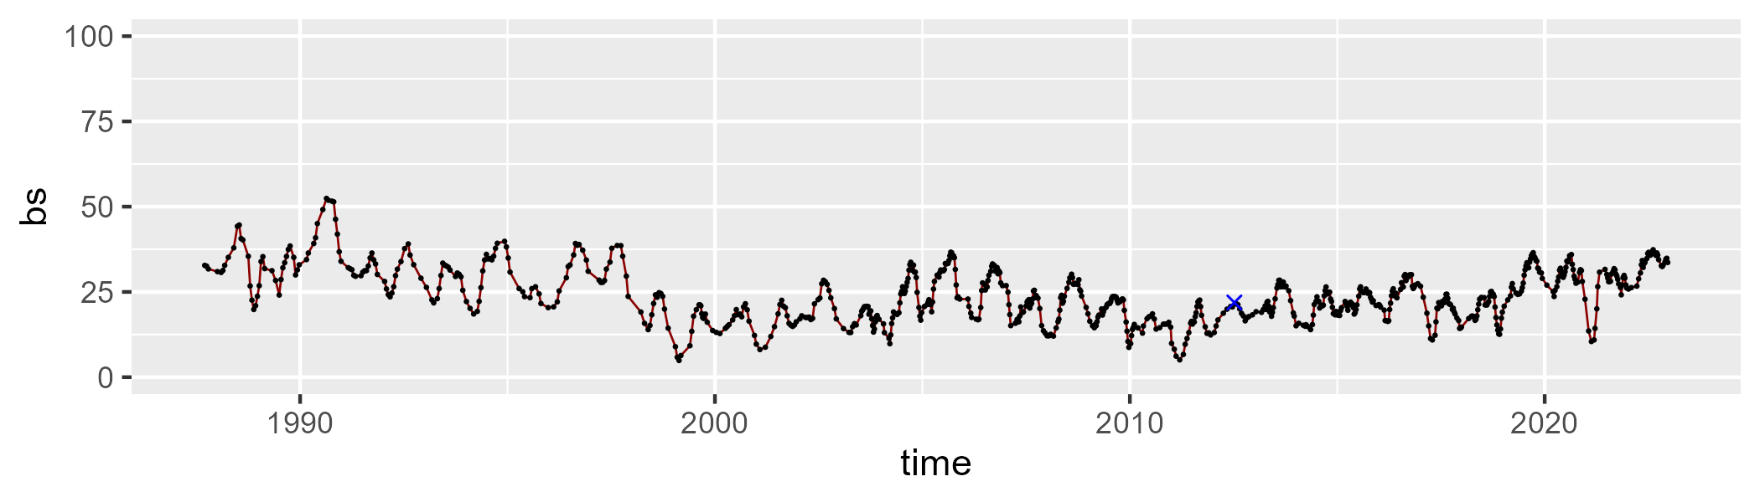

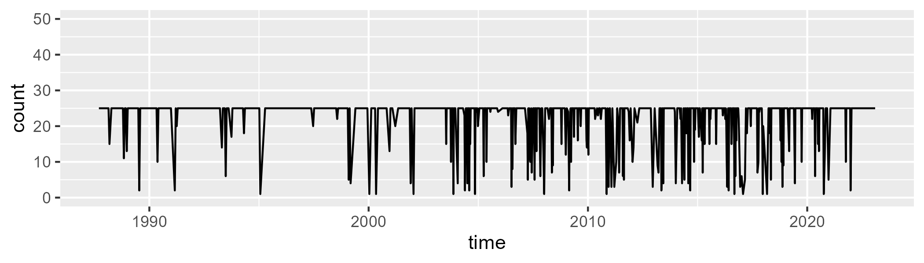

Min. : 1.00 1st Qu.:25.00 Median :25.00 Mean :22.45 3rd Qu.:25.00 Max. :25.00

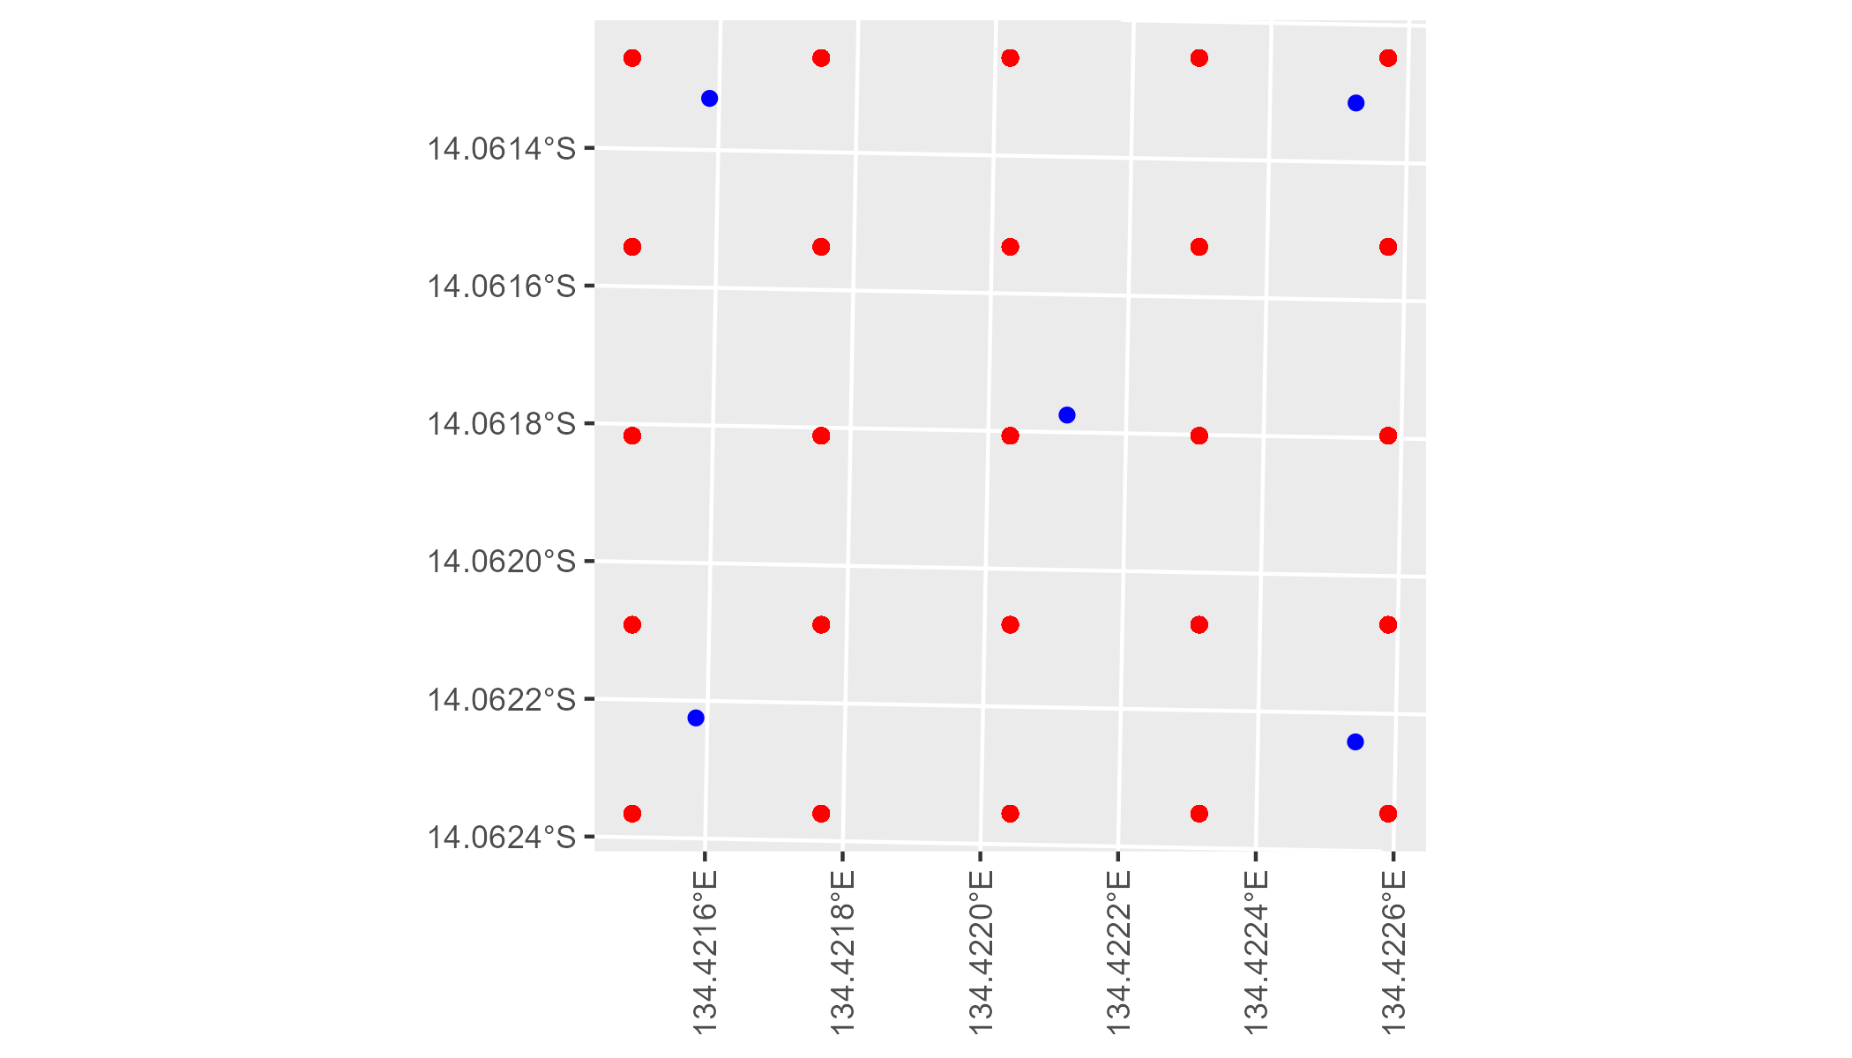

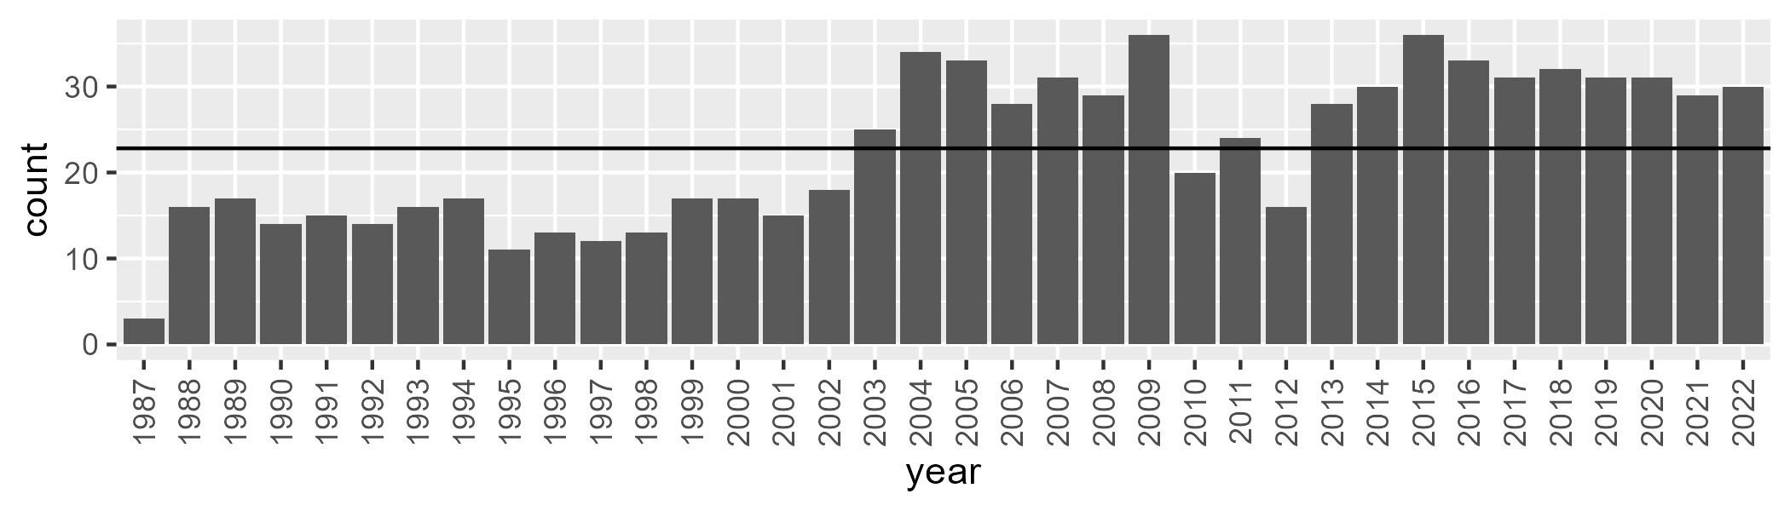

Number of samples: 815

# NTAGFU0035

| Min. | 1st Qu. | Median | Mean | 3rd Qu. | Max. |
| --- | --- | --- | --- | --- | --- |
| 6.496899 | 17.11598 | 22.71869 | 24.43986 | 30.93043 | 49.49938 |

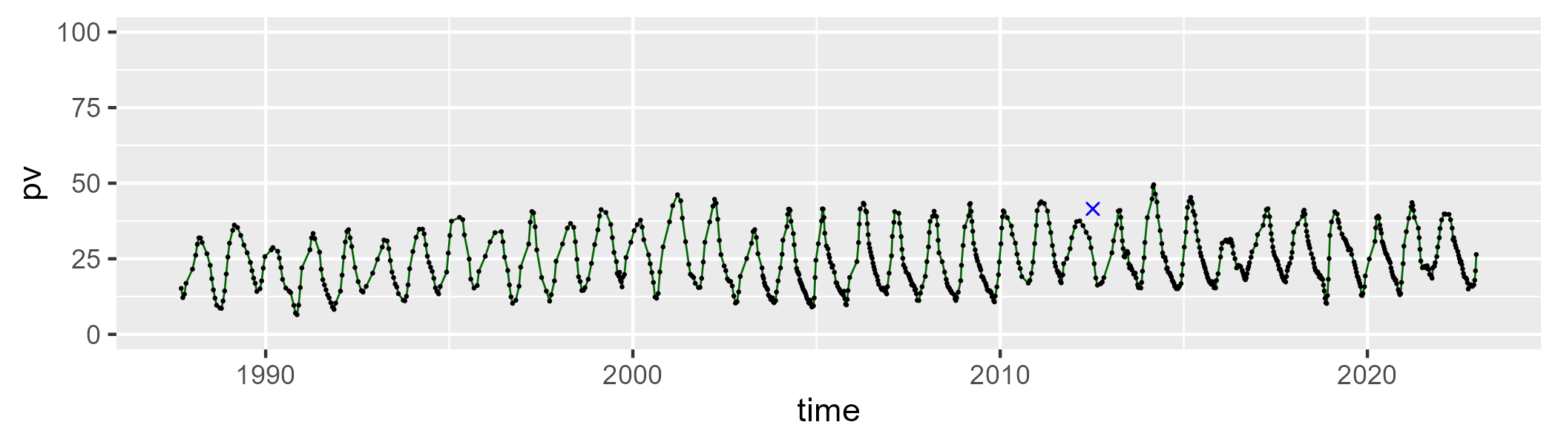

| Min. | 1st Qu. | Median | Mean | 3rd Qu. | Max. |
| --- | --- | --- | --- | --- | --- |
| 41.29216 | 54.47722 | 58.48026 | 58.37412 | 62.25333 | 81.66788 |

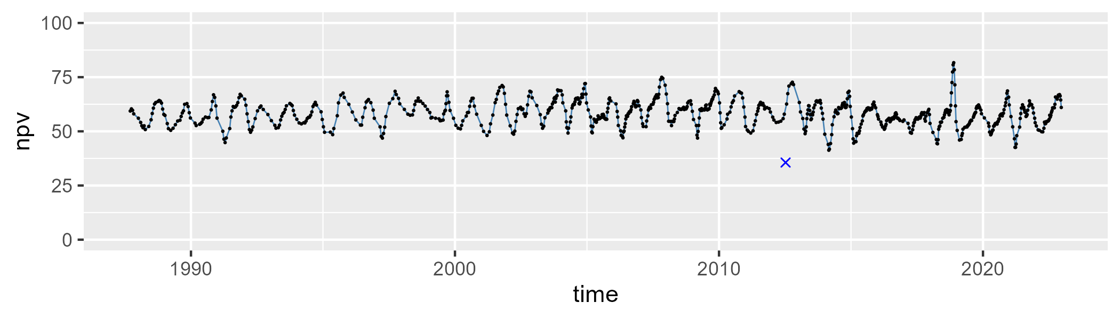

| Min. | 1st Qu. | Median | Mean | 3rd Qu. | Max. |
| --- | --- | --- | --- | --- | --- |
| 1.293524 | 12.0419 | 16.40585 | 16.06919 | 20.30768 | 30.18018 |

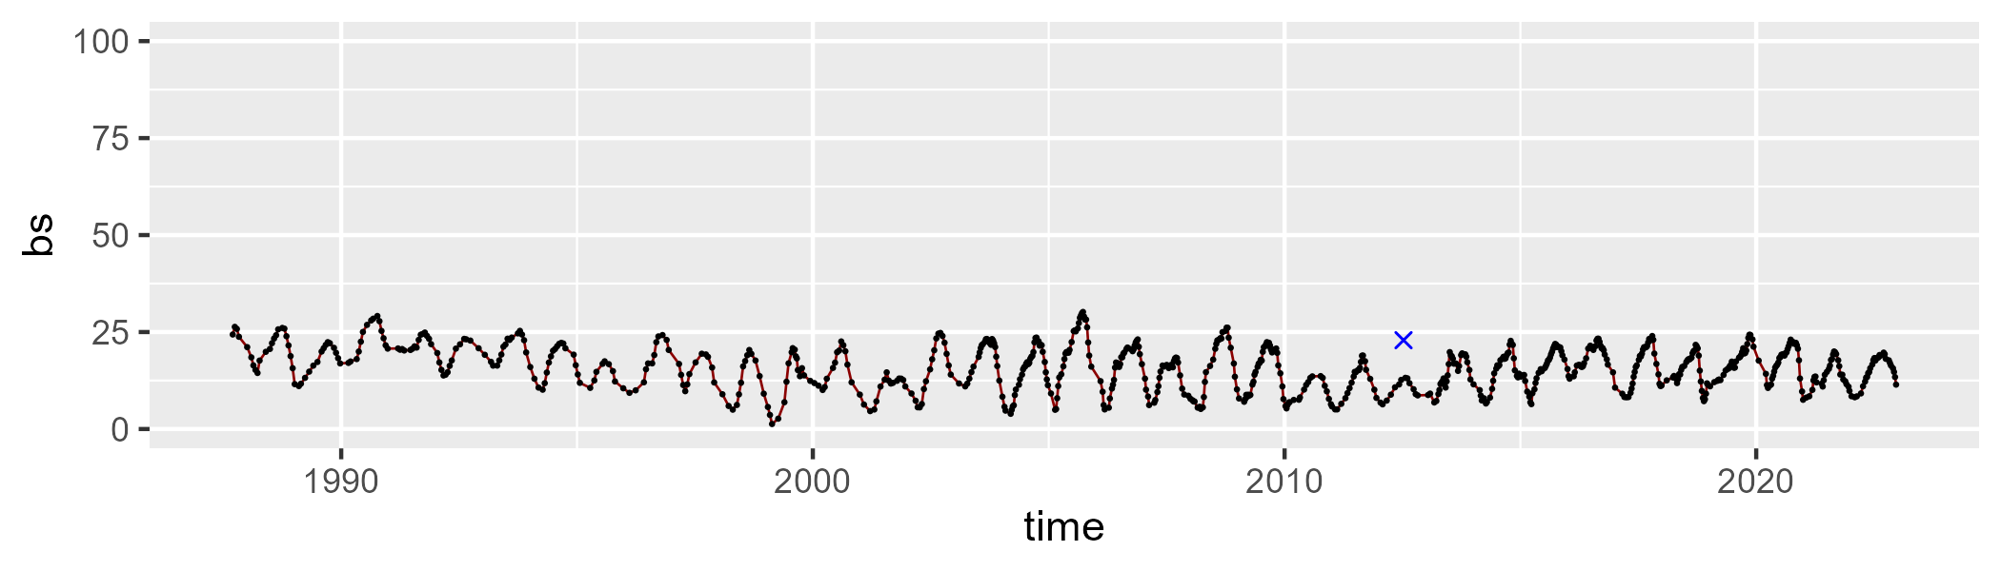

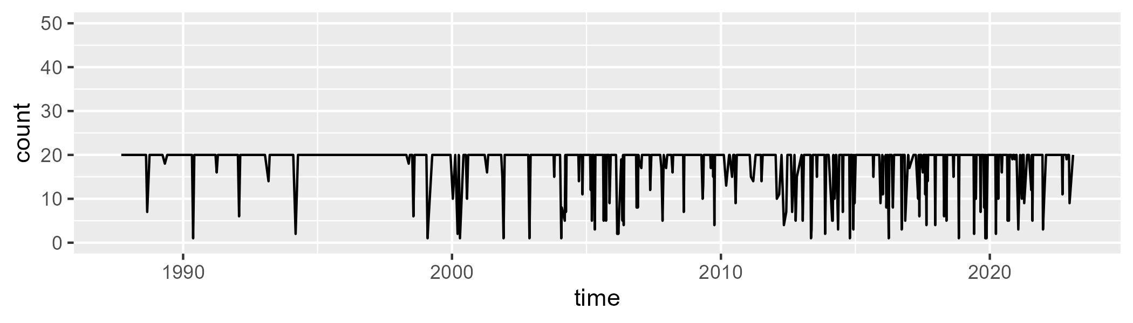

Min. : 1.00 1st Qu.:20.00 Median :20.00 Mean :18.27 3rd Qu.:20.00 Max. :20.00

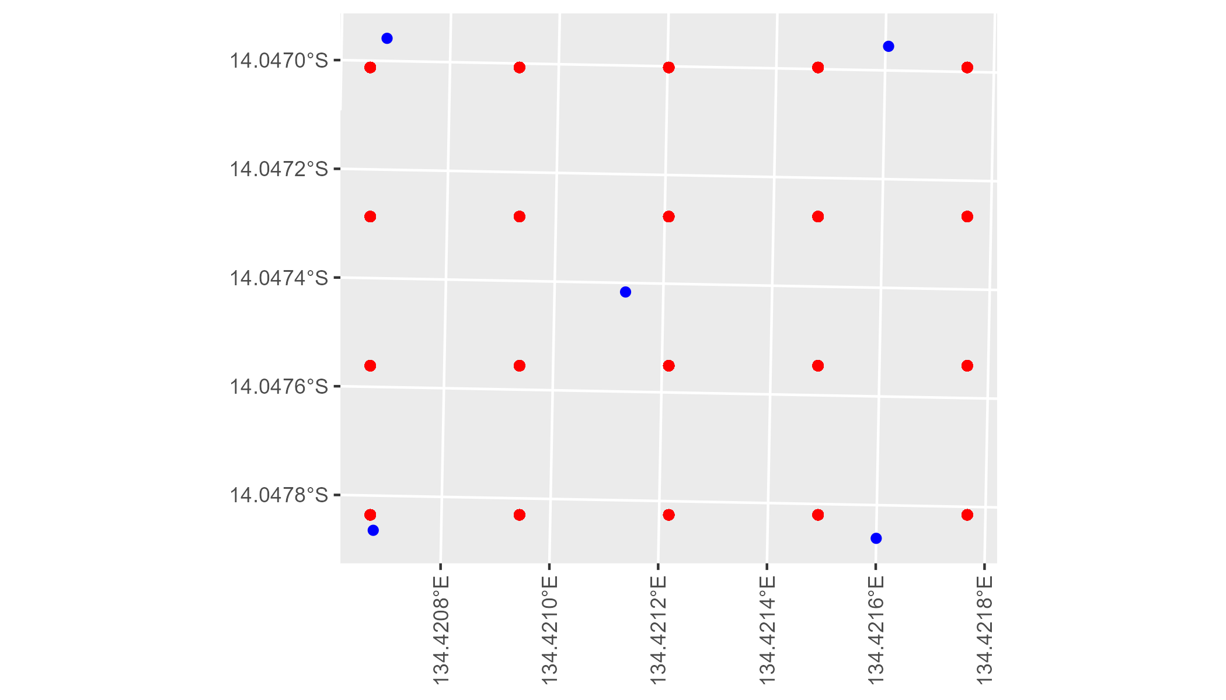

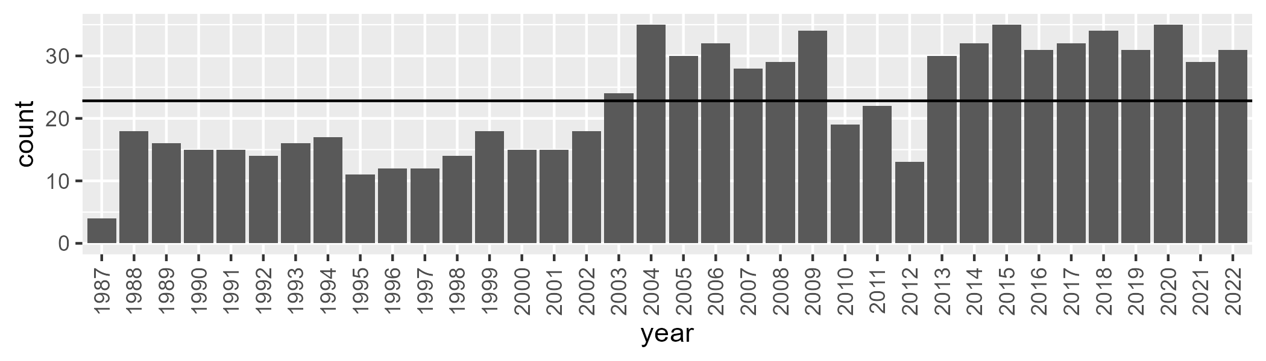

Number of samples: 816

# NTAGFU0036

| Min. | 1st Qu. | Median | Mean | 3rd Qu. | Max. |
| --- | --- | --- | --- | --- | --- |
| 10.62018 | 19.87869 | 23.89676 | 25.91704 | 31.02496 | 53.80185 |

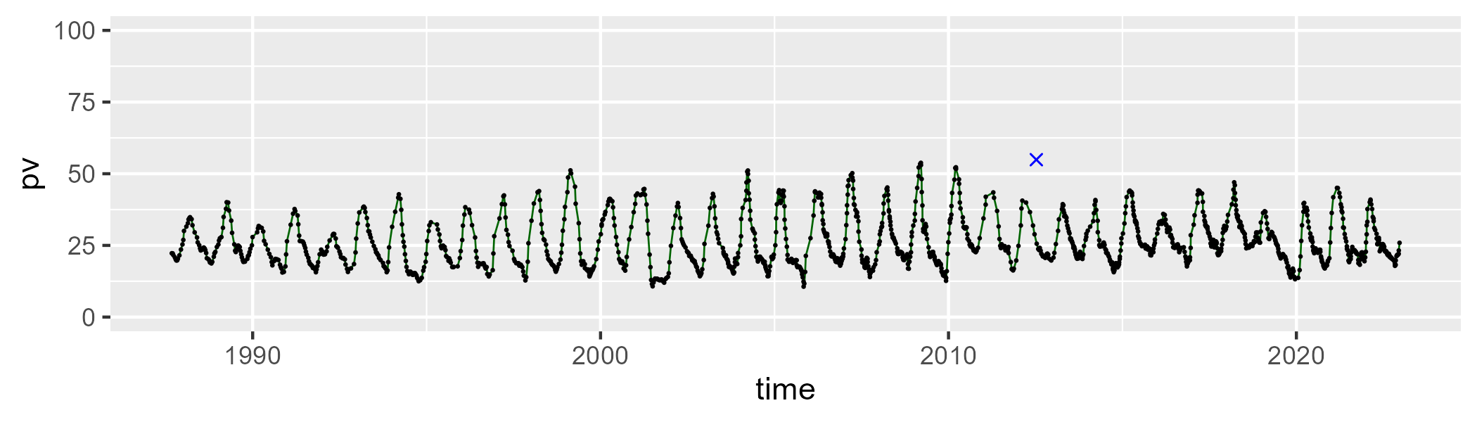

| Min. | 1st Qu. | Median | Mean | 3rd Qu. | Max. |
| --- | --- | --- | --- | --- | --- |
| 40.06267 | 57.56322 | 61.72754 | 61.52033 | 65.40555 | 83.22585 |

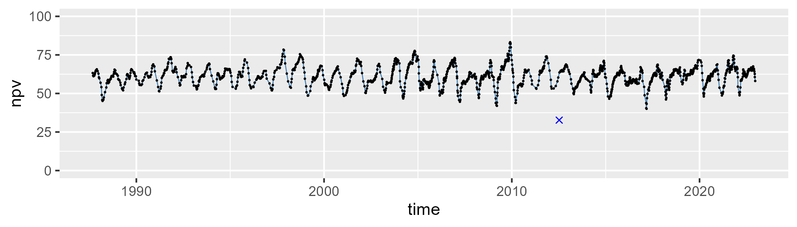

| Min. | 1st Qu. | Median | Mean | 3rd Qu. | Max. |
| --- | --- | --- | --- | --- | --- |
| 0 | 8.298936 | 10.94638 | 11.45258 | 14.52515 | 25.31935 |

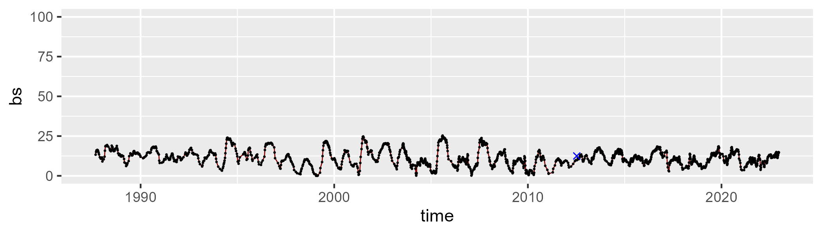

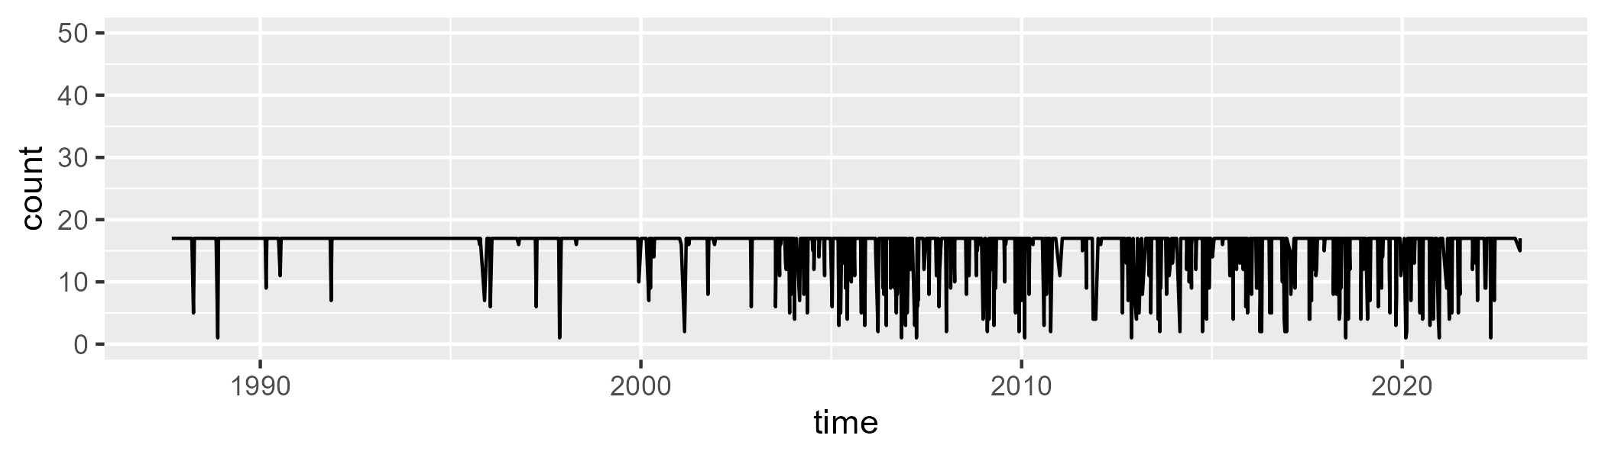

Min. : 1.00 1st Qu.:17.00 Median :17.00 Mean :15.69 3rd Qu.:17.00 Max. :17.00

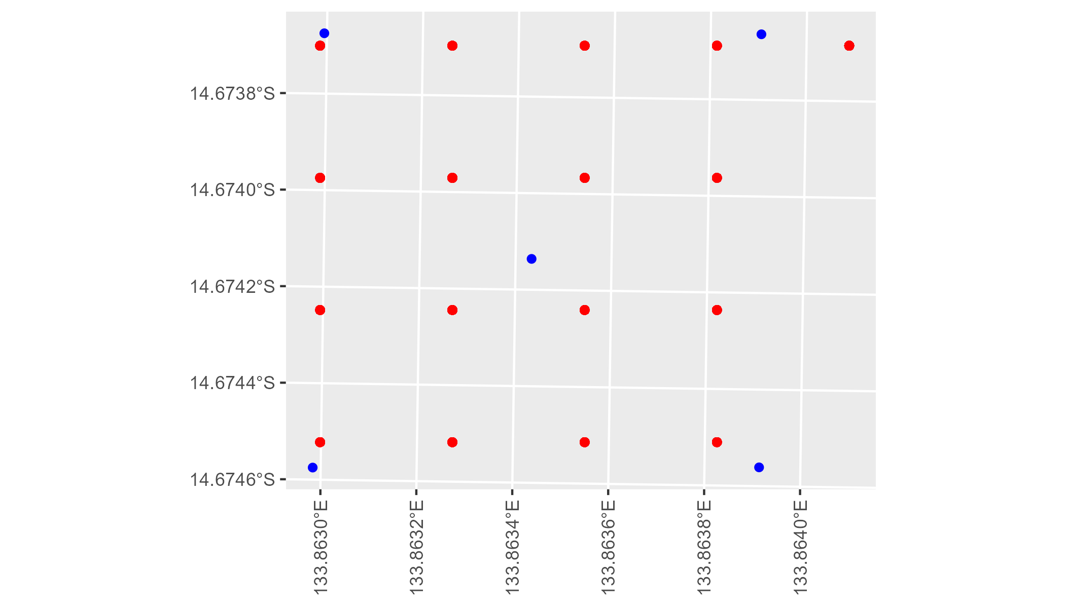

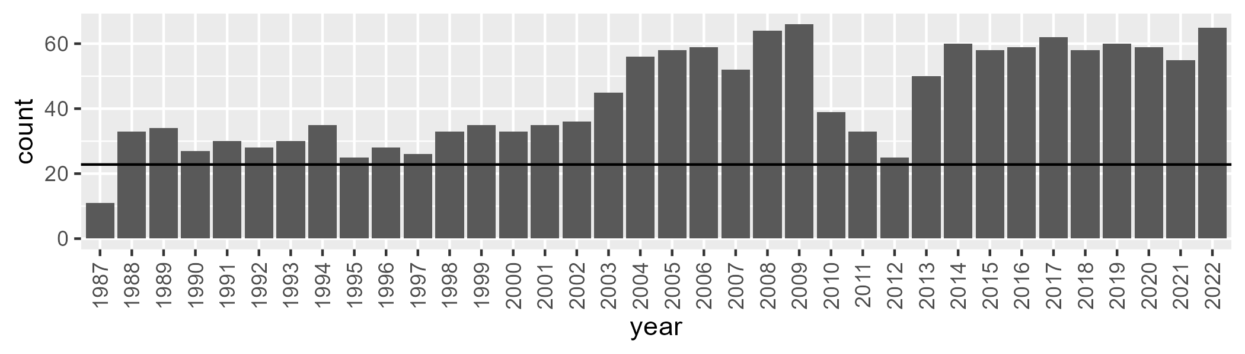

Number of samples: 1562

# NTAGFU0037

| Min. | 1st Qu. | Median | Mean | 3rd Qu. | Max. |
| --- | --- | --- | --- | --- | --- |
| 9.360226 | 20.00735 | 25.8855 | 28.65852 | 36.77569 | 57.63435 |

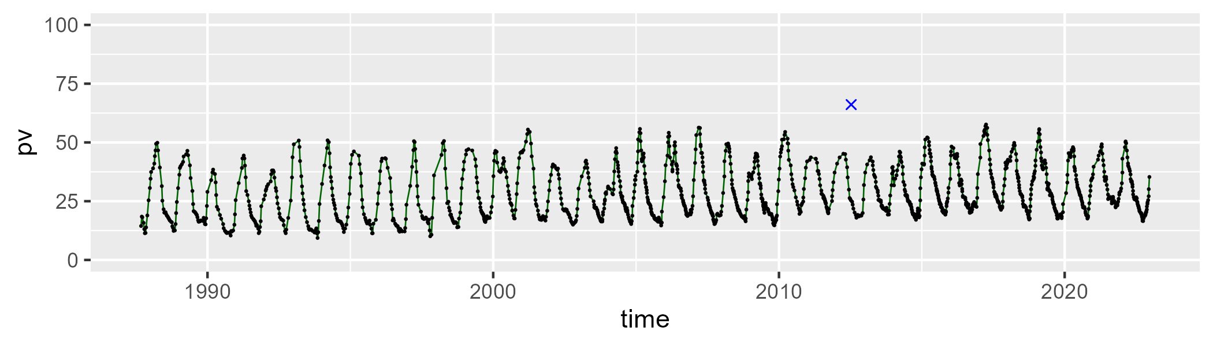

| Min. | 1st Qu. | Median | Mean | 3rd Qu. | Max. |
| --- | --- | --- | --- | --- | --- |
| 30.12263 | 51.30699 | 58.46208 | 57.23565 | 63.86501 | 83.07971 |

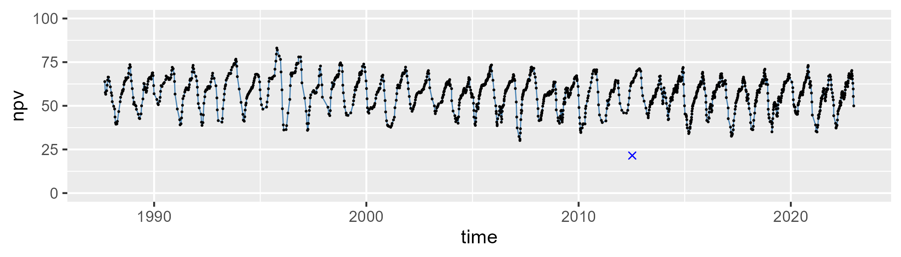

| Min. | 1st Qu. | Median | Mean | 3rd Qu. | Max. |
| --- | --- | --- | --- | --- | --- |
| 0 | 9.626388 | 13.08388 | 12.93434 | 15.8095 | 28.77985 |

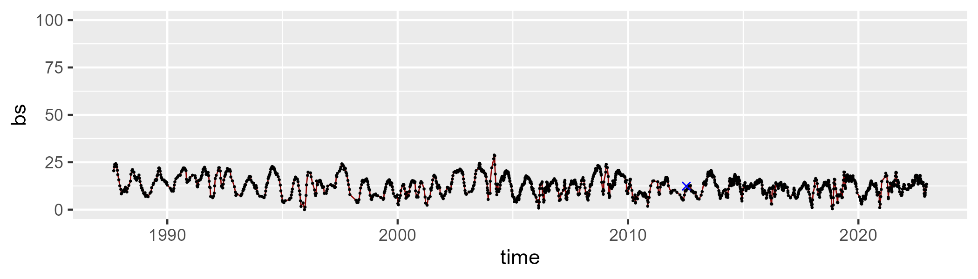

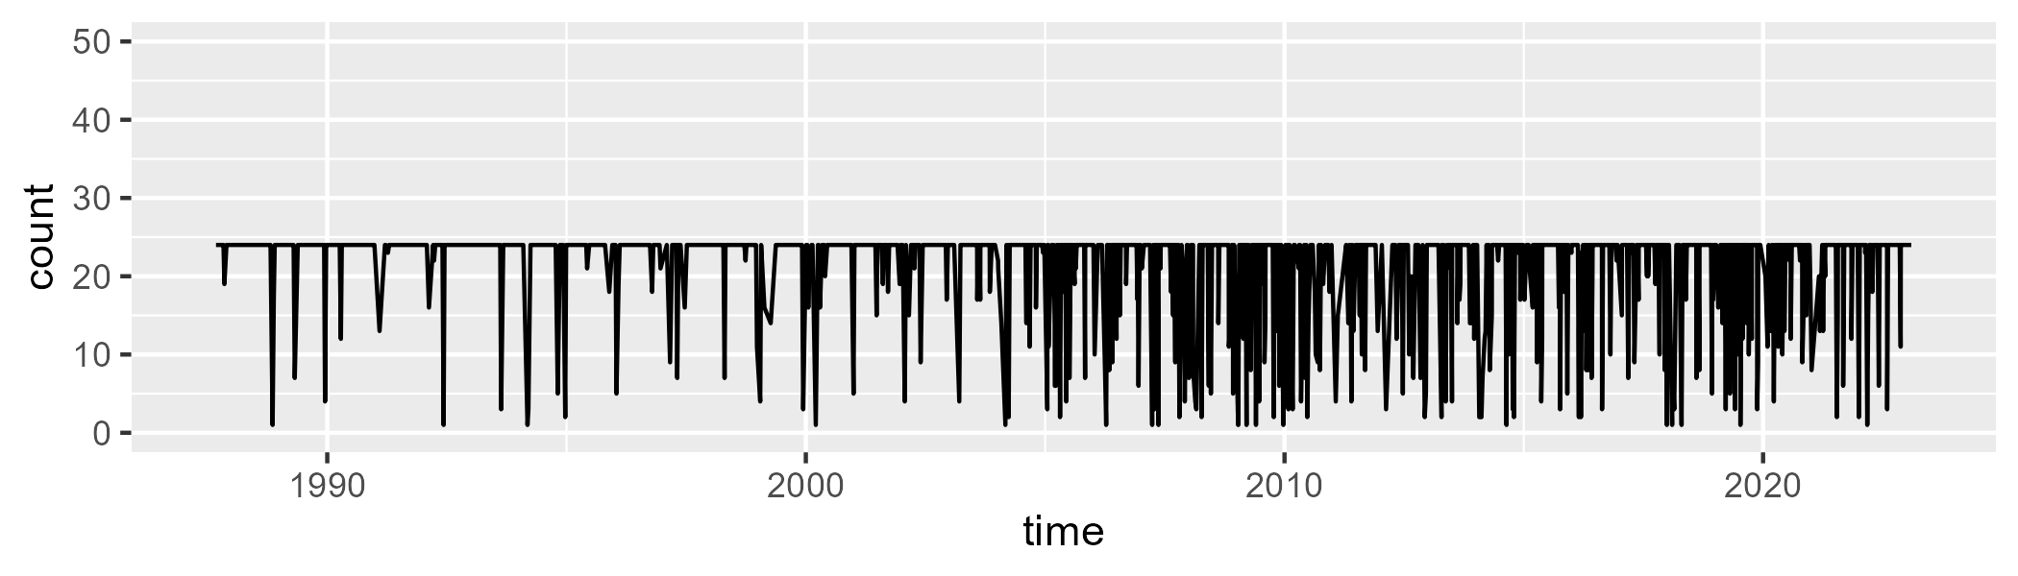

Min. : 1.00 1st Qu.:24.00 Median :24.00 Mean :21.59 3rd Qu.:24.00 Max. :24.00

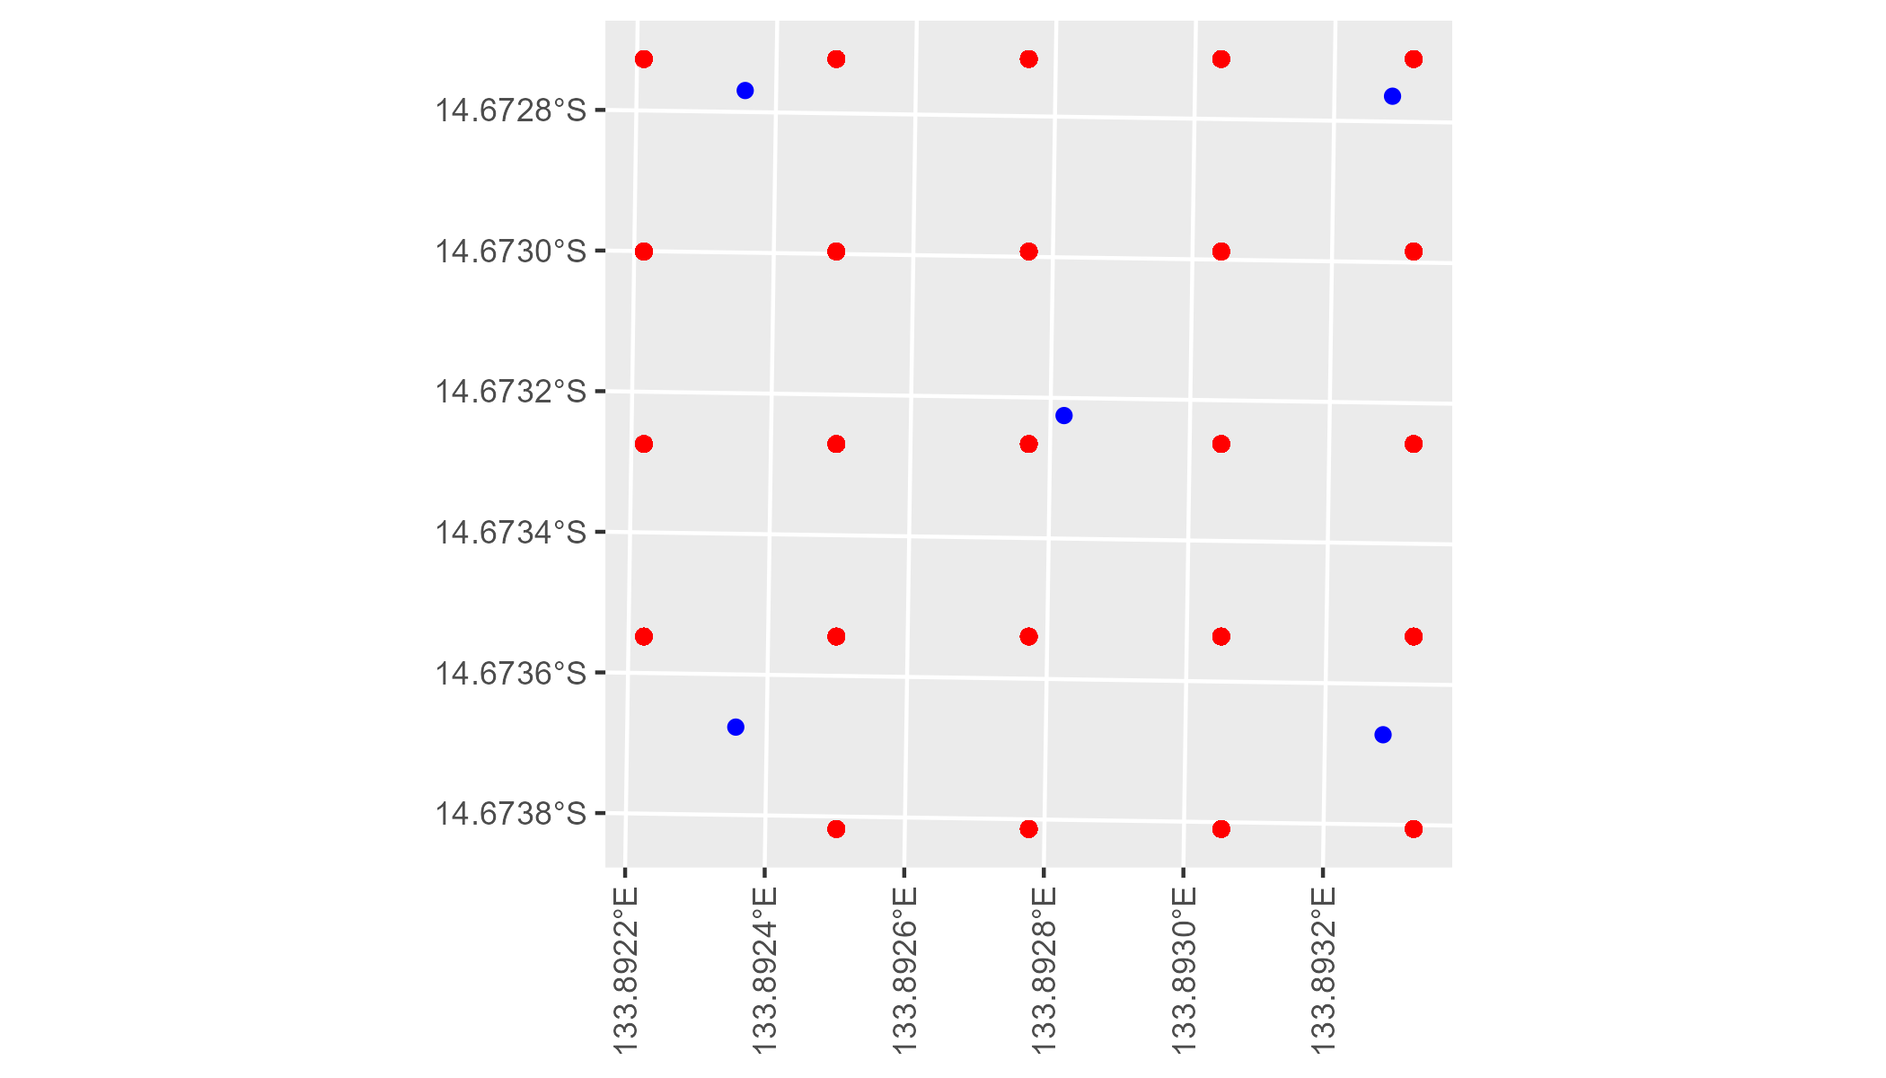

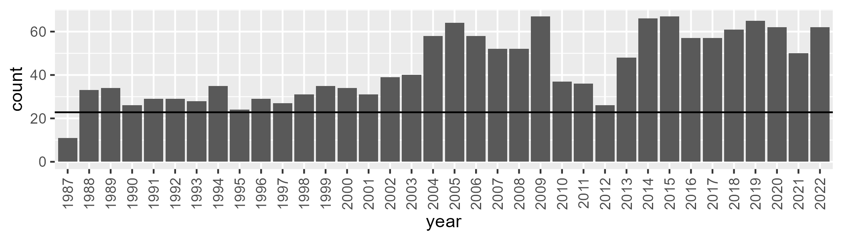

Number of samples: 1560

# NTAGFU0038

| Min. | 1st Qu. | Median | Mean | 3rd Qu. | Max. |
| --- | --- | --- | --- | --- | --- |
| 11.65562 | 20.83024 | 25.6417 | 27.57034 | 33.31992 | 53.92594 |

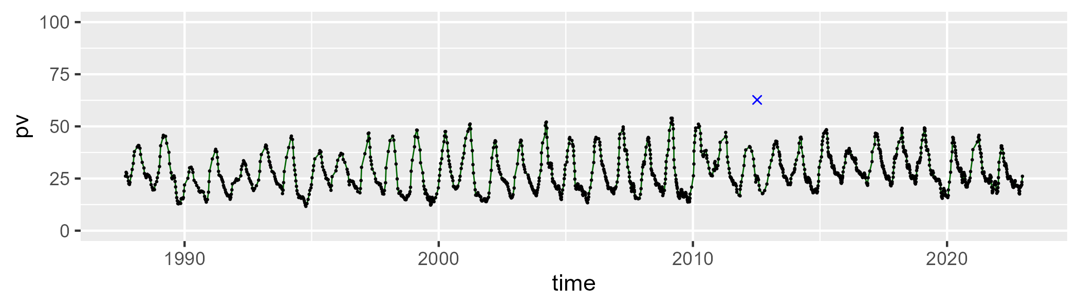

| Min. | 1st Qu. | Median | Mean | 3rd Qu. | Max. |
| --- | --- | --- | --- | --- | --- |
| 41.79878 | 56.4747 | 61.0979 | 60.94378 | 65.58348 | 78.35776 |

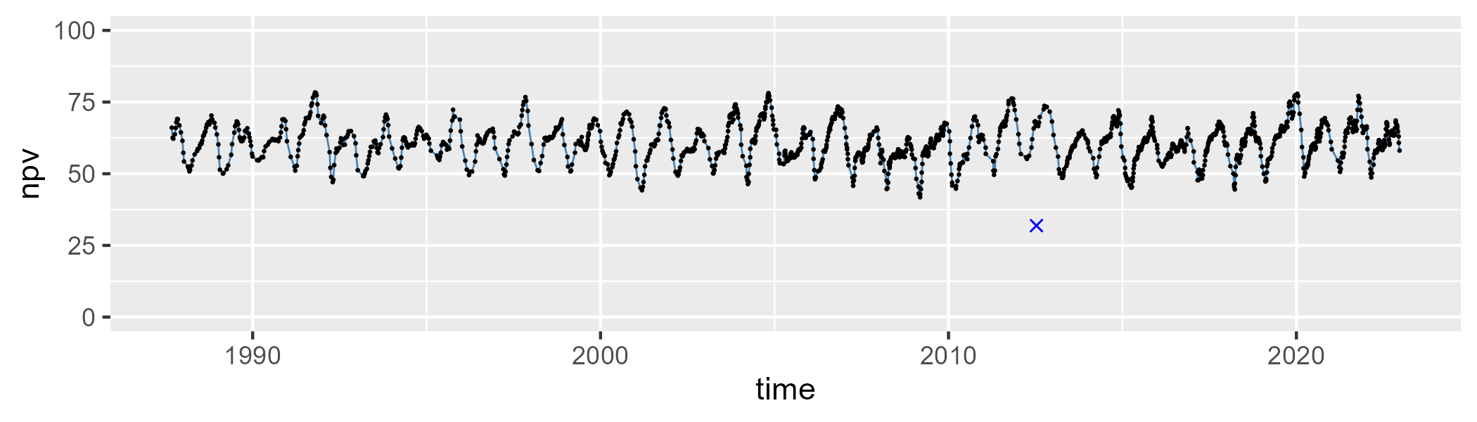

| Min. | 1st Qu. | Median | Mean | 3rd Qu. | Max. |
| --- | --- | --- | --- | --- | --- |
| 0 | 6.669484 | 9.152954 | 10.3861 | 13.61 | 25.51736 |

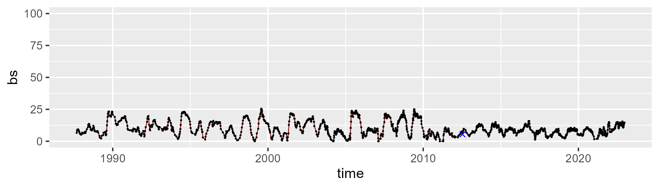

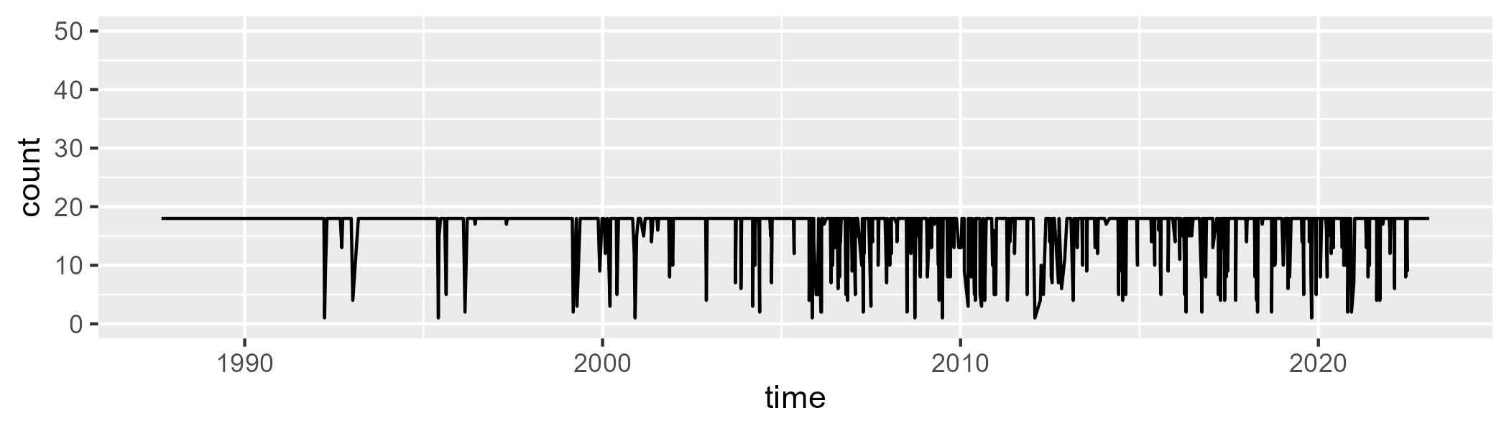

Min. : 1.00 1st Qu.:18.00 Median :18.00 Mean :16.82 3rd Qu.:18.00 Max. :18.00

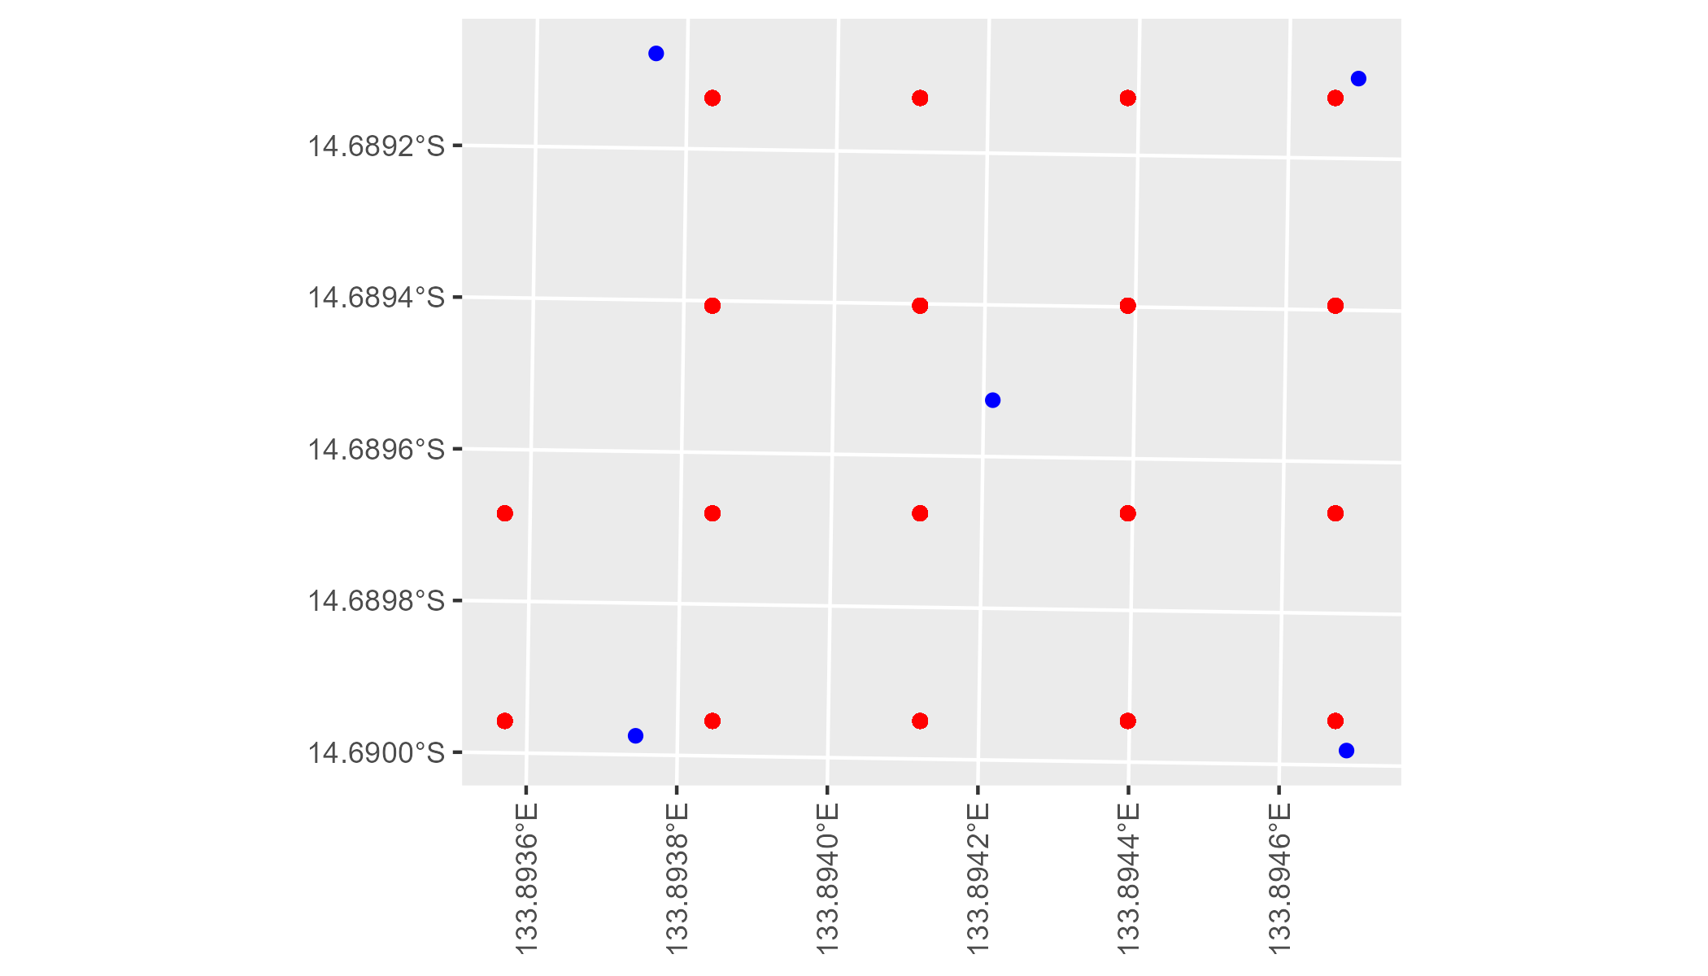

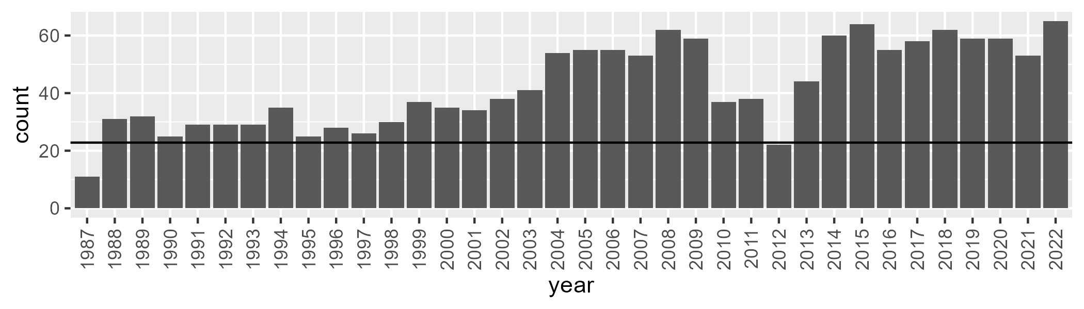

Number of samples: 1529

# NTAGFU0039

| Min. | 1st Qu. | Median | Mean | 3rd Qu. | Max. |
| --- | --- | --- | --- | --- | --- |
| 2.090435 | 15.94224 | 21.87351 | 26.82472 | 36.3766 | 64.97211 |

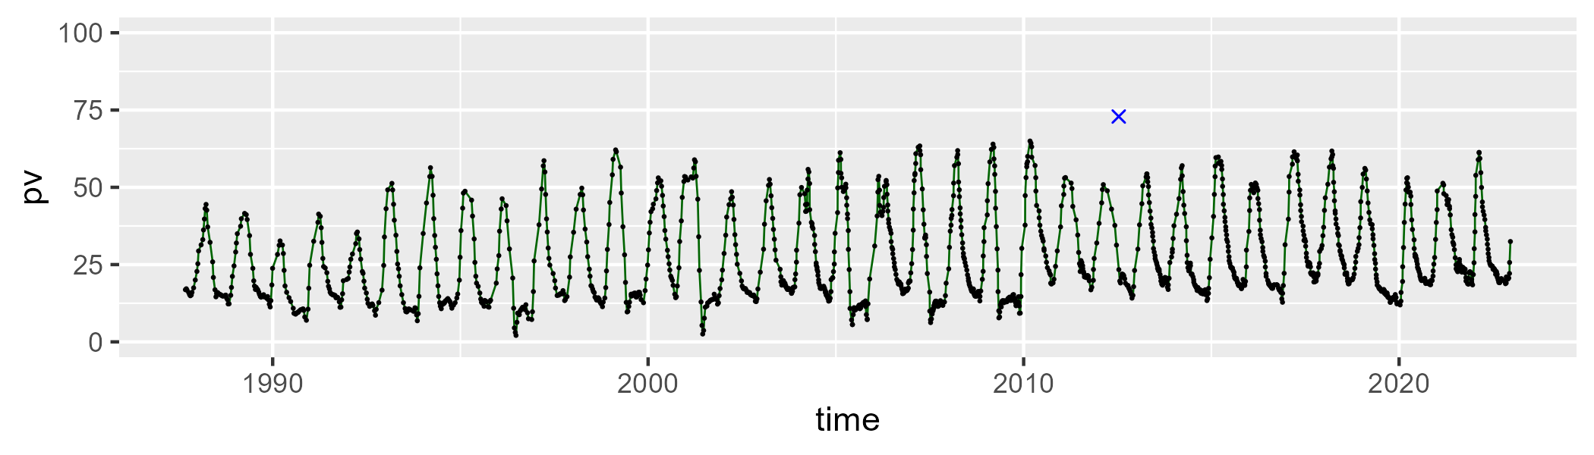

| Min. | 1st Qu. | Median | Mean | 3rd Qu. | Max. |
| --- | --- | --- | --- | --- | --- |
| 25.26259 | 49.59207 | 57.84416 | 57.15528 | 65.68908 | 81.87454 |

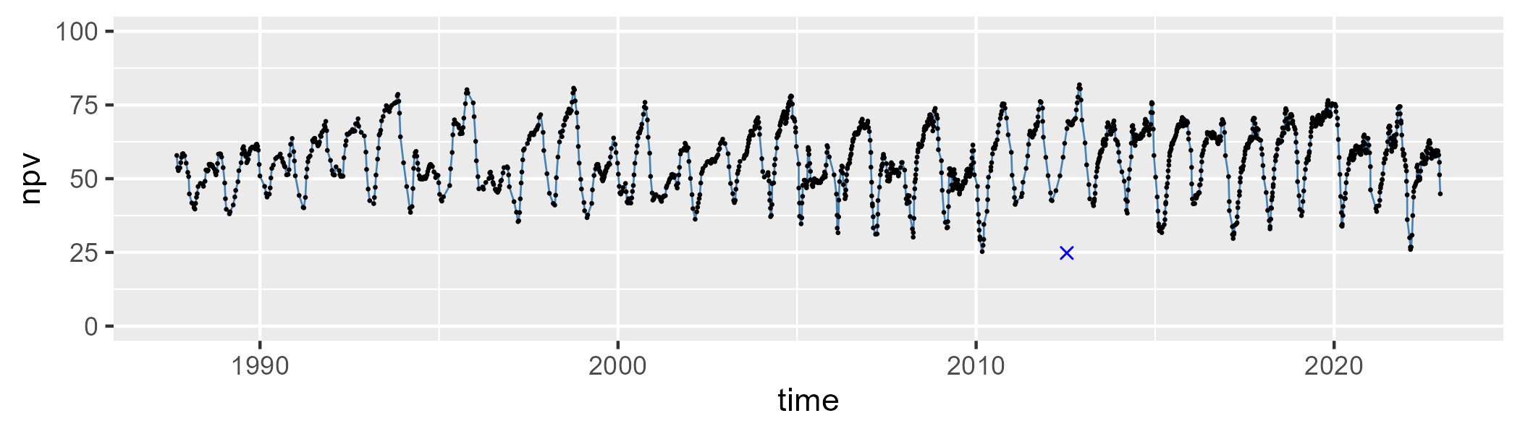

| Min. | 1st Qu. | Median | Mean | 3rd Qu. | Max. |
| --- | --- | --- | --- | --- | --- |
| 0 | 7.368345 | 12.00953 | 14.8294 | 19.66333 | 45.96548 |

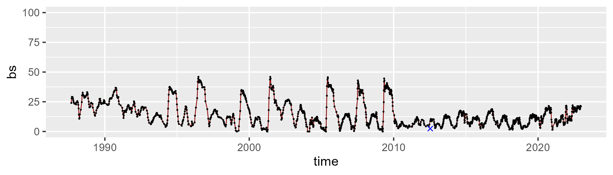

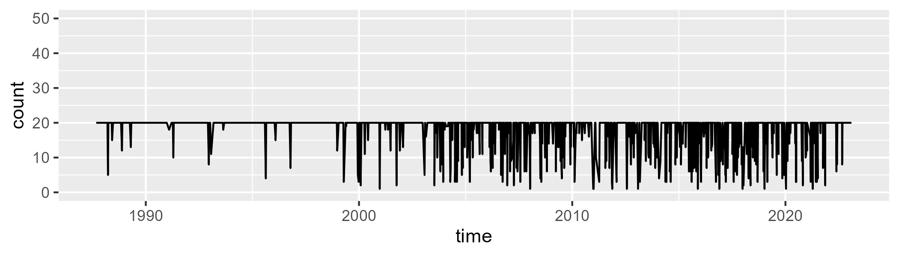

Min. : 1.00 1st Qu.:20.00 Median :20.00 Mean :18.23 3rd Qu.:20.00 Max. :20.00

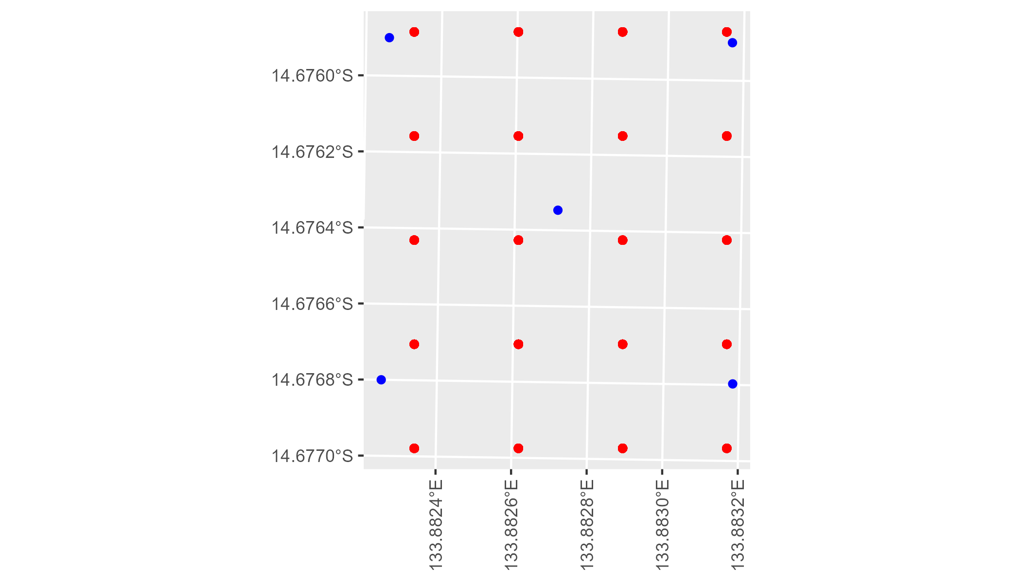

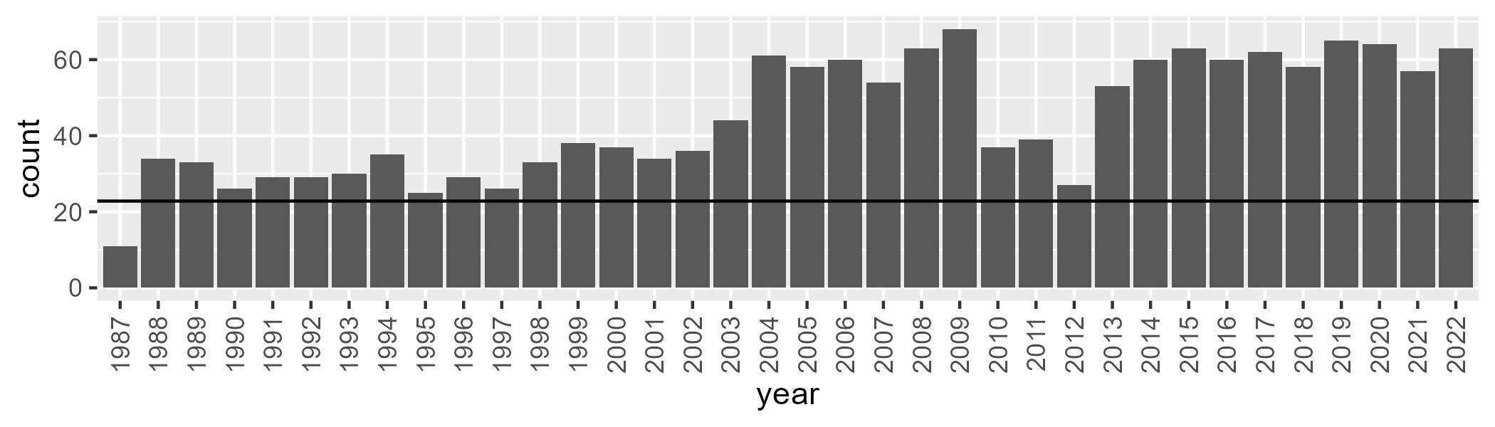

Number of samples: 1601

# NTAGFU0040

| Min. | 1st Qu. | Median | Mean | 3rd Qu. | Max. |
| --- | --- | --- | --- | --- | --- |
| 5.165486 | 26.96875 | 36.52563 | 39.35612 | 51.72395 | 75.88987 |

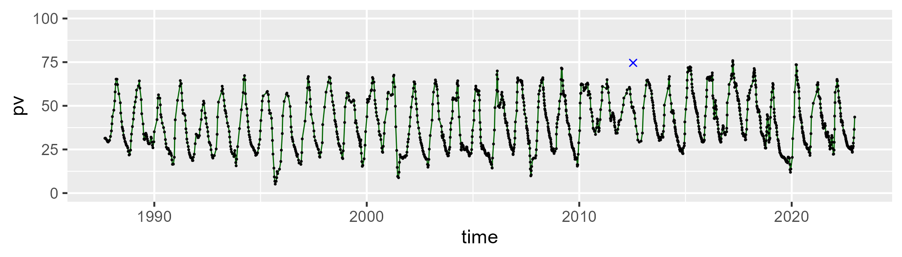

| Min. | 1st Qu. | Median | Mean | 3rd Qu. | Max. |
| --- | --- | --- | --- | --- | --- |
| 16.67521 | 43.86007 | 54.63756 | 52.70348 | 61.66334 | 83.16917 |

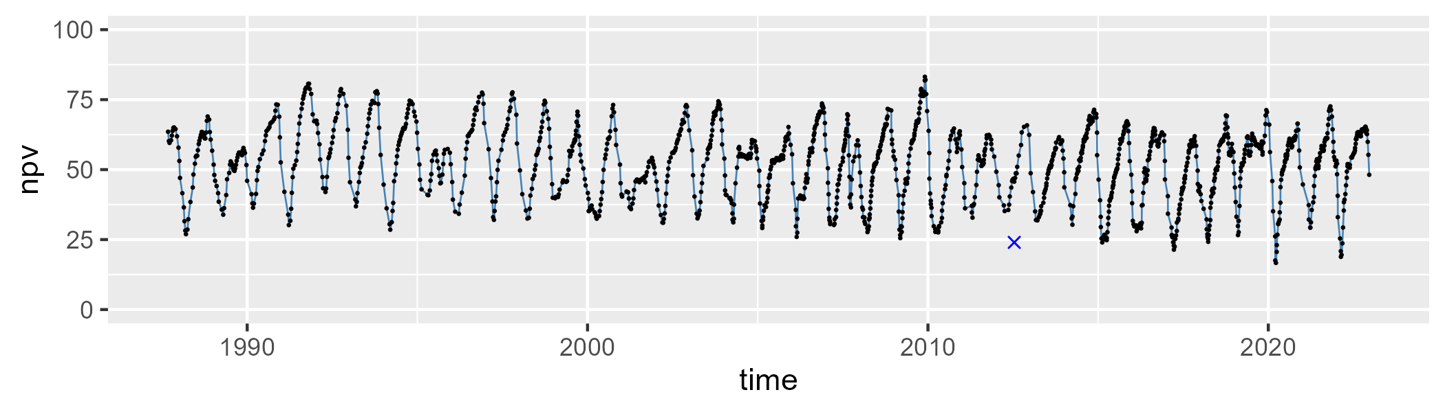

| Min. | 1st Qu. | Median | Mean | 3rd Qu. | Max. |
| --- | --- | --- | --- | --- | --- |
| 0 | 2.134694 | 4.846964 | 6.867732 | 8.589504 | 51.6384 |

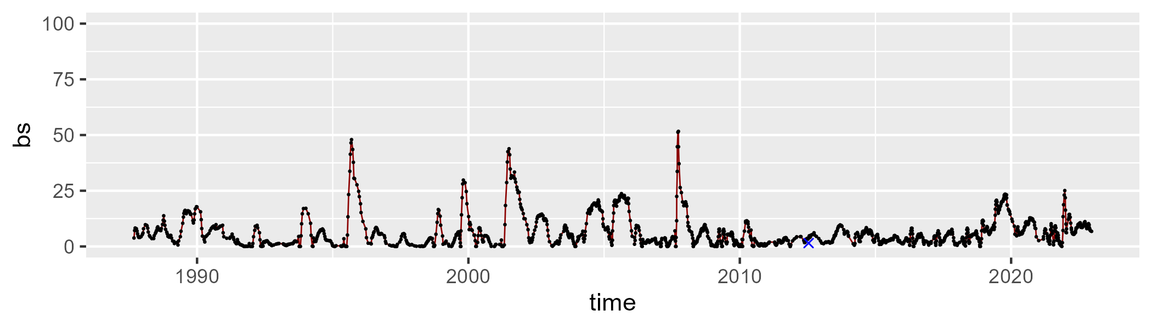

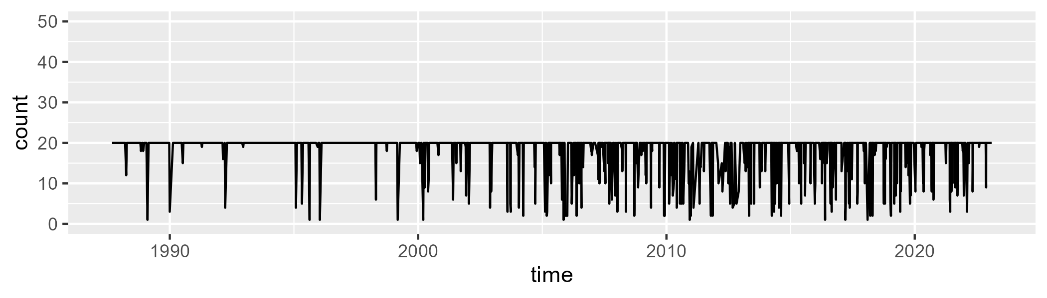

Min. : 1.00 1st Qu.:20.00 Median :20.00 Mean :18.48 3rd Qu.:20.00 Max. :20.00

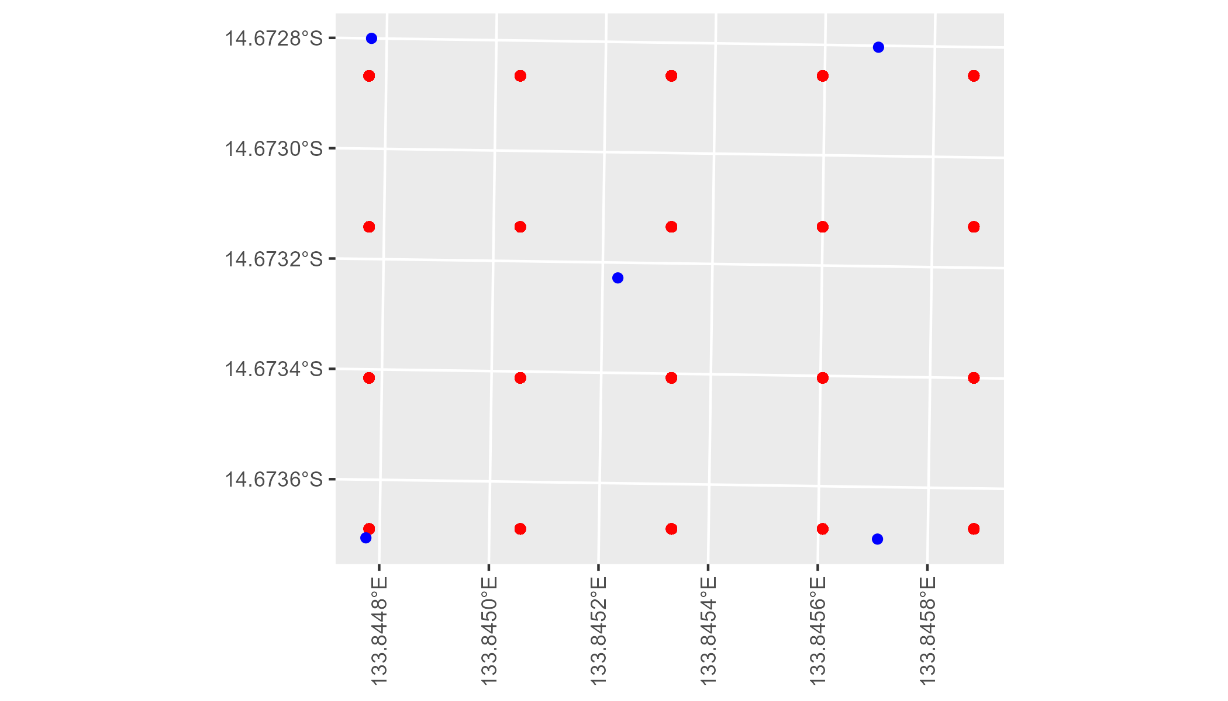

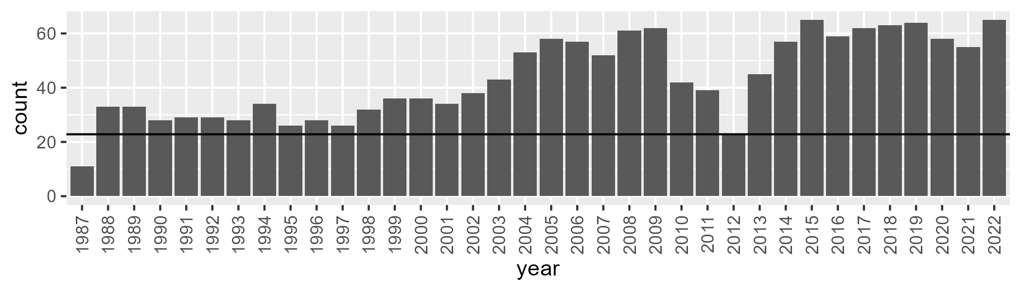

Number of samples: 1564

# NTAGFU0041

| Min. | 1st Qu. | Median | Mean | 3rd Qu. | Max. |
| --- | --- | --- | --- | --- | --- |
| 12.12231 | 27.07496 | 35.55046 | 38.07095 | 49.10242 | 69.81189 |

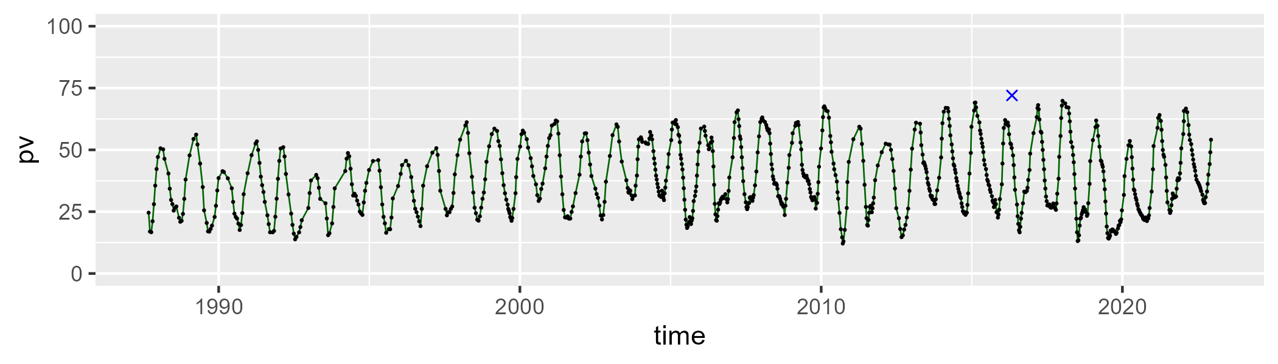

| Min. | 1st Qu. | Median | Mean | 3rd Qu. | Max. |
| --- | --- | --- | --- | --- | --- |
| 20.55422 | 40.62765 | 46.57557 | 47.459 | 55.10368 | 72.58119 |

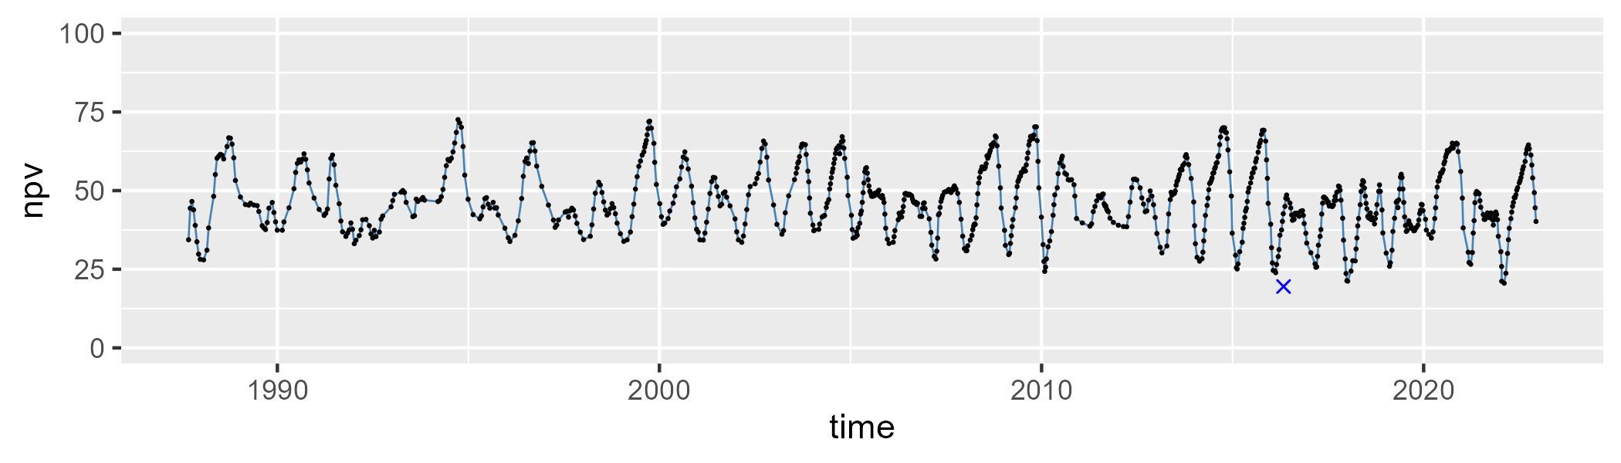

| Min. | 1st Qu. | Median | Mean | 3rd Qu. | Max. |
| --- | --- | --- | --- | --- | --- |
| 0 | 4.484897 | 8.777469 | 13.24547 | 21.04233 | 48.40055 |

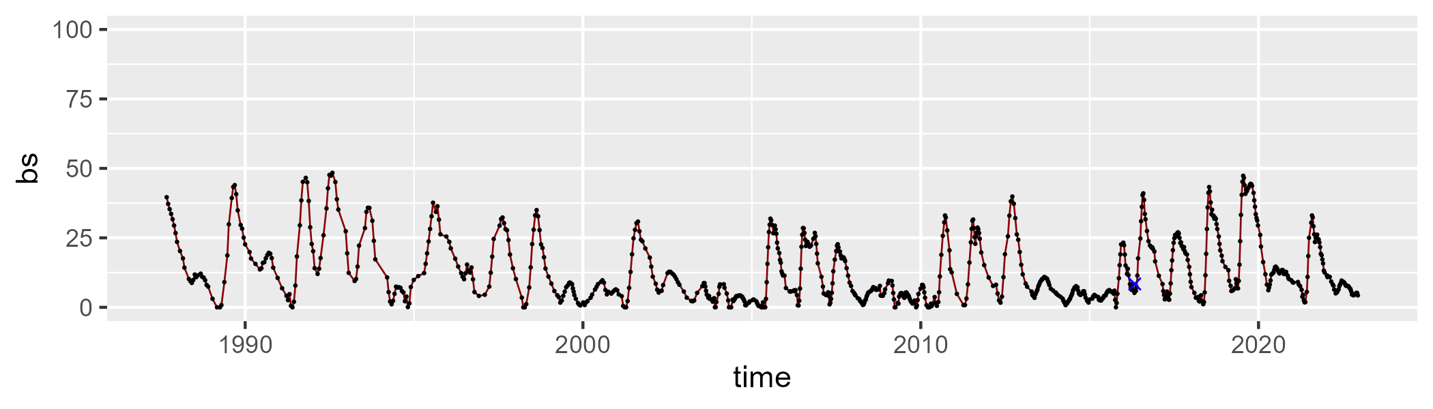

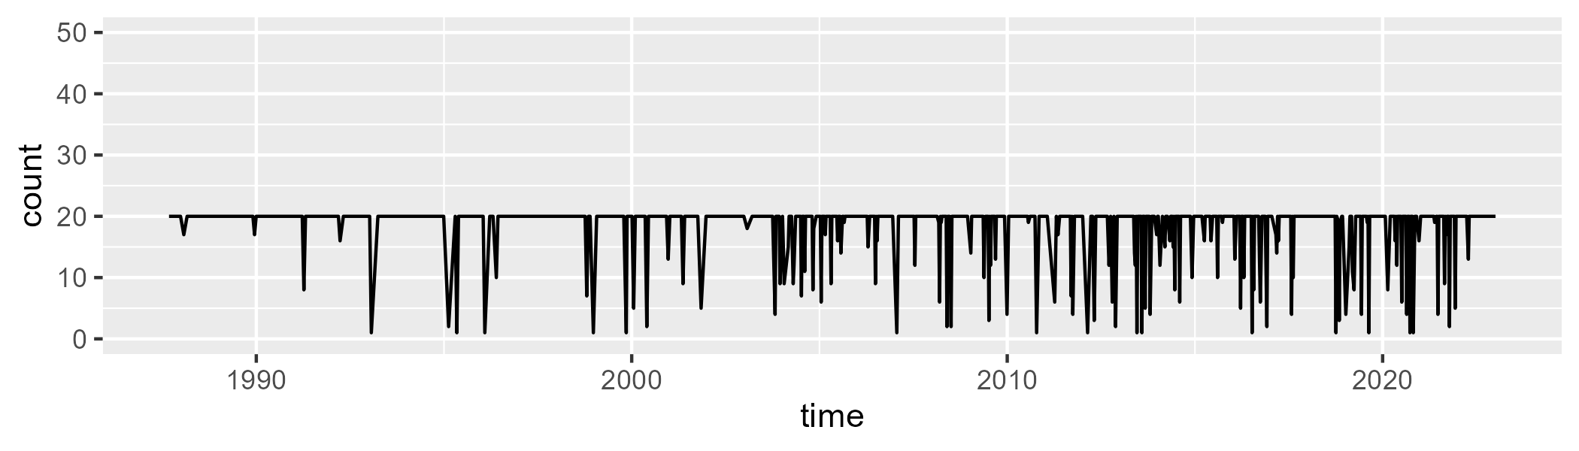

Min. : 1.0 1st Qu.:20.0 Median :20.0 Mean :18.6 3rd Qu.:20.0 Max. :20.0

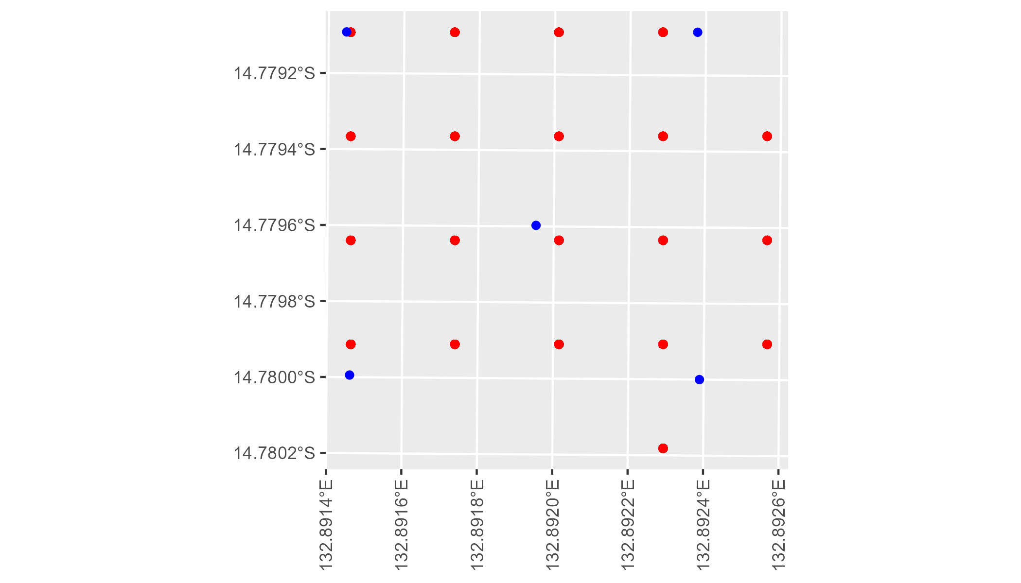

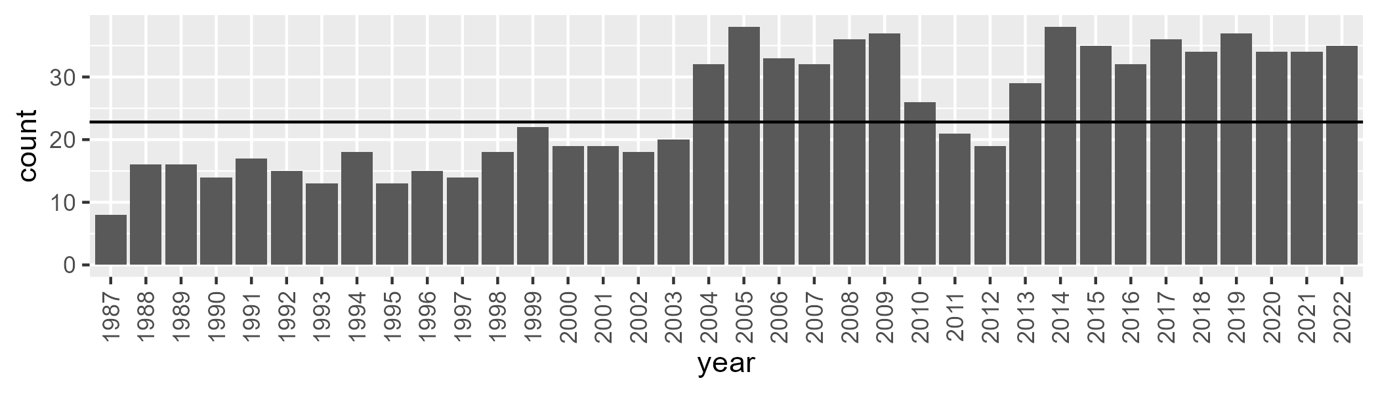

Number of samples: 893

# NTAMAC0001

| Min. | 1st Qu. | Median | Mean | 3rd Qu. | Max. |
| --- | --- | --- | --- | --- | --- |
| 2.421954 | 10.63719 | 13.14913 | 14.36934 | 17.34318 | 36.33778 |

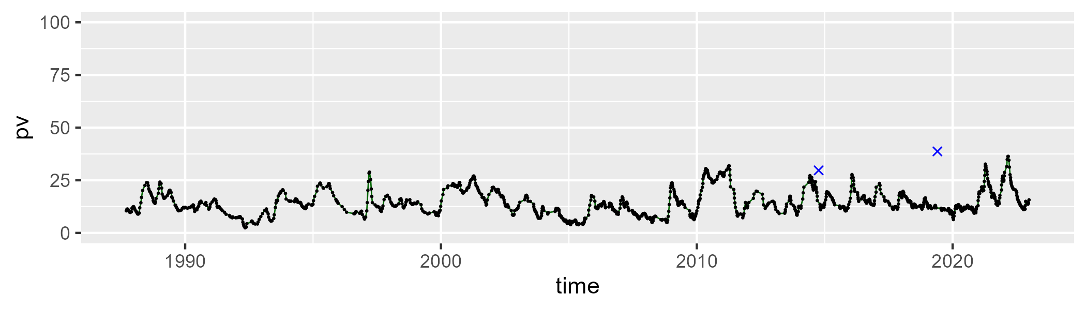

| Min. | 1st Qu. | Median | Mean | 3rd Qu. | Max. |
| --- | --- | --- | --- | --- | --- |
| 11.4354 | 25.68732 | 33.72115 | 33.8424 | 41.64779 | 70.23697 |

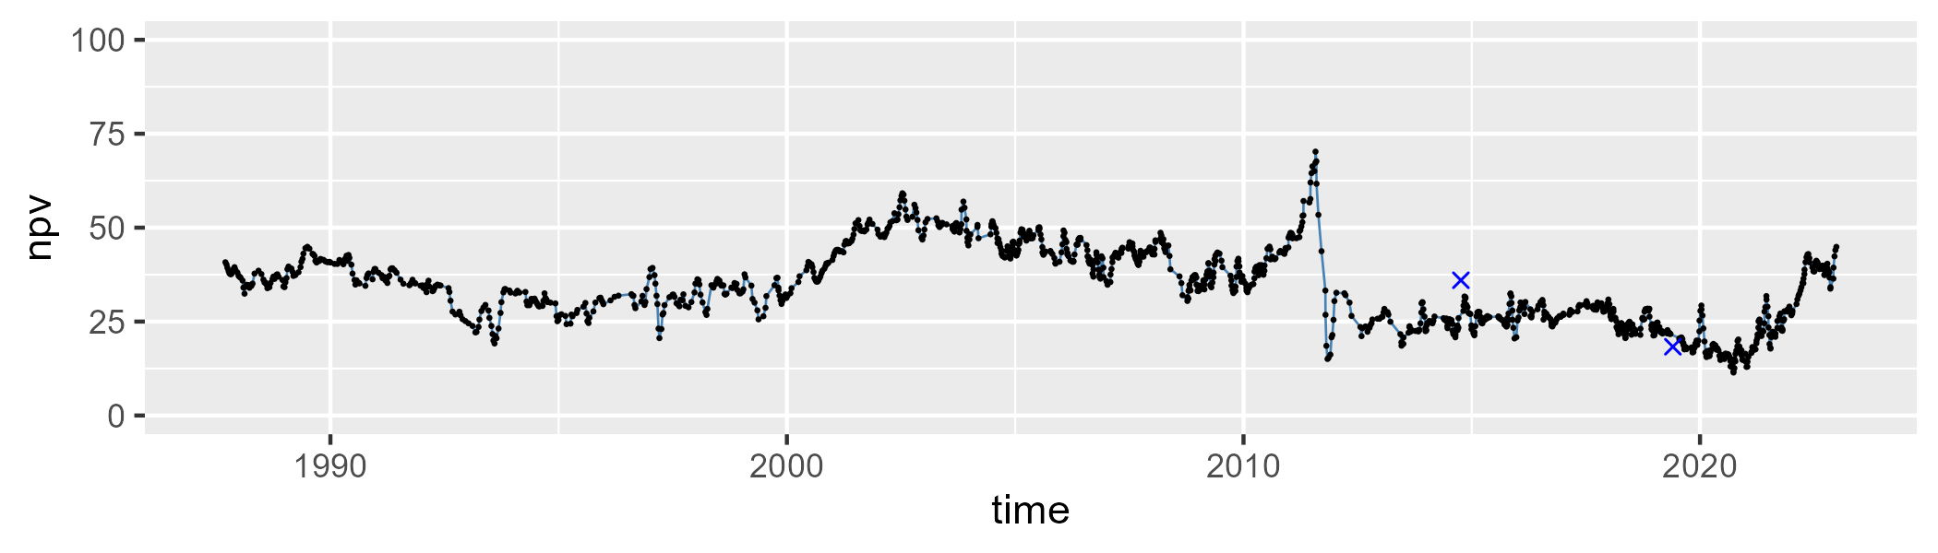

| Min. | 1st Qu. | Median | Mean | 3rd Qu. | Max. |
| --- | --- | --- | --- | --- | --- |
| 16.56103 | 43.68089 | 50.26267 | 50.20863 | 58.35251 | 74.45885 |

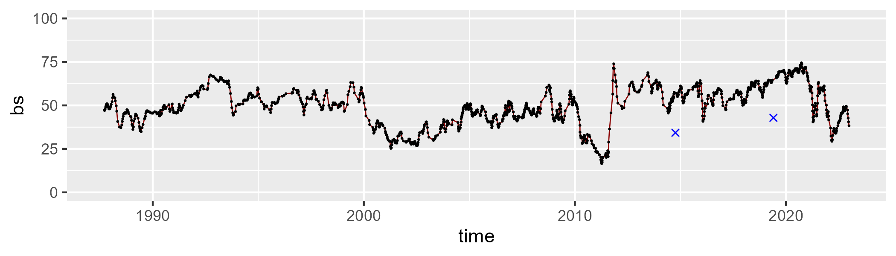

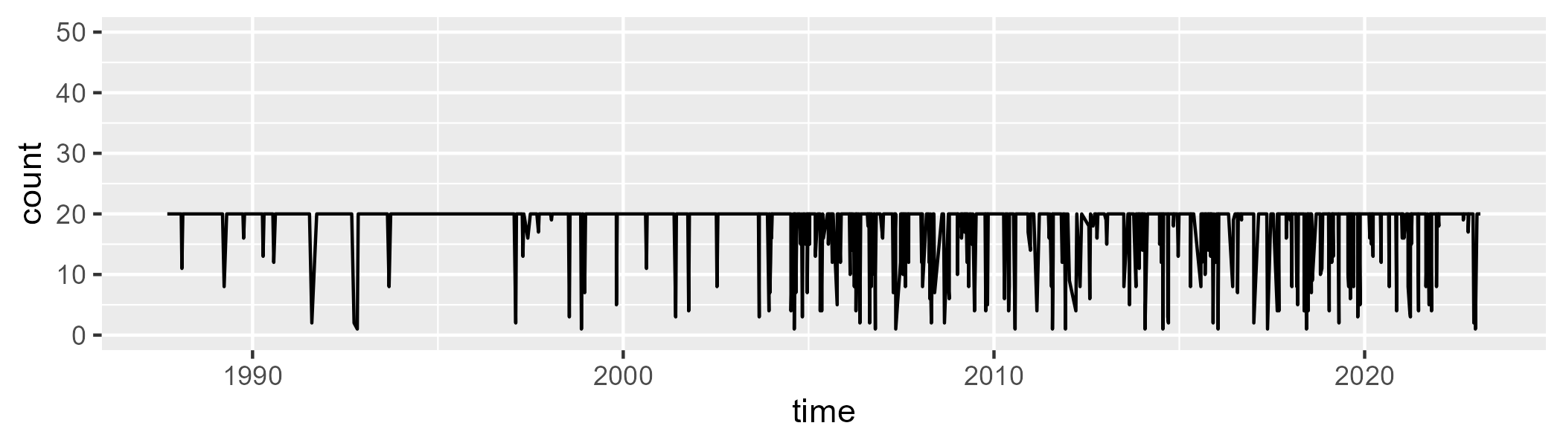

Min. : 1.00 1st Qu.:20.00 Median :20.00 Mean :18.46 3rd Qu.:20.00 Max. :20.00

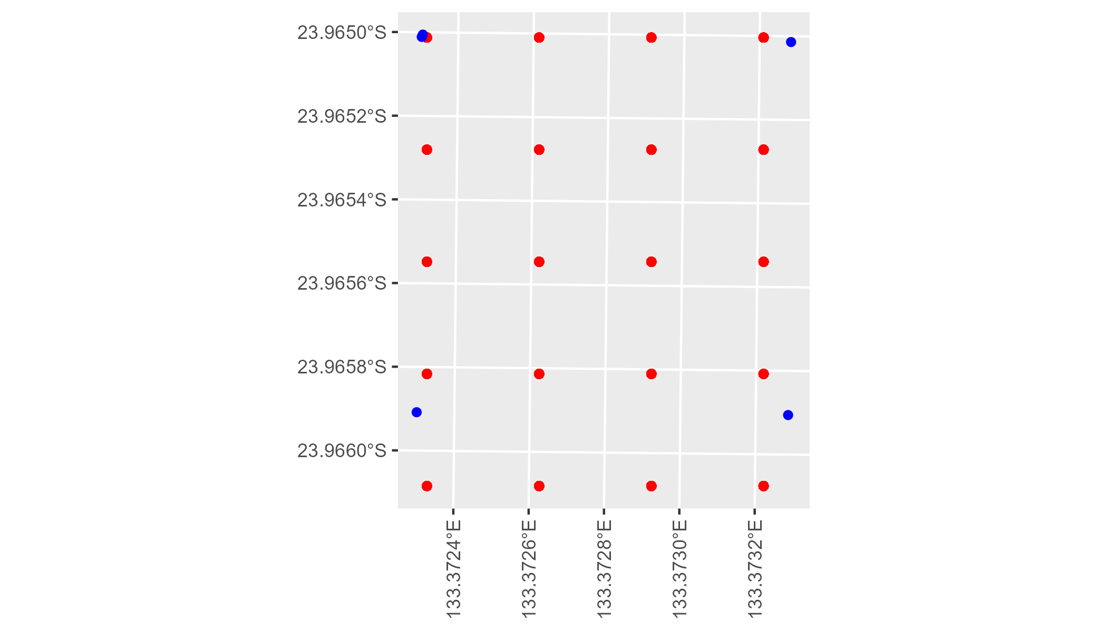

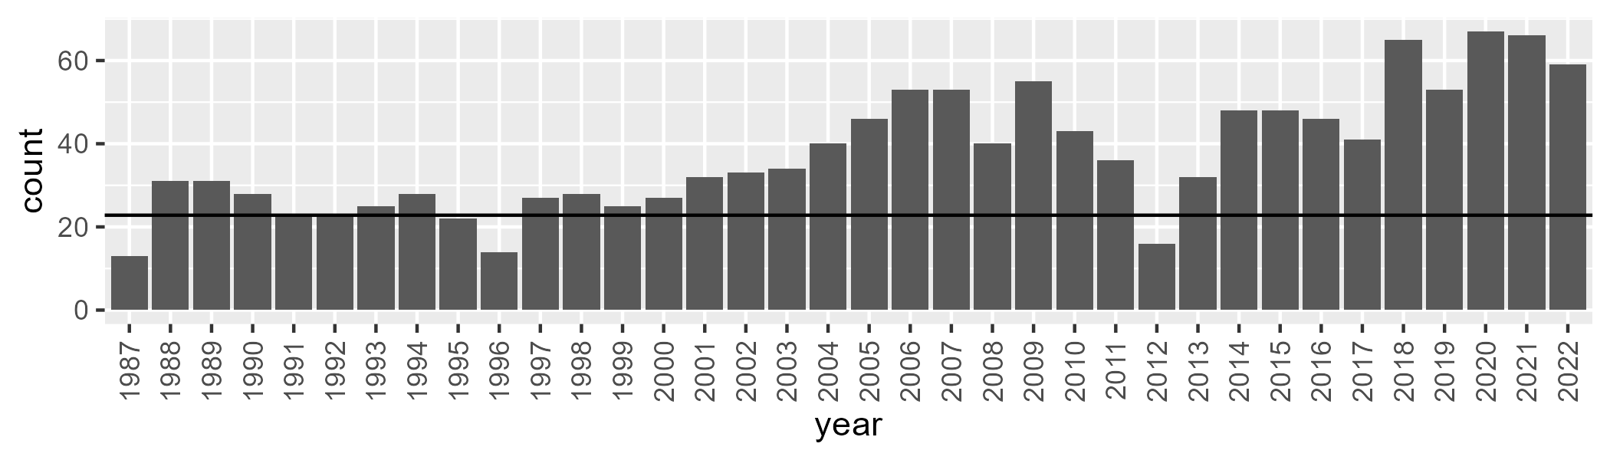

Number of samples: 1351

# NTAMAC0002

| Min. | 1st Qu. | Median | Mean | 3rd Qu. | Max. |
| --- | --- | --- | --- | --- | --- |
| 4.945851 | 14.87643 | 18.79304 | 18.1102 | 21.6271 | 28.28826 |

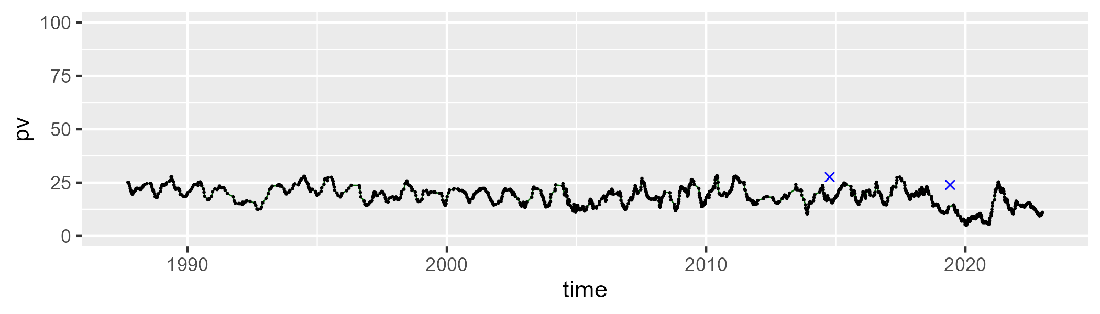

| Min. | 1st Qu. | Median | Mean | 3rd Qu. | Max. |
| --- | --- | --- | --- | --- | --- |
| 14.45545 | 31.94999 | 37.84989 | 37.62973 | 44.17622 | 56.52964 |

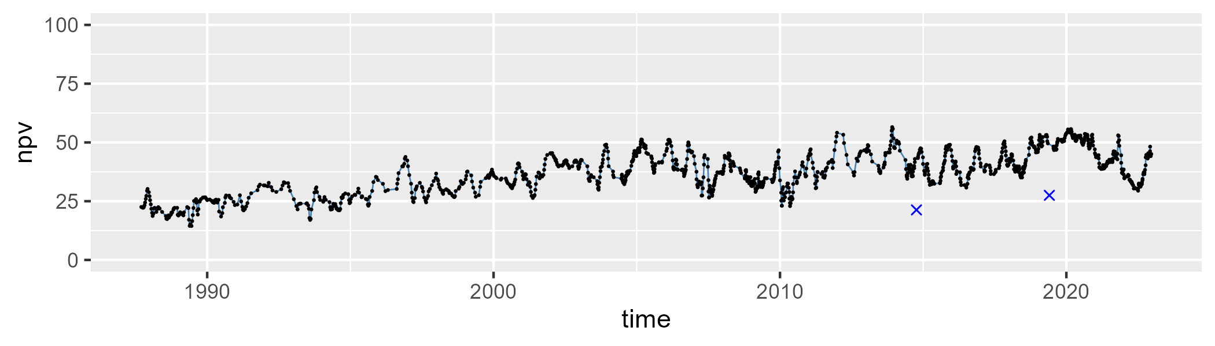

| Min. | 1st Qu. | Median | Mean | 3rd Qu. | Max. |
| --- | --- | --- | --- | --- | --- |
| 24.59606 | 37.88267 | 41.90974 | 42.82717 | 47.2265 | 60.34981 |

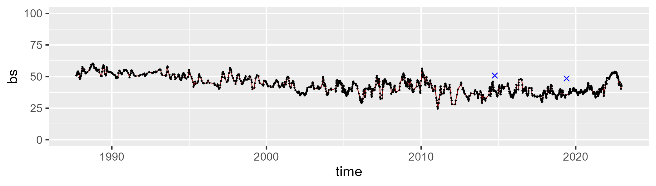

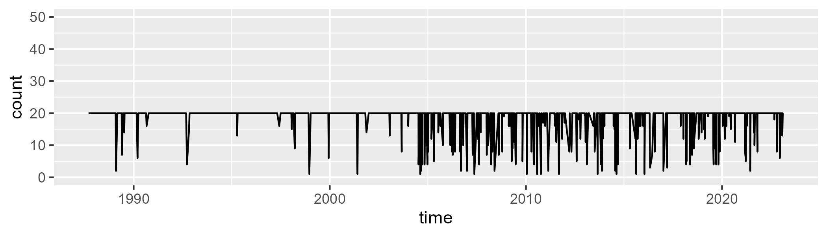

Min. : 1.00 1st Qu.:20.00 Median :20.00 Mean :18.65 3rd Qu.:20.00 Max. :20.00

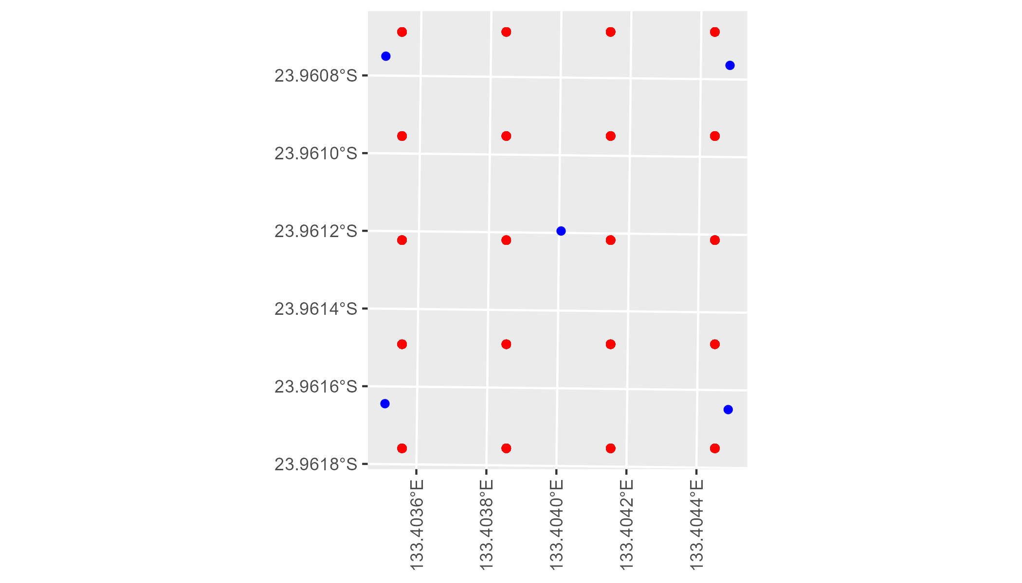

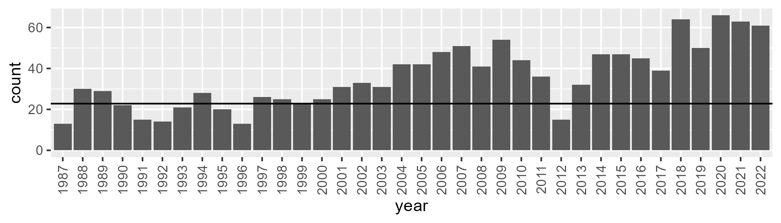

Number of samples: 1286

# NTAMAC0003

| Min. | 1st Qu. | Median | Mean | 3rd Qu. | Max. |
| --- | --- | --- | --- | --- | --- |
| 0 | 3.097203 | 6.463142 | 9.343863 | 12.95674 | 47.37208 |

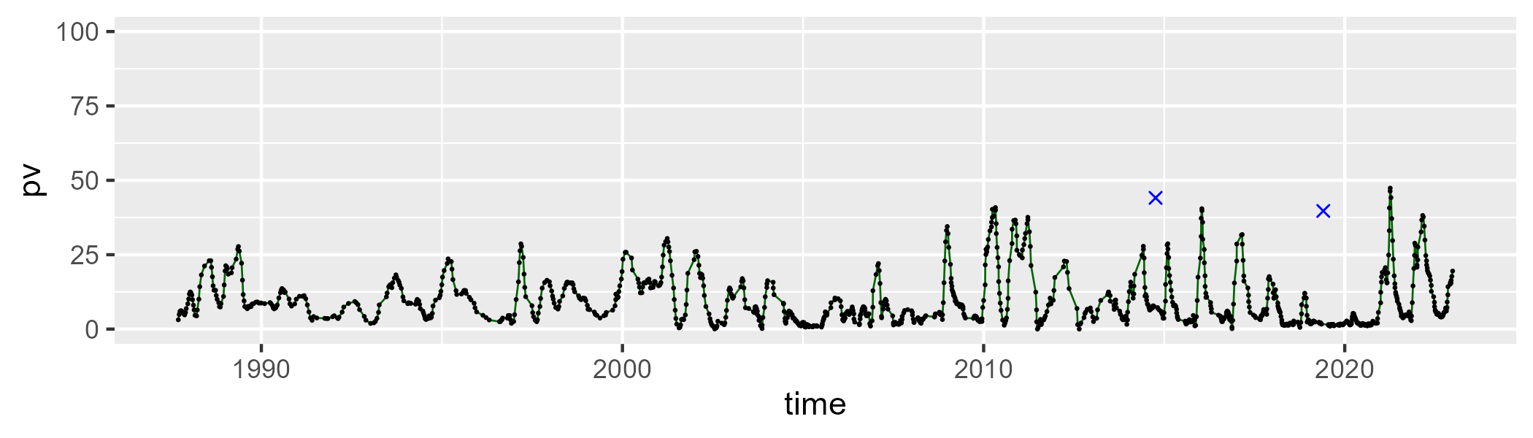

| Min. | 1st Qu. | Median | Mean | 3rd Qu. | Max. |
| --- | --- | --- | --- | --- | --- |
| 8.905607 | 30.17174 | 36.22239 | 36.42431 | 42.06171 | 75.74272 |

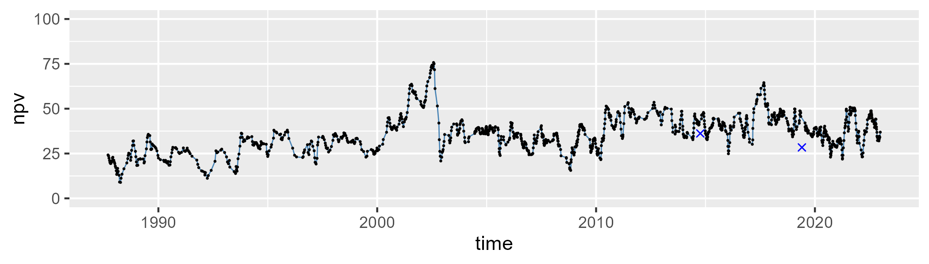

| Min. | 1st Qu. | Median | Mean | 3rd Qu. | Max. |
| --- | --- | --- | --- | --- | --- |
| 20.4695 | 45.90013 | 53.56468 | 52.75419 | 60.61214 | 83.17602 |

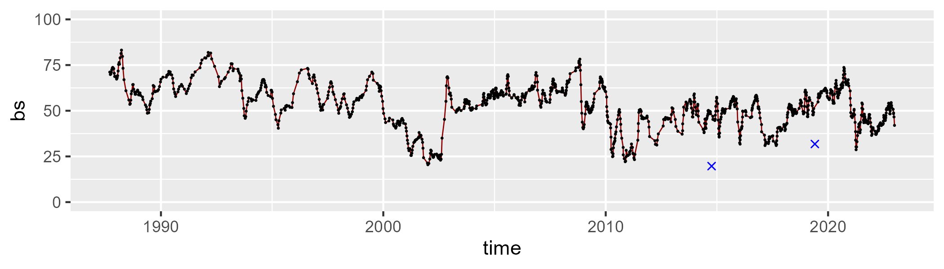

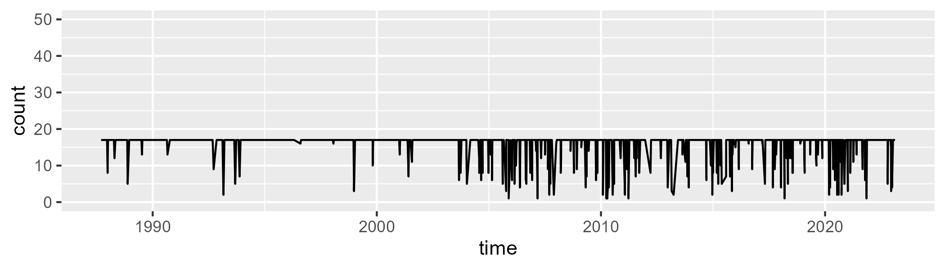

Min. : 1.00 1st Qu.:17.00 Median :17.00 Mean :15.94 3rd Qu.:17.00 Max. :17.00

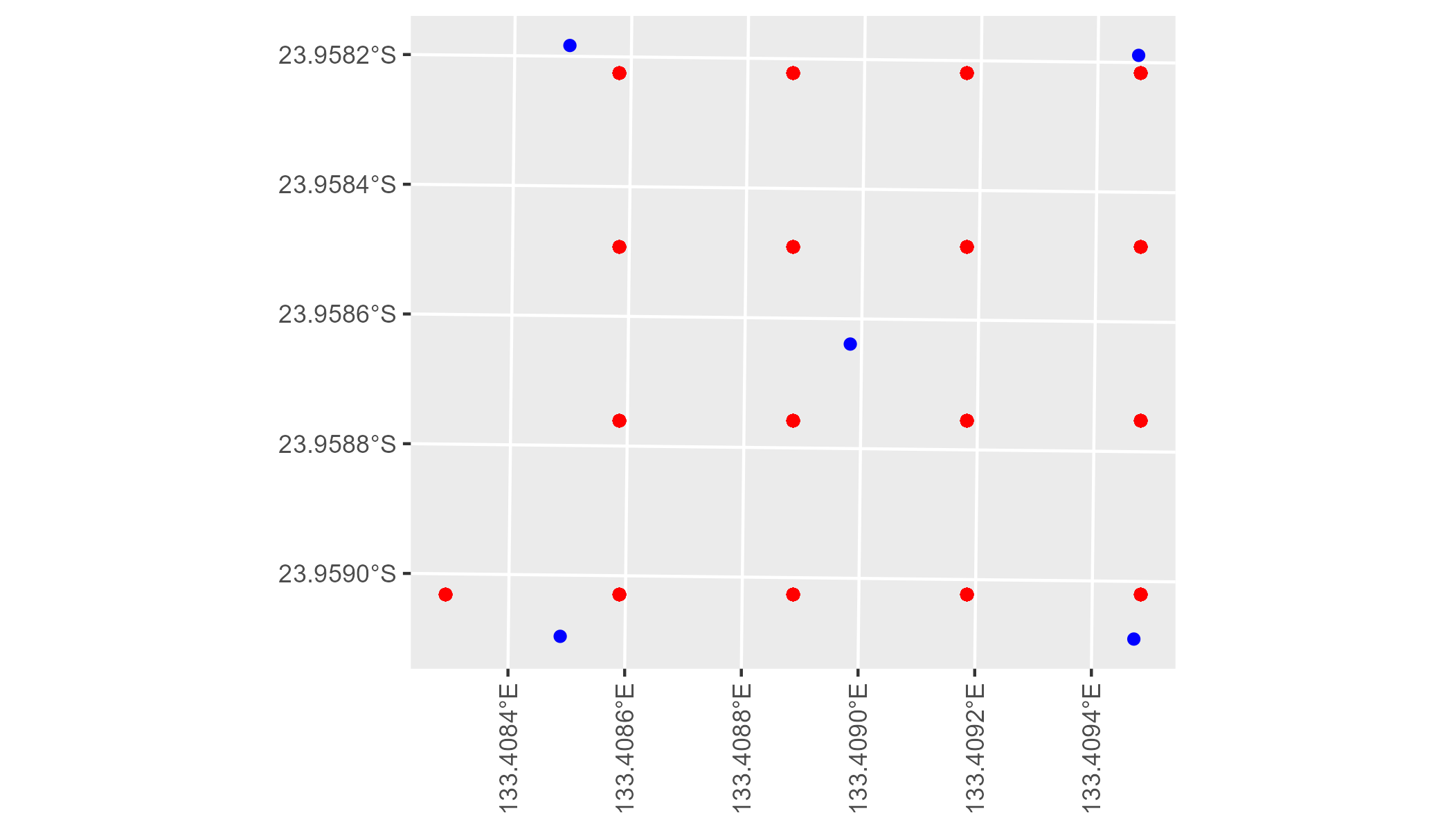

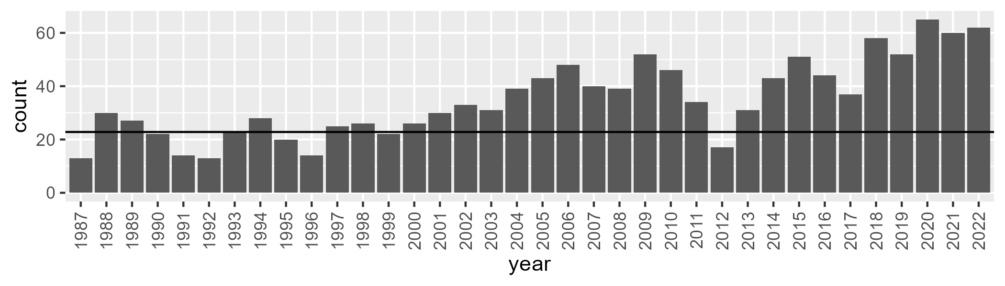

Number of samples: 1258

# NTAMGD0001

| Min. | 1st Qu. | Median | Mean | 3rd Qu. | Max. |
| --- | --- | --- | --- | --- | --- |
| 0 | 10.69297 | 13.86806 | 15.09687 | 18.6066 | 53.14468 |

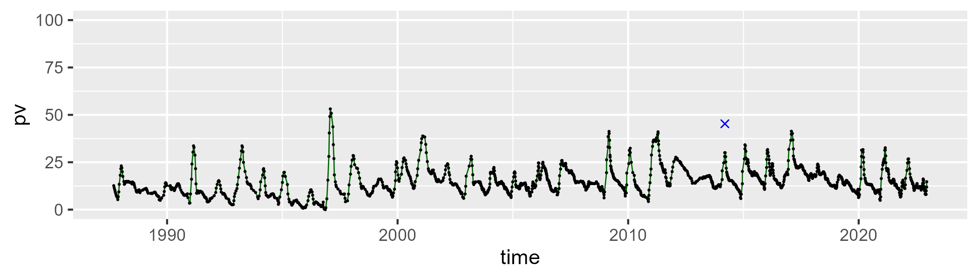

| Min. | 1st Qu. | Median | Mean | 3rd Qu. | Max. |
| --- | --- | --- | --- | --- | --- |
| 35.64304 | 53.84899 | 56.95166 | 57.42421 | 60.76558 | 89.09131 |

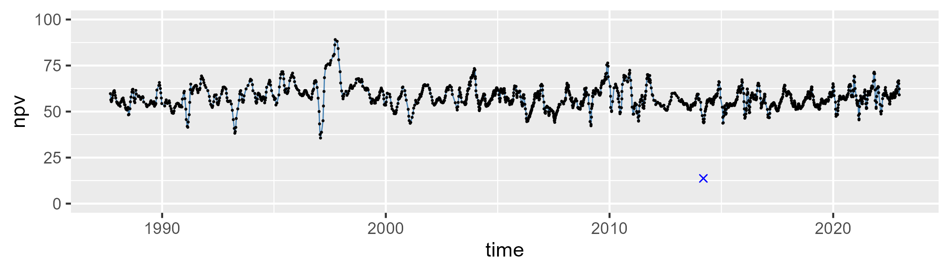

| Min. | 1st Qu. | Median | Mean | 3rd Qu. | Max. |
| --- | --- | --- | --- | --- | --- |
| 5.614478 | 22.68121 | 26.77216 | 26.16223 | 30.02426 | 40.48691 |

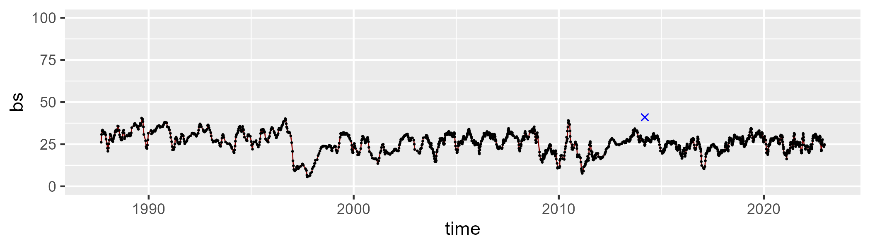

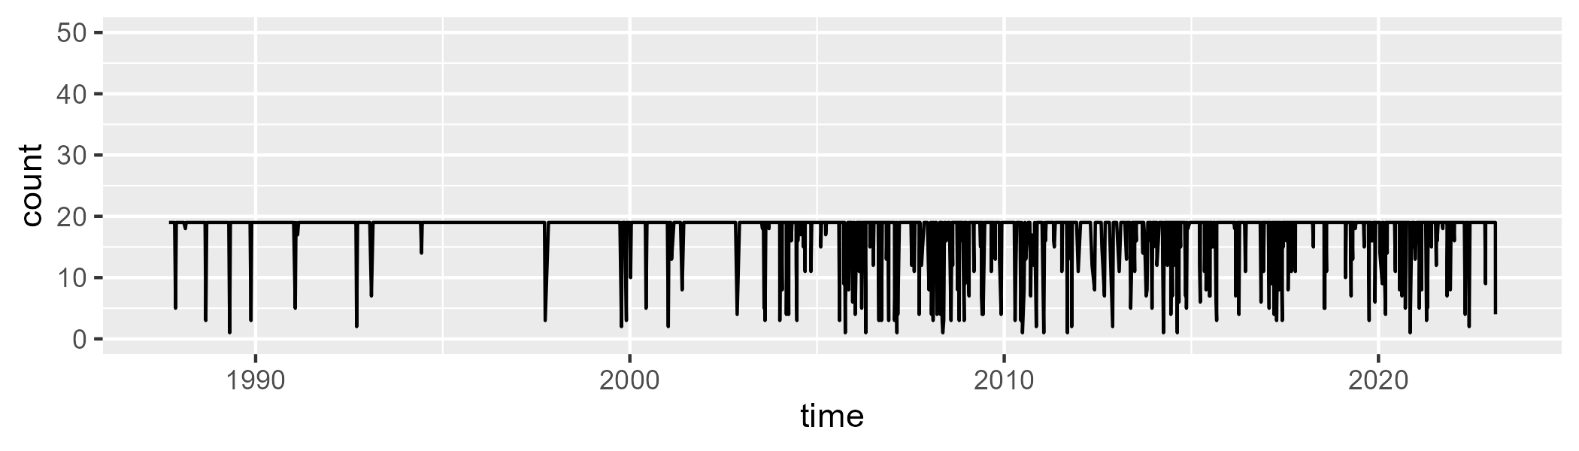

Min. : 1.0 1st Qu.:19.0 Median :19.0 Mean :17.7 3rd Qu.:19.0 Max. :19.0

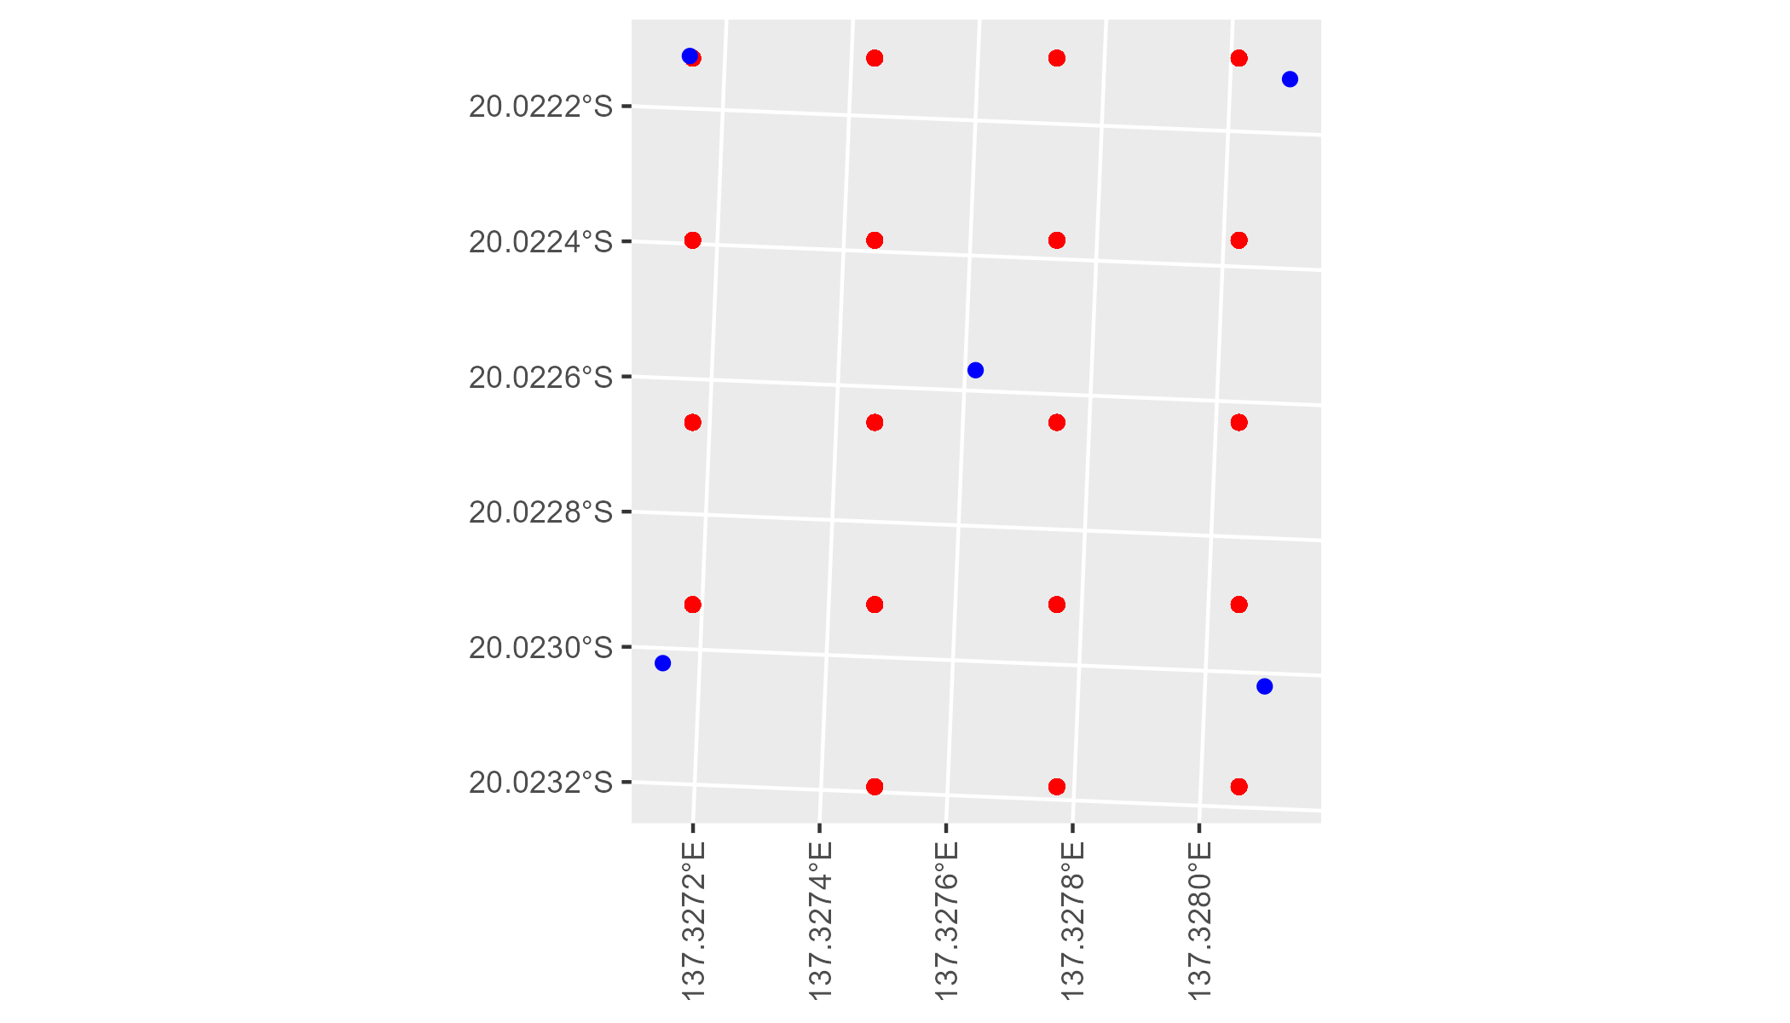

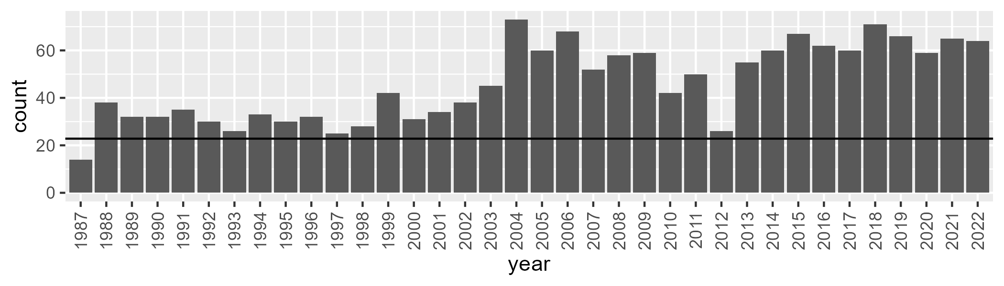

Number of samples: 1662

# NTAMGD0002

| Min. | 1st Qu. | Median | Mean | 3rd Qu. | Max. |
| --- | --- | --- | --- | --- | --- |
| 0 | 0.4413552 | 1.910523 | 6.656137 | 8.924058 | 53.84309 |

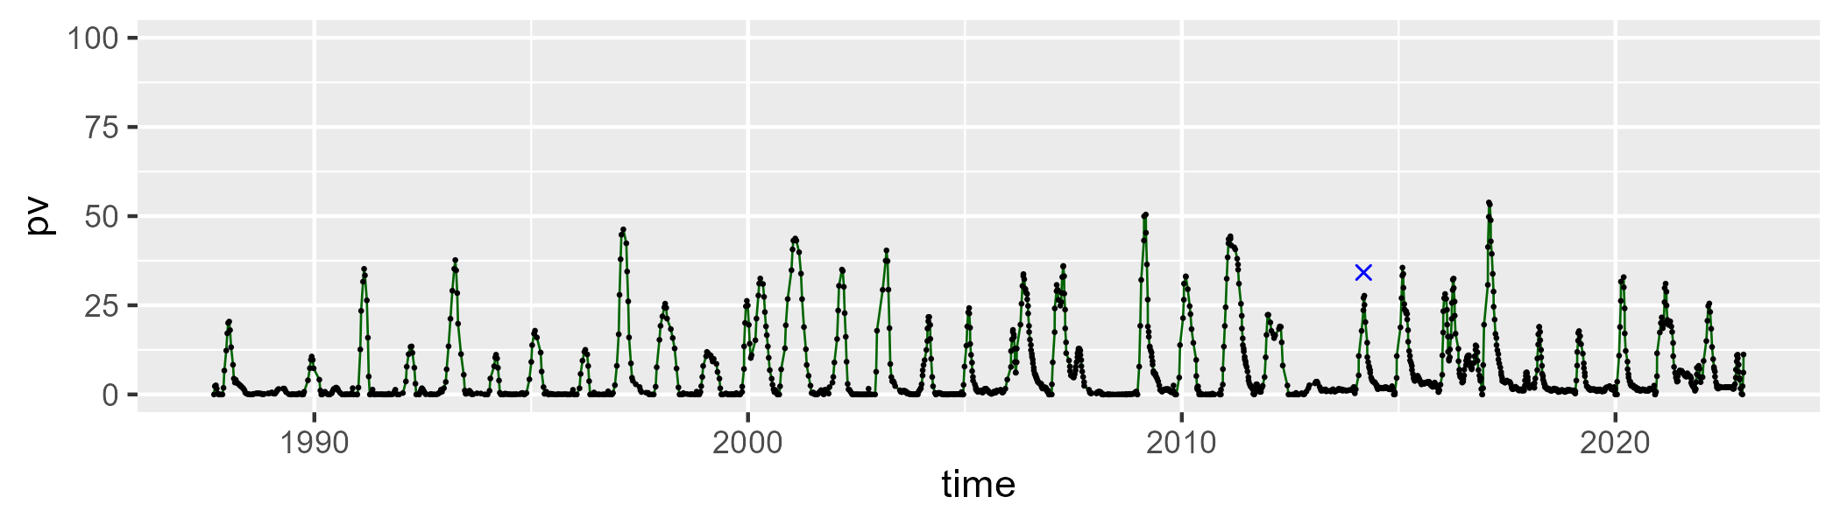

| Min. | 1st Qu. | Median | Mean | 3rd Qu. | Max. |
| --- | --- | --- | --- | --- | --- |
| 26.97052 | 49.3967 | 55.86773 | 57.95783 | 65.28728 | 96.04007 |

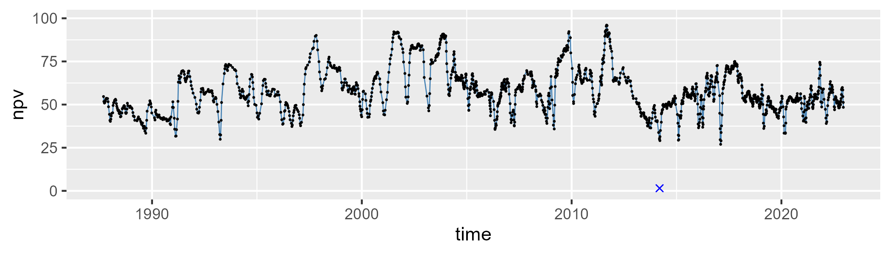

| Min. | 1st Qu. | Median | Mean | 3rd Qu. | Max. |
| --- | --- | --- | --- | --- | --- |
| 2.586044 | 26.02863 | 35.4172 | 34.18594 | 43.44733 | 66.11408 |

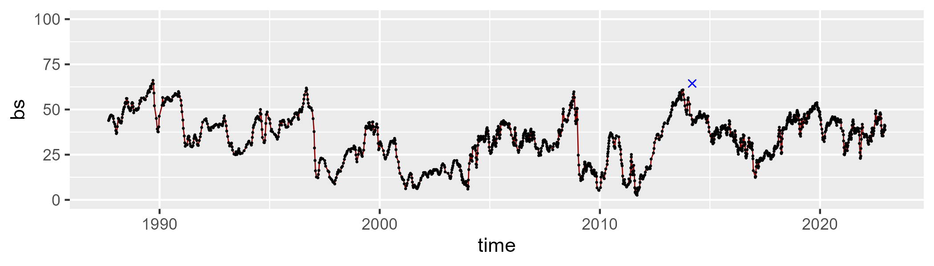

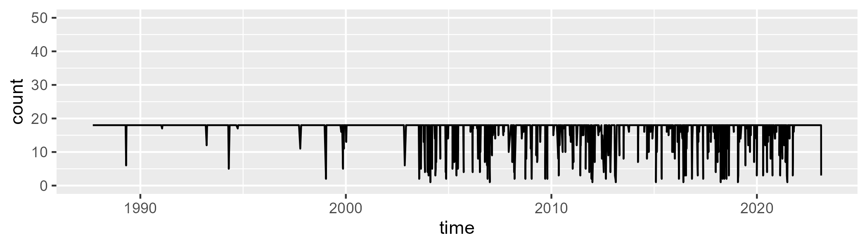

Min. : 1.00 1st Qu.:18.00 Median :18.00 Mean :16.92 3rd Qu.:18.00 Max. :18.00

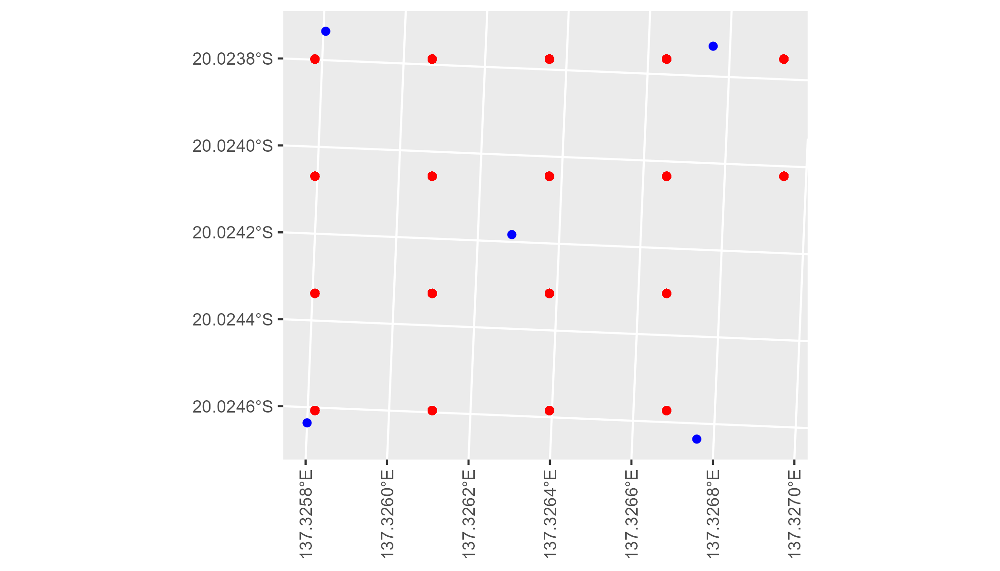

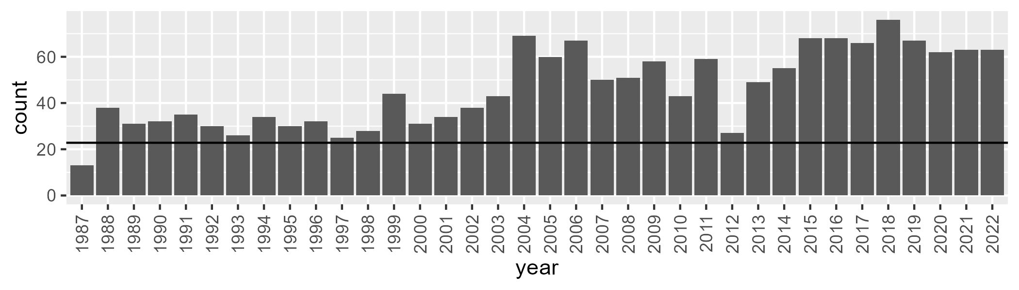

Number of samples: 1665

# NTAMGD0003

| Min. | 1st Qu. | Median | Mean | 3rd Qu. | Max. |
| --- | --- | --- | --- | --- | --- |
| 0 | 16.26635 | 23.96971 | 24.30423 | 32.22211 | 52.35102 |

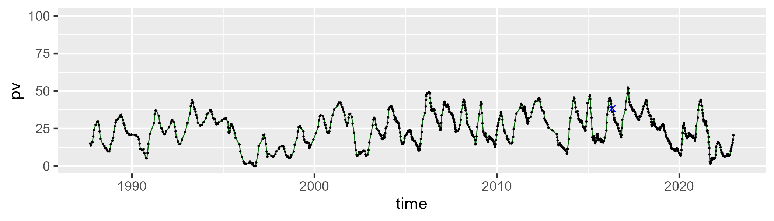

| Min. | 1st Qu. | Median | Mean | 3rd Qu. | Max. |
| --- | --- | --- | --- | --- | --- |
| 25.88436 | 46.34984 | 51.28282 | 51.5342 | 56.63849 | 75.87842 |

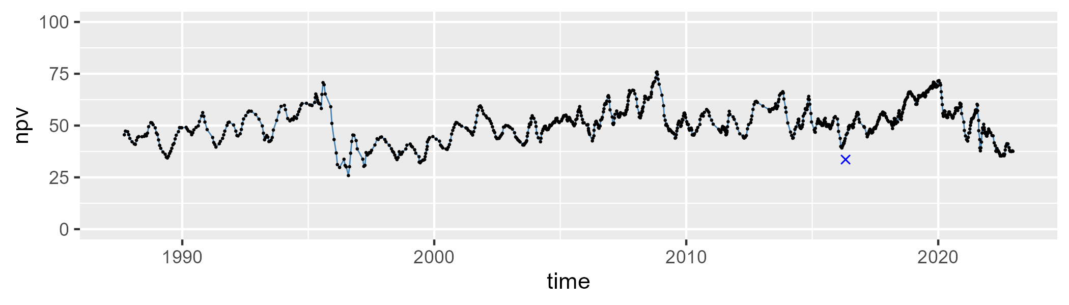

| Min. | 1st Qu. | Median | Mean | 3rd Qu. | Max. |
| --- | --- | --- | --- | --- | --- |
| 0 | 11.73084 | 20.14784 | 22.85438 | 30.41681 | 71.59766 |

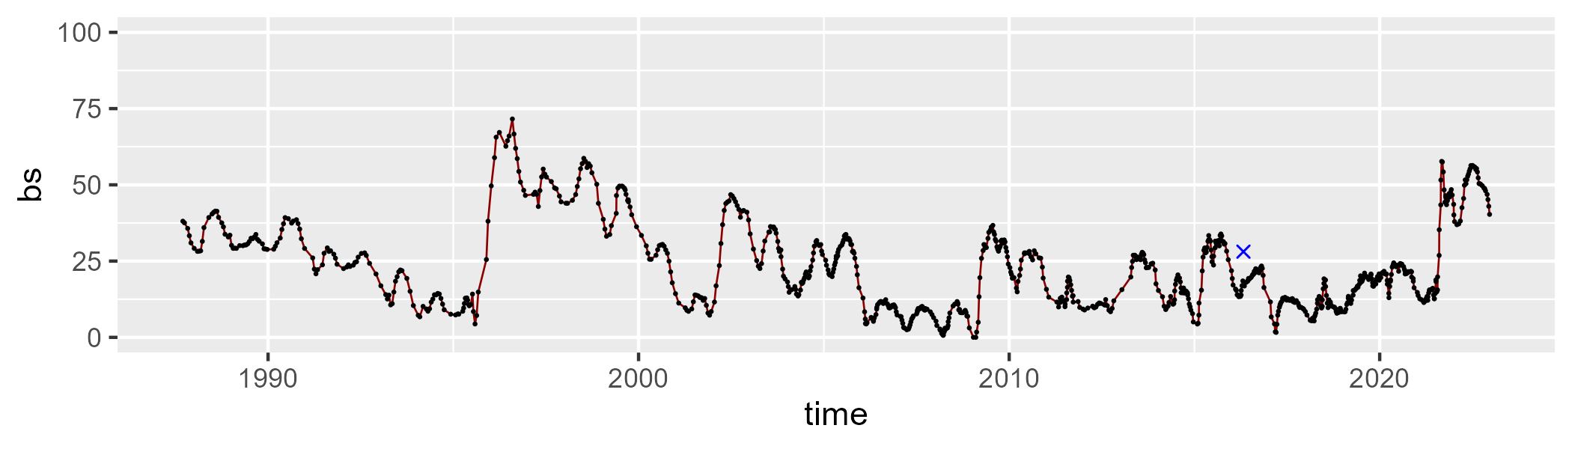

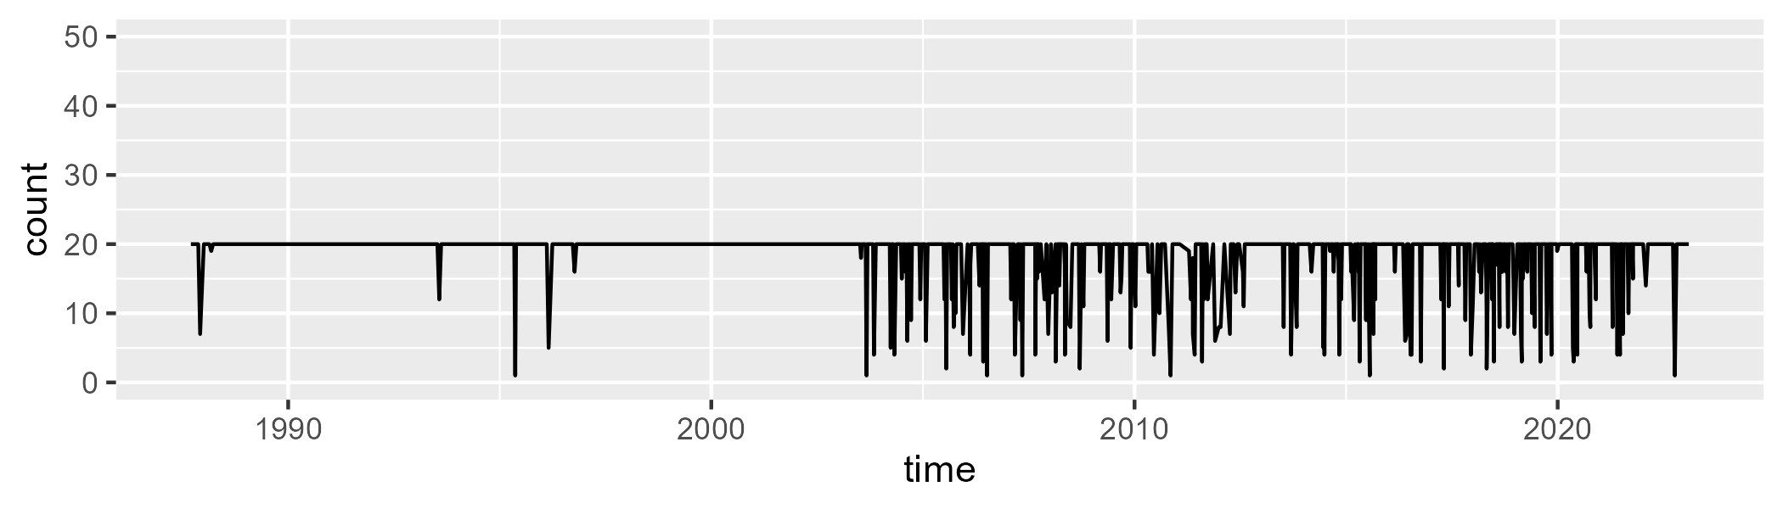

Min. : 1.00 1st Qu.:20.00 Median :20.00 Mean :18.29 3rd Qu.:20.00 Max. :20.00

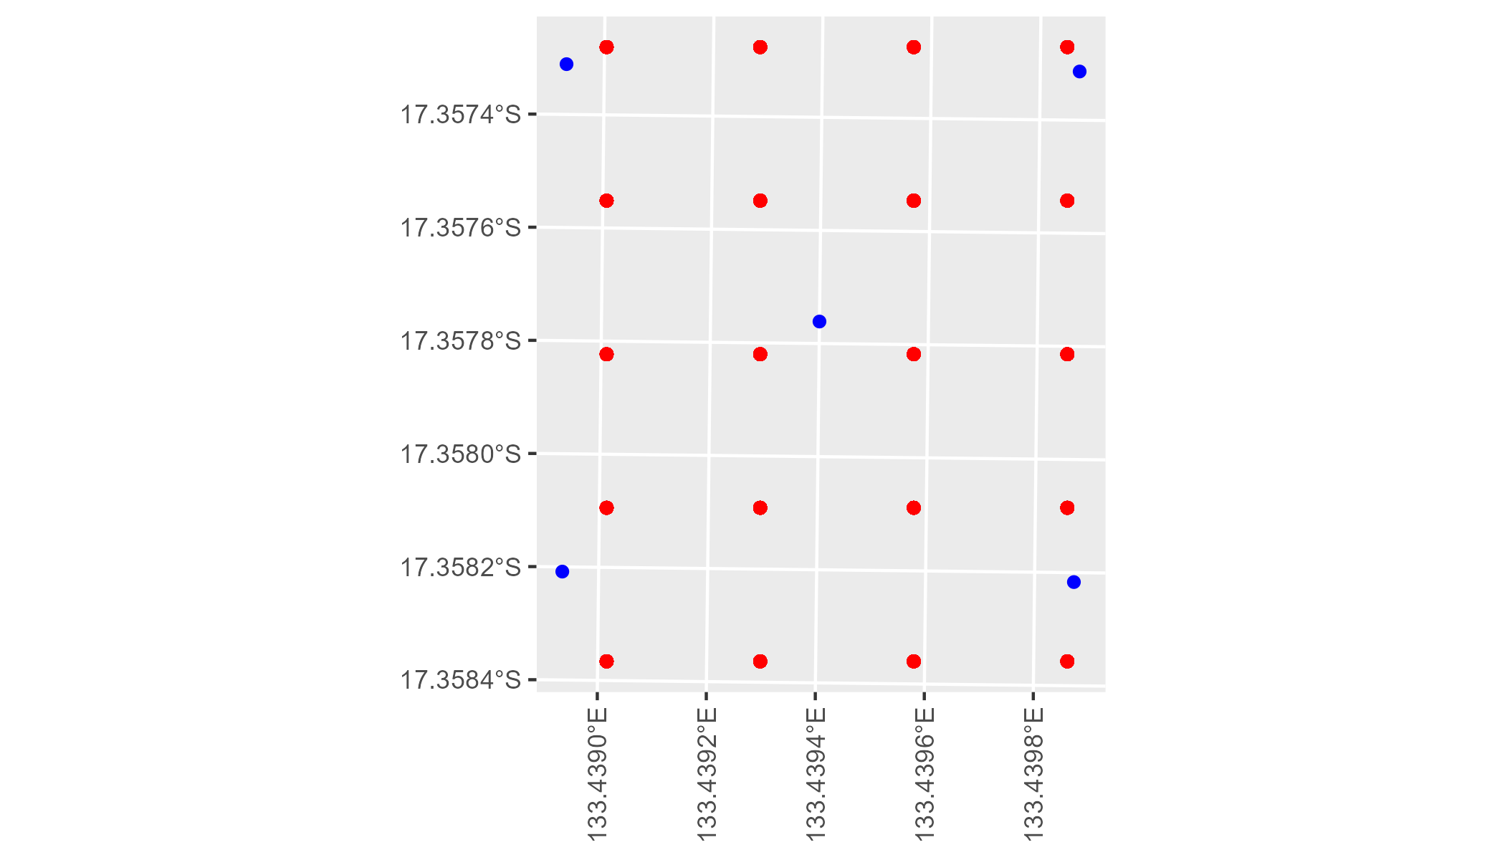

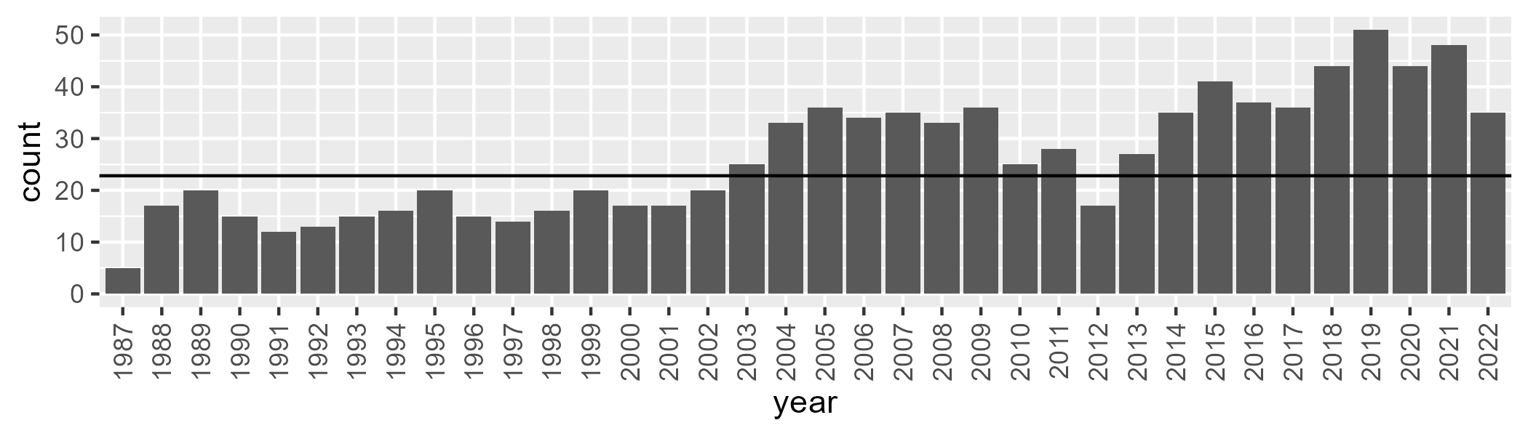

Number of samples: 952

# NTAMGD0004

| Min. | 1st Qu. | Median | Mean | 3rd Qu. | Max. |
| --- | --- | --- | --- | --- | --- |
| 0.6199158 | 12.78109 | 19.10324 | 22.19558 | 30.07179 | 54.03884 |

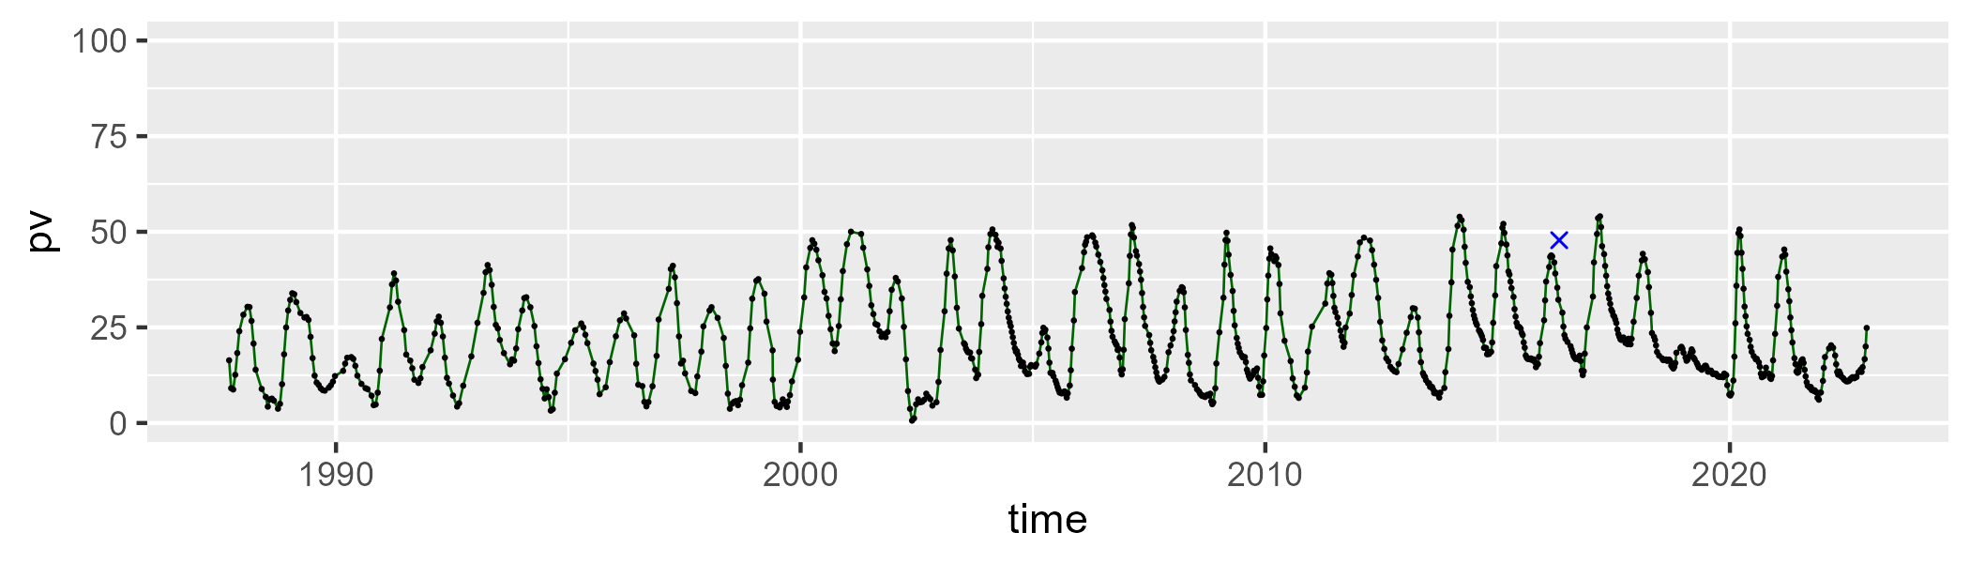

| Min. | 1st Qu. | Median | Mean | 3rd Qu. | Max. |
| --- | --- | --- | --- | --- | --- |
| 13.7088 | 39.26758 | 46.39752 | 47.43321 | 57.88303 | 79.5865 |

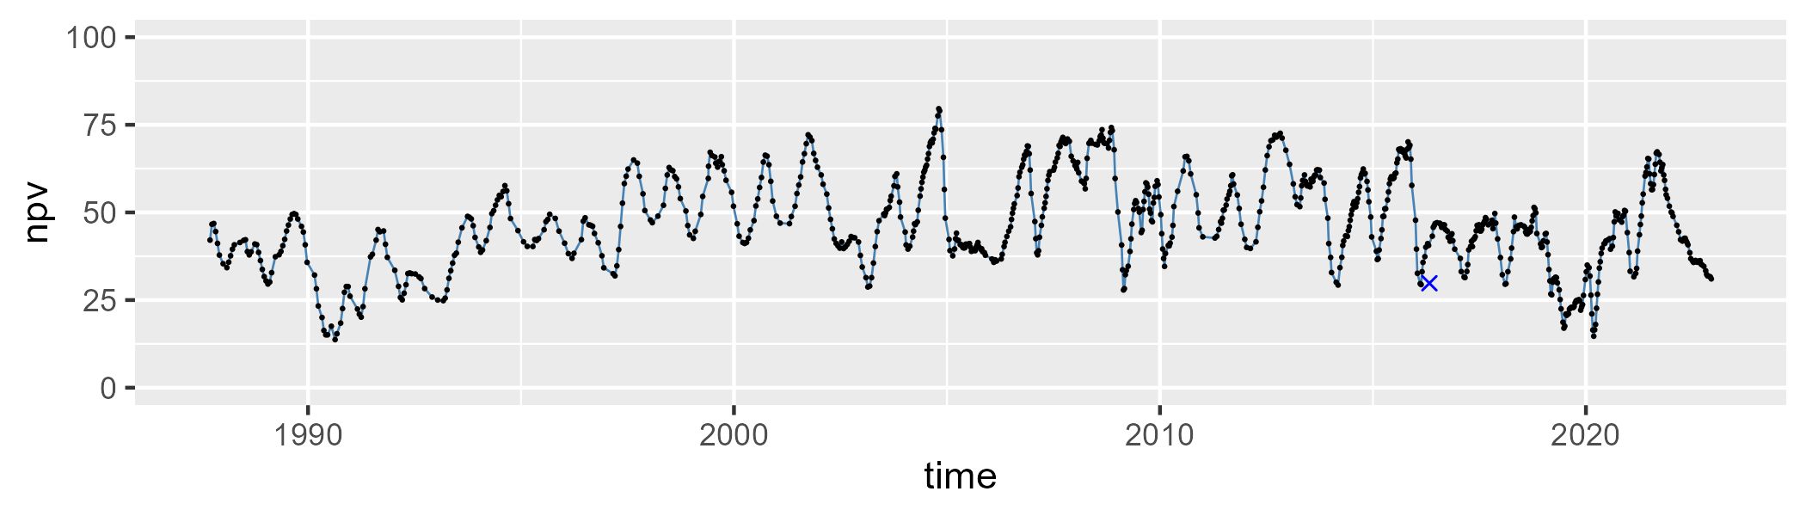

| Min. | 1st Qu. | Median | Mean | 3rd Qu. | Max. |
| --- | --- | --- | --- | --- | --- |
| 0.3220788 | 16.45465 | 27.99938 | 28.95614 | 37.98116 | 75.54931 |

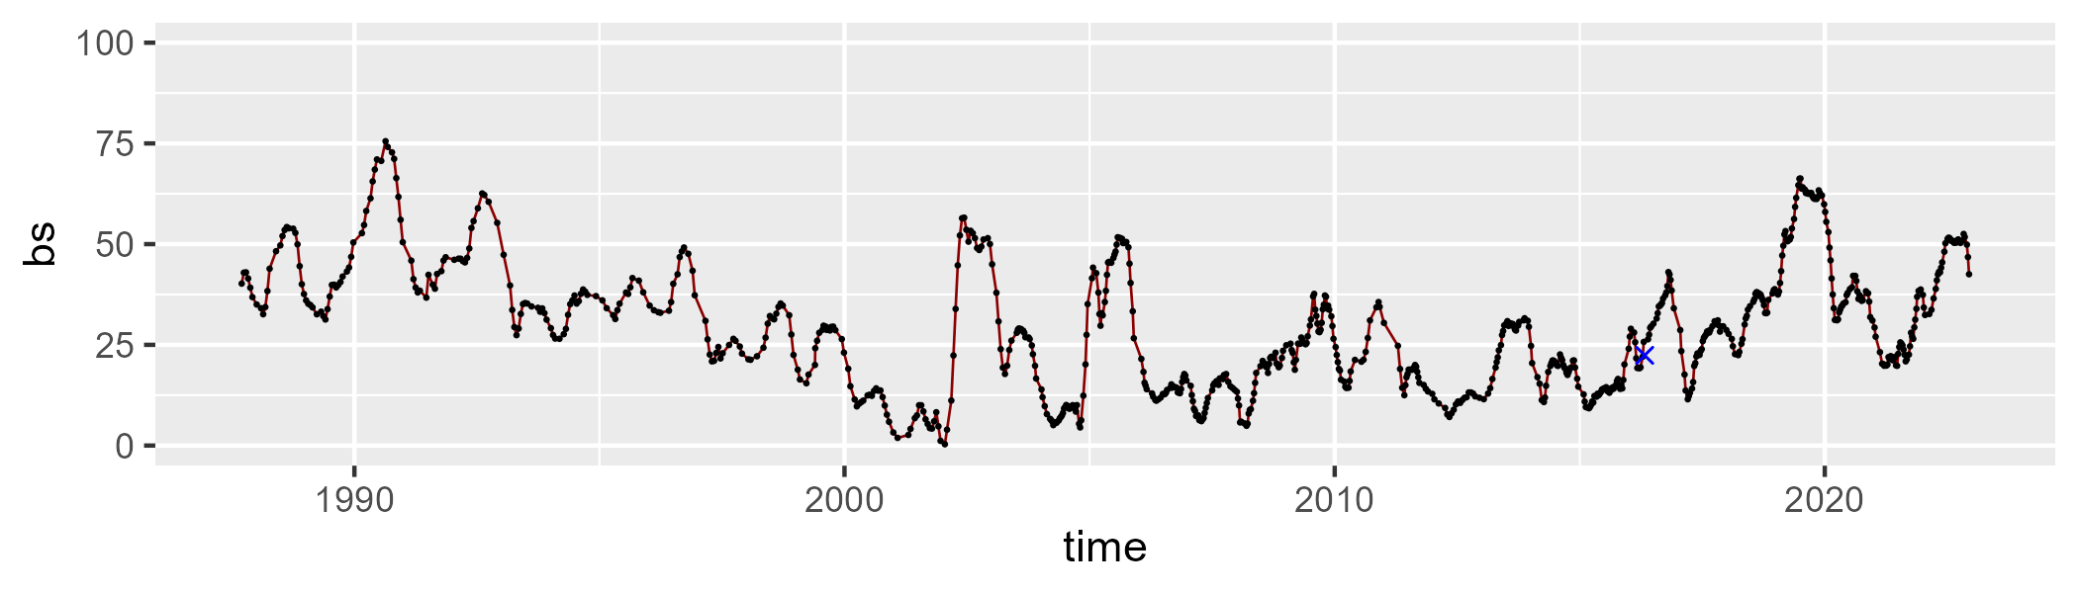

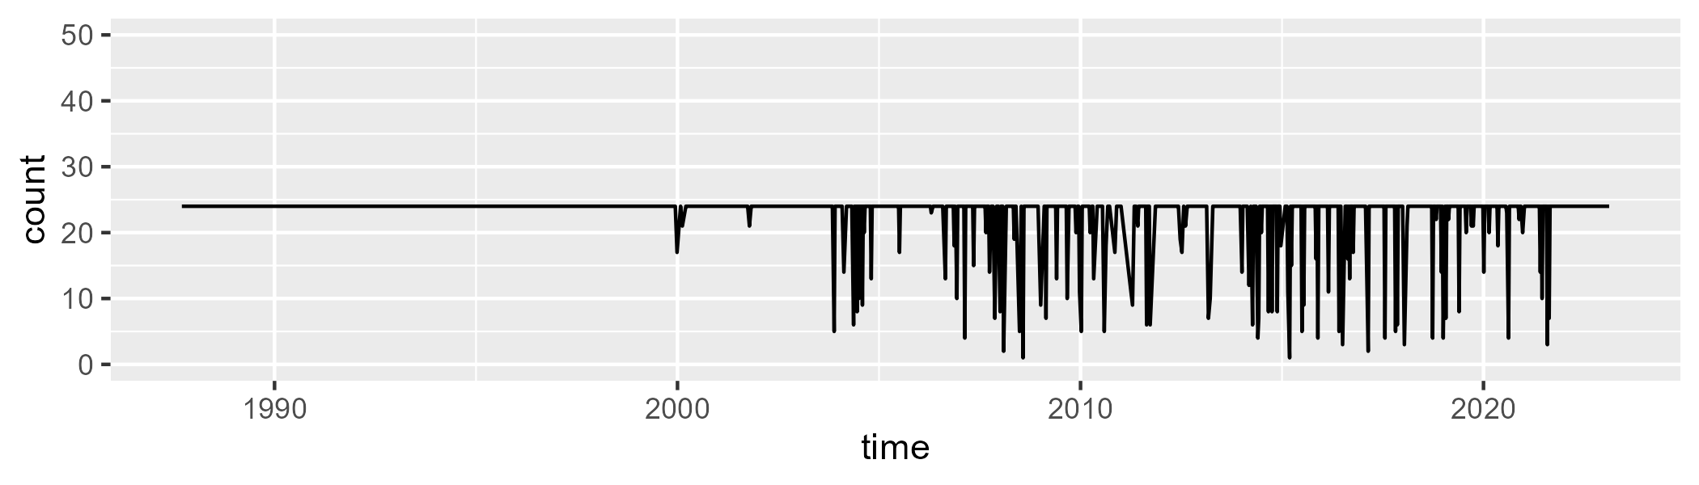

Min. : 1.00 1st Qu.:24.00 Median :24.00 Mean :22.62 3rd Qu.:24.00 Max. :24.00

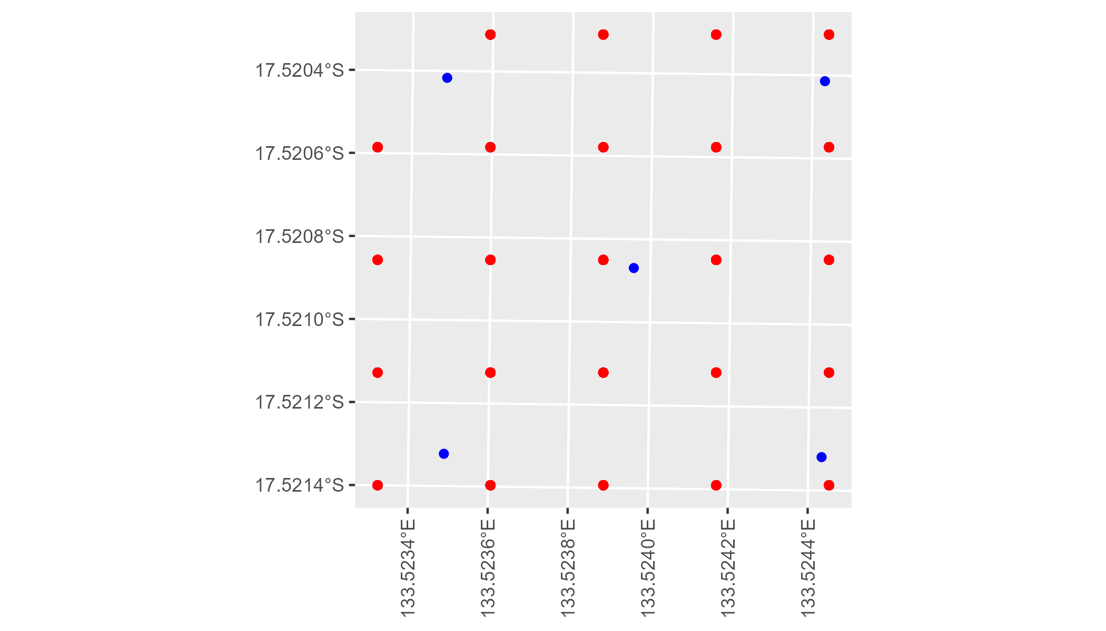

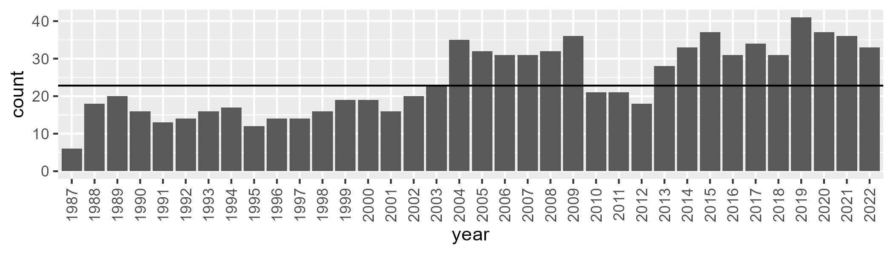

Number of samples: 871

# NTAMGD0005

| Min. | 1st Qu. | Median | Mean | 3rd Qu. | Max. |
| --- | --- | --- | --- | --- | --- |
| 4.116323 | 13.59404 | 22.27678 | 22.74582 | 30.57995 | 54.25324 |

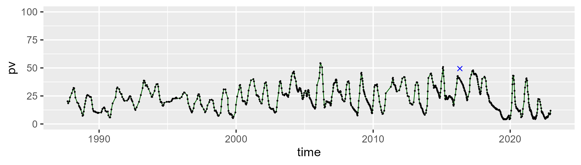

| Min. | 1st Qu. | Median | Mean | 3rd Qu. | Max. |
| --- | --- | --- | --- | --- | --- |
| 13.95441 | 41.77798 | 48.56624 | 48.09446 | 56.02349 | 81.51162 |

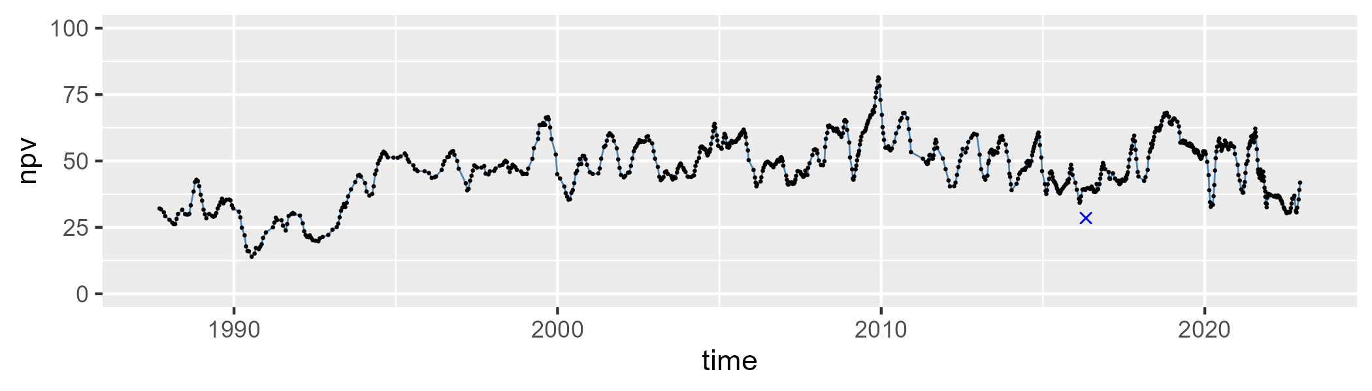

| Min. | 1st Qu. | Median | Mean | 3rd Qu. | Max. |
| --- | --- | --- | --- | --- | --- |
| 3.645088 | 16.64257 | 26.26166 | 27.78088 | 34.11832 | 75.74027 |

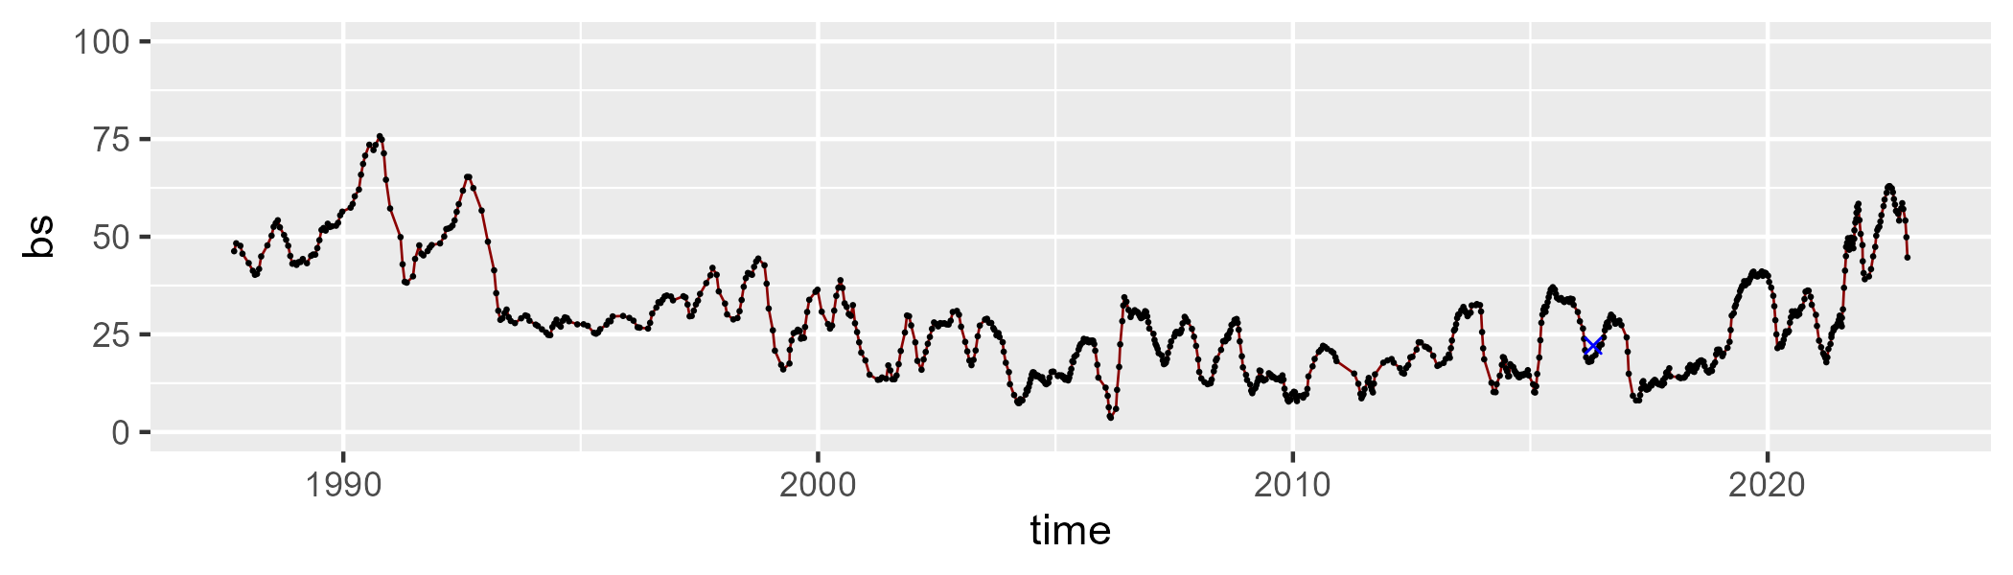

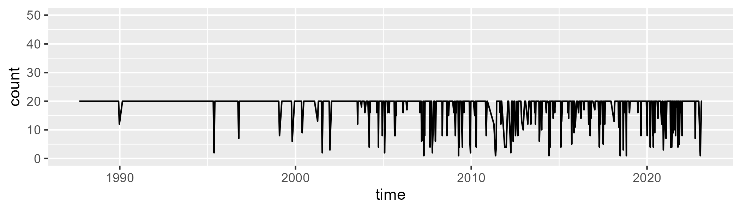

Min. : 1.00 1st Qu.:20.00 Median :20.00 Mean :18.44 3rd Qu.:20.00 Max. :20.00

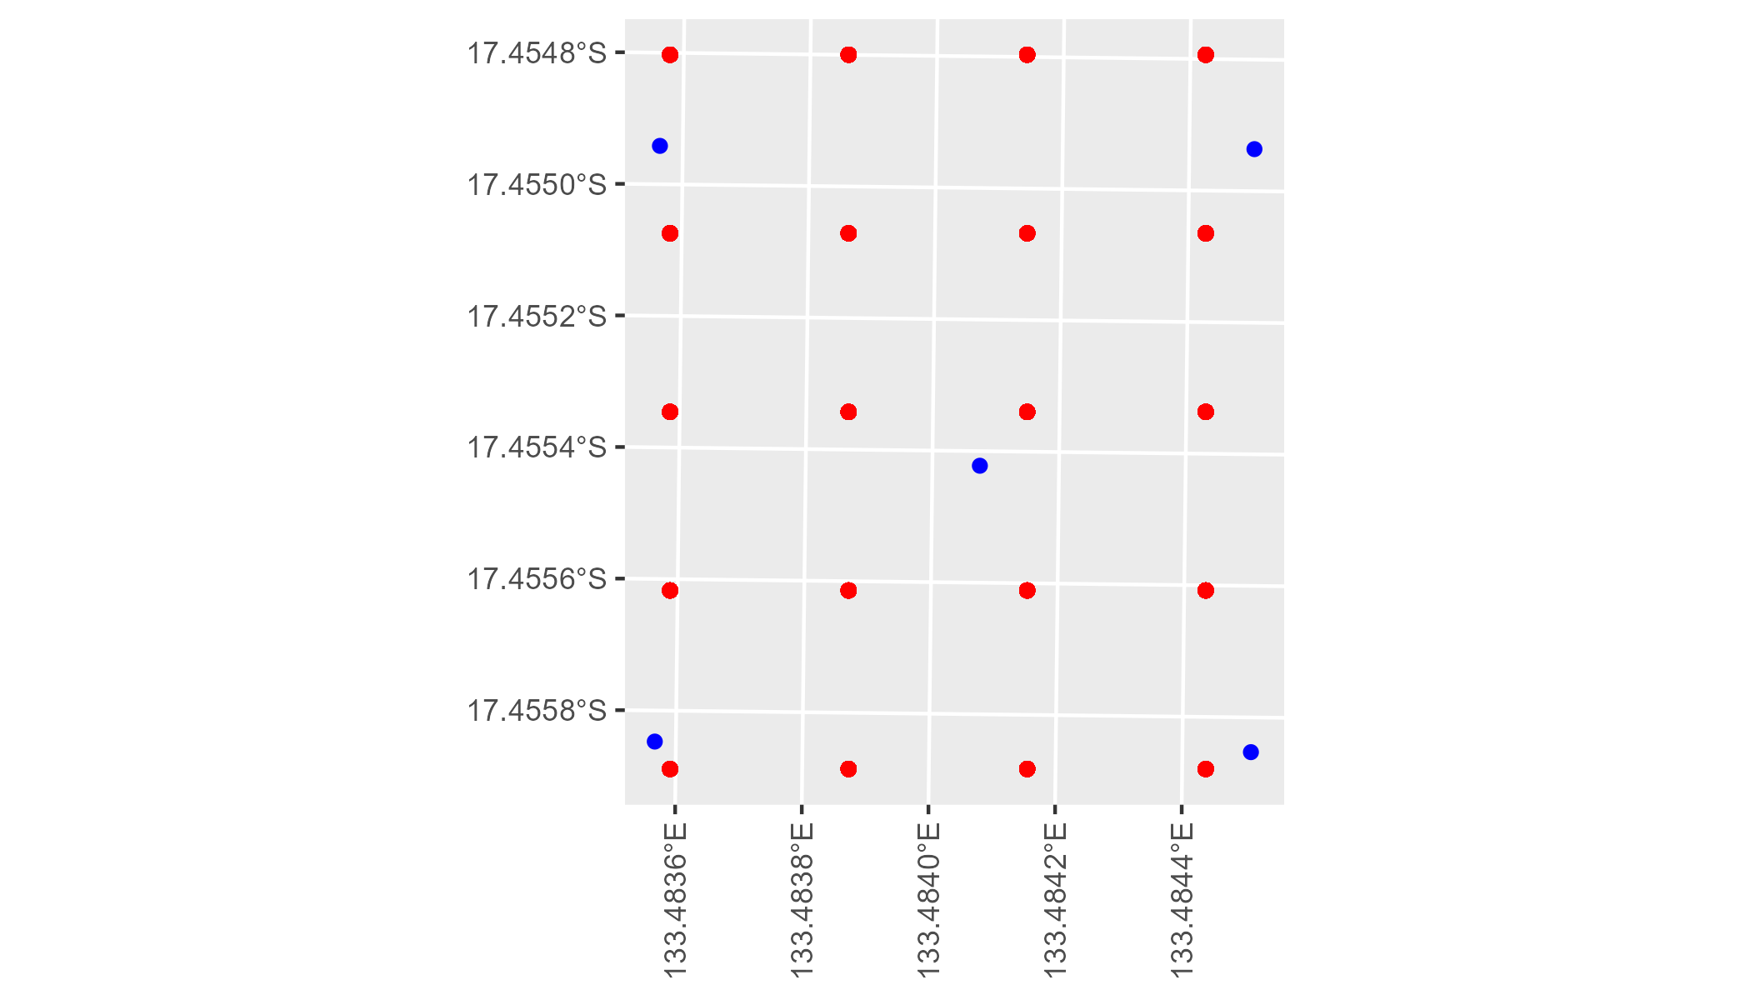

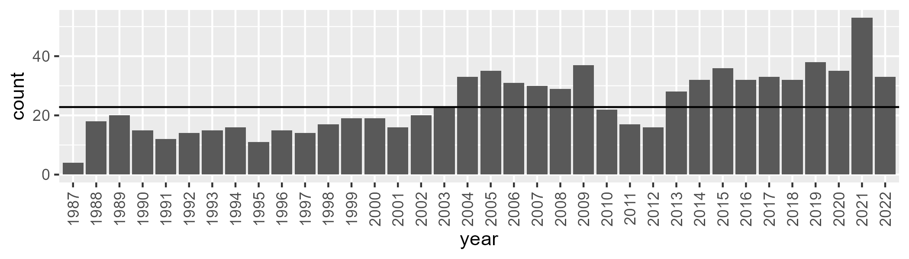

Number of samples: 870

# NTAPCK0001

| Min. | 1st Qu. | Median | Mean | 3rd Qu. | Max. |
| --- | --- | --- | --- | --- | --- |
| 14.05983 | 38.23362 | 44.59158 | 47.29449 | 57.21928 | 76.89532 |

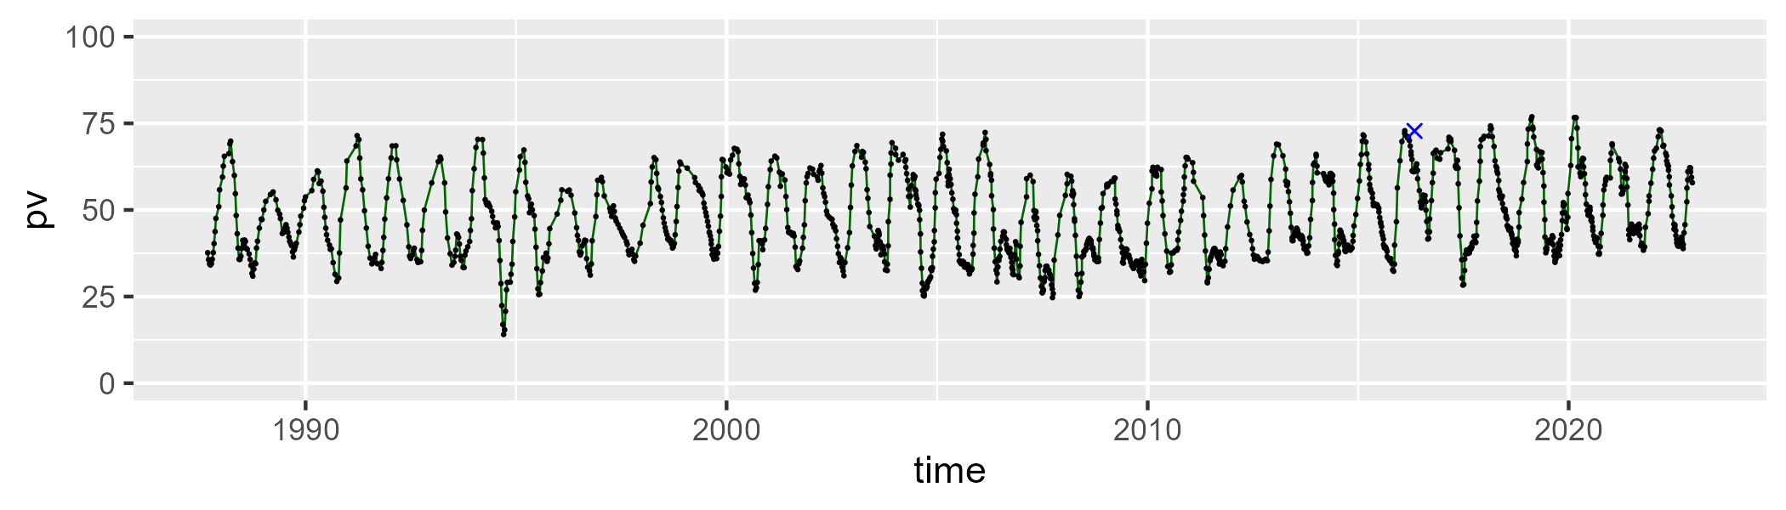

| Min. | 1st Qu. | Median | Mean | 3rd Qu. | Max. |
| --- | --- | --- | --- | --- | --- |
| 16.13025 | 36.62455 | 45.50641 | 43.27845 | 50.15481 | 64.51834 |

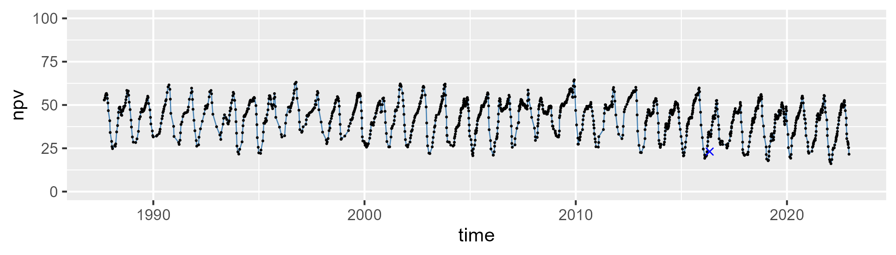

| Min. | 1st Qu. | Median | Mean | 3rd Qu. | Max. |
| --- | --- | --- | --- | --- | --- |
| 0 | 4.292534 | 6.939529 | 8.064315 | 10.96719 | 32.16314 |

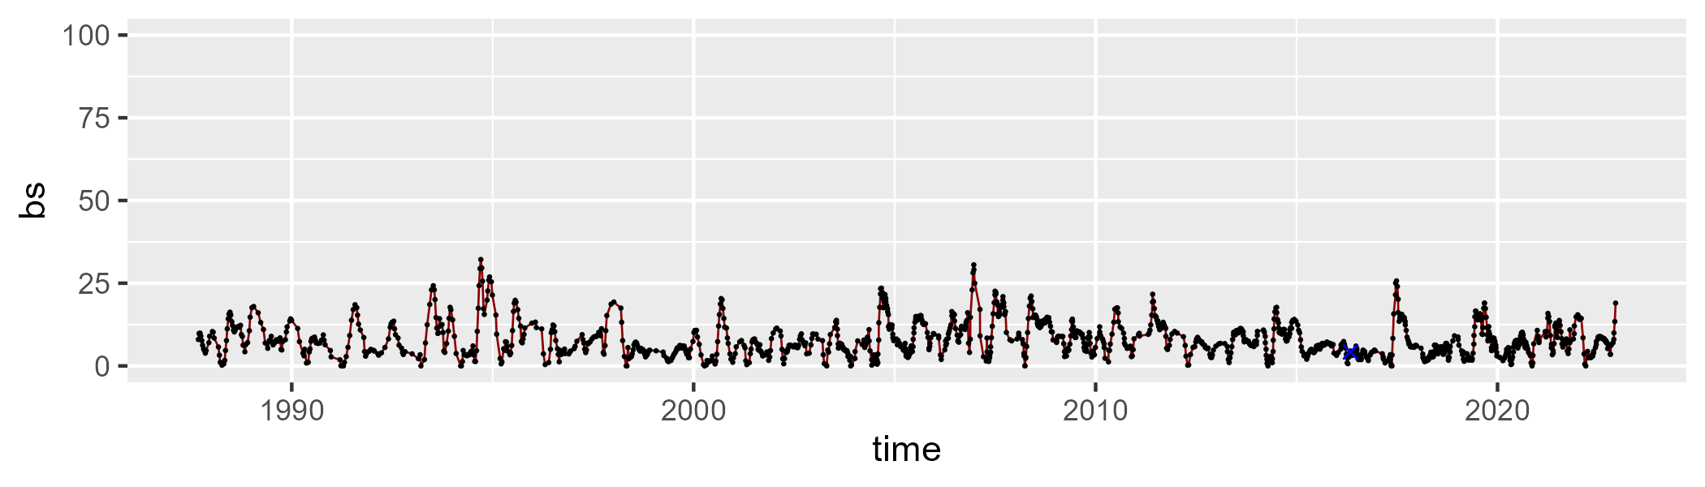

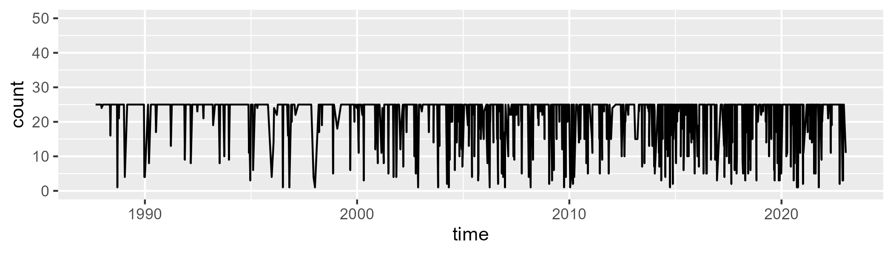

Min. : 1.00 1st Qu.:25.00 Median :25.00 Mean :22.39 3rd Qu.:25.00 Max. :25.00

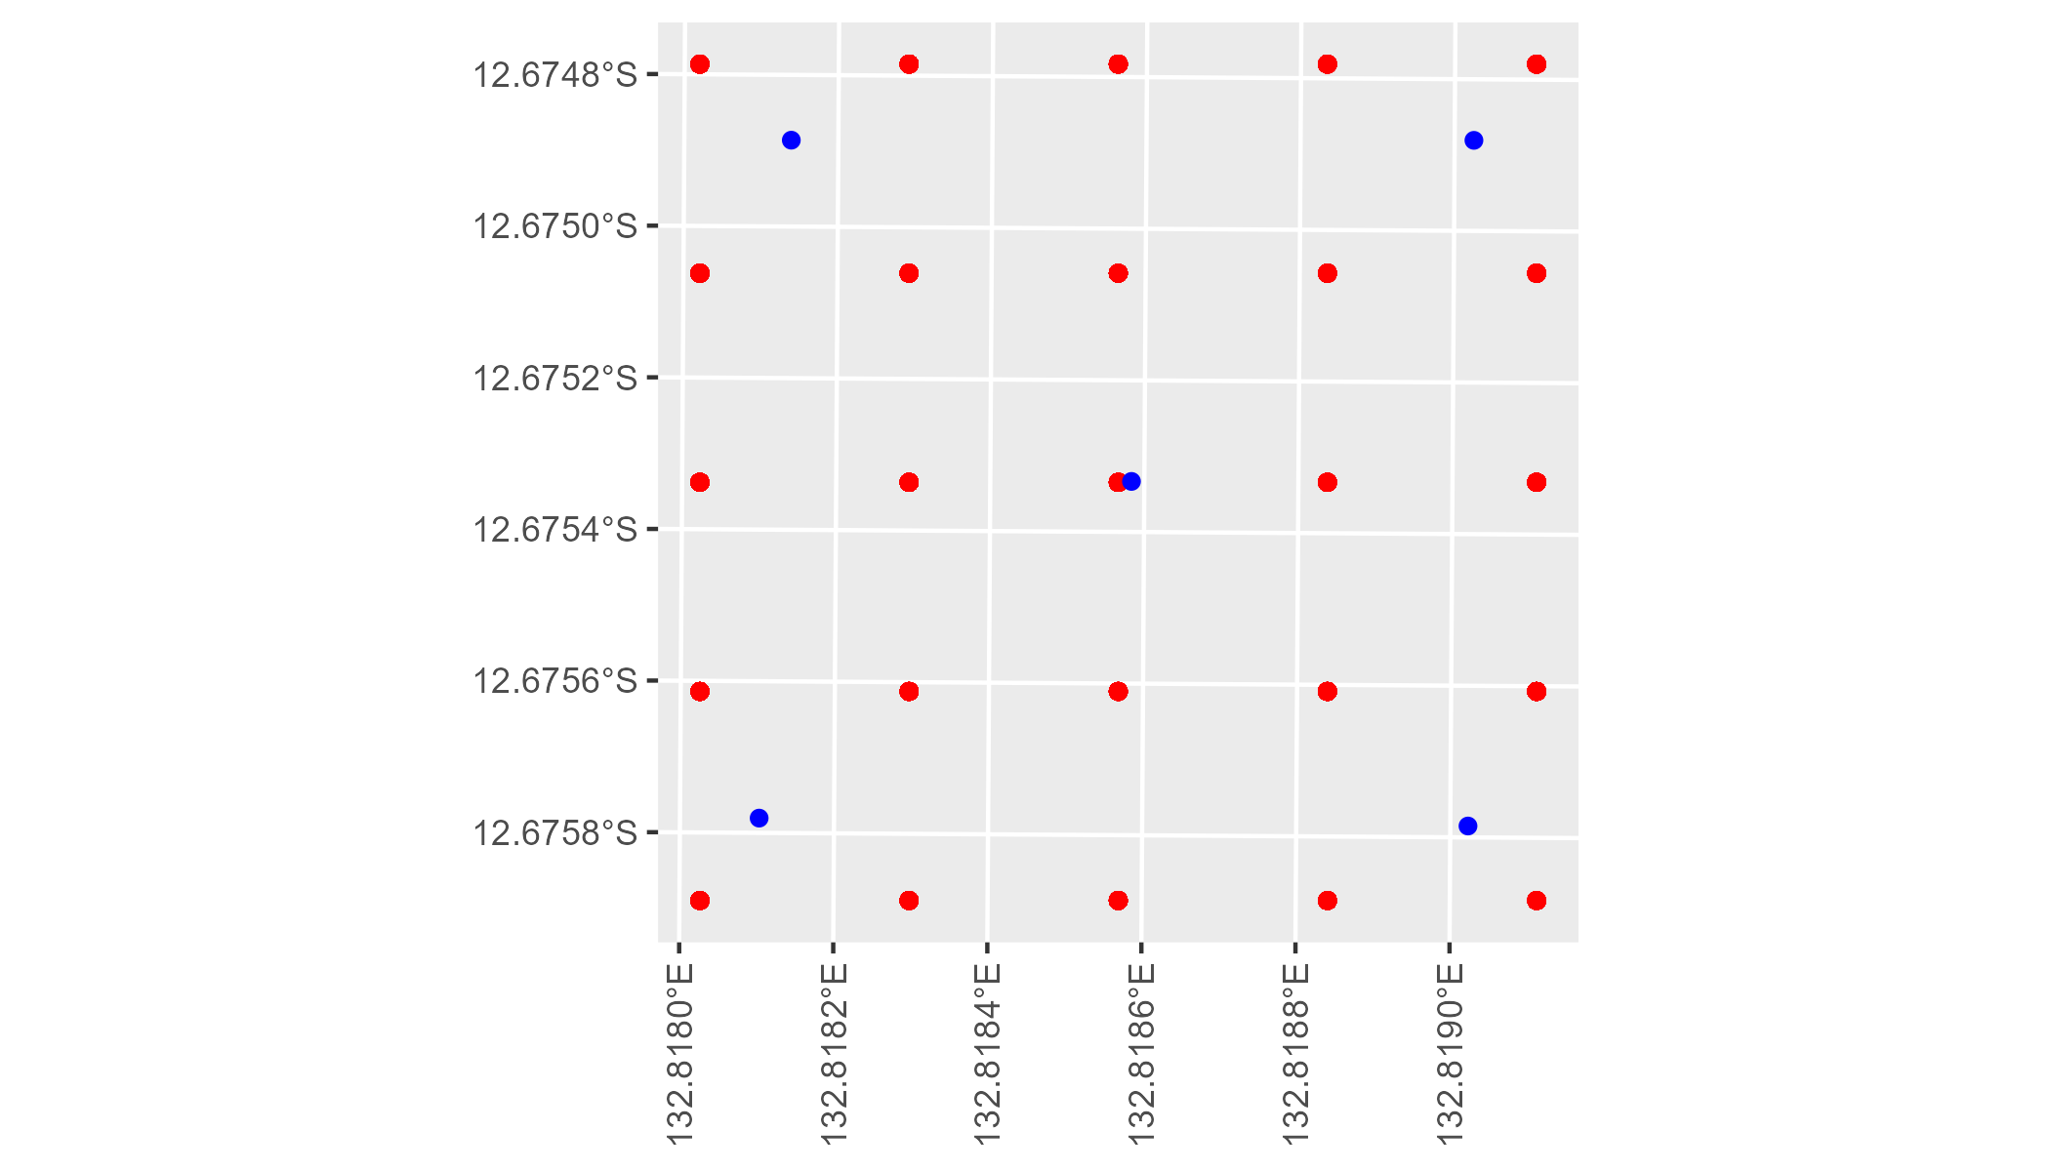

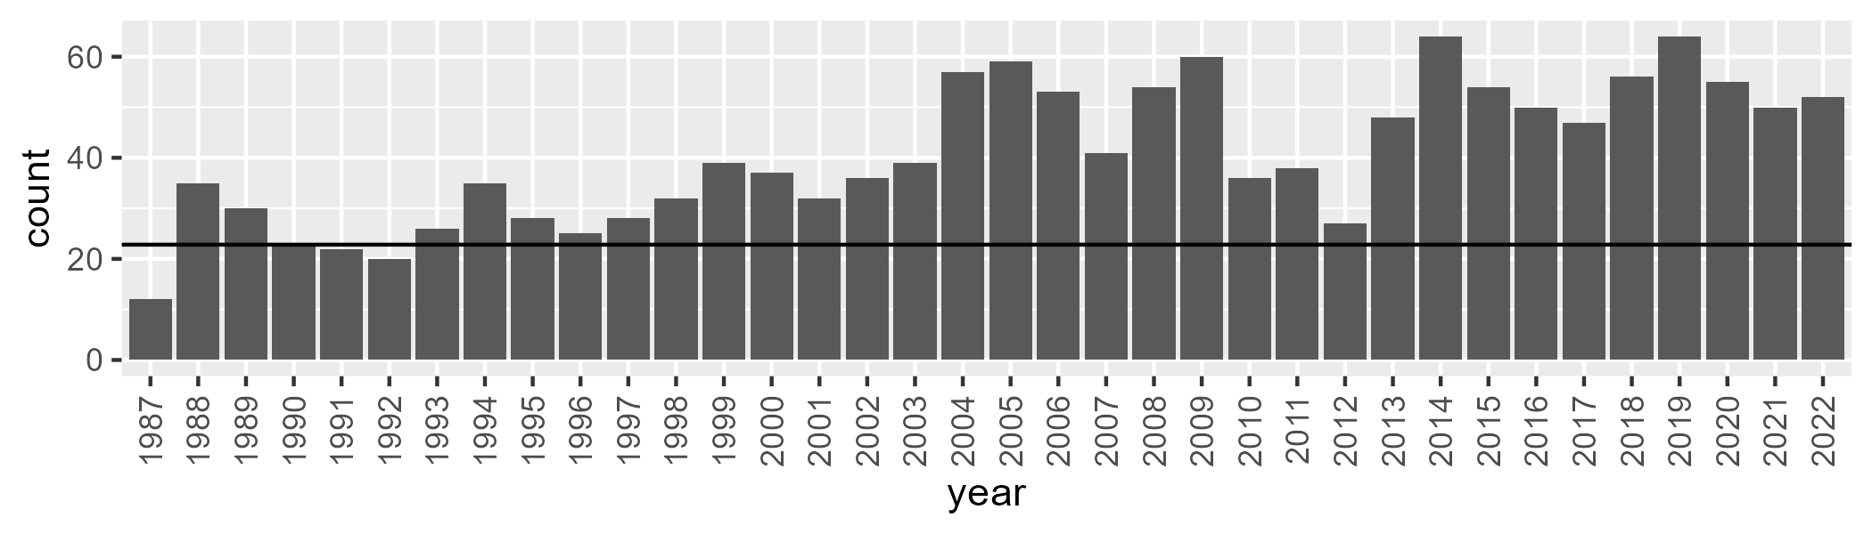

Number of samples: 1464

# NTAPCK0002

| Min. | 1st Qu. | Median | Mean | 3rd Qu. | Max. |
| --- | --- | --- | --- | --- | --- |
| 12.59372 | 39.85679 | 46.48855 | 48.82121 | 58.34356 | 76.87018 |

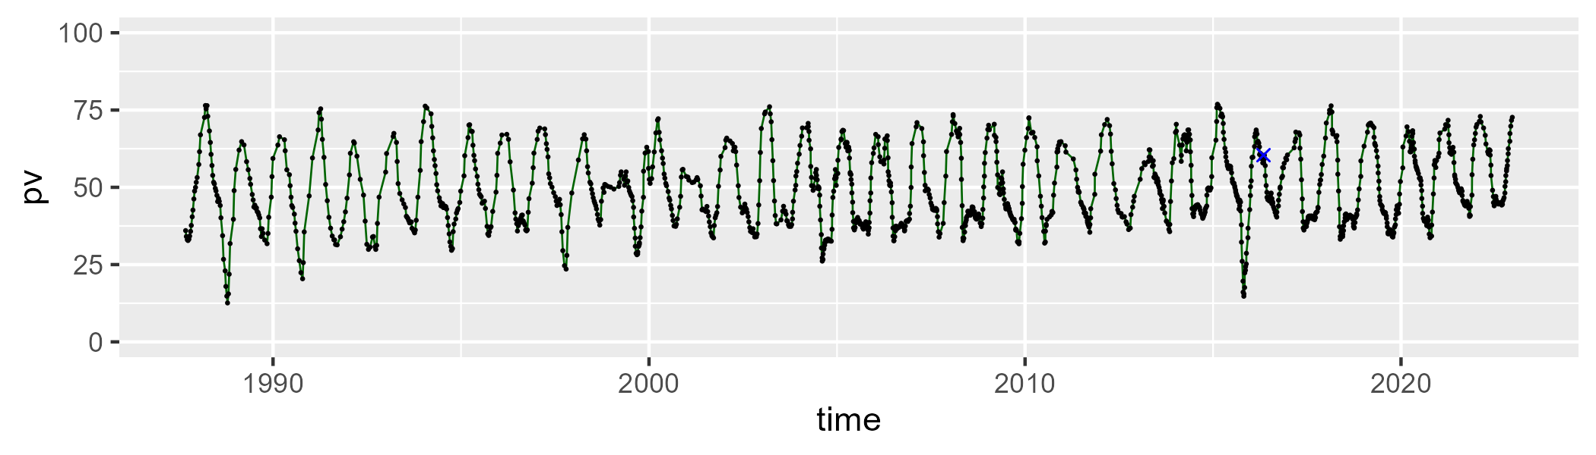

| Min. | 1st Qu. | Median | Mean | 3rd Qu. | Max. |
| --- | --- | --- | --- | --- | --- |
| 14.97751 | 34.34225 | 43.98886 | 41.14839 | 47.70167 | 63.49594 |

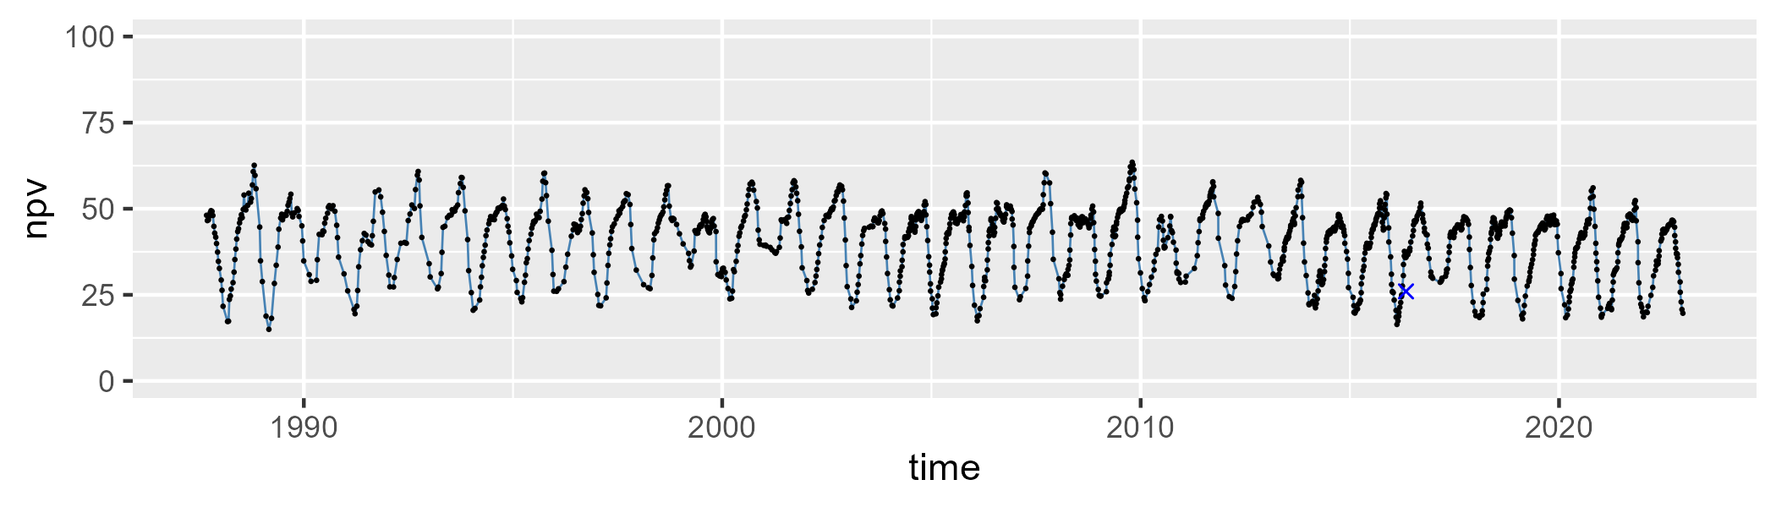

| Min. | 1st Qu. | Median | Mean | 3rd Qu. | Max. |
| --- | --- | --- | --- | --- | --- |
| 0 | 4.174998 | 7.445347 | 8.678933 | 12.22423 | 39.67419 |

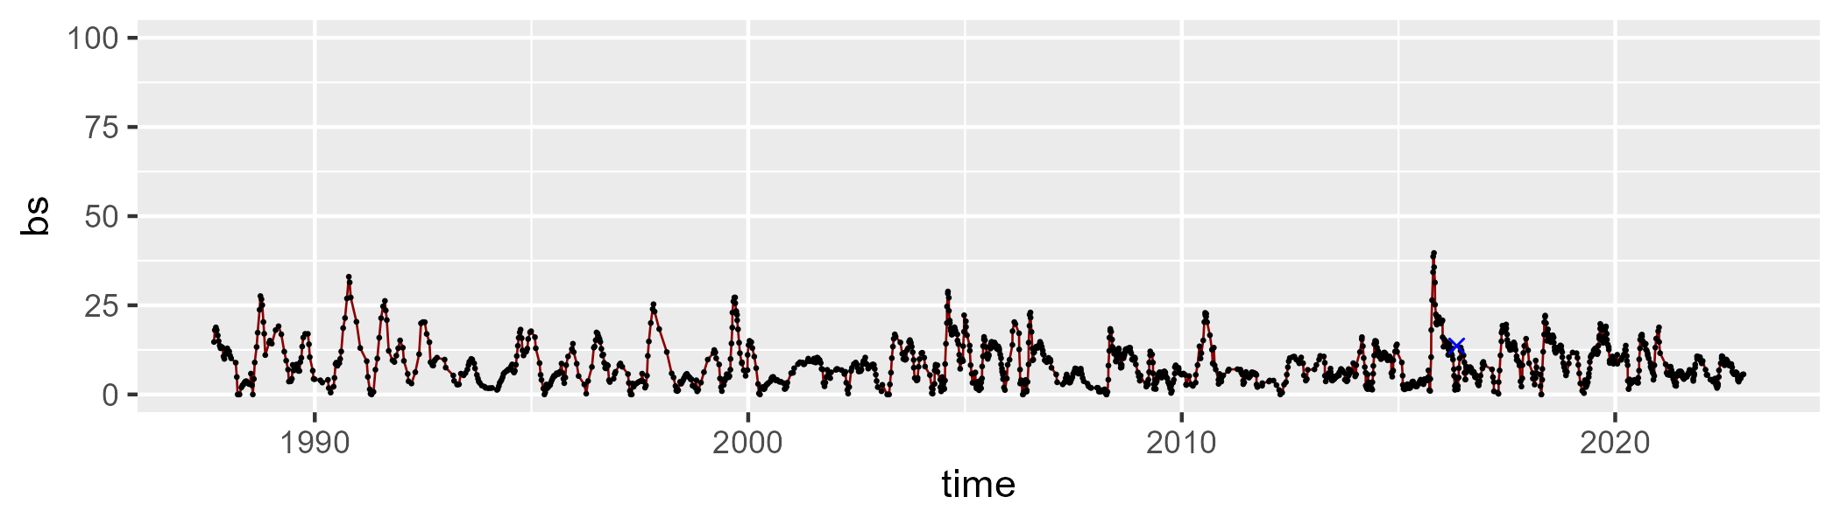

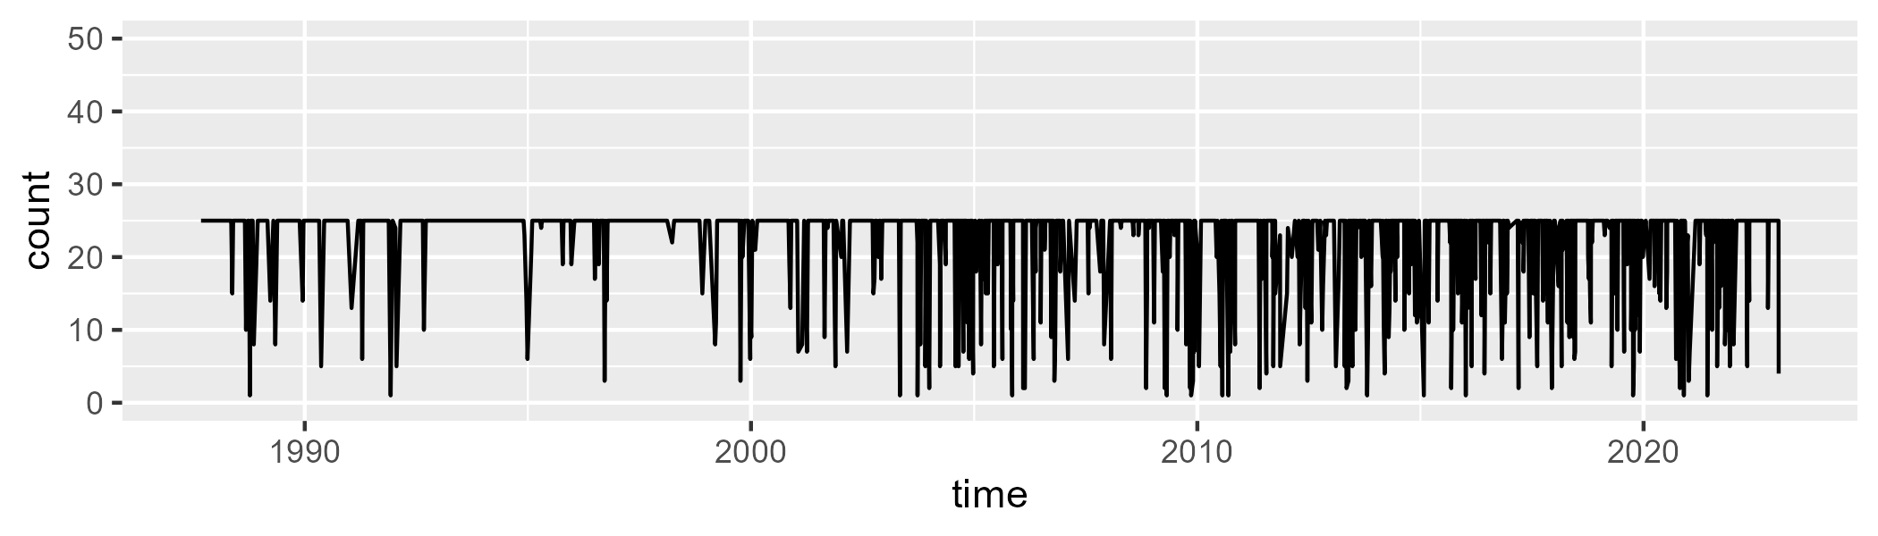

Min. : 1.00 1st Qu.:25.00 Median :25.00 Mean :22.55 3rd Qu.:25.00 Max. :25.00

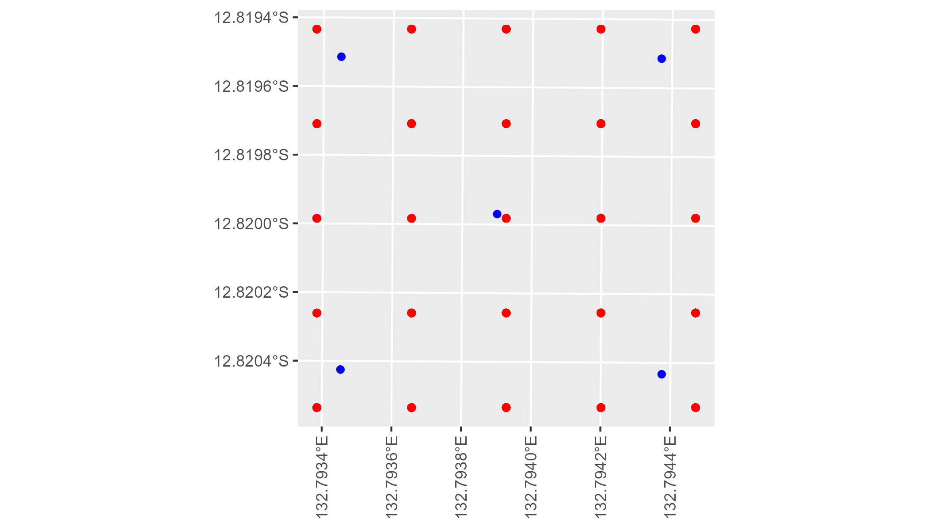

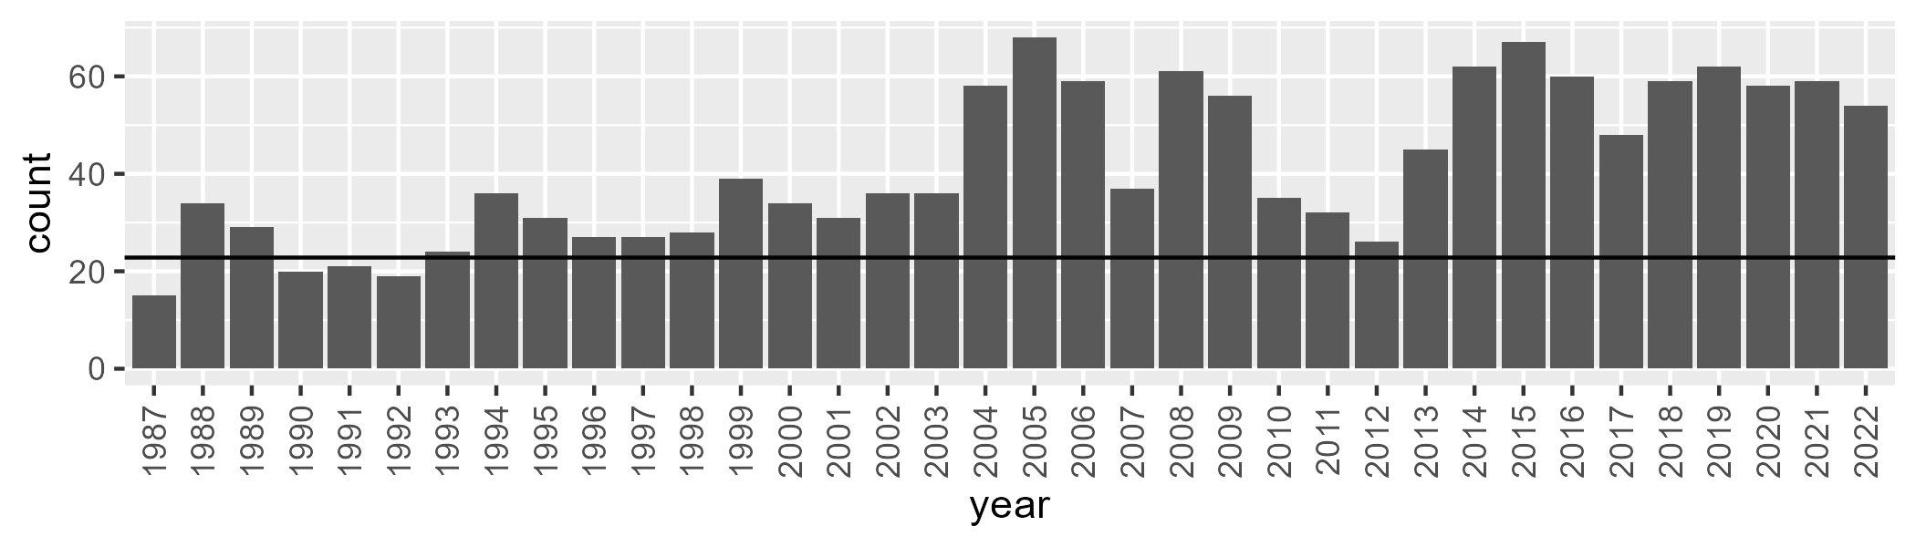

Number of samples: 1493

# NTAPCK0003

| Min. | 1st Qu. | Median | Mean | 3rd Qu. | Max. |
| --- | --- | --- | --- | --- | --- |
| 24.6867 | 39.31748 | 47.22911 | 49.91188 | 59.99482 | 83.9158 |

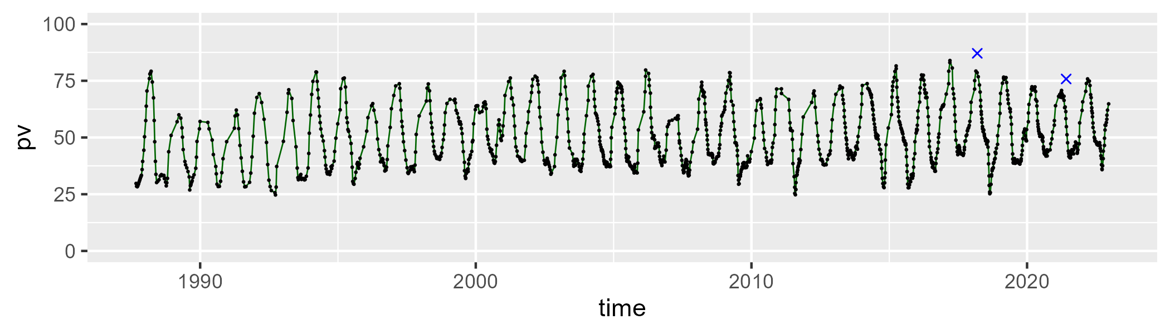

| Min. | 1st Qu. | Median | Mean | 3rd Qu. | Max. |
| --- | --- | --- | --- | --- | --- |
| 14.78998 | 32.58504 | 43.08373 | 39.68229 | 47.10972 | 59.68107 |

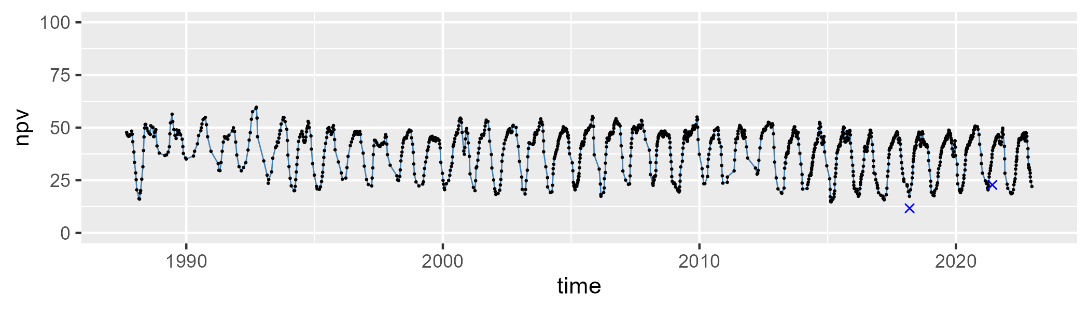

| Min. | 1st Qu. | Median | Mean | 3rd Qu. | Max. |
| --- | --- | --- | --- | --- | --- |
| 0 | 4.084199 | 8.264862 | 9.03847 | 12.98506 | 30.02343 |

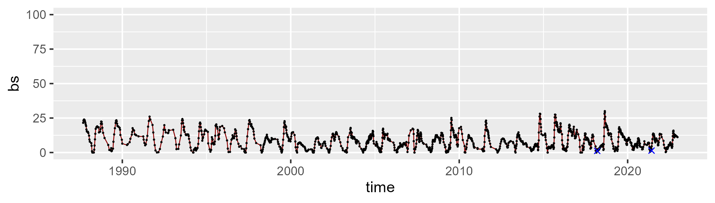

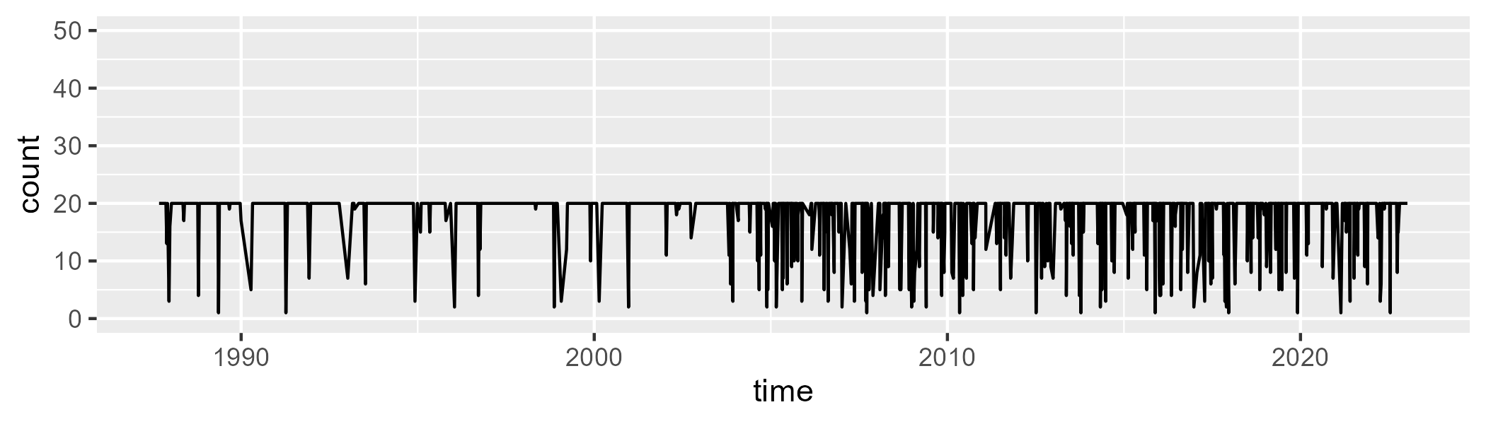

Min. : 1.00 1st Qu.:20.00 Median :20.00 Mean :18.31 3rd Qu.:20.00 Max. :20.00

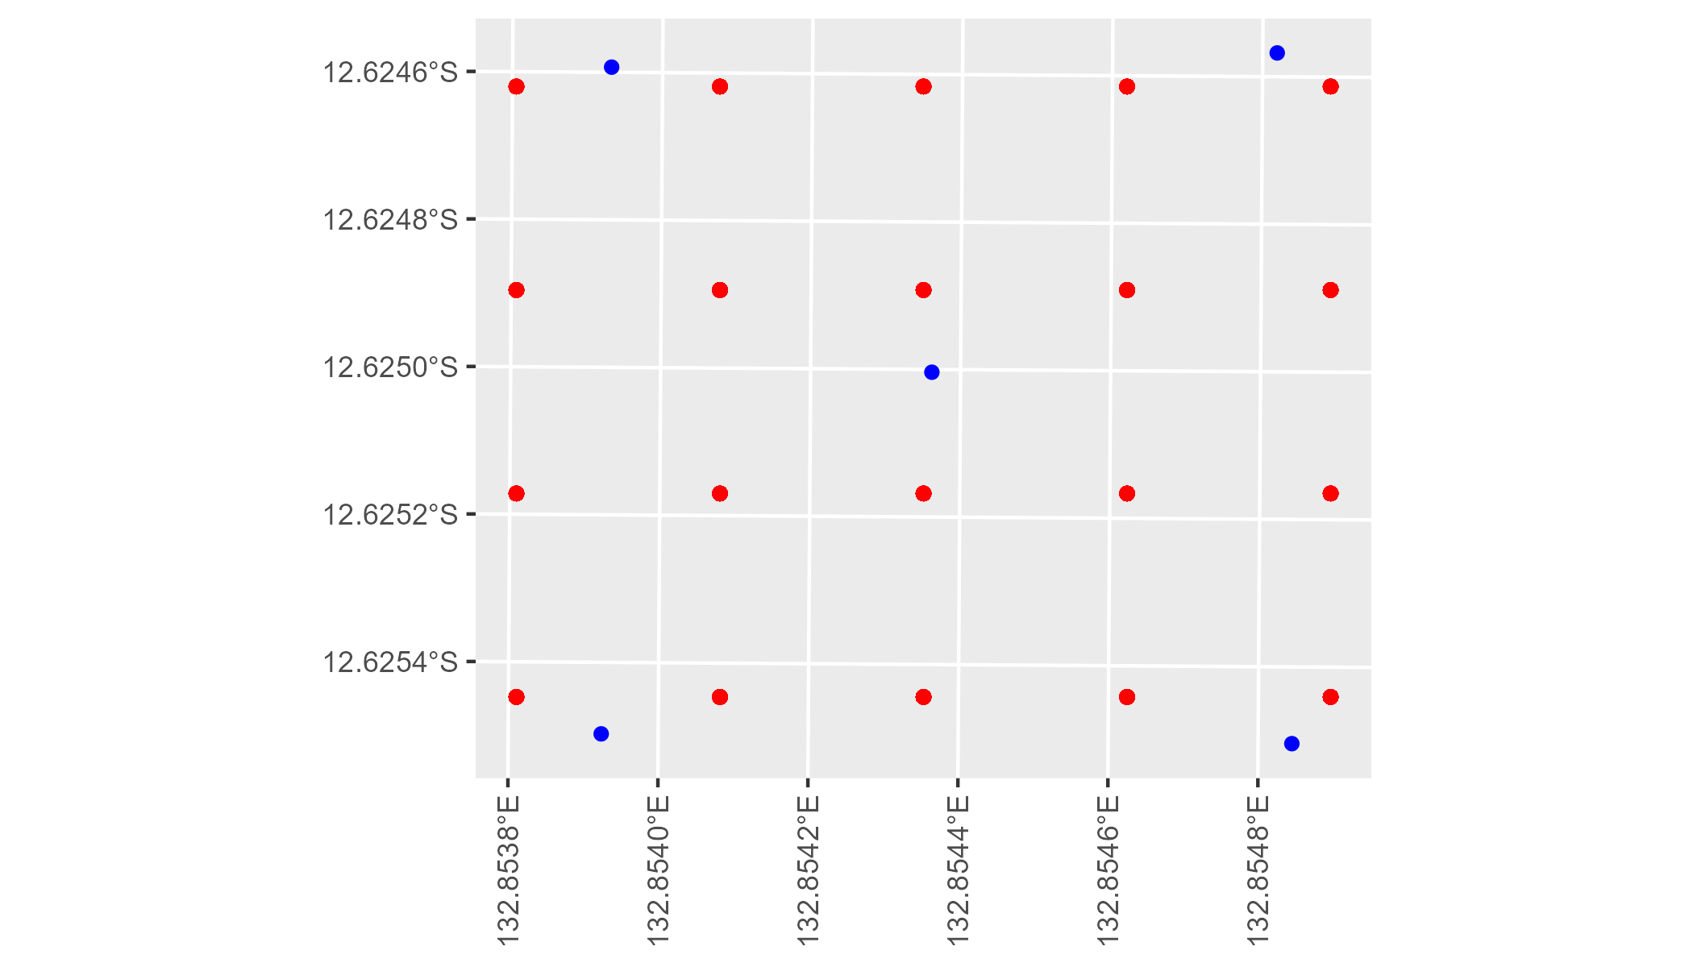

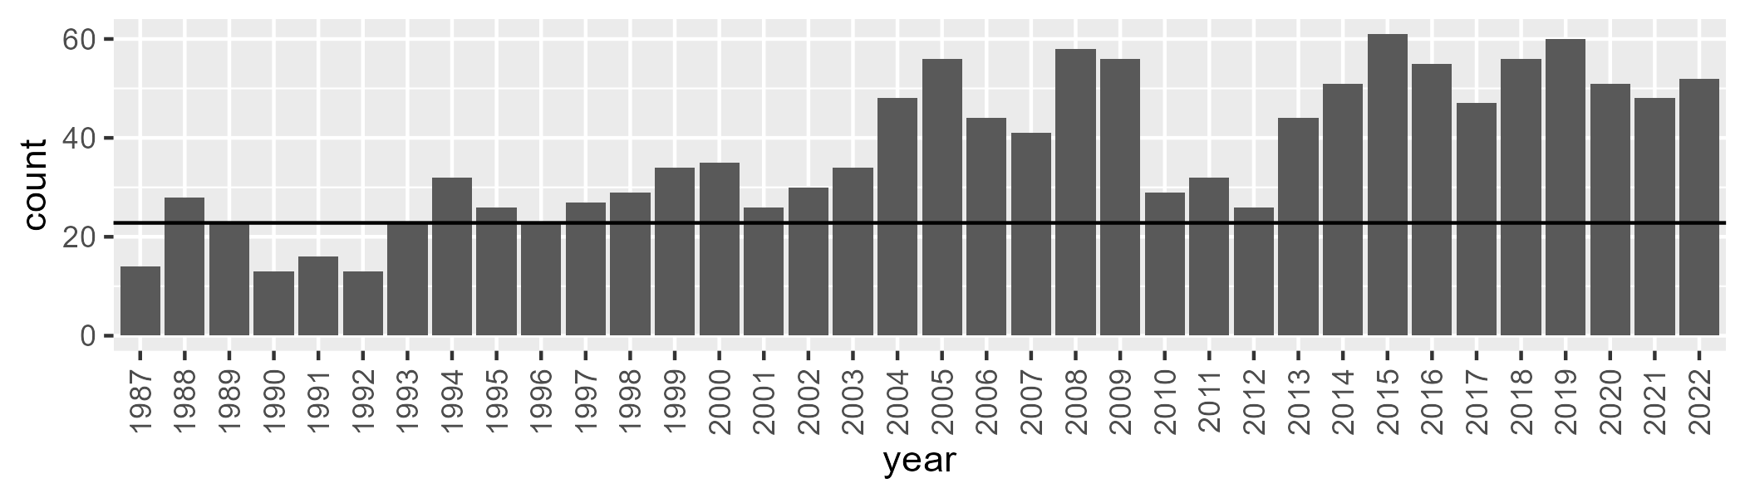

Number of samples: 1341

# NTAPCK0004

| Min. | 1st Qu. | Median | Mean | 3rd Qu. | Max. |
| --- | --- | --- | --- | --- | --- |
| 15.55723 | 29.72758 | 35.34525 | 39.64463 | 49.52225 | 69.87827 |

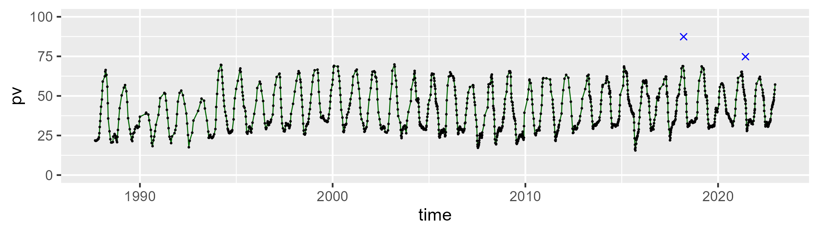

| Min. | 1st Qu. | Median | Mean | 3rd Qu. | Max. |
| --- | --- | --- | --- | --- | --- |
| 22.62016 | 42.44531 | 48.09265 | 45.96402 | 51.53637 | 65.06346 |

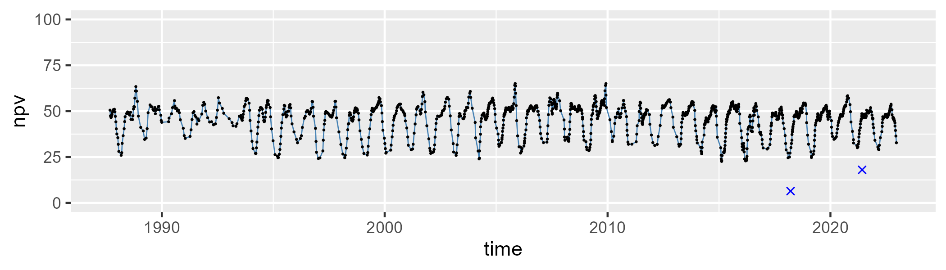

| Min. | 1st Qu. | Median | Mean | 3rd Qu. | Max. |
| --- | --- | --- | --- | --- | --- |
| 0 | 6.63043 | 12.72393 | 13.07013 | 18.58354 | 34.26509 |

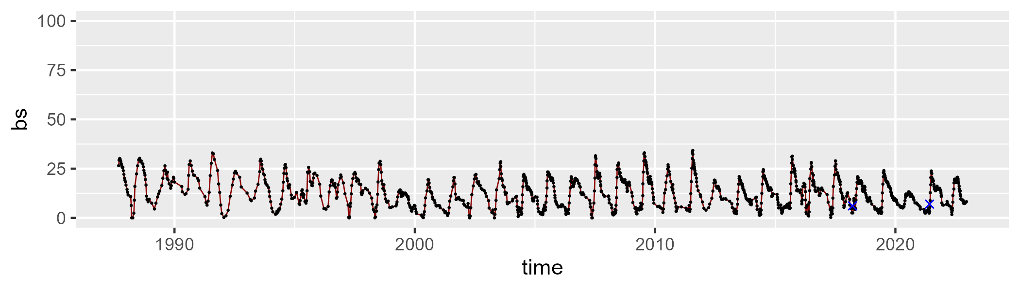

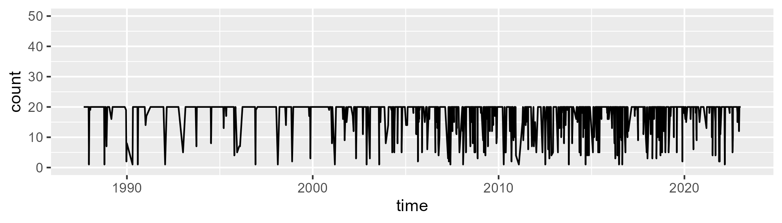

Min. : 1.00 1st Qu.:20.00 Median :20.00 Mean :18.16 3rd Qu.:20.00 Max. :20.00

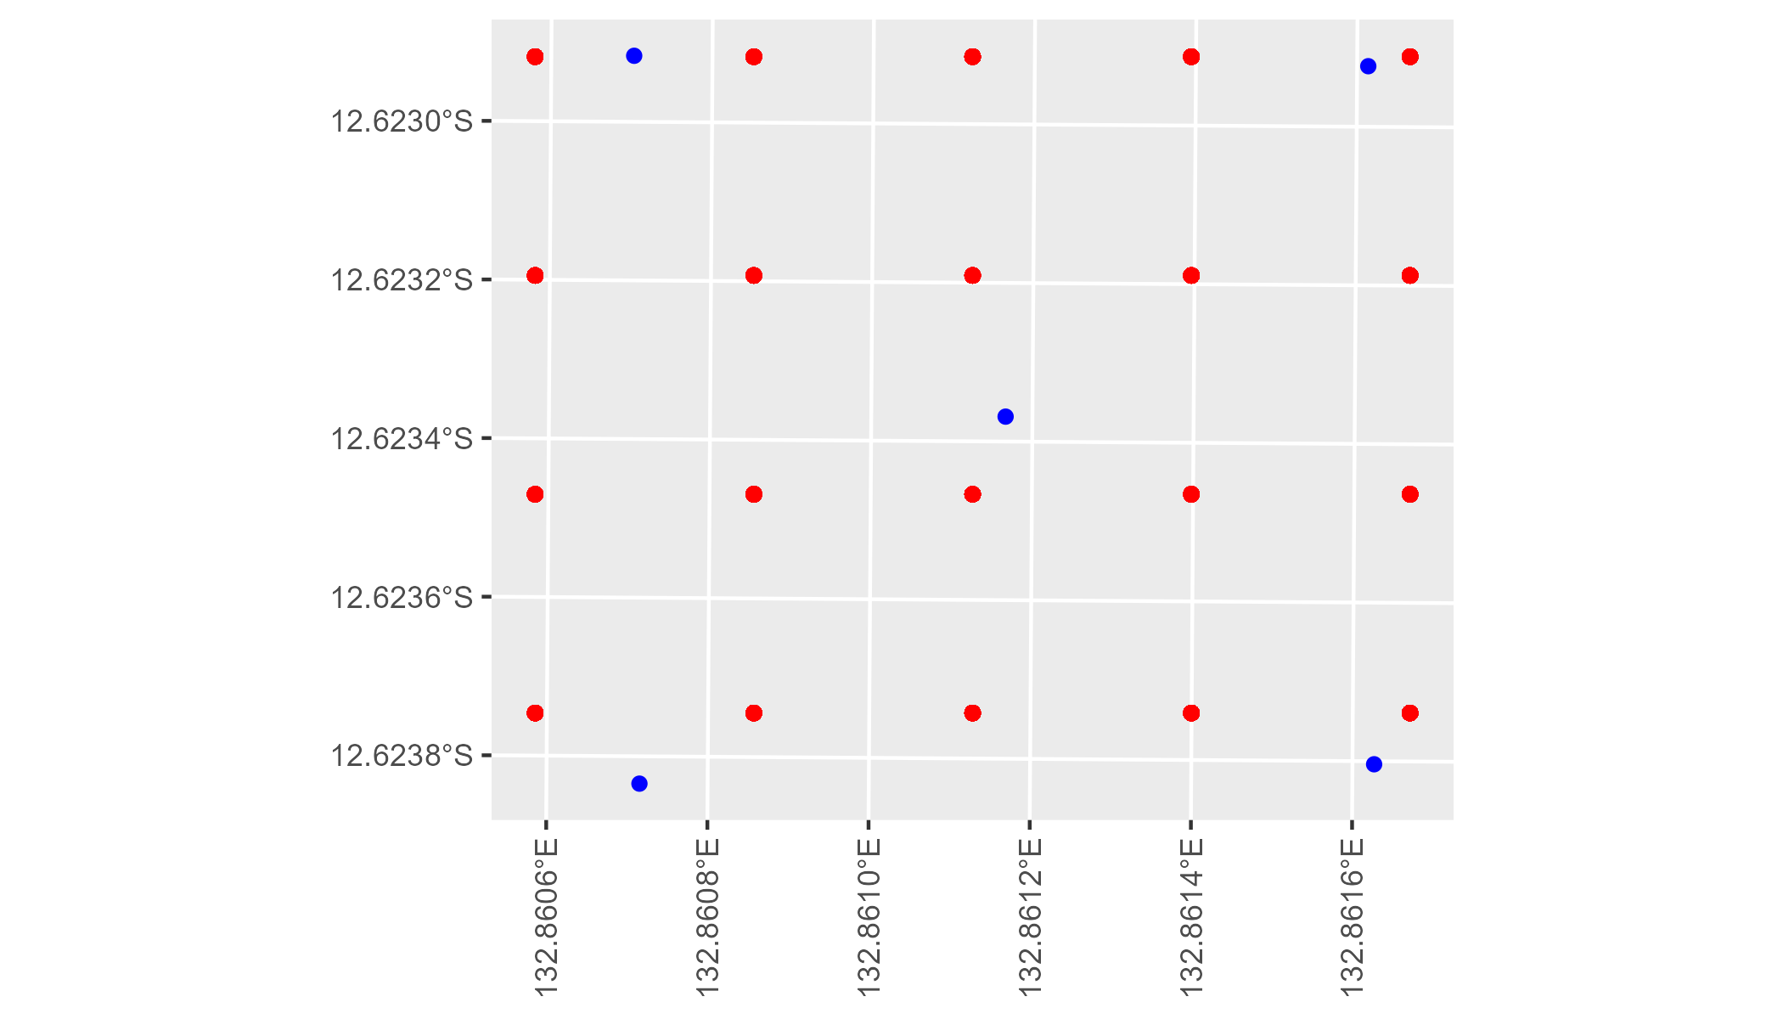

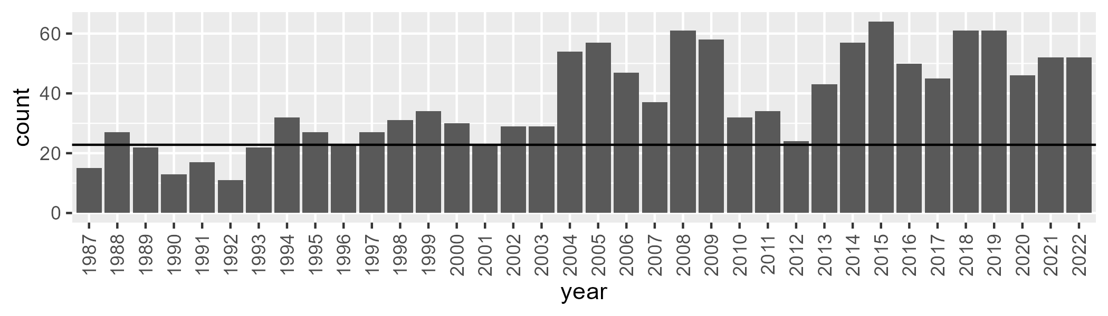

Number of samples: 1347

# NTAPCK0005

| Min. | 1st Qu. | Median | Mean | 3rd Qu. | Max. |
| --- | --- | --- | --- | --- | --- |
| 14.82909 | 30.03754 | 36.12067 | 41.37715 | 53.78631 | 79.54698 |

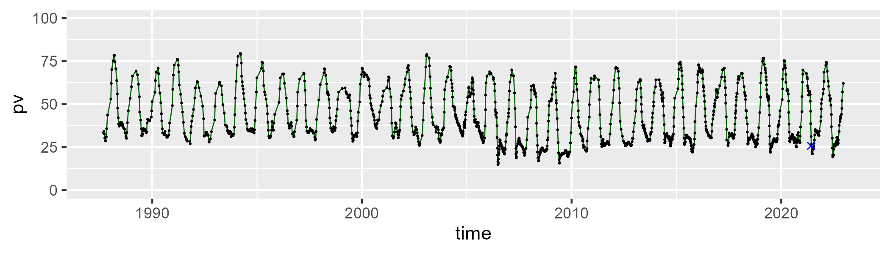

| Min. | 1st Qu. | Median | Mean | 3rd Qu. | Max. |
| --- | --- | --- | --- | --- | --- |
| 16.72229 | 39.71095 | 49.7027 | 45.669 | 52.7314 | 64.3003 |

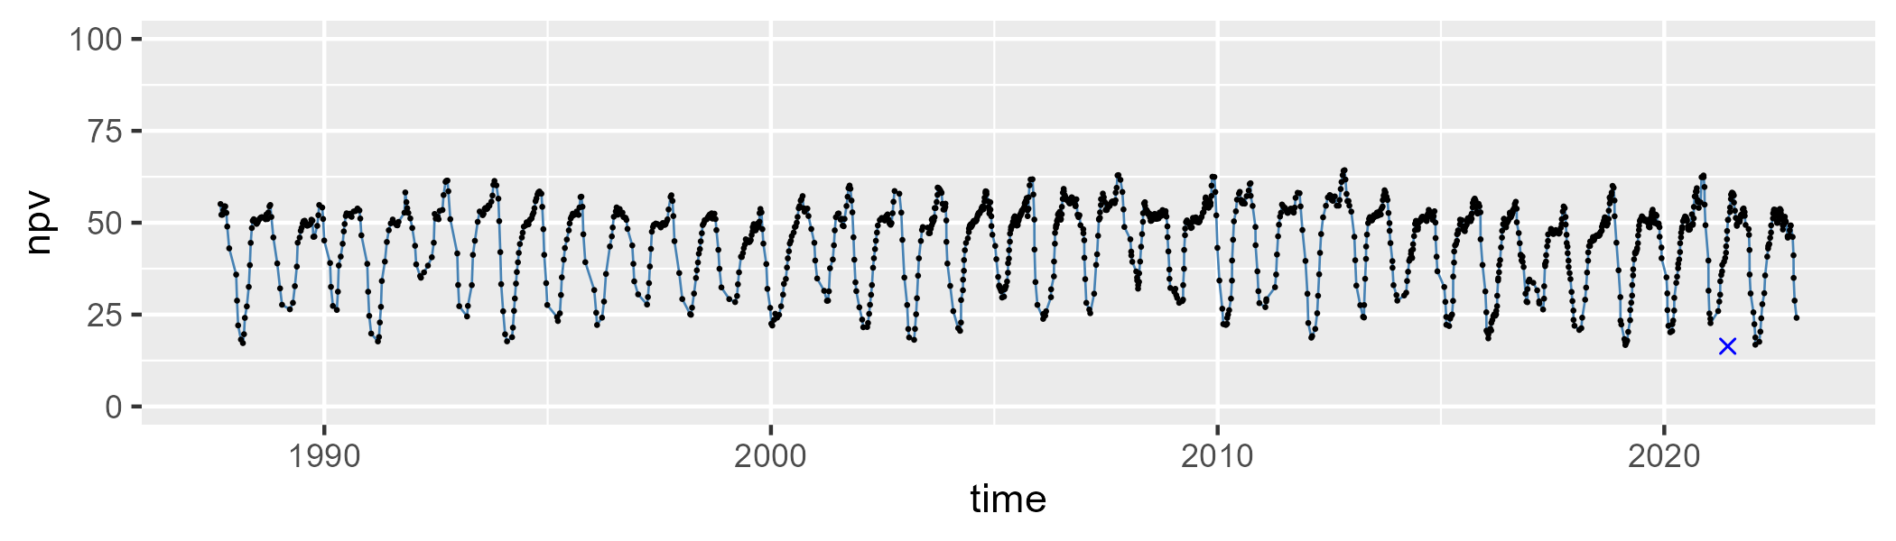

| Min. | 1st Qu. | Median | Mean | 3rd Qu. | Max. |
| --- | --- | --- | --- | --- | --- |
| 0 | 6.319716 | 11.55015 | 11.70613 | 16.68384 | 33.99091 |

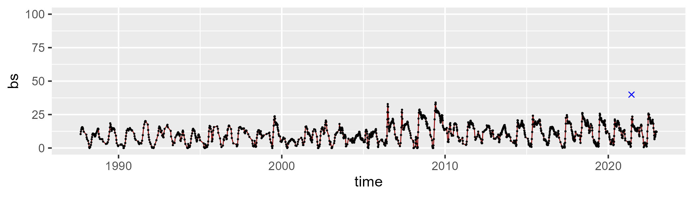

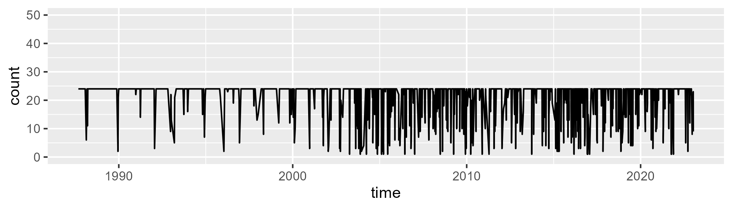

Min. : 1.00 1st Qu.:24.00 Median :24.00 Mean :21.45 3rd Qu.:24.00 Max. :24.00

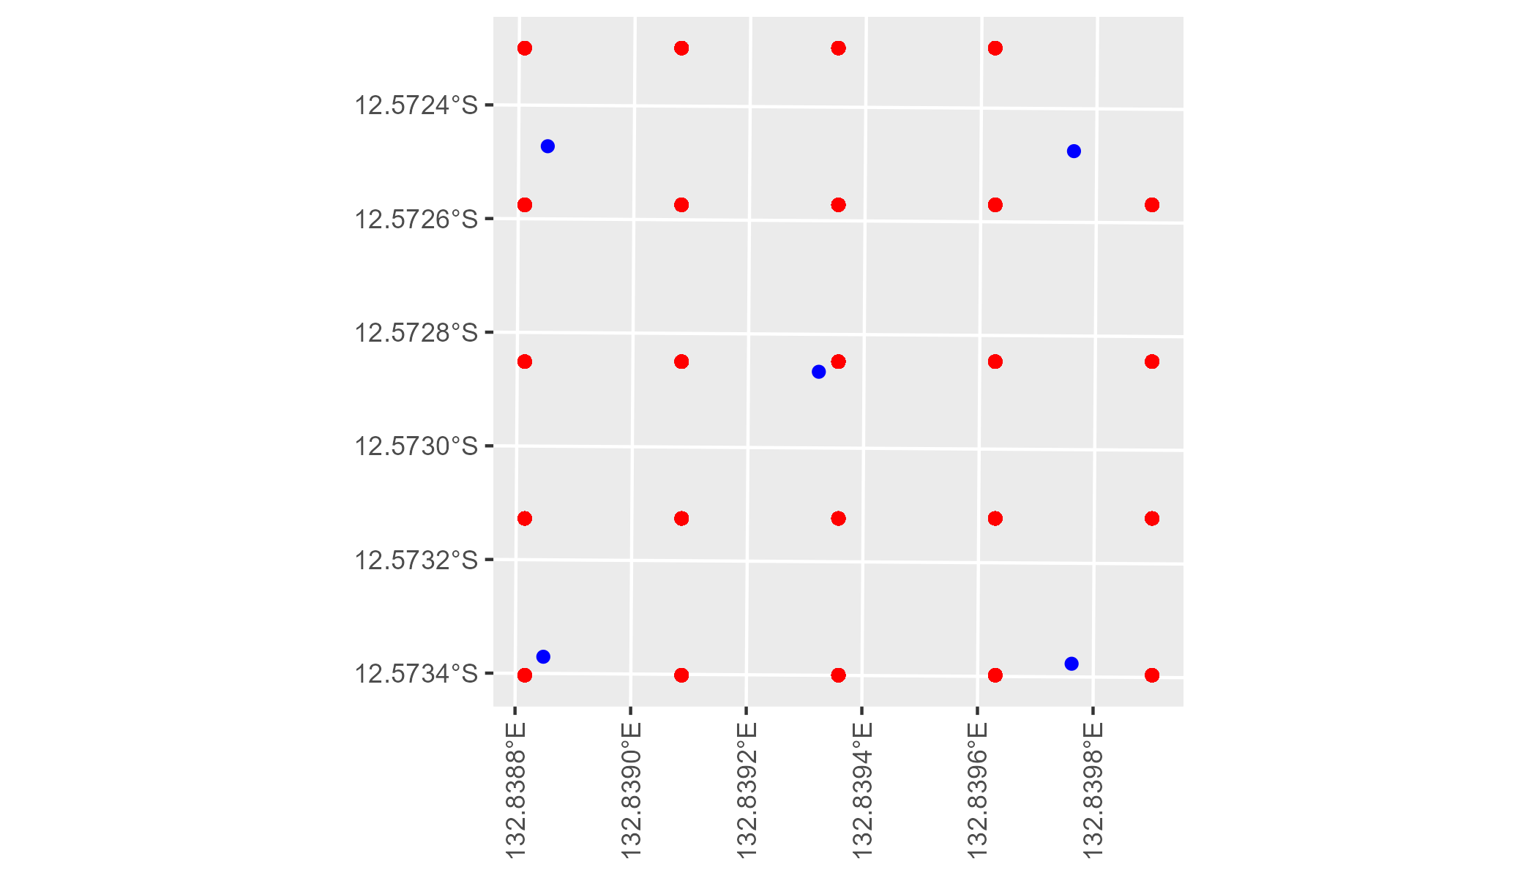

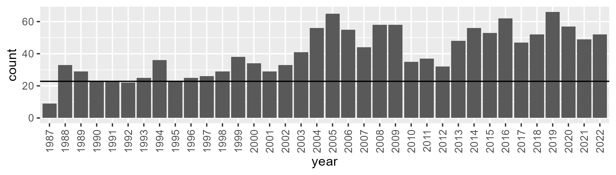

Number of samples: 1460

# NTAPCK0006

| Min. | 1st Qu. | Median | Mean | 3rd Qu. | Max. |
| --- | --- | --- | --- | --- | --- |
| 4.242192 | 20.85924 | 29.28053 | 30.72525 | 41.23257 | 57.83217 |

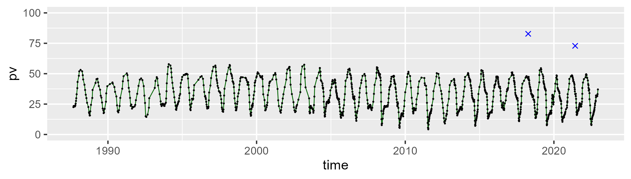

| Min. | 1st Qu. | Median | Mean | 3rd Qu. | Max. |
| --- | --- | --- | --- | --- | --- |
| 29.07824 | 48.01667 | 52.37684 | 51.58896 | 55.84304 | 70.39932 |

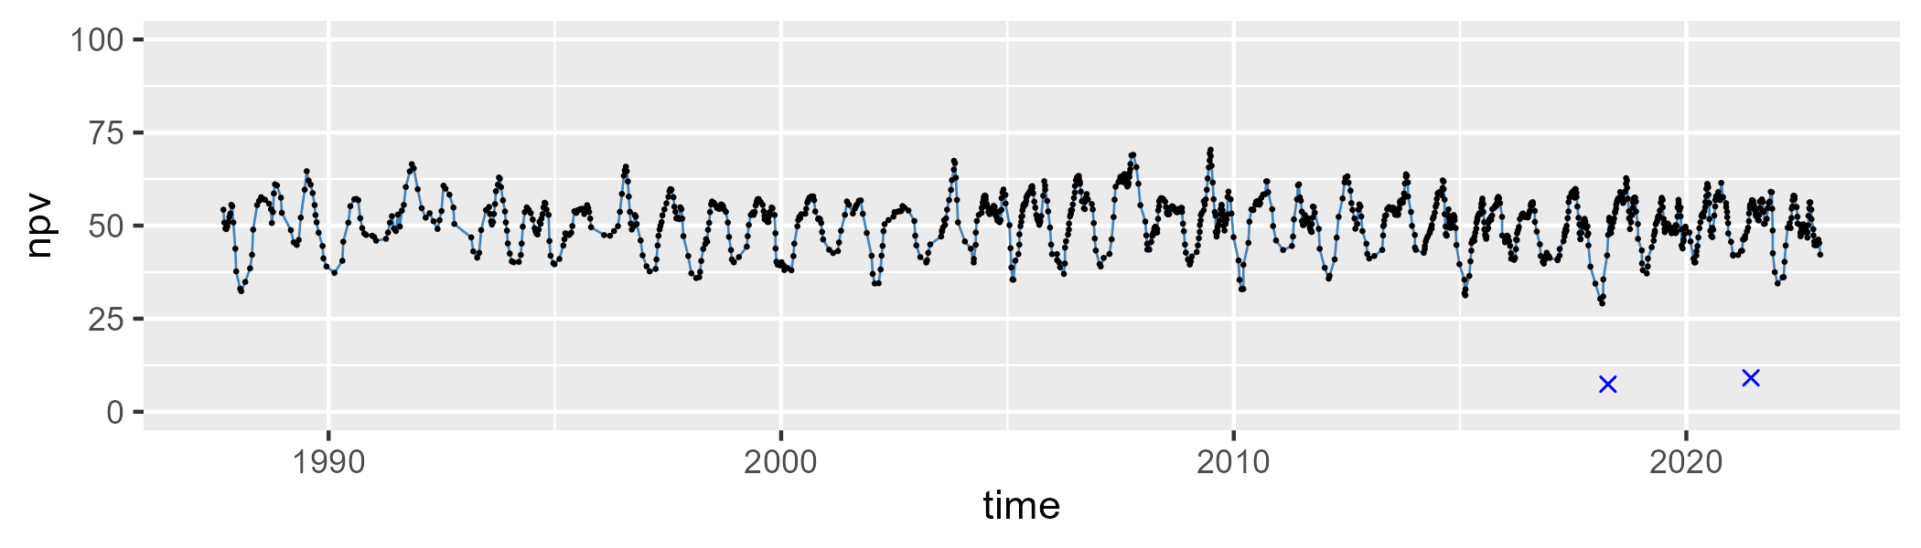

| Min. | 1st Qu. | Median | Mean | 3rd Qu. | Max. |
| --- | --- | --- | --- | --- | --- |
| 0 | 8.081245 | 14.84017 | 16.44009 | 23.54591 | 46.06807 |

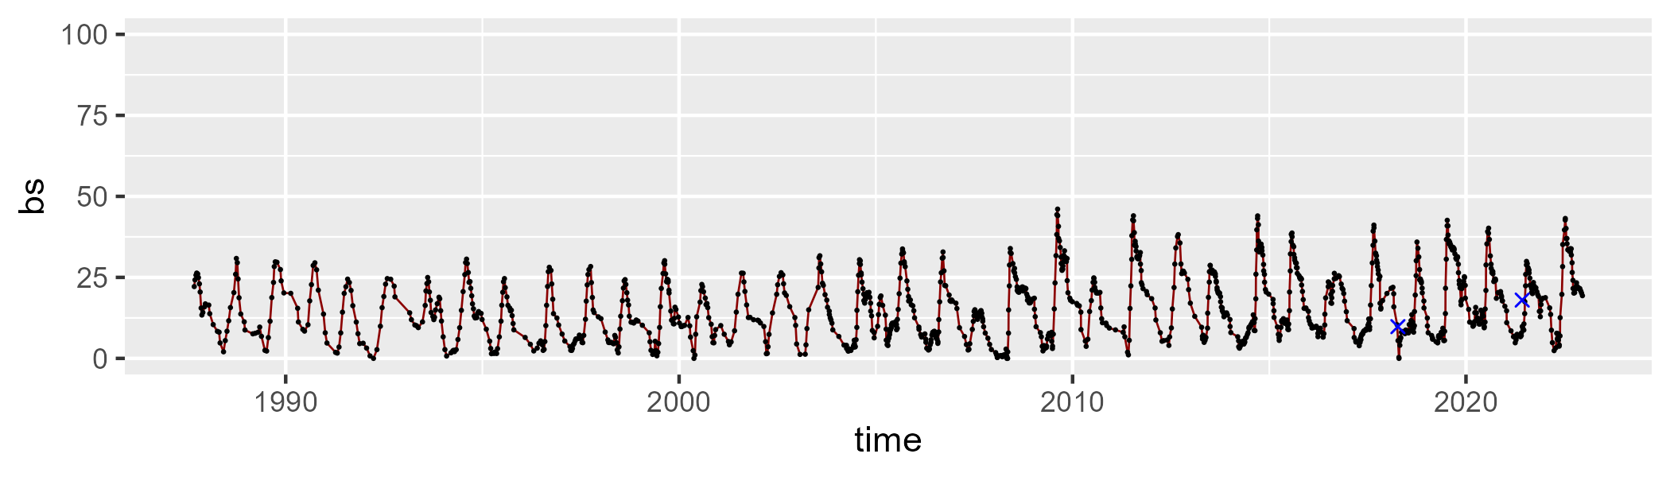

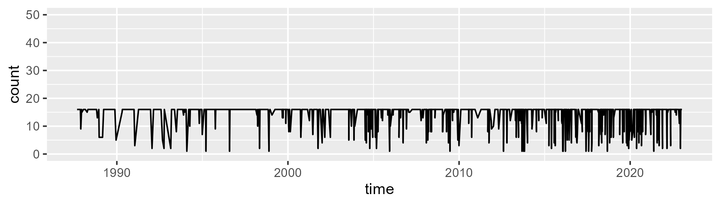

Min. : 1.00 1st Qu.:16.00 Median :16.00 Mean :14.64 3rd Qu.:16.00 Max. :16.00

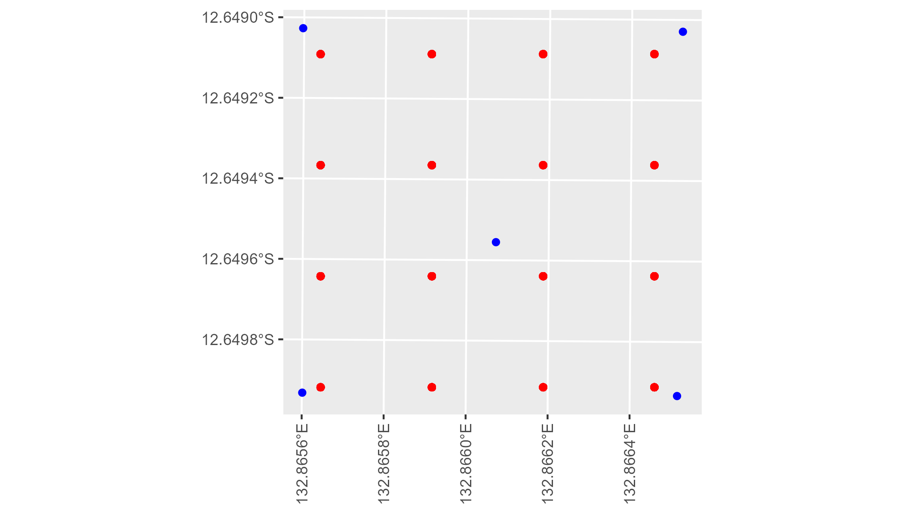

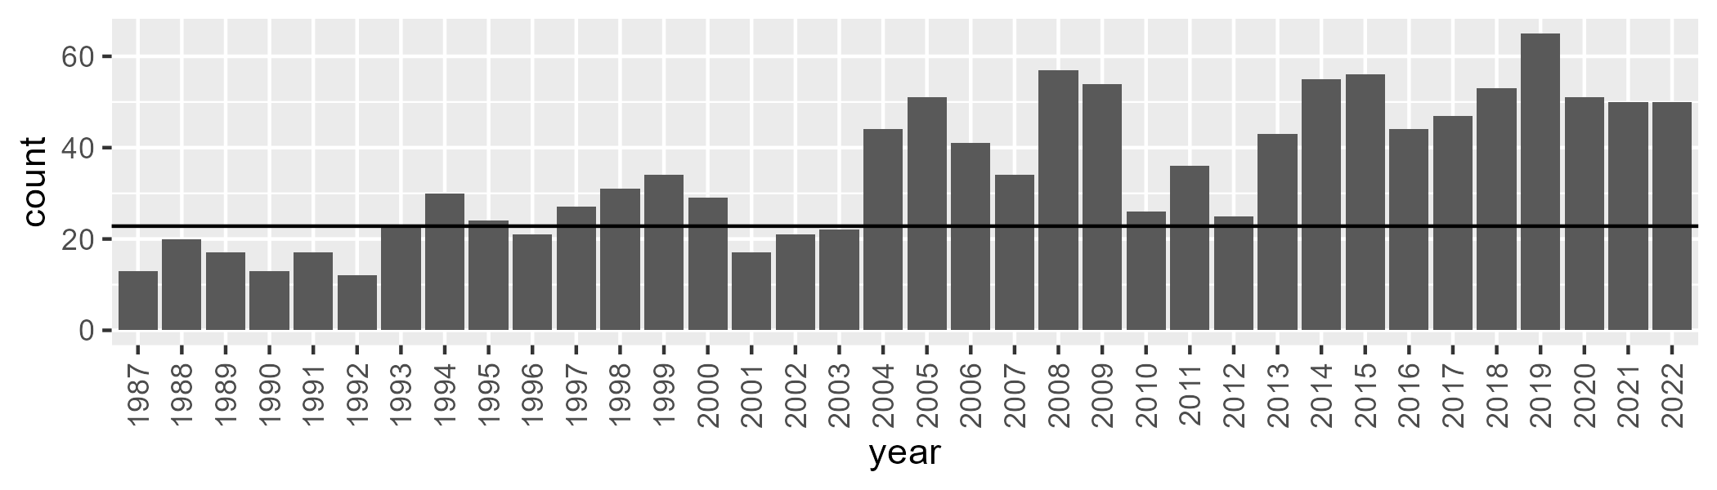

Number of samples: 1253

# NTAPCK0007

| Min. | 1st Qu. | Median | Mean | 3rd Qu. | Max. |
| --- | --- | --- | --- | --- | --- |
| 19.66457 | 31.76988 | 38.48831 | 41.59746 | 52.32224 | 69.28736 |

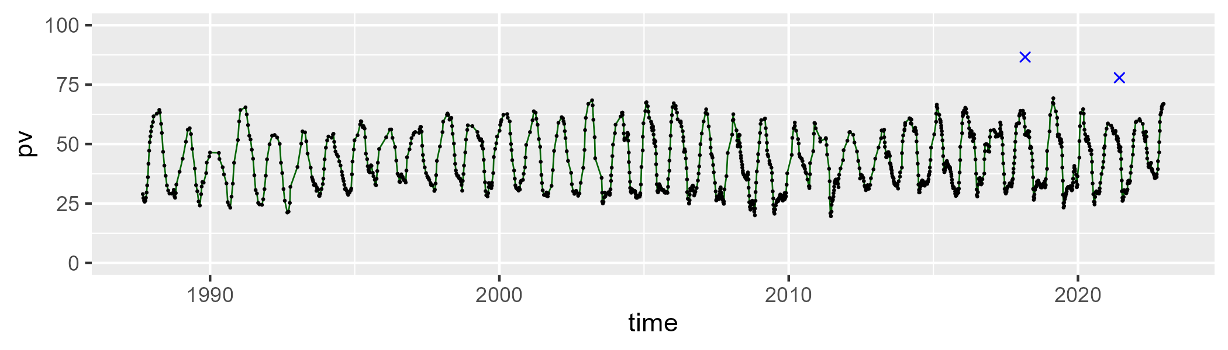

| Min. | 1st Qu. | Median | Mean | 3rd Qu. | Max. |
| --- | --- | --- | --- | --- | --- |
| 23.90359 | 41.93956 | 49.74425 | 47.44242 | 53.21597 | 67.9194 |

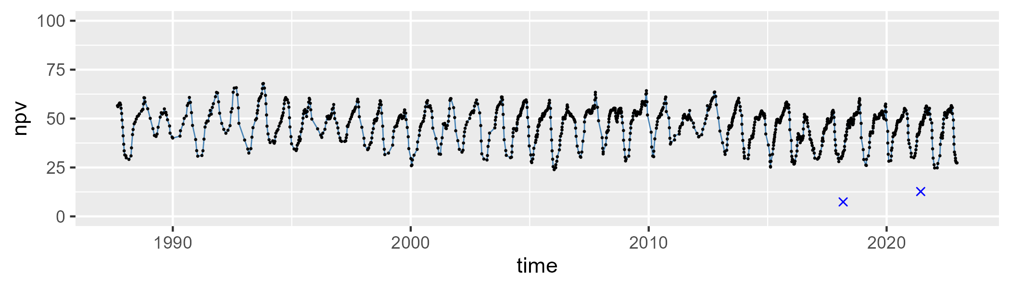

| Min. | 1st Qu. | Median | Mean | 3rd Qu. | Max. |
| --- | --- | --- | --- | --- | --- |
| 0 | 5.083448 | 8.964804 | 9.669558 | 13.6306 | 28.02515 |

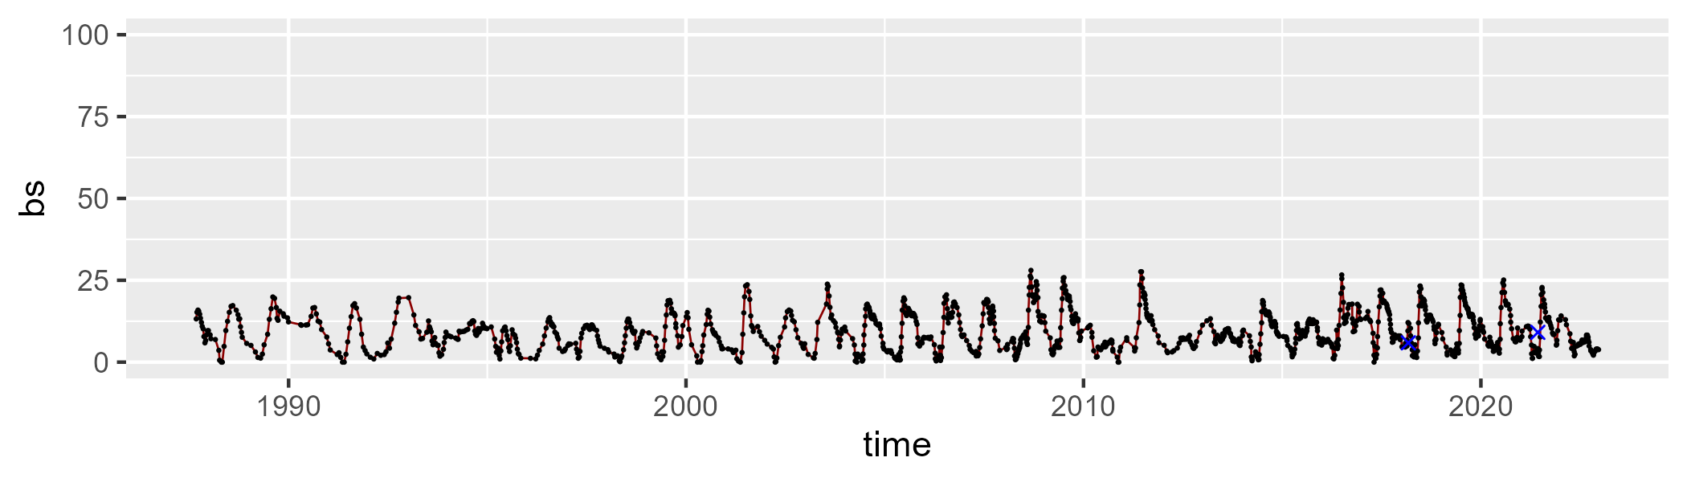

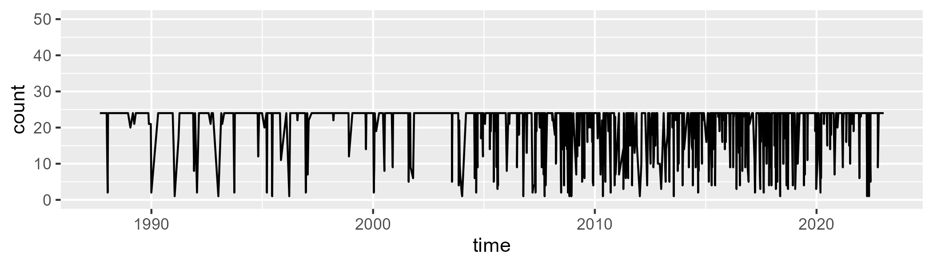

Min. : 1.00 1st Qu.:24.00 Median :24.00 Mean :21.52 3rd Qu.:24.00 Max. :24.00

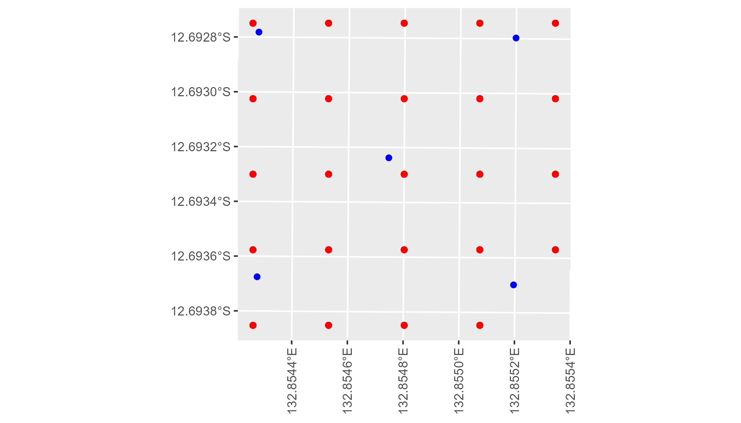

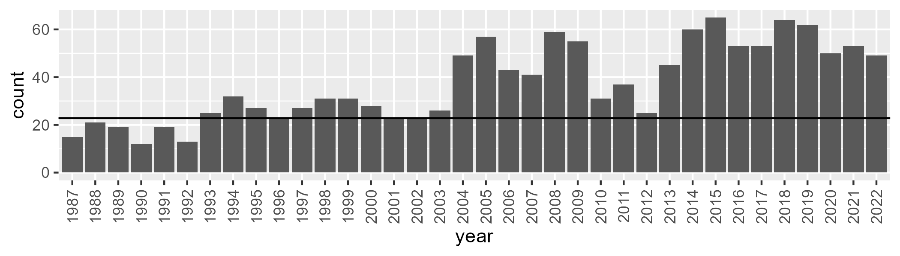

Number of samples: 1346

# NTAPCK1009

| Min. | 1st Qu. | Median | Mean | 3rd Qu. | Max. |
| --- | --- | --- | --- | --- | --- |
| 8.591293 | 35.85067 | 45.35709 | 43.09916 | 50.88732 | 65.9754 |

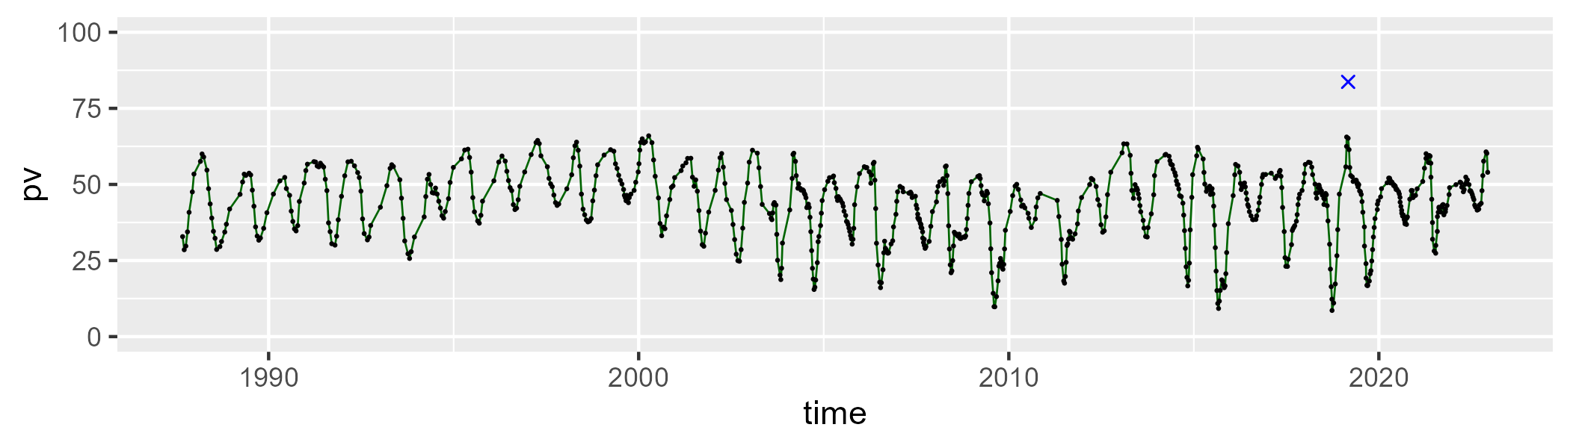

| Min. | 1st Qu. | Median | Mean | 3rd Qu. | Max. |
| --- | --- | --- | --- | --- | --- |
| 22.88421 | 39.65032 | 44.82016 | 44.75724 | 50.03822 | 65.86701 |

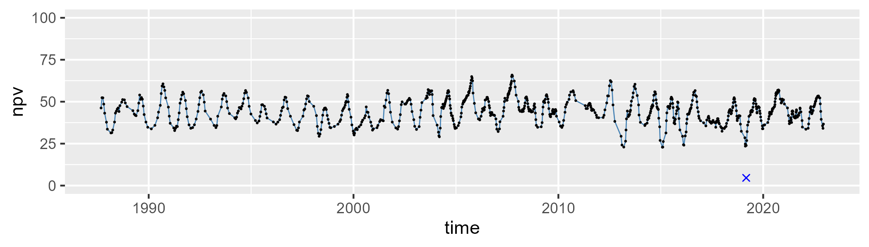

| Min. | 1st Qu. | Median | Mean | 3rd Qu. | Max. |
| --- | --- | --- | --- | --- | --- |
| 0 | 3.38502 | 6.821286 | 10.95156 | 16.8437 | 50.72075 |

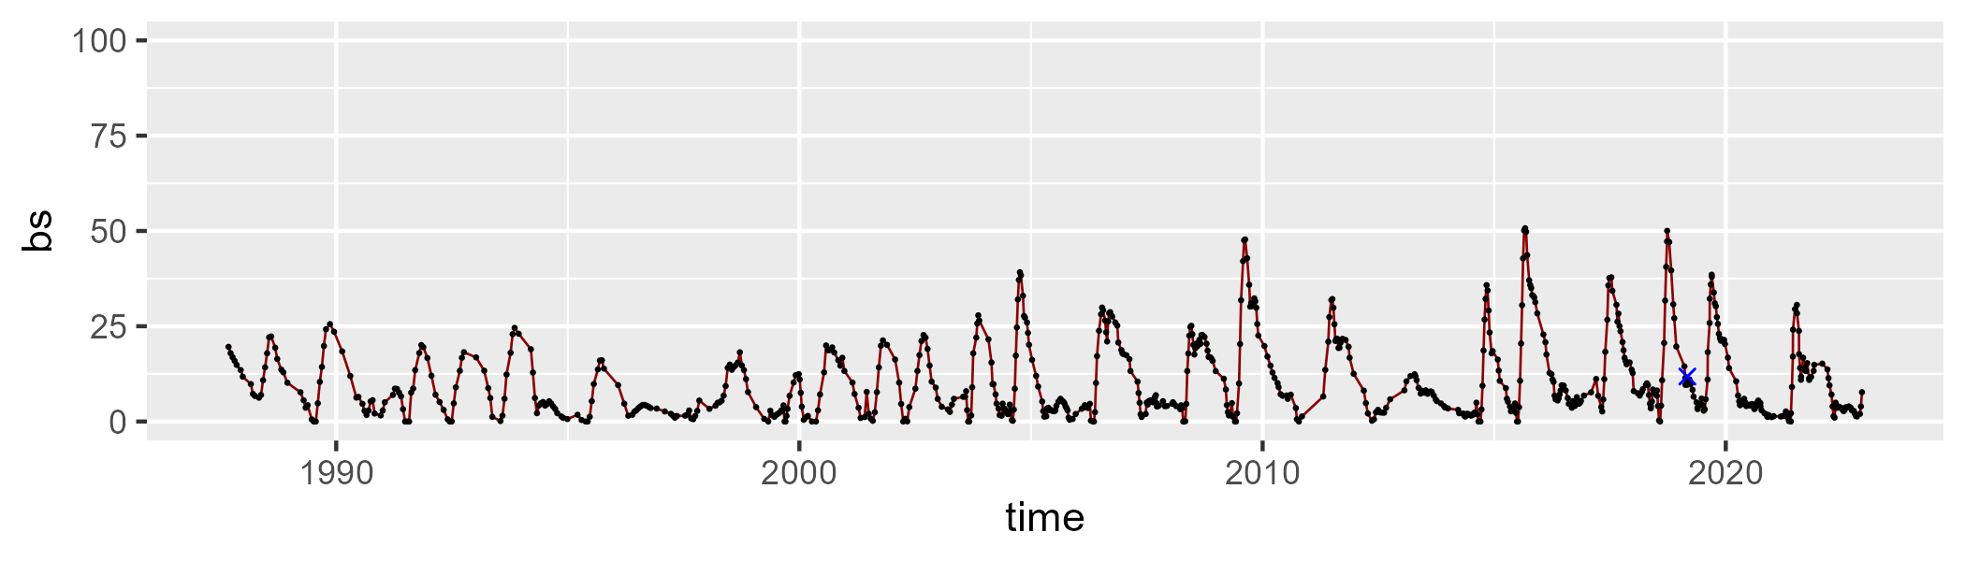

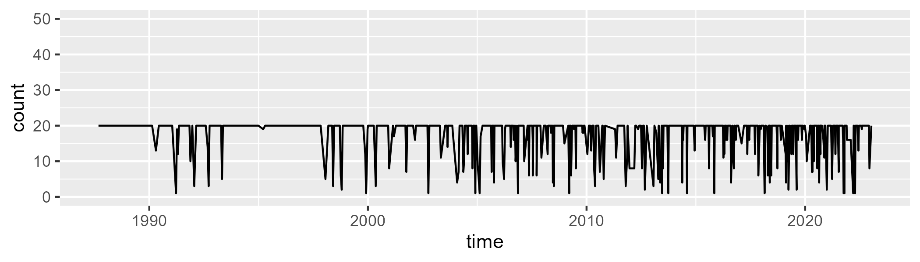

Min. : 1.00 1st Qu.:20.00 Median :20.00 Mean :17.96 3rd Qu.:20.00 Max. :20.00

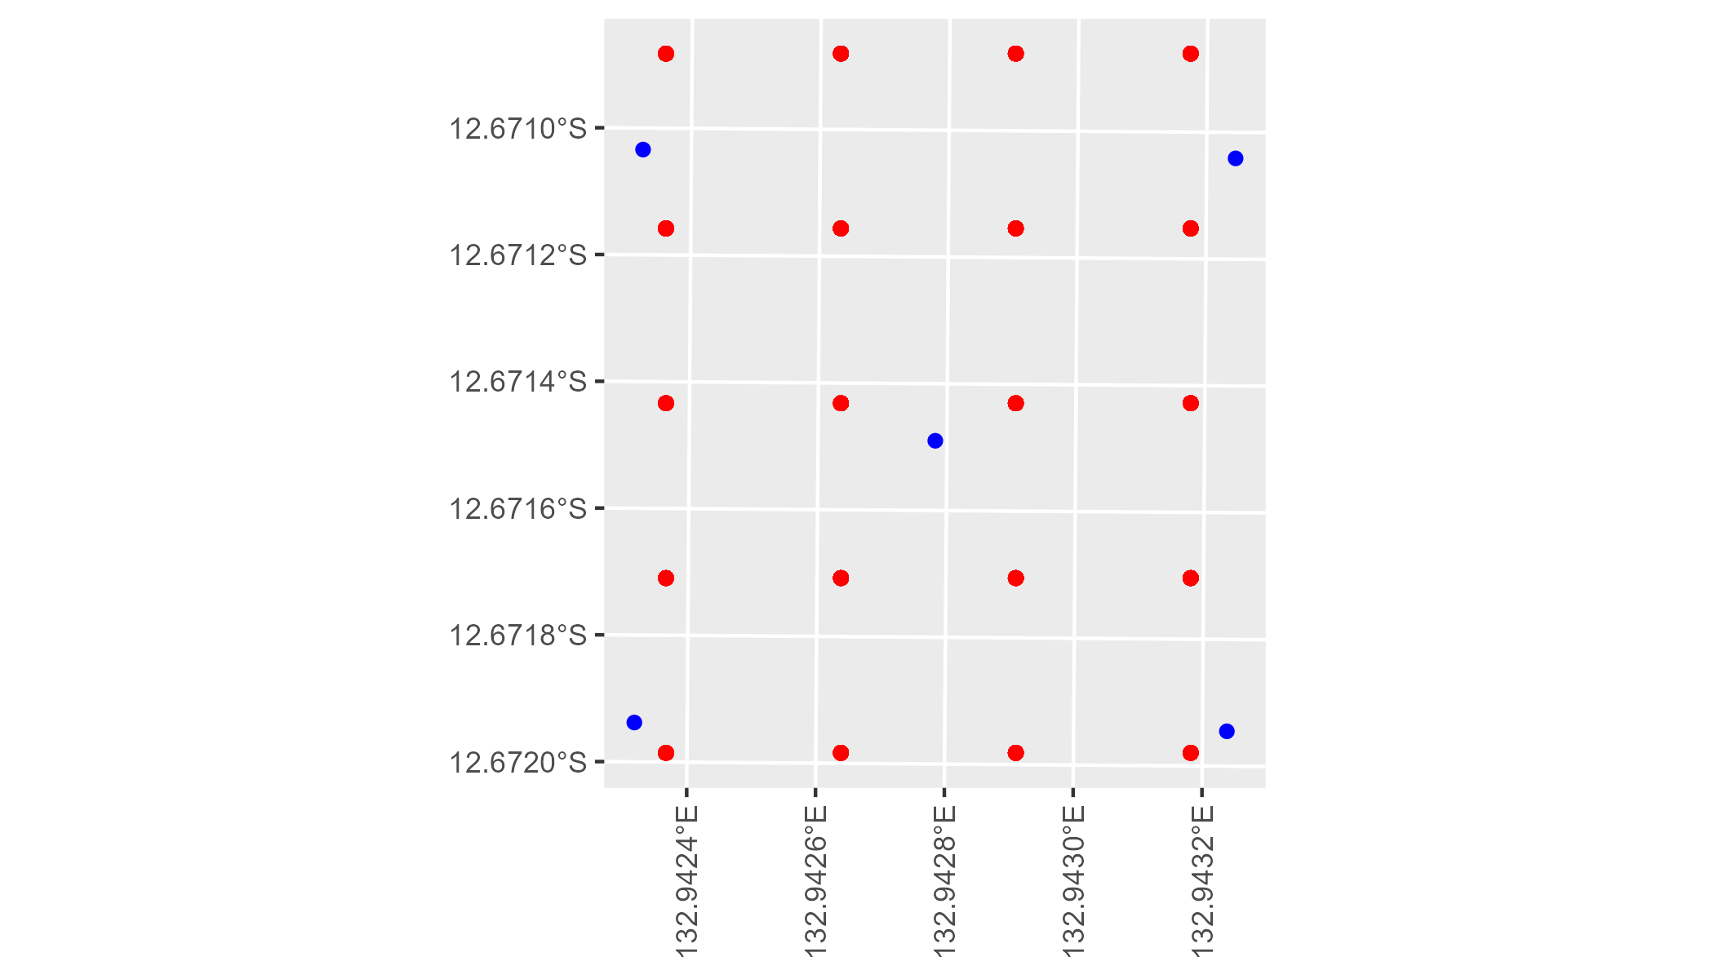

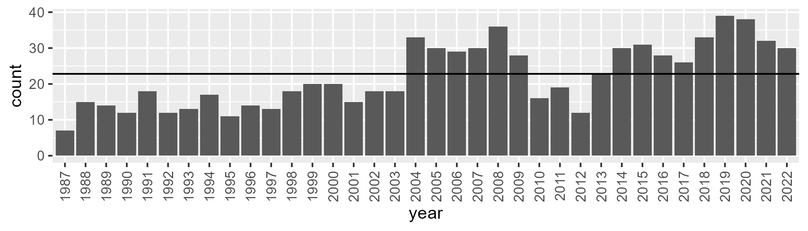

Number of samples: 798

# NTAPCK1010

| Min. | 1st Qu. | Median | Mean | 3rd Qu. | Max. |
| --- | --- | --- | --- | --- | --- |
| 13.89006 | 42.53041 | 50.16251 | 48.3918 | 56.17308 | 68.72507 |

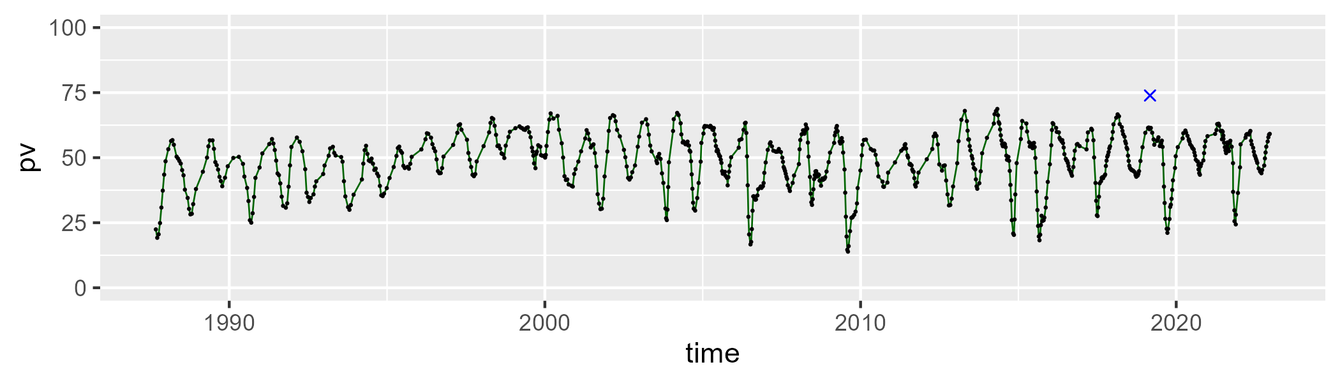

| Min. | 1st Qu. | Median | Mean | 3rd Qu. | Max. |
| --- | --- | --- | --- | --- | --- |
| 21.45815 | 36.3029 | 41.5414 | 41.1795 | 46.37404 | 66.0136 |

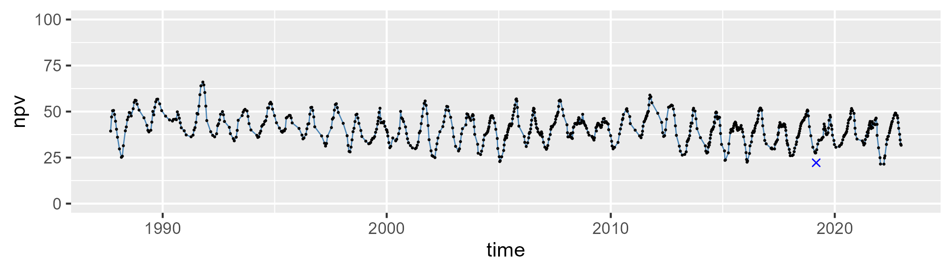

| Min. | 1st Qu. | Median | Mean | 3rd Qu. | Max. |
| --- | --- | --- | --- | --- | --- |
| 0 | 3.496481 | 6.029692 | 9.135037 | 12.69261 | 42.48437 |

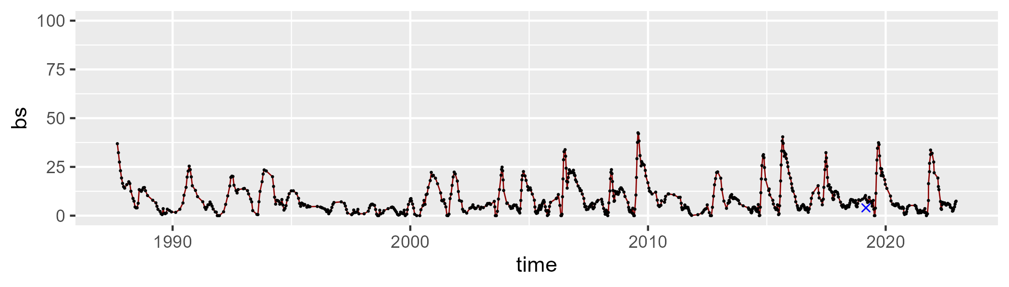

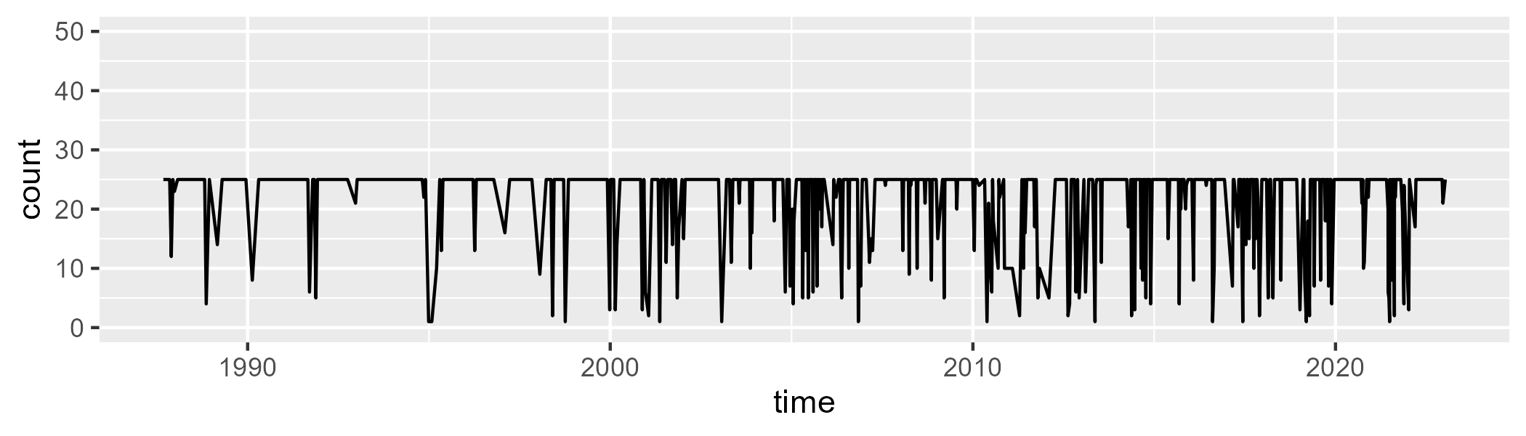

Min. : 1.00 1st Qu.:25.00 Median :25.00 Mean :22.13 3rd Qu.:25.00 Max. :25.00

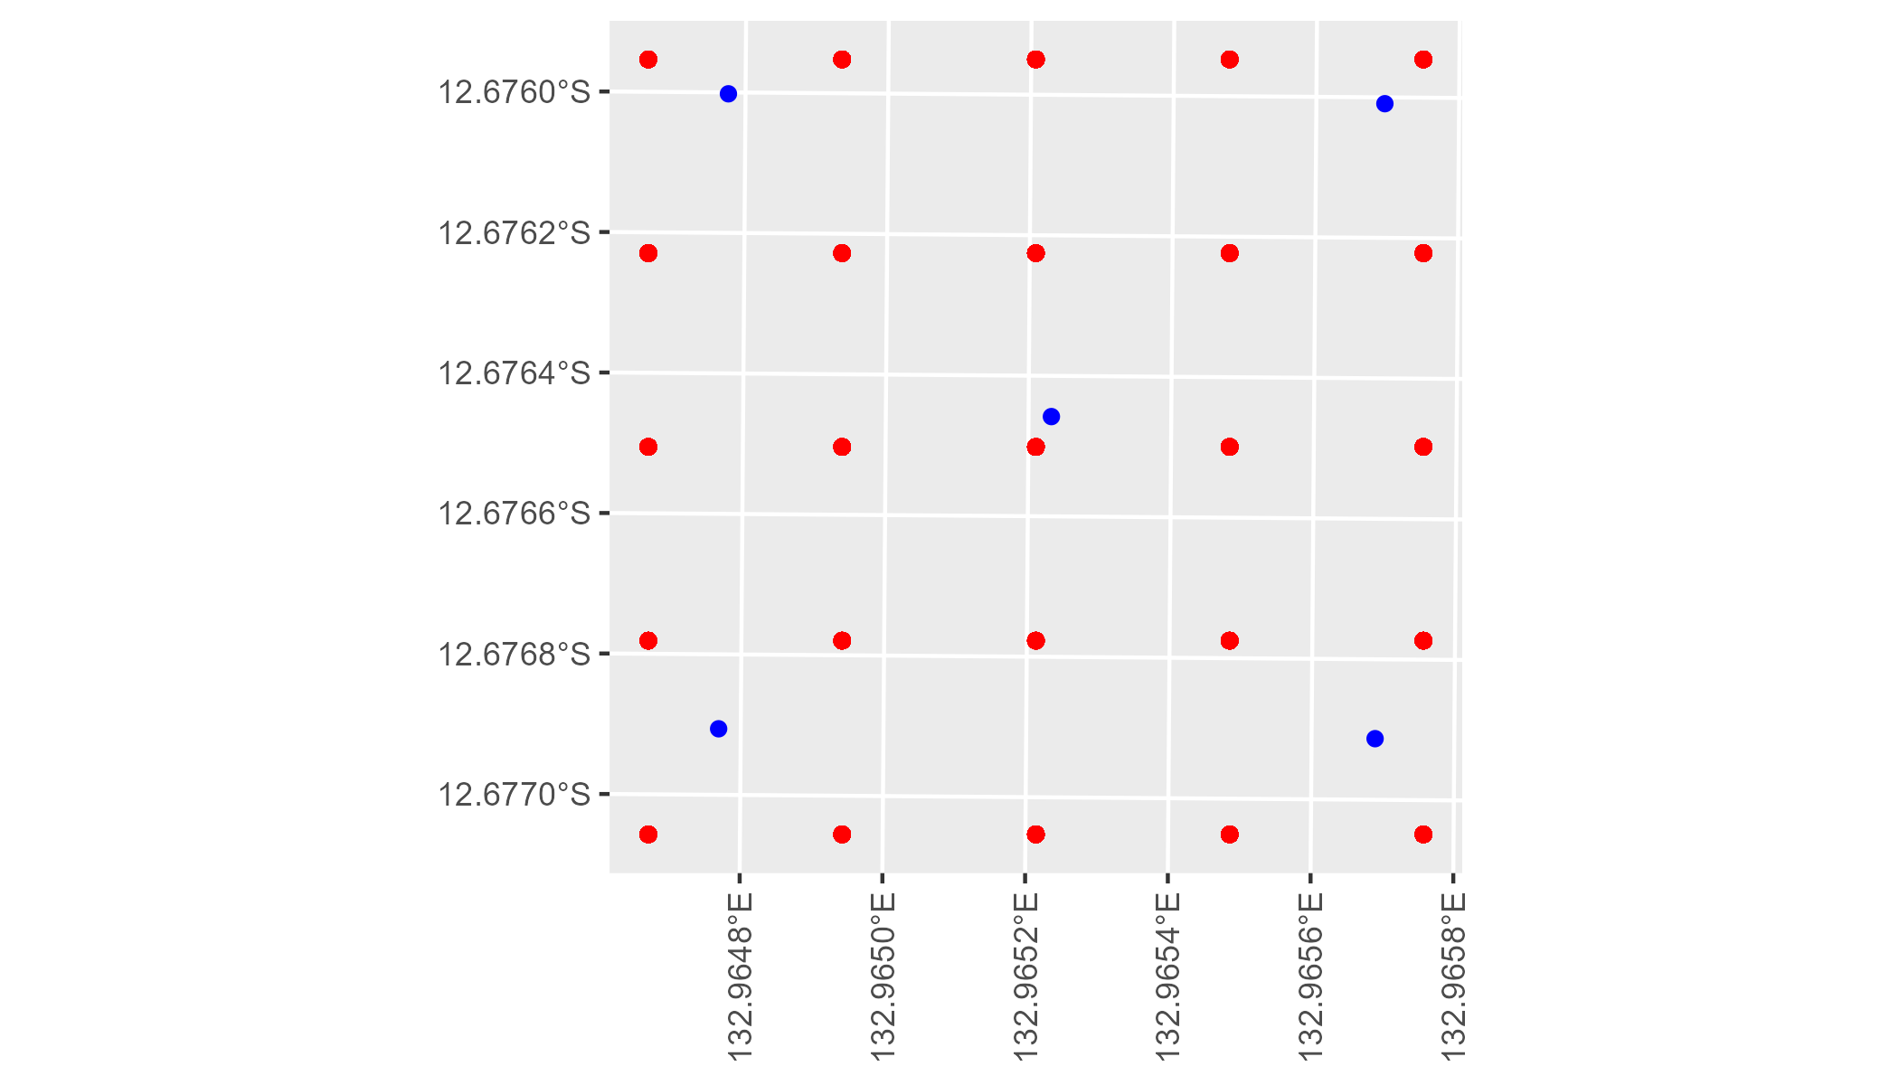

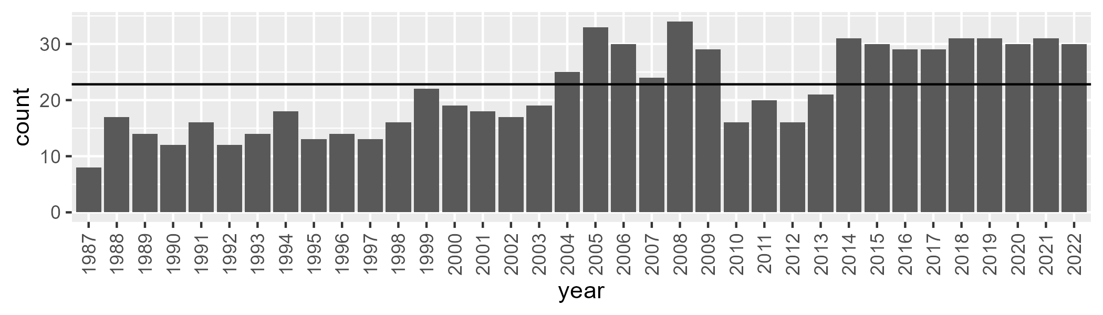

Number of samples: 782

# NTAPCK1011

| Min. | 1st Qu. | Median | Mean | 3rd Qu. | Max. |
| --- | --- | --- | --- | --- | --- |
| 16.13592 | 34.98692 | 41.67978 | 42.32081 | 50.72724 | 71.50987 |

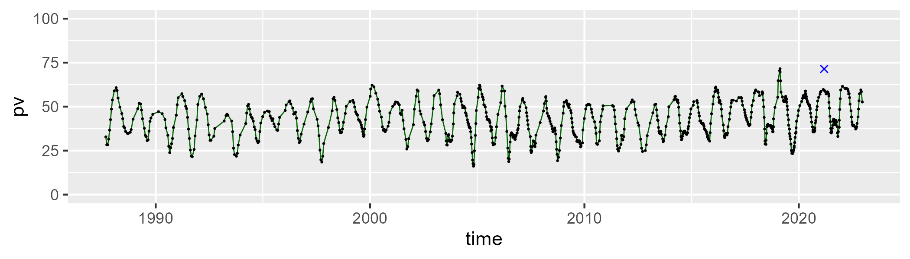

| Min. | 1st Qu. | Median | Mean | 3rd Qu. | Max. |
| --- | --- | --- | --- | --- | --- |
| 23.77185 | 41.38914 | 45.88133 | 45.80241 | 50.31069 | 68.27576 |

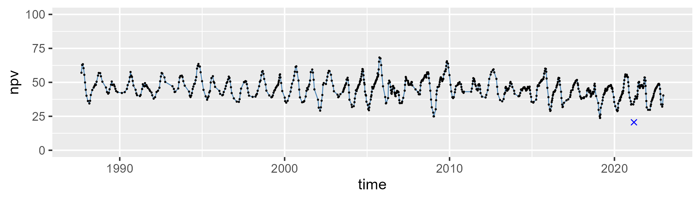

| Min. | 1st Qu. | Median | Mean | 3rd Qu. | Max. |
| --- | --- | --- | --- | --- | --- |
| 0 | 5.295318 | 8.680986 | 10.60738 | 15.1419 | 37.60557 |

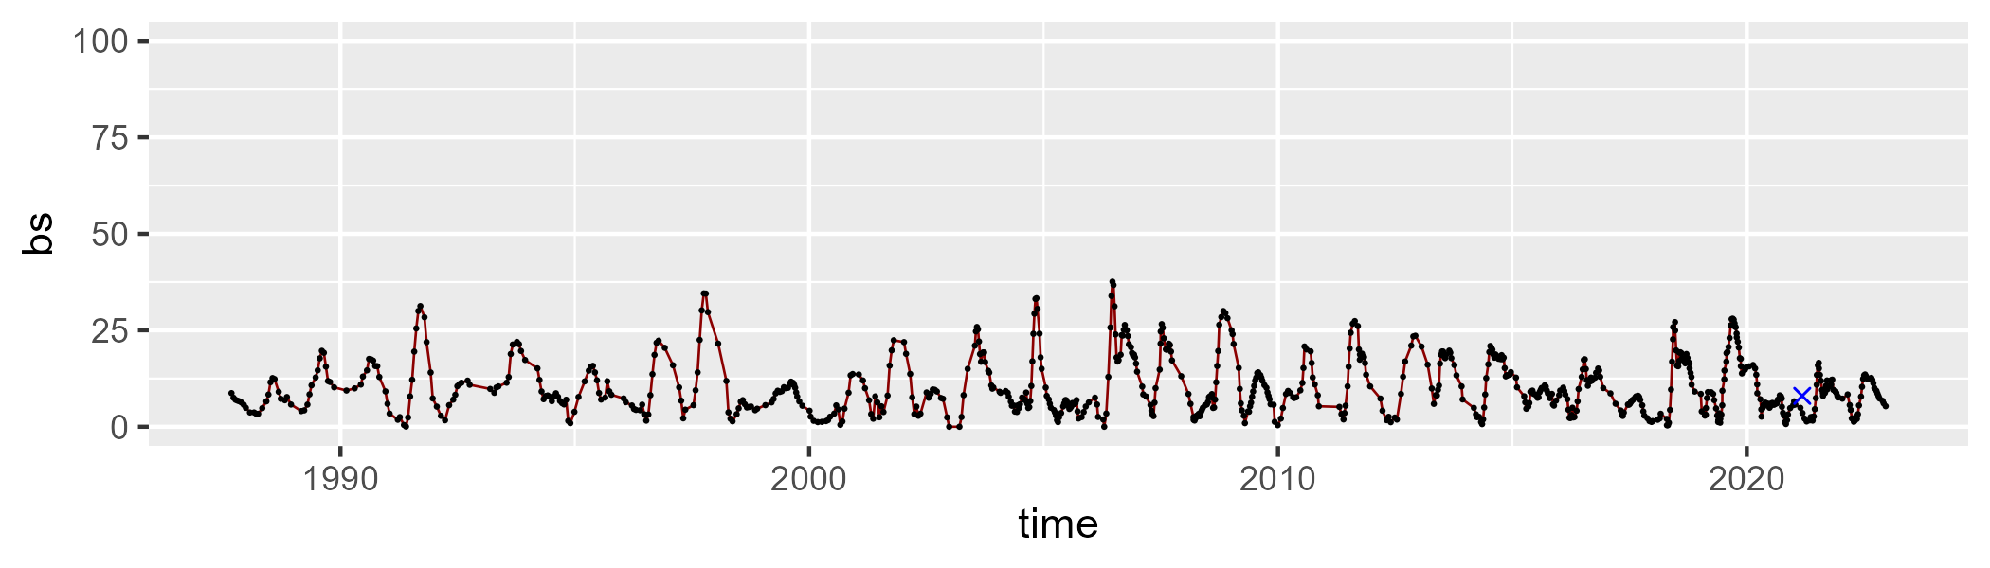

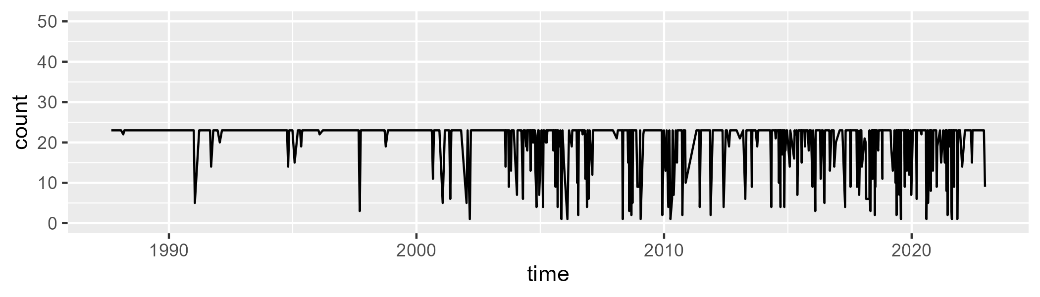

Min. : 1.00 1st Qu.:23.00 Median :23.00 Mean :20.67 3rd Qu.:23.00 Max. :23.00

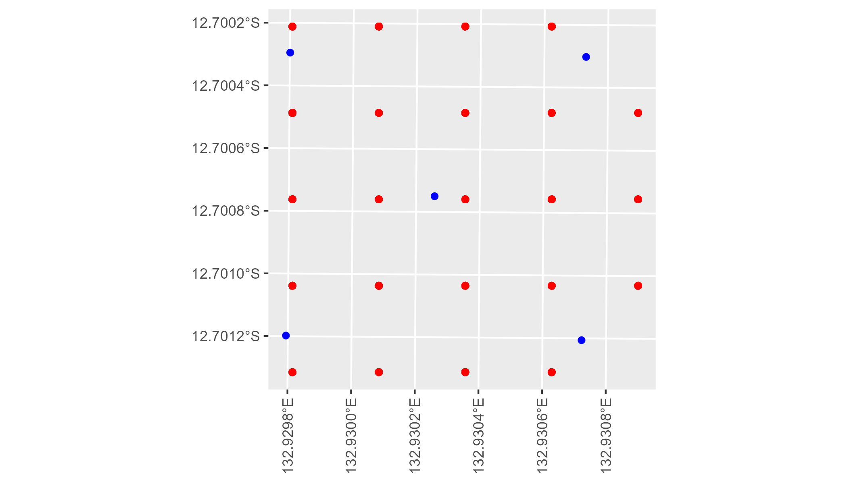

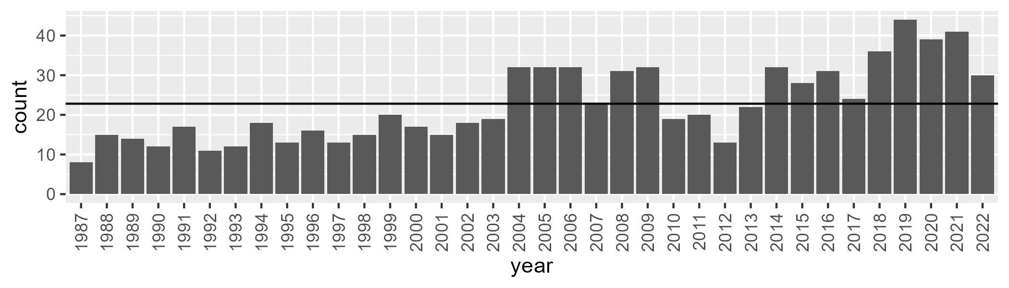

Number of samples: 814

# NTAPCK1012

| Min. | 1st Qu. | Median | Mean | 3rd Qu. | Max. |
| --- | --- | --- | --- | --- | --- |
| 19.78291 | 39.41599 | 47.36008 | 46.97566 | 54.90704 | 72.35426 |

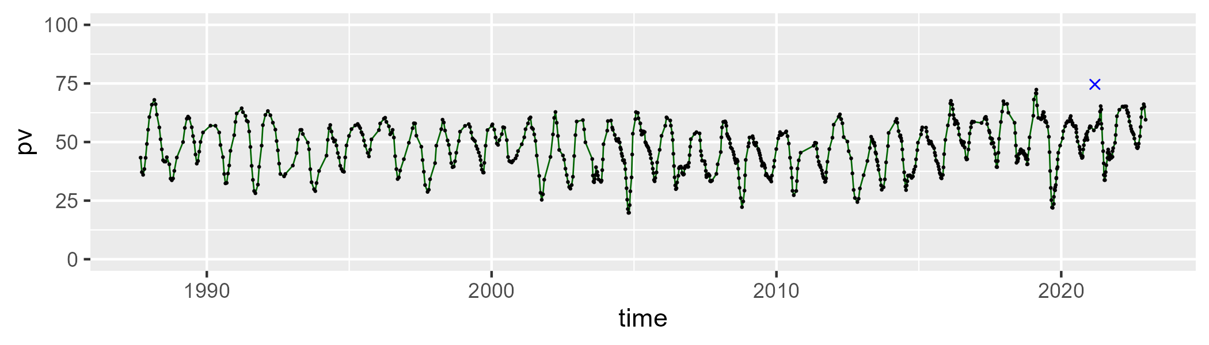

| Min. | 1st Qu. | Median | Mean | 3rd Qu. | Max. |
| --- | --- | --- | --- | --- | --- |
| 21.55691 | 37.48053 | 44.66357 | 43.70729 | 49.27625 | 63.111 |

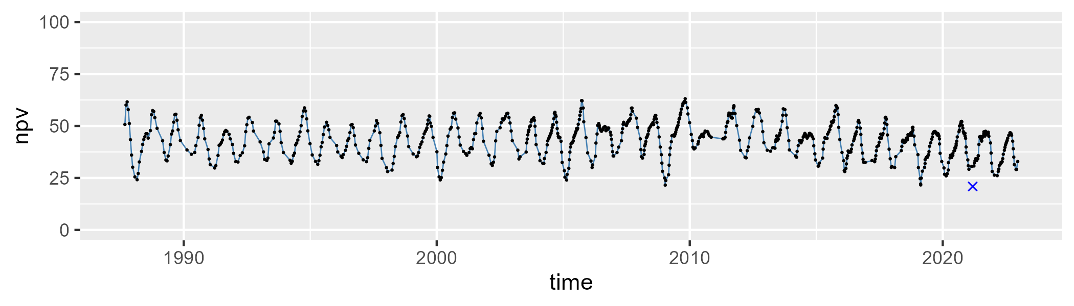

| Min. | 1st Qu. | Median | Mean | 3rd Qu. | Max. |
| --- | --- | --- | --- | --- | --- |
| 0 | 3.276007 | 5.963946 | 8.005191 | 10.72766 | 34.77561 |

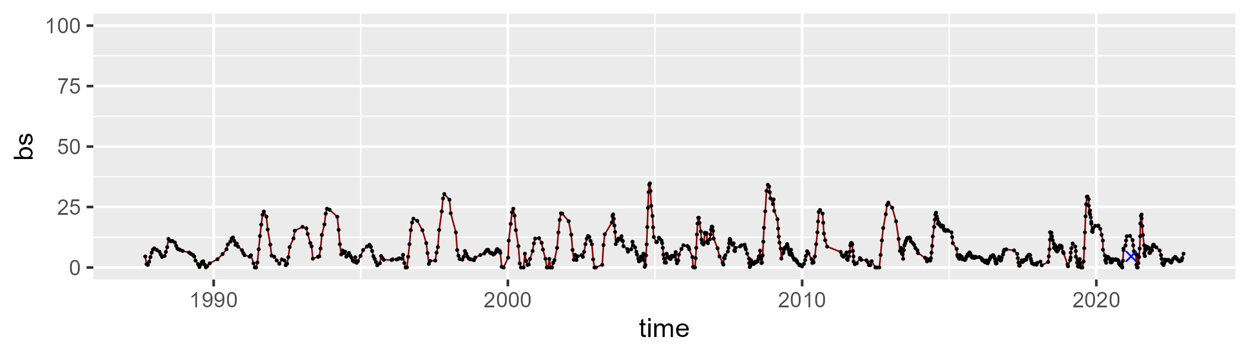

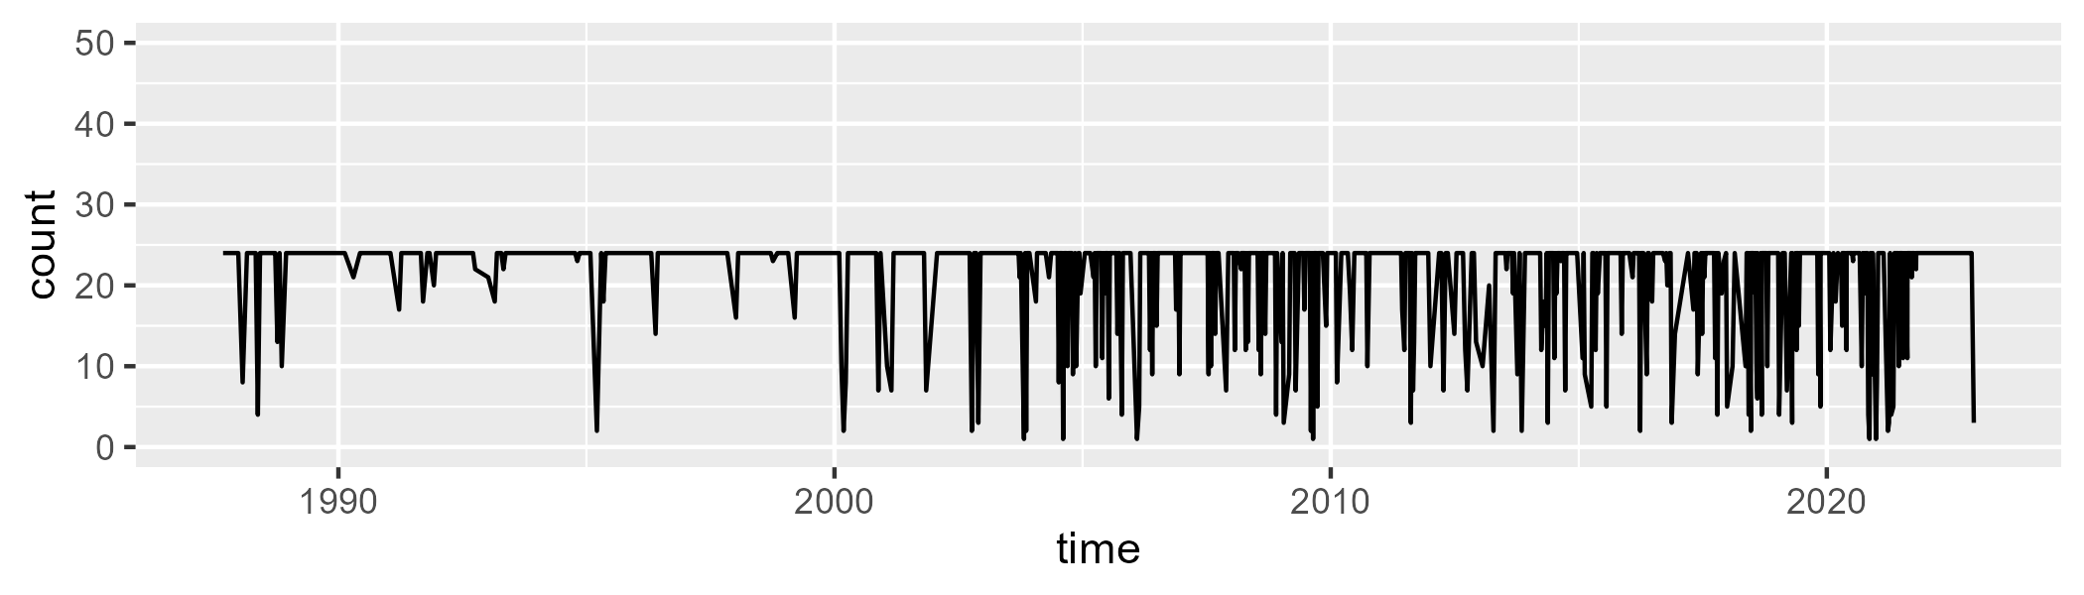

Min. : 1.00 1st Qu.:24.00 Median :24.00 Mean :21.31 3rd Qu.:24.00 Max. :24.00

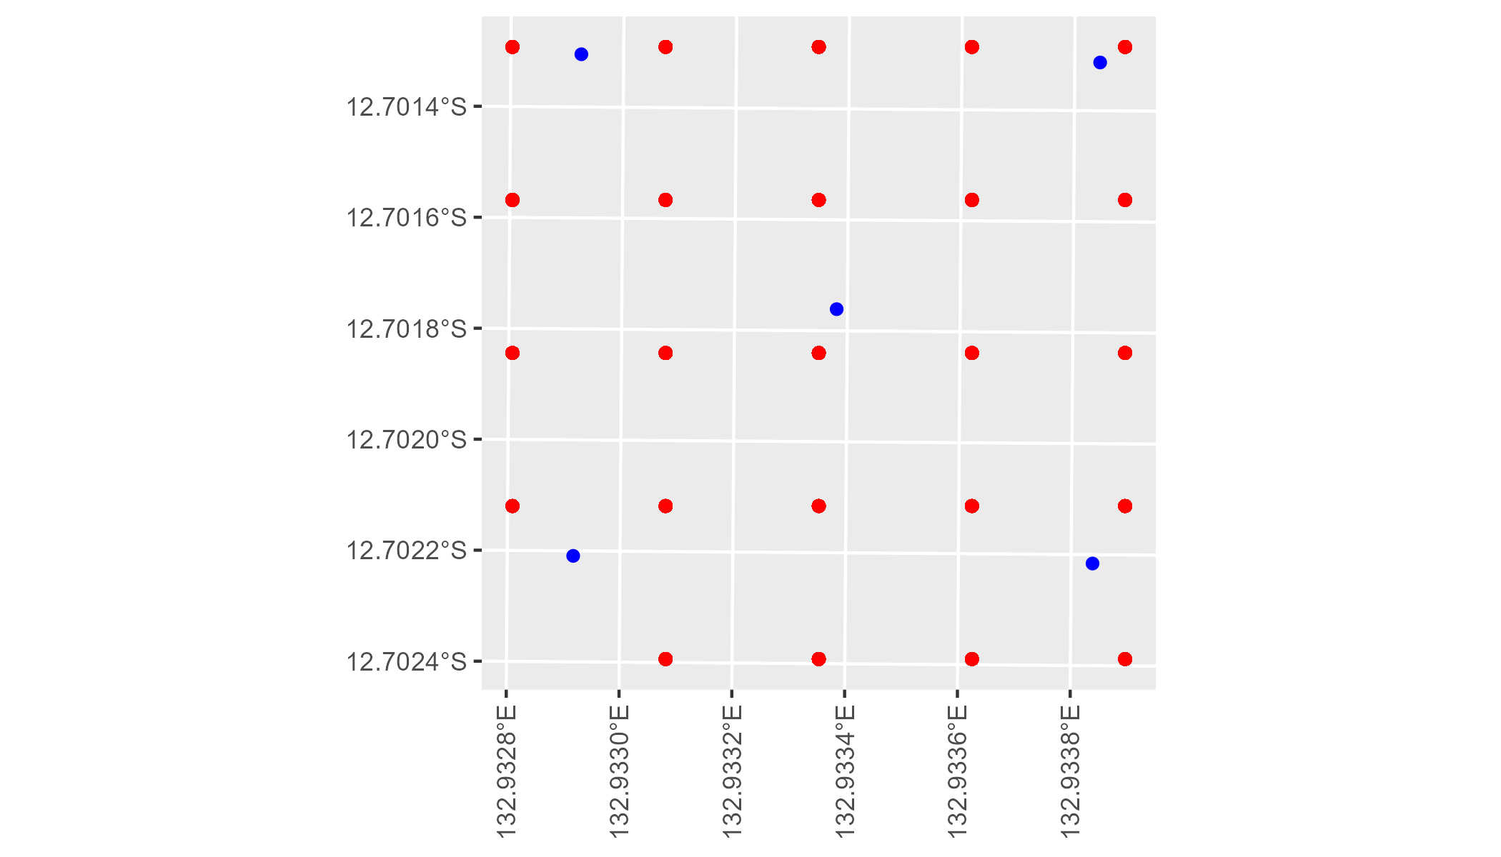

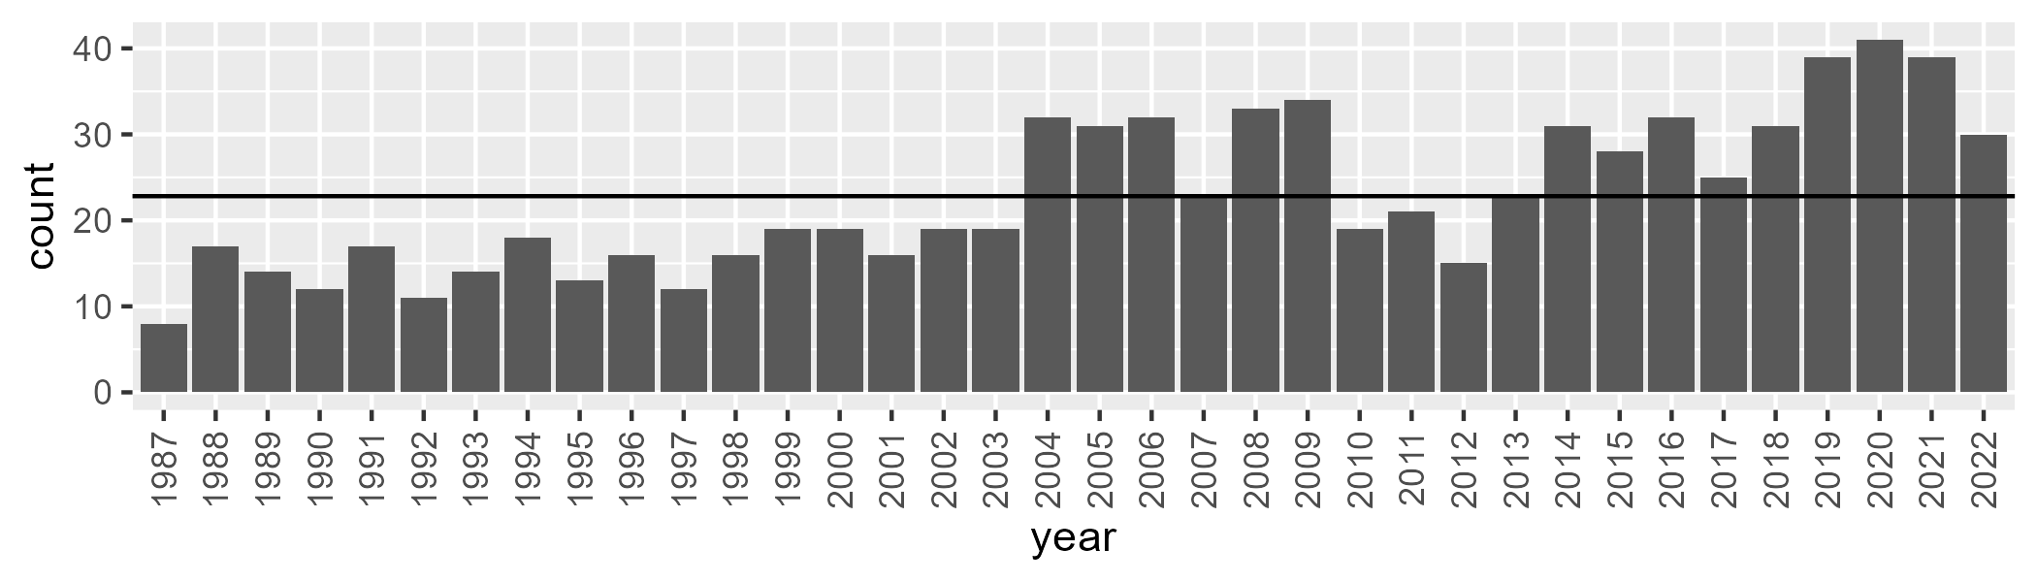

Number of samples: 819

# NTAPCK2013

| Min. | 1st Qu. | Median | Mean | 3rd Qu. | Max. |
| --- | --- | --- | --- | --- | --- |
| 13.8284 | 34.48973 | 42.99768 | 43.7962 | 53.3757 | 72.49868 |

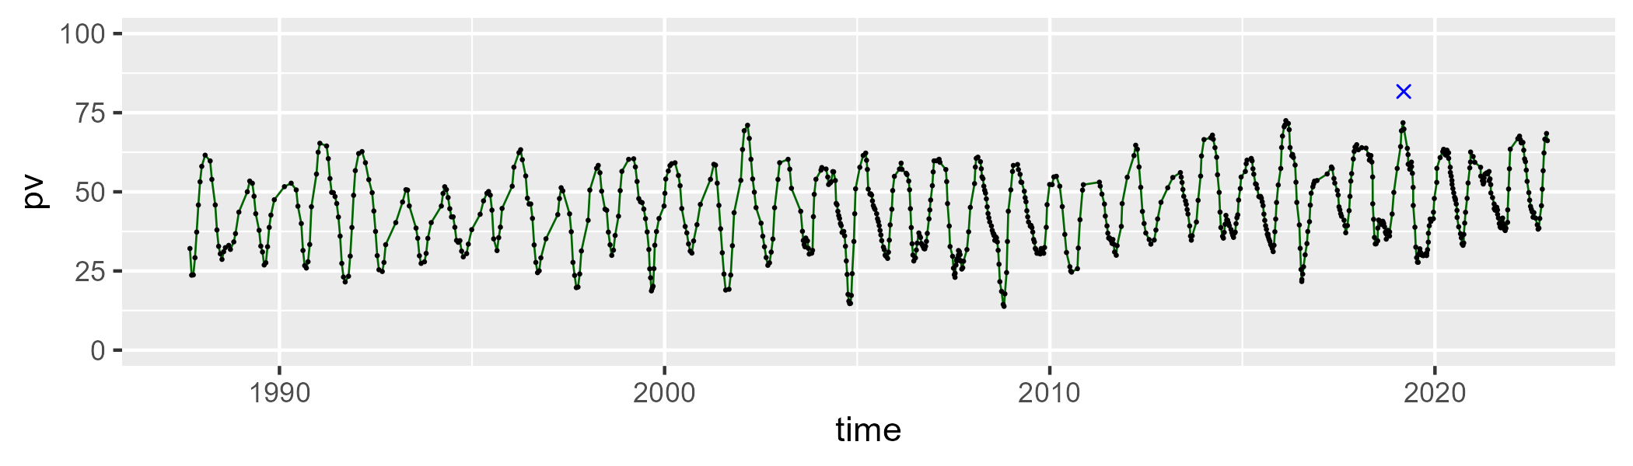

| Min. | 1st Qu. | Median | Mean | 3rd Qu. | Max. |
| --- | --- | --- | --- | --- | --- |
| 23.28249 | 40.49671 | 46.65779 | 46.01177 | 52.11167 | 70.08924 |

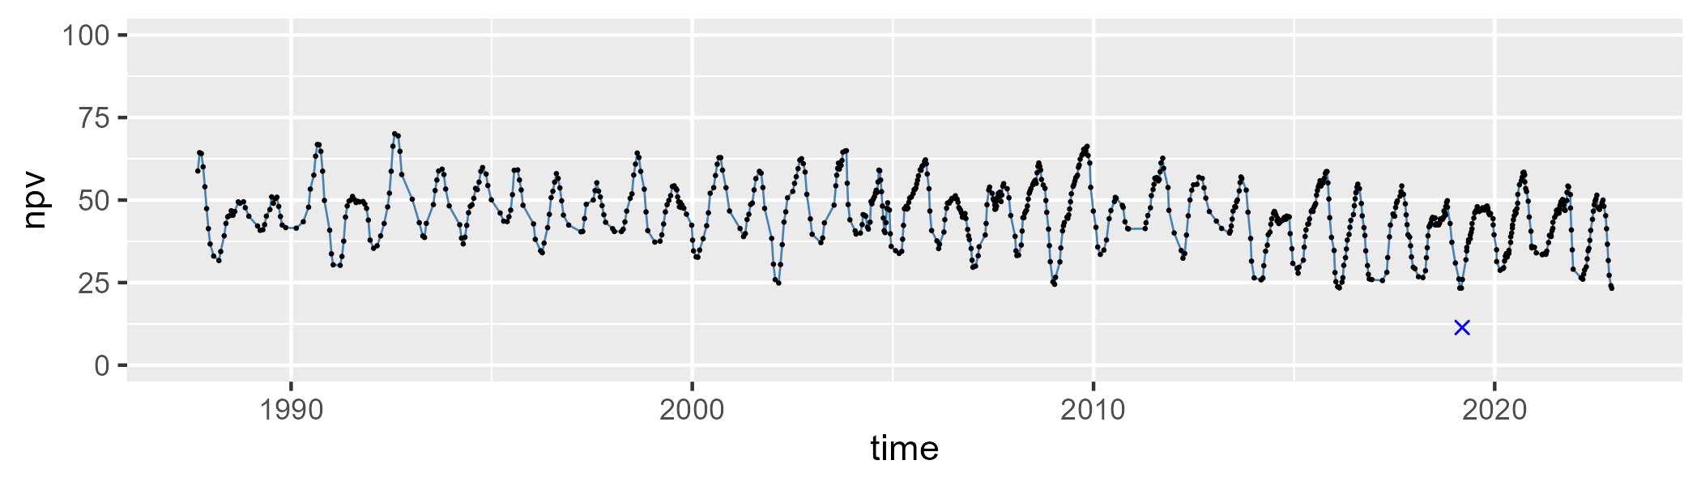

| Min. | 1st Qu. | Median | Mean | 3rd Qu. | Max. |
| --- | --- | --- | --- | --- | --- |
| 0 | 3.628454 | 6.681718 | 8.955258 | 12.70621 | 43.77453 |

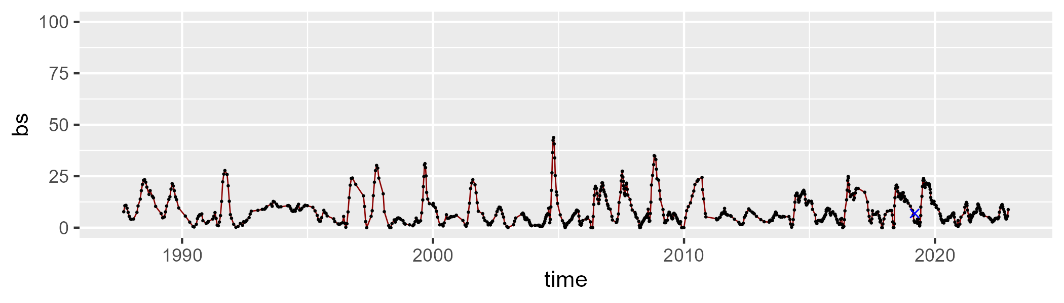

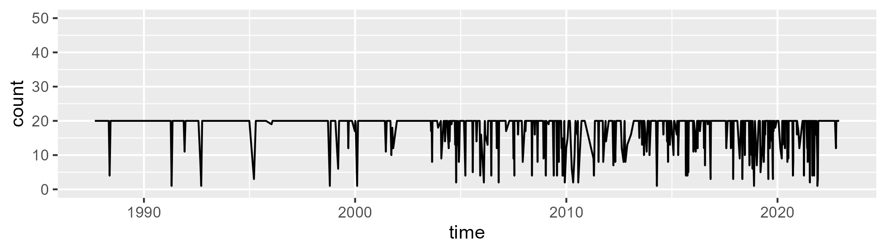

Min. : 1.00 1st Qu.:20.00 Median :20.00 Mean :17.97 3rd Qu.:20.00 Max. :20.00

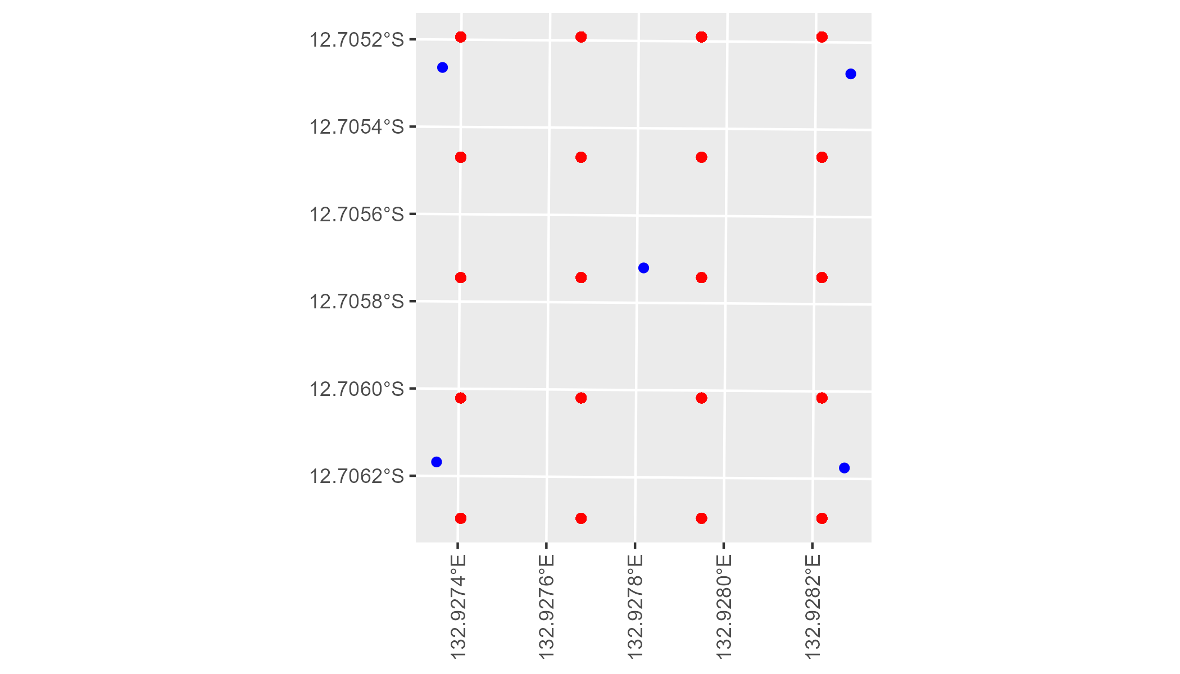

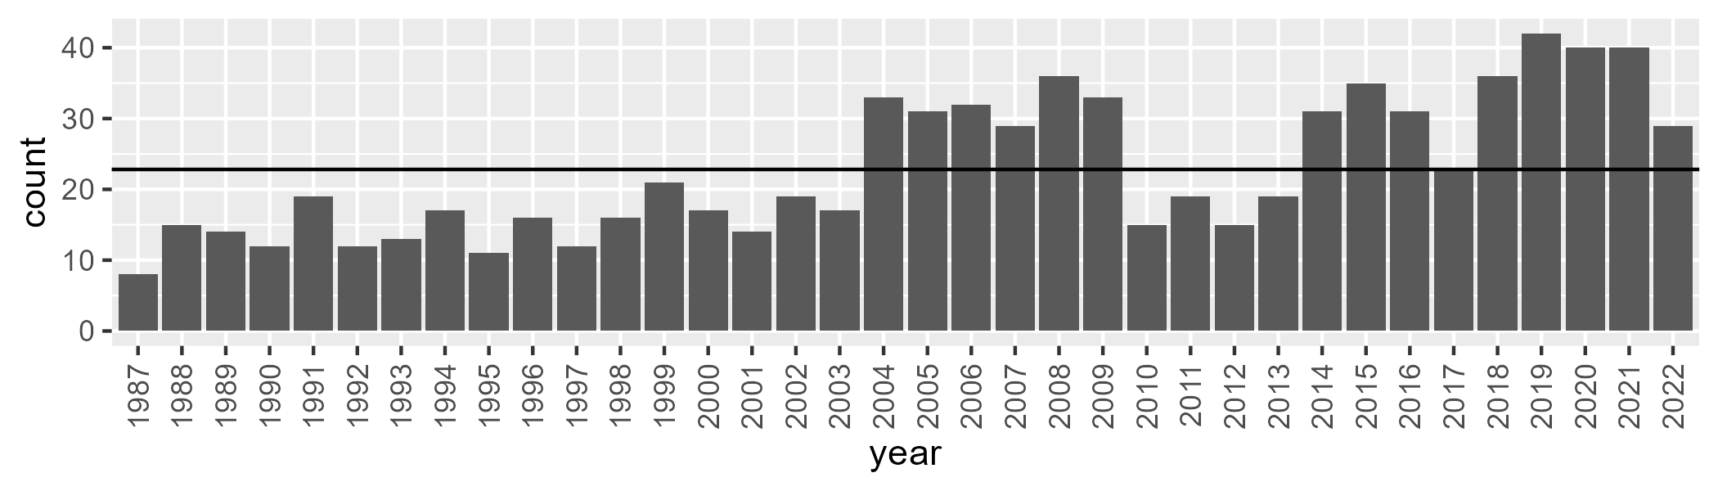

Number of samples: 822

# NTAPCK2014

| Min. | 1st Qu. | Median | Mean | 3rd Qu. | Max. |
| --- | --- | --- | --- | --- | --- |
| 13.71774 | 31.37416 | 38.47143 | 40.61796 | 50.21834 | 77.45025 |

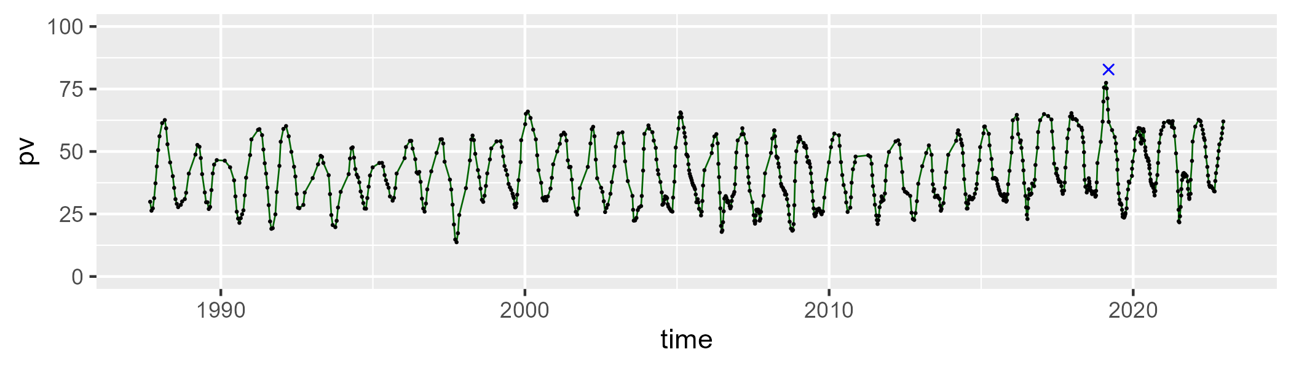

| Min. | 1st Qu. | Median | Mean | 3rd Qu. | Max. |
| --- | --- | --- | --- | --- | --- |
| 19.13977 | 41.62027 | 48.10144 | 47.28003 | 53.13942 | 70.1249 |

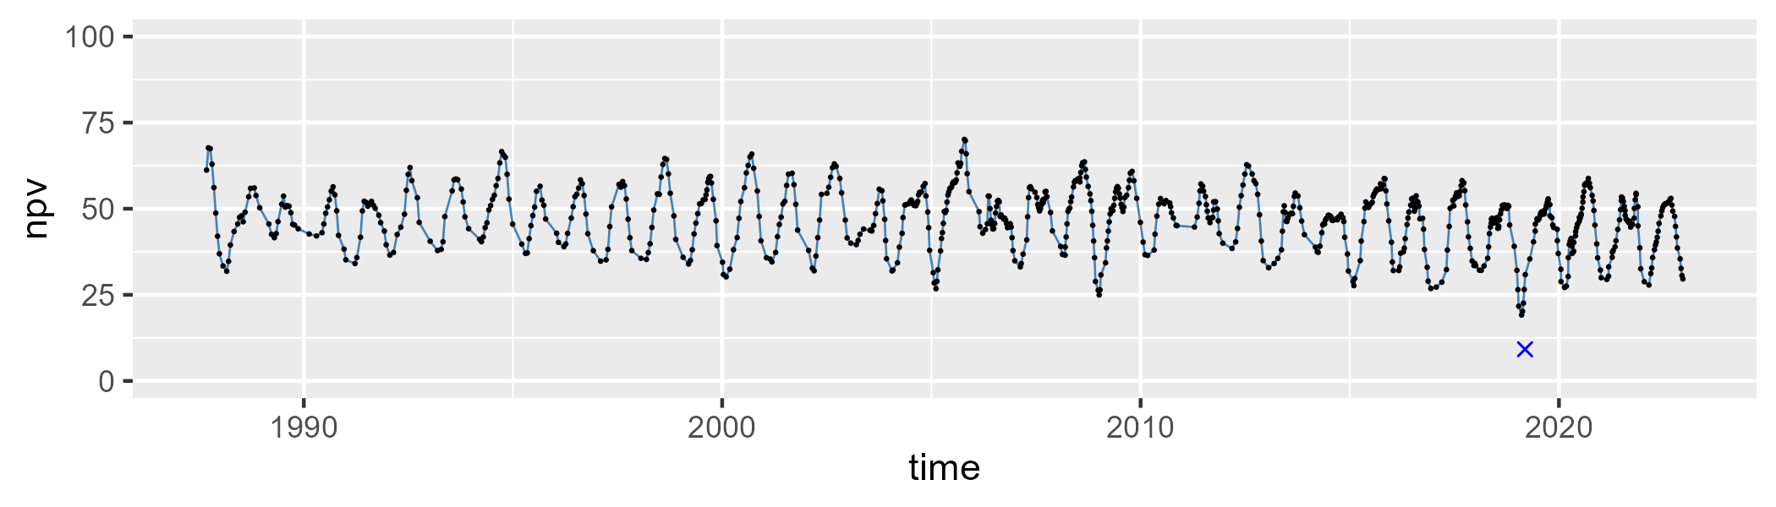

| Min. | 1st Qu. | Median | Mean | 3rd Qu. | Max. |
| --- | --- | --- | --- | --- | --- |
| 0 | 4.90437 | 9.128245 | 10.84841 | 16.13251 | 39.97518 |

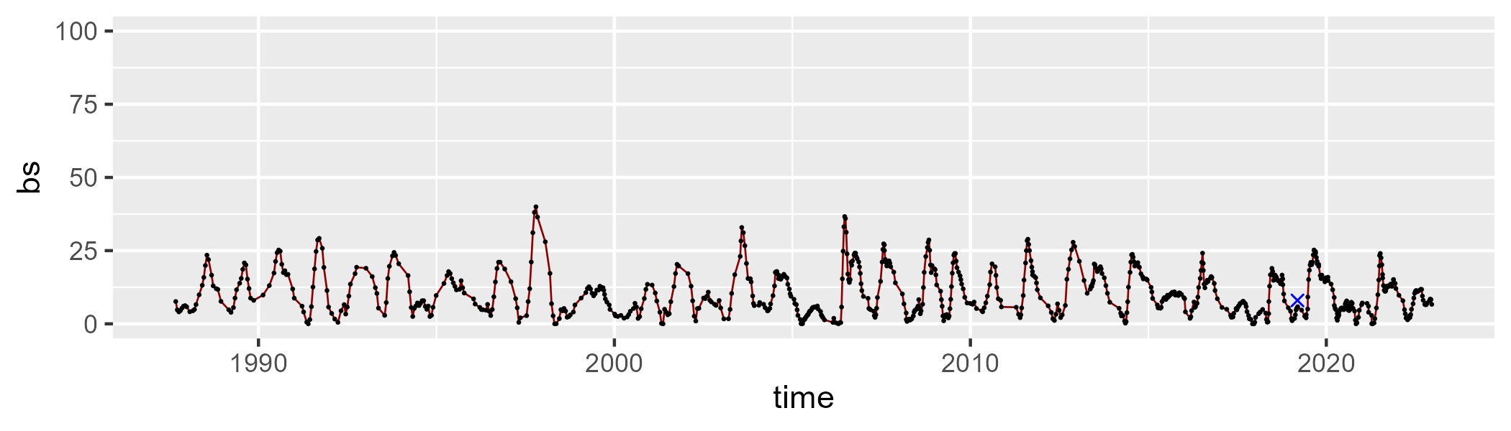

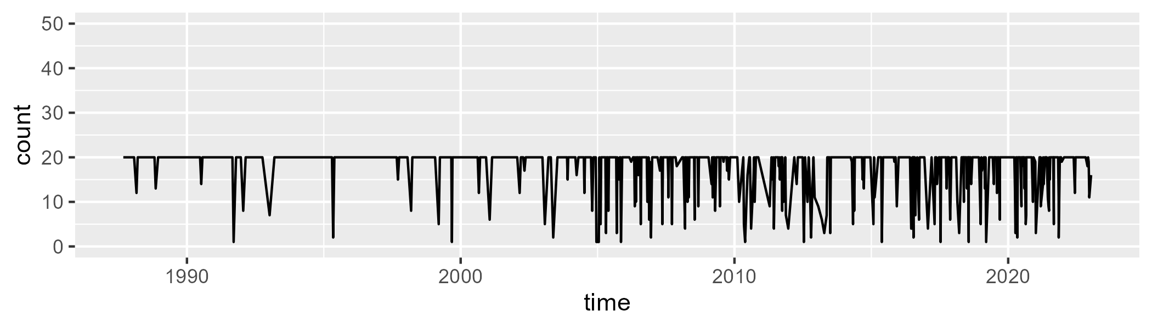

Min. : 1.00 1st Qu.:20.00 Median :20.00 Mean :18.04 3rd Qu.:20.00 Max. :20.00

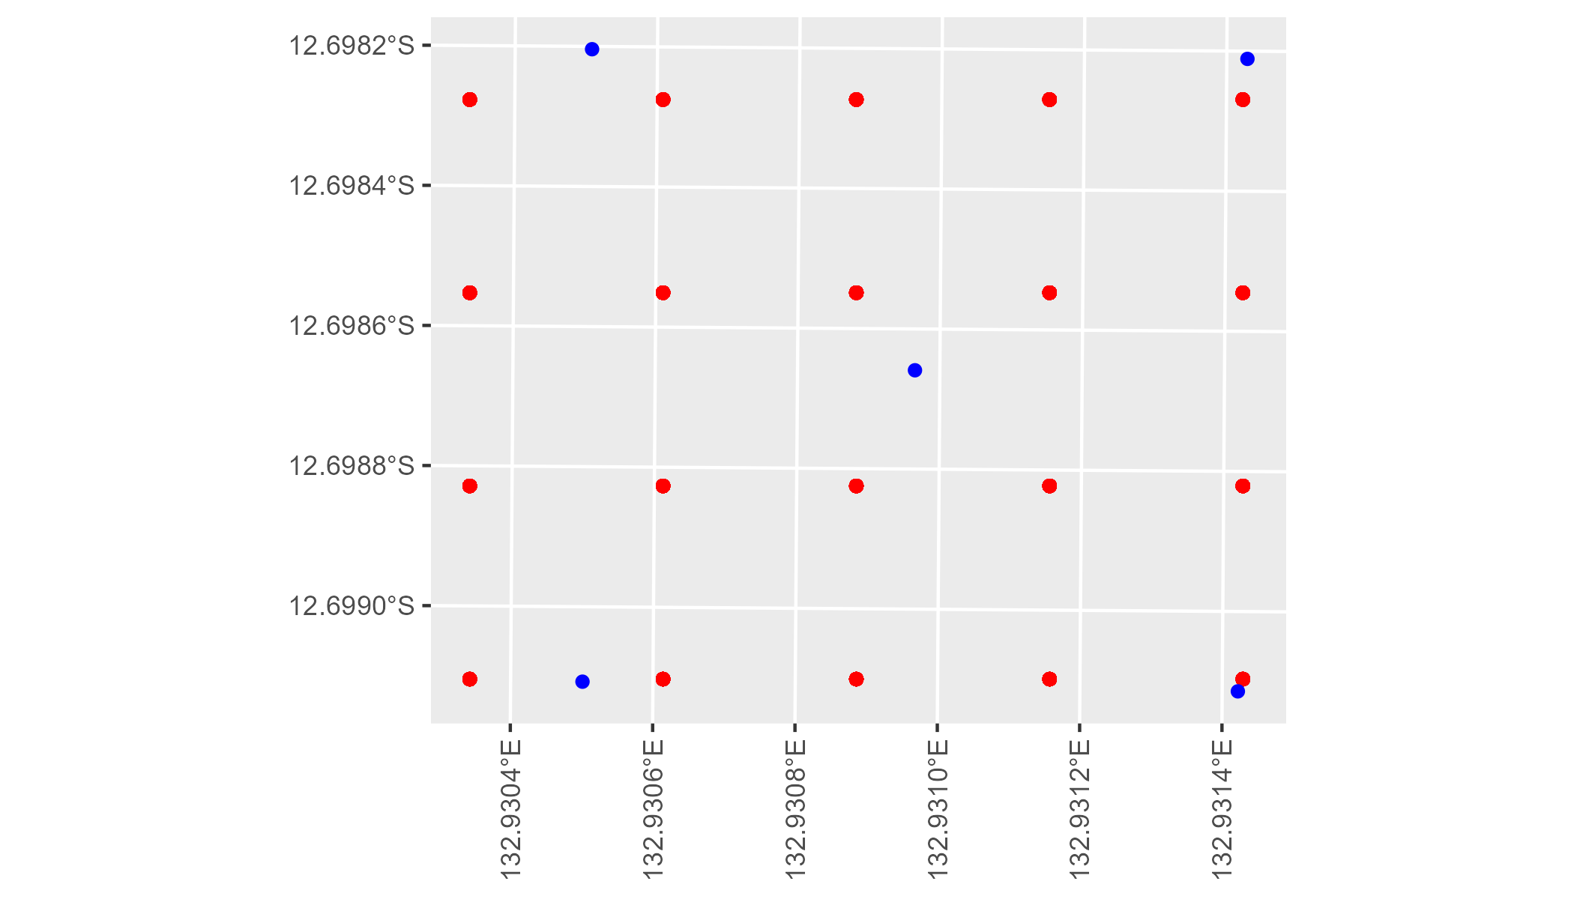

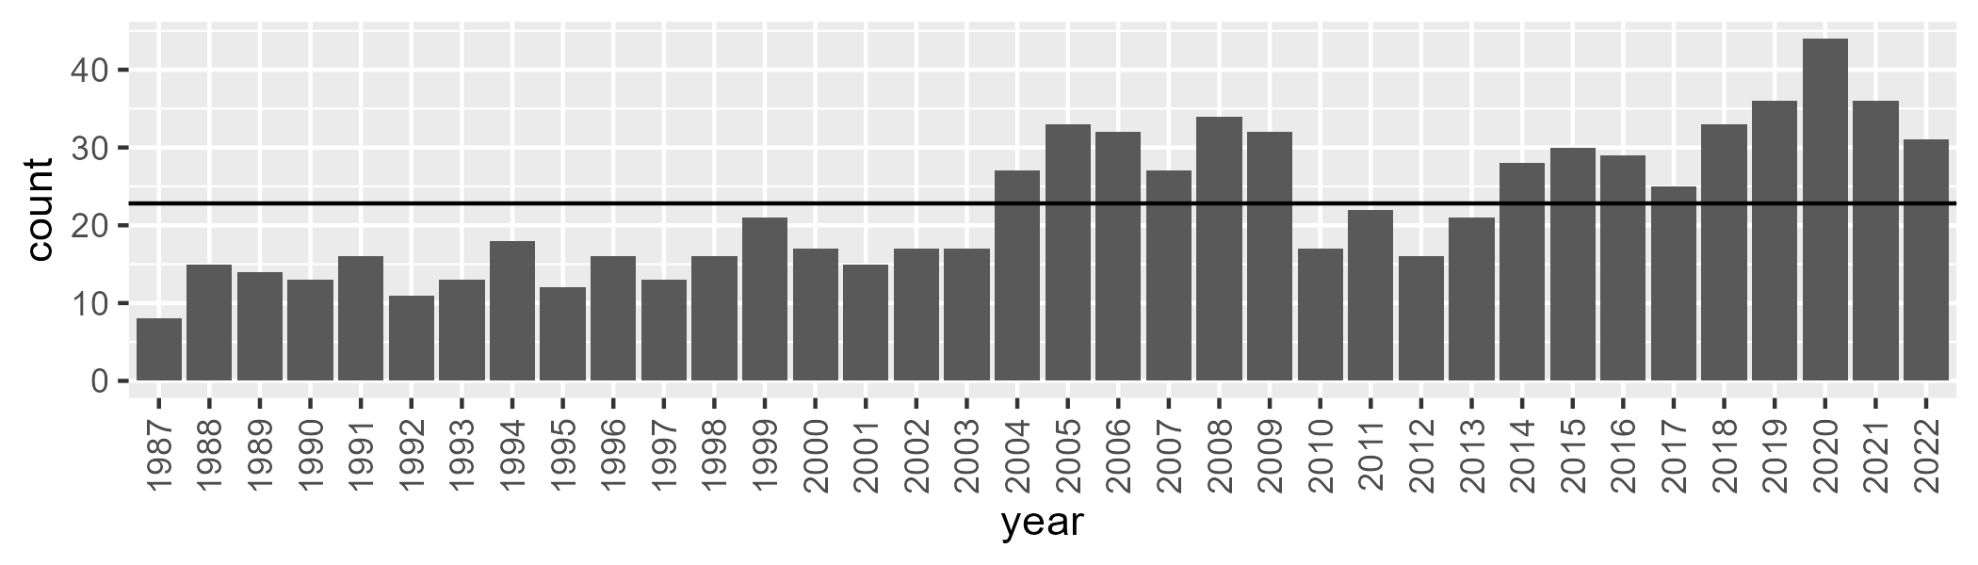

Number of samples: 805

# NTASSD0001

| Min. | 1st Qu. | Median | Mean | 3rd Qu. | Max. |
| --- | --- | --- | --- | --- | --- |
| 3.446758 | 9.312733 | 12.52865 | 12.74107 | 15.51347 | 32.70812 |

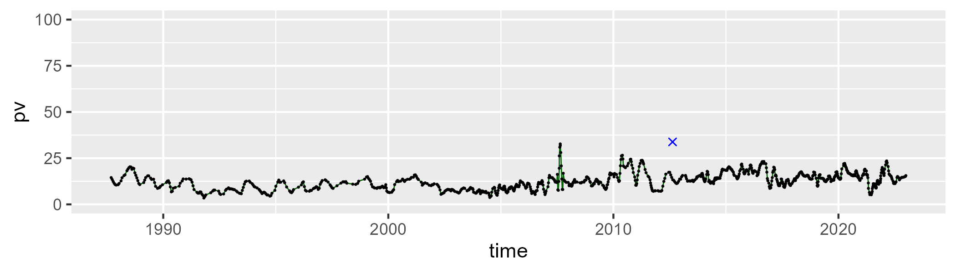

| Min. | 1st Qu. | Median | Mean | 3rd Qu. | Max. |
| --- | --- | --- | --- | --- | --- |
| 0 | 8.86143 | 17.01869 | 17.34779 | 23.53512 | 50.91678 |

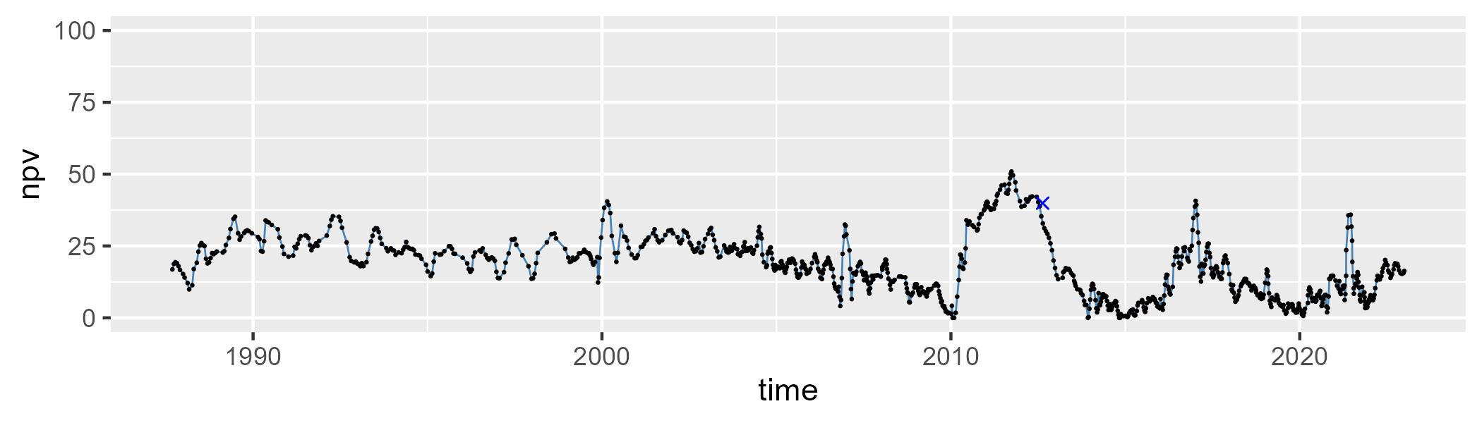

| Min. | 1st Qu. | Median | Mean | 3rd Qu. | Max. |
| --- | --- | --- | --- | --- | --- |
| 33.44533 | 64.16507 | 69.7439 | 68.42627 | 75.10284 | 85.34937 |

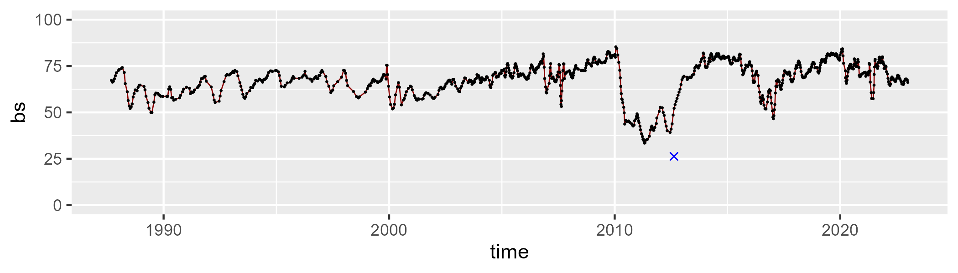

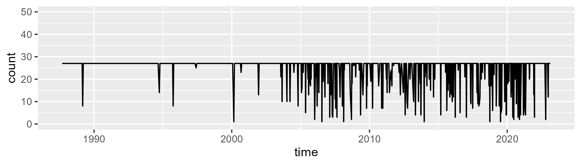

Min. : 1.00 1st Qu.:27.00 Median :27.00 Mean :24.65 3rd Qu.:27.00 Max. :27.00

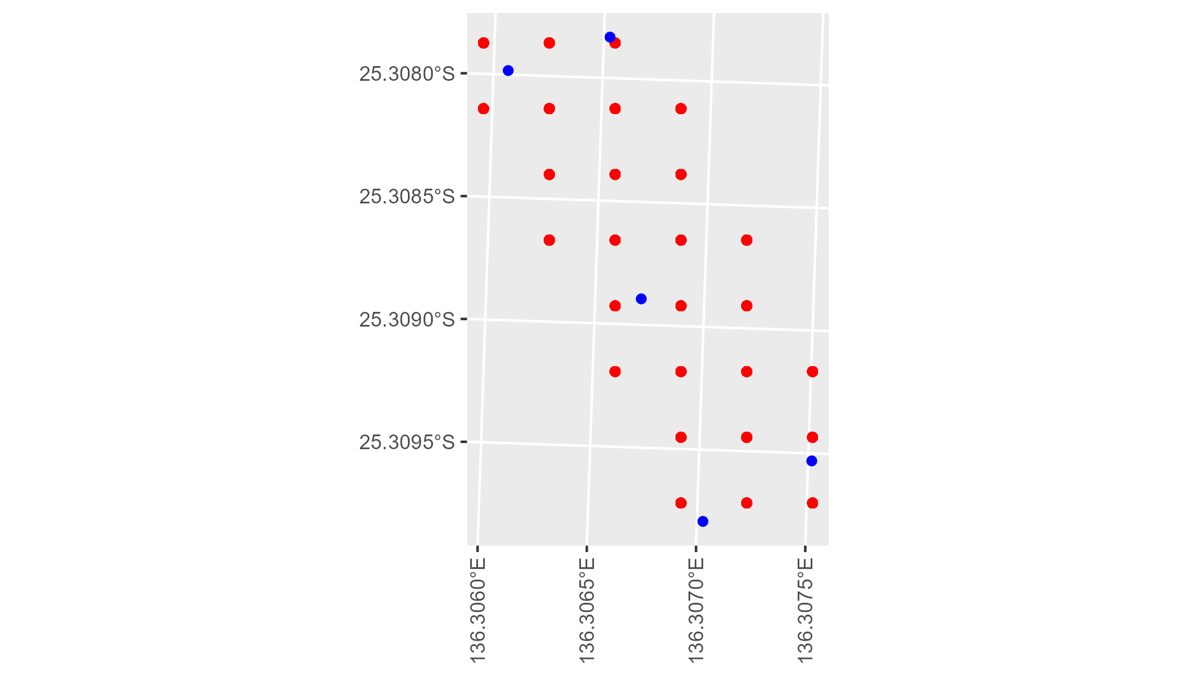

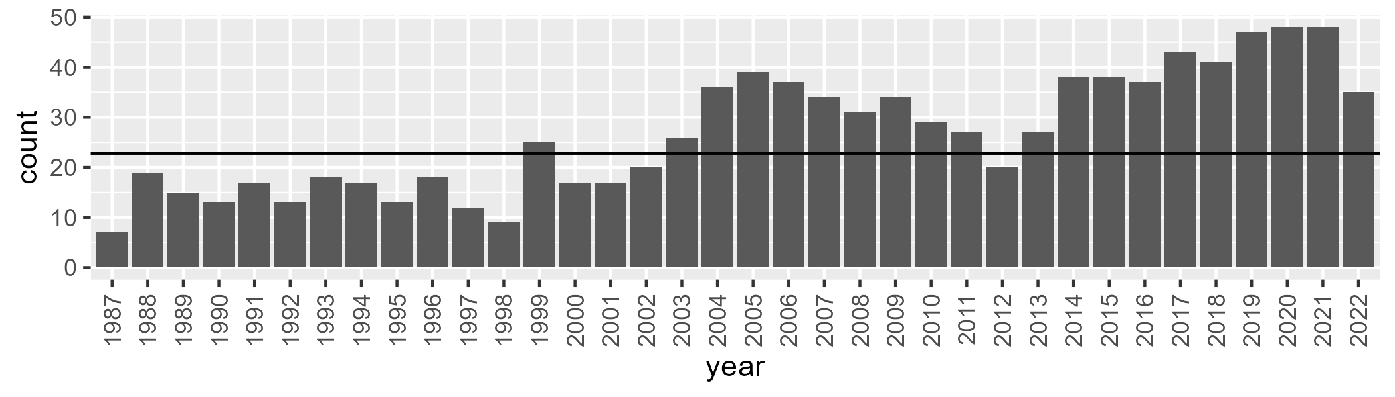

Number of samples: 965

# NTASSD0003

| Min. | 1st Qu. | Median | Mean | 3rd Qu. | Max. |
| --- | --- | --- | --- | --- | --- |
| 3.782341 | 10.20028 | 12.51667 | 13.17223 | 15.42203 | 28.99367 |

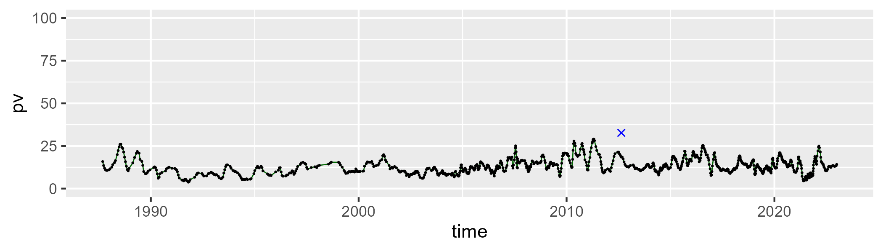

| Min. | 1st Qu. | Median | Mean | 3rd Qu. | Max. |
| --- | --- | --- | --- | --- | --- |
| 0 | 11.37732 | 17.94011 | 18.00145 | 24.14649 | 45.89806 |

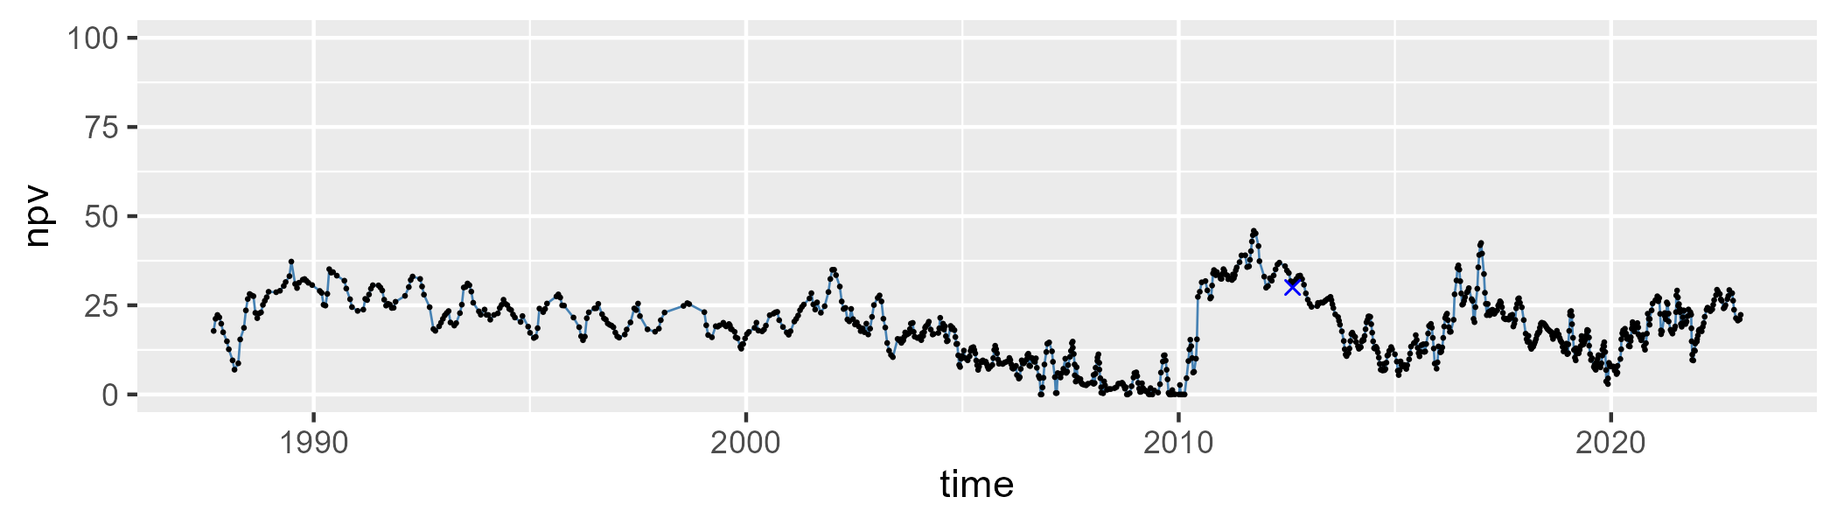

| Min. | 1st Qu. | Median | Mean | 3rd Qu. | Max. |
| --- | --- | --- | --- | --- | --- |
| 34.93216 | 61.62999 | 68.72069 | 67.35961 | 74.23438 | 86.46885 |

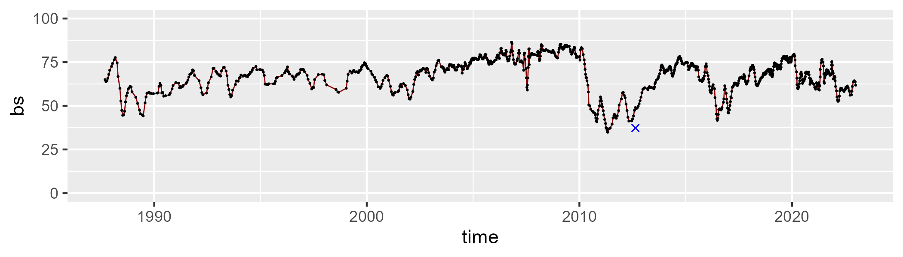

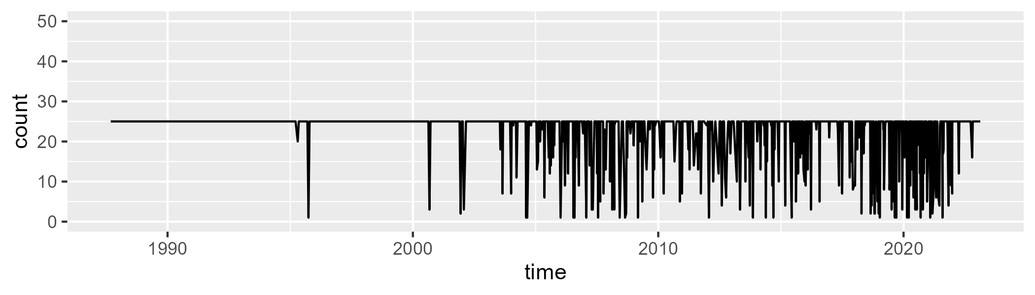

Min. : 1.00 1st Qu.:25.00 Median :25.00 Mean :22.23 3rd Qu.:25.00 Max. :25.00

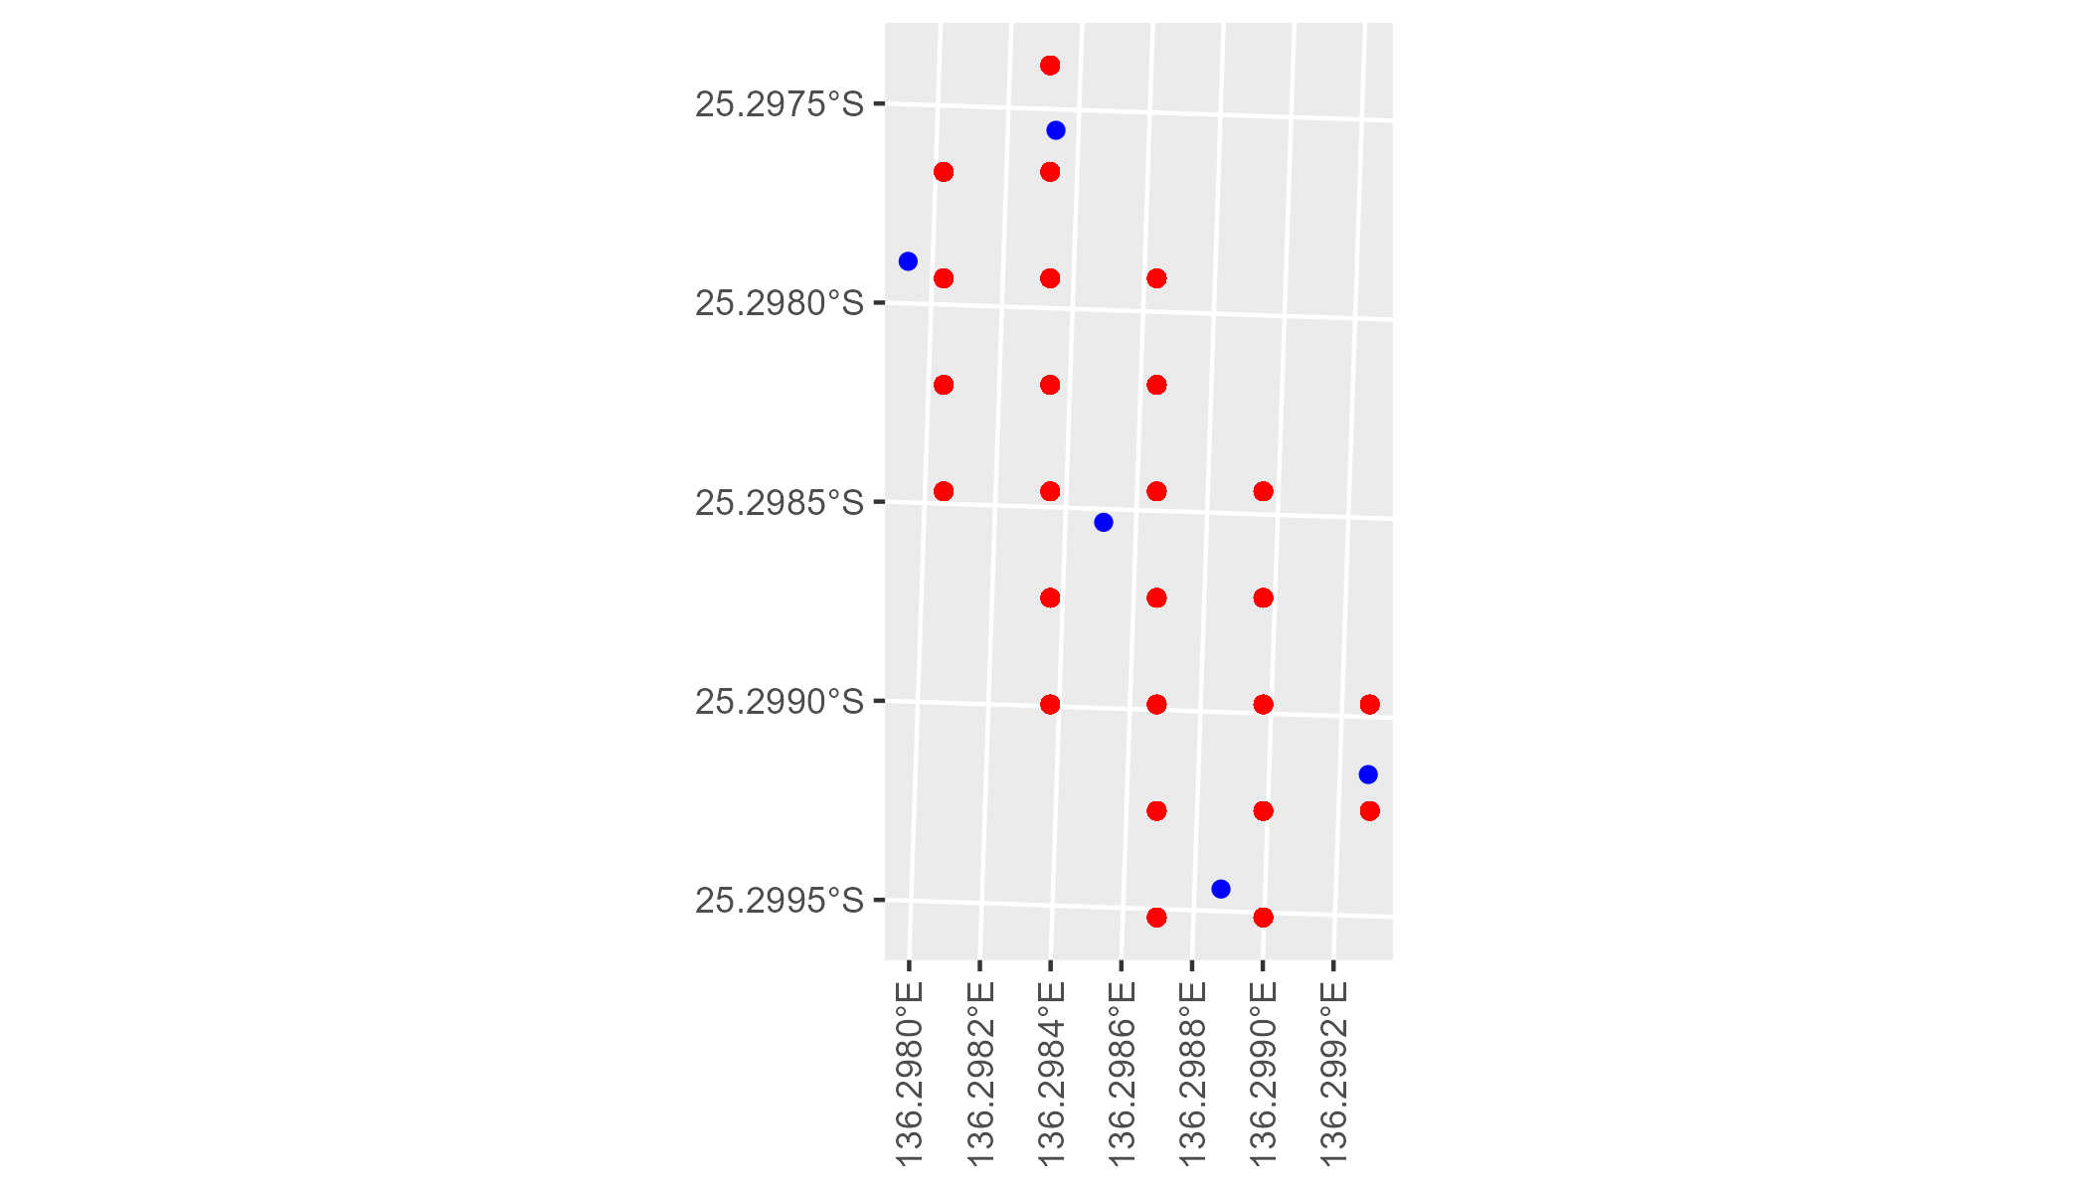

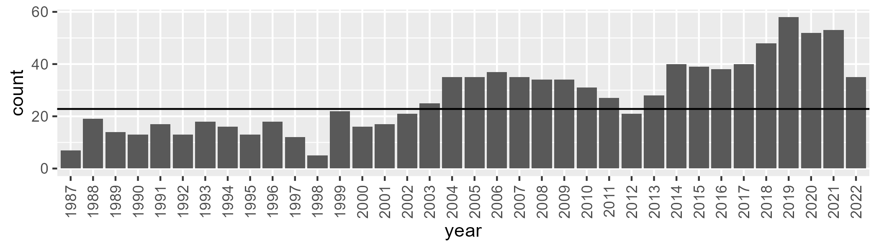

Number of samples: 986

# NTASSD0004

| Min. | 1st Qu. | Median | Mean | 3rd Qu. | Max. |
| --- | --- | --- | --- | --- | --- |
| 0.9127827 | 7.268991 | 9.878278 | 10.834 | 13.34732 | 30.29508 |

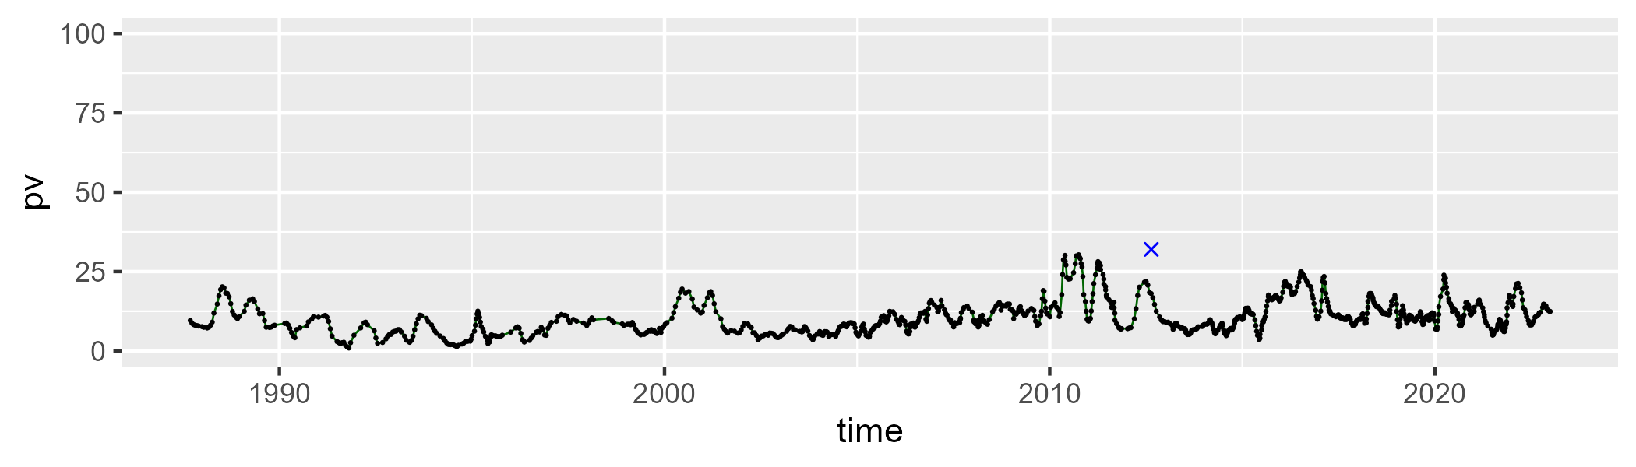

| Min. | 1st Qu. | Median | Mean | 3rd Qu. | Max. |
| --- | --- | --- | --- | --- | --- |
| 0 | 17.40502 | 23.69707 | 24.21743 | 31.25396 | 52.53007 |

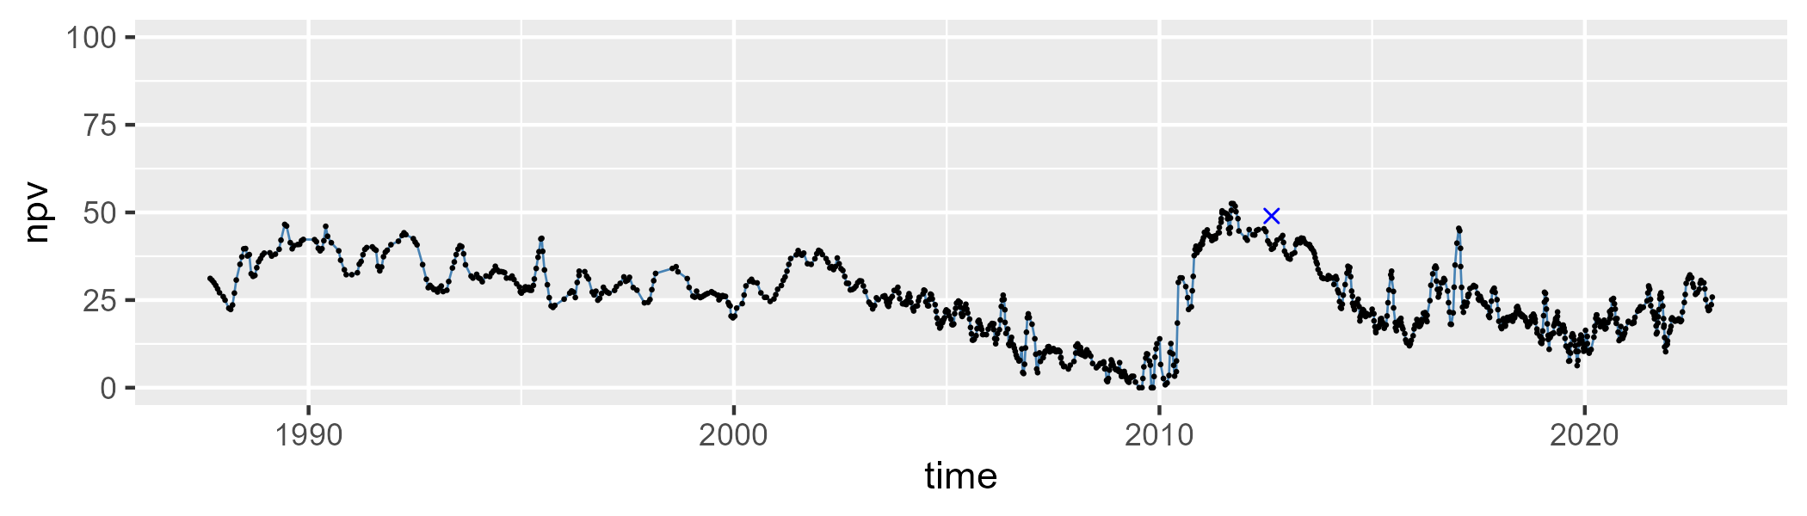

| Min. | 1st Qu. | Median | Mean | 3rd Qu. | Max. |
| --- | --- | --- | --- | --- | --- |
| 27.98033 | 57.97402 | 65.36745 | 63.46753 | 70.52524 | 86.5315 |

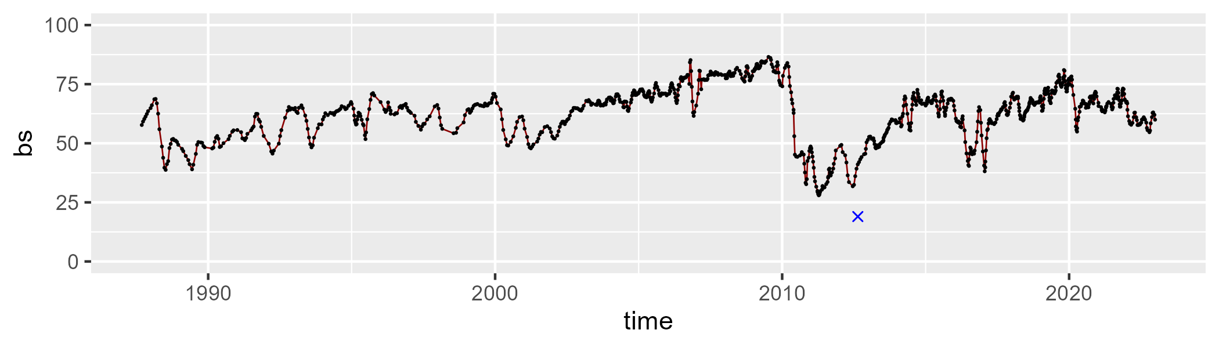

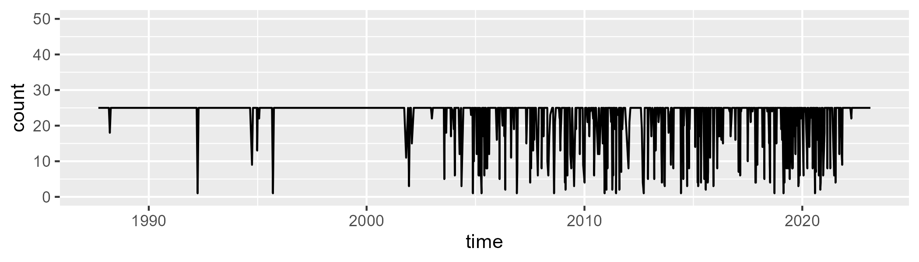

Min. : 1.00 1st Qu.:25.00 Median :25.00 Mean :22.21 3rd Qu.:25.00 Max. :25.00

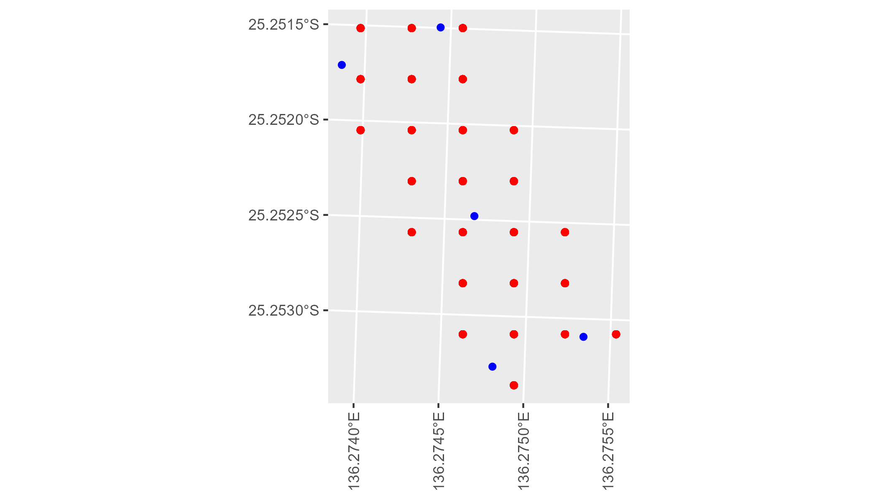

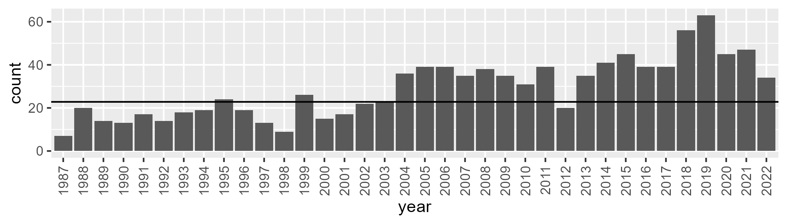

Number of samples: 1046

# NTASSD0005

| Min. | 1st Qu. | Median | Mean | 3rd Qu. | Max. |
| --- | --- | --- | --- | --- | --- |
| 3.145947 | 9.897003 | 13.15122 | 13.77749 | 17.02898 | 31.84503 |

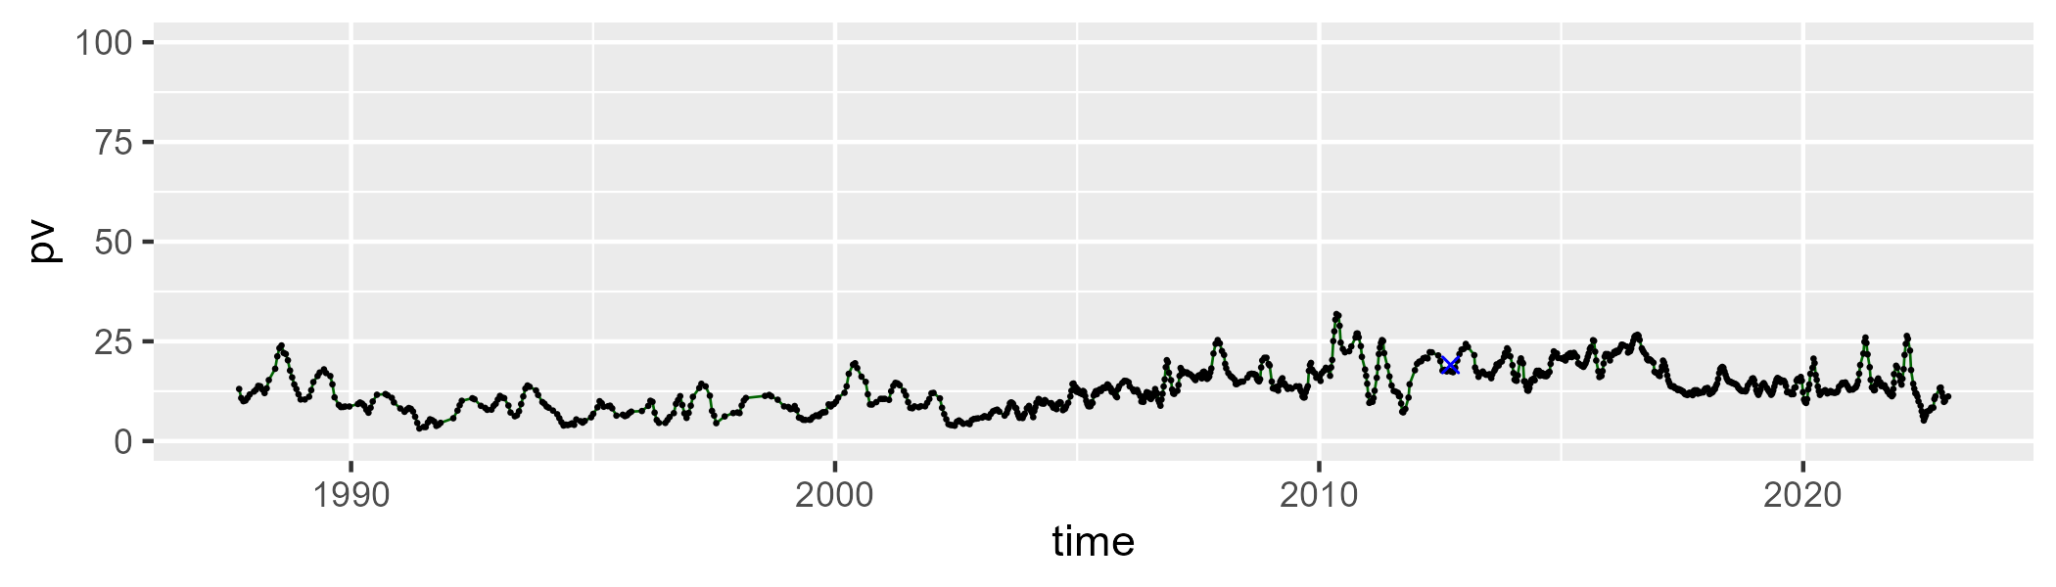

| Min. | 1st Qu. | Median | Mean | 3rd Qu. | Max. |
| --- | --- | --- | --- | --- | --- |
| 0 | 3.5422 | 11.84728 | 13.75178 | 22.17031 | 48.77254 |

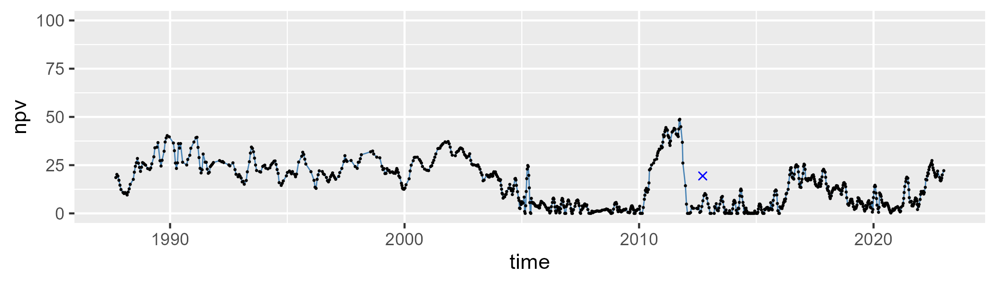

| Min. | 1st Qu. | Median | Mean | 3rd Qu. | Max. |
| --- | --- | --- | --- | --- | --- |
| 34.88322 | 65.53784 | 72.74257 | 71.10911 | 79.53495 | 86.90921 |

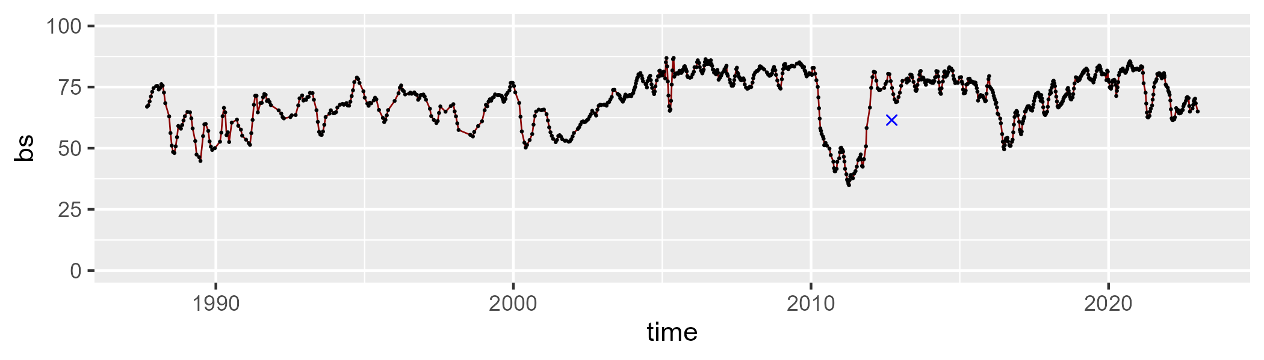

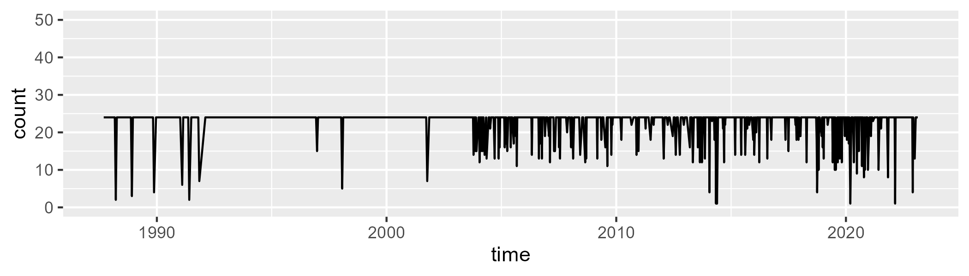

Min. : 1.00 1st Qu.:24.00 Median :24.00 Mean :22.62 3rd Qu.:24.00 Max. :24.00

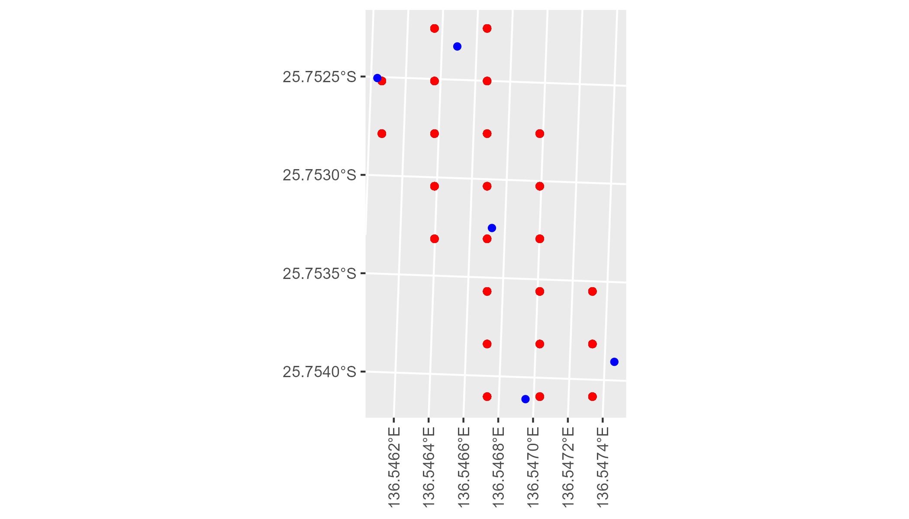

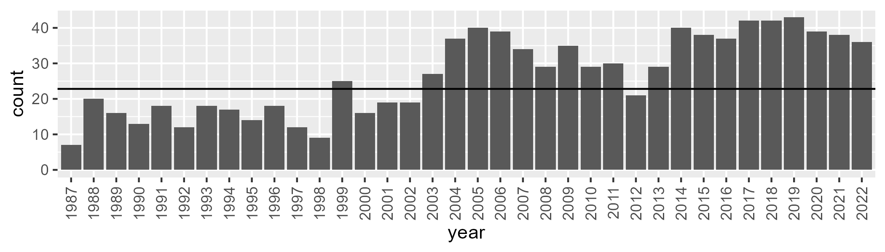

Number of samples: 958

# NTASSD0006

| Min. | 1st Qu. | Median | Mean | 3rd Qu. | Max. |
| --- | --- | --- | --- | --- | --- |
| 0.04463513 | 6.234543 | 10.26545 | 10.55641 | 13.38033 | 40.02155 |

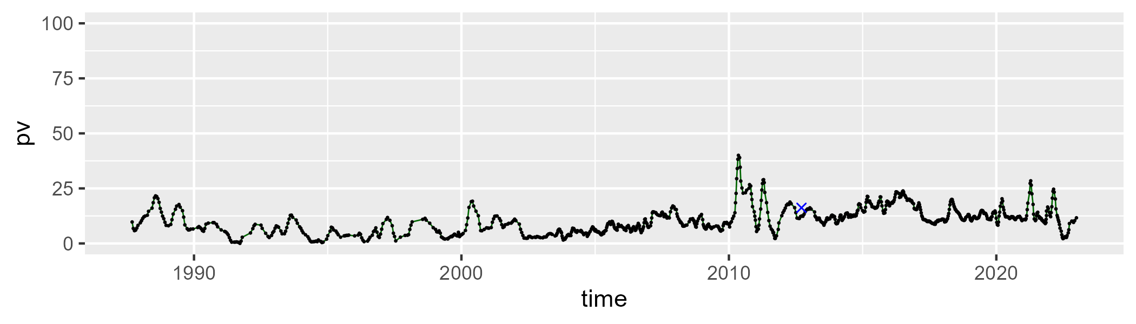

| Min. | 1st Qu. | Median | Mean | 3rd Qu. | Max. |
| --- | --- | --- | --- | --- | --- |
| 0 | 6.118003 | 13.78055 | 17.26851 | 26.93136 | 68.14988 |

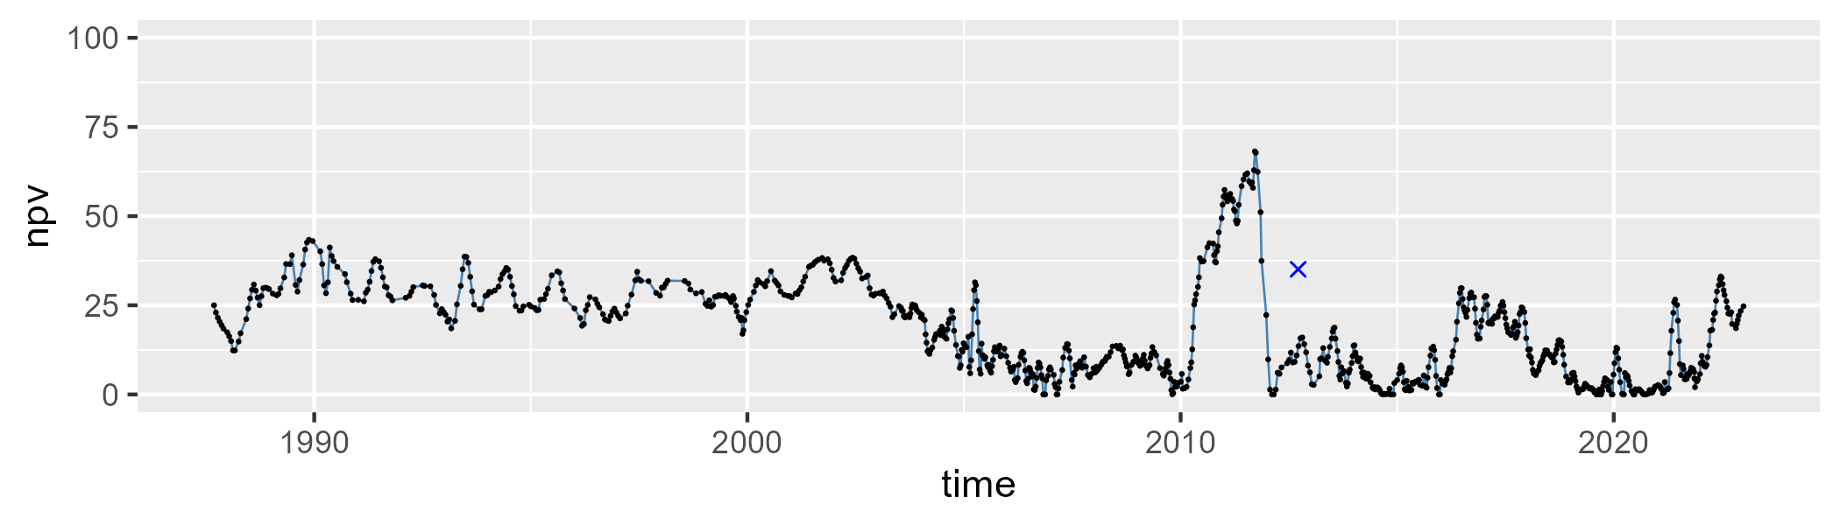

| Min. | 1st Qu. | Median | Mean | 3rd Qu. | Max. |
| --- | --- | --- | --- | --- | --- |
| 20.23462 | 64.04736 | 73.28398 | 70.72908 | 80.55321 | 90.88947 |

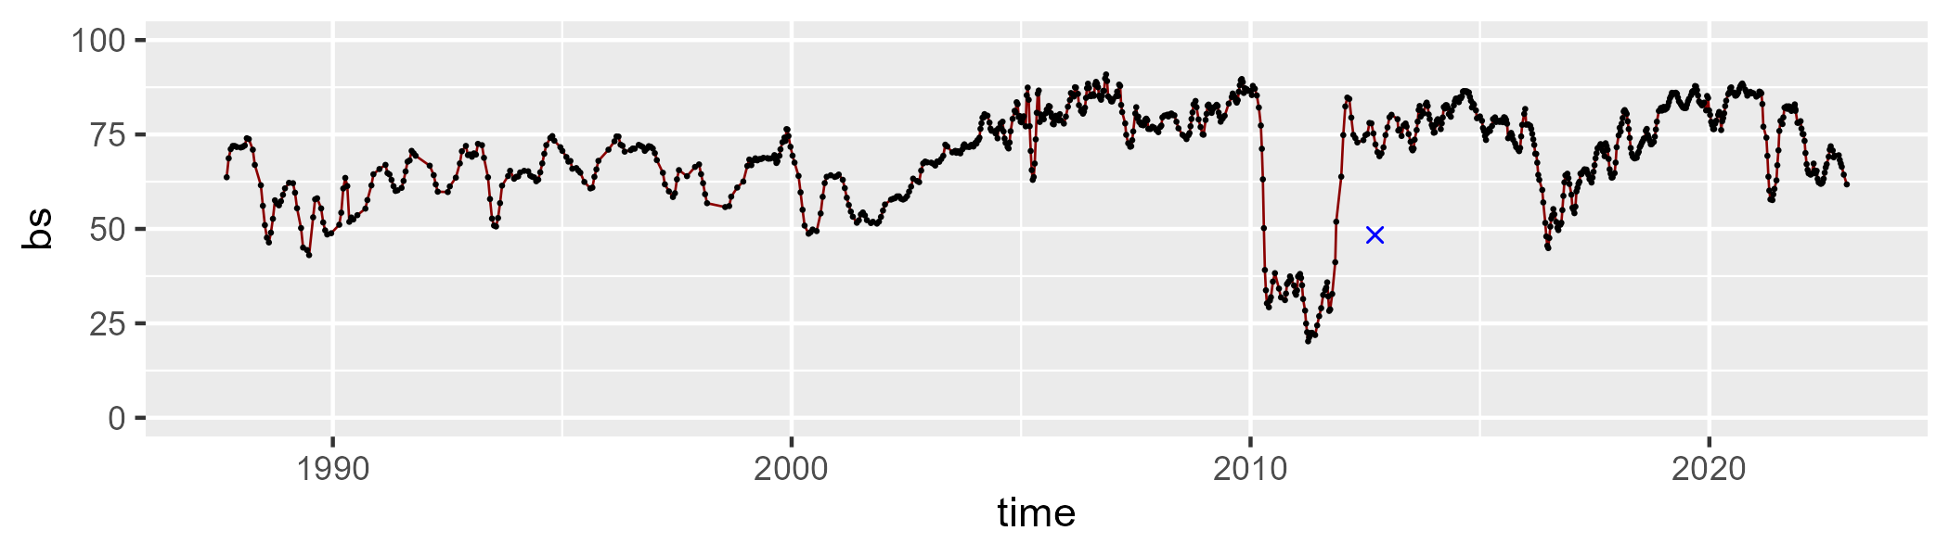

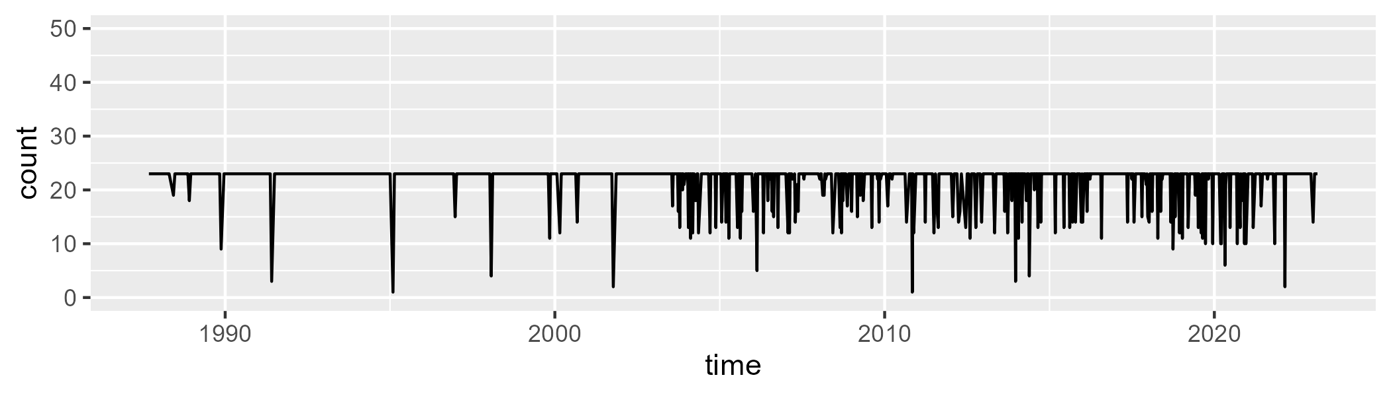

Min. : 1.00 1st Qu.:23.00 Median :23.00 Mean :21.69 3rd Qu.:23.00 Max. :23.00

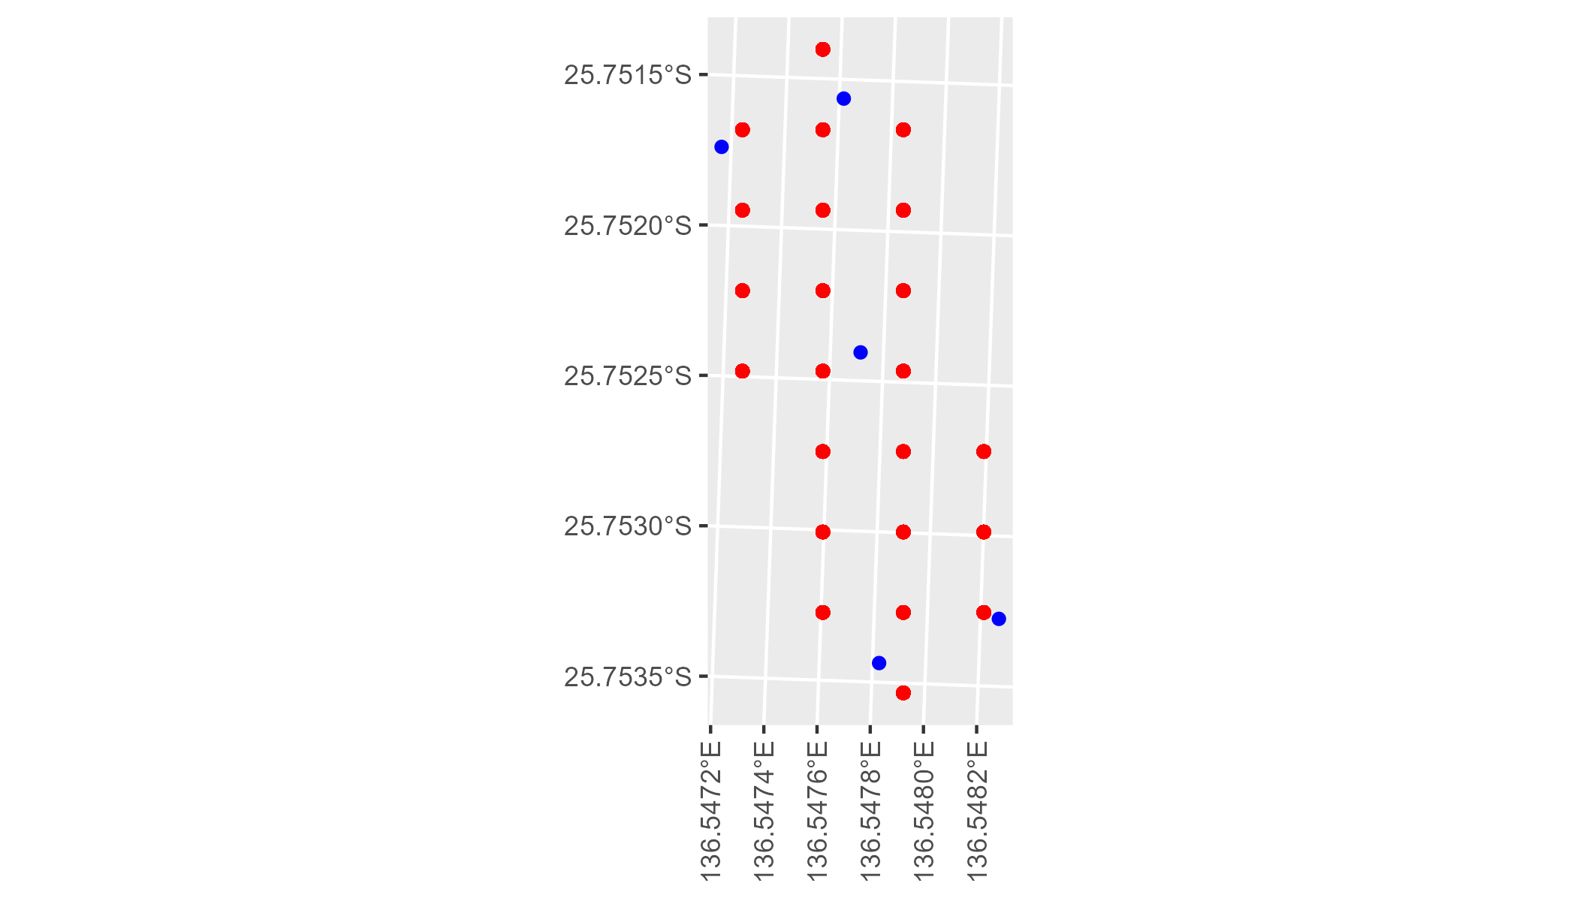

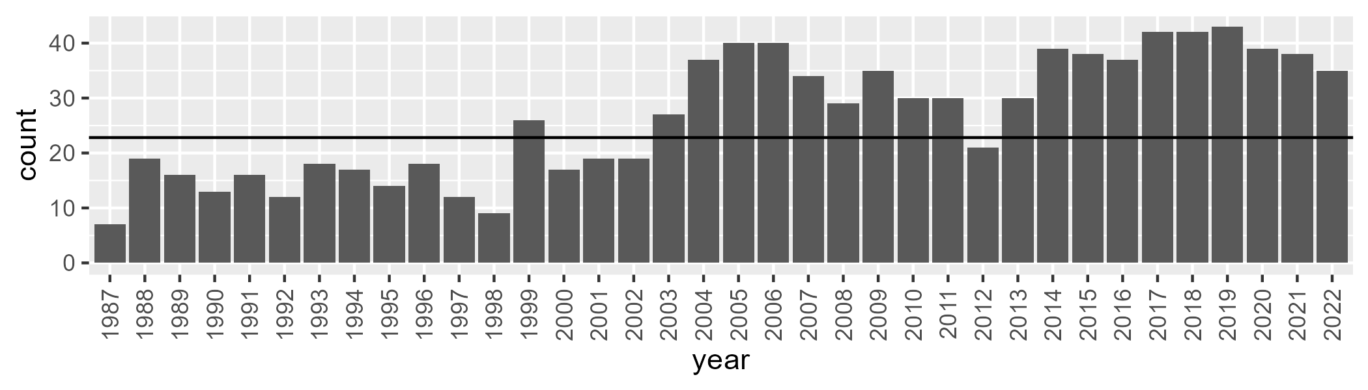

Number of samples: 958

# NTASSD0007

| Min. | 1st Qu. | Median | Mean | 3rd Qu. | Max. |
| --- | --- | --- | --- | --- | --- |
| 3.717849 | 12.19969 | 14.60574 | 15.36509 | 18.12522 | 35.03257 |

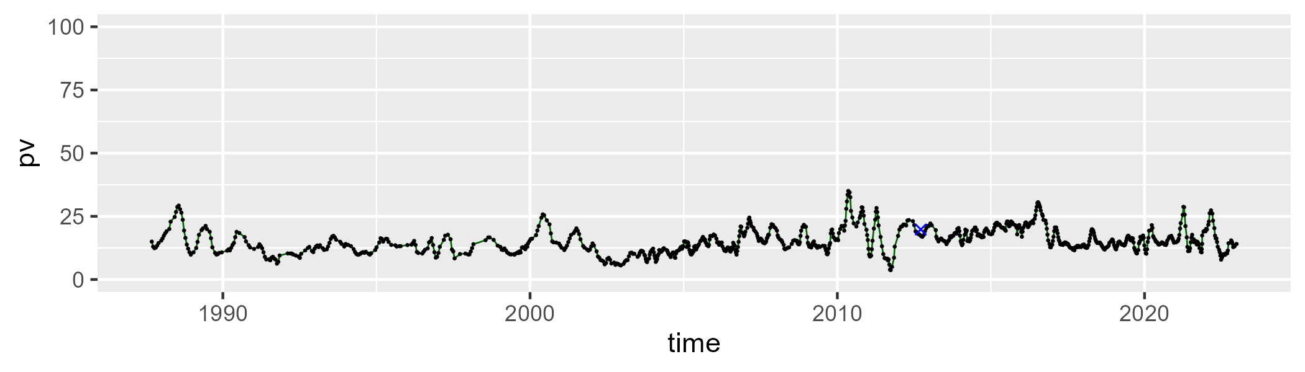

| Min. | 1st Qu. | Median | Mean | 3rd Qu. | Max. |
| --- | --- | --- | --- | --- | --- |
| 0 | 3.652721 | 8.62775 | 11.25758 | 16.0662 | 52.88339 |

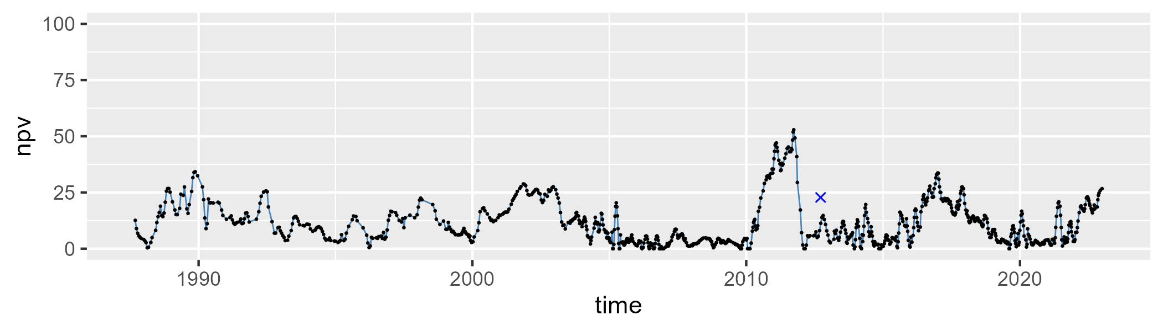

| Min. | 1st Qu. | Median | Mean | 3rd Qu. | Max. |
| --- | --- | --- | --- | --- | --- |
| 34.01783 | 66.69649 | 75.06848 | 72.02221 | 79.51822 | 87.61585 |

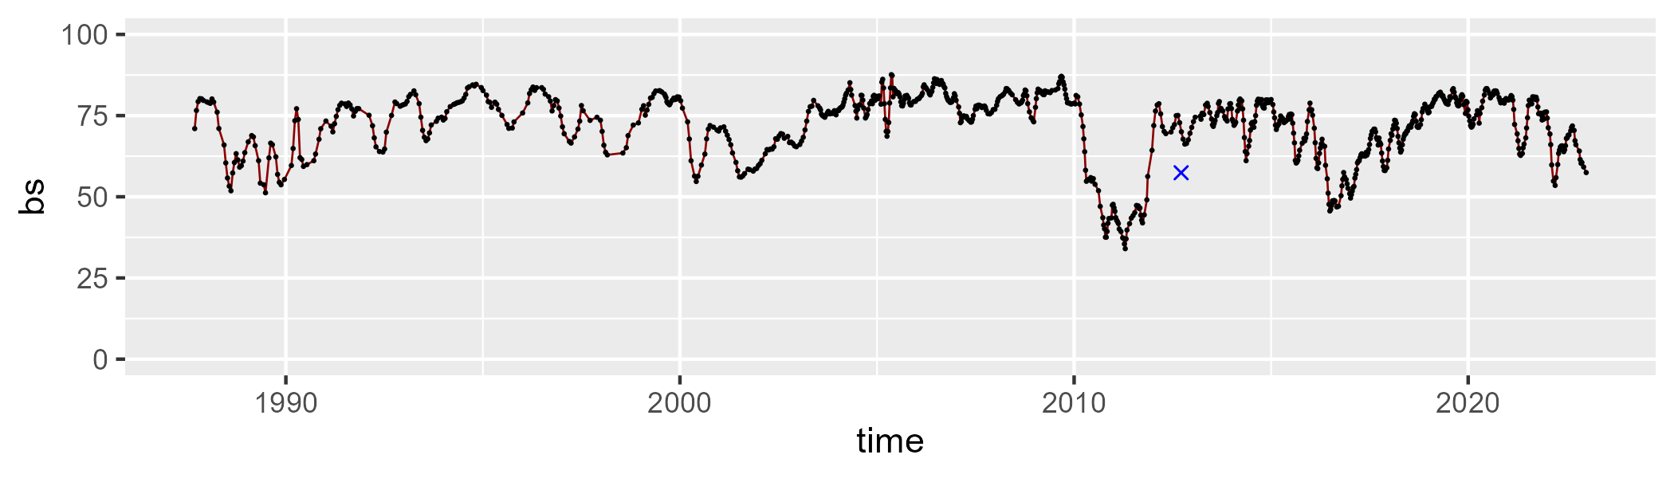

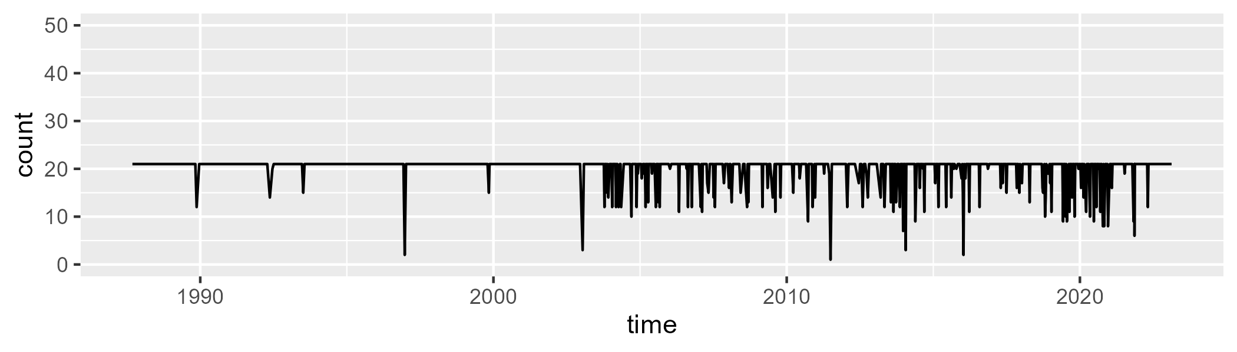

Min. : 1.00 1st Qu.:21.00 Median :21.00 Mean :20.02 3rd Qu.:21.00 Max. :21.00

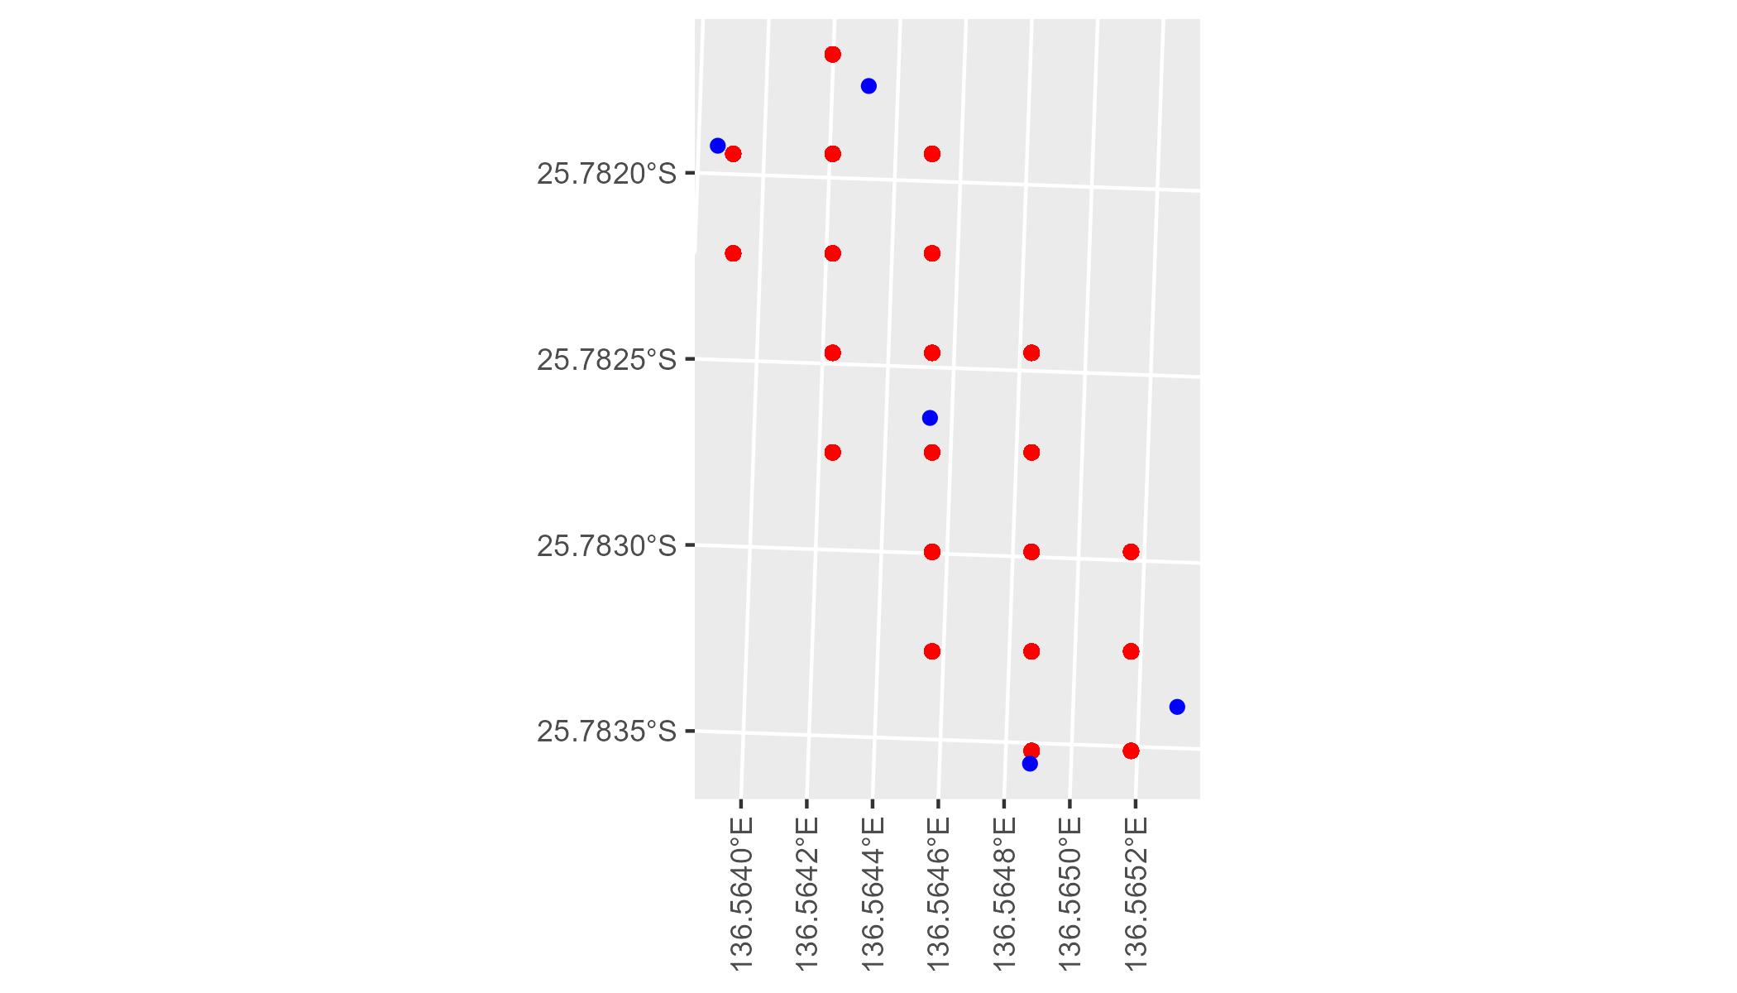

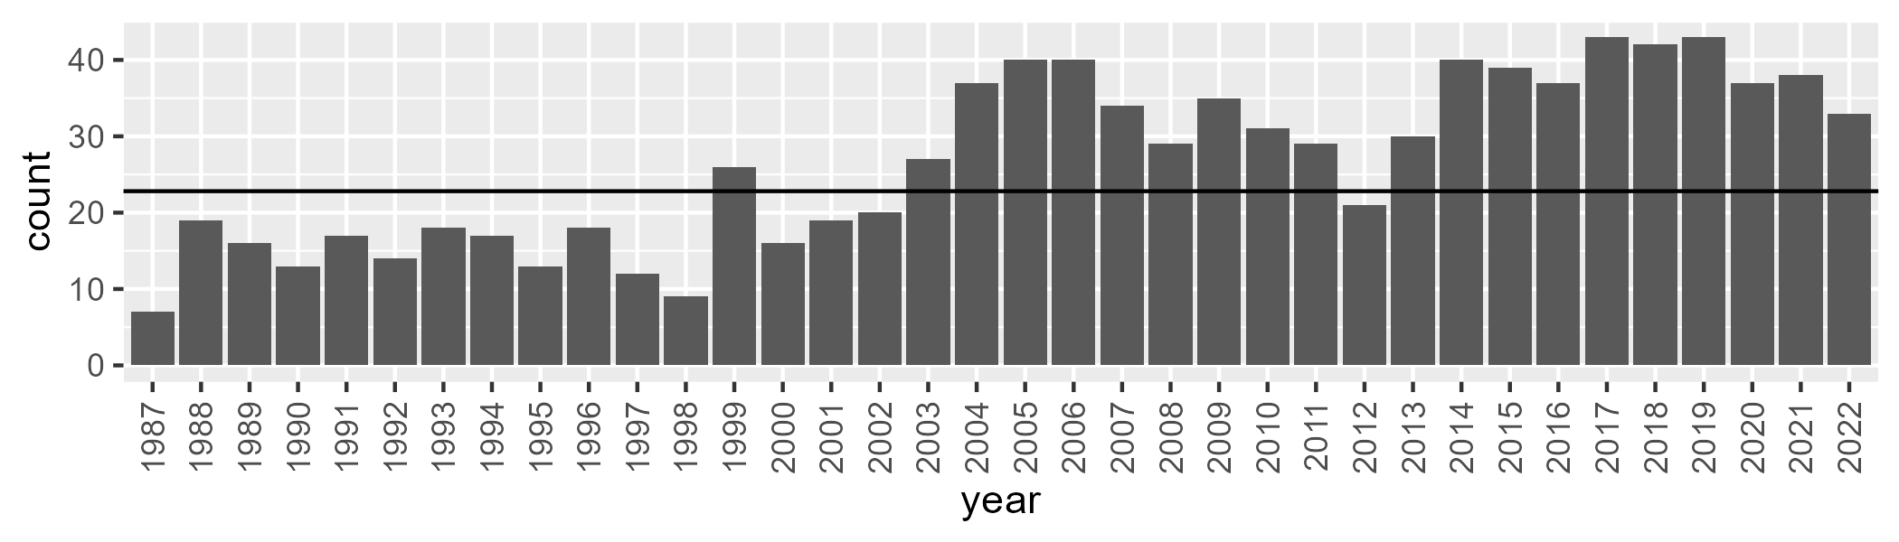

Number of samples: 959

# NTASSD0008

| Min. | 1st Qu. | Median | Mean | 3rd Qu. | Max. |
| --- | --- | --- | --- | --- | --- |
| 0 | 7.038717 | 11.86235 | 11.83035 | 15.44652 | 34.72577 |

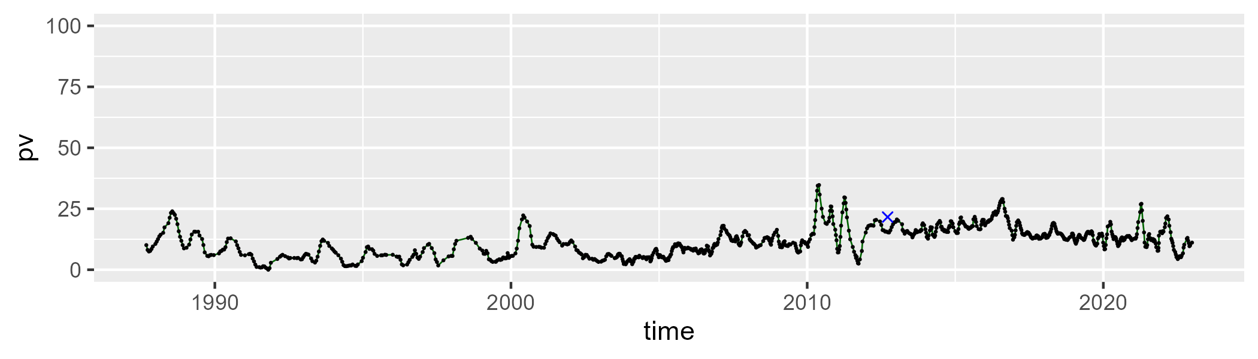

| Min. | 1st Qu. | Median | Mean | 3rd Qu. | Max. |
| --- | --- | --- | --- | --- | --- |
| 0 | 3.480705 | 11.74579 | 14.7038 | 24.0321 | 64.0987 |

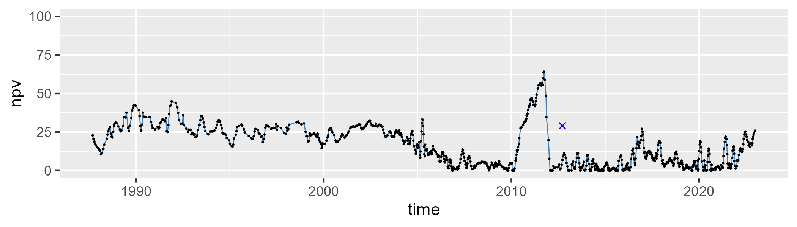

| Min. | 1st Qu. | Median | Mean | 3rd Qu. | Max. |
| --- | --- | --- | --- | --- | --- |
| 26.28096 | 65.85256 | 74.55842 | 72.09661 | 80.66788 | 90.73939 |

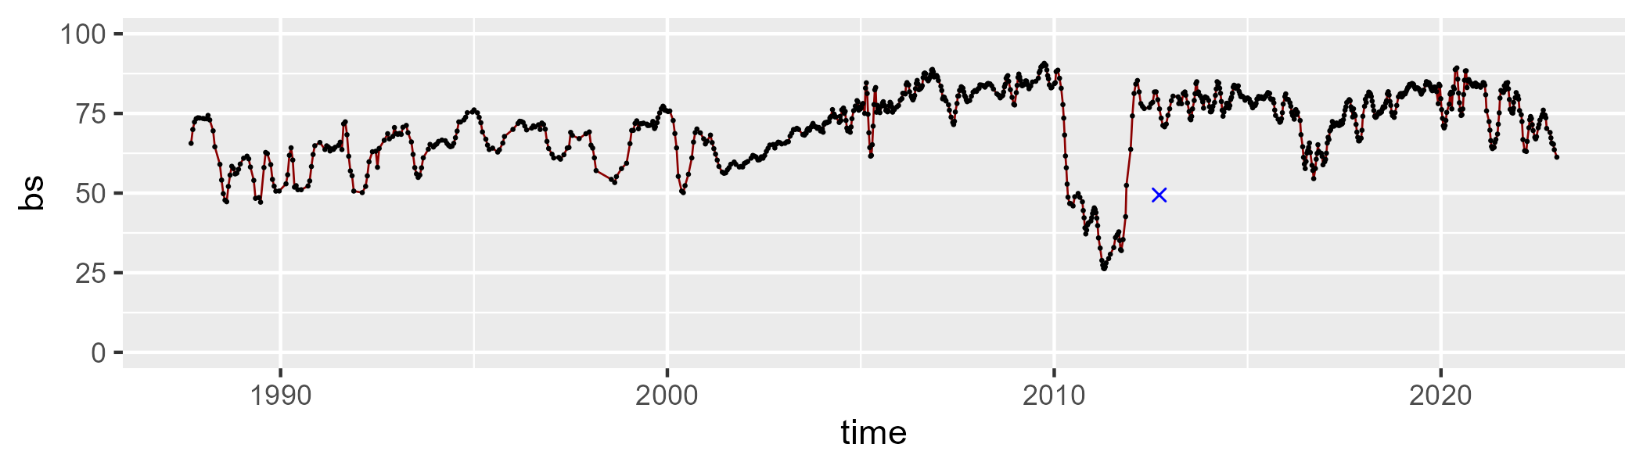

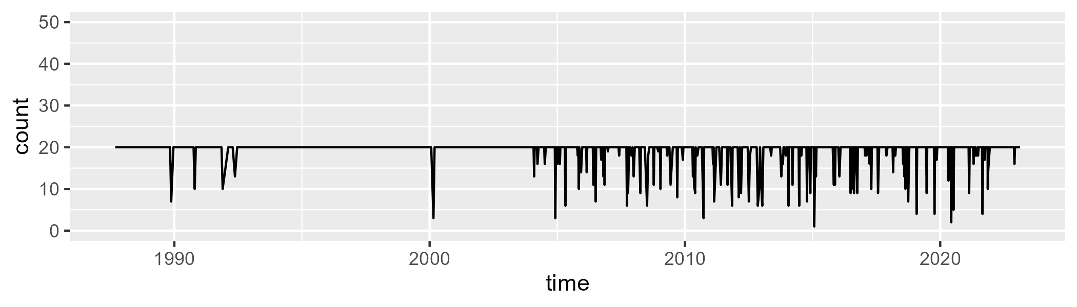

Min. : 1.00 1st Qu.:20.00 Median :20.00 Mean :19.08 3rd Qu.:20.00 Max. :20.00

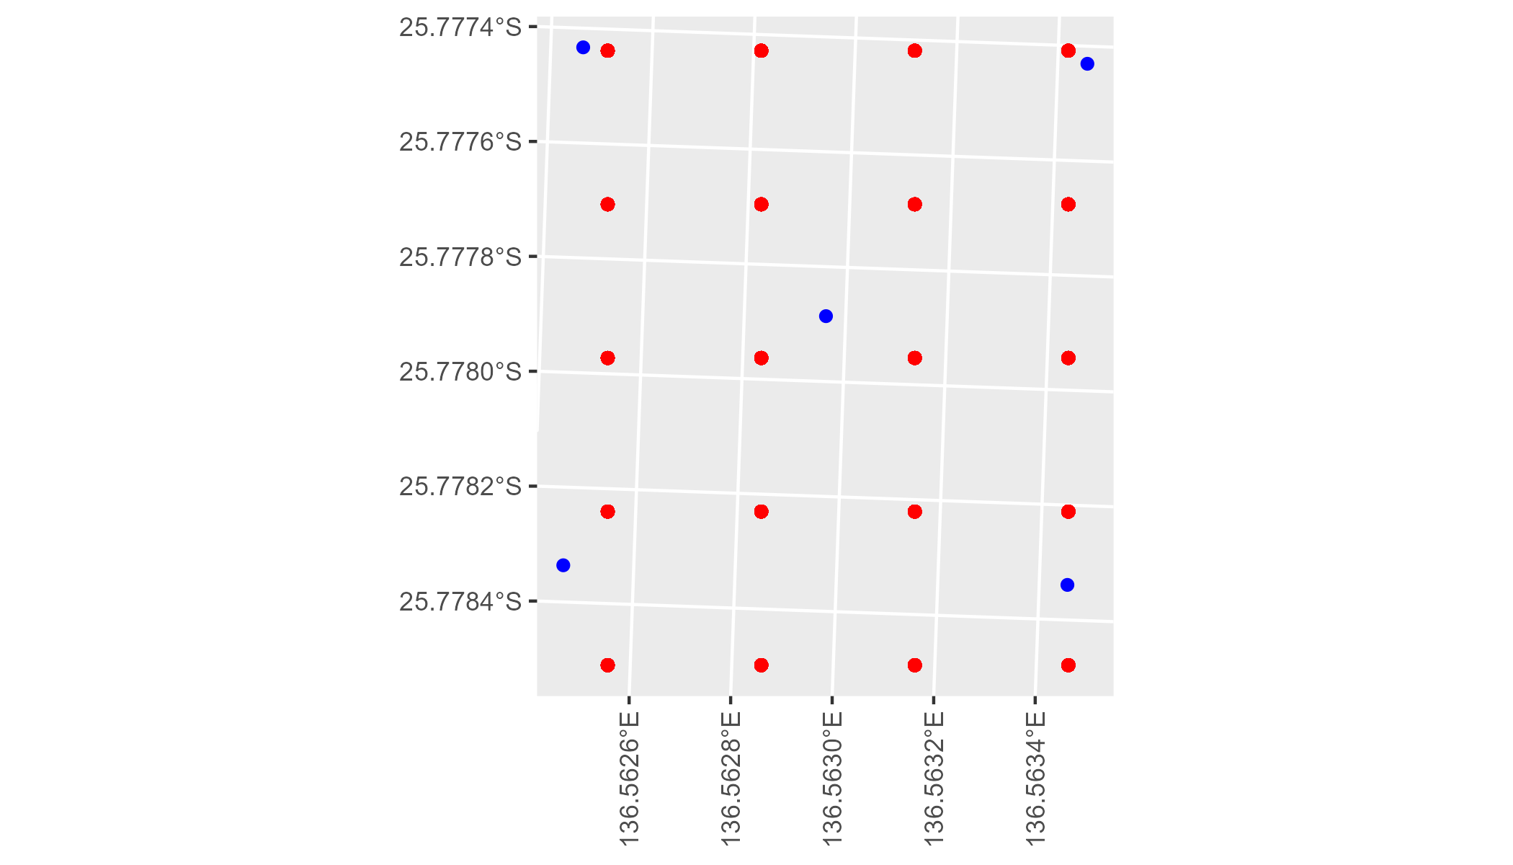

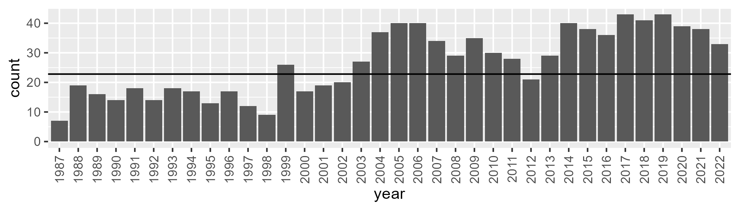

Number of samples: 957

# NTASSD0009

| Min. | 1st Qu. | Median | Mean | 3rd Qu. | Max. |
| --- | --- | --- | --- | --- | --- |
| 1.007435 | 7.949895 | 10.22211 | 11.15488 | 12.83203 | 32.10719 |

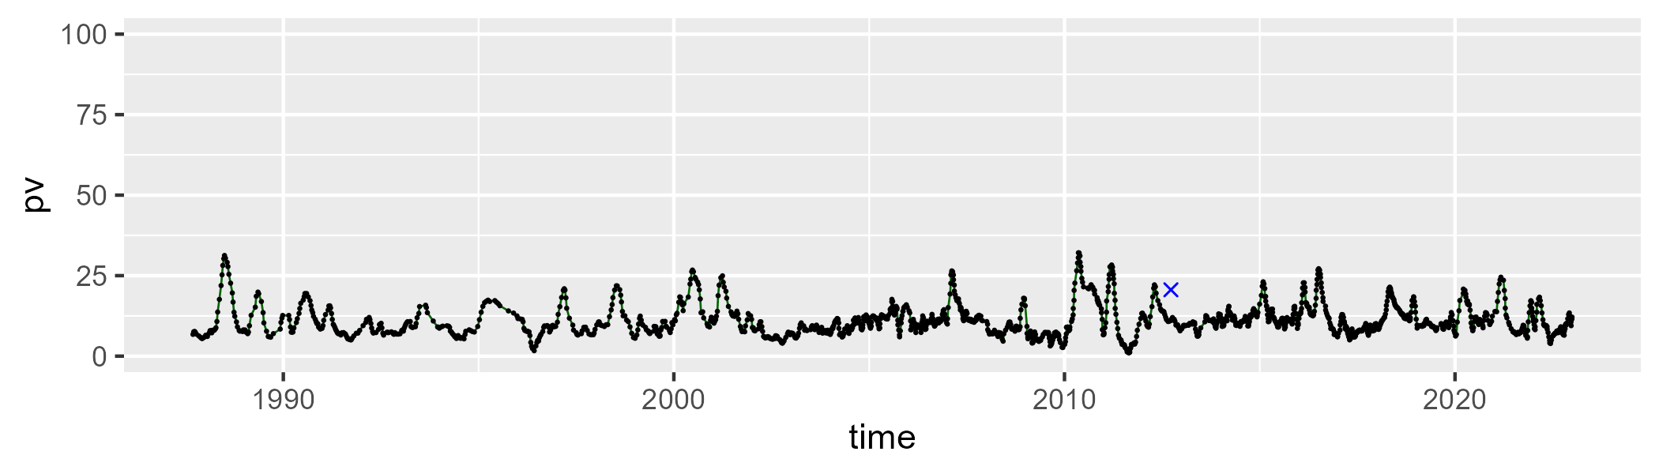

| Min. | 1st Qu. | Median | Mean | 3rd Qu. | Max. |
| --- | --- | --- | --- | --- | --- |
| 0 | 10.35774 | 17.16307 | 18.25982 | 23.75498 | 62.24498 |

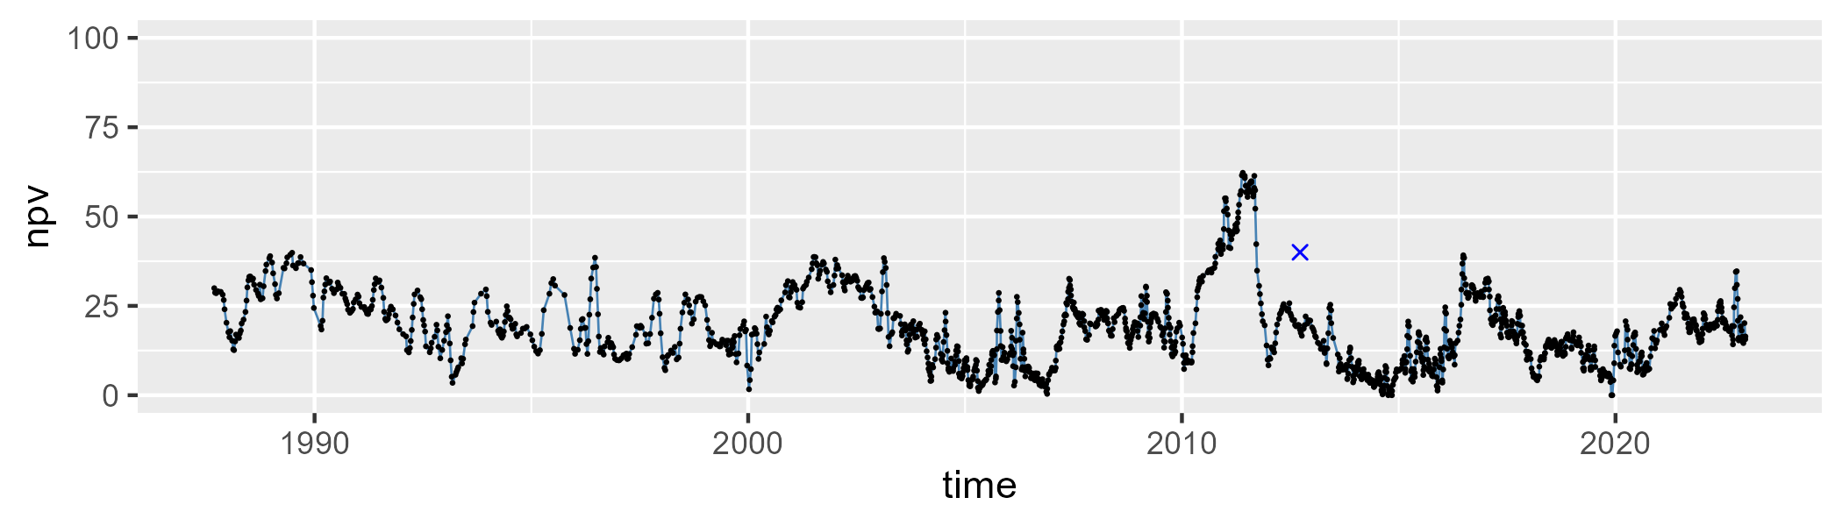

| Min. | 1st Qu. | Median | Mean | 3rd Qu. | Max. |
| --- | --- | --- | --- | --- | --- |
| 24.45334 | 63.87805 | 71.30293 | 69.04576 | 77.18685 | 86.51165 |

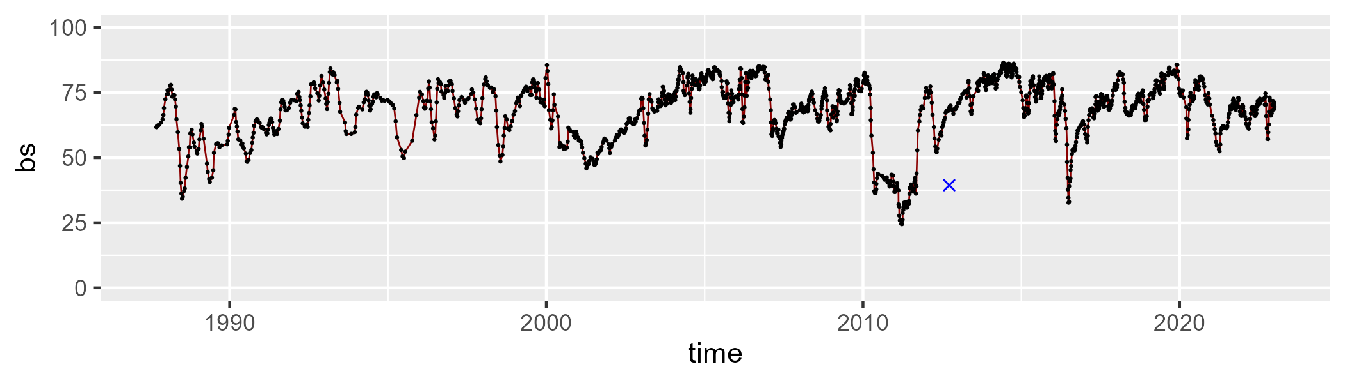

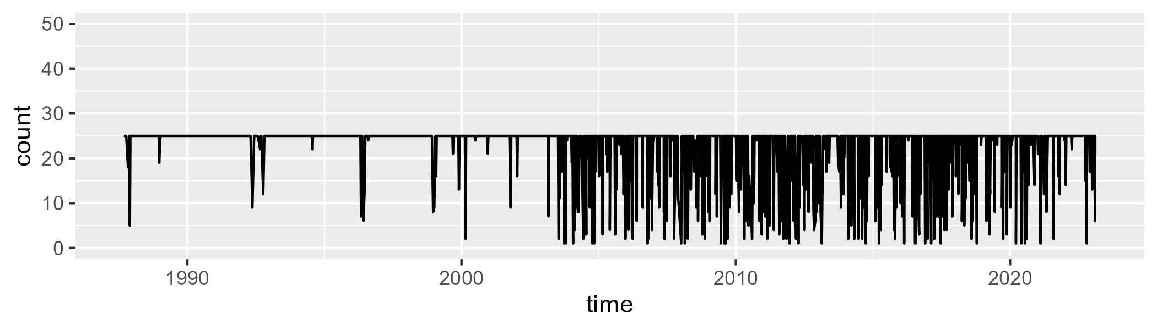

Min. : 1.00 1st Qu.:25.00 Median :25.00 Mean :22.37 3rd Qu.:25.00 Max. :25.00

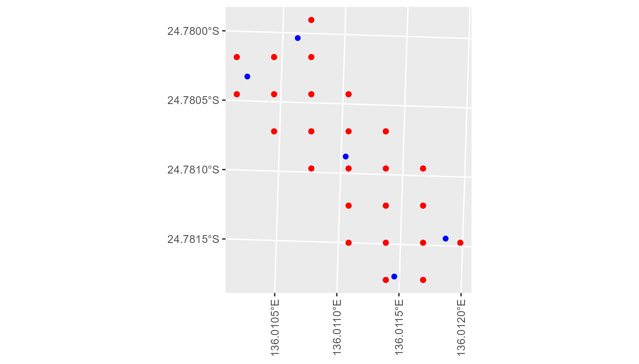

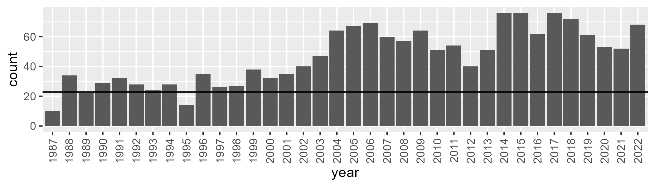

Number of samples: 1674

# NTASSD0010

| Min. | 1st Qu. | Median | Mean | 3rd Qu. | Max. |
| --- | --- | --- | --- | --- | --- |
| 1.686264 | 11.27627 | 13.67966 | 14.25296 | 16.72484 | 29.44316 |

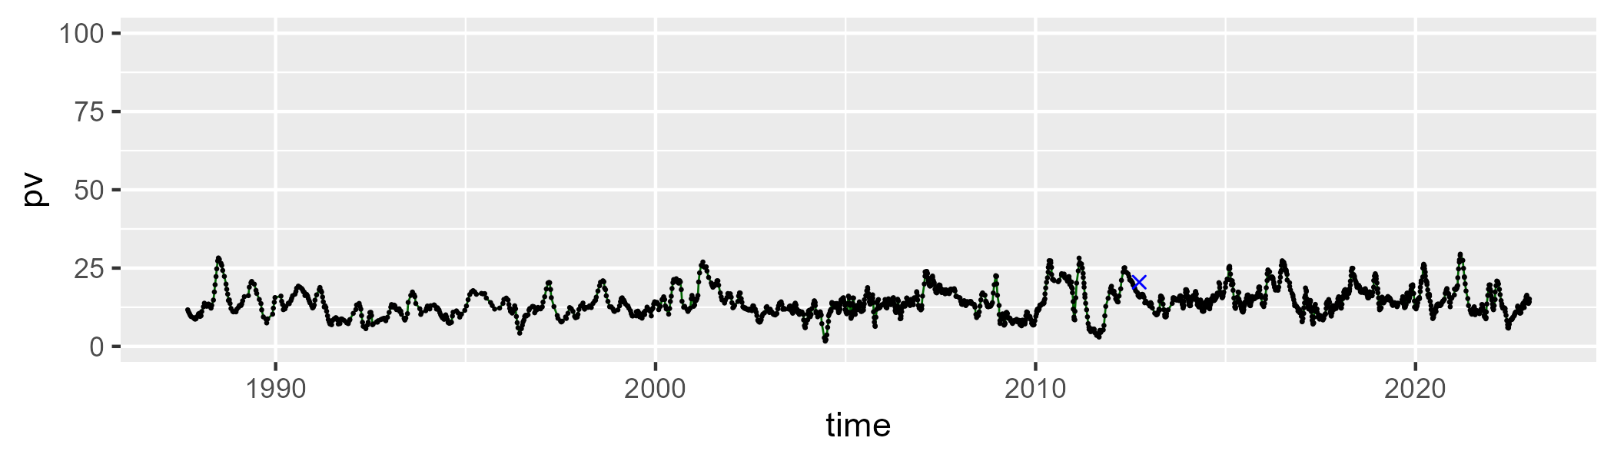

| Min. | 1st Qu. | Median | Mean | 3rd Qu. | Max. |
| --- | --- | --- | --- | --- | --- |
| 0 | 8.336481 | 14.49271 | 15.50311 | 21.02127 | 60.78646 |

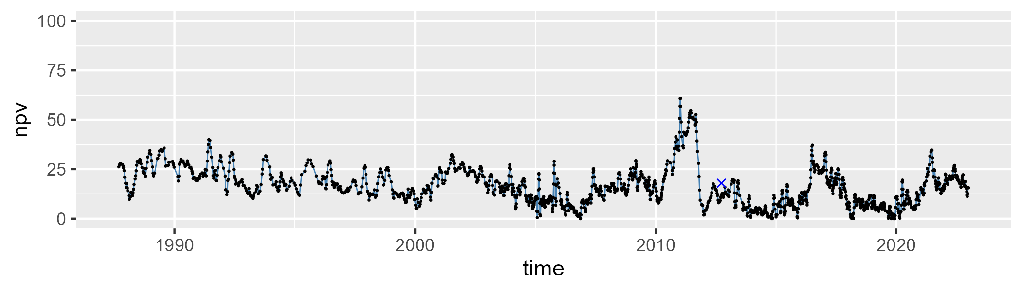

| Min. | 1st Qu. | Median | Mean | 3rd Qu. | Max. |
| --- | --- | --- | --- | --- | --- |
| 28.29018 | 64.60594 | 70.54198 | 68.76934 | 75.96567 | 85.53601 |

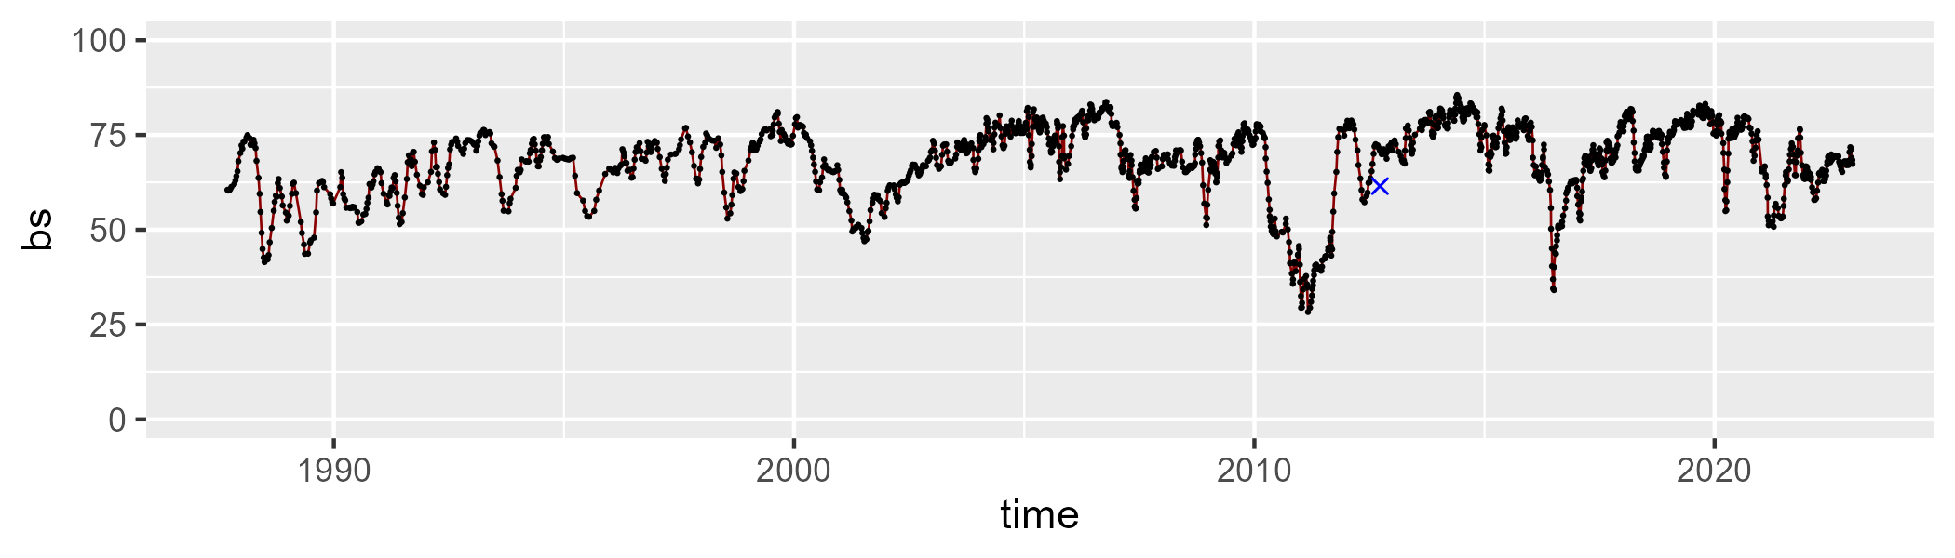

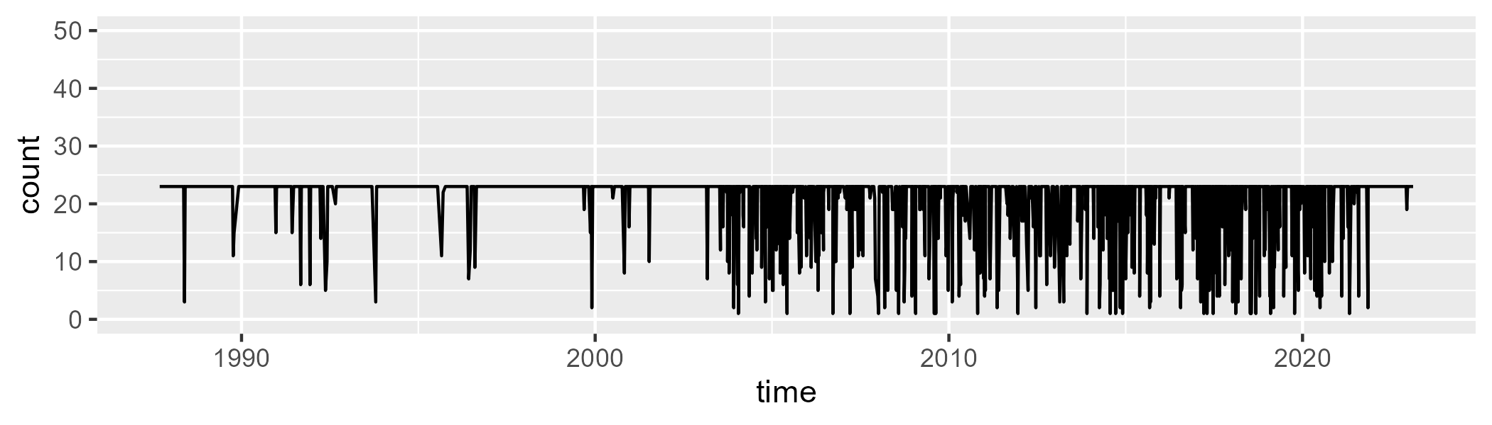

Min. : 1.00 1st Qu.:23.00 Median :23.00 Mean :20.82 3rd Qu.:23.00 Max. :23.00

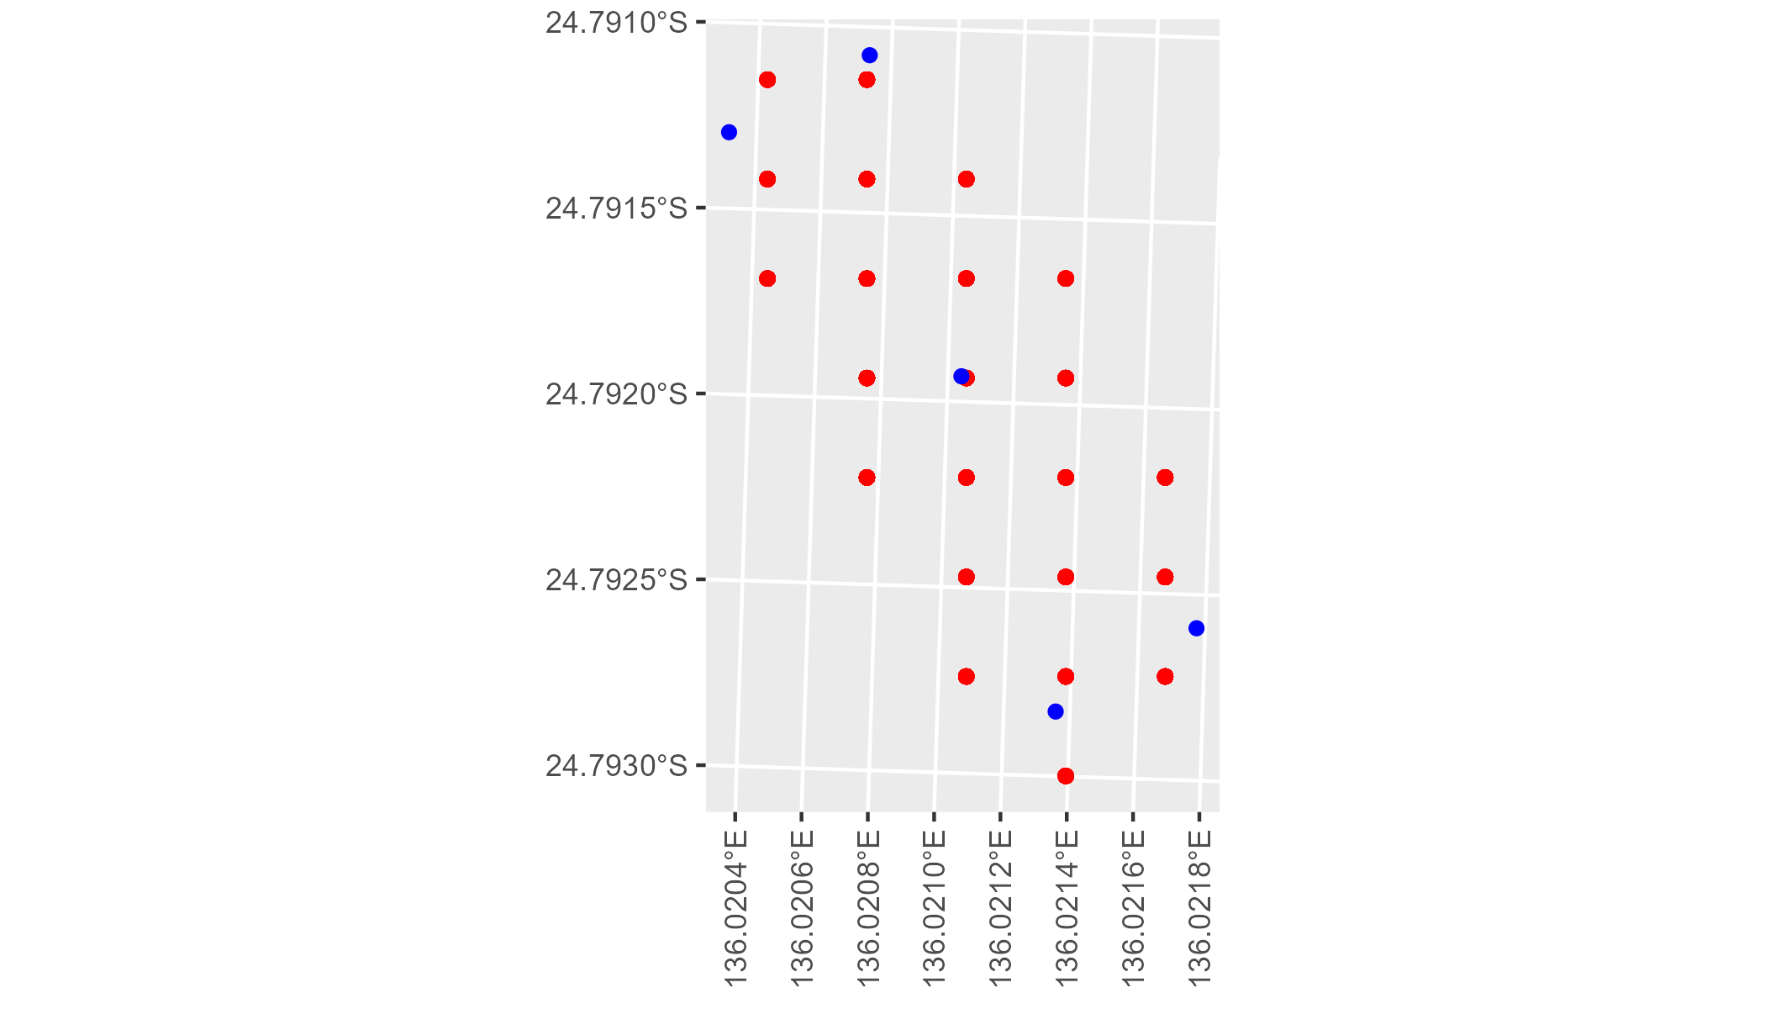

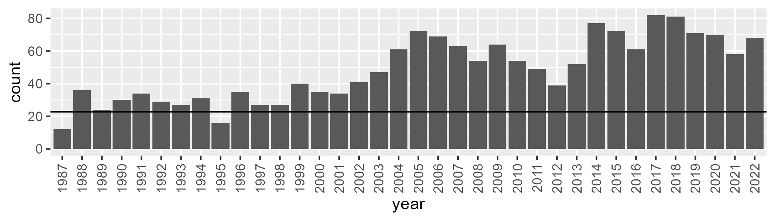

Number of samples: 1742

# NTASSD0011

| Min. | 1st Qu. | Median | Mean | 3rd Qu. | Max. |
| --- | --- | --- | --- | --- | --- |
| 0 | 0.1115155 | 0.820491 | 1.060527 | 1.446293 | 9.127463 |

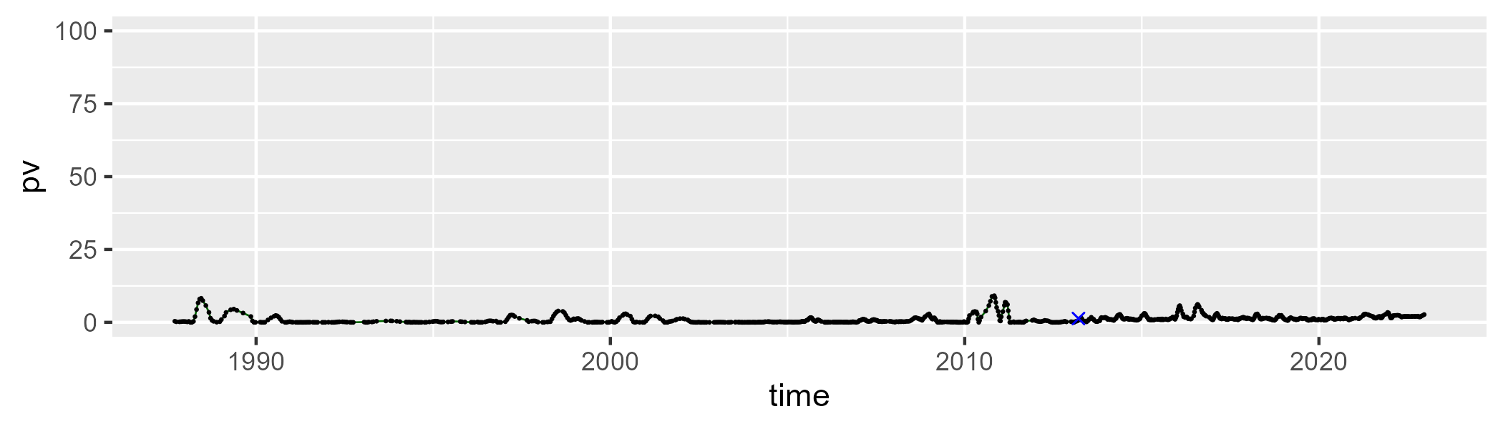

| Min. | 1st Qu. | Median | Mean | 3rd Qu. | Max. |
| --- | --- | --- | --- | --- | --- |
| 18.49675 | 31.84896 | 34.19364 | 34.36849 | 36.98339 | 45.95804 |

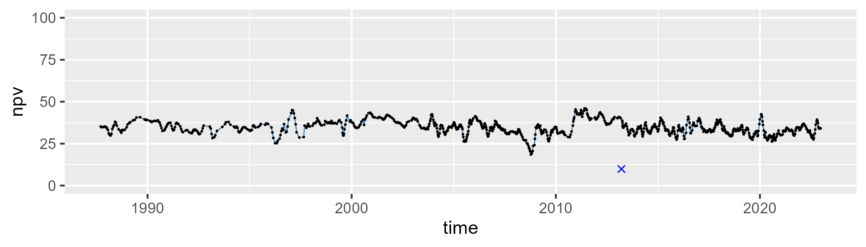

| Min. | 1st Qu. | Median | Mean | 3rd Qu. | Max. |
| --- | --- | --- | --- | --- | --- |
| 48.69295 | 60.73964 | 63.67951 | 63.33383 | 65.98999 | 79.24277 |

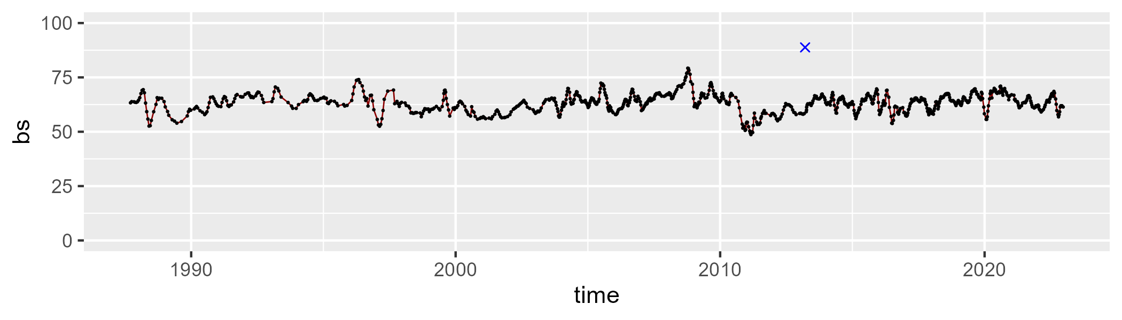

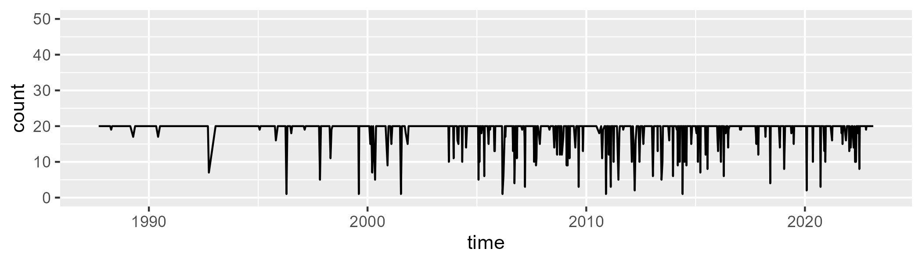

Min. : 1.00 1st Qu.:20.00 Median :20.00 Mean :18.89 3rd Qu.:20.00 Max. :20.00

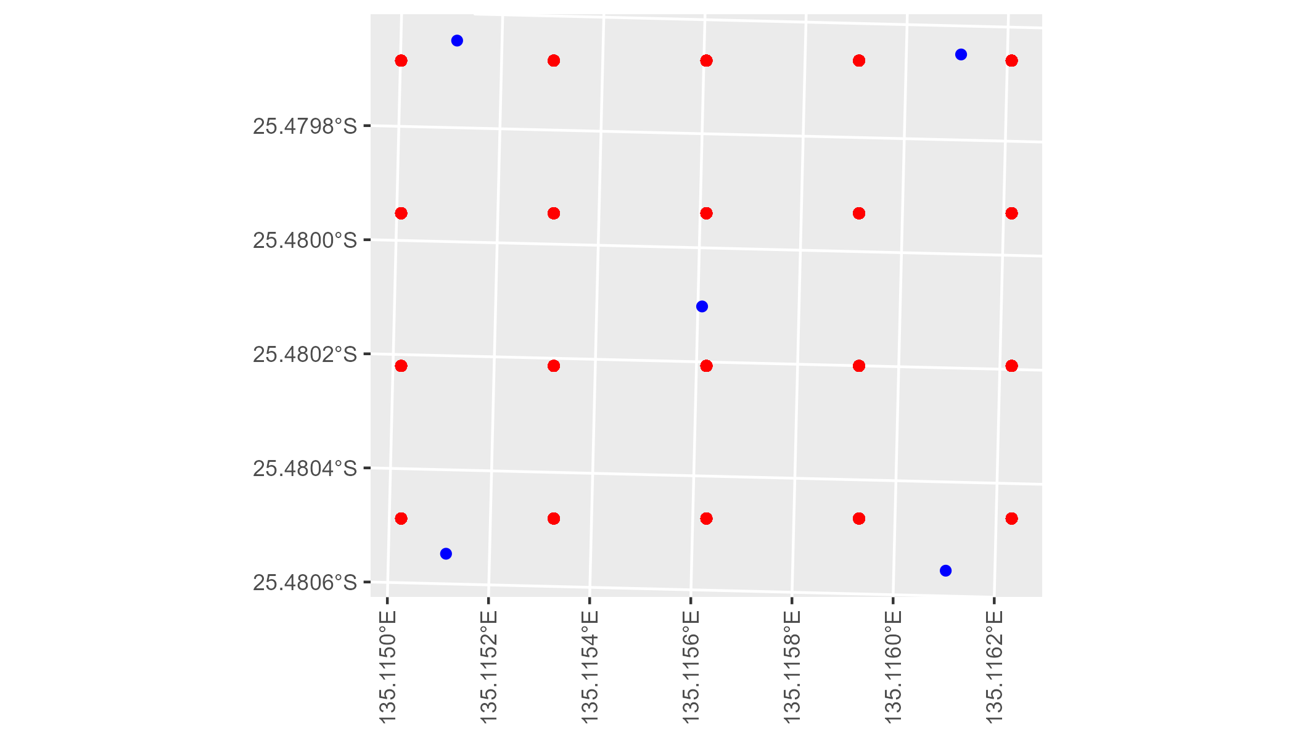

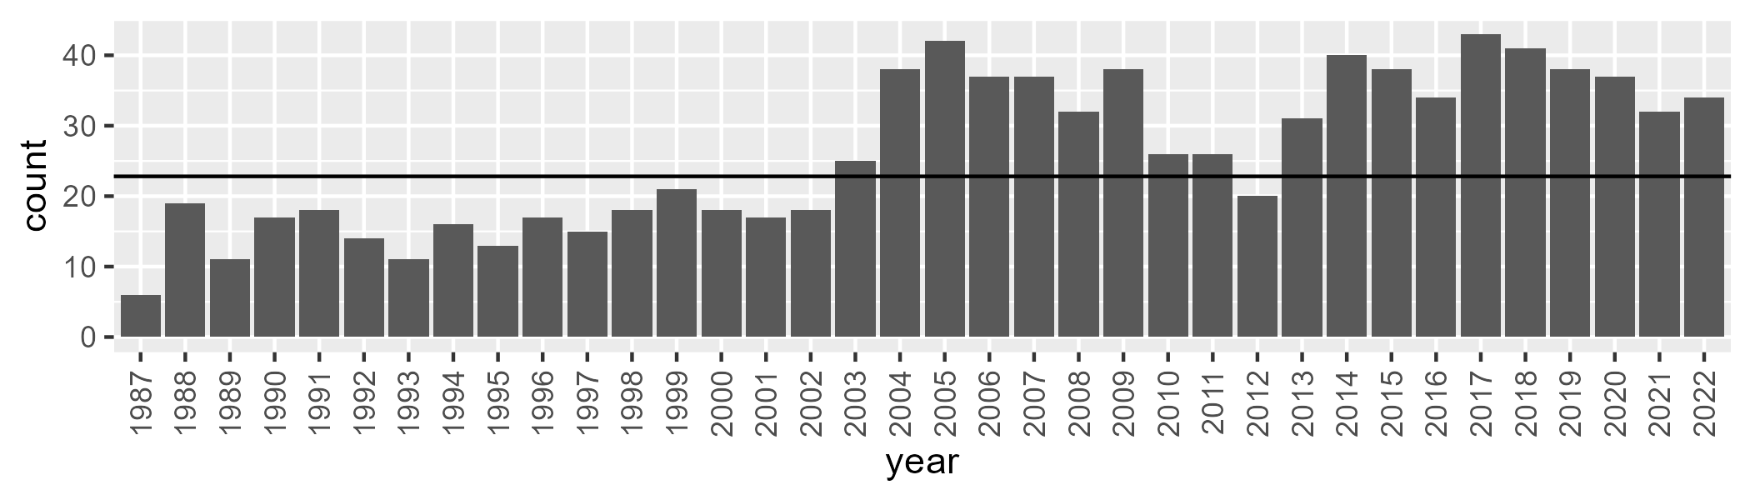

Number of samples: 938

# NTASSD0012

| Min. | 1st Qu. | Median | Mean | 3rd Qu. | Max. |
| --- | --- | --- | --- | --- | --- |
| 0 | 0.03969503 | 0.7222687 | 0.9526746 | 1.34031 | 8.693628 |

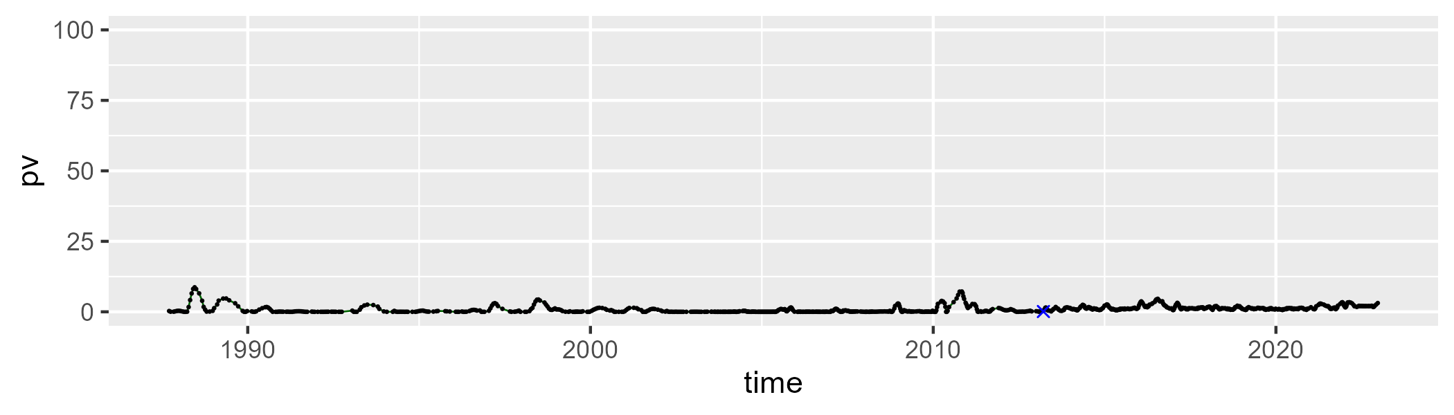

| Min. | 1st Qu. | Median | Mean | 3rd Qu. | Max. |
| --- | --- | --- | --- | --- | --- |
| 12.44119 | 27.93059 | 31.78701 | 32.41916 | 36.5779 | 55.16267 |

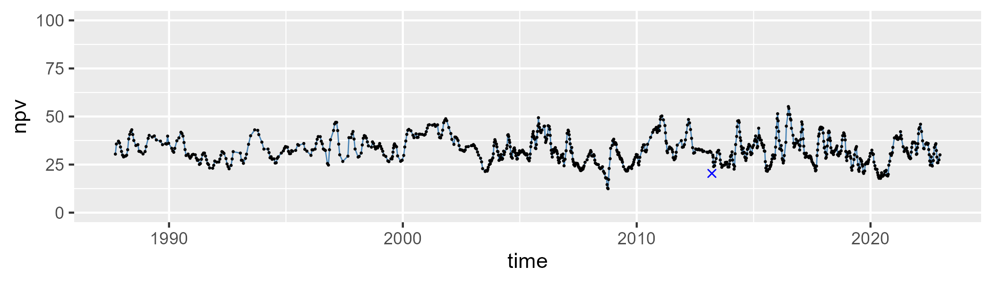

| Min. | 1st Qu. | Median | Mean | 3rd Qu. | Max. |
| --- | --- | --- | --- | --- | --- |
| 39.14588 | 60.68597 | 66.62629 | 65.41956 | 70.5424 | 86.65135 |

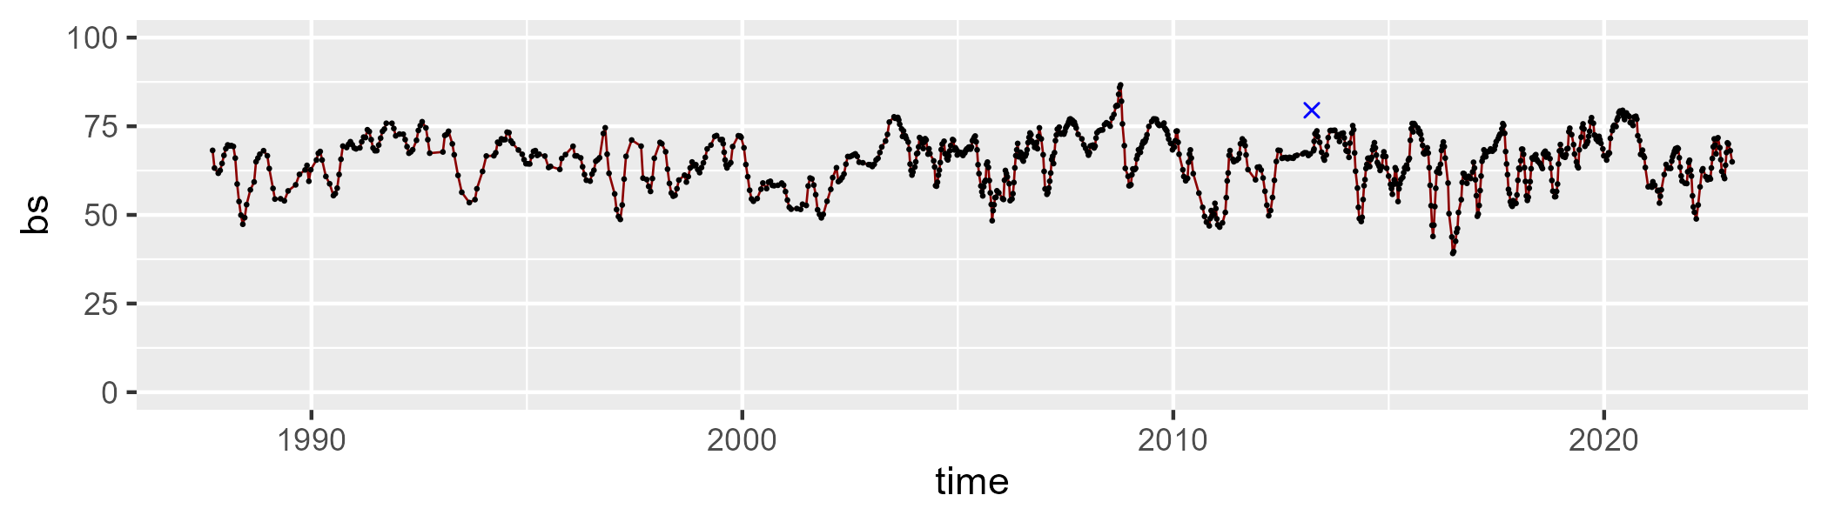

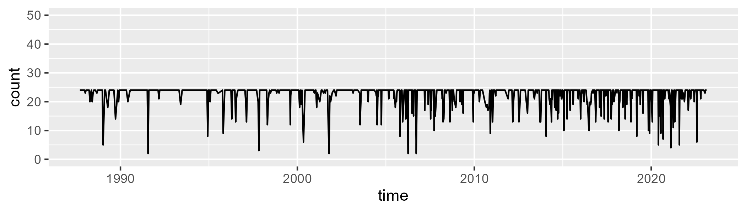

Min. : 2.00 1st Qu.:24.00 Median :24.00 Mean :22.51 3rd Qu.:24.00 Max. :24.00

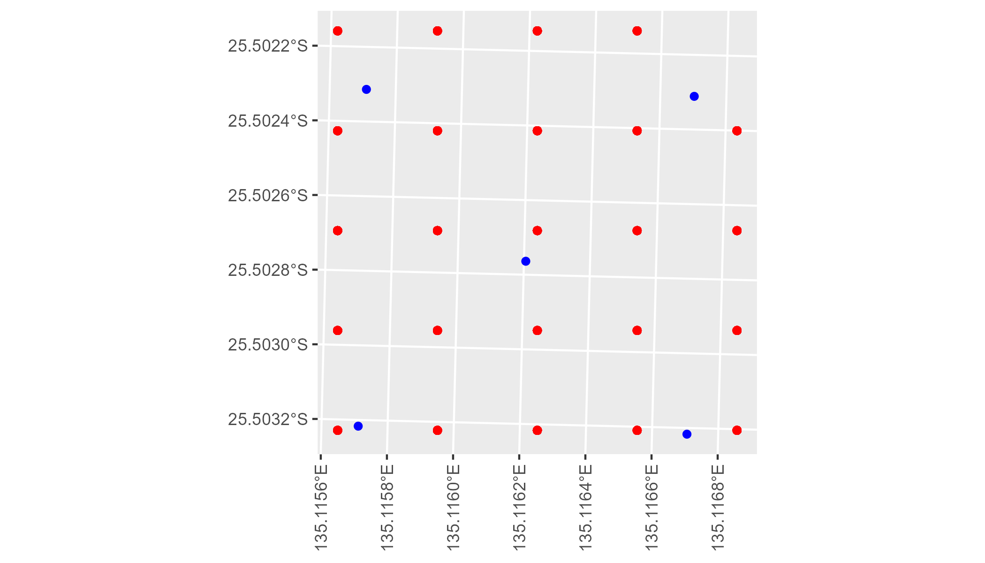

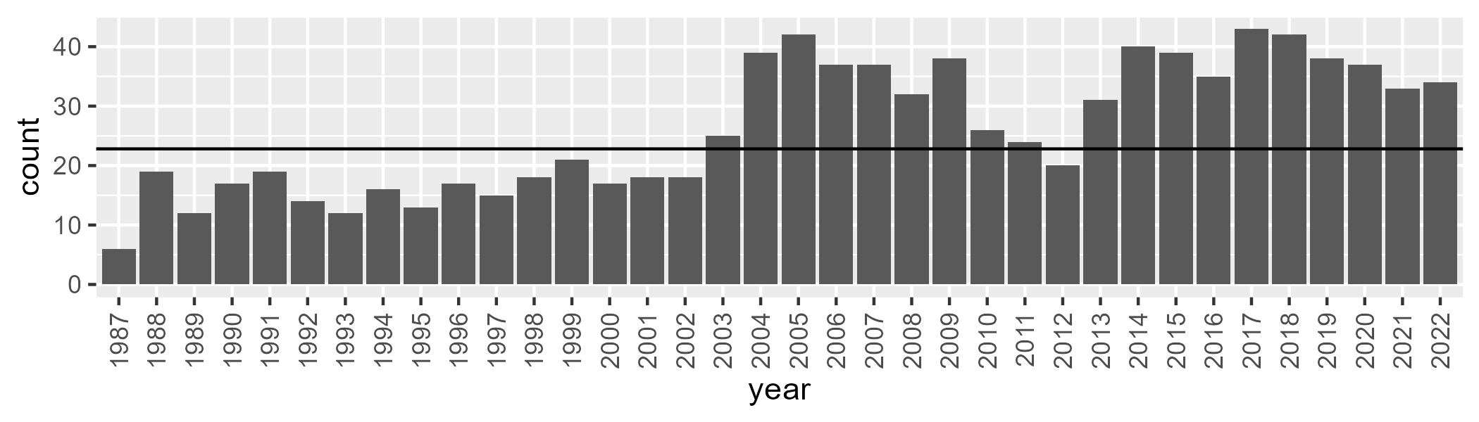

Number of samples: 944

# NTASSD0013

| Min. | 1st Qu. | Median | Mean | 3rd Qu. | Max. |
| --- | --- | --- | --- | --- | --- |
| 0 | 0.06759509 | 0.4604974 | 0.7417846 | 1.165203 | 7.520364 |

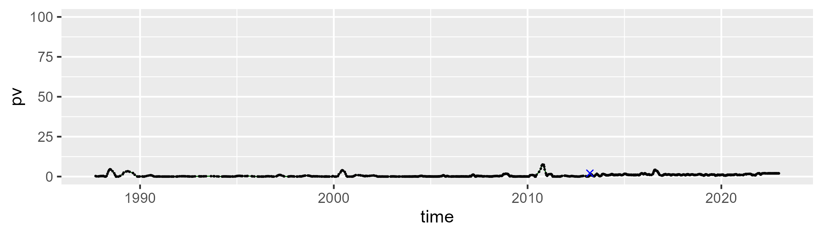

| Min. | 1st Qu. | Median | Mean | 3rd Qu. | Max. |
| --- | --- | --- | --- | --- | --- |
| 17.24149 | 31.46814 | 33.8731 | 34.44874 | 37.44352 | 48.41147 |

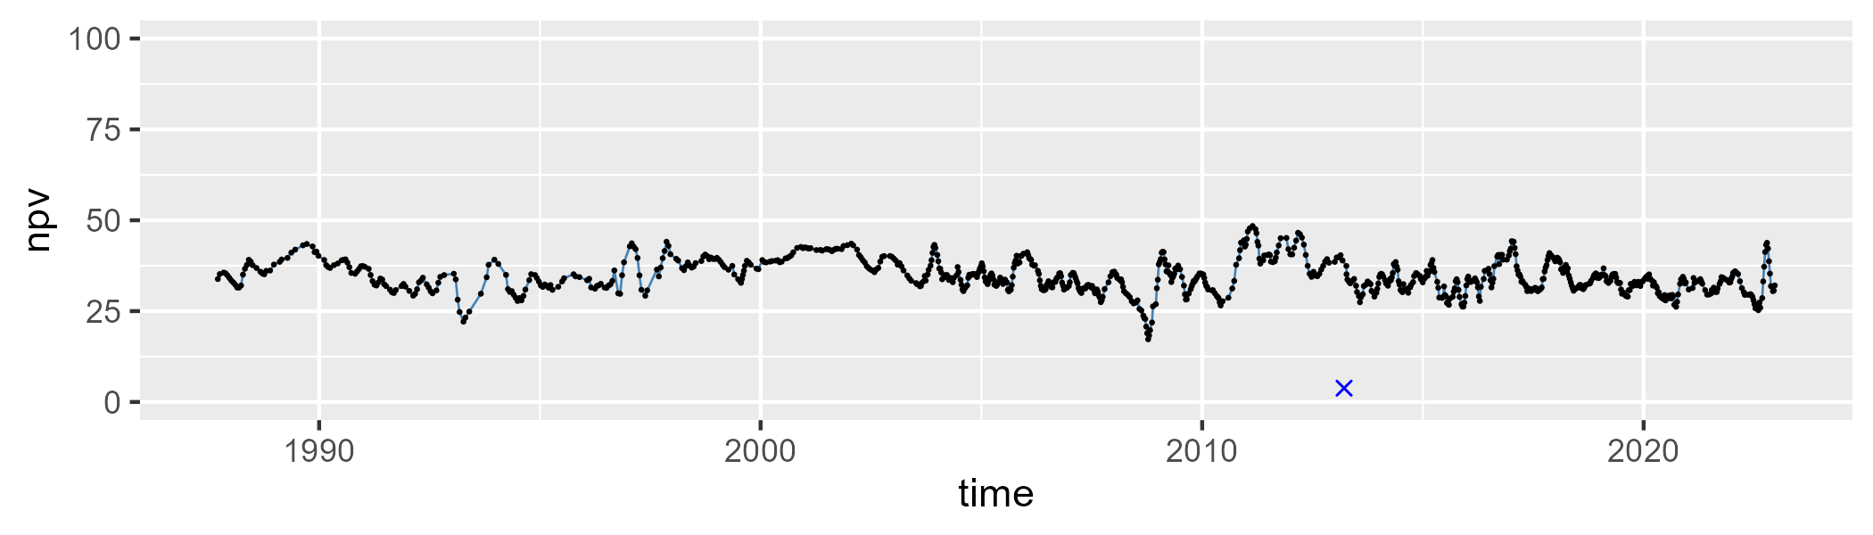

| Min. | 1st Qu. | Median | Mean | 3rd Qu. | Max. |
| --- | --- | --- | --- | --- | --- |
| 48.9205 | 60.88807 | 64.09263 | 63.64984 | 66.70478 | 79.75741 |

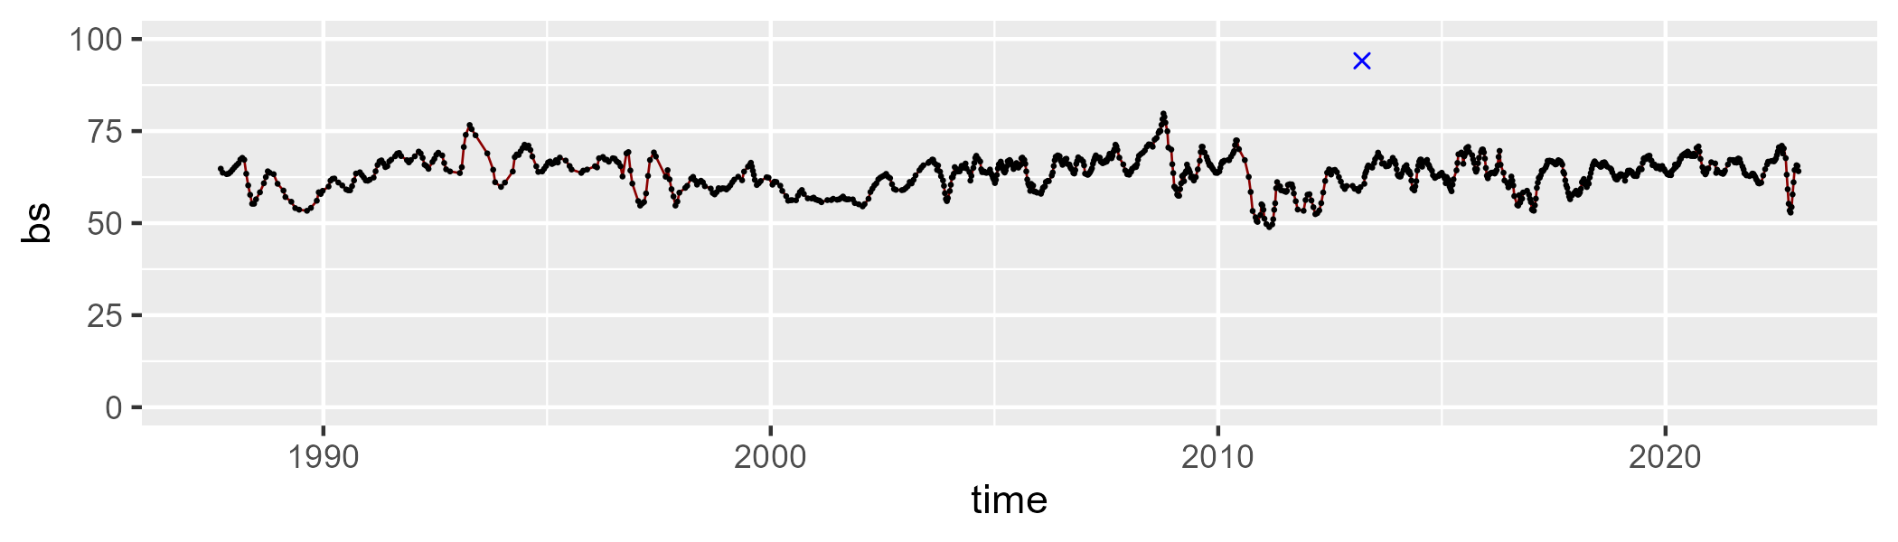

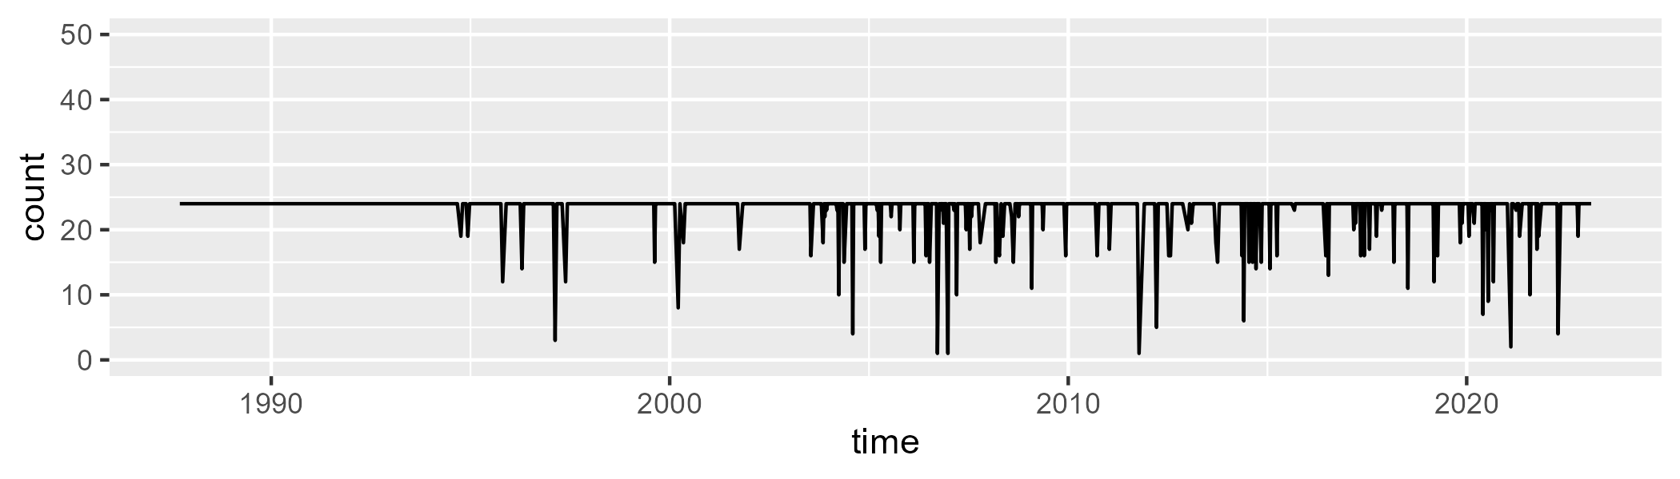

Min. : 1.00 1st Qu.:24.00 Median :24.00 Mean :23.16 3rd Qu.:24.00 Max. :24.00

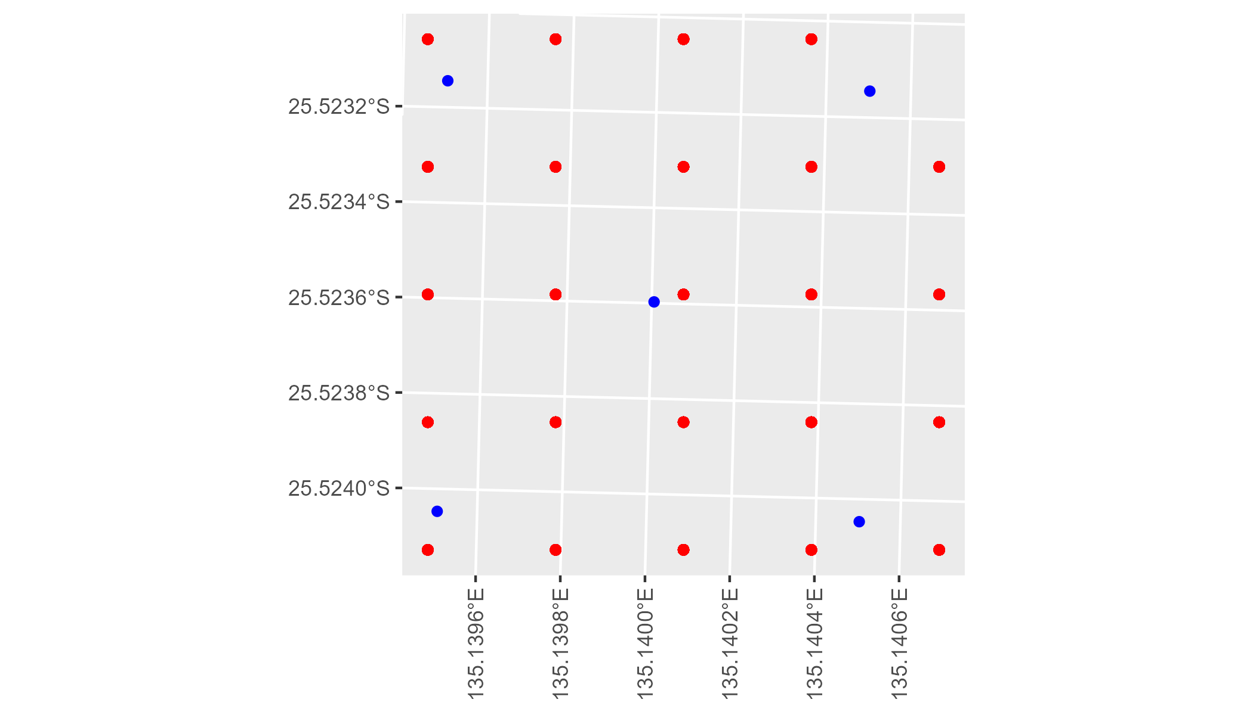

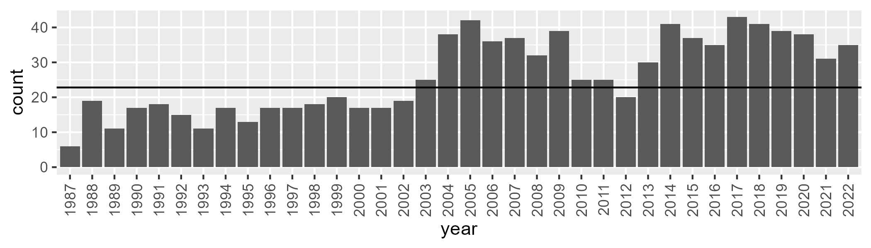

Number of samples: 941

# NTASSD0014

| Min. | 1st Qu. | Median | Mean | 3rd Qu. | Max. |
| --- | --- | --- | --- | --- | --- |
| 0 | 1.198044 | 3.134748 | 4.271443 | 5.293436 | 27.02805 |

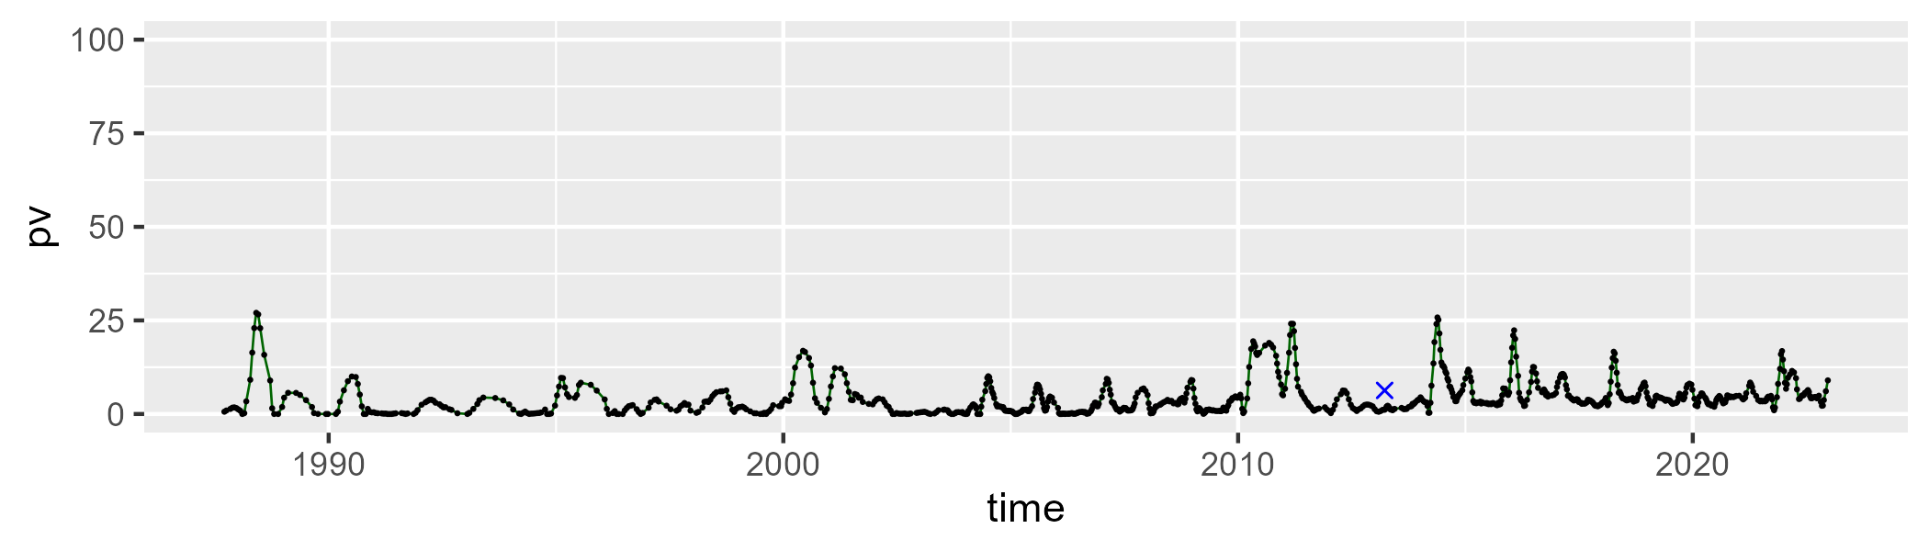

| Min. | 1st Qu. | Median | Mean | 3rd Qu. | Max. |
| --- | --- | --- | --- | --- | --- |
| 0 | 11.54777 | 17.82077 | 19.40711 | 26.20492 | 53.59706 |

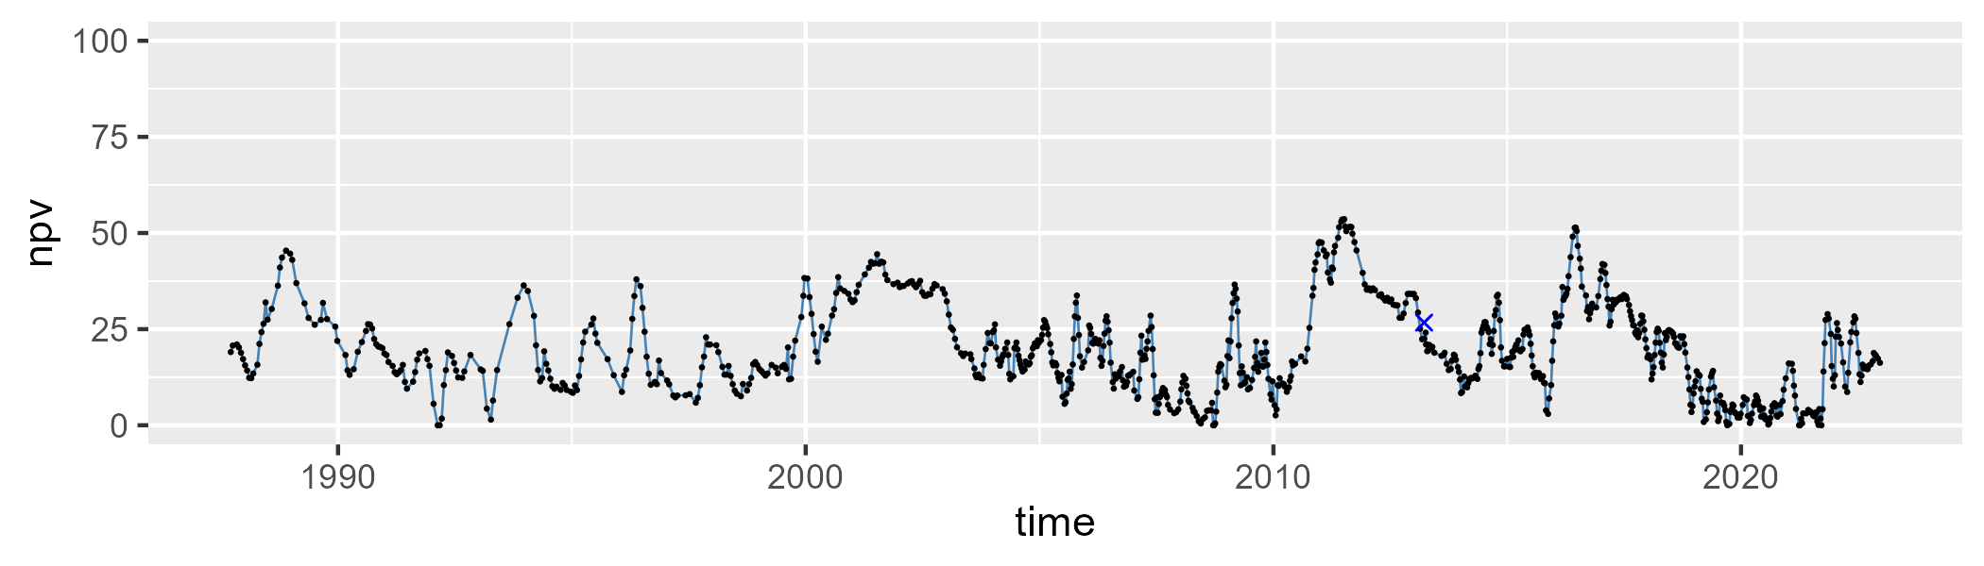

| Min. | 1st Qu. | Median | Mean | 3rd Qu. | Max. |
| --- | --- | --- | --- | --- | --- |
| 33.02393 | 66.14933 | 77.43429 | 74.84823 | 84.50071 | 96.71604 |

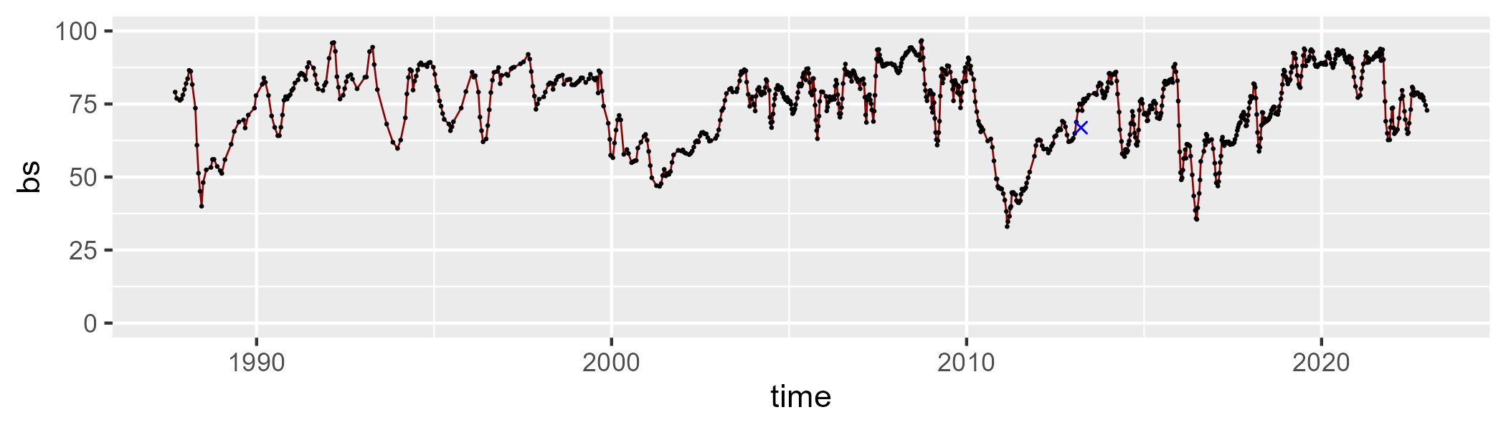

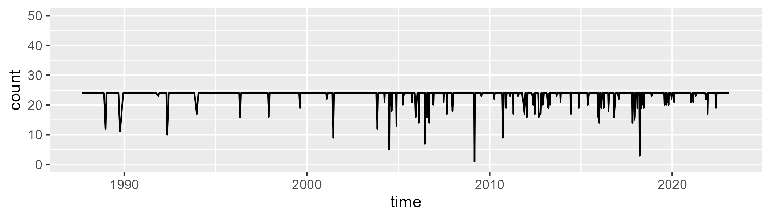

Min. : 1.00 1st Qu.:24.00 Median :24.00 Mean :23.42 3rd Qu.:24.00 Max. :24.00

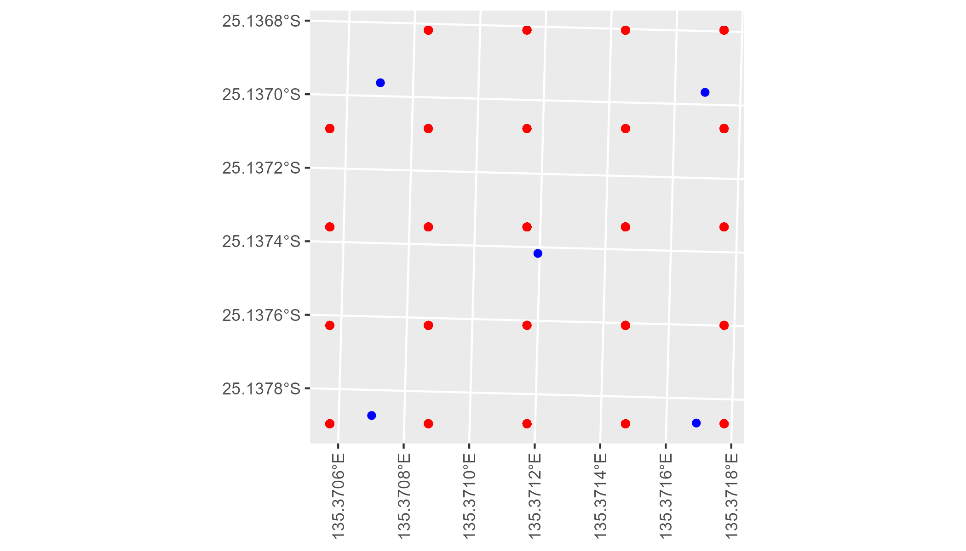

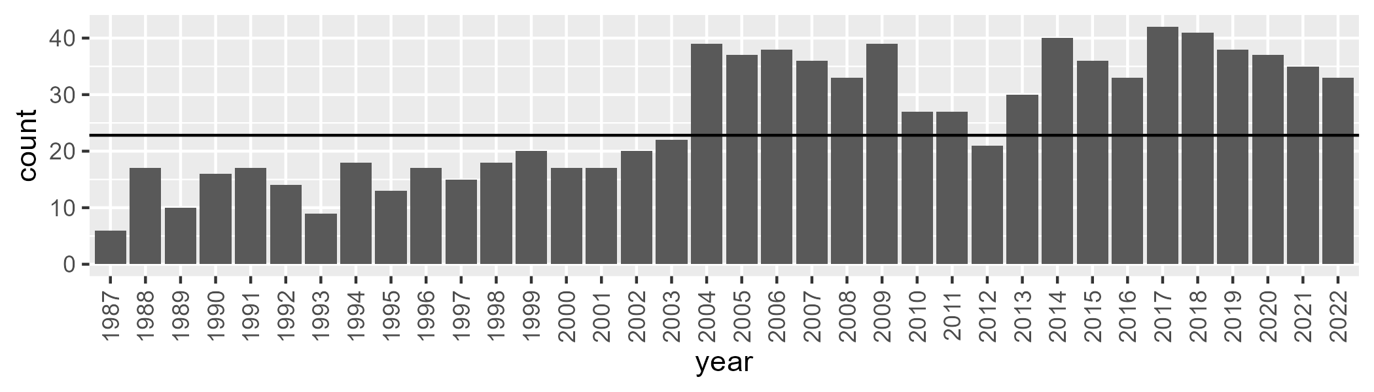

Number of samples: 928

# NTASSD0015

| Min. | 1st Qu. | Median | Mean | 3rd Qu. | Max. |
| --- | --- | --- | --- | --- | --- |
| 2.29007 | 6.905019 | 9.178002 | 10.52332 | 12.25622 | 41.39488 |

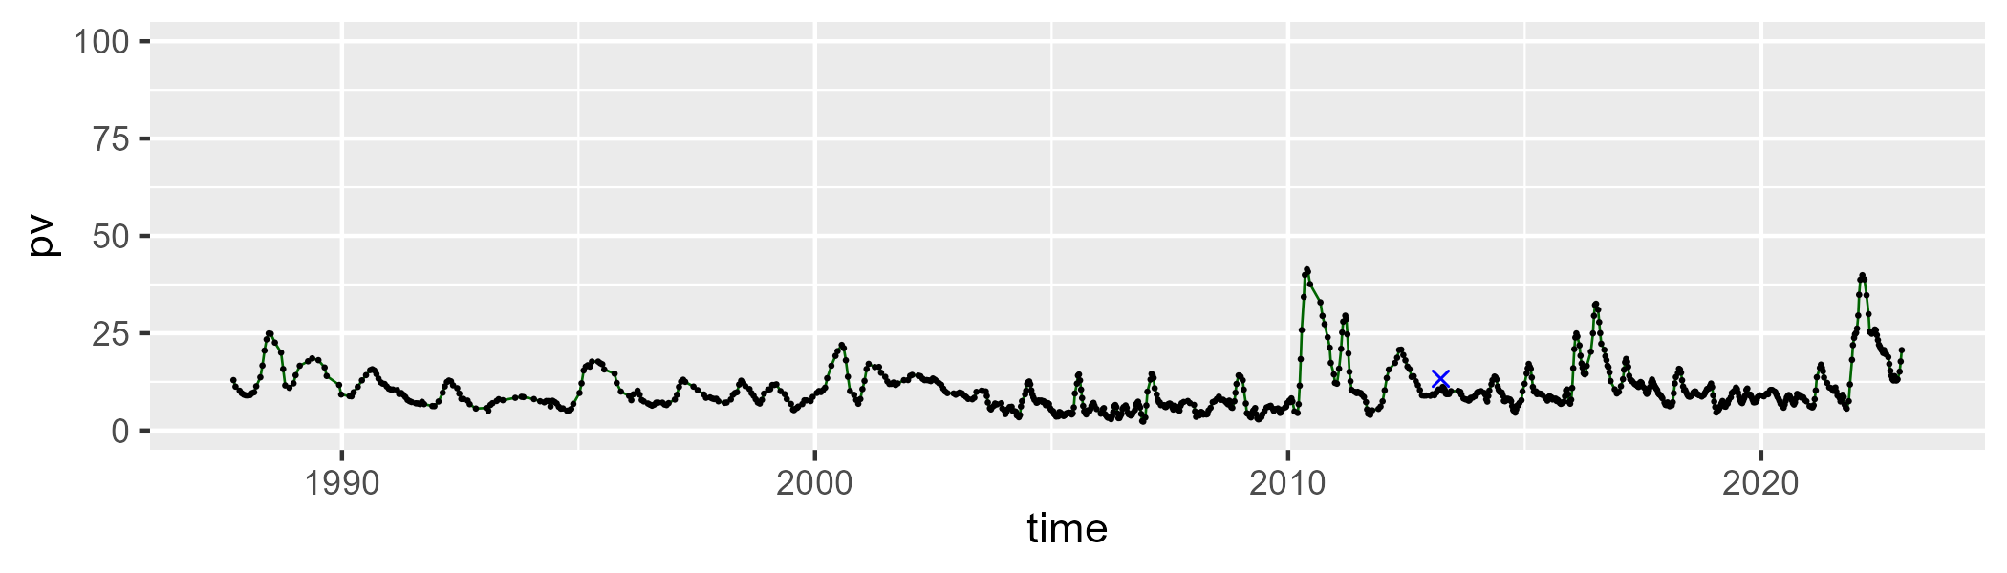

| Min. | 1st Qu. | Median | Mean | 3rd Qu. | Max. |
| --- | --- | --- | --- | --- | --- |
| 4.840031 | 20.52515 | 24.46416 | 24.69459 | 29.32574 | 56.52483 |

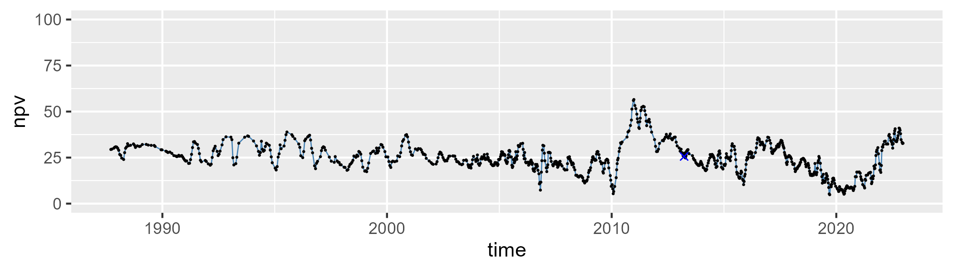

| Min. | 1st Qu. | Median | Mean | 3rd Qu. | Max. |
| --- | --- | --- | --- | --- | --- |
| 24.10804 | 57.44033 | 65.03942 | 63.21677 | 70.56227 | 84.91214 |

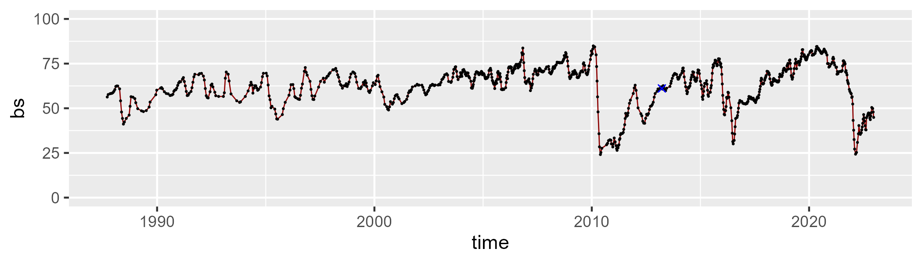

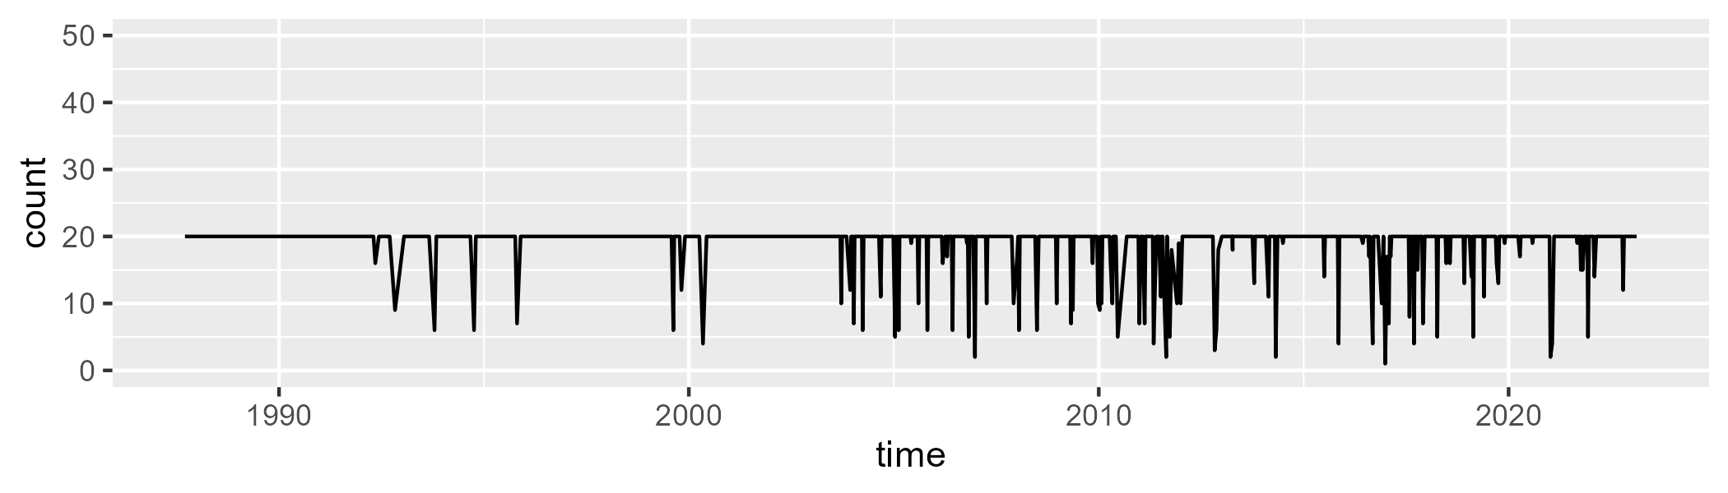

Min. : 1.00 1st Qu.:20.00 Median :20.00 Mean :19.02 3rd Qu.:20.00 Max. :20.00

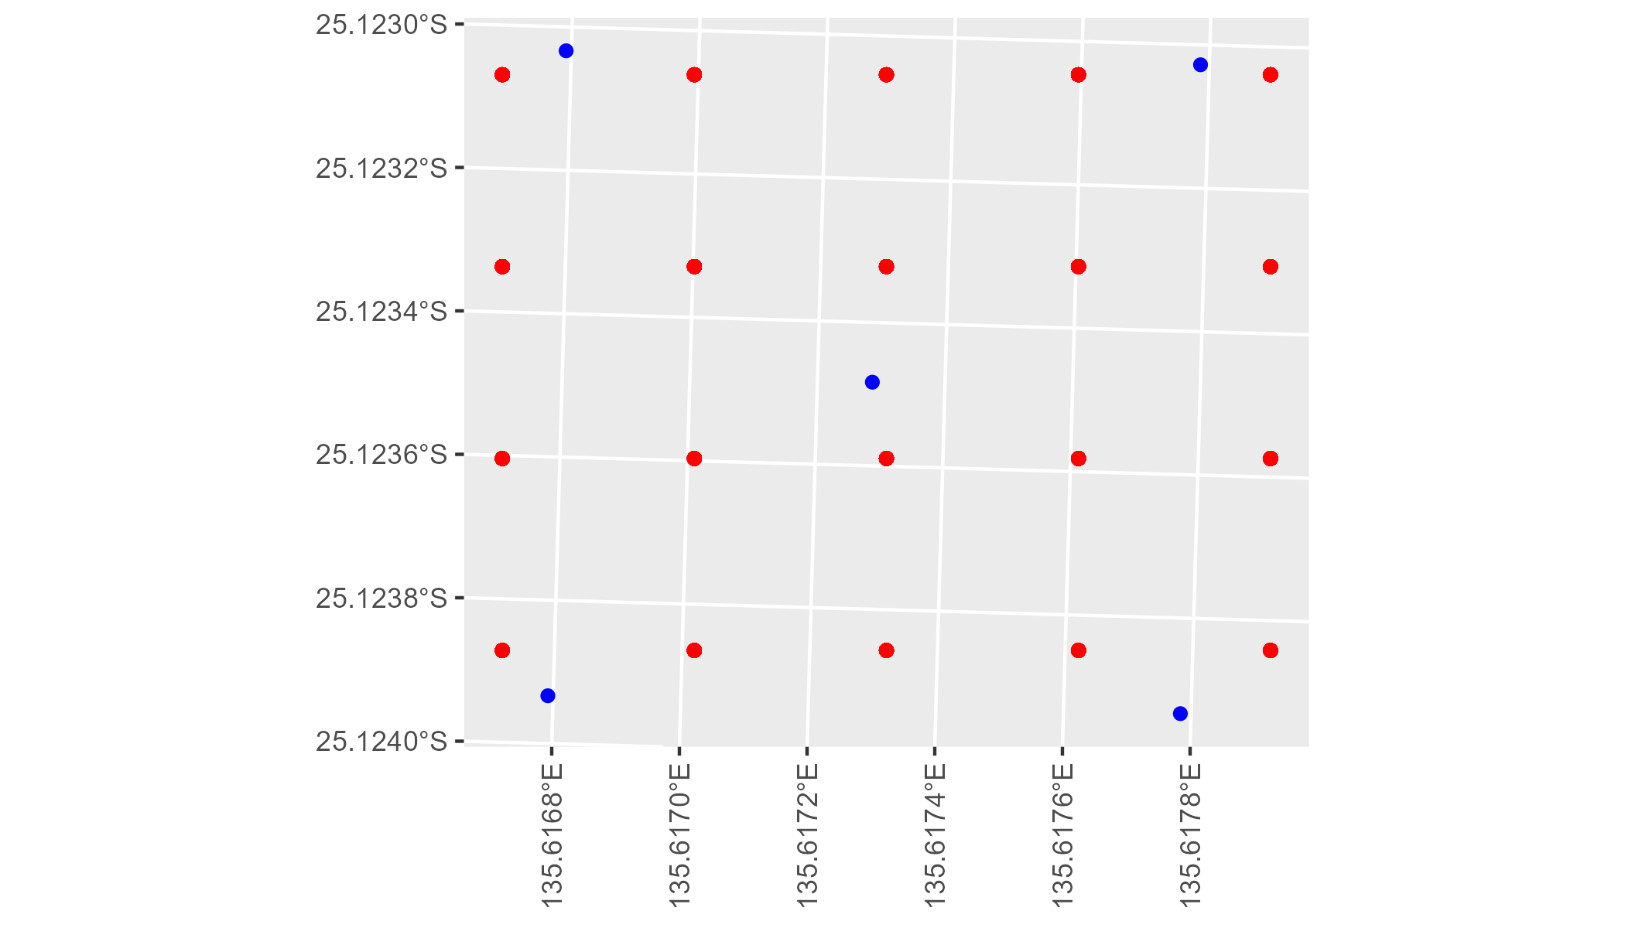

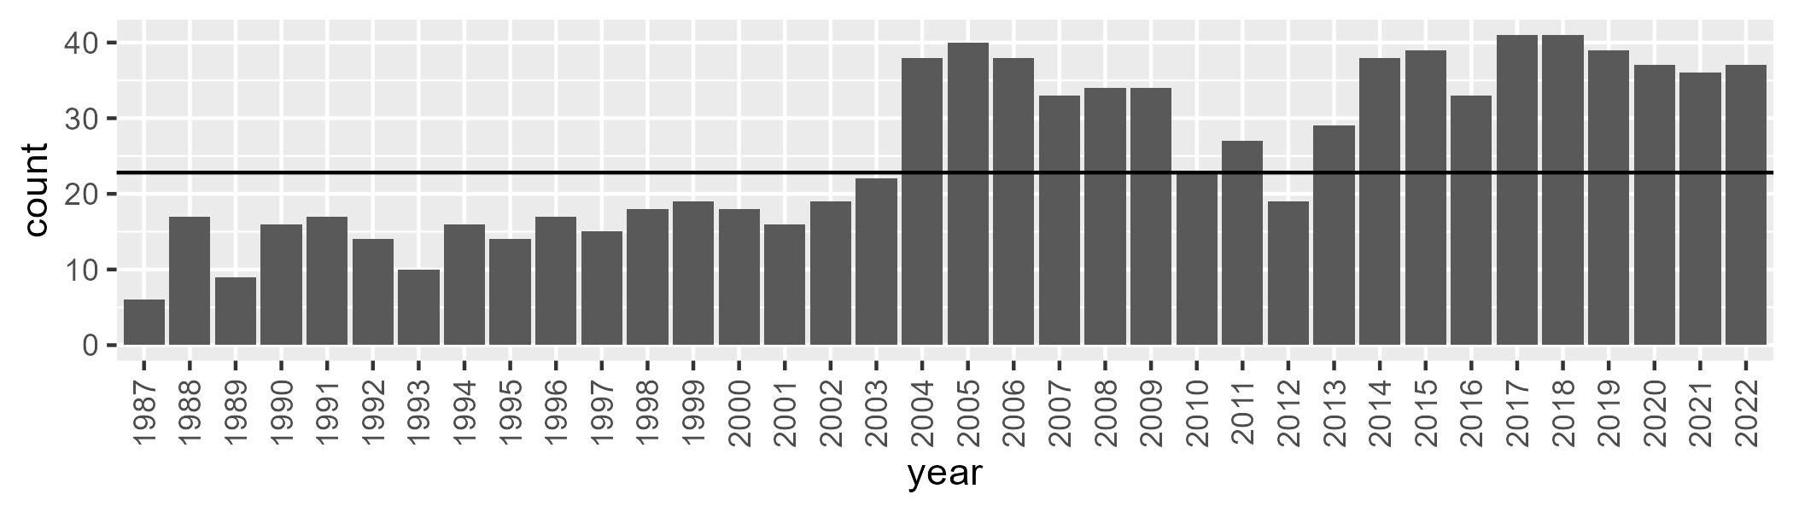

Number of samples: 919

# NTASSD0016

| Min. | 1st Qu. | Median | Mean | 3rd Qu. | Max. |
| --- | --- | --- | --- | --- | --- |
| 0 | 1.068738 | 2.062968 | 3.449685 | 4.029086 | 25.66892 |

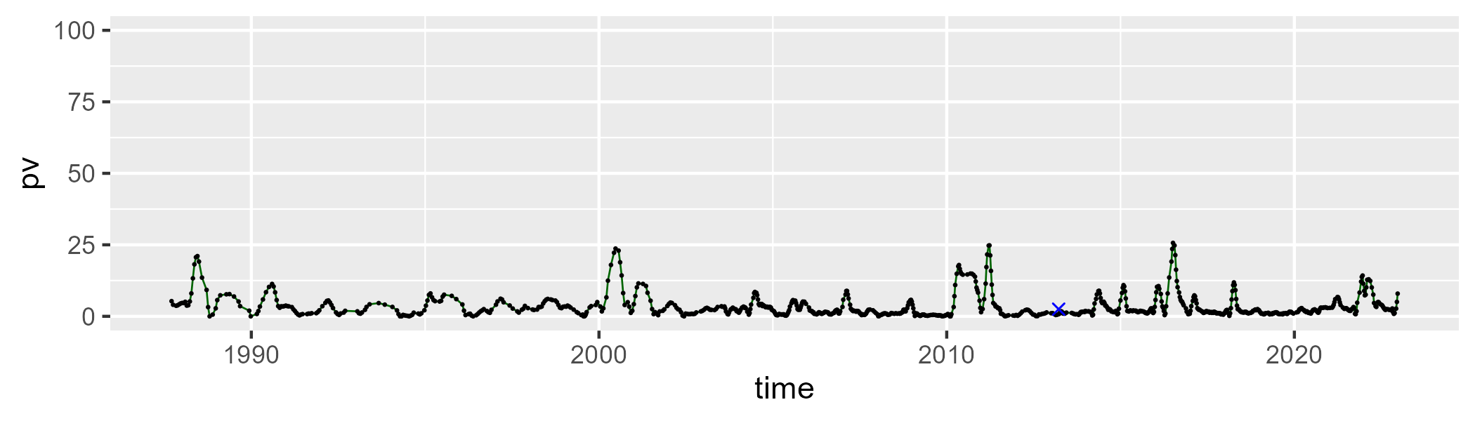

| Min. | 1st Qu. | Median | Mean | 3rd Qu. | Max. |
| --- | --- | --- | --- | --- | --- |
| 13.76918 | 26.34693 | 32.25517 | 33.67924 | 40.17805 | 60.57716 |

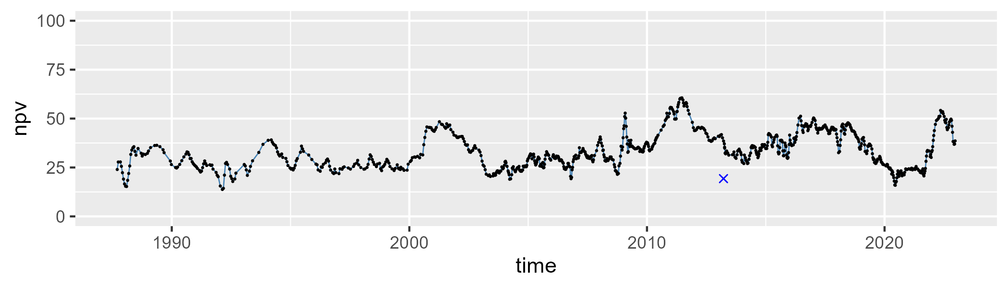

| Min. | 1st Qu. | Median | Mean | 3rd Qu. | Max. |
| --- | --- | --- | --- | --- | --- |
| 23.88924 | 54.43393 | 64.04434 | 61.47292 | 69.50927 | 81.57078 |

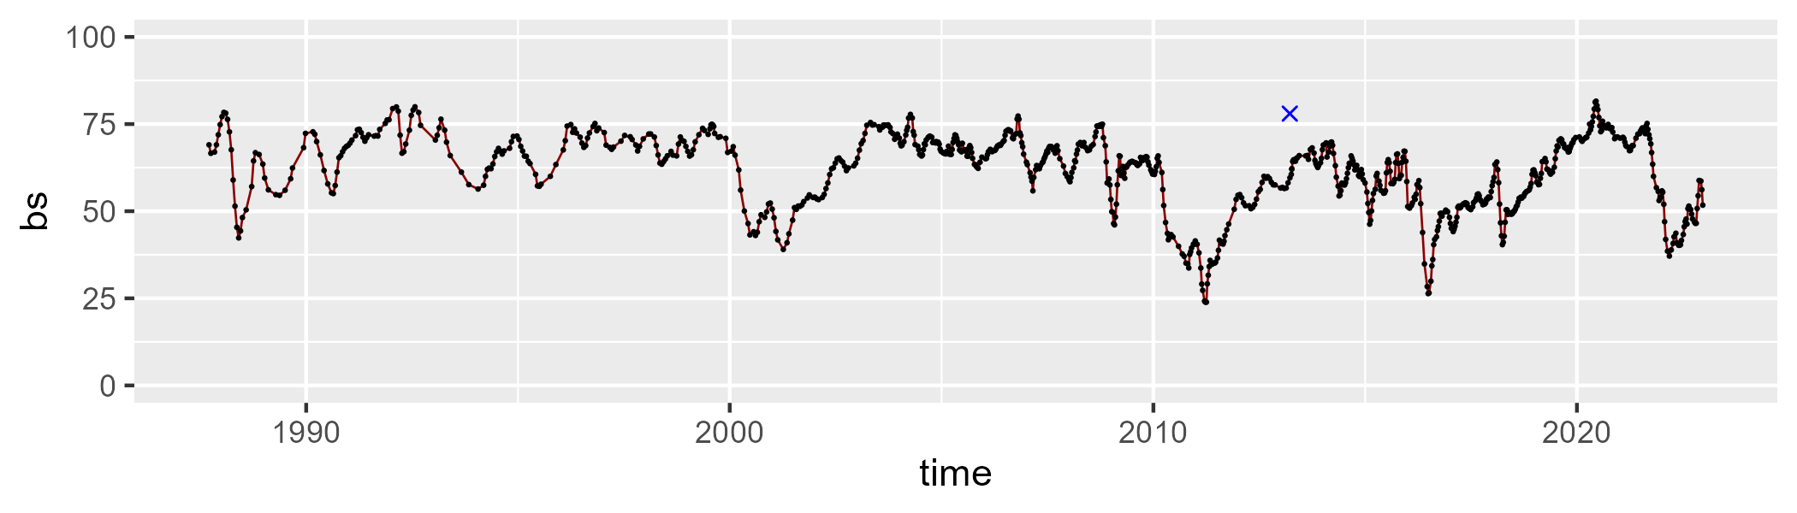

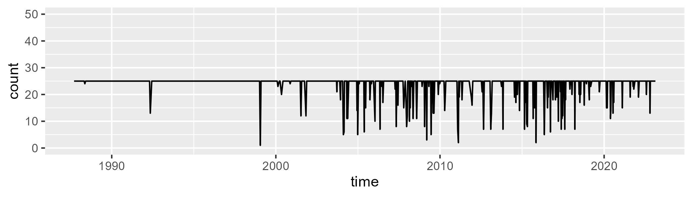

Min. : 1.00 1st Qu.:25.00 Median :25.00 Mean :23.79 3rd Qu.:25.00 Max. :25.00

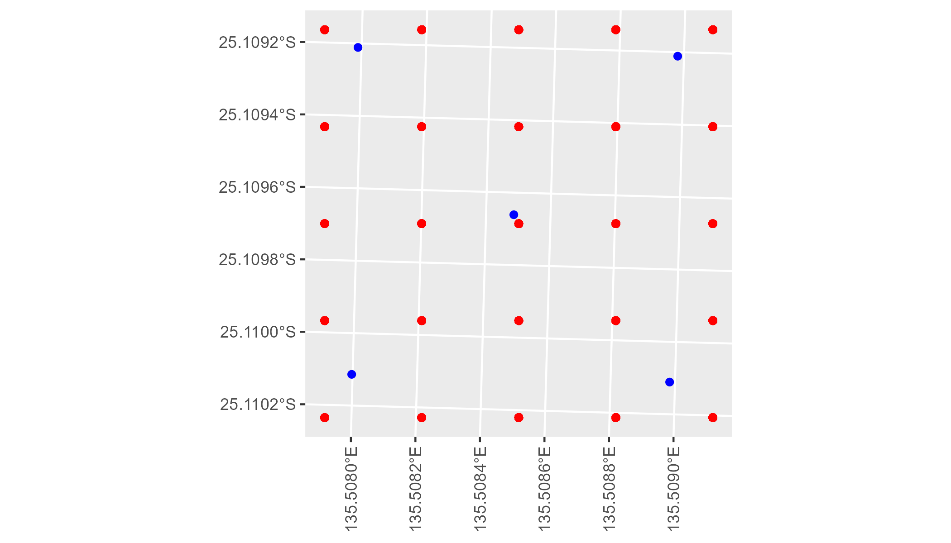

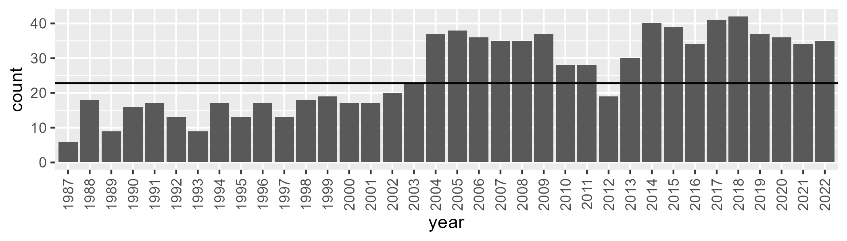

Number of samples: 923

# NTASSD0017

| Min. | 1st Qu. | Median | Mean | 3rd Qu. | Max. |
| --- | --- | --- | --- | --- | --- |
| 0 | 1.617814 | 2.72451 | 3.676282 | 4.585907 | 23.22537 |

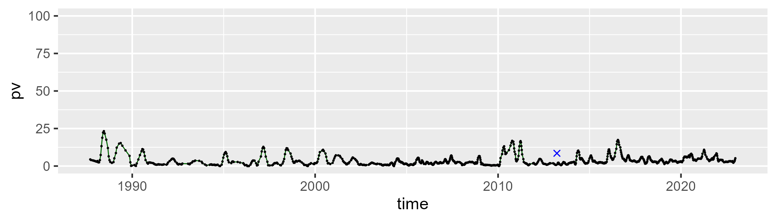

| Min. | 1st Qu. | Median | Mean | 3rd Qu. | Max. |
| --- | --- | --- | --- | --- | --- |
| 7.663528 | 30.11274 | 33.72631 | 33.85092 | 37.46174 | 59.2916 |

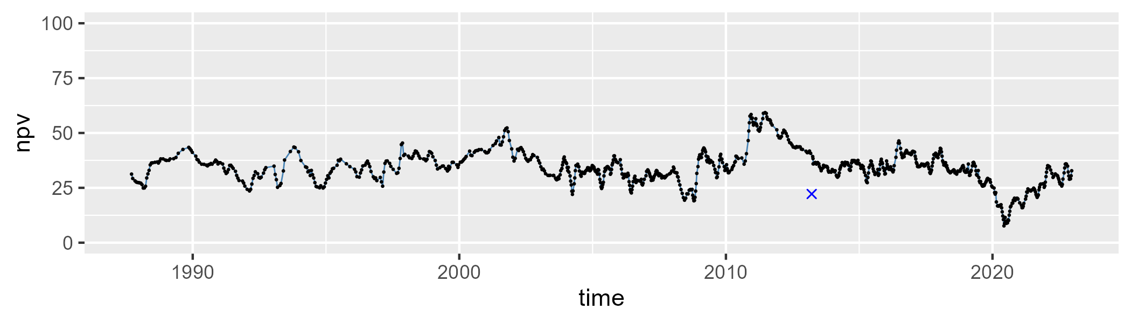

| Min. | 1st Qu. | Median | Mean | 3rd Qu. | Max. |
| --- | --- | --- | --- | --- | --- |
| 30.33894 | 57.14626 | 62.0529 | 61.09387 | 66.22221 | 83.63662 |

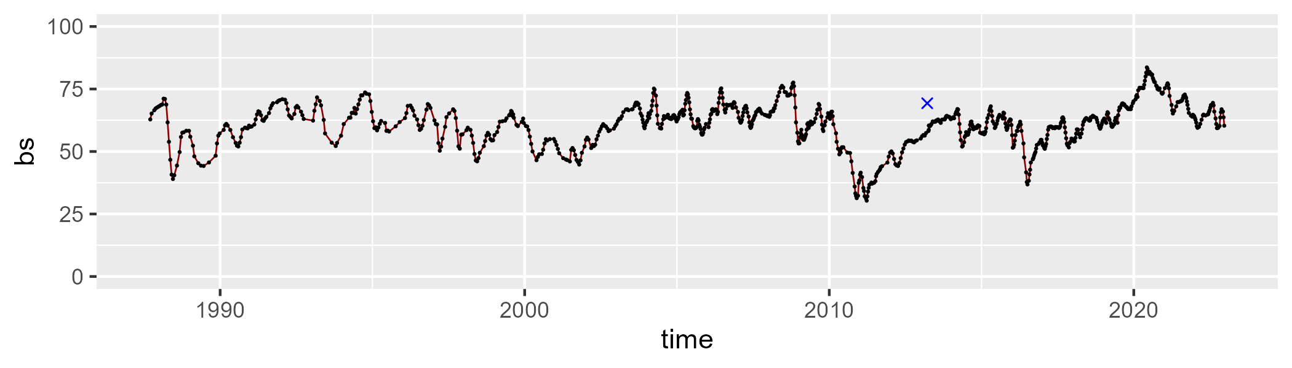

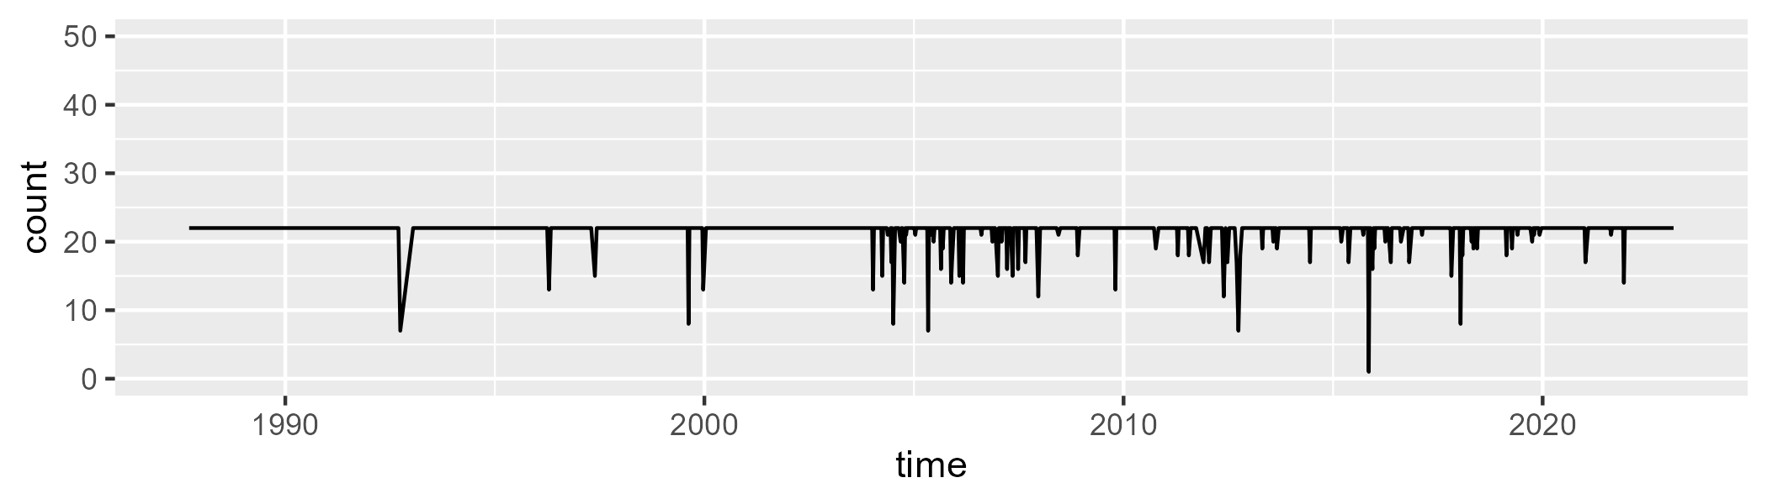

Min. : 1.00 1st Qu.:22.00 Median :22.00 Mean :21.58 3rd Qu.:22.00 Max. :22.00

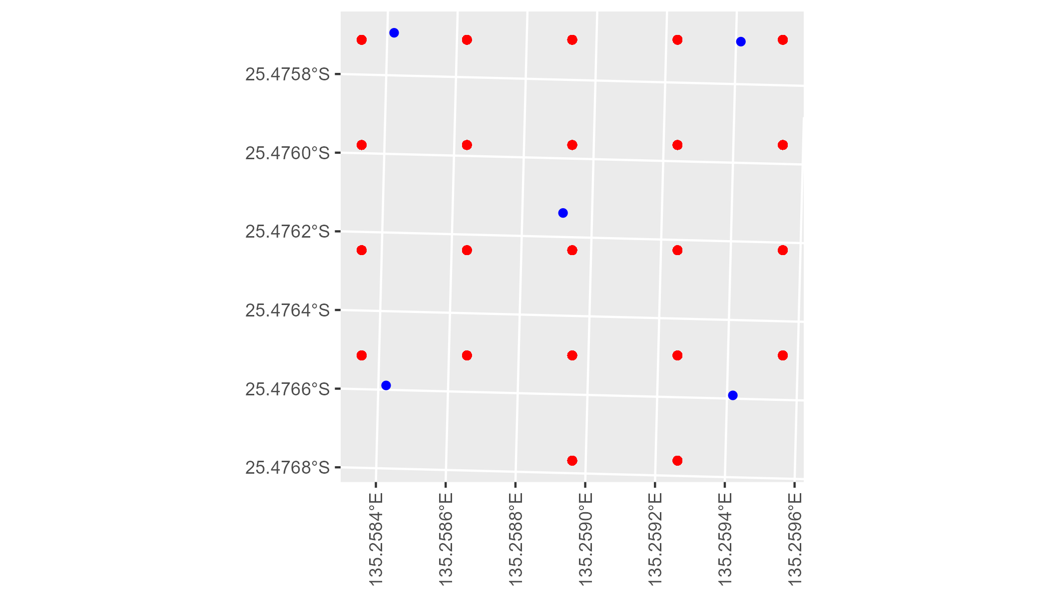

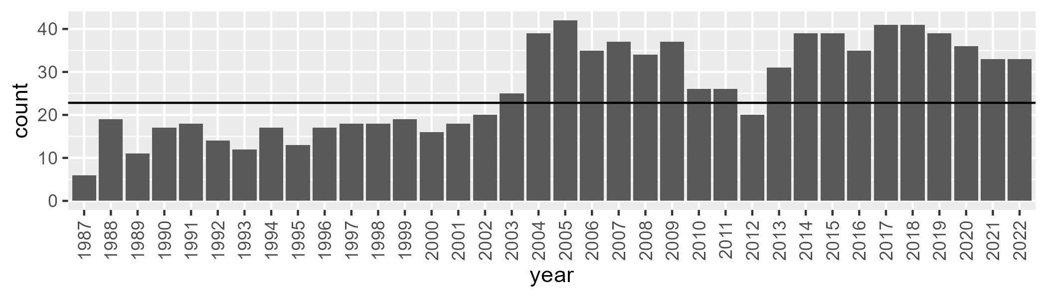

Number of samples: 941

# NTASSD0018

| Min. | 1st Qu. | Median | Mean | 3rd Qu. | Max. |
| --- | --- | --- | --- | --- | --- |
| 0 | 0.8260977 | 1.87787 | 2.571832 | 3.709941 | 13.56913 |

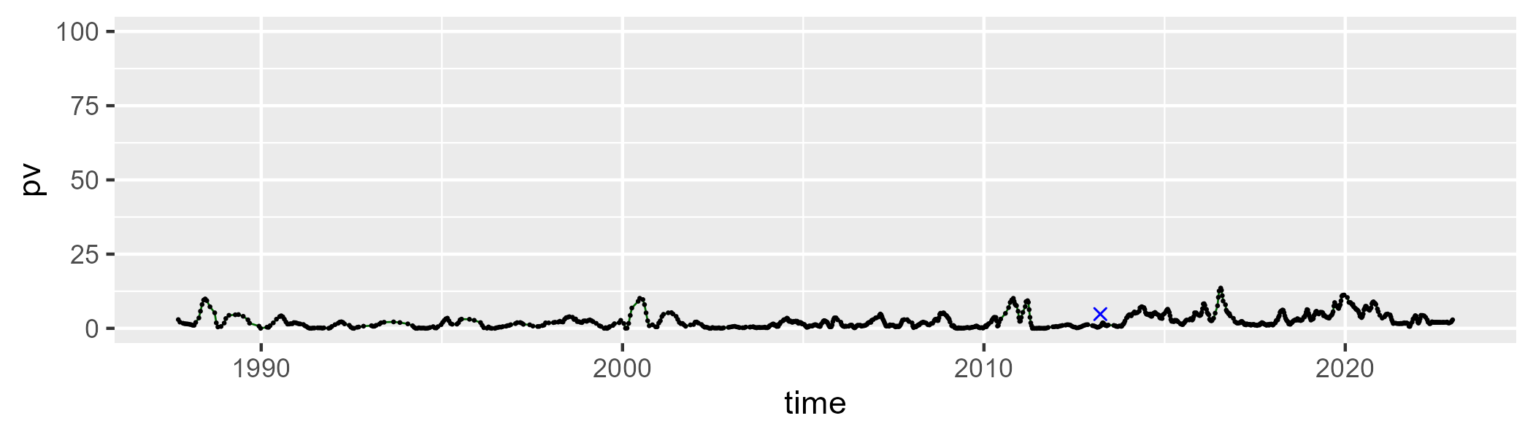

| Min. | 1st Qu. | Median | Mean | 3rd Qu. | Max. |
| --- | --- | --- | --- | --- | --- |
| 8.471316 | 29.80386 | 34.58833 | 33.66472 | 38.67339 | 56.39802 |

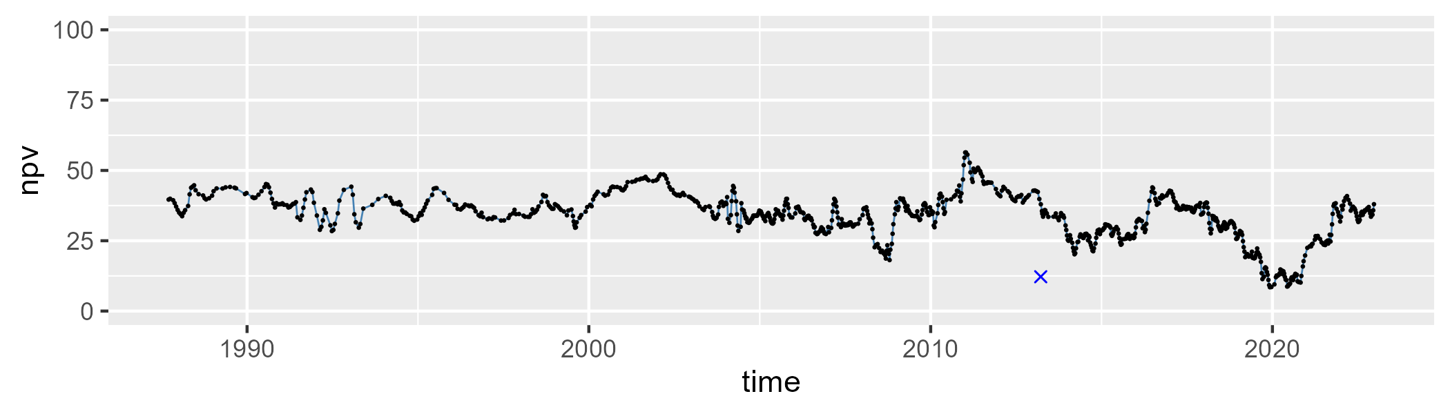

| Min. | 1st Qu. | Median | Mean | 3rd Qu. | Max. |
| --- | --- | --- | --- | --- | --- |
| 38.16131 | 58.42762 | 62.36549 | 62.40055 | 66.45905 | 85.85838 |

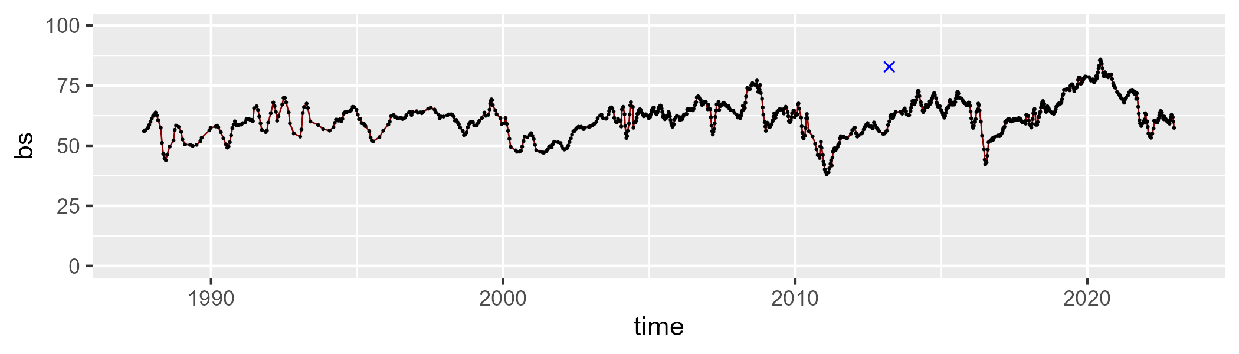

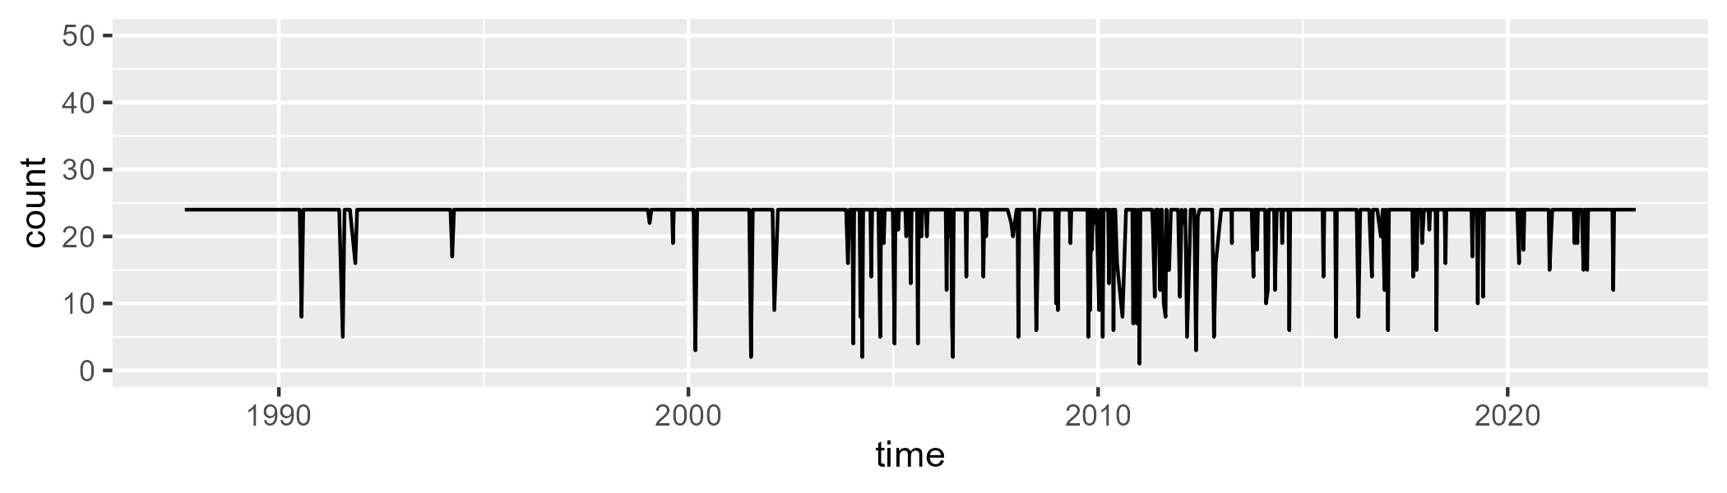

Min. : 1.00 1st Qu.:24.00 Median :24.00 Mean :22.77 3rd Qu.:24.00 Max. :24.00

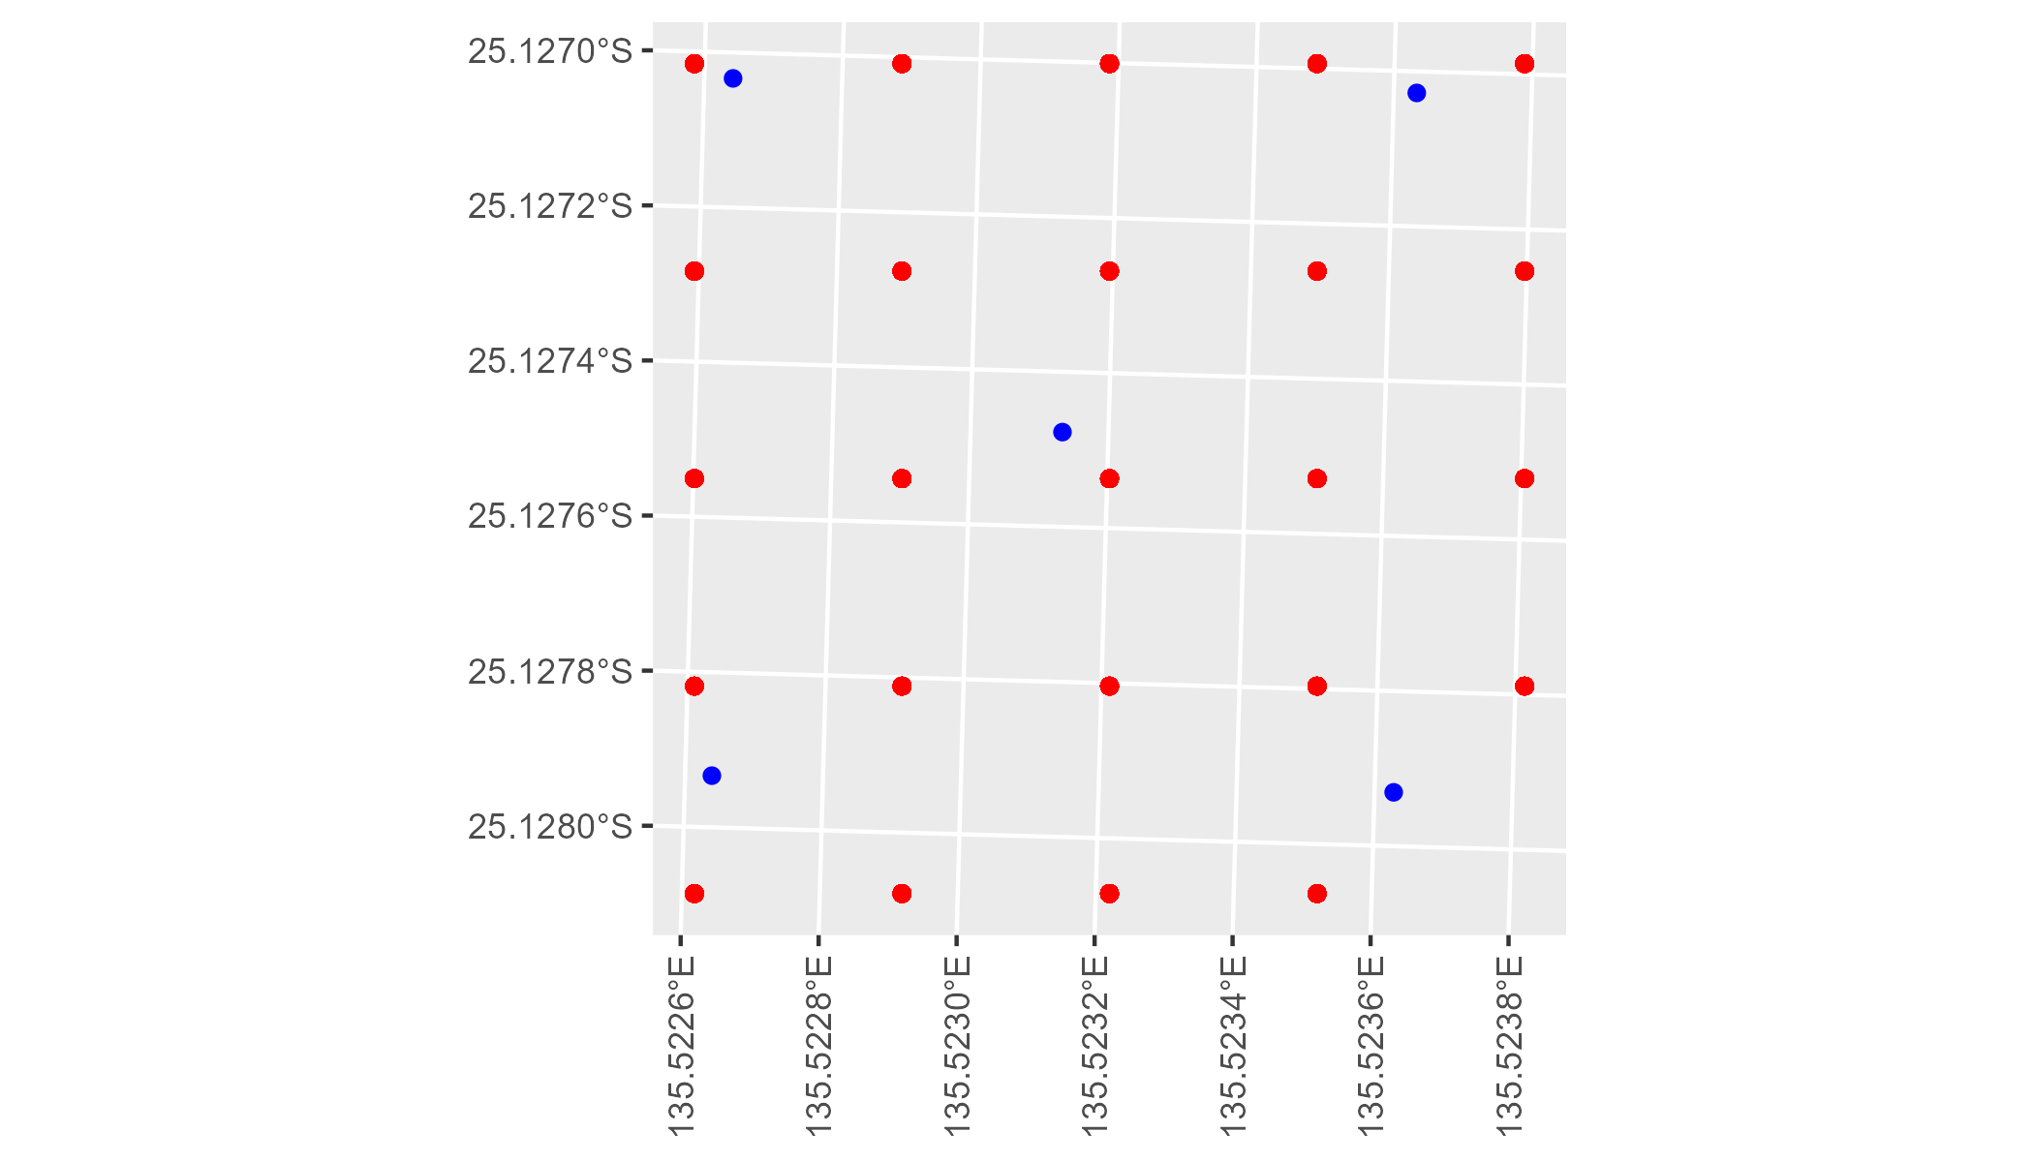

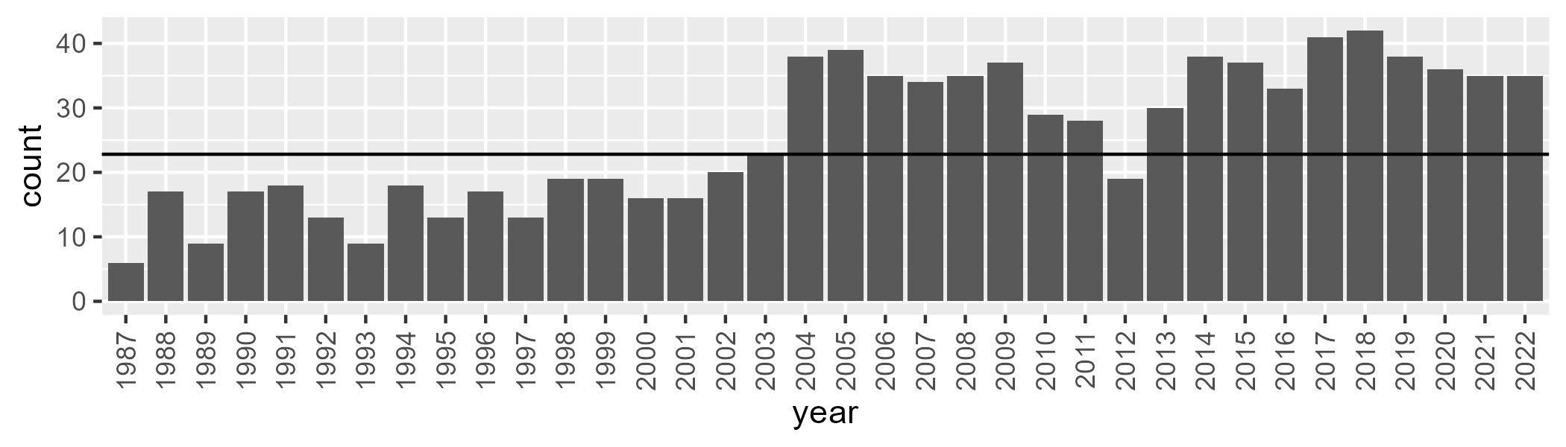

Number of samples: 922

# NTASSD0019

| Min. | 1st Qu. | Median | Mean | 3rd Qu. | Max. |
| --- | --- | --- | --- | --- | --- |
| 2.564598 | 8.344796 | 10.20154 | 10.95258 | 12.14379 | 31.53509 |

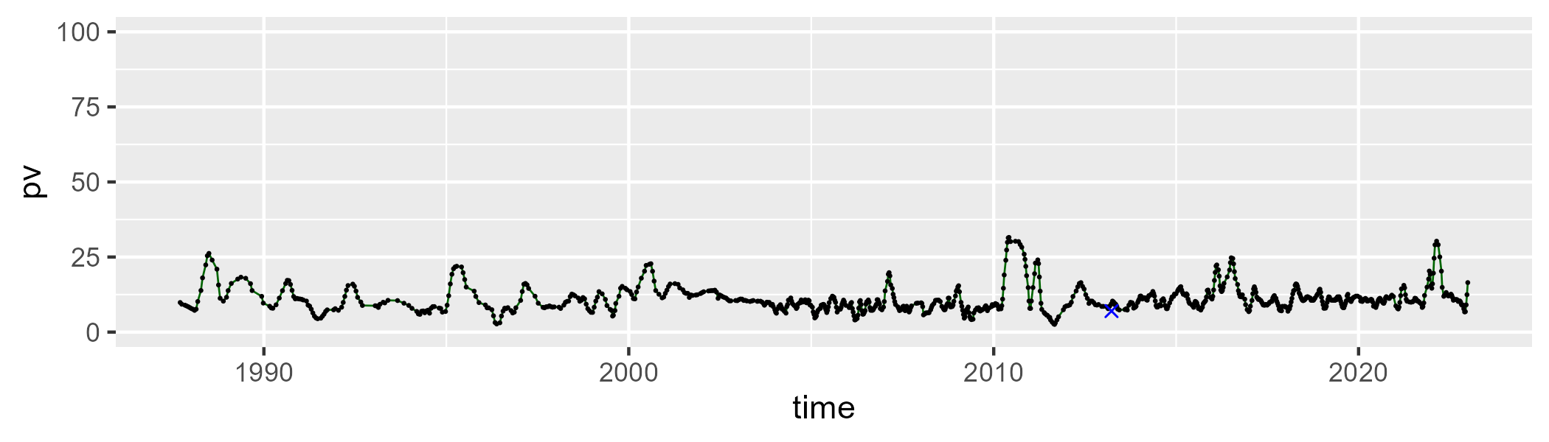

| Min. | 1st Qu. | Median | Mean | 3rd Qu. | Max. |
| --- | --- | --- | --- | --- | --- |
| 0 | 6.872456 | 12.60384 | 14.27082 | 18.93425 | 63.20088 |

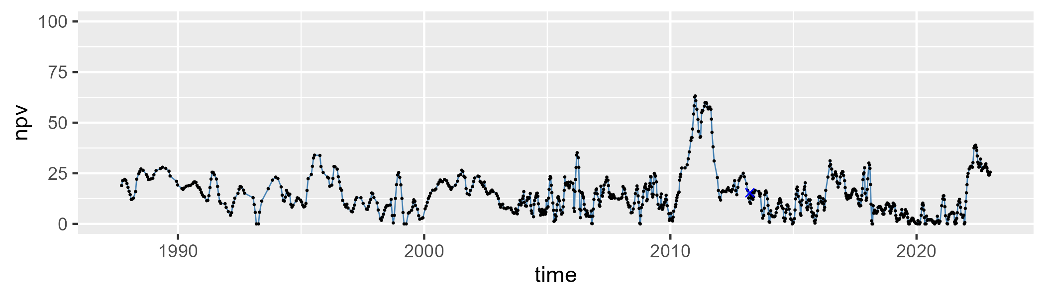

| Min. | 1st Qu. | Median | Mean | 3rd Qu. | Max. |
| --- | --- | --- | --- | --- | --- |
| 27.17489 | 68.53334 | 76.47493 | 73.25638 | 81.41077 | 90.13605 |

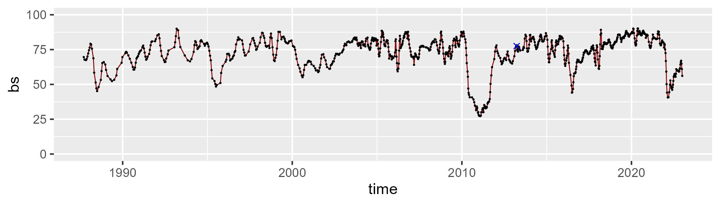

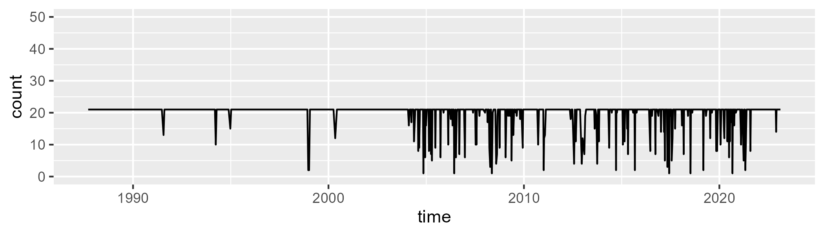

Min. : 1.00 1st Qu.:21.00 Median :21.00 Mean :19.73 3rd Qu.:21.00 Max. :21.00

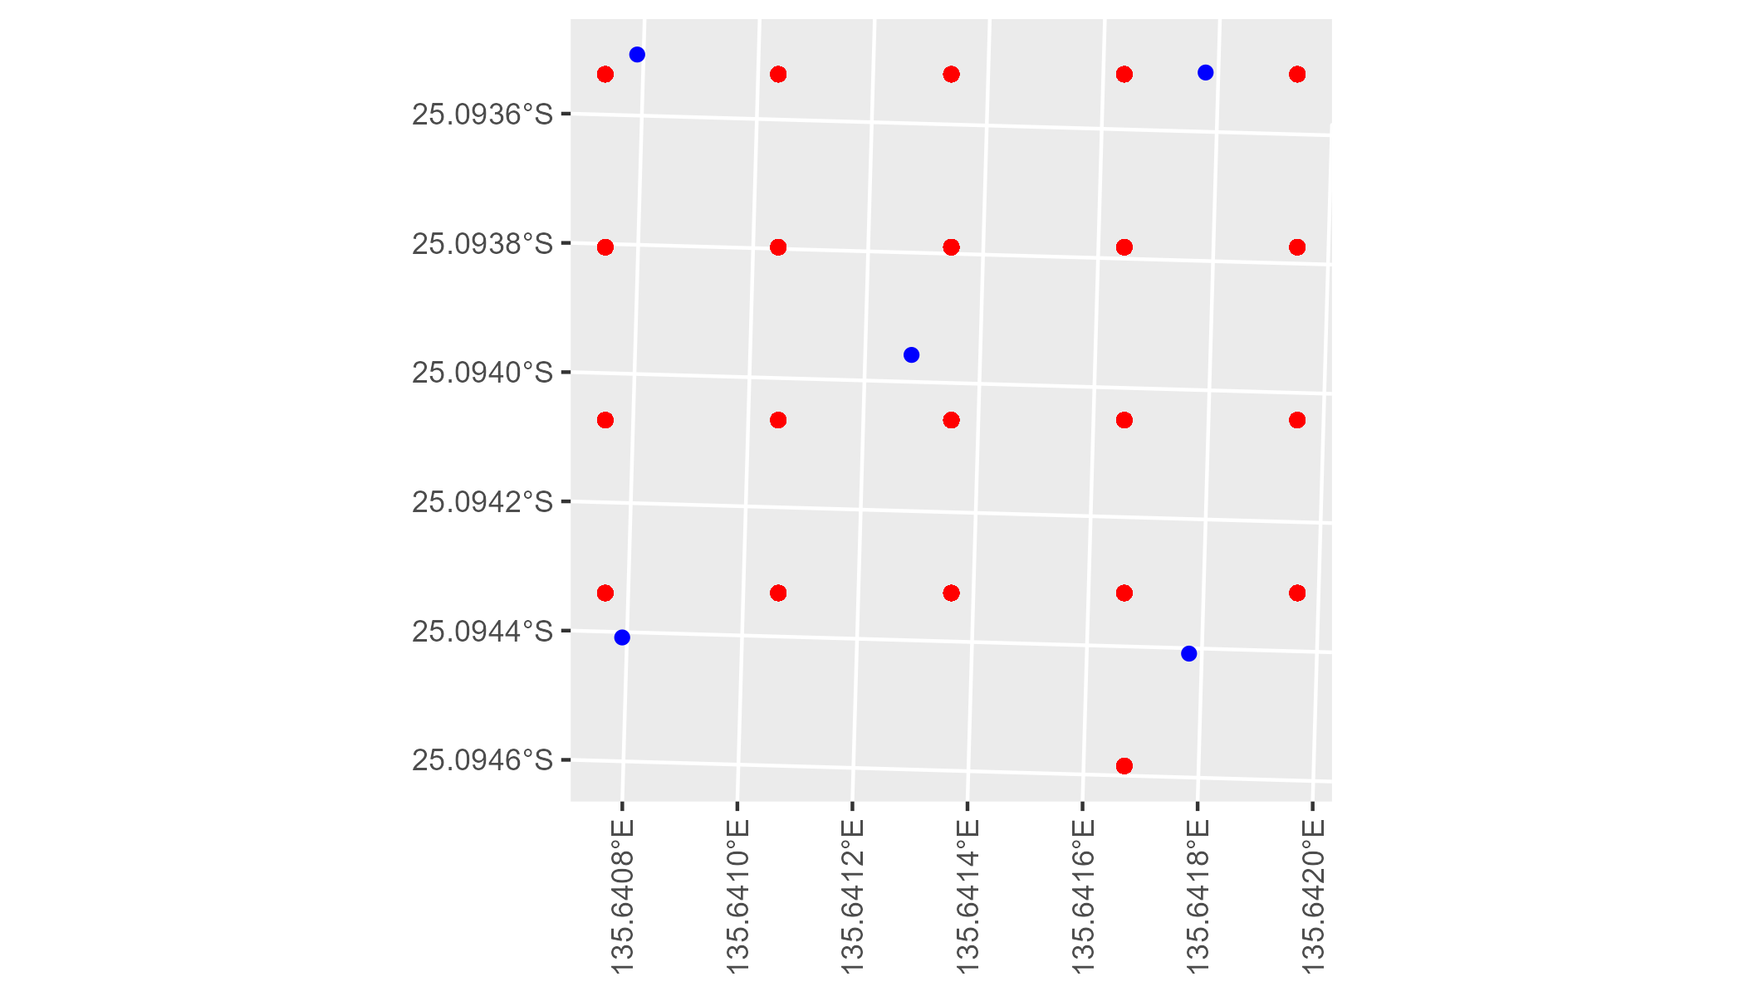

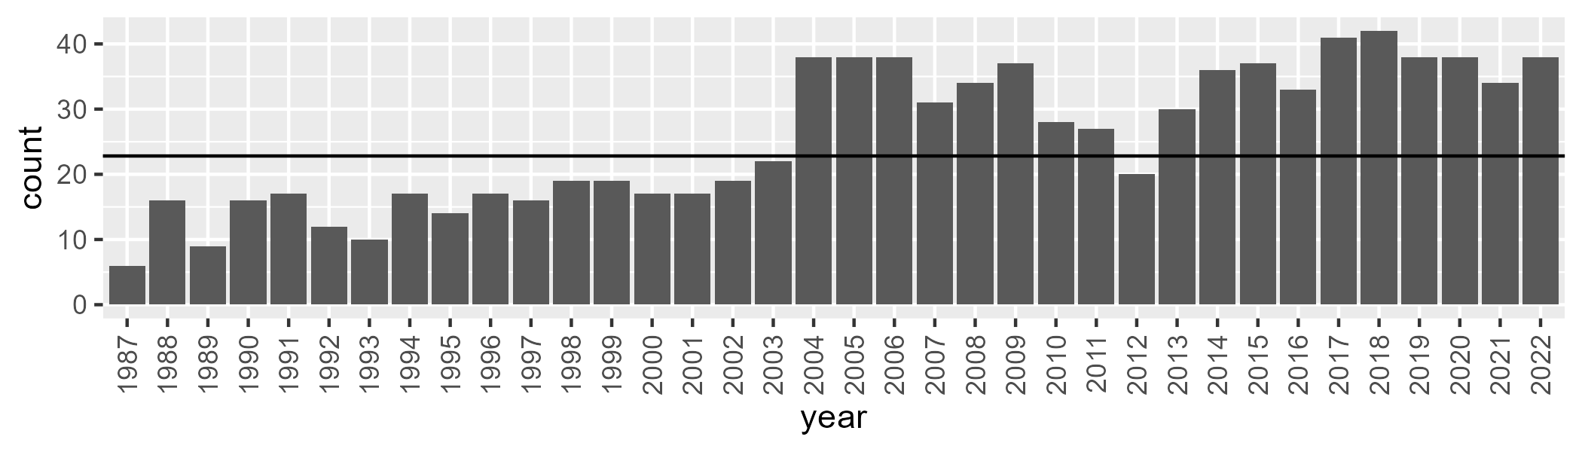

Number of samples: 921

# NTASTU0001

| Min. | 1st Qu. | Median | Mean | 3rd Qu. | Max. |
| --- | --- | --- | --- | --- | --- |
| 5.663056 | 22.95325 | 30.25766 | 33.40629 | 42.707 | 70.08858 |

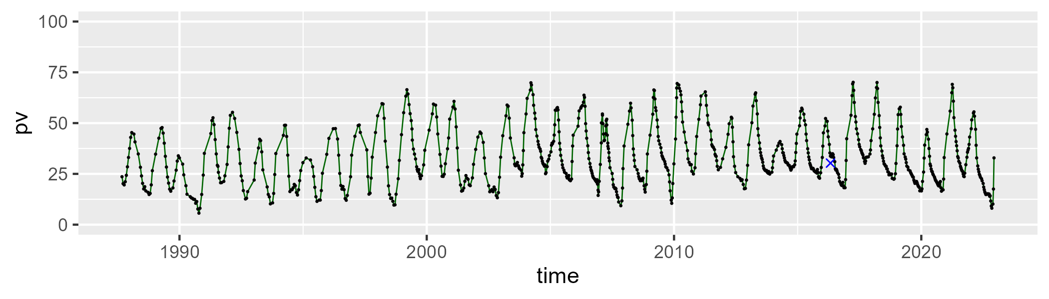

| Min. | 1st Qu. | Median | Mean | 3rd Qu. | Max. |
| --- | --- | --- | --- | --- | --- |
| 19.44831 | 47.32568 | 56.21199 | 55.22464 | 63.40749 | 88.73911 |

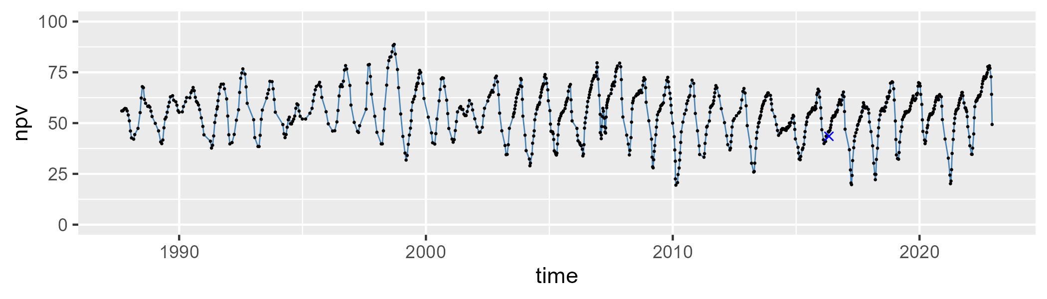

| Min. | 1st Qu. | Median | Mean | 3rd Qu. | Max. |
| --- | --- | --- | --- | --- | --- |
| 0 | 5.122879 | 9.785498 | 10.17499 | 14.30367 | 34.02803 |

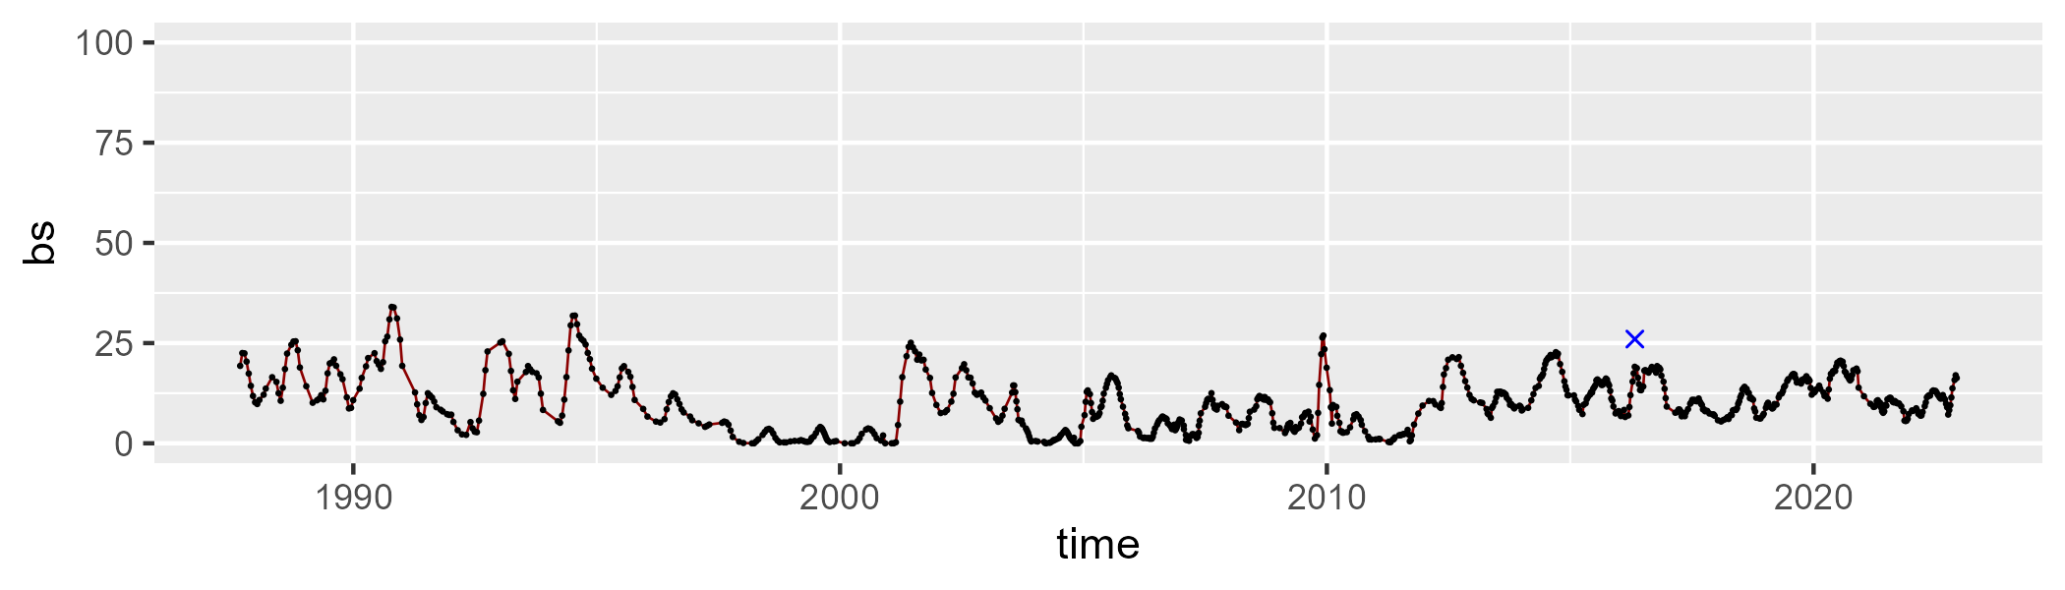

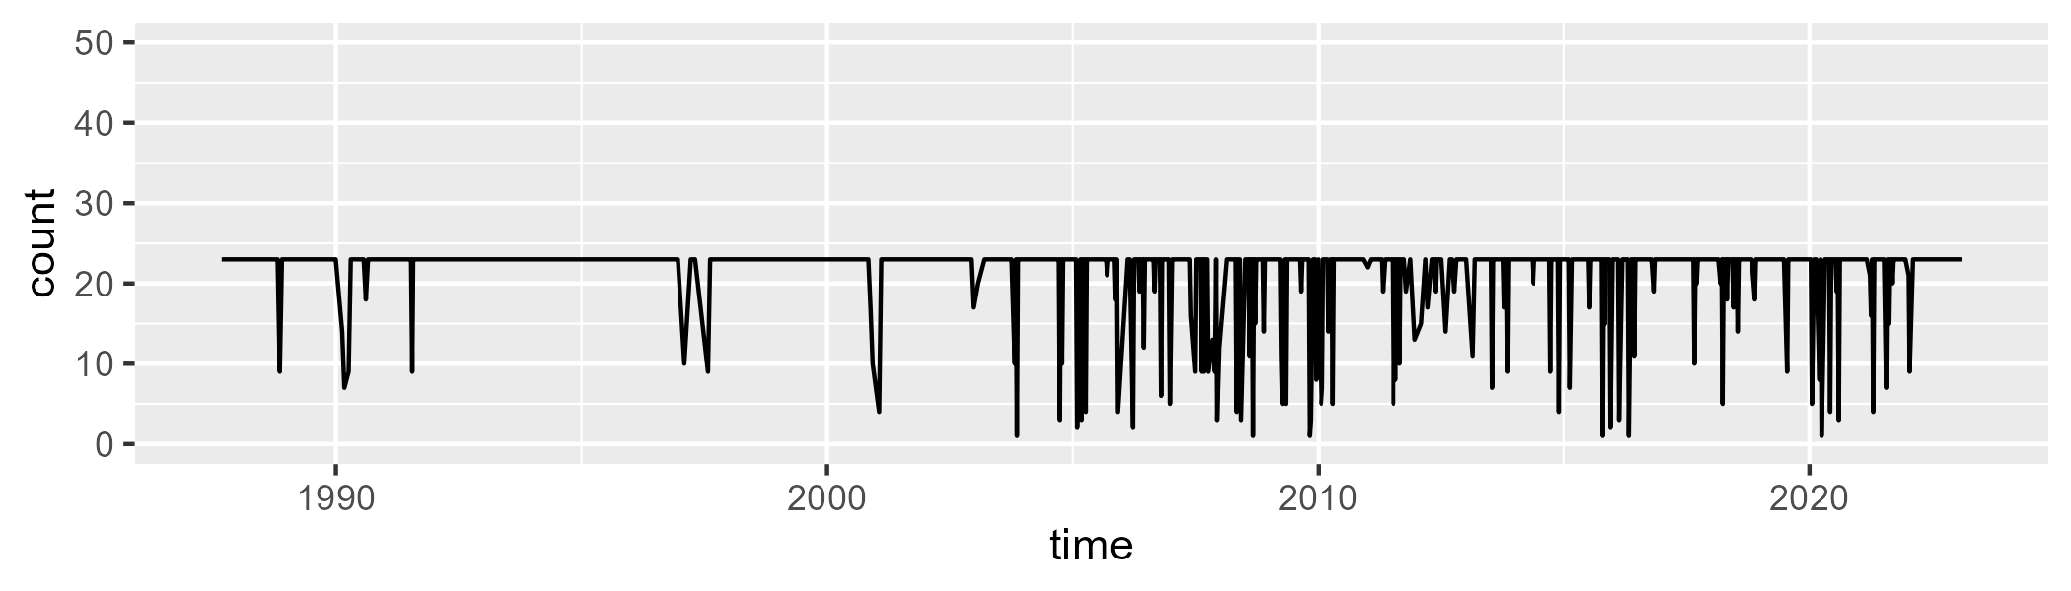

Min. : 1.00 1st Qu.:23.00 Median :23.00 Mean :21.48 3rd Qu.:23.00 Max. :23.00

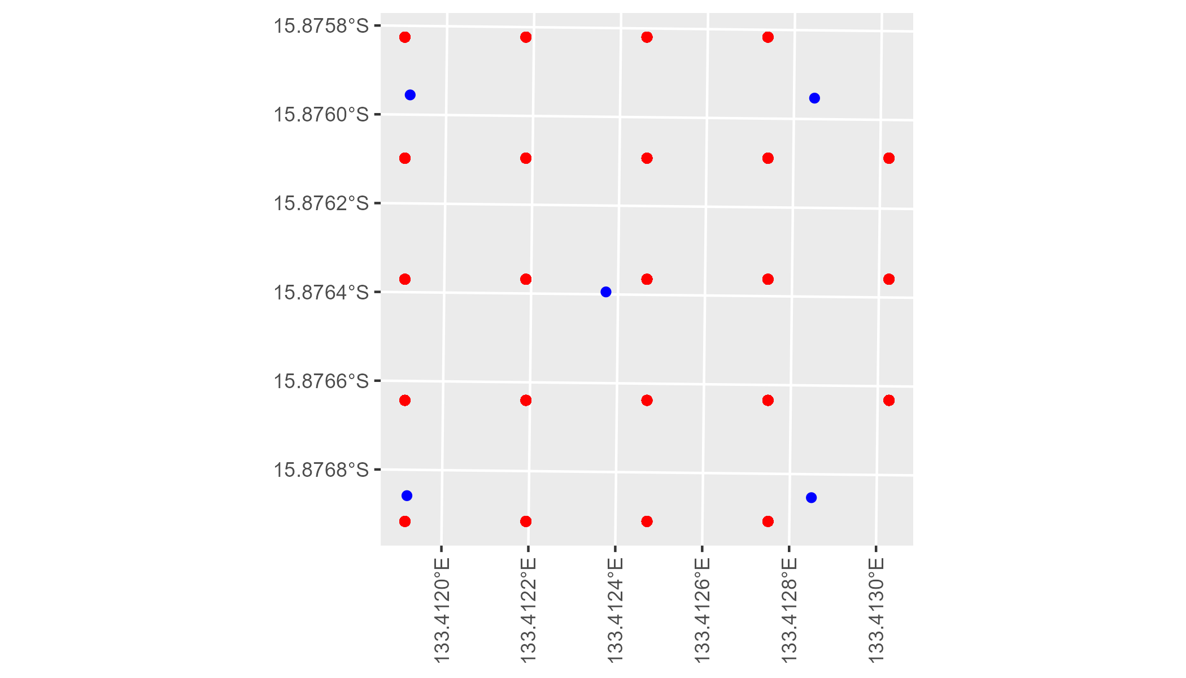

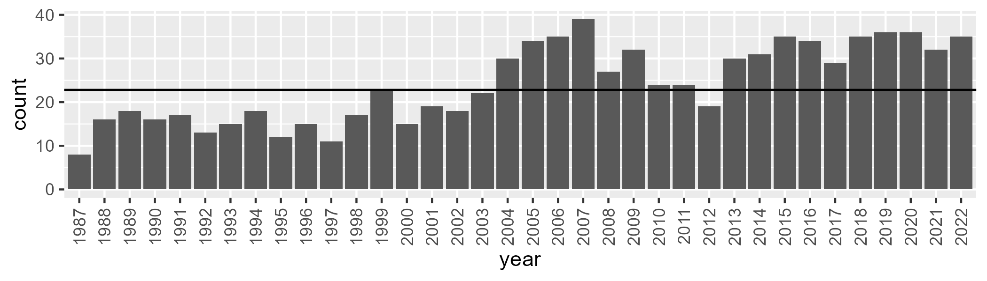

Number of samples: 870

# NTASTU0002

| Min. | 1st Qu. | Median | Mean | 3rd Qu. | Max. |
| --- | --- | --- | --- | --- | --- |
| 9.617489 | 23.93091 | 31.07534 | 34.17714 | 43.37086 | 69.61316 |

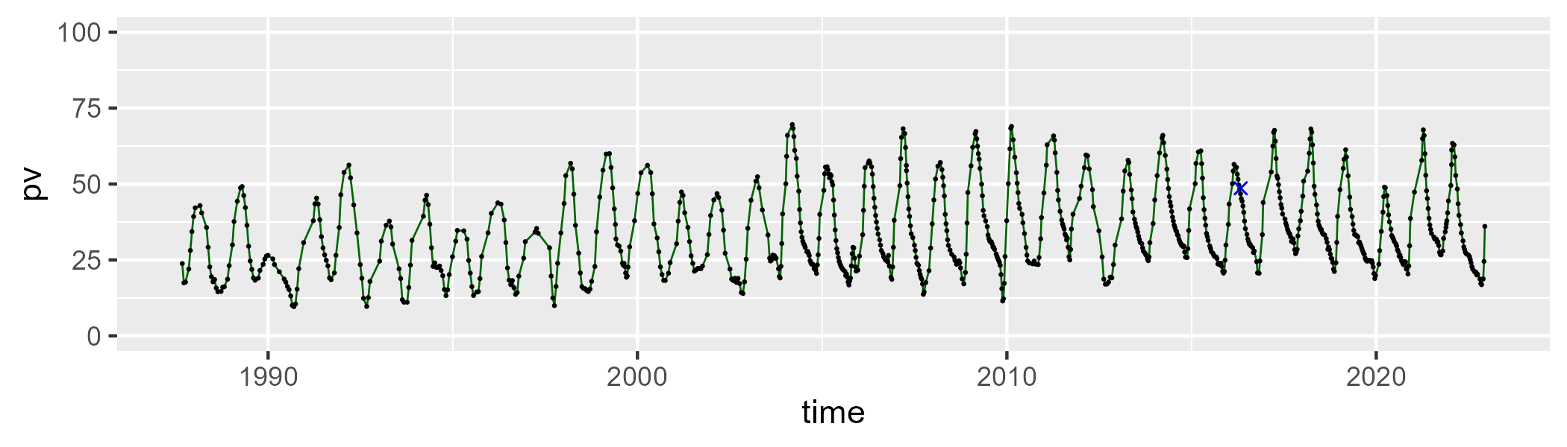

| Min. | 1st Qu. | Median | Mean | 3rd Qu. | Max. |
| --- | --- | --- | --- | --- | --- |
| 20.71176 | 47.07816 | 56.68429 | 55.1392 | 63.59285 | 81.00447 |

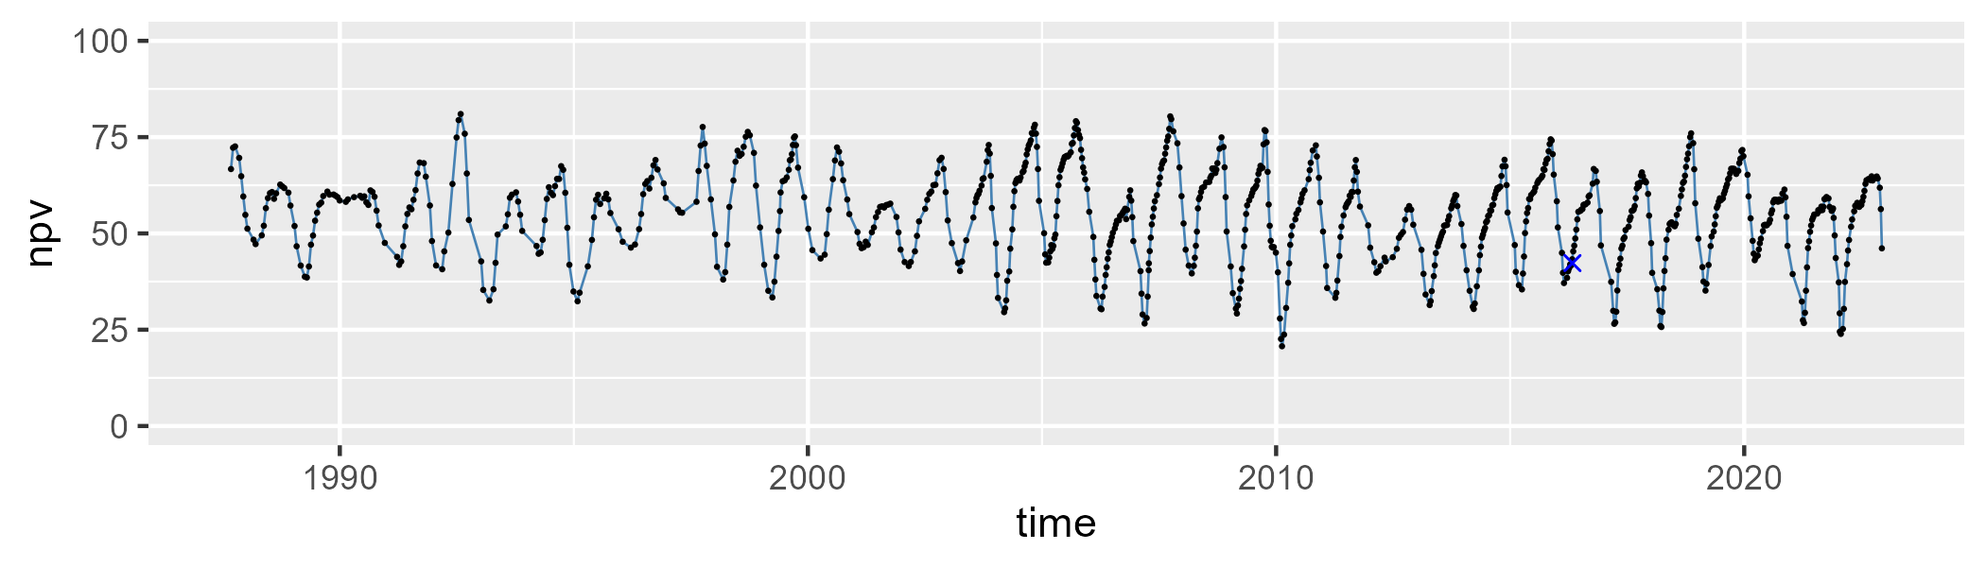

| Min. | 1st Qu. | Median | Mean | 3rd Qu. | Max. |
| --- | --- | --- | --- | --- | --- |
| 0 | 4.642472 | 8.123951 | 9.511077 | 13.38097 | 40.11527 |

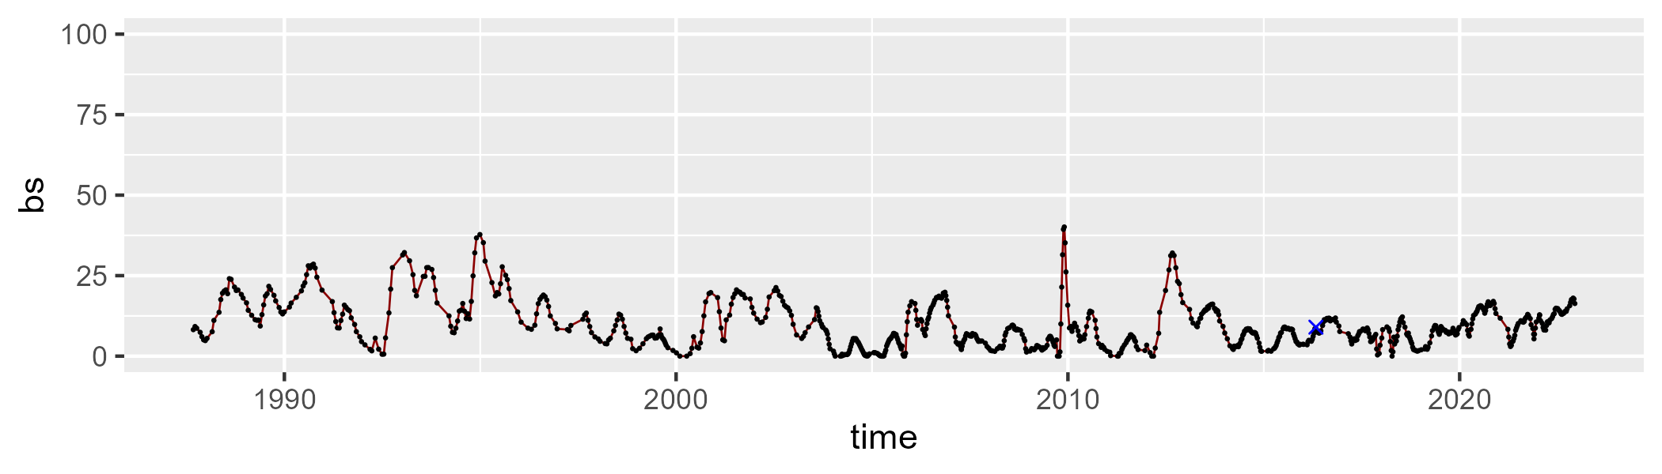

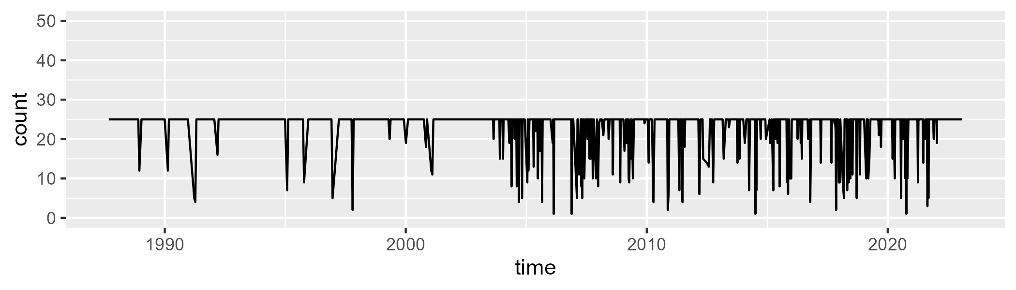

Min. : 1.00 1st Qu.:25.00 Median :25.00 Mean :23.07 3rd Qu.:25.00 Max. :25.00

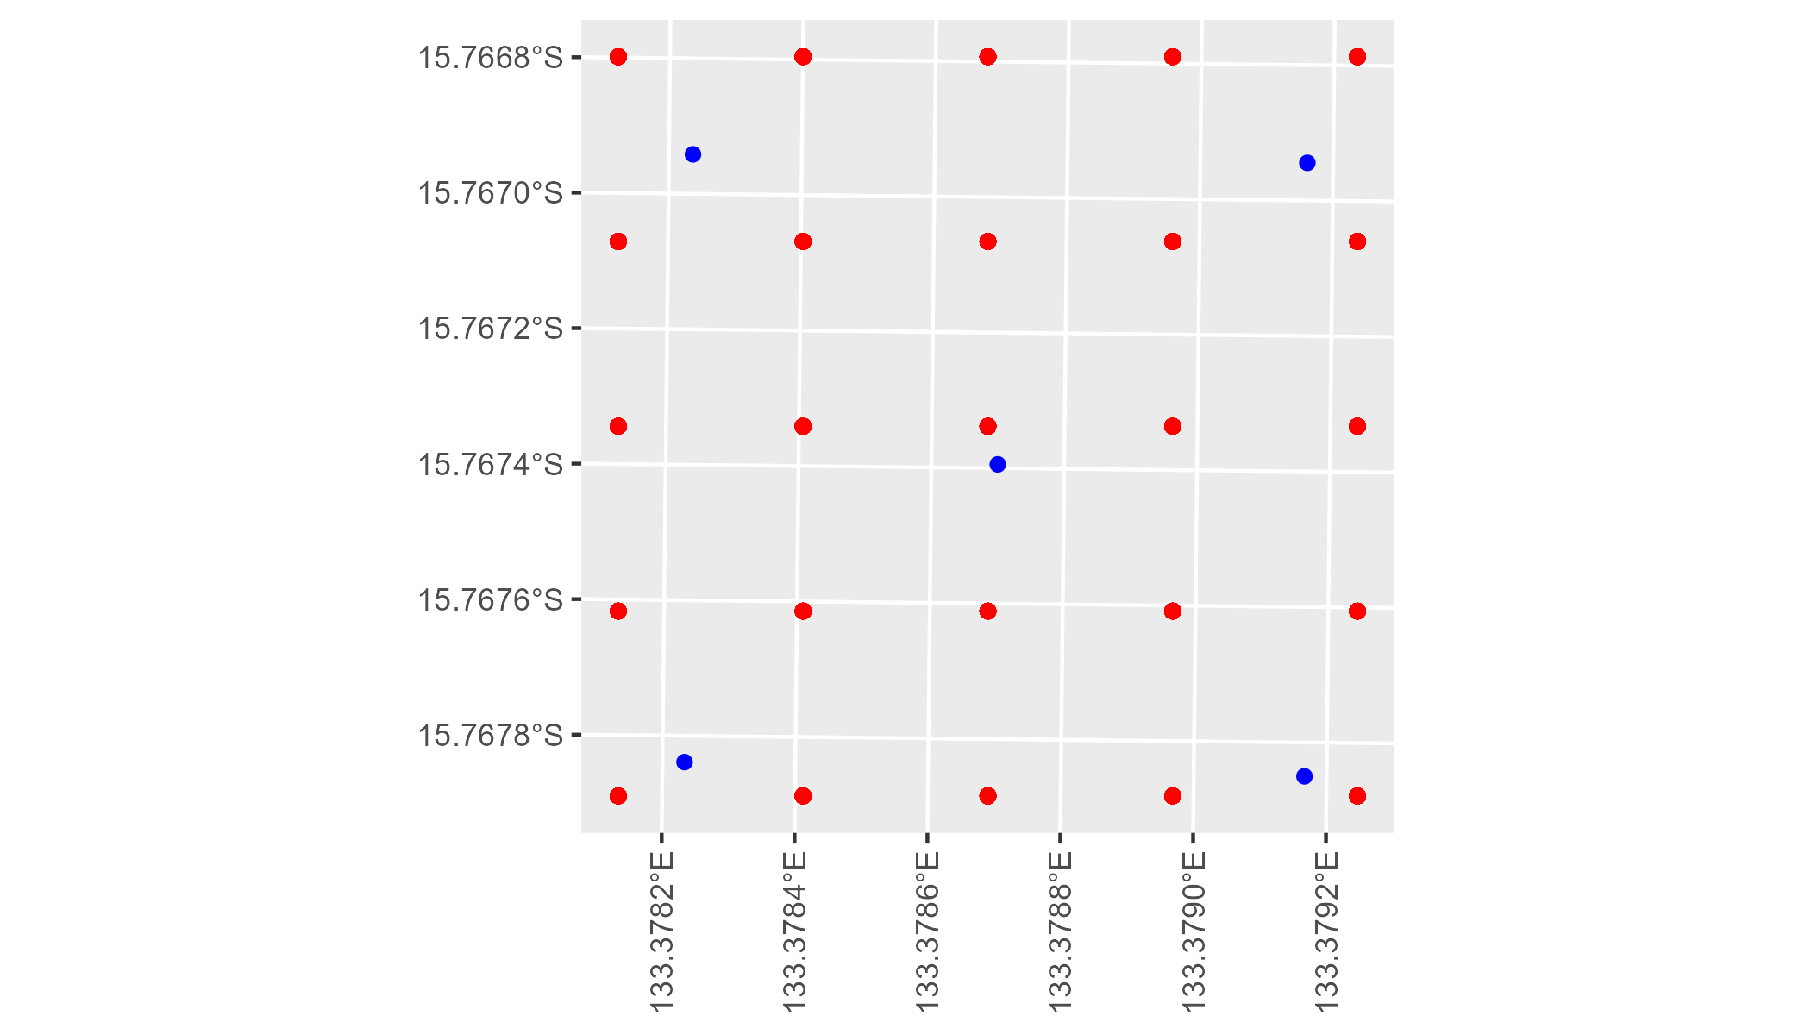

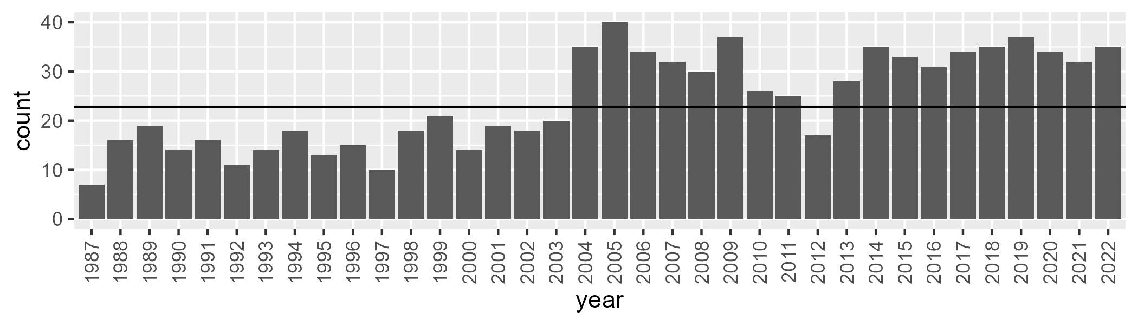

Number of samples: 873

# NTASTU0003

| Min. | 1st Qu. | Median | Mean | 3rd Qu. | Max. |
| --- | --- | --- | --- | --- | --- |
| 4.891348 | 25.47786 | 32.49432 | 35.92992 | 44.73201 | 72.5832 |

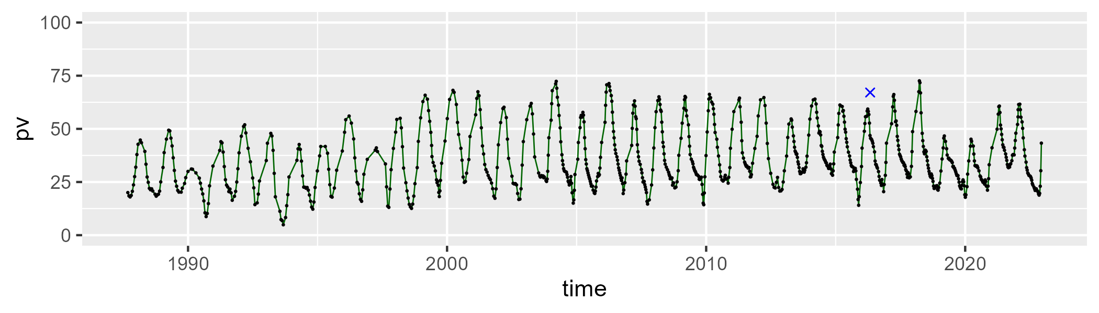

| Min. | 1st Qu. | Median | Mean | 3rd Qu. | Max. |
| --- | --- | --- | --- | --- | --- |
| 21.74404 | 41.32421 | 51.12756 | 50.31432 | 58.8064 | 83.59785 |

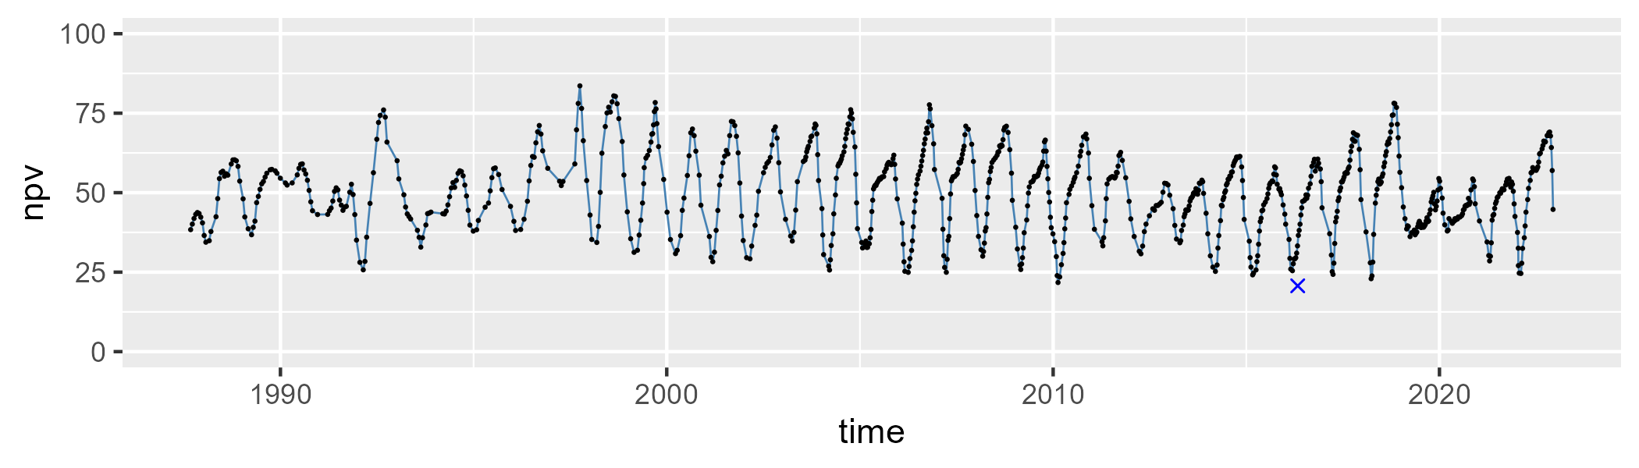

| Min. | 1st Qu. | Median | Mean | 3rd Qu. | Max. |
| --- | --- | --- | --- | --- | --- |
| 0 | 5.82594 | 10.4678 | 12.53118 | 17.15064 | 58.53356 |

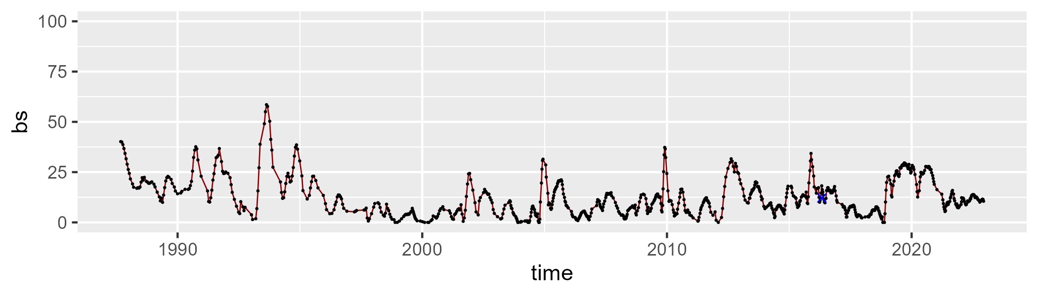

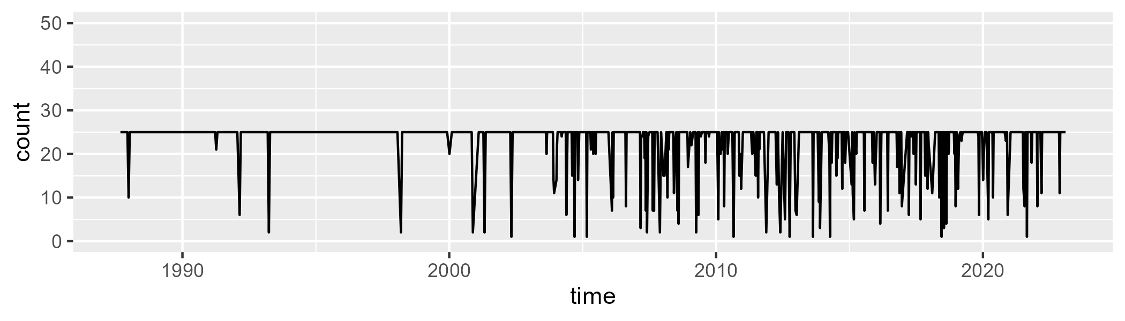

Min. : 1.00 1st Qu.:25.00 Median :25.00 Mean :23.09 3rd Qu.:25.00 Max. :25.00

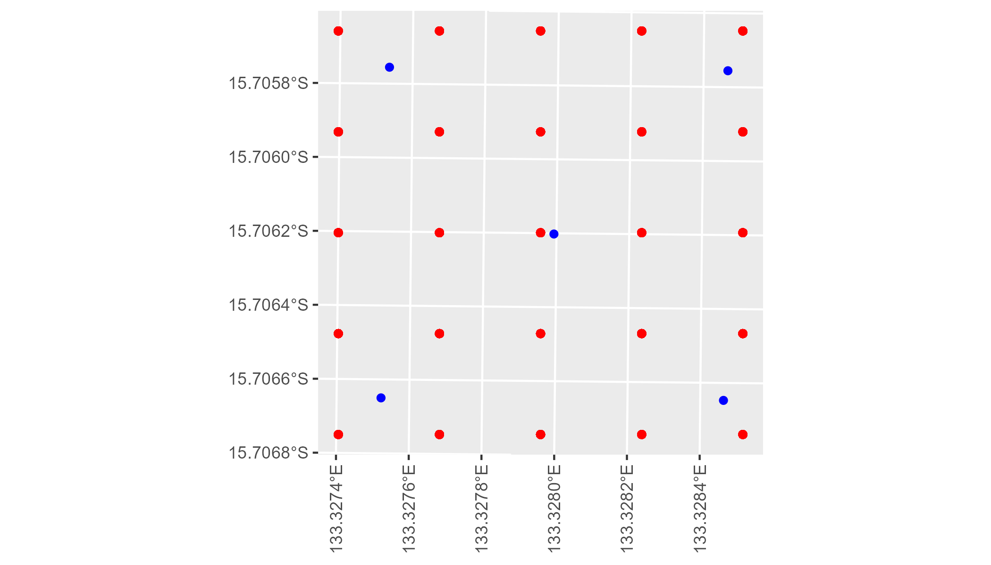

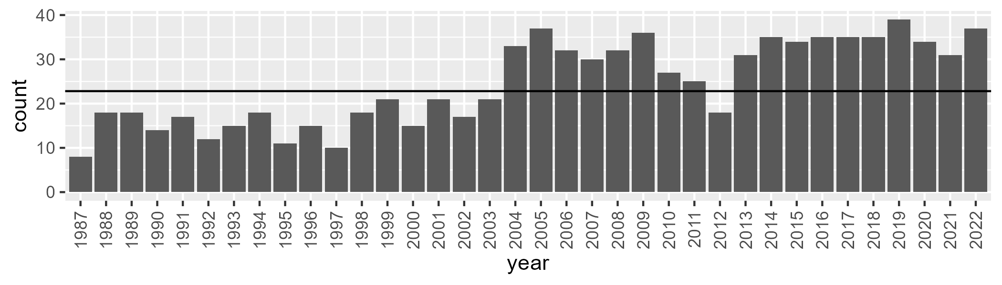

Number of samples: 885

# NTASTU0004

| Min. | 1st Qu. | Median | Mean | 3rd Qu. | Max. |
| --- | --- | --- | --- | --- | --- |
| 8.766942 | 25.87871 | 32.20202 | 35.60961 | 45.49878 | 69.07506 |

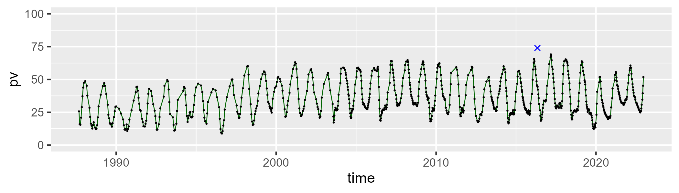

| Min. | 1st Qu. | Median | Mean | 3rd Qu. | Max. |
| --- | --- | --- | --- | --- | --- |
| 16.39045 | 40.78716 | 46.35054 | 46.24279 | 52.34458 | 70.14038 |

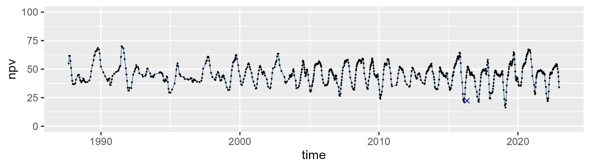

| Min. | 1st Qu. | Median | Mean | 3rd Qu. | Max. |
| --- | --- | --- | --- | --- | --- |
| 0 | 9.134567 | 14.91492 | 16.87091 | 22.65604 | 51.81329 |

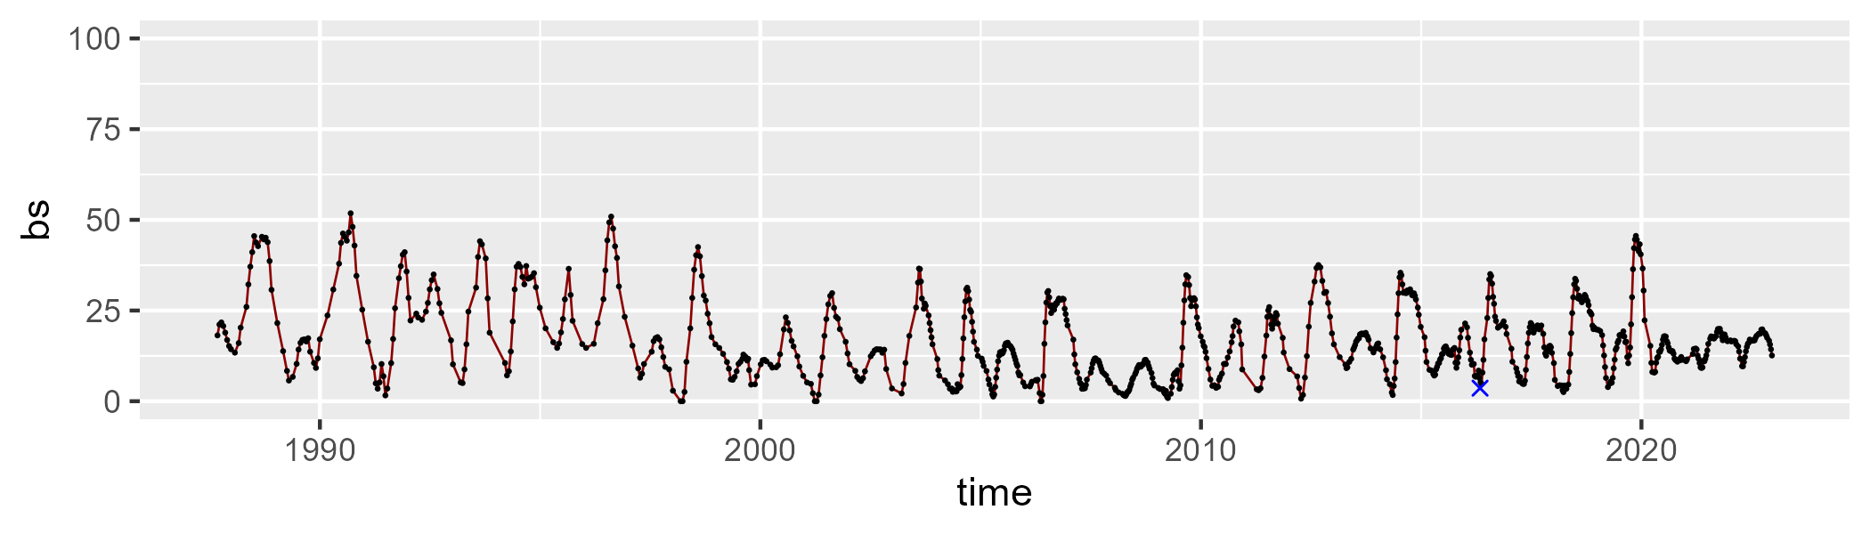

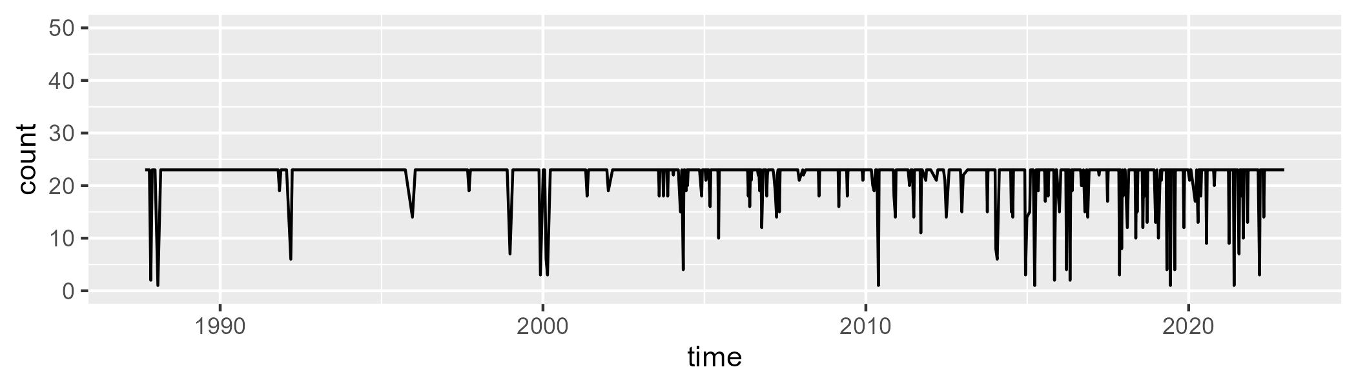

Min. : 1.00 1st Qu.:23.00 Median :23.00 Mean :21.88 3rd Qu.:23.00 Max. :23.00

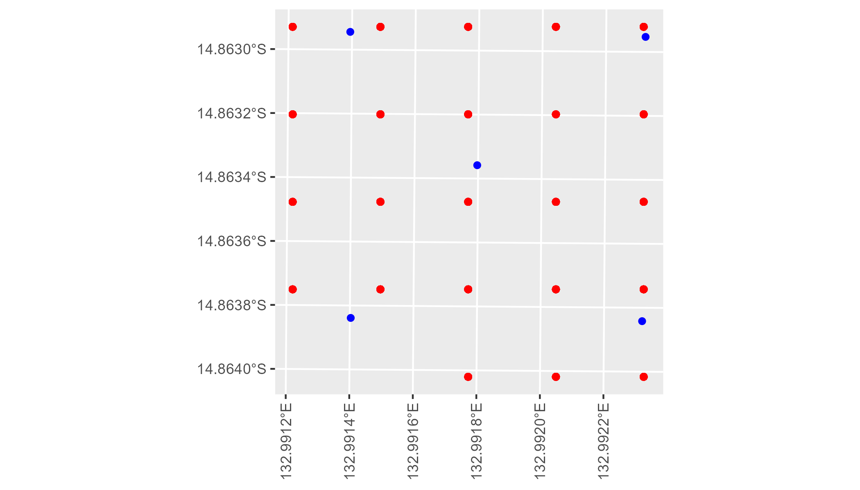

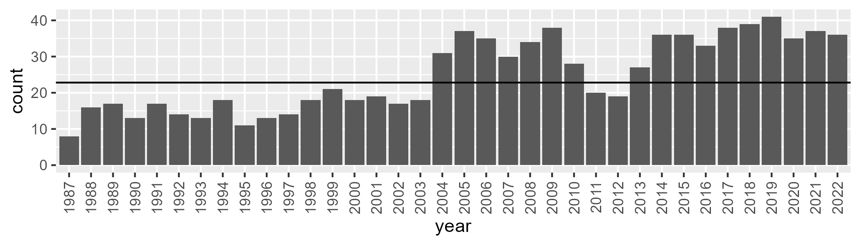

Number of samples: 895

# NTASTU0005

| Min. | 1st Qu. | Median | Mean | 3rd Qu. | Max. |
| --- | --- | --- | --- | --- | --- |
| 9.337071 | 28.67213 | 35.65612 | 37.78495 | 46.94855 | 68.77647 |

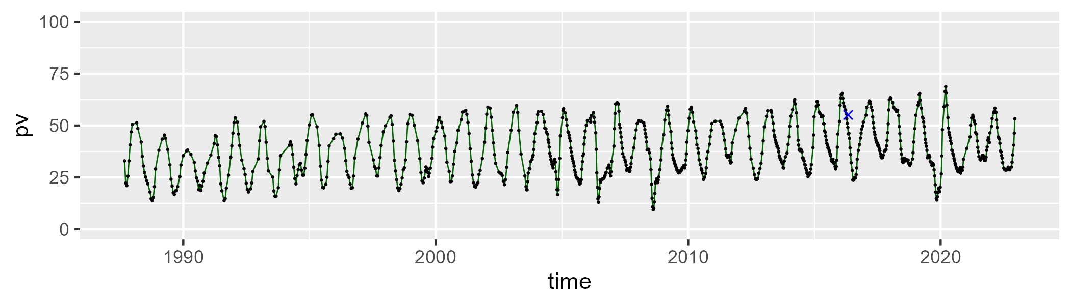

| Min. | 1st Qu. | Median | Mean | 3rd Qu. | Max. |
| --- | --- | --- | --- | --- | --- |
| 17.30403 | 41.55275 | 47.83549 | 47.27744 | 53.50895 | 71.23652 |

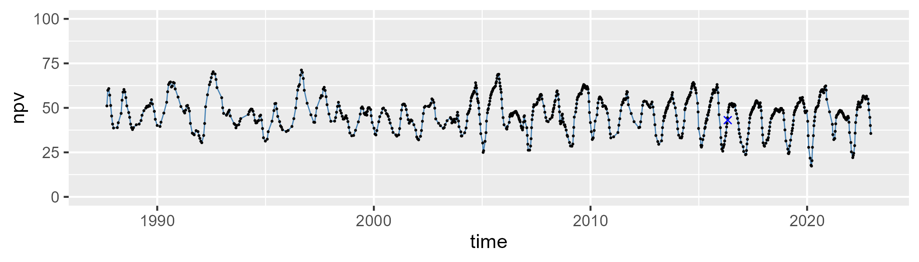

| Min. | 1st Qu. | Median | Mean | 3rd Qu. | Max. |
| --- | --- | --- | --- | --- | --- |
| 0 | 7.455248 | 10.81947 | 13.69056 | 17.65676 | 48.9379 |

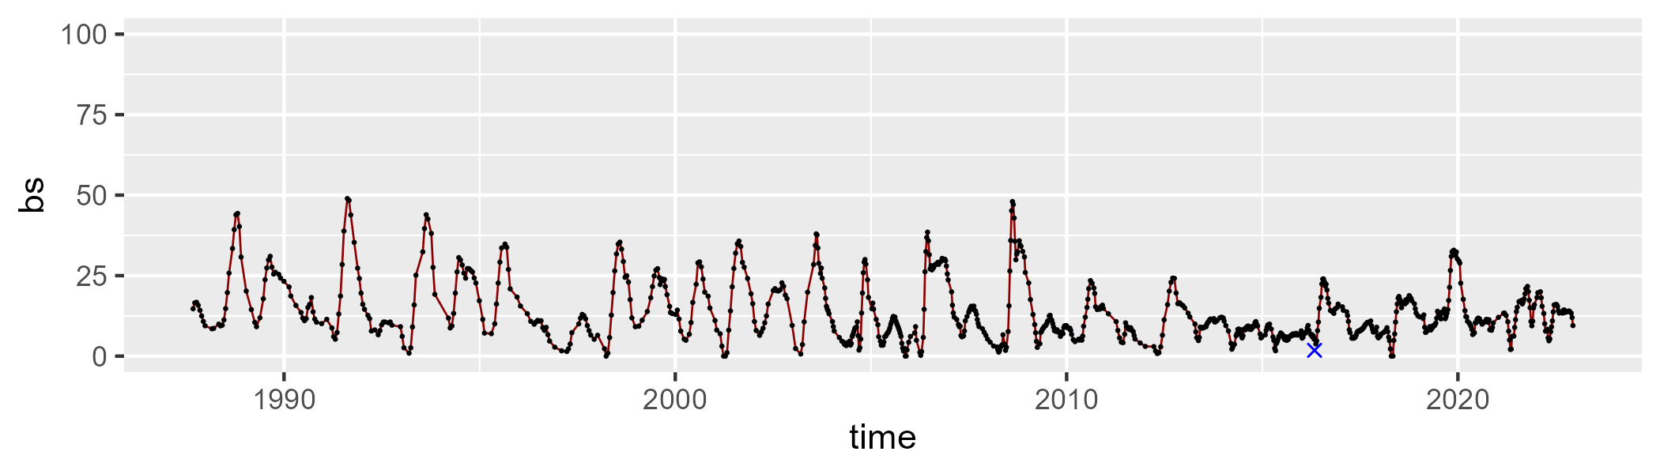

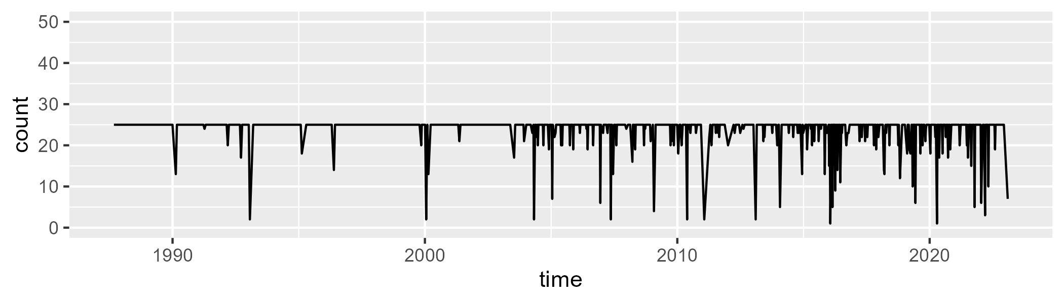

Min. : 1.00 1st Qu.:25.00 Median :25.00 Mean :23.85 3rd Qu.:25.00 Max. :25.00

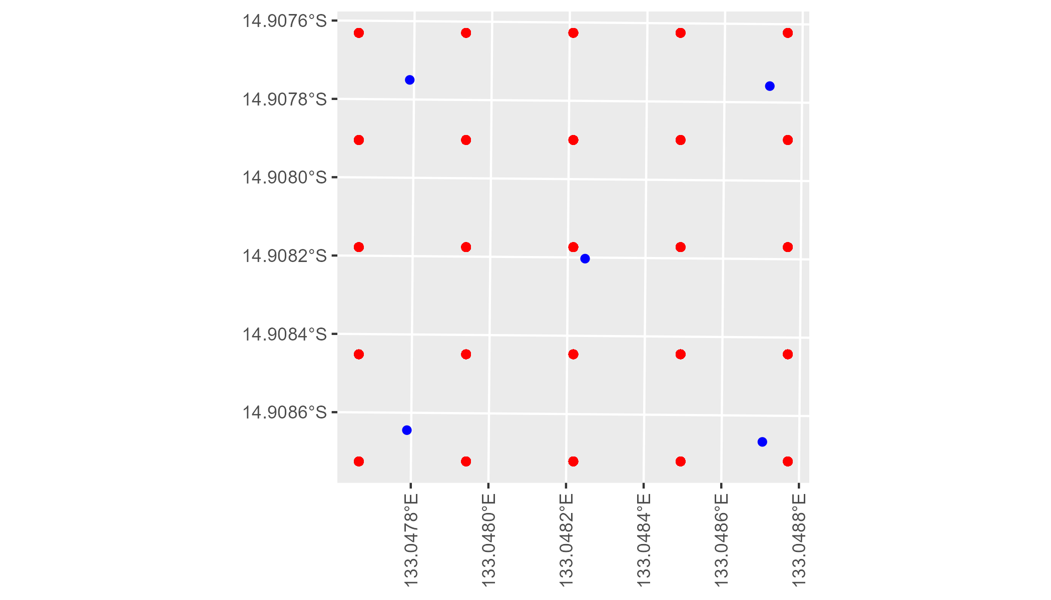

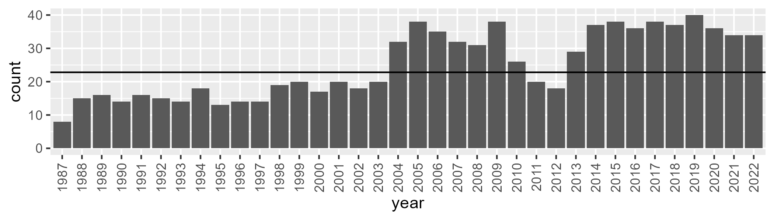

Number of samples: 900

# NTATAN0001

| Min. | 1st Qu. | Median | Mean | 3rd Qu. | Max. |
| --- | --- | --- | --- | --- | --- |
| 2.390685 | 12.3366 | 16.59967 | 17.60695 | 22.14284 | 41.24225 |

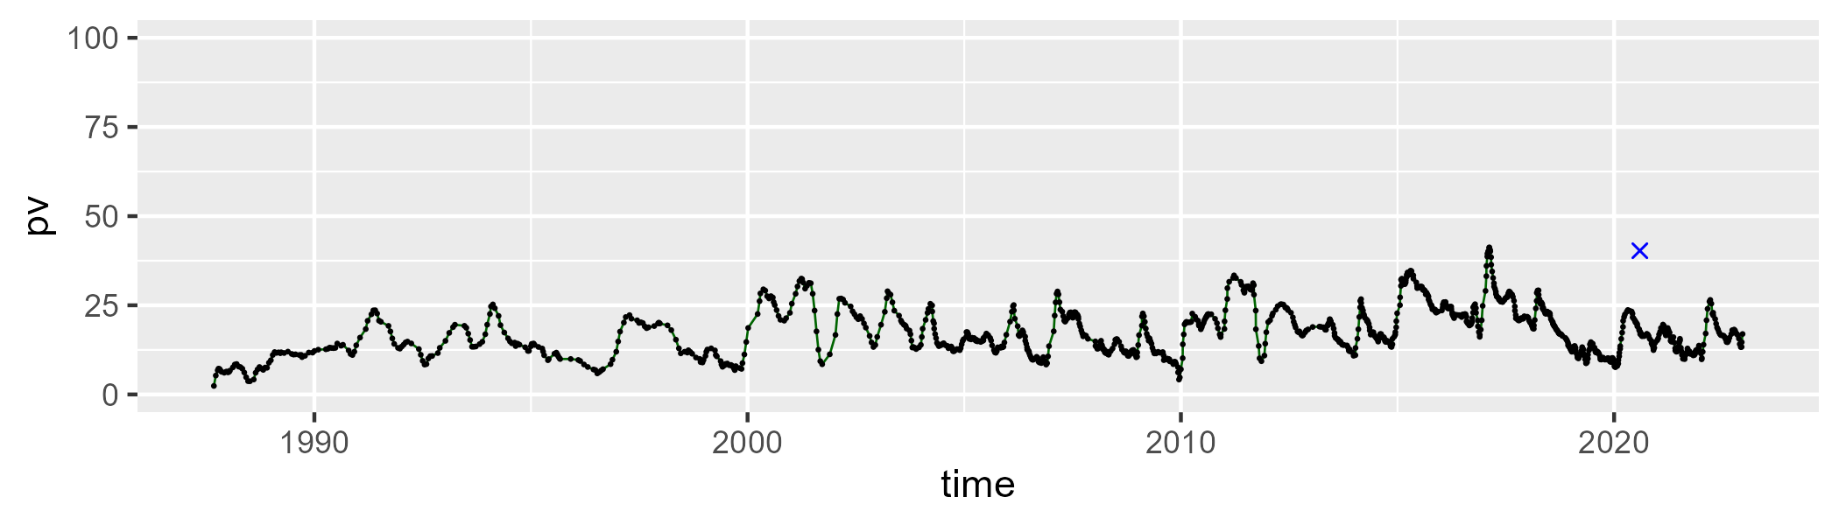

| Min. | 1st Qu. | Median | Mean | 3rd Qu. | Max. |
| --- | --- | --- | --- | --- | --- |
| 27.34483 | 40.22113 | 43.00152 | 42.9992 | 46.10278 | 58.10628 |

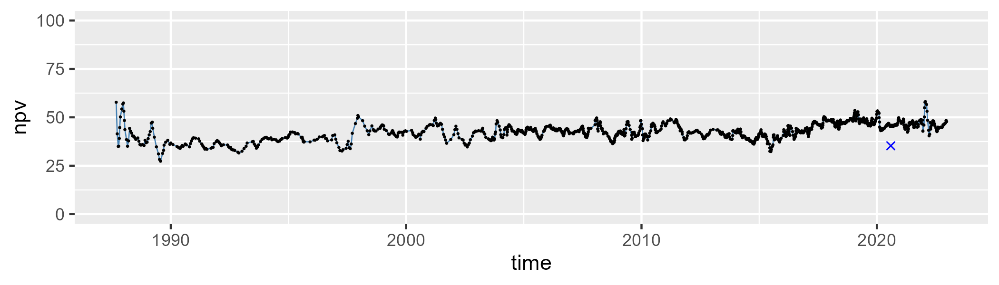

| Min. | 1st Qu. | Median | Mean | 3rd Qu. | Max. |
| --- | --- | --- | --- | --- | --- |
| 14.24045 | 32.78652 | 38.19863 | 37.93898 | 43.33759 | 59.98733 |

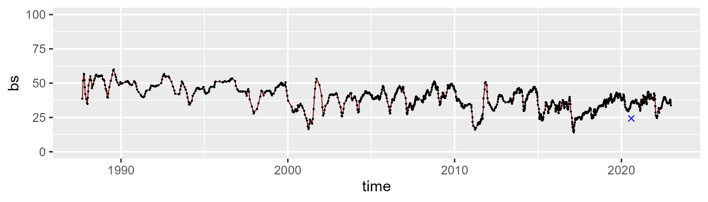

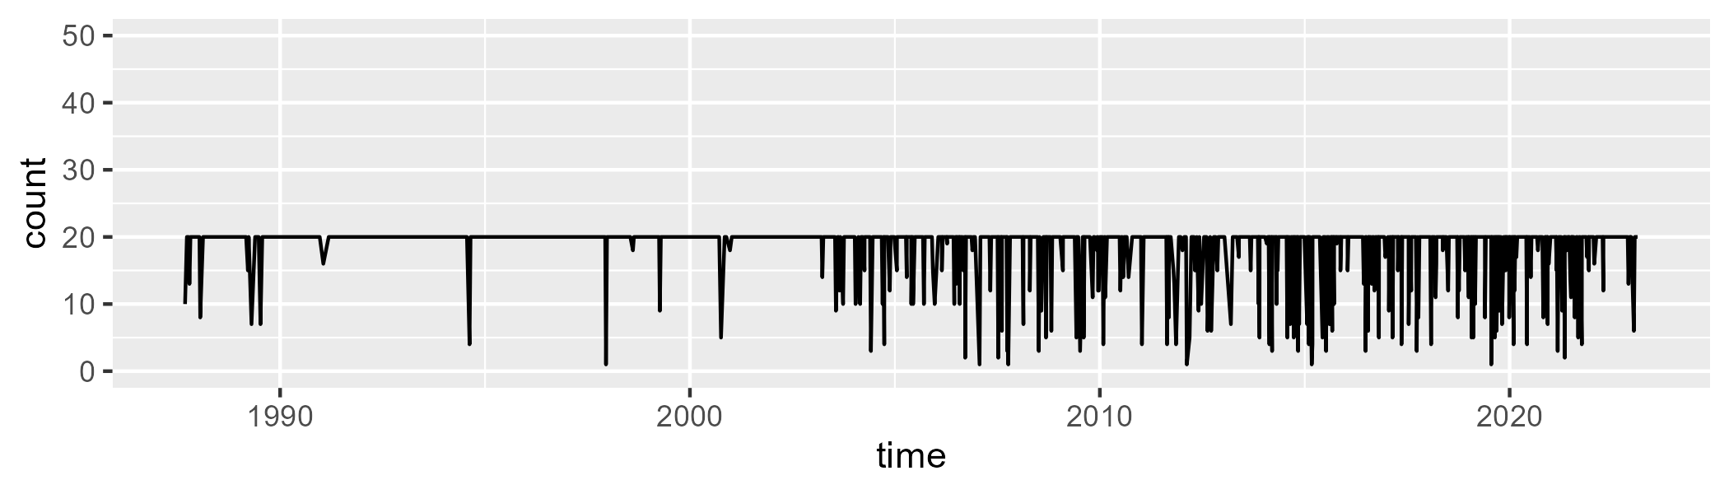

Min. : 1.00 1st Qu.:20.00 Median :20.00 Mean :18.43 3rd Qu.:20.00 Max. :20.00

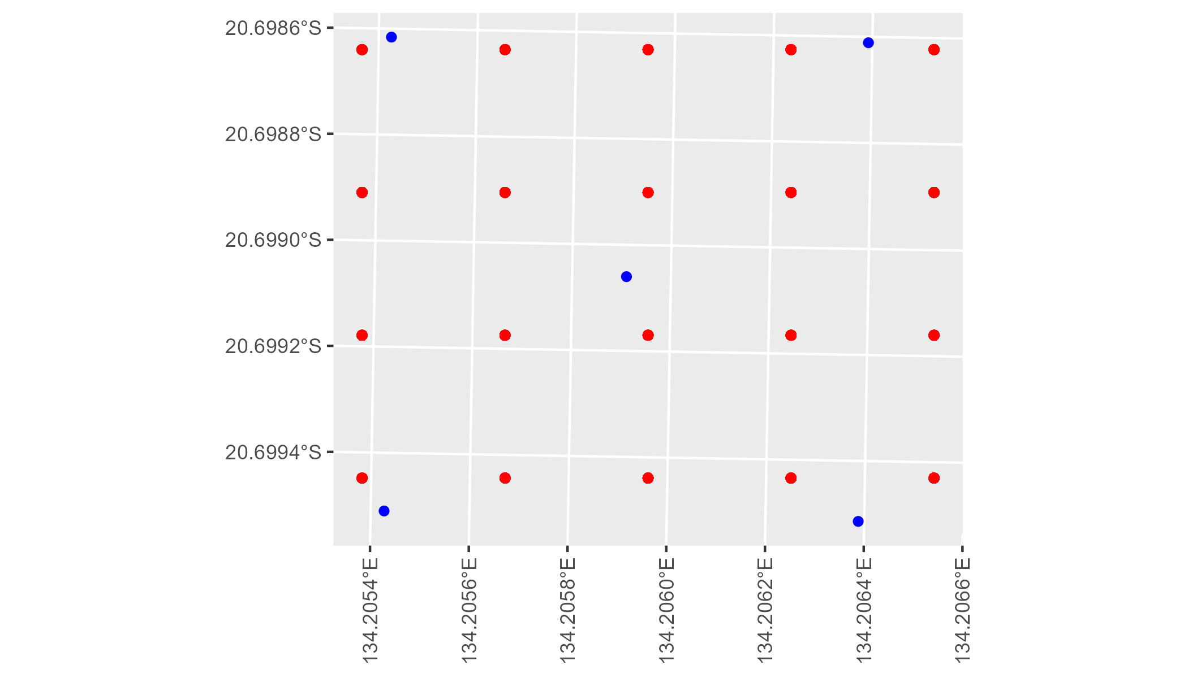

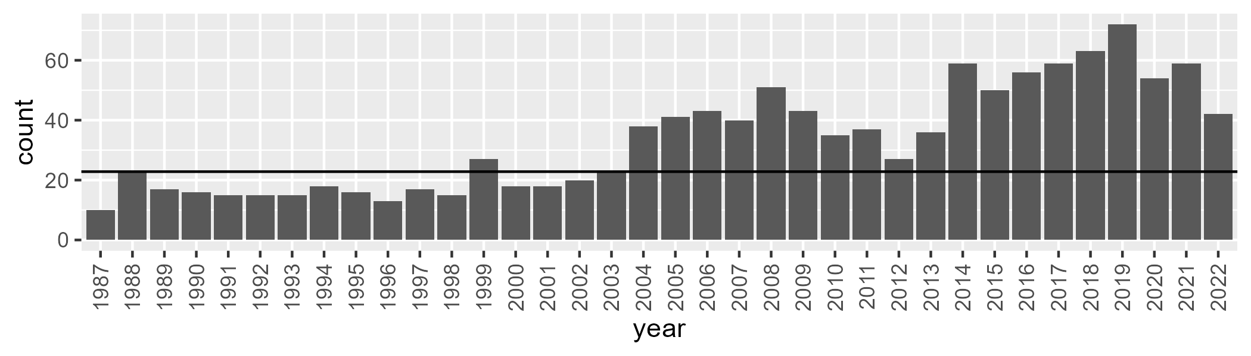

Number of samples: 1201

# NTATAN0002

| Min. | 1st Qu. | Median | Mean | 3rd Qu. | Max. |
| --- | --- | --- | --- | --- | --- |
| 6.083705 | 13.93687 | 17.58468 | 18.75379 | 23.3145 | 41.52983 |

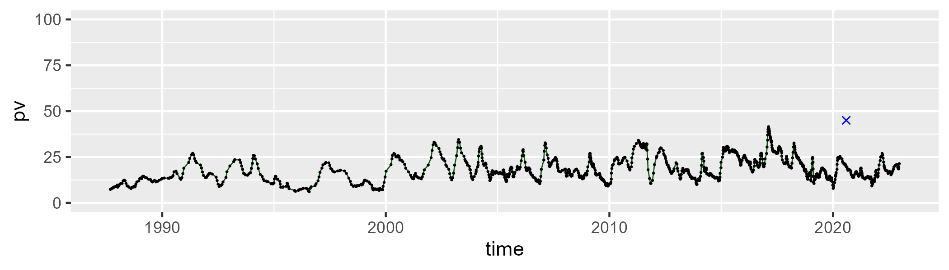

| Min. | 1st Qu. | Median | Mean | 3rd Qu. | Max. |
| --- | --- | --- | --- | --- | --- |
| 25.79142 | 38.78422 | 42.1156 | 41.45638 | 44.24078 | 52.65386 |

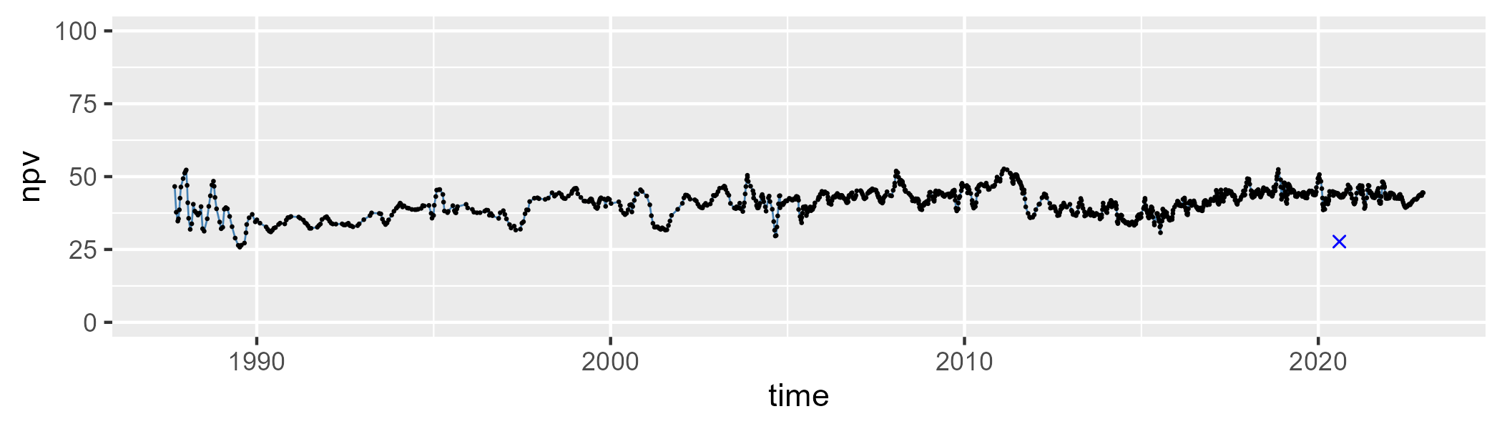

| Min. | 1st Qu. | Median | Mean | 3rd Qu. | Max. |
| --- | --- | --- | --- | --- | --- |
| 11.78837 | 33.19494 | 38.67491 | 38.31525 | 43.54091 | 60.91846 |

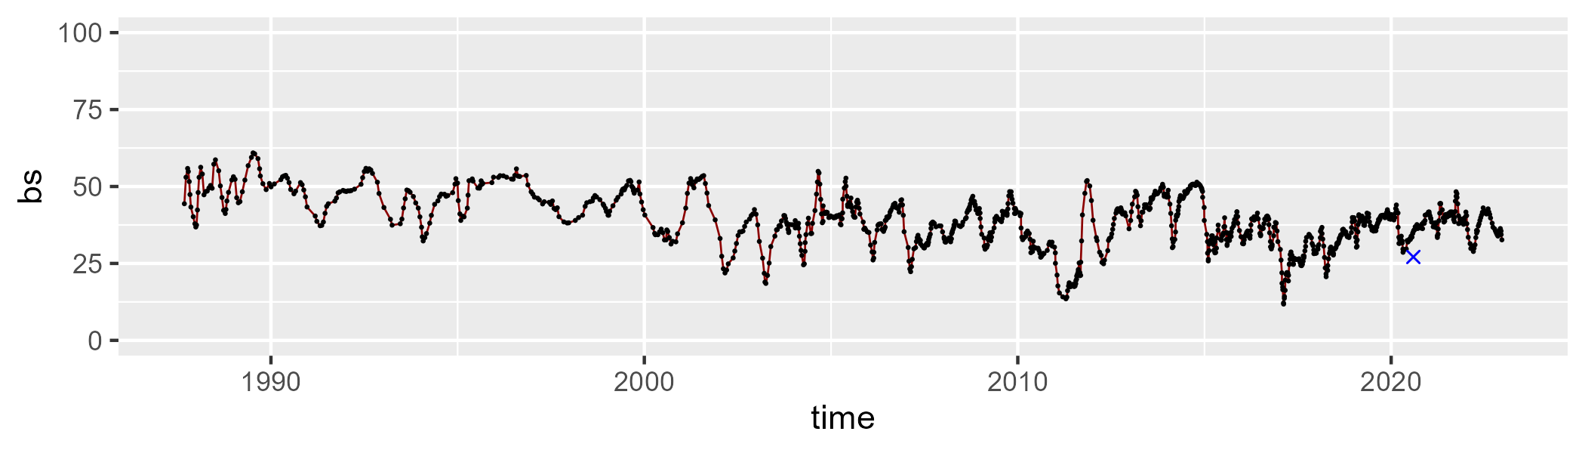

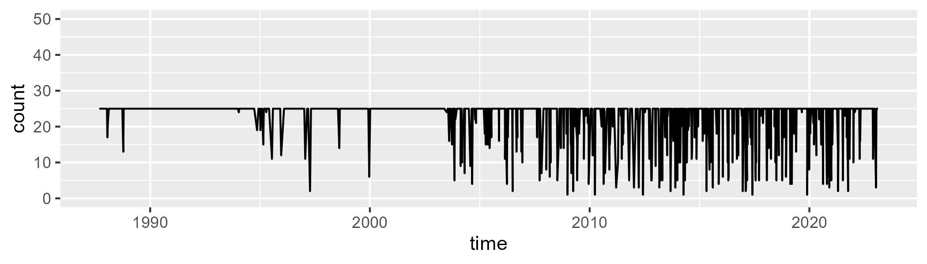

Min. : 1.00 1st Qu.:25.00 Median :25.00 Mean :22.66 3rd Qu.:25.00 Max. :25.00

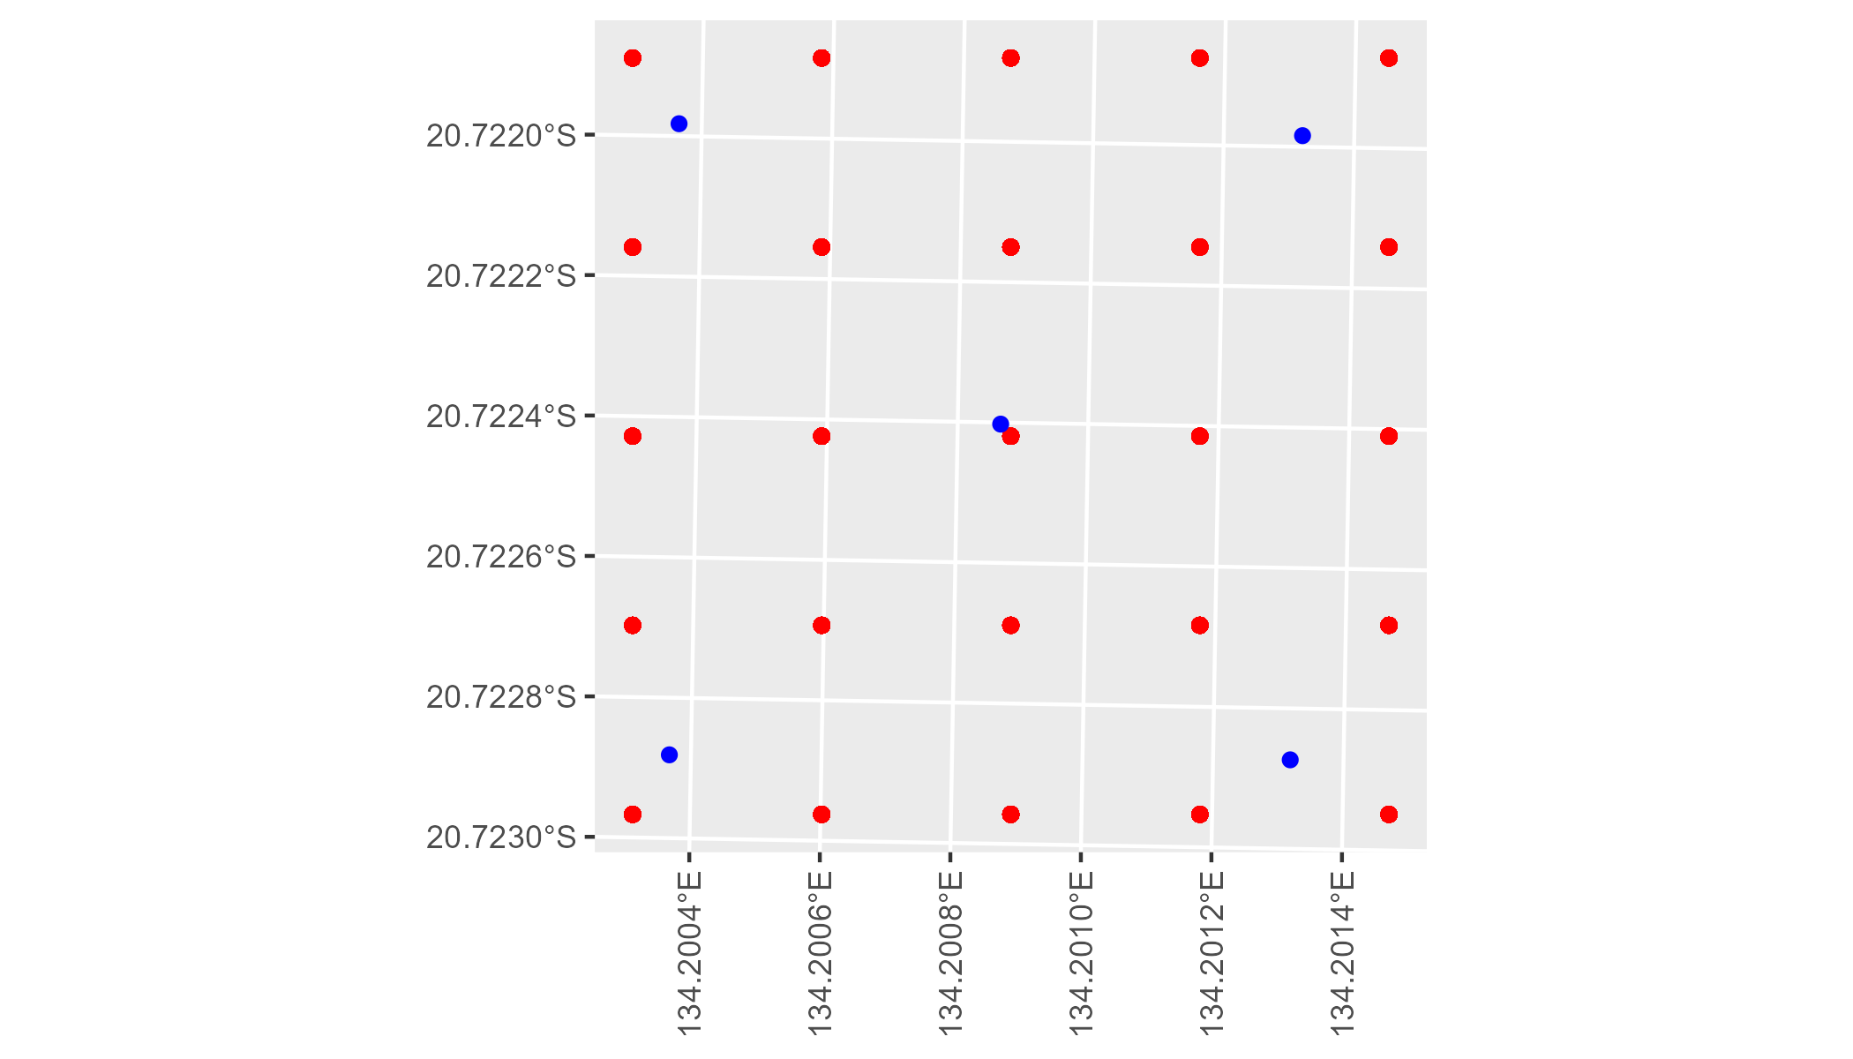

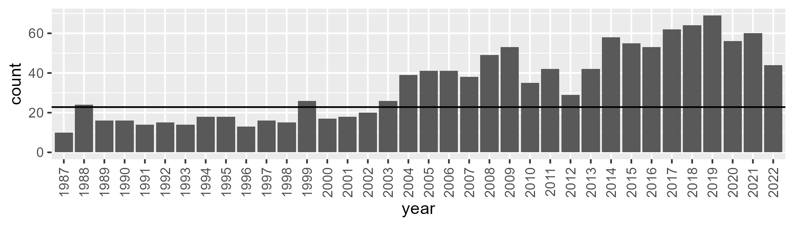

Number of samples: 1226

# NTATAN0003

| Min. | 1st Qu. | Median | Mean | 3rd Qu. | Max. |
| --- | --- | --- | --- | --- | --- |
| 0.271818 | 10.21123 | 13.26572 | 13.49943 | 16.92329 | 25.10468 |

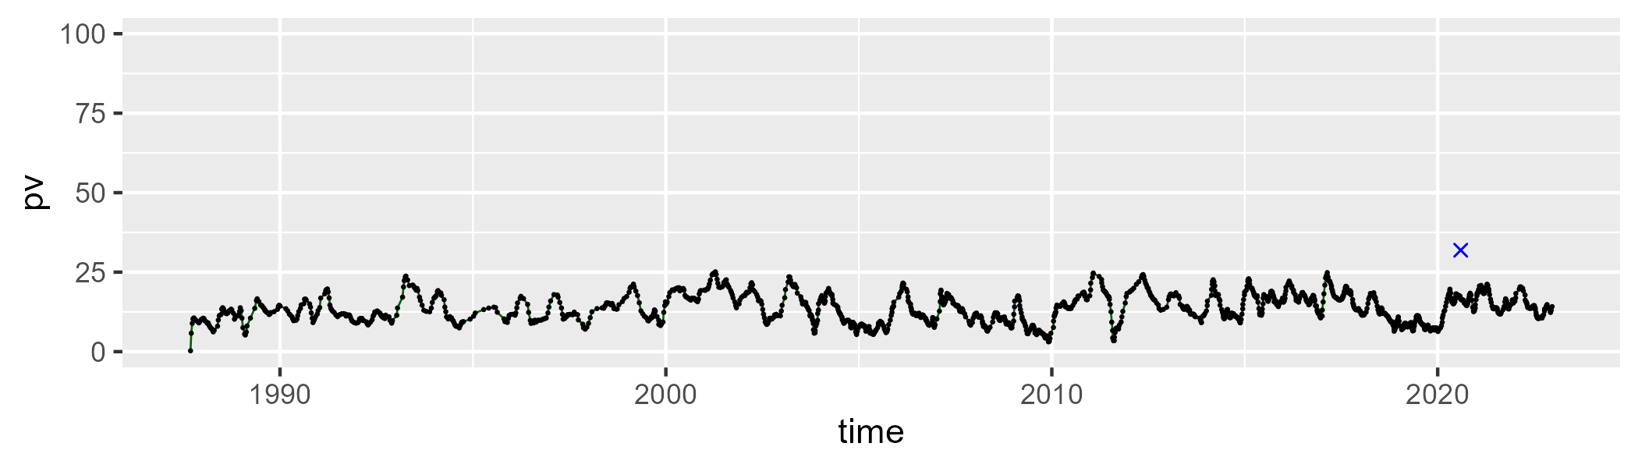

| Min. | 1st Qu. | Median | Mean | 3rd Qu. | Max. |
| --- | --- | --- | --- | --- | --- |
| 2.315091 | 26.77709 | 30.84753 | 30.31225 | 34.81884 | 61.51666 |

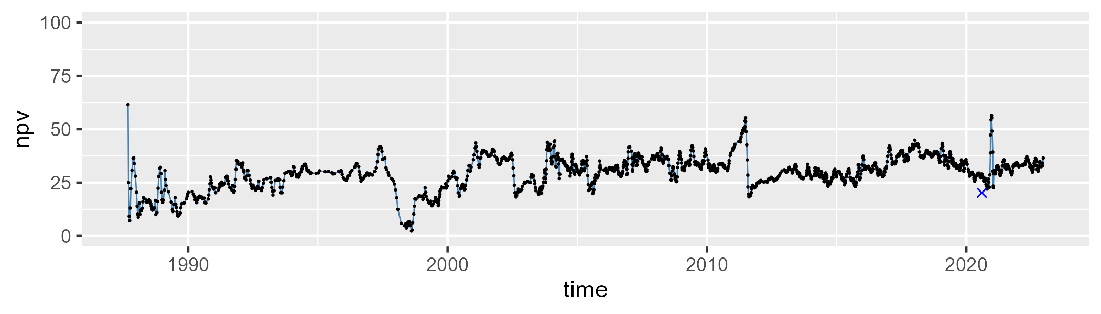

| Min. | 1st Qu. | Median | Mean | 3rd Qu. | Max. |
| --- | --- | --- | --- | --- | --- |
| 26.28554 | 49.41863 | 54.25593 | 54.60799 | 59.36831 | 81.33238 |

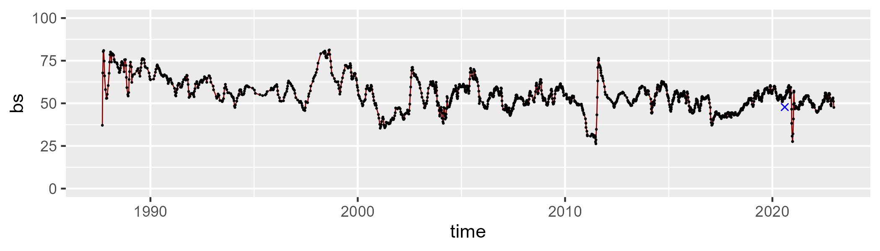

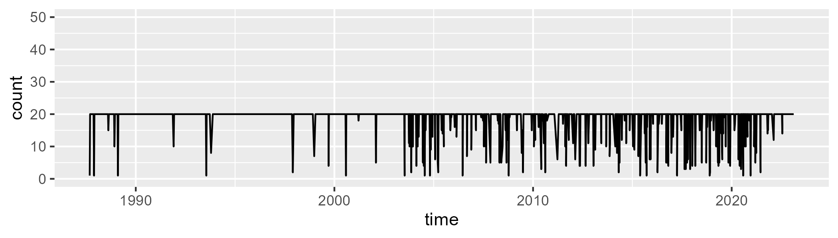

Min. : 1.00 1st Qu.:20.00 Median :20.00 Mean :18.72 3rd Qu.:20.00 Max. :20.00

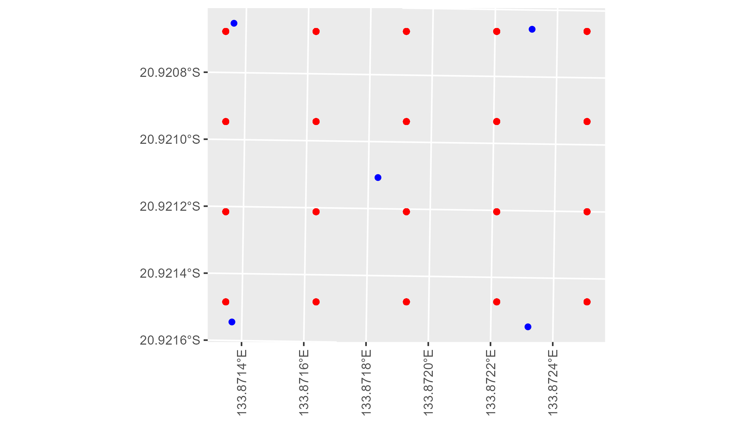

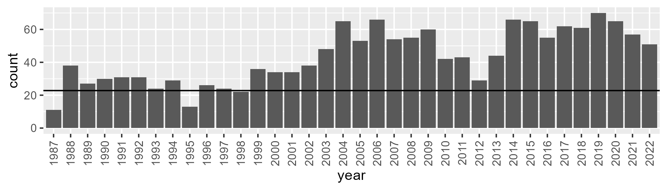

Number of samples: 1559

# NTATAN0004

| Min. | 1st Qu. | Median | Mean | 3rd Qu. | Max. |
| --- | --- | --- | --- | --- | --- |
| 4.063103 | 10.26604 | 12.98244 | 13.96856 | 17.41511 | 34.21746 |

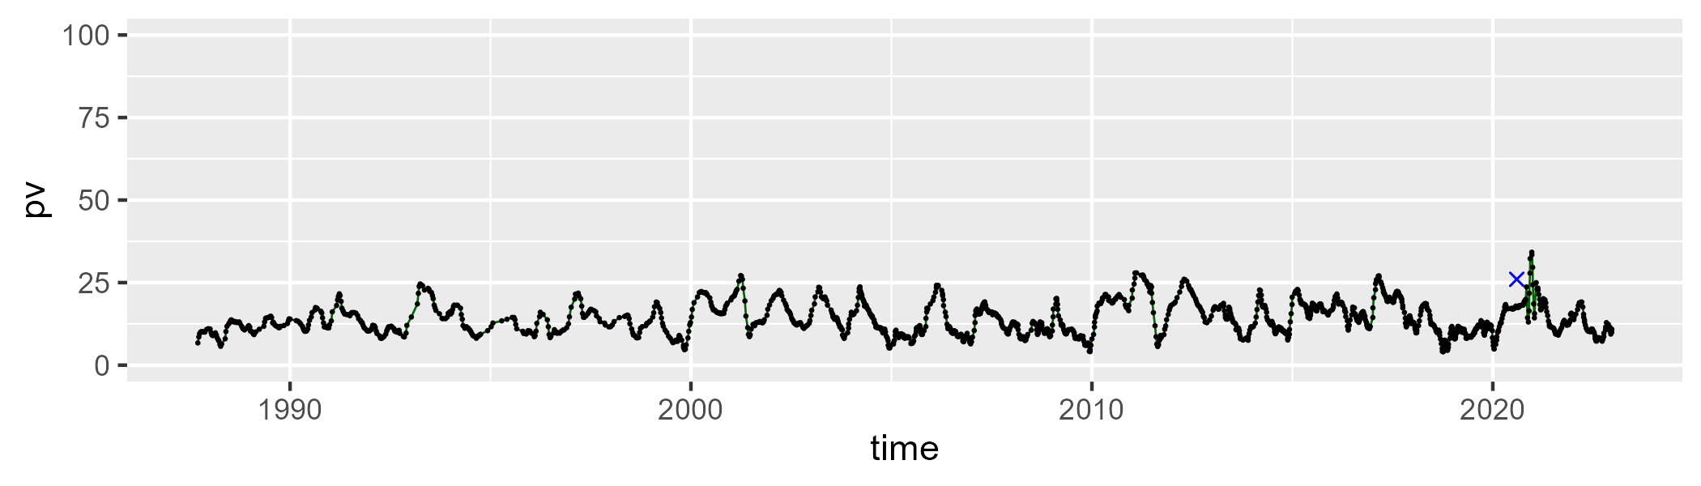

| Min. | 1st Qu. | Median | Mean | 3rd Qu. | Max. |
| --- | --- | --- | --- | --- | --- |
| 0 | 24.74366 | 32.24832 | 29.66195 | 37.5022 | 56.49256 |

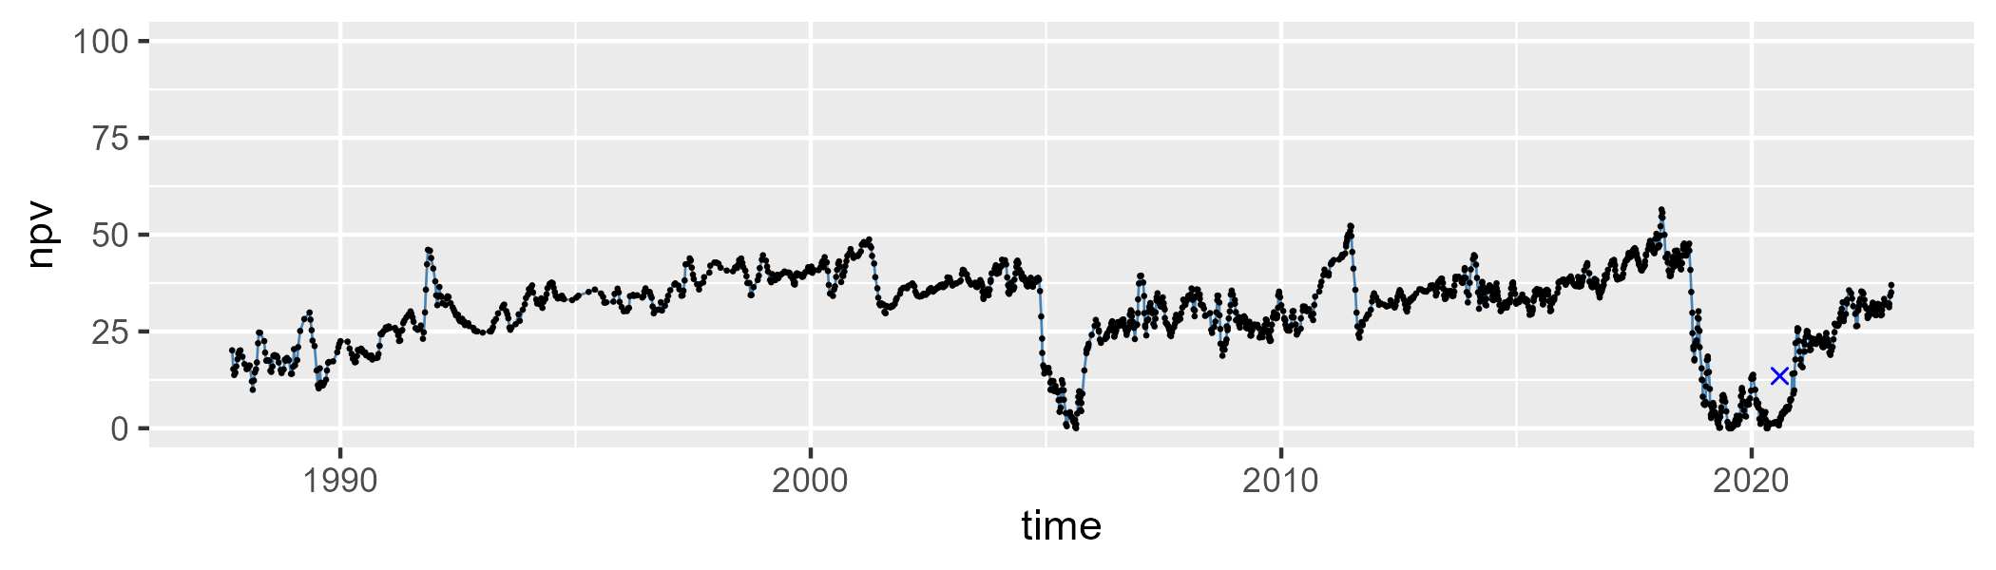

| Min. | 1st Qu. | Median | Mean | 3rd Qu. | Max. |
| --- | --- | --- | --- | --- | --- |
| 22.31564 | 45.62602 | 52.79725 | 54.81288 | 62.3493 | 90.23023 |

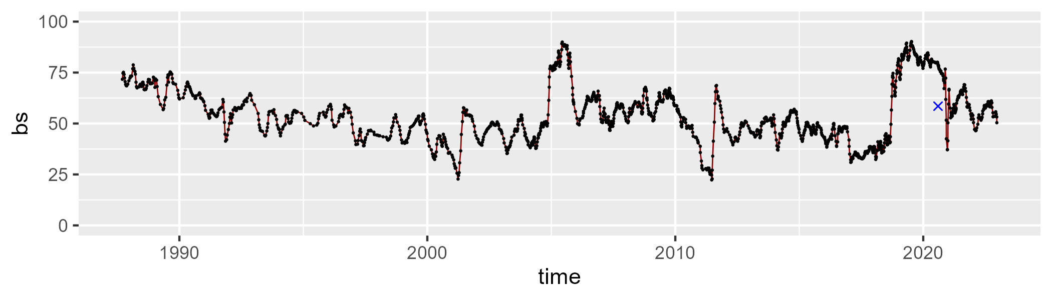

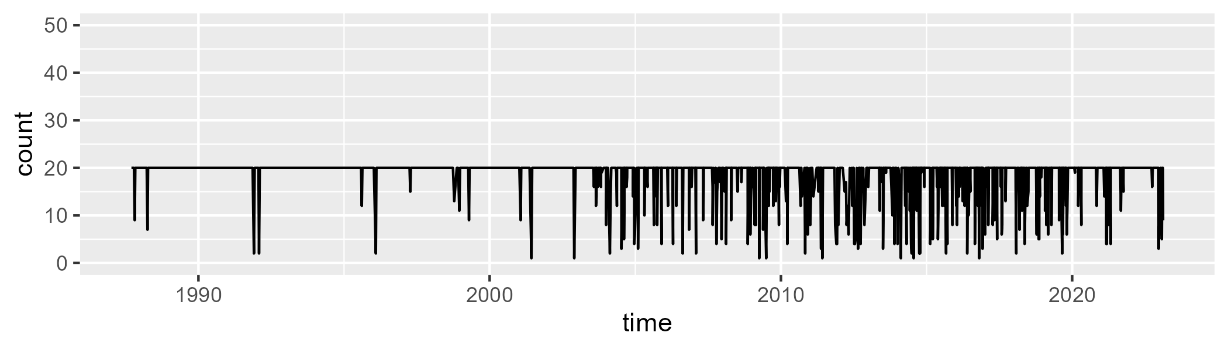

Min. : 1.00 1st Qu.:20.00 Median :20.00 Mean :18.62 3rd Qu.:20.00 Max. :20.00

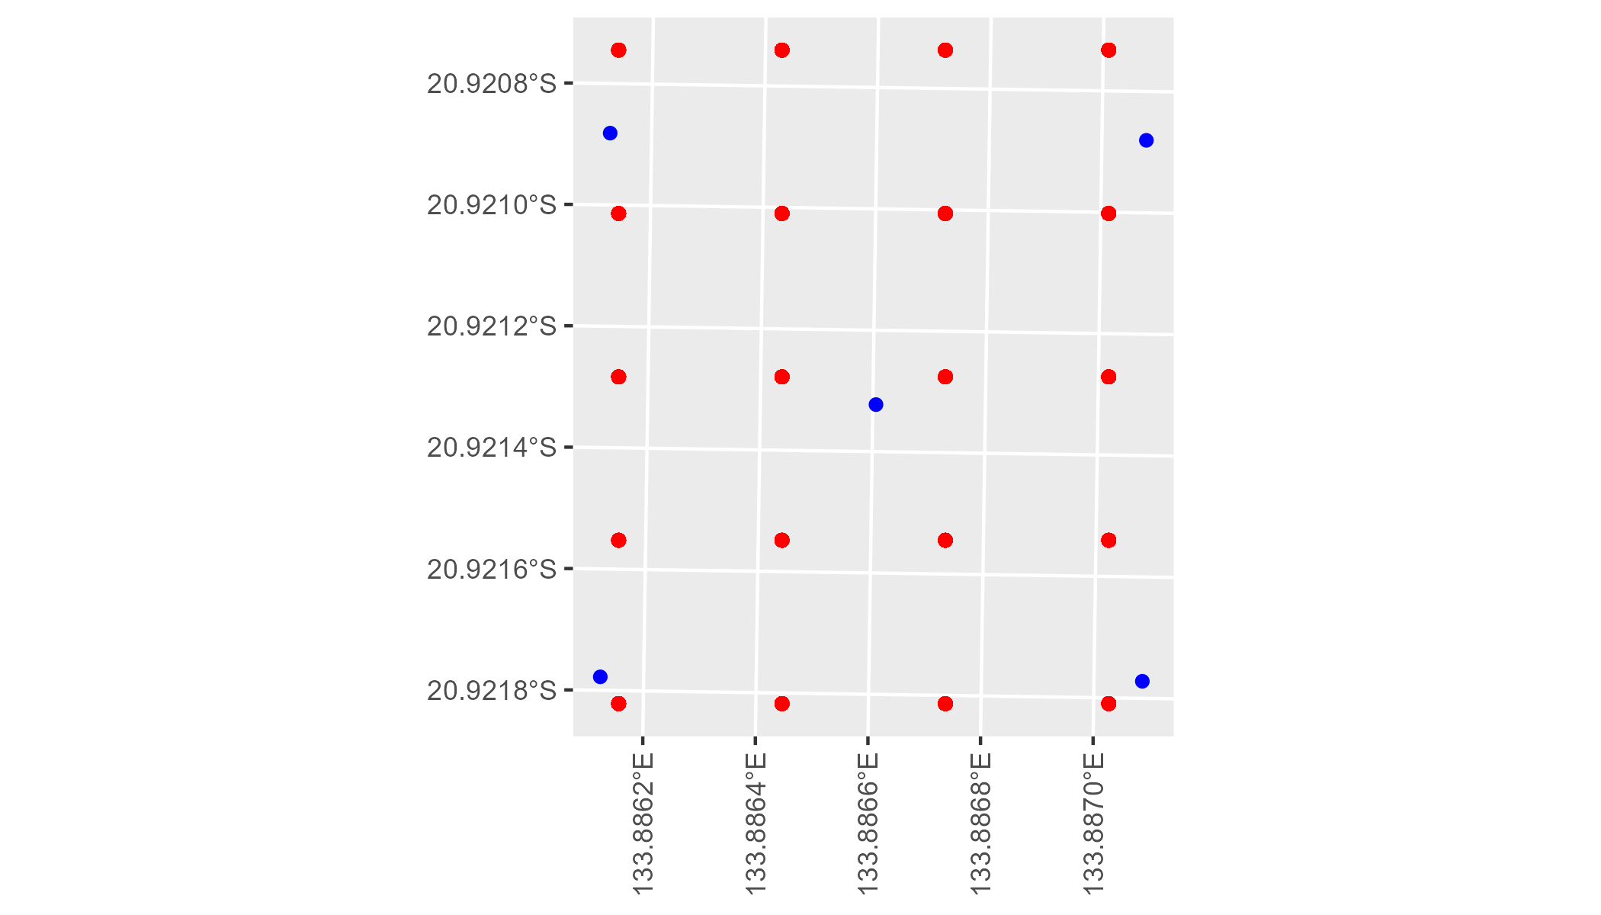

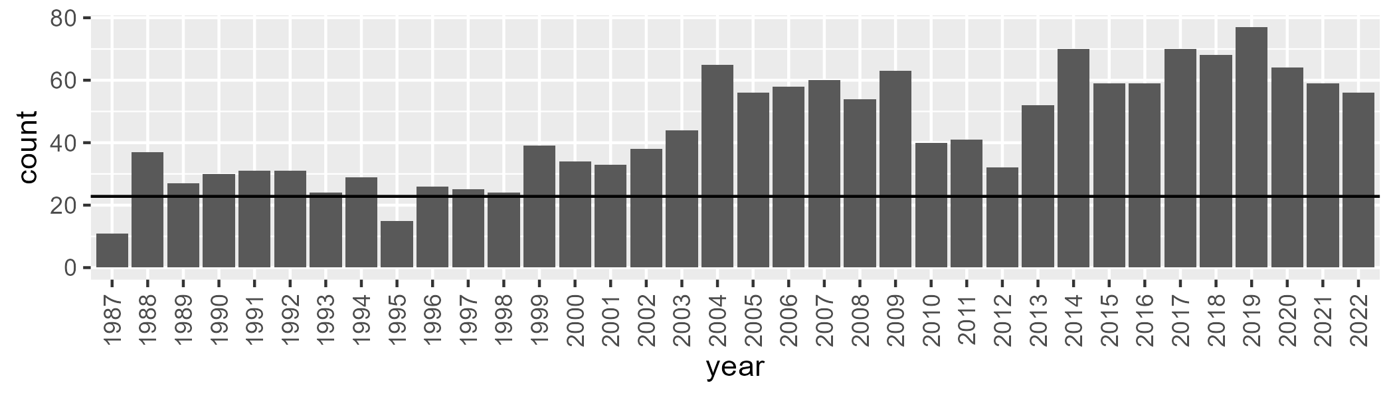

Number of samples: 1601

# NTTDAB0001

| Min. | 1st Qu. | Median | Mean | 3rd Qu. | Max. |
| --- | --- | --- | --- | --- | --- |
| 18.25269 | 35.95656 | 42.98841 | 43.1327 | 50.32814 | 63.47893 |

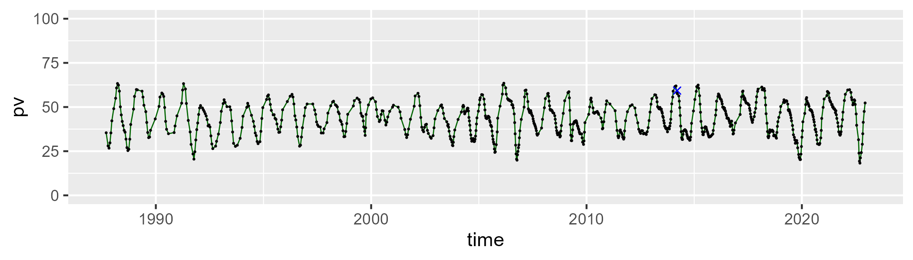

| Min. | 1st Qu. | Median | Mean | 3rd Qu. | Max. |
| --- | --- | --- | --- | --- | --- |
| 23.63482 | 39.83458 | 43.73936 | 44.85627 | 49.61671 | 71.26987 |

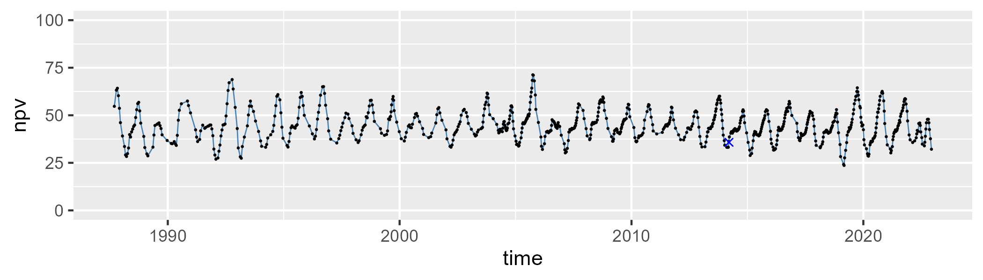

| Min. | 1st Qu. | Median | Mean | 3rd Qu. | Max. |
| --- | --- | --- | --- | --- | --- |
| 0 | 5.685248 | 9.167106 | 10.60743 | 14.24627 | 40.16782 |

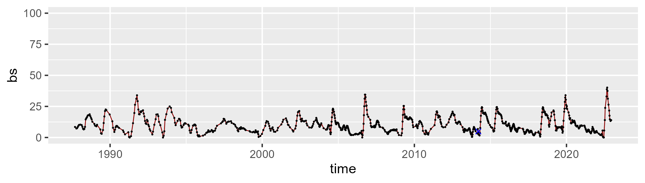

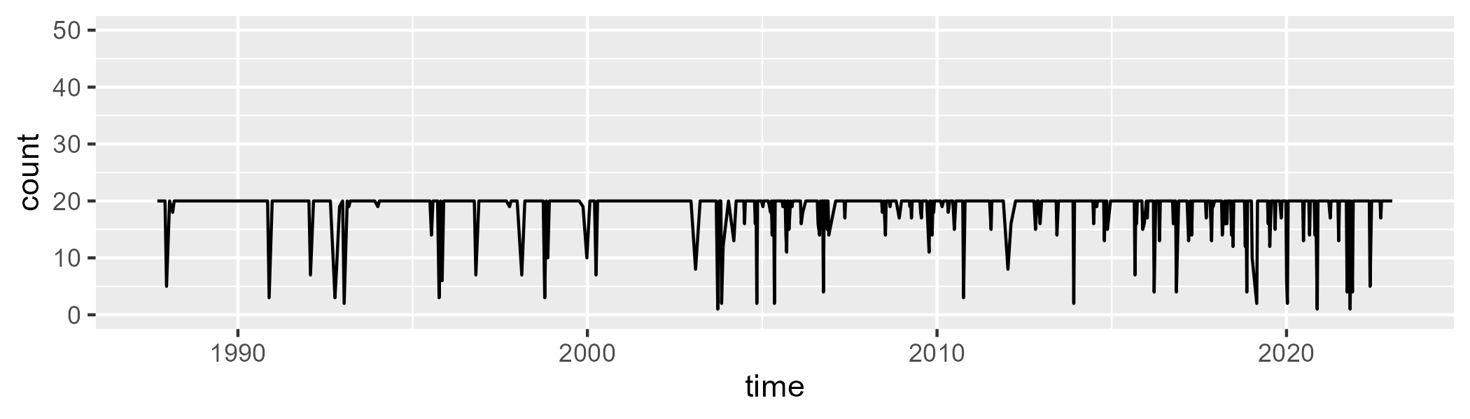

Min. : 1.00 1st Qu.:20.00 Median :20.00 Mean :18.94 3rd Qu.:20.00 Max. :20.00

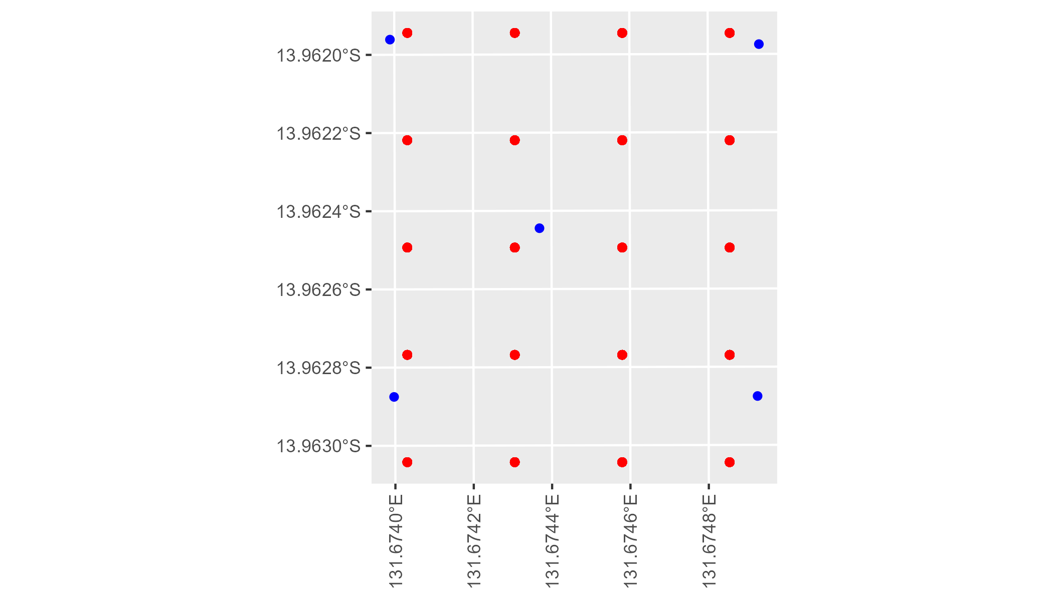

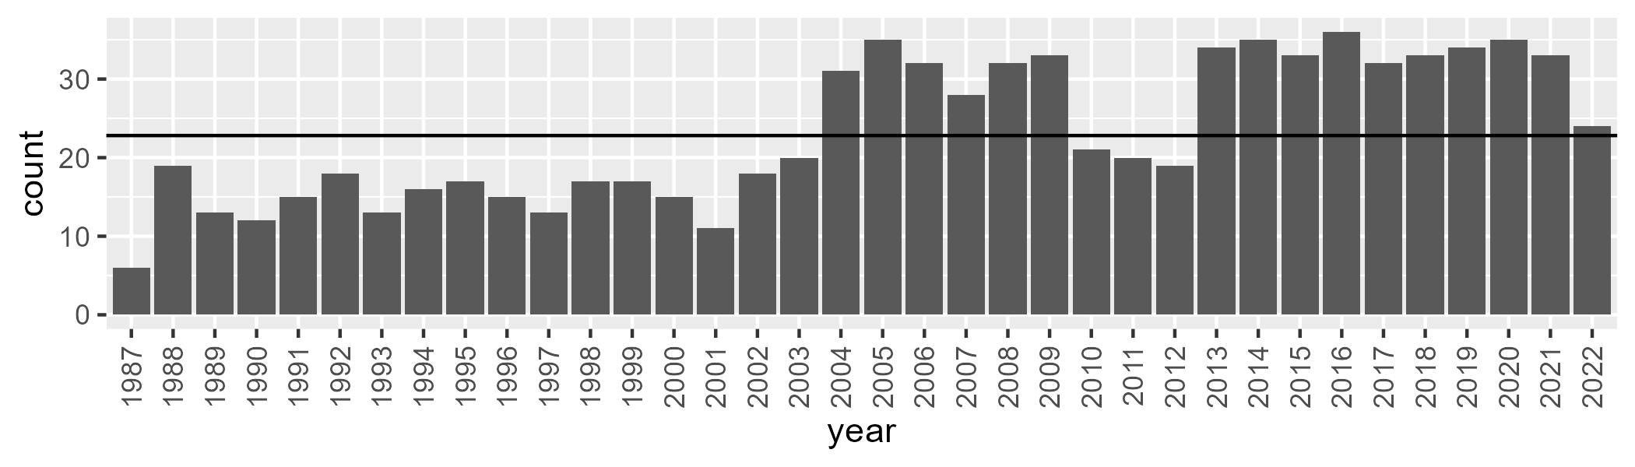

Number of samples: 835

# NTTDAC0001

| Min. | 1st Qu. | Median | Mean | 3rd Qu. | Max. |
| --- | --- | --- | --- | --- | --- |
| 15.6599 | 39.47187 | 45.67192 | 46.39209 | 53.23598 | 71.43116 |

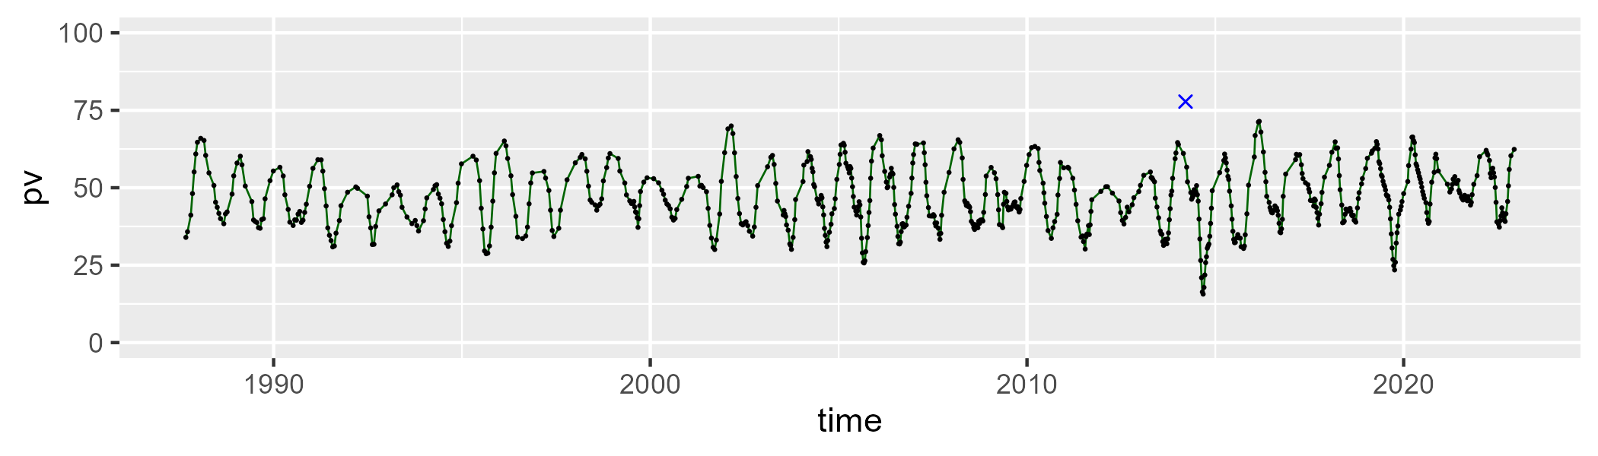

| Min. | 1st Qu. | Median | Mean | 3rd Qu. | Max. |
| --- | --- | --- | --- | --- | --- |
| 22.41156 | 38.34851 | 45.7465 | 43.72742 | 49.05507 | 66.08337 |

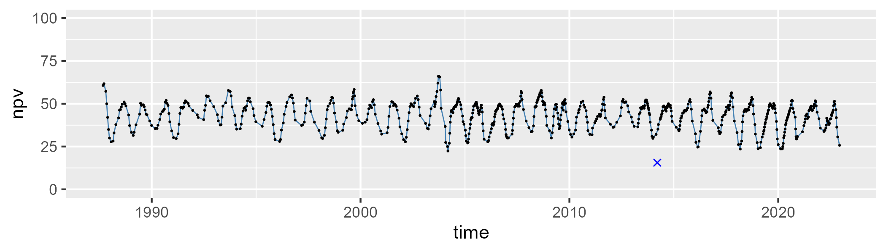

| Min. | 1st Qu. | Median | Mean | 3rd Qu. | Max. |
| --- | --- | --- | --- | --- | --- |
| 0 | 4.526922 | 7.307586 | 8.628781 | 11.58109 | 35.1129 |

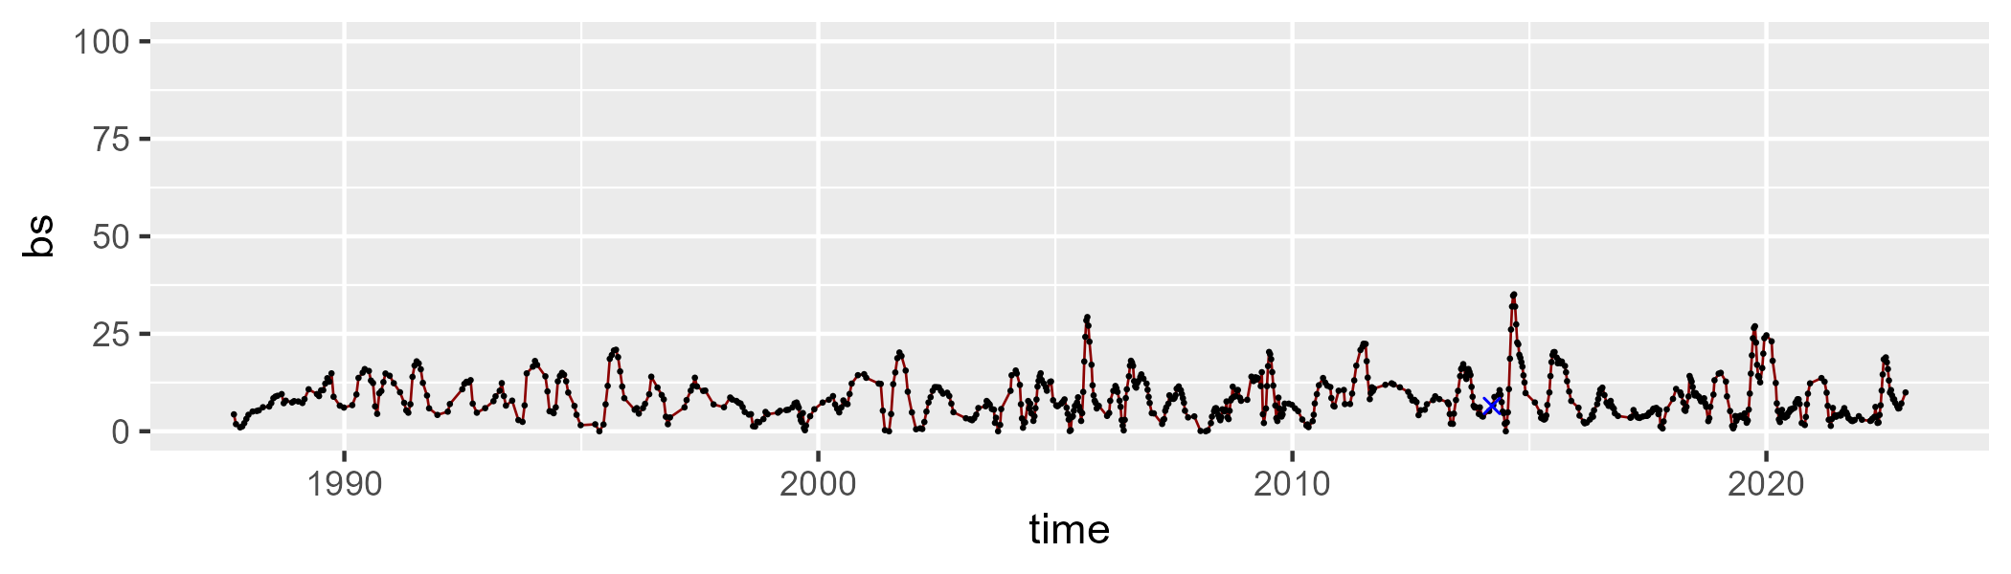

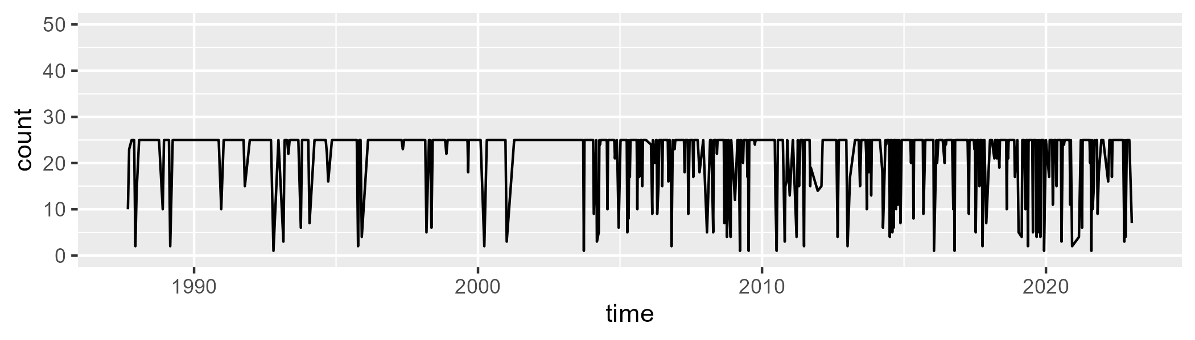

Min. : 1.00 1st Qu.:25.00 Median :25.00 Mean :22.24 3rd Qu.:25.00 Max. :25.00

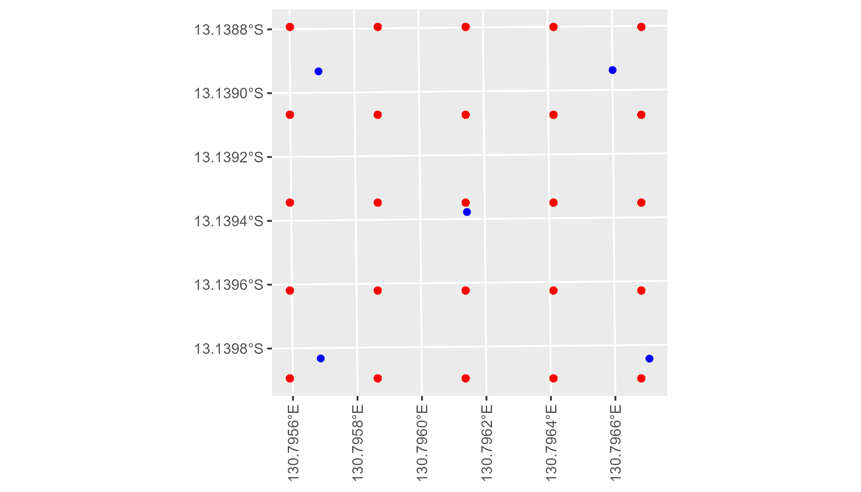

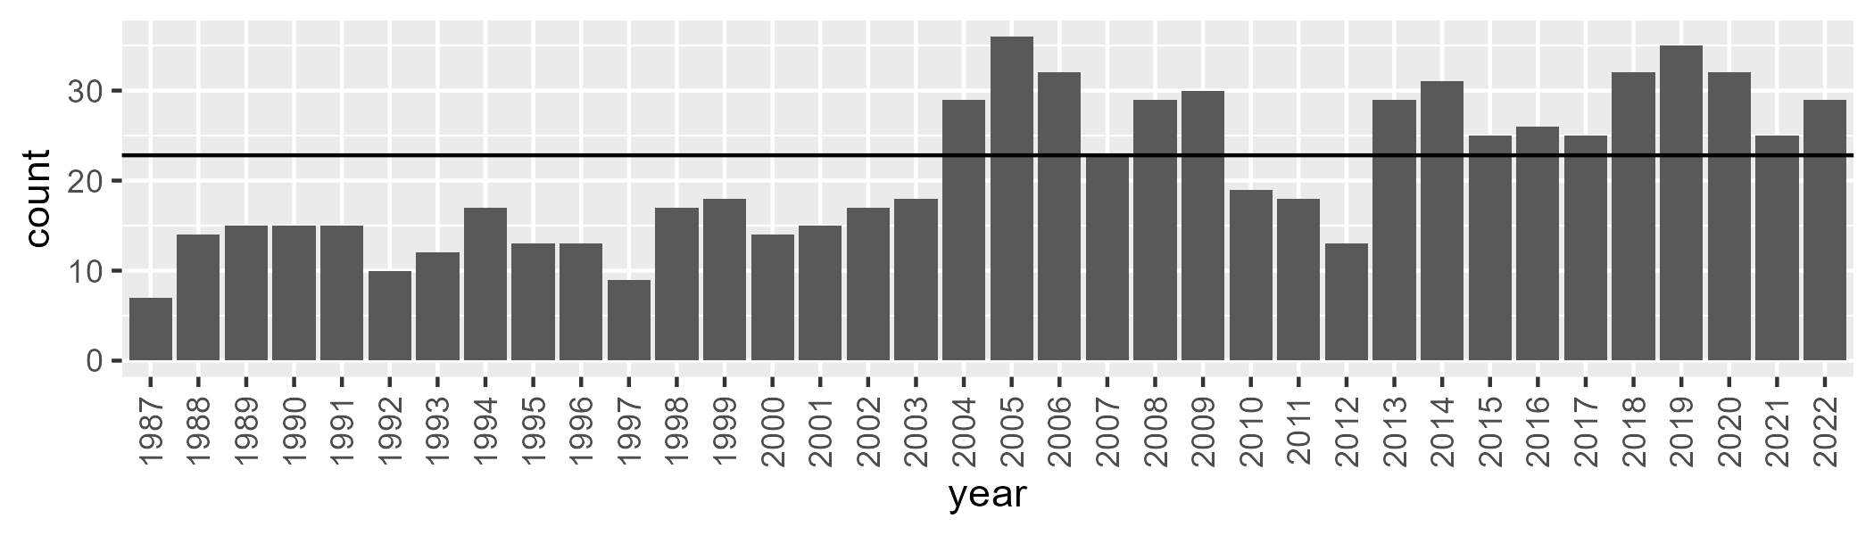

Number of samples: 757

# NTTDMR0001

| Min. | 1st Qu. | Median | Mean | 3rd Qu. | Max. |
| --- | --- | --- | --- | --- | --- |
| 6.430953 | 17.73939 | 23.25043 | 23.76361 | 29.7023 | 47.94433 |

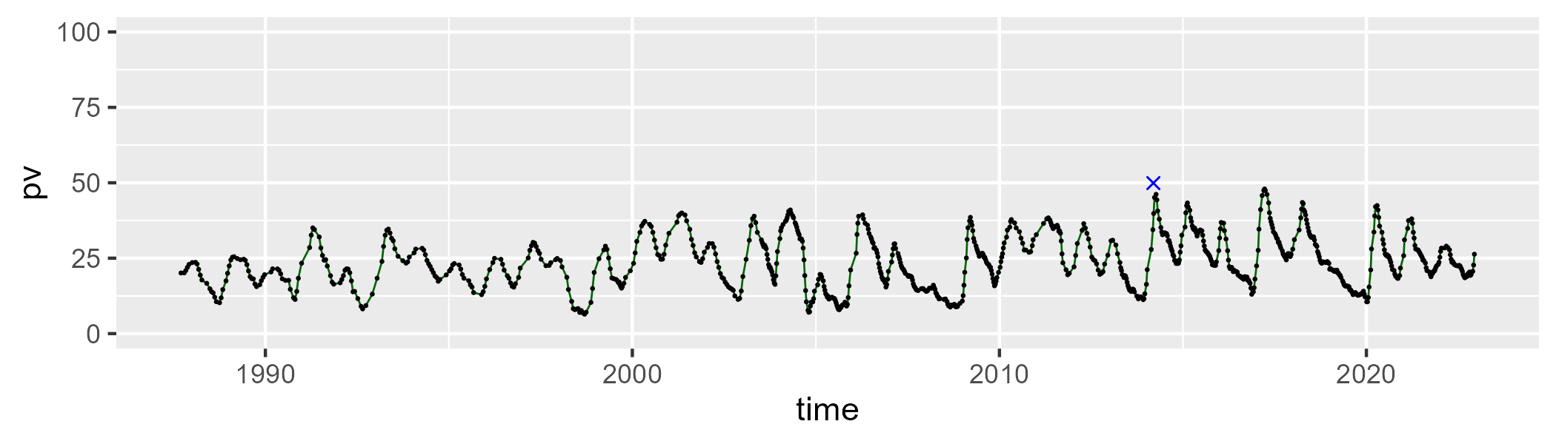

| Min. | 1st Qu. | Median | Mean | 3rd Qu. | Max. |
| --- | --- | --- | --- | --- | --- |
| 32.2329 | 45.9434 | 49.73051 | 50.70923 | 55.75517 | 70.27771 |

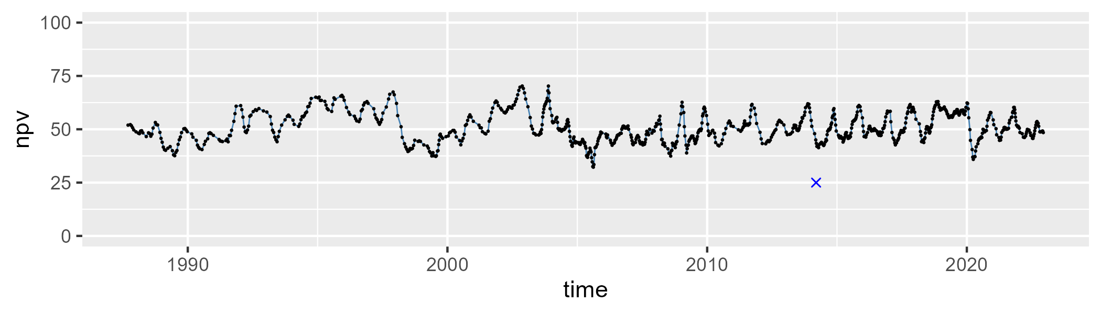

| Min. | 1st Qu. | Median | Mean | 3rd Qu. | Max. |
| --- | --- | --- | --- | --- | --- |
| 4.850066 | 17.11302 | 22.65892 | 24.18271 | 28.89004 | 58.37484 |

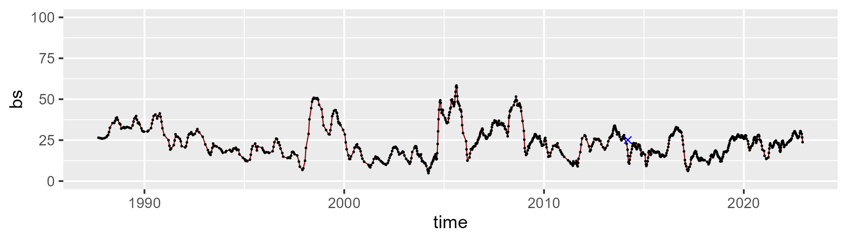

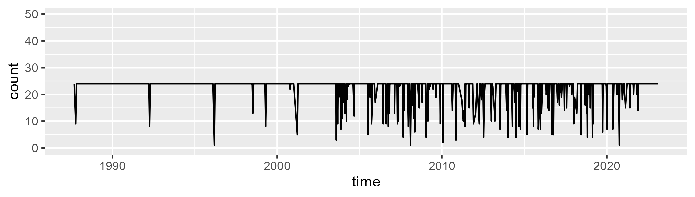

Min. : 1.00 1st Qu.:24.00 Median :24.00 Mean :22.36 3rd Qu.:24.00 Max. :24.00

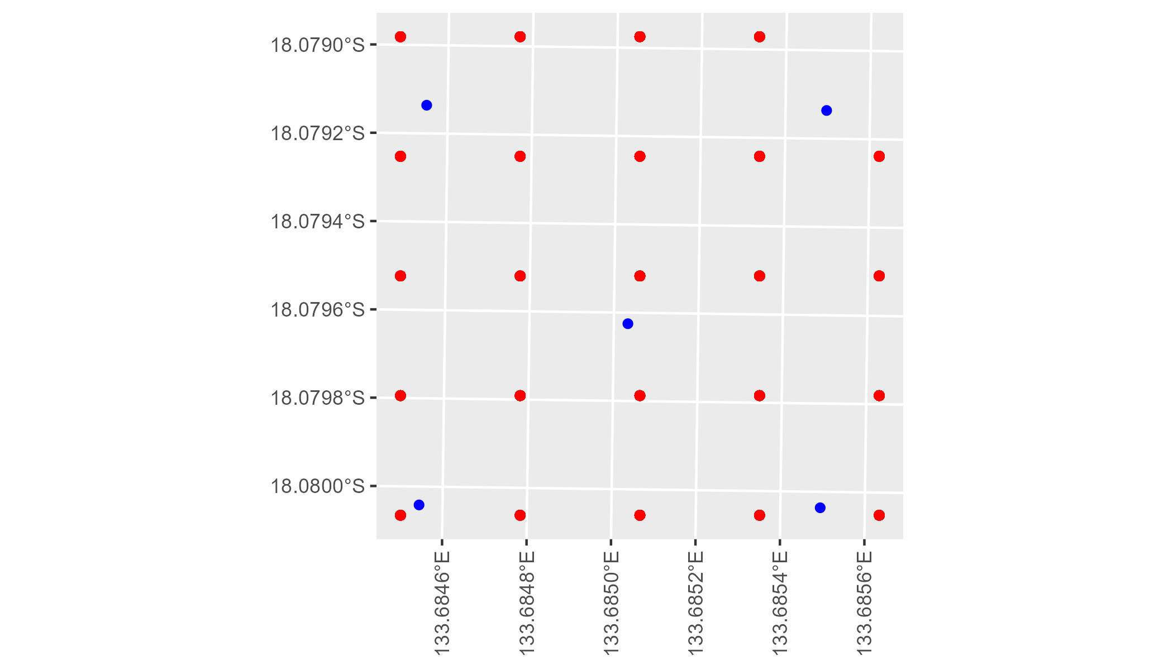

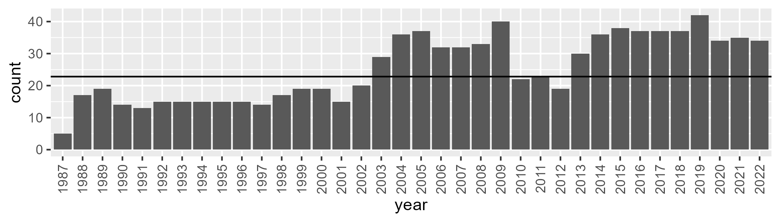

Number of samples: 910

# NTTDMR0002

| Min. | 1st Qu. | Median | Mean | 3rd Qu. | Max. |
| --- | --- | --- | --- | --- | --- |
| 0 | 10.04603 | 14.73775 | 17.27157 | 22.61555 | 46.64513 |

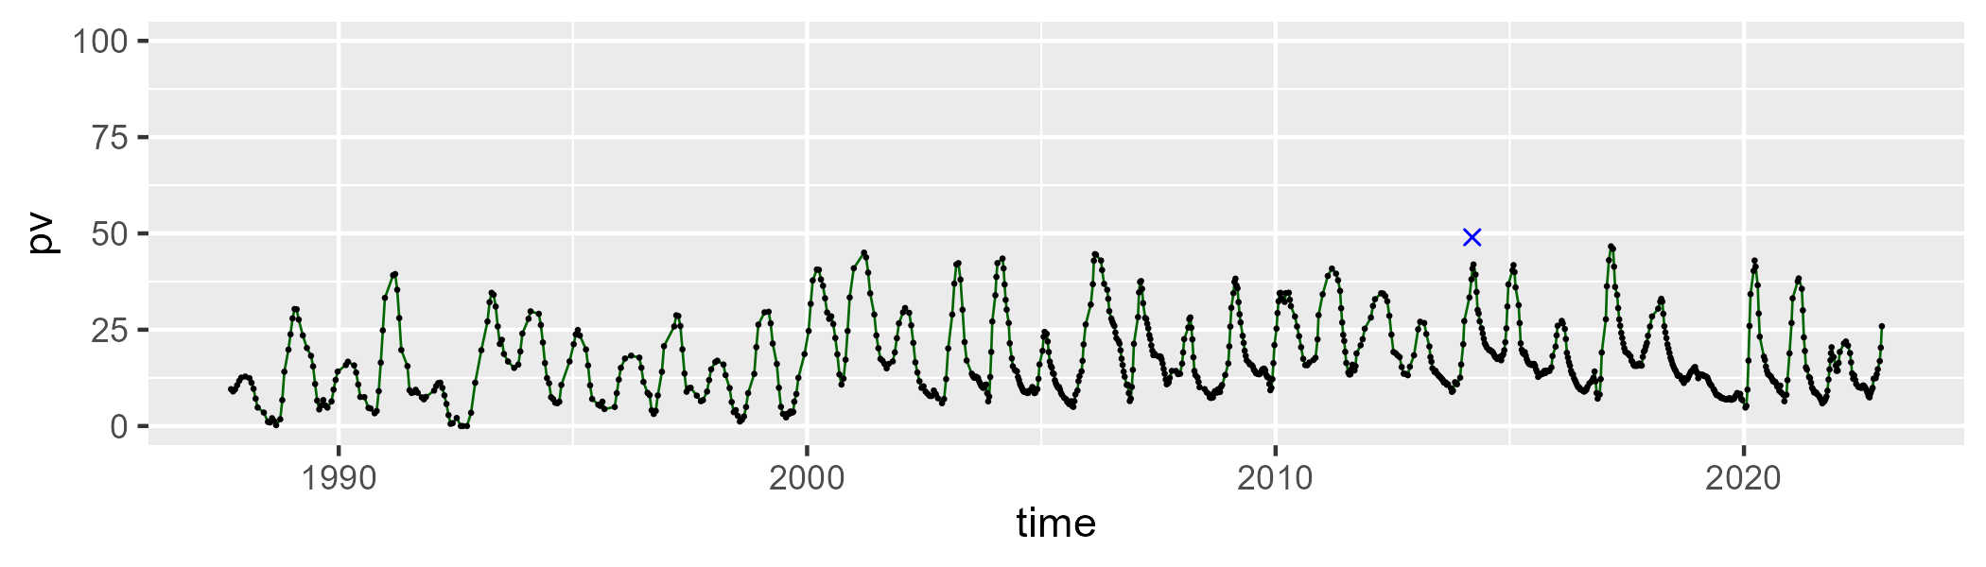

| Min. | 1st Qu. | Median | Mean | 3rd Qu. | Max. |
| --- | --- | --- | --- | --- | --- |
| 15.03276 | 38.59568 | 44.34421 | 44.95601 | 51.19598 | 68.01661 |

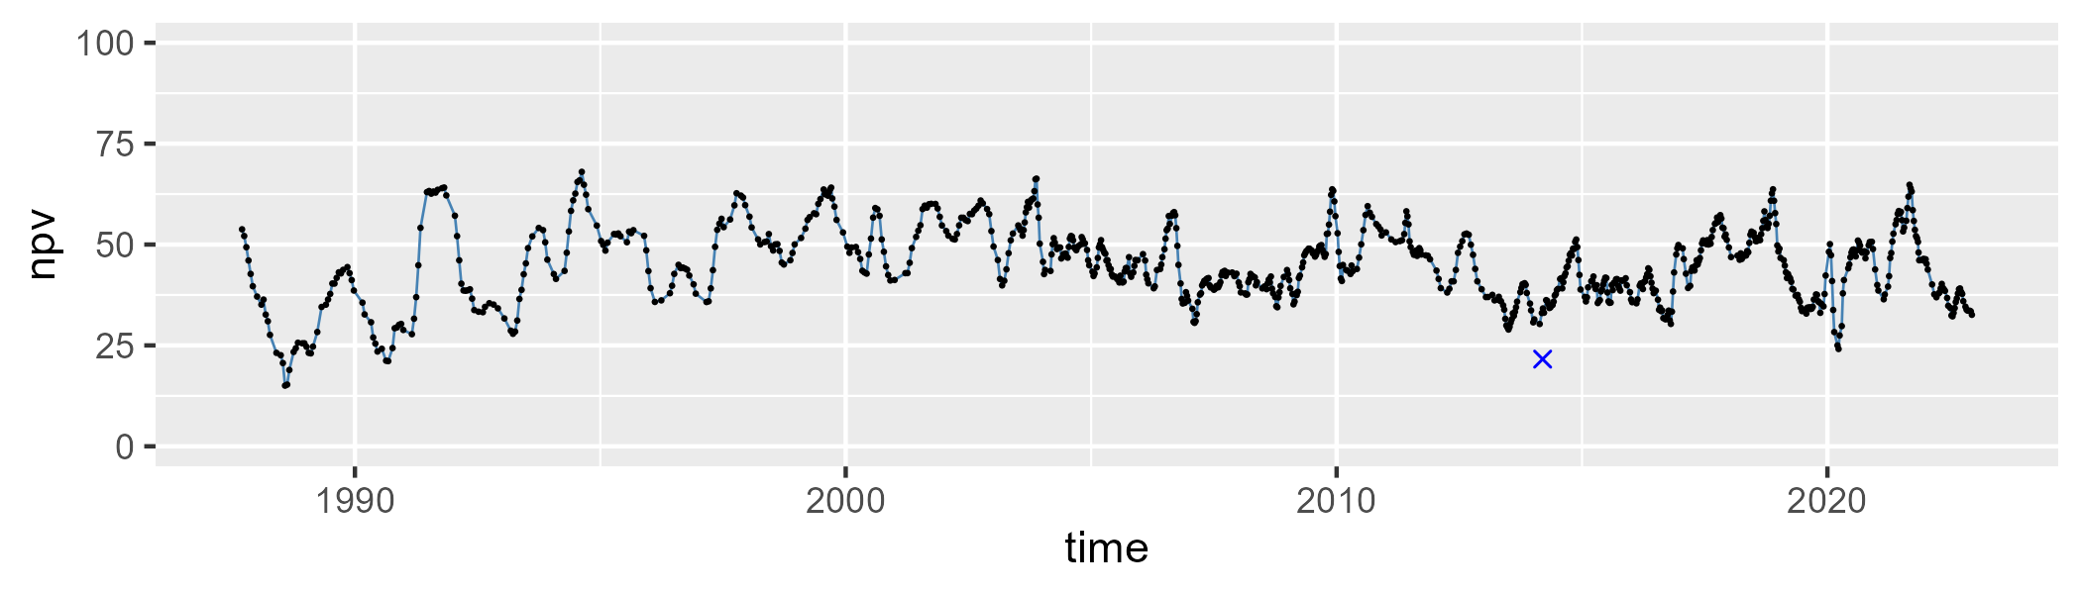

| Min. | 1st Qu. | Median | Mean | 3rd Qu. | Max. |
| --- | --- | --- | --- | --- | --- |
| 7.292753 | 27.55699 | 35.28888 | 36.34552 | 44.45426 | 81.95999 |

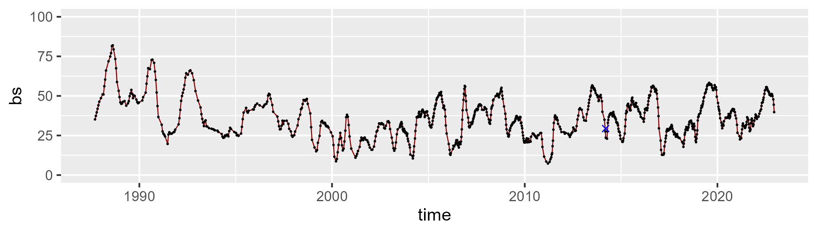

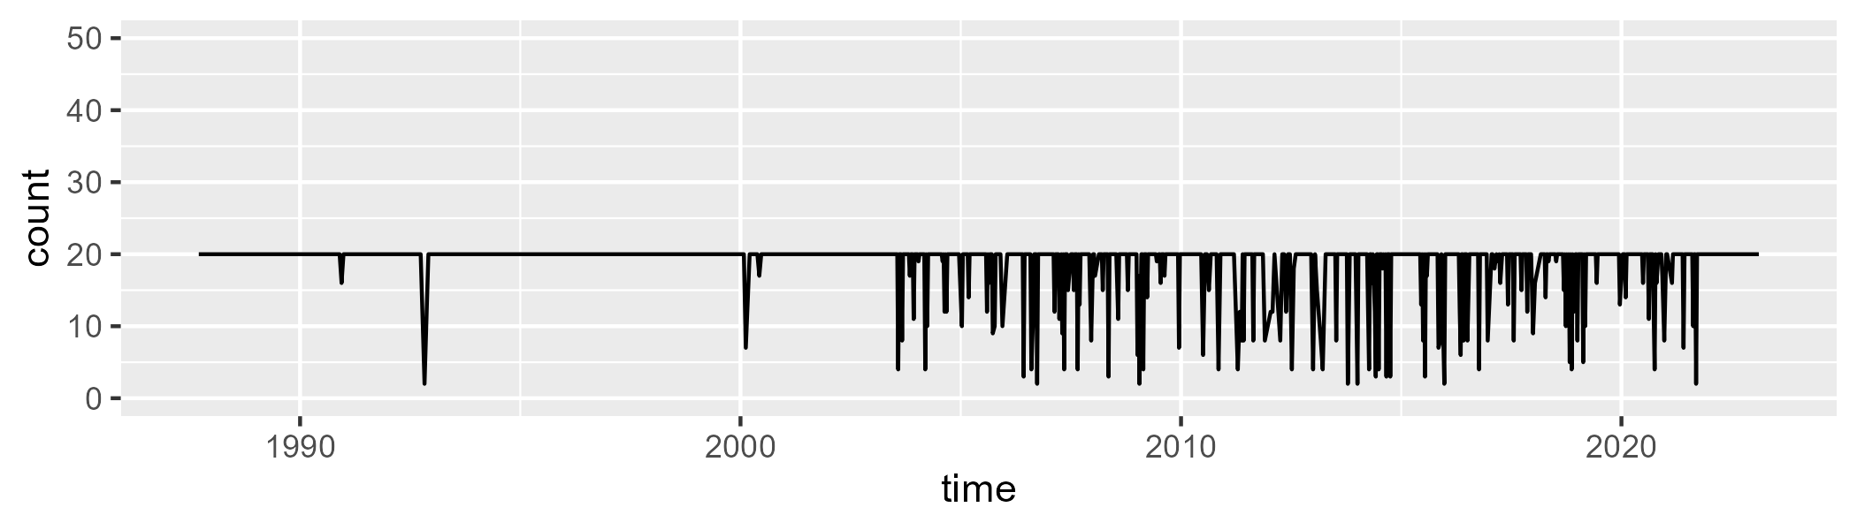

Min. : 2.00 1st Qu.:20.00 Median :20.00 Mean :18.66 3rd Qu.:20.00 Max. :20.00

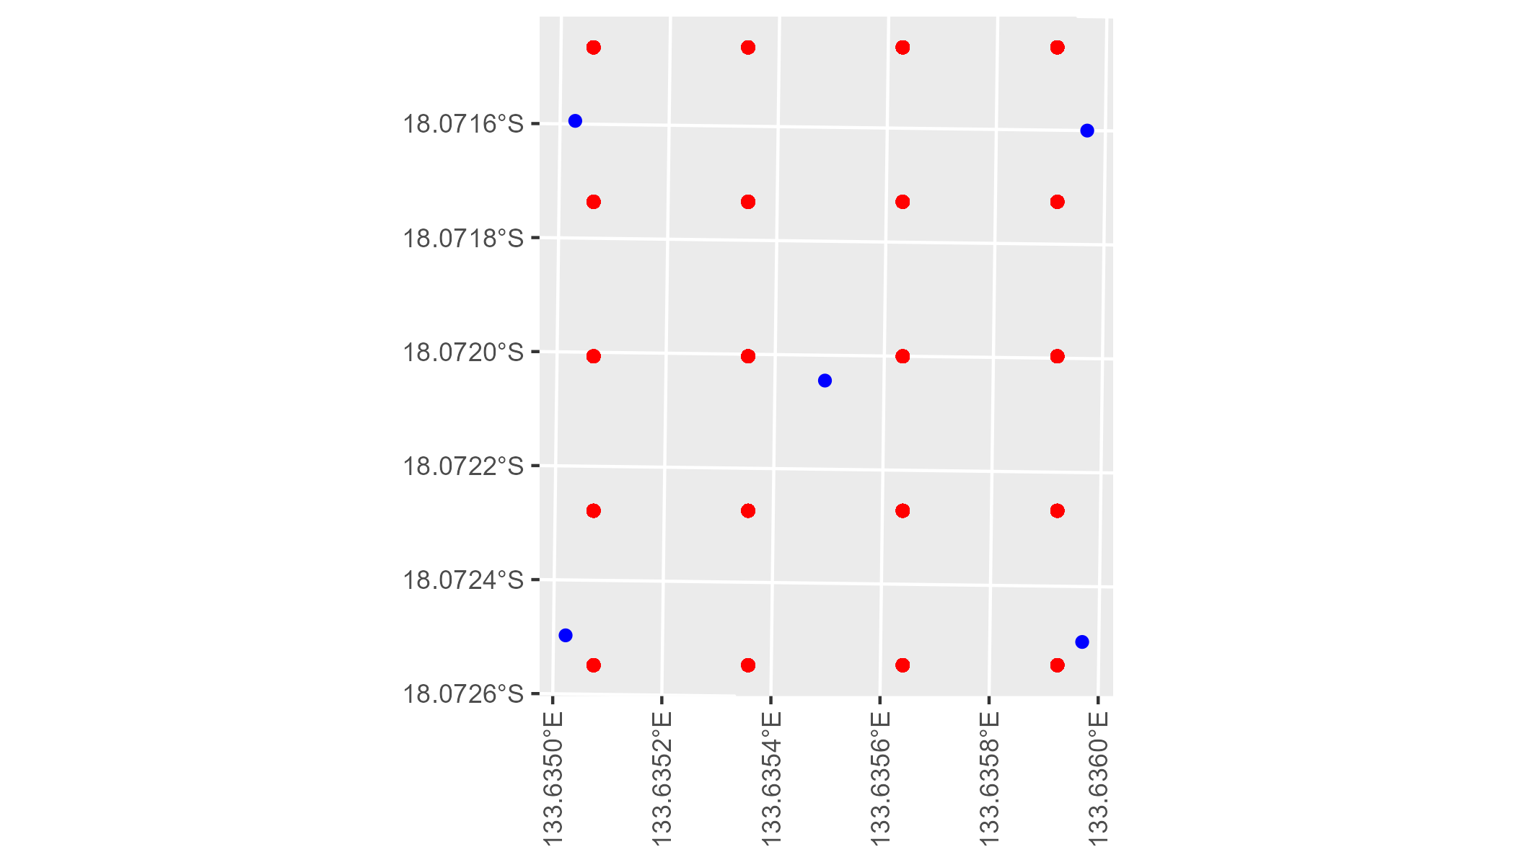

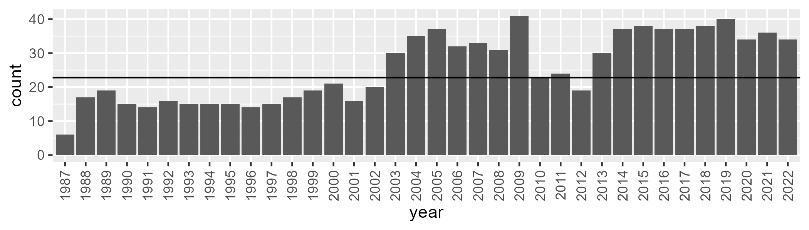

Number of samples: 920

# NTTDMR0003

| Min. | 1st Qu. | Median | Mean | 3rd Qu. | Max. |
| --- | --- | --- | --- | --- | --- |
| 0.4981615 | 12.48732 | 16.76445 | 19.75501 | 25.03132 | 56.72456 |

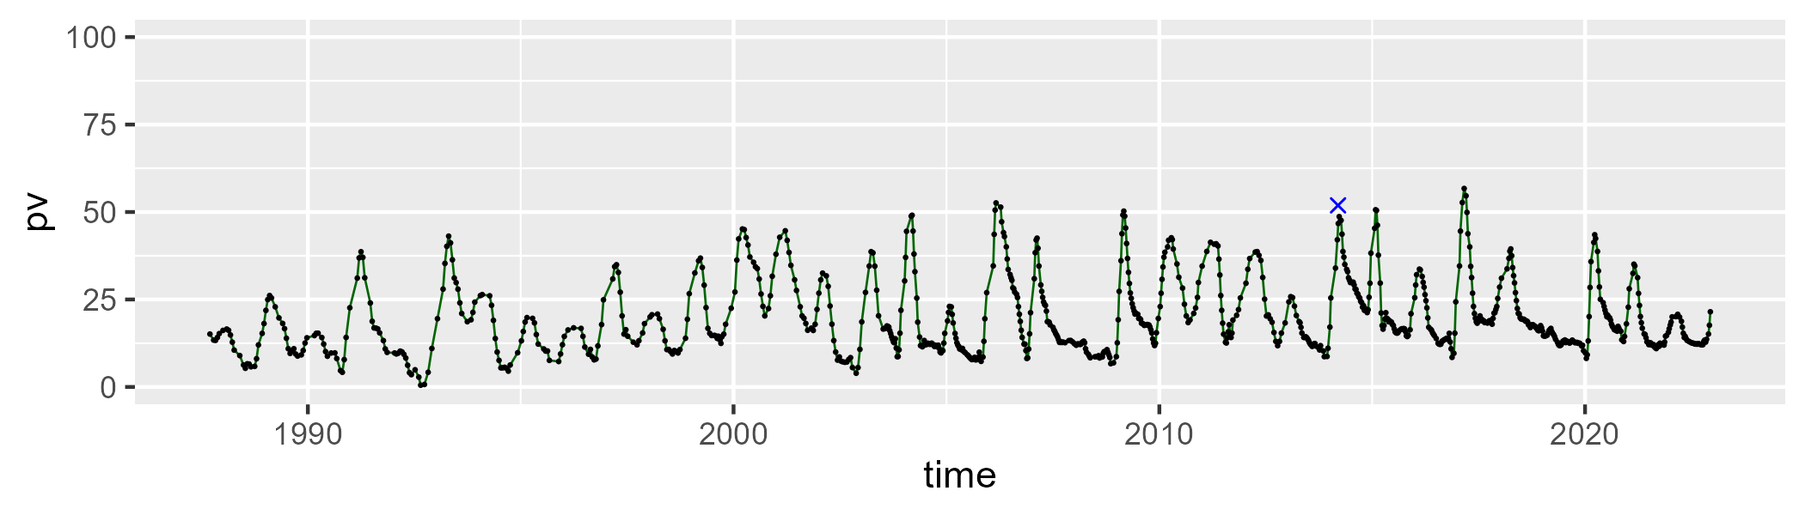

| Min. | 1st Qu. | Median | Mean | 3rd Qu. | Max. |
| --- | --- | --- | --- | --- | --- |
| 22.55047 | 36.53653 | 43.06001 | 43.96727 | 50.56019 | 82.10733 |

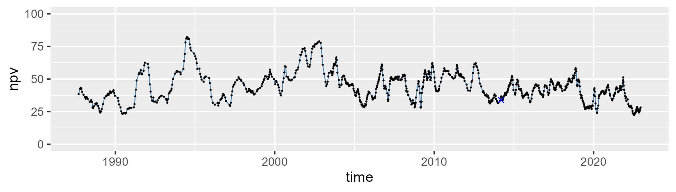

| Min. | 1st Qu. | Median | Mean | 3rd Qu. | Max. |
| --- | --- | --- | --- | --- | --- |
| 3.026276 | 23.77569 | 34.18253 | 34.84847 | 45.9305 | 66.97703 |

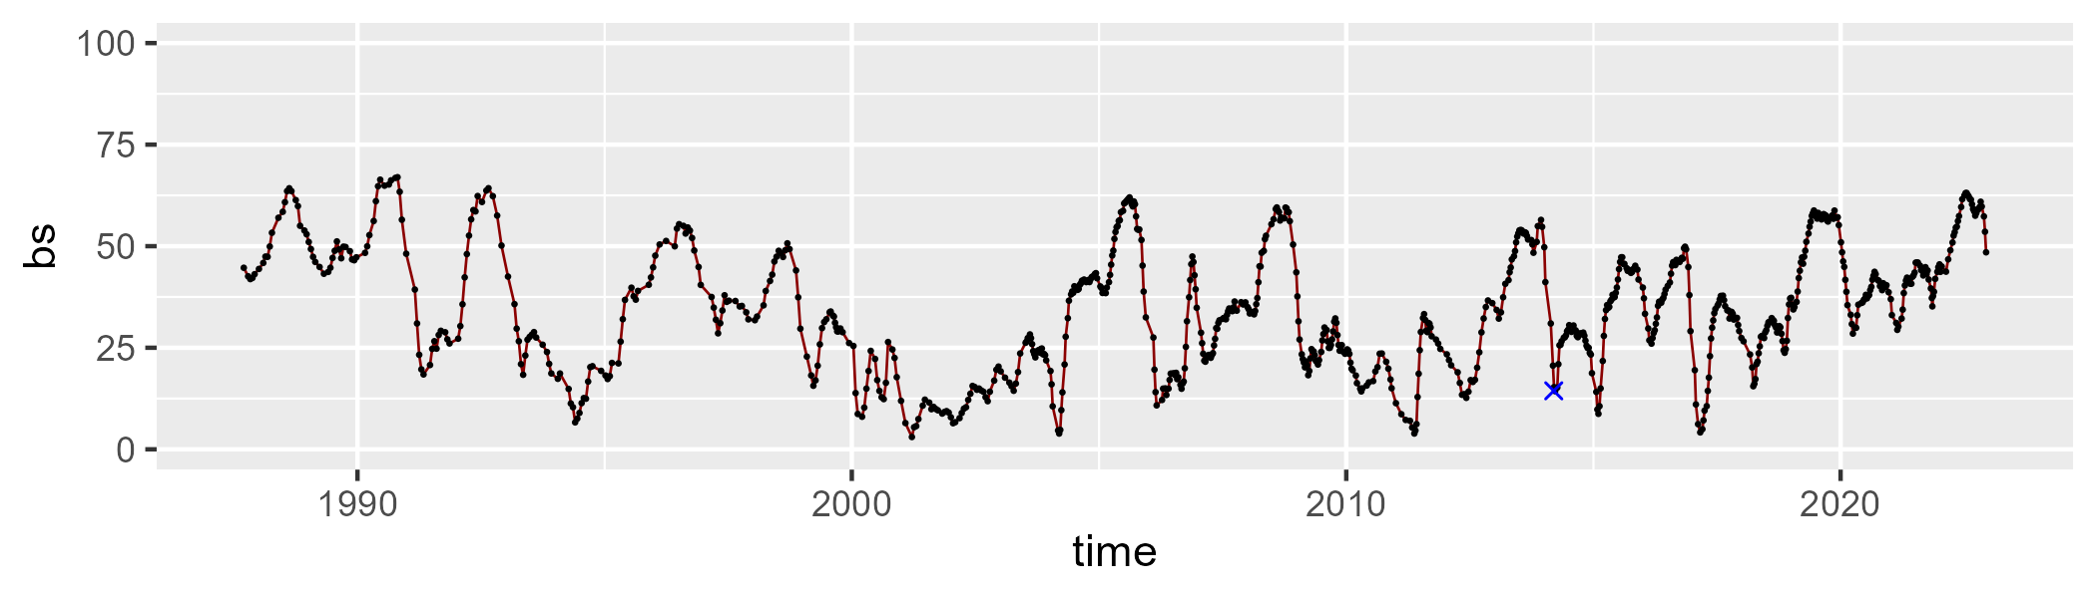

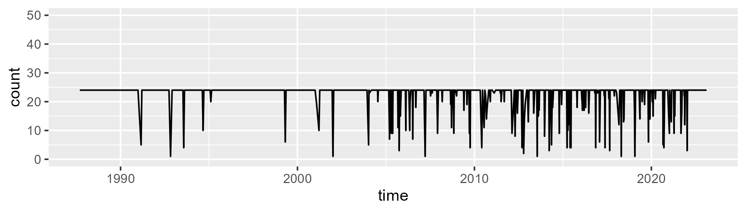

Min. : 1.00 1st Qu.:24.00 Median :24.00 Mean :22.58 3rd Qu.:24.00 Max. :24.00

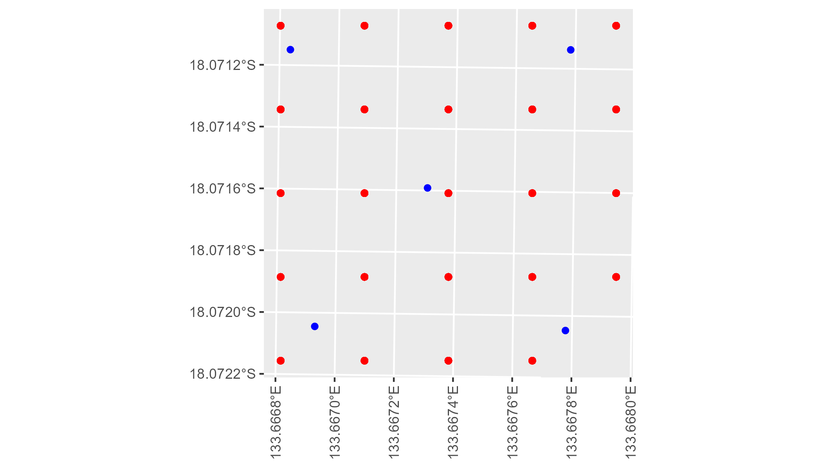

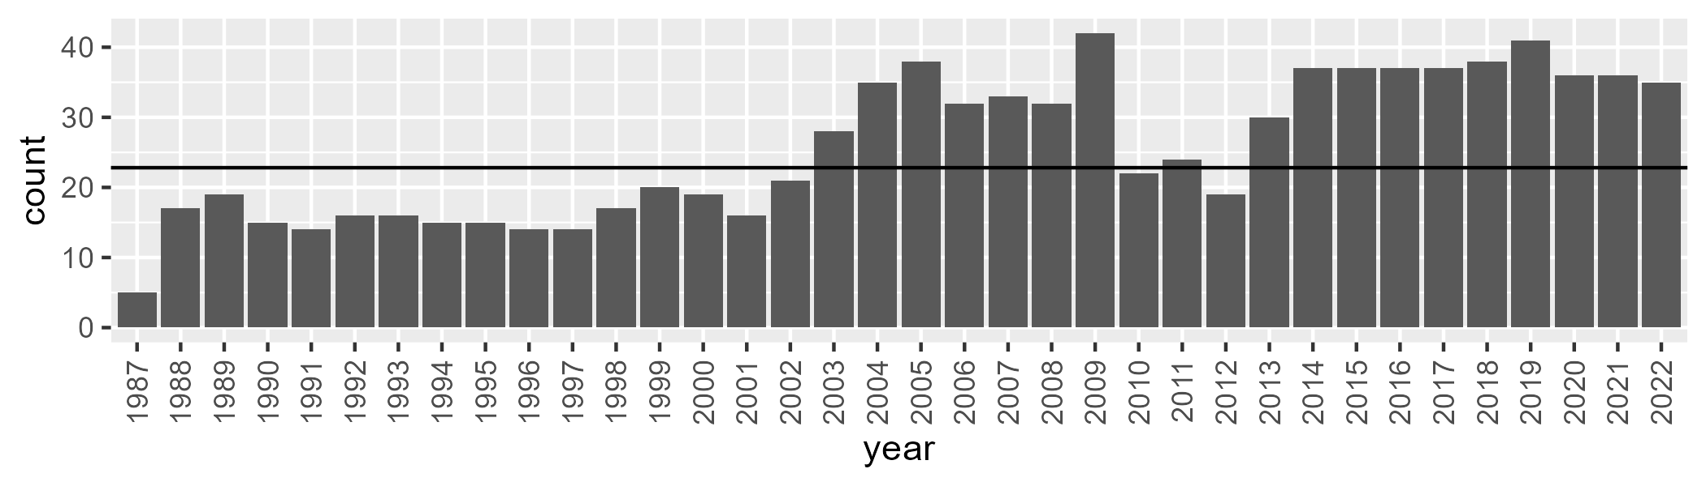

Number of samples: 922

# NTTMGD0001

| Min. | 1st Qu. | Median | Mean | 3rd Qu. | Max. |
| --- | --- | --- | --- | --- | --- |
| 0 | 9.070401 | 14.737 | 16.67397 | 23.13143 | 51.98428 |

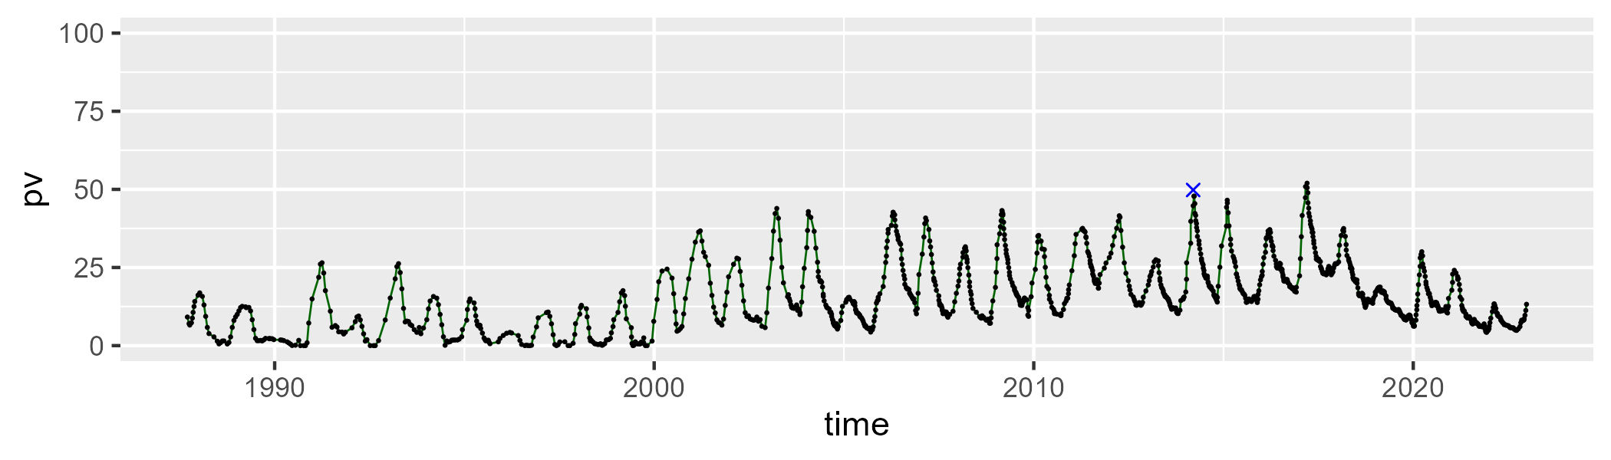

| Min. | 1st Qu. | Median | Mean | 3rd Qu. | Max. |
| --- | --- | --- | --- | --- | --- |
| 32.11104 | 48.61789 | 54.08705 | 55.00522 | 61.55789 | 79.46874 |

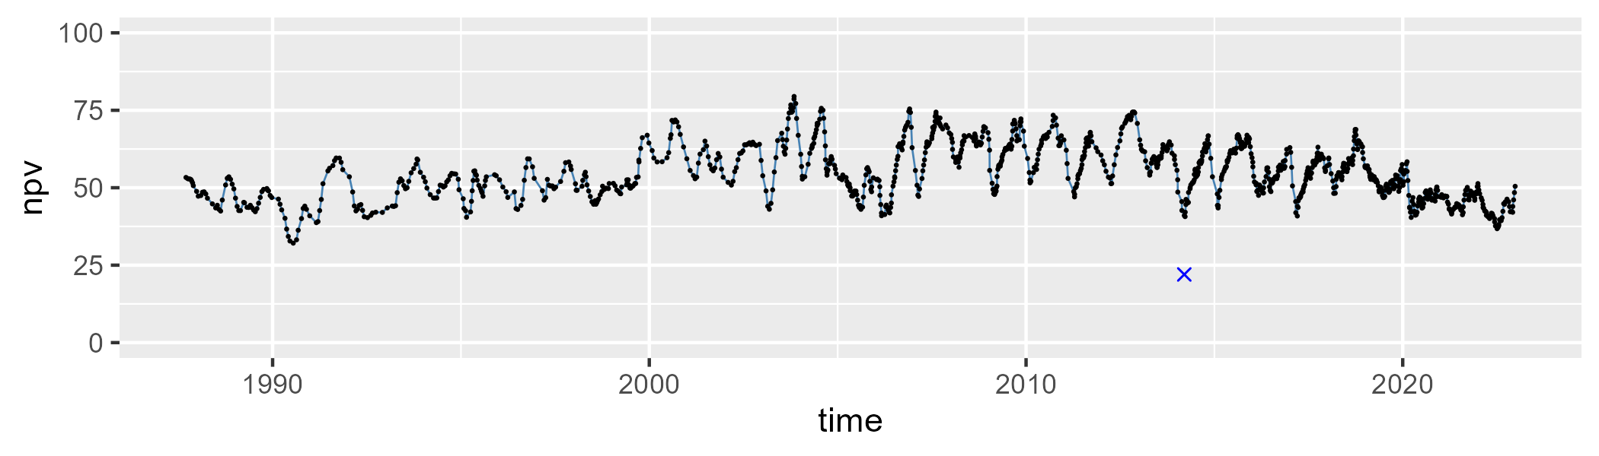

| Min. | 1st Qu. | Median | Mean | 3rd Qu. | Max. |
| --- | --- | --- | --- | --- | --- |
| 3.150578 | 15.66923 | 23.26225 | 27.01603 | 38.72916 | 66.6128 |

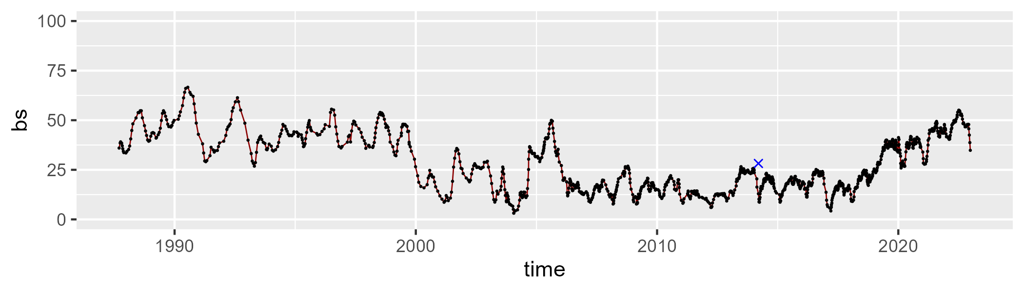

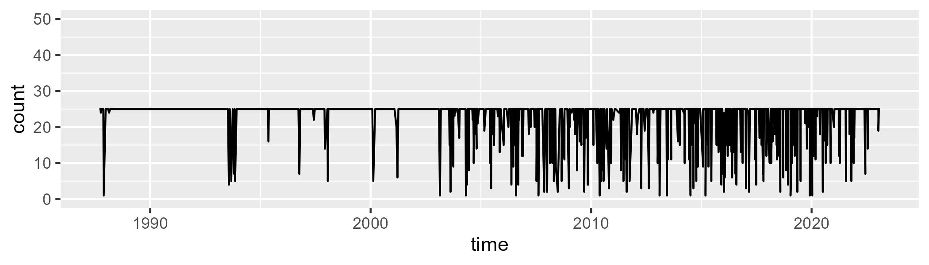

Min. : 1.00 1st Qu.:25.00 Median :25.00 Mean :22.61 3rd Qu.:25.00 Max. :25.00

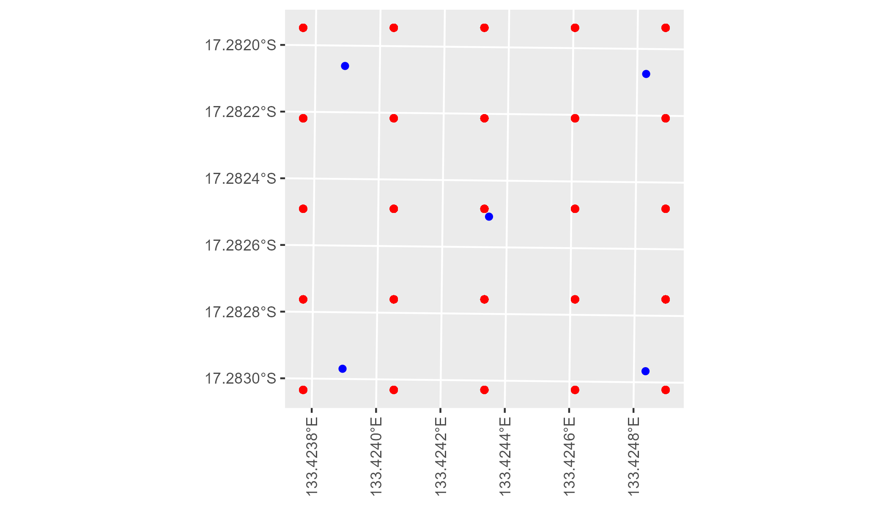

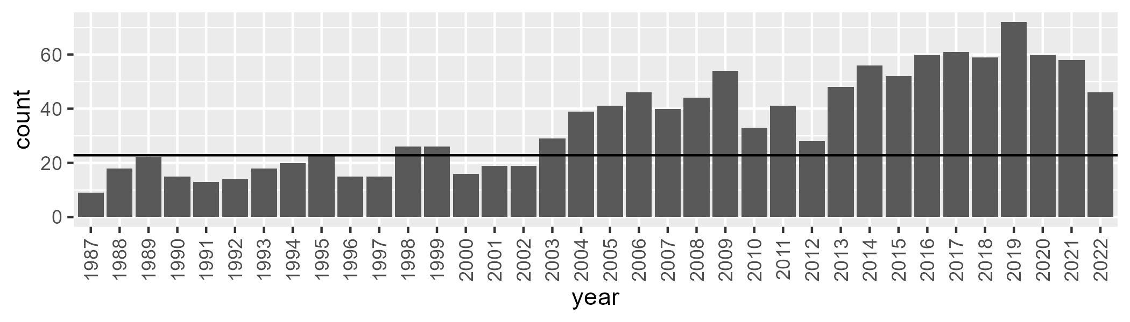

Number of samples: 1255

# NTTPCK0001

| Min. | 1st Qu. | Median | Mean | 3rd Qu. | Max. |
| --- | --- | --- | --- | --- | --- |
| 23.4577 | 39.92374 | 47.97945 | 50.63334 | 61.90035 | 81.21873 |

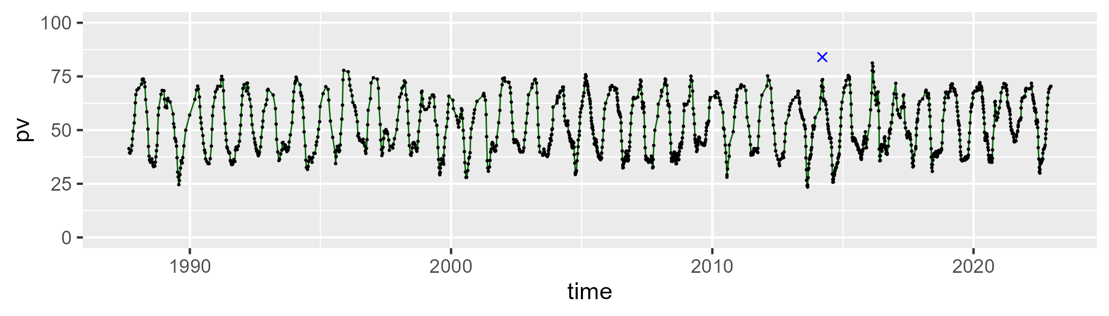

| Min. | 1st Qu. | Median | Mean | 3rd Qu. | Max. |
| --- | --- | --- | --- | --- | --- |
| 16.41165 | 30.81684 | 42.69572 | 39.44369 | 47.01791 | 59.3527 |

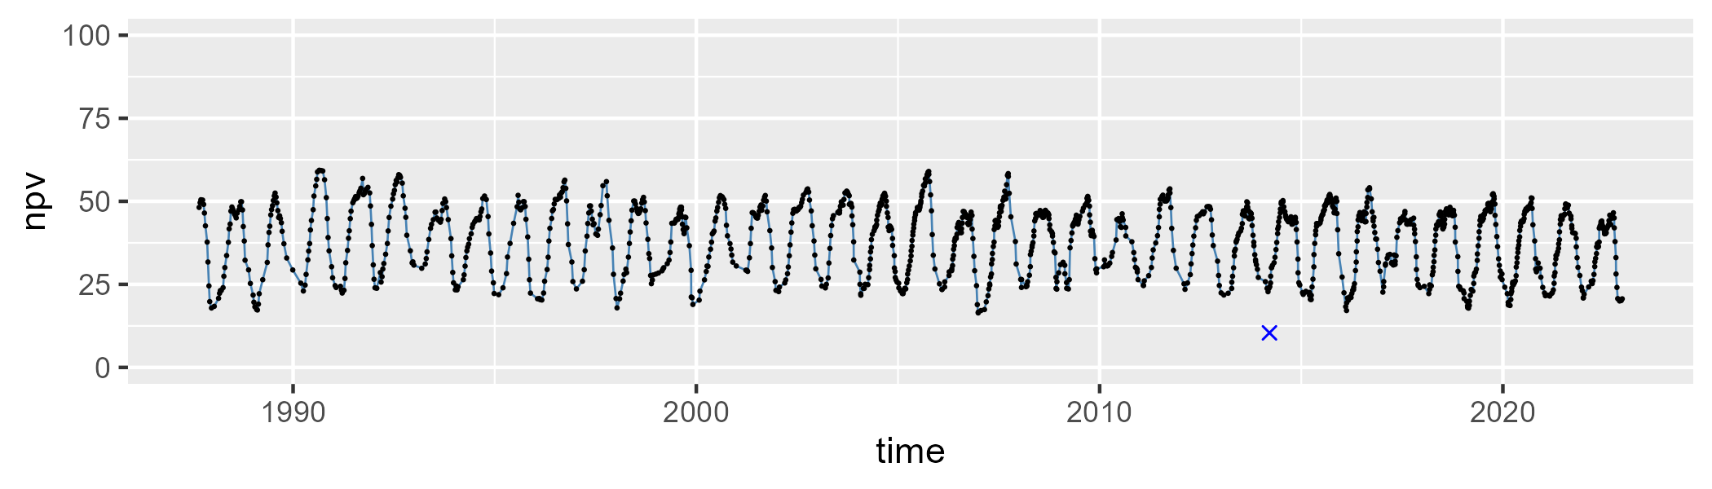

| Min. | 1st Qu. | Median | Mean | 3rd Qu. | Max. |
| --- | --- | --- | --- | --- | --- |
| 0 | 3.608306 | 7.418652 | 8.606941 | 12.63424 | 28.13584 |

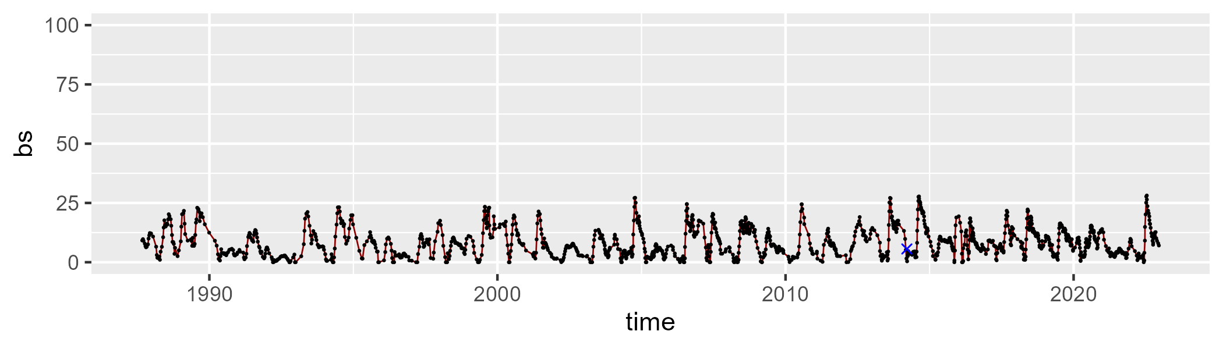

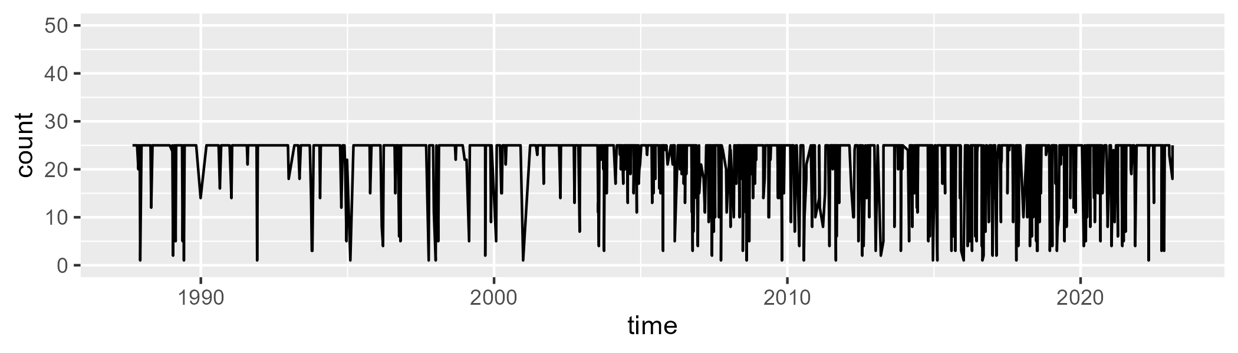

Min. : 1.00 1st Qu.:25.00 Median :25.00 Mean :22.43 3rd Qu.:25.00 Max. :25.00

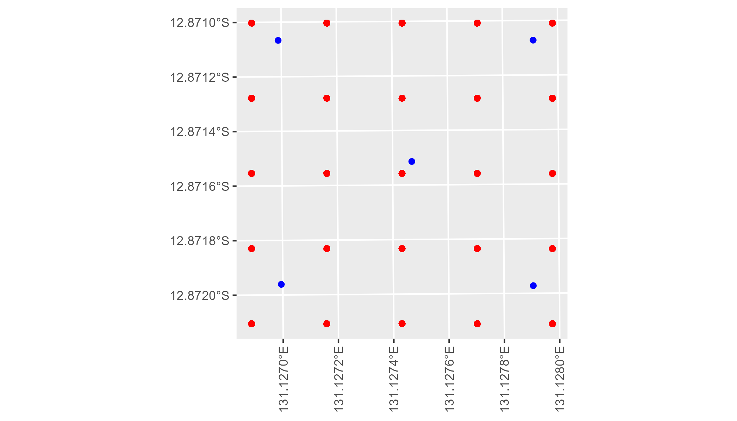

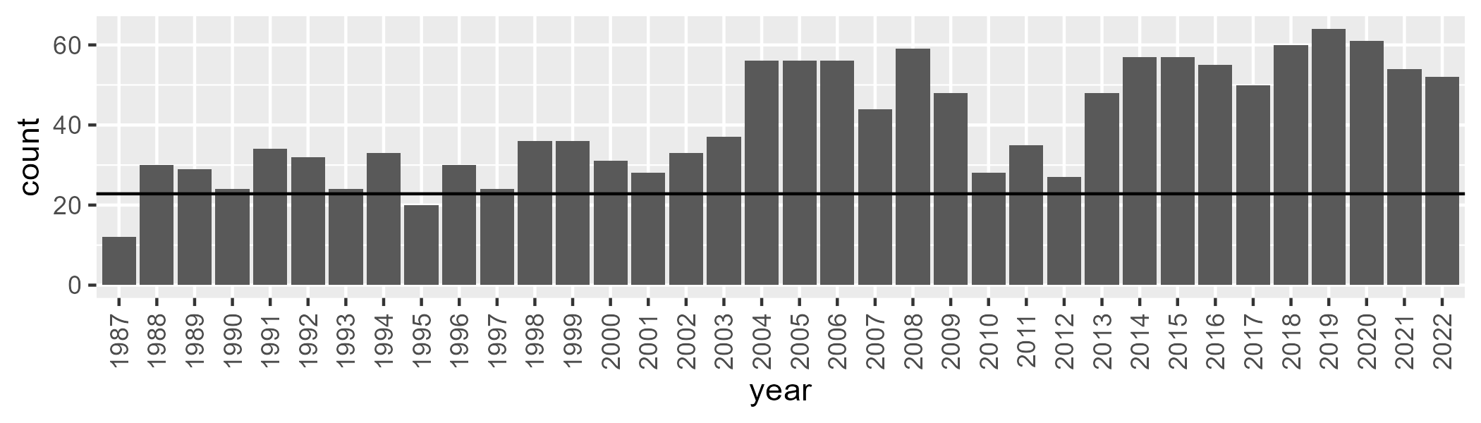

Number of samples: 1460

# NTTSTU0001

| Min. | 1st Qu. | Median | Mean | 3rd Qu. | Max. |
| --- | --- | --- | --- | --- | --- |
| 11.48301 | 23.03528 | 28.37166 | 29.74051 | 35.19147 | 56.48171 |

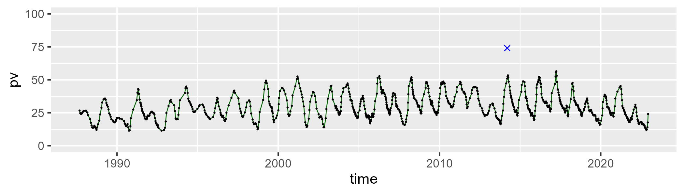

| Min. | 1st Qu. | Median | Mean | 3rd Qu. | Max. |
| --- | --- | --- | --- | --- | --- |
| 32.43667 | 50.75664 | 55.7289 | 55.5878 | 60.51158 | 72.69012 |

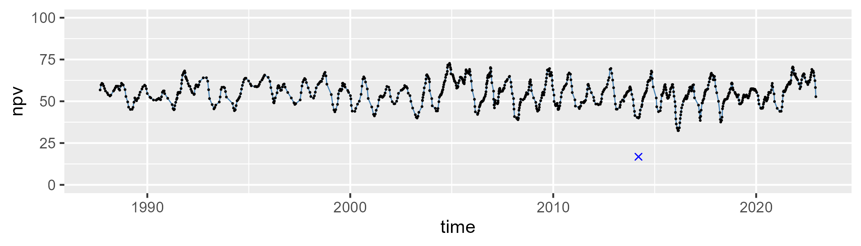

| Min. | 1st Qu. | Median | Mean | 3rd Qu. | Max. |
| --- | --- | --- | --- | --- | --- |
| 1.660148 | 8.716091 | 12.78128 | 13.4363 | 17.50646 | 32.26202 |

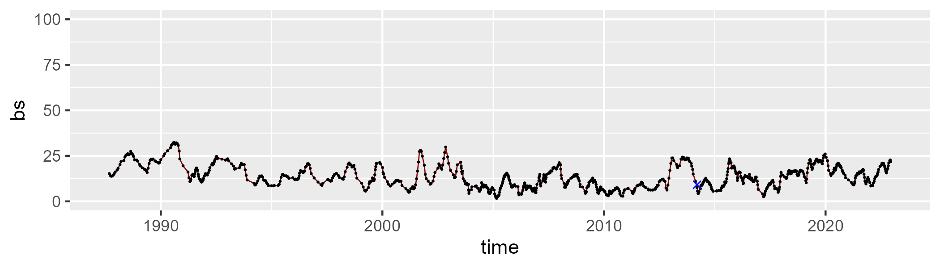

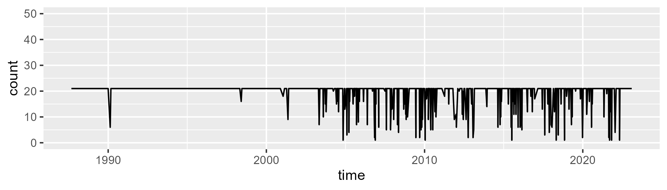

Min. : 1.00 1st Qu.:21.00 Median :21.00 Mean :19.53 3rd Qu.:21.00 Max. :21.00

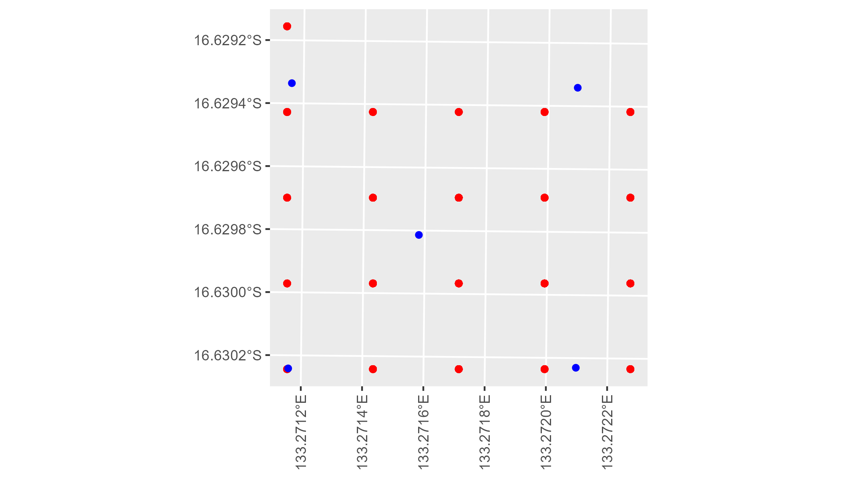

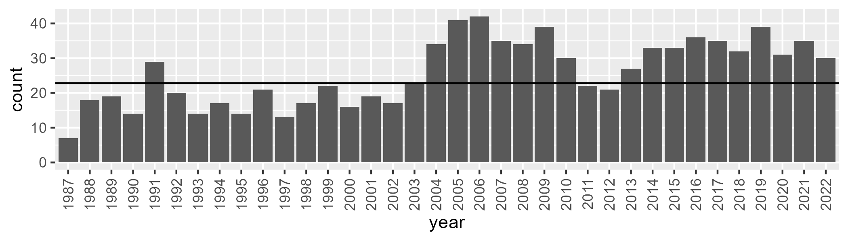

Number of samples: 929